Psychometric Test Battery for Leadership and Managerial Competencies

Introduction
The ability to measure leadership and managerial competencies objectively is among the foremost requirements of modern organizational selection and development. Judgment of a leader no longer rests on impression or seniority, but on an integrated structure of cognitive, emotional, and behavioral capacities that can be measured. In response to this need, the present battery was designed as a comprehensive Arabic instrument that brings together the cognitive, dispositional, and ethical domains framing successful leadership performance.
The battery comprises eight principal axes encompassing more than fifty subtests. It moves the examinee from higher cognitive abilities (reasoning, analysis, and abstraction) to attention, memory, and perception, then to leadership traits and emotional intelligence, followed by decision-making and problem-solving under pressure, and finally to integrity and ethical work conduct. Through this progression, the battery covers the complete construct of leadership competence as a system rather than a single isolated ability.
This edition has been prepared for scientific publication so that each of its axes corresponds to recognized international instruments well established in the psychometric and managerial assessment literature. This is intended to affirm content validity, clarify the measured constructs, and provide a sound theoretical reference that can be drawn upon during administration and local standardization.
Theoretical and Scientific Framework of the Battery
The battery is grounded in an integrative conception of leadership competence, which holds that effective leadership is the product of an interaction among cognitive abilities and attentional, mnemonic, and perceptual processes, together with personality traits and emotional and social intelligence, culminating in the capacity for decision-making and a commitment to integrity. The theoretical structure of each axis is outlined below:
Axis One — Higher Cognitive Abilities: Measures the mental processes responsible for decision quality: logical reasoning, critical and analytical thinking, abstract thinking, cognitive flexibility, and planning—the abilities addressed by critical-thinking scales and non-verbal intelligence matrices.
Axis Two — Attention: Measures the regulation of attentional resources: sustained, selective, and divided attention, and resistance to distraction, as a fundamental condition for performance under cognitive load.
Axis Three — Memory: Measures short-term memory, working memory, and the recall of decision-related information, as the medium in which managerial data are processed.
Axis Four — Perception: Measures the organization of visual input, the perception of relationships and social situations, and the interpretation of administrative cues within their context.
Axis Five — Leadership Traits and Professional Personality: Measures responsibility, self-discipline, and the personality traits associated with leadership performance, drawing on the major personality-factor models.
Axis Six — Emotional and Social Intelligence: Measures emotional self-awareness, emotion regulation, empathy, and social skills, in line with the ability and trait models of emotional intelligence.
Axis Seven — Decision-Making and Problem-Solving: Measures the quality of judgment in administrative situations and decision-making under time pressure, resource scarcity, conflict of interest, and public pressure, using the situational-judgment and simulation approaches.
Axis Eight — Integrity and Ethical Conduct: Measures professional integrity, moral judgment, and emotional response to crises, drawing on integrity tests and models of moral development.

Comparative International Benchmarking
To strengthen content validity and clarify the constructs, the following table sets out the correspondence between the battery's eight axes, the psychological constructs each axis measures, and the recognized international models and instruments parallel to them in the psychometric and managerial assessment literature. This correspondence is a theoretical reference clarifying the framework of the construct; it does not imply identity of items or of standardization, since local standardization remains a prerequisite for applied use:

Axis | Measured Psychological Construct | Reference International Models and Instruments
Part One: Higher Cognitive Abilities | Logical reasoning, critical and analytical thinking, abstract thinking, cognitive flexibility, mental planning | Watson–Glaser Critical Thinking Appraisal — Raven's Progressive Matrices — Wisconsin Card Sorting Test — Tower of London / BADS
Part Two: Attention | Sustained, selective, and divided attention, and resistance to distraction | Continuous Performance Test (CPT) — Stroop Color–Word Test — d2 Test of Attention — Trail Making Test — Test of Everyday Attention
Part Three: Memory | Short-term memory, working memory, decision-related recall | Digit Span / Wechsler Memory Scale — Corsi Block-Tapping Test — N-back Task
Part Four: Perception | Visual perception, perception of relationships, perception of social situations, interpretation of administrative cues | Benton Visual Retention Test — Bender–Gestalt Test — Embedded Figures Test — Reading the Mind in the Eyes
Part Five: Leadership Traits and Professional Personality | Responsibility, self-discipline, and leadership personality traits at work | NEO-PI-R (Big Five) — 16PF — Hogan Personality Inventory — California Psychological Inventory
Part Six: Emotional and Social Intelligence | Self-awareness, emotion regulation, empathy, social skills, and response to crises | MSCEIT — Bar-On Emotional Quotient Inventory (EQ-i) — Goleman–Boyatzis ESCI — Trait EI Questionnaire
Part Seven: Decision-Making and Problem-Solving | Judgment of administrative situations and decision simulation under pressure, resource scarcity, and conflict of interest | Situational Judgment Tests (SJT) — In-Basket / In-Tray Exercises — Assessment Center Method — Iowa Gambling Task
Part Eight: Integrity and Ethical Conduct | Professional integrity, moral judgment, and emotional response to crises | Overt & Personality-Based Integrity Tests — Defining Issues Test (DIT) — Integrity-based SJTs

Note: The instruments listed are a scientific reference for the measured construct; their original sources are provided in the list of references.

Methodology of Administration, Scoring, and Interpretation
Conditions of Administration
The test is administered individually or in groups in a quiet, distraction-free environment, after confirming that the examinee understands the instructions. The time allotted to each subtest must be observed as specified in its scoring key, since time is part of the measured construct in the cognitive and attentional tests.
Scoring Procedure
Ability tests (Axes 1–4 and 7): Scored objectively by awarding one point for each correct answer and zero for an incorrect one; scores are summed to obtain the axis score according to the keys provided after each test.
Trait, emotional-intelligence, and integrity scales (Axes 5, 6, 8): Scored according to the optimal-response key, in which the alternatives reflect a gradient of desirable behavior; for broader scientific application, it is recommended to convert them to a five-point (Likert) scale to capture individual differences more precisely.

Interpretation of Scores
The raw score is interpreted by referring it to the axis range; high scores indicate mastery of the measured construct, moderate scores indicate acceptable, developable performance, and low scores indicate a training need. Before adopting normative interpretation, it is recommended to derive local norms (standard scores or percentiles) from a sample representative of the target examinee population.
Evidence of Validity and Reliability and Standardization Steps
The researchers developed this battery and submitted it to a panel of experts and reviewers specializing in educational and psychological sciences to verify its validity. The battery achieved an agreement rate of 93%, indicating a high level of face validity. Furthermore, construct validity was established by administering the battery to a stratified random sample comprising unit and division directors and department heads at the university, as well as school principals. To assess the reliability of the battery, the test–retest method was employed, yielding a reliability coefficient of 0.79, which indicates an acceptable level of stability and consistency in measurement.
The battery was designed to possess content validity by deriving its items from clearly defined theoretical constructs and benchmarking them against recognized international instruments, as shown in the benchmarking table. To complete the requirements for publication and applied use, the following psychometric steps are recommended on the target population:
Verifying content validity through the judgment of a panel of experts in psychometrics and management, and computing the agreement ratio.
Conducting a pilot administration to compute item difficulty and discrimination indices and to refine the items.
Computing internal-consistency reliability (Cronbach's alpha) for each axis and for the battery as a whole.
Computing test–retest reliability over an appropriate interval to verify the stability of measurement.
Studying construct validity through factor analysis, and concurrent validity by relating scores to recognized external instruments.
Deriving local norms (standard scores / percentiles) from a representative sample in preparation for use in selection and development.
Through these steps, the battery moves from its well-structured theoretical framework to a standardized instrument with complete psychometric evidence, suitable for publication and use in leadership selection and training institutions.
Instructions to the Examinee
- Read each item carefully before choosing an answer, and observe the time allotted to each test.
- Each item has a single best answer; choose the alternative representing the soundest leadership behavior.
- Do not leave any item unanswered, and avoid prolonged hesitation on the behavioral situations.
- Responses are used for assessment and development purposes and are treated in full confidence.

Contents of the Battery
Comprehensive Psychometric Test Battery for Assessing Leadership and Managerial Competencies

Part One: Higher Cognitive Abilities Tests
- Logical Reasoning Tests
Item (1): If all sound managerial decisions rely on accurate information, and some available information is inaccurate, then the logical conclusion is:
A. All managerial decisions will be wrong
B. Some managerial decisions may be unsound
C. No managerial decision can be made
D. All managerial decisions are sound

Item (2): Every successful leader possesses planning skill, and some who possess planning skill do not succeed managerially. We conclude that:
A. Planning is unimportant in leadership
B. Planning alone is not sufficient for managerial success
C. All planners are successful leaders
D. Managerial success is a matter of chance

Item (3): If decision (A) led to outcome (B), and outcome (B) led to outcome (C), then the relationship between (A) and (C) is:
A. No relationship
B. An indirect causal relationship
C. A contradictory relationship
D. A purely probabilistic relationship

Item (4): Drawing a general conclusion from a single case is considered:
A. Scientific reasoning
B. A valid logical generalization
C. A logical fallacy
D. Precise analysis

Item (5): If the premises are true but the conclusion is false, then the flaw lies in:
A. The premises
B. The reasoning process
C. The wording of the question
D. The nature of the decision

Item (6): Which of the following conclusions rests on sound logical reasoning?
A. The decision failed because I do not support it
B. The decision failed due to a shortage of resources
C. The decision is always bad
D. The leader is incompetent

Item (7): The validity of a logical conclusion depends essentially on:
A. The status of the decision-maker
B. The truth of the premises
C. The number of supporters
D. The time factor

Item (8): Claiming that a complex managerial problem has only a single cause is an example of:
A. Scientific analysis
B. The single-cause fallacy
C. Precise inference
D. Methodical simplification

Item (9): Circular reasoning means:
A. Using the conclusion itself as a premise
B. Diversity of premises
C. Clarity of the causal relationship
D. Soundness of the conclusion

Item (10): The primary aim of logical reasoning in leadership work is:
A. To justify decisions already taken
B. To reach sound conclusions based on data
C. To impose one's personal opinion
D. To avoid managerial responsibility

Approved Scoring Key
Correct answer = 1 point
Total score = 10 points
Total time = 10 items × 30 seconds = 5 minutes

- Analytical Thinking Tests
Item (1): Before you is a managerial report containing conflicting information about the cause of a project's delay. What is the first sound analytical step?
A. Making an immediate decision to address the delay
B. Disregarding the conflicting information
C. Identifying the information sources and their credibility
D. Relying on personal experience

Item (2): Which of the following statements represents analysis rather than description?
A. The problem is complex
B. The problem is large
C. The problem results from three interrelated factors
D. The problem is annoying

Item (3): When analyzing a managerial problem, disregarding one of the influential variables often leads to:
A. Accelerating decision-making
B. A biased or incomplete analysis
C. Greater clarity of the problem
D. Reduced responsibility

Item (4): Which of the following practices indicates weakness in analytical thinking?
A. Linking causes to effects
B. Gathering data from multiple sources
C. Jumping to a conclusion without examining the data
D. Comparing the available alternatives

Item (5): When several possible causes exist for a single problem, the most precise analytical approach is:
A. Choosing the easiest cause
B. Adopting the most common cause
C. Analyzing the relationships among the causes and identifying the essential one
D. Postponing the analysis and making a quick decision

Item (6): What is the essential difference between description and analysis in managerial work?
A. Description portrays the phenomenon, while analysis explains its causes
B. Description relies on opinion, and analysis on intuition
C. Description is deeper than analysis
D. There is no real difference

Item (7): Which of the following is an indicator of balanced managerial analysis?
A. Focusing on a single cause only
B. Overlooking the general context
C. Examining the data and relating it to the organizational context
D. Relying on personal impressions

Item (8): Analysis is considered biased when:
A. Reliable data are used
B. All variables are taken into account
C. Information that does not support a predetermined decision is excluded
D. Results are reviewed before being adopted

Item (9): Which of the following is a common analytical error in managerial leadership?
A. Examining alternatives before deciding
B. Relating results to data
C. Confusing symptoms with causes
D. Documenting information

Item (10): How does analytical thinking contribute to improving managerial decision quality?
A. By accelerating decision-making without review
B. By reducing the number of available alternatives
C. By a deeper understanding of the problem before choosing a solution
D. By relying on experience alone

Approved Scoring Key
Correct answer = 1 point
Total score = 10 points
Total time = 10 items × 30 seconds = 5 minutes

- Abstract Thinking Tests
Item (1): What is the abstract common denominator among (leadership – planning – organizing)?
A. Daily procedures
B. People
C. Executive functions
D. Place

Item (2): Which of the following is an abstract concept rather than a concrete example?
A. A managerial meeting
B. An annual report
C. Organizational efficiency
D. A written decision

Item (3): When a leader focuses on general principles rather than minor details, this indicates:
A. Disregard for reality
B. Abstract thinking
C. Weak follow-up
D. Haste in decision-making

Item (4): Which of the following statements expresses a high level of abstract thinking?
A. An employee being late for work
B. Weak organizational commitment
C. An employee's absence today
D. Postponing a meeting

Item (5): Moving from multiple situations to a single general rule is an example of:
A. Concrete thinking
B. Descriptive thinking
C. Abstract thinking
D. Emotional thinking

Item (6): Which of the following represents a principle rather than a case?
A. A financial crisis in a particular department
B. Organizational sustainability
C. A staff shortage this month
D. An electronic-system breakdown

Item (7): When a leader links different decisions within a single framework, they are using:
A. Procedural thinking
B. Linear thinking
C. Structural abstract thinking
D. Impressionistic thinking

Item (8): Weak abstract thinking in a leader often leads to:
A. Improved strategic planning
B. Excessive focus on detail and neglect of the overall vision
C. Clarity of long-range goals
D. Enhanced strategic thinking

Item (9): Which of the following situations requires the most abstract thinking?
A. Addressing a single employee's lateness
B. Solving a routine daily problem
C. Formulating a future vision for the organization
D. Writing a weekly report

Item (10): The primary aim of abstract thinking in leadership is:
A. Accelerating task execution
B. Focusing on procedural details
C. Building an overall vision and making strategic decisions
D. Reducing the number of decisions

Approved Scoring Key
Correct answer = 1 point
Total score = 10 points
Total time = 10 items × 30 seconds = 5 minutes

- Cognitive Flexibility Tests
Item (1): If it becomes clear to a leader that the adopted plan is no longer suitable because circumstances have changed, the sound cognitive behavior is:
A. Continuing with the plan unchanged
B. Cancelling the plan entirely with no alternative
C. Re-evaluating and adjusting the plan according to the new data
D. Postponing any decision

Item (2): Cognitive flexibility means a leader's ability to:
A. Hold to an opinion regardless of outcomes
B. Change a decision merely under pressure
C. Adapt to variables without losing sight of the goal
D. Hesitate continually in decision-making

Item (3): When new information emerges that contradicts a previous decision, cognitive flexibility appears in:
A. Disregarding the new information
B. Defending the previous decision
C. Reconsidering the decision in light of the new information
D. Blaming others

Item (4): Which of the following behaviors indicates cognitive rigidity?
A. Reviewing the plan when needed
B. Making use of feedback
C. Insisting on the same solution despite its failure
D. Searching for new alternatives

Item (5): In complex managerial situations, cognitive flexibility is essential because it:
A. Reduces the number of decisions
B. Prevents error entirely
C. Allows strategies to be changed as the situation develops
D. Eliminates the need for planning

Item (6): Which of the following situations requires the highest level of cognitive flexibility?
A. Carrying out a fixed routine procedure
B. Applying clear instructions
C. Handling a sudden, multi-party crisis
D. Writing a periodic report

Item (7): Adjusting a decision after discovering an error in the data is considered:
A. Weakness in leadership
B. Managerial hesitation
C. An indicator of cognitive flexibility and leadership maturity
D. A loss of control

Item (8): The cognitively flexible leader is one who:
A. Changes decisions constantly without reason
B. Rejects opposing views
C. Is open to multiple viewpoints and evaluates them rationally
D. Adopts a single opinion only

Item (9): Weak cognitive flexibility in a leader often leads to:
A. Improved organizational performance
B. Faster problem-solving
C. Repeating errors and failing to adapt to change
D. Clarity of future vision

Item (10): The primary aim of cognitive flexibility in leadership is:
A. Pleasing all parties
B. Changing decisions constantly
C. Adapting effectively to a changing reality while preserving the goals
D. Reducing managerial responsibility

Approved Scoring Key
Correct answer = 1 point
Total score = 10 points
Total time = 10 items × 30 seconds = 5 minutes

- Mental Planning and Organization Tests
Item (1): What is the first correct mental step in the managerial planning process?
A. Executing the tasks directly
B. Distributing responsibilities
C. Defining the goal clearly
D. Following up on results

Item (2): Effective mental organization means a leader's ability to:
A. Perform several tasks at once without ordering them
B. Work only under pressure
C. Prioritize and coordinate tasks mentally
D. Rely on personal improvisation

Item (3): With multiple tasks and limited time, the sound planning behavior is:
A. Starting with the easiest tasks
B. Performing tasks in the order they arrive
C. Ordering tasks by importance and temporal priority
D. Postponing some tasks without planning

Item (4): Which of the following behaviors indicates weakness in mental planning and organization?
A. Setting a clear timetable
B. Anticipating potential obstacles
C. Executing overlapping tasks without a prior plan
D. Reviewing the plan when needed

Item (5): Short-sighted planning often results from:
A. Clarity of goals
B. Availability of information
C. Focusing on immediate results and neglecting the long range
D. Flexibility in execution

Item (6): Which of the following statements expresses a high level of mental organization?
A. Completing tasks when they are remembered
B. Working by reaction
C. Breaking the overall goal into clear sequential steps
D. Relying on experience alone

Item (7): Anticipating potential obstacles before execution indicates:
A. Managerial pessimism
B. Unnecessary complication
C. Effective mental planning and organization
D. Wasting time

Item (8): When a leader faces several simultaneous tasks, good mental organization appears in:
A. Performing all tasks at the same time
B. Postponing the decision
C. Scheduling the tasks and allocating time to each
D. Focusing randomly on a single task

Item (9): The absence of mental planning and organization often leads to:
A. Faster completion
B. Randomness and repeated errors
C. Clarity of roles
D. Improved decision quality
Item (10): The primary aim of mental planning and organization in leadership is:
A. Increasing the number of tasks
B. Literal adherence to procedures
C. Reducing managerial responsibilities
D. Achieving goals efficiently and reducing waste of time and effort

Approved Scoring Key
Correct answer = 1 point
Total score = 10 points
Total time = 10 items × 30 seconds = 5 minutes

Part Two: Attention Tests
- Sustained Attention Tests
General instructions to the examinee: Before you is a series of letters.
You are required to mark the letter (A) only when it comes immediately after the letter (X); ignore all other cases.
Time allotted per item: 30 seconds.
- X A B A X B X A A X X A B B X A.
- A X X B X A B B X A A A B X X A.
- X B B A X A A X X A B A X B X A.
- B A X A X B A A B X X A A B X A.
- X A A B B X X A X B A A X A B B.

- Selective Attention Tests
Item (1): An administrative memorandum included the following options regarding the implementation of a new decision:
A. This decision takes effect after the completion of all approved formal procedures.
B. The decision is executed in accordance with the delegated authorities and in a manner not conflicting with the regulations in force.
C. The decision is referred to the legal department for review before execution.
D. The decision is executed immediately without reference to any prior instructions.
E. The decision is executed after obtaining the relevant official approvals.
Question: Which option lacks a legal basis despite the similarity of wording?

Item (2): The follow-up report contained the following statements:
A. The department head bears responsibility for direct supervision of execution.
B. Periodic reports on completion rates are submitted in accordance with administrative procedures.
C. The procedure is executed when the necessary human resources are available.
D. The procedure is executed within a maximum period of 30 days.
E. The procedure is executed without specifying a party responsible for follow-up.
Question: Which statement lacks specification of direct responsibility?

Item (3): An internal circular stated the following:
A. Any prior directive conflicting with this circular is annulled.
B. This circular takes effect from the date of official notification.
C. General administrative controls are observed in application.
D. The circular is implemented at the discretion of each department.
E. The instructions apply to all organizational units.
Question: Which option contains deliberate administrative ambiguity?

Item (4): On reviewing the work-organization instructions, the following formulations appeared:
A. The execution time is set on the basis of an approved timetable.
B. Work commences after completing all official requirements.
C. Coordination with the relevant parties is observed.
D. The timing of execution is left to suitable circumstances.
E. Execution is followed up by the competent authority.
Question: Which option lacks a clear time frame?

Item (5): An administrative document included the following clauses:
A. Procedures are applied in accordance with the regulations in force.
B. Results are adopted after official ratification.
C. The employee bears legal responsibility in case of violation.
D. The procedure is executed as a permanent exceptional case.
E. Procedures are reviewed periodically for evaluation.
Question: Which option contains a subtle administrative contradiction?
- Divided Attention Tests
Item (1): Read the following statements and, at the same time, identify those containing a mandatory action, and write the number of statements that contain a specified time period:
A. The transaction must be completed within 10 days.
B. It is preferable to send the report as soon as possible.
C. The department is required to submit its reply within two weeks.
D. Procedures are reviewed periodically.
E. The decision must be executed immediately.

Item (2): Read the following clauses and, at the same time, identify those containing a direct responsibility, and ignore any clause that does not clearly specify a responsible party:
A. The unit manager bears responsibility for execution.
B. The instructions are executed according to the administrative context.
C. The department head is responsible for follow-up.
D. The general instructions are observed.
E. The employee bears the consequences of delay.

Item (3): Read the following data and, at the same time, identify the procedures whose time period has expired, and focus only on those not based on official approval:
A. The procedure must be executed after completing the requirements and ratification by the competent authority before 31/12/2023.
B. It is advised to update the data during the current year after obtaining administrative approval.
C. The department is required to execute the decision according to the plan approved and ratified for 2026.
D. The general controls are observed in application without specifying a time period.
E. The instructions must be applied during 2023 without reference to any official approval.

Item (4): Read the following statements and, at the same time, identify those containing a direct order, and ignore any statement lacking a clear condition:
- The procedure must be executed after completing the requirements.
- It is advised to update the data.
- The department is required to execute the decision according to the approved plan.
- The general controls are observed.
- The instructions must be applied.

Item (5): Read the following statements and, at the same time, identify the uncompleted transactions, focusing only on those whose time period has expired:
Transaction A – completed – 2026
Transaction B – not completed – 2024
Transaction C – not completed – 2027
Transaction D – completed – 2023
Transaction E – not completed – 2023

- Distraction-Resistance Tests
Item (1): Identify only the transaction number that meets the following conditions: not completed, belongs to the administrative department; ignore any additional information however important it may seem:
- Transaction 101 – administrative – not completed – note: urgent
- Transaction 102 – technical – not completed – note: prior delay
- Transaction 103 – administrative – completed – note: finished
- Transaction 104 – financial – not completed – note: under follow-up
- Transaction 105 – administrative – completed – note: final signature

Item (2): Identify the single statement that contains a direct order with a specified time.
- It is preferable to execute the procedure at the earliest opportunity.
- The decision must be executed within 14 days.
- The general circumstances are observed in application.
- It is advised to reconsider the mechanism.
- Proposals are taken into consideration.

Item (3): Identify the procedure requiring immediate execution according to the text only, and ignore words suggesting importance without obligation.
- This procedure is deemed highly important.
- The procedure must be executed immediately.
- Expediting execution is recommended.
- It is preferable not to delay.
- Execution will be considered later.
Item (4): Identify the number that satisfies both conditions: greater than 50 and even; ignore font emphasis or the order of the numbers:
- 49
- 52
- 67
- 58
- 73

Item (5): Identify the clause that transfers a direct legal responsibility, and ignore the explanatory or directive clauses.
- Procedures are reviewed periodically.
- The employee bears legal responsibility in case of violation.
- The administrative hierarchy is observed.
- Exceptional circumstances are taken into consideration.
- Adherence to the instructions is preferable.

Part Three: Memory Tests
- Short-Term Memory Tests
Figure (1): Look at the shapes shown in the figure for 10 seconds, then answer.
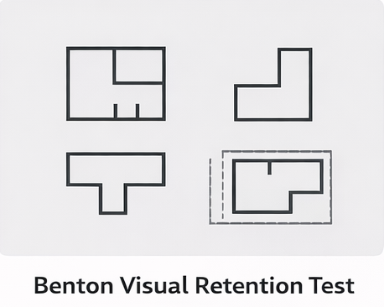
Question: How many shapes in the figure contain at least one internal line (a line inside the shape, not an outer boundary)?

Figure (2): Look at the figure shown for 10 seconds, then answer.
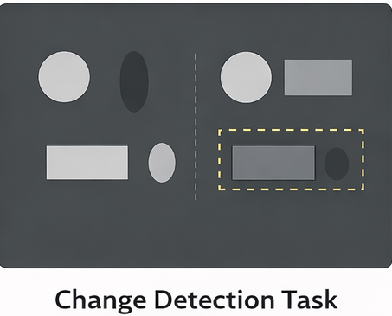

Question: In the right-hand panel only (to the right of the dashed vertical line), how many shapes are present?

Figure (3): Look at the figure shown for 10 seconds, then answer.
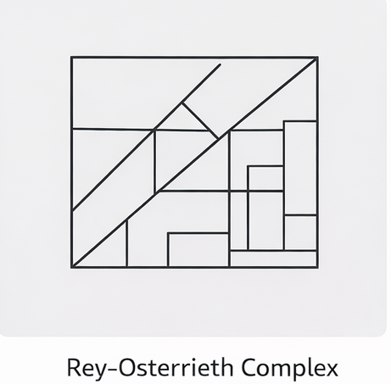

Question: How many shapes in total appear in the figure?

Figure (4): Look at the figure shown for 10 seconds, then answer.
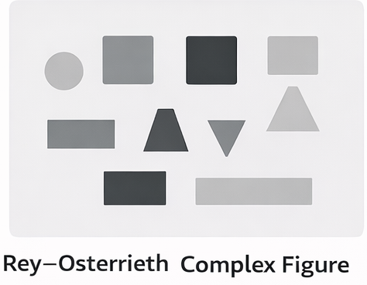

Question: In the right half of the composite figure, how many rectangles (whose length is greater than their width) are there?

Figure (5): Look at the figure shown for 10 seconds, then answer.
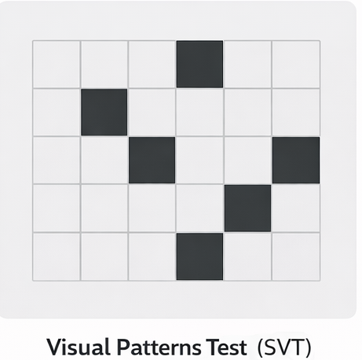

Question: How many shaded (dark) squares are present in the grid?

Figure (6): Look at the figure shown for 10 seconds, then answer.
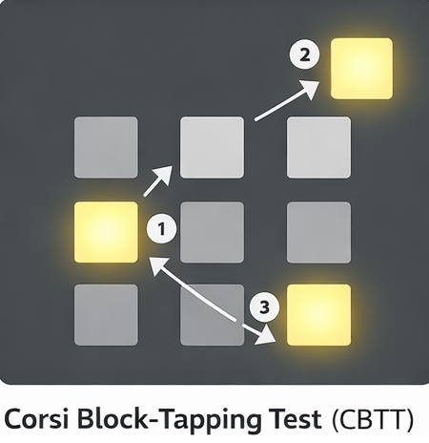

Question: How many lit squares appeared in the figure? And what is the position of the first and the last lit square?

- Working Memory Tests
Item (1): Read the numbers in order, and retain only the last 3 numbers that appear.
The sequence: 7 – 2 – 9 – 4 – 1 – 8 – 6
Question: What are the last three numbers that appeared, in order?

Item (2): Memorize the numbers, then rewrite them in ascending order (from smallest to largest).
The numbers: 42 – 17 – 33 – 28 – 19
Question: Write them in ascending order.

Item (3): Compute the result of each operation and retain the results, then write the results in order.
The operations: (6×3), (14−5), (8+7)
Question: What are the results, in order?

Item (4): Read the words, then state the number of administrative words and the number of non-administrative words, then state the last administrative word that appeared.
The list: decision – office – execution – window – approval – tree
Question: What is the number of administrative words and of non-administrative words?

Item (5): You have a “balance” starting at 50. Apply the commands in order and retain the value after each step, then state the final value.
The commands: +12, −7, +5, −10
Question: What is the final value?

- Decision-Related Information Recall Tests
Item (1): The project may be executed if:
- financial approval is available;
- the previous completion rate is no less than 70%;
- and there are no oversight remarks in the most recent report.
Question: Which condition relates to past performance and directly affects the decision?

Item (2): Management decided to postpone adopting the plan—not because of a lack of resources, but because it conflicted with regulatory instructions issued recently.
Question: What is the real reason on which the postponement decision was based?

Item (3): The report is prepared by the technical department, reviewed by the administrative division, while final approval of the decision is within the authority of the board of directors.
Question: Which party holds the authority to make the final decision?

Item (4): The decision is reviewed six months after its issuance, and it is not reconsidered before this period elapses except in emergencies.
Question: What is the basic time period associated with reviewing the decision?

Item (5): The reports showed that:
- the absence rate is high;
- resources are available;
- overall performance is acceptable;
- but there is one unaddressed legal violation.
Question: What information prevents a decision to continue despite the positivity of the remaining data?
Part Four: Perception Tests
- Visual Perception Tests
Item (1): Description of the figure: four similar organizational charts, from the right in order (A, B, C, D), each composed of three connected square units. In one chart, the position of the connecting (middle) unit differs in spatial orientation.
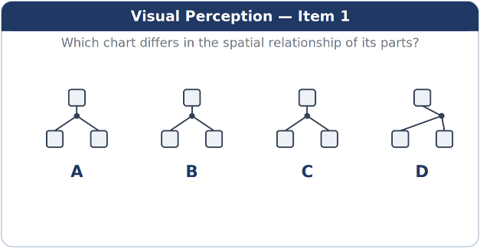

Question: Which chart differs visually in terms of the spatial relationship among its components?

Item (2): A series of four successive shapes beginning from the right (A, B, C, D); the orientation of each shape changes by a fixed angle.
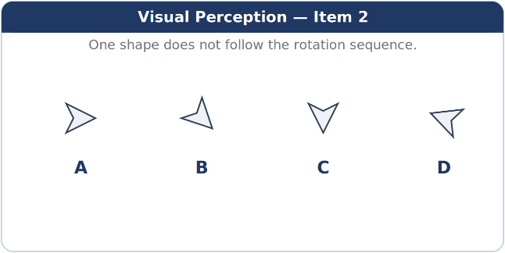

Question: One of the shapes does not follow this sequence.

Item (3): Four successive symbols from the right (A, B, C, D), visually identical in overall shape and color, but one of them differs in the orientation of one of its internal parts.
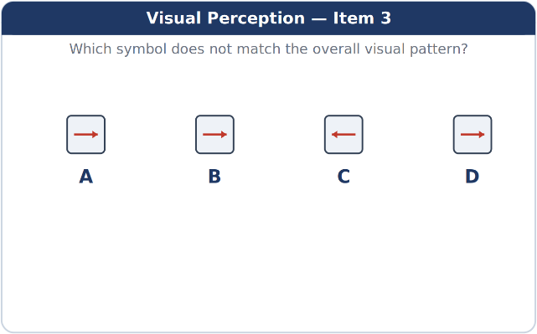
Question: Which symbol does not conform to the overall visual pattern?

Item (4): A composite figure containing several partially overlapping units, some of which share a common boundary.
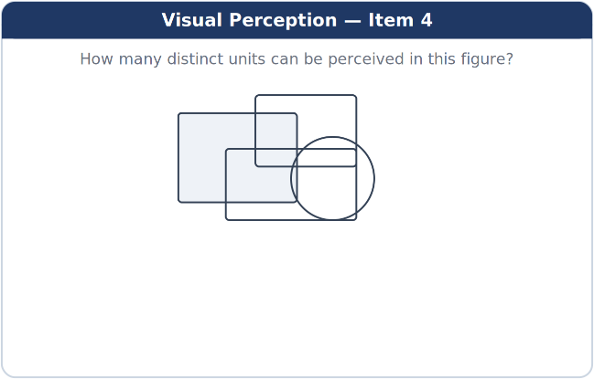
Question: How many units can be perceived in this figure?

Item (5): Four composite geometric shapes from the right (A, B, C, D), close in size and number of parts. Three of them show clear visual symmetry about a single axis, while one lacks this symmetry owing to the differing position of one of its parts.
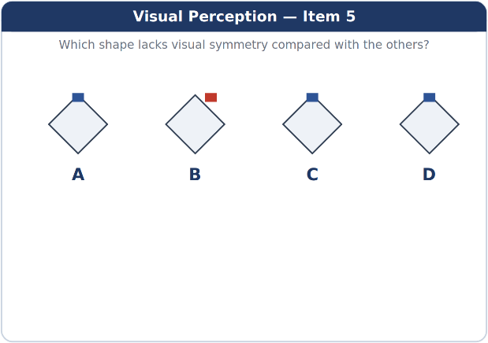
Question: Which shape lacks visual symmetry compared with the rest of the shapes?

- Relationship-Perception Tests
Item (1): An organizational chart showing three units (A, B, C) with arrows indicating supervision and subordination relationships. One unit appears as a pivot point for the rest of the units.
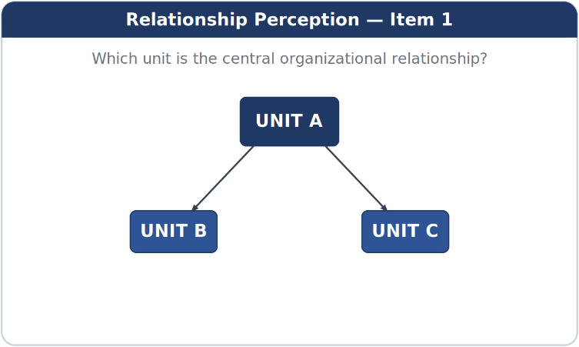
Question: Which unit represents the central organizational relationship in the chart?

Item (2): A chart showing a sequence of three elements linked by directional arrows (Outputs → Process → Inputs).
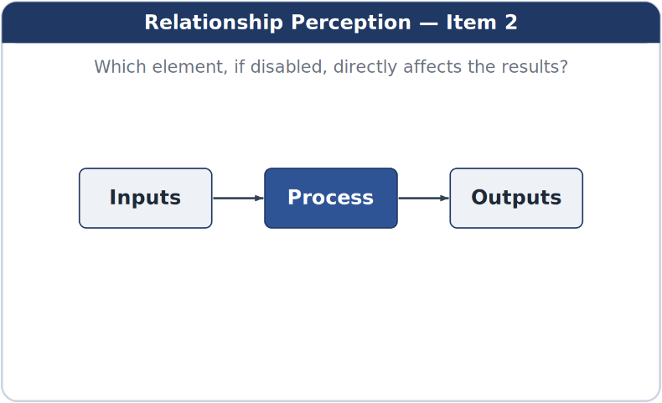
Question: Which element, if disabled, directly affects the results without passing through another element?

Item (3): Three circles representing different functional tasks, two of which intersect in a shared area.
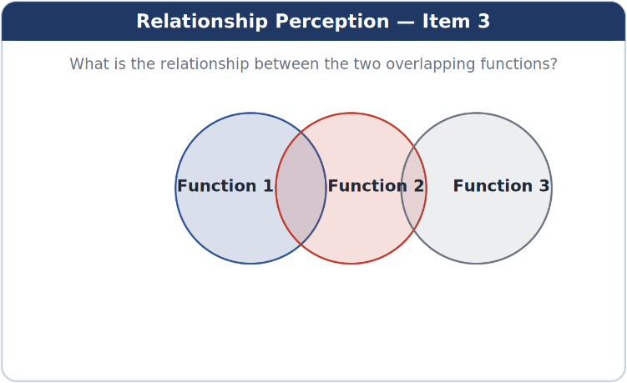
Question: What is the type of perceived relationship between the two overlapping functions?
A. A relationship of independence
B. A relationship of conflict
C. A relationship of functional overlap
D. A relationship of direct subordination

Item (4): A chart showing a sequence of decisions, in which a subsequent step cannot be executed until a specific prior step is achieved.
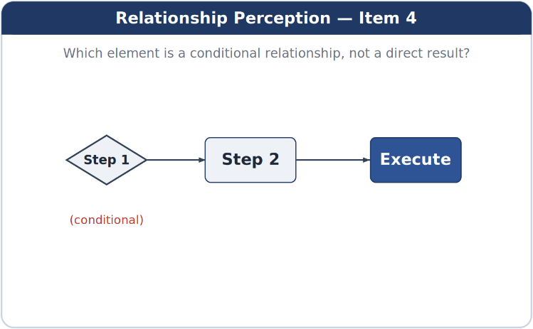
Question: Which element in the chart represents a conditional relationship rather than a direct result?
A. The first element
B. The second element
C. The third element
D. The last element

Item (5): An interconnected task network, in which one task connects directly to all the other tasks.
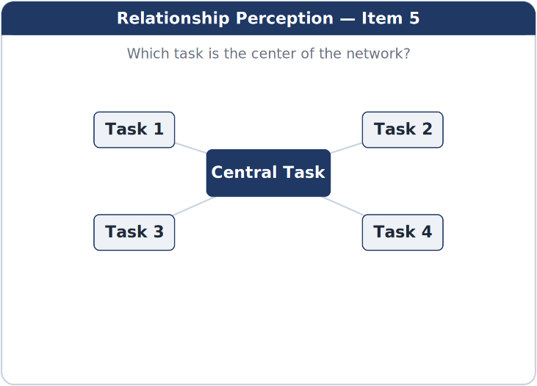
Question: Which task is the center of the organizational relationship within the network?
A. task 1
B. task 2
C. task 3
D. Central task

- Social-Situation Perception Tests
Item (1): A scene of a formal meeting with several participants. A direct question is put to one of the members, but he remains silent and looks at the table without eye contact.
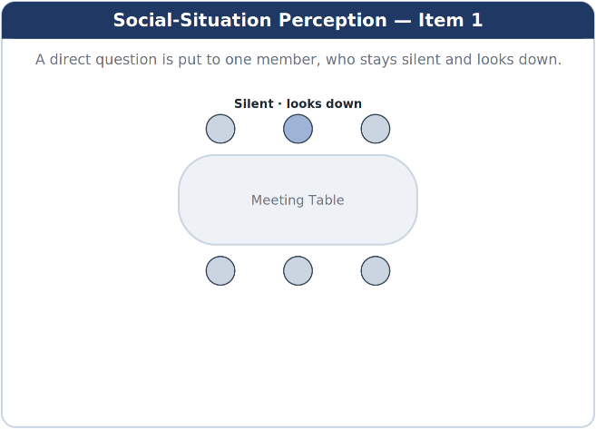
Question: What is the most likely perceptual interpretation of this behavior in the administrative context?
A. Lack of understanding
B. Weak attention
C. Deliberate social reserve
D. Lack of experience

Item (2): An employee is seen verbally agreeing to a proposal, while avoiding eye contact and showing signs of physical hesitation.
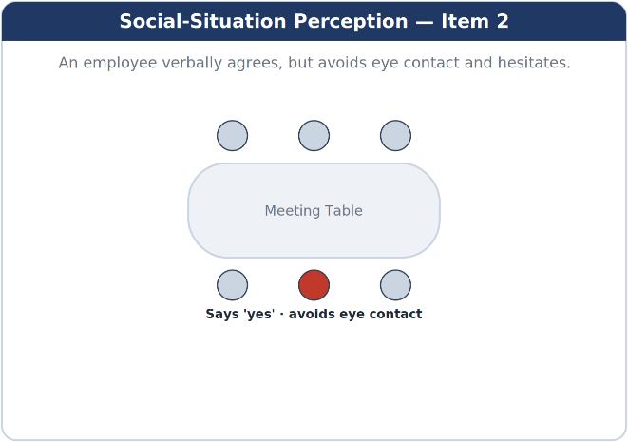
Question: What is the most likely perceptual significance of this contradiction?
A. Internal congruence
B. Undeclared refusal
C. Weak communication
D. Temporary confusion

Item (3): A deputy manager intervenes in a discussion outside his direct remit, interrupting the main speaker.
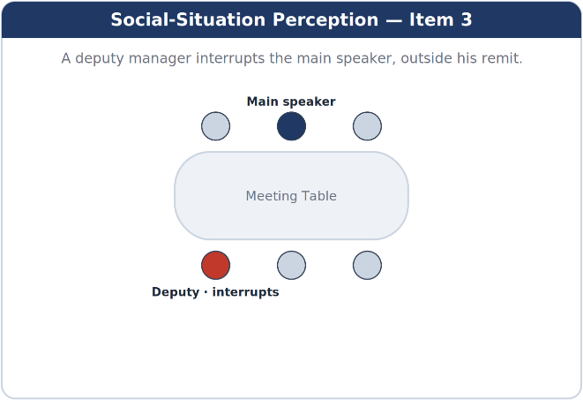
Question: What does the leader perceive socially from this behavior?
A. A positive professional initiative
B. A pursuit of influence
C. Organizational commitment
D. Group cooperation

Item (4): The same proposal is put forward again by more than one member during the meeting, with a slight difference in wording.
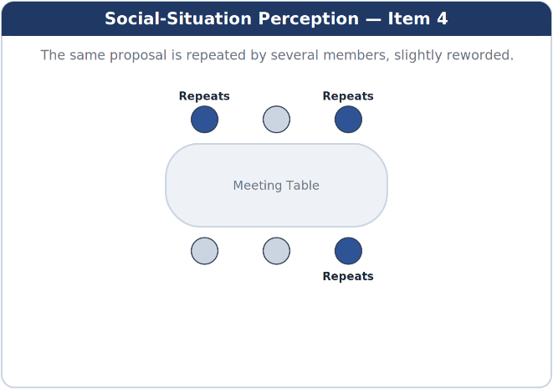
Question: What is the most likely perceptual meaning of this repetition in the social context?
A. Weak coordination
B. Lack of comprehension
C. The social importance of the proposal
D. Absence of leadership

Item (5): The work team appears split into two undeclared groups, with a clear divergence in tone of address and exchanged glances.
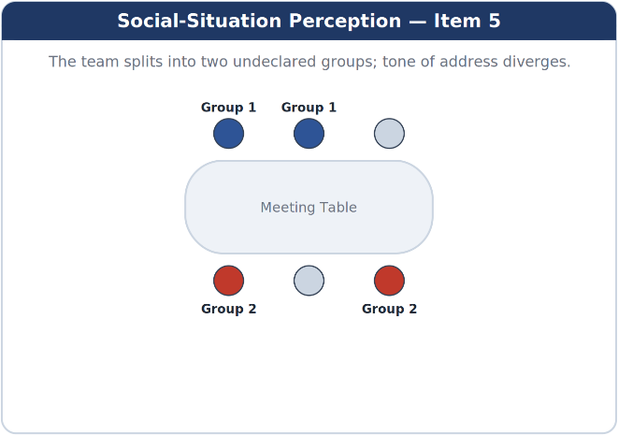
Question: Which social indicator is the most telling of this split?
A. Difference of opinion
B. Divergence in tone of address
C. Multiplicity of discussions
D. Distribution of tasks

- Tests of Interpreting Administrative Cues and Contexts
Item (1): Situation description: A formally and substantively complete transaction is returned without signature, with a terse phrase:
(Please wait).
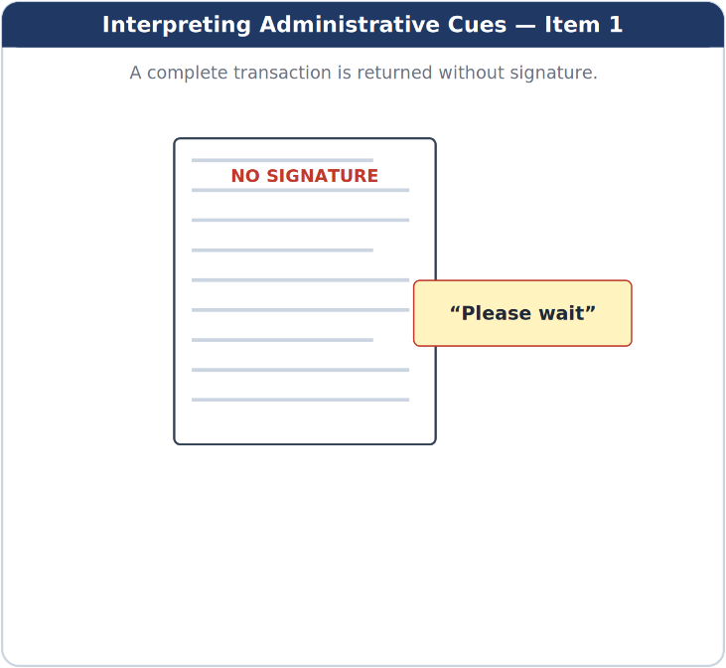
Question: What is the closest administrative interpretation of this cue?
A. Completion of the procedure
B. The presence of an undeclared reservation
C. A minor formal error
D. Expediting the decision

Item (2): Situation description: A brief administrative comment is attached to the file: (needs further review), without specifying any points or remarks.
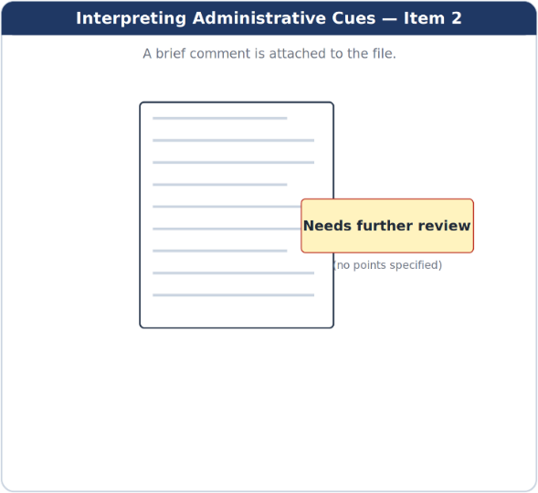
Question: How is this context interpreted administratively?
A. Completion of the transaction
B. The presence of ambiguity in the decision
C. A desire to postpone or re-evaluate
D. A final routine procedure

Item (3): Situation description: The transaction is referred to the same party more than once without any change to its content.
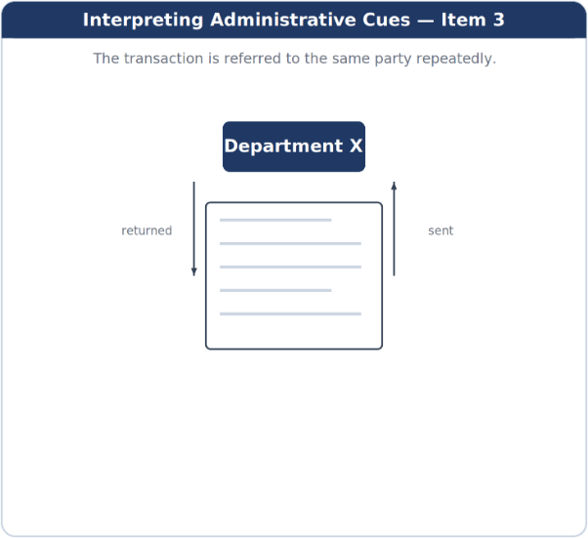
Question: What is the most likely administrative context indicated by this repeated referral?
A. Precise organizational compliance
B. A lack of authority or of decisiveness
C. Completion of the procedures
D. A natural administrative sequence

Item (4): Situation description: The style of correspondence changes from a direct form to an excessively formal one, with an expansion of titles and protocol expressions.
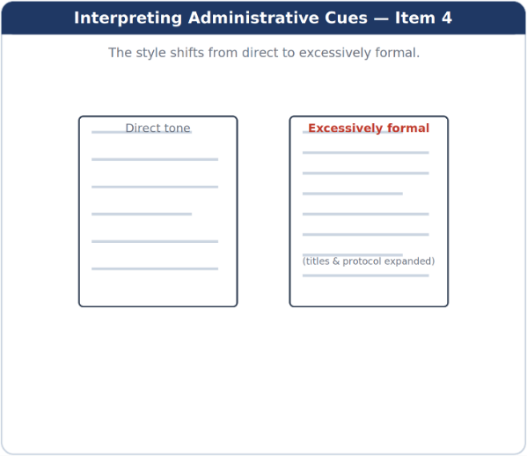
Question: What is the most likely contextual significance of this change?
A. Improving the style of communication
B. A potential administrative escalation
C. A usual formal procedure
D. Simplifying the procedures

Item (5): Situation description: The expression (the matter will be considered later) is used at the end of the correspondence.
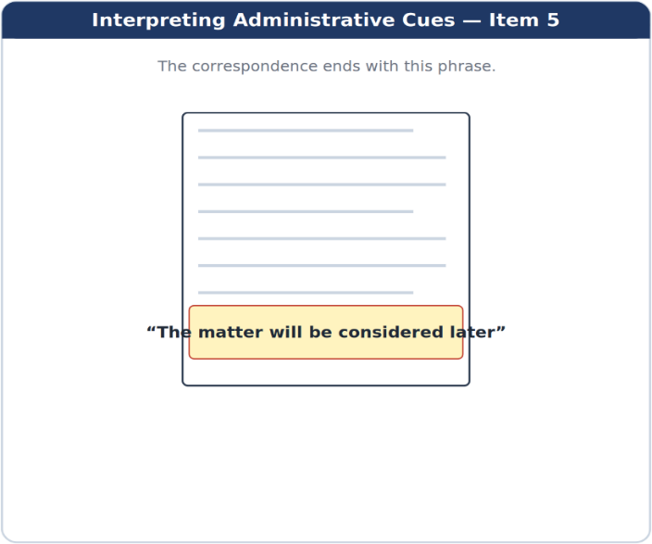
The matter will be considered later
Question: What is the closest administrative interpretation of this cue?
A. Immediate acceptance
B. Explicit refusal
C. Suspension of the decision without a time commitment
D. Direct execution

Part Five: Leadership Traits and Professional Personality Tests
- Scales of Responsibility and Self-Discipline
Item (1): Your team was late completing a task because of weak prior follow-up. What is the most responsible leadership action?
A. Placing full responsibility on the team
B. Ignoring the matter and focusing on upcoming tasks
C. Taking responsibility and addressing the flaw organizationally
D. Referring the matter to senior management

Item (2): You noticed a minor shortcoming that does not currently affect the workflow. How do you act?
A. Ignore it entirely
B. Address it immediately in accordance with the regulations
C. Postpone it to a later time
D. Leave it to the team

Item (3): You were asked to complete an additional task outside official working hours. What is the most disciplined stance?
A. Apologizing directly
B. Carrying it out without organization
C. Organizing your time and completing it efficiently
D. Transferring it to another colleague

Item (4): An administrative error occurred under your direct supervision. What is the responsible leadership action?
A. Denying any connection to the error
B. Justifying the error
C. Acknowledging and addressing the flaw
D. Placing the blame on another party

Item (5): You face simultaneous work pressures. What is the most disciplined behavior?
A. Completing the easiest first
B. Working randomly
C. Postponing some tasks without notice
D. Prioritizing and adhering to the plan

- Scales of Balanced Assertiveness
Item (1): An employee repeatedly violates the instructions. What is the balanced leadership action?
A. Ignoring the behavior
B. A public reprimand
C. Leniency for the sake of relationships
D. A firm warning in accordance with the regulations

Item (2): A subordinate requests an unjustified exception. What is the most appropriate stance?
A. Accepting to please him
B. A blunt refusal
C. A justified, calm refusal
D. Referring the request without taking a stance

Item (3): Your opinion conflicts with that of your team. How do you show balanced assertiveness?
A. Discussing the decision and taking a clear stance
B. Withdrawing completely
C. Imposing your opinion
D. Postponing the decision

Item (4): An employee exploits your leadership flexibility. What is the balanced action?
A. Sudden strictness
B. Continued overlooking
C. Re-setting the relationship clearly
D. Transferring the employee immediately

Item (5): A heated argument occurs in a formal meeting. How do you act?
A. Ending the meeting immediately
B. Managing the dialogue firmly and calmly
C. Siding with one party
D. Withdrawing from the discussion

- Scales of Leadership Initiative
Item (1): You notice an opportunity to improve an administrative procedure without a formal request. What is the most appropriate leadership behavior?
A. Waiting for direction
B. Ignoring the idea
C. Taking the initiative to put forward the proposal
D. Leaving it to a colleague

Item (2): A recurring defect appears in daily work. How do you take initiative?
A. Proposing a practical solution
B. Merely noting it
C. Repeating the warning
D. Only filing a complaint

Item (3): Your team faces a new challenge. What is the proactive leadership action?
A. Waiting for instructions
B. Focusing on routine
C. Anticipating the problem with a plan
D. Postponing dealing with it

Item (4): You are assigned a task with unclear parameters. How do you act?
A. Apologizing
B. Working without a conception
C. Referring the task
D. Gathering information and forming a conception

Item (5): An opportunity for professional development becomes available to you. What is the leadership behavior?
A. Ignoring it
B. Postponing it
C. Investing in it to develop performance
D. Leaving it to others

- Scales of Independence in Decision-Making
Item (1): The situation requires an urgent decision within your authority. What is the most appropriate action?
A. Waiting for senior approval
B. Hesitating
C. Postponing it
D. Making the decision and bearing its responsibility

Item (2): You receive conflicting opinions from your team. How do you act?
A. Evaluating the opinions and making an independent decision
B. Avoiding the decision
C. Following the majority only
D. Referring the decision

Item (3): You fear negative reactions to your decision. What is the correct leadership behavior?
A. Backing down
B. Ignoring the decision
C. Making a considered decision
D. Transferring the responsibility

Item (4): The decision requires a personal interpretation of the regulations. How do you act?
A. Abstaining
B. A responsible professional interpretation
C. A biased interpretation
D. Abandoning the decision

Item (5): You are granted a new authority. How do you deal with it?
A. Using it with excessive caution
B. Ignoring it
C. Employing it within the professional framework
D. Passing it to others
- Scales of Self-Control and Emotion Regulation
Item (1): You are subjected to unwarranted public criticism. What is the most appropriate leadership action?
A. An emotional response
B. Withdrawal
C. Controlling the emotion and responding professionally
D. Ignoring the situation entirely

Item (2): You feel pressure during a decisive meeting. How do you act?
A. Visible tension
B. Haste
C. Ending the meeting
D. Maintaining composure

Item (3): An employee provokes you with his behavior. What is the leadership behavior?
A. Sharp confrontation
B. Complete disregard
C. Self-control and professional handling
D. Immediate punishment

Item (4): You receive sudden negative news. How do you act?
A. Controlling the emotion and analyzing the situation
B. Postponing the decision
C. Showing emotion
D. Blaming others

Item (5): Daily pressures recur. What is the sound leadership behavior?
A. Repeated emotional outbursts
B. Exhaustion
C. Managing pressures consciously
D. Withdrawal

Part Six: Emotional and Social Intelligence Tests
- Emotional Self-Awareness
Item (1): During a formal meeting, you felt growing internal annoyance at a colleague's intervention. Which behavior indicates high emotional self-awareness?
A. Ignoring the feeling and continuing to speak
B. Noticing the feeling and understanding its source
C. A sharp response to stop the intervention
D. Withdrawing from the meeting

Item (2): You noticed that you make hasty decisions in times of pressure. Which action reflects emotional self-awareness?
A. Justifying the behavior by the pressure
B. Placing responsibility on the team
C. Denying the existence of the problem
D. Recognizing the pattern and trying to regulate it

Item (3): You feel intense enthusiasm toward a particular project. Which behavior is the most emotionally aware?
A. Imposing the project without discussion
B. Suppressing the enthusiasm entirely
C. Recognizing the enthusiasm and balancing it with objectivity
D. Leaving the decision entirely to the team

Item (4): You realized that you feel recurrent frustration with a particular task. What is the most appropriate behavior?
A. Ignoring the frustration
B. Reacting emotionally during execution
C. Changing the task without notice
D. Analyzing the feeling and its causes

Item (5): You receive a critical remark and immediately feel defensive. What indicates emotional awareness?
A. A defensive response
B. Pausing and noticing the feeling
C. Ending the dialogue
D. Ignoring the remark

- Emotion Regulation
Item (1): You face a provocative situation from an employee. Which behavior best regulates the emotion?
A. An immediate response
B. Ignoring the situation entirely
C. Self-control and postponing the response
D. Escalating the matter

Item (2): You feel angry during a decisive meeting. How do you regulate your emotion?
A. Raising your voice
B. Withdrawing
C. Suppressing the anger unconsciously
D. Deep breathing and controlling your tone

Item (3): You are under continuous work pressure. What is the most regulated behavior?
A. Venting anger on the team
B. Ignoring the feelings
C. Acknowledging the pressure and managing it
D. Surrendering to exhaustion

Item (4): You receive sudden negative news. How do you regulate your emotional response?
A. Showing displeasure publicly
B. Controlling the emotion and analyzing the situation
C. Blaming others
D. Postponing all decisions
Item (5): A heated dispute occurs in your team. What is the most emotion-regulated behavior?
A. Siding with one party
B. Imposing a quick decision
C. Withdrawing
D. Calming things before intervening

- Professional Empathy
Item (1): An employee faces a personal difficulty that has affected his performance. Which behavior reflects professional empathy?
A. Ignoring the matter
B. Reducing responsibilities without discussion
C. Listening and offering professional support
D. Disciplining him administratively

Item (2): An employee complains of work pressure. How do you show professional empathy?
A. Belittling the complaint
B. Understanding the situation while maintaining work requirements
C. Exempting him entirely from tasks
D. Transferring him to another department

Item (3): A subordinate makes an error out of stress. What is the most empathetic action?
A. A public reprimand
B. Disregard
C. Understanding with corrective guidance
D. Immediate punishment

Item (4): You notice a decline in an employee's motivation. How do you handle it with professional empathy?
A. Increasing pressure
B. Ignoring the decline
C. Investigating the causes and supporting him
D. Transferring him immediately

Item (5): An employee asks for understanding of an emergency circumstance. What is the most appropriate behavior?
A. Direct refusal
B. Absolute acceptance
C. Listening and making a balanced decision
D. Referring the request without consideration

- Conflict Management
Item (1): A dispute arises between two members of your team. What is the most appropriate leadership approach?
A. Siding with one of them
B. Ignoring the dispute
C. Listening to both parties and managing the dialogue
D. Imposing an immediate solution

Item (2): The dispute escalates and affects work. What is the most effective action?
A. Postponing intervention
B. Defusing the conflict and redirecting the dialogue
C. Transferring one of the parties
D. Ending the meeting

Item (3): Each party holds firmly to its position. How is the situation managed?
A. Imposing the leadership's opinion
B. Letting the dispute continue
C. Seeking a compromise
D. Cancelling the task

Item (4): The dispute results from a misunderstanding. What is the most appropriate measure to resolve it?
A. Escalation
B. Clarifying the positions and removing the confusion
C. Punishment
D. Ignoring the details

Item (5): Conflict recurs within the team. What is the correct leadership behavior?
A. Changing the team
B. Establishing clear rules for managing disagreement
C. Leaving the matter to personal relationships
D. Imposing discipline only

- Influence and Persuasion Skills
Item (1): You wish to persuade your team to change an existing procedure. What is the most influential approach?
A. Imposing the decision
B. Presenting the rationale and benefits
C. Threatening punishment
D. Ignoring objections

Item (2): The team shows resistance to a new idea. How do you influence positively?
A. Ignoring the resistance
B. Listening to the concerns and addressing them
C. Postponing the idea
D. Withdrawing the proposal

Item (3): You want support for an administrative decision before senior management. What is the most appropriate persuasive behavior?
A. Relying on authority
B. Exaggerating in the presentation
C. Presenting arguments supported by facts
D. Avoiding discussion

Item (4): Opinions differ over an important decision. How do you exercise influence?
A. Belittling other opinions
B. Imposing your opinion
C. Building gradual consensus
D. Withdrawing from the discussion

Item (5): Your team needs motivation to carry out a difficult task. What is the most persuasive approach?
A. Time pressure
B. Intimidation with consequences
C. Clarifying the goal and its meaning
D. Increasing the burdens

Part Seven: Leadership Decision-Making and Problem-Solving Tests
- Administrative-Situation Tests
Item (1): You noticed a decline in an employee's compliance with instructions, without it yet affecting the workflow. What is the most professional leadership decision?
A. Ignoring the behavior as long as it has no current effect
B. Addressing the matter early with clear professional guidance
C. Submitting an immediate report to senior management
D. Waiting for the behavior to recur before acting

Item (2): A minor dispute occurred between two employees during daily work. What is the most appropriate leadership measure?
A. Ignoring the dispute as transient
B. Transferring one of the employees
C. Listening to both parties and resolving the dispute professionally
D. Issuing a formal warning to both parties

Item (3): You were asked to make a decision outside official working hours, with the legal authority available. What is the most responsible leadership action?
A. Postponing the decision to official hours
B. Refusing to make the decision
C. Transferring the decision to another party
D. Making the decision and bearing its responsibility

Item (4): You noticed indirect resistance from the team you work with to implementing a new procedure. What is the most effective leadership decision?
A. Imposing the procedure without discussion
B. Withdrawing the decision immediately
C. Explaining the procedure and listening to the team's remarks
D. Ignoring the resistance

Item (5): A subordinate erred in carrying out a sensitive task. What is the most appropriate leadership action?
A. A public reprimand
B. Ignoring the error
C. Placing responsibility on the team
D. Addressing the error and holding the individual professionally accountable

- Decision Simulation Under Time Pressure
Item (1): Two hours before the deadline for an official report, a minor deficiency is found in one of the non-essential appendices. What is the most appropriate leadership decision under time pressure?
A. Postponing submission until the appendix is completed
B. Submitting the report as is without explanation
C. Completing the appendix quickly even at lower quality
D. Submitting the report with an explanation of the deficiency and a commitment to complete it

Item (2): A sudden malfunction occurred in an electronic system during peak hours, with increasing complaints from clients. What is the most time-effective leadership decision?
A. Halting work until the malfunction is repaired
B. Activating a temporary alternative procedure to keep work going
C. Waiting for instructions from senior management
D. Immediately blaming the technical team
Item (3): A senior official asks you for an urgent opinion within minutes on a new administrative procedure, without all the data available. What is the most balanced leadership decision?
A. Giving a final opinion without reservation
B. Refusing to give any opinion
C. Offering a preliminary opinion clearly stated as conditional
D. Postponing the reply entirely

Item (4): A few minutes before a formal meeting begins, one of the key members apologizes for not attending. What is the most appropriate leadership action?
A. Cancelling the meeting immediately
B. Postponing the meeting to a later date
C. Ignoring the absence and proceeding without adjustment
D. Redistributing the roles and proceeding with the meeting

Item (5): You are asked for a quick approval of a routine procedure within your authority, with very limited time available.
What is the correct leadership decision?
A. Signing quickly without review
B. Refusing to sign because of time constraints
C. A brief review and making the decision
D. Referring the procedure to another party

- Decision Simulation Under Resource Scarcity
Item (1): You were asked to carry out an urgent training activity, while the available budget does not cover all the requirements. What is the most appropriate leadership decision?
A. Cancelling the activity entirely
B. Carrying out the activity at low quality
C. Redesigning the activity according to the available resources
D. Requesting additional resources and postponing execution

Item (2): A number of key employees are absent during a period of high work pressure. How do you make the appropriate leadership decision?
A. Suspending work
B. Temporarily redistributing tasks and reorganizing
C. Loading those present with an additional burden without organization
D. Ignoring the shortage and continuing with the same plan

Item (3): A particular project requires equipment that is not currently available. What is the most professional decision?
A. Cancelling the project
B. Carrying out the project without the equipment
C. Searching for temporary alternatives
D. Placing responsibility on another team

Item (4): Financial resources shrank in mid-year. How do you act as a leader?
A. Halting all activities
B. Continuing without adjustment
C. Re-prioritizing
D. Ignoring the financial change

Item (5): The volume of work conflicts with the number of available employees. What is the sound leadership decision?
A. Assigning the team tasks beyond their capacity
B. Postponing all work
C. Distributing work by priority
D. Ignoring the problem

- Decision Simulation Under Conflict of Interest
Item (1): A relative of yours works in a department that will benefit from an administrative decision you are about to make. What is the most ethical leadership action?
A. Making the decision directly
B. Delegating the decision to a neutral party
C. Pushing the decision through quickly
D. Cancelling the decision
Item (2): You are asked to evaluate an employee with whom you have a personal relationship. What is the most appropriate decision?
A. Evaluating him positively to avoid embarrassment
B. Abstaining from the evaluation without an alternative
C. Referring the evaluation to an independent party
D. Ignoring the personal relationship

Item (3): Your decision may affect the interest of a party you previously worked with. How do you act?
A. Making the decision without consideration
B. Disclosing the relationship and taking a professional measure
C. Postponing the decision
D. Pushing the decision through without documentation

Item (4): You feel that one party is trying to influence you personally. What is the sound leadership decision?
A. Going along with the party
B. Ignoring the influence and deciding alone
C. Documenting the situation and adhering to procedures
D. Withdrawing from the decision without explanation

Item (5): There is a potential conflict between the public interest and an individual interest. How do you make the decision?
A. Giving precedence to the public interest in accordance with the regulations
B. Striking an unclear balance
C. Giving precedence to the individual interest
D. Postponing the decision

- Decision Simulation Under Public or Institutional Pressure
Item (1): You face media pressure to make a quick decision despite incomplete information. What is the most balanced leadership decision?
A. Making the decision immediately
B. Ignoring the pressure entirely
C. Clarifying the position and formally postponing the decision
D. Issuing a partial decision

Item (2): An influential institutional party demands bypassing a regulatory procedure. How do you act?
A. Complying with the request
B. Refusing without justification
C. Postponing the reply
D. Adhering to the procedures and explaining the reasons

Item (3): Clients' discontent grows because of a correct regulatory procedure. What is the most appropriate decision?
A. Changing the procedure immediately
B. Explaining the procedure and institutional communication
C. Ignoring the discontent
D. Placing responsibility on the employees

Item (4): An informal directive is issued to make a decision contrary to the instructions. What is the correct leadership behavior?
A. Executing the directive
B. Ignoring the directive
C. Requesting a formal written directive
D. Postponing the decision

Item (5): You are under internal pressure from management to expedite a sensitive decision. How do you act?
A. Yielding to the pressure
B. Adhering to the procedures while explaining the position
C. Withdrawing from the responsibility
D. Pushing the decision through without documentation

Part Eight: Scales of Integrity and Ethical Work Conduct
- Scales of Professional Integrity
Item (1): You were asked to expedite a formally completed transaction in return for an “informal facilitation.” What is the most ethical leadership action?
A. Accepting in exchange for a guarantee of no harm to the work
B. Refusing and documenting the attempt in due form
C. Ignoring the request without a response
D. Passing the transaction through without compensation

Item (2): You noticed a minor manipulation in the data of a report that does not directly affect the overall results. What is the most ethical behavior?
A. Overlooking it as long as the effect is limited
B. Amending the report on your own without notice
C. Reporting the flaw and addressing it formally
D. Postponing the correction

Item (3): A colleague asked you to conceal information that might embarrass him administratively. What is the sound leadership decision?
A. Protecting the colleague
B. Concealing the information temporarily
C. Presenting the matter to the competent management
D. Ignoring the request without action

Item (4): You discovered an administrative error under your direct supervision. What is the most ethical action?
A. Placing responsibility on the team
B. Correcting the error without documentation
C. Acknowledging the error and addressing it through proper channels
D. Denying any connection to the error

Item (5): You were offered an unauthorized job privilege. What is the correct leadership behavior?
A. Accepting it as long as it harms no one
B. Refusing it and adhering to what is regulatory
C. Postponing the decision
D. Consulting colleagues and then accepting

- Scales of Compliance with Laws
Item (1): You were asked to carry out an urgent procedure that conflicts with regulations in force. What is the correct leadership decision?
A. Executing it because of urgency
B. Executing it while documenting the reservation
C. Adhering to the regulations and requesting a formal directive
D. Ignoring the regulations

Item (2): There is ambiguity in a legal text concerning a particular procedure. How do you act?
A. Interpreting it according to interest
B. Consulting the competent legal authority
C. Executing the procedure without interpretation
D. Postponing the work entirely

Item (3): You noticed a minor legal breach that the team has grown accustomed to. What is the most appropriate leadership action?
A. Overlooking it because it is common
B. A verbal reminder only
C. Correcting the breach and adhering to the regulations
D. Transferring the responsibility

Item (4): You face pressure to finalize a transaction without meeting the legal conditions. What is the correct decision?
A. Finalizing the transaction
B. Postponing it without reason
C. Passing it through partially
D. Refusing the procedure until the conditions are met

Item (5): Adherence to the regulations leads to an undesirable delay. How do you act?
A. Bypassing the regulations
B. Adhering to the regulations while explaining the reasons
C. Changing the procedure
D. Ignoring the delay

- Scales of Resistance to Occupational Temptation
Item (1): You were offered a personal benefit to facilitate an administrative procedure. What is the correct leadership behavior?
A. Accepting with caution
B. Refusing and reporting
C. Ignoring the offer
D. Postponing the reply

Item (2): You can take advantage of a regulatory loophole without being detected. What is the sound decision?
A. Exploiting it temporarily
B. Ignoring it
C. Adhering to the rules and not taking advantage
D. Sharing the loophole with colleagues

Item (3): An opportunity arises to achieve a personal interest at the expense of the public interest. How do you act?
A. Giving precedence to the personal interest
B. Striking an unclear balance
C. Postponing the decision
D. Giving precedence to the public interest

Item (4): A client hints at a “reward” after the service is completed. What is the leadership stance?
A. Accepting later
B. A clear refusal
C. Ignoring the hint
D. Expediting the service

Item (5): You notice that some colleagues benefit from violations without accountability. How do you act?
A. Imitating them
B. Ignoring the matter
C. Adhering to your professional conduct
D. Benefiting cautiously

- Scales of Social Responsibility
Item (1): The local community is affected by an administrative decision you are about to make. What is the responsible leadership action?
A. Ignoring the community impact
B. Making the decision without consultation
C. Taking the community impact into account within the regulations
D. Cancelling the decision

Item (2): You notice that an administrative procedure imposes an unnecessary burden on citizens. How do you act?
A. Continuing the procedure
B. Proposing an improvement that eases the burden
C. Ignoring the complaint
D. Placing responsibility on the citizens

Item (3): Your department has the opportunity to take part in a community initiative without affecting work. What is the most appropriate leadership behavior?
A. Refusing to participate
B. Token participation only
C. Supporting and organizing the participation
D. Leaving the decision to individuals

Item (4): You face a justified community complaint against an official procedure. How do you handle it?
A. Ignoring it
B. Merely justifying the procedure
C. Forwarding it without follow-up
D. Listening to and addressing the complaint through proper channels

Item (5): The decision requires a balance between the institutional interest and the public interest. What is the sound leadership decision?
A. Always giving precedence to the institutional interest
B. Giving precedence to the public interest within the regulations
C. Postponing the decision
D. Leaving the decision to other parties

Part Nine: Scales of Stress Tolerance and Crisis Management
- Scales of Professional Stress Tolerance
Item (1): Multiple tasks accumulate on you in a short time with conflicting demands. What is the most stress-tolerant leadership behavior?
A. Working randomly to finish as many as possible
B. Temporarily withdrawing from responsibility
C. Prioritizing and organizing effort
D. Delegating all tasks without follow-up

Item (2): Occupational pressure continues for a long period without improvement in conditions. How do you cope professionally?
A. Surrendering to the pressure
B. Ignoring the feeling of exhaustion
C. Venting the tension on the team
D. Managing the pressure with organizational and personal mechanisms

Item (3): You face repeated criticism during a period of pressure. What is the most appropriate behavior?
A. An emotional response
B. Ignoring all the remarks
C. Selective listening and improving performance
D. Withdrawing from the discussion

Item (4): The pressure temporarily affects your concentration. What is the correct professional decision?
A. Reorganizing time and tasks
B. Stopping work completely
C. Continuing without adjustment
D. Placing responsibility on the team

Item (5): You feel mental fatigue before an important decision. How do you act?
A. Making the decision immediately
B. Postponing the decision without reason
C. Taking a short break and then deciding
D. Transferring the decision to others

- Scales of Psychological Resilience (Hardiness)
Item (1): An initiative you led failed despite the effort exerted. Which behavior indicates psychological resilience?
A. Frustration and withdrawal
B. Blaming the team
C. Avoiding initiatives afterward
D. Learning from the experience and continuing

Item (2): You face an unexpected obstacle at work. How do you respond?
A. Surrendering to the obstacle
B. Ignoring the problem
C. Searching for practical alternatives
D. Waiting for a solution from others

Item (3): You are subjected to an unfair administrative decision. What is the most resilient behavior?
A. An emotional response
B. Professional handling and follow-up through proper channels
C. Passive silence
D. Withdrawing from responsibility

Item (4): Failures recur within a short period. How do you maintain your psychological resilience?
A. Self-deprecation
B. Casting blame
C. Maintaining balance and continuing
D. Isolation

Item (5): You are assigned a difficult task outside your direct expertise. What is the most resilient action?
A. Refusal
B. Accepting without preparation
C. Transferring the task
D. Learning quickly and seeking support

- Emotional-Response-to-Crisis Tests
Item (1): A sudden malfunction occurs that affects the workflow. What is the sound emotional response?
A. Panic
B. Anger
C. Calm and analyzing the situation
D. Immediate blame

Item (2): You face media pressure during a crisis. How do you regulate your response?
A. Public emotional outburst
B. Calm, considered communication
C. Ignoring the media
D. Withdrawing from the front line

Item (3): You face inaccurate accusations during a crisis. What is the most appropriate behavior?
A. An emotional response
B. Absolute silence
C. A professional, fact-based response
D. Postponing the response without a plan
Item (4): Feelings of tension escalate within the team. How do you respond emotionally?
A. Sharing the tension
B. Ignoring the feelings
C. Imposing sharp orders
D. Calming the team and controlling the emotion

Item (5): You feel angry as a result of an external decision during the crisis. What is the sound action?
A. An angry expression
B. Suppressing the feelings unconsciously
C. Controlling the emotion and postponing the response
D. Making a hasty decision

- Simulation of Administrative or Institutional Crises
Item (1): An essential service breaks down suddenly. What is the first leadership decision?
A. Searching for the responsible party
B. Containing the situation and activating the emergency plan
C. Issuing an immediate statement without information
D. Waiting for later directives

Item (2): Inaccurate information spreads about your institution. How do you act?
A. Ignoring the rumors
B. An emotional response
C. Issuing a considered official clarification
D. Placing responsibility on the media

Item (3): The team's performance is affected as a result of the crisis. What is the most appropriate leadership measure?
A. Increasing pressure
B. Changing the team
C. Suspending work
D. Supporting the team and organizing the effort
Item (4): The crisis requires quick decisions with incomplete information. What is the sound decision?
A. Making a final decision immediately
B. Postponing the decision entirely
C. Making a phased, adjustable decision
D. Transferring the decision

Item (5): The crisis ends and the evaluation phase begins. What is the correct leadership behavior?
A. Ignoring the evaluation
B. Drawing lessons and improving
C. Blaming the parties
D. Returning to work immediately without review

Answer Key
The correct answers for all items are consolidated below, organized by part and subtest, to keep the test items answer-free.
Part One: Higher Cognitive Abilities Tests
Logical Reasoning Tests
1: B 2: B 3: B 4: C 5: B 6: B 7: B 8: B 9: A 10: B
Analytical Thinking Tests
1: C 2: C 3: B 4: C 5: C 6: A 7: C 8: C 9: C 10: C
Abstract Thinking Tests
1: C 2: C 3: B 4: B 5: C 6: B 7: C 8: B 9: C 10: C
Cognitive Flexibility Tests
1: C 2: C 3: C 4: C 5: C 6: C 7: C 8: C 9: C 10: C
Mental Planning and Organization Tests
1: C 2: C 3: C 4: C 5: C 6: C 7: C 8: C 9: B 10: D
Part Two: Attention Tests
Sustained Attention Tests
1. it recurs (16) times.
Selective Attention Tests
1: D 2: E 3: D 4: D 5: D
Divided Attention Tests
1. (A, C)
2. (A, C, E)
3. (E)
4. (A, C)
5. (B, E)
Distraction-Resistance Tests
1. (A)
2. (B)
3. (B)
4. (B, D)
5. (B)
Part Three: Memory Tests
Short-Term Memory Tests
1. two shapes (the upper-left shape + the lower-right shape)
2. 4 shapes (a circle + an upper rectangle + a rectangle inside the dashed frame + a dark oval shape)
3. ten shapes
4. 3 rectangles
5. 6 squares
6. Count: 3 — First: left (middle of the left column); Second: upper right; Third: lower right
Working Memory Tests
1. 1 – 8 – 6
2. 17 – 19 – 28 – 33 – 42
3. 18, 9, 15
4. administrative = 4 (decision, office, execution, approval); non-administrative = 2 (window, tree)
5. 62, 43, 55, 40
Decision-Related Information Recall Tests
1. (B)
2. the plan's conflict with recent regulatory instructions
3. the board of directors
4. six months from its date of issuance
5. the presence of an unaddressed legal violation
Part Four: Perception Tests
Visual Perception Tests
1. (D)
2. (D)
3. (B)
4. (4)
5. (B)
Relationship-Perception Tests
1. (A)
2. (Process)
3. C
4. A
5. D
Social-Situation Perception Tests
1: C 2: B 3: B 4: C 5: B
Tests of Interpreting Administrative Cues and Contexts
1: B 2: C 3: B 4: B 5: C
Part Five: Leadership Traits and Professional Personality Tests
Scales of Responsibility and Self-Discipline
1: C 2: B 3: C 4: C 5: D
Scales of Balanced Assertiveness
1: D 2: C 3: A 4: C 5: B
Scales of Leadership Initiative
1: C 2: A 3: C 4: D 5: C
Scales of Independence in Decision-Making
1: D 2: A 3: C 4: B 5: C
Scales of Self-Control and Emotion Regulation
1: C 2: D 3: C 4: A 5: C
Part Six: Emotional and Social Intelligence Tests
Emotional Self-Awareness
1: B 2: D 3: C 4: D 5: B
Emotion Regulation
1: C 2: D 3: C 4: B 5: D
Professional Empathy
1: C 2: B 3: C 4: C 5: C
Conflict Management
1: C 2: B 3: C 4: B 5: B
Influence and Persuasion Skills
1: B 2: B 3: C 4: C 5: C
Part Seven: Leadership Decision-Making and Problem-Solving Tests
Administrative-Situation Tests
1: B 2: C 3: D 4: C 5: D
Decision Simulation Under Time Pressure
1: D 2: B 3: C 4: D 5: C
Decision Simulation Under Resource Scarcity
1: C 2: B 3: C 4: C 5: C
Decision Simulation Under Conflict of Interest
1: B 2: C 3: B 4: C 5: A
Decision Simulation Under Public or Institutional Pressure
1: C 2: D 3: B 4: C 5: B
Part Eight: Scales of Integrity and Ethical Work Conduct
Scales of Professional Integrity
1: B 2: C 3: C 4: C 5: B
Scales of Compliance with Laws
1: C 2: B 3: C 4: D 5: B
Scales of Resistance to Occupational Temptation
1: B 2: C 3: D 4: B 5: C
Scales of Social Responsibility
1: C 2: B 3: C 4: D 5: B
Part Nine: Scales of Stress Tolerance and Crisis Management
Scales of Professional Stress Tolerance
1: C 2: D 3: C 4: A 5: C
Scales of Psychological Resilience (Hardiness)
1: D 2: C 3: B 4: C 5: D
Emotional-Response-to-Crisis Tests
1: C 2: B 3: C 4: D 5: C
Simulation of Administrative or Institutional Crises
1: B 2: C 3: D 4: C 5: B

Scientific References
- AERA, APA, & NCME. (2014). Standards for Educational and Psychological Testing. American Educational Research Association.
- Bar-On, R. (1997). The Emotional Quotient Inventory (EQ-i): Technical Manual. Multi-Health Systems.
- Baron-Cohen, S., Wheelwright, S., Hill, J., Raste, Y., & Plumb, I. (2001). The “Reading the Mind in the Eyes” Test, Revised Version. Journal of Child Psychology and Psychiatry, 42(2), 241–251.
- Bechara, A., Damasio, A. R., Damasio, H., & Anderson, S. W. (1994). Insensitivity to future consequences following damage to human prefrontal cortex (Iowa Gambling Task). Cognition, 50, 7–15.
- Bender, L. (1938). A Visual Motor Gestalt Test and Its Clinical Use. American Orthopsychiatric Association.
- Benton, A. L. (1974). The Revised Visual Retention Test (4th ed.). The Psychological Corporation.
- Brickenkamp, R. (1962). Test d2: Aufmerksamkeits-Belastungs-Test. Hogrefe.
- Costa, P. T., & McCrae, R. R. (1992). Revised NEO Personality Inventory (NEO-PI-R) Professional Manual. Psychological Assessment Resources.
- Goleman, D., & Boyatzis, R. E. (2007). Emotional and Social Competency Inventory (ESCI). Hay Group.
- Heaton, R. K., Chelune, G. J., Talley, J. L., Kay, G. G., & Curtiss, G. (1993). Wisconsin Card Sorting Test Manual. Psychological Assessment Resources.
- Hogan, R., & Hogan, J. (2007). Hogan Personality Inventory Manual (3rd ed.). Hogan Assessment Systems.
- Mayer, J. D., Salovey, P., & Caruso, D. R. (2002). Mayer–Salovey–Caruso Emotional Intelligence Test (MSCEIT) User’s Manual. Multi-Health Systems.
- Ones, D. S., Viswesvaran, C., & Schmidt, F. L. (1993). Comprehensive meta-analysis of integrity test validities. Journal of Applied Psychology, 78(4), 679–703.
- Petrides, K. V. (2009). Trait Emotional Intelligence Questionnaire (TEIQue) Technical Manual. London Psychometric Laboratory.
- Raven, J. C. (1938). Progressive Matrices: A Perceptual Test of Intelligence. H. K. Lewis.
- Reitan, R. M. (1958). Validity of the Trail Making Test as an indicator of organic brain damage. Perceptual and Motor Skills, 8, 271–276.
- Rest, J. R. (1979). Development in Judging Moral Issues (Defining Issues Test). University of Minnesota Press.
- Shallice, T. (1982). Specific impairments of planning (Tower of London). Philosophical Transactions of the Royal Society B, 298, 199–209.
- Stroop, J. R. (1935). Studies of interference in serial verbal reactions. Journal of Experimental Psychology, 18(6), 643–662.
- Thornton, G. C., & Byham, W. C. (1982). Assessment Centers and Managerial Performance. Academic Press.
- Watson, G., & Glaser, E. M. (2010). Watson–Glaser II Critical Thinking Appraisal: Technical Manual. Pearson.
- Wechsler, D. (1945). A standardized memory scale for clinical use. The Journal of Psychology, 19, 87–95.
- Weekley, J. A., & Ployhart, R. E. (Eds.). (2006). Situational Judgment Tests: Theory, Measurement, and Application. Lawrence Erlbaum.
- Witkin, H. A., Oltman, P. K., Raskin, E., & Karp, S. A. (1971). A Manual for the Embedded Figures Tests. Consulting Psychologists Press.

