INVESTIGATION OF SUSTAINABLE DESIGN STRATEGIES IMPLEMENTED IN SELECTED YOUTH CENTRES IN NIGERIA
¹Osahon James EDIAE*, ²Thaddeus ORIGHO, ³Olubunmi Oluchi EGWU-CHUKWU, ⁴Chukwuemeke Ufeli OVILI and ⁵Olawumi Adekunle ADEYEMO
^{1&4}Department of Architecture, University of Delta, Agbor, Delta State, Nigeria.
²Department of Geography and Environmental Management, Faculty of Environmental Sciences, University of Delta, Agbor.
³Department of Architecture, College of Science and Technology, Covenant University, Ota.
⁴Department of Architecture, Faculty of Environmental Design and Management, Oduduwa University, Ipetumodu.

¹ osahon.ediae@unidel.edu.ng; mansahon@gmail.com; ² thaddeus.origho@unidel.edu..ng ³olubunmi.egwu-chukwupgs@stu.cu.edu.ng; ⁴chukwuemeka.ovili@unidel.edu.ng & ⁵adeyemokay1@gmail.com
ABSTRACT
This study investigates the sustainable design strategies implemented in selected youth centers in Nigeria, aiming to evaluate their contribution to environmental sustainability. A systematic review of existing literature served as the primary method for data collection, employing qualitative research techniques. The search utilized multiple search engines, including ResearchGate and Google Scholar, along with additional websites with relevant information on sustainable design strategies in youth centers. This review was limited to publications from the past ten years. The gathered data underwent content analysis, which was subsequently presented through thematic analysis. The findings indicate that none of the case studies sufficiently incorporated all necessary sustainable design strategies, particularly regarding energy efficiency and sustainable site utilization. This research underscores the significance of sustainable design strategies in promoting environmental sustainability in public buildings. Implementing these strategies not only reduces energy consumption but also offers additional environmental benefits, positively affecting both public health and stakeholder finances. Ultimately, this study aims to contribute to the development of a framework that empowers building stakeholders to integrate sustainable design strategies at every stage of the building project life-cycle.
Keywords: Investigation, Sustainable Design, Strategies Implimented, Selected, Youth Centres.

- Introduction
A nation’s greatest asset is its youth, whose potential is intrinsically linked to its growth and development (Idike & Eme, 2015). However, the rapid increase in youth unemployment poses a significant challenge. Ample opportunities should be made available for the youth to live decently and contribute meaningfully to society (Odoh & Innocent, 2014). Catering to the development of the youth is not solely dependent on providing them with access to quality education but vocational training programs which can be facilitated through the establishment of youth centres (Pardo-Garcia & Barac, 2020).
Youth centres are community-based facilities that actively engage, nurture, and empower young individuals, fostering their growth, development, and social interaction among themselves (Obiadi & Onuorah, 2022). As a community space, its design and operation should incorporate sustainable practices which minimize their environmental impact, educate and inspire young individuals to become environmentally conscious citizens (Pauw, Gericke, Olsson & Berglund, 2015). Adopting sustainable design strategies in planning and constructing youth centres yields numerous benefits besides promoting environmental sustainability. These strategies include energy efficiency, sustainable site, water conservation, a good indoor environment, and renewable materials (Mohammed & Abbakyari, 2016).
Energy-efficient technologies, such as LED lighting and smart energy management systems, can significantly reduce energy consumption and greenhouse gas emissions (Gouldson, Colenbrander, Sudmant, Papargyropoulou, Kerr, McAnulla & Hall, 2016). Rainwater harvesting and efficient water fixtures can conserve water resources, while waste management practices, such as recycling and composting, contribute to a circular economy (Morseletto, Mooren & Munaretto, 2022; Yang, Chen, Wang, Msigwa, Osman, Fawzy, Rooney & Yap, 2023). Renewable materials, such as recycled or low-impact materials, minimize the carbon footprint associated with construction and contribute to the development of sustainable supply chains (Labaran, Mathur, Muhammad & Musa, 2022). Proper ventilation systems, air purification technologies, and the use of low-emission building materials enhances indoor air quality (Kelly & Fussell, 2019) whereas green spaces, native vegetation, and sustainable landscaping practices enhances biodiversity, improve stormwater management, and provide a resilient site (Mayrand & Clergeau, 2018; Darkhani, Tahir & Ibrahim, 2019).
The purpose of this research is to evaluate and analyse sustainable design strategies adopted in selected youth and convention centres in Nigeria. To achieve this aim, two research questions were developed: What specific sustainable design strategies are implemented in these youth and convention centres, and how effective are these strategies in improving environmental sustainability? To provide thorough answers to these questions, two objectives were established. The first is to identify the sustainable design strategies implemented in the selected youth and convention centres, and the second is to assess the effectiveness of the strategies in improving environmental sustainability.
This research encompasses an exploration of both energy-efficient practices and sustainable site strategies implemented in the selected youth centers. The investigation focused on three carefully chosen youth centers in Nigeria as the units of examination and observation for sustainable design strategies. The outcomes of this study hold significant value in increasing awareness among designers, students, and stakeholders regarding the practical application of sustainable design strategies for public buildings, thereby contributing to improved environmental sustainability. Additionally, researchers can utilize this study as a valuable resource for reference, appraisal, and further advancement in the field. The research manuscript is readily accessible, aligning with the promotion of specific targets outlined in the 17 Sustainable Development Goals (SDGs), including the well-being of users, inclusive learning opportunities, and the establishment of sustainable communities.
2.0 Literature Review
Sustainability is a broad scope that involves the nurture and preservation of the environment to ensure the well-being of present and future generation (Elleuch, Bouhamed, Elloussaief & Jaghbir, 2018). It ensures that human activities do not exceed the capacity of the environment to support them, promoting balance and harmony between social, economic, and environmental aspects of life (Erhun, 2015). Human activities such as industrial emissions, improper waste disposal, chemical use in agriculture, and urbanization contribute to air, water, soil, and noise pollution. These actions have detrimental effects on ecosystems, human health, and the overall environmental equilibrium (Manisalidis, Stavropoulou, Stavropoulos & Bezirtzoglou, 2020).
The importance of environmental sustainability extends to many facets of our daily lives. It helps to preserve ecosystems and protect biodiversity, ensuring that all living things, including humans, can thrive (Vasseur, Horning, Thornbush, Cohen-Shacham, Andrade, Barrow, Edwards, Wit & Jones, 2017). It also helps reduce greenhouse gas emissions and boost the planet's ability to adapt to climate-related occurrences and other hazards (Malhi, Franklin, Seddon, Solan, Turner, Field & Knowlton, 2020). Everyone play a crucial role in achieving a sustainable environment from the government down to businesses and private individuals (Kraft, 2017; Ogbo, Eneh, Agbaeze, Chukwu & Isijola, 2017; Stojanović, Milošević, Arsić, Mihajlović & Đorđević, 2018). The government should enforce policies that encourage sustainable development, conservation, and the transition to renewable energy sources while as businesses ought to employ sustainable practices, implement eco-friendly technologies, and embrace circular economy principles; and individuals should adopt sustainable lifestyles, practice responsible consumption, and spread awareness about environmental issues.
Sustainable design strategies prioritize environmental, social, and economic considerations in the design, construction, and operation of buildings. These strategies aim to enhance energy efficiency, promote resource conservation, and create healthy and comfortable spaces for occupants (Mohammed & Abbakyari, 2016). Public buildings, including government offices, schools, hospitals, and community centers, serve as influential landmarks within their communities, presenting an opportunity to establish a benchmark for sustainable practices. By incorporating sustainable design strategies and adopting measures such as renewable energy systems, energy-efficient technologies, green spaces, and sustainable materials, public buildings does not only educate citizens on sustainable practices but also set a model for other structures to follow suit (Leicht, Heiss & Byun, 2018; Kaur & Garg, 2019). This collective effort contributes to creating a more environmentally conscious society and fostering a sustainable future.
The increase in population results in a surge in the demand of natural resources, particularly energy and water, with adverse effects on human health (Semeraro, Scarano, Buccolieri, Santino & Aarrevaara, 2021). Consequently, there is a pressing need to formulate principles, strategies, and policies that address these concerns and promote sustainable resource management. The building industry which is the foremost energy consumer in the society, utilizes approximately 40% of the total energy produced (Mohammed et al., 2016). This high energy consumption stems from various lighting, heating, cooling, ventilation, and other energy-intensive processes (Bekele & Atakara, 2023).
Energy efficiency strategies focuses on optimizing building performance while reducing energy consumption by adopting passive design strategies for energy conservation, integrating renewable energy sources, efficient lighting systems, and HVAC systems (Karimi, Adibhesami, Bazazzadeh & Movafagh, 2023). Passive design strategies are incorporated from the initial design phase to minimize the need for mechanical heating and cooling thereby reducing energy demand and associated greenhouse gas emissions (Bekele & Atakara, 2023). These strategies include optimizing building orientation for solar gain and daylighting, employing natural ventilation systems, utilizing high-performance windows, incorporating high-performance building envelope, effective insulation (wall and roof), and shading devices (Alagbe, Caiafas, Olayemi & Joel, 2019; Somasundaram, Chong, Wei & Thangavelu, 2020).
Sustainable site design strategies are vital for fostering environmental sustainability in the built environment. It involves the selection of site and planning in respect to its proximity to public transportation, minimizing site disturbance and preserving natural habitats (Kibert, 2016). The incorporation of sustainable landscape practices such as utilizing native vegetation, implementing efficient irrigation systems, use of permeable paving materials, integrating green roofs to enhance storm water management; and green spaces enhance biodiversity, improve air quality, and enhance the overall aesthetic value of the site ( Barthel, Colding & 2013; Mohammed & Abbakyari, 2016; Labaran et al., 2022). Financial constraints, Lack of awareness, legislative constraints, limited availability of sustainable materials and technologies poses as challenges to the implementation of sustainable design strategies (Aghimien, Adegbembo, Aghimien & Awodele, 2018; Koko & Bello, 2020).
3.0 Methodology
The study was conducted to evaluate and analyse sustainable design strategies adopted in selected youth and convention centres. Two objectives were established to attain the aim of the study. The study adopted a pragmatic research approach. This means that the most suitable research approach to address each objective was considered and adopted. This necessitated the use of a mixed research method that employed both qualitative and quantitative research methods to conduct. Three buildings that were purposely designed for the development of youth were purposively selected for the study. The buildings include two youth centres and one convention centre in Lagos, Abuja and Calabar respectively. Table 1 shows the selected youth centres and one convention centre, as well as their locations.

Table 1: Selected Youth and Convention Centres in Nigeria
S/N | Name of Centres | Location
1 | Ikeja Youth Centre | Ikeja, Lagos
2 | FCT Ultra-Modern Youth Support Centre | Nyanya, Abuja
3 | Calabar International Convention Centre | Calabar, Cross River
Field data was collected to address the study's objectives, which involved identifying sustainable design strategies implemented in selected youth and convention centres. Qualitative research methods were used, including an observation guide, to gather data on the functionality and availability of these strategies. The collected data was analyzed through content analysis. Additionally, a quantitative approach was adopted to assess the effectiveness of the strategies in improving environmental sustainability. Questionnaires were distributed to visitors, and the data was analyzed using Likert scales and Statistical Product and Service Solutions software. The results were presented descriptively using charts and tables for clarity.
4.0 Result and Discussion
The results of the data analysis are as follows:
4.1 Overview of the Selected Youth and Convention Centres
4.1.1 Ikeja Youth Centre
The Ikeja Youth Centre located at Ikeja, Lagos, Nigeria. It serves as an energetic and dynamic hub for youth engagement and development initiatives. It offers a diverse range of facilities and resources aimed at empowering young individuals and nurturing their overall well-being.
4.1.2 FCT Ultra-Modern Youth Support Centre
The FCT Ultra-Modern Youth Support Centre is located at Nyanya, Abuja, Nigeria. It stands as a dedicated institution committed to providing unwavering support and empowerment to the local youth community. Through its comprehensive programs and initiatives, the center aims to enhance their skills, foster positive relationships, and create pathways for personal and professional growth.
4.1.3 Calabar International Convention Centre
It is located at Calabar, Cross River State, Nigeria. It is a cutting-edge venue that plays host to a multitude of prestigious conferences, exhibitions, and events. With its state-of-the-art facilities, the center serves as an invaluable platform for knowledge exchange, networking opportunities, and fruitful collaborations, attracting participants from both national and international spheres.
Table 2: Physical Characteristics
S/N | CHECKLIST | Centres
 | CHECKLIST | Ikeja Youth Centre | FCT Ultra-Modern Youth Support Centre | Calabar International Convention Centre
 | Windows | Moderate | Moderate | High
 | Doors | Moderate | Moderate | High
 | Artificial lighting | Moderate | Moderate | Moderate
 | Maintenance | Low | Low | Moderate
 | Doors | Moderate | Moderate | High
 | Natural lighting | High | Moderate | Moderate
 | Artificial lighting | Moderate | Moderate | Moderate
 | Space organization | Moderate | Moderate | High
 | Perimeter fencing | Moderate | Moderate | High
 | Carparks | Moderate | Moderate | Moderate
 | Open spaces | High | Moderate | High
 | Landscaping | Moderate | Low | Moderate
 | Facility zoning | High | Low | High
 | Roads | Moderate | Moderate | High
 | Walkways | Moderate | Moderate | Low
 | Access route | Moderate | Moderate | High
 | Security posts | Moderate | Moderate | Moderate
The selected buildings physical characteristics in Table 2 shows various variables highlighted under the building interior, exterior, site features and access to the centres.
4.2 Sustainable Design Strategies in the Selected Centres
The sustainable design strategies adopted in the youth and conventional centres are as presented in Table 3 (Sustainable Site Strategies) and Table 4 (Energy Efficiency Strategies).
Table 3: Sustainable Site Strategies
S/N | CHECKLIST | Centres
 | CHECKLIST | Ikeja Youth Centre | FCT Ultra-Modern Youth Support Centre | Calabar International Convention Centre
 | Native vegetation | Low | Low | Moderate
 | Future development | Absent | Low | Moderate
 | Erosion control | Absent | Absent | Moderate
 | Pervious materials | Moderate | Moderate | Moderate
 | Vegetated roof system | Absent | Absent | Absent
 | Non-toxic landscape materials | Moderate | Moderate | Moderate

Table 4: Energy Efficiency Strategies
S/N | CHECKLIST | Centres
 | CHECKLIST | Ikeja Youth Centre | FCT Ultra-Modern Youth Support Centre | Calabar International Convention Centre
 | Building envelope | High | Moderate | High
 | Daylighting | High | High | Moderate
 | Window shading devices | Moderate | Moderate | High
 | Building orientation | High | Moderate | Moderate
 | Clerestory | Absent | Absent | Absent
 | LED lighting | Moderate | Moderate | High
 | Motion sensor | Absent | Absent | Absent
 | Renewable energy | Absent | Absent | Absent

Ikeja Youth Centre and FCT Ultra-Modern Youth Support Centre implemented more of the energy efficiency strategies in comparison to that of the sustainable site strategies as presented in Table 3 and 4. Whereas, The Calabar International Convention Centre moderately applied majority of the sustainable site strategies and highly integrated a few of the energy efficiency strategies. From Tables 3 and 4, it shows that the Calabar International Convention Centre adopted more of the strategies when compared with the level of adoption of these strategies by the other centres.

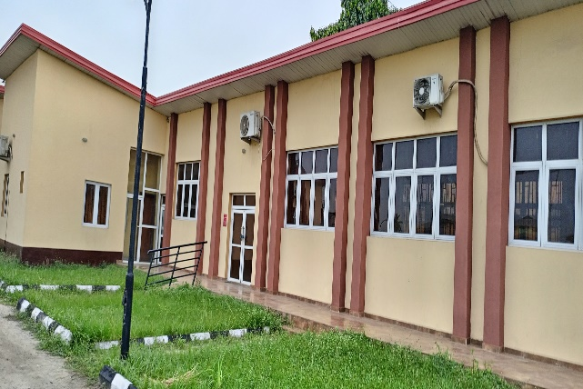
Plate 1: Building envelope, window arrangement
and glazing type of Ikeja Youth Centre

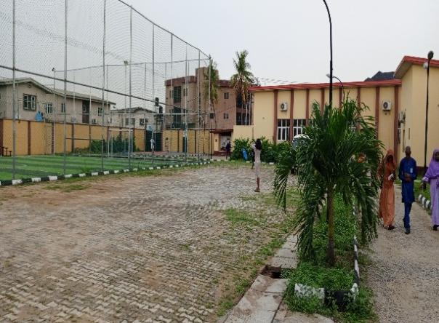
Plate 2: Landscape of Ikeja Youth Centre
Plate 1 indicates that Ikeja Youth Centre utilized high performance building envelope thereby utilizing daylight and enhancing natural ventilation. It was observed that the glazing of the window reduces solar glare. both natural and artificial lighting was adopted. Plate 2 shows the Landscape and its features that are not well optimized but averagely effective.

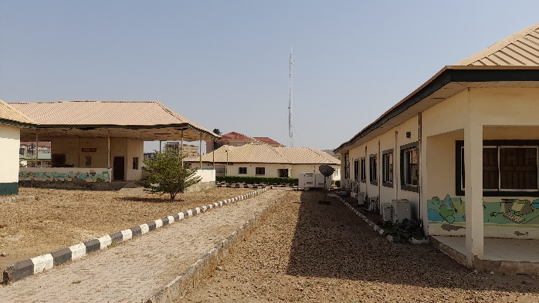
Plate 3: Landscape of FCT Ultra-Modern Youth Support Centre

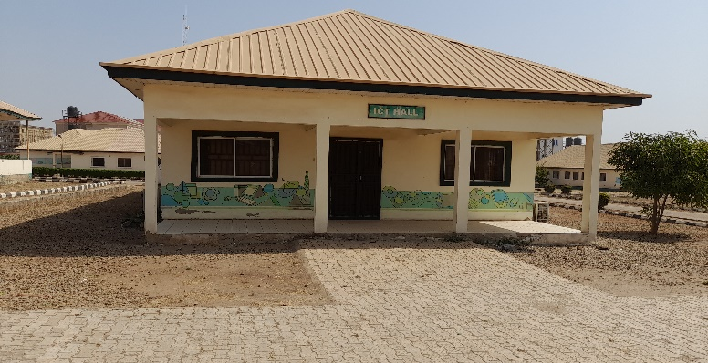
Plate 4: Building envelope, window arrangement of FCT Ultra-Modern Youth Support Centre
Plate 3 and Plate 4, portrays the FCT Ultra-Modern Youth Support Centre that demonstrate a more moderate approach while still valuing the significance of building envelope and window shading. The design showcases a prudent utilization of building envelope strategies, striking a balance between functional efficiency and thermal comfort.

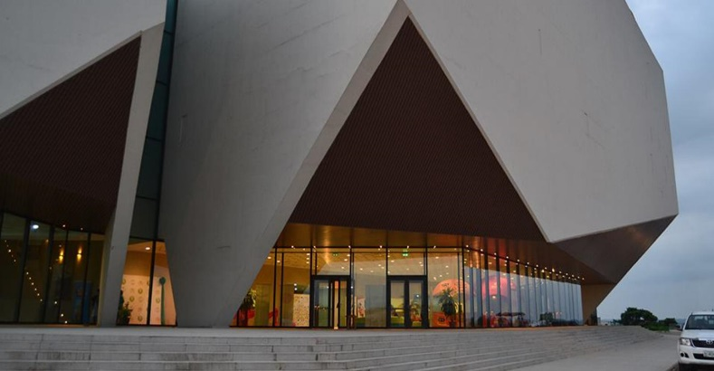
Plate 5: Building envelope and overhang to the curtain wall system of Calabar International Convention Centre

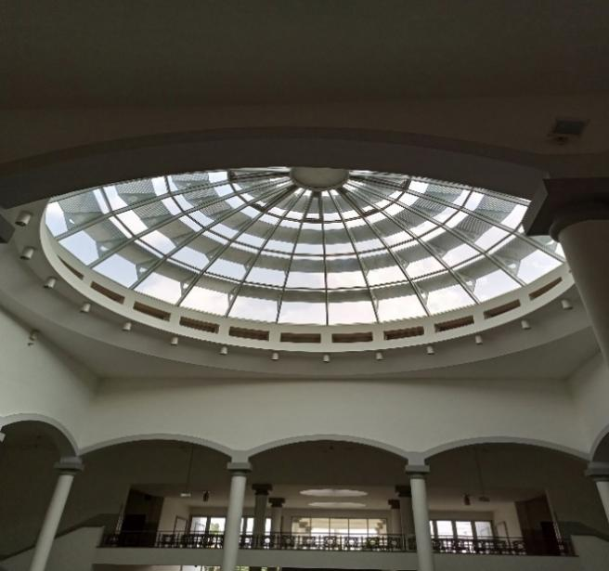
Plate 6: Dome skylight at the atrium of Calabar International Convention Centre

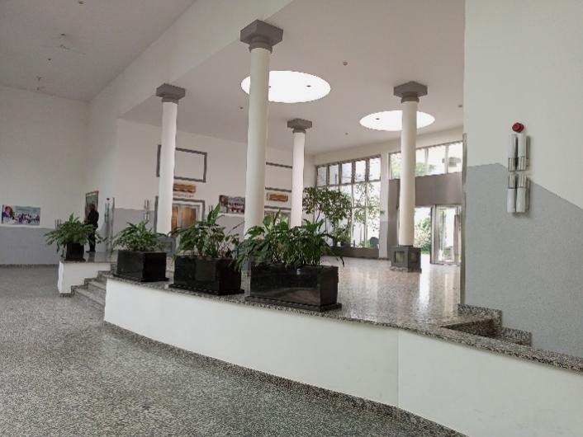
Plate 7: Reception showing lightwell arrangement of Calabar International Convention Centre
Plate 5, Plate 6 and Plate 7 shows the integrated approach of the design of Calabar International Convention Centre which ensures superior energy performance, mitigates solar glare and maximized the utilization of natural lighting. This design approach can significantly contribute to energy savings, promote a comfortable indoor environment, and enhance the overall sustainability performance of the building.

5.0 Conclusion and Recommendations
This study has explored the implementation and effectiveness of sustainable design strategies in youth and convention centers. Through a combination of qualitative and quantitative research methods, valuable insights have been gained regarding the sustainable practices adopted in these centers and their impact on environmental sustainability. The findings shed light on the importance of integrating sustainable design principles in the built environment to mitigate the negative effects of resource consumption and promote a more sustainable future.
The results indicate that sustainable design strategies such as energy efficiency, and sustainable site practices play a crucial role in reducing environmental impacts and conserving resources. The incorporation of passive design strategies, renewable energy sources, efficient lighting systems, and HVAC systems can significantly contribute to energy savings and greenhouse gas emissions reduction. Additionally, sustainable site practices including site selection, water management, and landscaping contribute to biodiversity preservation, ecosystem services, and overall occupant well-being.
Based on the study findings, the following recommendations are made towards adopting sustainable design strategies in youth and convention centres: awareness should be raised amongst stakeholders and educational programs can be conducted to enhance one’s understanding and promote the adoption of these sustainable design strategies; collaboration among stakeholders, researchers, and policymakers should be encouraged for sharing of knowledge and innovation in sustainable design should be encouraged; government and regulatory agencies should create sustainable construction codes and make them mandatory to ensure sustainable practices are implemented; and sustainable strategies' efficacy and improvement opportunities should be evaluated on a regular basis through monitoring and evaluation to guarantee the continued optimization of building performance and environmental sustainability.
REFERENCES
Aghimien, D. O., Adegbembo, T. F., Aghimien, E. I., & Awodele, O. A. (2018). Challenges of sustainable construction: a study of educational buildings in Nigeria. International Journal of Built Environment and Sustainability, 5(1).
Alagbe, O. A., Caiafas, M. A., Olayemi, B. O., & Joel, O. O. (2019, November). Enhancing energy efficiency through passive design: a case study of halls of residence in Covenant University, Ogun State. In IOP Conference Series: Materials Science and Engineering (Vol. 640, No. 1, p. 012017). IOP Publishing.
Bekele, M. T., & Atakara, C. (2023). Residential Building Energy Conservation in Mediterranean Climate Zone by Integrating Passive Solar and Energy Efficiency Design Strategies. Buildings, 13(4), 1073.
Darkhani, F., Tahir, O. M., & Ibrahim, R. (2019). Sustainable urban landscape management: An insight into urban green space management practices in three different countries. Journal of Landscape Ecology, 12(1), 37-48.
Elleuch, B., Bouhamed, F., Elloussaief, M., & Jaghbir, M. (2018). Environmental sustainability and pollution prevention. Environmental Science and Pollution Research, 25, 18223-18225.
Erhun, M. O. (2015). A sustainable approach to economic development in Nigeria: a legal perspective. Journal of Economics and Sustainable Development, 6(14), 1-6.
Freedman, B. (2018). Chapter 12~ Resources and Sustainable Development. Environ Sci Can Perspect, 1-37.
Gouldson, A., Colenbrander, S., Sudmant, A., Papargyropoulou, E., Kerr, N., McAnulla, F., & Hall, S. (2016). Cities and climate change mitigation: Economic opportunities and governance challenges in Asia. Cities, 54, 11–19. https://doi.org/10.1016/j.cities.2015.10.010
Idike, A., & Eme, O. I. (2015). Role of the Youths in Nation Building. Journal of Policy and Development Studies, 9(5), 50–71. https://doi.org/10.12816/0018243
Kaur, H., & Garg, P. (2019). Urban sustainability assessment tools: A review. Journal of Cleaner Production, 210, 146–158. https://doi.org/10.1016/j.jclepro.2018.11.009
Kelly, F. J., & Fussell, J. C. (2019). Improving indoor air quality, health and performance within environments where people live, travel, learn and work. Atmospheric Environment, 200, 90–109. https://doi.org/10.1016/j.atmosenv.2018.11.058
Kibert, C. J. (2016). Sustainable construction: green building design and delivery. John Wiley & Sons.
Koko, A. F., & Bello, M. (2020). Exploring the factors hindering the use of green architecture in Nigeria. In Zero-Energy Buildings-New Approaches and Technologies. IntechOpen.
Kraft, M. E. (2017). Environmental Policy and Politics. Taylor & Francis.
Labaran, Y. H., Mathur, V. S., Muhammad, S. U., & Musa, A. A. (2022). Carbon footprint management: A review of construction industry. Cleaner Engineering and Technology, 9, 100531. https://doi.org/10.1016/j.clet.2022.100531
Manisalidis, I., Stavropoulou, E., Stavropoulos, A., & Bezirtzoglou, E. (2020). Environmental and Health Impacts of Air Pollution: A Review. Frontiers in Public Health, 8, 14. https://doi.org/10.3389/fpubh.2020.00014
Mayrand, F., & Clergeau, P. (2018). Green Roofs and Green Walls for Biodiversity Conservation: A Contribution to Urban Connectivity? Sustainability, 10(4), Article 4. https://doi.org/10.3390/su10040985
Mohammed, A., & Abbakyari, M. (2016). STRATEGIES FOR ACHIEVING SUSTAINABILITY IN THE NIGERIAN BUILDING DESIGN AND CONSTRUCTION INDUSTRY. Ideal Jouranal of Engineering and Applied Sciences, 2, 103–108.
Morseletto, P., Mooren, C. E., & Munaretto, S. (2022). Circular Economy of Water: Definition, Strategies and Challenges. Circular Economy and Sustainability, 2(4), 1463–1477. https://doi.org/10.1007/s43615-022-00165-x
Obiadi, B., & Onuorah, I. (2022). ARCHITECTURE, TOURISM AND HOUSING: OHANEZE NDIGBO YOUTH CENTRE FOR CULTURAL EDIFICATION.
Odoh, Rt. Hon. E., & Innocent, E. O. (2014). Role of the Youths in National Development. Singaporean Journal of Business , Economics and Management Studies, 3(2), 164–181. https://doi.org/10.12816/0007349
Pardo-Garcia, C., & Barac, M. (2020). Promoting Employability in Higher Education: A Case Study on Boosting Entrepreneurship Skills. Sustainability, 12(10), Article 10. https://doi.org/10.3390/su12104004
Pauw, J. B., Gericke, N., Olsson, D., & Berglund, T. (2015). The Effectiveness of Education for Sustainable Development. Sustainability, 7(11), Article 11. https://doi.org/10.3390/su71115693
Semeraro, T., Scarano, A., Buccolieri, R., Santino, A., & Aarrevaara, E. (2021). Planning of Urban Green Spaces: An Ecological Perspective on Human Benefits. Land, 10(2), Article 2. https://doi.org/10.3390/land10020105
Somasundaram, S., Chong, A., Wei, Z., & Thangavelu, S. R. (2020). Energy saving potential of low-e coating based retrofit double glazing for tropical climate. Energy and Buildings, 206, 109570. https://doi.org/10.1016/j.enbuild.2019.109570
Vasseur, L., Horning, D., Thornbush, M., Cohen-Shacham, E., Andrade, A., Barrow, E., Edwards, S. R., Wit, P., & Jones, M. (2017). Complex problems and unchallenged solutions: Bringing ecosystem governance to the forefront of the UN sustainable development goals. Ambio, 46(7), 731–742. https://doi.org/10.1007/s13280-017-0918-6

