Impeachment Across Africa and the World: The Global Collision Between Constitutionalism, Political Power and Democratic Stability

ABSTRACT
Across Africa and the world, impeachment has increasingly become more than a constitutional process of accountability; it has emerged as a major battleground between law, politics and state power. From South Africa and Nigeria to the United States and Brazil, impeachment disputes have tested the strength of constitutions, the independence of courts and the stability of governments. Kenya now joins this global constitutional debate through the unprecedented crisis surrounding the impeachment of Deputy President Hon Geoffrey Rigathi Gachagua EGH and the swearing-in of Professor Abraham Kithure Kindiki. The constitutional crisis surrounding the impeachment of a Deputy President Hon Geoffrey Rigathi Gachagua EGH and the swearing- in of a successor Professor Abraham Kithure Kindiki has created one of the most serious
constitutional debates in Kenya’s democratic history. ¹The issue goes beyond ordinary political disagreements because it directly affects the stability of government, the authority of the Judiciary, the powers of Parliament and the supremacy of the Constitution of Kenya 2010.² At the center of the crisis is a difficult constitutional question: if a Deputy President is removed through a process that is later declared unconstitutional by the courts, can the Judiciary reverse the succession after another person has already taken the oath of office? This question has produced what legal scholars describe as the “Dual-Presidency Crisis,” a situation where one individual claims political legitimacy through swearing-in while another claims legal legitimacy through judicial protection.³ The crisis demonstrates a major conflict between two constitutional principles. On one side is constitutional supremacy, which requires every state action to comply strictly with the Constitution. On the other side is the principle of political finality and executive stability, which seeks to preserve continuity in government and prevent institutional confusion. The Judiciary is therefore placed in a difficult position where it must balance constitutional justice against the practical realities of governing a modern state.⁴
Keywords: Constitutionalism, Political power & Democracy

The “Fait Accompli” Argument and Political Finality
One of the strongest arguments against reinstating a former Deputy President is based on the doctrine of fait accompli, a French phrase meaning “an accomplished fact.”⁵ In constitutional law, the doctrine refers to a situation where political events have already taken place and

¹ Constitution of Kenya (2010), Article 150
² Marbury v. Madison, 5 U.S. (1 Cranch) 137 (1803).
³ B.O. Nwabueze, Constitutionalism in the Emergent States (C. Hurst & Co. 1973).
⁴ Yash Pal Ghai, Kenya's Constitution: An Instrument for Change (Katiba Institute 2011).
⁵Yash Pal Ghai, Kenya's Constitution: An Instrument for Change (Katiba Institute 2011).

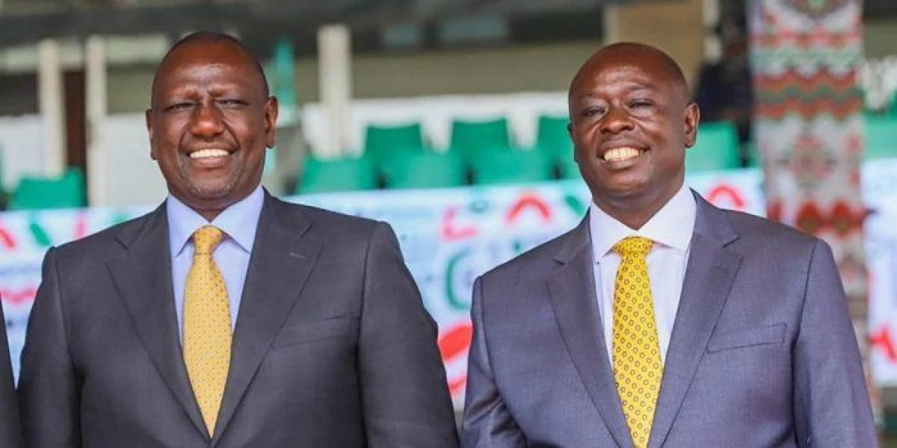
become practically difficult to reverse even when legal defects later emerge.

[President Ruto (Left) & Former Deputy Hon Geoffrey Rigathi Gachagua (Right) During Swearing in Ceremony at Kasarani, 13th SEP 2022]
Supporters of this doctrine argue that once a successor has been sworn into office under Article 148 of the Constitution, the constitutional transition becomes complete. The oath of office is viewed not merely as a ceremonial event, but as the formal transfer of constitutional authority. Immediately after the swearing-in ceremony, government institutions begin operating under the leadership of the new Deputy President. Cabinet meetings, state protocols, diplomatic engagements, administrative decisions and security arrangements all shift to recognize the successor as the lawful office holder. According to this argument, reversing succession after the transition has already occurred would create uncertainty and instability within government.⁶ Supporters of political finality insist that constitutional transitions must eventually come to an end. They argue that a country cannot remain trapped in endless constitutional uncertainty while court cases continue for months or years. Critics of reinstatement further warn that restoring a former Deputy President after another individual has already occupied the office would create what scholars call a “Constitutional Ghost.” In such a situation, the former Deputy President may possess legal recognition from the courts while the successor continues exercising practical authority within government. This, they argue, could undermine the effective functioning of the Executive branch and weaken public confidence in state institutions.⁷
The concern becomes even more serious because the Deputy President is not an ordinary public officer. Under Article 131 of the Constitution, the Deputy President forms part of the national Executive and participates directly in the governance of the Republic. Any uncertainty surrounding the office therefore affects the entire structure of government and national administration.

Constitutional Supremacy and the “Void ab Initio” Principle

⁶ Black's Law Dictionary (11th ed. 2019).
⁷ A.V. Dicey, The Law of the Constitution (1885).

Opponents of the fait accompli doctrine strongly reject the idea that unconstitutional actions can become valid simply because political events have already occurred. Their argument is founded on Article 2 of the Constitution, which declares that the Constitution is the supreme law of the Republic and that any act inconsistent with it is void.⁸ According to constitutionalists, if the impeachment process violated constitutional requirements such as fair hearing under Article 50, fair administrative action under Article 47 or public participation under Article 10, then the removal itself may have been unconstitutional. If the process of removal was unconstitutional, then the vacancy created by that removal may also have been legally defective. This argument is strengthened by the doctrine of void ab initio, meaning “void from the beginning.”⁹ Under this principle, an unconstitutional act is treated as though it never legally existed. Therefore, if a court later determines that the impeachment process violated constitutional standards, the legal consequence may be that the former Deputy President never lawfully left office in the first place.
This creates the central constitutional paradox. If the office never legally became vacant, then the successor may have assumed office without a valid constitutional foundation. Constitutional lawyers therefore argue that a successor sworn into office through a defective process holds what is known as a “defeasible title,” meaning a title that can later be defeated or invalidated by judicial decision. ¹⁰Supporters of constitutional supremacy argue that allowing unconstitutional transitions to stand merely because another person has already been sworn in would weaken the rule of law and encourage future abuses of power. In their view, constitutional violations cannot become legitimate through political speed or convenience.
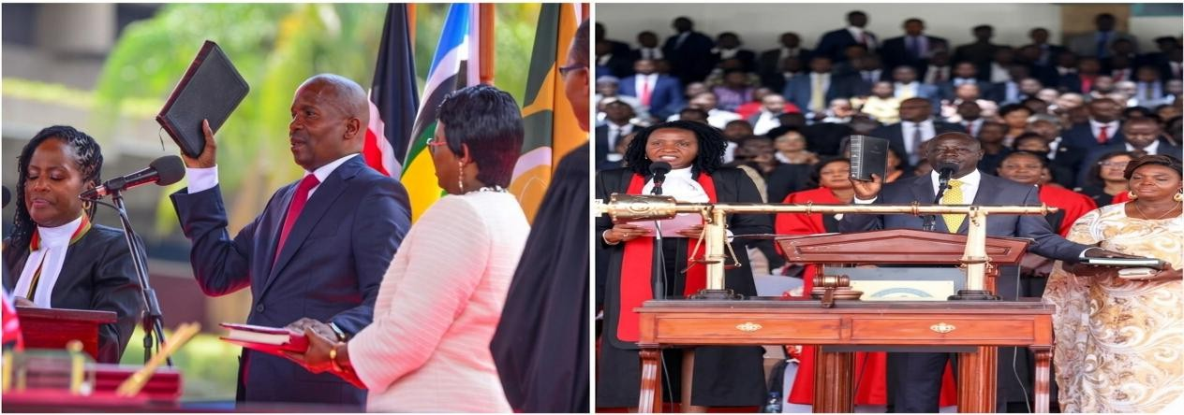

Judicial Authority and Constitutional Oversight
The Constitution of Kenya 2010 transformed the Judiciary into an active guardian of constitutionalism. Under Article 165, the High Court has broad powers to determine whether

⁸ Lon L. Fuller, The Morality of Law (Yale 1964).
⁹ Connolly, Niamh. "The Prospective and Retrospective Effect of Judicial Decisions in Ireland." Comparing the Prospective Effect of Judicial Rulings Across Jurisdictions. Cham: Springer International Publishing, 2015. 27-63. ¹⁰MacFoy v. United Africa Co. Ltd [1961] 3 All ER 1169.

any action taken by Parliament, the Executive or any state organ violates the Constitution.¹¹
Before the 2010 Constitution, courts were generally reluctant to interfere in political disputes involving Parliament because of the doctrine of parliamentary privilege. Parliament often argued that its internal proceedings were beyond judicial review. However, modern Kenyan constitutional jurisprudence has significantly changed this position. Today, Kenyan courts increasingly hold that parliamentary privilege cannot protect unconstitutional conduct.
Parliament, like every other state institution, remains bound by the Constitution and the Bill of Rights. As a result, impeachment proceedings are no longer viewed as purely political exercises. Because impeachment affects constitutional rights, political representation and access to public office, courts insist that the process must comply with constitutional standards of legality, fairness and due process. This expanded judicial authority means that courts are no longer passive observers of political disputes. They can actively intervene where constitutional violations occur. However, the unresolved issue is whether judicial review extends beyond examining the legality of the impeachment process to actually reversing succession after another person has already assumed office.

Comparative Jurisprudence and the African Experience
Comparative constitutional jurisprudence provides important guidance on how courts in other jurisdictions have handled similar crises. One of the strongest African precedents comes from Nigeria in the case of Ladoja v. INEC (2007). ¹²In that case, Governor Rashidi Ladoja of Oyo State was impeached through a constitutionally defective process. During the litigation, another individual had already assumed office as governor. Despite this, the Supreme Court of Nigeria declared the impeachment unconstitutional and ordered Ladoja’s immediate reinstatement. The Nigerian judiciary demonstrated remarkable constitutional courage by prioritizing constitutional legality over political convenience. The judgment established that unconstitutional succession cannot become irreversible merely because political events have

¹¹ Hans Kelsen, Pure Theory of Law (1967).
¹² Constitution of the United States, 25th Amendment.


already taken place.

[Governor Oba Rashidi Adewolu Ladoja of Oyo State, 2003-2007]
Kenyan courts have generally adopted a more cautious approach in impeachment disputes involving governors such as Hon Mike Mbuvi Sonko of Nairobi and Hon Ferdinand Waititu of Kiambu. ¹³In these cases, courts often emphasized the need to preserve stability within county governments after successors had already taken office. However, the Deputy Presidency differs significantly from county offices because it forms part of the national Executive structure and directly affects national governance. The United States provides a different perspective through the “Political Question Doctrine.” In the case of Nixon v. United States, American courts held that impeachment is largely committed to Congress and therefore unsuitable for extensive judicial review. ¹⁴However, Kenya’s constitutional structure differs significantly because Article 165 expressly empowers courts to review constitutional violations committed by any state organ, including Parliament.

The Constitutional Paradox: Justice versus Stability
The Judiciary now faces one of the most difficult constitutional choices in Kenya’s democratic history. If the court reinstates the former Deputy President, it would strongly affirm constitutional supremacy and reinforce the principle that unconstitutional actions cannot survive judicial scrutiny. ¹⁵Such a decision would also send a strong warning that Parliament

¹³ Bwana, Ronald. "Impeachments and Their Intrigues: An Analysis of the Removal Process of Governors in Kenya." Available at SSRN 3931585 (2021).
¹⁴ Ladoja v. INEC [2007] 12 NWLR (Pt. 1048) 334.
¹⁵ Mike Mbuvi Sonko v. Clerk, Nairobi City County Assembly & 11 Others [2022] eKLR.

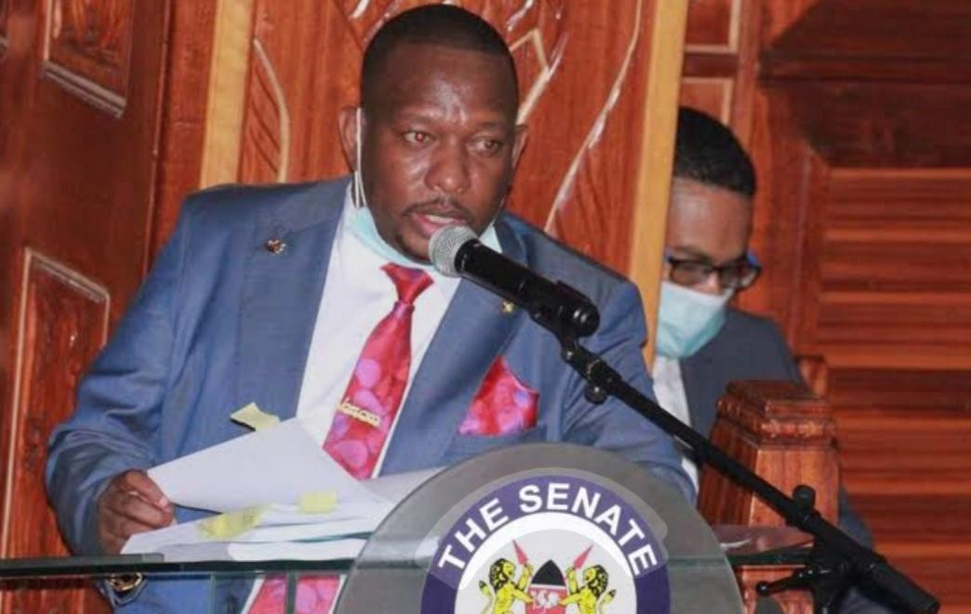
must strictly comply with constitutional requirements during impeachment proceedings.

[Former Nairobi County Governor Hon Mike Kioko Mbuvi Sonko during impeachment Hearings at Senate]
However, reinstatement may also create major institutional and political consequences. It could destabilize the Executive branch, create confusion within government institutions, and raise difficult questions regarding the validity of decisions made during the successor’s tenure.¹⁶ On the other hand, if the court refuses reinstatement despite finding constitutional violations, political stability may be preserved but constitutional accountability may appear weakened.
Critics would argue that such an outcome allows unconstitutional impeachments to achieve their political objectives simply because the political process moved faster than the judicial process. This is the true essence of the “Reinstatement Paradox.” The Judiciary must choose between enforcing constitutional purity and preserving governmental stability. ¹⁷Whatever choice the court eventually makes will shape the future of constitutional democracy in Kenya and determine the balance between law and politics under the Constitution of Kenya 2010. The Dual-Presidency Crisis represents one of the greatest constitutional tests facing Kenya since the promulgation of the Constitution of Kenya 2010. The conflict between judicial authority and political succession has exposed deep tensions within Kenya’s constitutional structure and raised fundamental questions about the meaning of constitutional supremacy. At the center of the debate lies a powerful legal question: can political transitions become irreversible even when founded on unconstitutional processes? The answer will determine not only the future of the Deputy Presidency, but also the strength of the Judiciary, the limits of parliamentary power and the future relationship between constitutional law and political power in Kenya. The Judiciary now stands at a historic constitutional crossroads. Its eventual decision will shape the future of constitutional governance and determine whether the rule of law remains powerful enough to reverse political outcomes that violate the Constitution.

¹⁶ Nixon v. United States, 506 U.S. 224 (1993).
¹⁷ Ronald Dworkin, Taking Rights Seriously (Duckworth 1977).

THE DOCTRINE OF NECESSITY; A SHIELD OR A SWORD FOR THE EXECUTIVE?
As the constitutional crisis surrounding the impeachment of a Deputy President Hon Geoffrey Rigathi Gachagua EGH continues to unfold, the debate gradually shifts from the legality of the impeachment process itself to the practicality of the remedy that the courts may eventually grant. ¹⁸Even where the Judiciary finds that constitutional violations occurred during the impeachment proceedings, another difficult question immediately arises: should the courts restore the former Deputy President to office if such a decision risks destabilizing the Executive branch of government? ¹⁹It is at this point that the Doctrine of Necessity becomes one of the most important and controversial constitutional principles in the entire debate.
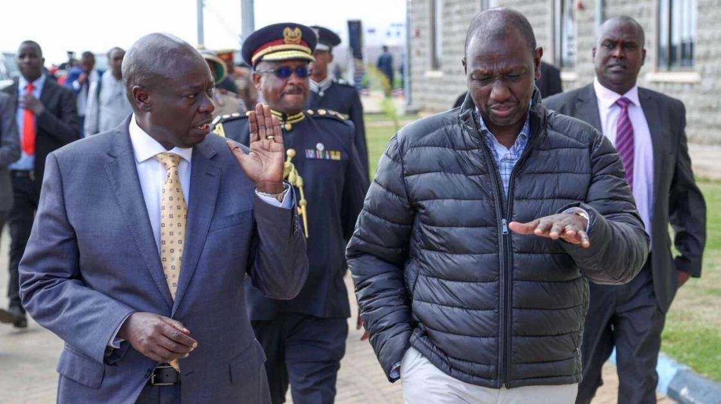
The Doctrine of Necessity is often invoked during periods of constitutional uncertainty, political instability or institutional crisis. The doctrine allows extraordinary actions to be temporarily validated if those actions are necessary to preserve the stability and survival of the state. ²⁰In the context of the Deputy Presidency crisis in Kenya, supporters of the government may argue that even if mistakes occurred during the impeachment process, reversing the succession after another Deputy President has already taken office could create serious confusion within government institutions and threaten national stability.²¹ However, critics strongly oppose this approach. They argue that allowing unconstitutional actions to stand simply because reversing them would be politically inconvenient weakens constitutional supremacy and encourages future violations of the Constitution. The Judiciary is therefore confronted with a difficult constitutional balancing exercise between preserving the rule of law and maintaining the

¹⁸ Alexander Bickel, The Least Dangerous Branch (1962).
¹⁹ Gustav Radbruch, Statutory Lawlessness and Ultra-Statutory Law (1946).
²⁰ Constitution of Kenya (2010), Article 23
²¹ O. Hood Phillips, Constitutional and Administrative Law (Sweet & Maxwell 2001).

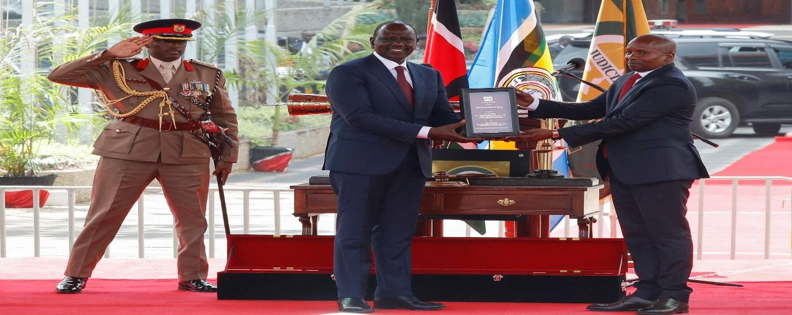
continuity of government.²²

[President William Ruto (Left) and Professor Abraham Kithure Kindiki (Right) During the take of Oath ]
Meaning and Nature of the Doctrine of Necessity
The Doctrine of Necessity is based on the ancient legal principle salus populi suprema lex, meaning “the welfare of the people is the supreme law.” The doctrine recognizes that in exceptional situations, strict adherence to ordinary constitutional procedures may become difficult or even impossible if the survival of the state itself is at risk. ²³In such circumstances, courts or governments may temporarily validate extraordinary measures in order to preserve constitutional order and prevent institutional collapse. ²⁴Historically, the doctrine has often appeared during moments of political turmoil such as coups, revolutions, constitutional breakdowns or national emergencies. ²⁵Supporters of the doctrine argue that constitutional law must ultimately serve society and the state.²⁶ According to this reasoning, preserving governmental stability and protecting the country from chaos may sometimes require flexible constitutional interpretation. In the Kenyan context, supporters of the Doctrine of Necessity argue that once a successor to the Deputy President has already been sworn into office, government systems begin operating around the authority of the new office holder. 27Cabinet coordination, security structures, diplomatic engagements, administrative operations and executive decision-making all shift toward recognizing the successor as the legitimate Deputy President. Removing that successor after the transition has already occurred may therefore destabilize the Executive branch and create confusion within state institutions.²⁸ Critics of the

²² Jakab, András. "What can constitutional law do against the erosion of democracy and the rule of law? On the interconnectedness of the protection of democracy and the rule of law." Const. Stud. 6 (2020): 5.
²³ Novak, William Joseph. Salus populi: the roots of regulation in America, 1787-1873. Brandeis University, 1992.
²⁴ L. Tribe, American Constitutional Law (3rd ed. 2000).
²⁵ Justice Muhammad Munir, The Constitution of the Islamic Republic of Pakistan (1960).
²⁶ John Locke, Second Treatise of Government (1689)
²⁷Hassan, Mai. "Continuity despite change: Kenya's new constitution and executive power." Democratization 22.4 (2015): 587-609.
²⁸ Roscoe Pound, Social Control Through Law (1942).

doctrine, however, warn that necessity has historically been used as a dangerous excuse for constitutional violations. ²⁹They argue that political actors often invoke “stability” whenever they seek to protect unconstitutional actions from judicial correction.³⁰ According to this view, necessity can easily become a tool for weakening constitutional accountability and protecting political power from legal scrutiny.³¹

The Stability Argument and Executive Continuity
One of the strongest justifications for invoking the Doctrine of Necessity is the need to preserve executive continuity. The Executive arm of government performs essential functions including administration of state affairs, coordination of national security, implementation of laws and management of public institutions. Any uncertainty within the Executive therefore has the potential to affect the entire country. ³²Supporters of executive stability argue that once a successor to the Deputy President has already assumed office, the constitutional machinery of government begins functioning under the authority of the new office holder. Senior government officers, Cabinet Secretaries, diplomats, security agencies and public institutions reorganize themselves around the successor’s leadership. State operations therefore continue on the assumption that the constitutional transition has already been completed.³³
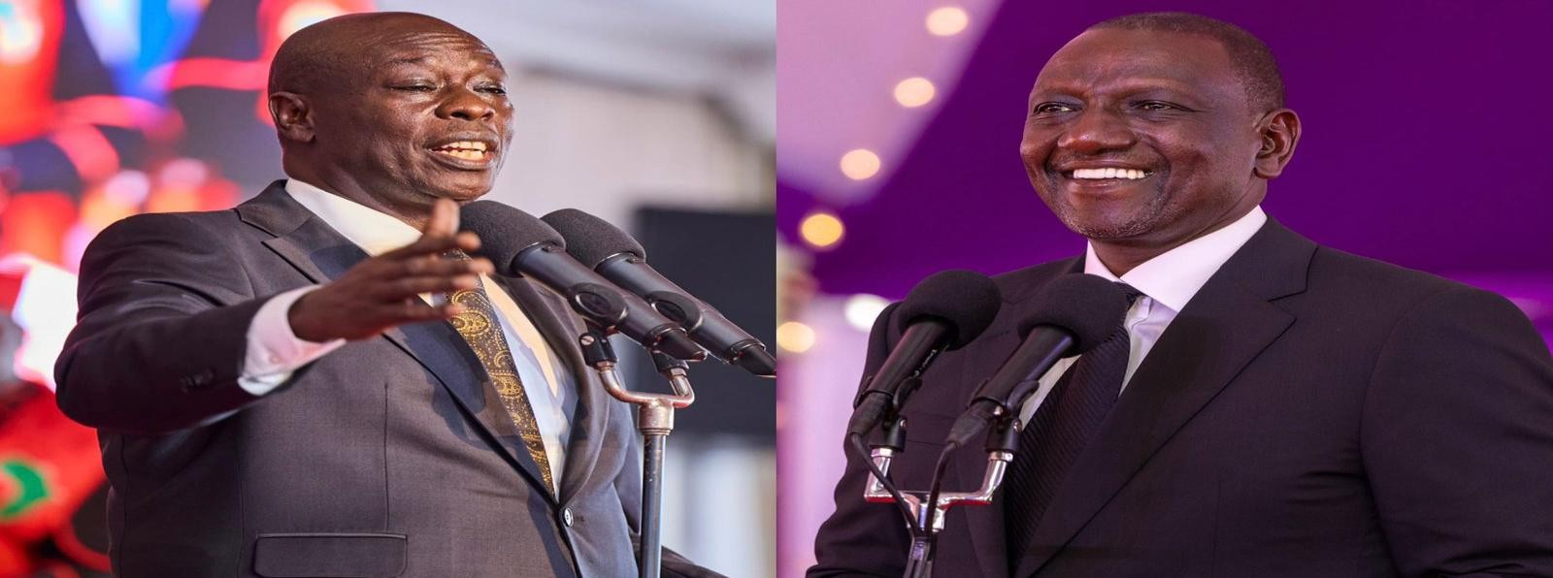
According to this argument, reversing the succession after another Deputy President has already taken office may create what some scholars call a “Dual-Executive Crisis.” ³⁴Government officers may become uncertain about whose authority to recognize. Questions may arise concerning the legality of decisions already made by the successor. 35Diplomatic

²⁹ The National Executive Coordination Act, No. 1 of 2023.
³⁰ Max Weber, Economy and Society (1922)
³¹ William Pitt the Younger, Speech in the House of Commons (1783)
³² Crossland, Craig, and Donald C. Hambrick. "Differences in managerial discretion across countries: how nation‐ level institutions affect the degree to which CEOs matter." Strategic management journal 32.8 (2011): 797-819. ³³ Giorgio Agamben, State of Exception (2005)
³⁴Calabresi, Steven G. "The political question of presidential succession." Stan. L. Rev. 48 (1995): 155.
³⁵ M.V. Pylee, Constitutional Government in India (2003).

relations and government coordination may also become complicated if the country appears uncertain about who lawfully occupies the second highest office in the Republic. ³⁶Supporters of this position therefore argue that constitutional law cannot operate in complete isolation from political and institutional reality. While courts may possess legal authority to declare an impeachment unconstitutional, enforcing physical reinstatement may create political instability capable of weakening governance itself. ³⁷In countries with fragile political environments, constitutional uncertainty can quickly escalate into broader national tensions.

Comparative Jurisprudence on the Doctrine of Necessity
Comparative constitutional jurisprudence provides valuable insight into how courts in different countries have approached the Doctrine of Necessity. ³⁸One of the most famous cases is Federation of Pakistan v. Maulvi Tamizuddin Khan (1955). ³⁹In this case, Pakistan’s Governor-General dissolved the Constituent Assembly in a move widely criticized as unconstitutional. Nevertheless, Chief Justice Muhammad Munir validated the dissolution using the Doctrine of Necessity, arguing that preserving the stability of the state justified extraordinary constitutional measures. ⁴⁰Although the decision temporarily preserved political order, it later received severe criticism from constitutional scholars and jurists. Many commentators argue that the judgment weakened constitutional democracy in Pakistan and encouraged future constitutional violations, including military interventions. The case is now frequently cited as a warning about the dangers of excessive judicial deference to political power.⁴¹ Another important precedent emerged from Grenada in Mitchell v. Attorney General (1986) following a period of political instability. ⁴²The Grenadian Court of Appeal attempted to place limits on the Doctrine of Necessity by establishing strict conditions for its use.
According to the court, necessity can only apply where there is an urgent and unavoidable crisis, where the action seeks to preserve constitutional order, where no lawful alternative

³⁶ Public Service Commission Act, No. 10 of 2017.
³⁷ Ginsburg, Tom, Aziz Huq, and David Landau. "The Comparative Constitutional Law of Presidental Impeachment." U. Chi. L. Rev. 88 (2021): 81.
³⁸ De Facto Doctrine, Norton v. Shelby County, 118 U.S. 425 (1886).
³⁹ Vienna Convention on the Law of Treaties (On state representation).
⁴⁰ S.A. de Smith, Constitutional and Administrative Law (7th ed. 1994).
⁴¹ V.C.R.A.C. Crabbe, Understanding Statutes (1994).
⁴² Federation of Pakistan v. Maulvi Tamizuddin Khan (1955) PLD FC 240.

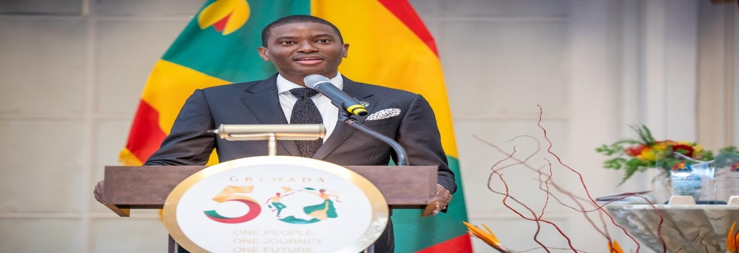
exists, and where the measures taken remain temporary and proportionate.

[Prime Minister of Granada Dickon Amiss Thomas Mitchell 2022-Present]
These principles are important because they prevent governments from permanently relying on “necessity” to justify unconstitutional conduct.⁴³ In the Kenyan context, the Grenadian approach suggests that the Judiciary must exercise great caution before allowing state stability to override constitutional legality.

The “Right Without a Remedy” Problem
One of the greatest criticisms of the Doctrine of Necessity is that it may create what lawyers describe as a “right without a remedy.” This occurs when a court acknowledges that constitutional rights were violated but refuses to provide meaningful restoration because of concerns about political stability or institutional practicality.⁴⁴ Under Article 23 of the Constitution of Kenya 2010, courts have broad powers to grant appropriate remedies where constitutional violations occur. Constitutional lawyers therefore argue that if a Deputy President was removed through an unconstitutional process, then the natural remedy should ordinarily be reinstatement to office. However, if the court relies on necessity to preserve executive stability, the former office holder may receive only symbolic relief such as declarations, compensation or public vindication without actual restoration to office. Critics argue that this weakens constitutional supremacy because unconstitutional actions would still achieve their intended political outcomes despite judicial condemnation. The High Court was urged on Monday 27th April 2026 to award former Deputy President Rigathi Gachagua his full salary and benefits for a five-year term, ⁴⁵with his lawyer arguing that the claim is firmly

⁴³ Wolf-Phillips, Constitutional Legitimacy: A Study of the Doctrine of Necessity (1979).
⁴⁴ Fletcher, William A. "The discretionary constitution: Institutional remedies and judicial legitimacy." The Yale Law Journal 91.4 (1982): 635-697.
⁴⁵ Steeves, Jeffrey. Democracy Challenged in the 2022 Presidential Succession in Kenya: The African Imperial President. Cambridge Scholars Publishing, 2023.

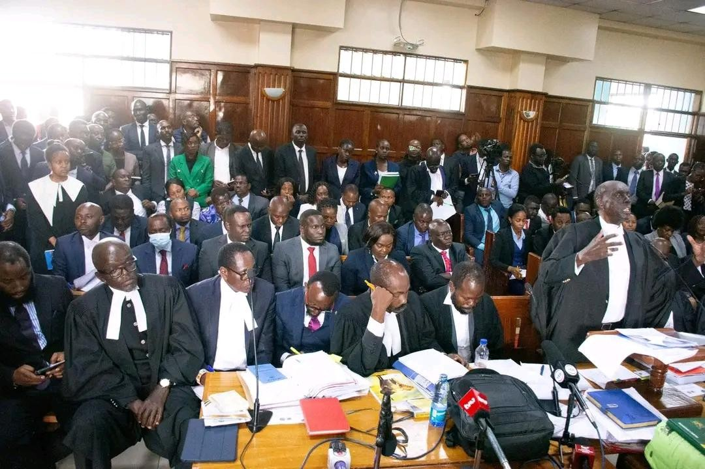
grounded in law and precedent. ⁴⁶
Appearing before the court on Monday, John Njomo submitted that his client is entitled to comprehensive compensation, including general, punitive and aggravated damages, arising from alleged constitutional violations. He said the legal team had undertaken detailed computations outlining what Gachagua earned, what he was entitled to, and what he would have received had he served the full five-year mandate.“The first petitioner seeks general damages, as well as punitive and aggravated damages. These prayers are not far-fetched, as courts have previously affirmed that such remedies are awardable where constitutional violations are established,” Njomo told the court. ⁴⁷Supporters of necessity on the other hand respond that, constitutional remedies must remain practical and proportionate. According to this view, courts should avoid remedies that could produce greater institutional crises than the constitutional violation itself. The Judiciary must therefore balance the principle of effective remedies against the practical realities of governance and national stability.⁴⁸

Scholarly Perspectives on Necessity and Constitutionalism
Legal scholars remain sharply divided on the proper role of the Doctrine of Necessity in constitutional governance. Prominent constitutional scholar Ben Nwabueze strongly criticized the use of necessity to override constitutional procedures. According to him, constitutionalism is fundamentally about limiting governmental power, while necessity often becomes a justification for expanding political authority beyond constitutional limits. He warned that constitutional democracies begin to weaken when political convenience replaces constitutional discipline. ⁴⁹Other scholars adopt a more pragmatic approach. They argue that constitutions are not “suicide pacts” and that preserving the survival of the state may sometimes justify

⁴⁶ Constitution of Kenya 2010, Article 150.
⁴⁷ Gitobu Imanyara v. Attorney General [2013] Eklr .
⁴⁸ Republic v. El Mann [1969] EA 357.
⁴⁹ B.O. Nwabueze, Constitutionalism in the Emergent States (1973); B.O. Nwabueze, The Presidential Constitution of Nigeria (1982) .

temporary departures from ordinary constitutional procedures. According to this school of thought, constitutional law must remain flexible enough to respond to extraordinary national crises without collapsing governmental stability.⁵⁰ This scholarly disagreement reflects a broader philosophical tension between constitutional idealism and political realism. Constitutional idealists insist that the Constitution must be followed strictly regardless of political consequences. Political realists, however, argue that constitutional interpretation must sometimes consider the practical survival of state institutions and the need for continuity in governance.⁵¹
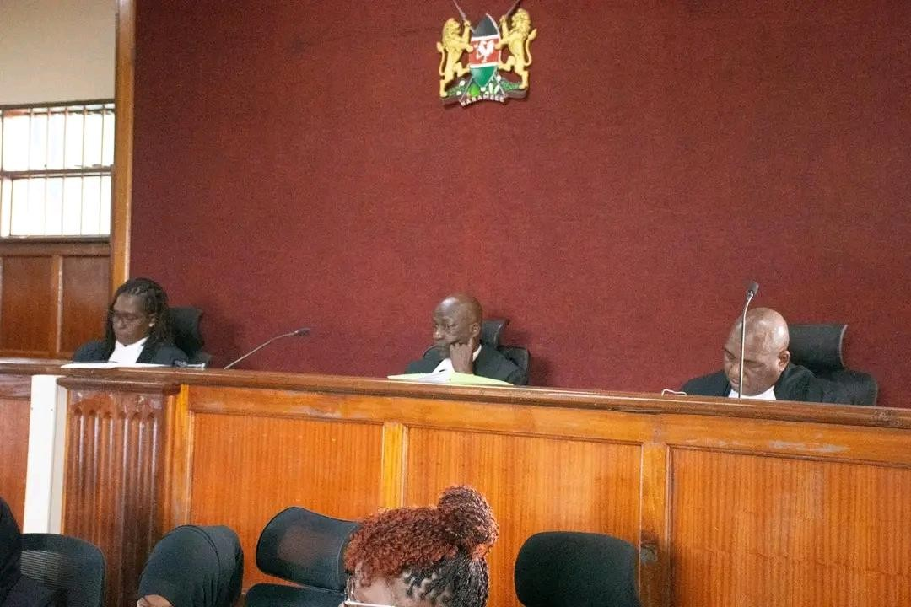

[The Three Bench Judge hearing Gachagua case from Left to Right; Justices Freda Mugambi, Eric Ogola and Antony Mrima]
Although the Doctrine of Necessity may appear useful during constitutional crises, excessive reliance on the doctrine creates serious dangers for constitutional democracy. First, it risks encouraging political actors to deliberately violate constitutional procedures knowing that courts may later preserve the resulting political outcomes in the name of stability. This weakens deterrence against unconstitutional conduct. ⁵²Second, repeated use of necessity may gradually erode public confidence in constitutional institutions. Citizens may begin to believe that constitutional rules apply only when politically convenient and that powerful political actors can escape constitutional accountability by invoking national stability. Third, excessive judicial deference to political necessity may transform the Judiciary from an active guardian of constitutional supremacy into a passive observer of political power. ⁵³This undermines the transformative vision of the Constitution of Kenya 2010, which sought to establish strong

⁵⁰ Terminiello v. Chicago, 337 U.S. 1 (1949).
⁵¹ Hans Morgenthau, Politics Among Nations.
⁵² Kenya Law Reform Commission, Working Paper on the Enforcement of Constitutional Sanctions.
⁵³ J.B. Ojwang, The Judiciary in Kenya: The Case for Reform.

constitutional checks and balances after decades of executive dominance.⁵⁴ For these reasons, many constitutional scholars insist that the Doctrine of Necessity must remain an exceptional and temporary principle applied only in the rarest circumstances where no lawful alternative exists. The Doctrine of Necessity remains one of the most controversial principles in constitutional law because it forces courts to choose between strict constitutional legality and practical political stability. In the context of Kenya’s Deputy Presidency crisis, the doctrine places the Judiciary in an extremely difficult position. ⁵⁵On one hand, the court has a constitutional duty to protect the supremacy of the Constitution and correct unconstitutional actions. On the other hand, the Judiciary must remain conscious of the potential consequences that reinstatement may have on executive stability and national governance.⁵⁶
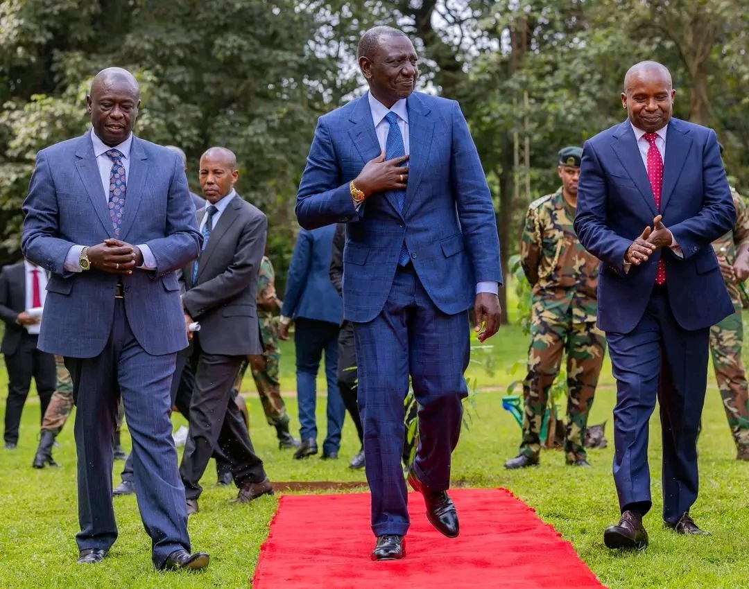
Supporters of necessity argue that preserving the functionality of the state is essential to maintaining order and preventing institutional paralysis. Critics, however, warn that allowing unconstitutional actions to survive merely because reversing them may be inconvenient weakens

⁵⁴ Willy Mutunga, "The 2010 Constitution: A Transformative Document", Journal of African Law (2012).
⁵⁵ Attorney General of the Republic v. Mustafa Ibrahim [1964] LRC 1.
⁵⁶ Judicial Service Commission v. Mwilu [2020] eKLR.

constitutional democracy and encourages future abuses of power. ⁵⁷The ultimate challenge for the Kenyan Judiciary will therefore be determining whether necessity should operate as a temporary shield protecting the state from chaos or whether it risks becoming a dangerous sword capable of undermining constitutional supremacy itself.⁵⁸

THE “RIGHT TO A REMEDY” (ARTICLE 23) VERSUS THE “POLITICAL QUESTION” DOCTRINE
As the constitutional dispute surrounding the impeachment of a Deputy President intensifies, the debate gradually moves beyond the legality of the impeachment process itself and focuses on the nature of the remedy that the courts should grant. The major constitutional question is no longer simply whether the impeachment violated the Constitution, but whether the Judiciary can practically and legally reverse the political transition after another Deputy President has already been sworn into office. ⁵⁹This debate creates a direct conflict between Article 23 of the Constitution of Kenya 2010, which guarantees effective constitutional remedies and the Political Question doctrine, which traditionally discourages courts from interfering in highly political disputes.⁶⁰
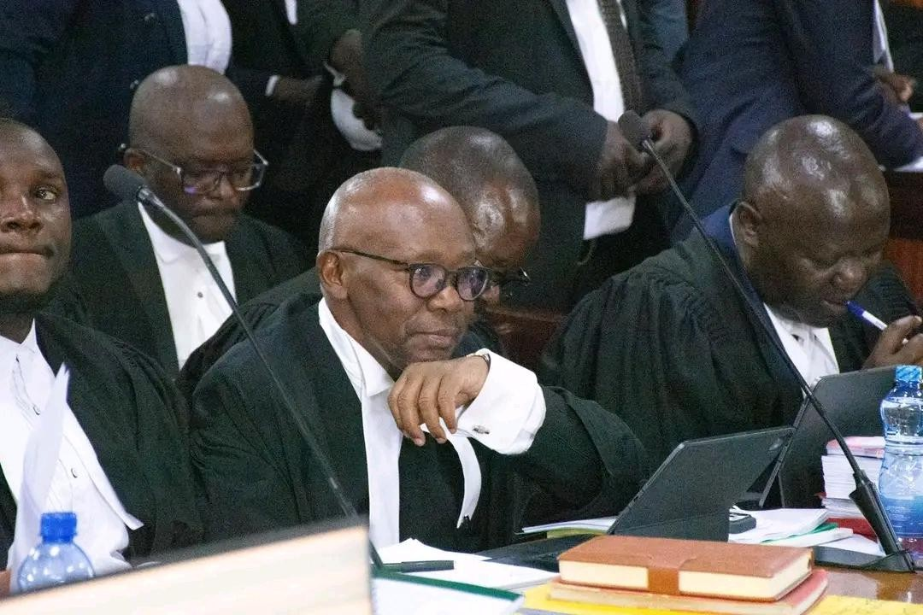
This constitutional conflict places the Judiciary at the center of one of the most sensitive political and legal questions in modern Kenya. On one hand, the courts have a constitutional obligation to protect the supremacy of the Constitution and provide meaningful remedies where rights have been violated. On the other hand, the Judiciary must also remain conscious of the practical

⁵⁷ Madzimbamuto v. Lardner-Burke [1968] 3 All ER 561 .
⁵⁸ Necessity as a Sword or Shield: The Dilemma of Post-Colonial Courts", African Journal of Legal Studies.
⁵⁹ The Political Question Doctrine; Baker v. Carr, 369 U.S. 186 (1962).
⁶⁰Constitution of Kenya 2010, Article 23 .

consequences that may arise if it attempts to reverse an already completed political succession. The tension between constitutional legality and political reality therefore becomes unavoidable.⁶¹

Article 23 and the Right to Effective Constitutional Remedies
Article 23 of the Constitution of Kenya 2010 gives the High Court broad powers to enforce the Bill of Rights and provide appropriate relief whenever constitutional rights are violated. The Constitution deliberately grants courts expansive remedial authority because the framers understood that constitutional rights would become meaningless if courts lacked the power to enforce them effectively. ⁶²Under Article 23, the Judiciary may issue declarations, injunctions, conservatory orders, compensation, judicial review remedies or any other relief necessary to protect constitutional rights. The philosophy behind Article 23 is that constitutional rights must not exist merely on paper. A right without a practical remedy becomes an illusion because the injured party remains without genuine constitutional protection. ⁶³In the context of the Deputy Presidency crisis, supporters of reinstatement argue that if the impeachment process violated constitutional provisions such as the right to a fair hearing under Article 50 or the right to fair administrative action under Article 47, then the only meaningful remedy is restoration to office.⁶⁴
According to this reasoning, merely declaring that the impeachment was unconstitutional while allowing the successor to remain in office would reduce constitutional justice to symbolism.
Constitutional litigators often compare this situation to ordinary civil disputes. If a person is unlawfully removed from property, the court ordinarily restores possession to the rightful owner. ⁶⁵Similarly, if a constitutional office holder is unlawfully removed from office, the natural remedy should ordinarily be reinstatement. Supporters of this position further argue that courts cannot allow unconstitutional political actions to achieve their intended outcomes merely because political events have already moved forward. If this happens, political actors may begin violating constitutional procedures intentionally while relying on political finality to shield themselves from meaningful judicial correction. Such an approach would weaken constitutional supremacy and undermine public confidence in the Judiciary.⁶⁶

The Political Question Doctrine and Judicial Restraint
The Political Question doctrine originated mainly within American constitutional law and is based on the principle that certain disputes are too political in nature for courts to determine. According to this doctrine, some matters are constitutionally assigned to political branches such as Parliament or the Executive and should therefore be resolved through political rather than judicial processes.⁶⁷

⁶¹ Karua v. Independent Electoral and Boundaries Commission [2019] eKLR.
⁶² Constitution of Kenya 2010, Article 23(1).
⁶³Gouriet v. Union of Post Office Workers [1977].
⁶⁴ Constitution of Kenya 2010, Article 47.
⁶⁵ Civil Procedure Act, Cap 21.
⁶⁶ Article 3(1), Constitution of Kenya 2010.
⁶⁷ Herbert Wechsler, "Toward Neutral Principles of Constitutional Law", Harvard Law Review (1959).

The doctrine became prominent in cases such as Marbury v. Madison and later developed further in Baker v. Carr. In the American context, courts have often avoided interfering with impeachment proceedings because impeachment is viewed as a constitutional responsibility assigned primarily to Congress.⁶⁸
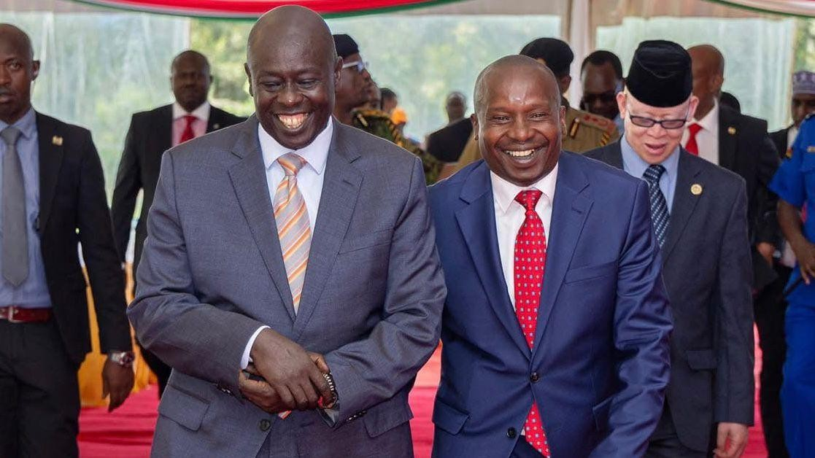
The doctrine is closely linked to the principle of separation of powers. Courts applying the Political Question doctrine argue that judicial intervention in highly political matters may disrupt democratic governance and interfere with the functions of elected institutions. According to this view, impeachment is fundamentally a political process conducted by representatives elected by the people, and courts should therefore exercise caution before overturning parliamentary decisions. ⁶⁹Supporters of judicial restraint argue that courts are not designed to resolve every political conflict. Judges possess legal authority, but they do not control political machinery, legislative processes or administrative structures. Excessive judicial interference in political disputes may therefore create institutional conflict between branches of government and weaken democratic governance. However, the Political Question doctrine has become increasingly controversial in modern constitutional democracies, especially in countries with transformative constitutions such as Kenya.⁷⁰

The Kenyan Constitutional Position after 2010
The Constitution of Kenya 2010 significantly transformed the role of the Judiciary and weakened the traditional Political Question doctrine. Unlike older constitutional systems where courts frequently avoided political disputes, the Kenyan Constitution deliberately established a strong Judiciary with broad powers to review constitutional violations committed by any state organ, including Parliament and the Executive. 71Article 165 gives the High Court authority to determine whether any law, action or exercise of public power violates the Constitution. This means that no institution is completely immune from constitutional scrutiny

⁶⁸ United States Constitution, Article I, Section 3.
⁶⁹ Alexander Bickel, The Least Dangerous Branch: The Supreme Court at the Bar of Politics (1962).
⁷⁰ Upendra Baxi, "The Avatars of Indian Judicial Activism".
⁷¹ Law Society of Kenya v. Attorney General & others [2013] eKLR.

merely because its actions are political in nature. Modern Kenyan constitutionalism emphasizes that all state organs remain subordinate to the Constitution.72
This constitutional transformation became particularly evident during the 2017 Kenyan Presidential Election Petition. In that historic decision, the Supreme Court nullified a presidential election despite the enormous political consequences involved. The judgment demonstrated that even highly political processes remain subject to constitutional review where constitutional violations are alleged. ⁷³As a result, many constitutional scholars argue that the Political Question doctrine no longer carries the same force in Kenya as it does in countries like the United States. The Kenyan Judiciary is no longer expected to avoid constitutional disputes merely because they involve politics. Instead, the courts are expected to ensure that every exercise of public power complies with constitutional requirements.⁷⁴ Nevertheless, although the Judiciary possesses broad constitutional authority, practical and institutional realities still create significant challenges. While courts may legally review impeachment proceedings, reversing succession after another Deputy President has already taken office creates political and administrative complications that cannot easily be ignored.⁷⁵

The Conflict Between Constitutional Remedies and Political Reality
The greatest challenge facing the Judiciary in the Deputy Presidency crisis is the conflict between constitutional principle and political reality. Article 23 strongly supports the idea that constitutional violations should receive effective remedies. However, political transitions often move faster than judicial processes, meaning that by the time courts reach final decisions, political institutions may already have fully adjusted to the new office holder. ⁷⁶If the court physically reinstates the former Deputy President after another individual has already assumed office, serious constitutional and administrative questions may arise. Government officers may become uncertain about whose authority to recognize. Executive coordination may be disrupted. Questions may also emerge concerning decisions already made by the successor

⁷² Constitution of Kenya 2010, Article 165(3)(d).
⁷³ Supreme Court of Kenya, Presidential Election Petition No. 1 of 2017, Raila Amolo Odinga & another v. Independent Electoral and Boundaries Commission & 2 others.
⁷⁴ Gautam Bhatia, The Transformative Constitution: A Magisterial Diaspora (2019).
⁷⁵ Justice J.B. Ojwang, "The Nature of Judicial Power through History", Journal of African Law (2001).
⁷⁶ Constitution of Kenya 2010, Article 20(3) .

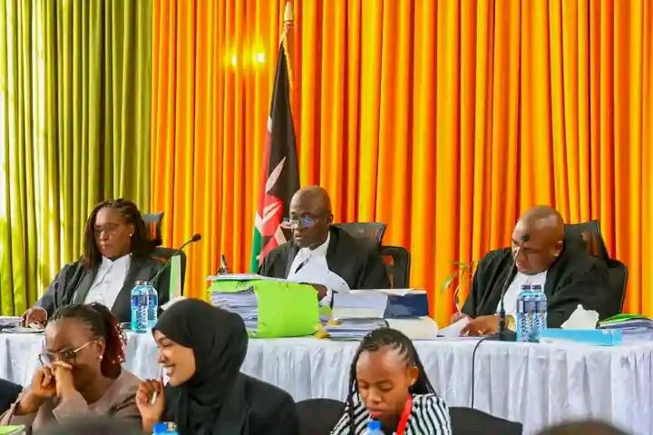
during their time in office.⁷⁷
At the same time, refusing reinstatement despite finding constitutional violations may weaken public confidence in constitutional accountability. Citizens may begin to believe that unconstitutional actions can ultimately succeed so long as political transitions occur quickly enough before courts intervene. This creates what many constitutional scholars describe as the “Remedy versus Reality” dilemma. ⁷⁸The Judiciary must determine whether constitutional
justice should always involve complete restoration of the injured party or whether practical political realities may justify limiting constitutional remedies in certain exceptional situations. The difficulty of this balancing exercise demonstrates the complexity of constitutional governance in modern democracies where legal principles and political realities frequently collide.⁷⁹

Comparative Jurisprudence and the South African Approach
South African constitutional jurisprudence offers important guidance on balancing constitutional legality with practical governance concerns. South African courts often apply the principle of “just and equitable” remedies when dealing with unconstitutional governmental actions. Under this approach, courts may declare government conduct unconstitutional while crafting remedies that minimize institutional disruption and protect administrative stability. ⁸⁰This means that a court may recognize constitutional violations without necessarily restoring the exact political situation that existed before the violation occurred.⁸¹

⁷⁷ Interpretive Guide to the Constitution of Kenya, Kenya Law Reform Commission Publications.
⁷⁸ Richard Fallon, "The Linkage between Justiciability and Remedies", Columbia Law Review.
⁷⁹Walter Murphy, Constitutional Democracy: Creating and Maintaining a Just Political Order.
⁸⁰ Constitution of the Republic of South Africa, 1996, Section 172(1)(b).
⁸¹ Hoffmann v. South African Airways [2000] ZACC 17 .

South African courts frequently consider factors such as the consequences of invalidating government action, the impact on public administration and the need to preserve institutional continuity. This flexible remedial approach attempts to balance constitutional accountability with practical governance realities. ⁸²Applied to the Kenyan Deputy Presidency crisis, such an approach could allow the court to declare the impeachment unconstitutional while declining physical reinstatement in order to preserve executive stability. Instead, the court might grant alternative remedies such as compensation, declaratory relief or public vindication.⁸³ Supporters of this approach argue that constitutional justice must remain practical and proportionate. Critics, however, warn that limiting remedies despite constitutional violations risks weakening the deterrent effect of constitutional accountability and encouraging future abuses of power.⁸⁴

Constitutional Avoidance and Judicial Hesitation
Some legal scholars explain judicial hesitation in politically sensitive cases through the principle of constitutional avoidance. This theory suggests that courts sometimes deliberately avoid making decisions capable of creating major political crises or institutional conflict. 85American legal scholar Cass Sunstein argues that courts occasionally use procedural technicalities, delays or narrow rulings to avoid entering politically explosive disputes. According to this theory, judicial restraint may sometimes protect institutional stability even if certain constitutional questions remain unresolved. ⁸⁶In Kenya, critics argue that courts occasionally issue temporary orders, prolonged stays or delayed judgments in politically sensitive disputes. Over time, political realities solidify while the litigation gradually loses practical significance. By the time final judgments are delivered, the political transition may already have become deeply entrenched.⁸⁷ Supporters of judicial restraint maintain that courts must remain aware of their institutional limitations. Although judges possess legal authority, they do not directly control political or administrative machinery. Courts therefore risk damaging their own legitimacy if they issue orders that become impossible or extremely difficult to enforce in practice. ⁸⁸This tension between legal authority and political practicality remains one of the most difficult aspects of constitutional adjudication.⁸⁹
The conflict between Article 23 and the Political Question doctrine represents one of the most significant constitutional struggles in contemporary Kenya. At the center of this debate lies a fundamental question: if constitutional rights are violated during impeachment proceedings, should the Judiciary fully restore the injured office holder or merely acknowledge the violation while preserving political stability? ⁹⁰Article 23 strongly supports the principle that constitutional violations must receive effective remedies. At the same time, political and

⁸² Minister of Health v. Treatment Action Campaign (No 2) [2002] ZACC 15.
⁸³ Fose v. Minister of Safety and Security [1997] ZACC 6 .
⁸⁴ Article 259, Constitution of Kenya 2010.
⁸⁵Cass Sunstein, One Case at a Time: Judicial Minimalism on the Supreme Court (1999).
⁸⁶Cass Sunstein, "Foreword: Leaving Things Undecided", Harvard Law Review (1996).
⁸⁷ P. Kaluma, Judicial Review of Administrative Actions in Kenya (2012).
⁸⁸ Justice Robert Jackson, The Supreme Court in the American System of Government (1955).
⁸⁹ The Judicature Act, Cap 8 (Laws of Kenya).
⁹⁰ Speaker of the National Assembly v. Karume [1992] eKLR.

institutional realities create serious challenges when courts attempt to reverse completed political transitions. The Constitution of Kenya 2010 greatly expanded judicial authority and reduced the traditional force of the Political Question doctrine, but practical limitations still influence how far courts may be willing to go.⁹¹ The Judiciary is therefore required to strike a delicate balance between constitutional justice and institutional stability. Whatever approach Kenyan courts ultimately adopt will profoundly shape the future of constitutional remedies, judicial authority, and democratic accountability within the Republic.⁹²
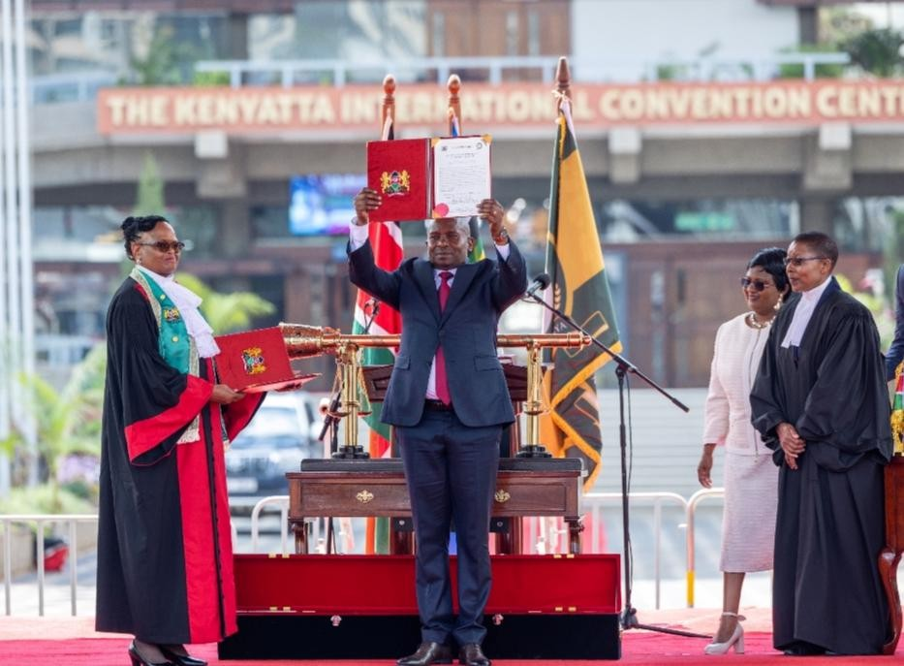

THE “DE FACTO” DOCTRINE OF PROTECTING THE VALIDITY OF GOVERNMENT ACTIONS
As the constitutional dispute over the impeachment and replacement of a Deputy President continues, another critical legal issue arises concerning the validity of actions taken by the successor while occupying office. If the courts eventually determine that the impeachment
process was unconstitutional and that the successor’s appointment was legally defective, an immediate constitutional dilemma emerges: what happens to the decisions, appointments, agreements and executive actions already undertaken during the successor’s tenure? This question is extremely important because modern governments operate through continuous administrative actions that affect millions of citizens every day.⁹³ The answer to this constitutional problem lies in the De Facto Doctrine, one of the most significant principles in constitutional and administrative law. The doctrine exists to preserve public confidence in government institutions and to prevent administrative chaos whenever an official who

⁹¹ James T. Gathii, "The Dream of Judicial Review by Transnational Courts in Africa".
⁹² Miyandazi, Victoria. "The role of Kenyan courts in tackling persistent inequalities: navigating deference and accountability." German Law Journal 26.2 (2025): 234-254.
⁹³ William Wade & Christopher Forsyth, Administrative Law (11th Ed., 2014).

appeared to hold office lawfully is later discovered to have had defects in their appointment. Without such a doctrine, every action taken by a government official could become vulnerable to challenge whenever constitutional disputes arise, thereby creating instability throughout the state. In the context of the Deputy Presidency crisis in Kenya, the De Facto Doctrine operates as a stabilizing mechanism. Even if the courts later conclude that the succession process was constitutionally flawed, the doctrine may still preserve the legal validity of governmental actions already taken by the successor during the period they occupied office. The doctrine therefore attempts to strike a balance between constitutional accountability and administrative continuity.⁹⁴

Meaning and Purpose of the De Facto Doctrine
The De Facto Doctrine is a legal principle that validates the official acts of a person who occupies a public office under the appearance or “color” of lawful authority, even where it is later discovered that the appointment was legally defective. The doctrine is based on the practical reality that ordinary citizens cannot constantly investigate the legality of every public official’s appointment before interacting with government institutions. The term “de
facto” means “in fact” or “in practice.” A de facto officer is therefore someone who publicly performs the duties of office and appears to possess lawful authority even though hidden constitutional or procedural defects may later emerge concerning their appointment. The law recognizes the acts of such officials as valid in order to protect the stability of government administration and preserve public trust in state institutions.⁹⁵ The purpose of the doctrine is to prevent administrative paralysis. Governments make countless decisions every day involving national security, public finance, diplomatic relations, public appointments, contracts and implementation of laws. If every governmental action became uncertain whenever disputes
arise concerning an official’s appointment, public administration would become unstable and chaotic. In the Deputy Presidency context, supporters of the doctrine argue that once the successor was officially sworn into office through recognized constitutional procedures, both the public and state institutions were entitled to treat the successor as the lawful Deputy President unless and until a competent court declared otherwise. As a result, the actions performed during that period should remain legally valid in order to protect continuity of governance and public confidence in constitutional institutions.⁹⁶

The Concept of “Color of Authority”
One of the most important elements of the De Facto Doctrine is the concept of “color of authority” or “color of title.” This refers to the appearance of lawful authority created by
official procedures, ceremonies or institutional recognition. Even if defects later emerge, the official initially appears to occupy office legally in the eyes of the public and government institutions. In the Kenyan Deputy Presidency crisis, the successor derives this appearance of authority from several constitutional and institutional processes. These include:

⁹⁴ "The De Facto Doctrine in Administrative Law".
⁹⁵ Baldwin v. City of Buffalo, 15 N.Y.2d 168.
⁹⁶ Public Service Commission of Kenya, Manual on Administrative Law and Procedures.

- the Senate’s vote approving the removal of the predecessor
- the declaration of vacancy
- the official swearing-in ceremony
- recognition by state institutions and public officers.97
These actions collectively create the appearance of constitutional legitimacy. Until the courts conclusively determine otherwise, citizens and public institutions are generally entitled to rely upon that appearance when dealing with the office holder. The importance of this principle lies in protecting public reliance. Citizens should not suffer uncertainty merely because constitutional litigation later reveals procedural defects in the succession process. If ordinary people were required to constantly question the legal validity of government officials before interacting with public institutions, the functioning of the state would become impossible.⁹⁸
The De Facto Doctrine therefore protects not only the government itself but also innocent citizens, institutions, businesses and foreign governments that interact with public officials in good faith.⁹⁹

Historical and Comparative Jurisprudence
The De Facto Doctrine has deep roots within common law systems and has been recognized by courts across many jurisdictions. One of the classic authorities is State v. Carroll, where the court held that the acts of a de facto officer remain legally valid because public policy and justice require stability in government administration. The court emphasized that ordinary citizens should not suffer because of technical defects affecting appointments to public office.
¹⁰⁰In Kenya, the Supreme Court has also acknowledged the importance of preserving institutional continuity even where questions arise concerning the legality of appointments. In In Re the Matter of the Interim Independent Electoral Commission, the court emphasized that technical irregularities affecting appointments should not automatically invalidate governmental actions where public interest and institutional stability are involved.¹⁰¹ Ugandan courts have similarly recognized the doctrine. In Advocates Coalition for Development and Environment v. Attorney General, the court emphasized that citizens must be able to trust and rely upon public institutions without constantly fearing that hidden defects in appointments may invalidate government actions. The court recognized that protecting public transactions and maintaining administrative continuity are essential constitutional objectives. These comparative precedents demonstrate that the De Facto Doctrine is widely accepted as an important mechanism for preserving constitutional order and preventing administrative confusion during periods of institutional uncertainty.¹⁰²

⁹⁷ Assumption of Office of President Act, No. 21 of 2012.
⁹⁸ Council of Civil Service Unions v. Minister for the Civil Service [1985] AC 374.
⁹⁹ United Nations Convention on Jurisdictional Immunities of States and Their Property.
¹⁰⁰ State v. Carroll, 38 Conn. 449 (1871).
¹⁰¹ Supreme Court of Kenya, Advisory Opinion No. 2 of 2011.
¹⁰² Advocates Coalition for Development and Environment (ACODE) v. Attorney General (Miscellaneous Cause No. 0100 of 2004) [2005] UGHC 16.

Distinguishing a De Facto Officer from a Usurper
A very important distinction exists between a de facto officer and a usurper. A de facto officer enters office through procedures that appear lawful and receives public recognition from constitutional institutions even if defects later emerge. Such an officer acts openly, publicly and under apparent constitutional authority.¹⁰³ A usurper, however, is someone who seizes office without any lawful basis or constitutional appearance of legitimacy. This may occur through force, fraud, military intervention or direct disregard of constitutional procedures.
Unlike a de facto officer, a usurper lacks even the appearance of lawful authority. This distinction is important because the De Facto Doctrine generally protects the actions of de facto officers but does not protect the actions of usurpers. Courts are more willing to preserve official acts where the office holder initially appeared to possess lawful authority.¹⁰⁴ In the Deputy Presidency crisis, supporters of the successor argue that the office holder cannot be described as a usurper because the succession occurred through recognized constitutional procedures including parliamentary action and official swearing-in ceremonies. Even if the process is later found unconstitutional, the successor still entered office under apparent constitutional legitimacy rather than through unlawful seizure of power. This distinction strengthens the argument that actions already taken during the successor’s tenure should remain legally valid

¹⁰³ Peter Leyland & Anthony Williams, The Administrative System: An Introduction.
¹⁰⁴ Cooley, Constitutional Limitations.

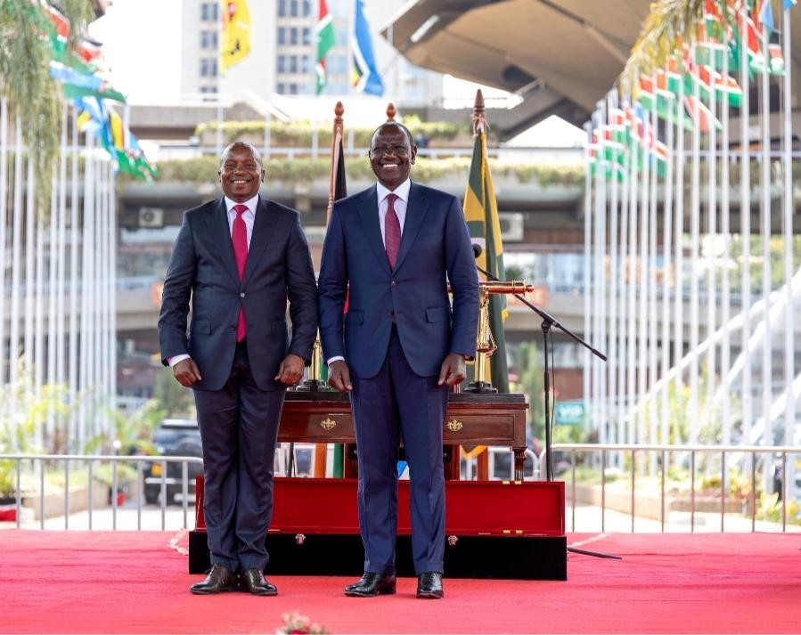
even if the underlying succession process is eventually invalidated by the courts.105

Public Policy and Administrative Stability
The De Facto Doctrine is heavily influenced by considerations of public policy and administrative stability. Modern governments depend upon continuity in decision-making and institutional coordination. Every day, public officials make decisions affecting contracts, security operations, diplomatic engagements, appointments, public finance and implementation of laws. If every governmental action became uncertain whenever disputes
arise concerning the legality of an official’s appointment, the state would face severe administrative instability. Public confidence in government institutions would weaken, and ordinary governance could become impossible. The doctrine therefore protects innocent third parties who interact with government institutions in good faith. Citizens should not be punished because constitutional litigation later uncovers defects in the appointment process of a public official. In the context of the Deputy Presidency crisis, the doctrine protects:
- agreements signed during the successor’s tenure
- executive directives issued
- diplomatic actions undertaken
- appointments made

¹⁰⁵ Senate Standing Orders (Kenya) regarding Impeachment.

administrative decisions implemented while the successor occupied office.106
This protection preserves continuity in governance and prevents constitutional litigation from causing broader disruption to public administration and national stability. Without the De Facto Doctrine, constitutional disputes concerning public appointments could potentially destabilize entire sectors of government and create uncertainty throughout the legal system.¹⁰⁷
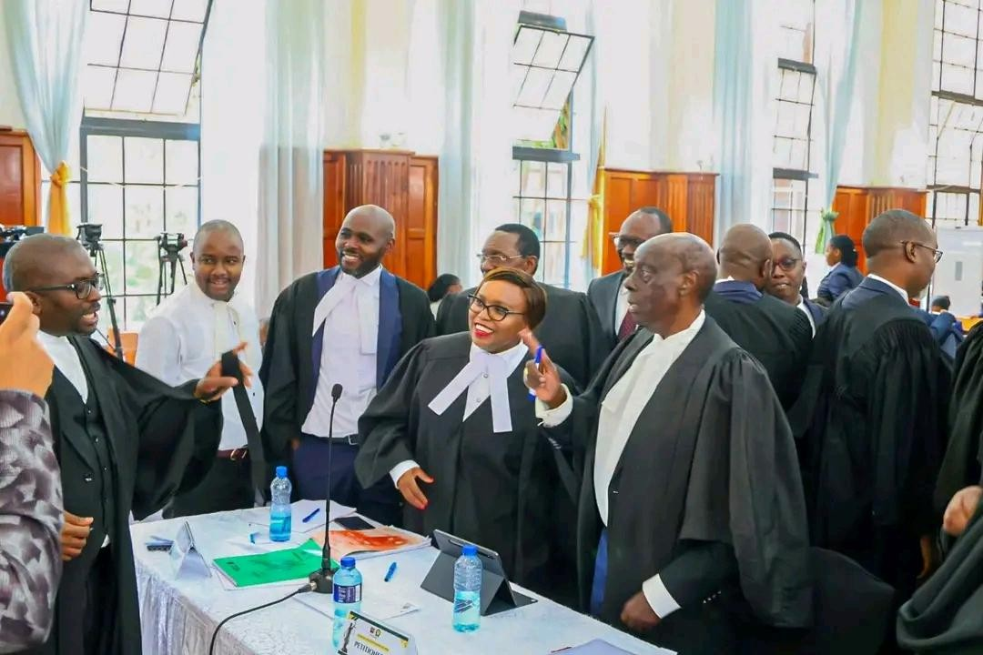

Scholarly Perspectives on the Doctrine
Legal scholars have long defended the De Facto Doctrine as essential for preserving the functioning of modern administrative states. Prominent administrative law scholar H. W. R. Wade described the doctrine as necessary for preventing the collapse of public administration through what he called “retroactive invalidity.” According to Wade, if every technical defect automatically invalidated official acts, government administration would become unmanageable. ¹⁰⁸In Kenya, constitutional scholars such as Professor Migai Akech have argued that the doctrine acts as a bridge between constitutional ideals and practical governance realities. While constitutional violations must still be corrected, the law must also protect the public from the devastating effects of administrative uncertainty. These scholarly views emphasize that the doctrine is not designed to excuse unconstitutional conduct. Instead, it exists to protect innocent public reliance and preserve the continuity of state operations during periods of constitutional litigation.¹⁰⁹

Limits of the De Facto Doctrine

¹⁰⁶ Treaty Making and Ratification Act (No. 45 of 2012).
¹⁰⁷ Paul Craig, Administrative Law (8th Ed., 2016) on "Stability and Administrative Necessity".
¹⁰⁸ H.W.R. Wade, Administrative Law (7th Ed., Oxford University Press).
¹⁰⁹ Migai Akech, Administrative Law (Strathmore University Press, 2016).

Although the De Facto Doctrine protects official actions already performed, it does not necessarily protect the office holder’s continued occupation of office once constitutional defects are established. The doctrine preserves governmental actions for purposes of stability and public reliance, but it does not automatically legitimize unconstitutional succession itself.¹¹⁰
This means that a court may:

preserve the validity of executive actions already undertaken,
- simultaneously declaring the appointment unconstitutional and ordering removal from office.111
The doctrine therefore distinguishes between protecting administrative continuity and legitimizing constitutional violations. Additionally, courts remain careful not to allow the doctrine to become a shield for deliberate abuse of constitutional procedures. The doctrine cannot be used to justify unlawful seizure of power or intentional disregard of constitutional requirements. Its application must therefore remain limited and proportionate.¹¹² The De Facto Doctrine remains one of the most important stabilizing principles within constitutional and
administrative law. In the context of Kenya’s Deputy Presidency crisis, the doctrine protects the validity of governmental actions undertaken during the successor’s tenure even where constitutional disputes later emerge concerning the legality of succession. The doctrine exists because constitutional litigation should not paralyze government administration or create uncertainty for citizens who relied in good faith upon public institutions. By validating the acts of officials who operated under apparent constitutional authority, the doctrine preserves continuity in governance and protects public confidence in the state. At the same time, the doctrine does not completely shield unconstitutional succession from judicial correction. Courts may still declare the appointment unlawful and remove the office holder while preserving the legal validity of actions already taken during the period of occupation.¹¹³
The De Facto Doctrine therefore reflects an important constitutional compromise between strict constitutional legality and practical governance realities. It seeks to ensure that while constitutional supremacy remains protected, the ordinary functioning of the state does not collapse under the weight of retroactive constitutional invalidity.¹¹⁴

COMPARATIVE CONSTITUTIONALISM ON HOW THE WORLD HANDLES THE “DUAL-OFFICER” CRISIS
The Kenyan Deputy Presidency dispute raises a problem that is not unique to Kenya. Across different constitutional systems, courts have repeatedly faced situations where an office holder is removed, replaced or challenged while legal proceedings are still ongoing. This creates a serious constitutional tension because, in practice, two individuals may end up claiming

¹¹⁰ Constitution of Kenya 2010, Article 165(3).
¹¹¹ Republic v. Commissioner of Lands ex parte Lakeview Estate Limited [2014] eKLR.
¹¹² R v. Thames Magistrates' Court, ex parte Polemis [1974] 1 WLR 1371.
¹¹³. Kenya Law Reports (KLR), Analytical Review of the Doctrine of Necessity and De Facto Validity.
¹¹⁴Article 259(1), Constitution of Kenya 2010.

authority over the same office at different times or under competing legal interpretations. This situation is often described in comparative constitutional law as a “dual-office crisis.”¹¹⁵
Different countries have responded to this problem in different ways. Some courts prioritize strict constitutional legality and are willing to reverse succession decisions even after a new office holder has taken oath. Others prioritize political stability and treat succession as final once it has occurred, even if procedural defects are later discovered. A third group of systems attempts to balance both legality and stability through carefully designed judicial remedies. For Kenya, these comparative experiences are important because they provide guidance on how courts may resolve the tension between constitutional supremacy and political practicality in the 2026 Deputy Presidency dispute. They also show that the issue is not new in global constitutional practice, and that courts often face difficult trade-offs when deciding whether to reinstate a removed leader or preserve an already completed succession.¹¹⁶
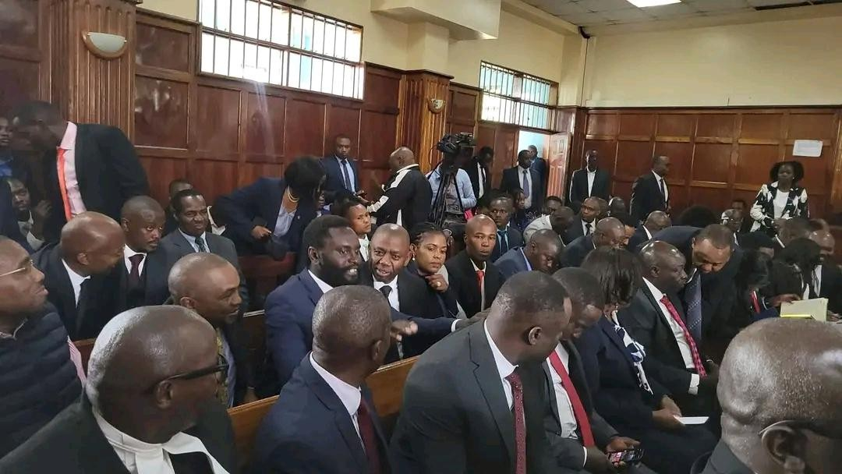

The Nigerian Approach: Judicial Willingness to Reinstate
Nigeria provides one of the strongest examples in Africa of judicial willingness to intervene in executive succession disputes. In the landmark decision of Ladoja v. Independent National Electoral Commission (INEC) (2007), the Supreme Court of Nigeria dealt with the impeachment of a state governor who had been removed from office while legal challenges were still pending. A successor had already been sworn in and had begun performing official duties. The court found that the impeachment process was constitutionally defective because it failed to comply with required procedural safeguards. On that basis, the court held that the removal was unlawful from the beginning. As a result, it ordered the immediate reinstatement of the impeached governor, even though a new office holder was already in place.¹¹⁷

¹¹⁵ Jan-Erik Lane, Constitutions and Political Theory.
¹¹⁶. Vicki C. Jackson & Mark Tushnet, Comparative Constitutional Law (2014).
¹¹⁷ Ladoja v. Independent National Electoral Commission (INEC) [2007] 12 NWLR (Pt. 1048) 334.

This decision is significant because it confirms that, in Nigerian constitutional law, legality takes priority over political finality. If the removal process is unconstitutional, then the
successor’s appointment is also treated as legally defective. The successor’s title is therefore considered defeasible and subject to reversal by judicial order. However, this approach is not without controversy. While it strongly protects constitutional integrity, it may also create political uncertainty and administrative instability. Reinstating a removed official after succession has already taken place can lead to institutional conflict and confusion in government operations. Despite these concerns, the Nigerian model remains one of the clearest examples of strong judicial enforcement of constitutional compliance in executive removal cases.¹¹⁸

The Brazilian Approach: Stability and Finality of Political Transition
Brazil represents a contrasting constitutional philosophy that places greater emphasis on political stability and finality of succession. In the impeachment of President Dilma Rousseff in 2016, Vice President Michel Temer assumed office following Senate proceedings that were widely debated and politically controversial. Although there were serious arguments raised regarding procedural fairness and the political nature of the impeachment process, the Brazilian Supreme Federal Court largely refrained from reversing the political outcome once the transition had occurred. The court focused more on whether formal constitutional procedures were followed rather than attempting to undo the succession after the fact.¹¹⁹ This approach reflects a judicial preference for stability over reversal. Once political succession is completed and a new executive is functioning, courts are generally reluctant to disturb that arrangement, even if questions remain about the fairness or motivation behind the impeachment process. The Brazilian model therefore prioritizes institutional continuity. It assumes that reversing succession after it has been completed may create more harm than allowing the new political reality to stand. However, critics argue that this approach may weaken constitutional accountability by allowing procedural violations to stand uncorrected simply because political transition has already occurred.¹²⁰

The Malawian Experience: Strict Constitutional Succession
Malawi offers a different and instructive example of constitutional enforcement during leadership transition. In 2012, following the death of President Bingu wa Mutharika, a political crisis emerged when certain political actors attempted to prevent the Vice President, Joyce Banda, from assuming office. Despite political resistance, Malawian courts and state institutions upheld the Constitution strictly, insisting that succession must follow the constitutional order without deviation. The Vice President Joyce Banda was sworn in based on constitutional automatic succession principles, reinforcing the supremacy of the written Constitution over political maneuvering. This case demonstrates the importance of constitutional clarity and strict adherence to succession rules. It shows that when constitutional provisions are clear and firmly enforced, the risk of competing claims to office is

¹¹⁸ Constitution of the Federal Republic of Nigeria 1999, Section 188.
¹¹⁹Brazilian Constitution of 1988, Article 85 & 86
¹²⁰ "The Impeachment of Dilma Rousseff: A Constitutional Analysis", Oxford Journal of Legal Studies (2017).

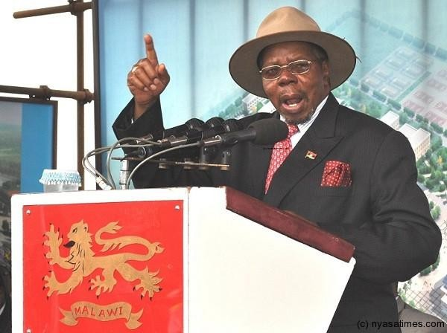
significantly reduced.¹²¹

[Economist & Former Malawi President the Late Bingu wa Mutharika 2004-2012]
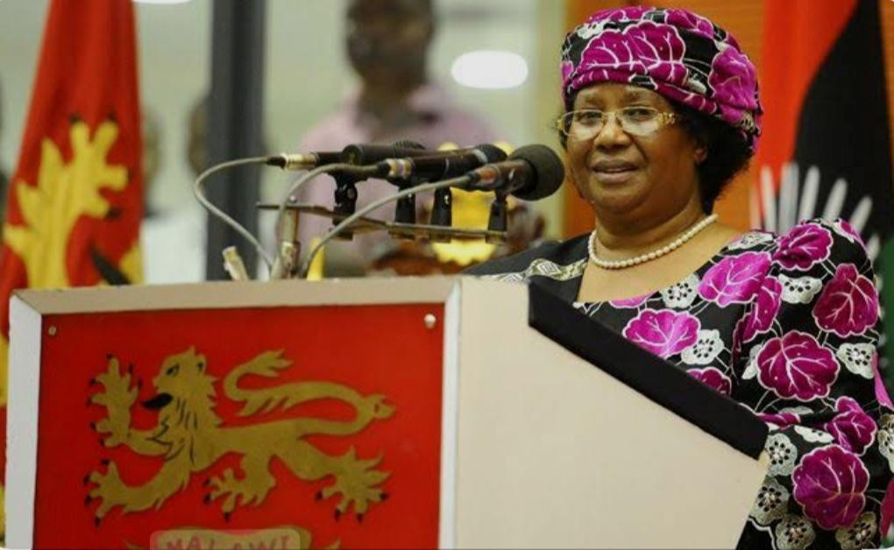
[Activist & Former President of Malawi Joyce Banda 2012-2014]
In later constitutional litigation, including Chilima v. State (2020), the Malawian courts further demonstrated willingness to intervene strongly in electoral and leadership disputes, including nullifying election results and ordering fresh elections where constitutional violations were established. This reinforces a pattern of judicial assertiveness in protecting constitutional legitimacy.¹²²

The South Korean Model: Judicial Confirmation Before Final Removal
South Korea presents a structured constitutional mechanism that helps avoid the problem of dual-office claims altogether. In its constitutional system, impeachment by the legislature does not automatically result in removal from office. Instead, the Constitutional Court must

¹²¹Constitution of the Republic of Malawi, Section 83.
¹²² Chilima & Another v. Mutharika & Another (Constitutional Referral No. 1 of 2019) [2020] MWSC 1.

confirm the impeachment before it becomes effective. This system introduces a judicial safeguard before final political transition occurs. It ensures that constitutional review is completed before a new office holder assumes power, thereby preventing situations where courts later attempt to reverse a completed succession. ¹²³The strength of this model lies in its preventive design. By requiring judicial confirmation before removal becomes final, it reduces the likelihood of post-succession disputes and eliminates the need for reinstatement controversies. However, such a system requires explicit constitutional design and may not be easily adopted in systems that already allow immediate succession upon impeachment.¹²⁴

The United States Approach: Political Question and Judicial Restraint
The United States adopts a more restrained judicial approach to impeachment and succession disputes. Impeachment is largely treated as a political process within Congress, and courts are generally reluctant to interfere with the outcomes of such proceedings. In cases such as Nixon v. United States, the Supreme Court held that impeachment trials fall within the exclusive authority of the Senate and are not subject to detailed judicial review. This reflects the application of the Political Question doctrine, which limits judicial intervention in matters constitutionally assigned to political branches. ¹²⁵Under this model, once impeachment and succession occur, courts rarely attempt to reverse the outcome. The focus is on maintaining separation of powers and respecting institutional boundaries, even where procedural concerns may exist.¹²⁶ This approach strongly favors political finality and institutional stability. However, critics argue that it may leave gaps in constitutional accountability where procedural injustices cannot be effectively corrected through judicial intervention.¹²⁷
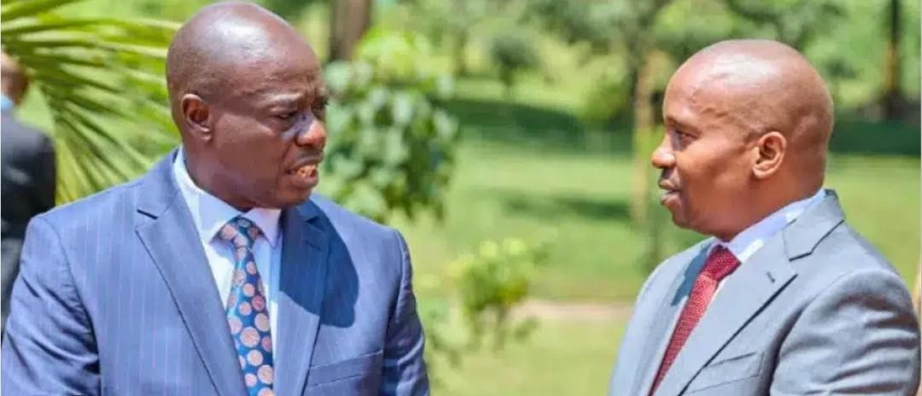

Scholarly Perspectives on Comparative Models

¹²³ Constitution of the Republic of Korea, Article 65 & 111.
¹²⁴ Chun-wook Hyun, "The Constitutional Court of Korea", Journal of Korean Law (2001).
¹²⁵ Constitution of the United States, Article II, Section 4.
¹²⁶ Michael Gerhardt, The Federal Impeachment Process: A Constitutional and Historical Analysis.
¹²⁷ Raoul Berger, Impeachment: The Constitutional Problems (Harvard University Press).

Constitutional scholars remain divided on which approach best balances constitutional supremacy and political stability. Some scholars argue that strong judicial intervention, as seen in Nigeria, is necessary to ensure that constitutional violations are not tolerated simply because political transitions have already occurred. ¹²⁸Others argue that reversing succession decisions may create instability and weaken governance effectiveness. Legal scholar Aharon Barak supports strong judicial protection of constitutional norms, arguing that courts must act as guardians of legality even during politically sensitive transitions. In his view, constitutional violations must be corrected regardless of political consequences.¹²⁹ On the other hand, scholars such as Noah Feldman caution that reinstating removed leaders may sometimes produce “hollow victories,” where the reinstated leader lacks political authority or control over the state apparatus. This may result in a weakened or ineffective administration despite legal correctness. These scholarly debates highlight the difficulty of designing remedies that both uphold constitutional principles and maintain effective governance.¹³⁰

Implications for Kenya’s 2026 Crisis
Kenya’s Judiciary now faces the challenge of choosing between these competing global approaches. The Nigerian model supports the possibility of reinstatement where impeachment is found to be unconstitutional. The Brazilian and United States models emphasize finality and stability after succession. The Malawian and South Korean models emphasize strict constitutional adherence and preventive judicial safeguards. ¹³¹The central question for Kenya is whether constitutional legality should override political reality after a successor has already assumed office, or whether stability should take precedence once transition has been completed. The answer to this question will not only determine the outcome of the Deputy Presidency dispute but will also shape the future direction of constitutional interpretation and judicial authority in Kenya.¹³² Comparative constitutional practice demonstrates that there is no single universal solution to the problem of dual claims to constitutional office. Each jurisdiction has developed its own balance between legality and stability based on its constitutional structure and political history. Nigeria demonstrates strong judicial willingness to correct unconstitutional removals through reinstatement. Brazil and the United States emphasize political finality and institutional restraint. Malawi and South Korea show the importance of strict constitutional enforcement and preventive mechanisms that reduce post-succession disputes. ¹³³Kenya’s current crisis therefore sits within a global constitutional conversation. The Judiciary must carefully balance constitutional supremacy with political stability, ensuring that its decision strengthens both the rule of law and the long-term stability of governance.¹³⁴

¹²⁸ Professor Itse Sagay, "The Rule of Law and the Challenge of Impeachment", Nigerian Bar Journal.
¹²⁹ Aharon Barak, The Judge in a Democracy (Princeton University Press, 2006).
¹³⁰ Noah Feldman, The Three Lives of James Madison: Genius, Partisan, President.
¹³¹ G.A. Figueroa, "The Role of Courts in Executive Succession: A Comparative Perspective".
¹³²Article 10, Constitution of Kenya 2010.
¹³³ International Journal of Constitutional Law (I•CON), "Comparative Impeachment Studies".
¹³⁴Constitution of Kenya 2010, Article 159.

THE LEGISLATIVE VACUUM THAT NECCESSIATES THE NEED FOR AN IMPEACHMENT PROCEDURE ACT
The 2026 Deputy Presidency crisis has exposed a deep structural weakness in Kenya’s constitutional and legislative framework: the absence of a detailed, comprehensive Impeachment Procedure Act. While the Constitution provides the basic framework for impeachment under Articles 145 and 150, it does not provide detailed procedural rules governing how impeachment should be conducted in practice.¹³⁵ This gap has forced the Senate to rely heavily on its Standing Orders, which are internal parliamentary rules rather than full- fledged legislation. As a result, impeachment processes have increasingly been shaped by political discretion rather than uniform legal standards. This has raised serious concerns about fairness, consistency and constitutional compliance in high-level removals from office. ¹³⁶The absence of a clear statutory framework has therefore contributed significantly to the uncertainty and controversy surrounding the Deputy Presidency impeachment process. It has also created a situation where courts are increasingly called upon to fill legislative gaps that ideally should have been addressed by Parliament.¹³⁷

The Problem of “Ad Hoc” Impeachment Procedures
In the absence of a dedicated Impeachment Procedure Act, each impeachment process in Kenya tends to develop its own procedural character depending on political context, parliamentary composition, and institutional interpretation of Standing Orders. This has led to what can be described as “ad hoc justice,” where procedures are not standardized but instead adjusted depending on circumstances.¹³⁸ Standing Orders are primarily designed to regulate internal parliamentary conduct, not to govern processes that directly affect constitutional offices such as the Deputy Presidency. While they provide procedural guidance, they lack the legal depth and certainty required for proceedings that result in removal from high constitutional office.¹³⁹ This creates a serious legal problem. Because Standing Orders can be amended relatively easily by parliamentary majority, there is a risk that impeachment procedures may be shaped to fit political outcomes rather than legal standards. This undermines the principle of legality and raises questions about whether impeachment decisions are being made on the basis

¹³⁵Constitution of Kenya 2010, Articles 145 & 150.

¹³⁶Senate Standing Orders, Standing Order 74 & 75.
¹³⁷ "Gaps in the Kenyan Impeachment Law", Parliamentary Research Service Working Paper (2025).
¹³⁸ T.O. Kaindi, Constitutional Law of Kenya: A Contemporary Approach.
¹³⁹ Parliamentary Powers and Privileges Act, No. 29 of 2017.

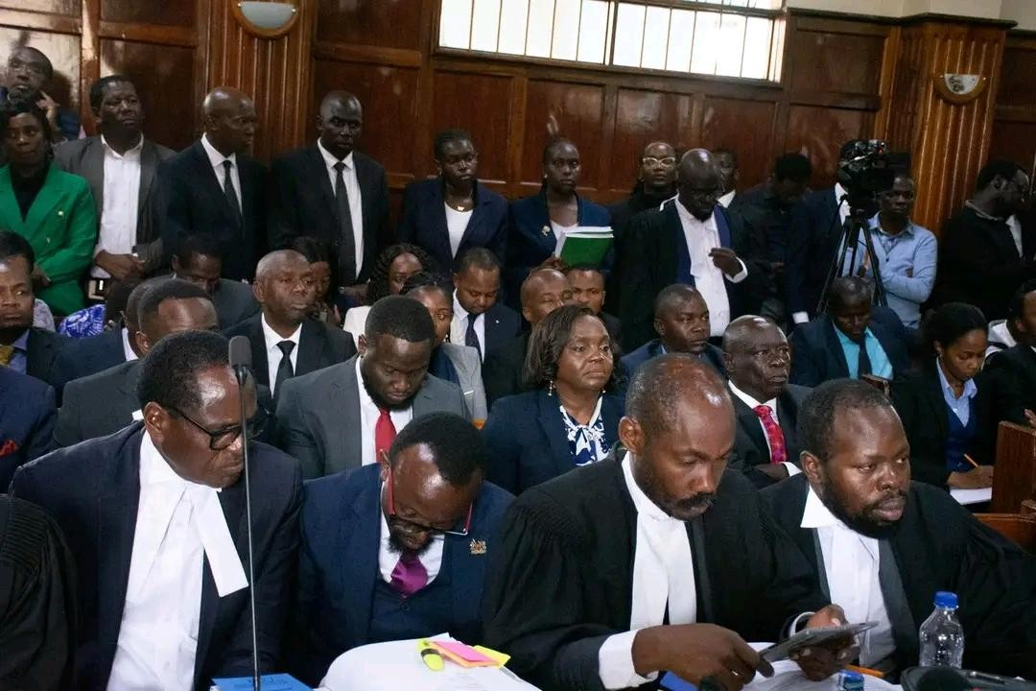
of law or political convenience.¹⁴⁰
In the 2024–2026 impeachment proceedings, Defense lawyers of former Deputy President, have argued that procedural rules were adjusted or interpreted flexibly during the process, creating the impression that the rules were shaped to achieve a predetermined outcome rather than to ensure fairness and justice. ¹⁴¹Lawyer Senior Counsel Elisha Ongoya briefly lightened the mood at the Milimani High Court on Monday, 27th April 2026, after making a historical comparison between former Deputy President Rigathi Gachagua’s impeachment proceedings and history’s 'trial of Jesus Christ.' Ongoya, who is part of Gachagua’s legal team, made the remarks while addressing the three-judge bench hearing petitions challenging the former Deputy President’s impeachment process. “Thank you, my Lords and My Lady. My name is Elisha Ongoya. I have reflected on a number of unjust trials in human history, the trial of St Thomas More, the trial of Socrates and even the trial of Jesus Christ,” Ongoya told the court. His reference to the trial of Jesus Christ triggered laughter from those present in the courtroom, briefly easing the tense atmosphere surrounding the high-profile constitutional case. Ongoya, however, quickly returned to his submission, saying such trials shared one common feature: predetermined outcomes. “One element characterises these trials. When you read history, there are trials that are carried out with predetermined outcomes. Those who are taken through the trials are taken through the motions, for the sake of it,” he said. He argued that Gachagua’s impeachment process followed a similar pattern, where constitutional procedures were observed in form but not in substance.¹⁴²

The Proposed Impeachment Procedure Bill, 2026
In response to growing concerns about procedural uncertainty, Parliament has attempted to address the gap through the proposed Impeachment Procedure Bill, 2026. The Bill seeks to

¹⁴⁰Martin Loughlin, Foundations of Public Law (Oxford University Press, 2010).
¹⁴¹Constitutional Petition No. E532 of 2024, Rigathi Gachagua v. Speaker of the National Assembly & 3 others.
¹⁴²Black Jr, Charles L. Impeachment: a handbook. Yale University Press, 1998.

introduce a more structured and legally grounded framework for handling impeachment proceedings.¹⁴³
One of the key proposals in the Bill is the introduction of mandatory timelines for public participation. Under previous practice, public participation periods have been extremely short, sometimes lasting only a few days. The proposed law seeks to extend this period to at least 14 days to ensure meaningful public engagement in impeachment proceedings. ¹⁴⁴The National Assembly of Kenya’s handling of public participation during the impeachment of former Deputy President Rigathi Gachagua come under legal challenge, with his legal team arguing that the process failed to meet constitutional standards of public engagement. Appearing before the court on Thursday, 7th May 2026, Kirinyaga County Woman Representative and advocate Njeri Maina, who is part of Gachagua’s legal team, claimed that the exercise was rushed, poorly notified and deliberately structured in a way that excluded meaningful participation by members of the public. Maina told the court that the process was marred by what she described as “orchestrated and systematic exclusion” in several constituencies, alleging that some constituency offices were closed during the exercise, effectively limiting access for citizens who wished to participate.¹⁴⁵ Another significant proposal is the introduction of judicial oversight at the preliminary stage of impeachment. Under this model, the Chief Justice or a designated judicial body would be required to certify that impeachment charges meet a minimum legal threshold before they can proceed to full Senate trial. This is intended to prevent politically motivated or legally weak charges from advancing to formal proceedings. ¹⁴⁶The Bill also proposes a “suspension model” rather than immediate removal. Under this system, a Deputy President would be temporarily suspended during impeachment proceedings rather than fully removed from office. This is intended to prevent the emergence of dual claims to office while legal proceedings are ongoing. If implemented, these reforms could significantly reduce constitutional uncertainty and prevent the kind of “dual-office crisis” currently being experienced.¹⁴⁷

Jurisprudential Precedence: Impeachment as a Quasi-Judicial Process
Kenyan courts have increasingly characterized impeachment as a quasi-judicial process, meaning it must adhere to standards of fairness similar to those applied in judicial proceedings, even though it takes place in a political institution. In cases involving impeachment of county governors and other officials, courts have emphasized that impeachment is not purely a political vote but a structured constitutional process that must respect due process rights. ¹⁴⁸This principle was strongly reinforced in cases such as Hon. Mike Mbuvi Sonko v. The Clerk, Nairobi City County Assembly (2022), where the courts

¹⁴³Ginsburg, Tom, Aziz Huq, and David Landau. "The Comparative Constitutional Law of Presidental Impeachment." U. Chi. L. Rev. 88 (2021): 81.
¹⁴⁴Constitution of Kenya 2010, Articles 118 & 196.
¹⁴⁵Tom, Mulisa. Public participation in constitution-making: A critical assessment of the Kenyan experience. MS thesis. University of Pretoria (South Africa), 2009.
¹⁴⁶ Proposal for Judicial Certification, Committee on Justice, Legal Affairs and Human Rights.
¹⁴⁷ "The Suspension Model: Resolving the Dual-Officer Crisis", Kenya Law Review Journal.
¹⁴⁸ Wambora v. Speaker of the County Assembly of Embu [2014] eKLR.

examined whether impeachment procedures complied with constitutional standards of fairness and legality.¹⁴⁹ The court emphasized that while the legislature has jurisdiction over impeachment, that jurisdiction is not unlimited. It must be exercised in accordance with constitutional principles, including fair hearing, transparency and procedural propriety. In the 2026 context, legal arguments are being made that failure to comply with strict procedural standards especially in the absence of a clear statutory framework renders impeachment decisions legally vulnerable. This reinforces the argument that Standing Orders alone are insufficient to support such high-stakes constitutional outcomes.¹⁵⁰

The Constitutional Gap and Its Consequences
The absence of a detailed Impeachment Procedure Act has created a significant constitutional gap. This gap allows political majorities within Parliament to shape impeachment processes in ways that may not always align with principles of fairness and due process.¹⁵¹ Legal scholars have observed that when the Constitution provides broad principles without detailed procedures, political actors often fill the gap with practices that reflect immediate political interests rather than long-term constitutional stability. This creates inconsistency in how impeachment is conducted across different cases.¹⁵² In practice, this has led to situations where impeachment proceedings vary significantly depending on political context. Issues such as the standard of proof, time allowed for defense, admissibility of evidence and scope of public participation have not been uniformly defined.¹⁵³
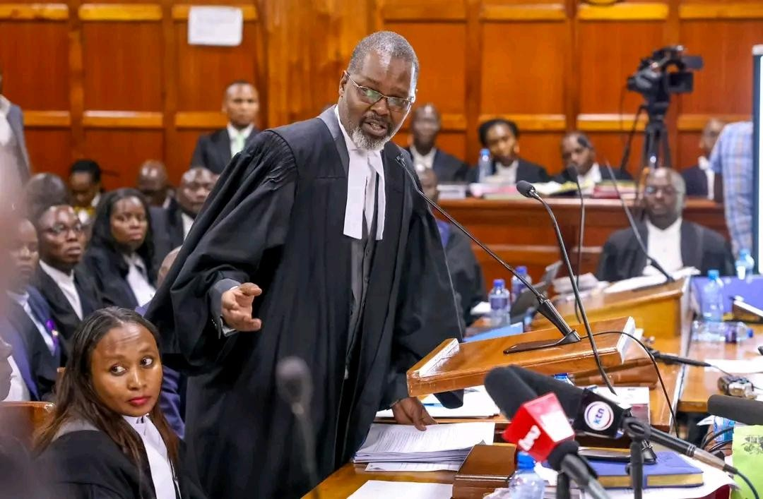

¹⁴⁹ Hon. Mike Mbuvi Sonko v. The Clerk, Nairobi City County Assembly [2022] eKLR.
¹⁵⁰ Article 47, Constitution of Kenya 2010.
¹⁵¹ B.M. Musembi, Legislative Procedures in Kenya: A Legal Analysis.
¹⁵² Constitution of Kenya 2010, Article 1(3).
¹⁵³Jill Cottrell & Yash Pal Ghai, The 2010 Constitution of Kenya: A User's Guide.

As a result, impeachment processes risk being perceived not as neutral constitutional mechanisms but as political tools. This perception undermines public trust in constitutional institutions and increases the likelihood of judicial intervention.¹⁵⁴

Scholarly Perspectives on the Legislative Vacuum
Constitutional scholars have long warned about the dangers of leaving procedural gaps in high-impact constitutional processes. Legal scholar Yash Pal Ghai has argued that the Kenyan Constitution is rich in values but often limited in procedural detail. According to this view, where the Constitution is silent, political actors tend to define procedures in ways that suit their immediate interests. ¹⁵⁵This creates a situation where constitutional processes are vulnerable to manipulation unless clearly defined by legislation. In the context of impeachment, this means that without a detailed statutory framework, procedural fairness may vary depending on political composition rather than legal consistency. Other scholars argue that impeachment, due to its serious consequences, should not be left to flexible interpretation. ¹⁵⁶Instead, it should be governed by strict legal rules similar to criminal or quasi-judicial proceedings to ensure fairness, predictability and constitutional integrity.¹⁵⁷
The absence of such a framework in Kenya is therefore seen as a major gap in constitutional design that needs urgent legislative attention.¹⁵⁸

Judicial Intervention as a Consequence of Legislative Failure
Because Parliament has not fully legislated impeachment procedures, courts have increasingly been required to intervene in impeachment disputes. This judicial involvement is not necessarily a sign of judicial overreach but rather a response to legislative silence. ¹⁵⁹When procedural rules are unclear or inconsistently applied, courts step in to ensure that constitutional rights are not violated. This includes enforcing fair hearing rights, reviewing procedural fairness and ensuring that constitutional thresholds are met before removal from office.¹⁶⁰ However, this increased judicial involvement also creates tension between the Judiciary and Parliament.
Parliament may view judicial intervention as interference in legislative affairs, while the Judiciary views it as necessary to protect constitutional supremacy. The result is a growing institutional friction that further complicates impeachment processes and reinforces the need for clear legislative reform.¹⁶¹ The legislative vacuum surrounding impeachment procedures in Kenya is one of the key structural causes of the current Deputy Presidency crisis. The reliance on Standing Orders instead of a detailed statutory framework has created inconsistency, unpredictability and increased political influence in what should be a strictly constitutional

¹⁵⁴ Eskridge Jr, William N. "Pluralism and distrust: How courts can support democracy by lowering the stakes of politics." Yale LJ 114 (2004): 1279.
¹⁵⁵ Tom Bingham, The Rule of Law (Penguin Books, 2010).
¹⁵⁶ Yash Pal Ghai, "The Role of the Constitution in Kenya's Transition", African Affairs.
¹⁵⁷ H. Kwasi Prempeh, "African Constitutions: Selling the Architecture of Liberty".
¹⁵⁸ "Fairness in Political Trials", Journal of African Judicial Review.
¹⁵⁹ Parliamentary Service Commission, Legislative Needs Assessment Report.
¹⁶⁰ Judicial Service Commission v. Mwilu [2020] eKLR.
¹⁶¹ Kim, Young Hun. "Impeachment and presidential politics in new democracies." Democratization 21.3 (2014): 519-553.

process. The proposed Impeachment Procedure Bill, 2026 represents an important attempt to address these weaknesses by introducing clearer rules, stronger procedural safeguards, and greater judicial involvement at early stages of impeachment. Ultimately, without comprehensive legislative reform, impeachment will continue to operate in a gray area between law and politics. This will increase the likelihood of constitutional disputes, judicial intervention, and crises similar to the current “Reinstatement Paradox.” ¹⁶²

THE STANDARD OF PROOF : IS IMPEACHMENT CRIMINAL, CIVIL OR SUI GENERIS?
The question of the standard of proof in impeachment proceedings is one of the most important and contested issues in constitutional law. In the 2026 Kenyan Deputy Presidency dispute, this question has become central because it determines the threshold of evidence required to lawfully remove a high constitutional office holder. The answer directly affects whether impeachment is treated as a political decision, a civil-type determination or a process requiring a higher level of evidentiary certainty similar to criminal proceedings. ¹⁶³ This issue is not purely academic. It goes to the heart of fairness, constitutional accountability and protection against abuse of political power. If the evidentiary threshold is too low, impeachment may become a political weapon used to remove officials based on weak or untested allegations. If the threshold is too high, it may become nearly impossible to hold senior public officials accountable even in serious cases of misconduct. The law must therefore balance accountability with protection from politically motivated removal.¹⁶⁴
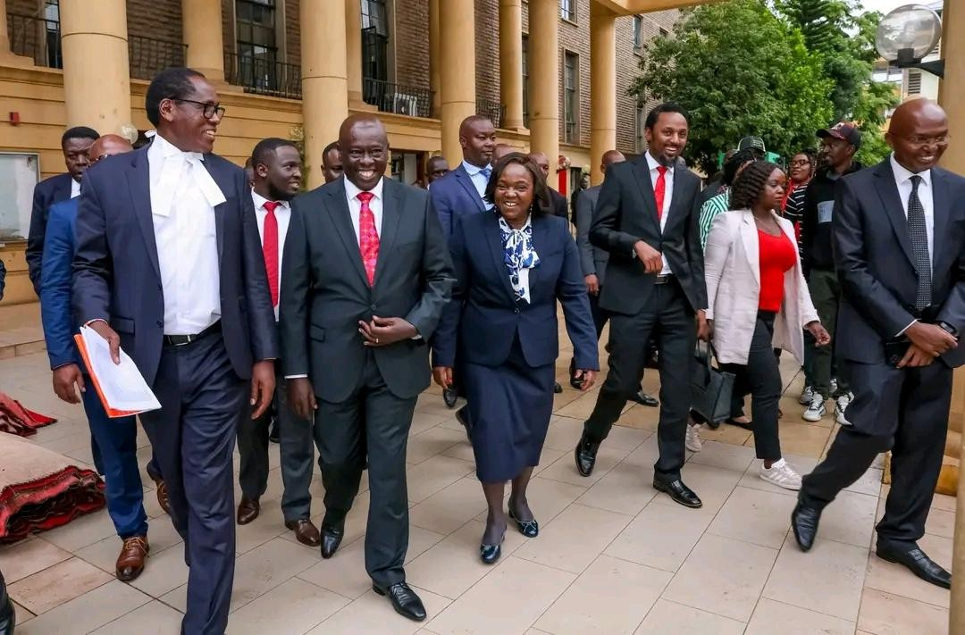

¹⁶² Article 165(3)(d), Constitution of Kenya 2010.
¹⁶³ Goldstein, Abraham S. "The state and the accused: Balance of advantage in criminal procedure." Yale LJ 69 (1959): 1149.
¹⁶⁴ Huq, Aziz Z. "Removal as a political question." Stanford Law Review (2013): 1-76.

The Nature of Impeachment Proceedings
Impeachment is often described in political terms, but in constitutional law it is more accurately understood as a quasi-judicial process. This means it combines elements of both political decision-making and judicial reasoning. It is conducted by a legislative body, yet it deals with allegations that require factual proof, evidentiary assessment and procedural fairness.
¹⁶⁵Unlike ordinary parliamentary votes, impeachment involves serious accusations such as gross misconduct, abuse of office, violation of the Constitution or corruption. These allegations carry significant reputational and legal consequences. As a result, courts increasingly treat impeachment as a process that must comply with minimum standards of fairness similar to those applied in judicial proceedings.¹⁶⁶ However, impeachment is also not a criminal trial. It does not result in imprisonment or criminal conviction. Instead, it results in removal from office and sometimes political disqualification. This dual nature creates uncertainty about the correct standard of proof to apply.¹⁶⁷

Competing Standards of Proof
Three main standards of proof are generally discussed in impeachment-related legal analysis.
The first is the civil standard, commonly referred to as the ‘‘balance of probabilities.” Under this standard, a finding is made if it is more likely than not that the alleged misconduct occurred. This is the lowest standard of proof and is widely used in civil disputes. ¹⁶⁸The second is the criminal standard, known as “beyond a reasonable doubt.” This is the highest standard of proof in law and is applied in criminal cases where liberty and personal freedom are at stake. ¹⁶⁹Some legal arguments suggest that because impeachment involves serious allegations such as corruption and abuse of office, a similar strict standard should apply to protect office holders from wrongful removal.¹⁷⁰ The third is an intermediate or heightened standard, often described as “clear and convincing evidence” or “high degree of
probability.” This standard is stricter than civil proof but lower than criminal proof. ¹⁷¹It is commonly used in cases involving serious allegations that affect reputation, public trust or professional status. In modern constitutional practice, this intermediate standard is often considered the most appropriate for impeachment proceedings because it balances fairness with the need for accountability.¹⁷²

Kenyan Jurisprudence on Standard of Proof
Kenyan courts have not always provided a single fixed standard for impeachment cases, but jurisprudence shows a clear trend toward requiring a higher threshold than ordinary civil

¹⁶⁵ Article 73, Constitution of Kenya 2010
¹⁶⁶ Administrative Law: De Smith's Judicial Review (8th Ed., 2018).
¹⁶⁷ Article 50(1), Constitution of Kenya 2010.
¹⁶⁸ Hamer, David. "The civil standard of proof uncertainty: Probability, belief and justice." Sydney L. Rev. 16 (1994): 506.
¹⁶⁹ Woolmington v DPP [1935] AC 462.
¹⁷⁰ Laurence Tribe, American Constitutional Law (3rd Ed., Foundation Press).
¹⁷¹ Colorado v. New Mexico, 467 U.S. 310 (1984).
¹⁷² "Burden of Proof in Impeachment Trials", Harvard Law Review (2020).

disputes. In cases involving removal of governors and other constitutional office holders, courts have emphasized that the seriousness of allegations requires stronger evidentiary support.
¹⁷³The courts have consistently held that impeachment cannot be reduced to a simple political vote. Instead, it must be based on verifiable facts and procedural fairness. ¹⁷⁴Where allegations involve violations of the Constitution, corruption or abuse of office, courts tend to require a higher degree of certainty before removal is justified.175 However, in parliamentary practice, impeachment has sometimes been conducted more as a political decision than a structured evidentiary process. This creates tension between parliamentary decision-making and judicial expectations of constitutional fairness. ¹⁷⁶In the 2026 dispute, the High Court is being asked to determine whether a Senate vote alone is sufficient to justify removal, or whether Senators must rely on properly tested evidence that meets constitutional standards of proof.¹⁷⁷

The Sui Generis Nature of Impeachment
A significant legal argument is that impeachment is sui generis, meaning it is a unique constitutional process that does not fit neatly into either civil or criminal categories. It is designed as a special mechanism for protecting the state rather than punishing individuals.¹⁷⁸ This approach is reflected in comparative jurisprudence such as Estrada v. Desierto, where impeachment was described as a unique constitutional safeguard rather than a criminal trial or civil dispute. ¹⁷⁹Under this view, impeachment does not require strict adherence to criminal procedural rules. However, this does not mean it is free from legal standards. Even as a sui generis process, it must still comply with constitutional principles such as fairness, reasoned decision-making and respect for due process. ¹⁸⁰The key challenge is therefore not whether standards exist, but what level of proof is constitutionally sufficient given the seriousness of the

¹⁷³ Martin Nyaga Wambora v. County Assembly of Embu [2015] eKLR.
¹⁷⁴ Constitution of Kenya 2010, Article 150(2).
¹⁷⁵ Justice J.B. Ojwang, The Nature of Judicial Power in Kenya.
¹⁷⁶ Morris J. Odhiambo, "The Politics of Impeachment in Kenya", Nairobi Law Journal.
¹⁷⁷ Schweber, Howard, ed. SCOTUS 2025: Major Decisions and Developments of the US Supreme Court. Springer Nature, 2026.
¹⁷⁸ Blum, Gabriella. "The Crime and Punishment of States." Yale J. Int'l L. 38 (2013): 57.
¹⁷⁹ Estrada v. Desierto, G.R. Nos. 146710-15 .
¹⁸⁰ Article 10(2)(a), Constitution of Kenya 2010.


consequences involved.¹⁸¹

The Problem of Political Votes as Evidence
A major concern in recent impeachment practice is the reliance on majority voting as a substitute for evidentiary proof. In some instances, decisions appear to have been influenced more by political alignment than by tested factual evidence. ¹⁸²This raises a serious constitutional issue. A vote reflects preference or opinion, not proof. While democratic decision-making is fundamental in legislative institutions, impeachment requires more than numerical strength. It requires factual justification supported by credible evidence.¹⁸³ If impeachment is treated purely as a political vote, it risks becoming a tool of political elimination rather than a mechanism of accountability. This undermines the rule of law and weakens constitutional protections for public office holders. ¹⁸⁴The High Court is therefore being asked to clarify whether Senate votes can stand alone as justification for removal or whether they must be grounded in properly tested and reliable evidence.¹⁸⁵

Comparative Jurisprudence on Proof Standards
Different jurisdictions apply different approaches to impeachment standards of proof. In the United States, impeachment is largely treated as a political process, and there is no formally fixed evidentiary standard imposed by courts. ¹⁸⁶The process is left largely to legislative discretion. In contrast, jurisdictions such as the Philippines and several Commonwealth legal

¹⁸¹ A.M. Dharamsi, The Sui Generis Nature of Parliamentary Trials.
¹⁸² Brace, Paul R., and Melinda Gann Hall. "The interplay of preferences, case facts, context, and rules in the politics of judicial choice." The Journal of Politics 59.4 (1997): 1206-1231.
¹⁸³ "Evidence vs. Allegation: The Senate as a Fact-Finder", Journal of Legislative Studies.
¹⁸⁴ Friedrich Hayek, The Constitution of Liberty.
¹⁸⁵ Judiciary of Kenya, Bench Bulletin on Constitutional Law (2025).
¹⁸⁶ U.S. Senate, "Manual of Parliamentary Practice".

systems increasingly require structured evidentiary justification and heightened procedural fairness, even where impeachment is conducted by political institutions.¹⁸⁷ In South Korea, the system goes further by requiring judicial confirmation of impeachment decisions before removal becomes final, thereby ensuring that evidentiary and constitutional review occurs before succession takes effect. ¹⁸⁸These comparative models show that there is no single global standard, but rather a spectrum ranging from political discretion to strict judicial oversight.¹⁸⁹

Scholarly Perspectives on Evidentiary Thresholds
Legal scholars remain divided on the appropriate standard of proof in impeachment proceedings. Some argue that requiring criminal-level proof would make it extremely difficult to remove high officials, even in cases of serious misconduct. ¹⁹⁰Others argue that lowering the threshold exposes office holders to political abuse and undermines constitutional stability.¹⁹¹ Constitutional theorists such as Ronald Dworkin have argued that where state action results in severe consequences, such as removal from high public office, the process must be supported by strong evidentiary safeguards. ¹⁹²This ensures fairness and prevents misuse of political power. In Kenya, scholar and Kisumu Senator Prof. Tom Ojienda have argued that allegations of gross misconduct and corruption carry reputational consequences that are similar in effect to criminal accusations. ¹⁹³Therefore, a heightened evidentiary standard is necessary to ensure that impeachment is not based on rumor, political hostility, or untested claims.

Implications for the 2026 Dispute
The determination of the correct standard of proof will significantly influence the outcome of the Deputy Presidency case. If the court adopts a lower standard, it may uphold the Senate’s decision and limit judicial intervention. ¹⁹⁴If it adopts a higher standard, it may find that the impeachment process was constitutionally defective and open the possibility of reinstatement. A strict evidentiary approach would strengthen constitutional accountability but may increase political tension. ¹⁹⁵A more flexible approach would support stability but risk weakening protection against misuse of impeachment powers. The court must therefore carefully balance constitutional integrity with practical governance realities.¹⁹⁶ The standard of proof in impeachment proceedings remains one of the most complex issues in constitutional law.
Impeachment cannot be neatly classified as either criminal or civil. It is best understood as a
sui generis constitutional process that requires a unique evidentiary standard. However, this

¹⁸⁷ Justice Artemio Panganiban, "The Standards of Impeachment", Philippine Daily Inquirer.
¹⁸⁸ Constitution of South Korea, Article 111(1).
¹⁸⁹ "Comparative Standards of Proof: A Global Survey", Oxford Constitutional Law.
¹⁹⁰ Cass Sunstein, Impeachment: A Citizen's Guide.
¹⁹¹ P.L.O. Lumumba, The Judicial Review of Administrative Action in Kenya.
¹⁹² Ronald Dworkin, Taking Rights Seriously (Duckworth, 1977).
¹⁹³ Ogutu, Ken. "A Tale of Four Lawyers: Advocate-Client Confidentiality & the Role of the Legal Profession in Corruption in Kenya." The Platform 58 (2020).
¹⁹⁴ Hansard Report, Senate Debate on Deputy President Impeachment, October 2024.
¹⁹⁵ Marbury v. Madison, 5 U.S. 137 (1803).
¹⁹⁶ S.N. Gicheru, "The Judicial Dilemma in Political Disputes", Kenya Bar Review.

uniqueness does not mean the absence of legal standards. ¹⁹⁷Courts increasingly require heightened proof to ensure that impeachment is not used as a political weapon. The challenge for the Kenyan Judiciary in 2026 is to define a standard that preserves constitutional accountability while protecting public office holders from unjust removal. ¹⁹⁸The resolution of this issue will play a decisive role in shaping the future of impeachment law in Kenya and determining whether impeachment remains a legal safeguard or becomes primarily a political instrument.¹⁹⁹

THE ROLE OF THE SPEAKER AS ARBITER OR AGENT OF THE EXECUTIVE?
In impeachment proceedings, the Speaker occupies one of the most powerful and sensitive positions in the entire constitutional process. Although often perceived as a procedural figure, the Speaker’s decisions can determine whether an impeachment motion proceeds, how it is structured, and whether constitutional safeguards are properly observed. ²⁰⁰In the 2026 Deputy Presidency dispute, the role of the Speaker has become central to the question of whether impeachment was conducted as a neutral constitutional process or as a politically driven exercise.²⁰¹ This raises a deeper constitutional question: does the Speaker act as an impartial guardian of parliamentary procedure, or does the office function as an extension of political interests within the legislature and, indirectly, the Executive? ²⁰²The answer to this question has significant implications for the legitimacy of impeachment outcomes.²⁰³
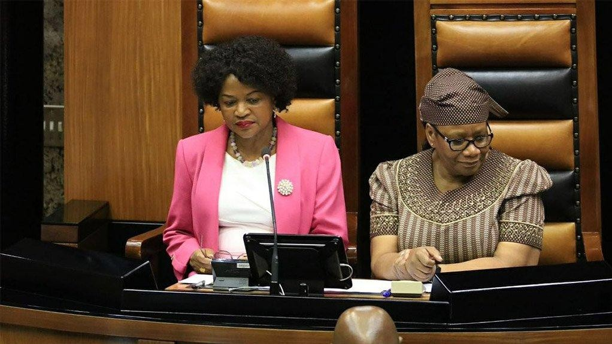

¹⁹⁷ Constitution of Kenya 2010, Article 259.
¹⁹⁸ Banjul Charter on Human and Peoples' Rights, Article 7.
¹⁹⁹ Hon. Anne Waiguru v. County Assembly of Kirinyaga [2020] eKLR.
²⁰⁰ Shaub, Jonathan David. "Congress's Power Of Inquiry In Impeachment." (2026).
²⁰¹ Gerhardt, Michael J. "The Special Constitutional Structure of the Federal Impeachment Process." Law and Contemporary Problems 63.1/2 (2000): 245-256.
²⁰² Article 106, Constitution of Kenya 2010
²⁰³ "The Speaker's Dilemma: Party Man or House Man?", The Jurist Journal.

[ON Left Former Deputy President & Speaker of South Africa Baleka Mbete] The Gatekeeping Function of the Speaker
The Speaker plays a critical “gatekeeping” role at the beginning of impeachment proceedings. Before an impeachment motion is debated or voted on, it must first be admitted and certified as procedurally valid. This includes ensuring that the motion is properly drafted, supported by sufficient particulars, and compliant with constitutional and parliamentary rules.²⁰⁴ In theory, the Speaker is expected to act as a neutral constitutional officer at this stage. This means assessing whether the motion meets minimum legal and procedural requirements, rather than considering its political desirability. ²⁰⁵The Speaker is therefore not merely an administrator but a constitutional filter who ensures that only properly grounded impeachment motions proceed.²⁰⁶ In the 2026 dispute, the Speaker’s role has been questioned on whether sufficient scrutiny was applied before allowing the impeachment motion against the Deputy President to proceed.
Critics argue that if the motion was vague, rushed or lacking in detailed evidence, it should have been rejected at the preliminary stage to protect constitutional fairness. ²⁰⁷In Case of United Democratic Movement v Speaker of the National Assembly (2017), the South African Constitutional Court addressed the duty of neutrality expected from the Speaker of Parliament. The dispute arose when the Speaker of the National Assembly, Baleka Mbete, refused to allow a secret ballot during a motion of no confidence against then-President Jacob Zuma, arguing that she lacked the authority to do so.²⁰⁸ The Constitutional Court ruled that the Speaker did have the power to permit a secret ballot where circumstances required it. The Court emphasized that the Speaker must act impartially and exercise her powers in a way that promotes accountability, fairness and constitutional democracy rather than party loyalty.²⁰⁹ The Court further stated that constitutional mechanisms such as motions of no confidence should not become “a sham” because of political intimidation or partisan pressure. The decision therefore established an important principle that the Speaker must remain a neutral arbiter who safeguards parliamentary integrity and ensures effective accountability of the

²⁰⁴ J.S. Mill, Considerations on Representative Government.
²⁰⁵ Senate Standing Order No. 74(2).
²⁰⁶ "The Gatekeeper of Democracy: The Office of the Speaker", Commonwealth Law Bulletin.
²⁰⁷ Speaker Kenneth Marende's "Solomonic Ruling", Kenya National Assembly Hansard (2009).
²⁰⁸ Constitutional Petition No. E210 of 2026, Petitioner v. Speaker of the Senate.
²⁰⁹ United Democratic Movement v. Speaker of the National Assembly [2017] ZACC 21.

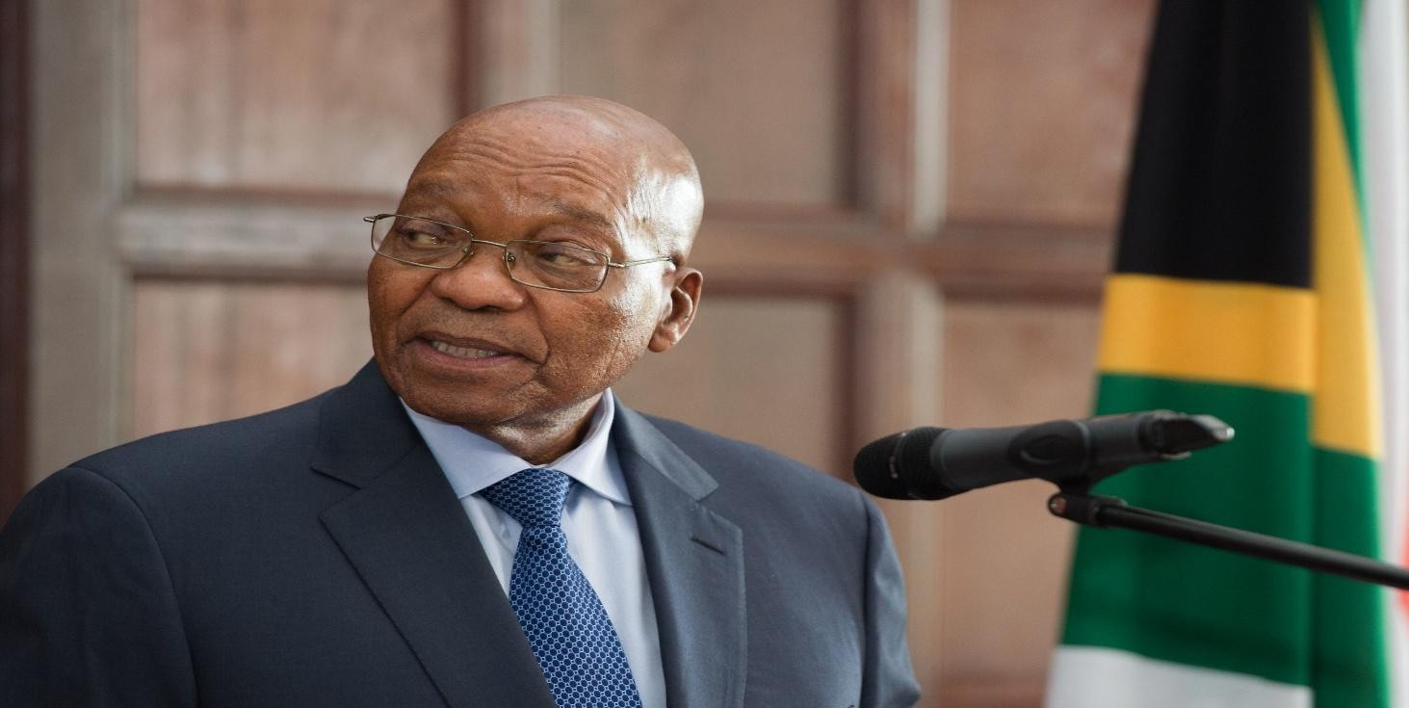
Executive.²¹⁰

[Former South Africa President Jacob Gedleyihlekisa Zuma 2009-2018] The Neutrality Problem
A central challenge in understanding the Speaker’s role is the issue of neutrality. While the Speaker is expected to act impartially, the office is often held by individuals who are politically affiliated or supported by political parties. This creates an inherent tension between political identity and constitutional responsibility. ²¹¹Once Parliament engages in quasi-judicial functions such as impeachment, the Speaker is expected to shift from a political role to a quasi-judicial role. This means acting as a presiding officer over a process that resembles a trial in structure and consequence. In such circumstances, neutrality becomes not only desirable but constitutionally necessary.²¹² However, concerns arise when the Speaker’s decisions appear to align with political interests rather than strict procedural fairness. In such cases, questions may arise as to whether the impeachment process was influenced by bias or political pressure. This can open the door to judicial review of the entire process. ²¹³The neutrality problem therefore lies at the heart of whether impeachment proceedings can be considered fair and constitutionally valid. ²¹⁴ In 2021, Ghana experienced a unique political arrangement where the Speaker of Parliament, Alban Bagbin, belonged to the opposition NDC, while President Nana Akufo-Addo came from the ruling NPP government. This period tested the neutrality and independence of the Speaker’s office.²¹⁵ During the State of the Nation Addresses and parliamentary debates, Bagbin maintained a professional and non-partisan approach by

²¹⁰ South African Constitution, Sections 55, 57 & 102.
²¹¹ Jacobsohn, Gary J. Constitutional identity. Harvard University Press, 2010.
²¹² "Political Impartiality in Parliamentary Presiding Officers", Legislative Studies Quarterly.
²¹³ Lord Campion, An Introduction to the Procedure of the House of Commons.
²¹⁴ Anisminic Ltd v Foreign Compensation Commission [1969] 2 AC 147.
²¹⁵ S.A. de Smith, Judicial Review of Administrative Action.

enforcing order among MPs from both sides. He famously declared that he was “Speaker of the Parliament of Ghana, not a Speaker for the NDC,” emphasizing that his duty was to Parliament and the Constitution rather than to his political party. ²¹⁶His neutrality was especially tested during debates over the controversial E-Levy bill. Although members of his own party opposed the proposal, Bagbin strictly applied parliamentary rules and Standing Orders even when it frustrated the opposition. At the same time, he defended Parliament’s independence by rejecting executive actions he considered unconstitutional.²¹⁷
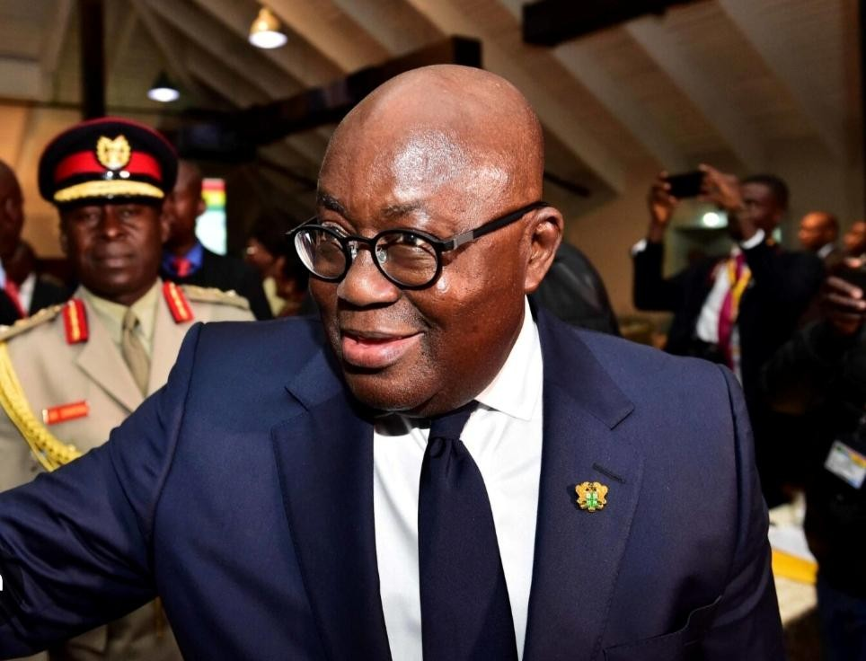

[ 13th President of Ghana Nana Addo Dankwa Akuffo Addo in a Past event in Ghana]
The Ghanaian experience demonstrated that a Speaker must act as a neutral arbiter who protects fairness, parliamentary integrity and constitutional democracy above partisan interests.²¹⁸

Judicial Review of the Speaker’s Decisions
Kenyan courts have consistently affirmed that the Speaker’s authority, although significant, is not absolute. Parliamentary privilege does not shield unconstitutional conduct from judicial scrutiny. ²¹⁹Where the Speaker’s decisions affect constitutional rights or procedural fairness, courts retain the power to review and, if necessary, nullify those decisions. In earlier jurisprudence involving legislative bodies, courts have emphasized that Parliament is not above

²¹⁶ Constitution of the Republic of Ghana 1992, Article 95.
²¹⁷ "The Alban Bagbin Presidency: A Study in Bipartisanship", West African Law Review.
²¹⁸ Parliament of Ghana, Official Report (Hansard), 2021-2022 Sessions.
²¹⁹"Speaker Neutrality in a Hung Parliament: The Ghana Case", Journal of Parliamentary Law.

the Constitution. ²²⁰The Speaker’s rulings must therefore conform to constitutional standards, especially when dealing with matters that affect fundamental rights or removal from office. This principle was reinforced in comparative jurisprudence such as Speaker of the National Assembly v. De Lille, where the court held that parliamentary authority is subordinate to constitutional supremacy. ²²¹The decision confirmed that even internal parliamentary procedures must comply with constitutional requirements. In the Kenyan context, this means that if the Speaker’s handling of an impeachment motion violates principles of fairness, clarity or due process, courts may intervene and invalidate the proceedings.²²²

The Sub-Judice and Institutional Conflict Problem
A recurring issue in the 2026 impeachment proceedings has been the tension between Parliament and the Judiciary regarding ongoing court cases. The sub-judice principle prohibits legislative discussion or action on matters that are actively before a court. ²²³However, Parliament has sometimes continued impeachment proceedings despite pending court orders. This has created a constitutional standoff between judicial authority and parliamentary autonomy. On one hand, courts issue orders to suspend or halt proceedings to preserve constitutional fairness. On the other hand, the Speaker and Parliament often argue that impeachment is a time-bound constitutional process that should not be interfered with by external institutions. ²²⁴This conflict raises serious questions about separation of powers. If Parliament proceeds despite court orders, it risks contempt of court. If courts interfere excessively in parliamentary proceedings, they risk being accused of overreach into legislative functions.²²⁵ The Speaker therefore becomes a central figure in managing this institutional tension, as decisions to proceed or pause impeachment often rest on the interpretation and enforcement of procedural rules.²²⁶

Parliamentary Privilege and Its Limits
Parliamentary privilege is designed to protect legislative independence and allow Parliament to perform its functions without external interference. However, this privilege is not absolute. It cannot be used to justify unconstitutional actions or to shield processes that violate fundamental rights.²²⁷ In the context of impeachment, parliamentary privilege must be balanced against the right to a fair hearing, constitutional supremacy and judicial review. When impeachment affects the rights of an individual holding a high constitutional office, courts have consistently held that procedural fairness becomes essential.²²⁸ This means that the Speaker’s

²²⁰ Article 165(3), Constitution of Kenya 2010.
²²¹ Speaker of the Senate v. Attorney General [2013] eKLR.
²²² De Lille v Speaker of the National Assembly [1998] ZAWCHC 1.
²²³ Cleaver, Craig. "Ruling without reasons: Contempt of court and the sub judice rule." S. African LJ 110 (1993): 530.
²²⁴ Hon. Gladys Boss Shollei v. Judicial Service Commission [2014] eKLR.
²²⁵ McIlwain, Charles Howard. "The High Court of Parliament and Its Supremacy: an historical essay on the boundaries between legislation and adjudication in England." (1910).
²²⁶ Justice G.V. Odunga, "Separation of Powers and the Sub Judice Rule".
²²⁷ Hale, Robert L. "Unconstitutional conditions and constitutional rights." Columbia Law Review 35.3 (1935): 321- 359.
²²⁸ Standing Orders of the National Assembly (Kenya), Order 89.

actions, even when taken within parliamentary proceedings, may still be subject to constitutional scrutiny if they affect fairness or legality. ²²⁹The idea that parliamentary procedure is completely immune from judicial review has increasingly been rejected in modern constitutional practice.²³⁰

Scholarly Perspectives on the Speaker’s Role
Legal scholars have long debated the nature of the Speaker’s role in constitutional democracies. In Westminster-style systems, the Speaker is traditionally expected to act as a neutral arbiter, detached from party politics. ²³¹In practice, however, this neutrality is often difficult to maintain in politically charged environments. In Kenya, scholars and Lawyers such as Prof Githu Muigai have observed that the Speaker’s role exists at the intersection of law and politics.
²³²While formally required to act impartially, the Speaker often operates within a politically active environment, making complete neutrality difficult to achieve.²³³ Other scholars argue that the credibility of impeachment proceedings depends heavily on the perceived neutrality of the Speaker. If the Speaker is seen as aligned with political interests, the legitimacy of the entire impeachment process may be questioned. This perception-based legitimacy is important because impeachment is not only a legal process but also a public confidence mechanism. If the public perceives bias, even legally valid proceedings may lose legitimacy.²³⁴

The Agent Versus Arbiter Debate
A major constitutional debate centers on whether the Speaker acts as an independent arbiter or as an agent of political forces within Parliament. If the Speaker is an arbiter, then the role requires strict neutrality, procedural fairness and protection of constitutional rights. If the Speaker is an agent of political authority, then impeachment risks becoming an extension of political competition rather than a legal accountability process. ²³⁵In the 2026 crisis, this distinction is particularly important. If the Speaker is viewed as a neutral constitutional officer, then impeachment proceedings are more likely to be seen as legitimate. If the Speaker is viewed

²²⁹ Chaffetz v. United States, 345 F.2d 12 (1965).
²³⁰ Constitution of Kenya 2010, Article 25.
²³¹ Erskine May, Parliamentary Practice (25th Edition).
²³²Prof. Githu Muigai, The Power of the Speaker in Kenyan History.
²³³ "Partisanship and the Kenyan Speaker", African Journal of Legal Studies.
²³⁴ Tom Tyler, Why People Obey the Law (Princeton University Press).
²³⁵ V.O. Key Jr., Politics, Parties, and Pressure Groups.

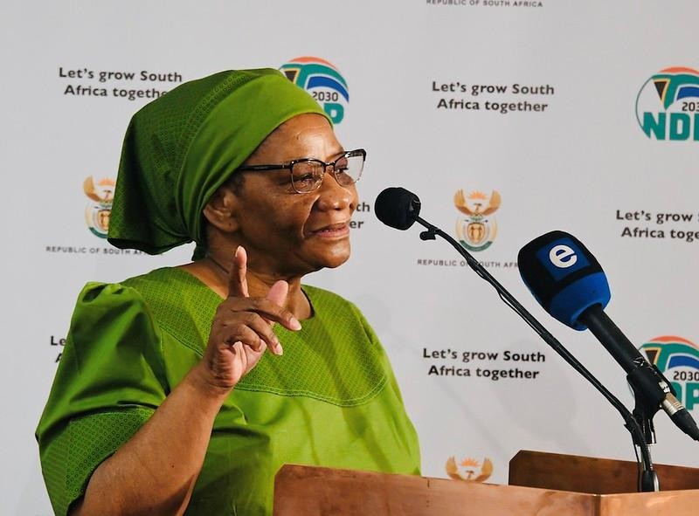
as politically influenced, then the entire process may be vulnerable to judicial invalidation.

[Former Speaker of National Assembly South Africa 22 may 2009- 5th Aug 2021, Ms. Thandi Modise]
The agent-versus-arbiter question therefore goes beyond theory. It directly affects the legal sustainability of impeachment outcomes and the credibility of legislative processes in constitutional governance. ²³⁶The role of the Speaker in impeachment proceedings is both powerful and constitutionally sensitive. While the Speaker is expected to manage parliamentary procedure, the office also carries quasi-judicial responsibilities when dealing with removal of high constitutional office holders. Speaker of Parliament Thandi Modise played an important role in restoring professionalism and neutrality in the Parliament of South Africa after years of political tension during the administration of former President Jacob Zuma. During the State of the Nation Addresses (SONA) delivered by President Cyril Ramaphosa, Modise was

²³⁶ "Arbiter or Agent? Theoretical Perspectives on the Speaker", Parliamentary Affairs.

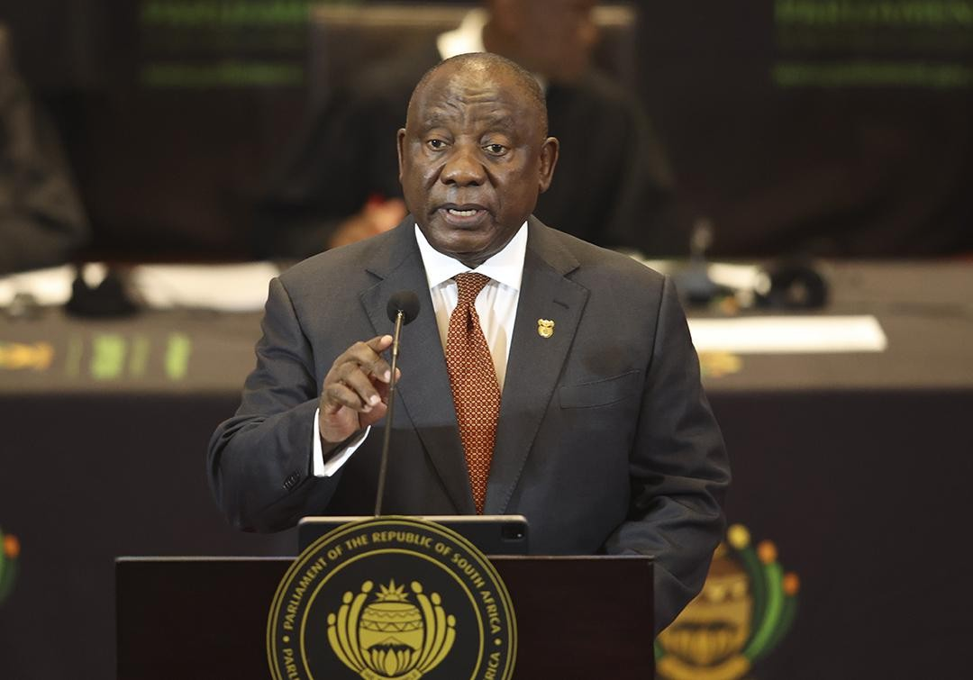
praised for her firm and impartial management of parliamentary proceedings.²³⁷

[South Africa President Cyril Ramaphosa Delivering State of the Nation Address (SONA) at Cape Town City Hall]
She handled disruptions from members of the Economic Freedom Fighters (EFF) and other MPs by applying parliamentary rules equally to both the opposition and ruling party members. Those who breached parliamentary procedures were disciplined regardless of political affiliation. 238Modise maintained the image of the Speaker as a neutral “umpire” by remaining calm, professional and non-partisan while presiding over the House. Her leadership demonstrated that a Speaker strengthens democracy by enforcing rules fairly, protecting parliamentary order and ensuring that debates are conducted with dignity and constitutional integrity.²³⁹ The 2026 Kenyan Deputy Presidency dispute highlights the tension between neutrality and political influence in the Speaker’s role. Courts have made it clear that
parliamentary authority is not absolute and that the Speaker’s decisions remain subject to constitutional scrutiny. Ultimately, the legitimacy of impeachment proceedings depends heavily on whether the Speaker acts as a neutral constitutional gatekeeper or as a politically influenced participant. This distinction is central to determining whether impeachment is a lawful constitutional process or a politically driven exercise disguised in legal form.²⁴⁰

THE RIGHT TO BE HEARD : CROSS-EXAMINATION AND THE EVIDENCE RULES

²³⁷ South African Parliament, "Management of SONA 2020", News Archive.
²³⁸ Rules of the National Assembly (South Africa), Rule 12.
²³⁹ "Restoring Parliamentary Integrity", South African Journal of Public Law (2021).
²⁴⁰ Gerhardt, Michael J. The federal impeachment process: A constitutional and historical analysis. University of Chicago Press, 2019.

The right to be heard is one of the most fundamental principles in constitutional law and natural justice. In impeachment proceedings, this principle becomes even more critical because the consequences are severe, including removal from high constitutional office, loss of political authority and permanent damage to public reputation. ²⁴¹In the 2026 Deputy Presidency dispute, the fairness of the process has largely been tested against whether the affected office holder was given a genuine and meaningful opportunity to defend themselves.²⁴² At the centre of this issue is a simple but powerful question: can an impeachment process be considered fair if the accused is not allowed to fully challenge the evidence presented against them? This question brings into focus issues of cross-examination, disclosure of evidence, and the reliability of the material used to justify removal.²⁴³

Constitutional Basis of the Right to Be Heard
The right to be heard is firmly anchored in Article 50 of the Constitution, which guarantees fair hearing in any process affecting rights or legal interests. In impeachment proceedings, this means that the Deputy President must be given adequate notice of all allegations, sufficient time to prepare a defence and full access to the evidence being relied upon. ²⁴⁴Beyond mere notice, the right to be heard requires that the accused is allowed to respond effectively to every allegation. This includes access to documents, the ability to challenge witnesses and the opportunity to present counter-evidence. ²⁴⁵A hearing that does not meet these requirements cannot be considered fair, regardless of the political nature of the process.²⁴⁶ In constitutional terms, fairness is not optional. It is a mandatory requirement that applies even within parliamentary or quasi-judicial settings such as impeachment proceedings.²⁴⁷

The Role and Importance of Cross-Examination
Cross-examination is one of the most important tools for ensuring truth in any adversarial process. It allows the accused to question witnesses, test credibility, expose inconsistencies and challenge the reliability of evidence presented against them. ²⁴⁸Without cross-examination, allegations remain untested and therefore potentially unreliable. In impeachment proceedings, where allegations often involve serious claims such as corruption, abuse of office or gross misconduct, the absence of cross-examination significantly weakens the integrity of the process. ²⁴⁹Statements that are not subjected to questioning may reflect opinion, assumption or incomplete information rather than verified fact.²⁵⁰

²⁴¹ Ridge v. Baldwin [1964] AC 40.
²⁴² Constitution of Kenya 2010, Article 50(1).
²⁴³ Lord Steyn, "The Weakest Link? Natural Justice in the 21st Century".
²⁴⁴Article 50(2)(j) & (l), Constitution of Kenya 2010.
²⁴⁵ Re Pollen Estate [1982] 1 NZLR 731.
²⁴⁶ Peter Leyland, The Constitution of the United Kingdom: A Contextual Analysis.
²⁴⁷ McWhinney, Edward. "Supreme courts and judicial law-making: constitutional tribunals and constitutional review." (1986): 1-324.
²⁴⁸ Wigmore on Evidence, Vol. 5, § 1367 ("The greatest legal engine ever invented for the discovery of truth").
²⁴⁹ "Cross-Examination in Parliamentary Committees", Oxford Journal of Legal Studies.
²⁵⁰ H.L.A. Hart, The Concept of Law (Oxford University Press).

In the 2026 proceedings, concerns have been raised that some evidence was considered without adequate opportunity for cross-examination. This raises constitutional questions about whether the process met the minimum standards required for fairness and due process.²⁵¹

Hearsay Evidence and Investigative Reports
Another major concern in impeachment proceedings is the reliance on hearsay evidence and investigative reports. Institutions such as anti-corruption agencies and investigative bodies often produce reports that summarize findings based on interviews, documents and secondary sources. While such reports may be useful as background material, they do not automatically qualify as conclusive evidence unless their contents are tested in a proper hearing. ²⁵²The authors of such reports must be available for questioning, and the sources of their information must be verified.²⁵³
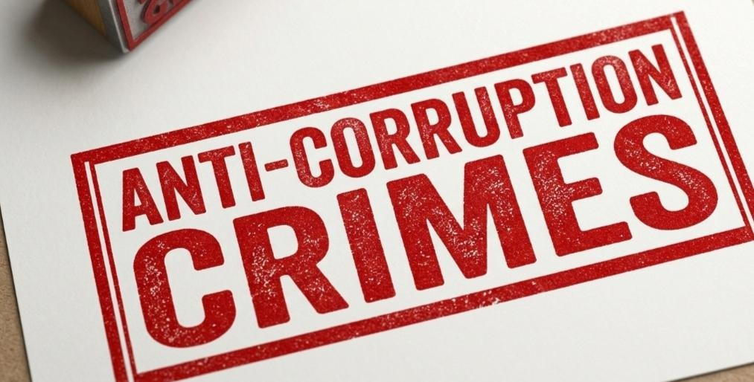
The danger arises when impeachment decisions are based primarily on untested reports. In such cases, the process risks relying on second-hand information that has not been subjected to legal scrutiny. This undermines the reliability of the findings and raises serious constitutional concerns about fairness.²⁵⁴

Challenges of Digital Evidence
Modern impeachment proceedings increasingly involve digital evidence such as emails, WhatsApp messages, audio recordings and social media content. While this type of evidence can be powerful, it also presents serious challenges relating to authenticity, integrity and context. Digital evidence must be properly authenticated to ensure that it has not been altered

²⁵¹Israel, Jerold H. "Free-Standing Due Process and Criminal Procedure: The Supreme Court’s Search for Interpretive Guidelines." Saint Louis University Law Journal 45.2 (2001): 4.
²⁵² Subramaniam v. Public Prosecutor [1956] 1 WLR 965.
²⁵³ Section 63, Evidence Act (Cap 80, Laws of Kenya).
²⁵⁴ "The Dangers of Trial by Investigative Report", Yale Law Journal.

or taken out of context. ²⁵⁵Without proper verification, such evidence can easily be misleading or manipulated. ²⁵⁶This is why evidentiary rules require strict compliance with authentication procedures before electronic materials can be relied upon. In the 2026 context, the use of digital material without full verification has raised concerns about whether the impeachment process met the required evidentiary standards. ²⁵⁷This further reinforces the importance of strict procedural safeguards in quasi-judicial proceedings.²⁵⁸

Jurisprudence on Fair Hearing
The principle of fair hearing has been consistently reinforced in Commonwealth jurisprudence. In the landmark case of Kanda v. Government of Malaya (1962), the court held that a fair hearing requires not only knowledge of the case against a person but also a genuine opportunity to respond to every allegation. ²⁵⁹B. Surinder Singh Kanda was a high- ranking police officer in the Federation of Malaya. Following a commission of inquiry into his conduct, the Commissioner of Police initiated disciplinary proceedings against him, which ultimately led to his dismissal. Kanda challenged the dismissal on the grounds that the proceedings were unconstitutional and violated the principles of natural justice. 260
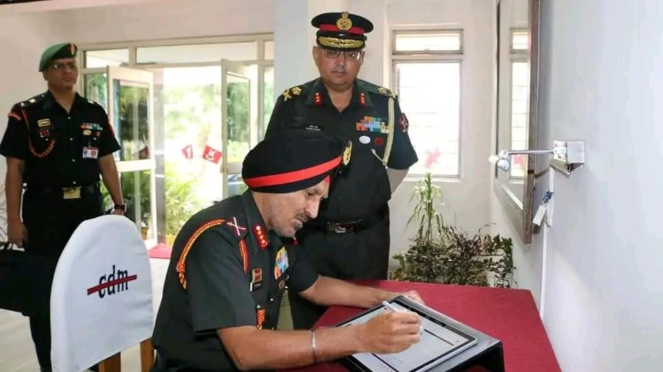

[Lt Gen Surinder Singh Officer of Federation of Malaya]
The Privy Council, with the judgment delivered by Lord Denning, ruled in favor of Kanda. The Court held that the 1957 Constitution was the supreme law of the land. Any existing law

²⁵⁵ Section 106B, Evidence Act (Laws of Kenya).
²⁵⁶ R v. Spiby [1990] 91 Cr App R 186.
²⁵⁷ Judiciary of Kenya, Guidelines on Electronic Evidence.
²⁵⁸ "Digital Forensics in Constitutional Litigation", Journal of Law and Technology.
²⁵⁹ Kanda v. Government of Malaya [1962] AC 322.
²⁶⁰ Federation of Malaya Constitution 1957, Article 135.

or regulation (like the Police Ordinance of 1952) that gave the Commissioner the power to dismiss an officer was void to the extent of its inconsistency with the Constitution, which vested that power in the Police Service Commission. ²⁶¹The most famous part of the holding concerns the "Inquiry Report." Kanda was never shown the report used by the Commissioner to reach a decision. Lord Denning famously held:
"If the right to be heard is to be a real right which is worth anything, it must carry with it a right in the accused man to know the case which is made against him. He must know what evidence has been given and what statements have been made affecting him: and then he must be given a fair opportunity to correct or contradict them."262
Kenyan courts have adopted similar reasoning in impeachment-related disputes. In Wambora v. Speaker of the County Assembly of Embu (2014), the court nullified impeachment proceedings on the basis that the affected governor had not been given adequate time and information to prepare a defence. ²⁶³The court emphasized that fairness cannot be sacrificed for speed or political convenience. Lawyer Tom Macharia accused the Senate during the impeachment proceedings, at Milimani Law Courts, of handling the impeachment with ungodly speed,saying the process was rushed without giving Gachagua adequate time to prepare and defend himself against the charges.²⁶⁴
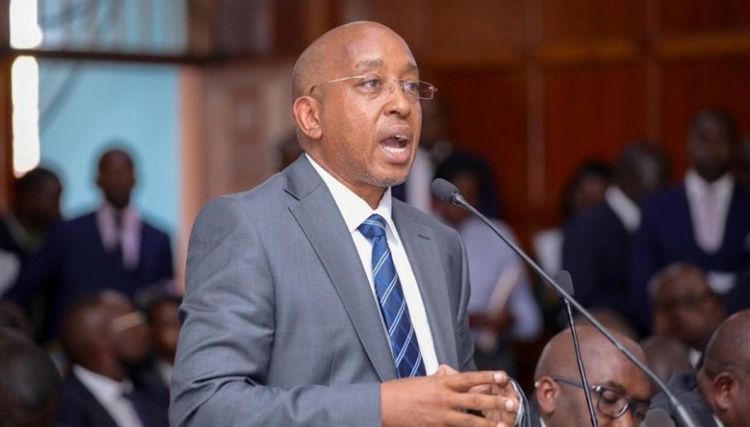

[ Ex Deputy President Rigathi Gachagua Lawyer Tom Macharia making Submission about ongoing Impeachment Case at Milimani Law Courts]

²⁶¹ "Lord Denning's Legacy in Administrative Law", Cambridge Law Journal.
²⁶² Privy Council (UK), Appeal No. 16 of 1961.
²⁶³ Wambora v. Speaker of the County Assembly of Embu [2014] eKLR.
²⁶⁴ Kinyua, Laban Kithinji. "Impeachment or Ouster? Making Sense of Gubernatorial Impeachment in Kenya’s Devolved State." ASC-TUFS Working Papers 5 (2025): 79-101.

This jurisprudence is highly relevant to the 2026 Deputy Presidency dispute, where concerns have been raised about the speed and structure of the impeachment process and whether adequate time and disclosure were provided.²⁶⁵

The Problem of Haste in Impeachment Proceedings
A recurring issue in impeachment practice is the tendency to conduct proceedings under strict and often compressed timelines. While efficiency in governance is important, excessive haste can undermine fairness and compromise the quality of justice. ²⁶⁶When an accused person is given limited time to respond to complex allegations or when large volumes of evidence are introduced without sufficient time for review, the fairness of the entire process becomes questionable. ²⁶⁷Impeachment is not intended to be a rushed political exercise but a structured constitutional process that demands careful consideration of evidence. In the case of Dapianlong v. Dariye, six members of the twenty-four-member Plateau State House of Assembly hurriedly removed Speaker Simon Lalong and installed Michael Dapianlong as Speaker Pro-Tempore. The same group quickly impeached Governor Joshua Dariye through rushed and controversial proceedings.²⁶⁸
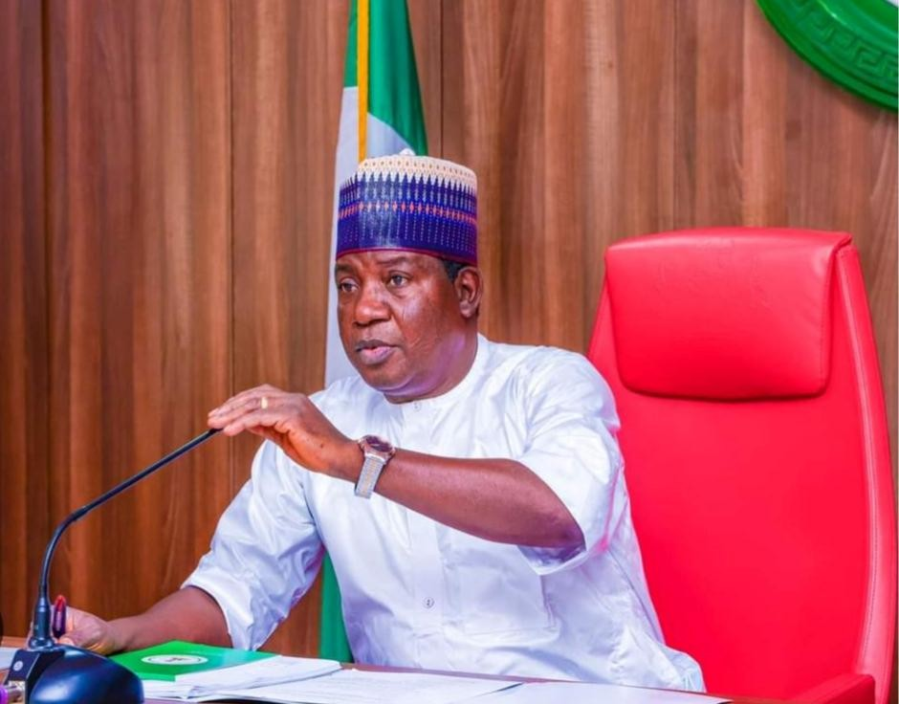

[ Plateau State House of Assembly Speaker Simon Bako Lalong]

²⁶⁵ Gerhardt, Michael J. "How Impeachment Works." Mo. L. REv. 87 (2022): 743.
²⁶⁶ Justice V.C.R.A.C. Crabbe, Legislative Drafting.
²⁶⁷"The Rush to Judgment: Impeachment Timelines", Constitutional Commentary.
²⁶⁸ Dapianlong v. Dariye [2007] 8 NWLR (Pt. 1036) 239.

The Supreme Court held that the impeachment was unconstitutional because Section 188 of the Nigerian Constitution requires a two-thirds majority of all members of the House, not just those present. Since only six members participated, the process was invalid. The Court described the actions as a “constitutional travesty” and reinstated both Governor Dariye and Speaker Simon Lalong. ²⁶⁹Where speed overrides fairness, the legitimacy of the process is weakened, and the likelihood of judicial intervention increases significantly.²⁷⁰


[ On Right Hon Joshua Chibi Dariye Ex- Governor Plateau State in Nigeria] Scholarly Views on Due Process in Impeachment
Legal scholars have consistently emphasized that due process is essential in all constitutional proceedings, including impeachment. The requirement that justice must not only be done but must also be seen to be done remains a guiding principle in constitutional law. ²⁷¹Scholars such as S.C. Ahmednasir Abdullahi have argued that impeachment processes that rely heavily on untested allegations, limited defence time or procedural shortcuts risk transforming a constitutional safeguard into a political weapon. ²⁷²

²⁶⁹ Constitution of the Federal Republic of Nigeria 1999, Section 188.
²⁷⁰ "Constitutional Travesties in Nigeria's Fourth Republic", African Journal of International & Comparative Law.
²⁷¹ R v. Sussex Justices, ex parte McCarthy [1924] 1 KB 256.
²⁷² Ahmednasir Abdullahi, "The Judicial Review of Impeachment: A Kenyan Perspective".

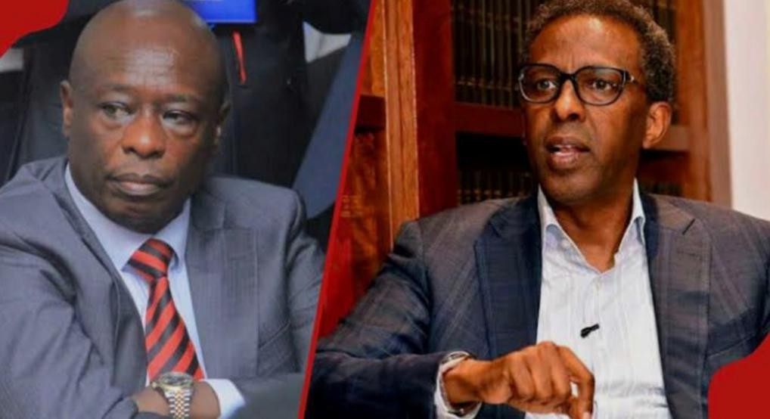
This undermines the legitimacy of constitutional institutions and weakens public confidence in governance. The broader academic consensus is that fairness must remain central even in politically sensitive processes such as impeachment, because the integrity of the constitutional system depends on it.²⁷³
The right to be heard is the foundation of all fair legal and quasi-judicial processes. In impeachment proceedings, it includes adequate notice of allegations, full access to evidence, sufficient time to respond and the opportunity to cross-examine witnesses. Without these safeguards, the process cannot be considered fair in a constitutional sense.²⁷⁴ In her powerful
submission during the hearing of Hon Geoffrey Rigathi Gachagua’s impeachment petition, Kirinyaga Women Rep and Lawyer Hon Njeri Maina anchored her argument on a strong and classical legal principle. She invoked the maxim “Fiat justitia ruat caelum,” meaning “Let
justice be done though the heavens fall.” ²⁷⁵Through this principle, she emphasized that the court must remain firm, independent and committed to justice, even where political pressure or consequences may be severe. Her submission underscored that the rule of law must prevail above all other considerations, and that constitutional fairness should never be

²⁷³ D.J. Galligan, Due Process and Fair Procedures (Clarendon Press).
²⁷⁴ Article 47, Constitution of Kenya 2010.
²⁷⁵ Somerset v. Stewart [1772] 98 ER 499.


compromised regardless of the surrounding circumstances.²⁷⁶

[ Hon Njeri Maina Advocate of High Court & Kirinyaga Women Representative]
The 2026 Deputy Presidency dispute highlights serious concerns about whether these requirements were fully met. If impeachment proceedings are conducted without proper adherence to these principles, they risk losing constitutional legitimacy and becoming instruments of political expediency. ²⁷⁷Ultimately, the strength of any constitutional democracy depends not only on outcomes but on the fairness of the processes used to reach those outcomes.²⁷⁸

THE FUTURE OF THE PRESIDENCY AND PROPOSED REFORMS TO ARTICLES 147–150
The 2026 constitutional crisis surrounding the Deputy Presidency has exposed deep structural weaknesses in Kenya’s framework governing executive succession and impeachment. While the Constitution provides a general outline for removal and replacement of a Deputy President, it does not provide sufficient procedural safeguards to address situations where impeachment, judicial review and immediate succession occur at the same time. ²⁷⁹This gap has produced legal uncertainty and institutional tension, especially where courts are still

²⁷⁶ Allan, Trevor RS. Constitutional justice: a liberal theory of the rule of law. OUP Oxford, 2003.
²⁷⁷ "Political Expediency vs. Rule of Law", International Journal of Constitutional Law.
²⁷⁸ Lon Fuller, The Morality of Law (Yale University Press).
²⁷⁹ Constitution of Kenya 2010, Articles 147-150.

determining the validity of an impeachment while a successor has already been sworn in.²⁸⁰ The “Reinstatement Paradox” demonstrates that constitutional stability and legal correctness can come into direct conflict. As a result, there is increasing scholarly and institutional consensus that Articles 147 to 150 require careful reform to prevent future crises of competing claims to the same office and to strengthen the coherence of executive transitions.²⁸¹

The Problem of the Immunity Gap
One of the most significant weaknesses in the current constitutional structure is the absence of immunity for the Deputy President similar to that granted to the President. ²⁸²While the President enjoys constitutional protection from civil and criminal proceedings during their term in office, the Deputy President does not enjoy equivalent protection. This creates what is commonly described as an “immunity gap.” In practice, it exposes the Deputy President to continuous legal and political litigation that may disrupt the performance of constitutional duties. ²⁸³It also opens the possibility that legal processes may be used strategically to weaken or destabilize the office rather than genuinely enforce accountability.²⁸⁴ The concern is not that accountability should be limited but rather that it must be structured in a way that prevents abuse. Without a degree of procedural protection, the Deputy Presidency becomes vulnerable to excessive litigation that can interfere with executive stability and national governance.285

The Need for a Stay of Succession Mechanism
Another critical reform proposal is the introduction of a mandatory delay between impeachment and succession. Under the current constitutional arrangement, once the Senate removes a Deputy President, a successor can be sworn in almost immediately, even where court proceedings challenging the impeachment are ongoing. ²⁸⁶This creates a situation where judicial review may become ineffective in practice because the constitutional office is already occupied by a successor before courts conclude their determination. ²⁸⁷This is one of the central causes of the dual-office conflict witnessed in 2026.²⁸⁸ To address this, reform proposals suggest introducing a mandatory “stay of succession” period, commonly proposed as 30 days. During this period, the office would remain legally in transition, and no successor would be sworn in until courts have had an opportunity to determine whether the impeachment process was constitutionally valid. ²⁸⁹Such a reform would strengthen judicial authority, preserve the

²⁸⁰ "Succession Chaos in the Executive", East African Law Review.
²⁸¹Katiba Institute, "Proposed Constitutional Amendments to Executive Succession".
²⁸² Article 143, Constitution of Kenya 2010.
²⁸³ "The Immunity Gap: Protecting the Deputy President", Kenya Bar Review.
²⁸⁴ U.S. Constitution, Article I, Section 3.
²⁸⁵ Alexander Hamilton, The Federalist Papers, No. 65.
²⁸⁶ Article 149, Constitution of Kenya 2010.
²⁸⁷ "The Irreversibility of Swearing-In", Journal of Judicial Review.
²⁸⁸ Cavataro, Benjamin L. "The Two-Hat Problem." Columbia Law Review (forthcoming) (2026).
²⁸⁹ Judicial Service Commission of Kenya, Strategic Reform Agenda 2026.

effectiveness of court orders, and reduce the risk of irreversible constitutional outcomes based on disputed or defective proceedings.²⁹⁰

Clarifying the Meaning of Gross Misconduct
A persistent challenge in impeachment law is the lack of a precise legal definition of “gross misconduct.” The Constitution uses this term as a basis for removal, but it does not define its exact scope or limits. ²⁹¹This leaves interpretation largely to Parliament and political actors, creating inconsistency and unpredictability. In practice, what is considered gross misconduct in one impeachment case may be treated differently in another, depending on political circumstances. ²⁹²This lack of clarity weakens legal certainty and increases the risk of politically motivated interpretations.²⁹³ Reform proposals therefore recommend the introduction of a statutory definition of gross misconduct. This definition could include clearly identifiable categories such as criminal conviction, proven abuse of office, persistent violation of constitutional duties or conduct that seriously undermines public trust in constitutional institutions. ²⁹⁴A clear definition would ensure that impeachment is guided by objective legal standards rather than shifting political interpretations, thereby strengthening fairness and predictability.²⁹⁵

Judicial Confirmation of Impeachment Decisions
One of the most significant proposed reforms is the introduction of a judicial confirmation stage in the impeachment process. Under this model, Parliament would retain the power to initiate and vote on impeachment, but a constitutional court or designated judicial body would be required to confirm the legality of the process before removal becomes final. ²⁹⁶This model is already reflected in comparative constitutional systems, where courts play an active role in validating legislative removal decisions. It ensures that impeachment is not only a political determination but also a legally verified constitutional process.²⁹⁷ The advantage of judicial confirmation is that it introduces an independent safeguard against abuse of parliamentary power while preserving the role of the legislature in holding executive officials accountable. It also prevents immediate succession disputes by ensuring that removal is legally final only after judicial scrutiny.²⁹⁸

Jurisprudential Support for Constitutional Reform

²⁹⁰ Fletcher, William A. "The discretionary constitution: Institutional remedies and judicial legitimacy." The Yale Law Journal 91.4 (1982): 635-697.
²⁹¹ Articles 145(1)(b) & 150(1)(b), Constitution of Kenya 2010.
²⁹² "Defining Gross Misconduct", Journal of African Law.
²⁹³ Vermeule, Adrian. Judging under uncertainty: an institutional theory of legal interpretation. Harvard University Press, 2006.
²⁹⁴Leadership and Integrity Act (Cap 182, Laws of Kenya).
²⁹⁵ "Legislating the Standards for Removal", Parliamentary Research Digest.
²⁹⁶ Constitution of the Republic of Korea, Article 65.
²⁹⁷ "Judicial Review of Impeachment Decisions: A Comparative Study", I.CON.
²⁹⁸ Montesquieu, The Spirit of Laws.

Kenyan constitutional jurisprudence increasingly recognizes the Constitution as a living document that must evolve in response to emerging governance challenges. ²⁹⁹Courts have consistently emphasized that constitutional interpretation must promote stability, accountability and institutional coherence. In the context of impeachment and executive succession, the 2026 crisis demonstrates that procedural gaps can lead to institutional conflict between Parliament and the Judiciary. ³⁰⁰This reinforces the need for structural reform that clearly defines roles, timelines and legal thresholds in impeachment processes.³⁰¹ The judiciary has also consistently affirmed that constitutional processes must not only be lawful in form but also fair in substance. This principle supports reforms aimed at strengthening procedural safeguards in impeachment and succession procedures.³⁰²

Global Trends in Executive Removal Systems
Comparative constitutional practice shows a growing global trend toward more structured and legally regulated impeachment systems. In many jurisdictions, impeachment is no longer treated as a purely political vote but as a hybrid legal process requiring judicial oversight or strict procedural safeguards. ³⁰³Some systems require constitutional courts to confirm impeachment decisions before they take effect, while others impose strict evidentiary and procedural requirements at the legislative stage. ³⁰⁴These developments reflect a broader recognition that executive removal must balance political accountability with legal certainty.³⁰⁵ Kenya’s 2026 experience places it within this global trend, highlighting the need to modernize its constitutional framework to prevent ambiguity, reduce institutional conflict, and enhance predictability in executive transitions.³⁰⁶

Balancing Accountability, Stability and Constitutional Supremacy
Any meaningful reform to Articles 147–150 must carefully balance three competing constitutional values: accountability, stability and constitutional supremacy. ³⁰⁷Accountability ensures that public officials can be removed for misconduct. Stability ensures continuity in governance and prevents executive paralysis. Constitutional supremacy ensures that all actions comply with legal and procedural standards. ³⁰⁸The challenge is ensuring that no single value dominates at the expense of the others. Overemphasis on stability may shield unconstitutional removals, while overemphasis on strict legality may create governance paralysis. ³⁰⁹A balanced framework is therefore necessary to preserve both democratic accountability and institutional

²⁹⁹ "Safeguarding the Deputy Presidency", Harvard Law Review.
³⁰⁰ Hunter et al. v. Southam Inc. [1984] 2 S.C.R. 145.
³⁰¹ "Institutional Friction in the 2026 Crisis", African Journal of Legal Studies.
³⁰² Judiciary of Kenya, State of the Judiciary and the Administration of Justice Report 2025/2026.
³⁰³ Broughton, J. Richard. "Conviction, Nullification, and the Limits of Impeachment as Politics." Case W. Res. L. Rev. 68 (2017): 275.
³⁰⁴ "The Judicialization of Politics: Impeachment Systems", Journal of Democracy.
³⁰⁵ Constitution of Brazil, Articles 51, 52 & 86.
³⁰⁶ "Global Trends in Executive Accountability", Stanford Law Review.
³⁰⁷ African Union, African Charter on Democracy, Elections and Governance.
³⁰⁸ Andreescu, Marius, and Claudia Andreescu. "Supremacy of the Constitution theoretical and Practical Considerations." Lex et Scientia 25.2 (2018): 116.
³⁰⁹ A.V. Dicey, Introduction to the Study of the Law of the Constitution.

continuity. Reforms must therefore aim not to weaken impeachment, but to structure it in a way that is fair, predictable and legally robust.³¹⁰ The 2026 Deputy Presidency crisis has revealed
significant structural gaps in Kenya’s constitutional framework governing impeachment and executive succession. These gaps have resulted in legal uncertainty, institutional tension and competing claims to constitutional office. ³¹¹Proposed reforms such as introducing a stay of succession period, defining gross misconduct more precisely, strengthening judicial confirmation mechanisms and addressing the immunity gap represent important steps toward constitutional stability. ³¹²These reforms aim to ensure that impeachment remains a lawful accountability mechanism rather than a source of political instability.³¹³

Ultimately, the future of Kenya’s Presidency and Deputy Presidency depends on whether the constitutional system evolves to address these challenges. The “Reinstatement Paradox” serves as a critical lesson that constitutional clarity is essential for both justice and stability in a modern constitutional democracy.³¹⁴

Authors : Omwansa Kemosi
Co -Author: Omwansa Onduko
Institution: Law Students at Kabarak University School of Law

³¹⁰ "Legality vs Stability", Journal of Constitutional Theory.
³¹¹ Landau, David. "Political institutions and judicial role in comparative constitutional law." Harv. Int'l LJ 51 (2010): 319.
³¹² "Gaps in the 2010 Constitution: Lessons from 2026", Kenya Law Review.
³¹³ Resende, Ranieri L. "Impeachment: A mechanism between political accountability and legal responsibility? Common law sources and the Brazilian originalist model." Global Journal of Comparative Law 11.2 (2022): 222- 253.
³¹⁴ Munyao, Andrea. "An Inquiry into the Limits of judicial Intervention in the Impeachment Process of Governors in Kenya." Strathmore L. Rev. 5 (2020): 139.

