Documentation of Ethnomedicinal Flora of Pilibhit Tiger Reserve, Uttar Pradesh, India

Rajesh Kumar Sonkar, Atul Kumar Anand, Shubham Kumar and Alka Kumari*
Department of Botany, University of Lucknow, Lucknow-226007, India
*Corresponding author: kumarialkasanjay@gmail.com

ABSTRACT
An ethnomedicinal survey was conducted in Pilibhit Tiger Reserve (PTR) located in the Pilibhit and Shahjahanpur districts of Uttar Pradesh. The present study aimed to document medicinal plant species used by indigenous people for the treatment of various ailments, with particular emphasis on common and chronic diseases. Ethnomedicinal information was collected through structured questionnaires, personal interviews and field interaction with traditional healers and local inhabitants. The survey documented a total of 52 medicinal plant species belonging to 49 genera and 31 families used to treat a wide range of health conditions, including abdominal disorders, skin diseases, malaria, jaundice and other ailments. The results highlight the urgent need for systematic documentation of indigenous ethnobotanical knowledge before it is lost and emphasise the importance of conservation strategies for medicinal plant resources in the region.

Keywords: Ethnobotany, Medicinal plants, Ethnic people, PTR

INTRODUCTION
Since ancient times, traditional societies have depended heavily on plants for their food, shelter, fibre and medicines, with plant-based remedies have been orally passed down through generations [1]. It has been mentioned in Vedas as well as in ancient Charak and Shushrut samhitas and other classical texts. Conventional herbal systems are still widely used as one of the major sources of primary health care, especially in developing countries like India, where plant-based system has been long standing as a part and parcel of indigenous medical practice [2]. In India, the use of plants as treatment of healthcare is deeply rooted since ancient traditions. Even today, plant-based medicines form a vital component of primary healthcare systems, particularly in rural and tribal regions where access to modern medical facilities remains limited. It is estimated that more than 8,000 plant species are utilised for medicinal purposes in India, reflecting the country’s rich ethnomedicinal heritage [3]. Therefore, documentation of ethnobotanical knowledge plays a vital role in understanding the interactions between indigenous communities and plant resources, thereby linking traditional knowledge with scientific research.
Pilibhit Tiger Reserve (PTR) is situated in the Pilibhit and Shahjahanpur, as well as some parts of the Lakhimpur Kheri district of the Himalayan tarai zone of Uttar Pradesh (latitudes 28°8'-28°50'N and longitudes 79°53'02" 81°18'03" E) [4, 5]. PTR represents a biologically rich and culturally diverse landscape. The reserve is part of the Sharda River irrigation system's catchment area and contributes significantly to the preservation of the local water balance and climate stability, both of which are necessary for agriculture and related pursuits [6]. The area has extensive forest flora and receives a lot of monsoonal rainfall. Additionally, PTR is home to a sizable tribal population, mostly Tharu and Bengali groups, who live in and surrounding wooded regions and rely heavily on forest resources for their cultural customs, healthcare, and means of subsistence. Various ailments and diseases are common in the Terai region, and access to contemporary medical services is still restricted in isolated tribal communities [3].
In context of the above, the current study was conducted to record and examine the ethnomedicinal plant resources utilized by the local indigenous people and tribal populations of PTR, with a focus on their therapeutic uses, traditional knowledge systems, and connection to traditional medical literature. This kind of recording is crucial for maintaining traditional knowledge, encouraging the preservation of the variety of medicinal plants, and laying the groundwork for further pharmacological research. Such kind of studies provides an insight to select some potential medicinal plants useful for pharmaceutical purposes.

MATERIALS AND METHODS
Selection and Description of sites:
The present study site is Pilibhit Tiger Reserve (PTR) situated in the foothills of Himalayas [6].

Plant Collection:
An extensive field survey of Pilibhit Tiger Reserve was conducted thrice in a year covering all the three seasons. During the period of March 2024 to December 2025 to study and document the medicinal plants in this area. Climatic data were collected from metrological department of U.P. government.
During exploration, herbarium voucher specimens of each species were collected. Habitat and morphological characters of each species was noted in field note book for identification and documentation of the collected specimens along with altitudinal distribution by GPS handsets. All collected specimens were identified by the key of species available in literature of upper Gangetic floras [7] and processed for herbarium following standard herbarium techniques [8] for future reference material.

Collection of Ethnomedicinal Data:

Regular field visits were undertaken throughout the study area to survey the habitats of local communities and collect plant specimens along with relevant information pertaining to their medicinal uses. Ethnomedicinal data were collected following the methodology of Jain [9] through general conversations/questionnaire with the informants. Interviews and discussions were carried out in the local dialect to facilitate effective and clear communication with participants. Local residents, elders, women, children, and traditional healers were contacted about the usage of medicinal plants, including 33 traditional healers comprising 24 men and 9 women, who provided comprehensive knowledge on herbal preparations (Figure 2). Plant specimens were collected and processed for herbarium preparation and subsequent studies. The collected plant specimens were identified using standard taxonomic literature and published flora and preserved according to standard herbarium techniques.

RESULTS
The overall collected data and information have been compiled in tabular (Table 1) and figure form (Figure 1). All the collected plant materials were immediately identified and processed for the preparation of herbarium as future reference materials.

Table 1: Ethnomedicinal information collected during field visit:
S. No. | Family | Plant Name | Common Name | Habit | Plant Part used | Medicinal Uses
1 | Fabaceae | Abrus precatorius | Gomachi | Climber | Root | Dental problem, Malarial fever
1 | Fabaceae | Acacia concinna | Shikakai | Shrub | Leaf, Bark, Fruit | Hair Dandruff
1 | Fabaceae | Butea monosperma | Dhaak | Tree | Root | Infertility
1 | Fabaceae | Clitoria ternatea | Koyal Aprajita | Climber | Root | Hemicrania, Vitiligo
2. | Malvaceae | Abutilon indicum | Kanghi | Shrub | Root | Miscarriage
2. | Malvaceae | Urena lobata | Ban Kapas | Herb | Root | Rheumatism
3. | Amaranthaceae | Achyranthus aspera | Chirchita | Herb | Root | Goitre, Delayed delivery, fever, nausea
3. | Amaranthaceae | Digera muricata | Latmahuria | Herb | Leaves | Constipation, digestive aid
4. | Rutaceae | Aegle marmalos | Bel | Tree | Root | Diarrhoea
5. | Nyctaginaceae | Boerhavia diffusa | Gadahpurna | Climbing herb | Whole plant, leaves | Oedema, Asthma, Jaundice
6. | Annonaceae | Annona squamosa | Sitaphal | Tree | Leaves | Eczema
7. | Meliaceae | Azadirachta indica | Neem | Tree | Leaves | Leprosy, pimples
8. | Lamiaceae | Clerodendrum indicum | Agia | Shrub | Stem, root, leaf | Herpes, cough and dyspnoea
8. | Lamiaceae | Ocimum sanctum | Tulsi | Herb | Leaves | Throat infection, ringworm
8. | Lamiaceae | Ocimum americanum | Kala tulsi | Herb | Leaves | Fever, Bronchitis, Asthma
9. | Asteraceae | Xanthium strumarium | Kutiya | Shrub | Leaves | Fungal infection
9. | Asteraceae | Eclipta prostrata | Bhringraj | Herb | Whole plant | Hair growth, liver disorders
9. | Asteraceae | Sonchus asper | Jangli palak | Herb | Leaves | Liver disorders
9. | Asteraceae | Tridax procumbens | Ghamra | Herb | Leaves | Hair growth, wound
9. | Asteraceae | Ageratum conyzoides | Jangli pudina | Herb | Leaves | Fever, cuts, burn
9. | Asteraceae | Cyanthilium cinereum | Sadodi | Herb | Whole plant | Skin diseases, Ringworm, asthma, Digestive problems, Arthritis
10. | Euphorbiaceae | Euphorbia hirta | Dudhi | Herb | Plant latex | Cuts, wounds, boils
10. | Euphorbiaceae | Ricinus communis | Andauwa | Shrub | leaves | Join pain
11. | Moraceae | Ficus bengalensis | Bargad | Tree | Leaves | Skin burn
11. | Moraceae | Ficus glomerata | Goolar | Tree | Fruit | Wound
12. | Plantaginaceae | Bacopa monnieri | Brahmi | Herb | Whole plant | Leprosy
13. | Solanaceae | Datura stramonium | Dhatura | Herb | Leaves | Skin burn
13. | Solanaceae | Solanum nigrum | Makuiya | Herb | Leaves | Insect bite
14. | Apocynaceae | Rauvolfia serpentina | Sarp booti | Shrub | Roots | Hypertension
14. | Apocynaceae | Calotropis gigantea | Madar | Shrub | Leaves, root, latex | Skin diseases, pain, asthma
15. | Zygophylloceae | Tribulus terrestris | Gokhru | Herb | Leaves | Wound
16. | Verbenaceae | Vitex negundo | Nirgudi | Shrub | leaves | Malarial fever
17. | Poaceae | Phragmites karka | Narkat | Grass | Root | Acid eructation, dysuria, burning micturition, urolithiasis
17. | Poaceae | Cynodon dactylon | Doob | Grass | Whole plant | Wound
17. | Poaceae | Vetiveria zizanioides | Sinka | Grass | Root | Heat stroke, burning micturition
18. | Caesalpinaceae | Carissa carandas | Karonda | Shrub | Stem, root | Eczema, Leprosy,
19. | Cyperaceae | Cyperus rotundus | Motha | Herb | Tuber | Skin Allergy, dysentery, abdominal pain, flatulence
20. | Plumbaginaceae | Plumbago zeylanica | Chita | Herb | Bark, latex, leaf | Vitiligo, Boils, abscess, abortifacient, general debility, colitis
21. | Convolvulaceae | Ipomoea aquatica | Karemua | Herb | Whole plant root, flower, tender branch | General debility, fever, burning micturition
22. | Menispermaceae | Cissampelos pariera | Batalu | Climber | Stem | Skin disease, pimples
22. | Menispermaceae | Tiliacora racemosa | Patha | Climber | Root | Diarrhoea
22. | Menispermaceae | Tinospora cordifolia | Giloy | Climber | Leaves, Root | Malaria and Dengue fever, Diabetes
23. | Rutaceae | Feronia limonia | Kiatha | Tree | Seed | Eczema, scabies
24. | Zingiberaceae | Curcuma longa | Haldi | Herb | Rhizome | Inflammation, wound
25. | Zygophyllaceae | Tribulus terrestris | Gokhru | Herb | Whole plant | Urinary disorders
26. | Aizoaceae | Trianthema portulcastrum | Bisakhapra | Herb | Root, leaves, whole plant | Spermaturia, jaundice, oedema wounds
27. | Boraginaceae | Cordia macleodii | Dahiman | Tree | Bark, leaves | Fever, digestive disorders
27. | Boraginaceae | Cordia dichotoma | Lassora | Tree | Leaves, Bark, seeds, fruits | Migraine, Diarrhoea, dyspepsia, dysentery, urinary problems, gonorrhoea, ringworm
28. | Balsaminaceae | Impatiens balsamina | Gulmehendi | Herb | Leaves, flowers | Nail infections, Burns
29. | Anacardiaceae | Semecarpus anacardium | Bhilwa | Tree | Fruit | Skin diseases, arthritis
30. | Sapotaceae | Madhuca longifoli | Mahua | Tree | Leaves, Flowers, bark | Teeth infection, rheumatism, tonsillitis, ulcers, and muscular pain
31. | Dipterocarpaceae | Tectona grandis | Sagwan | Tree | Roots, bark, leaves | Eczema, bronchitis, and digestive problems

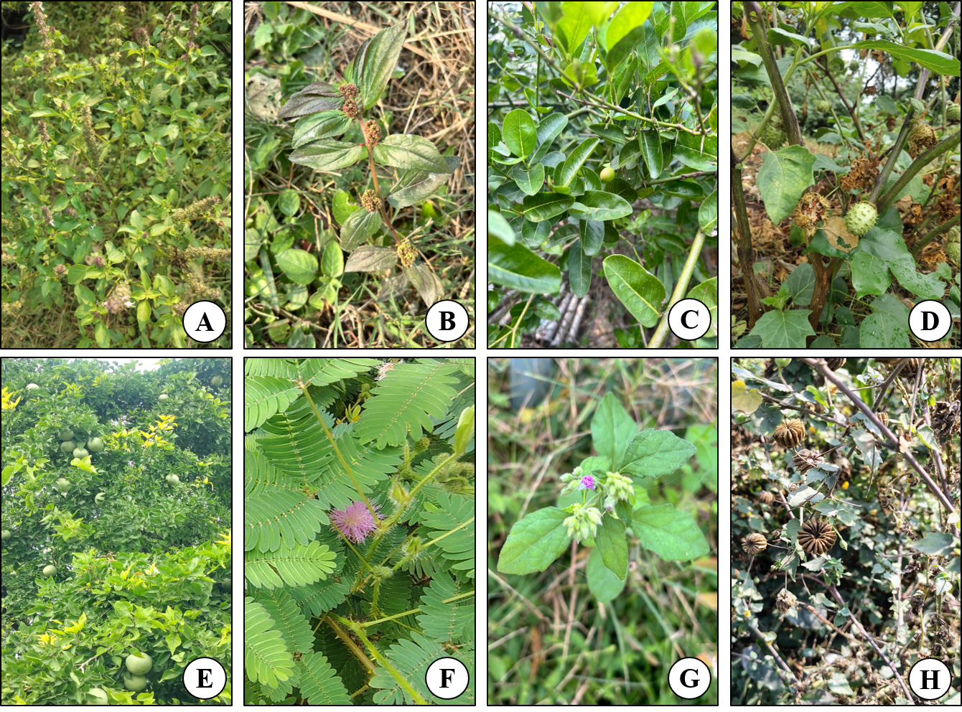
Figure 1. Some ethnomedicinal plants from Pilibhit Tiger Reserve A. Ocimum americanum, B. Euphorbia hirta, C. Carissa carandas, D. Datura stramonium E. Aegle marmalos F. Mimosa pudica G. Cyanthilium cinereum H. Abutilon indicum

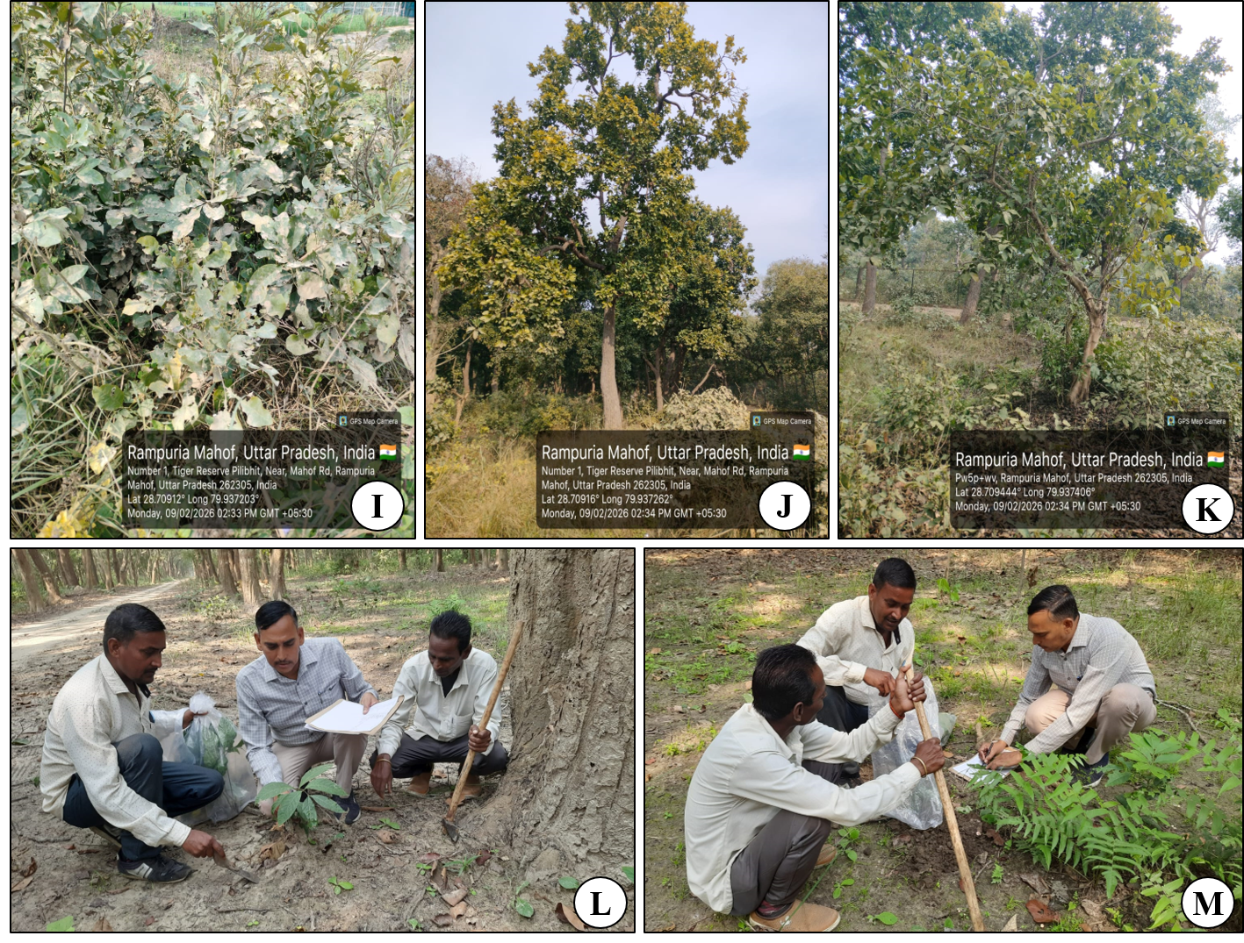
Figure 2. Some dominant plants from Pilibhit Tiger Reserve I. Cordia dichotoma J. Madhuca longifolia K. Tectona grandis L – M. Rajesh Kumar Sonkar with local ethnic people

DISCUSSION
This ethnomedical study highlights the Pilibhit Tiger Reserve's great floristic diversity and long-standing traditional medical practices. A total of 52 medicinal plant species from 31 families and 49 genera have been identified as essential elements of local health traditions, and they are utilized to cure approx. 90 distinct illnesses. The study's extensive therapeutic spectrum is indicative of an advanced indigenous medical system that closely adheres to the therapeutic concepts outlined in traditional medical literature. The methodical and empirical character of the region's traditional herbal therapies is further supported by the use of both single plants and multi-plant combinations to treat particular illnesses. Roots and whole plant were the most commonly used plant parts, followed by leaves and bark, which suggests that herbs are preferred for local treatment. A single species, but several plant parts were also used in some treatments, which indicates the informed knowledge of local practitioners about the plants. Formulation-wise, paste (kalka) was the most frequently prescribed, followed by decoctions, powders, juices, and extracts. This favouritism may be due to the ready supply of fresh plant material and ease in preparation by traditional methods. Herb drugs were both consumed as internal or external applications, though internal consumption is more common. Furthermore, the use of medicinal plants to treat livestock diseases highlights the wider ethnoveterinary importance of these materials.
CONCLUSION
Traditional healers are fundamental to primary health care in the region, particularly in more inaccessible villages where modern medical facilities are not easily accessible, and diseases such as malaria are prevalent. The use of plant-based remedies persists due to their cultural acceptability, perceived safety and local lifestyle coherence. The result underscores the importance of conserving medicinal plant resources and scientific validation of traditionaly utilized antimalarial and other ethnomedicine plants in order to prevent their overexploitation, depletion after harvesting, and help integrate them into the modern health care system.
ACKNOWLEDGEMENT
The authors are thankful to the PCCF officer, range officers and local forest guards for granting permission as well as help and support during field survey of Pilibhit Tiger Reserve. Thanks are also due to local informants, Vaids (medicine mans) and tribal people to share their knowledge about medicinal uses of plants. Authors are also thankful to Head, Botany Department for providing laboratory facilities.
REFERENCES
[1]. Dixit, G., & Vakshasya, S. (2020). Herbal contact therapy practiced by the ethnic people of indo-nepal border of Pilibhit Tiger Reserve (ptr), India. The Journal of Indian Botanical Society, 99(3and4), 177-181.
[2]. Jain, A., Tewari, R. K., Gupta, S. C., & Mishra, H. S. (2025). A Survey of Some Ethnomedicinal Plants in Pilibhit Tiger Reserve of Uttar Pradesh, India. Journal of Ayurveda, 19(3), 272-279.
[3]. Singh, D., & Khare, A. K. (2020). Ethnomedicinal investigation of plants used for the treatment of various skin diseases by local folks in and around Pilibhit Tiger Reserve, Uttar Pradesh, India.
[4]. Wagh, V. V. (2016). Preliminary study on Ethno-medicinal plants used for treating malarial fever in Pilibhit Tiger Reserve, Uttar Pradesh, India. Int J Bioassays, 5(7), 4672-4676.
[5]. Rajesh Kumar Sonkar, Pratibha, Shubham Kumar, Atul Kumar Anand, and Alka Kumari (2025). Floristic Diversity and Threat Status in Pilibhit Tiger Reserve, Uttar Pradesh. Environmental Reports; an International Journal. https://doi.org/10.51470/ER.2025.7.1.129
[6]. Dixit, G. (2025). Medicinal Plants of Pilibhit Tiger Reserve (PTR) India. Bentham Science Publishers.
[7]. Duthie, J. F. (1903). Flora of the upper Gangetic plain, and of the adjacent Siwalik and sub-Himalayan tracts (Vol. 1). Superintendent of Government Printing.
[8]. Jain, S. K., & Rao, R. R. (1977). A handbook of field and herbarium methods.
[9]. Jain, S. K. (1981). A dictionary of Indian Folk Medicine.

