Design of an IoT-Based Automated Fuel Theft Prevention System for Two-Wheelers
Indirani S¹, M.Vasanthakumar¹, C.Bharanitharan¹, S.Dhamothiran¹
Department of Electronics and Instrumentation Engineering,
SRM Institute of Science and Technology, Kattankulathur, Chennai, INDIA

ABSTRACT
Fuel theft is still a common issue in two-wheelers and small vehicles, especially when they are parked without any monitoring. This paper presents an IoT-based automated fuel theft protection system for early detection and prevention of fuel theft. The proposed system is designed using an ESP32 microcontroller with ultrasonic, float, and flow sensors to monitor the changes in fuel level and flow rates in real-time. A push-button interface is also included to identify the operational status of the vehicle, ensuring that the monitoring process is active only during the parked state to avoid false notifications. When an abrupt change in fuel level beyond a predefined threshold is identified, the system identifies the situation as fuel theft. An alarm signal is generated, and notifications with fuel details are sent to the user via GSM mobile platforms. Furthermore, fuel theft is prevented by automatically shutting down the fuel supply through a relay-controlled solenoid valve. The proposed system provides a cost-effective, efficient, and feasible solution for enhancing fuel security.
Keywords - IoT, Fuel Theft Detection, ESP32, Fuel Level Monitoring, GSM Communication, Solenoid Valve Control

I.INTRODUCTION
Fuel theft has become a rising concern in two-wheelers, especially because of the accessibility of the fuel tanks and the absence of advanced security systems. This problem is more prevalent when two-wheelers are parked in open or public places, causing economic losses and inconvenience to the owners. The conventional fuel security system relies entirely on manual checking, which is inefficient and does not provide real-time information about theft occurrences. With the increasing trend of Internet of Things (IoT) technology, it is now possible to design intelligent monitoring systems for improving security in vehicles. IoT technology allows the combination of sensors, microcontrollers, and wireless communication for real-time monitoring and control. Although various conventional security systems for vehicles are based on locking mechanisms and GPS tracking, fuel theft detection in two-wheelers is still an unaddressed problem. This paper proposes an IoT-based automated fuel theft protection system for two-wheelers. The proposed system employs an ESP32 microcontroller and fuel monitoring sensors for identifying irregular fuel theft during parked modes. The system provides instant notifications and automated fuel management, which is a feasible and economical solution for two-wheeler fuel security.

II.LITERATURE REVIEW
Fuel theft detection and fuel monitoring systems have been widely studied based on embedded systems and wireless communication technologies. Initial efforts explored Global System for Mobile communication (GSM)-based systems integrated with microcontrollers and fuel level sensors to detect abnormal drops in fuel levels and transmit Short Messaging Service alerts to vehicle owners [1]–[4]. Although remote notifications were generated on abnormal fuel drop, no control action was taken to halt further fuel loss.
To enhance the measurements, ultrasonic sensors and digital level sensing techniques were introduced in the fuel monitoring systems [5], [6]. Besides, Global Positioning system integration brought about tanker vehicles’ tracking and route monitoring [6], [7]. While relevant to large-scale fuel transportation, the systems are typically complex and inefficient in catering to compact two-wheelers’ needs.
With advancement in IoT technologies, several researchers proposed cloud-enabled fuel monitoring systems that can transmit data to a mobile app in real time [8]–[11].The architectures facilitate improved accessibility and centralized data logging. However, most of the implementations focus on processes to monitor and analyse the data rather than prevent siphoning in the attended state (i.e., when siphoning is ongoing and the car is parked).
Authentication based mechanisms including One Time Password verification have also been introduced in securing fuel dispensing operations [12], [13]. Although, these approaches regulate controlled access, they escalate hardware complexity and system cost. Further developments embed vehicle security frameworks based on a combination of tracking, intrusion-detection and control systems based on network systems [14]–[16]. Fuel-based theft detection is included as a part of the combined measures, with mere secondary focus on the feature.
Other recent studies also examine Radio Frequency Identification-based authentication, intelligent fuel validation mechanisms [17], [18], and industrial fuel monitoring frameworks using cloud-based detection models [19], [20]. These monitoring systems are mostly advanced approaches of fuels management and leakage monitoring rather than compact operational antitheft solutions.
From the review of existing literatures [1]–[20], it is evident that most systems either individually focus on monitoring, alerting, tracking, or authentication. Very limited research integrates multi-sensor-monitoring, conditional-activation based on the vehicle state, real-time communication, and automatic solenoid-based fuel cut-off, all in a very compact and low-cost approach tailored to two-wheelers. This system is a solution to the stated research gap by integrating a combination of both detection and preventive control mechanisms.
III.PROPOSED SYSTEM

A. System Architecture
The proposed IoT-based automated fuel theft protection system’s architecture is designed to monitor the fuel level, detect the unauthorized fuel withdrawal, and prevent fuel theft in two wheelers. The system is categorized into three main parts: input unit, processing and control unit, and output and alert unit, as depicted in Figure 1.
The input unit comprises fuel level monitoring sensors installed in the fuel tank and fuel line, and a push-button sensor to detect the vehicle ON/OFF status. The processing and control unit revolves around an ESP32 microcontroller, which handles the processing of sensor inputs and cloud service communication. The output and alert unit comprises display, alert, and control devices that alert the user and control fuel flow during fuel theft.
The system uses a 12 V DC adapter to provide power, which is regulated to deliver the required voltage levels to the controller, sensors, and actuators. The system enables both local and remote alerting and control capabilities using GSM and IoT platforms, which is ideal for Realtime fuel theft protection.

B. Block Diagram Description
Figure.1 shows the block diagram of the proposed fuel theft protection system. The fuel level measurement is done using an ultrasonic sensor and a float level sensor placed inside the fuel tank. These sensors continuously measure the fuel level and transmit the data to the ESP32 microcontroller. A flow sensor placed in the fuel line detects any irregular fuel flow, which helps in detecting any unauthorized fuel withdrawal. A push-button module is employed to detect the operational status of the vehicle. If the vehicle is in the ON state, the system is in idle mode to avoid false alarms. However, when the vehicle is in the OFF state, the monitoring phase is activated. The ESP32 microcontroller compares the sensor data with the pre-defined threshold values to detect any irregular fuel level reduction.
The processed data is then shown on an LCD module, which displays the fuel level and system status. When fuel theft occurs, a buzzer module is triggered to give an audio signal. At the same time, warning messages are sent to the user through a GSM module (SMS messages) and through the Blynk cloud server using Wi-Fi connectivity for remote monitoring.
To avoid further fuel theft, a relay-controlled solenoid valve is triggered to interrupt fuel flow in the fuel line. The user can also check the system status and remotely control the solenoid valve using a mobile app.
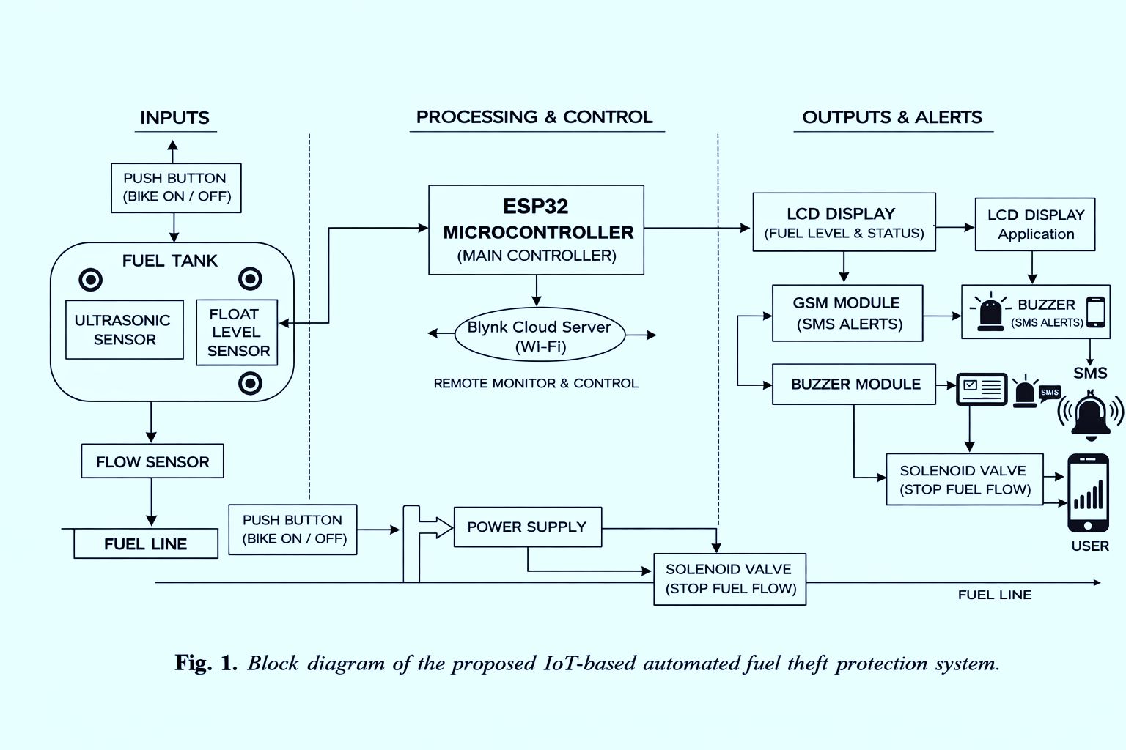
Figure 1: block diagram

IV. METHODOLOGY
The IoT-based automated fuel theft protection system for two-wheelers works in a simple manner: detect, notify, and prevent. The complete process is illustrated in Figure 2.
The process begins with the powering up of the device. The ESP32 is turned on and initializes all the connected devices: the GSM module, the LCD display, the fuel sensors, and all the communication interfaces. After all the devices are turned on, the system checks the push button to see whether the bike is on or off. If the button indicates that the bike is running, the system remains in the disabled mode to prevent false notifications. During this phase, the LCD displays the message, “Bike ON – System OFF.” When the button indicates that the bike is parked, the system enters the monitoring phase.
During the monitoring phase, the ultrasonic sensor and the float-level sensor monitor the fuel level in the tank continuously, and the flow sensor monitors fuel flow in the pipe. The ESP32 module compares all the data with the predefined levels to identify any abnormal fuel level depletion or fuel flow.
If there is no theft, the system displays the current fuel level on the LCD and continues to monitor. If there is theft, the system immediately activates an audible buzzer to notify the user locally. Simultaneously, a notification message is sent to the bike owner through the GSM module and the IoT mobile application (Blynk). To prevent further fuel theft, the system activates a relay-controlled solenoid valve to cut off fuel supply automatically.
After the notification, the system waits for the user’s input through the mobile application and continues to monitor or reset accordingly.
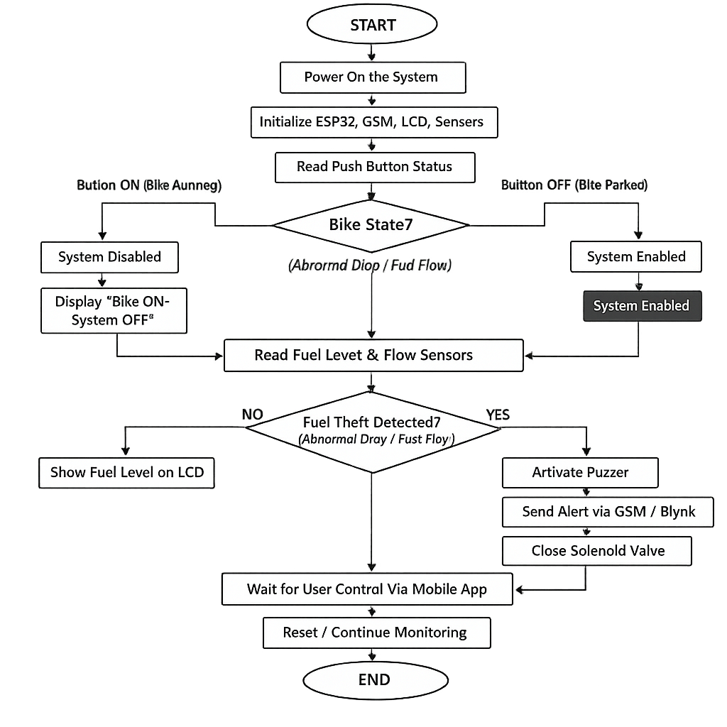
Figure 2: Flow chart

V.RESULTS AND DISCUSSION
The prototype of the IoT-based automated fuel theft protection system was developed as a separate fuel tank prototype, incorporating the entire electronic system, and tested in that environment itself, instead of being tested on a two-wheeler. The purpose of the test rig was to demonstrate that the system functions as expected in a controlled environment. The tests were conducted in both off and on modes using a push-button to simulate the bike being parked versus turned on. When the system was in the off mode, the fuel monitoring system remained inactive without any alerts, thereby demonstrating the absence of false alerts. When the system was in the on mode, the system continuously monitored the fuel level and fuel flow using an ultrasonic sensor, float sensor, and flow sensor.
When functioning normally, the LCD displayed the current fuel level without any alerts. To simulate theft, the system was subjected to planned fuel extraction and simulated fuel flow in the prototype tank. In these cases, the system sensed the anomaly, triggered the buzzer, sent alerts via the GSM network and IoT app, and automatically turned off the relay-controlled solenoid valve. The results show that the detection and response capabilities functioned as expected in the prototype setup.

VI.CONCLUSION
This paper presents an IoT-based, automated shield against fuel theft for motorcycles. By combining multiple fuel theft sensors with an ESP32 microcontroller, the system is able to detect irregular fuel level depletion and fuel theft when the motorcycle is parked. A push-button switch is used to simulate the motorcycle’s operating condition, thus reducing false alarms during normal operation.
The researchers developed a test bed using a different fuel tank mock-up that included the entire electronic circuit. The tests demonstrated reliable fuel theft detection, rapid notifications through GSM and a mobile IoT app, and successful prevention of fuel theft by actuating a relay-controlled solenoid valve. Although a complete test on a real vehicle was not conducted, the findings from the prototype validate the underlying concept and feasibility of the approach.
In summary, the proposed solution provides a cost-effective, reliable, and scalable solution for fuel theft protection that can easily be applied to real-world two-wheeler operation with minimal modifications.

VII.REFERENCES
- N. S. Lepcha, T. S. Sherpa, and J. S. Tamang, “GSM based fuel theft detector using microcontroller,” Int. J. Advance Electrical and Electronics Eng., vol. 4, no. 3, pp. 7–12, 2015.
- M. Saini and S. Khan, “GSM based fuel theft detection,” in Proc. 1st Int. Conf. Power Electronics and Energy (ICPEE), Greater Noida, India, 2021.
- M. Rinait, N. Tarpe, P. Gadewa, G. Barde, A. Mohurle, and S. S. Kamble, “Vehicle fuel monitoring and theft detection system with SMS indication using GSM,” J. VLSI Design and Signal Processing, vol. 3, no. 1, pp. 1–7, 2017.
- A. Madhavan, S. S. J., A. Raj, and S. A., “Detecting fuel theft with Arduino,” in Proc. 2nd Int. Conf. Emerging Trends in Information Technology and Engineering (ICETITE), 2024.
- P. Bhilegaonkar, R. Patil, A. Belekar, M. Gujarathi, and S. Sondkar, “Fuel theft prevention system,” in Proc. 2020 Int. Conf. Industry 4.0 Technology (I4Tech), Pune, India, Feb. 2020, pp. 126–130.
- M. F. Fadjrimiratno, A. Wicaksono, R. C. Prayogo, H. A. Y. Sidabutar, and S. Sumardi, “Automatic oil tank truck alarm system from illegal fuel hoarding with microcontroller and GSM module based system,” in Proc. IEEE Conf., 2015.
- T. M. Bojan, U. R. Kumar, and V. M. Bojan, “Designing vehicle tracking system – An open source approach,” in Proc. IEEE Int. Conf. Vehicular Electronics and Safety (ICVES), 2014, pp. 135–140.
- J. Sun, Z. Zhang, and X. Sun, “The intelligent crude oil anti-theft system based on IoT under different scenarios,” in Proc. Int. Conf. Knowledge Based and Intelligent Information Engineering Systems, 2016, pp. 1581–1588.
- I. M. Ahmed, A. Kumari, S. N. S. Al-Humairi, and A. M. H. Al-Hakimi, “Design and implementation of IoT-based smart fuel monitoring system,” 2023.
- “IoT enabled fuel level monitoring and automatic fuel theft detection system,” 2022.
- S. P., Y. V. Vamsi, S. A. Lakshmanan, and B. Devanathan, “Smart vehicle security system: Real-time tracking and theft prevention with IoT,” in Proc. Innovations in Power and Advanced Computing Technologies (i-PACT), 2025.
- S. Lee, B. Kang, K. Cho, D. Kang, K. Jang, L. Park, and S. Park, “Design and implementation for data protection of energy IoT utilizing OTP in wireless mesh network,” in Proc. 4th Int. Conf. Power and Energy Systems Engineering (CPESE), 2017.
- A. Kumar and R. Singh, “OTP-based fuel dispensing security system,” Int. J. Engineering Research, 2019.
- M. Sharma and K. Patel, “Embedded vehicle security system using GSM and GPS,” Int. J. Smart Systems, 2018.
- R. Verma and S. Tiwari, “ARM-based intelligent vehicle monitoring framework,” IEEE Conf. Proc., 2020.
- P. Joshi and A. Nair, “Integrated GPS-GSM vehicle protection system,” Proc. IEEE Vehicular Tech. Conf., 2019.
- A. F. Raj, R. S. Krishnan, and S. Abarna, “Smart FuelGuard: RFID-based protection against wrong fueling,” 2024.
- S. Kumar and P. Mehta, “RFID-based automated fuel authentication system,” 2023.
- I. M. Ahmed, A. Kumari, and S. N. S. Al-Humairi, “Industrial IoT fuel storage monitoring system,” 2021.
- J. Sun and X. Sun, “Cloud-based crude oil anti-theft detection framework,” 2022.

