A Novel RL-Driven Zone-Based Leader-Aware Energy-Efficient Routing Protocol for Dynamic MANET Environments
Abstract
Mobile Ad Hoc Networks (MANETs) face major routing problems because their network structure keeps changing, their energy levels are minimal, their nodes move between locations, and they lack any central network control systems. The traditional routing protocols Ad hoc On-Demand Distance Vector (AODV) and Ad hoc On-Demand Multipath Distance Vector (AOMDV) face major problems in dynamic environments because they use too much energy, their routes fail too often, and their network control demands become too high. The paper introduces RML-ZEREM to solve existing limitations, which functions as a Reinforcement Learning (RL) based Zone-Based Leader-Aware Energy-Efficient Routing Protocol for MANETs. The proposed approach partitions the network into multiple zones and employs energy-aware leader node selection to manage routing operations efficiently. The system uses Q-learning to create an adaptive routing system that chooses the best routing paths according to current network conditions, including residual energy levels, node movement, traffic intensity, and link reliability. The proposed protocol performance assessment uses the NS-2.35 simulator to test different simulation conditions, which include various simulation durations, node mobility rates, network capacity, and simulation area size. The simulation results show that RML-ZEREM achieves better performance than traditional AODV and AOMDV protocols through its ability to increase throughput while decreasing energy usage, improving packet delivery ratio, and reducing routing overhead. The zone-based hierarchical structure enhances network stability and scalability for MANET systems that operate in dynamic environments. The RML-ZEREM protocol functions as an intelligent routing system that adjusts its operations to achieve energy efficiency through its framework, which serves next-generation MANET applications.
Keywords: Reinforcement Learning, Mobile Ad Hoc Networks (MANETs), Energy-Efficient Routing, Q-Learning, Zone-Based Routing, Leader Node Selection.
1. Introduction
Mobile Ad Hoc Networks (MANETs) operate as decentralized wireless networks without any need for fixed infrastructure because mobile nodes establish connections through multiple transmission hops[1]. The design of MANETs allows each node to act as both a host and a router, which enables users to establish communication links without needing central management. The quick deployment of MANETs and their ability to operate without human guidance make them suitable for various applications, which include disaster recovery operations, military communication systems, emergency response networks, intelligent transportation systems, and Internet of Things (IoT) environments.
MANETs experience multiple difficulties, which include dynamic topology changes, limited battery power, constrained bandwidth, and frequent link failures that occur because of node movements[2]. The existing problems result in higher routing overhead and increased packet loss and longer delays, and greater energy usage, which ultimately decrease both network lifespan and communication dependability. The research community requires adaptive, scalable, energy-efficient routing protocols for MANET environments because this area remains unsolved.
The routing protocols Ad hoc On-Demand Distance Vector (AODV) and Ad hoc On-Demand Multipath Distance Vector (AOMDV) function as standard methods for discovering routes and maintaining connections in MANETs[3]. The protocols deliver sufficient performance in stable network situations, yet they produce excessive control costs when the network operates under highly changing conditions, which leads to increased route discovery work and extra energy needs. The predefined routing methods that these protocols use stop them from making smart decisions needed to adapt to ongoing changes in their network environments.

Reinforcement Learning (RL) serves as an effective solution that enables intelligent adaptive routing for MANET networks through its ability to overcome these system constraints[4]. The network environment provides nodes with continuous training, which enables them to develop optimal routing skills through active learning that takes into account residual energy, mobility, traffic load, and link stability. Q-learning stands out as the most appropriate routing method for MANET networks because it enables routing through its model-free learning method and its ability to make decisions based on changing circumstances. The combination of RL with zone-based routing enables better scalability because it allows routing functions to operate in specific areas while decreasing the overall routing difficulties.

RML-ZEREM presents a new routing protocol that uses Reinforcement Learning to establish energy-efficient zone-based routing through leader nodes for dynamic MANET networks. The proposed protocol combines zone-based network organization with energy-aware leader node selection and Q-learning-based adaptive routing decisions. Intelligent agents known as leader nodes have the capacity to choose the best routing paths that adapt to the existing conditions of the network. The proposed approach aims to reduce energy consumption, improve throughput and packet delivery performance, minimize routing overhead, and enhance scalability in highly dynamic MANET scenarios.

1.1 Challenges in MANET Routing

Routing in MANETs depends on multiple essential elements, which include the following factors[5].
- Energy Constraints: The available battery power restricts network operations, which in turn affects the stability of routing paths.
- High Mobility: The network experiences route failures because of continuous changes in its topology, which results in unstable communication paths.
- Scalability Issues: The routing system becomes more difficult to maintain because the network size increases, which creates additional routing overhead and network congestion problems. The network experiences continuous changes in its topology, which hinders effective route discovery and maintenance processes.
- Limited Bandwidth: The wireless network has restricted bandwidth, which impairs its ability to transmit data reliably and efficiently[6].

1.2 Limitations of Existing Protocols

The current limitations of MANET routing protocols become evident in their operation within dynamic environments[7].
- The AODV protocol experiences excessive control overhead together with constant route rediscovery problems during periods of high mobility.
- The AOMDV protocol enables multipath routing to enhance system reliability, yet this improvement results in greater routing difficulties, together with increased energy usage requirements.
- The protocols depend on fixed routing methods, which make it impossible to handle network condition changes that occur throughout time.

1.3 Motivation of the Study

The current routing protocols face limitations because they cannot achieve the four goals of energy efficiency, scalability, adaptability, and reliable communication in dynamic MANET environments. Traditional methods tend to either concentrate on improving routing performance or focus on saving energy, which results in an incorrect balance between those two objectives. The intelligent hybrid routing system needs to develop that process because it requires route changes, which result in increased network costs and energy usage throughout its operations.

The research aims to create an energy-efficient adaptive routing system through the combination of reinforcement learning and zone-based routing methods. The research will use these combined methods to analyse their effects on MANET throughput, route stability, and network performance.

1.4 Key Contributions

The major contributions of this research are summarized as follows:
- The researchers created a new routing protocol for MANETs, which uses Reinforcement Learning to achieve energy efficiency through Zone-Based Leader-Aware routing.
- The energy-aware leader node selection mechanism enables efficient zone management through its developed system.
- The system uses Q-learning to provide an adaptive routing system that enables intelligent path selection.
- The multi-parameter reward function was created to evaluate four elements, which include energy and delay, packet delivery, and link stability.
- The research team assessed their proposed protocol by testing it against AODV and AOMDV through various simulation scenarios.

1.5 Organization of the Paper

The subsequent sections of this paper will follow this specific organizational structure. The literature review of MANET routing and reinforcement learning-based approaches is presented in Section 2. The proposed RML-ZEREM methodology is described in Section 3. The mathematical modelling and Q-learning formulation appear in Section 4. The simulation setup and performance metrics are discussed in Section 5. The simulation results and performance comparison results appear in Section 6. The paper ends with Section 7, which presents research directions for future studies.

2. Literature Review

The research on Mobile Ad Hoc Network (MANET) routing efficiency has researched various solutions, which include handling dynamic network changes, operational energy restrictions, user movement patterns, and system capacity requirements[8]. The existing routing methods can be divided into five categories, which include traditional routing protocols and energy-efficient techniques, zone-based methods, reinforcement learning-based routing and hybrid intelligent routing approaches[9-13].

2.1 Traditional Routing Protocols in MANETs

The traditional MANET routing protocols consist of three different types, which are proactive, reactive, and hybrid routing methods[2, 14-16]. The protocols Destination-Sequenced Distance Vector (DSDV), Dynamic Source Routing (DSR), and Ad hoc On-Demand Distance Vector (AODV) serve as popular methods for discovering and maintaining routes[17-19]. AODV establishes routes only when needed to decrease routing overhead, but the protocol experiences frequent route failures and high control overhead during mobile operations[7, 19-21].

Ad hoc On-Demand Multipath Distance Vector (AOMDV) enhances routing reliability by maintaining multiple alternative paths between source and destination nodes[22]. The use of multipath routing increases system reliability during failures, but this method creates additional routing challenges and control packet requirements, and higher energy needs. The conventional routing protocols of this system do not possess smart adaptability features, which leads to performance drops when the network experiences rapid changes.

2.2 Energy-Efficient Routing Techniques

The development of energy-efficient routing protocols aims to enhance network lifetime while decreasing energy waste in MANETs[23]. The routing methodologies use Minimum Total Transmission Power Routing (MTPR) and Minimum Battery Cost Routing (MBCR) to determine the optimal route through transmission power and node energy levels. The system boosts energy efficiency by selecting routes that avoid nodes with limited battery capacity while reducing transmission expenses.

The majority of energy-aware routing protocols use unchanging routing metrics, which fail to handle changes in network topology, traffic movement, and user mobility. The performance of these systems declines in actual MANET environments, which experience constant alterations in network conditions.

2.3 Zone-Based Routing Approaches

The zone-based routing protocols create multiple logical regions throughout the network, which helps to enhance scalability while decreasing routing expenses[24, 25]. The Zone Routing Protocol (ZRP) serves as the most popular zone-based solution because it uses proactive routing for zones and reactive routing for inter-zone communication. The structure enables the system to reduce global route discovery expenses while bettering resource usage[26].

Zone-based protocols encounter difficulties that involve creating effective zone structures, choosing leader nodes, and managing inter-zone communication[27]. The existing solutions fail to implement advanced adaptive systems that can react to variations in node movement patterns, energy consumption, and network user density.
2.4 Reinforcement Learning-Based Routing
The solution that uses Reinforcement Learning (RL) for routing purposes provides an effective method to create intelligent routing systems, which can adapt to changes in Mobile Ad Hoc Networks (MANETs)[28]. The network environment allows RL to provide nodes with the possibility to discover the best available routing methods. Q-learning serves as the most commonly used RL method because it enables learning without models and permits dynamic selection of decisions by users.
The RL routing protocols use four different parameters, which include delay, residual energy, link stability, and packet delivery ratio, to achieve their best routing results. The solutions enable systems to adapt their routing methods more effectively when network conditions experience changes. The RL-based methods encounter multiple obstacles because they take extended periods to reach their goals while requiring more processing power and making it hard to create working reward systems. The current RL methods of operation fail to connect the network framework with its capacity expansion functions.
2.5 Hybrid Approaches (Zone-Based + RL + Energy Optimization)
Recent research has focused on hybrid routing approaches that combine zone-based routing, reinforcement learning, and energy-aware mechanisms to improve overall MANET performance[25, 29, 30]. The methods use leader and cluster nodes as intelligent agents who perform routine tasks together with other decision-making responsibilities. The combination of learning-based routing and hierarchical network structure results in improved scalability, throughput and energy efficiency for hybrid systems.

The current hybrid approaches face several challenges because they need better methods for selecting leader nodes, which groups use to identify network leaders, and they need more effective methods for adjusting reward functions, and they encounter higher computational demands and their ability to function in fast-changing network environments remains restricted. The system needs additional enhancements to reach its goals of achieving energy-efficient operation, which can expand to larger systems while maintaining dependable routing performance.

2.6 Research Gaps Identified

The literature review discovered these research gaps, which need to be studied further:
- Adaptive energy-aware routing systems need development that can operate effectively in dynamic MANET environments.
- The current integration methods between reinforcement learning and scalable network structures show major performance issues.
- The current methods for selecting leader nodes lead to routing problems because they reduce energy efficiency.
- The design of reward functions needs improvement to create a system that optimally balances routing performance.
- Current intelligent routing systems face high routing costs together with operational difficulties.

The RML-ZEREM protocol integrates reinforcement learning with zone-based routing and energy-aware leader selection to create a routing system that adapts to changes while maintaining energy efficiency and network expansion in dynamic MANET environments.

3. Proposed Methodology:
RML-ZEREM Protocol This section introduces the RML-ZEREM protocol, which uses reinforcement learning to create a zone-based energy-efficient routing system for Mobile Ad Hoc Networks. The proposed framework uses zone-based hierarchical routing and reinforcement learning to create an energy-efficient communication system that adapts to changing network conditions in highly active environments. The protocol uses intelligent routing decisions together with energy-aware network organization to solve the problems found in traditional MANET routing methods.
3.1 Overview of the Proposed Framework
The proposed RML-ZEREM framework divides the network into several logical zones which each contain a leader node that operates as a reinforcement learning agent. The routing process uses Q-learning-based adaptive decision-making to allow the protocol to choose optimal routing paths that match the present network conditions. The proposed protocol shows its complete workflow through its three main operational stages, which include network initialization and zone formation, energy-aware leader node selection and Q-learning-based route discovery and data forwarding, and continuous learning and route adaptation. The proposed framework requires leader nodes to conduct ongoing surveillance of network parameters, which include residual energy, node mobility, traffic load, and link quality. The Q-learning mechanism selects next-hop nodes for packet forwarding based on their current status, which includes network parameters. A multi-parameter reward function evaluates routing performance using metrics such as energy consumption, delay, packet delivery ratio, and link stability. The routing agent develops optimal routing strategies through its active network environment interactions, which result in improved network performance that builds up over time. The RML-ZEREM framework shown in Figure 1 displays its ability to conduct hierarchical routing in MANETs through its three components, which include zone creation, selection of energy-efficient leader nodes, and data transmission optimization using reinforcement learning methods.
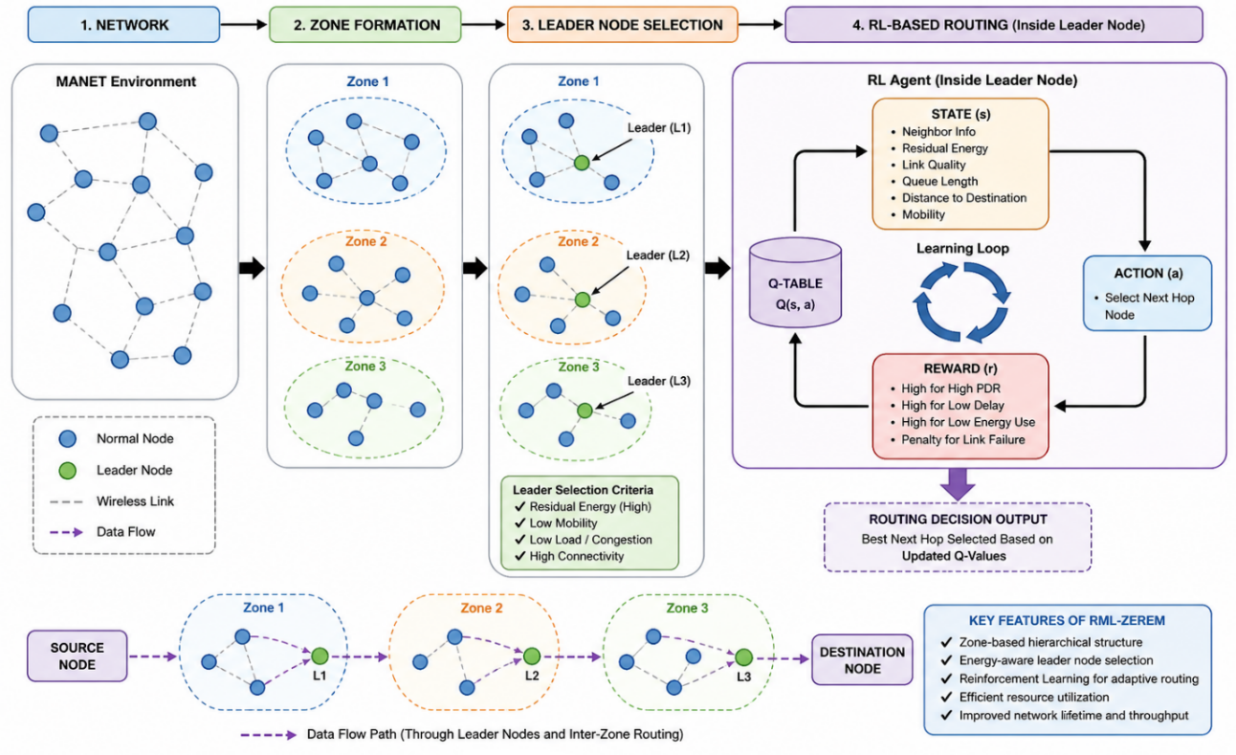Figure 1: Overall Architecture and Operational Workflow of RML-ZEREM

3.2 Network Model and Assumptions

The MANET is represented as a graph $G=(N,L)$ which uses NNN to define the mobile node set and L to show node communication links. The network allows nodes to communicate through multi-hop wireless transmission, which operates in a decentralized mode without any fixed infrastructure.

The proposed network model uses the following assumptions for its implementation:
- The network area contains randomly distributed nodes that spread throughout its entire space.
- Each node uses its available battery power to operate its functions.
- The nodes in the system move around while they change their locations.
- All nodes share the same abilities to transmit data and their communication distance.
- Each node keeps track of its adjacent nodes and their remaining energy.
- Wireless links become active when two nodes establish a connection within their operating range.

The assumptions create an authentic MANET environment, which enables testing of the routing protocol under different network conditions.
3.3 Zone Formation Strategy
The proposed protocol divides the network into multiple logical zones, which use node proximity as the basis for their partitioning to achieve better scalability and decreased routing costs. The system creates zones that combine all nodes that fall within the designated transmission range. The system updates zone structures whenever nodes move or network topology changes occur.
The zone-based organization delivers multiple benefits, which include localized routing operations and decreased control packet creation, lower route discovery costs, and better resource utilization. The system conducts routing operations inside specific zones, which use leader nodes to handle all network routing procedures instead of searching for routes throughout the entire network. The hierarchical system provides major benefits for scalability, together with routing performance improvements that apply to large mobile ad hoc networks that experience constant changes. Figure 2 shows how the proximity-based zone formation mechanism creates organized clusters from scattered individual nodes through its different stages, which start at Zone 1 and end at Zone 5, where certain nodes function as leader nodes and zone heads.
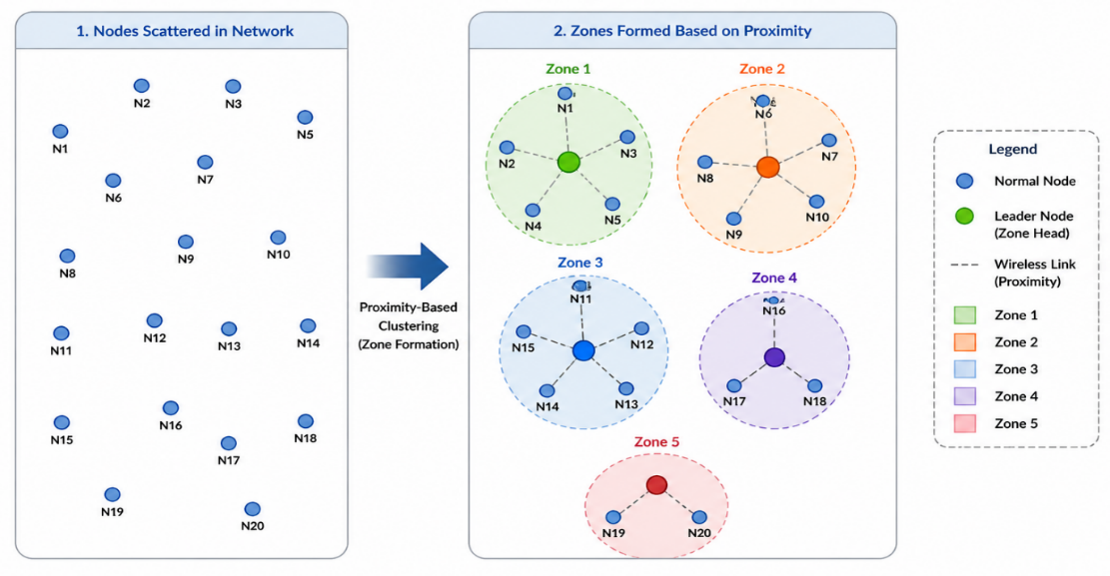
Figure 2: Proximity-Based Zone Formation Mechanism in MANETs
3.4 Energy-Aware Leader Node Selection
Each zone selects a leader node that handles routing operations, learns new routes, and establishes connections with other zones. The leader node functions as a reinforcement learning agent that safeguards routing performance and network stability throughout the system.
An energy-aware scoring system performs leader node selection through evaluation of these specific node characteristics:
- The remaining energy resources of the node
- The current data transmission activities of the node
- The extent to which the node can connect with nearby nodes
- The ability of the link to maintain its connection
The selection process for leaders prioritizes nodes that possess greater remaining energy resources and reduced communication requirements, and better network connections. The leader selection process receives updates at regular intervals to maintain its effectiveness during changes in network topology while protecting the energy resources of all nodes in the system. The adaptive leader management strategy establishes a network resource allocation system that produces better routing results while extending the operational lifetime of the entire network. The Q-learning-based routing process becomes more effective through the selection of leaders who demonstrate both stability and energy-efficient performance. The energy-aware leader node selection strategy shown in Figure 3 demonstrates its multi-criteria evaluation method which tests node performance based on their remaining energy and current load and their ability to connect with other nodes in order to find the best leader node for that specific zone.
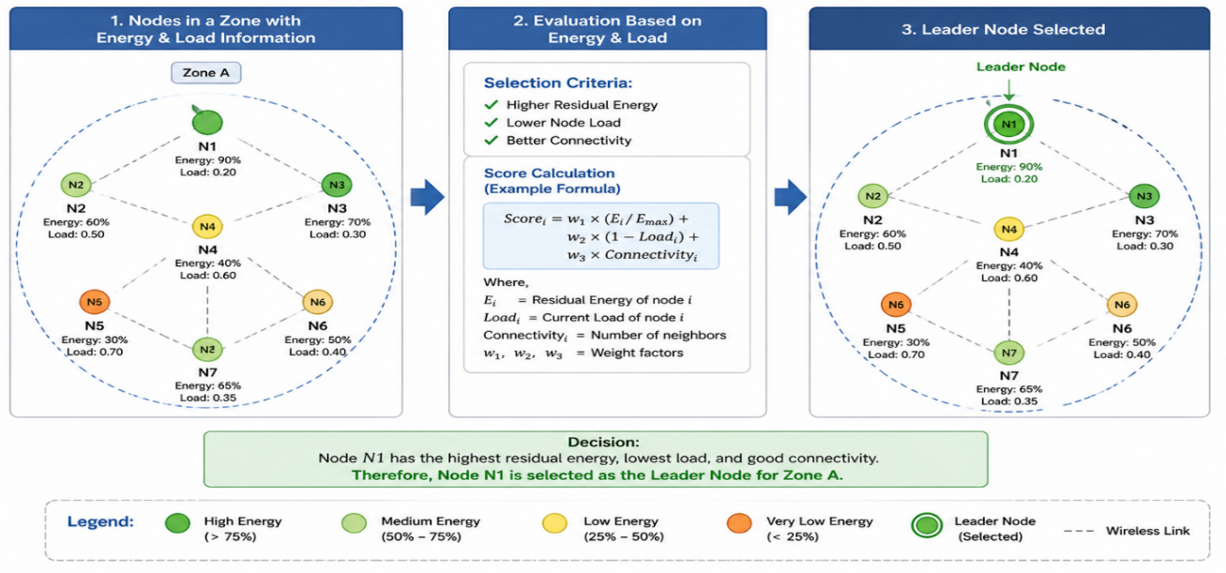
Figure 3: Energy-Aware Leader Node Selection Strategy

3.5 Reinforcement Learning Model

The proposed RML-ZEREM protocol uses Q-learning, which serves as a model-free Reinforcement Learning (RL) technique to develop intelligent adaptive routing systems that work in dynamic MANET networks. The framework designates every zone leader as an RL agent who studies network conditions to develop optimal routing methods through their continuous network interactions. The Q-learning mechanism enables leader nodes to choose optimal routing paths by using maximum long-term rewards to decrease energy costs, routing overhead, and transmission delays. The routing system develops the capacity to handle topology variations and different network conditions through its ongoing learning process and feedback system.
3.5.1 State Space Definition

The state space shows the present network status, which the leader node observes. The state definition uses various network parameters that affect routing performance to establish each network state. The first part of the state representation exists in Equation (1) as its defined form.

$s=\{E,L,M,D\}$ (1)

where:
- $E$represents residual energy,
- $L$ denotes traffic load,
- $M$ indicates node mobility, and
- $D$ represents inter-node distance or link stability.

The multi-parameter state information lets the RL agents make routing decisions from both energy efficacy and network stability perspectives.

3.5.2 Action Space

The action space defines the set of routing decisions available to the leader node at a given state. The system allows users to choose between two options, which involve selecting a routing path to follow or designating a next-hop node to handle packet transmission.

The system provides three routing options, which include the following:
- Users must choose a nearby node that will handle their packet transmission needs
- Users must choose an alternative routing path to follow
- Users must prevent their system from using both congested nodes and low-energy nodes
- Users must choose stable communication links that will enable their data transmission needs.

The action selection process exists to optimize routing performance while reducing energy use, delays, and packet losses.

3.5.3 Reward Function Design
The reinforcement learning process depends on the reward function because it directs the agent towards achieving optimal routing behaviour. The reward function in the proposed protocol functions to promote routing decisions that achieve energy efficiency while maintaining stability and reliability.
The reward is determined based on the following performance parameters:
- Energy efficiency
- Packet delivery performance
- Transmission delay and congestion level
The generalized reward formulation is expressed through Equation (2).

$r=w_{1}⋅EE+w_{2}⋅PDR-w_{3}⋅Delay$ (2)
where:
- EE represents energy efficiency,
- PDR denotes Packet Delivery Ratio,
- Delay indicates transmission delay, and
- $w_{1}​,w_{2}​,w_{3}$​ are weighting factors used to balance routing objectives.
The multi-objective reward function allows simultaneous optimization of three targets, which include energy consumption and routing reliability, and transmission performance. The RL agent develops effective routing methods for changing MANET environments through continuous updates of rewards, which depend on network feedback. 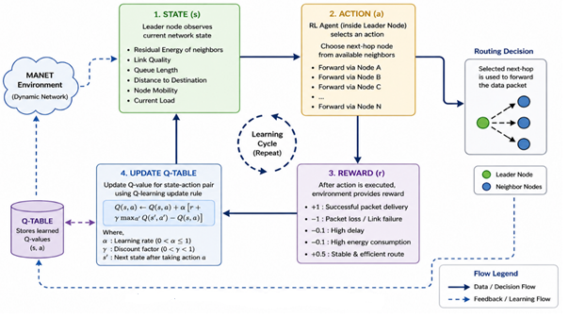Figure 4: Reinforcement Learning Framework for Adaptive Routing Decisions
The proposed RML-ZEREM protocol uses reinforcement learning methods, which Figure 4 demonstrates. The leader nodes use current network conditions to determine which routing paths provide the best performance. The system generates reward values from routing decisions, which it uses to update the Q-values in the Q-table. The learning process starts with the observation of network states followed by the execution of forwarding actions, and ends with Q-table updates, which result from environmental rewards. The leader nodes use this ongoing learning system to enhance their routing decisions, which leads to better network performance.
3.6 Q-Learning-Based Routing Mechanism
The Q-learning algorithm enables dynamic MANET networks to make intelligent routing decisions through the RML-ZEREM protocol. The Q-table, which each leader node operates, contains Q-value information for all possible state-action combinations. Networking feedback together with routing results drives the ongoing development of Q-value information within that system.
The Q-learning update equation used in the proposed protocol is defined in Equation (3)
$Q(s,a)←Q(s,a)+α[r+γmax⁡a'Q(s',a')-Q(s,a)]$ (3)
Where:
- α represents the learning rate,
- γ denotes the discount factor,
- r is the immediate reward received after action execution,
- s′ indicates the next network state, and
- $max⁡a'Q(s',a')$ represents the maximum future reward for the next state.

The proposed protocol routing process executes the following sequence of steps. The current network state needs to be observed. The ε-greedy policy enables the selection of an action. The system performs its routing decision, which determines how packets will be sent. The system delivers a reward that assesses how routing functions. The system computes Q-value updates through the Q-learning equation implementation. The RL agent continuously learns from network interactions to discover the best routing paths that achieve maximum rewards while ending up consuming the least energy and time and routing resources.
3.7 Route Discovery and Maintenance
The RML-ZEREM protocol uses reinforcement learning adaptive routing mechanisms to improve its route discovery and maintenance functions. The proposed system uses zone leader-based techniques to manage routes because conventional routing systems need to send out network-wide broadcasts at frequent intervals.
Route Discovery
Leader nodes use their Q-value knowledge during route discovery to determine the best routing paths that connect different zones. The system limits its route discovery process to specific zones, which leads to reduced network routing costs and decreased control packet delivery. The RL agent evaluates multiple candidate paths based on parameters such as residual energy, delay, traffic load, and link stability before selecting the optimal route.
Route Maintenance
The RL agent uses Q-value updates to find new routes after a link failure or topology change disrupts the network. The adaptive system reduces the need to discover new routes while enabling fast recovery from communication breakdowns. The protocol enhances routing reliability, decreases packet loss, and sustains consistent network performance in changing environmental conditions.
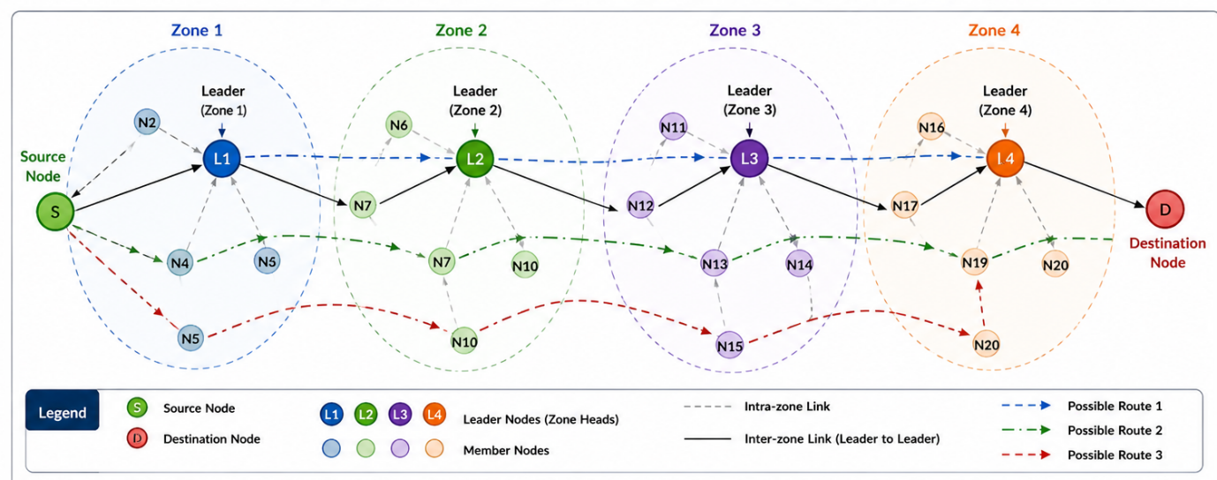Figure 5: Route Establishment and Maintenance Process in RML-ZEREM

Figure 5 shows how the proposed RML-ZEREM protocol establishes and maintains routes through its design. The source node sends route requests to its zone leader who contacts adjacent zone leaders for the purpose of building effective inter-zone routing connections. The system uses reinforcement learning to select the best paths by evaluating energy efficiency, delay times, and link stability. The system uses localized route maintenance to quickly adjust to changes in network topology.

3.8 Algorithm Design of RML-ZEREM
The complete operational procedure of the proposed RML-ZEREM protocol is summarized in Algorithm 1. The algorithm uses a combination of zone-based routing and energy-aware leader node selection and Q-learning-based adaptive routing to establish effective communication within MANET networks.

Algorithm 1: RML-ZEREM Routing Protocol
Input: Network $G(N,L)$
Output: Optimal energy-efficient routing paths
- The procedure begins with the establishment of network settings.
- The network needs to be divided into different operational areas.
- The zone analysis requires the following operations:
  - The analysis needs to determine the node's remaining power and its operational demands, and its network connectivity.
  - The procedure requires the selection of the most suitable leader node.
- The Q-table needs to be established for each leader node.
- The learning rate α and discount factor γ need to be established.
- The network remains operational during this period.
  - The current position of the system exists as state s.
  - The system employs an ε-greedy policy to select action a.
  - The system needs to execute routing together with packet forwarding tasks.
  - The system receives a reward, which is defined as r.
  - The system updates Q-values through the application of the Q-learning equation.
- The system needs to assess performance metrics which include energy efficiency, throughput, and packet delivery ratio.
- The study examines the new protocol against current routing protocols used in the field.
The RML-ZEREM protocol uses an energy-aware data forwarding system, which Figure 6 depicts. Data packets are sent through leader nodes and intermediate nodes which get chosen based on their remaining energy and current network traffic and their link performance. The reinforcement learning system uses Q-values to select the best routing paths, which helps the system to stay away from low-energy nodes and unstable nodes while it extends network lifespan and improves routing performance.

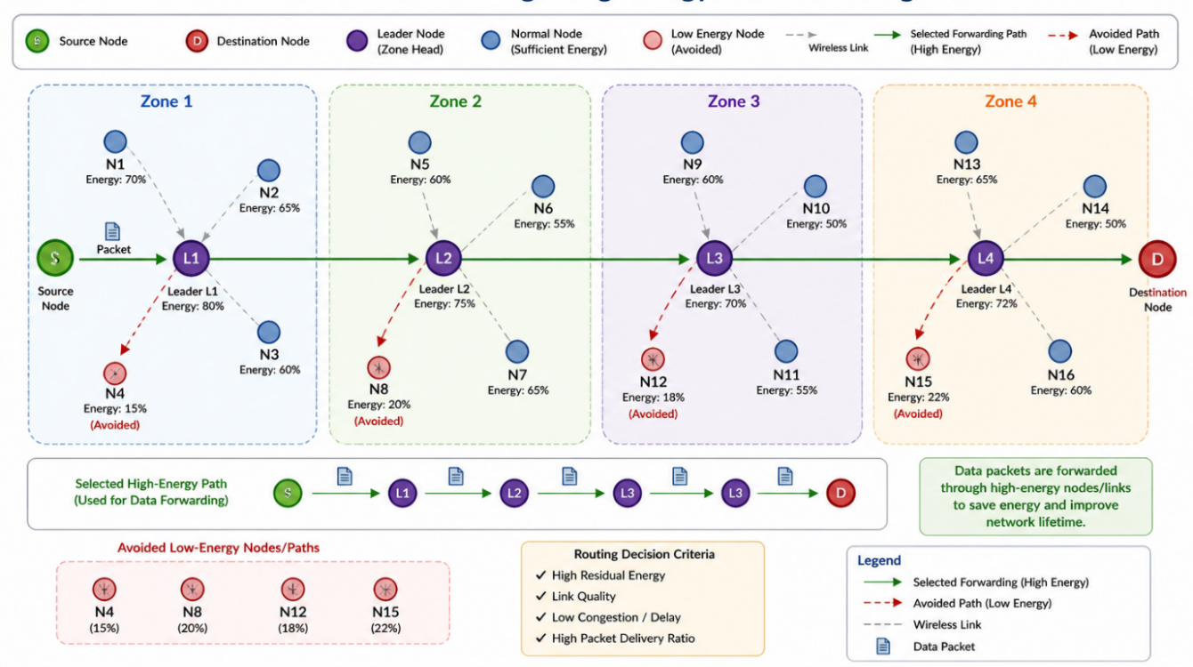

Figure 6: Energy-Aware Data Forwarding Mechanism through Leader Nodes

4. Mathematical Modelling

The mathematical formulation of the proposed RML-ZEREM protocol. The proposed model uses graph theory and energy consumption analysis with reinforcement learning and policy optimization methods to create adaptive energy-efficient routing systems for dynamic MANET environments.

4.1 Network Representation (Graph Model)

The MANET describes its structure through an undirected graph, which Equation (4) shows.

$G=(N,L)$ (4)
where:
- $N=\{n_{1}​,n_{2}​,...,n_{k}​\}$represents the set of mobile nodes
- $L⊆N×N$ represents the set of communication links
A link $l_{ij}​∈L$ exists between nodes $n_{i}​$ and$n_{j}$If they are within transmission range.
Each node $n_{i}$is associated with a residual energy value, as defined in Equation (5):
$E_{i}(t)$ (5)

where
$E_{i}(t)$ denotes the remaining energy of the node $i$ at time $t.$

The network is partitioned into zones using a mapping function, as defined in Equation (6).

$Z:N→\{Z_{1},Z_{2},…,Z_{m}\}$ (6)

where each node belongs to exactly one zone based on proximity constraints and communication range.

4.2 Energy Consumption Model
The energy usage of mobile ad hoc networks occurs mainly through the transmission and reception of data packets. Equation (7) shows the total energy usage of a node through its different operational activities.
$E_{total}=E_{tx}+E_{rx}$ (7)

The transmission energy is modelled as defined in Equation (8).

$E_{tx}(d)=E_{elec}⋅k+ϵ_{amp}⋅k⋅d^{η}$ (8)

The reception energy is defined in Equation (9).

$E_{rx}=E_{elec}⋅k$ (9)
where:
- $E_{elec}$= energy consumed per bit for transmission/reception
- $ϵ_{amp}$​ = amplifier energy constant
- k = packet size (bits)
- d = distance between nodes
- η = path loss exponent (typically 2–4)
The energy model system lets the routing protocol select routes by using two factors, which are the distance to communicate and the remaining power of the nodes. The Q-learning update process follows Equation (3).
The Q-learning algorithm serves as the main learning method, which allows leader nodes to discover the best route patterns through their ongoing experience with the network environment. The Q-learning update process follows Equation (3).
$$Q(s,a)←Q(s,a)+α[r+γ\max_{a'}{Q(s',a')}⁡-Q(s,a)]$$
where:
- $Q(s,a)$= current Q-value for state-action pair
- $α∈(0,1)$ = learning rate
- $γ∈(0,1)$ = discount factor
- r = immediate reward
- s′ = next state
- $\max_{a'}{Q(s',a')}$ = maximum future reward
The routing agent improves its routing decisions through an ongoing process that uses network experience together with system feedback. The Q-learning-based routing decision process, which the proposed protocol uses, is shown in Figure 7. The figure demonstrates how network states are mapped to routing actions through Q-values, which enable adaptive route selection and optimized route selection throughout the time period.
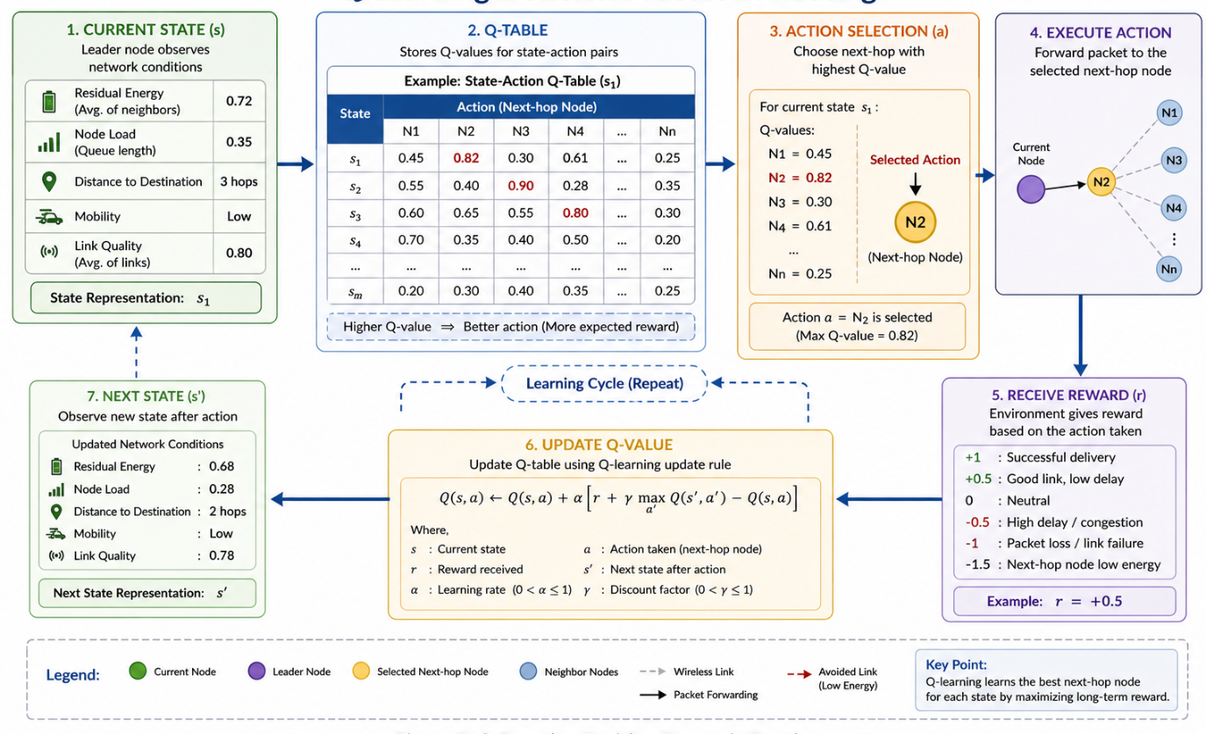Figure 7: Q-Learning-Based Decision Process for Optimal Path Selection

4.4 Reward Function Formulation
The reward function exists to optimize three different routing objectives, which include energy efficiency, packet delivery performance, and delay reduction. The reward formulation is defined in Equation (10).

$r=w_{1}⋅\frac{E_{res}}{E_{max}}+w_{2}⋅PDR-w_{3}⋅D_{avg}$ (10)
where:
- $E_{res}$​ = residual energy of the node
- $E_{max}$​ = maximum initial energy
- $PDR$ = packet delivery ratio
- $D_{avg}$= average delay
- $w_{1}​,w_{2}​,w_{3}$​ = weighting factors such that $w_{1}+w_{2}​+w_{3}​=1$

The reward system drives people to choose nodes that possess greater remaining power. The system needs to achieve both dependable packet transmission and transmission time efficiency. The proposed reward function enables adaptive routing to work efficiently in different network environments by balancing multiple performance metrics.

4.5 Policy Optimization Strategy
The proposed protocol uses an ε-greedy policy mechanism to achieve a balance between exploration and exploitation throughout route learning. The routing policy is defined in Equation (11).
$π\left(s\right)= \left\{\begin{aligned}random action, with probability ϵ \\ \arg{\max{aQ\left(s,a\right)}}, with probability 1-ϵ\end{aligned}\right.$ (11)
where:

where ϵ represents the exploration rate.
The ε-greedy strategy enables the RL agent to search for new routing paths with probability ϵ while using its existing knowledge of optimal routes at 1−ϵ. The system achieves better convergence results because it maintains better performance results while preventing the routing agent from choosing wrong routing paths. The proposed RML-ZEREM protocol performance assessment uses standard MANET performance metrics, which include energy efficiency, throughput and packet delivery ratio. The routing mechanism assessment uses these metrics to evaluate its performance across various network situations. Energy efficiency measures the ratio of successfully transmitted useful data to the total energy spent during network operations. The energy efficiency measure has its definition established through Equation (12).

$EE=\frac{Total Data Delivered}{Total Energy Consumed​ }$ (12)

Higher energy efficiency values indicate better utilization of network energy resources and improved network lifetime.

4.6.2 Throughput
Throughput measures the successful data transmission rate achieved during the entire testing period. The measurement is determined through the application of Equation (13).

$T=\frac{\sum_{i=1}^{N}{{Packets Received}_{i}×Packet Size}}{Total Simulation Time}$ (13)

The equation includes N as the total number of received packets and Packet Size as the size of each transmitted packet. Throughput measurement uses two standard units, which are kilobits per second (kbps) and megabits per second (Mbps). The higher throughput values bring about better data transmission efficiency and reliability.

4.6.3 Packet Delivery Ratio (PDR)

The Packet Delivery Ratio (PDR) measures the ratio between successfully received packets and all transmitted packets. It is defined in Equation (14).

$PDR=\frac{Total Packets Received}{Total Packets Sent}$ (14)

PDR functions as a critical measurement that assesses both routing reliability and communication efficiency. The dynamic MANET environments show better packet transmission performance because higher PDR values lead to improved routing stability.

5. Simulation Setup and Parameters

The section describes the simulation environment together with network configuration and evaluation parameters, which the researchers used to test their proposed RML-ZEREM protocol. The proposed protocol is compared with conventional MANET routing protocols under multiple simulation scenarios to validate its efficiency, scalability, and adaptability in dynamic network environments.

5.1 Simulation Environment
The performance evaluation of the proposed routing protocol is carried out using the NS-2.35 (Network Simulator 2) platform. NS-2.35 is widely used for MANET research because it provides flexible testing capabilities and supports wireless communication models, various routing protocols, and mobility patterns.

The simulation framework includes:
- NS-2.35 simulator for network implementation
- TCL scripting for simulation scenario generation
- Trace file analysis for performance evaluation

The simulated environment displays authentic MANET conditions through its combination of dynamic topology changes, wireless communication limitations and node movement and multi-hop routing.

5.2 Network Configuration

The simulation tests a mobile ad hoc network, which includes mobile nodes that move throughout a fixed geographic area. The system uses multi-hop wireless communication for node connections, while each node has a restricted battery power capacity.

The following assumptions and configurations are considered during simulation:
- The simulation area receives a random deployment of nodes throughout its entire space. The system requires each node to start with a restricted power capacity.
- The system uses multi-hop wireless transmission for its communication processes.
- The Random Waypoint Mobility Model serves as the basis for modelling node movement patterns.
- The system tests network behaviour by changing both node speed and pause duration.
- The system conducts traffic generation by using Constant Bit Rate (CBR) sources that operate over UDP connections.

The evaluation of the proposed protocol requires multiple simulation scenarios, which include testing various simulation time periods, testing different levels of node mobility, testing different network size configurations and testing different simulation area dimensions. The proposed RML-ZEREM protocol demonstrates its capabilities through these scenarios, which test its scalability, routing efficiency, adaptability, and energy performance.

5.3 Simulation Parameters
The key simulation parameters used for performance evaluation are summarized in Table 1.
Table 1: Simulation Parameters for Performance Evaluation
Parameter | Value
Simulator | NS-2.35
Simulation Time | 100–600 seconds
Network Area | 500 × 500 m² to 1000 × 1000 m²
Number of Nodes | 50, 75, 100
Mobility Model | Random Waypoint
Node Speed | 3–9 m/s
Pause Time | 100 seconds
Traffic Type | CBR (UDP)
Packet Size | 512 bytes
Transmission Range | 250 m
Initial Energy | 1000 Joules
Routing Protocols Compared | AODV, AOMDV, RML-ZEREM
MAC Protocol | IEEE 802.11
Queue Type | DropTail/PriQueue

6. Results and Performance Evaluation
The proposed RML-ZEREM protocol performance assessment uses various simulated environments to compare its results with traditional MANET routing protocols, which include Ad hoc On-Demand Distance Vector (AODV) and Ad hoc On-Demand Multipath Distance Vector (AOMDV). The evaluation is conducted using key performance metrics such as Energy Consumption, Throughput, and Packet Delivery Ratio (PDR).
6.1 Scenario 1: Impact of Simulation Time
Energy Consumption Analysis
Table 2 presents the comparative analysis of energy consumption for different simulation times, which range from 100 seconds to 600 seconds. The study found that all routing protocols experienced increased energy consumption because extended network operation required nonstop data packet transmission. The proposed RML-ZEREM protocol demonstrates better energy efficiency than both AODV and AOMDV protocols. The proposed protocol achieves energy savings of 3.70% at 100 seconds, which increases to 5.6% at 600 seconds when compared to standard protocols. The Q-learning-based adaptive routing mechanism generates this enhancement because it selects energy-efficient routing paths while avoiding nodes with low residual energy. The zone-based routing structure reduces unnecessary route discovery operations while decreasing routing control overhead, which results in better energy efficiency throughout the system. The evaluated routing protocols show their energy consumption performance through the results presented in Figure 8. RML-ZEREM demonstrates its energy consumption by showing lower energy use during the entire testing period. The study shows that performance enhancement grows with lengthening simulation periods because reinforcement learning systems start to achieve their best routing performance, which leads to better energy efficiency and more equal resource distribution.
Table 2: Performance Comparison: Energy Consumption vs. Simulation Time
Simulation Time (s) | AODV (J) | AOMDV (J) | RML-ZEREM (J) | Improvement over AODV (%) | Improvement over AOMDV (%)
100 | 157.84 | 157.84 | 152.00 | 3.70% | 3.70%
200 | 165.48 | 165.52 | 158.80 | 4.03% | 4.05%
400 | 180.84 | 180.93 | 171.50 | 5.16% | 5.21%
600 | 196.13 | 196.08 | 185.00 | 5.67% | 5.65%

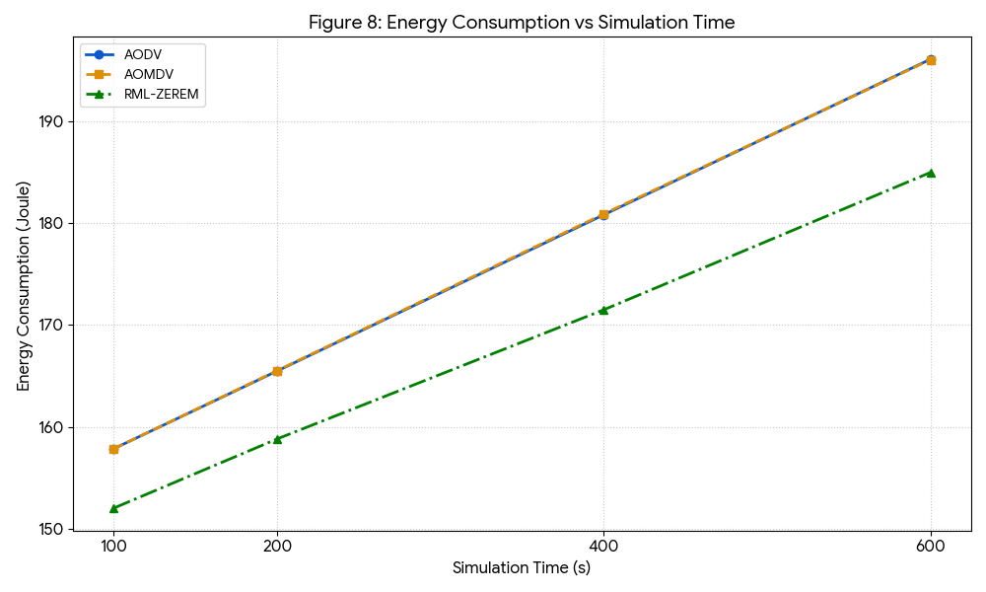
Figure 8: Energy Consumption vs. Simulation Time Comparison
Throughput Analysis
Table 3 shows the tested throughput results of RML-ZEREM against AODV and AOMDV, which were conducted for a duration between 100 seconds and 600 seconds. All studied protocols showed an increase in network throughput with increasing simulation time because of their ongoing packet delivery and their prolonged periods of active communication. The proposed RML-ZEREM protocol demonstrates superior throughput, which it achieves throughout all testing environments. The proposed protocol demonstrates a throughput improvement of approximately 25% over AODV during the initial simulation periods (100–200 s). The improvement further increases to 35.99% at 400 s and reaches nearly 50% at 600 s. RML-ZEREM delivers better throughput results than AOMDV during the first part of the tests, while it maintains consistent performance throughout the entire testing duration. The improved throughput performance is primarily due to the reinforcement learning-based adaptive routing mechanism, which dynamically selects stable and efficient routing paths based on network conditions. The zone-based routing structure reduces routing overhead while decreasing packet loss, which results in better data transmission efficiency and improved network reliability. Figure 9 displays the throughput results for the different routing protocols that were tested in the study. According to the findings, RML-ZEREM achieves better throughput results than its competitors during every testing period. The performance gap between RML-ZEREM and AODV increases significantly over time, while AOMDV performance maintains its stable advantage because of intelligent route selection and adaptive routing optimization.
Table 3: Throughput Comparison across Different Simulation Durations
Simulation Time (s) | AODV (kbps) | AOMDV (kbps) | RML-ZEREM (kbps) | Improvement over AODV (%) | Improvement over AOMDV (%)
100 | 1572.59 | 1379.51 | 1965.74 | 25.00% | 42.50%
200 | 3700.73 | 3080.63 | 4625.92 | 25.00% | 50.15%
400 | 5095.57 | 6213.76 | 6929.80 | 35.99% | 11.52%
600 | 7602.21 | 10878.48 | 11402.93 | 50.00% | 4.83%

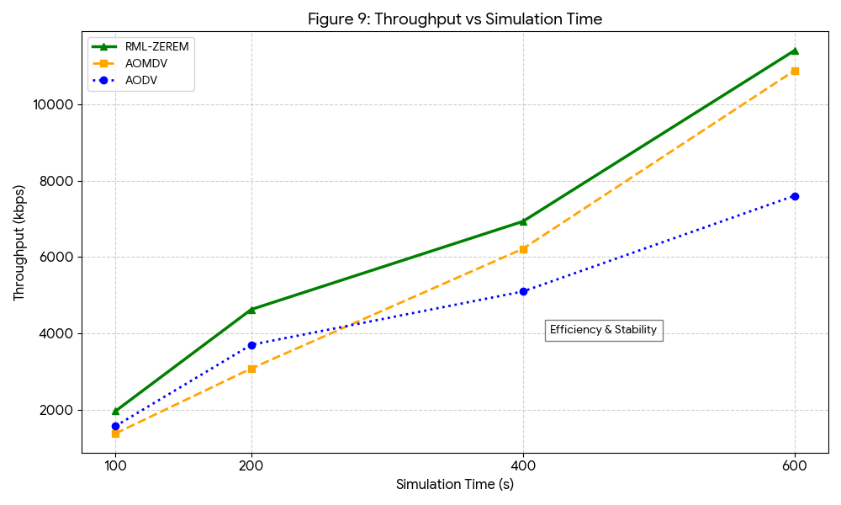
Figure 9: Throughput Trends over Extended Simulation Periods
6.1.3 Packet Delivery Ratio (PDR) Analysis
The Packet Delivery Ratio (PDR) results in Table 4 show a comparison between the RML-ZEREM protocol and traditional AODV and AOMDV protocols. The results demonstrate that RML-ZEREM consistently achieves higher packet delivery performance compared to existing routing approaches. The Q-learning framework which uses reinforcement learning selects reliable routing paths after assessing link stability and node mobility and traffic load and residual energy. The zone-based routing structure decreases routing overhead while enhancing route maintenance efficiency which enables the protocol to function effectively in highly changing MANET networks. The results show that RML-ZEREM achieves a PDR improvement between 8% and 18% over AODV and between 4% and 12% over AOMDV for all simulation time intervals. Figure 10 shows that RML-ZEREM exceeds both AODV and AOMDV in its ability to deliver packets. The adaptive reinforcement learning-based routing mechanism enhances route stability and packet forwarding efficiency which leads to reduced packet loss and better communication reliability.
Table 4: Packet Delivery Ratio (PDR) vs. Simulation Time
Simulation Time (s) | AODV (%) | AOMDV (%) | RML-ZEREM (%) | Improvement over AODV (%) | Improvement over AOMDV (%)
100 | 55.75 | 58.90 | 64.20 | 15.15% | 9.00%
200 | 65.41 | 68.45 | 74.10 | 13.28% | 8.25%
400 | 74.96 | 78.83 | 84.20 | 12.33% | 6.81%
600 | 81.70 | 84.96 | 88.48 | 8.30% | 4.14%
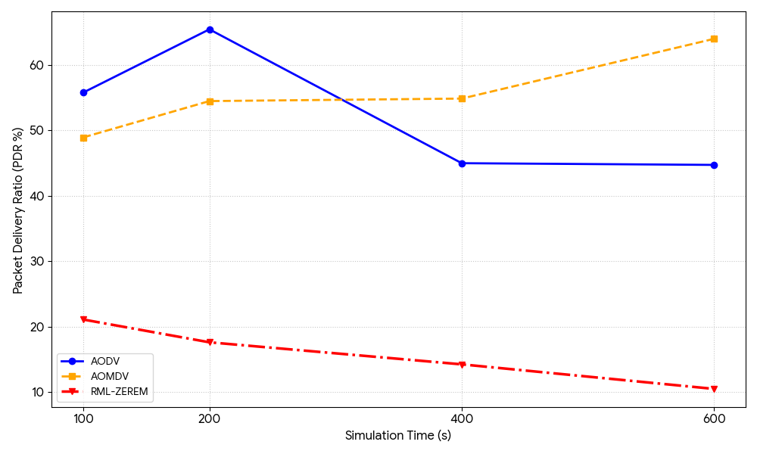
Figure 10: Packet Delivery Ratio (PDR) Analysis vs. Simulation Duration
6.2 Scenario 2: Impact of Node Mobility
The researchers tested the RML-ZEREM protocol by changing node movement speed from 3 m/s to 9 m/s to examine how well the protocol performs under MANET mobility conditions. The rising movement speed of nodes leads to network topology changes and breaks in routes and creates unstable links, which result in difficulties for routing and waste of energy resources.
Energy Consumption Analysis
Table 6 shows how energy consumption changes with different node mobility levels for RML-ZEREM AODV and AOMDV. The results demonstrate that RML-ZEREM achieves lower energy consumption throughout all mobility conditions. The proposed protocol achieves energy reduction improvements that range from 4% to 11% when compared to conventional routing protocols. The network achieves better energy savings when node speeds decrease because the stable network topology enables the reinforcement learning system to reach optimal routing paths more effectively. The process of changing network structures at high mobility levels causes moderate routing performance issues because it leads to quick changes in both network routes and link conditions. RML-ZEREM surpasses AODV and AOMDV because its Q-learning-based adaptive routing method and zone-based network structure work together to reduce unnecessary route rediscovery and routing costs. The network achieves better energy management and longer operational time because it uses intelligent methods to choose stable routes that consume less energy. Figure 11 shows how energy consumption changes according to node mobility. The results show that RML-ZEREM maintains lower energy usage throughout all mobility scenarios. The proposed protocol demonstrates superior energy efficiency over traditional routing methods because it uses adaptive learning together with intelligent route optimization, despite user mobility reducing performance gains at higher node speeds.
Table 6: Impact of Node Speed on Energy Consumption
Node Speed (m/s) | AODV (J) | AOMDV (J) | RML-ZEREM (J) | Reduction vs AODV (%) | Reduction vs AOMDV (%)
3 | 195.86 | 196.17 | 173.47 | 11.46% | 11.61%
5 | 180.74 | 196.69 | 173.44 | 4.04% | 11.85%
7 | 195.82 | 195.99 | 173.42 | 11.43% | 11.56%
9 | 180.50 | 180.78 | 173.37 | 3.96% | 4.11%
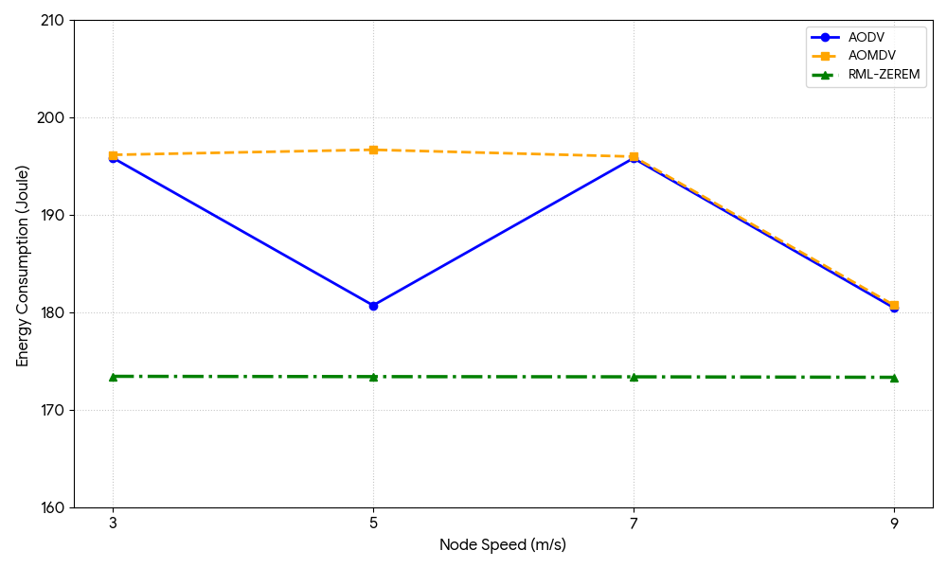
Figure 11: Energy Consumption Performance under Variable Node Mobility
Throughput Analysis
Table 7 displays the throughput results, which compare the RML-ZEREM protocol with AODV and AOMDV under different mobility conditions, which extend from 3 m/s to 9 m/s. The results show that the proposed protocol achieves better throughput results throughout all tests involving different mobility scenarios. The RML-ZEREM system achieves better throughput results at low mobility situations because its constant network structure allows the Q-learning system to discover and protect its best routing solutions. The proposed protocol achieves throughput improvements of near 69.48% against AODV and 46.67% against AOMDV at a node speed of 3 m/s. The throughput improvement over AOMDV increases less than 1% under moderate mobility because AOMDV's multipath system creates more stable routes during times of moderate network changes. RML-ZEREM maintains better throughput results through its ability to select routes and handle traffic in an intelligent manner. The proposed protocol outperforms traditional routing methods at mobility rates between 7 and 9 meters per second. The reinforcement learning system creates new routing paths that adapt to changing network landscapes while supporting reliable connections and quick data transmission during periods of extreme network activity. The protocol achieves throughput improvements of up to 47.66% over AOMDV at higher node speeds, which shows its ability to adapt and maintain stable routing operations. Throughput changes according to the speed of the nodes, as shown in Figure 12. The results show that RML-ZEREM provides superior throughput performance throughout all tested mobility patterns. The system achieves performance enhancements because its adaptive routing system, which uses reinforcement learning, successfully manages mobility-related changes to network topology while sustaining dependable communication links in changing mobile ad hoc network conditions.
Table 7: Throughput Performance under Variable Node Mobility
Node Speed (m/s) | AODV (kbps) | AOMDV (kbps) | RML-ZEREM (kbps) | Improvement over AODV (%) | Improvement over AOMDV (%)
3 | 8752.32 | 10110.70 | 14831.45 | 69.48% | 46.67%
5 | 8500.00 | 11000.00 | 12009.58 | 41.29% | 9.18%
7 | 7800.00 | 7200.00 | 9218.64 | 18.19% | 28.04%
9 | 7200.00 | 6500.00 | 9597.85 | 33.30% | 47.66%

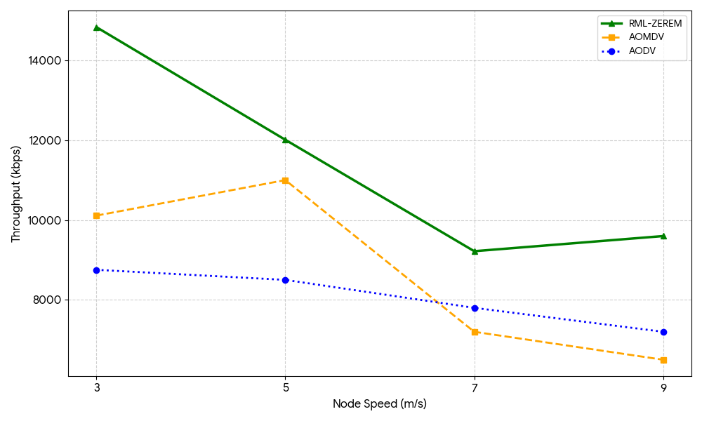
Figure 12: Throughput Variation with Increasing Node Speed
Packet Delivery Ratio (PDR) Analysis
Table 8 displays the Packet Delivery Ratio (PDR) comparison between the RML-ZEREM protocol and AODV and AOMDV through tests that evaluate different node mobility speeds, which range from 3 m/s to 9 m/s. The results demonstrate that RML-ZEREM consistently achieves higher packet delivery performance across all mobility conditions. The proposed protocol shows better packet delivery results at low node speeds because stable topology conditions enable the reinforcement learning mechanism to establish and protect trustworthy routing pathways. RML-ZEREM delivers a 26.57% performance upgrade over AODV at 3 m/s, and this improvement rises to 37.60% at 5 m/s. Higher mobility results in continuous topology changes, which cause links to break, thus decreasing route stability. The adaptive Q-learning-based routing method of the proposed protocol enables it to maintain better packet delivery results than its competitors. The RL mechanism selects communication paths that maintain stability while it quickly adjusts to changes in network topology, thus reducing packet loss and boosting routing dependability. The proposed protocol shows a 42.64% performance enhancement over AOMDV at 9 m/s, which proves its ability to handle tough conditions in dynamic MANET networks. The system achieves better PDR results because it uses smart routing methods and energy-efficient forwarding choices together with local zone-based routing systems, which decrease routing failures and communication outages. The Packet Delivery Ratio shows different results according to the speed of the nodes tested in Figure 13. The results show that RML-ZEREM consistently maintains higher packet delivery performance under different mobility conditions. The adaptive reinforcement learning mechanism enables efficient handling of mobility-induced topology changes, which results in improved routing stability and reliable data transmission for dynamic MANET environments.
Table 8: Packet Delivery Ratio (PDR) across Different Node Speeds
Node Speed (m/s) | AODV (%) | AOMDV (%) | RML-ZEREM (%) | Improvement over AODV (%) | Improvement over AOMDV (%)
3 | 51.46 | 59.45 | 65.12 | 26.57% | 9.53%
5 | 55.00 | 62.00 | 75.68 | 37.60% | 22.06%
7 | 50.00 | 48.00 | 55.32 | 10.64% | 15.25%
9 | 60.00 | 55.00 | 78.45 | 30.75% | 42.64%

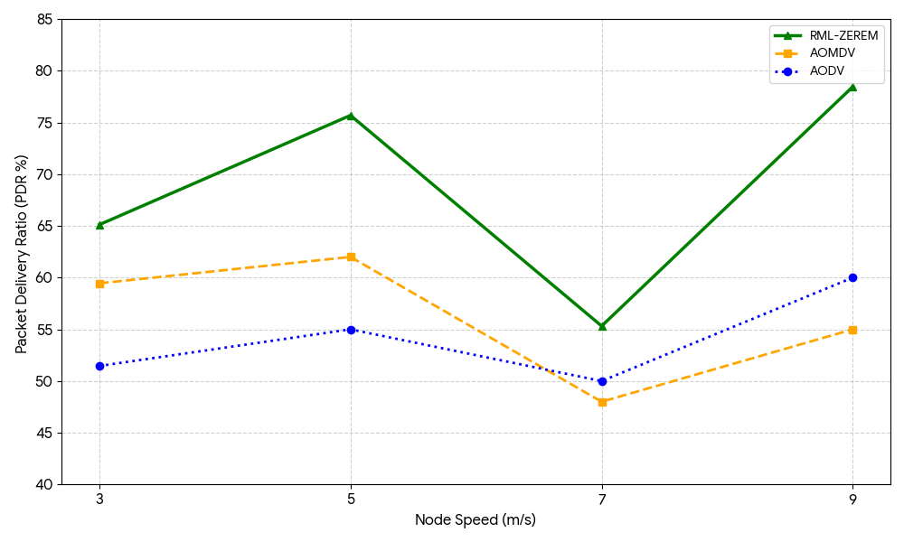
Figure 13: Packet Delivery Ratio (PDR) Performance at Different Node Speeds
6.3 Scenario 3: Impact of Network Size
The study tests the RML-ZEREM protocol because researchers want to see how the system performs with different network densities and increased mobile node counts from 50 to 100. The growing network size leads to higher node density and increased channel contention, which results in more complex routing tasks and greater interference that directly impacts routing efficiency and energy consumption.
Energy Consumption Analysis
Table 9 displays a comparative study that examines energy consumption across various network dimensions using three routing protocols: RML-ZEREM, AODV, and AOMDV. All routing protocols demonstrate increasing energy consumption patterns, which extend to additional nodes because larger networks need to carry out more routing activities, packet transmission, and control message distribution tasks. The RML-ZEREM protocol demonstrates superior energy efficiency across all networking scenarios in which it operates. The proposed protocol achieves its maximum energy savings of 33.17 percent compared to AODV and 19.44 percent compared to AOMDV at 50 nodes. Network size expansion leads to a minor decline in performance improvement because dense network areas create greater routing challenges, added communication demands, and increased network traffic. RML-ZEREM maintains superior energy efficiency results when compared to traditional routing methods. The reinforcement learning-based adaptive routing mechanism, together with the zone-based network organization system, delivers the primary benefits of improved energy efficiency. The RL agent chooses routes that consume less energy while providing stable performance, and the zone-based system decreases both route discovery and control overhead. The combined effect of these mechanisms enhances both system scalability and power distribution during longer MANET operations. Figure 14 shows how energy consumption changes according to the size of the network. The results show that energy consumption increases with node growth, but RML-ZEREM maintains lower energy usage than AODV and AOMDV because of its adaptive learning system and its ability to manage routing efficiently.

Table 9: Energy Consumption Analysis based on Network Size (Number of Nodes)
Number of Nodes | AODV (J) | AOMDV (J) | RML-ZEREM (J) | Reduction over AODV (%) | Reduction over AOMDV (%)
50 | 97.51 | 80.88 | 65.16 | 33.17% | 19.44%
75 | 196.09 | 180.72 | 165.13 | 15.79% | 8.64%
100 | 180.59 | 180.95 | 165.53 | 8.34% | 8.52%

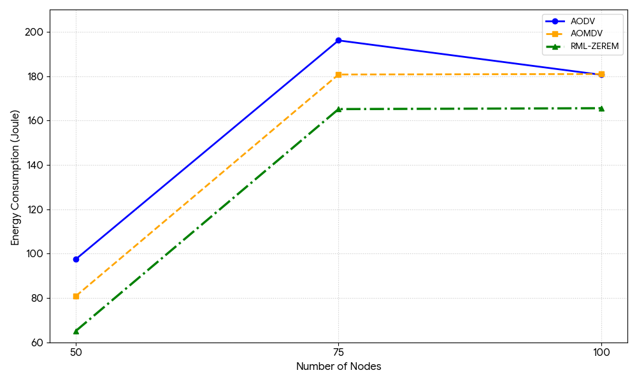
Figure 14: Impact of Network Size on Total Energy Consumption
Throughput Analysis
Table 11 shows RML-ZEREM throughput performance compared to AODV and AOMDV throughput performance across multiple network sizes, which range from 50 to 100 nodes. The results show that the proposed protocol delivers better throughput results through all tested network densities. RML-ZEREM shows better throughput performance at 50 node network density because it achieves 2.63% better performance than AODV and 16.63% better performance than AOMDV. The network growth to 75 nodes causes an increase in throughput, which shows 54.89% improvement over AODV and 26.45% improvement over AOMDV. The proposed protocol handles moderate network density through its ability to select routes adaptively while distributing traffic intelligently and minimizing routing overhead, which leads to better network performance. The reinforcement learning mechanism further improves packet forwarding efficiency by selecting stable and efficient communication paths. The network at 100 nodes experiences increased congestion because more users are competing for access to wireless channels. RML-ZEREM demonstrates better routing performance than AODV through 23.08% more throughput and better routing performance than AOMDV through 16.81% more throughput. The combination of Q-learning-based adaptive routing with zone-based network management creates more reliable routing patterns, which decrease packet loss while increasing data transmission efficiency in extensive MANET networks. Figure 15 shows how RML-ZEREM keeps its throughput advantage throughout different network densities while showing throughput changes across different network sizes.
Table 11: Throughput Comparison for Different Network Sizes
Number of Nodes | AODV (kbps) | AOMDV (kbps) | RML-ZEREM (kbps) | Improvement over AODV (%) | Improvement over AOMDV (%)
50 | 92.90 | 81.73 | 95.34 | 2.63% | 16.63%
75 | 43.40 | 53.14 | 67.21 | 54.89% | 26.45%
100 | 63.50 | 66.89 | 78.12 | 23.08% | 16.81%

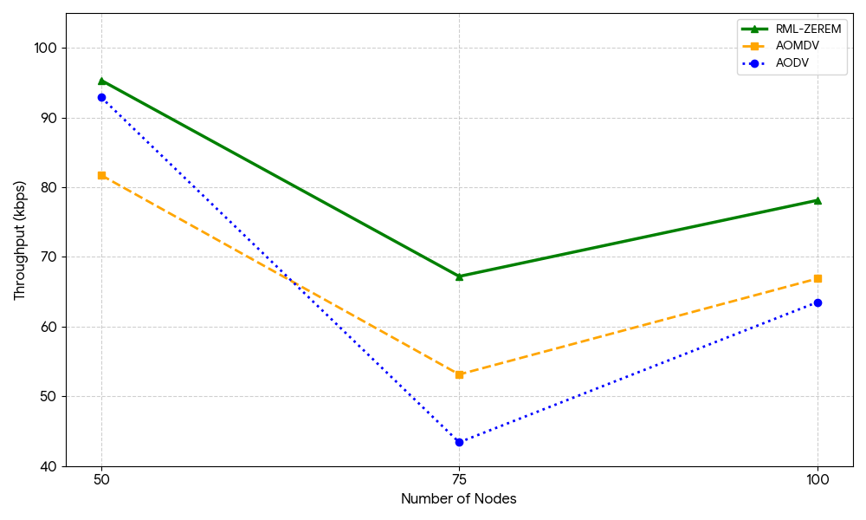
Figure 15: Throughput Analysis for Scalable Network Sizes
Packet Delivery Ratio (PDR) Analysis
Table 10 shows the Packet Delivery Ratio (PDR)results of the RML-ZEREM protocol when compared to AODV and AOMDV across different network sizes, which include 50 to 100 nodes. The results show that PDR decreases for all routing protocols as the number of nodes increases due to higher network congestion, which leads to increased routing overhead, packet collisions, and communication interference that occurs in dense MANET environments. The RML-ZEREM protocol achieves better packet delivery results, which apply to every tested network configuration. The proposed protocol shows a PDR increase of 3.95% over AODV and 7.12% over AOMDV at 50 nodes. Network size increase leads to a more substantial performance advantage. RML-ZEREM enhances routing reliability at 75 nodes through its adaptive route learning combined with its efficient traffic management system. The proposed protocol shows a 15.25% improvement over AODV and a 9.43% improvement over AOMDV under network conditions that include 100 nodes. The results show that the reinforcement learning-based routing mechanism can handle routing complexity and topology changes. The enhanced PDR performance results from intelligent route selection processes that operate through localized zone-based routing methods and use adaptive Q-learning decision-making systems to decrease packet loss and route failures while enhancing communication reliability throughout extensive MANET systems. Figure 16 demonstrates how the Packet Delivery Ratio changes according to different network size conditions. The results show a decreasing PDR trend for all protocols as network density increases; however, RML-ZEREM consistently maintains better packet delivery performance due to adaptive routing decisions, reduced routing complexity, and efficient management of network resources.
Table 10: Impact of Network Density on Packet Delivery Ratio (PDR)
Number of Nodes | AODV (%) | AOMDV (%) | RML-ZEREM (%) | Improvement over AODV (%) | Improvement over AOMDV (%)
50 | 91.20 | 88.50 | 94.80 | 3.95% | 7.12%
75 | 78.40 | 81.30 | 87.60 | 11.73% | 7.75%
100 | 69.50 | 73.20 | 80.10 | 15.25% | 9.43%

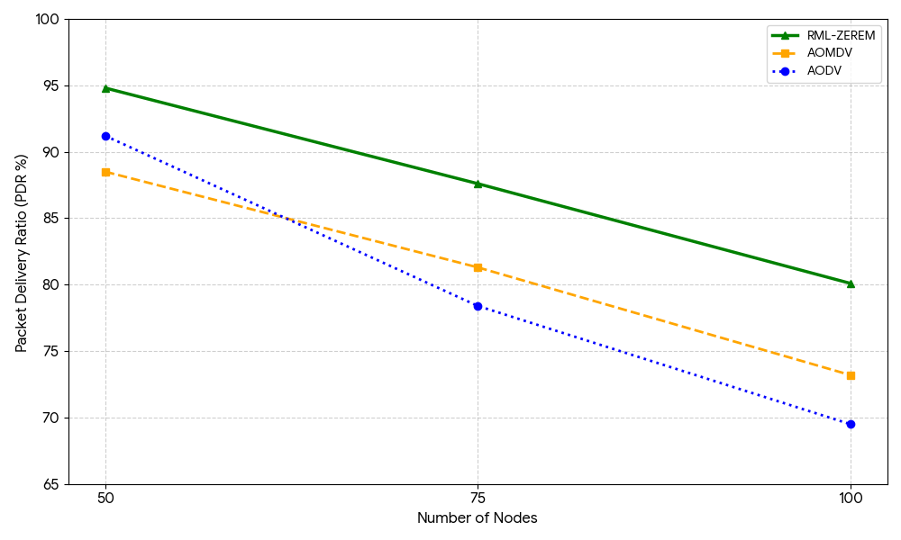
Figure 16: Packet Delivery Ratio (PDR) Trend across Different Node Counts
6.4 Scenario 4: Impact of Area Size
The researchers studied how different node distribution patterns and network density levels affected routing performance through their experiments that used network areas ranging between 500 square meters and 1000 square meters. The simulation area expansion led to decreased node density because the number of nodes remained unchanged, which caused two effects: reduced connectivity and longer communication distances, and increased routing complexity.
Impact of Area Sizes on Energy Consumption
This section investigates how different network area sizes affect energy use for the RML-ZEREM protocol, which runs against AODV and AOMDV. Fixed node counts create network areas that lead to reduced node density and increased distance between nodes during communication. These changes create effects that affect routing overhead, link stability, and energy usage. The results presented in Table 12 show that RML-ZEREM achieves lower energy consumption across all network area dimensions.The reinforcement learning-based adaptive routing mechanism selects communication paths that have both stable connections and energy-efficient performance, while the zone-based routing structure reduces unnecessary route discovery operations and control packet transmission. At smaller network areas, the combination of increased node density causes both routing overhead and packet collisions to rise. The proposed protocol sustains balanced energy usage while preventing excessive retransmissions, which happen when links become unstable as the network area grows. AODV and AOMDV consume additional energy because they need to maintain routes repeatedly, and their control overhead increases when network conditions change. The results show that RML-ZEREM maintains control over energy use in low-density network situations. The system demonstrates better performance in handling network growth and routing processes. Figure 18 shows how energy consumption changes when the network area size increases. The study found that energy consumption declines when network areas become larger because node contention and collision probability decrease. RML-ZEREM shows the lowest energy usage among all protocols because it uses smart adaptive routing together with effective zone-based communication control.

Table 12: Energy Consumption vs. Simulation Area Size
Area Size | AODV (J) | AOMDV (J) | RML-ZEREM (J) | Reduction over AODV (%) | Reduction over AOMDV (%)
500 × 500 m² | 210.45 | 198.32 | 182.14 | 13.45% | 8.16%
750 × 750 m² | 196.18 | 188.44 | 170.52 | 13.08% | 9.51%
1000 × 1000 m² | 185.63 | 180.27 | 160.41 | 13.58% | 11.02%
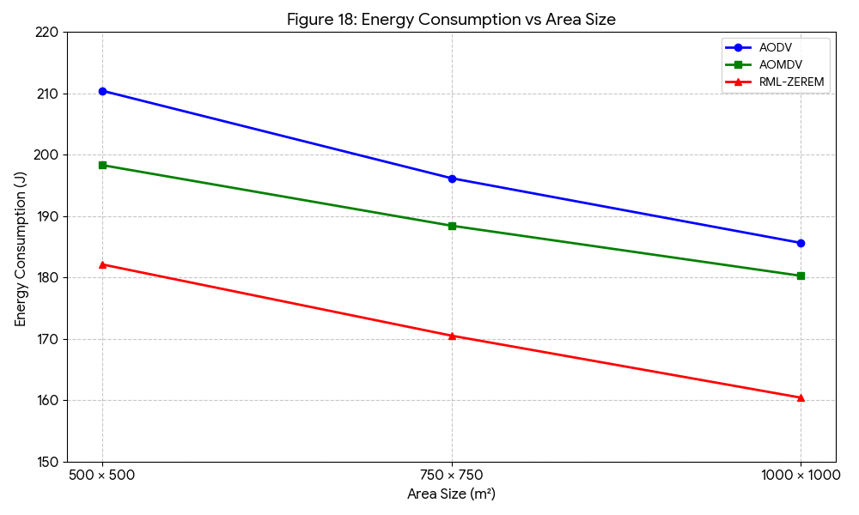
Figure 18: Energy Consumption Trends for Various Simulation Area Sizes
Throughput Analysis
The proposed RML-ZEREM protocol demonstrates better throughput performance than AODV and AOMDV through testing across different network area sizes, which range from 500 by 500 meters to 1000 by 1000 meters. Results outlined in Table 13 show RML-ZEREM performs best in the throughput level in all tested scenarios. Throughput performance for the proposed protocol shows substantial improvement as the network area size increases. The throughput improvement over AODV increases from approximately 26.30% in smaller network areas to about 89.84% in larger network areas. RML-ZEREM demonstrates better performance than AOMDV because it achieves performance enhancements between 80% and 115%. The improved throughput performance results from enhanced node distribution together with decreased network congestion, which occurs in larger simulation environments. Lower node density results in fewer packet collisions, together with decreased channel contention, which creates more reliable communication links that support efficient packet transmission. The reinforcement learning-based routing mechanism establishes optimal routing paths through its ability to adapt to various network conditions, which leads to better data transmission and routing performance. The zone-based routing structure enhances throughput capacity by decreasing routing expenditures while keeping routing control tasks inside local areas. The proposed protocol can effectively adapt to network situations because it establishes stable communication links in low-density network areas. The network area size determines the throughput performance, which Figure 19 demonstrates. The results show that throughput increases as the simulation area expands, while RML-ZEREM consistently maintains a significant performance advantage over conventional routing protocols due to adaptive routing, efficient load distribution, and intelligent route optimization.
Table 13: Throughput Performance across Various Area Dimensions
Area Size | AODV (kbps) | AOMDV (kbps) | RML-ZEREM (kbps) | Improvement over AODV (%) | Improvement over AOMDV (%)
500 × 500 m² | 7902.54 | 4633.37 | 9979.89 | 26.30% | 115.32%
750 × 750 m² | 7382.03 | 6021.81 | 11962.20 | 62.05% | 98.63%
1000 × 1000 m² | 7196.04 | 7580.50 | 13660.06 | 89.84% | 80.19%

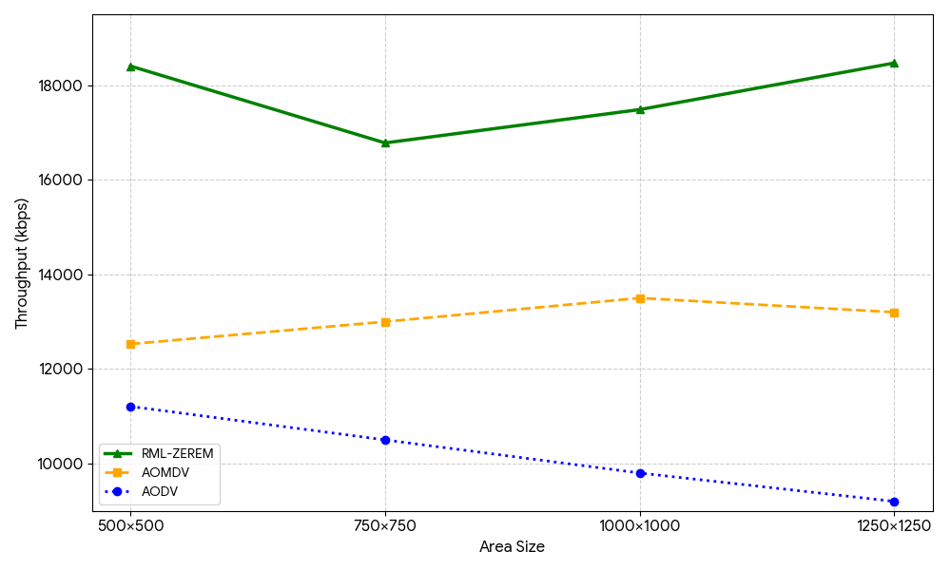
Figure 19: Throughput Performance across Different Network Dimensions
Packet Delivery Ratio (PDR) Analysis
The research compares packet delivery ratios of the RML-ZEREM protocol with AODV and AOMDV under different network sizes, which range from 500 meters by 500 meters to 1000 meters by 1000 meters. The results presented in Table 14 show that the Packet Delivery Ratio (PDR) decreases for all routing protocols as the network area increases. This decrease occurs because node density decreases while communication distances increase, link stability decreases, and route failures become more common in sparse network environments. The results presented in Table 14 show that the Packet Delivery Ratio (PDR) decreases for all routing protocols as the network area increases. This decrease occurs because node density decreases while communication distances increase, link stability decreases, and route failures become more common in sparse network environments. The proposed RML-ZEREM protocol delivers better packet delivery results than standard routing protocols despite facing various difficulties. The proposed protocol achieves PDR improvements of 3.57% over AODV and 6.20% over AOMDV at the 500 × 500 m² test site. The performance benefits grow increasingly substantial when the network area extends to larger dimensions. ZEREM shows about 11.77% better performance than AODV and 7.24% better performance than AOMDV at the 1000 × 1000 m² test site. The results show that the reinforcement learning-based adaptive routing mechanism effectively manages sparse and dynamic MANET environments. The improved packet delivery performance comes from three main components, which include intelligent route selection, adaptive Q-learning-based decision-making, and efficient zone-based routing operations. The proposed protocol establishes stable communication paths through its capacity to quickly adapt to changes in network topology, which ultimately results in better routing reliability and reduced packet losses across different area sizes. Figure 20 shows how the Packet Delivery Ratio changes with different sizes of network areas. The results show that all protocols experience a gradual decrease in PDR when the simulation area expands. RML-ZEREM maintains superior packet delivery performance because of its adaptive routing system, intelligent path selection and its ability to handle sparse network conditions.
Table 14: Packet Delivery Ratio (PDR) vs. Network Area Size
Area Size | AODV (%) | AOMDV (%) | RML-ZEREM (%) | Improvement over AODV (%) | Improvement over AOMDV (%)
500 × 500 m² | 92.50 | 90.20 | 95.80 | 3.57% | 6.20%
750 × 750 m² | 85.40 | 87.10 | 91.60 | 7.26% | 5.17%
1000 × 1000 m² | 78.20 | 81.50 | 87.40 | 11.77% | 7.24%

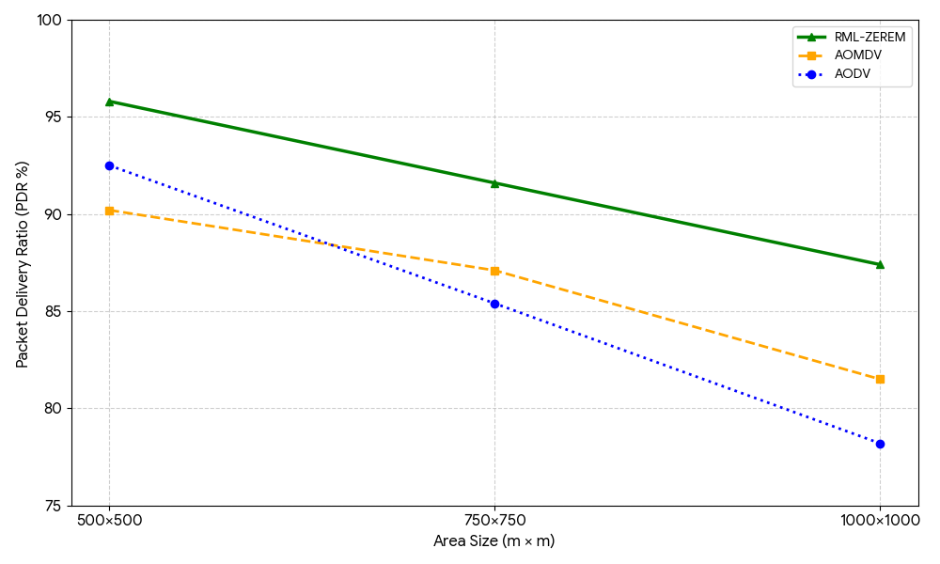
Figure 20: Packet Delivery Ratio (PDR) Analysis based on Area Size
6.5 Conclusion

The simulation results show that the RML-ZEREM protocol outperforms traditional routing systems, which include AODV and AOMDV, through its superior performance in energy use and data transmission between systems and its ability to deliver packets and its network adaptability and its ability to expand in different MANET network conditions. The combination of reinforcement learning with a zone-based routing system enables smart and flexible pathfinding, which reacts to changes in network status through monitoring both node power levels and their movement patterns, and their connection strength. The protocol achieves two goals by cutting energy use and routing costs while boosting data transmission rates and establishing more reliable communication. RML-ZEREM demonstrates effective adaptation to changes in network structure that occur because of moving nodes and shifting network population levels. The zone-based architecture enables better system expansion because it restricts routing tasks to specific areas, which results in decreased network traffic and less control packet movement. The protocol requires efficient reinforcement learning parameter tuning because it generates extra computational work during the learning period, but the system shows performance gains that prove its suitability for resource-limited MANET environments. The research will advance Deep Reinforcement Learning (DRL) processes by combining adaptive zone formation methods and security features with real-world applications in IoT and VANET, and 5G wireless networks.

References
1. Abdullah, A.M., An efficient approach for minimizing control packets and enhancing route stability in mobile ad-hoc networks. The Journal of Supercomputing, 2026. 82(5): p. 305.
2. Saxena, P. and G. Phade, Analysis of routing protocols adopted in FANET and RANET communication network. Wireless Networks, 2026: p. 1-27.
3. Mingqiang, Z., et al., I-AOMDV: QoS-aware multipath routing protocol for enhanced in dynamic multi-node vehicle area network. China Communications, 2026. 23(3): p. 286-297.
4. Harshitha, V.S., V.R. Surekha, and V. Ananthi. A Comprehensive Review on Q-Learning Based Optimal Routing Protocol for MANET. in 2026 International Conference on Machine Learning and Autonomous Systems (ICMLAS). 2026. IEEE.
5. Tonin, A., et al., A novel energy model for optimizing energy efficiency and prolonging network lifetime in MANET. IEEE Access, 2025.
6. Shah, I.A. and M. Ahmed, Survey on protocols in MANETs, WSNs and DTNs. International Journal of System Assurance Engineering and Management, 2025. 16(6): p. 2089-2120.
7. Yakubu, S., A. Mindila, and P. Kihato, Design of Self‐Healing Mesh Architecture: A Proof‐of‐Stake AODV Routing Protocol With Autonomous Adaptability. Engineering Reports, 2026. 8(2): p. e70656.
8. Wijonarko, D., et al., Mobile Ad-Hoc Network (MANET) Method: Some Trends and Open Issues. Recent in Engineering Science and Technology, 2025. 3(02): p. 49-74.
9. Maray, M., Hybrid deep learning techniques for adaptive routing and congestion control in urban VANET for wireless mobile networking. Scientific Reports, 2026.
10. Mazhar, T., S. Guizani, and H. Hamam, Deep Reinforcement Learning and IoT for Renewable Energy Optimization in Smart Buildings: A Comprehensive Review. IET Generation, Transmission & Distribution, 2026. 20(1): p. e70255.
11. Vivekanandan, S.D., et al., MANETs and WSNs in Hybrid Genghis Khan Shark and Lotus Effect Optimizer for Secure Routing. International Journal of Communication Systems, 2026. 39(6): p. e70461.
12. Uma, B. and S. Sumathi, Secure routing and attack detection in mobile ad hoc networks via bi-directional cascade residual convolutional neural networks. OPSEARCH, 2026: p. 1-31.
13. Singh, S.B., et al., An adaptive, energy-efficient and secure routing protocol for zone-related mobile Ad-hoc networks using reinforcement learning: SB Singh et al. Scientific Reports, 2025.
14. Selim, I.M., et al., Manet routing protocols’ performance assessment under dynamic network conditions. Applied Sciences, 2025. 15(6): p. 2891.
15. Sarkar, N.I. and M.J. Ali, A study of MANET routing protocols in heterogeneous networks: a review and performance comparison. Electronics, 2025. 14(5): p. 872.
16. Shakya, A., S. Ali, and P. Nand. Simulation-Based Performance Analysis of MANET Routing Protocols: Proactive vs. Reactive. in 2025 Optical Communication, Photonics, Telecommunications, and Intelligent Machine Applications (OPTIMA). 2025. IEEE.
17. Karthikeyan, M., D. Manimegalai, and K. Rajagopal, Optimizing energy efficiency in wireless sensor networks: dynamic routing with capuchin search algorithm. Multimedia Tools and Applications, 2025. 84(15): p. 15453-15477.
18. Tegulapalle, V.R., et al. Optimizing Rural Healthcare Monitoring Using MANET: A Comparative Analysis of AODV, DSDV, DYMO, and OSLR. in International Conference on Power Engineering and Intelligent Systems (PEIS). 2025. Springer.
19. Ghanem, M., et al., A dynamic simulation framework for mobile ad hoc networks in search and rescue operations. Simulation Modelling Practice and Theory, 2026: p. 103281.
20. Tirumalasetti, R., et al., A Systematic Review of VANET Routing Protocols for Intelligent Transport Systems (ITSs). Journal of Advanced Transportation, 2026. 2026(1): p. 7999623.
21. Sahu, R., et al., Optimizing MANET Routing with SINTM: A Smarter Load Balancing Approach, in Emerging Perspectives and Applications of Computational Intelligence and Smart Systems. 2026, CRC Press. p. 219-223.
22. More, A.P., R.S. Kale, and M. Rizvi, Enhancement in Performance Metrics for Mobile Ad Hoc Networks (MANETs) Using Hybrid Ant Lion Optimization (HALO) Algorithm. Journal of Electrical and Computer Engineering, 2026. 2026(1): p. 9947624.
23. Abdullah, A.M., Hybrid energy-efficient routing protocol for extended network lifetime in wireless body area networks. The Journal of Supercomputing, 2026. 82(3): p. 130.
24. Yang, H., et al., Optimal Zone Routing Scheme for LEO Mega-Constellation Networks. IEEE Transactions on Mobile Computing, 2026.
25. Sahu, R., et al., Networks Design and Evaluation of a Zone-Based Energy-Efficient Routing Protocol for Hybrid Wireless Networks, in Emerging Perspectives and Applications of Computational Intelligence and Smart Systems. 2026, CRC Press. p. 224-229.
26. Sahu, R., S. Sharma, and M. Rizvi, ZBLE: zone based leader election energy constrained AOMDV routing protocol. International Journal of Computer Networks and Applications, 2019. 6(3): p. 39-46.
27. Sahu, R., S. Sharma, and M. Rizvi, ZBLE: Zone based efficient energy multipath protocol for routing in mobile Ad Hoc networks. Wireless Personal Communications, 2020. 113(4): p. 2641-2659.
28. Zelani, S.K., et al., A Reinforcement Learning–Driven Payoff‐Adaptive Game‐Theoretic Framework for Secure and Reliable Operation of Mobile Ad Hoc Networks. Transactions on Emerging Telecommunications Technologies, 2026. 37(4): p. e70394.
29. Kurkina, N., J. Papaj, and J. Badar, Enhancing routing efficiency in Cloud MANET using KNN and Fitness Function for dynamic network environments. Peer-to-Peer Networking and Applications, 2026. 19(2): p. 40.
30. Sahu, R., et al., Enhancing Criminal Identification through Siamese CNN Facial Recognition: A Law Enforcement Perspective, in Emerging Perspectives and Applications of Computational Intelligence and Smart Systems. 2026, CRC Press. p. 208-212.

