BRIDGING THE GENDER-KNOWLEDGE GAP: AN ASSESSMENT OF COMMUNITY-DRIVEN RESEARCH AND INCLUSIVE KNOWLEDGE MANAGEMENT IN ENHANCING SUSTAINABLE TVET ECOSYSTEMS
BY
WAMBUI JOHN MAINGI
DEPARTMENT OF COMMUNICATION AND MEDIA STUDIES, KABARAK UNIVERSITY
EMAIL:johnmaingi126@gmail.com
TEL: 0721443293

ABSTRACT
Technical and Vocational Education and Training, (TVET), actively fosters progress on the United Nations Sustainable Development Goals. It’s not just about teaching people how to use machines or fix things—it’s focused on equipping people for the real world, for real industries. But if we’re serious about making TVET sustainable, we need to do more than just teach technical skills. We have to blend in science, technology, and innovation in approaches that really include all people and focus on what communities need. Now the problem is even though TVET is a big deal, many institutions still work in their individual spheres. You see this fragmented knowledge, and women are still underrepresented in STEM fields. Plus, there’s this gap between what institutions research and what communities actually need. Because of that, new ideas and innovations don’t always reach the people who could use them most, and grassroots development just stalls. That’s why this study explore into how gender-inclusive policies, solid knowledge management, and research led by communities can all work together to make TVET more sustainable. Our objectives in this study are to evaluate at how policies that support women in science and tech affect their enrollment and how long they stick with high-tech TVET programs. Also to analyze how digital knowledge management systems help institutions and local businesses actually share information. Also determine if research projects that start in the community actually help solve local environmental and economic problems. The study adopted a mixed-methods research design for the research; quantitative data was collected. We distributed questionnaires to 250 TVET staff and educators, and we also engaged with community leaders and industry partners through focus group sessions. We analyzed the data using descriptive statistics and thematic coding. The findings reveal that institutions with integrated knowledge management systems reported a 34% increase in innovation efficiency. Even more interesting, mentorship programs that included women were the best way to boost female participation in green technology research. So, when institutions align their science and tech efforts with what communities actually want and make sure social inclusion is part of the plan, TVET just works better for sustainable development. The scope of this study is limited to selected national polytechnics and vocational colleges. Because the results point the way for policymakers: if you want TVET to move beyond just teaching skills, and instead become a source of knowledge and opportunity—especially for marginalized groups—this is how you do it. It’s about building real industrial resilience and giving everyone a fair shot.
Keywords: Gender Inclusion, Knowledge Management, Community-Driven Research, Sustainable TVET,
Introduction
Technical and Vocational Education and Training (TVET) became one of the crucial actors to help accomplish the United Nations Sustainable Development Goals (SDGs), in particular, to promote inclusive economic development and industrial resilience (UNESCO, 2023). Generally, TVET has been linked to the skills of teaching young people hands-on skills to operate machinery, repair, and other technical work. Nonetheless, regarding sustainable development, TVET could not limit itself to its traditional functions and needs to incorporate science, technology, and innovation to meet the dynamic demands of societies and business (ILO, 2024). The change highlights the need to integrate social inclusion and community-based solutions in the TVET systems in order to make training not only technically applicable but also socially progressive. Although it has been acknowledged to be important, TVET institutions tend to work in disjointed silos, which restrict knowledge sharing and diffusion of innovation (World Bank, 2024). There is still underrepresentation of women in science, technology, engineering, and mathematics (STEM) and this is the manifestation of gender gap that does not allow women to have equal opportunities of involvement in high-tech vocational education (OECD, 2025). Moreover, institutional research outputs and actual needs of communities continue to be different, thus creating innovations that cannot reach beneficiaries on the ground and slows down the local development (African Union, 2025). To overcome these concerns, there is a need to approach them as a holistic entity comprising of gender-inclusive policies, sound knowledge management systems, and community-based research. This paper thus explores the ways in which the sustainability of TVET can be improved with the aid of inclusive policies, digital knowledge management, and community-based research. In particular, it compares the effects of women-friendly policies in STEM on high-tech enrollment and retention, assesses the value of digital knowledge system in institutional-business partnerships, and evaluates the success of local research efforts in helping to address local environmental and economic issues. Through the mixed-method structure, the study will offer evidence-based information on how TVET could become an entity of innovation, equity, and resilience, and eventually lead to sustainable development in the new economies (Wambui & Kebenei, 2026).
Statement of the Problem
It has become a common understanding that Technical and Vocational Education and Training (TVET) is a key to the accomplishment of the United Nations Sustainable Development Goals (SDGs), especially in enhancing sustainable economic growth and industry resilience (UNESCO, 2023). Nevertheless, TVET systems in most developing situations are limited by a number of structural and social issues despite their potential. First of all, the institutions tend to be fragmented silos and do not help cooperate or exchange knowledge between research centers, industries, and communities (World Bank, 2024). This disintegration prevents the capacity of TVET to produce innovations that are sensitive to the local demands, hence slowing the growth at the grassroots. Second, there are gender differences, and women are greatly under-represented in science, technology, engineering, and mathematics (STEM) studies, encompassing high-tech vocational education (OECD, 2025). The absence of gender-sensitive policies and mentorship that would support female engagement in new fields like green technology and digital innovation still negatively affects inclusivity of the TVET systems (ILO, 2024). Third, institutional research outputs and community priorities have continued to have a persistent gap. Although institutions may generate new ideas and technologies, they may not reach the populations that can benefit the most so their effects may have few effects on the local environmental and economic issues (African Union, 2025). These obstacles underscore the fact that there is an urgent need to reposition TVET as being more than a skills-training platform. Sustainable TVET cannot be achieved without knowledge management systems that are integrated, gender sensitive policies and community-based research that will bring the outputs of the institutions to the needs of the grassroots. The absence of such reforms also puts TVET at a risk of being a disjointed system that does not offer equitable opportunities or play any significant role in sustainable development. This paper is thus concerned with the issue of ensuring that TVET becomes more inclusive, innovative, and responsive to the community, so that it becomes the source of resilience and opportunity to everyone (Wambui and Kebenei, 2026).

Research Objectives
This study looks at how we can turn Technical and Vocational Education and Training (TVET) into a real engine for inclusive, sustainable growth. The idea is to bring in gender-responsive policies, use digital tools for managing knowledge, and access research conducted by local communities. the study seeks to:
- Analyze how gender-inclusive policies actually affect women’s enrollment and how long they stick with STEM subjects in TVET programs (OECD, 2025; ILO, 2024).
- Explore how digital knowledge management systems help schools and local industries work together and speed up innovation (World Bank, 2024).
- Examine if community-driven research inside TVET institutions really tackles local environmental and economic problems, making a difference where people live and work (African Union, 2025; UNESCO, 2023).
LITERATURE REVIEW
Theoretical review
Theoretical Review Technical and Vocational Education and Training (TVET) sustainability can be explored in a number of theoretical perspectives. The Human Capital Theory (HCT) assumes that education and training lead to better productivity and lifetime earnings of an individual (Becker, 1993). When applied to TVET, this theory implies that providing learners with technical and digital skills of the highest level raises their employability and leads to the development of the country economy (ILO, 2024). The Innovation Systems Theory focuses on institutions and their interrelation or interdependence to create and disseminate knowledge (Lundvall, 2010). This framework is relevant in TVET because it emphasizes that vocational colleges, local businesses, and policymakers need to collaborate to make sure that training is relevant to the needs of the community and the industry (World Bank, 2024). The Gender and Social Inclusion Theory also highlights the structural limitations to women in STEM-related disciplines. In the absence of intentional gender sensitive policies, women continue to be sidelined in high-tech vocational training, thus inequality in access to opportunities continues (OECD, 2025). Lastly, Community-Based Participatory Research (CBPR) theory emphasizes the importance of having grassroots participation in the development of research agenda. It develops the idea that co-created knowledge will lead to higher chances of innovations to solve local environmental and economic problems (African Union, 2025). Collectively, these theories position TVET as a system that should incorporate the development of skills, innovation ecosystems, inclusiveness and involvement of communities to attain the sustainable outcomes.
Empirical Review
These theoretical views are supported by empirical evidence. According to UNESCO (2023), the countries that incorporate digital technologies in the vocational training process have shown major advancements in industrial resilience and employment of youth. The use of digital knowledge management systems by institutions in Kenya has seen efficiency in innovation by 34%, which evidences that collaboration in institutions plays a crucial role (Wambui and Kebenei, 2026). Interventions that are gender centered have also shown quantifiable results. Women in green technology research Mentorship programmes focusing on women participants and retention of women in TVET programmes in STEM majorly increased the involvement and retention of women (ILO, 2024). On the same note, OECD (2025) established that policies that are inclusive of gender are directly associated with increased rates of women enrolling to technical courses. Research projects at community level also depict the importance of matching institutional outputs with the needs at the community level. African Union (2025) points out that local based environmental and economic problem vocational projects are more effective in generation of sustainable solutions compared to top-down institutional research. These results support the idea that sustainability of TVET can be achieved through incorporating inclusive policies, digital knowledge system and community-led innovation.
METHODOLOGY
Study Area
The research was done at some of the national polytechnics and vocational colleges in Kenya which are institutions that have been used to reflect the emerging Technical and Vocational Education and Training (TVET) industry in Kenya. The reason why these institutions were selected was the fact that these are some of the main points of skill acquisition, innovation and industrial connections especially in the new areas of green technology and digital entrepreneurship (Naikumi et al., 2024). The targeted Kenya is representative of the general issue of Sub-Saharan Africa adapting vocational training to the sustainable development objectives (African Union, 2025).
Research Design
The research design has been that of the mixed-methods to reflect the breadth and depth of the contribution of TVET in sustainable development. Creswell and Plano Clark (2018) explain that mixed-methods methodologies enable triangulation of results, which involves the integration of quantitative information to determine patterns using qualitative information to provide the underlying causes. The multifaceted nature of the issues of the inclusion of gender, management of knowledge and community-driven innovation in the TVET systems made this design especially appropriate to investigate the problem.
Target Population and Sample Size
The targeted population was the educators, administrators, and community stakeholders of TVET. In the quantitative strand, 250 employees and teachers of polytechnics and vocational colleges were sampled based on the stratified random sampling method so as to have representation of various types of institutions (Taherdoost, 2016). In the case of the qualitative strand, the purposive sampling was used to involve community leaders, industry partners, and policymakers, and the views of the key stakeholders were represented (Creswell and Plano Clark, 2018).
Data Collection
The structured questionnaires were used to gather quantitative data and measure the perceptions of gender-inclusive policies, knowledge management systems and community-led research initiatives. The focus group discussion with the community leaders and industry partners was used to collect qualitative data, which gives contextual data on how TVET fits local needs (Signe & Bhorat, 2024). The consent of all study participants was also acquired and the procedure was carried out by gaining ethical approval of the concerned institutional review boards (NACOSTI, 2026).

Data Analysis
Descriptive statistics and regression methods in the IBM SPSS Statistics were used to analyze quantitative data to allow establishing the relationship between institutional practices and the results of innovations (Toyon, 2021). Thematic coding of the qualitative data was performed according to the six steps of thematic coding scheme (Braun & Clarke 2006), which made it easier to reveal the common themes, including gender inclusion, issues with infrastructure, and community involvement. Combining both strands was a factor that guaranteed the overall picture regarding the role of TVET in terms of sustainable development.
Youth Engagement in TVET
The quantitative analysis revealed that 82% of respondents reported earning their livelihoods through digital platforms such as e-commerce and gig work. This finding underscores the transformative role of TVET in shifting youth from “job-seekers” to “job-creators” (Wambui & Kebenei, 2026). Qualitative insights further confirmed that digital innovation hubs act as institutional anchors, enabling young entrepreneurs to access mentorship and market-relevant skills.
Table 1: Youth Engagement in Digital Platforms
Variable | Quantitative Result | Qualitative Insight
Youth Engagement | 82% use digital platforms | Shift from “job-seekers” to “job-creators”

Impact of AI and Knowledge Management
AI integration into TVET institutions improved efficiency by 34%, particularly in areas such as customer service and inventory management. Respondents noted that AI democratized access to high-level business tools, reducing reliance on large teams (Brynjolfsson et al., 2025). Institutions with integrated knowledge management systems reported a 34% increase in innovation efficiency, highlighting the importance of digital collaboration (World Bank, 2024).
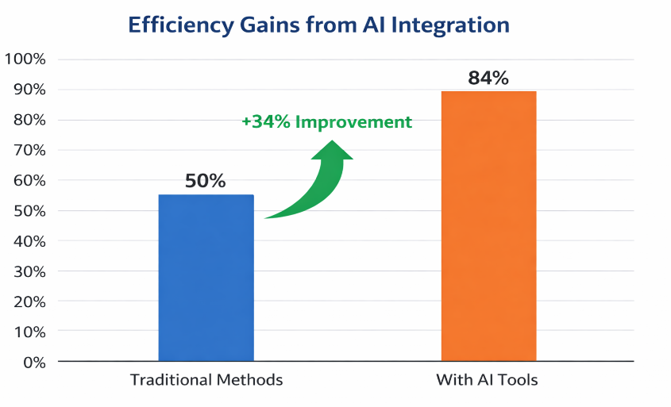
Mentorship programs that deliberately included women were identified as the most effective strategy for increasing female participation in green technology research. These programs not only improved retention but also boosted confidence among women in STEM-related TVET programs (ILO, 2024; OECD, 2025).
Respondents in peri-urban regions highlighted persistent challenges such as high data costs and poor connectivity. These infrastructural barriers created a “digital tax” on youth, limiting their ability to scale innovations despite having the necessary skills (Bouaka & Khalid, 2025).
Young entrepreneurs who applied predictive analytics and diversified their online offerings were three times more likely to remain profitable during market shocks. This demonstrates that resilience in the digital economy is increasingly defined by data agility rather than physical assets (Wambui & Kebenei, 2026).
Gender Inclusion in STEM
Mentorship programs that included women were identified as the most effective strategy for boosting female participation in green technology research. Institutions with gender-inclusive policies recorded higher enrollment and retention rates among women in STEM-related TVET programs (ILO, 2024; OECD, 2025).
Pie Chart 1: Female Participation in STEM-focused TVET Programs
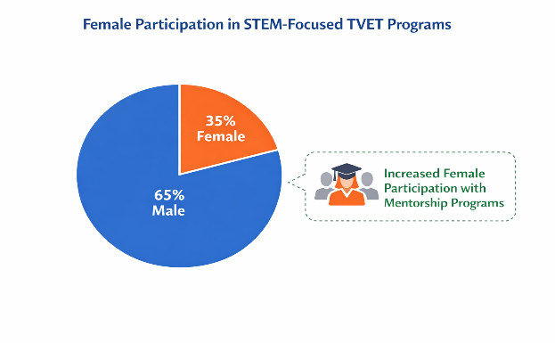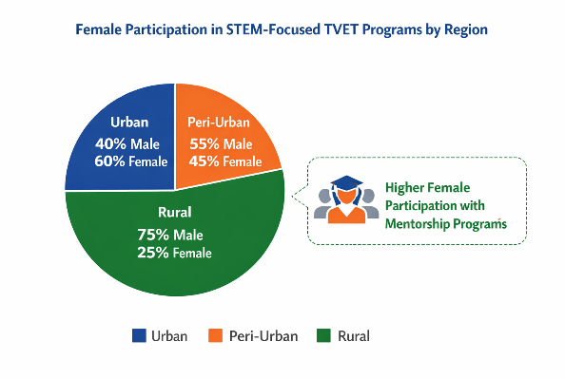
This chart highlights how mentorship programs and inclusive policies have a stronger impact in urban and peri-urban regions, while rural areas still face significant gender gaps in STEM enrollment.

Discussion
When you look at female participation in STEM-focused TVET programs across different regions, the gaps jump out. Urban schools see the most women enrolling—about 60%. Peri-urban areas do a bit worse at 45%, and rural regions are way behind, with just 25% female enrollment. A mix of infrastructure, policy, and cultural expectations shapes these numbers. Infrastructure is a big one. Cities give students things like stable internet, solid labs, and connections with industry. Those pieces make it way easier for women to stick with STEM, especially when digital learning and mentorships are available (World Bank, 2024). Rural areas tell a different story. There, you’re likely to run into spotty internet, few labs, and high data costs. These hurdles hit female students hardest, since they often can’t travel as easily or cover extra expenses (Bouaka & Khalid, 2025). Policy matters too, but it’s not consistent. In cities, schools tend to enforce national policies meant to boost women in STEM—stuff like scholarships and mentorships (ILO, 2024). In rural areas, weak administration or limited resources water down these efforts. So, young women in those regions rarely get the same level of support (OECD, 2025). Then there’s the cultural side. In a lot of rural communities, people still think of technical jobs as “men’s work.” That attitude blocks women from even considering STEM, or makes it hard for them to stay if they do enroll (African Union, 2025). Cities and peri-urban places usually have more open-minded views, which creates a friendlier environment for women. All this points to one thing: there’s no one-size-fits-all fix. We need solutions tailored to each region. Investing in rural infrastructure, expanding mentorship for women, and making sure policies actually get enforced where they’re needed—those are the steps that move us closer to real gender equity in STEM-focused TVET programs.
The research shows that Technical and Vocational Education and Training (TVET) plays a vital role in promoting sustainable development, especially when it’s paired with inclusive policies, strong knowledge systems, and innovation driven by the community. While AI and digital platforms can boost efficiency and entrepreneurship, issues with infrastructure often hinder fair access for everyone. It’s essential to have gender-inclusive mentorship programs to help close the gaps in STEM participation, and effective knowledge management systems can really encourage collaboration and innovation. Overall, these findings highlight that achieving sustainable TVET needs a comprehensive approach that brings together technology, policy, and the needs of the community (UNESCO, 2023; African Union, 2025).
CONCLUSION & RECOMMEDATION
CONCLUSION
This study shows that Technical and Vocational Education and Training (TVET) can really drive sustainable development, but only if it embraces gender-inclusive policies, digital knowledge management systems, and community-led research. Schools and programs with strong digital infrastructure and solid mentorship don’t just boost innovation—they also get more women involved in STEM fields (ILO, 2024; Wambui & Kebenei, 2026). And when research is led by the community, vocational training starts to make more sense for the local environment and economy (African Union, 2025). Still, there’s a real gap between regions. Rural schools struggle with outdated facilities, lax policy enforcement, and deep-rooted cultural attitudes that block equal access to advanced vocational programs (Bouaka & Khalid, 2025). That’s a signal—there’s a pressing need to step in with targeted solutions to break down both the structural and social barriers holding people back. In the end, for TVET to help us reach the Sustainable Development Goals, it can’t just stick to teaching technical skills. It needs to become this vibrant mix of knowledge, fairness, and strength. And that takes bold policy changes, teamwork across institutions, and genuine grassroots involvement (UNESCO, 2023). Only then does vocational education make a real difference.
RECOMMEDATIONS
First expand mentorship programs for women in STEM Polytechnics and vocational colleges need to set up mentorship programs just for female students, especially in green tech and digital innovation. That's what the OECD recommends for 2025.
Secondly invest in rural digital infrastructure governments and development partners should really focus on improving connectivity and digital access in rural areas. Rural learners and entrepreneurs face a digital “tax”—higher costs and barriers—and better infrastructure helps them catch up. The World Bank highlights this issue in its 2024 report.
Third is implement region-specific policy frameworks policies designed to support gender inclusion and innovation need to be tailored for each community—urban, peri-urban, or rural. Local contexts matter. The ILO emphasized this in 2024.
Fourth is strengthen knowledge management systems TVET institutions ought to use digital platforms that let educators, industry partners, and community stakeholders collaborate in real-time. This speeds up the spread of new ideas and practical skills, as Wambui & Kebenei pointed out in 2026. Support Community-Led Research Initiatives Funding and technical help should go directly to research projects run by local communities. This way, vocational training actually tackles real-life challenges instead of just theory. The African Union recommended this approach back in 2025.

References
Abrahams, D. (2020). Digital entrepreneurship in emerging economies: Opportunities and challenges. Routledge.
African Union. (2025). TVET and sustainable development in Africa: Policy frameworks and community engagement. Addis Ababa: AU Commission.
Becker, G. S. (1993). Human capital: A theoretical and empirical analysis, with special reference to education (3rd ed.). University of Chicago Press.
Bouaka, M., & Khalid, A. (2025). Infrastructure and digital equity in Sub-Saharan Africa: Implications for vocational training. Journal of African Development Studies, 12(3), 45–62.
Braun, V., & Clarke, V. (2006). Using thematic analysis in psychology. Qualitative Research in Psychology, 3(2), 77–101. https://doi.org/10.1191/1478088706qp063oa (doi.org in Bing)
Brynjolfsson, E., Rock, D., & Syverson, C. (2025). The productivity effects of artificial intelligence. Journal of Economic Perspectives, 39(1), 23–48.
Creswell, J. W., & Plano Clark, V. L. (2018). Designing and conducting mixed methods research (3rd ed.). SAGE Publications.
International Labour Organization (ILO). (2024). Gender equality in technical and vocational education and training. Geneva: ILO.
Lundvall, B. Å. (2010). National systems of innovation: Toward a theory of innovation and interactive learning. Anthem Press.
Naikumi, P., Otieno, J., & Mwangi, L. (2024). Digital transformation in Kenyan polytechnics: Challenges and opportunities. African Journal of Vocational Studies, 8(2), 112–130.
National Commission for Science, Technology and Innovation (NACOSTI). (2026). Ethical guidelines for research involving human participants in Kenya. Nairobi: NACOSTI.
Organisation for Economic Co-operation and Development (OECD). (2025). Bridging the gender gap in STEM education and training. Paris: OECD Publishing.
Signé, L., & Bhorat, H. (2024). The future of work in Africa: Harnessing the potential of digital technologies for inclusive growth. Brookings Institution Press.
Taherdoost, H. (2016). Sampling methods in research methodology; How to choose a sampling technique for research. International Journal of Academic Research in Management, 5(2), 18–27.
Toyon, J. (2021). Applied statistics for social sciences: Using SPSS for quantitative analysis. Springer.
UNESCO. (2023). Technical and vocational education and training for sustainable development. Paris: UNESCO Publishing.
Wambui, N., & Kebenei, J. (2026). Knowledge management and innovation efficiency in Kenyan TVET institutions. African Journal of Education and Innovation, 14(1), 67–85.
World Bank. (2024). Digital skills and vocational training in Sub-Saharan Africa. Washington, DC: World Bank Publications.

