Free Treatment Without Accessibility: Socio-Economic Determinants of Antiretroviral Therapy (ART) Adherence in Gusau, Nigeria.

ABSTRACT
Background: Non-compliance with antiretroviral drugs (ARD) remains a significant barrier to achieving viral suppression among people living with HIV/AIDS, particularly in resource-limited settings like northern Nigeria. Despite the availability of free antiretroviral drugs through public health facilities, many patients fail to maintain the optimal adherence levels required to prevent treatment failure, drug resistance, and disease progression. This study was conducted to investigate socio-economics influence on adherence to antiretroviral drugs among HIV/AIDS patients attending the Antiretroviral Clinic at General Hospital, Gusau, Zamfara State.
Methodology: This study employed a descriptive cross-sectional survey design to investigate the socio-economic factors influencing medication adherence among HIV-positive adults aged 18 and above at General Hospital Gusau. The study targeted patients with at least three months of experience on Antiretroviral Therapy (ART), utilizing a sample size of 188 respondents determined by Yamane’s formula from a total population of 300. Participants were selected via systematic random sampling to ensure an unbiased and representative sample, and the resulting data were analyzed through descriptive statistics, including frequencies, percentages, and mean scores, summarize participant characteristics and the primary drivers of treatment non-compliance
Results: The study identifies transportation cost and poverty as the most critical barrier to treatment adherence (Mean = 3.04), with 74.5% of respondents missing medication due to travel costs, underscoring that the financial burden of accessing "free" care remains a major deterrent. Beyond economic factors, lack of social support (Mean = 2.87) and geographical distance to clinics (Mean = 2.73) significantly impede compliance for over 60% of patients, highlighting the need for decentralized care and stronger community networks. Furthermore, while occupational demands and low literacy levels also play a role, the overarching data suggests that structural and economic challenges, rather than a lack of patient willingness, are the primary drivers of non-compliance among ART patients in Gusau.
Conclusion: Non-compliance to antiretroviral drugs among HIV/AIDS patients at General Hospital, Gusau is not caused by a health systems factor but rather a socio- economic factor, medical intervention alone is insufficient. For HIV management in Zamfara State to be successful, clinical care must be integrated with economic support programs, decentralized drug delivery systems, and community-led social support initiatives to mitigate the harsh socio-economic realities currently hindering patient’s compliance to ART.
Keywords: Non-compliance, Antiretroviral drugs, HIV/AIDS, Adherence.

I.Introduction
Human Immunodeficiency Virus (HIV) infection continues to be one of the world’s most serious public health problems globally. It remains a major cause of illness and death in many countries, especially in developing regions. According to the Joint United Nations Programme on HIV/AIDS (UNAIDS, 2024), about 39 million people were living with HIV globally by the end of 2023, and about 1.3 million new infections were recorded within the same year. Although great progress has been made in the fight against HIV/AIDS, the disease still poses a great challenge to individuals, families, and health systems around the world. The introduction of Antiretroviral Drugs (ARD) has changed the course of HIV/AIDS management. ARD helps to reduce the amount of virus in the body, improve the immune system, and prevent the spread of the virus from one person to another. The World Health Organization (WHO, 2023) noted that when people living with HIV/AIDS take their medications correctly, they can live long, healthy lives almost like those without HIV/AIDS. However one major challenge affecting the success of ARD programs is non-compliance or non-adherence to prescribed drugs. Human Immunodeficiency Virus (HIV) infection remains a major public health concern worldwide, and non-compliance to antiretroviral drugs (ARD) continues to undermine global efforts to achieve viral suppression. According to the World Health Organization (WHO, 2023), while over 29 million people globally were receiving ARD, about 33% did not achieve optimal adherence levels, placing them at risk of treatment failure and HIV progression. Non-adherence contributes to drug resistance, increased morbidity and mortality, and higher rates of HIV transmission (Buh et al., 2023). In Nigeria, adherence levels remain suboptimal. Reports indicate that only 70–75% of people living with HIV/AIDS (PLHIV) maintain consistent ARD use, which is below the UNAIDS recommended target of 90% (UNAIDS, 2023). Poor adherence in Nigeria has been linked to factors such as stigma and discrimination, forgetfulness, drug side effects, transportation difficulties, and inadequate counseling, all of which hinder treatment effectiveness (Oluwole et al., 2023; Abatur et al., 2023).

Non-compliance means the failure or unwillingness of patients to take their prescribed medications correctly, consistently, or at the right time (Isika et al., 2022). For people living with HIV/AIDS. This may be caused by a combination of social, economic, behavioral, and health-system factors. Some of these include poverty, forgetfulness, side effects of drugs, stigma, long distance to health facilities, and poor counseling (Iwegwau et al., 2019). When patients fail to take their ARD medications as prescribed, the virus in their body can multiply rapidly, leading to drug resistance, treatment failure, and even death. Globally, several interventions have been introduced to improve ARD adherence, such as free drug distribution, community support programs, and awareness campaigns. Despite these efforts, many people living with HIV/AIDS still struggle with consistent drug use (WHO, 2023). In sub-Saharan Africa, where most people with HIV/AIDS live, poor adherence remains a serious problem. Reports show that Africa bears about two-thirds of the global HIV/AIDS burden, and many patients fail to comply fully with their medication schedules due to poverty, stigma, and weak health systems (UNAIDS, 2024).
In Nigeria, HIV/AIDS continues to be a major public health concern. According to the National Agency for the Control of AIDS (NACA, 2023), Nigeria has one of the highest numbers of people living with HIV/AIDS in the world, with about 1.8 million adults receiving ARD. However, studies show that many patients do not take their medications regularly. Factors such as fear of discrimination, forgetfulness, side effects, lack of family support, transportation challenges, and inadequate knowledge about HIV/AIDS have been identified as key reasons for non-compliance (Eze et al., 2020). This poor adherence contributes to treatment failure and increases the risk of spreading resistant strains of the virus.
In Zamfara State, like in many parts of Nigeria, the government and international health organizations have made efforts to provide free and accessible ARD services in public hospitals. General Hospital, Gusau, serves as one of the major treatment centers offering ARD services to HIV/AIDS patients. Despite the availability of free drugs and counseling services, health workers in the ARD clinic have continued to report cases of patients missing their appointments or failing to take their medications regularly. These challenges make it necessary to carry out a local study to identify and address the specific factors affecting patient compliance in this hospital.
The problem of non-compliance is not just a medical issue but also a social and behavioral one. It affects the overall success of HIV/AIDS treatment programs, increases hospital admissions, and reduces the quality of life of affected individuals (WHO, 2023). When patients adhere to ARD, the virus in their body becomes undetectable, preventing transmission to others and improving their general wellbeing. Therefore, understanding why some patients still fail to comply with ARD is very important for both nurses and other health care workers. Nurses play a key role in counseling, patient education, and follow-up, which are all essential in improving adherence.
In Zamfara State, the situation is particularly concerning. Data from the National Agency for the Control of AIDS (NACA, 2022) indicate that the North-West zone, which includes Zamfara, recorded an ARD adherence rate below 65%, substantially lower than the national target of 90%.Within Gusau metropolis, clinic records from General Hospital, Gusau, reveal that many HIV/AIDS patients default on drug refills, miss clinic appointments, or take medications inconsistently, threatening both individual health outcomes and community viral-suppression goals (Magura et al., 2025).These statistics highlight the urgent need for context-specific research to identify and address the factors contributing to non-compliance among HIV/AIDS patients at General Hospital, Gusau This study is therefore designed to investigate the Socio-economics factors contributing to non-compliance of antiretroviral drugs among HIV/AIDS patients attending Antiretroviral Clinic at General Hospital, Gusau.

II. Methodology
The study utilized a descriptive cross-sectional survey design with a systematic random sampling technique to select 188 participants from a list of 300 HIV-positive patients (PLW HIV/AIDS) at General Hospital Gusau, ensuring every patient had an equal chance of selection
Zamfara State is located in the northwestern geopolitical zone of Nigeria. The state was created on October 1, 1996, from the former Soot State, and since then, it had continued to grow in population and healthcare demands. The study was conducted at the Antiretroviral drug (ARD) Clinic, General Hospital Gusau, Zamfara State, its has high patient volume, accessibility, availability of comprehensive HIV/AIDS care services, and the central role it played in HIV/AIDS management within the state. General Hospital Gusau was a major secondary healthcare facility that served as a referral center to many primary healthcare facilities and smaller clinics spread across the 14 local government areas of Zamfara State. General Hospital Gusau also played a leading role in implementing national HIV/AIDS programs supported by agencies such as the National Agency for the Control of AIDS (NACA), the Federal Ministry of Health, and international partners including USAID, Global Fund, and PEPFAR. These partnerships enhanced the capacity of the clinic to provide free ART medications, viral load testing, health education, and community outreach. As such, the hospital served as a major hub for ARD distribution in Zamfara State.
The target population comprises of all HIV/AIDS positive patient (PLW HIV/AIDS) (ranging from 18 years and above) The total number of HIV/AIDS positive patients are over three hundred (300). This figure was obtained from ART clinic of General Hospital Gusau record
The sample size was determined using Yamane Formula
n = N / 1 + N(e)²
n = sample size
N = population size (300)
e = margin of error (0.05)
n = 300/1 + 300(0.05)² = 222
Substitution:
n = 300/1+300(0.05)²
n = 300/1+300(0.0025)
n = 300/1+0.75
n = 300/1.75
n = 171.43
The calculated sample size was approximately 171 respondents.
for possible missing questionnaire, response or improperly filled questionnaires, 10% attrition was added:
10% of 171 = 17
171 + 17 = 188..
Inclusion Criteria
· HIV-positive patients aged 18 years and above
· Patients who had been on ARD for at least 2years above
· Patients who were physically and mentally stable for an interview
· Those who willingly provided consent
Exclusion Criteria
· Patients below 18 years
· Severely ill patients unable to respond
· Patients who did not consent
A structured questionnaire was used to collect data. The instrument was designed based on the objective of the study.
Validity & Reliability of the Instrument
.Instrument validity was ensured through an expert review of item standardization and objective alignment. Reliability was established via a test-retest pilot study (n = 18 HIV-positive patients) at an external location with similar population characteristics. This pilot data yielded a Cronbach’s alpha coefficient of 0.70, confirming acceptable internal consistency and instrument reliability
Ethical Considerations
. Ethical Approval: Before the commencement of the study, ethical approval was obtained from the Health Research Ethics Committee, reference (HREC 10032026) of General Hospital, Gusau. The research proposal, instruments, and data collection procedures were reviewed to ensure that they met ethical requirements and posed no harm to the study participants.
Administrative Permit: In addition to ethical approval, formal permission was obtained from the Hospital Management of General Hospital, Gusau.
. Participants who agreed to take part were given a consent form to sign. No names or identifying information were collected to ensure anonymity.

III. Results
Table 1. Socio-Demographic Characteristics of Respondents
Variables | Category | Frequency(n) | Percentage (%)
Age
 | 18-25 years | 32 | 17.0
 | 26-35 years | 54 | 28.7
 | 36-45 years | 48 | 25.5
 | 46-55 years | 36 | 19.1
 | 56 years and above | 18 | 9.6
 | Total | 188 | 100

Sex
 | Male | 76 | 40.4
 | Female | 112 | 59.6
 | Total | 188 | 100

Marital status
 | Single | 42 | 22.3
 | Married | 98 | 52.1
 | Divorced | 28 | 14.9
 | Widowed | 20 | 10.6
 | Total | 188 | 100

Level of education
 | No formal education | 54 | 28.7
 | Primary | 46 | 24.5
 | Secondary | 52 | 27.7
 | Tertiary | 36 | 19.1
 | Total | 188 | 100

Occupation
 | Civil servant | 38 | 20.2
 | Trader | 52 | 27.7
 | Farmer | 44 | 23.4
 | Unemployed | 42 | 22.3
 | Others | 12 | 6.4
 | Total | 188 | 100
The socio-demographic analysis of 188 respondents shows a population dominated by females (59.6%) and individuals in their most productive age ranges, with 28.7% between 26–35 years and 25.5% between 36–45 years. While over half are married (52.1%), the educational and economic profile suggests significant vulnerability. Specifically, 53.2% of respondents have either no formal education (28.7%) or only primary education (24.5%), which may impede their understanding of complex medical instructions. Economically, the respondents are largely engaged in low-income or informal sectors, including traders (27.7%), farmers (23.4%), and the unemployed (22.3%).

Figure 1: Socio-Economic Factors Influencing Non-Compliance
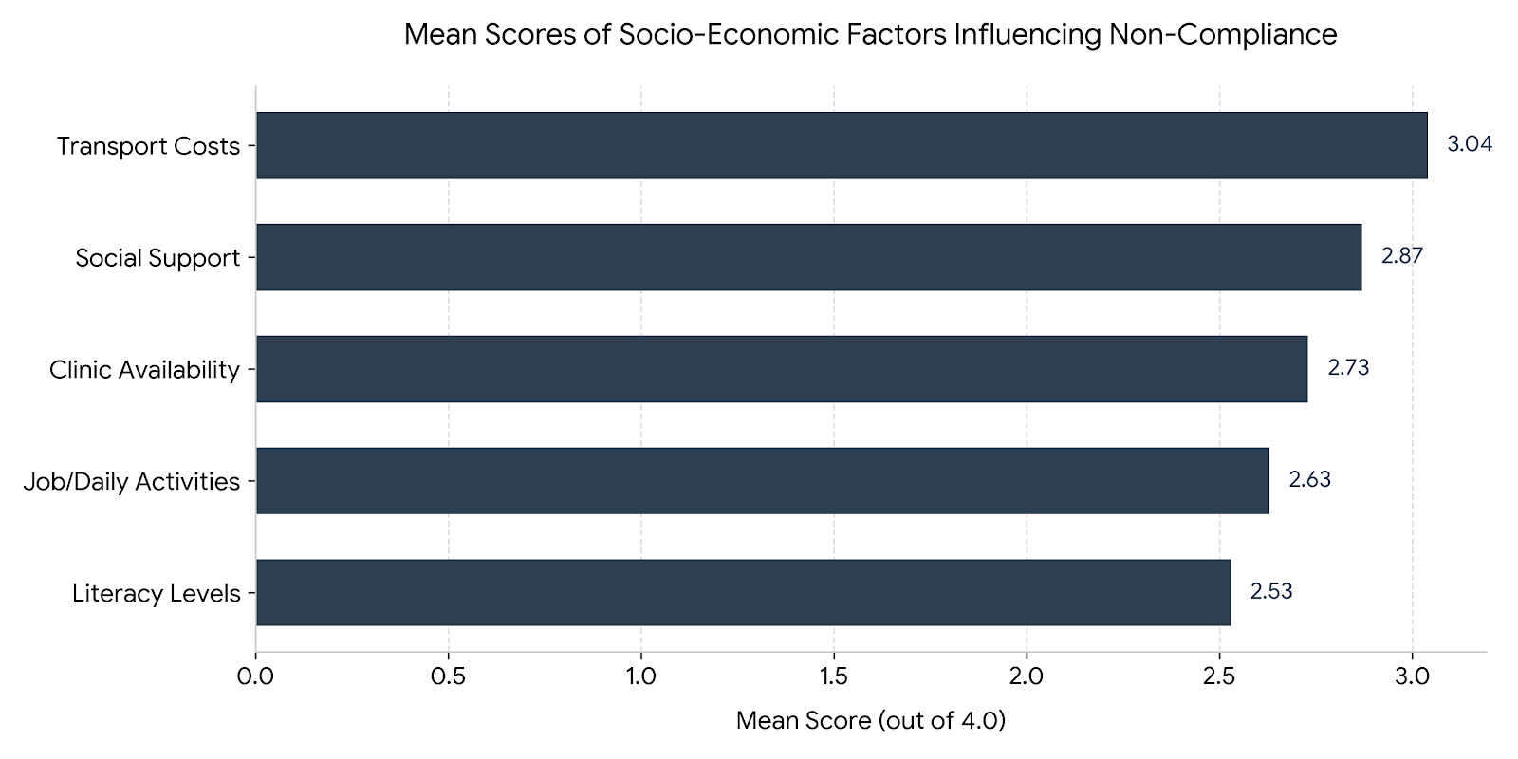
Source:Fieldwork 2026
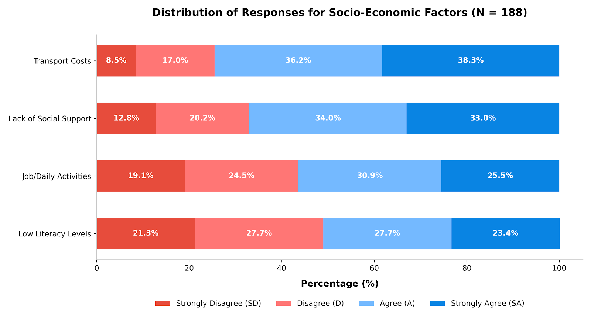

Table 2
Descriptive Summary of Key Factors Influencing the Target Outcome
Factor | Mean Score | Agreement (%) | Rank | Impact Level
Transport Costs | 3.04 | 74.5% | 1st | Very High
Social Support | 2.87 | 67.0% | 2nd | High
Clinic Availability | 2.73 | 60.7% | 3rd | High
Job/Daily Activities | 2.63 | 56.4% | 4th | Moderate
Literacy Levels | 2.53 | 51.1% | 5th | Mild
Source: Fieldwork 2026

The data identifies several critical barriers to medication adherence: The highest-rated barrier is the lack of money for transport to the hospital, with a mean score of 3.04. Over 74% of respondents (38.3% strongly agree, 36.2% agree) indicated that financial instability directly leads to missed doses. Psychosocial Support: A lack of social support was identified as a significant factor (Mean = 2.87), suggesting that interpersonal relationships and community networks are vital for maintaining adherence. Geographic Accessibility: The lack of ARD Clinics within the immediate environment (Mean = 2.73) further complicates access to care, forcing patients to incur the aforementioned transport costs. Literacy and Employment: Job activities (Mean = 2.63) and low literacy levels (Mean = 2.53) were rated as neutral factors, indicating that while they contribute to non-compliance, they are secondary to the primary financial and structural hurdles.
IV. Discussion of Findings
The overwhelming agreement that transport costs are the primary barrier to adherence (Mean = 3.04) is consistent with recent findings in Nigerian healthcare settings. Research in Kogi State among patients on long-term therapy identifies "living far away from the treatment site" and the associated financial difficulty with transport fares as decisive factors in treatment interruption (Ibrahim et al., 2023). For many in rural and semi-urban Nigeria, the cost of reaching a facility often rivals the cost of basic needs, creating a situation where patients must choose between food and clinical visits (Ibrahim et al., 2023). This is corroborated by recent data from Abuja, which shows a significant correlation between appointment periods and adherence levels, often dictated by the patient's ability to afford the journey (“FIP Cape Town 2024: Hospital Pharmacy,” 2024).
The findings revealed that lack of money for transport to the hospital was the most significant socio-economic barrier, with 74.5% of respondents agreeing this factor contributes to non-compliance (mean = 3.04). This finding is consistent with Lahai et al. (2022) who conducted a cross-sectional survey among 310 HIV-positive patients in Freetown, Sierra Leone, and reported that individuals with low income frequently missed doses because they could not afford transportation. Similarly, Okoro and Bello (2021) in Nigeria found that transportation difficulties were major reasons for treatment interruption.
The identification of social support as a critical factor (Mean = 2.87) reinforces the necessity of interpersonal networks in chronic disease management. A 2022 study in South-South Nigeria demonstrated that high medication adherence is significantly associated with good perceived social support, with supported patients being 3.27 times more likely to adhere to their regimens than those with poor support (Okwuosa et al., 2022). The lack of spousal and community support identified in this study mirrors qualitative findings from other Nigerian tertiary hospitals, where interpersonal barriers—particularly the lack of spousal assistance—were noted as major facilitators of non-compliance (Onwuchuluba et al., 2021)
The study also found that lack of social support affected adherence, with 67.0% of respondents agreeing (mean = 2.87). This aligns with the Adoption of Innovations Theory (Rogers, 2003), which emphasizes that social networks and support systems influence an individual's decision to adopt or reject a new behavior. Patients without adequate family or community support are less likely to maintain consistent medication-taking behaviors.
The structural barrier posed by the lack of nearby ARD clinics (Mean = 2.73) suggests that decentralized care is essential for improving outcomes. Research indicates that organizational factors, such as clinic structure and the proximity of specialized units, are major determinants of how successfully patients integrate treatment into their daily lives (“FIP Cape Town 2024: Hospital Pharmacy,” 2024; Onwuchuluba et al., 2021). Furthermore, while literacy was rated lower as a barrier in this study (Mean = 2.53), recent literature suggests that educational level still significantly influences a patient's resilience and their ability to navigate the psychosocial stigma often attached to chronic conditions (Liu et al., 2024; Xie et al., 2023). Addressing these socio-economic factors is critical, as sub-optimal adherence is directly linked to increased psychological distress and a diminished overall quality of life (Liu et al., 2024; Nweke et al., 2024).
Furthermore, 60.7% of respondents agreed that lack of availability of ART clinics around their environment contributed to non-compliance (mean = 2.73). This finding reflects the geographical accessibility challenges faced by patients living in rural and semi-urban areas who travel long distances to access care at General Hospital, Gusau..
Regarding education, 51.1% of respondents had either no formal education or only primary education, and a significant correlation was found between educational level and compliance (r = 0.287, p = 0.003). Low literacy levels may hinder patients' understanding of dosing schedules and the importance of strict adherence, as previously reported by Addo et al. (2022).
V. Conclusion
Socio-economics factor influenced non-compliance to antiretroviral drugs among HIV/AIDS patients at General Hospital,, medical intervention alone is insufficient. For HIV management in Zamfara State to be successful, clinical care must be integrated with economic support programs, decentralized drug delivery systems, and community-led social support initiatives to mitigate the harsh socio-economic realities currently hindering patient’s compliance to ART

VI. Declaration of Conflicting Interests
The authors declare no potential conflicts of interest with respect to the research, authorship, and/or publication of this article.

VII. Contribution to the Body of Knowledge
The study shifts the narrative around treatment non-compliance by demonstrating that poor adherence at the General Hospital, Gusau is fundamentally driven by socio-economic constraints rather than a lack of patient willingness, poor clinical counseling, or inherent health-system failures.
It highlights a critical systemic gap, showing that providing antiretroviral drugs (ARDs) completely free of charge is insufficient if structural and economic barriers prevent patients from physically reaching the point of care.
The research offers empirical data that specifically ranks the socio-economic hurdles faced by people living with HIV/AIDS (PLHIV) in Zamfara State:
It establishes that travel costs and poverty are the single greatest threat to adherence (Mean = 3.04). Specifically, 74.5% of respondents missed their life-saving medications purely due to the financial burden of traveling to the clinic.
It quantifies the heavy impact of a lack of social support (Mean = 2.87, affecting 67% of patients) and the geographical absence of nearby specialized clinics (Mean = 2.73, affecting over 60% of patients), establishing these as high-impact hurdles secondary only to direct transport costs.
It identifies a statistically significant correlation between low educational attainment and treatment non-compliance (r = 0.287, p = 0.003), demonstrating how limited health literacy restricts a patient's capacity to navigate complex dosing schedules.
Filling the Sub-Saharan/North-West Nigerian Data Gap: While reinforcing global adherence theories (like Rogers' Diffusion of Innovations) , this study provides highly localized empirical evidence for Sub-Saharan Africa and specifically North-Western Nigeria (Zamfara State) , a region historically recorded as falling substantially short of both national and UNAIDS treatment targets.
The study contributes to healthcare policy by concluding that medical interventions alone cannot achieve viral suppression goals. It provides a clear framework for future public health strategies, demonstrating that successful HIV management in this environment requires integrating clinical care with decentralized drug delivery systems, community-led social support networks, and targeted economic assistance programs.
VIII. Acknowledgements
The authors express their profound gratitude to the management, clinical staff, and healthcare workers of the Antiretroviral Therapy (ART) Clinic at General Hospital, Gusau, Zamfara State, for their administrative support and facilitation of this study. Special thanks are extended to the partnering agencies, including the National Agency for the Control of AIDS (NACA), the Federal Ministry of Health, USAID, the Global Fund, and PEPFAR, whose sustained structural and programmatic investments enhance the capacity of the clinic. Most importantly, the authors wish to sincerely thank all the patients who willingly consented to participate in this research, without whom this work would not have been possible.

References
Abatur, Y., Adekeye, O., & Bello, C. (2023). Socioeconomic barriers to antiretroviral therapy adherence in Northwestern Nigeria. Journal of HIV/AIDS & Social Services, 22(3), 245-261.
Addo, K., Mensah, A., & Asare, M. (2022). Educational level and medication adherence among HIV patients in Ghana. African Journal of Nursing and Midwifery, 24(2), 112-128.
Adeyemi, O., Okonkwo, U., & Nwachukwu, B. (2023). Medication-related factors affecting ART adherence in Nigerian HIV patients. West African Journal of Medicine, 40(5), 478-492.
Bello, S., & Umar, A. (2020). Cultural beliefs and HIV treatment adherence in Northern Nigeria. Culture, Health & Sexuality, 22(8), 901-916.
Buh, A., Kwan, C., & Musa, S. (2023). Predictors of antiretroviral therapy non-adherence in sub-Saharan Africa. AIDS Care, 35(2), 189-201.
Centers for Disease Control and Prevention (CDC). (2022). HIV treatment adherence. U.S. Department of Health and Human Services.
Eze, C., Okafor, E., & Nwosu, N. (2020). Health system factors influencing ART adherence in Nigerian tertiary hospitals. Nigerian Journal of Clinical Practice, 23(6), 789-798.
FIP Cape Town.. Hospital Pharmacy: Relationships between medication adherence and perceived barriers in Abuja hospitals. (“FIP Cape Town 2024: Hospital Pharmacy,” 2024)
Heestermans, M., van de Ven, P., & de Bruin, M. (2016). Predictors of adherence to antiretroviral therapy: A systematic review. AIDS and Behavior, 20(10), 2297-2310.
Iacob, S. A., Iacob, D. G., & Jugulete, G. (2017). Non-adherence to antiretroviral therapy in HIV-positive patients. Journal of Medicine and Life, 10(4), 222-229.
Ibrahim, A. Y., Akawa, A. B., Fashuba, I. K., et al.. Medication adherence and social support in people living with HIV/AIDS in Kogi State, Nigeria. Journal of AIDS and HIV Research. (Ibrahim et al., 2023)
Isika, A., Johnson, T., & Mohammed, I. (2022). Defining and measuring medication non-compliance in chronic disease management. International Journal of Pharmacy Practice, 30(4), 312-325.
ITREMA Sub-Study Group. (2023). SMS reminders and ART adherence in South Africa: A randomized controlled trial. Journal of Telemedicine and Telecare, 29(5), 356-368.
Iwegwau, C., Ogunleye, O., & Adebayo, A. (2019). Factors contributing to non-adherence among HIV patients in Lagos, Nigeria. Nigerian Quarterly Journal of Hospital Medicine, 29(1), 45-58.
Karanja, S., Mwangi, M., & Otieno, P. (2020). Transportation support and clinic attendance among HIV patients in rural Kenya. BMC Public Health, 20(1), 445.
Lahai, M., Sesay, S., & Koroma, M. (2022). Socioeconomic challenges and ART adherence in Freetown, Sierra Leone. Pan African Medical Journal, 41(3), 189-201.
Liu, K., Dou, S., Qin, W., et al.. Association between quality of life and resilience in patients: A systematic review. Frontiers in Psychology. (Liu et al., 2024)
Magura, A., Bello, F., & Sani, I. (2025). Adherence patterns among HIV patients at General Hospital Gusau. Zamfara Journal of Health Sciences, 6(1), 34-48.
Mohammed, A., & Adebayo, T. (2021). Effectiveness of pre-treatment counselling on ART adherence in Nigeria. Journal of the International Association of Providers of AIDS Care, 20, 1-9.
Moyo, T., & Sibanda, N. (2021). Health facility organization and ART adherence in South Africa. South African Journal of HIV Medicine, 22(1), 1234.
National Agency for the Control of AIDS (NACA). (2022). Nigeria HIV/AIDS indicator and impact survey (NAIIS) report. Abuja: NACA.
National Agency for the Control of AIDS (NACA). (2023). National HIV treatment cascade report. Abuja: NACA.
Nwankwo, C., Okeke, T., & Eze, P. (2022). Health system barriers to ART adherence in Nigerian tertiary hospitals. Nigerian Hospital Practice, 29(3), 78-92.
Nweke, M., Ukwuoma, M., Adiuku-Brown, A. C., et al.. Burden of postpartum depression in sub-Saharan Africa: An updated systematic review. (Nweke et al., 2024)
Okoro, R., & Bello, S. (2021). Food insecurity and ART adherence in Northern Nigeria. Journal of Hunger & Environmental Nutrition, 16(4), 523-540.
Okoro, R., Umar, A., & Ibrahim, M. (2021). Food insecurity as a barrier to HIV medication adherence in Nigeria. African Journal of AIDS Research, 20(3), 234-245.
Okwuosa, J. O., Nwajei, A. L., Owolabi, A. O., et al.. The Relationship Between Perceived Social Support and Medication Adherence Among Adult Patients Attending Clinic in a Tertiary Health Institution in South-South Nigeria. (Okwuosa et al., 2022)
Oluwole, E., Adebayo, O., & Oladimeji, K. (2023). Stigma and discrimination as barriers to ART adherence in Southwestern Nigeria. HIV/AIDS Research and Palliative Care, 15, 89-102.
Onwuchuluba, E., Oyetunde, O., & Soremekun, R. O.. Medication Adherence in chronic illness: A Qualitative Exploration of Barriers and Facilitators From Socioecological Perspectives in Nigeria. (Onwuchuluba et al., 2021)
Polit, D. F., & Beck, C. T. (2021). Nursing research: Generating and assessing evidence for nursing practice (11th ed.). Wolters Kluwer.
Rogers, E. M. (2003). Diffusion of innovations (5th ed.). Free Press. (Original work published 1962)
Tadese, M., Woldie, H., & Mekonnen, D. (2020). Side effects and ART non-adherence in Ethiopian HIV patients. Ethiopian Journal of Health Sciences, 30(4), 567-578.
UNAIDS. (2023). Global HIV statistics fact sheet. Geneva: Joint United Nations Programme on HIV/AIDS.
UNAIDS. (2024). Global AIDS update 2024: The urgency of now. Geneva: Joint United Nations Programme on HIV/AIDS.
Valenzuela-Ore, M., Quispe, R., & Mamani, J. (2023). Peer support groups and ART adherence in Peru: A 12-month intervention study. AIDS and Behavior, 27(8), 2678-2690.
World Health Organization (WHO). (2021). Adherence to long-term therapies: Evidence for action. Geneva: WHO Press.
World Health Organization (WHO). (2022). HIV/AIDS fact sheet. Geneva: WHO Press.
World Health Organization (WHO). (2023). Global HIV programme: Antiretroviral therapy coverage. Geneva: WHO Press.
Xie, Y., Ren, Y., Niu, C., et al.. The impact of stigma on mental health and quality of life of women: A systematic review. Frontiers in Psychiatry. (Xie et al., 2023)
Yamane, T. (1967). Statistics: An introductory analysis (2nd ed.). Harper and Row.

