Palatability and Durability Test of Coumatetralyl Rodenticide

ABSTRACT
Rats are wild animals that are often found in various habitats and become a nuisance in human life. Rats can cause damage and losses to crops, one of which is oil palm plantation. Therefore, control efforts are needed, one of which is chemical control using rodenticides. This study aimed to determine the level of attractiveness of Malayan field rats to various formulations of coumatetralyl-based rodenticides with cereal-based baits and with vegetable and animal flavorings. Study also conducted to measure the durability and effectiveness of these rodenticides after being exposed in the oil palm crop. The types of rodenticides used were coumatetralyl rodenticides in rice bait and rice plus wheat baits, with chocolate, pandanus, strawberry, and mealworm flavorings. This study consisted of three tests: Palatability, durability, and mealworm tests. The methods used were choice test. Data were analyzed using a randomized block design, R Studio with Tukey's test at α = 5%. The results showed that the consumption of Malayan field rats on coumatetralyl rodenticides with flavored baits in the palatability and durability tests was not significantly different, while it was significantly different in the mealworm test. Coumatetralyl rodenticides with pandanus and chocolate flavors, with rice and rice-wheat baits, and positive control rodenticides with mealworms were more preferred by Malayan field rats than others.

Keywords: Effectiveness, chocolate, choice test, mealworm, pandanus, rice bait

INTRODUCTION
Rats are wild mammals commonly found in various habitats and are known as pests in human life. These animals are pests because they cause damage in various sectors, from agriculture, plantation, forestry, to health (Priyambodo 2009, Purbaningsih and Widyanto 2018). In agriculture and plantations, rats cause damage to almost all types of crops, including oil palm (Ngidha et al. 2016). Oil palm (Elaeis guineensis Jaqc.) is a plantation commodity that plays a vital role in building the Indonesian economy. Therefore, in oil palm cultivation, pest attacks must be considered because they impact production yields and quality (Subiantara et al. 2022).
Rats attack oil palms during the immature and mature phases. Rats can cause up to 80% losses in immature crops and up to 30% damage to fruit bunches in mature crops, with a rat abundance index in the field of 20% (Dhamayanti 2009). Rat infestations on fruit bunches can reduce palm oil production by up to 240 kg/ha/year, when the rat population in the field reaches 306 rats/ha. Malayan field rat, Rattus tiomanicus, is the main rat species pest in oil palm plantations in Indonesia. A single of R. tiomanicus can consume 5.94–13.7 g of oil palm mesocarp per day (Gunawan et al. 2024).
Based on the damage and losses caused by rat infestations in the plantation, control efforts are necessary. Rat pest control commonly employed by humans includes: Sanitation (clean cultivation), technical culture (agronomic methods), physical-mechanical methods, the use of natural enemies (biological control), and chemical methods. Chemical rat control using rodenticides is the most effective strategy for suppressing the rat populations (Priyambodo 2006, Saipullah and Iskarlia 2018). Chemical control using poison bait (rodenticides) in the field typically involves only one type of active ingredients and baits in rodenticide with standard flavoring. The use of rodenticides with standard flavorings is often ineffective because rats are less attracted to the rodenticides. To improve the effectiveness in chemical control, rodenticide trials with various types of bait and flavorings are necessary to be conducted, in order to increase the chances of success in the rat management.

METHODS

Time and Place
The research was conducted at the Laboratory of Vertebrate Pest, Department of Plant Protection, Faculty of Agriculture, Bogor Agricultural University (IPB University), Bogor, Indonesia and oil palm crops on the Kamper Street, Bogor Agricultural University Campus, Bogor, Indonesia, from December 2024 to February 2025.

Tools and Materials
The tools and materials used in this study were scales, bowls or small containers, glasses, spoons, bamboo tubes, trays, coconut milk strainers, mortars and pestles. Include experimental cages measuring 90 cm x 90 cm x 90 cm and 60 cm x 40 cm x 20 cm, test animals (R. tiomanicus), rice as feed, ready to use coumatetralyl rodenticide with various baits and flavorings, meal worm (larvae of beetle, Tenebrio molitor), and water.

Research Methods
The anticoagulant rodenticide, coumatetralyl, was tested on Malayan field rats (R. tiomanicus) using the choice test method. This rodenticide test involved three tests using the same method: Palatability, durability, and meal worms test. All test conducted sequentially.

Test Animal Preparation
The Malayan field rats tested were healthy, non-pregnant, male and female, and weighed more than 65 g. Eleven Malayan field rats were required for the palatability test, twelve rats for the durability test, and eight rats for the meal worms test.

Feed Preparation
The feed used in the test was rice, which was fed before and after the poison treatment. The rice fed to the Malayan field rats was weighed at a rate of 20 g per rat per day and placed in a small container.

Rodenticide Preparation
The ready-to-use coumatetralyl rodenticide used in the palatability and durability tests consisted of eight (8) types of bait and flavoring: Coumatetralyl rodenticide in rice bait with chocolate (A), pandanus (B), and strawberry flavoring (C). Coumatetralyl rodenticide in rice and wheat bait with chocolate (D), pandanus (E), and strawberry flavoring (F). Coumatetralyl rodenticide negative control without additional bait and flavoring (G). Coumatetralyl rodenticide positive control (H) (Figure 1).
Durability testing was conducted after all of the rodenticides were exposed under oil palm crops for fourteen (14) consecutive days (Figure 2). The rodenticides used in the meal worm test were: The positive control coumatetralyl rodenticide with meal worm (A) and without meal worm (B). Rodenticide A in the meal worm test was obtained from a mixture of 144 g of coarsely ground coumatetralyl rodenticide and 16 g of finely ground meal worm. Rodenticide B was the positive control coumatetralyl rodenticide in the coarsely ground form. The rodenticides prepared for testing were each weighed at 20 g per rat per day in separate bowls.

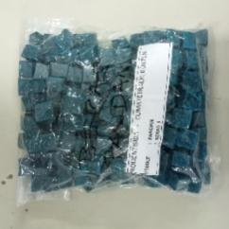
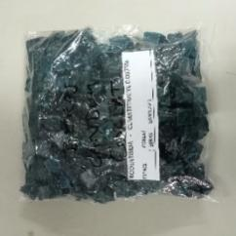
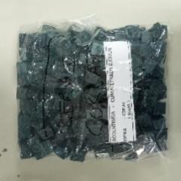
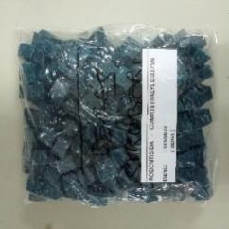

C
B
D
A
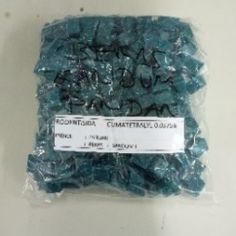
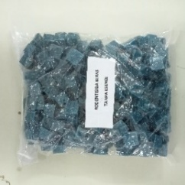
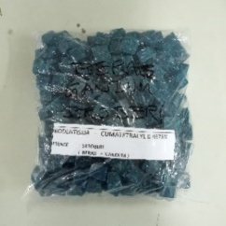
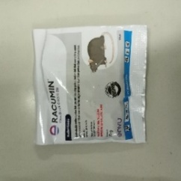

E
F
G
H

Figure 1. Coumatetralyl rodenticide for rice bait with chocolate (A), pandanus (B), strawberry flavoring (C), coumatetralyl rodenticide for rice and wheat bait with chocolate (D), pandanus (E), strawberry flavoring (F), coumatetralyl rodenticide negative control without additional bait and flavoring (G). coumatetralyl rodenticide positive control (H)

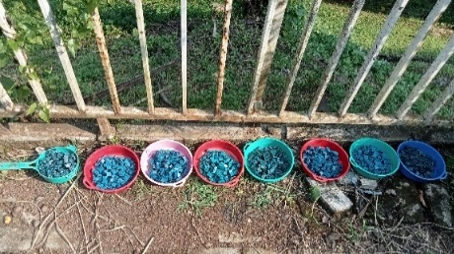

Figure 2. Exposure to the rodenticide coumateralyl bait and flavoring under an oil
palm crops for fourteen days in the durability test.

Testing Methods
The Malayan field rats were placed in experimental cages containing water cups and bamboo tubes. They were kept for three (3) consecutive days and fed rice. After three days, the rodenticide bait and flavoring treatments were administered. The rodenticides used in the palatability, durability, and meal worm tests were placed in random locations within the experimental cages for three consecutive days. If the Malayan field rats consumed the poisoned bait, resulting in decreasing their weight below 20 g per container, the poisoned bait was added.
Afterward, the rats were fed rice again until the rats died within fourteen days, calculated from the first day of rodenticide administration. If a rat was still found to have survived after fourteen days, it was considered to have survived. The consumption of rats to the poison and feed was recorded daily. Provided that the rats had consumed more than 1 g of poisoned bait and feed, allowing for the next day's change. The dead and non-dead rats were weighed to determine their body weight, which was used to determine the final weight of the Malayan field rats.

Experimental Design
Consumption data on animal test obtained from the test, then converted to 100 g rat body weight (Aprilia 2022) using the following formula:

Bait or rodenticide conversion (g/100 g body weight) = Bait or rodenticide
consumed (g) x 100 divided by average rat’s body weight

Average rat body weight (g) = (Initial weight + final weight) divided by 2

The data were analyzed using a Randomized Block Design (RBD) using one rat species (R. tiomanicus) with eleven (11) replications for palatability test, twelve (12) replications for durability test, and eight (8) replications for meal worm test. Further testing was performed using R Studio Programme with Tukey's test at the α level of 5%.

RESULTS AND DISCUSSIONS

Palatability Test of Malayan Field Rat Attractiveness to Coumatetralyl
Rodenticide with Various Baits and Flavors
This test was conducted to determine the preference of Malayan field rats for coumatetralyl rodenticide with several baits and flavors. Malayan field rat consumption to the rodenticides treatment is shown at Table 1.

Table 1. The consumption of Malayan field rat in the palatability test to eight types of coumatetralyl rodenticide with various baits and flavors

Treatment | Consumption (g/100 g body weight)
Rice bait with chocolate flavoring | 2.65 a
Rice bait with pandanus flavoring | 3.30 a
Rice bait with strawberry flavoring | 2.72 a
Rice and wheat bait with chocolate flavoring | 1.24 a
Rice and wheat bait with pandanus flavoring | 1.70 a
Rice and wheat bait with strawberry flavoring | 1.27 a
Coumatetralyl rodenticide negative control (without additional bait and flavoring) | 1.71 a
Coumatetralyl rodenticide positive control | 1.20 a
Mean | 1.97
Note: Numbers in the column followed by the same letter indicate no significant
difference based on the Tukey test at the α = 5% level.

The consumption of Malayan field rat on the rodenticides in this test did not show a significant difference with a Pr (F) value of 0.143. The consumption value ranged from 1.20 to 3.30 g with an average of 1.97 g. Malayan field rat consumption to coumatetralyl with rice bait and with pandanus flavoring was the highest among the others (3.30 g). Pandanus contains essential oils that produce a distinctive aroma or eugenol (Kurniati 2017). This aroma can increase the attraction of Malayan field rats to the poison bait. In addition to poison consumption, calculations were also carried out on the consumption to rice, before and after poison treatment (Table 2).

Table 2. Consumption of rice by Malayan field rats before and after treatment in
the coumatetralyl rodenticide palatability test with various baits and flavorings

No. of Rat | Mean of rice consumption (g/100 g body weight)
No. of Rat | Before treatment | After treatment
1 | 6.80 | 7.17
2 | 9.10 | 5.15
3 | 9.77 | 6.83
4 | 9.33 | 5.95
5 | 7.90 | 6.15
6 | 4.93 | The rat got out of the cage
7 | 4.87 | 5.00
8 | 8.70 | 6.23
9 | 6.77 | 5.67
10 | 9.47 | 12.95
11 | 4.90 | 3.13
Mean ± Std. Dev | 7.504 ± 1.945 | 5.839 ± 3.102

The average rice consumption before treatment was 7.504 g and after treatment it was 5.839 g, indicating a decrease in consumption. This is because the Malayan field rats experienced a decrease in appetite due to consuming rodenticide (Natawigena et al. 2021). The rice consumption of rats tested No. 1 and 10 after treatment was higher than before treatment, because the rats were stimulated to eat more to detoxify the poison that entered their bodies (Zailani et al. 2015). Rat No. 6 had a consumption of no value, because the rat escaped, indicated by the presence of gnaw marks on the cage wire.

Durability Test of Malayan Field Rat Attraction to Various Baits and Flavorings of the Rodenticide Coumatetralyl
This test was conducted to determine the resistance and effectiveness of coumatetralyl rodenticide with various baits and flavorings after exposure to oil palm crops. Malayan field rat consumption of rodenticides in durability test is shown in Table 2.

Table 2. Consumption of Malayan field rats in durability test to eight types of
coumatetralyl rodenticide with various baits and flavorings

Treatment | Consumption (g/100 g of body weight)
Rice bait with chocolate flavoring | 1.72 a
Rice bait with pandanus flavoring | 1.22 a
Rice bait with strawberry flavoring | 1.77 a
Rice and wheat bait with chocolate flavoring | 2.10 a
Rice and wheat bait with pandanus flavoring | 1.13 a
Rice and wheat bait with strawberry flavoring | 1.84 a
Coumatetralyl rodenticide negative control without additional bait and flavoring | 1.60 a
Coumatetralyl rodenticide positive control | 1.98 a
Mean | 1.67
Note: Numbers in the column followed by the same letter indicate no significant
difference based on the Tukey test at the α = 5% level.

The Malayan field rat’s consumption of rodenticides in this test did not show any significant difference with a Pr (F) value of 0.874. The consumption value ranged from 1.13 g to 2.10 g with an average of 1.67 g. The consumption of Malayan field rat on coumatetralyl with rice and wheat bait, and with chocolate flavoring was the highest among the others (2.10 g). This treatment contains rice and wheat bait with chocolate flavoring. The combination of rice and wheat produces a stronger and more complex variety of flavors and aromas, that are attractive to the Malayan field rats. The consumption of rice before and after treatment was also calculated to determine the rats' dietary patterns (Table 4).

Table 4. The consumption of rice by Malayan field rats in durability test before
and after treatment in the coumatetralyl rodenticide test with various baits and flavorings.

No. of Rats | Mean of Rice Consumption (g/100 g of body weight)
No. of Rats | Before Treatment | After Treatment
1 | 7.80 | 0.53
2 | 8.13 | 3.57
3 | 12.53 | Dead
4 | 5.53 | 3.48
5 | 8.87 | 5.75
6 | 10.27 | 4.58
7 | 7.20 | 0.26
8 | 5.50 | Dead
9 | 13.30 | Dead
10 | 4.33 | 0.94
11 | 10.80 | 2.87
12 | 6.33 | The rat got out of the cage
Mean ± Std. Dev. | 8.3825 ± 2.859 | 2.7475 ± 1.999

The consumption value of Malayan field rats to rice in the durability test before poison treatment ranged from 4.33 to 13.30 g with an average of 8.38 g. The consumption value after poison treatment ranged from 0.26 g to 5.75 g with an average of 2.75 g. Rice consumption after poison treatment decreased because the rats experienced a decrease in appetite due to consuming rodenticide (Natawigena et al. 2021). Rats No. 3, 8, and 9 had no value because the rats died during the poison treatment. Rat No. 12 had no value because the rat escaped, indicated by the discovery of bite marks on the cage wire in the Vertebrate Pest Laboratory.

The Attractiveness Test of Malayan Field Rat for Coumatetralyl Rodenticide
with Mealworm
This test was conducted to compare the effectiveness of the rodenticide coumatetralyl, a positive control with mealworms, and coumatetralyl without mealworms. Mixing the poisoned bait with mealworms was expected to increase the consumption of the poisoned bait by Malayan field rats. The consumption of the Malayan field rat to the positive control coumatetralyl in the mealworm test could be seen in Table 5.

Table 5. The consumption of Malayan field rat to coumatetralyl rodenticide in the
mealworm test

Treatment | Consumption (g/100 g of body weight)
Rodenticide with mealworm  Rodenticied without mealworm | 5.24 a  1.64 b
Mean | 3.44
Note: Numbers in the column followed by the same letter indicate not significant
difference based on the Tukey test at the α = 5% level.

Coumatetralyl rodenticide with and without mealworm were significantly different based on the Tukey test at the α level = 5% with a Pr (F) value = 0.022. Coumatetralyl with mealworm is widely consumed by Malayan field rats. Coumatetralyl with mealworm is favored because it has its own appeal and has a distinctive aroma and taste. Flavoring ingredients can increase the chance of rats finding the bait and eating a lot (Posmaningsih et al. 2014). Coumatetralyl without mealworm is less preferred by Malayan field rats because this toxic bait does not have additional animal protein flavoring ingredients. Rice consumption before and after treatment was also calculated to determine the eating patterns of rats could be seen in Table 6.

Table 6. The consumption of rice by Malayan field rats before and after treatment
in the mealworm test

No. of Rats | Mean of Rice Consumption (g/100 g of body weight)
No. of Rats | Before Treatment | After Treatment
1 | 4.13 | 0.03
2 | 2.02 | 0.90
3 | 5.50 | 0
4 | 7.19 | 0
5 | 2.94 | 0.23
6 | 2.97 | 8.41
7 | 2.60 | 3.29
8 | 4.86 | 4.33
Mean ± Std. Dev. | 4.026 ± 1.742 | 2.149 ± 3.029

The average rice consumption of Malayan field rat before treatment was 4.026 g and after treatment was 2.149 g. After the poison treatment, the test rats consumed small amounts of rice because the rats experienced a decreased appetite due to consuming rodenticide (Natawigena et al. 2021). Rats No. 3 and 4 had zero rice consumption because they died during the poison treatment. Rats No. 6 and 7 had higher rice consumption after treatment because they survived 14 days of rice administration.

Malayan Field Rat’s Mortality
The Malayan field rats died starting at the sixth day on the palatability test, at the first day on the durability test, and at the third day on the mealworm test (Table 7).

Table 7. The mortality of Malayan field rat in the palatability, durability, and
mealworm tests

No. of Rats | Malayan field rat’s died (days)*
No. of Rats | Palatability | Durability | Mealworm
1 | 6 | 7 | 8
2 | 7 | 10 | 11
3 | 6 | 1 | 3
4 | 7 | Survive | 3
5 | 7 | 7 | 14
6 | The rat got out of the cage | Survive | Survive
7 | 5 | 4 | Survive
8 | 7 | 3 | Survive
9 | 6 | 2 | -
10 | 5 | 8 | -
11 | 7 | 13 | -
12 | - | The rat got out of the cage | -
* Death of the Malayan field rats was calculated from the first day of poison treatment.

The time required for the active ingredient, coumatetralyl, to halve the pharmacological activity, as excretory function, to eliminate the substance from the rats' bodies, is approximately 71 hours, or three days (Natawigena et al. 2021). All Malayan field rats died in the palatability test. However, in the durability test, two rats remained undead and one escaped from the experimental cage. Three Malayan field rats remained undead in the mealworm test. The rats that did not die in the durability test are suspected to have degraded the poison, thus reducing its effectiveness. In the melworm test, the rats allegedly consumed a small amount of poison and possessed resistance genes. Furthermore, feeding after the poison treatment affected the mortality of rats, as rats can recover from the effects of rodenticide poisoning by consuming more food. The dead rats were found lethargic in their cages (Figure 6). This lethargy, due to chronic poisoning, does not cause pain, but causes fatigue and lethargy, and will not leave the nest (Natawigena et al. 2021).

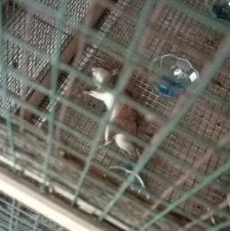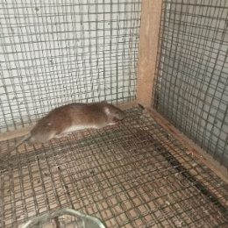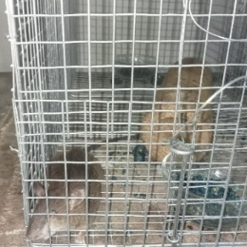
c
b
a

Figure 6. Death of Malayan field rats during palatability test (a), durability test (b), and mealworm test (c).

Dead rats exhibited symptoms of bleeding from various natural orifices, including the mouth, nose, anal, and leg (Figure 7). They experienced bleeding from the nose and ears. Other symptoms included reduced pupil size and paler ear color. These symptoms occurred before the rats died, typically at 96, 120, or 144 hours, depending on the active ingredient of rodenticides (Natawigena et al. 2021).

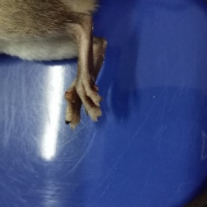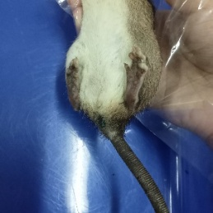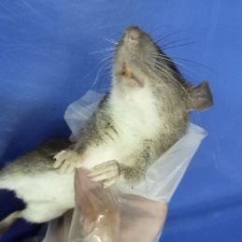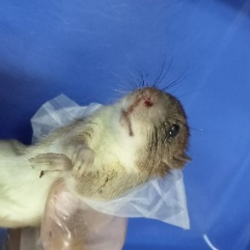
d
c
b
a

Figure 7. Symptoms of poisoning include blood stains on the legs (a), anal (b), mouth (c), and nose (d)

CONCLUSION
Malayan field rats (Rattus tiomanicus) prefer the rodenticide coumatetralyl flavored with rice bait and pandanus flavoring. After being exposed under oil palm crops, coumatetralyl rice and wheat bait with chocolate flavoring is preferred by Malayan field rats. This evidence because the rodenticides with pandanus and chocolate flavoring have a distinctive aroma that is attractive to the Malayan field rats. The positive control of rodenticide coumatetralyl mixed with mealworm (animal protein) is also preferred by Malayan field rats compared to the positive control of rodenticide coumatetralyl without mealworm. This fact because mealworm are one of the animals favored by rats.

REFERENCES
Aprilia H. 2022. Penentuan jenis dan konsentrasi bahan penyedap pada umpan untuk meningkatkan palatabilitas tikus pohon (Rattus tiomanicus Mill.) [skripsi]. Bogor: Institut Pertanian Bogor.
Dhamayanti A. 2009. Kajian sosial ekonomi pengendalian tikus pohon, Rattus tiomanicus Mill. dengan burung hantu, Tyto alba pada perkebunan kelapa sawit. Strategi Perlindungan Tanaman Menghadapi Perubahan Iklim Global dan Sistem Perdagangan Bebas. Prosiding Seminar Nasional Perlindungan Tanaman; 2009 Agustus 5-6; Bogor, Indonesia. Bogor. Institut Pertanian Bogor. P. 439-445; [accessed 2025 Feb 17].
Gunawan TR, Pradana MG, Yusup CA, Rozziansha TAP, Priwiratama H, and Prasetyo AE. 2024. Intensitas serangan tikus di perkebunan kelapa sawit: Studi kasus di Kabupaten Tanjung Jabung Timur, Jambi. Warta PPKS. 29(1): 61-68. [accessed 2025 Feb 17].
Kurniati E. 2017. Uji repelensi dari serbuk daun pandan wangi (Pandanus amaryllifolius Roxb) terhadap kutu beras (Sitophilus oryzae L) dan sumbangsihnya pada materi hama dan penyakit pada tanaman di Kelas VII SMP/MTs [skripsi]. Palembang: Universitas Islam Negeri Raden Fatah.
Natawigena WD, Bari IN, and Surachman CR. 2021. Pengaruh beberapa bahan aktif dalam formulasi rodentisida terhadap metabolisme dan perilaku tikus putih (Rattus norvegicus Wistar) di laboratorium. Seminar Biodiversitas Serangga dan Perannya dalam Pengelolaan Lingkungan yang Berkelanjut-an. Prosiding Seminar Nasional Biologi 6; 2021 Jul 15; Bandung. Indonesia. Bandung: UIN Sunan Gunung Djati. P. 257-277; [accessed 2025 Feb 24].
Ngidha SA, Tarmadjaya S, and Kristalisasi EN. 2016. Uji efektivitas beberapa macam rodentisida terhadap pengendalian tikus. Jurnal Agromast. 1(2): 1-9. [accessed 2025 Feb 17].
Posmaningsih DAA, Purna IN, and Sali IW. 2014. Efektivitas pemanfaatan umbi gadung (Dioscorea hispida Dennust) pada umpan sebagai rodentisida nabati pengendalian tikus. Jurnal Skala Husada. 11(1): 79-85. [accessed 2025 Mar 10].
Priyambodo S. 2006. Tikus. Dalam Sigit SH dan Hadi UK (editor) Hama Permukiman Indonesia. Unit Kajian Pengendalian Hama Permukiman, FKH, IPB, Bogor. P. 195 - 258.
Priyambodo S. 2009. Pengendalian Hama Tikus Terpadu. Penerbit Penebar Swadaya, Jakarta. 135 p.
Purbaningsih VC and Widyanto A. 2018. Deskripsi jumlah dan spesies tikus di Desa Banjarpanen Kecamatan Sumpiuh Kabupaten Banyumas. Kesling- mas. 38(4): 305-364. [accessed 2025 Feb 13].
Saipullah and Iskarlia GR. 2018. Pengendalian hama tikus pada tanaman kelapa sawit (Elaeis guineensis Jacq.) fase tanaman menghasilkan (TM) di PT Hasnur Citra Terpadu. Jurnal Sains dan Terapan Politeknik Hasnur. 6(1): 6-12. [accessed 2025 Feb 17].
Subiantara A, Hakim AR, Diana R, Wijaya NC, Yusuf M, and Arianti S. 2022. Analisis kerugian serangan hama tikus di perkebunan kelapa sawit (studi kasus di PT. Sakti Mait Jaya Langit). Green Economy dan Pembangunan Berkelanjutan. Prosiding Seminar Nasional Universitas PGRI Palangka Raya 2022; 2022 Jul 12-13; Palangka Raya. Indonesia. Palangka Raya: Universitas PGRI Palangka Raya. P. 63-73; [accessed 2025 Feb 13].
Zailani HF, Sutjipto, and Prastowo S. 2015. Uji efektivitas rodentisida ekstrak buah bintaro (Cerbera manghas Boiteau, Pierre L.) terhadap hama tikus. Berkah Ilmiah Pertanian. 10(10): P. 1-5. [accessed 2025 Maret 10].

