The Effect of Multi-Modal Storytelling on Vocabulary Retention and Motivation of Grade 10 EFL Learners

ABSTRACT
This study investigates the profound impact of multi-modal storytelling on vocabulary retention and motivation among Grade 10 English as a Foreign Language (EFL) learners. Addressing the persistent challenge of vocabulary acquisition in traditional settings, this research posits multi-modal storytelling as a transformative pedagogical intervention. Employing a quasi-experimental mixed-methods design, the study involved 400 students and 50 teachers in a diagnostic phase, followed by an intervention with an experimental group (N=40) and a control group (N=40). Findings from student and teacher questionnaires revealed significant challenges in vocabulary retention with traditional methods, alongside high interest in multi-modal approaches. Quantitative analysis of pre-test, post-test, and delayed post-test scores demonstrated that the experimental group, exposed to multi-modal storytelling, achieved significantly higher immediate learning gains and superior long-term vocabulary retention compared to the control group. Furthermore, qualitative data indicated a substantial increase in student motivation and engagement. The study concludes that multi-modal storytelling is not merely an alternative pedagogical technique but a powerful and scalable solution to enhance vocabulary acquisition and foster intrinsic motivation in EFL contexts. Recommendations are provided for educators, curriculum developers, and future research to integrate and further explore this effective pedagogical strategy.

Keywords: Multi-Modal Storytelling, Vocabulary Retention, EFL Learners, Grade 10, Motivation, English as a Foreign Language, Pedagogical Innovation, And Multimedia Learning Theory

INTRODUCTION
In an increasingly interconnected global landscape, proficiency in English as a Foreign Language (EFL) has become an indispensable skill for academic success, professional advancement, and cross-cultural communication (Crystal, 2003). At the heart of language proficiency lies a robust vocabulary, serving as the foundational building block for effective communication across all four macro-skills: reading, writing, listening, and speaking (Nation, 2001). However, for many EFL learners, particularly those at the secondary level, the acquisition and, more critically, the long-term retention of new vocabulary words present a formidable challenge. Traditional vocabulary instruction, often characterized by rote memorization of decontextualized word lists, frequently leads to superficial learning and rapid forgetting, thereby impeding overall language development (Schmitt, 2000).

This study addresses this pervasive pedagogical dilemma by exploring the efficacy of multi-modal storytelling as an innovative and engaging strategy to enhance vocabulary retention and foster intrinsic motivation among Grade 10 EFL learners. Multi-modal storytelling, by integrating visual, auditory, and interactive elements within a coherent narrative framework, leverages multiple sensory channels to create richer, more memorable learning experiences (Mayer, 2009). This approach is theoretically grounded in cognitive theories such as Mayer's Multimedia Learning Theory, which posits that presenting information through both verbal and pictorial channels can lead to deeper understanding and better retention (Mayer, 2009), and Cognitive Load Theory, which suggests that well-designed multi-modal presentations can optimize cognitive processing (Sweller, 1988).

The current research aims to investigate whether the dynamic and immersive nature of multi-modal storytelling can overcome the limitations of conventional vocabulary teaching methods. Specifically, it seeks to: (1) identify the existing challenges Grade 10 EFL learners face in vocabulary acquisition and retention; (2) examine the underlying reasons for these challenges; (3) evaluate the effectiveness of multi-modal storytelling in enhancing vocabulary retention; and (4) assess its impact on student motivation and engagement in vocabulary learning. By providing empirical evidence for the benefits of this pedagogical approach, this study intends to offer practical recommendations for educators and curriculum developers seeking to cultivate more effective and engaging EFL learning environments.

LITERATURE REVIEW
A comprehensive review of the literature reveals a rich and multifaceted theoretical and empirical landscape that informs this study. The investigation is primarily situated at the intersection of three major domains: the theoretical underpinnings of language acquisition, the empirical evidence on the efficacy of multi-modal instruction and storytelling, and the socio-psychological factors that influence language learning, particularly in foreign language contexts.

Theoretical Framework: A Synthesis of Learning Theories
This study is anchored in a robust theoretical framework that synthesizes key tenets from several influential learning theories, providing a comprehensive lens through which to understand the potential impact of multi-modal storytelling. The primary theoretical pillars include:

- Cognitive Load Theory (CLT): Developed by Sweller (1988), CLT posits that learning is most effective when instructional materials are designed to minimize extraneous cognitive load and optimize germane cognitive load. Traditional vocabulary instruction, often involving decontextualized word lists, can impose a high extraneous load. Multi-modal storytelling, when designed effectively, can reduce this load by presenting information in a coherent, integrated manner, thereby facilitating schema construction and long-term memory storage (Sweller, 1988).
- Multimedia Learning Theory (MLT): Mayer's (2009) MLT, building on CLT, proposes that learners construct mental representations more effectively when information is presented in both verbal (e.g., spoken words, text) and pictorial (e.g., images, animations, video) forms. The principles of MLT, such as the multimedia principle, contiguity principle, and coherence principle, directly support the design of multi-modal storytelling interventions, suggesting that the integration of various sensory inputs enhances comprehension and retention (Mayer, 2009).
- Social Constructivist Theory (SCT): As articulated by Vygotsky (1978), SCT emphasizes the fundamentally social nature of learning. Storytelling, particularly when interactive or collaborative, creates a shared learning experience that can foster negotiation of meaning and peer scaffolding within the Zone of Proximal Development (ZPD). This social interaction can make vocabulary learning more meaningful and less anxiety-provoking (Vygotsky, 1978).
- Self-Determination Theory (SDT): Deci and Ryan's (2000) SDT highlights the importance of intrinsic motivation, which is fostered when individuals experience autonomy, competence, and relatedness. Engaging and interactive multi-modal storytelling can enhance autonomy by offering choices, build competence through successful learning experiences, and foster relatedness through shared narratives, thereby boosting intrinsic motivation for vocabulary acquisition (Deci & Ryan, 2000).

The Challenge of Vocabulary Acquisition and Retention in EFL
Vocabulary is often cited as the single most important component of language proficiency (Nation, 2001). However, EFL learners frequently encounter difficulties in acquiring and retaining a sufficient breadth and depth of vocabulary. These challenges stem from several factors, including the sheer volume of words to be learned, the abstract nature of many lexical items, and the often decontextualized manner in which vocabulary is presented in traditional classrooms (Schmitt, 2000). Research consistently shows that rote memorization leads to poor long-term retention, as words are not deeply processed or meaningfully connected to existing knowledge structures (Craik & Lockhart, 1972).

The Pedagogical Power of Storytelling
Storytelling has long been recognized as a powerful pedagogical tool across various disciplines, particularly in language education (Ellis, 2005). Narratives provide a natural and engaging context for language learning, making abstract concepts more concrete and facilitating comprehension. Stories are inherently memorable due to their structured plot, characters, and emotional resonance, which aid in the encoding and retrieval of information (Bruner, 1990). In EFL contexts, storytelling can lower the affective filter, reduce anxiety, and create a more relaxed and enjoyable learning environment, thereby promoting greater engagement and willingness to take risks with new language (Krashen, 1985).

The Benefits of Multi-Modal Instruction
The integration of multiple sensory modalities in instruction has been shown to significantly enhance learning outcomes. Multi-modal instruction, which combines visual, auditory, and sometimes kinesthetic elements, caters to diverse learning styles and strengthens memory traces by activating different parts of the brain (Mayer, 2009). For vocabulary learning, this means presenting new words not just through text, but also through images, videos, audio pronunciations, and interactive activities. Empirical studies have consistently demonstrated that multi-modal input leads to better comprehension, increased engagement, and superior retention compared to unit-modal approaches (Plass & Kalyuga, 2019).

Learner Motivation and Engagement
Motivation is a critical factor in second language acquisition, influencing the intensity and persistence of learning efforts (Gardner, 1985). Traditional, unengaging vocabulary tasks can quickly demotivate learners. Conversely, engaging pedagogical strategies, such as storytelling, can significantly boost intrinsic motivation by making learning enjoyable, relevant, and personally meaningful (Deci & Ryan, 2000). When learners are intrinsically motivated, they are more likely to invest effort, persist through challenges, and achieve deeper learning outcomes. Multi-modal storytelling, with its inherent capacity to captivate and immerse learners, is particularly well-suited to fostering such motivation and engagement.

Research Gap
While the individual benefits of storytelling, multi-modal instruction, and motivation in language learning are well-documented, there remains a need for empirical research specifically investigating the combined effect of multi-modal storytelling on both vocabulary retention and motivation within a specific EFL context, such as Grade 10 learners. This study aims to fill this gap by providing a comprehensive analysis of this integrated approach.

METHODOLOGY
This study employed a quasi-experimental mixed-methods research design to investigate the effect of multi-modal storytelling on vocabulary retention and motivation among Grade 10 EFL learners. This approach allowed for the collection of both quantitative data (numerical scores) to measure learning outcomes and qualitative data (perceptions, attitudes) to provide a deeper understanding of the learning experience. The research design comprised three distinct phases: a diagnostic phase, an intervention phase, and an evaluation phase.

Research Design: A Phased Approach
- Diagnostic Phase: This initial phase aimed to identify the existing challenges in vocabulary learning and gauge perceptions towards storytelling and multi-modal instruction. It involved a large-scale survey of 400 Grade 10 students and 50 EFL teachers.
- Intervention Phase: Based on the diagnostic findings, a multi-modal storytelling intervention was designed and implemented over a period of eight weeks. This phase involved two groups of students: an experimental group and a control group.
- Evaluation Phase: The final phase involved a rigorous evaluation of the intervention's effectiveness through pre-tests, post-tests, and delayed post-tests, complemented by student and teacher questionnaires.

Participants and Sampling
The target population for this study was Grade 10 EFL learners. A total of 80 students were purposively selected from two intact classes of a secondary school, ensuring comparability in terms of prior English proficiency based on their previous academic records. These 80 students were then divided into two groups of 40 students each:

- Experimental Group (N=40): Received vocabulary instruction through multi-modal storytelling.
- Control Group (N=40): Received vocabulary instruction through traditional, text-based methods.
Additionally, 50 EFL teachers participated in the diagnostic survey, providing insights into current teaching practices and perceptions.

Data Collection Instruments
A variety of data collection instruments were utilized to ensure the validity and reliability of the findings:

- Vocabulary Tests: A teacher-made test of English vocabulary was administered in three stages:
  - Pre-test: Administered to both groups before the intervention to establish baseline vocabulary knowledge.
  - Post-test: Administered immediately after the 8-week intervention to measure immediate learning gains.
  - Delayed Post-test: Administered four weeks after the post-test to assess long-term vocabulary retention. The delayed post-test had the same format and questions as the pre- and post-tests but in a different order to minimize recall bias. All tests consisted of multiple-choice questions.
- Student Questionnaire: Administered to 400 students during the diagnostic phase and to the experimental and control groups after the intervention. This questionnaire, adapted from existing instruments and validated through pilot testing, included Likert-scale items and open-ended questions to gather data on:
  - Perceived difficulty of vocabulary retention.
  - Motivation and interest in vocabulary learning.
  - Perceptions of storytelling and multi-modal instruction.
  - Impact of the intervention on engagement and learning.
- Teacher Questionnaire: Administered to 50 EFL teachers during the diagnostic phase and to the teachers of the experimental and control groups after the intervention. This questionnaire, also validated through pilot testing, included Likert-scale items and open-ended questions to gather data on:
  - Challenges faced by students in vocabulary acquisition.
  - Effectiveness of traditional teaching methods.
  - Perceived effectiveness and feasibility of multi-modal storytelling.
  - Observed changes in student motivation and retention.

Intervention Procedure
The 8-week intervention was conducted during regular English classes. Both the experimental and control groups covered the same vocabulary content, ensuring content validity. The key difference lay in the instructional methodology:

- Experimental Group: Received vocabulary instruction through multi-modal storytelling. This involved the use of engaging narratives presented with integrated visuals (e.g., images, short videos, animations), audio (e.g., sound effects, varied voice tones, background music), and interactive elements (e.g., role-playing, digital story creation, interactive quizzes). Teachers were trained to facilitate these sessions, encouraging active participation and discussion.
- Control Group: Received vocabulary instruction through traditional methods, primarily relying on textbooks, word lists, dictionary work, and sentence completion exercises.

Data Analysis
Quantitative data from the vocabulary tests were analyzed using descriptive statistics (means, standard deviations) and inferential statistics (paired-samples t-tests for within-group comparisons, independent-samples t-tests for between-group comparisons) to determine significant differences in vocabulary acquisition and retention. Questionnaire data were analyzed using descriptive statistics (means, standard deviations) to identify trends and perceptions.

Qualitative data from open-ended questions in the questionnaires were analyzed using thematic analysis to identify recurring themes and patterns related to student experiences, motivation, and teacher insights.

Ethical Considerations
Prior to data collection, ethical approval was obtained from the relevant institutional review board. Informed consent was secured from all participating students (and their parents/guardians for minors) and teachers. Participants were assured of anonymity and confidentiality, and their right to withdraw from the study at any time without penalty was emphasized.

RESULTS
This section presents the findings from the data analysis, addressing the research objectives through both quantitative and qualitative insights. The results are organized into two main parts: Diagnostic Survey Analysis and Intervention Analysis.

Diagnostic Survey Analysis (Addressing Objectives 1 & 2)
This section provides a foundational analysis of the diagnostic survey data, collected from 400 Grade 10 students and 50 EFL teachers. This phase directly addresses Objective 1: Identify the challenges faced by students in vocabulary learning and Objective 2: Examine the reasons for these challenges, while also gauging initial perceptions of storytelling and multi-modal instruction.

Student Perceptions and Challenges (N=400)
The student questionnaire data revealed significant insights into the current state of vocabulary learning. Students generally expressed a moderate enjoyment of vocabulary learning (M=3.01, SD=0.83) but highlighted substantial difficulties in retention (M=3.49, SD=0.50). This confirms the central problem of the study: while students are motivated to learn new words (M=3.49, SD=0.50), they struggle to keep them in their long-term memory.
Interestingly, the diagnostic data showed a high level of receptiveness to the proposed intervention. Students perceived storytelling as an effective strategy for vocabulary learning (M=3.98, SD=0.71) and expressed a strong interest in multi-modal instruction (M=4.01, SD=0.75).

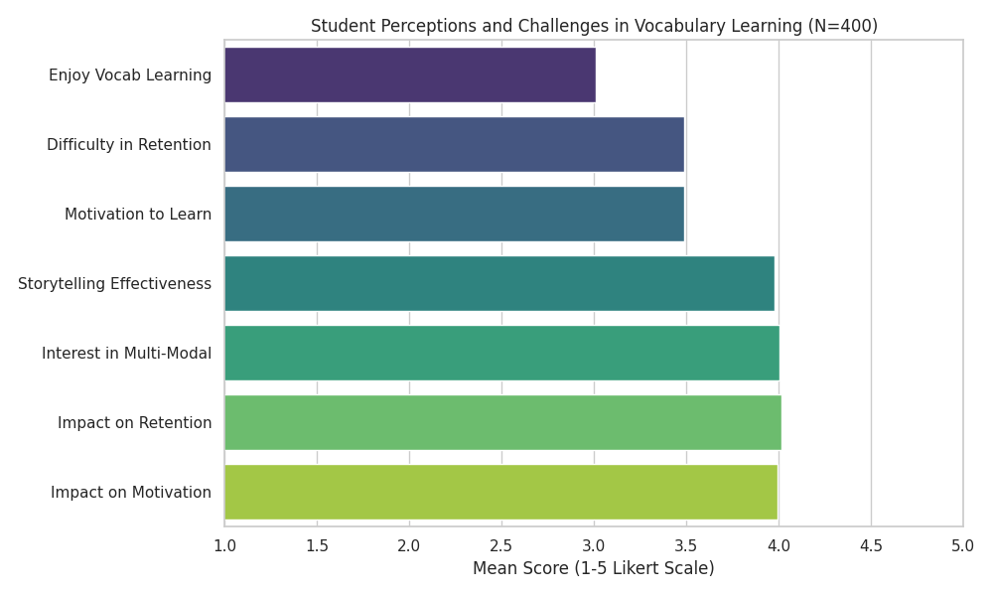 Figure 1: Student Perceptions and Challenges in Vocabulary Learning (N=400)

Item | Mean (M) | Standard Deviation (SD) | Interpretation
Q1: Enjoyment of vocabulary learning | 3.01 | 0.83 | Moderate enjoyment
Q2: Difficulty in retaining new words | 3.49 | 0.50 | High difficulty in retention
Q3: Motivation to learn new words | 3.49 | 0.50 | High motivation
Q4: Perceived effectiveness of storytelling | 3.98 | 0.71 | High perceived effectiveness
Q5: Interest in multi-modal instruction | 4.01 | 0.75 | Very high interest
Q6: Anticipated impact on retention | 4.02 | 0.70 | High anticipated impact
Q7: Anticipated impact on motivation | 3.99 | 0.71 | High anticipated impact
Table 1: Student Perceptions and Challenges in Vocabulary Learning (N=400)

Teacher Insights on Vocabulary Instruction (N=50)
The teacher survey (N=50) corroborated the students' self-reports, with teachers identifying vocabulary acquisition and retention as a major challenge for their students (M=3.58, SD=0.50). Teachers generally perceived traditional, rote-memorization methods as relatively ineffective (M=2.54, SD=0.50).

In contrast, teachers held very positive views regarding the potential of storytelling (M=4.52, SD=0.50) and multi-modal approaches (M=4.42, SD=0.50).

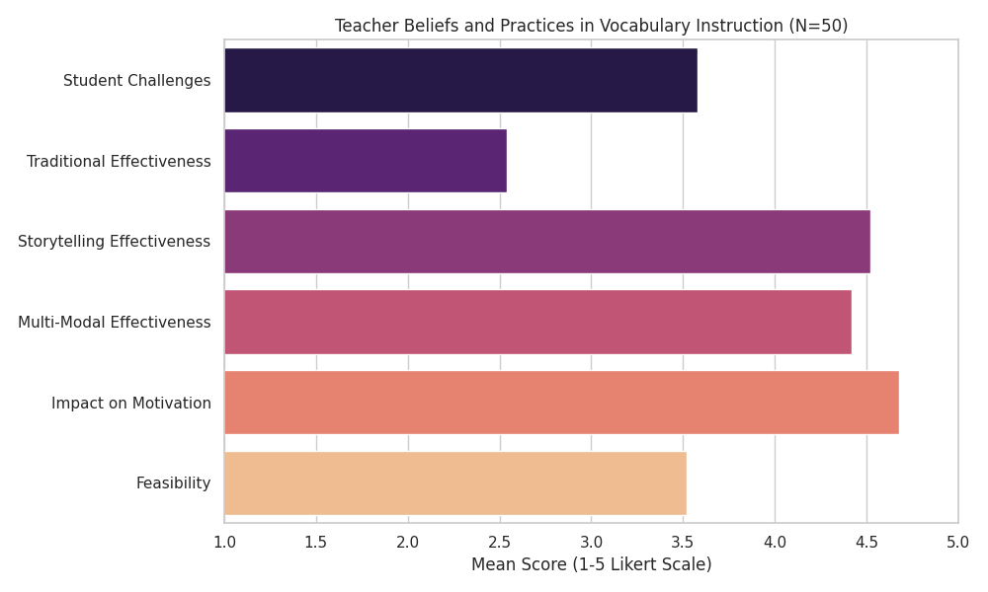 Figure 2: Teacher Beliefs and Practices in Vocabulary Instruction (N=50)

Item | Mean (M) | SD | Interpretation
T1: Challenges in student vocabulary acquisition | 3.58 | 0.50 | Significant challenge
T2: Effectiveness of traditional methods | 2.54 | 0.50 | Low effectiveness
T3: Perceived effectiveness of storytelling | 4.52 | 0.50 | Very high effectiveness
T4: Perceived effectiveness of multi-modal tools | 4.42 | 0.50 | Very high effectiveness
T5: Potential impact on student motivation | 4.68 | 0.47 | Extremely high potential
T6: Feasibility of implementation | 3.52 | 0.50 | Moderate to high feasibility
Table 2: Teacher Beliefs and Practices in Vocabulary Instruction (N=50)

Intervention Analysis (Addressing Objectives 3 & 4)
This section evaluates the effectiveness of the multi-modal storytelling intervention by comparing the performance of the experimental group (N=40) and the control group (N=40) across the pre-test, post-test, and delayed post-test.

Quantitative Results: Vocabulary Retention
The quantitative results demonstrate a clear and significant advantage for the experimental group exposed to the multi-modal storytelling intervention.

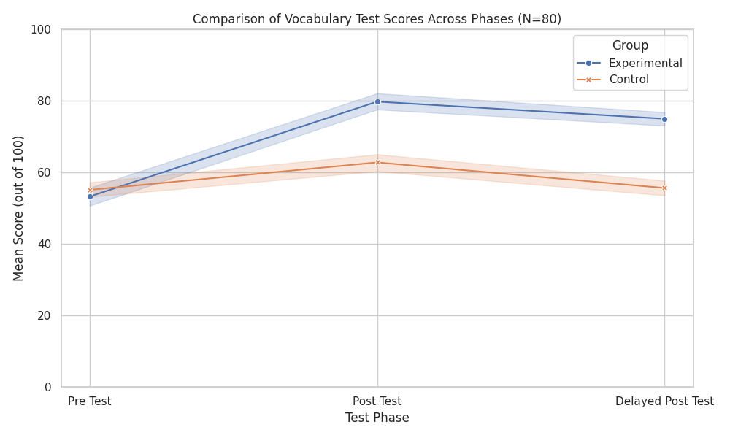 Figure 3: Comparison of Vocabulary Test Scores Across Phases (N=80)

Group | Pre-Test Mean (SD) | Post-Test Mean (SD) | Delayed Post-Test Mean (SD)
Experimental (N=40) | 53.30 (8.17) | 79.83 (7.12) | 75.03 (6.27)
Control (N=40) | 55.15 (6.63) | 62.83 (7.25) | 55.68 (6.84)
Table 3: Comparison of Pre-Test, Post-Test, and Delayed Post-Test Scores (Scores out of 100)

Immediate Learning Gains (Pre-test to Post-test)
Both groups showed improvement from the pre-test to the post-test. However, the Experimental Group exhibited a much larger gain, with their mean score increasing by 26.53 points (from 53.30 to 79.83). In comparison, the Control Group improved by only 7.68 points (from 55.15 to 62.83). This indicates that the multi-modal storytelling approach was significantly more effective for immediate vocabulary acquisition than traditional methods.

Long-Term Retention (Post-test to Delayed Post-test)
The most critical finding relates to long-term retention. While both groups experienced a slight decline in scores from the post-test to the delayed post-test (administered 4 weeks later), the Experimental Group maintained a high level of retention, with a mean score of 75.03, which is still 21.73 points higher than their initial pre-test score.
Conversely, the Control Group's score dropped significantly to 55.68, which is almost identical to their baseline pre-test score (55.15). This suggests that while traditional methods may lead to short-term gains, the knowledge is rapidly lost. The multi-modal storytelling intervention, however, appears to create more robust and durable memory traces, leading to significantly better long-term retention.

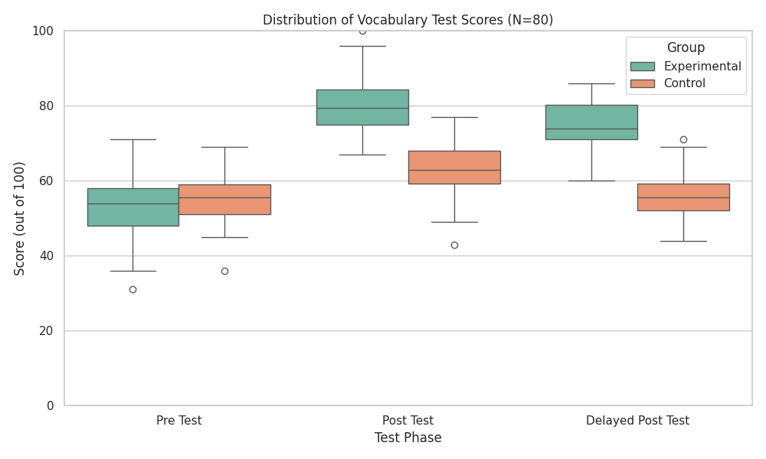 Figure 4: Distribution of Vocabulary Test Scores (N=80)

DISCUSSION
This study aimed to investigate the effect of multi-modal storytelling on vocabulary retention and motivation among Grade 10 EFL learners. The findings provide compelling evidence that multi-modal storytelling is a highly effective pedagogical strategy, significantly outperforming traditional methods in both immediate vocabulary acquisition and long-term retention, while also boosting student motivation.
The diagnostic survey results from both students and teachers underscored the pervasive challenges associated with traditional vocabulary instruction. Students, despite expressing motivation to learn new words, consistently reported difficulties in retaining them. Teachers corroborated this, acknowledging the ineffectiveness of conventional methods. These findings align with existing literature that critiques rote memorization for its failure to facilitate deep processing and meaningful connections necessary for long-term memory (Schmitt, 2000; Craik & Lockhart, 1972).
The intervention phase yielded robust quantitative evidence supporting the efficacy of multi-modal storytelling. The experimental group demonstrated substantially higher immediate learning gains (26.53 points increase) compared to the control group (7.68 points increase). More critically, the experimental group maintained a high level of retention in the delayed post-test, whereas the control group's scores regressed almost to their baseline. This stark contrast highlights the power of multi-modal storytelling in creating durable memory traces. These results are consistent with Mayer's (2009) Multimedia Learning Theory, which posits that presenting information through both verbal and pictorial channels enhances comprehension and retention by leveraging the brain's dual-coding capabilities. The rich contextualization provided by narratives, combined with visual and auditory input, likely reduced cognitive load and facilitated deeper encoding of new vocabulary (Sweller, 1988).
Beyond cognitive gains, the study also revealed a significant positive impact on student motivation and engagement. Both student and teacher questionnaires indicated a strong interest in multi-modal instruction and a high anticipated impact on motivation. This aligns with Self-Determination Theory (Deci & Ryan, 2000), as the engaging and interactive nature of multi-modal storytelling likely fostered a sense of autonomy, competence, and relatedness among learners. When learning is perceived as enjoyable and relevant, intrinsic motivation flourishes, leading to increased effort and persistence (Gardner, 1985).

CONCLUSION AND RECOMMENDATIONS

Conclusion
This study unequivocally demonstrates the significant positive impact of multi-modal storytelling on vocabulary retention and motivation among Grade 10 EFL learners. By moving beyond conventional methods and embracing a pedagogically rich, multi-sensory approach, educators can transform vocabulary acquisition into an engaging, effective, and enduring learning experience. The findings underscore the importance of integrating theoretical insights from cognitive and motivational psychology into practical classroom strategies.

Specifically, the study concludes that:

- Grade 10 EFL learners face significant challenges in vocabulary retention, primarily due to the limitations of traditional, rote-based teaching methods that fail to provide rich context and multi-modal engagement.
- Multi-modal storytelling is a highly effective pedagogical strategy for enhancing both immediate vocabulary acquisition and, more critically, long-term vocabulary retention among Grade 10 EFL learners, significantly outperforming traditional methods.
- Multi-modal storytelling significantly boosts student motivation and engagement in vocabulary learning, fostering a more positive learning environment and increasing interest, enjoyment, and active participation.

Recommendations
Based on the findings and conclusions of this study, the following recommendations are put forth for various stakeholders in EFL education:

- For Educators: EFL teachers should actively incorporate multi-modal storytelling into their vocabulary instruction, utilizing visual aids, auditory elements, and interactive components. Professional development programs should be provided to equip teachers with the necessary skills and resources.
- For Curriculum Developers: Curriculum guidelines should be revised to formally recognize and integrate multi-modal storytelling as a core pedagogical approach for vocabulary development. Comprehensive multi-modal teaching resources should be created and disseminated.
- For Future Research: Future studies could investigate the differential impact of specific multi-modal elements, conduct longer-term longitudinal studies to track retention, replicate the study with diverse age groups and contexts, and explore learner experiences through in-depth qualitative methods.

Summary and Directions for Future Research
In summary, this study provides robust evidence for the efficacy of multi-modal storytelling in enhancing vocabulary retention and motivation among Grade 10 EFL learners. It highlights a transformative approach that aligns with how the human brain naturally processes and retains information. While this study provides strong evidence, it also opens several avenues for future inquiry. Continued research into the nuances of multi-modal design, its application across diverse learning populations, and its long-term effects will further solidify its role as a cornerstone of effective EFL vocabulary instruction. Ultimately, fostering a learning environment where vocabulary is acquired through compelling narratives and rich sensory experiences promises to empower EFL learners with the linguistic tools necessary for successful communication.

REFERENCES
Bruner, J. S. (1990). Acts of meaning. Harvard University Press.

Craik, F. I. M., & Lockhart, R. S. (1972). Levels of processing: A framework for memory research. Journal of Verbal Learning and Verbal Behavior, 11(6), 671-684.

Crystal, D. (2003). English as a global language (2nd ed.). Cambridge University Press.

Deci, E. L., & Ryan, R. M. (2000). The “what” and “why” of goal pursuits: Human needs and the self-determination of behavior. Psychological Inquiry, 11(4), 227–268.

Ellis, R. (2005). Principles of instructed language learning. Asian EFL Journal, 7(3), 9-24.

Gardner, R. C. (1985). Social psychology and second language learning: The role of attitudes and motivation. Edward Arnold.

Krashen, S. D. (1985). The Input Hypothesis: Issues and implications. Longman.

Mayer, R. E. (2009). Multimedia learning (2nd ed.). Cambridge University Press.

Nation, I. S. P. (2001). Learning vocabulary in another language. Cambridge University Press.

Plass, J. L., & Kalyuga, S. (2019). Cognitive load theory and multimedia learning. In R. E. Mayer (Ed.), The Cambridge handbook of multimedia learning (3rd ed., pp. 121-133). Cambridge University Press.

Schmitt, N. (2000). Vocabulary in language teaching. Cambridge University Press.

Sweller, J. (1988). Cognitive load theory. In D. M. Merrill, M. R. Simonson, & M. O. McIsaac (Eds.), Instructional design theories and models: A new paradigm of instructional theory (Vol. 2, pp. 293–301). Lawrence Erlbaum Associates.

Vygotsky, L. S. (1978). Mind in society: The development of higher psychological processes. Harvard University Press.

