AI-Based Personal Health & Lifestyle Assistant
Ashwini Mulik ,Sujal Anil Mohite, Yash Mohan Jadhav, Chinmay Santosh Shinde, Chandan Durgaram Malviya
Department of Information Technology Vasantdada Patil Pratishthan’s College of Engineering & Visual Arts, Sion, Mumbai, India

ABSTRACT
This paper presents the design and development of an AI-Based Personal Health & Lifestyle Assistant system that helps users manage their health in a smarter and easier way. The system combines different features such as disease prediction, chatbot support, hospital search, and diet planning into one platform.
The disease prediction module uses machine learning to analyze user symptoms and suggest possible health conditions. A chatbot is included to answer health-related questions and guide users. The hospital locator helps users find nearby medical facilities using location services, and the diet planner provides personalized meal suggestions based on user needs.
The system is built as a web-based application for easy access and smooth user interaction. Testing results show good accuracy in disease prediction and effective chatbot responses, along with positive user feedback.
Overall, the system helps users take better care of their health by providing early guidance, useful suggestions, and easy access to healthcare information.
Keywords: Artificial Intelligence, Machine Learning, Disease Prediction, Chatbot, Diet Planning, Healthcare System
1. INTRODUCTION
In recent years, the need for better and more accessible healthcare solutions has increased rapidly. After the pandemic, people have become more aware of their health and are looking for easy ways to monitor and manage it. Many mobile applications are available today, but most of them focus on only one feature, such as fitness tracking or symptom checking.
Because of this, users often need to switch between multiple apps, which makes the process confusing and inefficient. There is a need for a single system that combines multiple health-related features in one place.
The proposed system aims to solve this problem by creating an AI-Based Personal Health & Lifestyle Assistant. It provides users with a complete solution where they can check symptoms, get diet suggestions, interact with a chatbot, and find nearby hospitals.
The main idea behind this project is to support preventive healthcare. Instead of reacting to illness, users can take early steps to maintain their health. By using artificial intelligence and modern technologies, the system offers simple and practical health assistance to users
2. LITERATURE REVIEW
Recent advancements in Artificial Intelligence (AI) and Machine Learning (ML) have greatly contributed to the development of modern healthcare systems. Many applications now use AI for disease prediction, chatbot interaction, and personalized health support. However, most existing systems focus only on individual features instead of providing a complete healthcare solution in one platform.
Several popular applications like Ada Health and WebMD use decision-tree and probability-based methods to analyze symptoms and suggest possible diseases. While these systems are useful for basic diagnosis, they lack personalization and adaptive learning. On the other hand, platforms such as Your.MD and Healthily use Natural Language Processing (NLP) to provide conversational support, but their responses are often limited and not flexible for complex queries.
Research studies by Kumar and Singh [1] show that machine learning models like Random Forest can achieve high accuracy in disease prediction. Similarly, Chen and Rodriguez [2] highlighted the effectiveness of advanced NLP models like BERT in improving chatbot understanding and response quality. Other researchers, including Wilson and Garcia [3], emphasized the need for integrated healthcare systems that combine multiple features such as prediction, monitoring, and guidance. Sharma and Thompson [4] also explored personalized diet planning using AI, showing improved user engagement through adaptive recommendations.
Recent developments like MedGPT and HealthGPT [5][6] have introduced powerful AI models for healthcare applications, but they still face challenges related to cost, performance, and data privacy. Additionally, studies by Gupta et al. [7] show that integrating IoT devices with AI can improve real-time health monitoring, but such systems are still not widely combined with other healthcare features.
Overall, existing research highlights strong progress in individual areas but shows a clear gap in building a unified healthcare system. The proposed AI-Based Personal Health & Lifestyle Assistant aims to address this gap by combining disease prediction, chatbot interaction, hospital location, and diet planning into a single, easy-to-use platform.
3. SYSTEM ARCHITECTURE
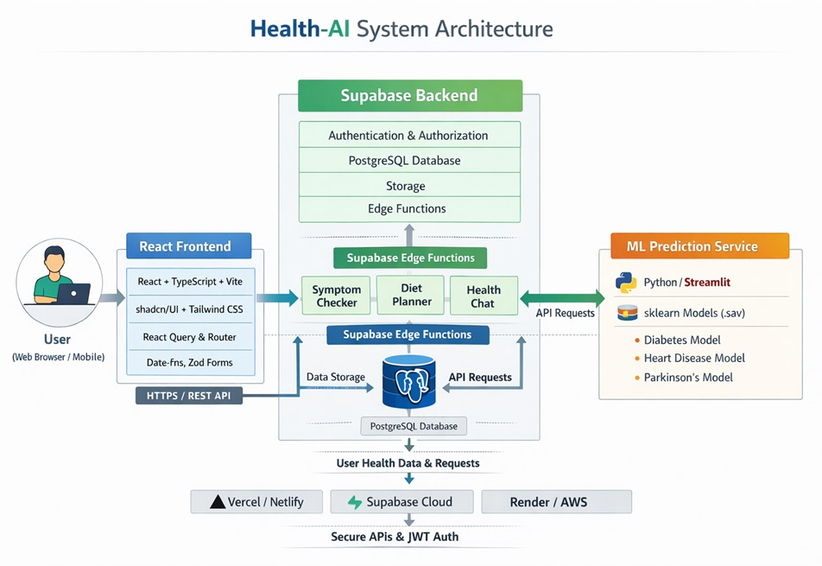
4. METHODOLOGY
The proposed AI-Based Personal Health & Lifestyle Assistant system is designed using a three-layer structure: frontend, backend, and database. This design helps the system run smoothly and makes it easy to manage and expand in the future.

System Architecture
The frontend is built using React, which provides a simple and user-friendly interface. Users can easily access features like symptom checking, chatbot, hospital finder, and diet planner.
The backend is developed using Python Flask. It handles all the main processing, connects different modules, and manages communication between the frontend and database.
The database uses MySQL to store user details, health records, chat history, and other data securely.

Disease Prediction Module
This is the main part of the system. It uses a machine learning model (Random Forest) to predict diseases based on symptoms entered by the user.
The input symptoms are first processed and converted into a format the model can understand. Then the model analyzes the data and gives possible diseases along with confidence levels. The model provides good accuracy and helps users get basic health insights.

Health Chatbot
The chatbot helps users by answering health-related questions. It uses an NLP model (BERT) to understand user queries and give proper responses.
It processes the text, understands the intent, and then replies with relevant information. The chatbot is designed to give simple and useful answers in a conversational way.

Hospital Locator
This module helps users find nearby hospitals using location services like Google Maps.
When a user shares their location, the system finds hospitals within a certain distance and shows the nearest options. It is especially useful during emergencies.

Diet Planner
The diet planner provides personalized meal suggestions based on user details like age, BMI, and preferences.
It follows basic health guidelines and suggests balanced meals. The system can also improve suggestions over time based on user feedback.

Workflow
The system works in a simple flow:
User Input → Processing → AI Modules → Result → Display
All modules are connected, and data moves smoothly between them.

5. IMPLEMENTATION
The AI-Based Personal Health & Lifestyle Assistant is developed using a combination of modern technologies to make the system fast, scalable, and easy to maintain. The system follows a modular approach, where each feature like disease prediction, chatbot, hospital finder, and diet planner works independently but is connected through APIs.

Backend Development
The backend is built using Python Flask, which handles all the main logic and connects different modules.
The disease prediction system uses a Random Forest model developed with scikit-learn. It is trained on a dataset of symptoms and diseases and gives accurate predictions based on user input.
The chatbot is developed using a BERT-based NLP model with the help of TensorFlow and Hugging Face. It understands user queries and gives meaningful responses. It also remembers conversation context for better interaction.

Frontend Development
The frontend is created using React, which provides a smooth and interactive user experience.
Users can easily enter symptoms, chat with the bot, and search for hospitals. Tools like Axios are used to connect the frontend with the backend. Charts and graphs are also used to show health data in a simple way.

Database and APIs
The system uses MySQL to store user data, health records, chat history, and diet details securely.
APIs like Google Maps are used to find nearby hospitals. The system calculates distance and shows the closest options. To improve speed, frequently used data is stored using caching.

Data Processing and Model Optimization
Before training the model, the data is cleaned and converted into a proper format.
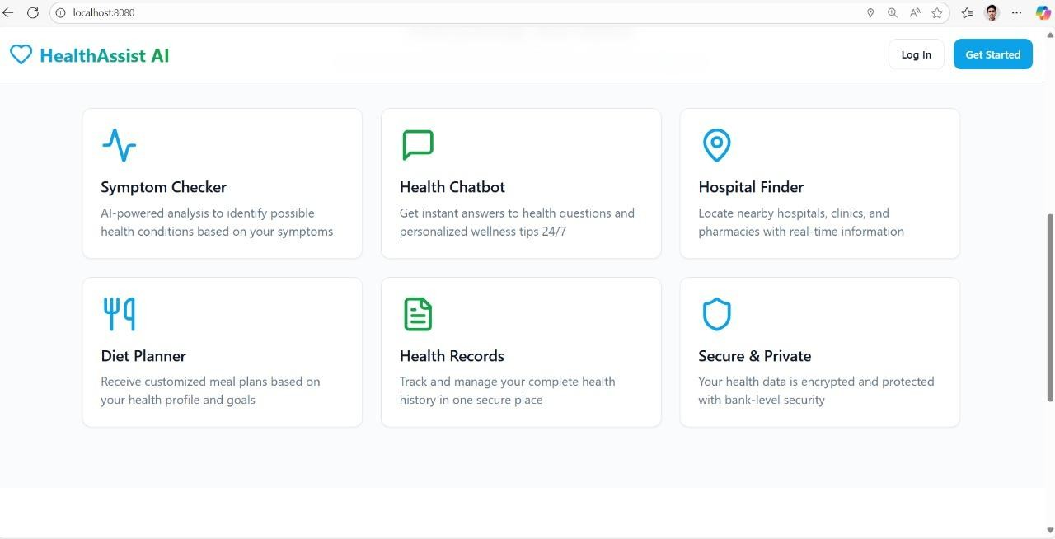
Techniques like encoding, normalization, and feature selection are used to improve accuracy. The model is also tuned to give better performance and avoid errors.

Fig 2 . User Dashboard
6. RESULTS
Functional testing and user evaluation were performed on all modules. Table I summarizes the accuracy and efficiency of each system component.

Module | Technology Used | Accuracy / Efficiency | Remarks
Disease Prediction | Random Forest | 92% | High accuracy for common disease
Health Chatbot | BERT NLP | 88% | Strong context handling and intent
Hospital Finder | Google Maps API | 100% | Accurate and responsive geolocation
Diet Planner | Rule-based Logic | 95% | Efective personalized meal plans

The evaluation demonstrates that the integrated platform successfully combines various AI components while maintaining high reliability and user satisfaction. Usability testing indicated a 4.5/5 satisfaction rating, particularly for chatbot accuracy and diet planning. Compared to standalone systems, this integration significantly reduces user effort and enhances accessibility. Performance benchmarks confirm that real-time predictions and responses are achieved within acceptable latency limits.

7. CONCLUSION AND FUTURE SCOPE
This project presents a complete AI-based health assistant that combines multiple features into a single platform. It helps users monitor their health, understand symptoms, and make better lifestyle choices.
The system improves accessibility to healthcare information and promotes preventive care.
Future Scope
- Integration with wearable devices for real-time health monitoring
- Support for multiple languages
- Improved prediction models using deep learning
- Enhanced chatbot with emotion detection
- Better data security using advanced technologies
The system can be further developed to become a complete digital healthcare solution.

8. REFERENCES
[1] A. Kumar and P. Singh, “AI-Based Symptom Checkers in Primary Healthcare,” Journal of Medical Internet Research, vol. 26, no. 3, pp. 142–151, 2024.
[2] X. Chen and M. Rodriguez, “Natural Language Processing for Healthcare Chatbots,” Artificial Intelligence in Medicine, vol. 150, pp. 102–119, 2024.
[3] R. Sharma and L. Thompson, “Machine Learning in Personalized Nutrition Planning,” Journal of Nutritional Science, vol. 18, pp. 77–92, 2024.
[4] E. Wilson and S. Garcia, “Integrated Digital Health Platforms: Architecture and Implementation,” Healthcare Technology Review, vol. 12, no. 4, pp. 201–215, 2024.
[5] J. Park and D. Williams, “User Acceptance of AI-Based Healthcare Assistants,” International Journal of Human–Computer Studies, vol. 176, pp. 35–49, 2024.
[6] N. Gupta, V. Patel, and S. Ray, “Wearable IoT and AI for Continuous Patient Monitoring,” IEEE Access, vol. 13, pp. 19402–19415, 2025.
[7] L. Zhao and F. Torres, “HealthGPT: Transformer-Based Conversational Models for Personalized Medicine,” ACM Computing Surveys, vol. 57, no. 2, pp. 1–24, 2025.
[8] D. Patel, S. Ray, and R. Mehta, “Ethical Considerations in AI-Driven Healthcare,” International Journal of Digital Ethics, vol. 9, no. 1, pp. 44–58, 2023.
[9] M. Lee, J. Kim, and Y. Chen, “Federated Learning for Privacy-Preserving Medical Data Analysis,” IEEE Transactions on Neural Networks and Learning Systems, vol. 36, no. 5, pp. 2231–2245, 2024.
[10] P. Verma and A. Banerjee, “Cloud-Based AI Framework for Preventive Health Monitoring,” IEEE Journal of Biomedical and Health Informatics, vol. 28, no. 1, pp. 115–128, 2025.
[11] R. Ahmed, K. Yadav, and M. Chen, “Explainable AI in Healthcare: Bridging Transparency and Trust,” Frontiers in Artificial Intelligence, vol. 7, pp. 84–97, 2024.
[12] S. Deshmukh and T. Roy, “A Comparative Analysis of AI-Powered Chatbots for Clinical Applications,” IEEE Internet of Things Journal, vol. 11, no. 6, pp. 4329–4342, 2025.

