CampusClique: Transforming Campus Interaction Through Unified Platform

- INTRODUCTION
Social media has changed the way people connect, work together, and share information in today's fast-paced, tech-driven world. For students, social platforms have gone beyond
just chatting and now play a big role in learning, building connections, and showing off skills. However, most social media sites are built for the general public and don't have features that help with academic growth, organized teamwork, or school involvement. This gap shows there's a need for a special platform that's focused only on students and educational systems.
To fix this, CampusClique has been created and put into use as a single community and opportunity platform for students and schools. Unlike regular social media, Campus Clique helps with academic activities by letting students share their accomplishments, projects, and experiences with their classmates in a clear and meaningful way. The platform also gives colleges and universities their own official areas where they can share real opportunities like internships, workshops, cultural events, competitions, and job updates, so students get accurate and timely information.
The system fills in the gaps in academic networking by helping students connect with others at their own school and also with students from different colleges. This kind of connection across schools encourages teamwork, sharing of knowledge, and building a stronger academic group
In addition to teamwork and finding opportunities, Campus Clique has features that help with mentorship. Students can connect with experienced professionals, alumni, and teachers for advice on projects, research, career plans, and skill building. This helps students have meaningful conversations and get real-world insights, exposure to actual problems, and chances to network professionally.

- RELATED WORKS
Anitha Julian et al. [1] talked about how to make digital platforms for schools and colleges easier to use and more visually pleasing. She pointed out the importance of keeping

student data safe and making sure the system can handle more users without getting slow. Their research said that having a simple interface along with good data management is very important. These ideas helped Campus Clique make a user-friendly interface and better data handling to support more people smoothly.

Dr. D. S. Waghole et al. [2] built a social platform for students that uses machine learning for secure teamwork. Their work showed that adaptive systems, secure access, and smart tools are valuable. Campus Clique follows this by using secure login systems and a flexible design that can later include smart features. The platform only allows verified students and schools, keeping the environment safe and controlled.

Rebecca Thomas et al. [3] criticized strict education systems that focus only on grades. They believed in a learning model that gives students freedom, independence, and the chance to explore. This inspired Campus Clique to become a platform offering various opportunities. Students can find internships, join events, work on projects, and connect with others outside the regular curriculum, which helps both their studies and careers.

Jennifer Griffiths et al. [4] stressed the need for ethical awareness and responsible tech use in professional education. They emphasized the importance of trustworthy online spaces and proper online behavior. Campus Clique supports this by checking institution accounts, controlling content sharing, and giving access based on user roles. These features help ensure that information is real, sharing is responsible, and interactions are professional.

Jothi Rani et al. [5] studied how digital spaces that link academics and community activities can improve learning. They showed that sharing resources and having conversations with peers increases involvement. Campus Clique uses these ideas by using student groups, shared content, and collaborative spaces. This helps students stay connected with their studies and form a focused educational community.

Pramod Jain et al. [6] noticed that there are not complete platforms for college communities. They suggested a single system that includes social networking, club forums, and a peer marketplace. Personalized feeds and club areas help students interact more and stay engaged longer. Their study also stressed the need to improve recommendation systems and test them in real situations.

To better manage campus events, Akansha Pansare et al. [7] built a Smart Event Management System for college using the MERN stack. It brings all event information like locations, schedules, and fees together, reducing mistakes and improving reports. With its simple design and scalable setup, the system improves the efficiency and reach of campus activities.

Dadan Umair Altaf et al. [8] created Campus Connect using the MERN stack to make academic management and communication smoother. It centralizes student records, attendance, and grades to help teachers, parents, and students stay involved. Its secure and scalable design solves key issues
with data security and compatibility, making the whole institution more efficient.

Prof. Deepika Walanjkar et al. [9] found that integrated platforms help share campus events, but real engagement comes from instant alerts and rewards. Current systems often separate these features, leaving a gap. This project aims to combine real-time notifications with a rewards system to increase student participation.

James D. Herbsleb et al. [10] noticed that most hackathon research focuses on social results like teamwork, while code reuse is not studied much. Their study looks at how hackathon code evolves over time, including how it is changed and maintained after events.

Zhao and their team [11] explored how social media platforms could use machine learning to recommend educational content. Their research, published in Symmetry, showed how natural language processing (NLP) and data science can personalize learning experiences online. The study explains that customized content feeds can significantly increase learner engagement and performance, highlighting the potential of social media-style recommendation systems in academic settings.

Souabi et al.[12] looked at e-learning recommender systems in the Electronic Journal of e-Learning. They looked at different methods such as Content-Based Filtering, Collaborative Filtering, and Hybrid approaches. Content-Based Filtering uses detailed metadata, while Collaborative Filtering relies on strong user data.

Anandhan et al. [13] did a study on Social Media Recommender Systems (SMRS) from 2000 to 2021 in IEEE Access. They found that hybrid personalization models are now the standard for social media and education platforms, supporting adaptive learning technologies.

Dhananjaya et al. [14] looked at digital recommendation systems for personalized learning in IEEE Access. After looking at sixty studies, they noted a move from traditional filtering to advanced AI systems. They also mentioned ongoing challenges like cold-start issues and disengagement, suggesting future solutions like Fluxy AI, Twin Technology, and AI-powered virtual assistants.

A study by Dr. Vinod Wadne et al. [15] suggested a single platform where students can share opportunities, celebrate achievements, and connect with each other in one place, making it easier to access and more engaging. But this idea didn’t include personalized features. The new CampusClique system builds on that by adding all those functions along with a mixed recommendation system, making the platform more tailored and useful for each user.

I. METHODOLOGY
The methodology for this project focuses on creating and building a social networking platform centered around students. This platform combines academic teamwork, finding

opportunities, and mentorship into one secure environment. The process was based on looking at current social media and educational platforms to spot what's missing and what's needed specifically for student communities.
At first, we did a detailed requirement analysis to understand the shortcomings of existing solutions. Although social media platforms are important for student communication, learning, and self- expression, popular ones like Facebook, Instagram, and LinkedIn are either too general or more focused on professional use. On the other hand, most educational platforms offer very limited social features, usually just for announcements, small group chats, or sharing content, without allowing interaction between different campuses, mentorship, or integration of opportunities.
Based on these findings, we designed a unified platform structure to address the issues caused by using multiple apps for academic and extra-curricular activities. The system we built allows students from different colleges to connect, work together, and share their academic accomplishments. Educational institutions are given verified accounts to post real opportunities like internships, workshops, competitions, seminars, and events.
We developed the platform using modern web technologies with a modular design to make it scalable and easy to maintain. We implemented secure authentication methods to verify the identities of
students and institutions, which helps stop unauthorized access and ensures data safety. We also used role-based access control to separate the functions for students, mentors, and administrators.
To help with academic growth and professional guidance, we included mentorship features that let verified faculty members, alumni, and industry experts connect with students through dedicated mentorship areas. We also added interactive elements like posts, discussion threads, and activity-based engagement to promote peer learning and active involvement.

By bringing together academic networking, mentorship, and opportunity access into one digital space, the methodology ensures better student engagement, less fragmentation in platforms, and more access to learning and career development resources.

Key Features of the Implemented System:
The Unified College Platform includes the following main features to make it work well, easy to use, and ready for future changes:

Scalability:
The system was built with a modular and scalable design, allowing it to handle more students and institutional accounts as the user base grows, without slowing down. The database is structured efficiently, and the backend is optimized to keep everything running smoothly even with higher usage.

Accessibility:
The platform can be used through a responsive web interface, which means students can access it from different devices and locations. The user interface was created to be
simple, easy to navigate, and quick to learn for new users.

Interactivity:
To help students stay engaged, the system offers real-time notifications, the ability to share posts, discussion threads, and interactive communication tools. These features encourage teamwork, sharing of information, and ongoing participation between students and institutions.

Security:
Strong authentication and role-based access control were added to keep user data safe and protect privacy. Only verified institutional accounts can publish content, and publishing rights are controlled to ensure the platform remains authentic and is not used improperly.

Extensibility:
The platform is built in a modular way, making it easy to add new features in the future, like gamification, achievement tracking, certification modules, and AI-powered recommendations, without needing to rebuild the main system.
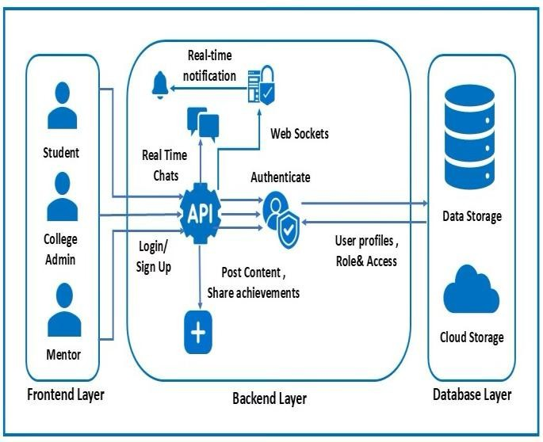
Fig. 1: System Architecture

Fig. 1 shows the overall system setup of Campus Clique, explaining how students, college staff, and mentors interact through RESTful APIs and real-time communication using WebSocket. The system is based on a client-server model, with a secure database and cloud storage services to manage user content and media.

The technology stack for Campus Clique was chosen to make sure the system can grow, work efficiently, and follow modern web development standards. The system was built using a full-stack. JavaScript setup, which makes it easier to connect the parts that users see on the website with the parts that handle the behind-the-scenes work.
To make the experience more personalized and boost student involvement, a hybrid recommendation system that mixes Collaborative Filtering (CF) and Content-Based Filtering (CBF) was introduced in Campus Clique.
- Collaborative Filtering (CF) Implementation Collaborative Filtering was used to guess what a student might like based on how similar other students behave.
A matrix called R was created, where each row was a student and each column was a post, opportunity, mentor, or event. Missing data was filled in by looking at how similar students' behavior was.

The similarity between two students, u and v, was calculated using this formula:
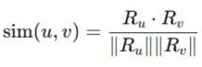

The system recommends items that other students with simil ar interests have liked or interacted with.
For example, if Student A has interacted with opportunities X and Y, and Student B has interacted with X, the system would suggest Y to Student B.
After the system was set up, looking at interaction logs showed a big rise in discovering new content across different areas, with more engagement in opportunities and mentorship connections among students who had similar interests.
- Content-Based Filtering (CBF) Implementation Content-Based Filtering was used to suggest items that are similar to what a student has interacted with before. Each post, opportunity, or event was turned into a feature vector based on tags, categories, and text details.
Similarity between two items, i and j, was calculated using cosine similarity:
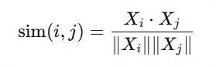
For example, if a student often interacts with AI-related posts, the system would highlight content in categories like artificial intelligence and machine learning.
The implementation of a hybrid recommendation system that combines Collaborative Filtering with Content-Based Filtering significantly improved the quality of the user feed in Campus Clique. By analysing user interaction patterns and aligning recommendations with personal interests, the system delivered more relevant posts, opportunities, events, and mentorship suggestions. This reduced information overload and enhanced content accessibility for users.
To check how well the recommendation system works, we used common measures like Precision, Recall, F1-Score, and Hit Rate. These measures help us understand how accurate, how much they cover, and the general quality of the recommendations. Where K represents the number of top recommendations shown to each user. In this study, K is set to 5, meaning that the system evaluates the top 5 recommended items for each user.
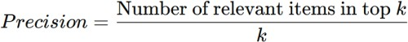

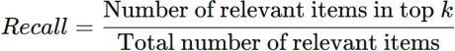

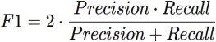

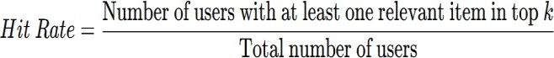

For the evaluation, five users were chosen. Their interaction data was used to check how well the recommendation system worked, and the following results were found. The evaluation used these parameters: k=5, which means the top five recommendations were given to each user, and five sample users were picked from the platform. A recommendation was seen as relevant if the user clicked on it, liked it, or signed up or applied for it. The user interaction logs helped figure out which recommendations were relevant and allowed the evaluation metrics to be calculated.

Table 1: User-wise Performance Metrics of Recommendation System
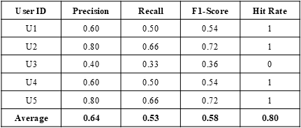

Table 1 shows that recommendation system works well at giving users content they are interested in. The average Precision of 0.64 means most of the items suggested are relevant. The Recall of 0.53 shows that the system covers a decent amount of the relevant items users could find.
The F1-Score of 0.58 shows a good balance between how accurate the recommendations are and how many relevant items the system finds. Also, the Hit Rate of 0.80 means most users got at least one relevant item in their top recommendations.
The personalization caused a noticeable rise in user engagement, shown by more clicks, likes, and involvement in opportunities.
Users were able to discover a broader range of relevant content across various domains, improving platform exploration and knowledge sharing. Furthermore, the system strengthened community connections by suggesting mentors and peers with similar interests, fostering collaboration and networking among students.
The implementation of the recommendation system transformed the user experience from a generic and static content feed into a dynamic, intelligent, and personalized environment. This not only improved user satisfaction and retention but also increased active participation, making the platform more engaging, efficient, and impactful for student communities.

- FEATURES AND FUNCTIONALITIES
The CampusClique platform includes several modules that help students and educators connect, work together, find mentors, and discover opportunities in one place.

Core Features
  - Profile Creation and Management
Students can make and update detailed profiles that show their education, skills, projects, certifications, and accomplishments.
The system allows users to upload pictures, certificates, and project files.
There is also a bookmarking feature so users can save posts, achievements, and opportunities for later.

Explore Feed
A central feed displays posts, discussions, achievements, and updates from institutions. It changes based on user interests, past activity, and college membership to show relevant content.

Mentorship Connect
A mentorship section was built where verified mentors can create profiles showing their expertise and availability.
Students can request mentorship, set up one-on-one or group sessions, and track their interactions within the platform.

Opportunities and Events Module
Colleges and organizations can post internships, workshops, competitions, seminars, and job opportunities.
Students can view details, apply directly through the platform, and get automatic reminders before deadlines.

Interaction and Communication
The system lets users like, comment, share, and react to posts. A real-time messaging feature, using WebSocket technology, allows direct communication between students, mentors, and groups.

Community Building and Group Participation
To encourage peer collaboration, a community module was added. Students can join or start groups based on interests like AI, Web Development, Hackathons, Competitive Exams, and more.
Each group has discussion threads, shared posts, announcements, and spaces for interaction, helping with networking and sharing knowledge across campuses.

Personalized Experience
An intelligent system organizes content based on user behavior, engagement, and stated interests.
This ensures that relevant posts, mentorship suggestions, and opportunities are shown first, making the experience more satisfying and engaging.

System Functionalities
  - Profile and Content Management
Users can update their profiles, manage uploaded content, and adjust privacy settings.
Institutions have the ability to publish official announcements and verified opportunities with controlled access.

Mentorship Workflow
Students can submit mentorship requests, schedule sessions, and keep logs of their communication.
Mentors can approve sessions and track their guidance records.

Opportunity Registration and Notifications
Students can sign up for events and opportunities directly on the platform.
An automated system sends reminders and notifications about deadlines and upcoming events.

Real-Time Communication
The platform supports secure direct messaging and interactive discussion areas within communities, which helps improve collaboration.

Personalization and Recommendation Engine
A hybrid recommendation system suggests relevant posts, communities, mentors, and opportunities based on user activity.
The feed changes over time as users interact more with the platform.

    - RESULTS AND DISCUSSION
The CampusClique platform was successfully put into use, and all main features are working well. These features include user login and verification, managing profiles, interacting with others, connecting with mentors, sharing opportunities, and communicating in real time. The system uses token-based authentication to keep access secure, allowing only approved users and protecting data based on their roles. From the user's perspective, the platform is built to be straightforward and user-friendly, allowing people to move around and use it without facing much trouble.
Students can create profiles, look through content, join groups, and apply for opportunities without facing major technical problems. The system also uses a single architecture, which means it doesn't rely on many outside tools, making it more efficient and convenient overall. CampusClique helps solve problems like poor communication, limited teamwork, and lack of access to opportunities by bringing together mentorship, event planning, community involvement, and personalized content in one place.
Fig. 2 illustrates a comparison between LinkedIn and CampusClique, looking at how well they perform in areas like SEO, following best practices, and overall system performance. It shows that Campus Clique works better in these areas.
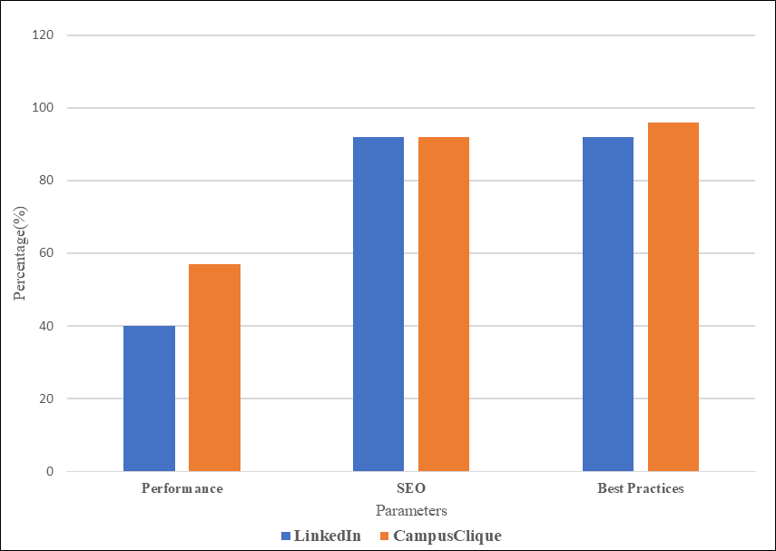

Fig 2 : Comparison of LinkedIn with CampusClique

In addition to the qualitative comparison, there is also a quantitative evaluation of the recommendation system shown in Table 2. This evaluation compares CampusClique with LinkedIn using important performance measures like Precision, Recall, F1-Score, and Hit Rate.

The results show that CampusClique performs better in all these areas. For example, CampusClique has a higher Precision of 0.64, which means it gives more accurate and relevant recommendations than LinkedIn, which is around
0.55. The Recall score for CampusClique is 0.53, meaning it finds a bigger share of relevant content than LinkedIn's 0.45. The F1-Score of 0.58 shows that CampusClique strikes a better balance between accuracy and coverage. Additionally, the Hit Rate of 0.80 for CampusClique is much higher than LinkedIn's, showing that it is more successful at providing useful suggestions to users.

Table 2 : Comparative Performance Evaluation of CampusClique and LinkedIn Recommendation Systems
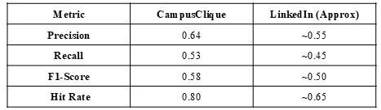

Following Fig. 3 shows the visualised comparative analysis of CampusClique with LinkedIn.

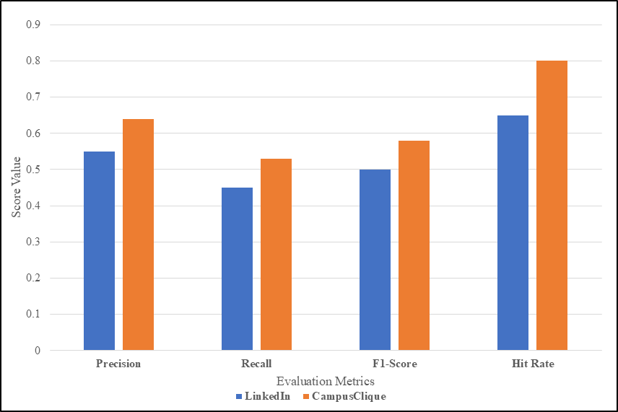

Fig 2 : Comparative Analysis of Recommendation System Performance Metrics

Early use of the platform shows that users are busy in various areas. The feature for finding opportunities was the most used, then came mentorship, group discussions, and event joining. This shows the platform helps students grow in many ways and uses its features evenly. The way users get benefits from different areas is shown in Fig. 3 with academic opportunities being the biggest part, followed by mentorship, collaboration, and networking.
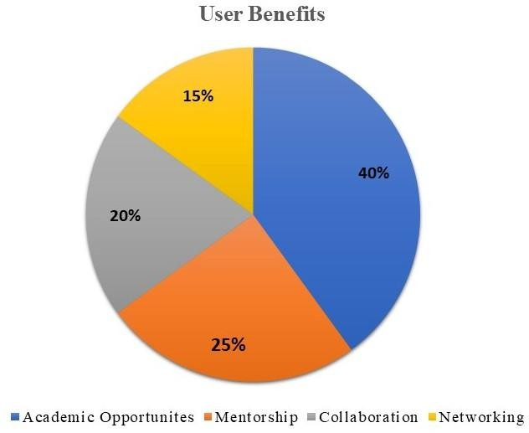
Fig 3 : Distribution of use cases of CampusClique

Even though the main features work well, the system is still being improved. Future upgrades will include better data analysis, smarter recommendations, fun game-like elements, AI-powered assistants, and more personalized options. These changes are meant to boost user involvement and make CampusClique a smart and flexible academic space.

Also, a way to keep getting feedback has been set up through surveys, forms inside the platform, and user chats. This helps make sure the changes made are based on real data and meet what users need, letting the platform keep improving as academic needs change.

Overall, the results show that the system is technically possible, welcomed by users, and useful in real situations. The implementation confirms the original goals and shows how a combined approach works well. Future plans will focus on making the system bigger, adding smart automation, and improving features that are centred on the user.

    - CONCLUSION
Campus Clique was successfully created and put into use as a single academic networking platform that connects students, mentors, and educational institutions within a secure digital environment. The system combines secure login processes, access control based on user roles, real-time messaging, community interaction, mentorship links, and personalized content into one organized platform.

The platform effectively solves major issues like scattered communication, limited collaboration between campuses, and challenges in finding genuine academic opportunities.
By bringing together profiles, communities, mentorship programs, and event coordination in one place, the platform makes it easier for students to access resources, stay involved, and participate more fully.
The system's scalable and flexible design ensures it can grow and perform well as more users join. Possible future improvements might include AI-driven recommendation systems, blockchain-based certificate verification, gamification elements, and smarter mentorship tools to boost personalization and user involvement.

Overall, Campus Clique shows a practical, secure, and expandable solution for creating a complete, student-focused academic environment.

    - FUTURE SCOPE
Even though Campus Clique has been successfully launched with its main features like academic networking, mentorship, and community building, there are still many ways it can be improved. In the future, the platform could include more advanced AI systems that use hybrid and deep learning techniques to offer better personalized recommendations for content, mentors, and opportunities. Using Natural Language Processing (NLP) can help make search functions smarter, automate tagging, and improve content moderation. Adding blockchain technology for certificate verification would make it easier and safer to check student achievements and qualifications. Including gamification features such as badges and leaderboards could make the experience more engaging for users. AI-powered virtual mentors could also offer real- time support and guidance. Expanding the platform into a mobile app and adding detailed analytics dashboards for educational institutions would make the system more accessible, scalable, and useful for making data-driven decisions. These changes can help Campus Clique grow into a smarter, more future-focused academic environment.

    - REFERENCES
- A. Julian, S. K. Kumar, A. W. J. Alen, and R. Kishore, “Socializing platform for educational institutions,” in Proc. 2023 Int. Conf. on Computer Communication and Informatics (ICCCI), 2023. DOI: 10.1109/ICCCI56745.2023.1012

- D. S. Waghole , A. Shelke, S. Achaler, V. Bhand, and O. Mate, “College social networking website with machine learning,” Int. J. of Engineering Research and Technology (IJERT), vol. 12, no. 3, Mar. 2023. [Online].
- R. Thomas, S. Appelhans, M. Thompson, S. J. Thomas, and A. Chevill, “Student valuations for opportunity-based education,” in Proc. 2024 IEEE Frontiers in Education Conf. (FIE), 2024. DOI: 10.1109/FIE61694.2024.10893129.
- J. Griffiths, P. Ghosh, D. C. Hurtado, and F. Suleiman, “ETHICS-2025 Session D1 – Presentations: New perspectives on engineering and technology ethics education,” in Proc. 2025 IEEE Int. Symp. on Ethics in Engineering, Science, and Technology (ETHICS), 2025. DOI: 10.1109/ETHICS65148.2025.11098335.

- J. Rani, N. T. Singh, P. Kaur, R. Grover, and Himanshu, “CampusConnect: A collaborative college hub for reselling and sharing knowledge,” in Proc. 2nd Int. Conf. on Self Sustainable Artificial Intelligence Systems (ICSSAS), 2024. DOI: 10.1109/ ICSSAS64001.2024.10760485.
- Pramod Jain . S. A. Jain, S. Rao, P. C., and S. M., “Studex: A one- stop solution to all college community needs,” in Proc. 2nd Int. Conf. on Data Science and Information System (ICDSIS), 2024. DOI: 10.1109/ICDSIS61070.2024.10594406.
- A. Pansare, A. Patil, N. Patil, Y. Patil, and A. Bhonde, “Smart college event management system using MERN stack,” Int. J. for Research in Applied Science and Engineering Technology (IJRASET), vol. 11, no. 3, Mar. 2023.
- D. U. Altaf, M. N. Sameer, S. A. Sayeed, and S. W. Rahman, “Campus Connect: Student management system using ReactJS, NodeJS and MongoDB,” Int. J. of Scientific Research in Engineering and Management (IJSREM), vol. 8, no. 5, May 2024.
- D. Walanjkar, M. Ganore, K. Kadam, A. Lohar, and P. Ukade, “Boosting campus life with real-time event updates and rewards,” Int. J. for Multidisciplinary Research (IJFMR), 2024.
- A. S. I. Mahmoud, T. Dey, A. Nolte, A. Mockus, and J.
D. Herbsleb, “One-off events? An empirical study of hackathon code creation and reuse,” arXiv preprint, arXiv:2207.01015v1 [cs.SE], Jul. 2022.
- L. Zhao, Z. Liu, and K. Li, “Toward social media content recommendation integrated with data science and machine learning approach for e-learners,” Symmetry, vol. 12, no. 11,
p. 1798, 2020. DOI: 10.3390/sym12111798.
- S. Souabi, A. Retbi, M. K. Idrissi, and S. Bennani, “Recommendation systems on e-learning and social learning: A systematic review,” Electronic J. of e-Learning, vol. 19, no. 5, pp. 432–445, 2021. DOI: 10.34190/ejel.19.5.2482.
- A. Anandhan, M. A. Ismail, L. Shuib, and W. S. N. A. Othman, “Social media recommender systems (SMRS): A bibliometric analysis study 2000–2021,” IEEE Access, vol. 10, 2022. DOI: 10.1109/ACCESS.2022.3161497.
- D. G. M. Dhananjaya, R. H. Goudar, A. A. Kulkarni, V.
N. Rathod, and G. S. Hukkeri, “A digital recommendation system for personalized learning to enhance online education: A review,” IEEE Access, vol. PP, no. 99 , Jan. 2024 . DOI: 10 . 1109 / ACCESS.2024.3369901.
- V. Wadne, R. Kotwal, A. Pathan, S. Bhalerao, S. Patil, A. Gole, “CampusClique : A Single integrated platform tailored for students”, in International Conference on Research in Science, Engineering and Technology, 2026.

