Original Article

Digital Twin Supported AI-Assisted Synchronization and Intelligent Fault Ride-Through for Grid-Connected Photovoltaic Inverters
Sanju¹, Kusum Lata Agarwal², Satya Sai Srikant³, Manoj Singh⁴
¹Department of EEE, SRM Institute of Science and Technology, Delhi-NCR, Ghaziabad, U.P, India
²Professor and Dean Academics, Karnavati University, Gandhinagar, Gujarat, India
³Department of ECE, SRM Institute of Science and Technology, Delhi-NCR, Ghaziabad, U.P, India ⁴Department of CSE, Government Engineering College, Bikaner, Rajasthan, India sanju.bidyasar@gmail.com
Received: Revised: Accepted: Published:

Abstract -High PV penetration in low-voltage microgrids creates operating problems such as voltage sag, harmonics, and frequency variation. These issues can disturb inverter operation and increase current stress and DC-link voltage stress. This paper presents a practical integrated method that combines a calibrated digital twin, improved synchronization, and an intelligent fault ride-through (FRT) strategy in one workflow. The digital twin is a physics-based model of the PV, DC-link, converter, and grid system. It is calibrated using lab data so that it matches real disturbances and helps in controller tuning. Augmenting this, an AI-based phase-locked loop (PLL) enhances the performance of a standard synchronous reference frame (SRF)-PLL by learning and compensating for residual phase and frequency errors during distorted voltage sags. Finally, an intelligent FRT layer safely reduces active current and injects reactive current for voltage support, and decides tripping using clear limits on current and DC link voltage. Experimental validation, conducted on a programmable PV and grid emulation platform, demonstrates that the digital twin accurately reproduces the measured DC-link voltage and current waveforms. Furthermore, the AI-PLL exhibits superior angle tracking performance under distorted conditions, and the FRT strategy effectively reduces peak current and DC-link stress while maintaining reactive power support during deep voltage sags.
Keywords -Photovoltaic inverter, Digital twin, Grid synchronization, AI-assisted PLL, Fault ride-through, Voltage sag, Re- active current injection
V_{pv}, I_{pv} PV terminal voltage and current.
I_{ph} Photocurrent of the PV cell.
I_{o} Diode reverse saturation current.
R_{se}, R_{pl} Series and shunt resistances of the PV model. V_{dc}, C_{dc} DC-link voltage and DC-link capacitance. v_{d}, v_{q}, i_{d}, i_{q} dq-axis PCC voltages and inverter currents. L_{f} , R_{f} Grid-side filter inductance and resistance.
Nomenclature

θ, θˆ ω, ωˆ
True and estimated grid phase angle.
True and estimated grid angular frequency.

k_{sag}, T_{sag} Sag depth and sag duration.

i∗d, iq∗
Reference currents for the inner current controller.

I_{max} Inverter current limit.

Introduction
Power distribution networks are undergoing changes with the rapid growth of renewable energy sources. Among these, solar photovoltaic (PV) systems are leading the way be- cause of their ability to be scaled up and the continuous re- duction in their costs, which has been reported in sources [3, 4]. Moreover, government initiatives and clean energy

Table 1: Short summary of related PV fault and monitoring studies

Topic Main focus Refs.

goals further accelerate this growth, as indicated in [5–7]. However, with very high penetration of PV systems in low- voltage feeders, there are a number of operational issues that arise. These feeders are normally characterized by high impedance and non-linear loads, which further contribute to
Fault reviews and monitoring
Reviews of PV electrical faults and monitoring architectures
[9, 10]

increased voltage sag, higher harmonic distortion, and larger variations in frequency.
Grid codes require that PV inverters stay connected to the grid during faults and contribute to the grid by injecting re- active current while ensuring safe current limiting. This is
Diagnostic modeling Mismatch
effects and diagnostic models for PV systems
[11, 12]

difficult to achieve because a single fault can cause a loss of synchronization, a reduction in the inverter current margin, and increased stress on the DC-link, as explained in [8]. Al- though a number of studies have been carried out on fault de- tection schemes for PV systems, most of them consider fault diagnosis and inverter ride-through as two distinct problems. However, a calibrated digital twin provides a common plat- form that integrates these two problems. A digital twin can simulate disturbances in the grid, estimate uncertain param- eters, and offer improved monitoring and control capabil- ities in real-time operating conditions, as shown in refer- ences [19–24]. For a quick reference, Table 1 provides a brief summary of the important research areas and their re- spective emphases.
Motivation and research gap Most research on photo- voltaic (PV) fault analyses focuses on array-side fault de- tection, with inverter synchronization and current control
Thermography in-
spection

Reflectometry and string faults

Ground-fault detec- tion
Field and
plant-level thermal in- spection for fault identifi- cation Reflectometry- based meth- ods and string-level failure anal- ysis
Robust schemes for PV array ground-fault detection
[13, 14]

[15]

[16]

loops often modeled ideally. Many fault ride-through (FRT) strategies rely on ideal phase locking and an accurate plant model. These models, however, are not generally applicable to low-voltage microgrids. Distortion may affect phase esti- mation in phase-locked loop (PLL) circuits, inaccuracies in plant parameters may reduce control performance, and cur- rent limits may require a compromise between DC-link volt- age control and reactive current supply during faults. There- fore, a practical and comprehensive solution to digital twin calibration, synchronization, and safe FRT operation in non- ideal grid environments is required.

Contributions
Table 2 lists the main contributions of this work.
Data-driven diagnosis Real-time
monitoring, statistical meth-
ods, and ML/ANN-
based fault classification
Digital twin support Disturbance
replication, parameter estimation, and control support
[17, 18]

[19, 20]

Smart PV and net- zero design
Model-based design sup- port for
smart PV and net-zero systems
[21–24]

Table 2: Main contributions of this work

No. Contribution

C1 A calibrated digital twin of a grid-connected PV inverter test setup is built using a unified PV-DC-link-converter- grid model and lab-based parameter tuning.
C2 A learning-assisted PLL (AI-PLL) is presented to improve SRF-PLL phase and frequency tracking during volt- age sag and harmonic distortion.
C3 An intelligent FRT layer is developed to handle current limiting, reactive support, and trip decisions based on sag level, DC-link stress, and protection limits.
C4 Experimental results confirm twin-to-plant matching and show improved synchronization and ride-through re- sponse under grid disturbances.

Table 3: Literature survey of PV monitoring and diagnosis.

Ref. | Year | Scope and main technique | Data-driven ele- ment | Key strengths and limitations
[1] | 2009 | PV mismatch loss analysis and behaviour. | Model based | Not designed for fast converter events.
[2] | 2016 | Electrical fault study for PV ar- rays; fault signatures. | Limited | Not a control oriented ride through solution.
[3] | 2018 | Review of PV fault detection and monitoring systems. | Review | Implementation details vary by plant.
[4] | 2016 | PV system control and design foundations. | Limited | Not focused on disturbance ride-through.
[7] | 2019 | Review of protection challenges and PV fault diagnosis. | Review | Lacks DT-based coordination with control.
[39] | 2019 | Robust synchronization under unbalance and distortion using SOGI/IFLL type methods. | No | Improves angle tracking but not linked to cali- brated digital twin tuning.
[40] | 2021 | Low voltage ride through im- provement using fast sequence handling control. | Limited | Mainly microgrid focused and not unified with PV inverter digital twin calibration.
[41] | 2022 | Review of fault ride through schemes and control strategies for PV plants. | Review | Does not provide an integrated digital twin and synchronization approach.
[42] | 2023 | Enhanced PLL for non ideal grids using disturbance rejec- tion and filtering. | Limited | Better tracking under distortion but does not learn plant specific residual errors.
[43] | 2023 | Review of power quality im- provement during PV fault ride through. | Review | Strong overview but no experimental digital twin based disturbance replay.
[44] | 2023 | Review of digital twin technol- ogy in solar PV generation. | DT review | Digital twin survey and not converter control grade validation for ride through.
[44] | 2024 | Systematic review of digital twins for PV systems. | DT review | Review level and does not show end to end tun- ing with ride through constraints.
[45] | 2025 | Systematic review of digital twin for solar PV with applica- tions and prospects. | DT review | Review paper and no unified AI assisted syn- chronization with constrained ride through.
Proposed– DT with AI assisted PLL and DT and AI Joint modelling, synchronization and ride

work
intelligent fault ride through for micro grids.
through under explicit safety constraints.

Literature survey
Recent studies have improved PV fault monitoring and diag- nosis, but most works still treat monitoring and ride-through control as separate problems. This section gives a short re- view of the main methods and shows the gap addressed in this work.

System Modelling and Digital-Twin Development

PV array and DC-link model
A single-diode equivalent-circuit model is used for the PV array. The array output current is

I = I
−I exp Vpv + Ipv Rs − 1 − Vpv + Ipv Rs ,

PV Faults and Monitoring Techniques
pv ph o
nN_{s}V_{T}
Rsh
(1)

Many studies report PV fault diagnosis using model-based methods, signal processing, and thermal inspection. Re- views summarize common PV faults and monitoring system designs [25, 26]. Real-time and plant-level fault detection methods are also available, including methods linked with MPPT behavior [27]. Infrared thermography is widely used for fault inspection in both lab and field conditions [28]. Re- flectometry and failure experiments also help identify string- level faults [29, 30]. Ground-fault detection remains an im- portant safety topic, and several robust methods have been
where I_{pv} is the PV array output current (A), I_{ph} is the pho- tocurrent (A), I_{o} is the diode reverse saturation current (A), V_{pv} is the PV array terminal voltage (V), R_{s} is the series re- sistance (Ω), R_{sh} is the shunt resistance (Ω), n is the diode ideality factor (dimensionless), N_{s} is the number of series- connected cells (dimensionless), and V_{T} is the thermal volt- age (V) defined as V_{T} = k_{B}T/q. Here k_{B} is Boltzmann’s constant (J/K), T is the cell temperature (K), and q is the electron charge (C). The photocurrent depends on irradiance G and temperature T as
G

reported.
Iph = (Isc,ref + αIsc (T − Tref ))

Gref
, (2)

Data-Driven Diagnosis and Fault Toler- ance
Data-driven methods support PV fault diagnosis when fault patterns are complex. Learning-based methods, including
where G is the irradiance (W/m²), I_{sc,ref} is the reference short-circuit current (A), α_{Isc} is the temperature coefficient of short-circuit current (A/K), T_{ref} is the reference temper- ature (K), and G_{ref} is the reference irradiance (W/m²). The diode saturation current varies with temperature according to

sequence-based and satellite-based approaches, are reported
T ₃
qE_{g} 1
1

in [31]. Kernel-based models and feature optimization are used for PV fault diagnosis in [1]. Statistical monitoring and
Io(T ) = Io,ref
Tref
exp
nk_{B}
—
Tref T
, (3)

detection methods are discussed in [2,32]. Fault-tolerant and reconfiguration methods are also studied to maintain power generation under faulty conditions [33]. Other works use inferential monitoring, outlier detection, Kalman filtering, and reliability analysis to improve diagnosis and decision support [34–38].
where I_{o}(T ) is the saturation current at temperature T (A), I_{o,ref} is the reference saturation current at T_{ref} (A), and E_{g} is the semiconductor bandgap energy (J or eV, consistent with the constants used).
The DC-link capacitor dynamics are

Cdc
dV_{dc} = I
dt pv
— Iinv,dc
, (4)

The Need for Digital Twin-Supported
where C_{dc} is the DC-link capacitance (F), V_{dc} is the DC-link voltage (V), t is time (s), ^{dV}dc is the time derivative of the

Control
dt
DC-link voltage (V/s), and I_{inv,dc}
is the DC current drawn

The literature shows strong progress in monitoring and fault diagnosis, but inverter ride-through still depends on fast control action and accurate synchronization during faults. Some studies connect diagnosis with energy assessment and power management [27, 38], but a complete link between monitoring, synchronization, and ride-through control is still limited. A calibrated digital twin can fill this gap by
by the inverter from the DC link (A). Neglecting conversion losses, the instantaneous DC-AC power balance gives
VdcIinv,dc ≈ pac, (5)
where p_{ac} is the instantaneous AC-side active power (W). In the synchronous dq frame, the instantaneous active and reactive powers are

linking plant signals, synchronization, and ride-through control in one workflow. Table 3 summarizes the related literature and shows how the present work differs by

p_{ac} =
3
2 (v_{d}i_{d} + v_{q}i_{q}) , q_{ac} =
3
(v_{d}i_{q} − v_{q}i_{d}) , (6)
2

combining a calibrated twin, improved synchronization, and ride-through control.
where v_{d} and v_{q} are the dq-axis voltage components in the synchronous reference frame (V), and i_{d} and i_{q} are the cor- responding dq-axis current components (A). The quantity

q_{ac} denotes the instantaneous reactive power (var), and the sign convention in (6) corresponds to q_{ac} > 0 for reactive power injected into the grid.
Substituting (5)-(6) into (4) yields
sag depth factor. A frequency excursion is represented by
f_{nom}, t < t_{ω},
f (t) =
f_{nom} + ∆f, t_{ω} ≤ t ≤ t_{ω} + T_{ω},
ω(t) = 2πf (t),

C dVdc = I

— 3 v_{d}i_{d} + v_{q}i_{q} . (7)
f_{nom}, t > t_{ω} + T_{ω},

dc dt
pv 2
Vdc
(12)
where f (t) is the grid frequency, f_{nom} is the nominal grid

Equation (7) highlights the DC-link overvoltage mechanism under deep voltage sags: when the exported active power collapses while current limiting constrains i_{d}, the DC-link energy can accumulate and raise V_{dc}.

Reference-frame transformations and grid emulator
For three-wire, balanced operation (zero-sequence ne- glected), the Clarke transformation is
frequency, ∆f is the frequency step magnitude, t_{ω} is the start time of the frequency event, T_{ω} is its duration, and ω(t) is the grid angular frequency. The corresponding grid elec- trical angle is θ (t) = θ (0) + t ω(τ ) dτ , where θ (0) is the initial grid angle and τ is the integration variable.

Digital twin architecture and calibration workflow
g
g
0
g
∫
Fig. 1 depicts the digital twin architecture employed in this

"vα# =
v_{β}
2 1 − ¹ − ¹
√ √2
3
2
" 2
3
0
—

v_{a}
v_{b} , (8)
#  
 
3
2
v_{c}
study. The twin comprises a physics-based core that repro- duces the fast electrical dynamics of the PV source, DC-link,

and the Park transformation is
and inverter-side response, together with a measurement in- terface that acquires time-synchronized laboratory signals
for parameter identification. The twin is used in two com- plementary modes: (i) forward simulation to replay distur-

"vd# =
" cos θ sin θ# "v_{α}#

, (9)
bances and evaluate control actions under repeatable operat- ing conditions, and (ii) inverse calibration to estimate model

v_{q} − sin θ cos θ v_{β}
where v_{a}, v_{b}, and v_{c} are the three-phase voltages, v_{α} and v_{β} are the stationary αβ-frame voltages, v_{d} and v_{q} are the synchronous dq-frame voltages, and θ denotes the rotating- frame electrical angle.
The programmable grid emulator is described in the true grid-voltage-aligned synchronous frame (with θ = θ_{g}), such that v_{gq}(t) = 0 and
parameters that are not directly measurable from the experi- mental setup.
The experimental operating region is selected with ref- erence to the PV array characteristics under standard test conditions (STC), as shown in Fig. 2. The corresponding I-V and P -V curves are used to define repeatable operating points on the programmable PV source and to ensure that calibration covers the relevant voltage-current domain. Op- erating points are sampled in the vicinity of the maximum

v^{dq}(t) =
g
v_{gd}(t)
v_{gq}(t)
" #

= V_{g}(t)
"1#
0

, (10)
power point as well as on either side of it, so that the iden- tified parameters remain valid for both MPPT operation and power curtailment.
The calibration and validation arrangement is illustrated

where v^{dq}(t) is the grid-voltage vector in the synchronous frame, v_{gd}(t) and v_{gq}(t) are its d- and q-axis components, and V_{g}(t) denotes the grid-voltage magnitude (specified consistently as peak or rms, and as phase-neutral or line- line according to the experimental setup). A voltage sag is imposed through
g
in Fig. 3. A programmable PV source is used to impose re- peatable operating points, while a grid emulator applies volt- age sag and frequency profiles according to (11) and (12). The measurement locations shown in Fig. 3 are used consis- tently throughout the paper, DC-link sensing supports vali- dation of the DC-link dynamics in (7), PCC voltage sensing

V

nom
, t < t_{f} ,
provides the input to the PLL defined in (14)-(15), and cur- rent sensing is used to enforce the inverter current constraint

V_{g}(t) =
ksagVnom, tf ≤ t ≤ tf + Tsag,
V_{nom}, t > t_{f} + T_{sag},
0 < k_{sag} ≤ 1,

(11)
in (22).
Calibration is formulated as a weighted trajectory- matching problem that estimates the parameter vector ϕ (

where V_{nom} is the nominal grid-voltage magnitude, t_{f} is the sag inception time, T_{sag} is the sag duration, and k_{sag} is the
R_{se}, R_{pl}, filter parameters, and sensor gains) by minimizing the mismatch between measured and simulated trajectories:

ΣN ¨
ˆ ¨₂
¨ dq

ˆdq
¨2

ϕ = arg min
⋆
ϕ

k=1
w_{v}¨V_{dc}[k] − V_{dc}[k; ϕ]¨2 + w_{i}¨i
[k] − i
[k; ϕ]¨2
, (13)

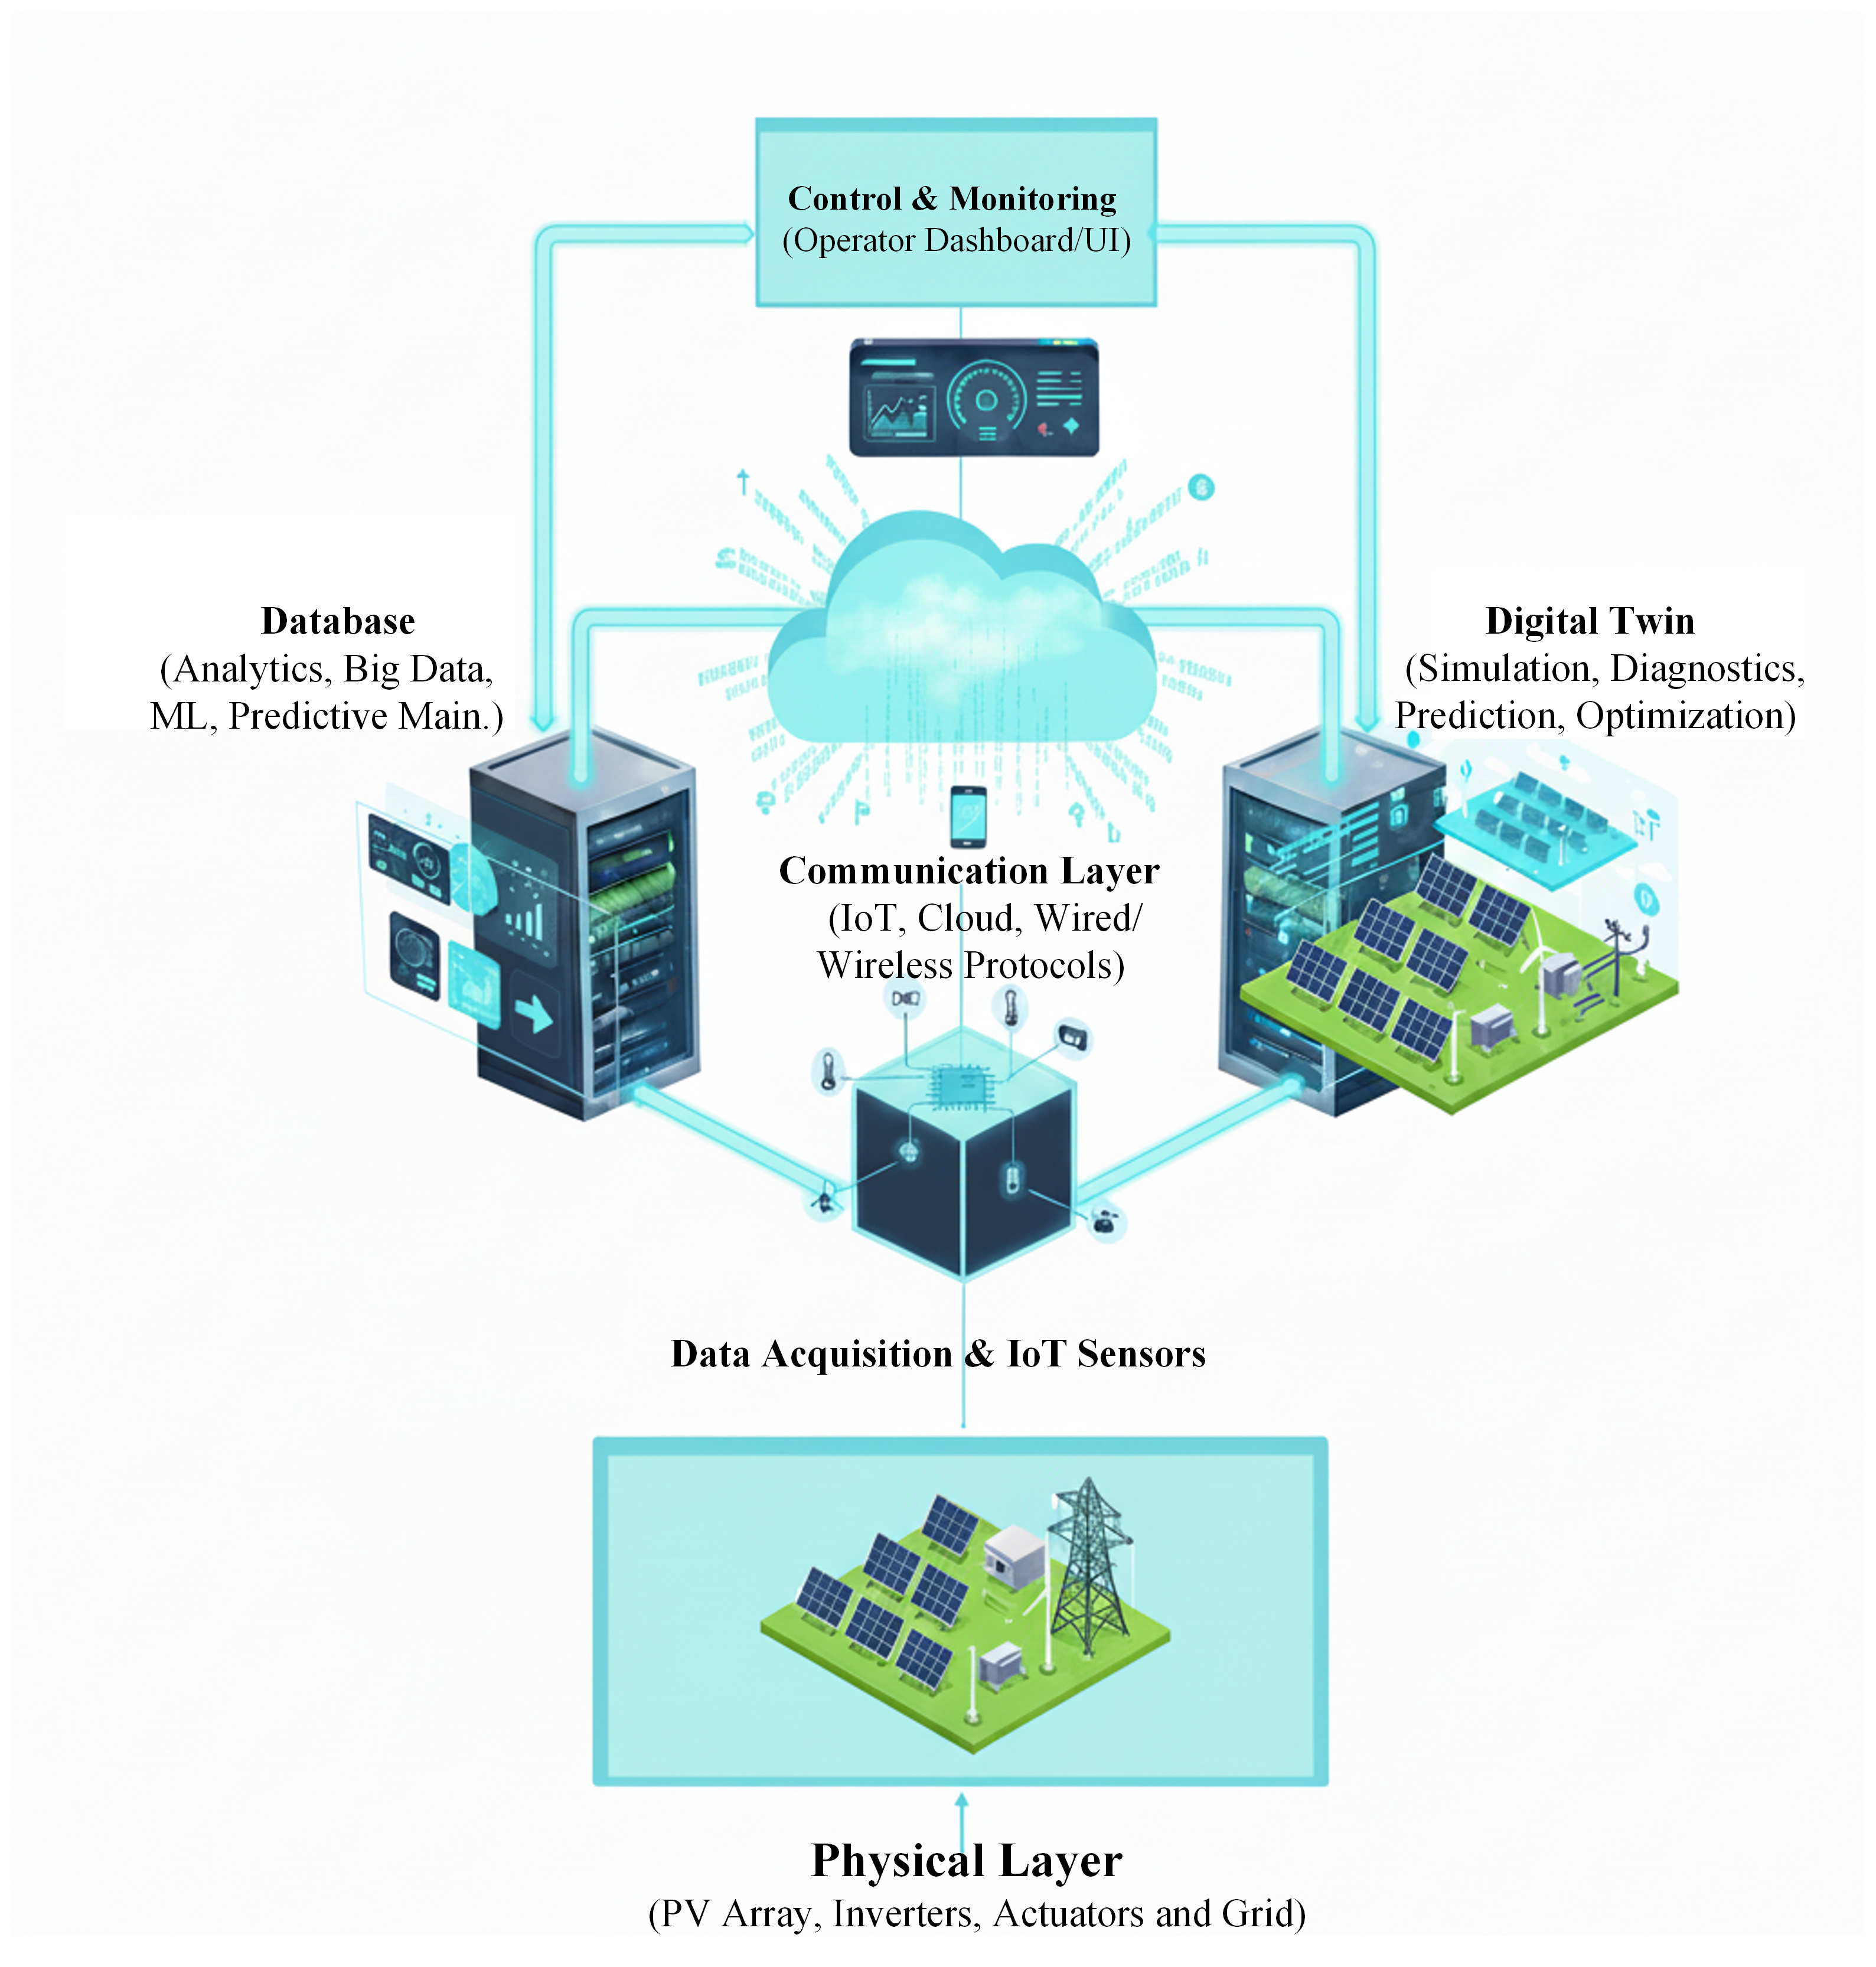
Figure 1: Digital twin architecture for grid-connected PV inverter operation.

where (ˆ·) denotes the digital-twin prediction and w_{v}, w_{i} are weighting factors. The identified parameter set ϕ⋆ is then fixed for the subsequent test campaign, and thecali-
brated twin is used for disturbance replay and for generating model-consistent internal variables required by the control and protection studies.

Proposed Learning-Assisted Syn- chronization and Intelligent Fault Ride-Through

Control overview
Figure 3 summarizes the control architecture. An inner cur- rent loop regulates the inverter currents in the synchronous frame to track the references (i∗d, iq∗). Outer loops gener- ate these references by regulating the DC-link voltage and providing reactive current support during grid disturbances.

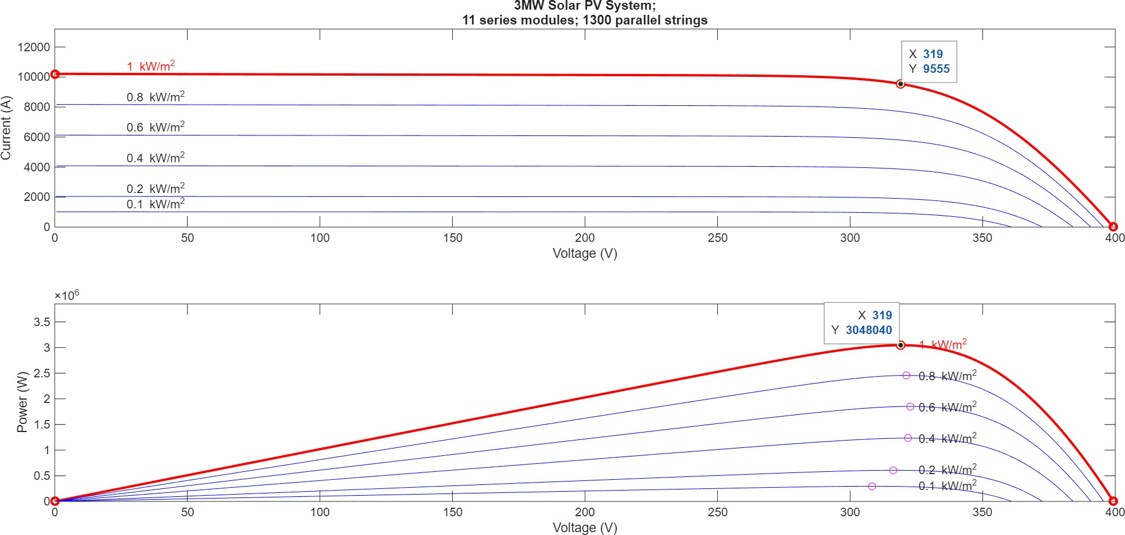
Figure 2: PV array characteristics under standard test conditions (STC).

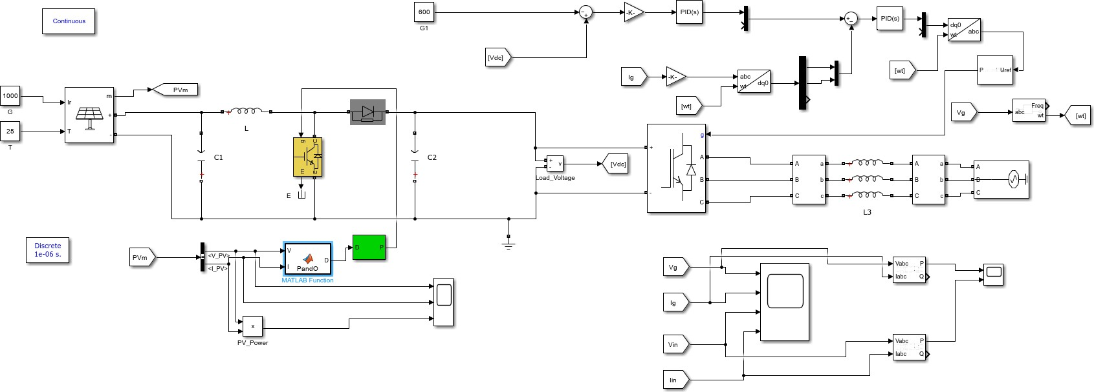

Figure 3: Simulink setup for grid connected system

Grid synchronization provides the angle estimate θˆ used in the Park transformation in (9). The proposed learning- assisted PLL augments the baseline SRF-PLL during sags and waveform distortion. In addition, a supervisory FRT layer generates fault-conditioned current references and ex- ecutes trip arbitration when protection limits are exceeded. The calibrated digital twin is used to replay disturbances un- der repeatable conditions and to generate labelled trajecto- ries for model validation and learning-stage development.

Baseline SRF-PLL and learning-assisted augmentation
A synchronous-reference-frame PLL uses the q-axis PCC voltage component as a phase-error signal,
e_{θ}(t) = v_{q}(t), (14)
where e_{θ}(t) is the PLL phase-error signal, v_{q}(t) is the q- axis PCC voltage component in the synchronous dq frame, and t is time. The quantity v_{q} is obtained from the Park transformation using the estimated angle θˆ(t), where θˆ(t) is the PLL-estimated grid angle. The baseline PLL dynamics

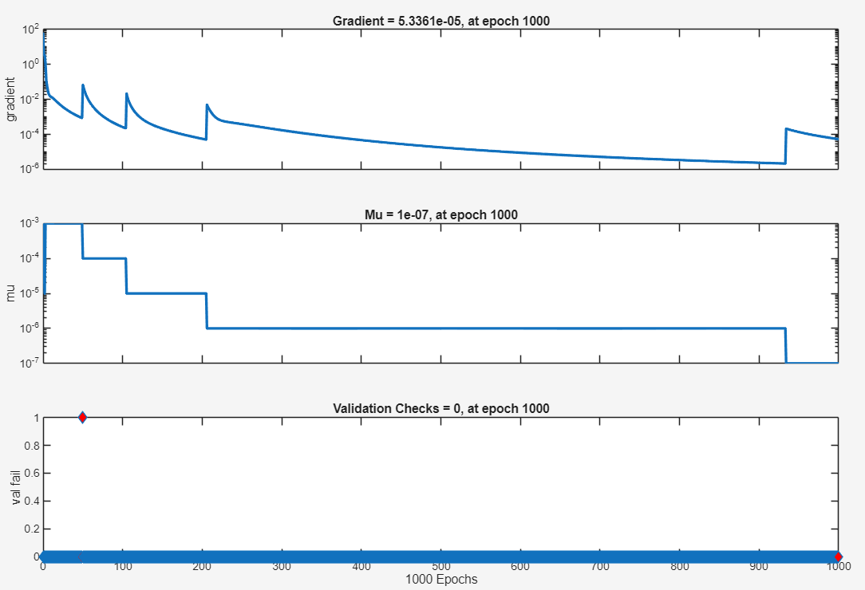
Figure 4: Training state: gradient, µ, and validation checks (1000 epochs).

are
dθˆ dt

= ωˆ,

ωˆ(t) = ω_{nom} + K_{p}e_{θ}(t) + K_{i}

t
e_{θ}(τ ) dτ.
∫
0
(15)
angle at sample k, θˆaug[k] is the augmented estimated an- gle at sample k, λ > 0 is a regularization coefficient, and
∆ωˆ_{aug}[k] is the discrete-time correction term at sample k.

where ωˆ(t) is the estimated grid angular frequency, ω_{nom} is the nominal grid angular frequency, K_{p} and K_{i} are the pro- portional and integral gains of the PLL controller, respec- tively, and τ is the integration variable.
To mitigate residual synchronization errors under dis- torted conditions, the augmented PLL introduces a data- driven correction term to the frequency estimate,

Fault feature extraction and classification
For event logging and fault-conditioned supervisory actions, grid/PV disturbances are classified using time-frequency features derived from PCC measurements. For a sampled signal x[k], a discrete wavelet transform (DWT) decompo- sition yields approximation and detail coefficients across J levels,

ωˆ_{aug}(t) = ωˆ(t) + ∆ωˆ_{aug}(t), ∆ωˆ_{aug}(t) = N_{ψ} z(t) ,

(16)
where ωˆ_{aug}(t) is the augmented frequency estimate,

x[k] =

J
a_{J,n} ϕ_{J,n}[k] + d_{j,n} ψ_{j,n}[k], (18)
Σ Σ Σ
n j=1 n

∆ωˆ_{aug}(t) is the correction term added to the baseline es- timate, N_{ψ}(·) denotes a feed-forward network parameter- ized by ψ, and z(t) is the feature vector used as input to the network. The elements of z(t) are constructed from mea- sured and/or twin-consistent variables; for example, v_{d}(t) and v_{q}(t) are the d- and q-axis PCC voltage components, v˙_{q}(t) is the time derivative of v_{q}(t), ωˆ(t) is the baseline fre- quency estimate, and V_{g}(t) is the grid-voltage magnitude
provided by the emulator. The augmented angle estimate
θˆaug(t) is obtained by integrating dθˆaug/dt = ωˆ_{aug}, where
where x[k] is the sampled measurement sequence, k is the discrete-time sample index, J is the number of decompo- sition levels, a_{J,n} is the approximation (low-frequency) co- efficient at level J and location n, d_{j,n} is the detail (high- frequency) coefficient at level j and location n, ϕ_{J,n}[k] is the scaling (father-wavelet) basis function at level J and shift n, ψ_{j,n}[k] is the wavelet (mother-wavelet) basis function at level j and shift n, and n is the translation (location) index.
Feature components are formed using band energies

θˆaug(t) is the augmented estimate of the grid angle.
Training is performed using replayed disturbances with a reference angle θ[k] provided by the grid emulator (or an
E_{j} = |d_{j,n}
n
Σ
|² , f = E₁, . . . , E_{J} , RMS(x), THD(x) ⊤,
(19)

equivalent high-accuracy reference). The objective penal-
izes phase-tracking error while regularizing excessive cor- rection magnitude:
N 2
L (ψ) = θ[k] − θˆ [k] + λ (∆ωˆ [k])² ,
1 Σ
where E_{j} is the energy of the jth detail sub-band, f is the feature vector, RMS(x) is the root-mean-square value of the analysis-window segment of x[k], and THD(x) is the total harmonic distortion computed over the same segment. The feature vector is normalized over the selected analysis win-

PLL
N
k=1
aug
aug
(17)
dow.
A multilayer perceptron produces posterior class proba-

where L_{PLL}(ψ) is the training loss function, ψ denotes the network parameters, N is the number of training samples, k
is the discrete-time sample index, θ[k] is the reference grid
bilities,
p = softmax(W₂ σ(W₁f + b₁) + b₂) , (20)

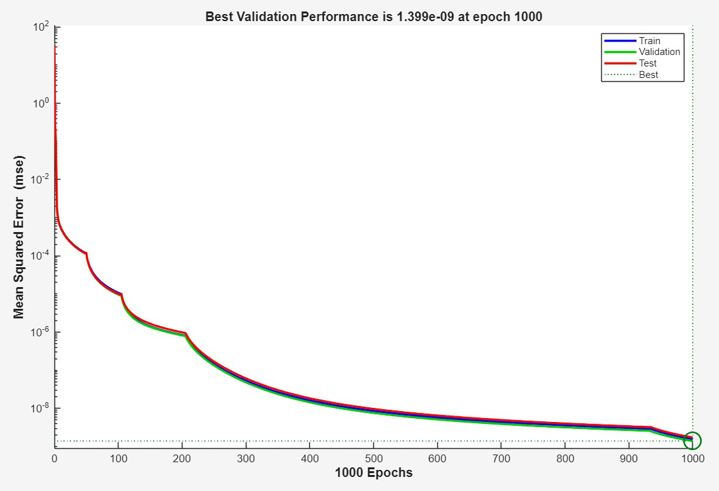

Figure 5: Training/validation/test MSE vs. epochs (best validation at epoch 1000)

where p ∈ R^{C} is the posterior probability vector over C dis- turbance classes, W₁ and W₂ are weight matrices, b₁ and b₂ are bias vectors, and σ(·) is an element-wise nonlinearity. The classifier is trained by minimizing cross-entropy
cating whether sample k belongs to class c, and p_{k,c} is the predicted posterior probability of class c for sample k.

Intelligent fault ride-through policy

N C
Σ Σ

LCE
= − 1 y
N
k=1 c=1

k,c
log p

k,c
. (21)
During voltage sags, the supervisory FRT layer generates the current references (i∗d, iq∗) to satisfy the inverter current

where L_{CE} is the cross-entropy loss, N is the number of training samples, k is the training-sample index, C is the number of classes, y_{k,c} ∈ {0, 1} is the one-hot label indi-
limit I_{max}, limit DC-link energy accumulation, and provide reactive current support. A practical reference law is

i∗ = sat k Vnom − Vg , −I , I , i∗ = sat 2 P ∗ , −qI2 − (i∗)2, qI2 − (i∗)2 , (22)
q
q
Vnom
max
max
d
3 max(V_{g}, ϵ)
max
q
max
q

J

χ(t) = V_{dc}(t) > V_{dc,max} ∨ i(t) > I_{max} ∨ V_{g}(t) < V_{min} , (23)

and the accumulated violation time time of the monitoring interval, ξ is the integration variable,
is the grace period, I(·) is the indicator function that
T
∫ _{t} grace
τ (t) =
t0
χ(ξ) dξ. (24)
returns 1 if its argument is true and 0 otherwise, and Trip(t) is the trip command.

The trip command is issued only when the violation persists beyond the grace period:

Trip(t) = I τ (t) ≥ T_{grace} . (25)
where χ(t) is a Boolean indicator that equals 1 when any protection limit is violated and 0 otherwise, V_{dc,max} is the DC-link overvoltage threshold, i(t) is the inverter output current vector in the chosen reference frame, i(t) is its magnitude, V_{min} is the minimum allowable grid-voltage magnitude for ride-through, τ (t) is the accumulated time for which violations have been present since t₀, t₀ is the start

Experimental setup and test protocol
The experimental platform comprises a programmable PV source, a grid-connected inverter, an L-type filter, and a pro- grammable grid emulator at the PCC (Fig. 3). The test pro- tocol is designed to separately validate the digital twin, syn- chronization performance, and fault ride-through behavior:
    - Twin validation: apply sags according to (11) and record V_{dc} and dq currents to compare measured tra- jectories against digital-twin predictions using (1)-(7).

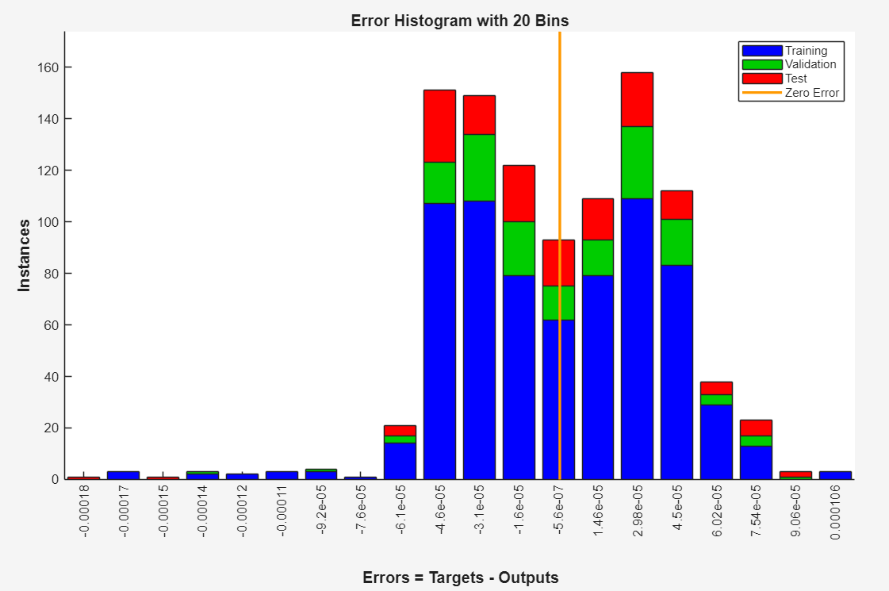
Figure 6: Error histogram (20 bins) for training, validation, and test sets
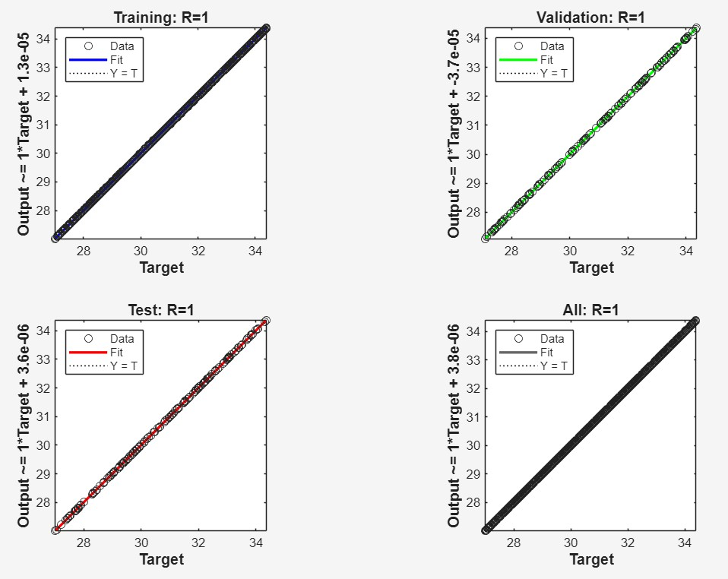
Figure 7: Regression plots for train/validation/test showing perfect fit (R = 1).

    - Synchronization tests: superimpose waveform distor- tion during sags and compare the baseline SRF-PLL (14)-(15) against the augmented PLL (16)-(17) using phase-tracking error and current-quality indices.

    - FRT tests: apply deep sags and evaluate current lim- iting and DC-link containment under the reference law
(22) and the trip arbitration in (25).

where the PCC denotes the point of common coupling be- tween the inverter and the grid emulator, the L-type filter is the series interface inductance between the inverter and the PCC, dq currents refer to the inverter output current compo- nents expressed in the synchronous reference frame, phase- tracking error quantifies the deviation between the estimated grid angle and the reference grid angle, and current-quality indices refer to standard power-quality metrics such as har- monic distortion and unbalance used for comparative assess- ment.

Experimental Validation and Re- sults

The digital twin (DT), synchronization, and fault ride- through (FRT) functions were implemented in MAT- LAB/Simulink version R2024b to enable disturbance re- play and closed-loop evaluation. Experimental measure- ments were acquired using a programmable PV source and a programmable grid emulator at the point of common cou- pling (PCC), with supervisory control and data logging per- formed in NI LabVIEW version 2025 Q3. All simulations and post-processing were performed on a personal computer equipped with an Intel Core i5 processor and 16 GB of RAM. Unless stated otherwise, all plots are interpreted over three distinct intervals: (i) pre-disturbance steady state, (ii) the disturbance window, and (iii) post-disturbance recovery.

Digital Twin Validation
Case A: Voltage Drop Event Fig. 8 shows the inverter re- sponse during a grid-voltage sag. Before the disturbance, the PCC voltage stays close to V_{nom}, the inverter delivers the scheduled active power, and the DC-link voltage re- mains regulated near its nominal value. At sag initiation (t_{f} ), the PCC voltage decreases and the inverter enters the current-limited region. As a result, the inverter cannot ex- port the pre-fault active power level. The mismatch between input and output power appears in the DC-link dynamics of
Eq. (7). During the sag interval, the term ³ ^{(v}did+vq iq ) de-
age. With this alignment, the injected current remains better regulated and the oscillatory content in the current waveform decreases.
The figure also indicates an improvement in current- quality metrics, including a reduction in distortion ( THD or an equivalent index). Table 4 summarizes the comparative dynamic response of Cases A-D in terms of active/reactive power behavior, DC-link voltage trend, and trip action under different grid disturbances.

5.3 Fault Ride-Through Behavior

2
creases, and the excess energy raises V_{dc}.
Vdc
Deep-Sag Ride-Through Fig. 12 presents the complete

Case B: Voltage Rise Event Fig. 9 shows the inverter re- action to a 6% voltage rise event. In this case, the PCC volt- age exceeds the nominal value, thus changing the inverter operating point and the corresponding current demand for power transfer and voltage support.
The plots confirm the digital twin validation process for overvoltage conditions, where the DT correctly captures the expected direction of the transient and the typical time scale of the recovery process after the voltage restoration. If the reactive power plot is considered in Figure 9, the sign and magnitude of the reactive power plot confirm the voltage support strategy adopted during the voltage swell (e.g., re- active power absorption to enable voltage reduction).

Synchronization Performance Under Sag and Distortion
Figure 10 shows a comparison of phase angle tracking per- formance between the original SRF-PLL and the proposed augmented PLL during a deep voltage sag of over 50% am- plitude. In the original SRF-PLL, the phase error signal is obtained from the q-axis voltage, as defined in Equation
(14). During a deep sag and distorted voltage waveform, the q-axis voltage signal v_{q} contains oscillations and transient errors. These errors are then injected into the PI controller defined in Equation (15), causing ripples and offsets in the
estimated angle θˆ.
The figure shows a clear reduction in peak angle error at fault entry for the augmented PLL. It also shows lower oscil- latory ripple during the sag interval. This behavior matches the action of the correction term in Eq. (16), trained through the loss function in Eq. (17) to reduce residual tracking er- ror under distorted PCC conditions. The improvement in angle estimation directly improves the Park transformation in Eq. (9). Better angle tracking preserves d-q decoupling, reduces cross-coupling between active and reactive current channels, and supports lower current distortion during se- vere grid disturbances.
Case D: Frequency Increase Event Fig. 11 shows the in- verter response during a grid-frequency increase event. Fre- quency excursions place a strong demand on the PLL be- cause the estimated frequency ωˆ must track ω(t) = 2πf (t) with adequate bandwidth while rejecting distortion. The figure indicates that improved synchronization keeps the current-controller reference frame aligned with the grid volt-
ride-through response for a deep sag, including three-phase grid voltages, inverter output currents, switching pulses, and the d-q control signals. At sag entry, the supervisory FRT layer updates the current references using Eq. (22). The controller increases the reactive current reference to support grid voltage and reduces the active current reference to keep the total current within the limit I_{max}. This current reallo- cation also limits DC-link stress through the power-balance dynamics of Eq. (7).
The current waveforms in Fig. 12 remain bounded during the full sag interval. This observation confirms correct op- eration of the saturation and circular current-limiting func- tions in Eq. (22). The figure also shows a higher reactive- current contribution during the fault, which is consistent with grid-support operation under undervoltage conditions. The d-q control signals show the expected transition: the re- active channel rises during the sag and the active channel reduces accordingly. The switching pulses remain continu- ous, which indicates stable converter operation with no loss of gating during the disturbance.

Conclusion
This paper presents a control scheme based on the digital twin for a grid-connected PV inverter in low-voltage grids with voltage sag, voltage swell, and frequency variation. The digital twin model is accurate in representing the main dynamics between the PV source, DC link, and converter, and it correctly models the inverter’s transient response as measured. This includes the active and reactive power dy- namics, DC-link voltage dynamics, and the activation of the trip actions. The case studies provided show the technical behavior in a clear and understandable manner. In Case A and Case B, with mild sag or swell, the inverter keeps the active power level close to its nominal value after a transient period. The reactive power increases to 0.9 MVAr with a small overshoot, and the DC-link voltage keeps close to its nominal value during normal operation. In Case C, with a deep sag of over 50% voltage reduction, the active power has a sharp drop at fault entry. The reactive power has the largest overshoot, ranging from 1.35 to 1.4 MVAr, and the trip signal is activated first among the cases, showing proper current limiting and fast protection activation under heavy stress. In Case D, with a frequency increase, the power loop

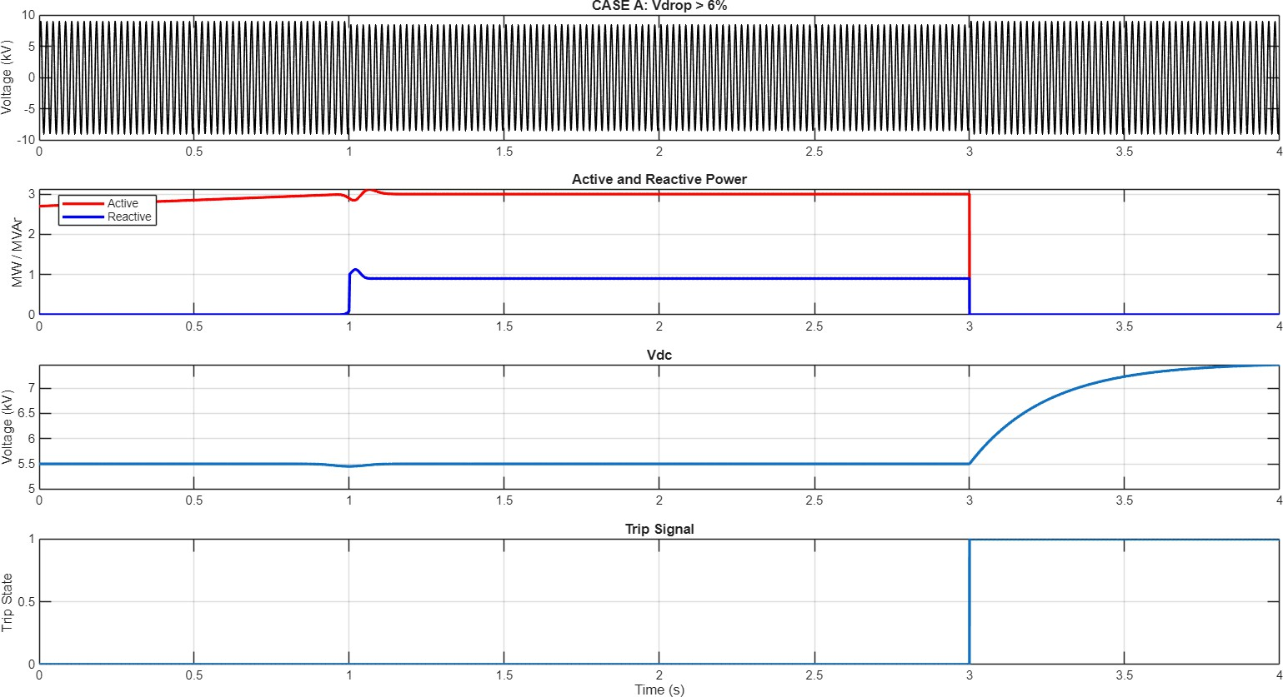

Figure 8: Case A: Grid voltage, active and reactive power, DC-link voltage, and trip signal during a voltage drop event.
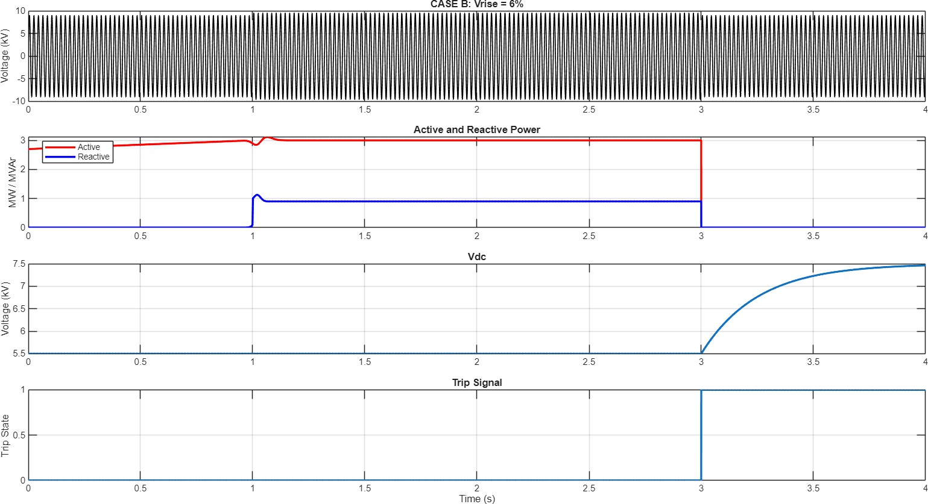

Figure 9: Case B: Response during a 6% voltage rise event.

remains stable, and the main impact is on the synchroniza- tion and trip timing. The control scheme shows excellent consistency between the digital twin and the actual inverter behavior, with stable control in non-ideal grid conditions and proper fault-ride-through and protection activation.

Declarations
Funding: Not applicable.
Conflict of Interest: The authors declare no conflicts of in- terest.
Data Availability: The developed software is accessible.
Code Availability: Code can be obtained from the corre-
sponding author.
Author Contributions: The corresponding author con- ducted simulations and developed the methodology; all au- thors contributed to the literature review.
Ethics Approval: Ethical clearance was obtained.
Consent to Participate: All authors consented to partici- pate.
Consent to Publish: All authors agreed to publication.

References
- A. Chouder and S. Silvestre, “Analysis model of mis- match power losses in PV systems,” Journal of Photo-

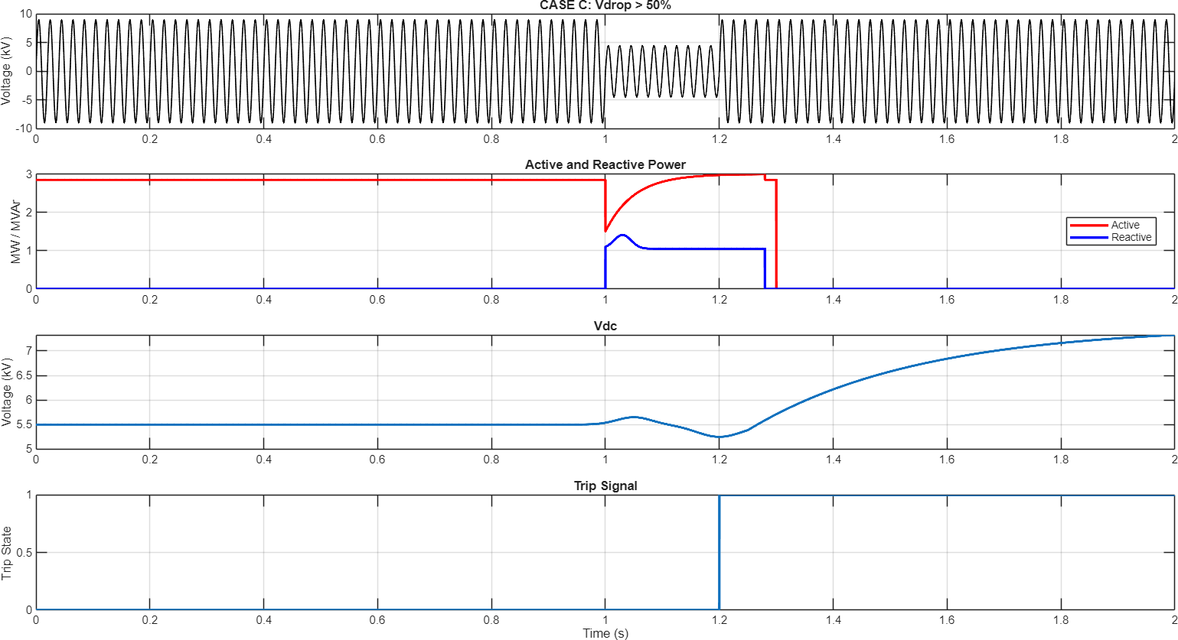

Figure 10: Case C: Response during a deep voltage drop exceeding 50%.
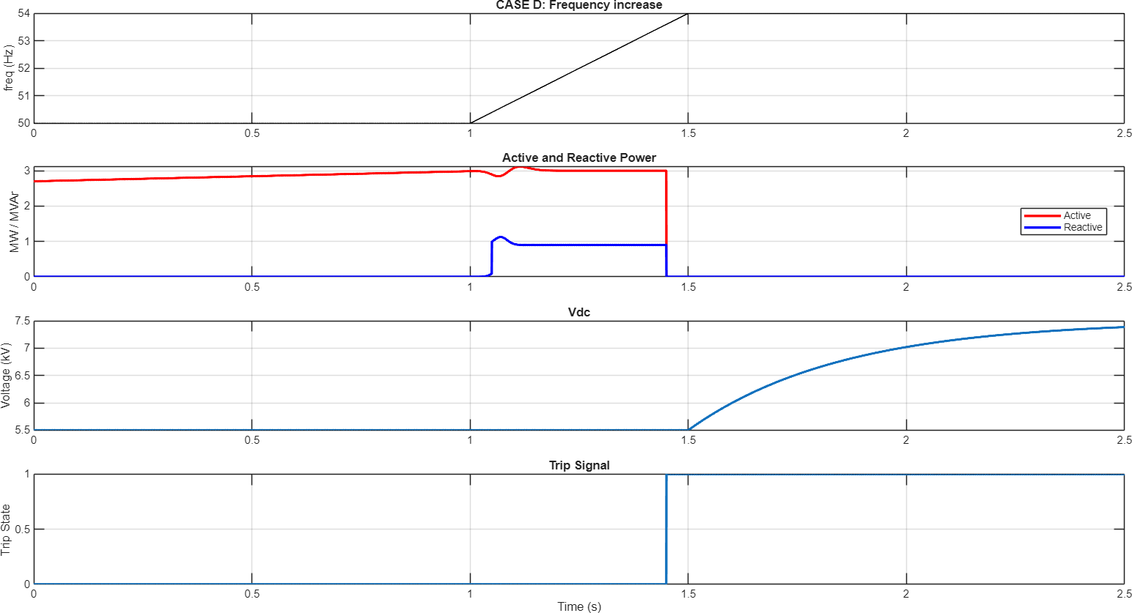

Figure 11: Case D: Response during a frequency increase event.

voltaics, vol. 2, no. 2, pp. 1 7, 2009.

- M. Sabbaghpur Ara, K. Naderi, and M. Fani, “The comprehensive study of electrical faults in PV ar- rays,” Journal of Electrical and Computer Engi- neering, vol. 2016, Article ID 8712960, 2016, doi: 10.1155/2016/8712960.

- A. Triki-Lahiani, A. Bennani-Ben Abdelghani, and
I. Slama-Belkhodja, “Fault detection and monitoring systems for photovoltaic installations: A review,” Re-
newable and Sustainable Energy Reviews, vol. 82,
pp. 2680-2692, 2018, doi: 10.1016/j.rser.2017.10.101.
- Y. Hu and W. Cao, Photovoltaic Power System: Mod- eling, Design, and Control. Wiley, 2016.
- M. Appiah, S. K. Fianko, “Review and performance evaluation of photovoltaic array fault detection and di- agnosis techniques,” International Journal of Photoen- ergy, vol. 2019, pp. 1 19, 2019.
- T. Dong, H. Guan, “Photovoltaic array fault detection by automatic reconfiguration,” Journal of Electrical

Table 4: Short comparison of Cases A-D (approximate from plots)

Case | Disturbance | Findings | Comparison
A | Vdrop > 6% | P shows small dip, Q rises to ∼0.9 MVAr, V_{dc} stays near  nominal, trip at ∼3 s. | Stable mild-sag response with low stress.
B | Vrise = 6% | P remains near nominal, Q rises with small overshoot, V_{dc}  remains stable, trip at ∼3 s. | Similar to Case A; strong DC-link reg- ulation.
C | Vdrop > 50% | P drops sharply, Q has highest overshoot, V_{dc} shows  bump/dip, trip at ∼1.2 s. | Most severe case; fastest protection ac- tion.
D | Frequency increase | P remains near nominal, Q rises, V_{dc} stays stable during  ramp, trip at ∼1.45 s. | Sync/protection-driven event; lower stress than Case C.
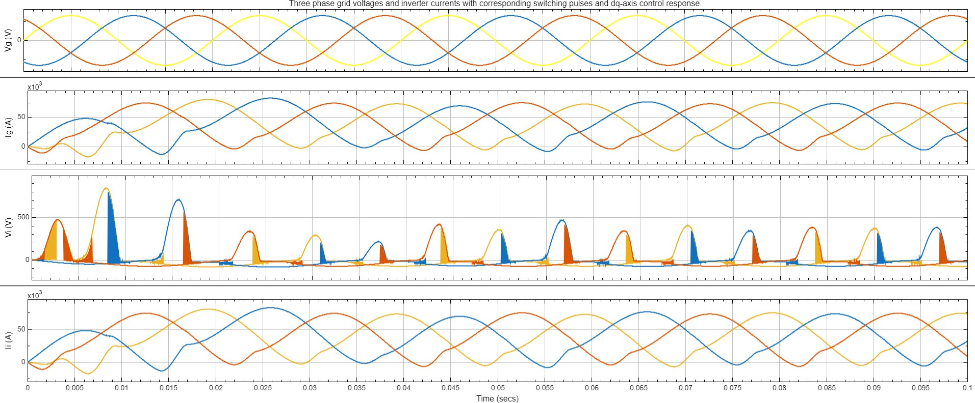
Figure 12: Three-phase grid voltages and inverter currents with corresponding switching pulses and dq-axis control response.

and Computer Engineering, vol. 2015, pp. 1 11, 2015.

- A. Y. Appiah, X. Zhang, B. B. K. Ayawli, and R. Fi- anko, “Review and performance evaluation of photo- voltaic array fault detection and diagnosis techniques,” International Journal of Photoenergy, vol. 2019, Arti- cle ID 6953530, 2019, doi: 10.1155/2019/6953530.

- A. Haque, S. Mekhilef, “Fault diagnosis of photo- voltaic modules,” Renewable and Sustainable Energy Reviews, vol. 85, pp. 348 358, 2018.

- M. Ali, S. Mekhilef, “Real time fault detection in pho- tovoltaic systems,” Energy Conversion and Manage- ment, vol. 133, pp. 301 312, 2017.

- X. Hu, J. J. Enrique, “Identifying PV module mismatch faults by a thermography-based temperature distribu- tion analysis,” Solar Energy, vol. 130, pp. 42 50, 2016.

- A. Aghaei, T. S. Kamel, “Fault inspection by aerial in- frared thermography in a PV plant after a meteorolog- ical tsunami,” Renewable Energy, vol. 145, pp. 1861 1871, 2020.

- M. Muttillo, M. Schirone, “On field infrared thermog- raphy sensing for PV system efficiency assessment: re- sults and interpretation,” Energy Procedia, vol. 101,
pp. 474 481, 2016.
- A. Takashima, T. Shinohara, “Fault finding in a 1 MW photovoltaic plant by reflectometry,” IEEE Journal of Photovoltaics, vol. 7, no. 5, pp. 1386 1394, 2017.
- T. Roy, S. P. Chowdhury, “Experimental studies of fail- ure detection methods in PV module strings,” Solar Energy, vol. 175, pp. 225 233, 2018.
- R. Pillai, M. B. Shadmand, “An irradiance- independent, robust ground-fault detection scheme for PV arrays based on correlation analysis,” IEEE Transactions on Industrial Electronics, vol. 67, no. 5,
pp. 3772 3782, 2020.
- M. Ali, S. Mekhilef, “Application of Artificial Neu- ral Networks to photovoltaic fault detection and di- agnosis,” Renewable and Sustainable Energy Reviews, vol. 116, p. 109420, 2019.
- A. Yousef, F. Blaabjerg, “Fault detection algorithm for grid-connected photovoltaic plants,” IET Renewable Power Generation, vol. 14, no. 2, pp. 1 10, 2020.
- F. J. Toledo, J. M. S. Rosas,“Online fault detection and the economic analysis of grid-connected photovoltaic systems,” Energy, vol. 196, p. 117098, 2020.
- L. Schirone, P. F. Catton, “Statistical fault detection in photovoltaic systems,” Measurement, vol. 98, pp. 39 46, 2017.

- M. Ali, S. Mekhilef, “Real time fault detection in pho- tovoltaic systems,” Energy Conversion and Manage- ment, vol. 133, pp. 301 312, 2017.
- Y. Hu, W. Cao, “A fast MPPT-based anomaly detec- tion and accurate fault diagnosis technique for PV systems,” IEEE Transactions on Power Electronics, vol. 35, no. 8, pp. 1 12, 2020.
- S. Takashima, T. Shinohara, “Satellite based fault di- agnosis of photovoltaic systems using recurrent neu- ral network,” IEEE Transactions on Power Electronics, vol. 35, no. 10, pp. 1 11, 2020.
- M. H. Hagh, S. M. Khosravi, “Intelligent fault diagno- sis of photovoltaic arrays based on optimized kernel extreme learning machine,” International Journal of Electrical Power & Energy Systems, vol. 110, pp. 196 208, 2019.
- R. Xiong, C. Zhang, “Reliability analysis method of a solar array by using fault tree analysis and fuzzy sets,” Reliability Engineering & System Safety, vol. 169,
pp. 103 113, 2018.
- A. S. Al-Sumaiti, M. A. Sayed, “Development of models for on-line diagnostic and energy assessment analysis of photovoltaic arrays,” IEEE Access, vol. 7,
pp. 10763 10775, 2019.
- S. M. M. El-Fouly, M. M. A. Salama, “A power man- agement scheme for grid-connected PV integrated with hybrid energy storage system,” IEEE Transactions on Sustainable Energy, vol. 6, no. 2, pp. 1 10, 2015.
- International Energy Agency (IEA), Renewables 2024. IEA, 2024.
- M. J. Hung, S. R. Wen, “U.S. market for solar photo- voltaic plug-and-play systems,” Solar Energy, vol. 85, no. 9, pp. 1 10, 2011.
- R. D. Marco, M. F. Liserre, “A comprehensive review of photovoltaic system topologies and efficiency im- provements,” Renewable and Sustainable Energy Re- views, vol. 163, p. 112539, 2022.
- National Renewable Energy Laboratory (NREL), Best Research-Cell Efficiency Chart. NREL, 2024.
- K.-H. Chao, C.-S. Wang, “A PV system fault diagnosis method,” Energy and Buildings, vol. 40, no. 11, pp. 1 7, 2008.
- S. Vergura, G. Acciani, “Inferential statistics for mon- itoring of photovoltaic plants,” Measurement, vol. 41, no. 9, pp. 1 10, 2008.
- S. Vergura, G. Acciani, “PV plant supervision by means of statistical procedures,” IEEE Transactions on Industrial Electronics, vol. 56, no. 4, pp. 1 9, 2009.
- Y. Zhao, Z. Yang, “Graph-based semi-supervised learning for photovoltaic array fault diagnosis,” Solar Energy, vol. 95, pp. 1 10, 2013.
- Y. Zhao, Z. Yang, “A novel outlier detection algorithm for photovoltaic array fault diagnosis,” Applied En- ergy, vol. 101, pp. 1 9, 2013.
- T. Dong, H. Guan, “Photovoltaic array fault detection by automatic reconfiguration,” Journal of Electrical and Computer Engineering, vol. 2015, pp. 1 11, 2015.
- A. M. Bazzi, M. A. Uddin, “PV fault diagnosis based on I-V curve analysis: a review,” Renewable and Sus- tainable Energy Reviews, vol. 59, pp. 1 12, 2016.
- M. S. Alam, T. S. Ustun, “A comprehensive review of PV system faults and fault diagnosis techniques,” IEEE Access, vol. 7, pp. 1 18, 2019.
- W. Ma, S. Ouyang, and W. Xu, “Improved frequency locked loop based synchronization method for three- phase grid-connected inverter under unbalanced and distorted grid conditions,” Energies, vol. 12, no. 6,
p. 1023, 2019, doi: 10.3390/en12061023.
- E. Buraimoh, I. E. Davidson, and F. Martinez-Rodrigo, “Decentralized fast delayed signal cancelation sec- ondary control for low voltage ride-through applica- tion in grid supporting grid feeding microgrid,” Fron- tiers in Energy Research, vol. 9, Article 643920, 2021, doi: 10.3389/fenrg.2021.643920.
- M. Tarafdar Hagh and T. Khalili, “A review of fault ride through of PV and wind renewable energies in grid codes,” International Journal of Energy Research, vol. 43, pp. 1342-1356, 2019, doi: 10.1002/er.4247.
- Z. Pan, D. Yang, L. Guo, and C. Lu, “An enhanced phase-locked loop based on the improved MAF and LADRC for three-phase grid-connected inverters un- der non-ideal grids,” International Journal of Electri- cal Power & Energy Systems, vol. 146, p. 108772, 2023, doi: 10.1016/j.ijepes.2022.108772.
- N. G. Kulkarni and V. B. Virulkar, “Enhancing the power quality of grid connected photovoltaic system during fault ride through: A comprehensive overview,”
J. Inst. Eng. India Ser. B, vol. 104, no. 3, pp. 821-836, 2023, doi: 10.1007/s40031-023-00870-7.
- D. D. Angelova, D. C. Fernández, M. C. Godoy,
J. A. Álvarez Moreno, and J. F. G. González, “A re- view on digital twins and its application in the mod- eling of photovoltaic installations,” Energies, vol. 17, no. 5, p. 1227, 2024, doi: 10.3390/en17051227.
- W. F. Mbasso, A. Harrison, I. Dagal, P. Jangir,
M. Khishe, H. Kotb, M. S. Shaikh, A. Smerat,
E. F. Donfack, and R. Kumar, “Digital twins in re- newable energy systems: A comprehensive review of concepts, applications, and future directions,” Energy

Strategy Reviews, vol. 61, Sep. 2025, Art. no. 101814, doi: 10.1016/j.esr.2025.101814.

