SHOPEASE: AN INTEGRATED PYTHON-BASED

ABSTRACT
In recent years, technology has transformed business operations, with e-commerce platforms enabling customers to browse products, place orders, and complete transactions digitally. Traditional shopping methods, which rely on physical presence, manual billing, and limited operating hours, are often inefficient and prone to human error. This study presents Shopease, an integrated Python-based shopping cart system that combines user registration, product management, shopping cart functionality, checkout processing, and transaction tracking through a MySQL database. The system employs Object-Oriented Programming (OOP) principles and a GUI built with Tkinter and CustomTkinter to provide a user-friendly and interactive interface. Functional testing demonstrated that all modules, including login/registration, product catalog, shopping cart operations, checkout, and admin panel management, performed as expected. Shopease improves efficiency, accuracy, and accessibility compared to manual or console-based systems, offering a reliable platform for managing products, customers, and transactions in an educational or small-scale business environment. Limitations include the absence of online payment integration, delivery tracking, email notifications, and advanced security protocols, which provide opportunities for future enhancements.
Keywords: Shopease, Python, MySQL, Shopping Cart System, GUI, Object-Oriented Programming, E-commerce
INTRODUCTION

Background of the Study
In recent years, the rapid growth of technology has transformed the way businesses operate and interact with customers. Across the world, many people, especially businessmen rely on computerized systems to improve efficiency, reduce manual work, and provide faster services. One of the most important developments in modern business is the growth of electronic commerce or (e-commerce), which enables customers to browse products, place orders, and complete transactions through digital platforms. According to khan, m. F., soni, p., janoria, p., & sheikh, m. S. (2025). Unlike conventional shopping methods that require physical presence, limited operating hours, and manual billing processes, online shopping systems offer continuous accessibility, faster transactions, and improved service quality. As customers increasingly prefer digital platforms for convenience, product variety, and secure payments, organizations must adopt reliable and scalable e-commerce solutions to remain competitive.
As online shopping continues to grow, many businesses rely on shopping systems to manage products, customer information, and transactions. These systems help automate processes that were traditionally done manually, reducing errors and improving accuracy.relational database management systems (rdbms) also play an important role in these platforms by ensuring reliable storage and retrieval of data. Several studies have highlighted the effectiveness of using database-driven systems in e-commerce applications. Technologies such as python and mysql are widely used in system development because they provide reliable tools for creating secure and efficient applications. Python offers a simple yet powerful programming environment, while mysql provides structured and consistent data management for products, customers, and transaction records.
Despite the growing number of e-commerce applications, there is still a need for simple shopping cart systems that demonstrate the integration of programming and database technologies. Many existing studies focus on large scale commercial platforms, while fewer studies emphasize the development of beginner-friendly systems that can effectively manage user accounts, product inventories, and purchasing transactions. This creates an opportunity to develop a system that demonstrates the practical application of python and mysql in e-commerce development.
Therefore, this study aims to develop an online shopping cart system using python and mysql. The system is designed to provide essential shopping cart functions such as user registration, product management, cart handling, and transaction processing.

Statement of the Problem

The growth of technology has changed how businesses operate, making online shopping more efficient than traditional physical stores. Traditional shopping methods require customers to visit stores in person, have limited operating hours, and rely on manual processing, which can lead to human errors and slow service. While large e-commerce platforms exist, there is still a need for simpler, console-based shopping systems that clearly demonstrate how a programming language and a database work together.
To address these concerns, this study aims to develop an Online Shopping Cart System using Python and MySQL. Specifically, this research seeks to answer the following questions:
- How can the Online Shopping Cart System be designed and developed using Python and MySQL?
- How should the database tables be structured to organize information regarding users, products, orders, and transactions?
- How will the Python program connect to the MySQL database to allow the storage and retrieval of data?
- How effective and reliable is the system in performing its core operations?
- Can users successfully complete the account registration and login process?
- Can customers add items to their cart, complete transactions, and will the system automatically update product stocks after a purchase?

- What are the strengths and limitations of the system based on its testing and evaluation?
- How well does the system perform in terms of functionality, usability, and reliability?

Objectives of the Study
The main objective of this study is to develop an Online Shopping Cart System using Python and MySQL. The Study aims to create a simple and efficient system that allows users to browse products, add items to a shopping cart, and complete transactions through a computerized process.
Specifically, this study aims to:
- Design and develop an Online Shopping Cart System for managing products and transactions.
- Implement system features such as user registration, login, product management, shopping cart, and checkout process.
- Apply programming concepts including functions, loops, conditional statements, and database integration in system development.
- Identify the strengths, limitations, and some possible improvements of the system.
- Evaluate the effectiveness and usability of the developed system.

Significance of the Study
The study demonstrates how technology and computerized systems can improve the efficiency and convenience of shopping transactions. The online shopping cart system provides a more organized and accessible way of managing products, orders, and customer information compared to the traditional methods.
The study may benefit the following:
Customers/Users. The system provides a convenient and user-friendly platform for browsing products and completing transactions.
Business Administrators/Owners. The system helps manage product information. Monitor customer orders, and organize transaction records efficiently.
Students and Developers. The study serves as a reference and learning material for understanding programming concepts, system development, and database integration using python and mysql.
Future Researchers. The study may provide useful information and serve as a guide for future studies related to online shopping systems and database-driven applications.

Scope and Limitations

Scope of the Study
This study focuses on developing an online shopping cart system using python and mysql. The system allows users to create an account, log in, browse products, add items to the cart, and checkout their orders. It also includes an admin panel where the admin can manage products and view transaction records.
The study mainly covers the use of python programming, mysql database integration, and gui design using tkinter. It is created for educational purposes to show how an online shopping system works using programming and database technologies.
Limitation of the Study
this study acknowledges certain limitations in the developed system. The current implementation does not support online payment gateways such as gcash, paypal, or credit card transactions. Furthermore, the system excludes functionalities related to delivery tracking, automated email notifications, and advanced security protocols. These constraints describe the scope of the present study and provide opportunities for future enhancement and integration.

REVIEW OF RELEVANT THEORY, STUDIES, AND LITERATURE
Computerized systems are widely used in managing records, processing transactions, and improving operational efficiency in different industries. These systems reduce manual work, minimize human errors, and provide faster and more accurate processing of information. In business environments, computerized shopping systems have become important because they allow customers and administrators to perform transactions efficiently through digital platforms.

Computerized Management System

Computerized management systems are designed to automate the storage, processing, and retrieval of business information. According to a study by IJERT (2020), e-commerce systems improve operational efficiency by allowing businesses to manage products, customer information, and transactions digitally. The researchers explained that computerized systems reduce manual errors and improve the organization of records and transactions.

Similarly, a study titled “Design and Development of an E-Commerce System in a Rapid Organized Way” published in International Journal of Science and Research (IJSR) (2020) stated that modern e-commerce systems provide faster transactions, better product management, and improved interaction between businesses and customers. The study emphasized the importance of security, usability, and organized system design in online shopping platforms.

Data-Based Management System

Database Management Systems (DBMS) are important in e-commerce applications because they manage customer records, product inventories, and transaction histories. A study entitled “Development of Database and Stored Procedures for E-Commerce Systems” published in 2020 explained that databases are essential for handling large amounts of e-commerce data efficiently. The researchers proposed the use of structured databases and stored procedures to improve the performance and reliability of shopping systems.

According to MySQL Official Website, MySQL is one of the most widely used Relational Database Management Systems (RDBMS) because it provides reliable storage, fast processing, and data consistency. MySQL is commonly integrated with shopping cart systems to maintain accurate records of products, users, and orders.

Python Programming in System Development

Python programming language is widely used in software and system development because of its simplicity, readability, and flexibility. According to Python Software Foundation, Python supports multiple programming approaches and provides libraries that help developers create efficient and user-friendly applications. Many developers use Python in developing management systems, automation tools, and e-commerce applications because it reduces development time and improves program maintainability.

A study entitled “Python-Based Application Development for Business Systems” (2021) explained that Python is effective in developing computerized systems due to its easy syntax and strong database integration capabilities. The study also highlighted that Python applications are easier to maintain and upgrade compared to traditional systems developed using more complex programming languages.

Gui Based Application

Graphical User Interface (GUI)-based applications are commonly used in computerized systems because they provide an interactive and user-friendly environment for users. A GUI allows users to interact with the system through buttons, menus, icons, and forms instead of using complex commands. According to a study on usability evaluation published in the International Journal of Interactive Mobile Technologies (2021), GUI-based applications improve user satisfaction, efficiency, and effectiveness because users can easily navigate and understand the system functions.

Another study entitled “Checking Conformance of Applications Against GUI Policies” (2021) explained that a well-designed GUI is important in improving application usability and ensuring better interaction between the user and the system. The researchers emphasized that GUI design contributes to faster task completion, reduced user confusion, and improved overall system performance.

In shopping and management systems, GUI-based applications are important because they make transactions easier for both customers and administrators. Through a GUI, users can browse products, manage orders, and perform transactions more efficiently. GUI applications also improve accessibility by allowing users with limited technical knowledge to operate the system easily.

Automation in Information Systems

Automation in information systems refers to the use of technology to perform tasks and processes automatically with minimal human intervention. Automated systems help organizations improve efficiency, reduce workload, and minimize errors in handling information and transactions. According to studies on automation systems, automation improves the speed and accuracy of data processing while reducing operational costs.

In computerized shopping systems, automation is commonly applied in inventory management, payment processing, order tracking, and report generation. Automated processes allow businesses to update records instantly and maintain accurate information about products, customers, and transactions. This reduces the delays and mistakes that are common in manual systems.

Furthermore, automation improves customer experience by providing faster transaction processing and real-time updates. It also helps administrators monitor sales, inventory levels, and customer activities more efficiently. Because of these advantages, automation has become an important feature in modern information systems and e-commerce applications.

METHODOLOGY

Research Design

The study used a developmental research design in creating and evaluating the Online Shopping Cart System. Developmental research focuses on designing, developing, and testing a system or application to solve a specific problem. In this study, the researchers developed a console-based shopping cart system using the Python programming language and integrated it with MySQL for database management. MySQL is a relational database management system (RDBMS) that stores and organizes data efficiently. The researchers also used XAMPP as the local server environment to manage and run the MySQL database during the development and testing of the system.

The system development followed the process of planning, designing, coding, testing, and evaluation. During the planning stage, the researchers identified the important features of the system such as user registration, login authentication, product management, cart handling, checkout process, and admin controls. In the design and coding stage, Python was connected to the MySQL database using MySQL Connector/Python to allow storage and retrieval of data through the XAMPP server environment.

The researchers also used testing methods to check if the system worked properly. The system was tested to ensure that users could successfully register accounts, add products to the cart, complete purchases, and update product stocks correctly after transactions. Error handling was also included to improve the reliability and usability of the program.

This research design is appropriate because it allows the researchers to evaluate both the functionality and effectiveness of the Online Shopping Cart System while identifying possible improvements for future development.

System Development Process

The development of the Online Shopping Cart System followed the Software Development Life Cycle (SDLC), specifically the waterfall model. The waterfall model is a step-by-step process where each phase is completed before moving to the next phase (IBM, 2024). The researchers used this process to ensure proper planning, development, testing, and evaluation of the system.

Planning Phase

In this phase, the researchers identified the objectives, features, and requirements of the system. The main goal was to create a console-based Online Shopping Cart System that allows users to register accounts, browse products, add items to the cart, and complete purchases. The researchers also planned the admin functions for managing products and monitoring transactions.

Design Phase

During the design phase, the structure of the system and database was prepared. The researchers designed the flow of the program, user interface, and database tables for users, products, orders, and transactions. MySQL was used as the database management system to ensure organized and consistent data storage.

Development Phase

In this phase, the researchers coded the system using the Python programming language and integrated it with MySQL using MySQL Connector/Python. Important features such as user authentication, cart management, checkout process, stock updates, and admin controls were implemented.

Testing Phase

The researchers tested the system to identify and fix errors in the program logic, database queries, and system functions. The testing process ensured that users could successfully log in, add products to the cart, complete purchases, and update stocks correctly after every transaction. Error handling was also added to improve the reliability of the system.

Implementation and Evaluation Phase

After testing, the system was evaluated based on its functionality, usability, and reliability. The researchers analyzed the strengths and limitations of the system and identified possible improvements such as adding password encryption, graphical user interfaces, and quantity adjustment features for the shopping cart.

System Design
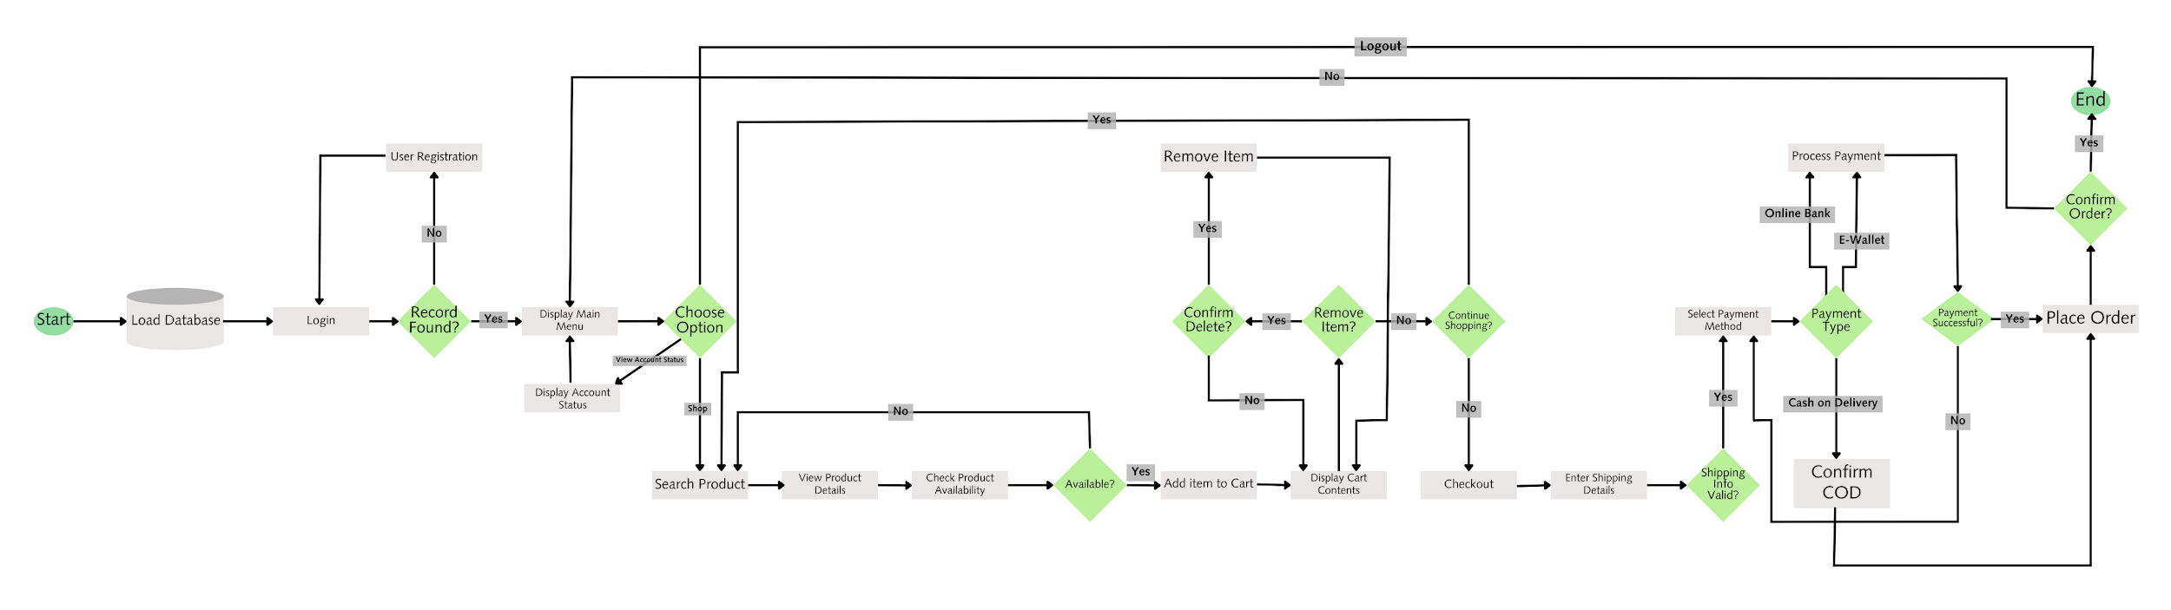

Figure 1. Flowchart of the Online Shopping Cart System

The design process of the system started with user authentication and data initialization, which establishes the foundation for the rest of the design in order to provide secure access and proper data management before any transactions are handled by the system.

The design of the system also follows a modular approach, where it consists of five interconnected modules: authentication, navigation, shopping, checkout, and order management module, in which each of these modules is represented in the flowchart, and is connected through decision nodes and validation checks. The authentication module functions as the one responsible for loading the database and checking whether the user has logged in or is currently registering as a new user. After the authentication and registration of an account, the navigation module now provides access to the main menu of the system and allows users to begin shopping, search for certain products and view their own account status. Then, the shopping module allows the user to browse products, view product details and the availability of the product, and also supports cart management functions. Afterwards, the checkout module validates the shipping details and payment methods of the user, while the order management module completes the process by placing the order and ending the session with the system logging out. Therefore, with the implementation of a modular structure in the design process of this system, it ensures that the system will remain user-centered, reliable, and logically organized.

Tools and Technologies Used

Python

The primary programming language that was used in order to develop the online shopping cart system. This programming language provides a powerful and simple environment when it comes to implementing the features of the system, such as user registration, login authentication, product management, cart handling, and transaction processing.

PyCharm
An Integrated Development Environment (IDE) was utilized to write, debug, and manage the Python code efficiently. By providing features like syntax highlighting, error detection, and product organization within the system, PyCharm enhanced the development process.

MySQL

For effective data storage and organization, a Relational Database Management System (RDBMS) is utilized. MySQL ensured reliable data management by handling user accounts, product inventories, and transaction records in the system.

XAMPP

XAMPP is an open-source cross-platform web server solution stack package that includes Apache, MySQL, PHP, and Perl. It is incorporated in this study to host and manage the MySQL database locally, where it also provides a convenient environment for database operations during the development and testing process of the system.

CustomTkinter

A modern extension of Tkinter used to design the graphical user interface (GUI) of the system. CustomTkinter provides a more customizable GUI and also makes the website more visually appealing, enabling user-friendly windows such as the interface’ login/registration, product catalog, shopping cart, checkout, and admin panel.

RESULTS AND DISCUSSION
System Overview

This project is an online shopping application developed in Python, featuring a Graphical User Interface (GUI) built with Tkinter. The Tkinter framework provides a simple yet powerful way to design interactive windows, buttons, menus, and input fields, allowing users to navigate the system without relying on command-line operations.

The purpose of the system is to provide a convenient and secure platform for customers to perform online shopping activities. It aims to simplify the purchasing process by integrating essential e-commerce functions such as product browsing, cart management, and transaction processing into an interface.

Through the GUI, customers can browse products, add items to their cart, and complete transactions efficiently. The backend logic, written in Python, manages critical operations including user authentication, product inventory control, order handling, and receipt generation. A MySQL database supports these functions by securely storing product details, user accounts, and transaction records, ensuring reliable data management and retrieval.

Overall, the system’s functions are designed to streamline online shopping by automating repetitive tasks, maintaining organized records, and enhancing user experience through responsive design.

System Features
The system provides the following key features:

User Authentication
- Secure Login and registration for customers
- Validation of credentials to ensure authorized access

Graphical User Interface
- Windows, buttons, and menus for simple navigation
- User-friendly design that minimizes technical barriers

Product Management
- Display of available products with details such as name, price, and stock quantity
- Functions for adding, updating, and removing products from the inventory

Shopping Cart Functionality
- Customers can add or remove items from their cart and review selections before checkout

Order Processing
- Checkout system that records customer purchases
- Automatic generation of receipts for completed transactions

Database Integration (MySQL)
- Centralized storage of user accounts, product details, and transaction records.
- Use of primary and foreign keys to maintain relational integrity.

Transaction Records
- Secure logging of all orders via admin login
- Easy retrieval of past transactions through the GUI

System Interface
This section presents the graphical user interface (GUI) of the Online Shopping Cart System developed using the Phyton and Tkinter framework. Each window is designed to be user-friendly, minimizing technical barriers while ensuring efficient navigation through the system’s core functionalities.

Login/Registration Window

The Login Window is the entry point of the system. It prompts the user to enter their username and password to gain access. Users who do not yet have an account may navigate to the Registration Window where they can create new credentials. Input validation ensures that only authorized users can access the system, displaying appropriate error messages for invalid entries.

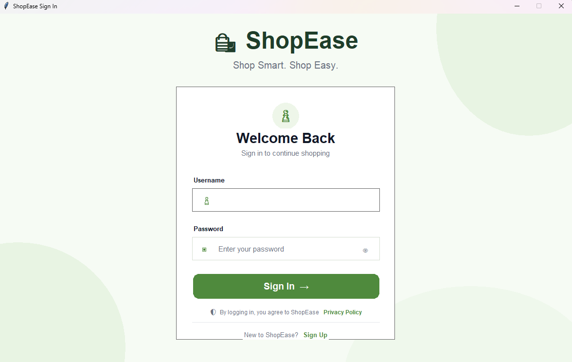

Figure 2. Login and Registration Window of the Shopease Online Shopping Cart System
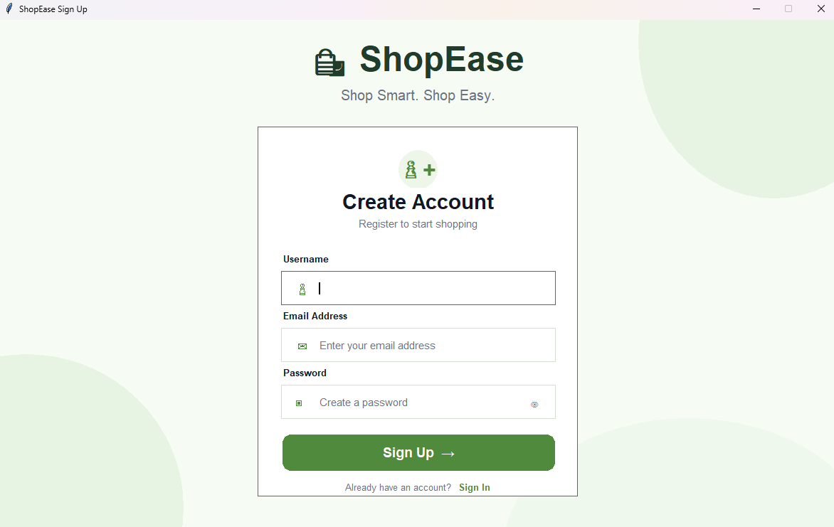
This figure shows the entry point of the Shopease system. Users enter their username and password to log in. New users can navigate to the Registration Window to create an account. Input validation ensures that only authorized users can access the system, and appropriate error messages are displayed for invalid entries, maintaining system security and data integrity.

Figure 3. Login/Registration Window

Product Catalog Window

The Product Catalog Window displays all available products stored in the MySQL database. Each product entry shows the product name, price, and current stock quantity. Customers can browse through the catalog and select items they wish to purchase. This window serves as the main browsing interface for the shopping experience.



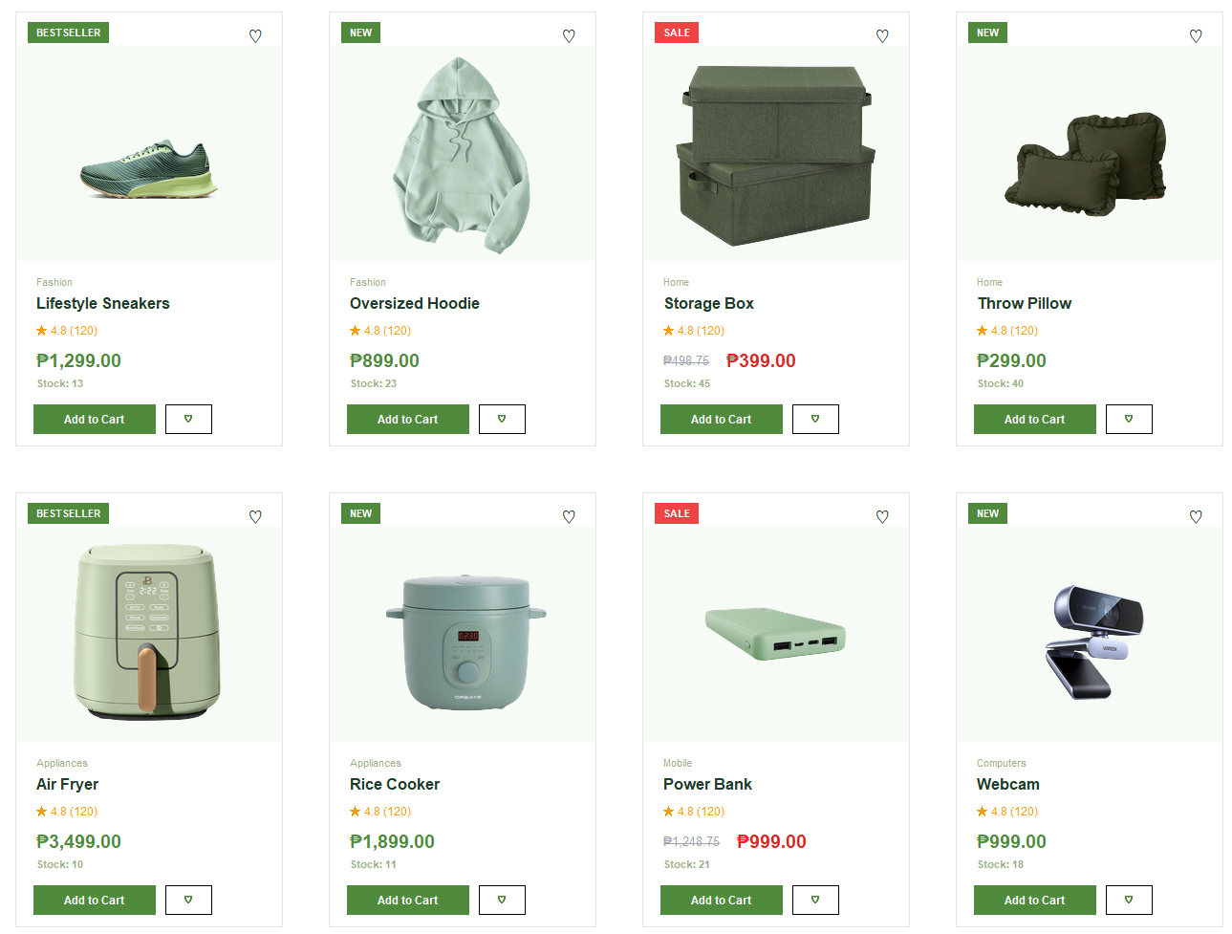



Figure 4. Product Catalog Window of the Shopease Online Shopping Cart System
This figure displays the Product Catalog Window, showing all available products retrieved from the MySQL database. Each product listing includes the name, price, and stock quantity, allowing customers to browse and select items for purchase, serving as the core shopping.

Shopping Cart Window

The Shopping Cart Window allows customers to review the items they have selected before proceeding to checkout. Users can add or remove items from the cart, and the window dynamically updates the total price based on the current selection. This ensures that customers can finalize their order before committing to a purchase.
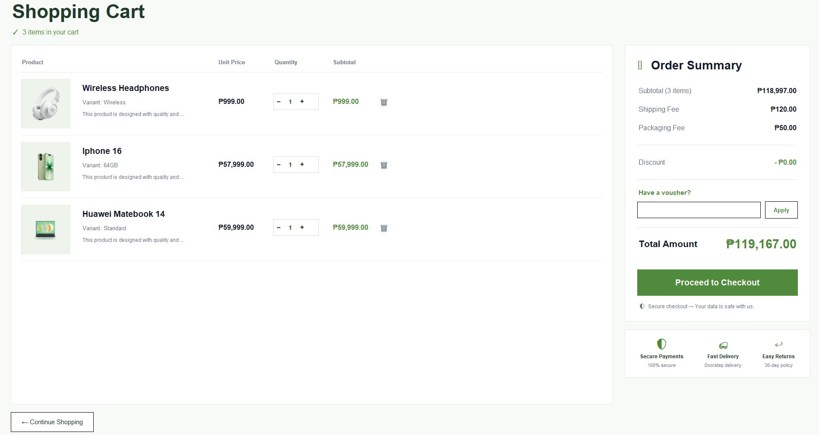

Figure 5. Shopping Cart Window of the Shopease Online Shopping Cart System
This figure shows the Shopping Cart Window, allowing customers to review selected items before checkout. Users can add or remove products, and the total price dynamically updates based on the current selection. This ensures customers can finalize their order accurately before completing the purchase.
Checkout/Receipt Window

The Checkout Window processes the customer’s confirmed order. Once the user clicks the checkout, the system records the transaction in the MySQl database and automatically generates a receipt. The receipt displays the list of purchased items, quantities, individual prices, and the grand total of the order.
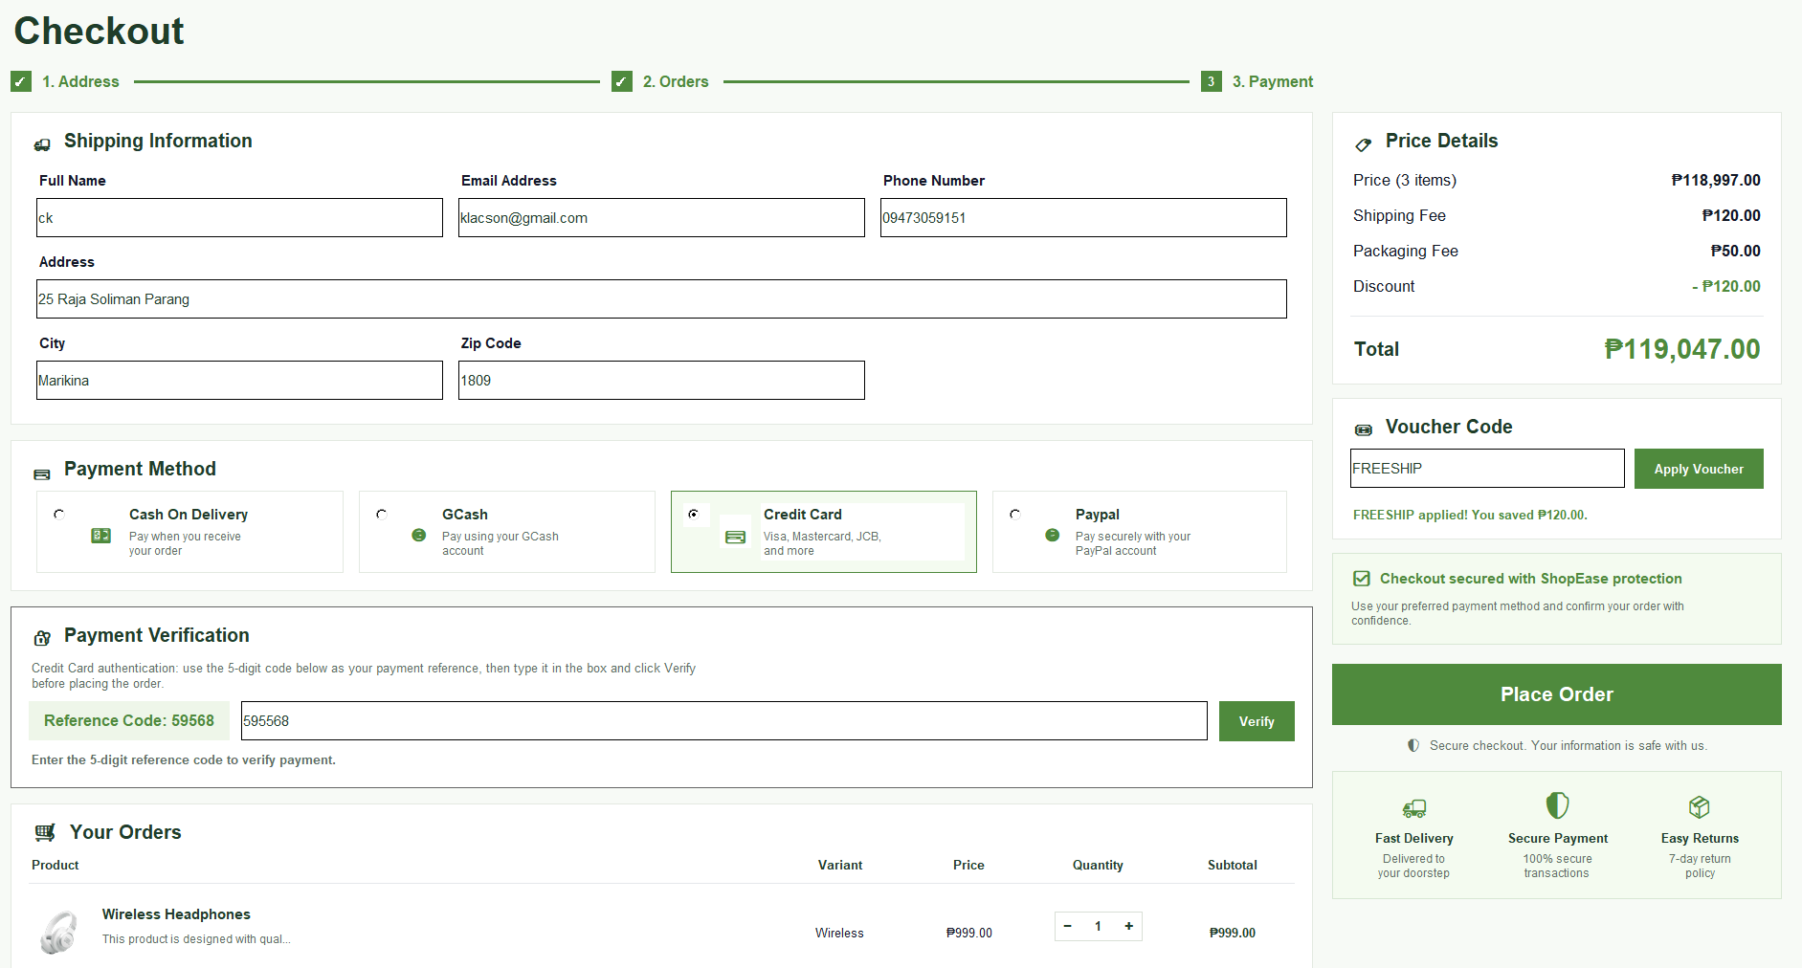







Figure 6. Checkout and Receipt Window of the Shopease Online Shopping Cart System
This figure shows the Checkout Window, which processes the customer’s confirmed order. Once the checkout button is clicked, the system records the transaction in the MySQL database and automatically generates a receipt. The receipt displays the purchased items, quantities, individual prices, and the grand total, providing a clear summary for both the customer and system records.
Admin Panel Window

The Admin Panel Window is accessible only to authorized administrators. It provides functionality for managing the product inventory, including adding new products, updating existing product details such as price and stock quantity, and removing discontinued items. Administrators can also view and retrieve all past transaction records securely through this interface.

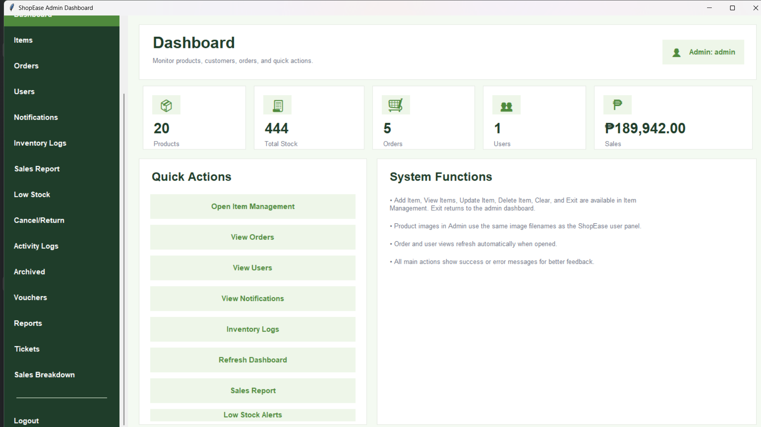

Figure 7. Admin Dashboard Interface of the Shopease Online Shopping Cart System
This figure shows the Admin Dashboard of Shopease, where administrators can monitor key metrics such as the total number of products, total stock, orders, users, and total sales. The dashboard provides quick access to system functions including item management, order viewing, and user management. It serves as the central control panel for managing all operations efficiently within the shopping cart system.
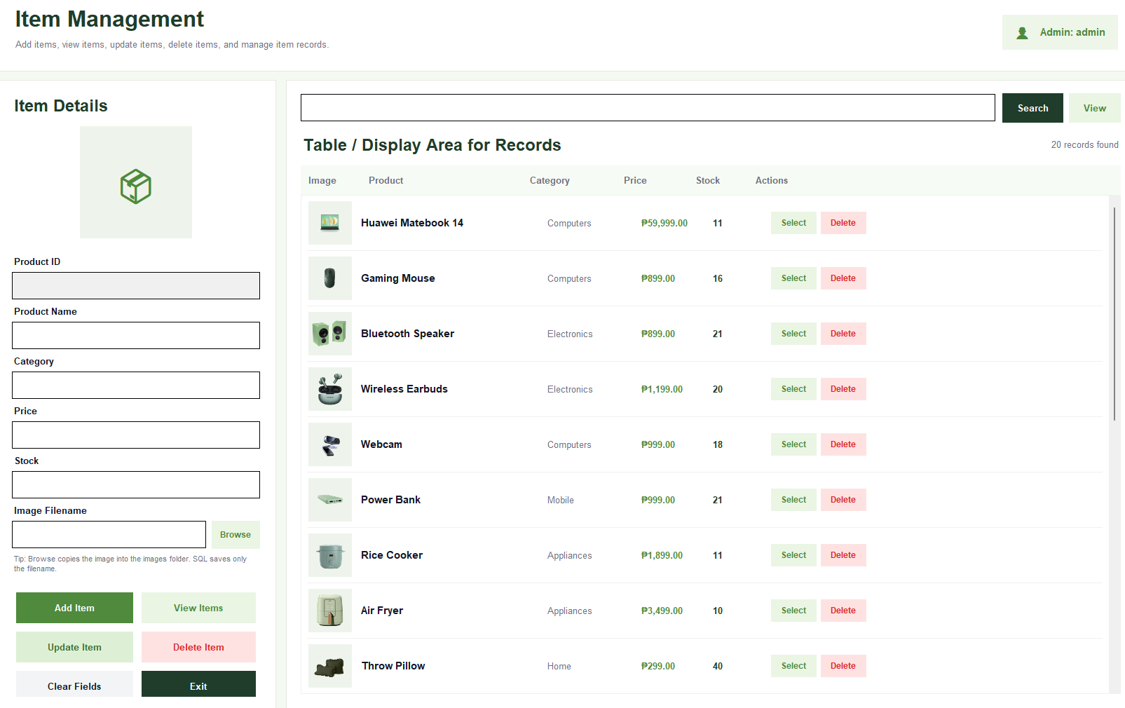

Figure 8. Item Management Interface of the Shopease Online Shopping Cart System
This figure shows the Item Management module of the Shopease admin panel. Administrators can add, view, update, and delete products while managing item details such as product ID, name, category, price, stock, and product image. The table on the right displays all current inventory items, allowing for quick selection and modification. This interface ensures organized and efficient management of the product catalog within the system.

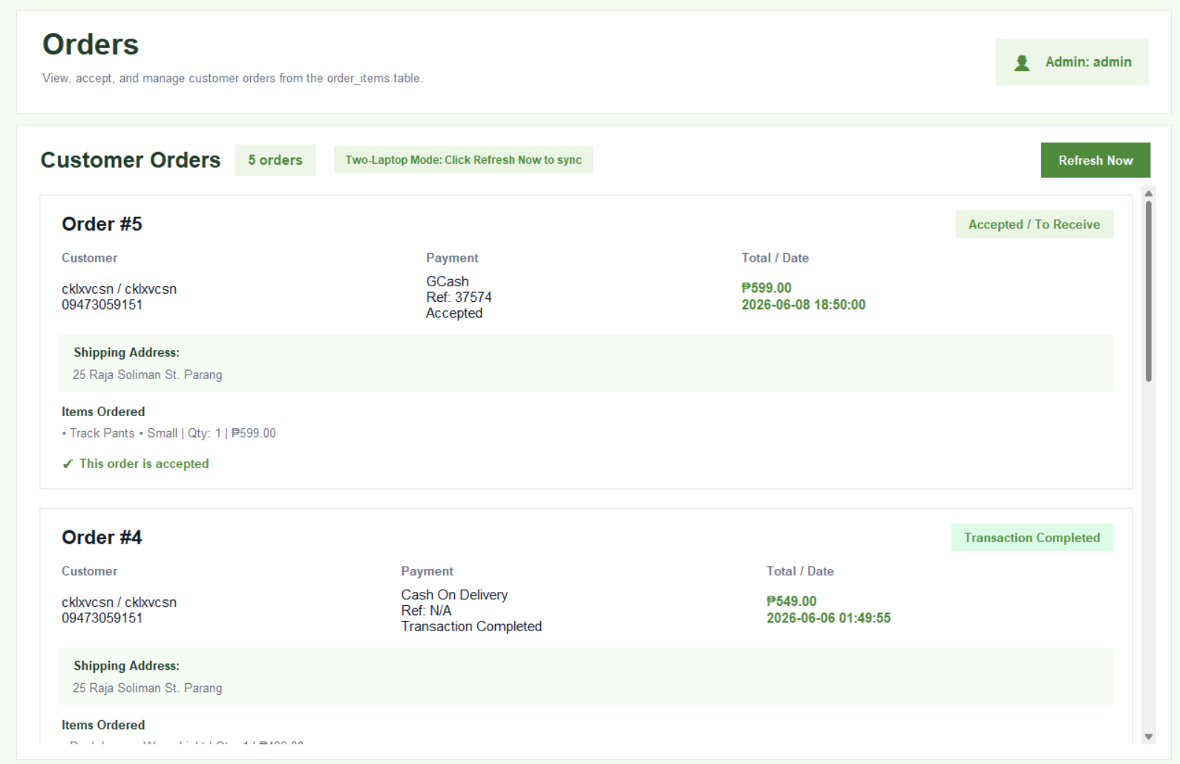
Figure 9. Orders Management Interface of the Shopease Online Shopping Cart System
This figure shows the Orders module of the Shopease admin panel. Administrators can view, accept, and manage customer orders, including details such as customer name, contact, payment method, shipping address, items ordered, and total amount. Orders are marked as pending or accepted, allowing the admin to track order status and ensure proper processing of all transactions efficiently.
System Testing

This section presents the testing procedures conducted to evaluate the functionality and reliability of the Online Shopping Cart System. White-box testing is employed wherein the developers tested the system with full knowledge of the source code, verifying internal logic, code paths, and module interactions. The test case below covers all major features of the system, including user authentication, product management, shopping cart operations, order processing, and database integration.
Table 1,
TC No. | Module | Test Description | Input | Expected Output | Actual Output | Status
TC-01 | User Authentication | Login with valid credentials | Correct username & password | Access granted, redirected to main menu | Access is granted | Passed
TC-02 | User Authentication | Login with invalid credentials | Wrong password | Error message displayed | Error message shown | Passed
TC-03 | User Registration | Register a new account | New username & password | Account created, redirected to login | Account saved to database | Passed
TC-04 | Product Management | Add new product (Admin) | Product name, price, quantity | Product added to inventory | Product saved to MySQL | Passed
TC-05 | Product Management | Update existing product | Modified price/quantity | Product details updated | Changes reflected in database | Passed
TC-06 | Product Management | Remove a product | Select product, click “Remove” | Product deleted from inventory | Product removed from database | Passed
TC-07 | Shopping Cart | Add item to cart | Select product, click “Add to Cart” | Items appears in cart with quantity | Item added successfully | Passed
TC-08 | Shopping Cart | Remove item from cart | Select item, click “Remove” | Items removed from cart | Item removed successfully | Passed
TC-09 | Order Processing | Complete checkout | Confirm cart items | Receipt generated, order is recorded | Receipt displayed & saved | Passed
TC-10 | Order Processing | View receipt after checkout | Click “View Receipt” | Receipt window opens with order details | Receipt displayed correctly | Passed
TC-11 | Database Integration | Retrieve past transactions | Admin login, navigate to records | Transaction history is displayed | Records fetched from MySQL | Passed
TC-12 | Database Integration | Store user account data | Register new user | User data is saved securely | Data stored with correct keys | Passed

Based on the results presented above, all twelve test cases passed successfully. Each module of the Online Shopping Cart System performed according to its expected output, confirming that the system is functional and meets the requirements outlined in the system features. The white-box testing approach allowed the developers to trace each test through the corresponding code paths, ensuring that both the logic and output of every module are correct. No critical errors were encountered during the testing.

CONCLUSION AND RECOMMENDATIONS

Conclusion

The Online Shopping Cart System successfully demonstrated the integration of Python and MySQL in developing a functional and reliable database-driven application. The system was able to provide essential e-commerce features such as user registration, login authentication, product browsing, shopping cart management, checkout processing, and transaction recording. In addition, the admin panel allowed administrators to manage products and monitor transaction records efficiently.
The study proved that computerized systems can improve the efficiency, accuracy, and organization of shopping transactions compared to traditional manual methods. Through the integration of MySQL, the system maintained reliable storage and retrieval of data, while Python provided an effective programming environment for implementing system functionalities. The use of a Graphical User Interface (GUI) through Tkinter and CustomTkinter also improved usability by making the application more interactive, accessible, and user-friendly for both customers and administrators.
Furthermore, the testing results showed that all major modules of the system functioned properly according to the expected outputs. The successful implementation of user authentication, product management, shopping cart operations, and database integration confirmed the reliability and effectiveness of the developed system.
However, the study also identified several limitations. The system does not yet support online payment integration, delivery tracking, email notifications, advanced security mechanisms, or password encryption. Despite these limitations, the project provided valuable learning experiences in programming, database management, system development, and problem-solving. Overall, the Online Shopping Cart System serves as a strong foundation for future improvements and more advanced e-commerce applications.

Recommendations

Based on the findings and limitations of the study, the following recommendations are suggested to further improve the Online Shopping Cart System:
- The system may be enhanced by integrating online payment methods such as GCash, PayPal, and credit or debit card payments to make transactions more realistic and convenient for users.
- Advanced security features such as password encryption, secure authentication, and data protection mechanisms should be implemented to improve system security and protect user information.
- Additional features such as order history, delivery tracking, email notifications, and sales reports may be added to improve the overall functionality and efficiency of the system.
- The shopping cart module may be improved by adding quantity adjustment functions, allowing users to increase or decrease the quantity of products directly within the cart.
- Future developers may upgrade the system into a fully web-based or mobile-based application to improve accessibility and allow users to access the platform from different devices.
- The graphical user interface may also be enhanced further by improving the design layout, responsiveness, and overall user experience.
- Future researchers may continue developing the project by applying more advanced programming frameworks, database technologies, and software engineering practices to improve the performance, scalability, and reliability of the application.

ACKNOWLEDGEMENT
The researchers would like to express their heartfelt appreciation to Engr. Meshelle N. Fabro, PCpE, for her dedicated mentorship, professional guidance, and expert supervision throughout the completion of this study. Her valuable insights, constructive suggestions, and continuous encouragement significantly contributed to the successful development and improvement of this research.
The researchers also extend their sincere gratitude to the Eulogio “Amang” Rodriguez Institute of Science and Technology (EARIST), particularly the Department of Computer Engineering, together with its faculty members, for providing the academic knowledge, technical resources, and institutional support necessary for the accomplishment of this project. The institution’s commitment to excellence in education, innovation, and research played an essential role in the success of this study.
Special thanks are also given to the families and friends of the researchers for their unwavering support, patience, understanding, and motivation. Their encouragement served as a source of inspiration and strength throughout the challenges encountered during the research process.
Above all, the researchers offer their deepest gratitude to Almighty God for the wisdom, guidance, strength, and perseverance bestowed upon them throughout this endeavor. This work is humbly dedicated to His glory, acknowledging that every achievement was made possible through His grace and blessings.

REFERENCES:
Design and Implementation of a Web-Based Electronic-Commerce System. (2026). Eu-Opensci.org. https://eu-opensci.org/index.php/ejeng/article/view/62789/12787
Drazen, E., Metzger, J., Koran, R., & Nadell, A. (1982). Benefits of Automation within DoD Hospitals. Proceedings of the Annual Symposium on Computer Application in Medical Care, 441. https://pmc.ncbi.nlm.nih.gov/articles/PMC2580327/?utm_source
GeeksforGeeks. (2020, February 26). Software Development Life Cycle (SDLC). GeeksforGeeks. https://www.geeksforgeeks.org/software-development-life-cycle-sdlc/
Islam, M. T., & Mojumder, M. S. (2020). Online Store using E-Commerce and Database Design and Implementation. International Journal of Engineering Research & Technology, 9(10). https://www.ijert.org/online-store-using-e-commerce-and-database-design-and-implementation
Khan, M., & Sheikh, S. (2025). Issue 8 www.jetir.org (ISSN-2349-5162). JETIR2508435 Journal of Emerging Technologies and Innovative Research, 12. https://www.jetir.org/papers/JETIR2508435.pdf
MySQL. (2026). Mysql.com. https://www.mysql.com/?
Performing Usability Evaluation on Multi-Platform Based Application for Efficiency, Effectiveness, and Satisfaction Enhancement. (2026). Online-Journals.org. https://online-journals.org/index.php/i-jim/article/view/20429/9257
Praiselin, S., & Andrew, S. (2021). ONLINE SHOPPING SYSTEM. International Journal of Creative Research Thoughts (IJCRT), 9(6), 2320–2882. https://www.ijcrt.org/papers/IJCRT2106820.pdf
Pykes, K. (2019, December 9). MySQL in Python Tutorial: Getting Started. Datacamp.com; DataCamp. https://www.datacamp.com/tutorial/mysql-python
Python. (2019, August 30). Welcome to Python.org. Python.org; Python.org. https://www.python.org/about/
Python - Connecting to MySQL Databases. (2024, January 6). MySQL Tutorial. https://www.mysqltutorial.org/python-mysql/python-connecting-mysql-databases/
Python MySQL Database Connectivity [Complete Guide]. (2018, July). PYnative. https://pynative.com/python-mysql-database-connection/
Think Topics IBM. (2024, November). Ibm.com. https://www.ibm.com/topics/waterfall-model
Yunus, A., & Masum, M. (2020). Design and Development of an E-Commerce System in a Rapid Organized Way. International Journal of Science and Research (IJSR), 9(3), 1368–1375. https://doi.org/10.21275/sr20325195821
Zhang, Z., Feng, Y., Ernst, M. D., Porst, S., & Isil Dillig. (2021). Checking conformance of applications against GUI policies. https://doi.org/10.1145/3468264.3468561

ABOUT THE AUTHORS

Necomel G. Dela Paz is a second-year Bachelor of Science in Computer Engineering student at Eulogio “Amang” Rodriguez Institute of Science and Technology (EARIST). She is also a Freelance Computer Technician specializing in troubleshooting and maintenance. Alongside her academic journey, she applies her technical skills in real-world scenarios, which strengthens her understanding of both hardware and software concepts. As a Computer Engineering student, she is motivated to explore how technology can be used to solve everyday problems and improve efficiency. Her goal is to become a skilled, responsible, and innovative professional in the field of Computer Engineering. She has a strong interest in the field of technology, particularly in developing games and creating web designs, which she aims to pursue as part of her future career

Krhistine Joyce M. Donayre is currently a first-year Bachelor of Science in Computer Engineering student at the Eulogio Amang Rodriguez Institute of Science and Technology. She is passionate about exploring different fields and continuously learning new things, especially in both hardware and software concepts. Before pursuing her studies, she gained work experience in the fast-food industry, including working at Jollibee, which helped her develop valuable skills such as teamwork, communication, adaptability, and responsibility. As an aspiring computer engineer, she continues to expand her knowledge, improve her technical skills, and explore opportunities that will help her grow both personally and professionally.

Kassandra Celyn R. Lacson is a first-year Bachelor of Science in Computer Engineering student at Eulogio “Amang” Rodriguez Institute of Science and Technology (EARIST). She is currently developing her knowledge and skills in programming, computer systems, mathematics, and engineering-related subjects. As a Computer Engineering student, she is interested in learning how technology can be used to solve real-life problems and improve daily tasks. She continues to enhance her skills through academic activities, projects, and hands-on exercises that help her understand both software and hardware concepts. Her goal is to become more knowledgeable, responsible, and skilled in the field of Computer Engineering.

Shayne Ashley Perez Mallillin is currently a first-year Bachelor of Science in Computer Engineering student at the Eulogio "Amang" Rodriguez Institute of Science and Technology (EARIST). She serves as a committee member of the Association of Computer Engineering Students (ACES) and is also an active member of the Institute of Computer Engineers of the Philippines – Student Edition – NCR (ICPEP). Her participation in these organizations reflects her commitment to leadership, collaboration, and professional growth within the field of computer engineering. Driven by her passion for technology and innovation, she continuously strives to enhance her knowledge, develop her technical skills, and contribute meaningfully to the engineering community as she progresses in her academic journey.

Hikari Mika Quibote is a first-year Bachelor of Science in Computer Engineering student at the Eulogio "Amang" Institute of Science and Technology. (EARIST). She is an active member of the Association of Computer Engineering Students (ACES) and the Institute of Computer Engineers of The Philippines (Student Edition), reflecting her dedication to the computer engineering profession and the broader engineering community. A consistent academic achiever, she graduated from both elementary and high school with honors. Passionate about technology and innovation, she is committed to developing her skills and knowledge as she advances in the field of computer engineering.

Daphne Angelique P. Santos is currently a first-year Bachelor of Science in Computer Engineering student at the Eulogio "Amang" Rodriguez Institute of Science and Technology (EARIST) Manila. She is an active member of the Institute of Computer Engineers of the Philippines (Student Edition) and also works as a freelance digital illustrator. As an undergraduate student, she is currently developing skills in computer technology, exploring foundational concepts in hardware, software, and systems design. With a strong sense of curiosity and a commitment to continuous learning, she aims to build proficiency in computer engineering and related technical fields.

Engr. Meshelle N. Fabro is a licensed Professional Computer Engineer and educator at the Eulogio “Amang” Rodriguez Institute of Science and Technology (EARIST), specializing in Operating Systems, CAD, and Object-Oriented Programming. She is currently pursuing a Master of Science in Computer Engineering at Bulacan State University and has professional industry experience as a Technical Engineer at Hewlett-Packard (HP) and an IT Engineer at IBM. She is a TESDA CSS NC II and Trainers Methodology Level I (TM1) holder, demonstrating her commitment to technical excellence and competency-based education. Passionate about teaching and innovation, she is dedicated to developing industry-ready, competent, and highly skilled students equipped for the evolving demands of the technology industry.

