A Conceptual Framework for Construction Delay Management Integrating Project and Weather Factors

ABSTRACT
Construction project delays remain a major challenge in the construction industry, often leading to cost overruns, reduced productivity, contractual disputes, and poor project performance. Traditional project management approaches, which rely heavily on manual scheduling techniques and historical project records, are often insufficient to address the dynamic nature of construction environments, particularly when influenced by external factors such as weather conditions. Previous studies have primarily focused on identifying delay factors and developing predictive models based on historical project data, with limited integration of environmental variables and practical decision-support mechanisms. This study aims to identify the key factors influencing construction work delays and to develop a conceptual predictive framework that integrates project information with weather-related data to support more effective delay management. The proposed framework incorporates scheduling analysis through the Critical Path Method (CPM) to identify critical activities and evaluate potential delay risks that may affect project completion. In addition, the framework conceptually demonstrates how Artificial Intelligence (AI) and Machine Learning (ML) can be integrated with project and environmental data to enhance project monitoring, risk assessment, and planning processes. The framework was developed to illustrate the interaction between project scheduling information, weather-related variables, and predictive decision-making within a structured management system. Validation was conducted through expert evaluation involving construction professionals to assess the practicality and relevance of the proposed framework in real construction environments. The findings indicate that the integration of project and environmental data has the potential to improve planning accuracy, increase awareness of delay risks, and support proactive decision-making throughout the project lifecycle. The proposed framework contributes to the advancement of data-driven construction management practices and provides a foundation for future studies involving empirical validation using real project datasets.
Keywords: Construction delay management, project scheduling, weather factors, decision-making, predictive framework
INTRODUCTION
The construction industry continues to face significant challenges related to project delays, which directly affect cost, schedule, quality, and overall project performance. Delays in construction projects often result in financial losses, reduced productivity, and disputes among stakeholders. In many cases, these delays are influenced by a combination of internal and external factors, including poor planning, resource constraints, and environmental conditions such as weather (Assaf & Al-Hejji, 2006; Haq et al., 2014).
Traditional project management approaches rely heavily on manual scheduling techniques and historical project data to manage delays. While these methods provide useful baseline information, they are often insufficient to address the dynamic and uncertain nature of construction environments (Flyvbjerg, 2014). The increasing complexity of construction projects requires more adaptive and data-informed approaches that can respond to real-time changes and external influences.
In recent years, Artificial Intelligence (AI) and Machine Learning (ML) have emerged as potential tools to support construction project management, particularly in predictive analysis and decision-making (Pan & Zhang, 2021). These technologies have been applied to analyse large datasets and identify patterns that may influence project performance. However, existing studies have primarily focused on predictive models developed using historical project data, with limited attention given to the integration of external environmental factors such as weather conditions (Haq et al., 2014).
Weather conditions are known to have a significant impact on construction activities, affecting productivity, scheduling, and overall project timelines. Previous studies have also reported that project delays can significantly affect both residential and infrastructure projects, resulting in increased costs, schedule overruns, and reduced project efficiency (Rivera et al., 2020; Fashina et al., 2021). Furthermore, critical delay factors such as planning deficiencies, resource constraints, and coordination issues continue to influence project performance across various construction sectors (Yap et al., 2017). Despite this, the incorporation of weather-related data into delay prediction and project management systems remains limited. Furthermore, there is a lack of structured frameworks that integrate predictive insights with practical scheduling tools that can be used directly by project managers in real project environments.
Therefore, this study aims to address these gaps by developing a conceptual predictive framework for construction delay management that integrates project data with weather-related information. The proposed framework incorporates scheduling analysis through the Critical Path Method (CPM) to identify critical activities that may influence project completion. In addition, the framework is designed to support practical decision-making rather than focusing solely on technical model performance.
The objectives of this study are as follows:
- To identify key factors influencing construction work delays.
- To develop a predictive framework for construction delay management by integrating project and weather-related data.
- To validate the proposed framework through expert evaluation.
LITERATURE REVIEW
Delay Analysis and The Role of Artificial Intelligence
Delay analysis is commonly conducted to evaluate the impact of project disruptions on construction schedules. One widely used approach is the time impact analysis, which estimates the effect of delays on the project’s critical path by incorporating delay events into the original schedule. This method allows for efficient evaluation as it is based on planned schedules rather than completed project data (Yusuwan & Adnan, 2013).
Despite its usefulness, traditional delay analysis methods often rely on manual interpretation and limited datasets. Such approaches may not adequately capture the complexity and dynamic nature of construction projects. In response to these limitations, Artificial Intelligence (AI) has emerged as a promising tool to support more advanced analysis and decision-making processes. AI techniques enable automated data processing and the identification of complex relationships among project variables (Zheng et al., 2023).
Recent studies have shown that organisations adopting AI technologies have experienced improvements in efficiency, productivity, and operational performance. The integration of AI with technologies such as Big Data and the Internet of Things (IoT) further enhances the ability to analyse large volumes of data and support more informed decision-making (Sen et al., 2016; Wamba-Taguimdje et al., 2020). These developments indicate the growing potential of AI to support construction delay analysis in a more systematic and data-driven manner. Beyond traditional approaches, delay analysis has increasingly emphasised the need to incorporate dynamic project conditions and external uncertainties. Several studies have shown that delay events are rarely isolated and are often influenced by interdependent factors such as resource allocation, sequencing constraints, and environmental variability (Doloi et al., 2012; Sambasivan & Soon, 2007). Weather-related disruptions have been identified as one of the most difficult factors to model using conventional techniques due to their variability and unpredictability. Recent research suggests that integrating data-driven approaches with traditional scheduling methods can provide a more comprehensive understanding of delay mechanisms. For instance, predictive analytics has been used to identify patterns in historical project data, allowing practitioners to anticipate potential risks and improve planning strategies (Gondia et al., 2023; Yaseen et al., 2020). However, these approaches still face limitations when external environmental data are not adequately incorporated into the analysis.
Applications of AI and ML in Digital and BIM-Based Construction Management
The advancement of digital technologies has significantly influenced the construction industry, particularly using Building Information Modelling (BIM). BIM enables the generation and management of large volumes of project data across different stages of the construction lifecycle. This creates opportunities for integrating data-driven approaches such as Artificial Intelligence (AI) and Machine Learning (ML) into construction management practices (Hong et al., 2020).
AI and ML techniques can transform BIM-generated data into meaningful insights for project planning, design optimisation, and monitoring. For example, design modifications within BIM environments contain valuable information related to cost, schedule, and project performance, which can be analysed to improve decision-making processes (Abdulfattah et al., 2023; Pilehchian et al., 2015).
Furthermore, the availability of large and structured datasets allows these techniques to be applied not only within individual projects but also across multiple projects with similar characteristics. Recent developments in digital project management technologies have further strengthened the ability of construction organisations to utilise integrated information systems for project monitoring and coordination (Gómez-Martínez et al., 2019). In addition, collaborative BIM environments have been shown to support real-time monitoring and information exchange among project stakeholders (Wang et al., 2024). This enhances the potential for improving consistency, efficiency, and predictive capability in construction project management.
The integration of digital technologies such as BIM with data-driven approaches has also been highlighted as a key enabler for improving construction management practices. BIM platforms provide a structured environment where project data can be continuously updated and analysed, enabling better coordination and information sharing among stakeholders (Hong et al., 2020). When combined with predictive techniques, these platforms can support more proactive decision-making by identifying potential conflicts and delays at earlier stages. In addition, various technical and digital tools have been developed to reduce construction errors and improve project accuracy, further supporting the adoption of technology-driven approaches in construction management (Rischmoller et al., 2006).
Despite these advantages, the practical implementation of such integrated systems remains limited. This is partly due to the complexity of aligning digital tools with existing workflows and the challenges associated with managing large volumes of project data (Álvarez et al., 2017). As a result, there is a need for simplified and adaptable frameworks that can bridge the gap between advanced digital technologies and real-world construction practices.
AI and ML Applications in Construction
AI and ML technologies are increasingly being adopted in construction to improve various aspects of project management, including scheduling, cost estimation, and safety monitoring. These technologies support more efficient decision-making by analysing complex datasets and identifying potential risks and patterns (Pan & Zhang, 2021; Yazici et al., 2023). Machine learning techniques provide the fundamental capability to identify hidden patterns, classify project information, and support predictive decision-making processes through data-driven analysis (Sarkar et al., 2018). Advanced intelligent systems have also been utilised to optimise construction workflows, improve project visibility, and support smart construction management practices aligned with Industry 4.0 initiatives (Luque et al., 2020; Tian & He, 2023).
Previous studies have demonstrated that ML-based approaches can be used to predict potential delays and support proactive project management. However, most of these studies rely heavily on historical project data and focus primarily on model development and performance. As a result, the practical integration of these approaches into real construction workflows remains limited (Gondia et al., 2023; Yaseen et al., 2020). This indicates a gap between technological development and practical application, particularly in terms of integrating predictive insights with existing project management tools and processes. While many studies have demonstrated the potential of AI and ML in improving construction project performance, their application is often focused on model accuracy and algorithm development rather than practical usability (Pan & Zhang, 2021). In real construction environments, decision-making is influenced by time constraints, uncertainty, and the need for clear and actionable insights. Therefore, there is increasing recognition that predictive systems must be designed not only for accuracy but also for usability and integration with existing project management practices (Lokshina et al., 2019).
Barriers to AI and ML Adoption in Construction
Although AI and ML offer significant benefits for construction delay management, their implementation in practice remains challenging. Several studies have identified key barriers that limit the adoption of these technologies within the construction industry.
One major challenge is the continued reliance on traditional methods, where contractors prefer familiar manual approaches over digital solutions (Flyvbjerg, 2014). In addition, high implementation costs, including investments in software, hardware, and training, pose significant constraints for organisations (Assaf & Al-Hejji, 2006).
Data-related issues also represent a critical barrier. Construction data are often fragmented and lack proper structure, making it difficult to develop reliable predictive systems (Regona et al., 2022). Furthermore, the shortage of skilled professionals with expertise in AI and data analytics limits the ability of organisations to implement and maintain such systems effectively (Prabhakar et al., 2023).
These challenges highlight the need for more practical and adaptable approaches that can bridge the gap between advanced technologies and real-world construction applications. Previous studies have also highlighted that the successful applicability of smart construction technologies depends on organisational readiness, user acceptance, and the ability to integrate new technologies into existing project workflows (Aripin et al., 2019). Previous studies have suggested that intelligent construction frameworks and stakeholder-centred digital systems can facilitate technology adoption when supported by effective implementation strategies and organisational commitment (Jia et al., 2019; Jung et al., 2023).
In addition to the technical and organisational challenges, the adoption of advanced technologies in construction is also influenced by the nature of project environments, which are often fragmented and involve multiple stakeholders. Construction projects typically require coordination among contractors, consultants, and clients, each with different levels of technological readiness and priorities. This creates additional complexity in implementing data-driven systems, as successful adoption depends not only on the availability of technology but also on effective collaboration and communication across project teams (Sambasivan & Soon, 2007).
Moreover, the uncertainty associated with construction activities further complicates the integration of predictive systems. Unlike manufacturing environments, construction projects are highly sensitive to external conditions such as weather, site constraints, and regulatory requirements. These factors can significantly influence project timelines and resource utilisation, making it difficult to rely solely on historical data for prediction (Doloi et al., 2012). As a result, there is an increasing need for frameworks that incorporate both internal project data and external environmental variables to improve the reliability of delay analysis. Recent studies have also highlighted that while AI-based approaches can provide valuable predictive insights, their effectiveness largely depends on the quality and integration of input data (Gondia et al., 2023). Poor data quality or incomplete datasets may lead to inaccurate predictions, which can reduce user confidence and limit practical application. Therefore, the development of simplified and adaptable frameworks that prioritise usability and data integration is essential to support wider adoption in the construction industry.

Table 1 provides a summary of the key barriers influencing the adoption of Artificial Intelligence (AI) and Machine Learning (ML) in the construction industry, including issues related to cost, data availability, and technical expertise.
Table 1. Barriers to AI and ML adoption.
Barrier | Description | Reference
Reliance on manual methods | Contractors still use traditional delay analysis | (Flyvbjerg, 2014)
High cost & resources | Requires investment in software, hardware, training | (Assaf & Al-Hejji, 2006)
Lack of structured data | Poor data integration between projects | (Regona et al., 2022)
Skill shortage | Limited AI-ML expertise in construction | (Prabhakar et al., 2023)

METHODOLOGY
This study adopts a structured approach to develop a conceptual predictive framework for construction delay management. The methodology consists of four main phases: data collection, data preparation, system development, and validation. The overall workflow of the proposed framework is illustrated in Figure 1.
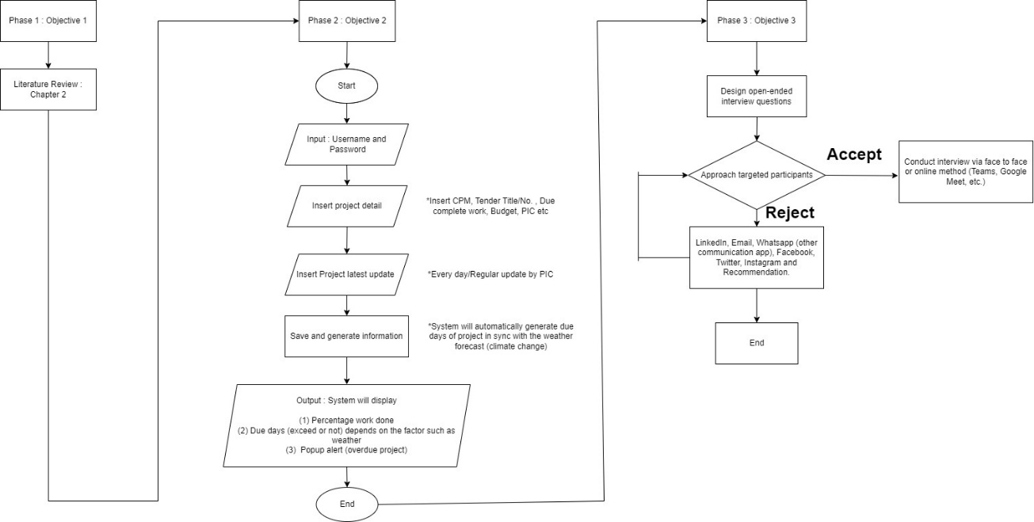
Figure 1. Conceptual workflow of the proposed predictive framework
Figure 1 presents the schematic representation of the system, illustrating the logical structure and interaction between project data, weather information, and delay analysis processes. The framework is conceptual in nature and is designed to demonstrate system functionality rather than empirical model performance. The first phase involves data collection, which includes project timelines, progress records, and historical delay information from construction projects. These data provide the basis for understanding project behaviour and identifying key delay-related factors. The collected data are then prepared and organised to ensure consistency and usability within the proposed framework.
The second phase focuses on system development. The framework integrates project scheduling information with external environmental data, particularly weather conditions, to support delay analysis. The Critical Path Method (CPM) is incorporated to identify critical activities that may significantly influence project duration. This integration enables the system to highlight potential delay risks and support more informed planning and monitoring processes. The third phase involves the conceptual integration of predictive analysis techniques. These techniques are used to illustrate how project and environmental data can be analysed to identify patterns and support delay prediction. The emphasis is placed on demonstrating the potential application of predictive approaches rather than on detailed model implementation. The conceptual nature of the framework is consistent with qualitative research approaches commonly used to explore emerging technological applications and assess their practical relevance before large-scale implementation (Agius, 2018).
The final phase involves validation through expert evaluation. Construction professionals, including project managers and engineers, were consulted to assess the practicality, logic, and relevance of the proposed framework. Feedback was collected through structured discussions focusing on system usability, integration of project and weather data, and its potential contribution to delay management. The responses were analysed and grouped into key themes, including usability, practicality, and applicability in real construction environments. The experts generally agreed that the proposed framework reflects actual construction practices and provides useful support for proactive delay management. Although qualitative in nature, this validation confirms the conceptual strength and potential applicability of the proposed system.
RESULTS
System Application in Construction Delay Management
The proposed system was analysed based on its potential application in construction delay management within a practical project setting. The system integrates project scheduling data, weather information, and the Critical Path Method (CPM) to identify activities that may be affected by external conditions.
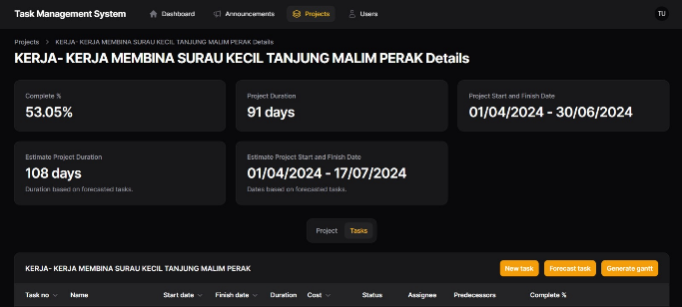
Figure 2. Conceptual illustration of project timeline variation influenced by weather conditions

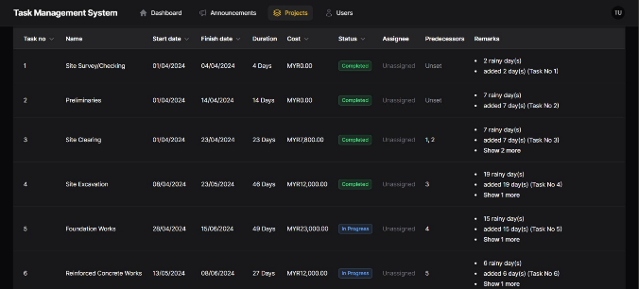
Figure 3. Conceptual representation of task-level delays under weather-related conditions
Figure 2 illustrates how project timelines may vary when weather-related disruptions occur. It shows the difference between planned and adjusted schedules when external factors are taken into consideration. Figure 3 presents how specific construction tasks, particularly those on the critical path, may be influenced under varying weather conditions. The figures presented in this study are conceptual in nature and are intended to illustrate system behaviour rather than empirical performance.
Expert Evaluation of the Proposed System
The respondents were asked to evaluate the advantages of the proposed system in construction delay management. The findings highlight the importance of further investigation into the practical application of the proposed system.
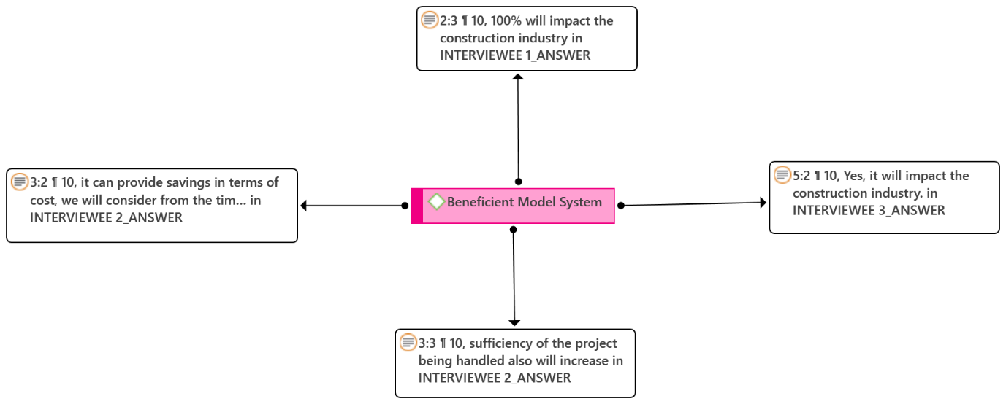
Figure 4. Perceived benefits of the proposed predictive system
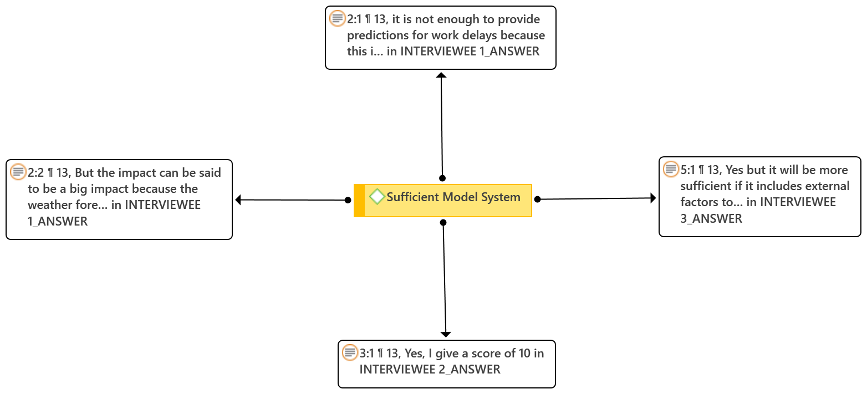
Figure 5. Expert agreement on system applicability
An expert evaluation was conducted to assess the practicality and relevance of the proposed system. The respondents consisted of construction professionals with experience in project management and site operations. The findings indicate that most respondents viewed the system as useful and relevant for construction delay management. They agreed that integrating weather information into project monitoring could support better planning and reduce unexpected disruptions. Figure 4 presents the perceived benefits of the system, while Figure 5 shows the level of agreement among experts regarding its applicability in real construction projects.
Implementation Considerations
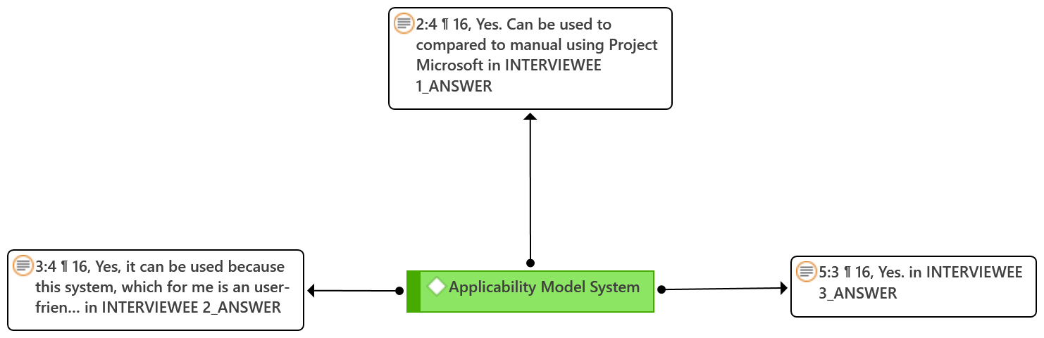
Figure 6. Applicability of Model System
Respondents also identified several factors that may influence the implementation of the proposed system. These include data availability, cost considerations, and the need for skilled personnel. Figure 6 summarises these factors and highlights that successful implementation depends on both technical capability and organisational readiness.
DISCUSSION AND RECOMMENDATION
The findings of this study highlight the importance of integrating project data with external factors, particularly weather conditions, in improving construction delay management. The proposed framework demonstrates how such integration can support better planning and monitoring by enabling earlier identification of potential delay risks. This is consistent with previous studies which emphasise the significant influence of environmental conditions on construction performance and scheduling (Haq et al., 2014).

The results also indicate that construction practitioners recognise the practical value of the proposed system. The positive response from experts suggests that integrating environmental data into project management processes can enhance decision-making and improve coordination among stakeholders. This finding supports earlier research showing that data-driven and digital approaches can contribute to improved efficiency and performance in construction projects (Pan & Zhang, 2021). The importance of integrating environmental data into construction management is further supported by studies that highlight the impact of weather variability on productivity and project outcomes (Haq et al., 2014). In practice, construction activities such as earthworks, concrete pouring, and structural installation are highly sensitive to weather conditions, which can lead to disruptions if not properly anticipated.
The findings also suggest that the integration of environmental data into construction management is not only beneficial for delay prediction but also contributes to a more proactive approach to project planning. In traditional project management practices, delays are often addressed after they occur, leading to reactive decision-making and increased project risks. By contrast, the incorporation of weather-related information enables project teams to anticipate potential disruptions and implement preventive measures at earlier stages. This shift from reactive to proactive management is increasingly recognised as a key factor in improving project performance (Flyvbjerg, 2014).
Furthermore, the ability to integrate multiple data sources within a single framework supports better visibility and coordination across different stages of a construction project. This is particularly important in complex projects where delays in one activity may have cascading effects on other tasks. The use of integrated systems can help project managers understand these interdependencies and make more informed decisions regarding resource allocation and scheduling (Pan & Zhang, 2021). The effectiveness of integrated systems can be further enhanced through real-time decision-support capabilities, simulation-based planning tools, and improved digital connectivity between project stakeholders (De Posgrado et al., 2020; Ramón-Elizondo & Barboza-Arguedas, 2019; Luo et al., 2022).
However, it is important to recognise that the successful implementation of such frameworks requires a gradual transition from traditional practices to more data-driven approaches. Construction organisations may need to invest in training and capacity development to ensure that personnel are equipped with the necessary skills to utilise these systems effectively. In addition, organisational support and clear implementation strategies are essential to overcome resistance to change and to ensure that the benefits of digital tools can be fully realised (Wamba-Taguimdje et al., 2020). In addition, the adoption of data-driven approaches in construction is closely linked to organisational readiness and the ability to manage change. Previous research indicates that successful implementation of digital technologies requires not only technical capability but also strong organisational support, training, and alignment with existing processes (Wamba-Taguimdje et al., 2020; Prabhakar et al., 2023). This reinforces the importance of developing practical and user-oriented systems that can be easily adopted by industry practitioners.
However, the study also reveals several challenges that may affect the implementation of such systems. Issues related to data availability, high implementation costs, and the lack of technical expertise remain significant barriers. These findings are consistent with previous studies which reported that the adoption of advanced technologies in the construction industry is often constrained by organisational and resource limitations (Assaf & Al-Hejji, 2006; Regona et al., 2022).
Furthermore, the effectiveness of the proposed framework depends not only on its technical capability but also on organisational readiness. Without proper integration into existing workflows and sufficient support from stakeholders, the potential benefits of digital tools may not be fully realised. This aligns with Wamba-Taguimdje et al. (2020), who emphasised the importance of organisational readiness in the successful adoption of digital technologies. The successful implementation of digital construction technologies is also influenced by user acceptance, implementation cost, and the perceived value of technology-enabled project management practices (Park et al., 2016; Ahn et al., 2023). Studies have further shown that digital transformation initiatives can improve productivity, project precision, and overall construction performance when supported by appropriate organisational strategies (Hickey et al., 2023; Li et al., 2021; Blanco et al., 2018).
Based on these findings, several recommendations can be proposed. First, construction organisations should consider gradually integrating environmental data, particularly weather-related information, into their existing project management practices to improve delay awareness and planning. Second, industry stakeholders should invest in capacity building and training to enhance the readiness of professionals in adopting data-driven approaches. Third, future research should focus on empirical validation of the proposed framework using real project data to further strengthen its applicability and effectiveness in real-world construction environments. The proposed framework also has broader implications for industry and policy. From an industry perspective, it supports the transition towards more data-informed project management practices, which are increasingly required in complex construction environments. From a policy perspective, the integration of environmental data into construction planning aligns with sustainability and risk management initiatives, particularly in regions affected by climate variability. This highlights the potential role of digital and predictive tools in supporting more resilient and adaptive construction practices.
Overall, this study contributes by providing a practical and adaptable framework that bridges the gap between emerging technologies and real construction practices, particularly in the context of delay management.
CONCLUSION
This study developed a conceptual predictive framework for analysing construction work delays by integrating project information with weather-related factors. The framework demonstrates how the combination of scheduling analysis and external environmental data can support more effective delay management in construction projects. The findings indicate that the proposed framework is practical and relevant for industry application, as confirmed through expert evaluation. The integration of weather-related information and scheduling analysis enhances the ability of project teams to identify potential delay risks and improve decision-making processes. These findings are consistent with previous studies highlighting the importance of data-driven and integrated approaches in improving construction project performance (Pan & Zhang, 2021). Despite its contributions, this study is limited to conceptual development and qualitative validation. Therefore, further research is recommended to conduct empirical validation using real project data and to examine the quantitative performance of the proposed framework. Future studies may also explore the integration of additional project variables to enhance its applicability in more complex construction environments. Overall, this study contributes by providing a practical and adaptable framework that bridges the gap between emerging digital approaches and real-world construction delay management practices.
DECLARATION OF COMPETING INTEREST
The authors declare that they have no known competing financial interests or personal relationships that could have appeared to influence the work reported in this paper.
DATA AVAILABILITY STATEMENT
The data supporting the findings of this study are available from the corresponding author upon reasonable request.
ACKNOWLEDGEMENT
The authors would like to thank Universiti Malaysia Pahang Al-Sultan Abdullah and the construction professionals who contributed to the expert evaluation in this study.
REFERENCES
- S. A. Assaf and S. Al-Hejji, “Causes of delay in large construction projects,” International Journal of Project Management, vol. 24, no. 4, pp. 349–357, 2006.
- Haq, A., Hassan, M., & Rahman, S. (2014) Impact of weather conditions on project performance Construction Engineering Journal, 27, 62–71.
- Doloi, H., Sawhney, A., Iyer, K. C., & Rentala, S. (2012) Analysing factors affecting delays in Indian construction projects International Journal of Project Management, 30(4), 479–489.B. Flyvbjerg, “What you should know about megaprojects and why: An overview,” Project Management Journal, vol. 45, no. 2, pp. 6–19, 2014.
- Sambasivan, M., & Soon, Y. W. (2007) Causes and effects of delays in Malaysian construction industry International Journal of Project Management, 25(5), 517–526.
- Y. Pan and Z. Zhang, “Artificial intelligence in construction engineering,” Automation in Construction, vol. 124, pp. 103–115, 2021.
- H. Yazici, R. Aydin, and A. Yildiz, “Deep learning in smart construction monitoring,” IEEE Access, vol. 11, pp. 1234–1246, 2023.
- H. Gondia, A. S. Javed, and P. S. Chauhan, “AI-based predictive modelling for construction delay management,” Journal of Building Engineering, vol. 62, 2023.
- M. Yaseen, T. Tariq, and R. Khan, “Machine learning applications in construction delay forecasting,” Automation in Construction, vol. 120, 2020.
- N. Yusuwan and N. Adnan, “Factors contributing to delays in construction projects,” Journal of Construction Management, vol. 18, pp. 21–28, 2013.
- R. Regona, F. Santos, and L. Kannan, “Barriers to AI adoption in the construction industry,” Journal of Civil Engineering Research, vol. 50, pp. 202–212, 2022.
- V. Prabhakar, A. S. Javed, and P. S. Chauhan, “A review on challenges and solutions in the implementation of AI, IoT, and blockchain in construction,” Automation in Construction, vol. 150, pp. 104–118, 2023.
- K. Fashina, M. Hassan, and A. Wahid, “Analysis of project delays in Malaysian public construction projects,” International Journal of Project Management, vol. 39, no. 3, pp. 230–242, 2021.
- L. Rivera, J. Battaineh, and H. Alsuliman, “Impact of delays on residential and infrastructure projects,” Journal of Construction Engineering and Management, vol. 146, no. 7, pp. 1–12, 2020.
- J. Yap, M. Skitmore, and K. Gray, “Critical delay factors affecting construction projects,” Automation in Construction, vol. 78, pp. 144–156, 2017.
- E. Lokshina, T. North, and D. Guo, “Automation and intelligent systems for construction project management,” Journal of Intelligent Systems, vol. 28, no. 5, pp. 667–681, 2019.
- Y. Wang, L. Xu, and C. Zhang, “Collaborative BIM integration for real-time project monitoring,” Advanced Engineering Informatics, vol. 59, pp. 101–122, 2024.
- P. Gómez-Martínez, F. Pérez, and D. García, “Digital project management technologies for construction,” Journal of Construction Informatics, vol. 27, pp. 110–129, 2019.
- M. Luque, R. Ruiz, and P. Torres, “Optimising construction workflows using AI-powered tools,” Automation in Construction, vol. 125, pp. 231–246, 2020.
- Z. Tian and Q. He, “Smart construction management in the era of Industry 4.0,” Journal of Construction Innovation, vol. 23, no. 4, pp. 451–469, 2023.
- E. Rischmoller, P. de Souza, and M. Araujo, “Technical tools to reduce construction errors,” Engineering Management Journal, vol. 18, no. 3, pp. 225–239, 2006.
- J. Hickey, P. Rao, and T. Blake, “Digital tools for enhancing project precision,” Journal of Civil Engineering and Management, vol. 29, no. 2, pp. 205–222, 2023.
- F. Ramón-Elizondo and L. Barboza-Arguedas, “Simulation-based design tools for complex projects,” Journal of Construction Simulation, vol. 31, pp. 150–165, 2019.
- J. De Posgrado et al., “Real-time decision-making systems for complex construction projects,” Automation in Construction, vol. 114, 2020.
- X. Luo, C. Li, and Y. Zhao, “Automation and connectivity in construction processes,” Journal of Civil Informatics, vol. 48, no. 6, pp. 601–615, 2022.
- H. Aripin, M. Arshad, and N. Jamaludin, “Applicability of smart construction technologies,” Journal of Built Environment Research, vol. 14, no. 2, pp. 233–245, 2019.
- R. Jia, Q. Lin, and S. Chen, “Intelligent construction frameworks for effective project delivery,” Construction Science and Technology, vol. 22, pp. 210–224, 2019.
- Y. Jung, S. Park, and M. Lee, “Stakeholder-centric smart construction systems,” Journal of Construction Innovation, vol. 15, no. 4, pp. 512–530, 2023.
- S. Park, H. Kim, and W. Han, “End-user utility in construction automation systems,” Automation in Construction, vol. 72, pp. 169–182, 2016.
- J. Ahn, S. Lee, and M. Choi, “Cost-effective implementation of intelligent construction technologies,” Journal of Civil Engineering Research, vol. 19, no. 5, pp. 112–130, 2023.
- L. Li, P. Nguyen, and K. Tan, “Measuring productivity indices in digital construction projects,” Journal of Project Management, vol. 36, pp. 441–455, 2021.
- J. Álvarez, A. Salas, and F. Guzmán, “Digital transformation in construction industries,” International Journal of Advanced Engineering Research, vol. 42, pp. 77–95, 2017.
- Zheng, Z., Wang, F., Gong, G., Yang, H., & Han, D. (2023b). Intelligent technologies for construction machinery using data-driven methods. Automation in Construction, 147, 104711.
- Jose Luis Blanco, Steffen Fuchs, Matthew Parsons, & Maria João Ribeirinho. (2018). Engineering and construction is behind the curve in implementing artificial intelligence solutions.
- Sen, D., Ozturk, M., & Vayvay, O. (2016). An Overview of Big Data for Growth in SMEs. Procedia - Social and Behavioral Sciences, 235, 159–167.
- Wamba-Taguimdje, S. L., Fosso Wamba, S., Kala Kamdjoug, J. R., & Tchatchouang Wanko, C. E. (2020). Influence of artificial intelligence (AI) on firm performance: the business value of AI-based transformation projects. Business Process Management Journal, 26(7), 1893–1924.
- Sarkar, D., Bali, R., & Sharma, T. (2018). Machine Learning Basics. In Practical Machine Learning with Python (pp. 3–65).
- Hong, T., Wang, Z., Luo, X., & Zhang, W. (2020). State-of-the-art on research and applications of machine learning in the building life cycle. In Energy and Buildings (Vol. 212). Elsevier Ltd.
- Abdulfattah, B. S., Abdelsalam, H. A., Abdelsalam, M., Bolpagni, M., Thurairajah, N., Perez, L. F., & Butt, T. E. (2023). Predicting implications of design changes in BIM-based construction projects through machine learning. Automation in Construction, 155, 105057.
- Pilehchian, B., Staub-French, S., & Nepal, M. P. (2015). A conceptual approach to track design changes within a multi-disciplinary building information modeling environment. Canadian Journal of Civil Engineering, 42(2), 139–152.

