DeepGuard: An Explainable Deep Learning Framework for Image Authenticity Detection Using ResNet50 and Grad-CAM
Kaustubh Manjarekar, Akash Kuarne, Paras Salunke, Shubham Phad, Prof. Vaibhav Sawalkar
Department of Computer Engineering MIT ADT University
Pune, India
Email: kaustubhmanjarekar87@gmail.com, akashkurane3011@gmail.com, salunkeparasorg@gmail.com, phadshubham44@gmail.com, vaibhav.sawalkar@mituniversity.edu.in

Abstract—The rapid advancement of generative artificial intel- ligence has significantly improved the capability of machines to generate highly realistic images. Modern generative models such as Generative Adversarial Networks (GANs) and diffusion-based models including Stable Diffusion and Midjourney are capable of producing synthetic images that are visually indistinguishable from authentic photographs. While these technologies provide innovative applications in fields such as digital art, media pro- duction, and entertainment, they also introduce serious challenges related to misinformation, digital forgery, and manipulation of visual content.
The increasing availability of AI-generated images raises concerns regarding the authenticity and credibility of digital media shared across social platforms and online communication channels. Detecting such images using traditional forensic tech- niques has become increasingly difficult due to the high realism achieved by modern generative models.
This paper presents DeepGuard, an explainable deep learn- ing framework designed to detect AI-generated images and distinguish them from real photographs. The proposed system utilizes a convolutional neural network based on the ResNet50 architecture to automatically learn discriminative visual features from image data. In addition, Grad-CAM (Gradient-weighted Class Activation Mapping) is incorporated as an explainable artificial intelligence technique to generate visual heatmaps that highlight the image regions influencing the model’s classification decisions.
Furthermore, the proposed detection model is integrated into a web-based platform developed using React for the frontend interface and FastAPI for the backend service. Experimental results demonstrate that the DeepGuard system achieves strong classification performance while providing interpretable expla- nations that improve user trust and transparency in AI-based forensic systems.
Index Terms—Image Forensics, Explainable Artificial Intelli- gence, Deep Learning, Convolutional Neural Networks, ResNet50, Grad-CAM, AI Generated Image Detection, Digital Media Au- thentication

- Introduction
Artificial intelligence has significantly transformed the way digital content is created and distributed in recent years. The development of powerful generative models has enabled ma- chines to produce highly realistic images that closely resemble
natural photographs. These advancements have opened new opportunities in fields such as digital art, entertainment, adver- tising, gaming, and virtual media creation. However, the same technologies that enable creative innovation also introduce new challenges related to digital authenticity, misinformation, and trust in visual media.
The increasing accessibility of generative AI tools has made it possible for individuals with minimal technical knowledge to create convincing synthetic images. As a result, the internet and social media platforms are experiencing a rapid increase in AI-generated content. While many of these applications are harmless and even beneficial, the misuse of such technology can lead to serious consequences. Synthetic images can be used to manipulate public perception, fabricate events, imper- sonate individuals, or spread misinformation.
Detecting whether an image is real or generated by artificial intelligence has therefore become an important challenge in the field of multimedia forensics. Traditional methods for iden- tifying manipulated images often rely on manual inspection or simple statistical analysis. However, modern generative models are capable of replicating complex visual patterns and textures, making detection increasingly difficult.
Recent research has focused on the use of deep learning techniques to automatically detect AI-generated images. Con- volutional Neural Networks (CNNs) have shown promising results in identifying subtle visual artifacts introduced during the generation process. Despite their effectiveness, many deep learning models lack interpretability, making it difficult to understand how classification decisions are made. In forensic applications, explainability is particularly important because investigators and users must be able to trust the model’s predictions.
To address these challenges, this research proposes Deep- Guard, an explainable deep learning framework designed to detect AI-generated images and distinguish them from real photographs. The system integrates a deep convolutional neu- ral network with explainable artificial intelligence techniques to provide both accurate classification and visual explanations

of the model’s decisions.
- Background
The field of generative artificial intelligence has experienced rapid progress with the introduction of models such as Genera- tive Adversarial Networks (GANs) and diffusion-based image generation techniques. GANs, first proposed by Goodfellow et al., consist of two neural networks known as the generator and the discriminator. The generator attempts to produce realistic synthetic images, while the discriminator tries to distinguish between real and generated images. Through this adversarial training process, the generator gradually improves its ability to create realistic images.
In recent years, diffusion models such as Stable Diffusion and Midjourney have further improved the quality of generated images. These models generate images by gradually refining random noise through a series of iterative denoising steps. The resulting images often exhibit extremely high levels of realism, making it increasingly difficult to differentiate them from authentic photographs.
The availability of such advanced generative models has significantly expanded the capabilities of artificial intelligence in creative applications. Artists, designers, and content cre- ators can now generate high-quality images using simple text prompts. However, these tools also raise concerns about the potential misuse of synthetic media.
The growing sophistication of AI-generated images has made it challenging for traditional forensic methods to de- tect them. As generative models continue to improve, more advanced detection techniques are required to ensure the authenticity and reliability of digital content.
- Problem Statement
One of the major challenges in the digital age is the increas- ing difficulty of distinguishing between real images and AI- generated images. Human perception alone is often insufficient to identify synthetic images produced by modern generative models. These models are capable of replicating intricate visual details such as lighting effects, shadows, textures, and facial features with remarkable accuracy.
Traditional forensic methods such as metadata analysis, compression artifact detection, and noise pattern analysis were effective for identifying earlier forms of image manipulation. However, these approaches are often ineffective against images generated by advanced generative models because such models can produce images without the typical artifacts associated with image editing.
The inability to reliably detect AI-generated images can have serious implications for society. Synthetic images can be used to spread misinformation, create fake news, manipulate political narratives, or damage the reputation of individuals. In journalism, law enforcement, and digital security, verifying the authenticity of images is critical for maintaining trust in visual evidence.
Therefore, there is a need for automated systems capable of accurately detecting AI-generated images while providing reliable explanations for their predictions.
- Motivation
The motivation behind this research arises from the grow- ing concerns regarding digital media authenticity in the era of generative artificial intelligence. As AI-generated content becomes more widespread, the ability to verify the authenticity of digital images becomes increasingly important.
While deep learning models have demonstrated strong per- formance in image classification tasks, many of these systems operate as black-box models. This lack of transparency makes it difficult for users to understand why a particular image is classified as real or synthetic. In critical applications such as digital forensics, security analysis, and journalism, inter- pretability is essential to build trust in automated detection systems.
Explainable Artificial Intelligence (XAI) techniques aim to address this issue by providing insights into how ma- chine learning models make decisions. Grad-CAM (Gradient- weighted Class Activation Mapping) is one such technique that generates visual heatmaps indicating the regions of an image that influence the model’s prediction.
By integrating explainable AI techniques with deep learning-based detection systems, it is possible to create mod- els that not only provide accurate predictions but also explain the reasoning behind those predictions. This improves trans- parency, interpretability, and user confidence in the system.
- Objectives
The primary objective of this research is to develop an explainable artificial intelligence framework for detecting AI- generated images. The proposed system aims to combine deep learning techniques with visual explanation methods to create a reliable and interpretable image authenticity detection system.
The specific objectives of this study are as follows:
  - To design and implement a deep learning-based image classification model capable of distinguishing between real and AI-generated images.
  - To utilize the ResNet50 convolutional neural network ar- chitecture for extracting meaningful visual features from input images.
  - To integrate Grad-CAM explainability techniques in order to provide visual explanations that highlight the regions influencing classification decisions.
  - To develop a web-based application that allows users to upload images and obtain real-time predictions along with visual explanations.
  - To evaluate the performance of the proposed system using standard classification metrics such as accuracy, precision, recall, and F1-score.
The successful implementation of these objectives will contribute toward improving the reliability and transparency of AI-based image authenticity detection systems.
- Literature Review
The detection of AI-generated images has become an im- portant area of research due to the rapid advancement of gen-

erative artificial intelligence technologies. Modern generative models such as Generative Adversarial Networks (GANs) and diffusion-based models are capable of producing highly real- istic images that can closely resemble authentic photographs. While these technologies provide many beneficial applications, they also raise concerns related to misinformation, digital manipulation, and media authenticity.
Researchers have proposed a variety of approaches to detect manipulated or synthetic images. These approaches can gener- ally be categorized into three main groups: traditional image forensic techniques, deep learning-based detection methods, and explainable artificial intelligence techniques used to inter- pret model predictions.

- Traditional Image Forensics
Before the rise of deep learning methods, digital image forensics primarily relied on handcrafted features and statis- tical analysis to detect image manipulation. These techniques focus on identifying inconsistencies in image properties such as compression artifacts, metadata information, and noise patterns. Although such methods were effective for detecting earlier forms of image editing, they are often less effective when applied to modern AI-generated images.
  - Error Level Analysis (ELA): Error Level Analysis (ELA) is a widely used technique for detecting manipulated regions in compressed images. The method works by recompressing an image at a known compression level and calculating the difference between the original image and the recompressed version. Regions that have been altered typically exhibit dif- ferent compression characteristics compared to the rest of the image.
ELA has been commonly used in digital forensic investi- gations to identify image tampering and editing operations. However, AI-generated images produced by modern genera- tive models often exhibit uniform compression characteristics, making ELA less reliable for detecting synthetic content.
  - Metadata Analysis: Metadata analysis is another tra- ditional forensic technique used to verify the authenticity of digital images. Most digital cameras and image editing software embed metadata information within image files. This metadata may include information such as camera model, timestamp, geolocation, and editing history.
Investigators can analyze metadata to determine whether an image has been modified or generated by software. For example, inconsistencies in metadata fields or missing camera information may indicate that an image has been manipulated. However, AI-generated images often contain minimal or arti- ficially generated metadata, which limits the effectiveness of this approach.
  - Noise Pattern Analysis: Noise pattern analysis is based on the observation that digital cameras introduce characteristic noise patterns during image acquisition. These patterns are often referred to as Photo Response Non-Uniformity (PRNU) noise and can act as a unique fingerprint for a particular camera sensor.
By analyzing noise patterns within an image, forensic experts can determine whether the image was captured using a real camera or generated synthetically. While this technique has shown promising results for certain types of image manip- ulation, advanced generative models are increasingly capable of simulating realistic noise patterns, making detection more challenging.
- Deep Learning Approaches
With the rapid progress of deep learning, convolutional neural networks (CNNs) have become the dominant approach for image classification and forensic analysis. CNN-based models are capable of automatically learning hierarchical features from large datasets, allowing them to detect subtle artifacts introduced during image generation.
Several studies have applied deep learning architectures to the problem of AI-generated image detection.
  - VGG16-Based Detection: The VGG16 architecture is one of the earliest deep convolutional networks used for large- scale image classification tasks. VGG16 consists of 16 layers and uses small convolutional filters to capture detailed visual features.
Researchers have used VGG16 as a feature extractor to identify patterns present in synthetic images generated by GAN models. While VGG16 demonstrates good performance in many classification tasks, its large number of parameters makes it computationally expensive for real-time applications.
  - InceptionV3-Based Detection: InceptionV3 is another widely used deep learning architecture designed to improve computational efficiency while maintaining high classification accuracy. The architecture uses parallel convolutional filters of different sizes to capture features at multiple scales.
Several studies have applied InceptionV3 to detect GAN- generated images by learning discriminative features that differentiate synthetic images from real photographs. While the architecture performs well in many scenarios, its inter- pretability remains limited without additional explainability techniques.
  - EfficientNet-Based Detection: EfficientNet is a more recent CNN architecture that improves model performance by scaling network depth, width, and resolution in a balanced manner. EfficientNet models have achieved state-of-the-art performance on various image recognition benchmarks.
Due to their improved efficiency and accuracy, EfficientNet- based models have been explored for detecting AI-generated images. However, similar to other CNN architectures, these models often lack transparency and provide limited insight into the reasoning behind their predictions.
- Explainable AI in Computer Vision
Explainable Artificial Intelligence (XAI) has emerged as an important research area aimed at improving the transparency and interpretability of machine learning models. In the context of computer vision, explainability techniques help researchers understand which regions of an image influence the model’s prediction.

Several explainability techniques have been proposed for interpreting deep learning models.
  - LIME: Local Interpretable Model-Agnostic Explana- tions (LIME) is a technique that explains model predictions by approximating the original model with a simpler interpretable model around a specific input instance. LIME perturbs the input data and observes changes in the model output to deter- mine which features contribute most strongly to the prediction. While LIME can provide useful explanations, its application in image classification often requires computationally expen-
sive sampling procedures.
  - SHAP: SHAP (Shapely Additive explanations) is an- other popular explainability method based on cooperative game theory. SHAP assigns importance values to input fea- tures by computing their contribution to the final prediction.
Although SHAP provides theoretically sound explanations, its computational complexity can make it difficult to apply in large-scale deep learning models.
  - Grad-CAM: Gradient-weighted Class Activation Map- ping (Grad-CAM) is a widely used explainability technique specifically designed for convolutional neural networks. Grad- CAM works by computing gradients of the target class with respect to the feature maps in the final convolutional layer.
These gradients are used to generate a heatmap that high- lights the regions of the image that have the greatest influence on the model’s prediction. Grad-CAM provides intuitive visual explanations and has been successfully applied in various computer vision applications.
- Gap Analysis
Although significant progress has been made in detecting AI-generated images, several limitations remain in existing approaches. Traditional forensic techniques often struggle to detect images produced by modern generative models due to their high visual quality and realistic patterns.
Deep learning-based approaches have demonstrated strong performance in classification tasks, but many existing systems function as black-box models. The lack of interpretability makes it difficult for users to understand why a particular image is classified as synthetic or authentic.
Furthermore, many research studies focus solely on detec- tion accuracy without considering practical deployment. Few systems provide user-friendly interfaces that allow non-expert users to interact with detection models in real-world scenarios. The proposed DeepGuard framework aims to address these limitations by combining deep learning-based detection with explainable AI techniques and deploying the system as a web- based application. By integrating Grad-CAM visual explana- tions and an accessible user interface, the system improves both transparency and usability in AI-generated image detec-
tion.
- Proposed Methodology
This section describes the proposed DeepGuard framework for detecting AI-generated images. The system integrates
deep learning techniques with explainable artificial intelli- gence methods to provide both accurate classification and interpretable visual explanations.
The overall framework consists of multiple components including the frontend user interface, backend API services, deep learning classification model, and explainability module. These components work together to create an end-to-end system capable of analyzing uploaded images and determining whether they are authentic or AI-generated.
The workflow begins when a user uploads an image through the web interface. The image is then sent to the backend server where preprocessing and model inference are performed. The convolutional neural network extracts visual features and pro- duces a classification result. Finally, Grad-CAM is applied to generate visual heatmaps that highlight the image regions influencing the model’s decision.
- System Architecture
The DeepGuard system follows a modular architecture designed to support real-time image analysis. The architecture consists of four main layers:
  - Frontend Interface: Allows users to upload images and visualize results.
  - Backend API: Handles image processing and communi- cation between components.
  - Deep Learning Model: Performs classification using the ResNet50 CNN architecture.
  - Explainability Module: Generates Grad-CAM heatmaps to explain predictions.
The system pipeline is illustrated in Fig. 1.
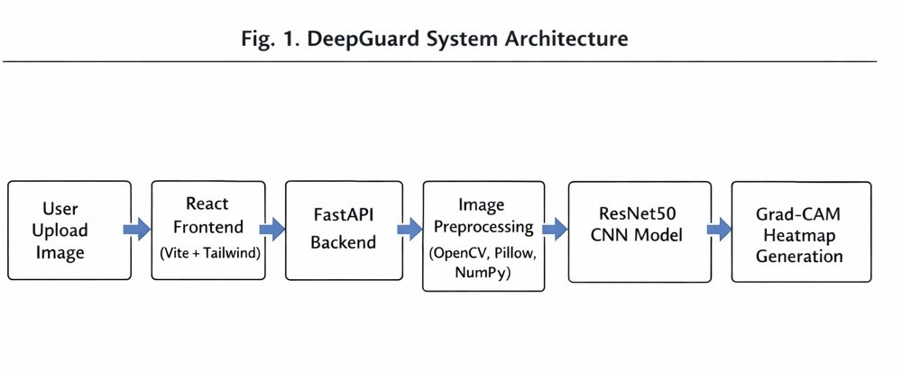
Fig. 1. DeepGuard System Architecture Pipeline

The workflow can be summarized as follows:
- User uploads an image via the web interface.
- The frontend sends the image to the backend API.
- The backend performs preprocessing and passes the image to the CNN model.
- The model predicts whether the image is real or AI- generated.
- Grad-CAM generates an explanatory heatmap.
- The prediction result and visualization are returned to the user.
- Dataset Acquisition
The performance of deep learning models strongly depends on the quality and diversity of the training dataset. For this

research, multiple datasets were used to train and evaluate the proposed system.
The datasets used in this study include both real images and AI-generated images collected from publicly available sources.

TABLE I
Dataset Sources Used for Training
Dataset | Type | Description
CIFAKE | Real / Fake | Dataset containing real and GAN  generated images
ArtiFact | Synthetic | Benchmark dataset for AI-  generated image detection
Custom Dataset | Synthetic | Images generated using diffusion  models

vanishing gradient problem, which often occurs when training very deep neural networks.
The residual learning concept allows the network to learn the residual mapping instead of directly learning the desired underlying mapping.
The residual learning function can be expressed as:

y = F (x, {W_{i}}) + x (1)

The custom dataset was generated using diffusion-based models such as Stable Diffusion in order to include modern AI-generated images within the training set.
By combining multiple datasets, the model is exposed to diverse image patterns and generation artifacts, which im- proves its ability to generalize across different synthetic image sources.
- Data Preprocessing
Before training the deep learning model, the dataset must undergo several preprocessing steps to ensure consistency and improve model performance.
The preprocessing pipeline includes the following steps:
  - Image Resizing: All images are resized to a fixed resolu- tion of 224 × 224 pixels to match the input requirements of the ResNet50 architecture.
  - Normalization: Pixel values are normalized to a range between 0 and 1 in order to stabilize training and improve convergence.
  - Data Augmentation: Various augmentation techniques are applied to increase dataset diversity and reduce over- fitting.
The augmentation techniques used in this study include:
  - Random rotation
  - Horizontal flipping
  - Zoom transformations
  - Random brightness adjustments
where:
  - x represents the input feature map
  - F (x, {W_{i}}) represents the residual mapping learned by the network
  - y represents the output feature map
This architecture enables deeper networks to be trained more effectively and improves classification accuracy.
In this research, transfer learning was applied by initializing the ResNet50 model with pretrained weights obtained from the ImageNet dataset. The final classification layer was modified to perform binary classification between real images and AI- generated images.
- Explainability Layer (Grad-CAM)
While deep learning models can achieve high classification accuracy, they often function as black-box systems, making it difficult to understand how predictions are generated. To address this issue, the DeepGuard framework integrates Grad- CAM as an explainable artificial intelligence technique.
Grad-CAM (Gradient-weighted Class Activation Mapping) is used to visualize the regions of an image that contribute most strongly to the model’s prediction. The technique works by computing the gradients of the predicted class with respect to the feature maps of the final convolutional layer.
These gradients are used to calculate importance weights that indicate the contribution of each feature map to the classification result. A weighted combination of these feature maps produces a heatmap that highlights important image regions.
The Grad-CAM heatmap can be expressed mathematically as:

These augmentation methods allow the model to learn invariant features and improve its robustness to variations in input images.
- Model Selection

where:
k

LGrad−CAM

= ReLU
Σk
αc Ak!
(2)

The core component of the DeepGuard framework is the convolutional neural network responsible for image classifica- tion. Among various deep learning architectures, the ResNet50 model was selected due to its strong performance in computer vision tasks and its ability to train deep networks efficiently.
ResNet50 is a deep residual network consisting of 50 lay- ers. Unlike traditional CNN architectures, ResNet introduces residual connections that allow information to bypass certain layers during training. These skip connections help address the
  - A^{k} represents the feature maps of the final convolutional layer
  - α^{c} represents the importance weight for feature map k
k
  - ReLU ensures that only positive contributions are con- sidered
The resulting heatmap is superimposed on the original im- age to visually indicate which regions influenced the model’s classification decision.
An example Grad-CAM visualization is shown in Fig. 2.

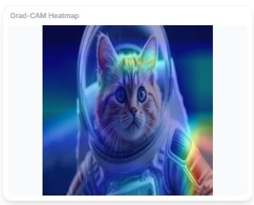
Fig. 2. Grad-CAM Heatmap Visualization

By providing visual explanations alongside predictions, the DeepGuard system improves transparency and helps users understand the reasoning behind model decisions.
- Model Training Process
The training process of the DeepGuard framework involves several stages including dataset preparation, feature extraction, model training, validation, and performance evaluation. The objective of the training phase is to enable the convolutional neural network to learn discriminative visual patterns that differentiate real images from AI-generated images.
To achieve reliable performance, the model training pipeline incorporates preprocessing, data augmentation, transfer learn- ing, and hyperparameter optimization. These steps ensure that the model generalizes well across diverse image sources and avoids overfitting during training.
- Training Pipeline
The training pipeline follows a structured sequence of steps that transform raw image data into trained model predictions. The pipeline begins with loading and organizing the dataset into training and validation sets. Data augmentation techniques are then applied to increase dataset diversity and improve the robustness of the model.
Once preprocessing is completed, the images are passed to the convolutional neural network for feature extraction. The pretrained ResNet50 architecture is used as the backbone model to extract hierarchical image features. These features are then fed into a fully connected classification layer that performs binary classification between real images and AI- generated images.
The training pipeline consists of the following steps:
  - Dataset loading and organization
  - Image preprocessing and normalization
  - Data augmentation
  - Feature extraction using pretrained ResNet50
  - Fine-tuning the classification layer
  - Validation and performance monitoring
- Training Strategy
Transfer learning is used to improve the efficiency and accuracy of the model training process. Instead of training the convolutional neural network from scratch, the ResNet50 model is initialized using pretrained weights obtained from the ImageNet dataset.
The early layers of the network are responsible for extract- ing general image features such as edges, textures, and shapes. These layers are kept frozen during the initial training phase to preserve the learned representations. The final layers of the network are then fine-tuned using the AI-generated image dataset.
This strategy significantly reduces training time while main- taining strong classification performance.
- Hyperparameter Configuration
The performance of a deep learning model is strongly influenced by the choice of hyperparameters. In this study, several training parameters were carefully selected to balance training efficiency and model accuracy.
Table II presents the hyperparameter configuration used during model training.

TABLE II
Training Hyperparameters

Parameter | Value
Learning Rate | 0.0001
Batch Size | 32
Epochs | 15–20
Optimizer | Adam
Loss Function | Binary Cross Entropy

These hyperparameters were selected based on empirical ex- periments and commonly used configurations in deep learning- based image classification tasks.
- Training Workflow
The complete workflow for training the DeepGuard model is illustrated in Fig. 3. The process begins with dataset preparation and preprocessing, followed by CNN training and validation. Finally, the trained model is evaluated using standard performance metrics.
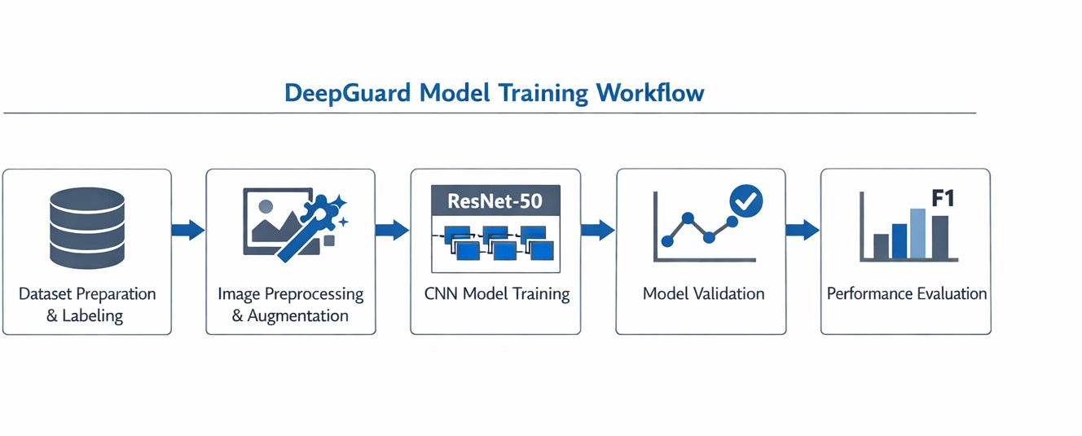
Fig. 3. DeepGuard Model Training Workflow

The training workflow can be summarized as follows:

  - Dataset preparation and labeling
  - Image preprocessing and augmentation
  - CNN model training
  - Model validation
  - Performance evaluation
- Training Graphs
During the training process, several performance metrics are monitored to evaluate the learning progress of the model. Two important indicators are the training accuracy and training loss measured across multiple epochs.
  - Accuracy vs Epoch: The training accuracy indicates how
well the model is able to correctly classify images during the learning process. As training progresses, the accuracy is expected to improve as the model learns meaningful features.

0.9
Accuracy

0.8

0.7

0.6
2 4 6 8 10
Epoch

Fig. 4. Training Accuracy vs Epoch
  - Loss vs Epoch: The training loss represents the differ- ence between the predicted outputs and the true labels. A decreasing loss value across epochs indicates that the model is successfully learning from the training data.

0.8

0.6
Loss

0.4
to enable real-time detection of AI-generated images. The architecture follows a client–server model where the frontend interface communicates with a backend API that performs model inference and generates explainability visualizations.
The implementation was designed to ensure scalability, responsiveness, and ease of deployment. Modern web devel- opment frameworks and deep learning libraries were used to build a complete end-to-end pipeline capable of processing user-uploaded images and returning detection results along with visual explanations.
- Development Environment
The DeepGuard system was implemented using a com- bination of modern machine learning and web development technologies. The development environment was carefully selected to ensure compatibility, performance, and flexibility. The deep learning model was developed using the Python programming language and the TensorFlow framework, which provides efficient tools for training and deploying neural networks. The backend server was built using FastAPI, a high- performance web framework that supports asynchronous API
communication.
The frontend user interface was implemented using React with the Vite build tool, which allows rapid development and optimized production builds. Tailwind CSS was used for styling the interface to create a modern and responsive design.
The main technologies used in the implementation are summarized in Table III.

TABLE III
Development Environment
Component | Technology Used
Programming Language | Python 3.11
Deep Learning Framework | TensorFlow 2.16
Backend Framework | FastAPI
Frontend Framework | React (Vite)
Styling Framework | Tailwind CSS
Model Architecture | ResNet50
Explainability Method | Grad-CAM

0.2

2 4 6 8 10
Epoch

Fig. 5. Training Loss vs Epoch

The integration of these technologies allows the system to provide real-time image analysis with a responsive user interface.
- Backend API

The graphs in Fig. 4 and Fig. 5 demonstrate that the model gradually improves its performance as training progresses. The increasing accuracy and decreasing loss indicate that the network successfully learns meaningful features for distin- guishing between real and AI-generated images.
- Implementation Details
This section describes the technical implementation of the DeepGuard framework. The system integrates deep learning- based image classification with a web-based user interface
The backend component of DeepGuard is responsible for handling image processing requests and performing deep learning inference. FastAPI was selected as the backend frame- work due to its asynchronous processing capabilities and high performance.
When a user uploads an image through the web interface, the image is sent to the FastAPI server through a REST API endpoint. The server performs the following operations:
- Receive the uploaded image file

- Perform image preprocessing (resizing and normaliza- tion)
- Load the trained ResNet50 model
- Run model inference to classify the image
- Generate Grad-CAM visualization
- Return prediction results to the frontend
The asynchronous processing capability of FastAPI ensures that multiple user requests can be handled efficiently without blocking the server. This allows the system to scale to multiple concurrent users.
- Web Application Workflow
The DeepGuard web application provides an intuitive inter- face that allows users to upload images and obtain authenticity analysis results. The workflow of the web application is illustrated in Fig. 6.
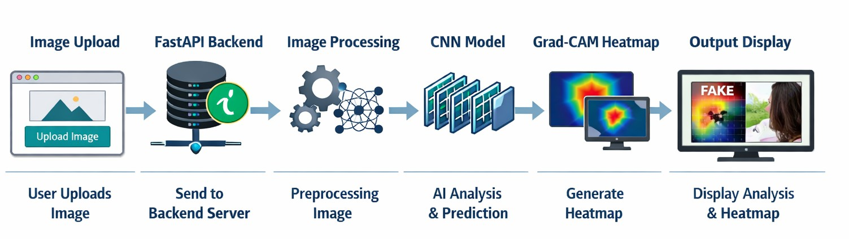
Fig. 6. DeepGuard Web Application Workflow

The workflow of the system consists of the following stages:
  - The user uploads an image through the web interface.
  - The image is sent to the FastAPI backend server.
  - The backend preprocesses the image and feeds it to the CNN model.
  - The model predicts whether the image is real or AI- generated.
  - Grad-CAM generates a heatmap highlighting important regions.
  - The results and visualization are returned to the frontend.
  - The frontend displays the classification result and heatmap to the user.
This workflow allows users to easily interact with the AI detection system without requiring technical expertise in machine learning or image forensics.
- User Interface Design
The frontend of DeepGuard was designed with usability and clarity in mind. React was used to build modular components that handle image uploads, result visualization, and status updates. Tailwind CSS was used to create a responsive layout that adapts to different screen sizes.
The main interface includes the following components:
- Image Upload Panel
- Prediction Result Display
- Grad-CAM Visualization Panel
- Model Confidence Indicator
- Processing Status Indicator
The interface ensures that users can easily understand the model predictions and interpret the explainability heatmaps generated by the Grad-CAM algorithm.
- System Deployment
To ensure accessibility and scalability, the DeepGuard sys- tem can be deployed on cloud-based infrastructure or local servers. The backend FastAPI service can be containerized using Docker and hosted on cloud platforms such as AWS, Google Cloud, or Microsoft Azure.
The frontend React application can be deployed as a static web application using platforms such as Vercel or Netlify. This architecture enables seamless integration between the frontend interface and backend inference server.
The modular design of the system allows future integration with additional detection models, video deepfake analysis tools, and large-scale forensic analysis systems.
- Results and Discussion
This section presents the experimental results obtained from the DeepGuard framework and analyzes the performance of the proposed AI-generated image detection system. The evaluation focuses on classification accuracy, precision, recall, and F1-score, along with confusion matrix analysis and visual interpretation using Grad-CAM.
The experiments were conducted using the CIFAKE dataset, the ArtiFact dataset, and a custom dataset of AI-generated im- ages produced using diffusion models. The trained ResNet50 model was evaluated on a validation dataset containing both real and synthetic images.
- Performance Metrics
To evaluate the effectiveness of the DeepGuard system, several widely used classification metrics were calculated. These metrics provide a comprehensive assessment of the model’s predictive capability.
  - Accuracy: Measures the overall percentage of correctly classified images.
  - Precision: Indicates the proportion of predicted AI- generated images that are actually AI-generated.
  - Recall: Measures the ability of the model to correctly identify AI-generated images.
  - F1 Score: The harmonic mean of precision and recall, providing a balanced evaluation of the model perfor- mance.
Table IV summarizes the performance of the DeepGuard model on the validation dataset.
The results demonstrate that the proposed DeepGuard sys- tem achieves high classification performance in distinguishing between real and AI-generated images.
- Confusion Matrix Analysis
To further analyze the classification behavior of the model, a confusion matrix was generated. The confusion matrix illustrates how predictions are distributed among the different classes.
The confusion matrix provides four key outcomes:
  - True Positives (TP) – AI-generated images correctly classified as AI-generated.

TABLE IV
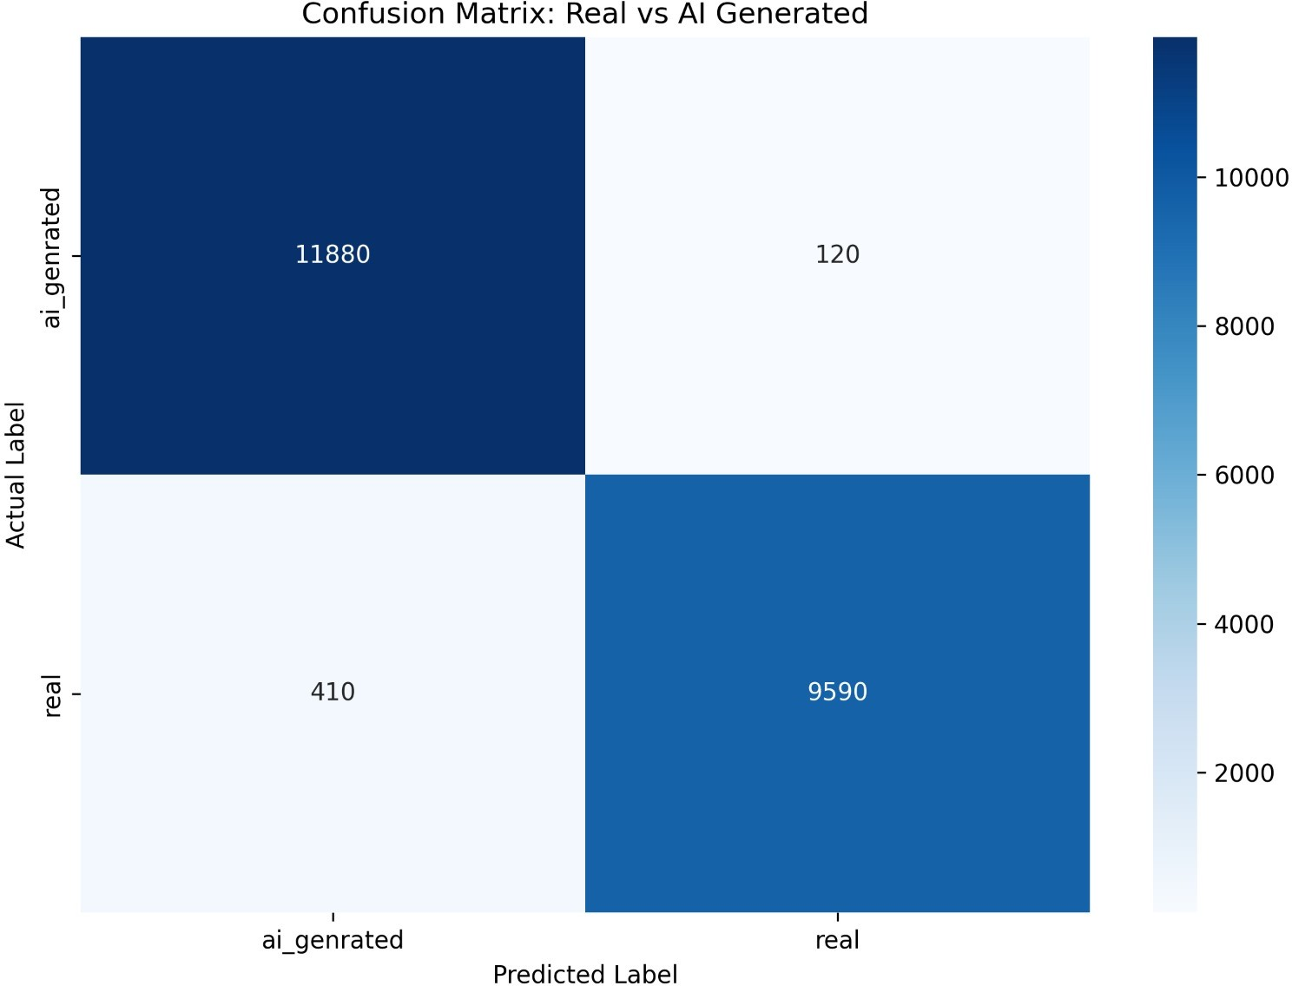
Performance Metrics of DeepGuard

Metric | Value
Accuracy | 98%
Precision For AI Images | 97%
Precision For Real Images | 99%
Recall For AI Images | 99%
Recall For Real Images | 96%
F1 Score For AI Images | 98%
F1 Score For Real Images | 97%

Fig. 7. Confusion Matrix for DeepGuard Model

  - True Negatives (TN) – Real images correctly classified as real.
  - False Positives (FP) – Real images incorrectly classified as AI-generated.
  - False Negatives (FN) – AI-generated images incorrectly classified as real.
Analysis of the confusion matrix indicates that the model successfully identifies the majority of AI-generated images with minimal false positives and false negatives. This demon- strates the robustness of the ResNet50 architecture for image authenticity detection tasks.
- Grad-CAM Visual Analysis
To improve interpretability, the DeepGuard system inte- grates Gradient-weighted Class Activation Mapping (Grad- CAM) to visualize the regions of the image that influence the model’s prediction.
Grad-CAM generates a heatmap that highlights the areas of the image that contribute most strongly to the classification decision.
For real images, the Grad-CAM heatmaps generally high- light natural structural features such as edges, textures, and

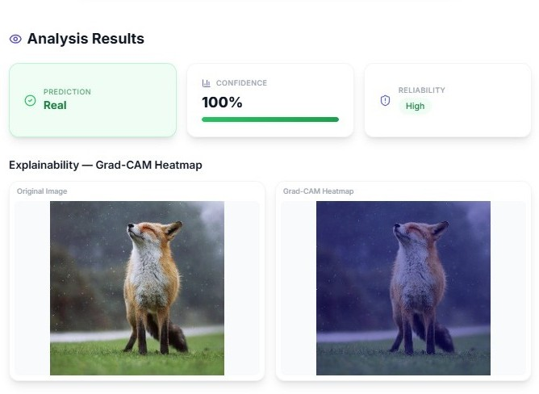
Fig. 8. Grad-CAM Visualization for a Real Image
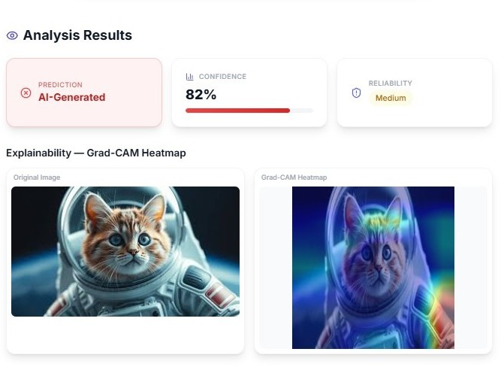
Fig. 9. Grad-CAM Visualization for an AI-generated Image

lighting patterns. In contrast, AI-generated images often ex- hibit attention on synthetic artifacts such as unnatural textures, inconsistent shadows, or diffusion artifacts.
This visual explanation enhances transparency and allows users to better understand the model’s decision-making pro- cess.
- Comparative Analysis
To evaluate the effectiveness of the DeepGuard framework, the performance of the proposed ResNet50-based model was compared with several commonly used convolutional neural network architectures.
Table V presents the comparative results.

TABLE V
Comparison with Other CNN Models

Model | Accuracy
VGG16 | 89.2%
InceptionV3 | 91.0%
EfficientNet-B0 | 92.4%
DeepGuard (ResNet50 + Grad-CAM) | 98%

The results indicate that the DeepGuard framework achieves higher accuracy compared to standard CNN architectures. Ad- ditionally, the integration of Grad-CAM provides explainabil-

ity, which is not typically included in traditional classification models.
- Discussion
The experimental results confirm that deep learning models can effectively detect AI-generated images when trained on diverse datasets containing both real and synthetic samples.
The use of the ResNet50 architecture enables the model to learn deep hierarchical features, which improves classification accuracy. Furthermore, the integration of Grad-CAM provides visual explanations that enhance transparency and user trust in the system.
Despite the strong performance, certain limitations were observed. The model may struggle with heavily compressed images or extremely low-resolution inputs, where subtle arti- facts become difficult to detect.
Future improvements may include incorporating transformer-based architectures, expanding the dataset with additional generative models, and extending the system to detect AI-generated videos and deepfakes.
- Conclusion and Future Work
The rapid advancement of generative artificial intelligence has made it increasingly difficult to distinguish between au- thentic images and synthetically generated content. Modern generative models such as Generative Adversarial Networks (GANs) and diffusion-based models are capable of produc- ing highly realistic images that can potentially be misused for misinformation, identity manipulation, and digital fraud. As a result, reliable image authenticity verification systems have become an essential component of digital forensics and cybersecurity.
In this research, we proposed DeepGuard, an explainable deep learning framework designed to detect AI-generated images and provide interpretable visual explanations for its predictions. The system integrates a convolutional neural net- work based on the ResNet50 architecture with the Grad-CAM explainability technique to highlight the regions of an image that contribute most strongly to the classification decision.
- Summary of Contributions
The primary objective of this work was to design and implement an intelligent image forensics system capable of detecting synthetic images generated by modern generative models. The DeepGuard framework combines deep learning- based classification with explainable artificial intelligence techniques to improve both performance and interpretability.
The major contributions of this research can be summarized as follows:
  - A deep learning-based image authenticity detection sys- tem was developed using the ResNet50 convolutional neural network architecture.
  - A comprehensive dataset consisting of real images and AI-generated images was constructed using the CIFAKE dataset, the ArtiFact dataset, and custom-generated syn- thetic images.
  - Transfer learning techniques were applied to leverage pretrained ImageNet weights, enabling efficient training and improved classification performance.
  - Grad-CAM was integrated into the system to generate heatmap visualizations that explain the model’s prediction process.
  - A complete web-based application was implemented us- ing React and FastAPI to allow real-time user interaction with the detection system.
Experimental results demonstrated that the DeepGuard sys- tem achieved strong classification performance with high ac- curacy, precision, recall, and F1-score values. In addition to accurate classification, the Grad-CAM visualizations provided meaningful insights into the features that the neural network relied upon during prediction.
- Limitations
Although the proposed DeepGuard framework demonstrated promising results, several limitations were identified during experimentation.
One of the primary limitations involves the model’s sensitiv- ity to image quality degradation. Highly compressed images or images with very low resolution may lose important forensic artifacts that the neural network relies upon for classification. In such cases, the detection accuracy may decrease.
Another limitation arises from the continuously evolving nature of generative AI models. As generative models improve, they may produce images with fewer detectable artifacts, making it increasingly challenging for detection systems to maintain high accuracy.
Furthermore, the current implementation focuses exclu- sively on static image analysis. The system does not yet support video-based deepfake detection, which is an important area of research in multimedia forensics.
- Future Work
Future research can expand the DeepGuard framework in several directions to improve its robustness, scalability, and applicability to real-world scenarios.
One potential direction is the extension of the system to support video deepfake detection. Modern misinformation campaigns frequently involve manipulated videos rather than static images. Integrating temporal analysis models and frame- level detection methods would enable DeepGuard to analyze video content more effectively.
Another promising direction involves the adoption of transformer-based architectures. Vision Transformers (ViTs) and hybrid CNN-transformer models have recently demonstrated strong performance in image classification tasks. Incorporating transformer-based models may further improve the detection capability of the system.
Future work may also focus on improving adversarial robustness. Attackers may attempt to manipulate images using adversarial perturbations designed to fool detection models. Developing robust training strategies and adversarial defense mechanisms could help mitigate such threats.

In addition, the dataset used for training can be expanded to include images generated by a wider range of generative models such as diffusion-based generators, style transfer sys- tems, and text-to-image models. Increasing dataset diversity will allow the model to generalize more effectively to unseen synthetic image types.
Finally, future versions of DeepGuard could incorporate advanced explainability techniques such as SHAP or integrated gradients to provide more comprehensive explanations of model predictions.
Overall, the proposed DeepGuard framework represents a significant step toward building transparent and reliable AI-generated image detection systems. With continued im- provements in model architecture, dataset diversity, and ex- plainability techniques, such systems will play a critical role in maintaining digital trust in an era of rapidly advancing generative AI technologies.
References
- K. He, X. Zhang, S. Ren, and J. Sun, “Deep Residual Learning for Image Recognition,” in Proceedings of the IEEE Conference on Computer Vision and Pattern Recognition (CVPR), 2016.
- R. R. Selvaraju et al., “Grad-CAM: Visual Explanations from Deep Networks via Gradient-Based Localization,” in International Journal of Computer Vision, vol. 128, no. 2, pp. 336–359, 2020.
- I. Goodfellow et al., “Generative Adversarial Networks,” in Communi- cations of the ACM, vol. 63, no. 11, pp. 139–144, 2020.
- Y. Li and S. Lyu, “Exposing DeepFake Videos by Detecting Face Warping Artifacts,” in IEEE Conference on Computer Vision and Pattern Recognition Workshops, 2020.
- M. Tan and Q. Le, “EfficientNet: Rethinking Model Scaling for Con- volutional Neural Networks,” in International Conference on Machine Learning (ICML), 2019.
- A. Adadi and M. Berrada, “Peeking Inside the Black-Box: A Survey on Explainable Artificial Intelligence (XAI),” in IEEE Access, vol. 8, pp. 52138–52160, 2020.
- H. Dang, F. Liu, J. Stehouwer, X. Liu, and A. Jain, “On the Detection of Digital Face Manipulation,” in IEEE Conference on Computer Vision and Pattern Recognition (CVPR), 2020.
- S. Hulzebosch, S. Ibrahimi, and M. Worring, “Detecting CNN-Generated Facial Images in Real-World Scenarios,” in IEEE/CVF Conference on Computer Vision and Pattern Recognition Workshops, 2020.
- T. Tolosana et al., “DeepFakes and Beyond: A Survey of Face Manipu- lation and Fake Detection,” in Information Fusion, vol. 64, pp. 131–148, 2021.
- A. Dosovitskiy et al., “An Image is Worth 16x16 Words: Transformers for Image Recognition at Scale,” in International Conference on Learn- ing Representations (ICLR), 2021.
- Z. Wang et al., “CNN-Based DeepFake Detection Using Visual Arti- facts,” in IEEE Access, vol. 10, pp. 102–115, 2022.
- M. Corvi et al., “Detection of GAN-Generated Images Using Frequency Analysis,” in IEEE International Conference on Multimedia and Expo, 2022.
- S. Bird and L. Lotfi, “CIFAKE: Image Classification and Explainable Detection of AI-Generated Images,” in IEEE Access, vol. 11, pp. 10245–10260, 2023.
- R. Rombach et al., “High-Resolution Image Synthesis with Latent Diffusion Models,” in IEEE/CVF Conference on Computer Vision and Pattern Recognition, 2022.
- D. Holz, “Advancements in Text-to-Image Diffusion Models,” in Pro- ceedings of the IEEE Conference on Artificial Intelligence, 2023.
- S. Lundberg and S. Lee, “A Unified Approach to Interpreting Model Predictions,” in Advances in Neural Information Processing Systems, 2020.
- J. Chen et al., “Deep Learning for Digital Image Forensics: A Survey,” in IEEE Transactions on Information Forensics and Security, 2024.
- H. Nguyen et al., “DeepFake Detection Using Hybrid CNN–Transformer Architecture,” in IEEE Access, 2024.
- L. Zhang et al., “Detection of AI-Generated Images Using Multi-Scale Feature Analysis,” in IEEE Transactions on Multimedia, 2025.
- A. Kumar et al., “Advances in AI-Generated Image Detection and Forensics,” in IEEE Access, 2026.

Appendix A
Web Application Interface
To demonstrate the practical applicability of the DeepGuard system, a web-based interface was developed that allows users to upload images and instantly verify their authenticity. The web application serves as a user-friendly front-end that communicates with the backend deep learning model through a REST API.
The frontend of the system was developed using React with the Vite framework for efficient development and deployment. Tailwind CSS was used for styling and responsive design. The backend API was implemented using FastAPI, which provides high-performance asynchronous processing for handling image uploads and model inference.
The workflow of the web application is illustrated as fol- lows:
  - The user uploads an image through the web interface.
  - The uploaded image is sent to the FastAPI backend server through an HTTP request.
  - The backend performs preprocessing steps such as re- sizing, normalization, and tensor conversion.
  - The processed image is passed to the trained ResNet50 model for classification.
  - Grad-CAM is applied to generate a visual explanation of the prediction.
  - The classification result along with the Grad-CAM heatmap is returned to the frontend and displayed to the user.

Fig. 10. DeepGuard Web Application Interface

The interface enables users to easily upload images and visualize both the classification result and the explanation heatmap. This approach improves transparency and usability for non-technical users.
Appendix B Example Detection Results
To evaluate the real-world usability of the DeepGuard system, several test images were processed through the web

application. The model was able to successfully classify both authentic images and AI-generated images.
Examples of detection results are shown in Fig. 11 and Fig. 12.
These visual explanations provide valuable insights into the model’s decision-making process and help increase user trust in the system.

Fig. 11. Example Detection Result for a Real Image

Fig. 12. Example Detection Result for an AI-generated Image

The results demonstrate that the DeepGuard framework is capable of identifying subtle visual artifacts that are typically present in AI-generated images.

Appendix C
Grad-CAM Visualization Examples
To improve interpretability, Grad-CAM was used to gen- erate heatmap visualizations that highlight the regions of the image that contribute most strongly to the model’s classifica- tion decision.
Grad-CAM works by computing gradients of the target class with respect to the feature maps of the final convolutional layer. These gradients are used to weight the feature maps, producing a coarse localization map that highlights important regions in the image.
In AI-generated images, the Grad-CAM heatmaps often focus on regions containing synthetic artifacts such as irregular textures, inconsistent lighting, or unnatural structural patterns. In contrast, real images typically exhibit more uniform atten- tion across natural edges and textures.

