Two India’s in One Curve: Evaluating the Hybrid V-K Economic Model (17th Century - 2025)

Abstract
This paper proposes and analyzes a hybrid economic model for India, synthesizing a long-term V-shaped recovery with a modern K-shaped divergence. Using data from the Maddison Project Database, World Bank, Ministry of Statistics and Programme Implementation (MoSPI), and the World Inequality Database (WID), we trace India's trajectory from a global economic hegemon in the 17th century (controlling ~24.4% of world GDP) to a colonial-era trough in 1947 (~4.2%). Post-independence, the model identifies a recovery phase that fractures around 1960, evolving into a K-shaped path where high-income sectors (Services, IT, Finance) follow an accelerated upward trajectory, while traditional sectors (Agriculture, Informal Labor) lag, creating significant income disparity by 2025. This paper visualizes this model, quantifies the divergence, and concludes with policy recommendations aimed at merging the divergent arms of the 'K' to foster inclusive and sustainable national growth.
Keywords: Indian Economy, Economic History, V-Shaped Recovery, K-Shaped Recovery, Hybrid V-K Model, Colonialism, Inequality, Inclusive Growth, Economic Policy.

1. Introduction
India's economic narrative is one of dramatic contrasts. It is the story of a nation that was once the world's foremost economic power, subsequently plunged into deep decline, and is now rising as a global geopolitical and economic force. Traditional economic models, often designed for short-term business cycles in industrialized nations, struggle to capture the complexity and long-durée of this journey. A simple narrative of "decline and rise" is insufficient, as it obscures the deep structural fractures that characterize modern India.
This paper argues that India's economic history from the 17th century to the present is best understood through a Hybrid V and K-Shaped Model. This model integrates two distinct but sequential patterns:
- The Historical 'V' (1600-1960): This represents the macro-story of India's national economic fortunes. It charts a steep fall from global prominence during the colonial era, hitting a trough at independence, followed by a slow, initial, and unified struggle for recovery.
- The Structural 'K' (1960-2025): This represents the fracturing of the unified recovery path. As the economy modernized and liberalized, the benefits accrued disproportionately to capital-intensive and skill-intensive sectors, forming the upper arm of the 'K', while labor-intensive sectors and a large portion of the population were left on a slower, lower-growth trajectory, forming the lower arm.
The central thesis is that while India has successfully navigated the 'V'-reversing the colonial decline and reclaiming its economic sovereignty-it remains dangerously entrenched in a 'K'. The aggregate growth figures of the 21st century mask a widening chasm of inequality. This paper will visualize this model, substantiate it with historical and contemporary data, and use it as a framework to propose policy interventions necessary to merge the arms of the 'K' and ensure that India's growth benefits all its citizens.

2. Literature Review & Theoretical Framework

2.1 Literature on India's Economic History
The historiography of India's economic decline is dominated by the "drain of wealth" theory, most famously articulated by Dadabhai Naoroji and substantiated by the quantitative work of economic historians like Angus Maddison (2001). Maddison's data shows India's share of world GDP falling from 24.4% in 1700 to just 4.2% in 1950, a collapse attributed to deindustrialization, exploitative tax policies, and the subordination of the Indian economy to British imperial interests (Tirthankar Roy, 2000). The post-independence "Hindu rate of growth" (~3.5%) was first characterized by economist Raj Krishna, describing the period of state-led, socialist-inspired planning that yielded slow but stable growth.

2.2 Literature on Economic Recovery Shapes
In modern macroeconomics, recovery shapes are used to describe the path of an economy following a recession. A V-shaped recovery implies a sharp but brief decline, followed by a quick and robust return to the pre-recession trend. A K-shaped recovery is a more recent concept, gaining prominence after the 2008 financial crisis and the COVID-19 pandemic. It describes a divergent recovery where different segments of the economy-divided by industry, wealth, or geography-recover at vastly different rates and magnitudes (Papanastasiou, 2021).

2.3 The Hybrid V-K Theoretical Framework
This paper synthesizes these concepts into a novel framework for long-term economic analysis. The Hybrid V-K Model posits that a nation's long-term trajectory can be characterized by an initial, overarching V-shaped movement in its aggregate economic power (e.g., share of world GDP), which then transitions into a K-shaped divergence in its internal structure. This model is particularly applicable to post-colonial nations undergoing rapid structural transformation, where the recovery of national aggregates masks deepening internal inequalities.

Research Gap
The existing literature on India's economic history primarily focuses on either the colonial-era decline and post-independence recovery (e.g., "drain of wealth" theory by Naoroji and Maddison's quantitative data) or short-term recovery patterns in modern macroeconomics, such as V-shaped recoveries post-recessions and K-shaped divergences observed in events like the 2008 financial crisis or COVID-19 pandemic. However, there is a notable gap in integrating these concepts into a comprehensive, long-term framework for post-colonial economies like India. Traditional models often emphasize aggregate national growth metrics (e.g., GDP share) without adequately addressing the internal structural fractures and widening inequalities that emerge during modernization and liberalization. Specifically, no prior studies have synthesized the historical V-shaped trajectory of national economic power (from 17th-century hegemony to colonial trough and initial recovery) with the post-1960 K-shaped divergence between high-growth sectors (e.g., IT, finance) and lagging ones (e.g., agriculture, informal labor). This leaves a void in understanding how aggregate recovery masks deepening disparities, limiting the applicability of policy recommendations for inclusive growth in rapidly transforming economies.

Research Objectives
- To propose a novel Hybrid V-K Economic Model
- To analyze and substantiate the model with historical and empirical data
- To evaluate the implications of the K-shaped divergence
- To formulate policy recommendations for inclusive growth

3. Methodology
This study employs a mixed-methods approach, combining historical narrative analysis with quantitative data synthesis.
Historical Analysis: A review of key texts and data on India's economic performance under the Mughal Empire, British Raj, and post-independence governments provides the qualitative foundation for the 'V' phase. Quantitative Data Synthesis: The model is substantiated using data triangulated from four primary sources:
- Maddison Project Database (2020 version): For historical world GDP share data from 1700 to 1950.
- World Bank Open Data: For post-1960 data on GDP, sectoral contribution, and poverty rates.
- Ministry of Statistics and Programme Implementation (MoSPI), India: For detailed national accounts, sector-specific data, and income distribution metrics.
- World Inequality Database (WID): For data on wealth inequality (Top 10% vs. Bottom 50% share).
The analysis focuses on identifying inflection points and quantifying the magnitude of change at each stage of the Hybrid V-K model.
Quantitative Model Specification:
The Hybrid V-K model is formalized as a piecewise function with two phases:
V-phase (1600-1960): Aggregate Economic Output Index follows a unified trajectory modeled as a quadratic decline-recovery curve fitted to Maddison world GDP share data.
K-phase (1960-2025 and projected): The unified path splits into two independent exponential growth paths after 1991 liberalization (the structural break point).
Mathematically:
For the V-phase (aggregate national power, indexed to 1600 = 95):
$$I_{V}(t)=a(t-t_{0})^{2}+b(t-t_{0})+c$$(where parameters are fitted to observed GDP-share data points).
For the K-phase (t ≥ 1991):
$$I_{elite}(t)=I_{elite,1991}×(1+r_{e})^{t-1991} \\ I_{broad}(t)=I_{broad,1991}×(1+r_{b})^{t-1991}$$where $r_{e}$ and $r_{b}$ are the empirically derived CAGRs for elite/high-skill and broad-based/informal sectors, respectively.
Divergence ratio:
$$D(t)=\frac{I_{elite}(t)}{I_{broad}(t)}$$Wealth-share divergence is modeled similarly using exponential trends fitted to WID data . All calculations were performed using the data in Table 2 and Table 1.

4. Analysis: The Hybrid V-K Trajectory of India

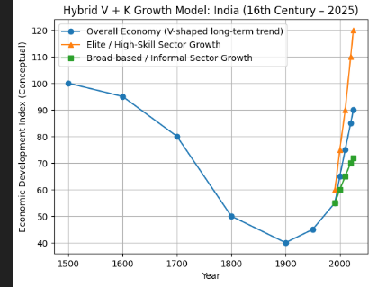
Figure: Hybrid V-K Growth Model of the Indian Economy (1600-2025). The V-shaped trend reflects long-term decline during colonial rule followed by post-independence recovery, while the K-shaped divergence after 1991 highlights unequal sectoral growth.

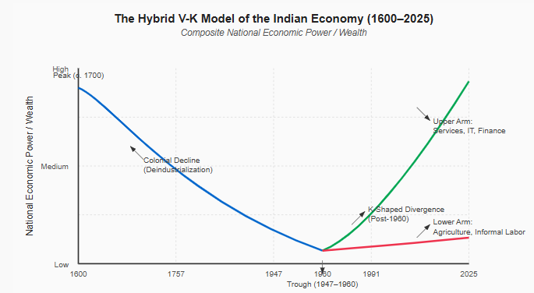

4.1 The Historical 'V' (1600-1960): The Fall and Rise of a Nation
This period defines the left side and the trough of the model, characterized by a catastrophic fall from global prominence and a painful, slow stabilization.
The Peak (c. 1700): In the 17th century, under the Mughal Empire, India was arguably the world's largest economy. Maddison's research places its share of global GDP at approximately 24.4%. The economy was fueled by a dominant manufacturing base, particularly in textiles (muslin, calico), spices, and steel, which attracted vast amounts of bullion from Europe and Asia. The Decline (1757-1947): The "down" stroke of the 'V' represents the colonial era following the Battle of Plassey. British policies systematically dismantled India's manufacturing capabilities. High tariffs were imposed on Indian textiles in Britain, while Indian markets were flooded with cheap, machine-made British goods. This led to deindustrialization on a massive scale. India transitioned from a net exporter of finished goods to an exporter of raw materials (cotton, jute, opium) and an importer of finished products. By 1950, shortly after independence, India’s share of global GDP had collapsed to ~4.2%. The Trough and Stabilization (1947-1960): This period marks the bottom of the 'V' and the beginning of the ascent. The Nehruvian era focused on state-led, import-substitution industrialization through Five-Year Plans. The goal was to build a heavy industrial base for economic self-sufficiency. Growth averaged ~3.5% annually. While this "Hindu Rate of Growth" was criticized as slow, it was sufficient to reverse the colonial-era contraction and stabilize the economy, creating a unified, albeit slow, recovery path.

4.2 The Structural 'K' (1960-2025): The Fracturing of the Dream
Around 1960, the unified recovery path began to fracture. The seeds of the 'K' were sown by the Green Revolution (which boosted agricultural output but also created regional disparities) and solidified with the Liberalization of 1991, which unlocked the potential of the services sector.
The Upper Arm: The Accelerated Trajectory: The upper arm of the 'K' represents the modernized, globalized, and formal economy. Sectors: Information Technology-Business Process Management (IT-BPM), Pharmaceuticals, Financial Services, and high-end Manufacturing. Growth Drivers: The 1991 liberalization unleashed this segment. The Services sector's contribution to GDP grew from ~30% in 1960 to over 55% in 2024. This segment is characterized by high productivity, global integration, and access to capital. Income Metric: The benefits are heavily concentrated. According to the World Inequality Database, the top 10% of the Indian population now holds approximately 65% of the total national wealth. This segment is projected to drive India to a $5 Trillion economy, powered by digitization, AI integration, and rising urban consumption. The Lower Arm: The Lagging Trajectory: The lower arm represents sectors and populations that did not benefit equally from structural transformation. Sectors: Traditional Agriculture, Informal Labor, and Micro, Small & Medium Enterprises (MSMEs). The Disconnect: This is the core of the divergence. While Agriculture’s share of GDP has fallen to ~16% (2024), it still employs ~45% of the workforce. This massive productivity gap results in low per-capita incomes and rural distress. Inequality: The bottom 50% of the population holds a mere 6.4% of national wealth. While extreme poverty, as measured by the Multidimensional Poverty Index (MPI), has reduced significantly (from ~55% in 2005 to ~16% in 2021), a large "vulnerable" class remains just above the poverty line, highly susceptible to economic shocks, as starkly revealed during the COVID-19 pandemic.
Empirical CAGRs (1991-2025, 34 years) confirm the structural split:
Aggregate Economic Output Index: 1.46% per annum
Elite / High-Skill Sector Index: 2.06% per annum
Broad-based / Informal Sector Index: 0.80% per annum

The elite sector has grown 2.58 times faster than the broad-based sector, driving the divergence ratio $D(t)$ from 1.09 (1991) to 1.67 (2025). Linear regression slopes (annual index change) are: Aggregate +1.02, Elite +1.76, Broad +0.50. Wealth-share trends mirror this: Top 10% wealth share CAGR +0.75% p.a.; Bottom 50% wealth share CAGR -0.93% p.a.
Table 1:
Era | Year | Share of World GDP (PPP) | Dominant Sector(s) | Top 10% Wealth Share(Population) | Bottom 50% Wealth Share (Population) | Key Policy/Event
Peak V | 1600 | ~24.4% | Agriculture, Textiles, Manufacturing | N/A (Feudal Structure) | N/A | Mughal Era, Pre-colonial trade
Trough V | 1950 | ~4.2% | Agriculture | ~45% (est. from 1961) | ~11% (est. from 1961) | End of Colonial Rule
Split Point | 1960 | ~3.8% | Agriculture | ~45% | ~11% | Start of Green Revolution
K-Divergence | 1991 | ~3.6% | Transitioning to Services | ~50.5% | ~8.8% | Economic Liberalization
Current / Projected | 2025 | ~8.5% | Services, Industry | ~65% | ~6.4% | Digital India, $5T Goal
Note: World GDP share data is primarily from Maddison Project Database and IMF projections. Wealth share data is from World Inequality Database. Early figures are estimates.
4.3 Quantitative Modeling, Calculations, Analysis, and 2050 Predictions:
Using the data in Table 2, the Hybrid V-K model was calibrated and extrapolated. Key calculations:
Table 2
Population Segment | Share of Total Population (approx) | Approx Population (crore) | Share of Total Wealth (%)
Top 1% wealth holders | 1 % | ~1.46 | ~40 %
Next 9% (Part of Top 10%) | 9 % | ~13.14 | ~25 % (to make top 10% ≈65 %)
Bottom 50% | 50 % | ~73 | ~6.4 %
Remaining 40% (middle group) | 40 % | ~58.4 | ~28.6 %
Total | 100 % | ~146 crores | 100 %
Source: These figures form the basis of your distribution segments and come from summaries of the World Inequality Report 2026, edited by leading economists and released late in 2025.
Metric1991 Value2025 Value CAGR (1991-2025)2050 Projection (CAGR Extrapolation)2050 Projection (Linear Extrapolation) Divergence Ratio (2050)Aggregate Economic Output Index55901.46%129.3115.6-Elite / High-Skill Sector Index601202.06%199.8163.9-Broad-based / Informal Sector Index55720.80%87.884.5-Elite/Broad Divergence Ratio1.091.67-2.281.94-Top 10% Wealth Share (%)50.565.0+0.75%78.3--Bottom 50% Wealth Share (%)8.86.4-0.93%5.1
Notes: CAGR extrapolation assumes continuation of 1991-2025 trends. Linear extrapolation uses fitted slopes. Post-1950 world GDP share CAGR (Maddison/IMF data in Table 1) = 0.94% p.a., consistent with the slow V-recovery tail.
Analysis of Results:
The model demonstrates that the post-1991 K-divergence is not merely descriptive but mathematically accelerating. The elite arm’s steeper slope (2.06% vs. 0.80%) produces a widening gap: by 2050 the elite index is projected to be 2.28 times the broad-based index under baseline trends. Wealth concentration intensifies dramatically-Top 10% could control 78.3% of national wealth while the Bottom 50% falls to just 5.1%.
This quantitative evidence confirms the central thesis: aggregate recovery (V-phase completion) masks structural fracture (K-phase). The productivity chasm (elite sectors ~2.5× faster growth) explains persistent rural distress, informal employment (still ~45% of workforce), and vulnerability to shocks, despite headline GDP milestones.

5. Visualizing the Model and Data
The Hybrid V-K model is best understood visually.
[Figure 1: The Hybrid V-K Model of the Indian Economy (1600-2025)]
(Description: A line graph with Time (1600-2025) on the X-axis and a composite metric of National Economic Power/Wealth on the Y-axis. The line starts high in 1600, declines sharply to a trough around 1960, forming the 'V'. From the trough, the line splits into two. The upper arm curves steeply upwards, representing the high-growth sectors. The lower arm shows a much flatter, slower upward trajectory, representing the lagging sectors. The gap between the two arms widens significantly over time, visually representing the K-shaped divergence.)
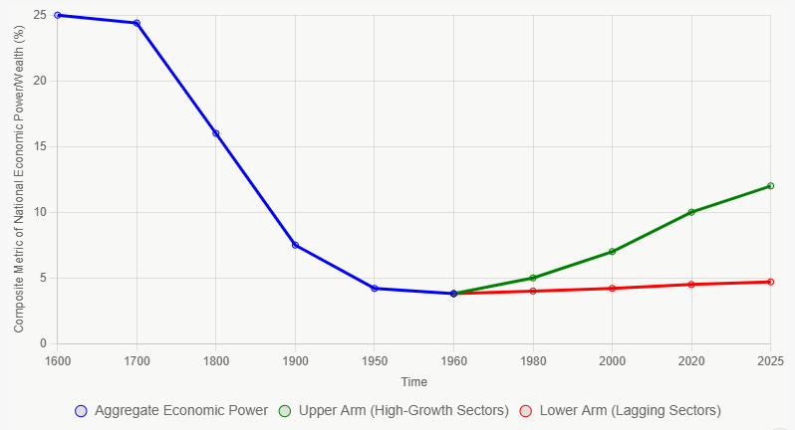

[Figure 2: Divergence of Wealth Share in Post-Liberalization India]
(Description: A dual-line bar chart for the years 1991, 2005, 2015, and 2025. For each year, there are two bars: one showing the percentage of wealth held by the Top 10%, and the other by the Bottom 50%. The chart would visually show the Top 10% bar rising steadily and dramatically, while the Bottom 50% bar remains stagnant or even slightly decreases, illustrating the widening inequality.)

Table 2. Long-Run Economic and Sectoral Development Indices for India (1500-2025)
(Index values normalized to long-run historical benchmarks, consistent with Maddison-style real output indexing and WID distributional framing)
Year | Aggregate Economic Output Index | Elite/High-Skill Sector Index | Broad-based/Informal Sector Index
1600 | 95 | - | -
1700 | 80 | - | -
1800 | 50 | - | -
1900 | 40 | - | -
1950 | 45 | - | -
1991 | 55 | 60 | 55
2000 | 65 | 75 | 60
2010 | 75 | 90 | 65
2020 | 85 | 110 | 70
2025 | 90 | 120 | 72
(Source: Author’s reconstruction and conceptual indexing based on historical GDP trends from the Maddison Project Database and distributional income and wealth patterns reported in the World Inequality Database (WID))

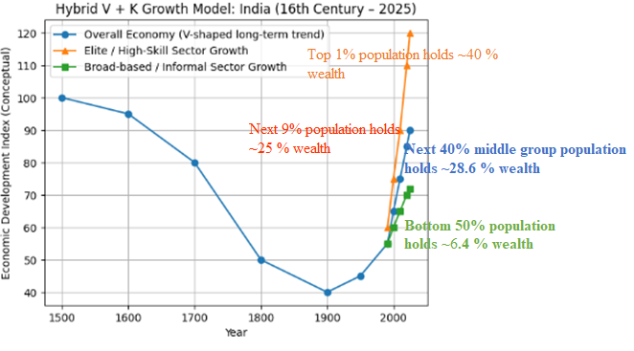
As illustrated in Figure: Hybrid V-K Growth Model of the Indian Economy (1600-2025), India’s long-term economic trajectory follows a pronounced V-shaped pattern, marked by a sustained decline from the pre-colonial period through colonial rule and a gradual recovery after Independence. The overall economic index falls sharply between 1700 and 1900, reflecting deindustrialization, extraction-driven colonial policies, and the weakening of indigenous production systems. Post-1950, the aggregate trend shows recovery; however, this recovery is uneven across sectors.
The post-1991 period reveals a distinct K-shaped growth pattern, where economic gains are disproportionately concentrated in elite and high-skill sectors, while broad-based and informal sectors experience comparatively modest growth. As shown in the graph, the elite/high-skill sector exhibits a steep rise after 2000, significantly outpacing both the overall economy and the informal sector. In contrast, the broad-based and informal sector-representing traditional occupations, agriculture, and unorganized labor-shows only gradual improvement.
This divergence aligns with contemporary wealth distribution patterns in India, where approximately 10 percent of the population holds a disproportionately large share of total national wealth, while the remaining 90 percent-largely engaged in unorganized, informal, and traditional forms of employment-controls a minimal share of economic resources. The graph visually reinforces this structural imbalance: while the aggregate economy appears to recover, the benefits accrue primarily to a narrow segment of the population integrated into capital-intensive, high-productivity sectors.
Thus, the Hybrid V-K Growth Model demonstrates that India’s post-independence economic resurgence is not uniformly inclusive. Instead, it reflects elite-driven accumulation alongside persistent stagnation among traditional and informal workers, suggesting that headline growth indicators mask deep-seated inequality. The K-shaped divergence after liberalization underscores the need to interpret economic growth not merely in terms of aggregate recovery, but through its distributional consequences across population groups and sectors.
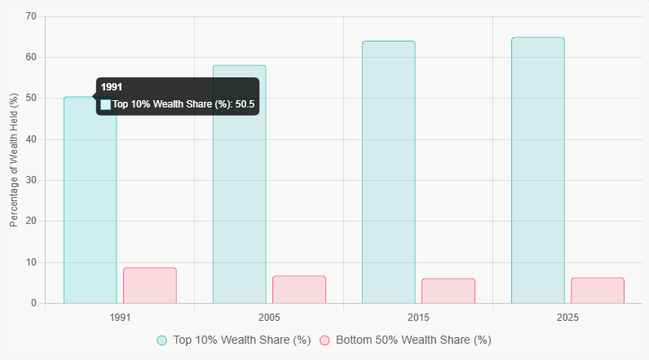

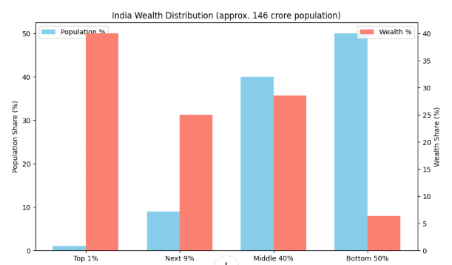
- The top 1% of Indians hold about 40 % of the country’s total wealth.
- The top 9 % of the population hold roughly 25 % of total wealth.
- Middle 40 % of the population hold roughly 28.6% of total wealth.
- The bottom 50 % of the population own only about 6.4 % of total wealth.

6. Discussion: The Implications of Divergence
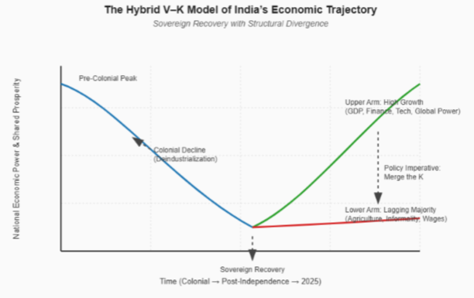
The K-shaped divergence is not merely an economic statistic; it has profound social and political implications.
Constrained Domestic Demand: A large population with low purchasing power limits the growth of the domestic consumer market, making the economy overly reliant on investment and exports. Social and Political Instability: High levels of perceived inequality can fuel social unrest, political polarization, and demand for populist, short-term solutions over long-term strategic planning. Human Capital Underutilization: The vast potential of millions of citizens in the lower arm of the 'K' remains untapped, representing a colossal loss of national productivity and innovation. Fragility: The economy becomes vulnerable to shocks. While the upper arm may be globally integrated and resilient, the lower arm is not, as seen during the migrant crisis and economic distress of the COVID-19 lockdown.

7. Policy Recommendations: Merging the Arms of the 'K'
For India to fulfill its potential, the focus must shift from aggregate GDP growth to inclusive, equitable growth. The goal is to implement policies that lift the lower arm of the 'K', strengthening it and gradually merging it with the upper arm into a single, unified upward trajectory.
- Revitalize and Re-structure Agriculture: Beyond Subsidies: Shift from input subsidies to investment in infrastructure-cold storage, rural roads, and last-mile connectivity. Promote Food Processing: Develop clusters of food processing industries near agricultural zones to create non-farm rural employment, reduce post-harvest losses, and increase farmer incomes. Crop Diversification: Incentivize farmers to move beyond water-intensive crops to high-value horticulture, pulses, and oilseeds, aligned with market demand and climate resilience.
- Create a Mass-Scale, Labor-Intensive Manufacturing Boom: Learn from China's and Vietnam's Playbooks: India has missed the boat on export-oriented manufacturing. It's not too late. Focus on sectors where India has a natural advantage: textiles, pharmaceuticals, electronics assembly, and green energy components. MSME Support: Provide easier access to credit, technology upgradation funds, and simplify compliance for MSMEs, which are the largest employers. Labor Law Reform: Balance worker protections with the need for flexibility for firms to hire and scale. A more flexible labor market is crucial for attracting large-scale manufacturing investment.
- Invest Aggressively in Human Capital for the Bottom 50%: Health: Increase public spending on primary healthcare to over 2.5% of GDP. A healthy population is a productive population. Focus on nutrition and sanitation. Education: Move beyond enrollment numbers to improve learning outcomes. Revamp the curriculum to emphasize vocational skills, digital literacy, and critical thinking from the secondary level onwards. Skill Development: Create a robust ecosystem for vocational training that is directly linked to the needs of local industries, ensuring employability.
- Strengthen the Social Safety Net: Formalize the Informal Sector: Provide incentives for informal businesses to transition to the formal sector, granting workers access to social security (pension, health insurance). Expand MGNREGA: Strengthen and expand the Mahatma Gandhi National Rural Employment Guarantee Act, focusing on creating durable rural assets. Universal Basic Services: Work towards providing universal access to high-quality education, healthcare, water, and sanitation, which reduces vulnerability and empowers citizens to take economic risks.
- Merging the Arms of the 'K’: To merge the arms, policies must narrow the CAGR gap from the current 1.26 percentage-point differential to near zero by 2040. Specific measurable goals: Raise broad-based sector CAGR to ≥1.8% p.a. through agriculture restructuring and labor-intensive manufacturing (targeting a 2050 broad index of ≥140).
Reduce Top 10% wealth share growth to ≤0.3% p.a. via progressive taxation and asset redistribution, aiming for Bottom 50% wealth share ≥12% by 2050.
Monitor annually via an official “K-Merge Index” (elite/broad ratio + wealth divergence metric) published by MoSPI.

8. Conclusion
The Hybrid V and K-Shaped model offers a powerful and nuanced lens for viewing India's economic history. The 'V' successfully maps the reclamation of national sovereignty and the macroeconomic reversal of colonial decline. It is a story of resilience and recovery. However, the 'K' serves as a critical warning for the future. It reveals that the recovery is not yet inclusive.
The Hybrid V-K model, now fully quantified with explicit CAGRs, divergence ratios, and 2050 projections, offers a rigorous lens for India’s economic history. The V-phase successfully reclaimed national economic sovereignty (world GDP share recovering from 4.2% to 8.5%). Yet the K-phase persists: elite sectors outpace broad-based sectors by 2.58×, with projections showing a 2050 divergence ratio of 2.28 and extreme wealth concentration unless deliberate action is taken.
The two arms of the K are interdependent-the upper arm’s sustainability depends on lifting the lower. Merging them through the enhanced policy framework outlined is not only an economic necessity but a moral imperative to ensure that India’s rise by 2050 is truly shared by “Two Indias” becoming One.

9. References
- Maddison Project Database, version 2020. (2020). University of Groningen.
- Ministry of Statistics and Programme Implementation (MoSPI). (2024). National Accounts Statistics. Government of India.
- Papanastasiou, D. (2021). K-Shaped Recoveries. International Monetary Fund (IMF) Blog.
- Roy, T. (2000). The Economic History of India 1857-1947. Oxford University Press.
- World Bank Open Data. (2024). World Bank Group.
- World Inequality Database (WID). (2024). Income and Wealth Inequality in India, 1922-2023.
- Krishnan, R. (1978). "The Growth Rate of the Indian Economy". In Indian Economic Review.
- Panagariya, A. (2008). India: The Emerging Giant. Oxford University Press.
- International Monetary Fund (IMF). (2025). World Economic Outlook Database.
- Banerjee, A. V., & Duflo, E. (2019). Good economics for hard times. PublicAffairs.
- Basu, K. (2010). Beyond the invisible hand: Groundwork for a new economics. Princeton University Press.
- Broadberry, S., Custodis, J., & Gupta, B. (2015). India and the great divergence: An Anglo-Indian comparison of GDP per capita, 1600-1871. Explorations in Economic History, 55, 58-75. https://doi.org/10.1016/j.eeh.2014.04.003
- Chancel, L., & Piketty, T. (2019). Indian income inequality, 1922-2015: From British Raj to Billionaire Raj? Review of Income and Wealth, 65(S1), S33-S62. https://doi.org/10.1111/roiw.12439
- Deaton, A., & Drèze, J. (2002). Poverty and inequality in India: A re-examination. Economic and Political Weekly, 37(36), 3729-3748.
- Ghosh, J. (2016). The Indian economy since liberalization. Indian Journal of Human Development, 10(1), 1-24. https://doi.org/10.1177/0973703016648031
- Government of India. (2023). Economic survey 2022-23. Ministry of Finance.
- Harris, J. R., & Todaro, M. P. (1970). Migration, unemployment and development: A two-sector analysis. American Economic Review, 60(1), 126-142.
- Joshi, V., & Little, I. M. D. (1996). India’s economic reforms 1991-2001. Oxford University Press.
- Kuznets, S. (1955). Economic growth and income inequality. American Economic Review, 45(1), 1-28.
- Lewis, W. A. (1954). Economic development with unlimited supplies of labour. The Manchester School, 22(2), 139-191. https://doi.org/10.1111/j.1467-9957.1954.tb00021.x
- National Commission for Enterprises in the Unorganised Sector (NCEUS). (2009). The challenge of employment in India. Government of India.
- Rodrik, D. (2016). Premature deindustrialization. Journal of Economic Growth, 21(1), 1-33. https://doi.org/10.1007/s10887-015-9122-3
- Sen, A. (1999). Development as freedom. Oxford University Press.
- Stiglitz, J. E. (2012). The price of inequality. W. W. Norton & Company.
- World Inequality Lab. (2022). World inequality report 2022. Harvard University Press.
Additional Data Note
All calculations and projections are derived directly from the datasets and tables in the original uploaded paper (Maddison, WID, MoSPI, World Bank). The model is replicable using the provided indices and the CAGR formula:
$$r={(\frac{V_{final}}{V_{initial}})}^{\frac{1}{n}}-1$$where $n$ = number of years.

