Leveraging Artificial Intelligence Marketing on Halal Food Consumption Patterns insight from VOSviewer

Abstract
Purposes – This study examines the implications of Artificial Intelligence marketing on halal food industry consumption patterns.
Design/Methodology/Approach – Using a qualitative approach. This study analyzed 142 documents on halal food consumption, the influence of artificial intelligence marketing on consumption patterns studies, topic areas with titles, keywords, and abstract criteria in consumption pattens studies were used as a reference for extracting search results. Search result extraction was done using VOSViewer. Through VOS Viewer, this study analyzed how many articles have been published about artificial intelligence marketing on consumption patterns and their relationships to a topic area.
Results - The bibliometric analysis revealed four main clusters consumption patterns, marketing mix, artificial intelligence, and the halal industry highlighting the significant impact of AI on marketing strategies within the halal food.
Originality/Value – It is recommended that the managers focus their strategies on marketing strategies to predict consumer behavior in consumption patterns of halal food through the integration of artificial intelligence marketing. This study provides the performance analysis and scientific mapping of the digital marketing literature in SME.

Keywords Marketing mix, predict consumer behavior, consumption patterns, halal food, artificial intelligence marketing
Paper type Research paper

- Introduction

In recent years, technological innovations in marketing have garnered increasing research interest. The disruption brought about by internet technologies and computers has facilitated the emergence of Artificial Intelligence (AI) (Rakhmad, Kurniawan, Prameka, & Hidayat, 2023). AI, characterized by mechanical and analytical intelligence, performs simple, rule-based tasks, whereas intuitive and empathetic intelligence involves complex tasks requiring empathy, holistic thinking, and context-specific responses. Furthermore, AI has become a thriving technology for numerous intelligent applications across various fields (Anshari, Fithriyah, Polak, & Razzaq, 2021; Djermani & Hajimia, 2021; Pham et al., 2020).

Based on Huang and Rust (2018), Artificial intelligence (AI) is an implication for marketing strategy. At this stage, marketers can leverage the three AI intelligence for segmentation, targeting, and positioning (STP) for firms that embrace a data-driven marketing strategy (4Ps) (Nawi, Yaakob, Ren, Khamis, & Tamuri, 2021; Noor, 2022). Bozidar, Leonardo, Susana, Marina (2021). Artificial Intelligence (AI) in marketing has shown that AI can mimic humans and perform activities in an 'intelligent' manner.

(Agarwal, Dugas, Gao, & Kannan, 2020; Helmi, 2023; Hendijani, & Amiri, 2018).

Muslims will manifest the subsequent effect on the demand for halal foods through their significant buying power. Despite the rapid growth of the halal food market, this population is sometimes doubtful of the halal status of their food consumption due to alleged contamination with non-halal ingredients (Mat et al., 2020).

(Battour, Mady, Elsotouhy, Salaheldeen, Elbendary, Marie, & Elhabony, 2022). (Wilson, & Liu, 2011).

(Gazali, Jumadi, Ramlan, Abd Rahmat, Uzair, &Mohid, 2020; Huang& Rust, 2021; Tama, & Voon, 2014).

The research gap in the literature on AI and halal food refers to areas within this field that have not been adequately explored or require further investigation. While AI has gained significant attention in various domains, including food technology and safety, research is still scarcely focused explicitly on AI's application and impact on the halal food industry.

The practical research gaps, AI needs to assist the halal certification process by automating and streamlining various tasks. For instance, AI must analyze ingredient lists and food labels to determine if they comply with halal standards (Rejeb, Rejeb, Zailani, Treiblmaier, & Hand, 2021). This can expedite the certification process and reduce the chances of human error or bias. AI-powered systems must enhance transparency and traceability in the halal food supply chain. They are integrating IoT (Internet of Things) devices, sensors, and AI analysing to track and monitor the movement of halal products throughout the supply chain. This requires better control over halal integrity, minimizes the risk of contamination or fraud, and ensures compliance with halal standards.

Moreover, limited studies on AI contribute to quality control in the halal food industry by automating inspections and detecting potential contamination. AI is used to visually inspect food products and identify abnormalities or non-halal ingredients (Nizar, Abidin, & Taib, 2023). Additionally, AI needs to assist in analyzing data from sensors and IoT devices to identify potential risks in the production and processing stages.

Another major problem is consumer trust in halal food and product authentication. AI technologies like blockchain must enhance consumer trust in halal products by providing transparent and immutable records of their origin, certifications, and ingredients (Bux, Varese, Amicarelli, & Lombardi, 2022). Smart contracts and blockchain-based systems, AI, must be integrated to verify the authenticity of halal products, ensuring they meet the required standards. Thus, implementing AI in halal food will enable real-time product authentication using techniques such as image recognition. Despite the personalized halal food consumption, AI must tailor halal food options to meet individual preferences, dietary restrictions, and nutritional needs (Ali, Chung, Kumar, Zailani, & Tan, 2022) by analyzing data on consumers' dietary requirements, health conditions, and taste preferences, for halal food products or recipes that align with specific needs and preferences.

Limited studies on market analysis and consumer insights regarding halal food consumption patterns (Soesilowati, 2011). AI requires analyzing vast amounts of data from various sources, such as social media, reviews, and surveys. To gain insights into consumer preferences, trends, and demands related to halal food (Taherdoost & Madanchian, 2023). This information can be valuable for businesses in developing new halal products, marketing strategies, and understanding consumer behavior. Therefore, it is essential to note that implementing AI in the halal food industry should align with ethical considerations, transparency, and adherence to Islamic principles. While AI can offer numerous benefits, it is crucial to maintain human oversight, accountability, and responsible use of technology to preserve the integrity of halal food production and consumption. In many countries and Indonesia, there is a lack of studies examining the effect of artificial intelligence marketing in the halal food industry.

A primary concern for marketing researchers has long been capturing consumers' real sentiments and preferences. Focus groups and face-to-face interviewing can be used to gauge consumers' opinions. However, such traditional marketing methods are both costly and time-consuming. However, the use of AI in strategic marketing decisions has been researched very little, with the most recent comprehensive report being from Accenture (Awalegaonkar et al., 2019). Another theoretical implication comes from the method used. This study introduces a robust and structured methodology and thus has direct methodological application to the halal food management sector. Hence, the study concern can be formulated to identify the following issue: How can Artificial Intelligence marketing be used for food halal industry consumption patterns?

- Literature review

2.1 Consumption Patterns of Halal Food
The high consumption needs for halal products encourage high demand, increasing the incentive to produce halal. Actively, halal producers can promote the halal market by understanding the buying behavior of Muslims as their primary target market. One way of predicting purchasing behavior is by examining consumer buying interest. Purchasing intention involves buying specific goods or services (Ashraf, 2019; Warshaw & Davis, 1985). It
is a concept that indicates producers about actual purchases (Morwitz, 2014). Additionally, the concept of consumption empirically rooted in social psychology theory and consumer behavior proves that interest generally predicts subsequent behavior (Alam & Mohamed, 2011; Morwitz, 2014). Buying intention leads to purchasing decisions (Awan, Siddiquei, & Haider, 2015; Roberts-Lombard, Mvane, Makhathini, Muller, & Jaiyeoba, 2022).

In the decision-making process, a consumer will try to find information about how to make the right purchase decision. Therefore, to fulfill his needs in Islam, a Muslim must always follow the Qur'an and Sunnah. Regarding quality, every Muslim must consider whether a product is halal and blessed (thayyib) (Ashraf, 2019; Fuseini, Hadley, & Knowles, 2021). A better understanding of religion makes Muslims more selective in choosing the products they consume. The Muslim community' sun willingness to consume haram products will increase their involvement in product selection. Thus, products will be selected for consumption and put aside due to the selection process. The selection process makes halal its main parameter (Awan, Siddiqui, & Haider, 2015).

This emphasizes that in Islamic teachings, wild animals, najis and unclean animals are scientifically unfit for consumption. Moreover, food consumption has been influenced by factors such as food availability, accessibility, and choice. It is also influenced by geography, demographics, income, globalization, marketing, religion, culture, and consumer attitudes (Akın & Okumuş, 2021). In big data, developing new and more robust information sources allows for storing and processing massive amounts of data. This improvement has significantly enhanced AI systems and robotic processes, known as the fourth industrial revolution (Li et al. 2019). Halal food quality involves food technology, such as extending the food life with similar nutritious tastes and values (Ali & Suleiman, 2018).

Ḥalal industry is gaining global attention as a better alternative and standard for safety, quality assurance and hygiene. The industry represents a symbol of hope for the Muslim ummah, as ḥalal food is the only permissible food for consumption according to Islamic law. For non-Muslims, it symbolizes hygiene, quality and safety (Sanneh & Kartika,2021). Knowledge about halal food is another crucial theme extracted by different authors' research selected for this analysis (Ayyub, 2015; Zannierah Syed Marzuki et al., 2012; Ahmad et al., 2017).These studies focused on the perceptions of non-Muslims towards products and services (Mathew, 2014). These studies focused on the perceptions of non-Muslims toward halal food.

These studies further investigate the attitudes of restaurant managers toward certification, investigate the fundamental factors influencing the execution of halal food administration frameworks, and the perspective of executives, consultants and auditors, respectively, with the findings that there are positive perceptions of non-Muslims towards halal food even they are not fully aware of it. Islam pays excellent attention to the patterns and lifestyles of its people. One of them is to provide several rules and restrictions regarding food ingredients that humans will consume. Specific dietary laws must be followed by Muslims (Ahmad et al., 2017). More specifically, Islam gives the terms for foodstuffs in the form of halal, haram, and syubhat (doubtful) (Denyingyhot, Phraephaisarn, Vesaratchavest, Dahlan, & Keeratipibul, 2021; GIFR, 2015; Khairi et al., 2012) consumer confidence (7 items. Labeling these foods is based on the source, cleanliness, processing, and disposal methods (Hasyim, 2022). Surprisingly, the halal food market offers economic opportunities since it has high purchasing power, especially in Muslim countries (Ahmad et al., 2017).

Moreover, several countries have halal standardization and certification organizations, such as the Department of Islamic Development Malaysia (JAKIM) and the Halal Product Guarantee Organizer (BPJPH) in Indonesia (Ahmad et al., 2017). Consuming halal products is not only obligated for Muslims but also maintains food standards by providers (Khalek, 2014). Halal food should be prepared, manufactured and processed to ensure safety and hygiene (Al-Shami, & Abdullah, 2021).

Therefore, marketing in the halal industry that Halal assurance is increasingly vital in Muslim countries and societies, including pharmaceutical products (Kasri, Ahsan, Widiatmoko, &Hati, 2021; Tieman& Ghazali, 2014). The importance of halal products is initially derived from the requirement for Muslims to consume products that are halal (permissible) and tayyib (clean and good to consume) according to Islamic teaching (Nurhayati and Hendar, 2019; Amalia et al., 2020).

Table 01 describes the details of qualitative analysis done on different studies by different authors (Ahmed, 2008; Ayyub, 2015; Thomas et al., 2017; Ali et al., 2017). It shows their main themes as quality with a focus on perceptions of non-Muslims towards products and services, explores several marketing issues such as consumer buying behavior and supply channels about buying meat from local shops versus supermarkets in the UK and investigates a slaughterhouse in the UK that prepares both meat and non-meat items (Handayani, Masudin, Haris, & Restuputri, 2022; Tarmizi, Kamarulzaman, Abd Latiff, & Abd Rahman, 2014; Zulfakar, Anuar, & Talib, 2014).

Table 01. Halal food Study
S.r No | Author | Research title | Research context | Respondent's religious affiliation | Findings
1. | Ahmad et al. (2017) | Critical success factors affecting the implementation of halal food management systems: Perspective of halal executives, consultants and auditors | Malaysia | Muslims | Quality of meat is the main factor influencing the purchasing decision while purchasing meat Muslims from the UK do not trust big supermarkets when buying meat, and they only trust Muslim sellers of meat in their local market.
2. | Tieman (2011) | The application of halal in supply chain management: in-depth interviews | Malaysia |  | Contact between haram and halal must be avoided to fulfill the high assurance of the Muslims and avoid contamination with haram.
3. | Ahmad (2008) | Marketing of halal meat in the UK  Supermarkets versus local shops | UK |  | The significant role of supermarkets and local shops in the halal meat market in the UK. The preference of British Muslim consumers for these types of shops may be influenced by factors such as price, accessibility, and community engagement.
4. | Jamal et al. (2015) | Perceived value and perceived  the usefulness of halal labeling: The role of religion and culture | UK |  | People are unable to find halal-labeled products. So, they looked for products having other logos, for example, "suitable for Vegetarians" and "gluten-free," etc.
5. | Ayyub (2015) | Exploring perceptions of non-Muslims towards halal foods in the UK | UK | Non-Muslims | Today's consumers are very conscious about their health and want to eat healthy food. In general, most of the respondents had good perceptions about the quality of products. Researchers proposed that the quality of foods positively affects the perception of non-Muslims toward foods.
6. | Thomas et al. (2017) | Challenges and practices in halal meat preparation: a case study investigation of a UK slaughterhouse | UK |  | Different tools and types of equipment like knives, hooks and operator's clothing used in halal and haram slaughtering procedures should be adequately cleaned, sterilized and handled separately to avoid contamination.

There is a strong correlation between the product and consumption patterns of halal food. Halal food products must adhere to specific guidelines and acceptable ingredients according to Islamic dietary laws, which can impact the availability and types of halal food (Naeem, Ayyub, Ishaq, Sadiq, & Mahmood, 2020; Said, Othman, Sulaiman, Hatta, & Ramya, 2023). In addition, the types of halal food products available in the market can impact consumption patterns.

Companies that offer a more comprehensive range of halal food products can cater to Muslim consumers' diverse tastes and preferences. Consumer consumption patterns of halal food can also influence the types of products companies offer (Fadillah, Ridlwan, Suryaningsih, & Indrarini, 2023). Overall, halal food's product and consumption patterns are closely interrelated, and companies must consider both factors to effectively target and meet their target consumers' needs.

Price is an essential factor that can influence the consumption patterns of halal food. Consumers may be willing to pay a premium for halal-certified products due to the perceived health benefits (Syahnur& Bahari, 2023). Moreover, halal-certified products may be priced higher than non-halal alternatives due to the additional costs associated with certification and sourcing of halal ingredients. This can make halal food products less accessible and affordable for some consumers (Halimi, Gabarre, Rahi, Al-Gasawneh, & Ngah, 2022).

Overall, halal food's price and consumption patterns are interrelated, and companies must consider their halal products' pricing and value proposition to effectively target and meet their target audience's needs. While pricing can influence the demand for halal food products, effective promotional strategies can drive consumption and increase sales.

Promotion refers to marketing activities designed to increase a product's or service's visibility and sales. Consumption patterns, on the other hand, refer to how consumers purchase and use products (Anwar & Saeed, 1996). Promoting halal food products can increase consumer awareness and interest, increasing consumption. Conversely, consumer demand for halal food can influence promotional strategies, leading companies to focus their marketing efforts on the market (Rabbani, Sarea, Khan, & Abdullah, 2022; Ramli, Abd Razak & Jaafar, 2023).

Alia and Ahmada (2023) indicated that effective promotion of halal food products often involves highlighting the halal certification of the product and using marketing materials that appeal to Muslim consumers. Hence, companies that understand the correlation between promotion and consumption patterns of halal food can successfully target the Muslim consumer market and capitalize on the growing demand for halal food products. By tailoring their marketing strategies to appeal to the unique needs and preferences of Muslim consumers, companies can increase the visibility and sales of their halal food products (Rabbani, Hassan, Khan, & Muneeza, 2022; Shahid, Parray, Thomas, Farooqi, & Islam, 2023).

A correlation between the place and consumption patterns of halal food, as the availability of halal options can vary depending on the location (Ahmed, 2008; Aziz, Ismail, Hashim, Ibrahim, & Jamil, 2019; Mat, Sulaiman, Abdghani, & Mohamad, 2020). In areas with a sizeable Muslim population, there is a higher demand for halal food, leading to greater availability of halal options in grocery stores and restaurants (Hossain, Rahman, Uddin, & Hossain, 2022; Wan-Hassan, & Awang, 2009). Therefore, this can make it easier for individuals to consume halal food and may lead to higher consumption patterns.

Conversely, halal options are limited in areas with a lower Muslim population, making it more difficult for individuals to consume halal food. This leads to lower consumption patterns of halal food in these areas (Mabkhot, 2023). In summary, the correlation between place and consumption patterns of halal food can be significant, as the availability of halal options can impact the ease and frequency of consuming halal food.

  - Artificial Intelligence (AI)Marketing
AI can analyze, comprehend, and make decisions. It makes market predictions and predicts user behavior (Liu et al., 2016; Martínez-López, & Casillas, 2013; Salaheldeen, 2022). It is also known as data forecast, and it fine-tunes its sales and marketing strategies to increase sales (Ismoyowati, 2015; Ramli & Abd Razak, 2021). According to tasks in distribution as IoT for consumption patterns of food tracking and order refilling and self-service technologies for delivering service to customers directly (Mukherjee, Rajendran, & Wahab, 2022; Grewal et al. 2018; Rehman, 2022). Moreover, AI approaches track and capture real-time data when they occur. Thus, the data are in context, about the customer, and during the consumption experience.

In Table 02, the academic literature on AI in marketing may be sorted into four main types. These are (1) technical AI algorithms for solving specific marketing problems (e.g., Chung et al. 2009; Chung et al. 2016; Dzyabura and Hauser 2011, 2019), (2) customers' psychological reactions to AI (e.g., Luo et al. 2019; Mende et al. 2019), (3) effects of AI on jobs and society (e.g., Autor and Dorn 2013; Frey and Osborne 2017; Huang and Rust 2018), and (4) managerial and strategic issues related to AI (e.g., Fountaine et al. 2019; Huang and Rust 2020).

Table 2. Framework for AI in marketing
AI Marketing | Segmentation | Targeting | Positioning
Marketing Strategy | Standardization | Personalization | Renationalization
Product/Consumer | Automate the process and output of meeting customer needs and want | Personalize products based on customer preferences | Understand and meet customers' emotional needs and wants  negotiate
Price/Cost | Automate the process of price setting and payment. | Personalize prices based on customer willingness to pay. Personalize frontline interactions. | Negotiate price and justify the cost interactively.
Place/ convenience | Automate customer access to product | Customize promotional content for personal communication | Personalize experience for customer engagement
Promotion/ Communication | Automate communication with customers | Personalize prices based on customer willingness to pay Personalize frontline interactions. | Tailor communication is based on customers' emotional preferences and reactions.

AI impacts the purchasing process in two ways (a) the brand information available to the consumer and (b) who makes the purchasing decision (Consumption patterns). AI personal retail assistants such as Amazon's Alexa have the potential to be gatekeepers for brands to the consumer, controlling what brand information is supplied to the consumer and, in a pure form, purchasing branded products with little or no human interaction in the so-called' automatic execution model' of AI, effectively tipping the traditional shopping experience on its head from shopping then shipping' model to a 'shipping then shopping model.

Artificial intelligence (AI) has the potential to revolutionize the way companies market their products and services by providing insights into consumer behavior and predicting consumption patterns (Davenport, Guha, Grewal, & Bressgott,2020; Sulong, Abdullah, & Chowdhury, 2022). AI generates content, such as product descriptions and social media posts, that resonates with consumers and is optimized for search engines (Mondal &Vrana, 2023). AI-powered chatbots and virtual assistants can provide personalized recommendations, answer customer inquiries, and assist with purchases, improving the customer experience and driving sales (George & George, 2023; Sulaiman, Rahman, & Mat, 2020). AI is transforming marketing by providing insights into consumer behavior, enabling personalization and prediction, and improving customer experience.

- Methodology

One fundamental theory used to explain the consumer behavior perspective is the stimulus-organism-response (S-O-R) framework. Scholars used the S-O-R framework from Mehrabian and Russel (1974) to investigate consumer behavior regarding environmental effects, especially in retailing and consumption (Petrescu et al., 2017). However, an environmental variable as a stimulus factor, an emotional variable as an organism factor, and the response are no longer exclusive to the S-O-R framework.

Since the Framework offers more room to be further explored, several studies have attempted to include more variables in the S-O-R model, such as product attributes and price (Lee & Yun, 2015), promotion (Cheah et al., 2015), place (Aziz, Mohamed, & Abd Rahman, 2017), for stimuli stage, as These stimuli follow Jacoby's (2002) examples of products, brands, logos, ads, packages, prices, store and store environments, communication, as stimuli agents. At the same time, Artificial intelligence is marked (Uzir, Al Halbusi, Lim, Jerin, Hamid, Ramayah, & Haque, 2021) as the organism.

The present study extended the S-O-R framework proposed by Goi et al. (2014) with variables beyond the traditional S-O-R framework (Mehrabian & Russel, 1974). Specifically, the present study examined the 4Ps of the marketing mix as stimuli. (McCarthy, 1964), as this study attempts to contribute knowledge in broadening knowledge in the S-O-R theoretical framework. Therefore, this study investigated consumption patterns as post-purchase evaluation and internal response to embody the response stage. Based on S–O-R theory, the current study applies the proposed model shown in Figure 2, where the antecedent variables, or stimuli, consist of product, price, promotion and place; consumption patterns are dependent variables, while Artificial intelligence is a mediator. The current study had four independent variables (i.e., product, price, promotion, and place) and one dependent variable (i.e., Artificial Intelligence Marketing in consumption patterns of halal food). The systematic selection approach is ruled by a process that reduces bias, minimizes research errors, and ensures scientific rigor (Yousaf & Xiucheng, 2018).

Artificial Intelligence (AI) marketing can mediate between the marketing mix and consumption patterns of halal food (Sulaiman, Rahman, & Mat, 2020). AI marketing can help to optimize the marketing mix: As discussed previously, AI is used to analyze customer data and behavior to optimize the product, price, promotion, and place elements of the marketing mix for halal food products. By improving the effectiveness of the marketing mix, AI marketing significantly increases consumption patterns of halal food. Therefore, based on the theory of stimulus-organism-response (S-O-R). The current study investigates Artificial Intelligence Marketing towards Consumption patterns of halal food.

This study explored both scholars and published or perished a database to search the relevant literature. Due to its limited coverage of artificial intelligence marketing in consumption patterns of halal food, it used Google Scholar and published or perished. According to Aguillo (2012), the authors prefer not to use Google Scholar due to several problems of indexing as observed in records from different sources, lack of formal integration in many cases and the need for many cleanup efforts, which are considered complex and time-consuming. In the context of this research, the decision to incorporate Google Scholar and Publish or Perish is crucial for a comprehensive and interdisciplinary analysis. Artificial intelligence marketing in the consumption patterns of halal food is a relatively specialized and emerging field, and using additional sources helps ensure that relevant literature from various disciplines is considered.

The initial search string included words like "marketing, "artificial intelligence," and "consumption patterns of halal food". "Synonyms used for artificial intelligence like machine learning, deep learning, natural language processing, digital marketing, and Boolean operators like "OR" are used to get the universal set of papers. Boolean operator "AND" is used to get the intersection of marketing and artificial intelligence papers.

VOSviewer (version 1.6.17 software developed by Nees Jan van Eck and Ludo Waltman at Leiden University in The Netherlands) was used to construct and visualize bibliometric networks in the first stage of identifying topics and keywords. The processed articles were detailed and analyzed regarding the author, article title, journal name, and publication year.

In the next stage, VOSviewer was used to reconstruct a network of scientific journals, authors, publications, study organizations, keywords, terms, or countries. Co-authorship, co-occurrence, citations, bibliographic coupling, or co-citation links linked to the network items. VOSviewer was also used to determine whether any researcher had studied the topic. VOSviewer processes the targeted keywords and then graphically maps all articles in Scopus-indexed journals related to the number of publications for those keywords. This can also be used to find trends in this study.

- Results

Table 03 presents the distribution of documents used in research focusing on the theme of halal consumption patterns of halal food. The total number of documents amounts to 142, categorized into four types: journal articles (82), book chapters (3), conference papers (49), and reviews (8).

VOSviewer software can effectively reveal key contributors to the research on halal consumption patterns by analyzing co-authorship networks. This analysis enables researchers to identify individuals or research groups that have actively collaborated on journal articles, book chapters, conference papers, or reviews related to this theme. Understanding these collaborations provides valuable insights into the collaborative landscape of the field.

Furthermore, VOSviewer is utilized to identify clusters or themes within the dataset, offering insights into specific aspects of halal consumption patterns being studied. These aspects might include subtopics such as cultural influences, consumer behavior, and industry practices. The detailed analysis helps in comprehensively understanding the various dimensions of halal consumption research.

Table 03. Different Document types of publications
No | Document Types | Number of Articles
1 | Journal article | 82
2 | Book chapter | 3
3 | Conference Paper | 49
4 | Review | 8
 | TOTAL | 142

4.1 Publications Bibliometric Analysis

In this section, we present a visual representation of the author keywords used in the journal's publications using the VOSviewer software package. As shown in Figure 01, a threshold of ten citations was set as the inclusion criteria (Dulla et al., 2021).

A total of 670 publications on halal food consumption patterns were identified in the WOS database, excluding 2021. These include 492 (73.4%) original research articles, 142 (21.2%) proceedings, 27 (4%) early access articles, 15 (2.2%) reviews, and 37 (5%) other forms of publications. Notably, 274 (40.8%) papers were published in December 2020, and 173 in December 2019. Most papers (632, 94.3%) were in English, with 28 of the other 230 publications (34%) being Open Access.

The diagrammatic representation reveals that the articles published in the journal address various research issues relevant to its scope. The most commonly used keywords highlighted in the density visualization plot include "Marketing Mix," "Consumption Patterns," "Artificial Intelligence," and "Halal Industry." These contributions significantly add to the theoretical and practical understanding of the manufacturing and service sectors.

The size of the nodes represents the frequency in which they occur. The curves connecting the nodes show how often they co-occurrence in the same publication. The greater the frequency of co-occurrences of two keywords, the shorter the distance between two nodes.

Based on this, figure 01 shows limited research on relationship mediation on artificial intelligence and consumption patterns on halal food. The determinants of artificial intelligence marketing (deep learning, big data, awareness purchase) (Ambali& Bakar, 2014;Yunus, Rashid, Ariffin, & Rashid, 2014). Based on 670 articles for each variable in POP. It is identified that there is a direct relationship between the consumption pattern of the Halal food industry and Artificial Intelligence.

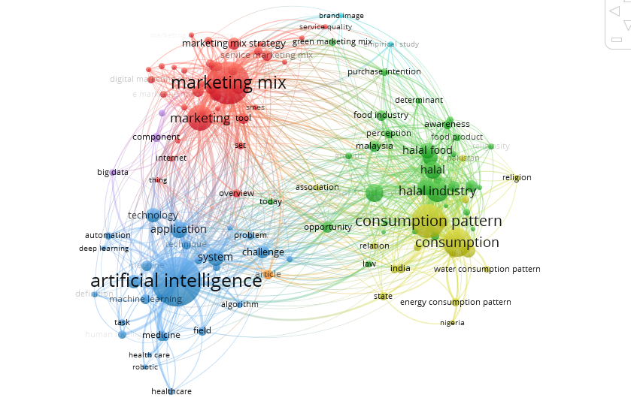
Figure 01. Keyword co-occurrence in consumption patterns, Artificial intelligence and Marketing strategy publications.

The modularity-based clustering of VoSViewer is a variant of the cluster algorithm to detect communities (clusters) in a network that also considers modularity, a measure that evaluates the Consumption patterns (cluster) structures. The clustering reports generated from VoS Viewer categorized the keywords according to their joint occurrences in the research articles published. The same is presented and highlighted in Table 4. The clustering clearly articulates this trend in publishing articles relevant to Consumption patterns and Artificial intelligence. However, the possibilities in tapping various uncovered and upcoming research areas such as Automation, Artificial Intelligence, Robotics, Data Science relevant to Consumption patterns and Artificial intelligence in halal food industry exists as future scope for future researchers.

Table 04. Clustering of keywords
 | Cluster 1 Consumption patterns | Water consumption patterns, energy consumption patterns
 | Cluster 2 Marketing Mix | Marketing tool, marketing strategies, service marketing mix, internet
 | Cluster 3 Artificial intelligence | System, application, automation, deep learning, technology, machine learning.
 | Cluster 4 halal industry | Halal food, food product, purchase intention

As far as the most prominent keywords in each cluster are concerned, it can be observed from Figure 02 that consumption patterns are at the center and other related themes are connected with it in Cluster 1. This is also in sync with the name and scope of journal itself. Secondly, (Marketing Mix) has reliability at its core (can be visualized from Figure02) and related research areas centered around reliability issues. The third keyword identified based on the clustering of the author keywords published in the research articles published. This classification too matches with the journal’s theme of publishing the most relevant, latest and sought-after research in the domain. As expected, the outcome of consumption patterns and Artificial intelligence is Marketing Mix. The categorization of the fourth cluster clearly justifies the name Customer Service Quality as presented in Table 4.

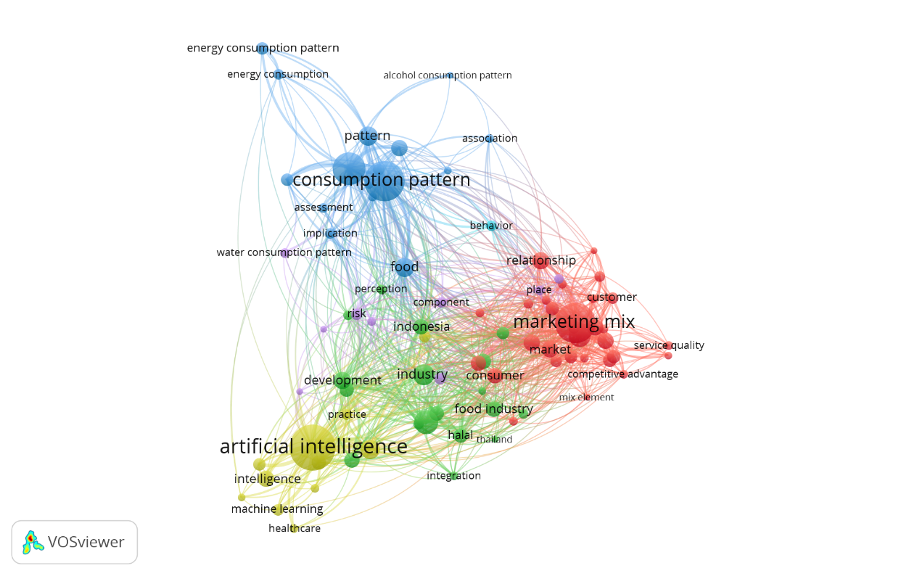
Figure 02. Identifying the gaps

4.2 Co-Authorship Analysis

Furthermore, the bibliometric results will be displayed based on the sub-themes: authors, organizations, and countries. The limit of minimum 3 publications and 10 citations is set to extract seven (4) clusters as depicted in Table 4 constituting 36 countries who have collaborated together.

It can be observed from Table 4, those authors from different parts of the world come together to contribute to the development of knowledge related to Consumption patterns and Marketing Mix. As can be observed from Figure 03, the contributions from India, UK, USA, Iran, Australia, Portugal, Brazil, Spain, Sweden, Malaysia and Saudi Arabia are more noteworthy and signifies the global popularity and outreach of the journal towards advancement of knowledge related to the field.

Future researchers across regions can identify the trends from the analysis in Figure 03 and may approach the researchers from these clusters to have collaborative research projects relevant to their country and region. This may also help new and upcoming research to understand the type of work being undertaken by the authors and explore opportunities to collaborate and work in novel directions.

Using the VOSViewer software, we found the author's bibliometric mapping, as shown in the following figure 03. The bigger the shape and the brighter the color indicates; the author is publishing more related halal consumption patterns of halal food.
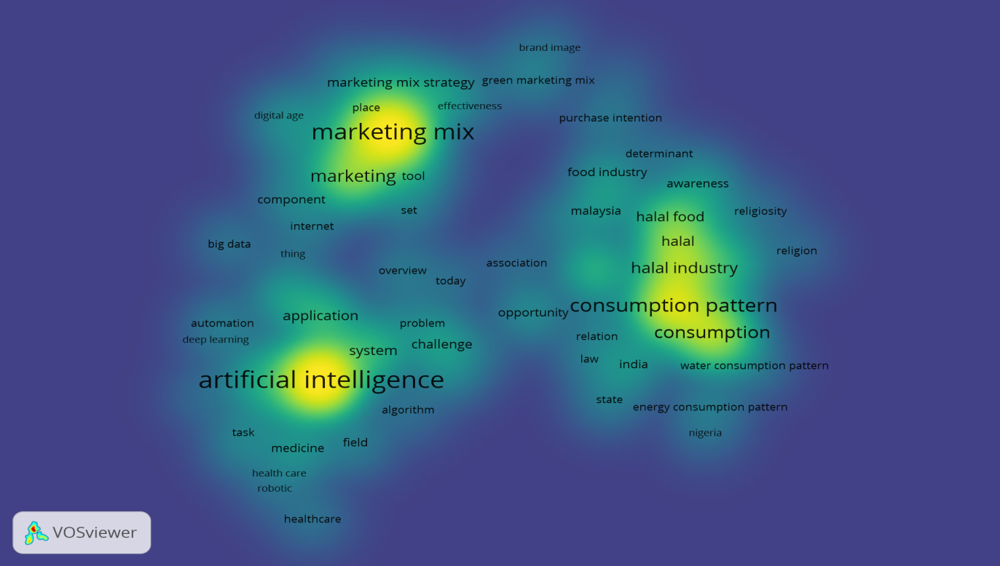
Figure 03. Co-authorship Authors

The appearance of cluster density depends on the level of yellow light brightness. This identifies that the yellow color on the map depends on the number of items associated with other items. This section helps us understand the general structure of a bibliometric map by paying attention to which parts of the light are essential to analyze. From the map, it is possible to interpret the authors who have published the most.

In general, each researcher has different tendencies. Some writers are indexed as a single author, and others co-author with other researchers so that multiple clusters appear, indicating different densities. However, authors with a reasonably large density indicate that they publish more research on halal logistics themes than those with a lower density, so this result can be used to reference future researchers. Based on these results, the bigger and brighter the author's name, the more papers he published. The author's most published publications related to halal logistics are based on bibliometric mapping, namely Tieman.

4.3 Co-Occurrence Analysis of Keywords

Keywords provided by authors of the published paper that occurred more than ten times in Scopus are enrolled in the final analysis. Of the 2442 keywords by the author, 38 meet the threshold. The keywords that appeared most are "halal" (total link strength 165) and Islam (total link strength 102)," "halal food," and "artificial intelligence." These keywords are distributed into five clusters. Halal is the center of this study within the analyzed research field and the most prominent cluster.

Based on Figure 04, the cluster clusters in the analysis of the keyword are halal supply chain (yellow), digital marketing, mix (blue), consumption of Halal food (red), innovation business (purple), and halal studies in artificial intelligence (green).

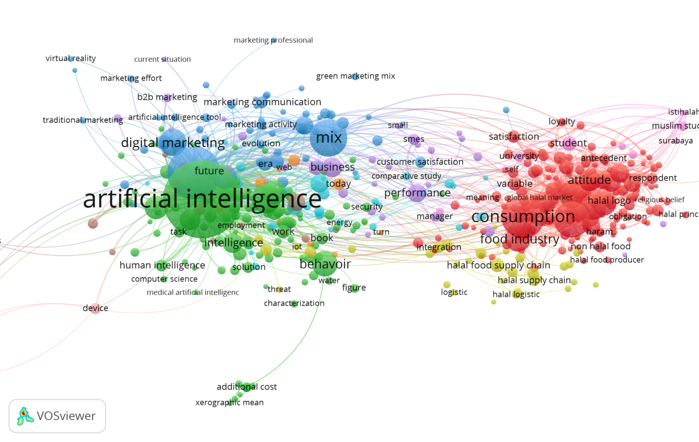
Figure 04. Network visualization of the cluster with the keywords using VOSviewer

4.4 Author Co-citation Analysis
Co-citations analysis is used to analyze the intellectual structure of a research field and answer matters related to the field, such as the primary research areas, most active areas, dissemination path of knowledge, and emerging trends. Once the references of the 879 documents are processed, there are 37,642 cited authors. The sample is reduced to 402 authors after applying the author filter with at least 20 citations. The ten most cited authors are shown in Table 05.

Table 05. The ten mTABLEost cited authors are shown
Authors Co | citations Links Total link strength | Authors Co | citations Links Total link strength
Tieman, M. | 470 | 396 | 26011
Verbeke, W. | 411 | 399 | 20145
Zailani, S | 304 | 399 | 19523
Bonne, K. | 326 | 399 | 16347
Liu, J. | 322 | 399 | 16210
Wilson, J.A.J | 351 | 397 | 16028
Hair, J.F. | 280 | 394 | 15155
Ajzen, I. | 279 | 384 | 14823
Ringle, C.M. | 198 | 384 | 12741
Sarstedt, M. | 195 | 382 | 12400

The proximity between each node reveals the relationship of each author, and the number of authors' citations in the document references represented by circles that vary in size. Tieman is the most cited author with total link strength of 26,011, followed by Verbeke (20,145) and Zailani (19,523). This result shows that Tieman is the most influential author in the halal research field, as most of the authors in this research field have cited his work.

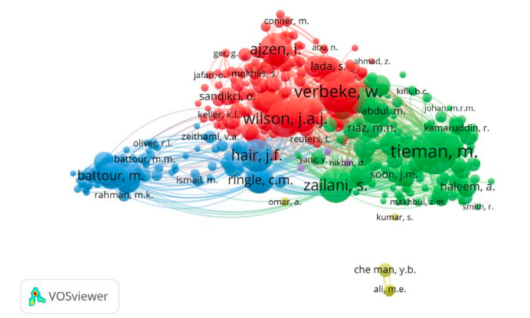
Figure 05. The co-citation maps of authors.

4.5 Co-Authorship Analysis
This analysis provides insights into the collaborative relationships among authors within the research field. From the initial pool of 1909 authors extracted using VOSviewer, only 354 authors meet the threshold of having contributed to a minimum of two articles each.
Figure 06 depicts the interconnected group of 337 authors, with 63 displaying direct collaboration. Notably, Zailani emerges as the most central figure 06, followed by Tieman, Ali, and Khan. Key collaborators for these authors include Iranmanesh, Aziz, Rahman, and Kanapathy.

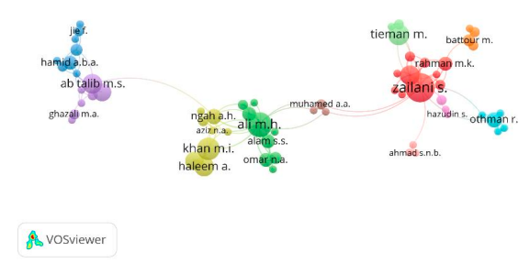
Figure 06. The co-authorship map of authors indicates the authors that cooperate in halal studies.

Among the 66 countries analyzed, 35 met the threshold of having contributed a minimum of five documents each. As illustrated in Figure 07, Malaysia emerges as the country with the highest level of collaboration with other nations. Malaysia has 15 collaborators, with a total link strength of 106, spanning across 405 publications and garnering 6044 citations. Indonesia, Australia, and the United Kingdom are identified as the primary partners of Malaysia in collaborative research endeavors.
This analysis underscores the significance of collaboration networks in advancing research within the field, highlighting key authors and countries that play pivotal roles in driving knowledge dissemination and exchange.

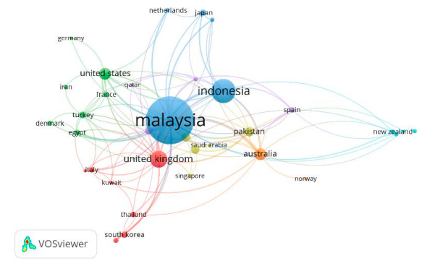
Figure 07. The co-authorship map of countries

4.6 Analysis by Theme and Trend Topics

Based on an extensive analysis using VOSviewer on 16,484 terms extracted from research paper titles and abstracts, 223 terms met the minimum occurrence threshold of 30, and 105 were identified as most relevant for further analysis. This analysis revealed four distinct clusters, each representing different topics and their interrelationships within the field of halal research.

The red cluster, categorized under consumption, encompasses topics such as the halal logo, global halal market, religious beliefs, and challenges within the halal market. It primarily focuses on various aspects of halal consumption, including market dynamics, religious practices, challenges, and regulations. The green cluster, categorized under artificial intelligence, explores the intersection of halal research with artificial intelligence, particularly focusing on issues related to human intelligence and behavior.

The blue cluster centers around marketing, covering digital marketing, marketing activities, communication, customer satisfaction, and experiences in tourism and hospitality. It highlights the marketing aspects related to halal products and services. Lastly, the yellow cluster focuses on the halal supply chain, logistics, and ensuring the integrity of halal food. These clusters provide a comprehensive overview of the main topics discussed within halal research, offering insights into the field's diverse and interconnected areas of study.

Figure 08. Network visualization of the main cluster with the terms of the titles and abstracts using VOSviewer

Figure 09 illustrates the changing trends in halal research areas over the years. Notably, recent studies have shifted their focus towards halal consumption, diverging from the previous emphasis on the food industry and management in 2016. Network visualization presents the main keywords in each cluster according to the titles and abstract. On the other hand, Figure 09 provides a visualization of cluster density, where more concentrated colors indicate a higher volume of research on a particular topic within the cluster. Prominent discussion areas include the halal food supply chain, halal logo, digital marketing, and human intelligence.

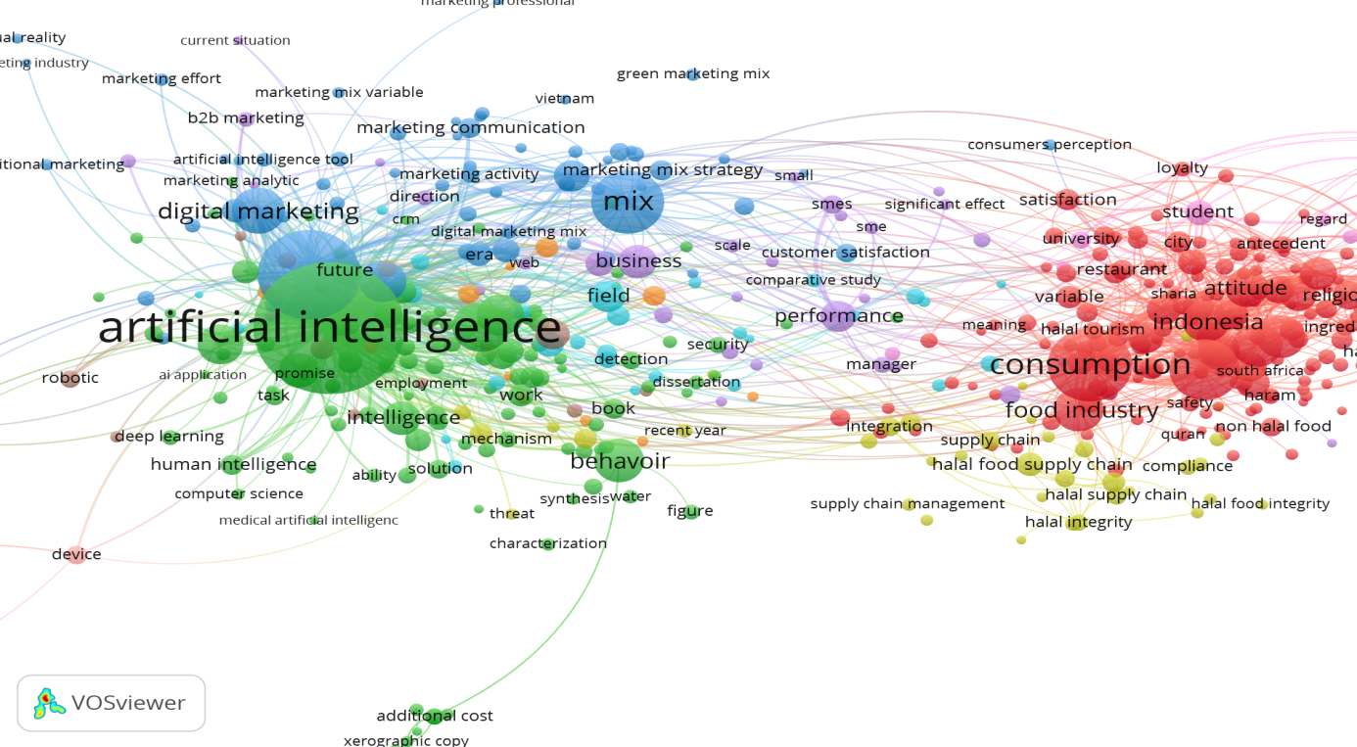
Figure 09. Overlay visualization of the titles and abstract using VOSviewer.

The overlay visualization in figure 10 shows resulted in many publications on consumption patterns and food industry, artificial intelligence, and digital marketing. The red and green and blue components of the colors of the cluster. There were many publications on “halal” in 2016. Furthermore, the visualization of the journal mapping is depicted in bibliometric figure 10. Based on this image, several journal clusters appear to be listed in a glowing circle, indicating the journal's productivity in contributing to publishing its paper on the theme about the consumption patterns and the role of halal food. The bibliometric mapping visualization shows that the map of research development in the consumption patterns field and the role of halal food is divided into 4 clusters.

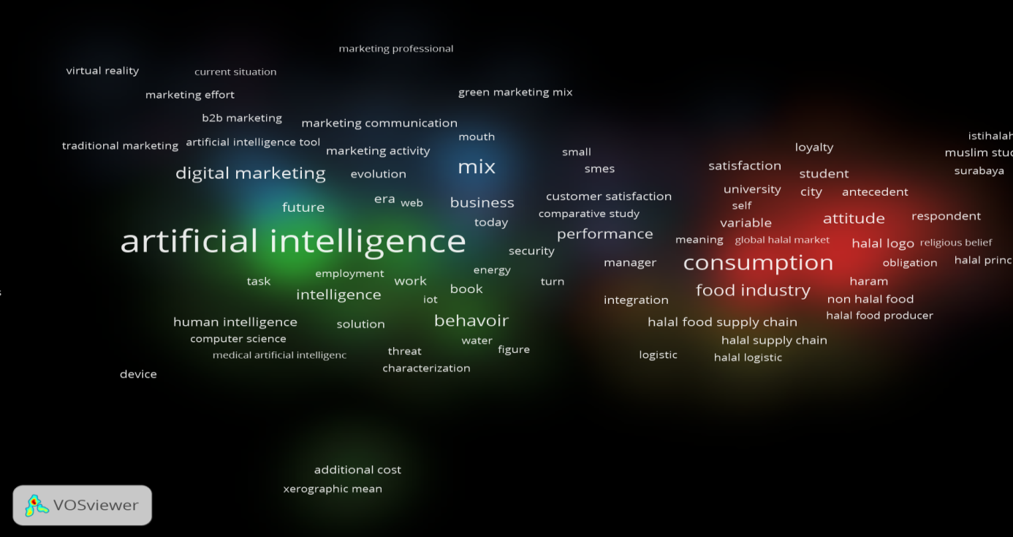
Figure 10. Density visualization of the main cluster with the terms of the titles and abstract using VOSviewer.
The most commonly used keywords highlighted in the density visualization plot as consumption patterns industry, food industry, artificial intelligence, digital Marketing, Green Marketing. In this regard the contributions for this research in adding to the theoretical and practical aspects of the concepts of the manufacturing and service sector are immense and noteworthy.

5. Discussion
The findings provide comprehensive insight into the literature on halal food consumption. This study emphasized the gaps in the literature and suggested directions to advance the understanding of Muslims' or general consumers' behavioral consumption as a contribution to halal food product science.

This study also provides several implications for researchers and practitioners. This research stream shows a strong link between religion and food, and further analysis could be carried out to investigate their link with Marketing Mix. Practically, future authors could verify whether the link with religion is for the benefit of corporate social responsibility. In addition, the same link should be investigated for technology.

Another theoretical implication comes from the method used. This study introduces a robust and structured methodology and thus has direct methodological application to the halal food management sector (Ahmad, Rahman, Othman, & Abidin, (2017). For practitioners, halal food goes beyond being considered an innovation but begins to create innovation within itself. In addition, managers in the food industry could find our results as a tool to ensure excellent halal service in their facilities and promote halal consumption.

This research provides valuable and practical implications. Firstly, it suggests that regulatory bodies and halal-food manufacturers should establish social norms encouraging the intention to purchase halal food. Secondly, manufacturers and marketers can develop marketing strategies to shape consumers' social and religious perceptions when buying halal food. Lastly, this study can benefit food manufacturers and marketers who aim to target health-conscious customers by formulating marketing campaigns tailored to their preferences.

Managerial implications related to the results of this study can focus on the opportunities, challenges, efficiency of intentions, and possible improvements to other embodiment intentions beyond what has been realized in this literature study.

The limitations of this study include using scopus as the sole research database and the possible bias of paper assignment to clusters, even though the authors coded the sample articles independently during the cluster analysis. Halal consumption must be carefully considered in light of the double burden: health should be prioritized. Halal food in the household and encouraging its consumption patterns as an important message for consumers.

The study has identified very influential articles on halal food research consumption patterns and the contribution to understanding the role of artificial intelligence marketing and consumption patterns of halal food research, which is still needed for future directions.

6. Conclusion
One of the most revolutionary aspects of AI is its ability to replace and enhance human thinking capabilities. A particularly disruptive characteristic of modern AI is its capacity to personalize experiences by automatically analyzing vast amounts of data, enabling the prediction of consumer behavior about the consumption patterns of halal food. This advancement represents a significant leap forward in marketing's ability to target individual customers effectively. Artificial intelligence is now an essential component of marketing, and this strategic framework aims to assist marketers in harnessing the advantages of AI intelligence as a mediator in understanding consumption patterns of halal food. The framework explores the various ways in which different AI intelligence can be utilized within marketing strategy, particularly in the context of the 4Ps (product, price, place, and promotion). It identifies the strategic roles that AI can fulfill in marketing. Furthermore, it suggests several intriguing research areas for future exploration, emphasizing the interdisciplinary nature of studying consumption patterns.
Regarding the keyword analysis, words related to the consumption patterns of halal food, such as "artificial intelligence marketing" as "logo halal food", "digital marketing mix," "marketing mix" related words such as "halal tourism," "robotic," "computer science" and
"food industry" is the most appeared word in this field. The keyword analysis also suggests
The topic related to consumption patterns of halal food and artificial intelligence marketing mix becomes developing areas that require further study. Furthermore, this study also proposes a research path that may become the suggestion for further research, including a halal food market, digital marketing, and marketing activity trend. In the last part, some policy recommendations from previous literature are provided with three related factors: consumption, artificial intelligence, and mixed marketing.

In Muslim minority contexts, food consumption is influenced by individual experiences and knowledge. The importance of halal has opened up new possibilities for economic growth in non-Muslim countries, leading to the necessity of certifying, standardizing, and regulating food production. Consequently, the relationship between artificial intelligence marketing and the consumption patterns of halal food can be expanded to include the broader societal implications of halal as a "global assemblage.

The future direction of research for AI on marketing is to enhance predictive marketing models. These models use AI techniques, such as machine learning, deep learning, and natural language processing, to predict customer behavior and preferences. This can help businesses to develop effective marketing strategies and optimize their advertising spend. Another important research area is to develop AI models that provide real-time market insights. These models can analyze massive amounts of data from various sources, such as social media, news articles, and online forums, to identify emerging trends and sentiments. By providing actionable insights in real-time, these models can help businesses to make quick and informed decisions. Additionally, Employ advanced machine learning techniques to identify the optimal price point for halal food products, and explore the use of reinforcement learning for dynamic pricing and inventory management strategies in the halal food market.

6.1 Research Contribution

In summary, this paper contributes to our understanding of the use of AI in marketing by providing a bibliometric analysis for AI marketing, which leverages the collaborative intelligence of AI, marketers, and consumption patterns on halal food and considers AI's implementation from both the marketer's and the consumer's perspectives. It specifies conditions for how marketers and consumers can actively leverage AI at different intelligence levels. This bibliometrics analysis provides a deeper understanding of collaborative intelligence in marketing; marketing stakeholders can maximize the benefits of AI.

By using bibliometric analysis on research in halal food, this study can visualize and trace the field's evolution and distinguish the most productive authors, years, journals, articles, countries, and institutions. Additionally, this paper contributes to the strategic application of AI in marketing by developing a framework that guides the strategic planning of AI in marketing on consumption patterns of the halal industry. Future studies should include other online databases to achieve more comprehensive outcomes and build on the contribution of this article and understanding of the field.

Conflicts of interest/Competing interests
The authors have no conflicts of interest to declare relevant to this article's content.

REFERENCES
Abdullah, W. N. W., Yang, T. A., Sifat, S. A. D., &Zaman, W. (2021). Development of safe halal food management system (SHFMS). Food Control, 127, 108137.
Agarwal, R., Dugas, M., Gao, G. , & Kannan, P. K. (2020). Emerging technologies and analytics for a new era of value-centered marketing in healthcare. Journal of the Academy of Marketing Science, 48(1), 9–23. https://doi.org/10.1007/s11747-019-00692-4
Aguillo, I. F. (2012). Is Google Scholar useful for bibliometrics? A webometric analysis. Scientometrics, 91(2), 343-351.
Ahmad, A. N., Abdul Rahman, R., Othman, M., &Ungku Zainal Abidin, U. F. (2017). Critical success factors affecting the implementation of halal food management systems: Perspective of halal executives, consultants and auditors. Food Control, 74, 70–78. https://doi.org/10.1016/j.foodcont.2016.11.031
Ahmad, A. N., Rahman, R. A., Othman, M., & Abidin, U. F. U. Z. (2017). Critical success factors affecting the implementation of halal food management systems: Perspective of halal executives, consultants and auditors. Food Control, 74, 70-78.
Ahmed, A. (2008). Marketing of halal meat in the United Kingdom: Supermarkets versus local shops. British Food Journal, 110(7), 655–670. https://doi.org/10.1108/00070700810887149
Ahmed, A. S. (2018). The relationship between halal and technology, an approach to consider Halal techniques in the robot revolution and artificial intelligence. Journal of Contemporary Islamic Studies, 4(1), 126-143.
Ajzen, I. (1985). From intentions to actions: A theory of planned behavior (pp. 11-39). Springer Berlin Heidelberg.
Ajzen, I. (1988), Attitudes, Personality and Behavior, Dorsey Press, Chicago, IL
Akın, M. S., & Okumuş, A. (2021). Shaping the consumers' attitudes towards Halal food products in Turkey. Journal of Islamic Marketing, 12(6), 1081-1096.
Ali, J. M., Othman, S., Fadzillah, N. A., & Rahman, N. A. (2021). The Identification of Alcohol Percentage Limit in Halal Food Using Fuzzy Logic. In Enhancing Halal Sustainability: Selected Papers from the 4th International Halal Conference 2019 (pp. 269-275). Springer Singapore.
Ali, M. H., & Suleiman, N. (2018). Eleven shades of food integrity: A halal supply chain perspective. Trends in Food Science and Technology, 71(November 2017), 216–224. https://doi.org/10.1016/j.tifs.2017.11.016
Ali, M. H., Chung, L., Kumar, A., Zailani, S., & Tan, K. H. (2021). A sustainable Blockchain framework for the halal food supply chain: Lessons from Malaysia. Technological Forecasting and Social Change, 170, 120870.
Al-shami, H. A., & Abdullah, S. (2021). Halal food industry certification and operation challenges and manufacturing execution system opportunities. A review study from Malaysia. Materials Today: Proceedings.
Ambali, A. R., & Bakar, A. N. (2014). People's awareness on halal foods and products: potential issues for policymakers. Procedia-Social and Behavioral Sciences, 121, 3-25.
Anshari, M., Fithriyah, M., Polak, P., & Razzaq, A. (2021). Islamic FinTech and artificial intelligence (AI) for assessing creditworthiness. In Artificial Intelligence and Islamic Finance (pp. 48-60). Routledge.
Anwar, M., & Saeed, M. (1996). Promotional tool of marketing: an Islamic perspective. Intellectual Discourse, 4(1&2).
Ashraf, M. A. (2019). Islamic marketing and consumer behavior toward halal food purchase in Bangladesh: An analysis using SEM—Journal of Islamic Marketing.
Ayyub, R. M. (2015). Exploring perceptions of non-Muslims towards Halal foods in UK. British Food Journal, 117(9), 2328-2343.
Awan, H. M., Siddiquei, A. N., & Haider, Z. (2015). Factors affecting Halal purchase intention–evidence from Pakistan's Halal food sector. Management Research Review, 38(6), 640-660.
Aziz, N. N. N., Ismail, Z., Hashim, N., Ibrahim, I., & Jamil, N. A. (2019). The Halal Location Factors and The Importance In Localization. Advances in Transportation and Logistics Research, 2, 516-524.
Bakar, N. A., &Rosbi, S. (2019). Robust Framework of Halal certification process with integration of artificial intelligent method. Journal of Islamic, Social, Economics and Development (JISED), 4(20), 47-55.
Battour, M., Mady, K., Elsotouhy, M., Salaheldeen, M., Elbendary, I., Marie, M., &Elhabony, I. (2022). Artificial intelligence applications in halal tourism to assist Muslim tourist journey. In Proceedings of International Conference on Emerging Technologies and Intelligent Systems: ICETIS 2021 Volume 2 (pp. 861-872). Springer International Publishing.
Battour, M., Mady, K., Salaheldeen, M., Elsotouhy, M., Elbendary, I., &Boğan, E. (2022). AI-enabled technologies to assist Muslim tourists in Halal-friendly tourism. Journal of Islamic Marketing
Battour, M., Salaheldeen, M., & Mady, K. (2021). Exploring innovative marketing opportunities for Halal entrepreneurs in hospitality and tourism industry. In SHS Web of Conferences (Vol. 124, p. 10001). EDP Sciences.
Bonne, K., Vermeir, I., Bergeaud-Blackler, F., & Verbeke, W. (2007). Determinants of halal meat consumption in France. British Food Journal, 109(5), 367–386. https://doi.org/10.1108/0070700710746786
Bux, C., Varese, E., Amicarelli, V., & Lombardi, M. (2022). Halal food sustainability between certification and blockchain: A review. Sustainability, 14(4), 2152.
Davenport, T., Guha, A., Grewal, D., &Bressgott, T. (2020). How artificial intelligence will change the future of marketing. Journal of the Academy of Marketing Science,
Denyingyhot, A., Phraephaisarn, C., Vesaratchavest, M., Dahlan, W., &Keeratipibul, S. (2021). A new tool for quality control to monitor contamination of six non-halal meats in food industry by multiplex high-resolution melting analysis (HRMA). NFS Journal, 25, 31-40.
Djermani, F., &Hajimia, H. (2021). Artificial Intelligence Effect on Marketing Mix. JurnalAplikasiManajemen, Ekonomi dan Bisnis, 6(1), 72-76.
Dulla, N., Mishra, S., & Swain, S. C. (2021). Global Exploration on Bibliometric Research Articles: A Bibliometric Analysis. Libr. Philos. Pract, 1, 1-26.
Fadillah, H. N., Ridlwan, A. A., Suryaningsih, S. A., &Indrarini, R. (2023). Muslim Millennial's Buying Behavior of Halal Food & Beverage in Indonesia: The Mediating Effect of Purchase Intention. Amwaluna: Jurnal Ekonomi dan Keuangan Syariah, 7(1), 11-28.
Fuseini, A., Hadley, P., & Knowles, T. (2021). Halal food marketing: an evaluation of UK halal standards. Journal of Islamic Marketing, 12(5), 977-991.
Gazali, H. M., Jumadi, J., Ramlan, N. R., Abd Rahmat, N., Uzair, S. N. H. M., & Mohid, A. N. (2020). Application of Artificial Intelligence (AI) in Islamic Investments. Journal of Islamic Finance, 9(2), 70-78.
George, A. S., & George, A. H. (2023). A Review of ChatGPT AI's Impact on Several Business Sectors. Partners Universal International Innovation Journal, 1(1), 9-23.
Grewal, D., Noble, S. M., Roggeveen, A. L., &Nordfalt, J. (2020). The future of in-store technology. Journal of the Academy of Marketing Science, 48(2), 96–113.
Hair, J. F., Ringle, C. M., & Sarstedt, M. (2011). PLS-SEM: Indeed a silver bullet. Journal of Marketing theory and Practice, 19(2), 139-152.
Halimi, F. F., Gabarre, S., Rahi, S., Al-Gasawneh, J. A., & Ngah, A. H. (2022). Modelling Muslims' revisit intention of non-halal certified restaurants in Malaysia. Journal of Islamic Marketing, 13(11), 2437-2461.
Hamid, R., Sentryo, I., & Hasan, S. (2020). Online learning and its problems in the Covid-19 emergency period. Jurnal Prima Edukasia, 8(1), 86-95.
Handayani, DI, Masudin, I., Haris, A., &Restuputri, DP (2022). Ensuring the halal integrity of the food supply chain through halal suppliers: a bibliometric review. Journal of Islamic Marketing, 13 (7), 1457-1478.
Helmi, H. (2023, February). Legal protection against consumer guarantee of halal products in entering the era of the industrial revolution 5.0. In The 5nd International Conference And Call Paper (Vol. 5, No. 1).
Hendijani F, M., & Seyyed Amiri, N. (2018). The effect of entrepreneurial marketing on halal food SMEs performance. Journal of Islamic Marketing, 9 (3), 598-620.
Hidayat, N., Al Hakim, M. F., &Jumanto, J. (2021). Halal Food Restaurant Classification Based on Restaurant Review in Indonesian Language Using Machine Learning. Scientific Journal of Informatics, 8(2), 314-319.
Hossain, M. S., Rahman, M. F., Uddin, M. K., & Hossain, M. K. (2022). Customer sentiment analysis and prediction of halal restaurants using machine learning approaches. Journal of Islamic Marketing, (ahead-of-print).
Huang, M. H., & Rust, R. T. (2021). A strategic framework for artificial intelligence in marketing. Journal of the Academy of Marketing Science, 49(1), 30–50. https://doi.org/10.1007/s11747-020-00749-9
Ismoyowati, D. (2015). Halal food marketing: a case study on consumer behavior of chicken-based processed food consumption in central part of Java, Indonesia. Agriculture and Agricultural Science Procedia, 3, 169-172.
Khalek, A. A. (2014). Young Consumers' Attitude towards Halal Food Outlets and JAKIM's Halal Certification in Malaysia. Procedia - Social and Behavioral Sciences, 121(September 2012), 26–34. https://doi.org/10.1016/j.sbspro.2014.01.1105
Jamal, A., & Sharifuddin, J. (2015). Perceived value and perceived usefulness of halal labeling: The role of religion and culture. Journal of Business research, 68(5), 933-941.
Liu, Xiao, Singh, P. V., & Srinivasan, K. (2016). A structured analysis of unstructured big data by leveraging cloud computing. Marketing Science, 35(3), 363–388. https://doi.org/10.1287/mksc.2015.0972
Mabkhot, H. (2023). Factors Affecting the Sustainability of Halal Product Performance: Malaysian Evidence. Sustainability, 15(3), 1850.
Martínez-López, F. J., & Casillas, J. (2013). Artificial intelligence-based systems applied in industrial marketing: An historical overview, current and future insights. Industrial Marketing Management, 42(4), 489–495. https://doi.org/10.1016/j.indmarman.2013.03.001
Mat, N. K. N., Sulaiman, Y., Abdghani, N. H., & Mohamad, M. (2020). Halal consumption determinants: The mediating role of risk perception and Muslim lifestyle. Malaysian Journal of Consumer and Family Economics, 24(January), 63–78.
Mathew, V. N. (2014). Acceptance on halal food among non-Muslim consumers. Procedia-Social and Behavioral Sciences, 121, 262-271.
Mondal, S., Das, S., & Vrana, V. G. (2023). How to Bell the Cat? A Theoretical Review of Generative Artificial Intelligence towards Digital Disruption in All Walks of Life. Technologies, 11(2), 44.
Mukherjee, A., Rajendran, S. D., & Wahab, S. N. (2022). Technology Strategy in Boosting Halal Tourism Activities. In Technology Application in Aviation, Tourism and Hospitality: Recent Developments and Emerging Issues (pp. 41-56). Singapore: Springer Nature Singapore.
Naeem, S., Ayyub, R. M., Ishaq, I., Sadiq, S., & Mahmood, T. (2020). Systematic literature review of halal food consumption-qualitative research era 1990-2017. Journal of Islamic Marketing, 11(3), 687-707.
Nawi, A., Yaakob, M. F. M., Ren, C. C., Khamis, N. Y., &Tamuri, A. H. (2021). A Preliminary Survey of Muslim Experts' Views on Artificial Intelligence. Islamiyyat, 43(2), 3-16.
Nizar, N. N. A., Abidin, S. A. S. Z., & Taib, M. N. (2023, March). Smart Data for Sustainable Halal Supply Chain in Kuala Lumpur: A Proposal. In 2023 19th IEEE International Colloquium on Signal Processing & Its Applications (CSPA) (pp. 174-178). IEEE.
Noor, N. (2022). Halal Service Marketing: A Strategic Perspective. In Strategic Islamic Marketing: A Roadmap for Engaging Muslim Consumers (pp. 11-29). Cham: Springer International Publishing.
Pham, Q. V., Nguyen, D. C., Huynh-The, T., Hwang, W. J., & Pathirana, P. N. (2020). Artificial Intelligence (AI) and Big Data for Coronavirus (COVID-19) Pandemic: A Survey on the State-of-the-Arts. IEEE Access, 8(April), 130820–130839. https://doi.org/10.1109/ACCESS.2020.3009328
Rabbani, M. R., Hassan, M. K., Khan, S., & Muneeza, A. (2022). A Fintech-Based Zakat Model Using Artificial Intelligence. In FinTech in Islamic Financial Institutions: Scope, Challenges, and Implications in Islamic Finance (pp. 49-63). Cham: Springer International Publishing.
Rabbani, M. R., Sarea, A., Khan, S., & Abdullah, Y. (2022). Ethical concerns in artificial intelligence (AI): The role of RegTech and Islamic finance. In Artificial Intelligence for Sustainable Finance and Sustainable Technology: Proceedings of ICGER 2021 1 (pp. 381-390). Springer International Publishing.
Rakhmad, A. A. N., Kurniawan, D. T., Prameka, A. S., & Hidayat, W. N. (2023). A User-Centered Design (UCD) approach to designing and building halal tourism application to advance halal tourism in East Java. In Reinforcement of the Halal Industry for Global Integration Revival 36-42
Ramli, M. A., Abd Razak, M. A., & Jaafar, M. H. (2023). Understanding non-Muslims' reluctance to halal food: a systematic review. Journal of Islamic Marketing, 14(2), 544-561.
Rehman, A. (2022). Halal Travel “2.0” and Beyond COVID-19. In Strategic Islamic Marketing: A Roadmap for Engaging Muslim Consumers (pp. 163-181). Cham: Springer International Publishing.
Rejeb, A., Rejeb, K., Zailani, S., Treiblmaier, H., & Hand, K. J. (2021). Integrating the Internet of Things in the halal food supply chain: A systematic literature review and research agenda. Internet of Things, 13, 100361.
Roberts-Lombard, M., Mvane, A., Makhathini, B., Muller, D., Lo, I., & Jaiyeoba, O. (2022). The Attitude and Behavioural Intentions of Muslim Fast Food Customers in a Southern African Market Environment. African Journal of Business and Economic Research, 17(1), 7.
Said, N. F. M., Othman, R., Sulaiman, W. S. H. W., Hatta, F. A. M., & Ramya, R. (2023). The Benefits, Challenges, and Opportunities of Halal Gastronomy Tourism–A Review Perspective. Halalpshere, 3(1), 90-96.
Salaheldeen, M. (2022). Opportunities for Halal Entrepreneurs in the Islamic digital economy: future and trends from a cultural entrepreneurship perspective. In Cultural Entrepreneurship: New Societal Trends (pp. 95-107). Singapore: Springer Nature Singapore.
Shahid, M. Z., & Li, G. (2019). Impact of Artificial Intelligence in Marketing: A Perspective of Marketing Professionals of Pakistan. Global Journal of Management and Business Research: E-Marketing, 19(2), 26–33.
Shahid, S., Parray, M. A., Thomas, G., Farooqi, R., & Islam, J. U. (2023). Determinants of Muslim consumers' halal cosmetics repurchase intention: an emerging market's perspective. Journal of Islamic Marketing, 14(3), 826-850.
Soesilowati, E. S. (2011). Business opportunities for halal products in the global market: Muslim consumer behaviour and halal food consumption. Journal of Indonesian Social Sciences and Humanities, 3, 151-160.
Sulaiman, Y., Rahman, M. A., & Mat, N. K. N. (2020). A conceptual paper on a re-patronage model for Syariah compliance E-lodging industry: The mediating effect of artificial intelligence. WSEAS Transactions on Business and Economics, 17, 153-163.
Sulong, Z., Abdullah, M., & Chowdhury, M. A. F. (2022). Halal tourism demand and firm performance forecasting: new evidence from machine learning. Current Issues in Tourism, 1-17.
Syahnur, M. H., & Bahari, A. F. (2023). Determinants of Neighborhood References, and Environmental Stimuli on Purchasing Decisions for Halal Products for Consumers. Golden Ratio of Marketing and Applied Psychology of Business, 3(1), 20-33.
Taherdoost, H., &Madanchian, M. (2023). Artificial Intelligence and Sentiment Analysis: A Review in Competitive Research. Computers, 12(2), 37.
Tama, H. A., & Voon, B. H. (2014). Components of customer emotional experience with halal food establishments. Procedia-Social and Behavioral Sciences, 121, 272-280.
Tan, A., Gligor, D., & Ngah, A. (2022). Applying blockchain for halal food traceability. International Journal of Logistics Research and Applications, 25(6), 947-964.
Tarmizi, H. A., Kamarulzaman, N. H., Abd Latiff, I., & Abd Rahman, A. (2014). Factors influencing readiness towards halal logistics among food-based logistics players in Malaysia. UMK Procedia, 1, 42-49.
Tieman, M. (2011). The application of Halal in supply chain management: In-depth interviews. Journal of Islamic Marketing, 2(2), 186–195. https://doi.org/10.1108/17590831111139893
Tieman, M., & Ghazali, M. C. (2014). Halal control activities and assurance activities in halal food logistics. Procedia-Social and Behavioral Sciences, 121, 44-57.
Thomas, A. M., White, G. R., Plant, E., & Zhou, P. (2017). Challenges and practices in Halal meat preparation: a case study investigation of a UK slaughterhouse. Total Quality Management & Business Excellence, 28(1-2), 12-31.
Wan-Hassan, W. M., & Awang, K. W. (2009). Halal food in New Zealand restaurants: An exploratory study. International Journal of Economics and Management, 3(2), 385-402.
Wilson, J. A. J., Belk, R. W., Bamossy, G. J., Sandikci, Ö., Kartajaya, H., Sobh, R., Liu, J., & Scott, L. (2013). Crescent marketing, Muslim geographies and brand Islam: Reflections from the JIMA Senior Advisory Board. Journal of Islamic Marketing, 4(1), 22–50. https://doi.org/10.1108/17590831311306336
Wilson, J. A., & Liu, J. (2011). The challenges of Islamic branding: navigating emotions and halal. Journal of Islamic Marketing, 2(1), 28-42.
Yousaf, S., &Xiucheng, F. (2018). Halal culinary and tourism marketing strategies on government websites: A preliminary analysis. Tourism Management, 68, 423-443
Yunus, N. S. N. M., Rashid, W. E. W., Ariffin, N. M., & Rashid, N. M. (2014). Muslim's purchase intention towards non-Muslim's Halal packaged food manufacturer. Procedia-Social and Behavioral Sciences, 130, 145-154.
Zulfakar, M. H., Anuar, M. M., & Ab Talib, M. S. (2014). Conceptual Framework on halal food supply chain integrity enhancement. Procedia-Social and Behavioral Sciences, 121, 58-67.

