Laser Spectral Characteristics for Various Modern Fiber Optic Cavity Layouts

Introduction
Laser spectra play a vital role in the performance and effectiveness of laser systems across various applications, including scientific [1], industrial [2], and medical fields [3]. They determine the wavelengths, central frequencies, and bandwidths at which lasers emit light, which directly impacts laser-matter interactions. Different materials, such as biological tissues, gases, and solid targets, have unique optical absorption properties. For biomedical applications such as tissue imaging and laser surgery, lasers must operate within the optical therapeutic window, which ranges from 700 to 1100 nanometers. This spectral region allows deeper light penetration into tissues and reduces scattering, making it ideal for medical use [4]. In gas spectroscopy and sensing, the laser spectrum must match the absorption profiles of target molecules in the mid-infrared range (2–5 µm) to enable accurate detection and analysis. In the realm of optical communications, controlling the laser spectrum in the C-band (1530–1625 nm) and L-band enables higher data transmission rates and minimises signal degradation, as these bands are compatible with low-loss silica fibers [5].
The laser spectrum is also a key factor in ultrafast photonics, where short pulse durations in the picosecond-to-femtosecond range require broad spectral bandwidths. This relationship is critical for applications such as time-resolved spectroscopy, multiphoton microscopy, and terahertz generation, all of which demand high temporal resolution and nonlinear light-matter interactions [6]. The spectral characteristics of the laser influence the selection of nonlinear optical materials for pulse generation, including graphene [7], black phosphorus (BP) [8], transition metal dichalcogenides (TMDs), organic material [9, 10], and metal oxides [11], each with unique nonlinear absorption properties and operational spectral ranges [12-15]. A mismatch between the laser spectrum and the absorber's response range can result in inefficient modulation, unstable pulse generation, or reduced performance. Therefore, laser spectra are not passive attributes; they actively determine laser system design, material selection, and the feasibility of specific applications [16-18]. Spectral control enables precise management of energy delivery, penetration depth, and wavelength tuning, establishing the laser spectrum as a critical parameter in modern photonics.
Ultrafast Lasers Spectra
In laser pulse generation, the spectrum refers to the set of wavelengths or frequencies that constitute the pulse [19]. The Fourier transform principle establishes the relationship between pulse duration and spectral width: a shorter pulse in the time domain corresponds to a broader spectrum in the frequency domain [20, 21]. The time-bandwidth product quantifies this relationship and defines the minimum achievable pulse duration for a given spectral width. Ultrashort pulses, including picosecond and femtosecond pulses, require a correspondingly broad optical spectrum [22, 23]. This principle is fundamental in the design of mode-locked lasers and ultrafast optical systems, where precise control of spectral properties is essential to achieve the desired temporal characteristics [24].
The gain medium of a laser fundamentally determines the initial spectral bandwidth available for pulse generation. Variations in material composition alter the gain bandwidth through their specific energy transitions. Rare-earth-doped fibres or crystals with narrow gain bandwidths limit the achievable pulse duration, while materials with broader gain profiles support the generation of ultrashort pulses [25]. The gain spectrum establishes the fundamental constraints on laser output. Mode competition within this bandwidth produces distinct spectral shapes. A broader gain bandwidth allows for more longitudinal modes within the cavity, resulting in a wider spectrum and shorter pulses during mode locking [26, 27].
Nonlinear optical effects contribute to spectral broadening during the formation of laser pulses. As intense pulses propagate through nonlinear materials, such as fibres or crystals, they generate new spectral components. Self-phase modulation (SPM) alters the refractive index in response to pulse intensity [28], while additional effects, including Raman scattering [29], cross-phase modulation [30], and four-wave mixing [31], further expand the spectrum. These nonlinear phenomena are essential for supercontinuum (SC) generation, pulse shaping and broadening within laser cavities and external pulse compression [32].
Spectral filtering and dispersion control are employed to refine and stabilise the laser pulse spectrum. Devices such as saturable absorbers (SA), chirped mirrors, prism pairs, and fibre Bragg gratings (FBG) selectively transmit or reflect specific wavelengths, thereby shaping the final spectrum and pulse profile [33, 34]. The dispersion characteristics of the laser cavity or external optics influence the phase relationships among frequency components, affecting both the spectrum and pulse duration [6]. Accurate dispersion management is essential for preserving the coherence and compressibility of broad spectra, especially in femtosecond lasers. In summary, the laser pulse spectrum results from the interplay of gain, nonlinearity, dispersion, and filtering, all of which require precise adjustment to achieve stable, high-quality pulses.
Ultrafast Lasers Spectra Types
The laser spectrum reveals the underlying mechanisms governing pulse formation and propagation within a laser cavity. Spectral shapes are strongly influenced by the interplay of dispersion, nonlinearity, gain, loss, and cavity configuration. Transform-limited pulses in low-intensity or dispersion-balanced systems typically exhibit a symmetric Gaussian spectrum, indicating minimal nonlinear effects. In soliton lasers, a sech² spectral profile is a hallmark of fundamental soliton operation. This spectrum arises from the balance between anomalous dispersion and self-phase modulation (SPM), producing stable, nearly chirp-free pulses. At higher pulse energies, higher-order solitons form and display breathing dynamics, leading to periodically varying spectral structures [35].
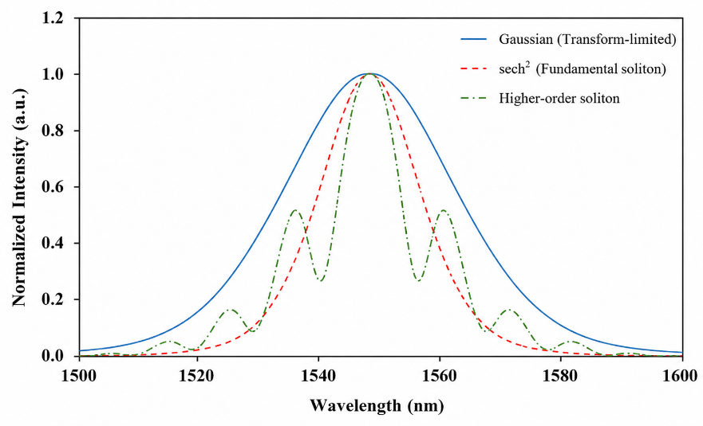
Fig.1. a sech² spectral profile
Different spectral profiles are produced by more complicated regimes beyond these typical solitons. Fig. 2 demonstrate the combined effects of dispersion, SPM, spectral filtering, and gain-loss dynamics result in broad, asymmetric spectra with sharp edges when dissipative solitons (DSs) are created in all-normal-dispersion (ANDi) fibre lasers [36]. In contrast, although noise-like pulse solitons (NLPS) are temporally incoherent, they provide large peak powers appropriate for nonlinear optics applications. NLPS arise from unstable mode-locking situations and produce incredibly wide, noisy, and irregular spectra. Furthermore, the severe nonlinear widening of ultrashort pulses in photonic crystal fibers (PCF), where SPM, Raman scattering, and soliton fission contribute to significant spectrum expansion, is employed in spectroscopy and OCT, resulting in SC spectra that are unusually broad and often flat [37-39]. In addition, a square-shaped or flat-top spectrum is typically created by using filters or spectral shaping techniques, representing rectangular time-domain pulses that are significant in coherent optical systems [40].
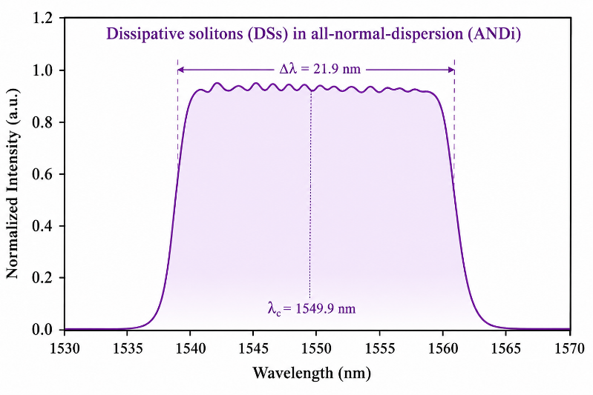
Fig. 2. Dissipative solitons (DSs) in all-normal-dispersion (ANDi).
Similarly, the severe nonlinear widening of ultrashort pulses in PCF, where SPM, Raman scattering, and soliton fission contribute to the significant spectrum expansion employed in spectroscopy and OCT, results in SC spectra, as shown in Fig. 3, which are unusually broad and often flat. In contrast, a square-shaped or flat-top spectrum is typically created by using filters or spectral shaping techniques, representing rectangular time-domain pulses that are significant in coherent optical systems. While, dispersion-managed solitons, designed for long-distance transmission with minimal distortion, have broadened spectra that resemble a combination of sech² and Gaussian shapes. These solitons are created in cavities with alternating normal and anomalous dispersion segments [41].
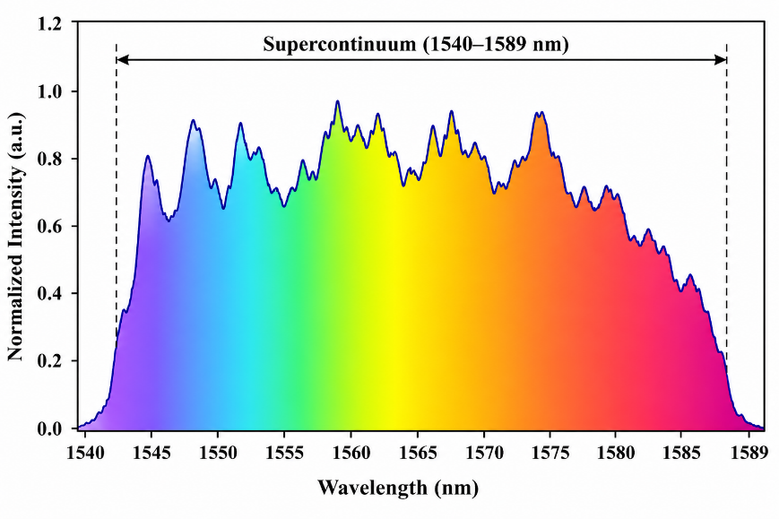
Fig. 3. Supercontinuum spectrum with high broadband spectral
In [42], the study reported sech² spectrum with centre 1893 nm, 3-dB bandwidth ≈5.1 nm, spectrum fitted to sech² (when citing durations, they expressly assume sech pulse). Still centred at around 1893 nm, the dissipative-soliton state has steep edges and an edge-to-edge bandwidth of about 9.6 nm (not sech²). Kerr nonlinearity (SPM) is balanced by anomalous dispersion in the net-anomalous dispersion region, in which the conventional soliton works. A sech² spectral envelope is obtained by Nonlinear Schrödinger Equation (NLSE) to design the hyperbolic-secant temporal shape of the soliton. In line with traditional solitons, the article verifies near-transform-limited Time–Bandwidth Product (TBP) and Kelly sidebands, which are characteristic soliton features, assuming a sech² profile. Through the combination of intracavity birefringent filtering and polarization controller modifications, the same cavity can transition to DS operation. The spectra of DSs have sharp edges (not sech²) because of their strong chirp and filtering/loss shaping. The pulse is not a straightforward NLSE soliton because of the intracavity birefringent filter and polarization-dependent loss, which alter the effective pulse shape. In [43], reports three devices with multi-gigahertz repetition rate passively mode-locked operation, featuring wavelength centres at around 1560 nm (two short cavities) and 1600 nm (longer device). The manuscript reported pulse lengths of around 0.68 to 0.94 ps and TBPs that are near the transform limit for sech² (TBP = 0.33 to 0.41), and they matched the output spectra well with a sech² profile for all three lasers. Intracavity dispersion and nonlinearity enable the creation of brief pulses approaching the NLSE soliton domain, while the saturable absorber (CNT film on mirror) begins pulse formation in these tiny Fabry-Pérot fibre lasers, which operate similarly to traditional mode-locked soliton sources. Both the straight sech² fitting and the near-transform-limited TBP show a temporal sech profile → sech² spectral shape with low chirp. The FFPL's short cavities and comparatively straightforward dispersion encourage soliton-like NLSE pulses.
The spectral characteristics of dissipative solitons (DSs), dark solitons, birefringence-managed solitons (BMSs), and supercontinuum (SC) generation are strongly governed by cavity dispersion, nonlinear effects, polarization dynamics, and laser design. In an EDF-based cavity operating near 1560 nm, birefringence-managed solitons arise when cavity birefringence is carefully controlled, producing a narrow quasi-sech² spectrum with sharp sidebands due to phase-matching effects. Although the cavity can support ANDi dissipative solitons with broad chirped spectra, birefringence-induced interference confines the spectrum and suppresses the typical wide parabolic profile. In contrast, a Yb-doped ANDi fiber laser operating at 1036.2–1043.4 nm generates dissipative solitons with broad spectral widths of approximately 12.5 nm and steep spectral edges. These spectra result from the balance of normal dispersion, self-phase modulation (SPM), gain, loss, and nonlinear polarization evolution (NPE), which acts as an artificial spectral filter. Unlike the EDF system, the Yb-doped laser exhibits the characteristic broad dissipative-soliton spectrum without significant sidebands [44, 45].
Supercontinuum generation is strongly affected by pump wavelength, fiber dispersion, nonlinearity, pulse duration, and propagation dynamics. An Er-fiber laser pumped at 1570 nm and coupled into a hybrid highly nonlinear fiber generated an octave-spanning supercontinuum extending from approximately 1010 to 2400 nm through the combined effects of SPM, optical wave breaking, and soliton dynamics. In another study, coherent intracavity supercontinuum generation centered at 1551 nm produced a spectral span of 1224–1832 nm by launching a high-order soliton into highly nonlinear fiber, where strong self-compression enhanced SPM and dispersive-wave generation. Although the intracavity spectrum was narrower than that of free-propagating systems, it maintained excellent coherence across most of the generated bandwidth, making it highly suitable for broadband and coherent light applications [46-48].
Table 1 compares the spectral characteristics of various fiber laser systems, including soliton, dark soliton, continuous-wave (CW), mode-locked, and supercontinuum (SC) spectra. The comparison considers gain medium, center wavelength, and spectral bandwidth. EDF-based lasers generate soliton and dark soliton spectra in the 1530–1600 nm range with bandwidths of 4.8–5.4 nm. TmDF lasers support both narrowband CW emission around 1940 nm and broader mode-locked spectra spanning approximately 1878–1926 nm. YDFA-based systems produce supercontinuum spectra extending from about 630 nm to beyond 2000 nm, offering extremely wide bandwidths. Overall, the results highlight the trade-off between narrowband spectral precision and broadband operational versatility among different fiber laser configurations.
Table 1: General comparison of various spectra types.
Ref. | Spectrum Type | Gain medium | Central (λ) (nm) | Spectrum Bandwidth (nm) (Δ λ)
[49] | Soliton (sech²) | TmDF | 1885 | 6
[50] | Dark-soliton | EDF | 1530 | 4.8
[51] | Soliton (sech²) | EDF | 1598.94 | 5.4
[52] | Continuous-wave narrowline | TmDF | 1940.32 | 0.05
[53] | Mode-locked oscillation | TmDF | ~1878-1926 | ~23-64
[54] | SC | YDFA | 1060 | 630-2000
[55] | SC | YDFA | N/R | 690-2350

Conclusion
A laser's spectrum is crucial to its operation and practical use. Wavelength, bandwidth, and shape directly affect light–material interactions, pulse fluctuations, and system stability. This research demonstrates that spectral behavior depends on balancing gain width, dispersion, nonlinear effects, and filters, all of which are precisely tuned for steady pulses and optimal performance. Comparing erbium-, thulium-, and ytterbium-doped fibre lasers reveals widely varying outputs, from narrow, steady light to broad, SC light. These cases demonstrate that spectrum management is an intentional and integral part of laser design. With careful design, fibre lasers can be tailored for single or multiple colours, serving communications, sensing, imaging, and high-speed photonics.
References
[1] A. A. Al-Azzawi et al., "A 95× 40 Gb/s DWDM transmission system using broadband and flat gain amplification of promoted parallel EDFA," Optical and Quantum Electronics, vol. 54, no. 12, p. 870, 2022.
[2] X. Chen, Y. Xu, N.-K. Chen, S. Shy, and H.-C. Chui, "In-situ depth measurement of laser micromachining," in Photonics, 2021, vol. 8, no. 11: MDPI, p. 493.
[3] M. Skórczakowski et al., "Mid-infrared Q-switched Er: YAG laser for medical applications," Laser physics letters, vol. 7, no. 7, p. 498, 2010.
[4] R. Liu, Y. Peng, L. Lu, S. Peng, T. Chen, and M. Zhan, "Near-infrared light-triggered nano-prodrug for cancer gas therapy," (in eng), J Nanobiotechnology, vol. 19, no. 1, p. 443, Dec 23 2021, doi: 10.1186/s12951-021-01078-x.
[5] G. P. Agrawal, Fiber-optic communication systems. John Wiley & Sons, 2012.
[6] T. Brabec and F. Krausz, "Intense few-cycle laser fields: Frontiers of nonlinear optics," Reviews of Modern Physics, vol. 72, no. 2, p. 545, 2000.
[7] F. Bonaccorso, Z. Sun, T. Hasan, and A. Ferrari, "Graphene photonics and optoelectronics," Nature photonics, vol. 4, no. 9, p. 611, 2010.
[8] N. Deng et al., "Black phosphorus junctions and their electrical and optoelectronic applications," Journal of Semiconductors, vol. 42, no. 8, p. 081001, 2021.
[9] M. M. Najm, M. N. Abdullah, A. A. Almukhtar, B. A. Hamida, M. Yasin, and S. W. Harun, "8-HQCdCl2H2O as an organic Q-switcher in erbium laser cavity," Optoelectronics letters, vol. 19, no. 11, pp. 681-685, 2023.
[10] M. M. Najm et al., "Effect of output coupling ratio on performance of Q-switched fiber laser based on MgQ2 organic saturable absorber," Optical Fiber Technology, vol. 93, p. 104287, 2025.
[11] A. S. Al-Hiti, A. H. Al-Masoodi, M. M. Najm, M. Yasin, and S. W. Harun, "Passively mode-locked laser at 1μm region based on tungsten trioxide (WO₃) saturable absorber," Optik, vol. 231, p. 166377, 2021, doi: 10.1016/j.ijleo.2021.166377.
[12] Q. Bao et al., "Atomic-Layer Graphene as a Saturable Absorber for Ultrafast Pulsed Lasers," Advanced Functional Materials, vol. 19, no. 19, pp. 3077-3083, 2009, doi: https://doi.org/10.1002/adfm.200901007.
[13] J. Sotor, G. Sobon, W. Macherzynski, P. Paletko, and K. M. Abramski, "Black phosphorus saturable absorber for ultrashort pulse generation," Applied Physics Letters, vol. 107, no. 5, 2015.
[14] K. Thakar and S. Lodha, "Optoelectronic and photonic devices based on transition metal dichalcogenides," Materials Research Express, vol. 7, no. 1, p. 014002, 2020.
[15] Y.-Y. Huang and L.-Y. Lin, "Synthesis of ternary metal oxides for battery-supercapacitor hybrid devices: influences of metal species on redox reaction and electrical conductivity," ACS Applied Energy Materials, vol. 1, no. 6, pp. 2979-2990, 2018.
[16] R. I. Woodward et al., "Wideband saturable absorption in few-layer molybdenum diselenide (MoSe₂) for Q-switching Yb-, Er- and Tm-doped fiber lasers," Opt. Express, vol. 23 15, pp. 20051-61, 2015.
[17] R. I. Woodward et al., "Tunable Q-switched fiber laser based on saturable edge-state absorption in few-layer molybdenum disulfide (MoS2)," Opt. Express, vol. 22, no. 25, pp. 31113-31122, 2014/12/15 2014, doi: 10.1364/OE.22.031113.
[18] P. Zhang, K. Dimyati, B. Nizamani, M. M. Najm, M. Yasin, and S. W. Harun, "Ultrashort pulse generation in all-fiber erbium-doped fiber cavity with thulium doped fiber saturable absorber," Optics & laser technology, vol. 149, p. 107888, 2022.
[19] J.-C. Diels and W. Rudolph, "1 - Fundamentals," in Ultrashort Laser Pulse Phenomena (Second Edition), J.-C. Diels and W. Rudolph Eds. Burlington: Academic Press, 2006, pp. 1-60.
[20] "Principles of Mode-Locking," in Ultrafast Optics, 2009, pp. 32-84.
[21] A. Monmayrant, S. Weber, and B. Chatel, "A newcomer's guide to ultrashort pulse shaping and characterization," Journal of Physics B: Atomic, Molecular and Optical Physics, vol. 43, no. 10, p. 103001, 2010/05/05 2010, doi: 10.1088/0953-4075/43/10/103001.
[22] T. Brabec and F. Krausz, "Intense few-cycle laser fields: Frontiers of nonlinear optics," Reviews of Modern Physics, vol. 72, no. 2, pp. 545-591, 04/01/ 2000, doi: 10.1103/RevModPhys.72.545.
[23] U. Keller, "Ultrafast solid-state lasers," in The European Conference on Lasers and Electro-Optics, 2000: Optica Publishing Group, p. CMB3.
[24] H. A. Haus, "Mode-locking of lasers," IEEE Journal of Selected Topics in Quantum Electronics, vol. 6, no. 6, pp. 1173-1185, 2002.
[25] S. Yamashita and S. Y. Set, "Advances and challenges of mode-locked fiber lasers," Optics Communications, p. 131406, 2025.
[26] U. Keller, "Ultrafast solid-state laser oscillators: a success story for the last 20 years with no end in sight," Applied Physics B, vol. 100, no. 1, pp. 15-28, 2010.
[27] M. M. Najm et al., "Performance investigation of erbium-doped fiber laser based on cadmium chloride hydrate saturable absorber," Optical and Quantum Electronics, vol. 55, no. 8, p. 682, 2023.
[28] G. P. Agrawal, "Chapter 4 - Self-Phase Modulation," in Nonlinear Fiber Optics (Fourth Edition), G. P. Agrawal Ed. San Diego: Academic Press, 2006, pp. 79-119.
[29] G. P. Agrawal, "Chapter 8 - Stimulated Raman Scattering," in Nonlinear Fiber Optics (Fourth Edition), G. P. Agrawal Ed. San Diego: Academic Press, 2006, pp. 274-328.
[30] G. P. Agrawal, "Chapter 7 - Cross-Phase Modulation," in Nonlinear Fiber Optics (Fourth Edition), G. P. Agrawal Ed. San Diego: Academic Press, 2006, pp. 226-273.
[31] G. P. Agrawal, "Chapter 10 - Four-Wave Mixing," in Nonlinear Fiber Optics (Fourth Edition), G. P. Agrawal Ed. San Diego: Academic Press, 2006, pp. 368-423.
[32] G. Genty, S. Coen, and J. M. Dudley, "Fiber supercontinuum sources (Invited)," J. Opt. Soc. Am. B, vol. 24, no. 8, pp. 1771-1785, 2007/08/01 2007, doi: 10.1364/JOSAB.24.001771.
[33] P. Vasa, C. Ropers, R. Pomraenke, and C. Lienau, "Ultra‐fast nano‐optics," Laser & Photonics Reviews, vol. 3, no. 6, pp. 483-507, 2009.
[34] A. M. Weiner, Ultrafast optics. John Wiley & Sons, 2011.
[35] W. Renninger, A. Chong, and F. Wise, "Dissipative solitons in normal-dispersion fiber lasers," Physical Review A—Atomic, Molecular, and Optical Physics, vol. 77, no. 2, p. 023814, 2008.
[36] A. Chong, L. G. Wright, and F. W. Wise, "Ultrafast fiber lasers based on self-similar pulse evolution: a review of current progress," Reports on Progress in Physics, vol. 78, no. 11, p. 113901, 2015.
[37] C.-S. Brès, A. Della Torre, D. Grassani, V. Brasch, C. Grillet, and C. Monat, "Supercontinuum in integrated photonics: generation, applications, challenges, and perspectives," Nanophotonics, vol. 12, no. 7, pp. 1199-1244, 2023.
[38] J. M. Dudley, G. Genty, and S. Coen, "Supercontinuum generation in photonic crystal fiber," Reviews of modern physics, vol. 78, no. 4, pp. 1135-1184, 2006.
[39] J. Hofmann, R. Scheibinger, and M. A. Schmidt, "Characterizing temporal stability of supercontinuum generation in higher-order modes supported by liquid-core fibers," Scientific Reports, vol. 14, no. 1, p. 23947, 2024.
[40] W. Du, H. Li, Y. Lyu, C. Wei, and Y. Liu, "Period doubling of dissipative-soliton-resonance pulses in passively mode-locked fiber lasers," Frontiers in Physics, vol. 7, p. 253, 2020.
[41] J. Peng, L. Zhan, Z. Gu, K. Qian, S. Luo, and Q. Shen, "Experimental observation of transitions of different pulse solutions of the Ginzburg-Landau equation in a mode-locked fiber laser," Physical Review A—Atomic, Molecular, and Optical Physics, vol. 86, no. 3, p. 033808, 2012.
[42] S. Xu, A. Turnali, and M. Y. Sander, "Group-velocity-locked vector solitons and dissipative solitons in a single fiber laser with net-anomalous dispersion," Scientific Reports, vol. 12, no. 1, p. 6841, 2022.
[43] A. Martinez and S. Yamashita, "Multi-gigahertz repetition rate passively modelocked fiber lasers using carbon nanotubes," Opt. Express, vol. 19, no. 7, pp. 6155-6163, 2011.
[44] D. Mao et al., "Birefringence-managed normal-dispersion fiber laser delivering energy-tunable chirp-free solitons," Ultrafast Science, 2022.
[45] J. Cao et al., "Multiple dissipative soliton Yb-doped fiber laser without an additional filter," The European Physical Journal D, vol. 75, no. 8, p. 233, 2021.
[46] S. Zhang, H. Qiao, T. Zhang, M. Zhou, and X. Xu, "All-fiber wideband supercontinuum generation in short hybrid highly nonlinear fibers with a femtosecond erbium-doped fiber laser," Frontiers in Physics, vol. 10, p. 915266, 2022.
[47] Q. Peng et al., "Supercontinuum generation with extended bandwidth and improved purity in graded-index ring-core fiber," Scientific Reports, vol. 14, no. 1, p. 30249, 2024.
[48] Y. Tian et al., "Intracavity coherent supercontinuum generation via high-order soliton dynamics in a dissipative soliton fiber laser," Opt. Express, vol. 32, no. 27, pp. 47970-47981, 2024.
[49] K. Kieu and F. W. Wise, "Soliton Thulium-Doped Fiber Laser With Carbon Nanotube Saturable Absorber," (in eng), IEEE Photonics Technol Lett, vol. 21, no. 3, pp. 128-130, Feb 1 2009, doi: 10.1109/lpt.2008.2008727.
[50] W. Liu et al., "Dark solitons in WS2 erbium-doped fiber lasers," Photonics Research, vol. 4, no. 3, pp. 111-114, 2016.
[51] M. H. M. Ahmed, A. A. Latiff, H. Arof, H. Ahmad, and S. W. Harun, "Soliton mode-locked erbium-doped fibre laser with mechanically exfoliated molybdenum disulphide saturable absorber," IET Optoelectronics, vol. 10, no. 5, pp. 169-173, 2016, doi: https://doi.org/10.1049/iet-opt.2015.0097.
[52] B. Guan et al., "High-Power, Narrow-Linewidth, Continuous-Wave, Thulium-Doped Fiber Laser Based on MOPA," Photonics, vol. 10, no. 4, p. 347, 2023. [Online]. Available: https://www.mdpi.com/2304-6732/10/4/347.
[53] T. Lim, S. Xu, L. Hooper, M. Davey, and M. Y. Sander, "Sub-200 fs Polarization-Maintaining All-Fiber Thulium-Doped Dissipative Soliton Fiber Laser System at 1920 nm," Photonics, vol. 12, no. 4, p. 361, 2025. [Online]. Available: https://www.mdpi.com/2304-6732/12/4/361.
[54] C. Lei, R. Song, Z. Chen, D. Pu, and J. Hou, "Supercontinuum Generation in an Ytterbium-Doped Fiber Amplifier With Cascaded Double-Clad Passive Fiber Tapers," IEEE Photonics Journal, vol. 9, no. 2, pp. 1-10, 2017, doi: 10.1109/JPHOT.2017.2678682.
[55] L. Jiang, R. Song, J. He, and J. Hou, "714 W all-fiber supercontinuum generation from an ytterbium-doped fiber amplifier," Optics Laser Technology, vol. 161, p. 109168, June 01, 2023 2023, doi: 10.1016/j.optlastec.2023.109168.

