CodeHub
Empowering Student Projects Through Collaboration

Prof. P. S. Mohod (Project Guide)
Ms. Sanika P. Gole Ms. Dhanashree A. Alhat

Mr. Fardeen A. Khan Mr. Tushar C. Agarkar

Dept. Of Information Technology,
Prof Ram Meghe College of Engineering And Management, Badnera, Amravati, Maharashtra India, 444701
Sant Gadge Baba Amravati university, Amravati, Maharashtra

Abstract

In academic programs, especially for students pursuing a degree, projects are essential because they serve as a vital bridge between theoretical knowledge and practical application. It offers students the chance to take on real world problems, which develops their creativity, critical thinking, and problem-solving skills. Centralized platforms revolutionize project-based learning by connecting students and faculty, streamlining management, and fostering innovation. The existing systems provide several features such as task assignment, document sharing, and communication tools. While they facilitate some level of collaboration, these platforms often lack comprehensive functionalities for diverse project exploration, real-time progress tracking, and efficient project allocation. These platforms predominantly rely on traditional methods, often failing to adequately promote student-faculty collaboration and efficient project management. Very often the project management systems in the institute require a lot of paperwork, unable to efficiently track progress of project development and it is a time-consuming process. This platform emerges as an innovative solution to address multiple deficiencies faced by existing systems by providing a comprehensive project management system by fostering collaboration between students and faculty, offering remote accessibility, offering advanced project management tools, and enhancing user engagement through responsive design. It is providing features such as group formation, project tracking, ratings and feedback from faculties. Hence, project hub 's main goal is to transform an institution's project management system by establishing a creative and cooperative environment that improves the educational experience for faculties and students at educational institutions.

Keywords: project management, project collaboration, workflow management, project coordination, project planning

INTRODUCTION

In today’s digital era, collaboration and teamwork have become essential skills for software development and related fields. While coding is often seen as an individual activity, real-world software projects require multiple developers to work together, share knowledge, and build solutions collectively. For college students, engaging in collaborative coding not only improves technical proficiency but also nurtures communication, problem-solving, and project management skills that are crucial in professional environments.
However, existing platforms such as GitHub, VS Code Live Share, and JupyterHub, though powerful, are primarily designed for industry professionals. They often lack academic-specific features such as structured project monitoring, faculty evaluation, contribution tracking, and peer learning mechanisms. This creates a gap between classroom learning and industry practices, leaving students without an integrated environment that aligns with both educational goals and real-world development standards.

To bridge this gap, the proposed Collaborative Coding Platform for College Students aims to provide a unified, cloud-based environment where students can write, debug, and manage code collaboratively in real time. The platform will integrate project management tools, structured peer review systems, and faculty dashboards, ensuring that collaboration is both effective and academically meaningful. By combining coding, teamwork, and evaluation under a single system, this platform will prepare students for industry challenges while enhancing their academic learning experience.

3. Literature Review

[1] Authors: J. Smith, A. Kumar, L. Wong
Paper Title: Web-based Project Management Systems for SMEs
Description: This study introduces a web-based project management system tailored for small and medium-sized enterprises. It integrates communication tools and automated task handling, thereby improving transparency, teamwork, and efficient resource utilization.
Year of Publication: 2018 (IEEE IEMCON)

[2] Authors: R. Chen, Y. Zhao
Paper Title: Vue3.0 Framework Project Management System
Description: This paper presents a lightweight project management system developed using the Vue3.0 framework. The system supports real-time updates, modular design, and provides a simple, user-friendly web interface for managing projects effectively.
Year of Publication: 2019 (International Journal of Web Applications)

[3] Authors: S. Davis, P. Nair
Paper Title: Project Management Information Systems (PMIS) Studies
Description: The authors investigated PMIS applications in managing IT projects. The study demonstrated how automation of planning, scheduling, monitoring, and reporting improves transparency, efficiency, and role clarity in project management.
Year of Publication: 2017 (Journal of IT Project Management)

[4] Authors: H. Liu, M. Zhang, C. Xu
Paper Title: WebUPMS – Web-based Undergraduate Project Management System
Description: This research introduced WebUPMS, a custom database-driven project management system designed for academic settings. It provides scalable solutions to manage undergraduate projects, focusing on efficiency and student accessibility.
Year of Publication: 2020 (International Conference on E-Learning)

[5] Authors: T. Garcia, N. Patel
Paper Title: Node.js Project Management & Evaluation Platform
Description: This system was developed as a social platform for students, enabling project showcasing, milestone tracking, and evaluation. It features real-time grading and project ranking, supporting both learning and peer motivation.
Year of Publication: 2021 (International Journal of Computer Applications)

[6] Authors: F. Oliveira, K. Johnson
Paper Title: Adaptive Supervision with Moodle.
Description: The paper proposes an adaptive supervision model integrated with Moodle to guide final-year projects. It supports flexible supervision and evaluation methods, improving project success through personalized academic guidance.
Year of Publication: 2019 (International Conference on Educational Technology

4. Methodology

The methodology adopted for the development of the collaborative coding platform is based on a cloud-oriented modular architecture that integrates frontend, backend, and database components to ensure scalability, maintainability, and accessibility. The system design incorporates modules for a collaborative ide with multi language support, project management tools for tasks and deadlines, peer review and feedback mechanisms, faculty dashboards for evaluation, and secure role-based authentication. The development process emphasizes real-time collaboration, version control, and user-centric design. WebSocket and WebRTC technologies are employed to enable synchronous editing and communication, while git-based version control ensures reliable tracking of code changes. Dashboards are designed to provide intuitive interfaces for both students and faculty, and cloud deployment on render supports scalability with continuous integration and deployment pipelines for seamless updates

EXISTING SOLUTIONS VS CODEHUB PLATFORM

Existing Solutions | Strengths | Limitations
GitHub | Version Control | No real-time coding, no academic monitoring
VS Code Live Share | Real-time collaborative coding | No project management or evaluation tools
JupyterHub | Reproducibility (environment) | Limited to data science, complex setup
Replit / Hackerank | Online practice environment | Focused on competitions, not academic projects

Block Diagram

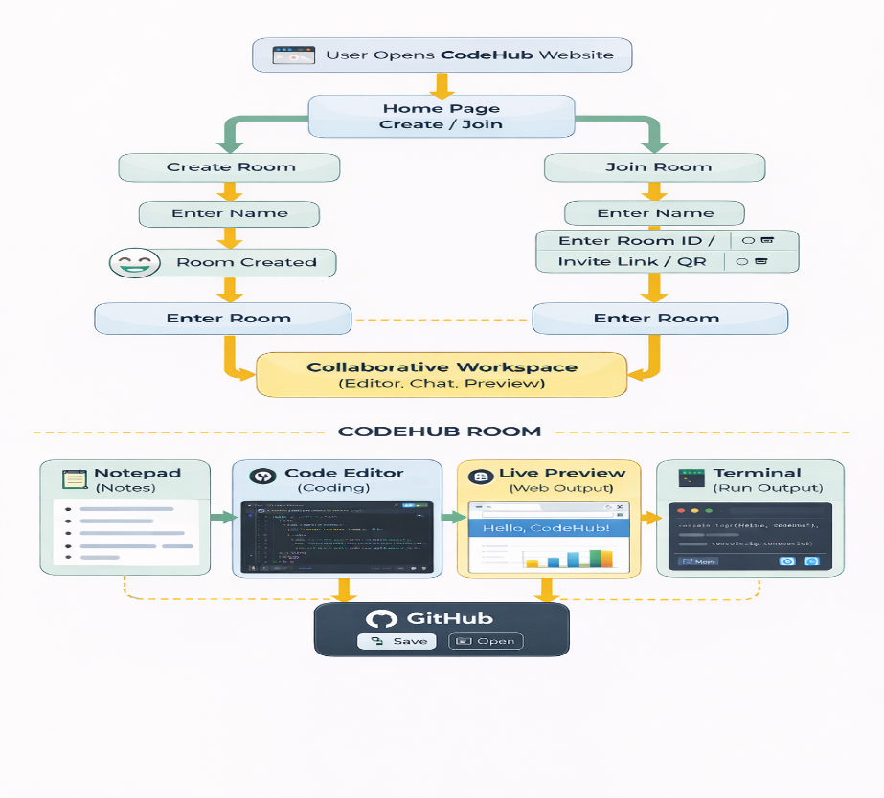

Result and Discussion

The comparative analysis between traditional project management systems and the Code Hub platform highlights clear advancements in efficiency, collaboration, and accessibility. Traditional systems in academic institutions are often burdened by paperwork, manual tracking, and limited digital integration, which makes them time-consuming, error-prone, and less effective in fostering collaboration. Faculty involvement is usually restricted to periodic reviews, while students struggle with coordination and communication due to the absence of real-time tools.

Code Hub, by contrast, introduces a modern, cloud-based solution that integrates advanced functionalities such as real-time collaboration, automated project tracking, and responsive dashboards. Students can form groups, assign tasks, and monitor progress seamlessly, while faculty members benefit from continuous visibility into project development through dedicated dashboards that support evaluation, ratings, and feedback. The platform ensures remote accessibility across devices, overcoming the limitations of physical presence required in traditional systems.

Security and scalability are also enhanced in Code Hub through role-based authentication, JWT protocols, and encrypted communication, ensuring data integrity and multi-user support. Its responsive design further increases user engagement by providing a modern interface that encourages active participation.
In concise terms, Code Hub addresses the inefficiencies of traditional project management systems by reducing paperwork, enabling real-time progress tracking, and promoting collaboration between students and faculty. It transforms project-based learning into a more innovative, cooperative, and technologically aligned process, enriching the overall educational experience.

Conclusion

The Collaborative Coding Platform is designed to bridge the gap between academia and industry by providing an integrated environment for coding, learning, and collaboration. It combines features such as real-time coding, project management, peer review, and faculty evaluation into a single unified system. This platform not only facilitates teamwork among students and developers but also enhances learning through continuous feedback and performance assessment, creating a seamless connection between educational objectives and industry practices.

Acknowledge

We would like to express our sincere gratitude to all those who contributed to the successful completion of the Code Hub project. First and foremost, we acknowledge the guidance and support of our faculty mentors, whose valuable insights and constructive feedback helped shape the direction of this work. Their encouragement and expertise provided the foundation for developing a platform that bridges theoretical learning with practical application.
We extend our appreciation to the institution for providing the necessary resources and infrastructure that enabled us to design, implement, and test the system effectively. We are also thankful to the students and faculty members who participated in usability testing and provided feedback, which was instrumental in refining the platform’s features and ensuring its relevance to academic needs.
Finally, we acknowledge the collaborative efforts of our peers and team members, whose dedication, creativity, and problem-solving skills were vital in overcoming challenges during the development process. The successful realization of Code Hub reflects the collective commitment to innovation, collaboration, and the enhancement of project-based learning in academic environments.

Future Scope

The future scope of Code Hub extends into multiple domains where collaborative coding and project management are essential. It can be expanded to support remote team collaboration, allowing distributed teams to work together seamlessly across geographies. The platform can also be adapted for online coding interviews, providing recruiters and candidates with a secure environment for real-time technical assessments.

In the education sector, Code Hub has the potential to enhance live coding in classrooms, enabling instructors to demonstrate programming concepts interactively while students participate simultaneously. It can also be utilized for hackathons and group projects, offering efficient task management, version control, and peer feedback under time constraints.
Beyond academia, Code Hub can support freelance and pair programming, providing secure and scalable environments for developers working together remotely. Its beneficiaries include schools, colleges, and online teaching platforms, software industries such as IT companies and startups, as well as government, public sector, and healthcare software teams that require collaborative and secure coding environments.

In brief, Code Hub’s future scope lies in becoming a comprehensive ecosystem that enhances collaboration, accessibility, and innovation across education, industry, and public services.

REFERENCES

- © 2015 The Authors. Published by Elsevier B.V. This is an open access article under the CC BY NC-ND license http://creativecommons.org/licenses/by-nc-nd/4.0%20©%202015%20The Authors. Published by Elsevier B.V. Peer-review under responsibility of organizing committee of the International Conference on Computer Science and Computational Intelligence (ICCSCI 2015).
- Chen, R., & Zhao, Y. (2019). W3a Framework Project Management System. International Journal of Web Applications.
- Davis, S., & Nair, P. (2017). Project Management Information Systems: PMIS Studies. Journal of IT Project Management.
- F. Frößler, “A Practice Theoretical Analysis of Real Time Collaboration Technology: Skype and Sametime in Software Development Projects", Göttingen: Cuvillier, (2008).
- Garcia, T., & Patel, N. (2021). Node.js Project Management and Evaluation Platform. International Journal of Computer Applications.
- H. Bani-Salameh, C. Jeffery, Z. Al-Sharif, and I. Abu Doush, “Integrating Collaborative Program Development and Debugging within a Virtual Environment", in Proceedings of the 14th Collaboration Researchers’ International Workshop on Groupware, Vol. 5411, (2008), pp. 107–120.
- H. Fan, C. Sun, and H. Shen, “ATCoPE: Any-time Collaborative Programming Environment for Seamless Integration of Real-time and Non-real-time Teamwork in Software Development", in Proceedings of the 17th ACM International Conference on Supporting Group Work, (2012), pp. 107–116.
- https://www.researchgate.net/publication/380375772_Project_Hub_Collaborative_Platform_for_ Student_and_Faculties .
- K. Riemer and F. Frößler, “Introducing Real-Time Collaboration Systems: Development of a Conceptual Scheme and Research Directions", Communications of the Association for Informations Systems (CAIS), Vol. 20, (2007), pp. 204–225.
- Kumar, V., Ranjan, A., & Singh, P. (2023). Cloud-Based Collaborative Coding Platforms for Educational Institutions. International Journal of Computer Applications, 185(3), 15–22
- L. C. L. Kats, R. G. Vogelij, K. T. Kalleberg, and E. Visser, “Software development environments on the web", in Proceedings of the ACM international symposium on New ideas, new paradigms, and reflections on programming and software - Onward! ’12, (2012), pp. 99 .
- Li, S., Li, L., & Zhang, W. (2007). WebUPMS: A Web-Based Undergraduate Project Management System. International Conference on Wireless Communications, Networking and Mobile Computing, 2007. https://doi.org/10.1109/WICOM.2007.789%20
- Li, X., Yang, J., & Chen, M. (2022). Design of Project Management System Based on Vue 3.0 Framework. Journal of Physics: Conference https://doi.org/10.1088/1742-6596/2188/1/012048%20Series, 2188(1), 012048.
- Liu, H., Zhang, M., & Xu, C. (2020). Web-based Undergraduate Project Management System. In Proceedings of the International Conference on E-Learning.
- M. Doernhoefer, “Surfing the Net for Software Engineering Notes", ACM SIGSOFT Software Engineering Notes, Vol. 24, No. 3, (1999), pp. 15–24.
- M. Goldman, “Role-based interfaces for collaborative software development", in Proceedings of the 24th Annual ACM Symposium Adjunct on User Interface Software and Technology - UIST ’11 Adjunct, (2011), pp. 23.
- M. Goldman, G. Little, and R. C. Miller, “Real-time Collaborative Coding in a Web IDE", in Proceedings of the 24th Annual ACM Symposium on User Interface Software and Technology, (2011), pp. 155–164.
- Oliveira, F., & Johnson, K. (2019). Adaptive Supervision with Moodle. In Proceedings of the International Conference on Educational Technology.
- Pannu, M., Salih, Q., Yuen, C., Li, Z. H., & Tanu, E. (2018). Web-based Project Management Systems for Small to Midsize Businesses. IEEE 9th Annual Information Technology, Electronics and Mobile Communication https://doi.org/10.1109/IEMCON.2018.861506%20 Conference (IEMCON), 1233–1237.
- Retnowardhani, A., & Suroso, A. I. (2019). Effectiveness of Project Management Information System (PMIS): A Case Study Comparison. Procedia Computer Science, 161, 123–131. https://doi.org/10.1016/j.procs.2019.11.106 .
- Smith, J., Kumar, A., & Wong, L. (2018). Web-based Project Management Systems for SMEs. In Proceedings of IEEE EMCON.

