The Era of Extremely Large Optical Telescopes I: The ELT

ABSTRACT
The advent of Extremely Large Telescopes (ELTs) - ground-based optical/infrared observatories with primary mirrors exceeding 20 m - heralds a transformative epoch in observational astronomy. This article examines the dawn of this new era, and the three upcoming facilities in the optical/infrared bands: the Giant Magellan Telescope (GMT), the Thirty Meter Telescope (TMT), and the European Extremely Large Telescope (ELT). This article focuses on the ELT, while a sequel will cover GMT and TMT. We describe the key technological breakthroughs enabling its construction, most notably segmented mirror design, advanced adaptive optics (AO), and laser guide star systems. These innovations will deliver more than an order of magnitude leap in light-gathering area and spatial resolution, providing image sharpness exceeding that of space-based telescopes for wide-field observations. The review also situates the facility within the broader transition from monolithic to segmented telescope architectures. The scientific impact of the ELT is profound and multifaceted. We discuss its inception and construction milestones and explore its potential to directly image and characterize the atmospheres of Earth-like exoplanets, search for biosignatures, and trace the formation of the first stars, galaxies, and supermassive black holes. Furthermore, the ELT will serve as an unprecedented probe of fundamental physics, offering stringent new tests for dark energy and dark matter models by measuring the universe’s expansion history and the chemical evolution of its earliest structures. This paper concludes that ELTs are not mere incremental improvements but foundational instruments that will redefine the frontiers of astrophysics, address some of science’s most enduring questions, and inevitably lead to discoveries beyond current prediction.
Keywords: Extremely Large Telescope, adaptive optics, segmented mirrors, exoplanets, observational astronomy
A BRIEF HISTORY OF THE TELESCOPE APERTURES
“Where there is an observatory and a telescope, we expect that any eyes will see new worlds at once.”
Henry David Thoreau
The quest for a bigger aperture - the diameter of a telescope’s primary light-gathering lens or mirror - is the holy grail of observational astronomy. More aperture means more light, which means fainter objects, finer detail, and a deeper view into the past and details of the cosmos. The finite speed of light is what lets us look back in time. As the Sun is 8 light-minutes away, the light we receive left the Sun 8 minutes ago. Similarly, if we look at distant objects that are millions of light-years away, we see those objects as they were millions of years ago, allowing us to study the universe in its early stages.
A larger telescope diameter also affects field of view. The real field of view is given approximately by the eyepiece field of view divided by magnification. To observe the full Moon, which spans about 0.5 degrees, through an eyepiece with a 60-minute field of view, a magnification of about 120X is required.
A Brief History of Telescopes
- The Refractor Era (1609-c. 1750)
- The Great Refractor and Early Reflector Era (c. 1750-1910)
- The Modern Glass-Mirror Reflector Era (c. 1900-1990)
- The Segmented Mirror and Adaptive Optics Era (c. 1990-2010)
- The Extremely Large Telescope Era (2010s-Future)
The story begins not with a quest for size, but for simple magnification. In 1609, Galileo Galilei used a simple refracting telescope with an aperture of about 37 mm (1.5 inches). Despite its small size, it revolutionized our cosmic view by revealing Jupiter’s moons, lunar craters, and the stellar nature of the Milky Way. For a century, these “spyglasses” remained small because of poor lens quality and chromatic aberration, or color fringing. Christiaan Huygens built long, tubeless aerial telescopes to minimize aberrations, with lenses up to 120 mm (5 inches). These unwieldy instruments led to the discovery of Saturn’s moon Titan.
The 18th century saw the mastery of lens-making, leading to the Great Refractors. Tired of the limitations of refractors, William Herschel built large reflecting telescopes, including his Great 40-foot telescope with a 1.2 m (48-inch) speculum metal mirror. It was monumental but clumsy. Herschel’s real workhorse was a 47 cm (18.7-inch) reflector, which he used to discover Uranus and map thousands of nebulae.
Key Disadvantages of Refractors
Chromatic Aberration: Colors do not focus at the same point, creating color fringes.
Size/Weight Limitations: Large lenses are difficult to manufacture, expensive, and heavy.
Physical Limitations: Very long tubes are required for high magnification, making the instruments cumbersome and requiring heavy, expensive mounts.
Light Loss: Light is absorbed by glass.
Spherical Aberration: Distortions arise because of lens imperfections.
The late 19th century saw a battle of giant lenses, culminating in the 1.02 m (40-inch) refractor at Yerkes Observatory in 1897, which remains the largest successful refractor ever built. The limits of glass lenses, including sagging under their own weight and chromatic aberration, had been reached.
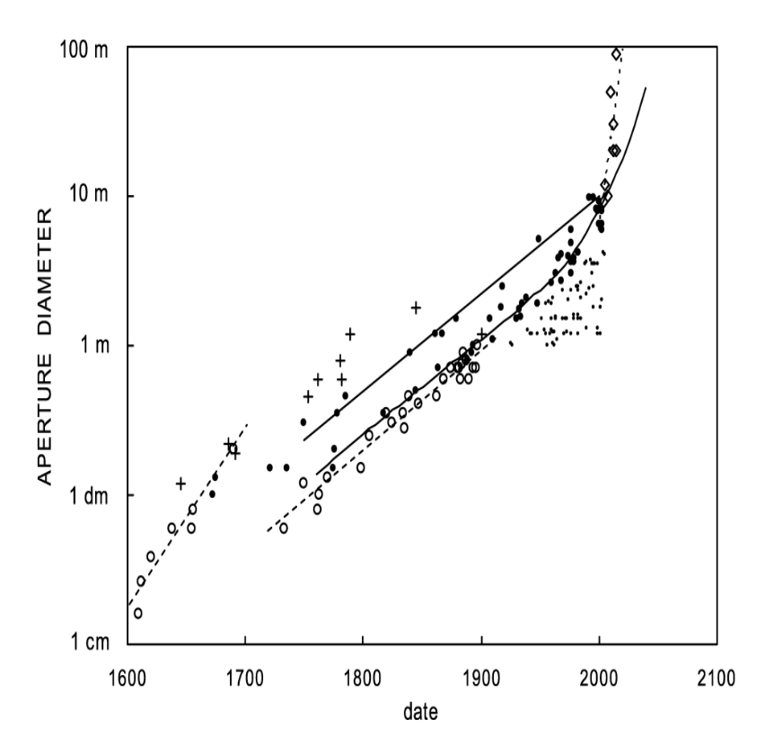
Figure 1: Aperture diameters as a function of commissioning dates for major telescopes. Open circles are refractors and filled circles are reflectors; small filled circles are 20th century telescopes with D ≥ 1; crosses indicate instruments with shortcomings; diamonds indicate future instruments, including five ELTs. Image credit: Racine [3].
The switch from metal to glass mirrors, coated with reflective aluminum, changed everything. Glass mirrors could be larger, lighter, and better supported. In 1917, at Mount Wilson Observatory, the 2.54 m (100-inch) Hooker Telescope reflector helped prove that spiral nebulae were distant galaxies beyond the Milky Way (Edwin Hubble, 1924) and, most importantly, helped redefine our cosmic scale through Hubble’s law and the expansion of the universe.
The Hale Telescope, a 5.08 m (200-inch) giant at Palomar Observatory, began operating in 1948 and reigned as the world’s largest effective telescope for 45 years. It was a marvel of engineering and pushed the limits of what a single, rigid mirror could be. It mapped the universe to unprecedented depths and contributed to the discovery and study of quasars.
In astronomy, seeing describes how much Earth’s atmosphere distorts telescopic images, affecting their clarity and sharpness. It is governed by turbulence and temperature fluctuations in the air: poor seeing causes stars to blur and twinkle, while good seeing yields steady, high-resolution views. Seeing is typically quantified in arcseconds, which corresponds to the diameter of a star image. Excellent seeing is ≤0.4 arcseconds, good seeing is about 0.4-0.9 arcseconds, and average seeing is about 1.0-2.0 arcseconds.
The Soviet BTA-6 Large Altazimuth Telescope, a 6 m aperture optical telescope at the Special Astrophysical Observatory in Russia, achieved first light in late 1975. It became the largest telescope in the world until 1990, when it was surpassed by the partially constructed Keck I. It pioneered the technique, now standard in large astronomical telescopes, of using an altazimuth mount with a computer-controlled derotator.
To grow beyond 8 m, engineers developed new concepts. The two Keck Telescopes, built in 1993 and 1996, were game changers. Each Keck telescope uses a 10 m primary mirror composed of 36 hexagonal segments, actively controlled by computers to act as a single surface. This segmented mirror design broke the single-mirror barrier and set the template for all future giants. The Very Large Telescope (VLT, 1998-2000) is made of four independent 8.2 m unit telescopes that can also combine light as an interferometer, achieving the resolution of a 130 m telescope.
At 8.4 m, the largest monolithic primary mirrors in operation today are those of the Large Binocular Telescope (LBT) in Arizona and the Vera C. Rubin Observatory in Chile. For larger mirrors, segmented mirrors are the way ahead. The maximum resolution a telescope can provide because of the diffraction caused by the wave nature of light is approximately 1.22λ/D. This is often called the diffraction limit. The atmosphere and turbulence add further distortion and can lead to poor seeing. Space telescopes avoid the atmosphere, giving them the advantage of diffraction-limited observations. Ground-based telescopes improve their seeing through the parallel revolutions of active and adaptive optics. These technologies use support systems and deformable mirrors to correct, often in real time, for distortions caused by gravity, temperature, and Earth’s atmosphere.
Table 1: Differences between Active and Adaptive Optics
Feature | Active Optics | Adaptive Optics
Correction Target | Telescope shape (gravity, thermal) | Atmospheric turbulence
Speed | Slow (≈1 Hz or less) | Fast (100-1000 Hz)
Component | Actuators on primary/secondary | Deformable mirror
Main Use | Maintaining mirror figure | High-resolution imaging/AO
Monolithic vs. Segmented Telescope Mirrors
Monolithic (Single-Piece) Mirrors: The largest in operation are 8.4 m mirrors used by the Large Binocular Telescope and the Vera C. Rubin Observatory. The Subaru Telescope’s 8.2 m mirror also remains one of the largest single mirrors.
Segmented Mirrors (For Larger Apertures): Segmented mirrors are composed of many smaller, usually hexagonal pieces working together as one large surface. A computer-controlled active optics system uses actuators built into the support cell to constantly align the segments, allowing them to function as a single unified mirror.
For mirrors larger than about 8 m, segmentation is essential. This design allows telescopes to achieve much larger total apertures. However, segmented mirrors have drawbacks: each segment may require a precise asymmetrical shape, and the entire system relies on a complicated computer-controlled mounting system. Segment edges also introduce diffraction effects in the final image.
Examples of telescopes and their numbers of primary mirror segments include Keck I and II (36), the Gran Telescopio Canarias (36), Hobby-Eberly Telescope (91), Southern African Large Telescope (91), Large Sky Area Multi-Object Fibre Spectroscopic Telescope (24), and the James Webb Space Telescope (18). In these telescopes, the mirror segments must be polished to a precise shape and aligned by active optics so that they function as a single unified mirror.
The future now is the era of Extremely Large Telescopes. The three primary proposed or under-construction ground-based ELTs are the European Extremely Large Telescope in Chile (39.5 m), the Thirty Meter Telescope in Hawaii (30 m), and the Giant Magellan Telescope in Chile (effective 25.4 m).
Advancements in Image Quality and Telescope Technology
Overcoming Atmospheric Interference: To avoid atmospheric distortion, one solution is to place telescopes in space, as in the case of the James Webb Space Telescope.
Revolution in Resolution: Interferometry: Interferometry combines signals from separate telescopes or antennas to achieve the resolution of a much larger aperture.
Very Large Array (VLA): A radio interferometer using 27 movable antennas in New Mexico.
Event Horizon Telescope (EHT): An international collaboration using Very Long Baseline Interferometry that imaged the supermassive black hole at the center of the galaxy M87.
Atacama Large Millimeter/submillimeter Array (ALMA): A high-altitude array in Chile consisting of 66 antennas.
Square Kilometre Array (SKA): A next-generation massive radio telescope array currently under construction.
The European Extremely Large Telescope is the current record-holder in development. It is a 39 m segmented-mirror telescope with 798 segments, under construction in Chile. The Giant Magellan Telescope uses seven of the world’s largest monolithic mirrors, each 8.4 m, to form an effective 25.4 m aperture. The Thirty Meter Telescope is a 30 m segmented-mirror telescope with 492 segments. Earlier proposed ELTs that have been shelved include the Canadian Very Large Optical Telescope (20 m) and the Overwhelmingly Large Telescope (100 m).
The parallel revolution in improving image quality has been the rise of space telescopes. The James Webb Space Telescope’s 6.5 m segmented mirror is the largest currently in space, constrained by launch vehicle fairings. Radio interferometry has achieved remarkable milestones through the VLA, the Event Horizon Telescope, ALMA, and the Square Kilometre Array. More speculative ideas include liquid mirror telescopes, telescopes on the Moon, and solar gravitational lens telescopes that use the Sun’s gravity as a lens, which could theoretically create apertures measured in kilometers or astronomical units.
From Galileo’s 37 mm spyglass to the 39 m behemoths under construction, the light-gathering area of our greatest telescopes has increased by a factor of more than one million. This relentless drive for more photons has been the engine of cosmic discovery, repeatedly redefining our place in the universe and promising answers to questions we are only now learning to ask. The history of aperture is the history of astronomy itself.
This article focuses on the ELT; an accompanying paper by the author will discuss GMT and TMT.
THE EUROPEAN EXTREMELY LARGE TELESCOPE
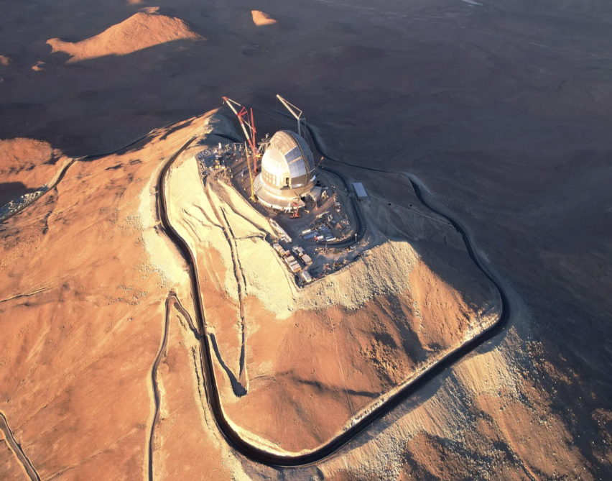
Figure 2: The Extremely Large Telescope under construction in Chile. Image credit: G. Vecchia/ESO.
Future and Theoretical Concepts
Liquid Mirror: Telescopes using rotating reflective liquid, such as mercury, as a primary mirror.
Lunar Telescopes: Telescopes located on the Moon.
Solar Gravitational Lens: Using the Sun’s gravity as a natural lens to focus light, enabling direct imaging of exoplanet surfaces.
Every great telescope begins with the right location. The ELT’s home is Cerro Armazones, a 10,000-foot peak in Chile’s Atacama Desert, selected for its near-perfect conditions: about 300 crystal-clear nights per year, a commanding view of the entire southern sky and a large portion of the northern hemisphere, and exceptionally low wind, dust, and temperature fluctuations.
Construction work on the ELT site started in June 2014. To prepare the site, engineers executed a monumental feat of earthworks, blasting away 200,000 cubic meters of rock to create a vast, flat platform anchored to the mountain’s bedrock. The foundation incorporates 118 seismic isolators - sophisticated dampers designed to keep the telescope stable during the region’s frequent earthquakes.
ELT Highlights
Dome Rotation: The 5,800-ton upper dome rotates smoothly on 36 giant trolleys, tracking the telescope at speeds up to 2 degrees per second to switch between targets in under five minutes.
Dome Aperture: At night, two 55 m tall doors open with no glass barrier, preventing distorting temperature layers.
Climate Control: During the day, multi-layer insulation and a massive heating, ventilation, and air conditioning system cool the interior so that it matches the outside air temperature by nightfall.
Telescope Structure: A 4,600-ton altitude-azimuth mount rotates on a near-frictionless film of hydrostatic oil bearings.
Protecting the ELT’s delicate optics is a colossal dome wider than a professional soccer field. It is not a passive shell but an active environmental control system. The 5,800-ton upper dome rotates smoothly on 36 giant trolleys, allowing the observatory to switch between celestial targets in under five minutes.
At night, two 55-meter-tall doors, each weighing as much as a commercial jet, swing open. There is no glass barrier because it would create distorting temperature layers. The telescope observes the sky directly. During the day, multi-layer insulation and a massive heating, ventilation, and air conditioning system actively cool the interior so that the entire structure matches the outside air temperature by nightfall, preventing heat distortions that would ruin observations.
Inside the dome rests the 4,600-ton telescope structure. This altitude-azimuth mount rotates with exquisite smoothness on a near-frictionless film of hydrostatic oil bearings. This engineering marvel must be both incredibly rigid and exquisitely precise.
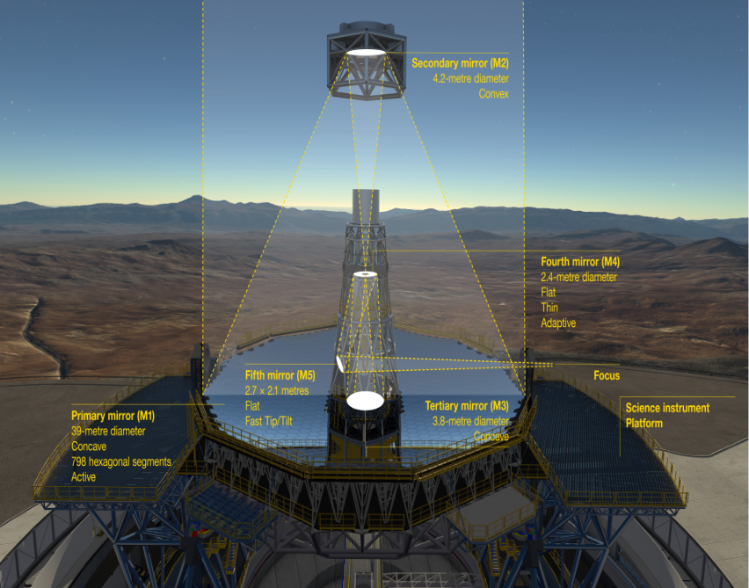
Figure 3: The ELT mirror system. Image credit: ESO.
The ELT’s true brilliance is its five-mirror optical system, a cascade of engineering that refines starlight into a scientifically usable image. More details can be found in [1] and [4].
ELT Mirror System
Primary Mirror (M1): A 39-meter segmented giant made of 798 hexagonal segments, each 1.4 m wide, polished to atomic-scale smoothness and silver-coated. An active support system with thousands of actuators adjusts each segment thousands of times per second to maintain a flawless surface.
Secondary (M2) and Tertiary (M3) Mirrors: M2, at 4.2 m and 3.5 tons, is the largest secondary mirror ever built. Together with M1 and M3, it forms an anastigmat system that mathematically cancels key optical distortions across a wide field of view.
Adaptive Mirror (M4): The world’s largest adaptive optics mirror, composed of six flexible glass shells just 2 mm thick. It is deformed 1,000 times per second by more than 5,000 actuators to cancel atmospheric turbulence in real time.
Tip-Tilt Mirror (M5): M5 makes rapid, fine adjustments to counteract residual vibrations from wind or the telescope itself, locking the image in place for sharp, long exposures.
Adaptive Optics System: M4 and M5 form an adaptive optics system built into the telescope’s core optics, enabling images up to 16 times sharper than conventional ground-based telescopes.
First-Generation ELT Instruments
The corrected light is routed to a suite of first-generation instruments, each designed for specific cosmic quests. MICADO delivers ultra-sharp near-infrared imaging to study faint objects and exoplanets; HARMONI analyzes the light of stars and galaxies to reveal their composition and motion; METIS probes dusty birthplaces of stars and planets in the mid-infrared; MOSAIC observes hundreds of galaxies at once to map the Universe in 3D; and ANDES performs ultra-precise spectroscopy to search for biosignatures in Earth-like exoplanet atmospheres.
MICADO: A powerful near-infrared camera to capture ultra-sharp images and hunt for faint exoplanets.
HARMONI: A spectrograph to dissect the light of stars and galaxies, revealing their composition and motion.
METIS: A mid-infrared camera/spectrograph to peer through dust and study the birth of stars and planets.
MOSAIC: A multi-object spectrograph capable of analyzing hundreds of galaxies simultaneously, mapping the universe in 3D.
ANDES: An ultra-precise spectrograph designed to search for chemical biosignatures in the atmospheres of Earth-like exoplanets.
To guide its adaptive optics, the ELT cannot always rely on natural stars. Its solution is to create its own. The telescope will fire up to eight powerful orange lasers into the sky, exciting a layer of sodium atoms about 90 km high to create artificial laser guide stars. Multiple lasers allow tomographic adaptive optics, building a 3D map of atmospheric turbulence.
Processing this torrent of data requires a supercomputer that performs a monumental task: it takes 10,000 measurements, solves complex algorithms, and commands thousands of actuator adjustments, all up to 1,000 times every second.
The ELT is progressing on a disciplined schedule, with mirror installation set for 2027 and first light targeted for 2028. With an estimated cost of approximately $1.5 billion, it stands as a model of ambitious yet focused engineering.
Scientific Mission
- Directly image and analyze the atmospheres of Earth-like exoplanets, searching for signs of habitability and life.
- Witness the cosmic dawn by observing the formation of the universe’s first stars and galaxies.
- Probe the mysteries of dark matter and dark energy by studying the universe’s expansion and the growth of cosmic structures.
- Watch stars being born and planets coalescing from disks of dust and gas.
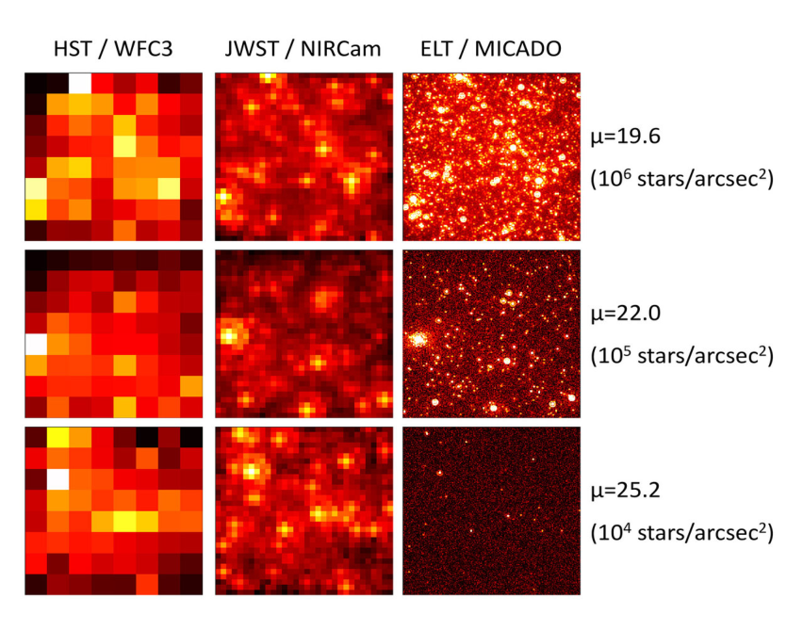
Figure 4: Comparison of images of crowded stellar fields observed by the Hubble Space Telescope (HST, left), the James Webb Space Telescope (JWST, centre), and ELT’s MICADO instrument (right) for three different stellar densities. Credit: ESO/MICADO consortium.
Among the ELTs, the ELT is the largest, GMT is the light-collecting specialist, and TMT is the high-precision imaging and astrometry machine. The Extremely Large Telescope is more than an instrument; it is a gateway. It represents humanity’s relentless curiosity, poised to open a new window on the universe and answer questions we have only just begun to ask.
CONCLUSION
The ELT has currently opted for a standard protected silver coating, which challenges its near-UV performance. The ELT will not work alone. It will be part of an unparalleled era of discovery, teaming up with observatories such as the GMT, TMT, James Webb Space Telescope, the future Roman Space Telescope, and many more telescopes. A sequel to this article will describe the GMT and TMT.
DECLARATIONS
Ethical approval: Not applicable.
Conflict of interest: [NA].
Data availability: NA
ACKNOWLEDGEMENTS
Not applicable.
REFERENCES
1. Gilmozzi, R., & Spyromilio, J. (2007). The European Extremely Large Telescope (E-ELT). The Messenger, 127, 11.
2. Hook, I. M. (2019). The science case for the next generation of Extremely Large Telescopes. Contemporary Physics, 60(3), 234-250.
3. Racine, R. (2004). The historical growth of telescope aperture. Publications of the Astronomical Society of the Pacific, 116(815), 77.
4. Tamai, R., et al. (2018). The ESO’s ELT construction progress. Proceedings of SPIE, 10700, 107001L.

