Land Use-Land Cover (LULC) and Vegetation Change in Sokoto Settled–Close Zone Sokoto State, Nigeria

INTRODUCTION
Earlier studies conducted by Susan et al., (2010) and Elmqvist et al., (2015) submit that, Land Use-Land Cover (LULC) changes is a process in which the society and the environment are interrelated in space and time also, different economies respond to LULC change with an example that on urban settings infill development on land is growing in importance as countries at local and national level seek to protect increasingly scarce agricultural and forested plans from economic development. Similarly, the reasons for the Land Use Land cover and vegetation change range from natural (geographical, soil characteristics, etc.) to human induced factors of urbanization and population growth (Isah, 2023). In Sokoto state, the prevalence of vegetation change is climate change driven with attending consequences of desertification, flood, soil erosion, pollution and drought which are all cyclical and interwoven (Isah, 2024). This research derives basically from the idea that there is a strong positive correlation between urbanization, pressure of population, land use, land cover and vegetation change that may lead to adverse environmental consequences on the study area. The observations by the authors reviewed above serve as allusions to how precarious the vegetation change could be on the study area and beyond; So, the research will attempt to contend the apprehension technologically and scientifically by employing Landsat Imageries data and observations to produce an accurate and incontestable result on the Land Use-Land Cover (LULC) and Vegetation Change in Sokoto Settled–Close Zone of Sokoto State,
Many Scholars (e.g. Hails and Ormerod 2013, Uprety, et al., 2017, Isah, 2020) opined that universally, several regions undergo vegetation change: the study area is at the frontline of severe environmental degradation, thus, may not be an exception. Human land use affects the environment and increases the potential for soil erosion, land pollution and flood. On their part scholars like, Swindell et al (1982) and Adamu et al., (2017) have examined environmental issues in the West African Sahel that report the original vegetation in Sokoto State (north-western Nigeria) has been changed by anthropogenic activities. In recent decades’ vegetation change is alarming at 3.5% per annum in Nigeria and ironically, there is refusal of replacement of the converted vegetation, causing gradual loss of vegetation to built-up, open spaces and similar land uses. Adamu et al., 2017; Isah, 2020 revealed that Vegetation alteration is one of the most serious environmental challenges facing the state, turning vegetated areas into open land thereby, rendering the state more vulnerable to environmental threats for instance, a study on vegetation conducted shows that vegetation covers in Sokoto metropolis alone in 1986 occupied 3,426 hectares but reduced to 621 hectares in 2019. Already, Sokoto state is at the frontline of severe environmental degradation, also, the study area records high temperature, depletion of green space and increase in built up and barren surfaces as the main drivers of LULC (Abdullahi, et, al. 2025) however, most of the vegetation changes are found in urban centres witnessing many of environmental and social problems. The vegetation conversion emanates from the core of the city and gradually coalesces into suburbs. Conceivably, there has been a persistent fall in trend in vegetation and land use type. The LULC patterns showed that, the vegetation disappeared, the built up expands at an outstanding level bringing about LULC change (Isah and Shehu, 2024). Hence, filling the research gap on the LULC and vegetation change will be necessary for sustainable environment aimed at a balanced ecosystem in the study area. Furthermore, this research derives basically from the idea that there is a strong positive correlation between pressure of population growth, urbanization and LULC conversion that may lead to adverse environmental concerns in Sokoto state
The aim of this research is to assess Land Use-Land Cover (LULC) and Vegetation Change in Sokoto Settled–Close Zone
The specific objectives are to:
- Detect vegetation change in Sokoto Settled–Close Zone (Metropolis) in Sokoto State
- Assess the vegetation change between 2006-2026 in the study area
MATERIALS AND METHODS
Combined methods of Reconnaissance Survey, Remote Sensed (RS) data and level I (5 class scheme) of Anderson et al., (1976), Ground Truthing (GT) at the site were adopted for the LULC Classification; the study area was delineated following the steps of Michael (2009) whereby, the classified maps were used for sampling. Equally, following the method of (Isah, 2020) a Reconnaissance Survey in the study area was the first phase of the research; Data obtained from the preliminary surveys were used in the conduct of the research and choice of satellite data. Several authors (Ulbricht and Heckendorff, 1998; Michael. 2009; Li et al.2013. Eniolorunda, et al., 2015 and Isah, 2020) concede that Landsat images are able to identify numerous surface phenomena better than ground-based investigations (EIA). In view of its significant advantages, data were collected using Landsat data. The satellite data used and cited for scrutiny are; 2006 Landsat 5 Thermal Mapper (TM), 2016 Landsat 8 OLI/TIRS, Operational Land Imager Thematic Infrared Sensor, 2026 Landsat 9 0LI-2/TIRS-2 Operational Land Imager Thematic Infrared Sensor. The Landsat images of the previous years were then registered to the 2026 Landsat image for overlay.
The Landsat imageries used for the LULC analysis were sourced from USGS. The Land Use-Land Cover (LULC) Types Classification was mapped out via Maximum Likelihood Classifier (MLC). On LULC Change Detection and Post Classification Comparison (PCC) the maps were overlaid on one another for comparison following Eniolorunda et al., (2015) technique, the area coverage of each class in the LULC map was calculated, after which those classes were compared from one date to another. The classes’ categorized: Built up: (urban areas, roads, buildings), Vegetation: (forests grasslands, scrubs), Water body: (rivers, lakes, reservoirs), Farmlands: (cropland, pasture, plantations) and Bare surfaces: (exposed soil, rock sand and desert) of the three epochs of 2006, 2016 and 2026 years respectively
Study Area
Location of the Study Area
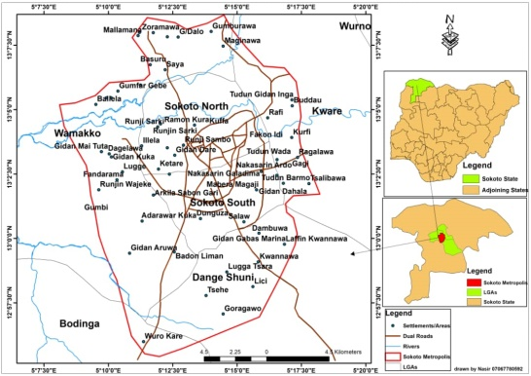
Fig 1 Map of Sokoto Settled–Close Zone: Author’s Compilation, (2026)
Source: DIVA GIS and Open Street Map
The study area lies between latitude 12 55 30N to 13 8 45N and longitude 5 8 5E to 5 18 30E. Physically, the study area will cover the following Local Government Areas (LGAs) namely, Sokoto South, Sokoto North, Wamakko, part of Kware, and Dange-Shuni
RESULTS AND DISCUSSION
This section will outline the finding and discuss the results obtained from the analysis
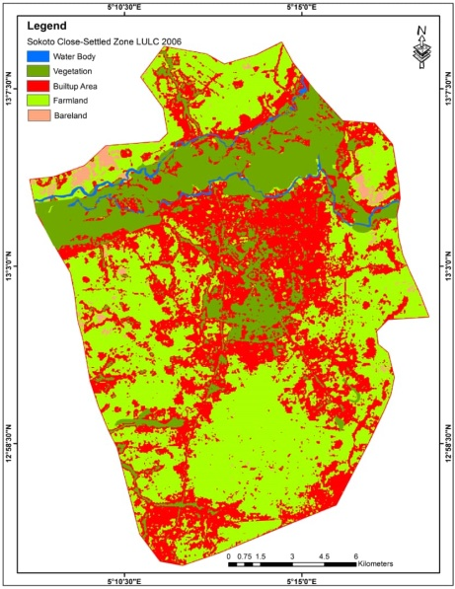 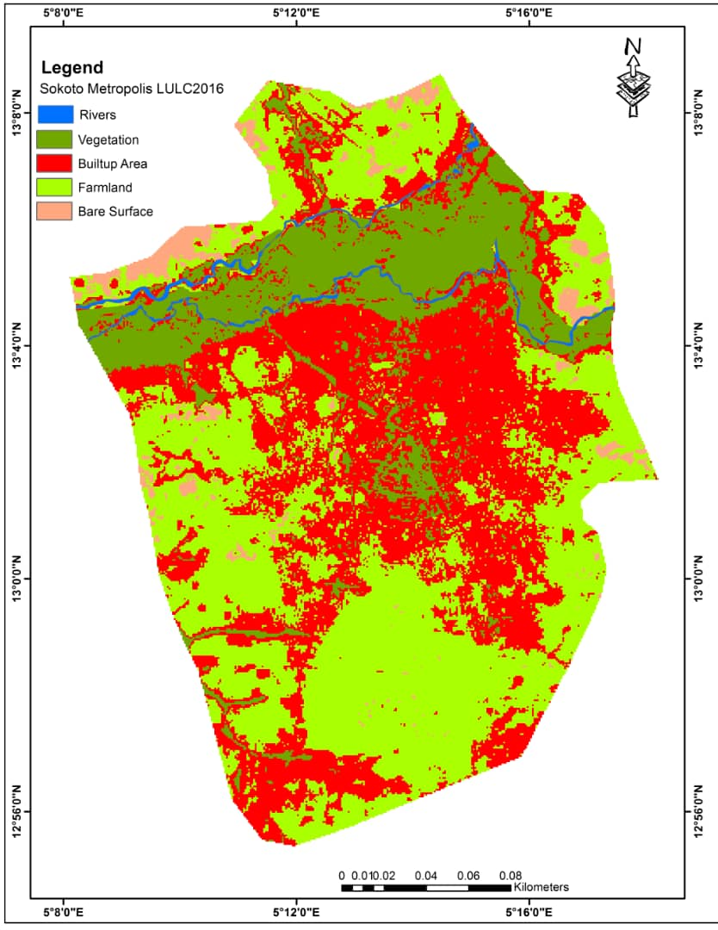 Figure 2 LULC Map (2006) Figure 3 LULC Map (2016)
Source: Authors Compilation (2026) Source: Authors Compilation (2026)
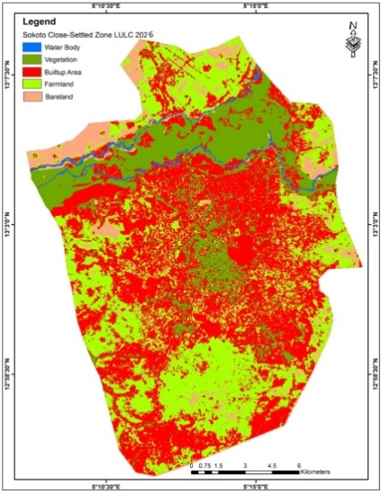

Figure 4 LULC Map (2026)
Source: Authors Compilation (2026)
Table 1 Land Use Land Cover (2006-2026) of the Study Area (Hectares)
Land Use Types | 2006 | 2016 | 2026 | Area
Built up | 8257.9 | 11.195.9 | 13282.2
Vegetation | 3012.4 | 2416.3 | 2102.6
Water Body | 286.3 | 283 | 293.7
Farmland | 15507.9 | 13218.4 | 11584.8
Bare Surface | 1411.1 | 1362 | 1212.3
TOTAL Area |  |  |  | 28475.6
Source; Authors’ Compilation (2026)
The principal finding on land use land cover change in the study area reveals that, built up stood at 8257.9 hectares (28.9%), vegetation occupied 3012.4 hectares (10.6%); water bodies was 286.3 1411.1 hectares (5.0 %) in 2006. On the other hand, in 2016, the built up was converted to 11.195.9 hectares (39.3%), vegetation had reduced to 2416.3 hectares (8.5%); accordingly, vegetation declined to 2102.6 hectares (7.4%). in 2026 a change of 909.8 hectares (3.2%) of vegetation between 2006 and 2026; the built up area covered 13282.2 hectares (46.6%) in 2026 show an increase of 5024.3 hectares (17.6%). This corroborated (Isah, 2020) that opined Sokoto metropolis vegetation (greenbelt) in 1986 occupied 3,426 hectares (32%); open space covered 5,864 hectares (55%) and built-up was 1,385 hectares (13%). However, in 2015, the greenbelt had reduced to 1,179 hectares (11%); open space had increased to 6,203 hectares (58%) while built-up had expanded to 3,293 hectares (31%) over the spate of 30 years (1986-2015) in the metropolis. Similarly, on their part Akinyemi et. al., (2025) pointed out that in northern Nigerian desert frontline state dense vegetation declined to light vegetation by 58% and water bodies’ decreased, built up areas increased substantially. Eventually, about 53.36% of dense vegetation in 1984 was converted to light vegetation by 2022.
Conversely, water body shows an increased trend with a total coverage of 286.3 hectares (1.0%) in 2006 to 293.7 hectares (1.01%) in 2026 and this could be attributable to floods recorded particularly in the year 2010 related to climate change. Equally, farmlands in Sokoto Settled–Close Zone has witnessed a significant conversion whereby, the total land use coverage was 15507.9 hectares (54.5%) in 2006, 13218.4 hectares (46.4%) in 2016 and 11584.8 hectares (40.7%) in 2026. Bare surface has recorded a remarkable land use change over the period with 198.8 hectares (0.7%) decrease. Scholars (e.g. Ayab, et al., (2024) affirmed and alluded that, from 1995-2020 in Gwadabawa LGA of Sokoto state mining sites coverage surge to 58.23 ha while vegetation cover declined rapidly from 56.25 ha to 2.15 ha. Bare soil increased from 25.75 ha to 32.1 ha. It was also observed that, depletion of green space and increase un built up/bare surfaces are the major drivers causing the upsurge of temperature in Sokoto metropolis similar to Abdullahi et., al. (2025) revelation. Scholars (e.g. Mohammed et,. al. 2025) lament that, in Maiduguri’s built up expanded from 324.8km² to 464.9km² while cropland collapsed from 966.9km² to 103.6km² while barren surface surged from 38.6km² to 834.1km² thus, reflecting the Sahelian desertification tendencies. Generally various researchers indicate that built up and barren land expansion are at the expense of the dense vegetation. This was attributed to urbanization, population growth, climate change, mining and other related dynamics.
Recommendations in the light of this research are: Sokoto state government should emphasize on the need for a policy framework on sustainable urban green infrastructures in the metropolis. Land Use and Forestry Laws of Sokoto State should be revisited by the legislators with a view to enacting stiffer penalties for people felling trees without replacement. Urban planning authorities in the state should be well funded, adequately staffed and retrained to monitor the manifestation of LULC conversion and growth of slums (unplanned urbanization) at the expense of vegetation cover. Urban dwellers in Sokoto Settled–Close Zone (Metropolis) should be sensitized on preserving and maintaining vegetation, greenbelt and recreational facilities etc. in order to enhance the balancing of the ecosystem. Finally, there is need to formulate an action plan to protect and maintain the urban environment using proficiency from Sokoto Urban and Regional Planning Board (SURPB), Sokoto State Ministry of Lands and Housing, Sokoto State Ministry of Environment, Non-Governmental Organizations (NGO’s) and Academia from tertiary institutions in the state
CONCLUSION
Sokoto state is at the frontline of severe environmental degradation due to desertification. In recent years’ vegetation alteration is one of the most serious environmental challenges facing the state, turning vegetated areas into built up, farmlands bare surface etc. thereby, rendering the state more susceptible to environmental pressures. These vegetation conversions are ordinarily found in urban centres. The vegetation change emanates from the core of the town and gradually merges into the suburbs. Credibly, from the study, over the decades (2006-2026) there has been a change in the trends of LULC for instance, persistent fall in vegetation, built up areas are on the increase, water body increased, farmlands has plummeted and bare surface is on decrease. Therefore, this research has recognized there is strong relation between pressures of population; urbanization, land use and land cover conversion that may lead to environmental threats and other effects in Sokoto State. Finally, the finding of the research is expected to filled-in the awareness gap on LULC and vegetation change in Sokoto state for sustainable environment aimed at a balanced ecosystem.
ACKNOWLEDGMENTS
The authors would like to acknowledge Tetfund and Umaru Ali Shinkafi Polytechnic, Sokoto, for their support, backing and funding to conduct this research
REFERENCES
- Abdullahi A.A. Sulaiman. M.B Aliyu, S.M. (2025) Examining the Relationship between Green space depletion and Urban Heat Island Effect in Sokoto Metropolis, Sokoto. State. Nigeria .Kaduna Journal of Geography
- Adamu, I. A. Dangulla, M. Eniolorunda, N. B. and Isah, Y. S. (2017) An Inventory of Biodiversity Resources in some Vegetation Patches in Sokoto Metropolis, Sokoto State, 2-9.
- Akinyemi, O.A. Ibrahim, J.T... Musa, K.U (2025) Multi temporal land use and land cover change detection in northern Nigeria’s frontline states geospatial insights for sustainable development and climate adaptation. (2025 journal of geography, environmental earth sciences international
- Ayab, I. . Bello, S.M. Dikko, H.U (2024). Assessment of the impacts of mining activities on vegetation cover and restoration efforts using GIS in Gwadabawa sand mining site Sokoto. State. Nigeria Research gate/ independent study
- Elmqvist, T. Setala, H. Handel, S. N. Van der Ploeg, S. Aronson, J. Blignaut, J. N. Gomez Baggethun, E. Nowak, DJ. Kronenberg, J. and de Groot, R. (2015) Benefits of restoring ecosystem services in urban area, Science Direct, 14. 101-108
- Hails R. S. Ormerod S. J. (2013) Ecological Sciences for Ecosystems Services and Stewardship of Natural Capital (Appl. Ecol. 50: 807- 11)
- Isah Y.S. (2020) Ecological Effects of Land Use-Land Cover Change on Greenbelt Vegetation and Soil in Sokoto Metropolis. A Ph. D Thesis submitted to the Post Graduate School un fulfilment of the requirements for the Award of the Degree of Doctor of Philosophy in Geography, Usmanu Danfodiyo University Sokoto. (Unpublished)
- Isah, Y. S., and Eniolorunda, N. B. (2023) Effects of Greenbelt Change on Soil Status in Sokoto Metropolis; Sokoto State, Nigeria. a paper presented at 63^{rd.} National Annual Conference of the Association of Nigerian Geographers (ANG) held at Shehu Shagari College of Education Sokoto, 5th to 11th November, 2023.
- Isah, Y.S. and Shehu M.T. (2024) An assessment on Land Use-Land Cover Change in Umaru Ali Shinkafi Polytechnic (UASP) in Sokoto Metropolis, Sokoto State (Quest journals: Article Id of QE126009 June, 2024) accepted for publication
- Susan, D. Day, P. Wiseman, E. Sarah, B. D. and Harris, R. J. (2010) Tree Root Ecology in the Urban Environment and Implications for a Sustainable Rhizosphere, Arboriculture and Urban Forestry 36(5)
- Swindell, K. Main, H. A. C. McCarthy, M. Davis, G. Boyd, J. Bode, J. Abdu, P. S. (1982) Sokoto state in maps: an atlas of physical and human resources, university press limited, 12-25.
- Ulbricht, K. A. and Heckendorff, W. D. (1998) Satellite images for recognition of landscape and landuse changes, ISPRS Journal of Photogrammetry and Remote Sensing, 53, 235-243
- Uprety, Y. Asselin, H. and Bergeron, Y. (2017) Preserving Ecosystem Services on Indigenous Territory through Restoration and Management of a Cultural Keystone Species, forests
- Eniolorunda, N. B. (2015) land use land cover and soil quality in the Rima river floodplain Sokoto Nigeria. A thesis submitted for an award of Ph.D. Degree in Geography, Umaru Musa Yar’Adua University, Katsina (Unpublished)
- Li, Z. L. Tang B. H. Wu, H. Ren, H. Yang, G. Wan, Z. Trigo, I. F. Sobrino, J. A. (2013) Satellite-derived land surface temperature: current status and perspectives. Remote sensing of environment 131: 14-37
- Michael, N. D. (2009) GIS FOR DUMMIES Mexico State University, Wiley Publishers Inc; Indianapolis, Indiana1-81
- Mohammed, B.K. Goni, A.S.. Yusuf. F.A (2025). Maiduguri metropolis and environmental implications in the period 2000-2025. Journal of environmental geography and planning

