IoT -Based Real-Time Air Quality Monitoring with Automated Control System

Introduction
Air pollution has become a pressing global environmental crisis, endangering human well-being, ecosystem stability, and the progress of sustainable cities. The rapid pace of industrial growth, urban expansion, and the surge in vehicle numbers have sharply increased the emission of dangerous pollutants. Substances like carbon monoxide (CO), nitrogen oxides (NOx), sulfur dioxide (SO₂), particulate matter (PM), and volatile organic compounds (VOCs) are linked to severe health effects such as respiratory illnesses, heart conditions, and lasting chronic ailments. With pollution levels steadily climbing, there is a growing demand for effective systems that can monitor air quality in real time and promptly activate corrective measures.
Traditional air quality monitoring equipment delivers high accuracy, but it comes with significant downsides: high cost, large physical size, and the need for intricate calibration and regular maintenance. Such setups are typically managed by government bodies or research institutions and are ill-suited for broad implementation in homes, small-scale industries, or local neighborhoods. Consequently, most people lack convenient access to immediate, location-specific data about the air they are exposed to on a daily basis.
Advances in low-cost sensors and embedded systems have paved the way for affordable, portable air quality monitors. This study introduces a real-time air quality monitoring and control setup built around the Arduino Uno microcontroller. The system employs an MQ135 gas sensor to identify harmful gases like ammonia, benzene, and smoke, while a DHT11 sensor tracks temperature and humidity. All measured values are shown on a 16×2 LCD screen, giving users a continuous view of their immediate environment.
Unlike conventional monitoring systems that only provide air quality information, the proposed system incorporates an automated control mechanism. When pollutant levels exceed predefined safety thresholds, a relay-controlled exhaust fan is activated to improve ventilation and reduce pollutant concentration. Additionally, a buzzer alerts users whenever hazardous conditions are detected, ensuring immediate awareness and response.To enhance functionality and scalability, the system can be integrated with Internet of Things (IoT) platforms such as NodeMCU and ThingSpeak. This enables remote monitoring, cloud-based data storage, visualization, and long-term trend analysis, making the system suitable for smart home and smart city applications. The use of low-cost, readily available components ensures affordability and ease of implementation while maintaining reliable performance.

The proposed system offers a practical and cost-effective approach to improving indoor and localized air quality management. By combining real-time monitoring, automated control, and IoT connectivity, it contributes toward creating healthier living environments and supports the broader goal of sustainable urban development.

RELATED WORK
The growing concern over pollution's effects on human health and environmental sustainability has driven significant research into air quality monitoring and forecasting. Recent efforts have concentrated on creating intelligent, economical, and expandable solutions that integrate modern sensing technologies, Internet of Things (IoT) platforms, wireless sensor networks, and machine learning methods.
Pellegrino and colleagues introduced the SMILE project a multi-sensor portable device for capturing air quality data at urban street intersections. This mobile platform effectively recorded localized pollution levels and supported environmental assessments within smart city frameworks [1].Das et al. examined how human activity affects indoor air quality in schools using a simultaneous multi-pollutant measurement approach. Their work underscored the necessity of ongoing indoor monitoring to preserve healthy educational settings and reduce exposure to harmful substances [2].
Alves et al. designed a real-time air quality monitoring system based on FreeRTOS for smart campus environments. Their architecture achieved enhanced responsiveness and low-latency data transmission, enabling rapid environmental updates and early alert functions [3]. Rosa-Bilbao et al. created an IoT-driven indoor air quality management system tailored for intelligent educational spaces. This solution offered live monitoring, alert generation, and predictive capabilities to foster safer indoor conditions [4].
González-Gómez et al. developed an extremely low-cost colorimetric ink for selective indoor CO₂ detection. This sensing technology provided an economical, scalable, and environmentally durable method for preserving indoor air quality [5].Han et al. introduced SmartCamAir Detect, an image-driven technique to estimate ambient air pollution with minimal labeled data. By leveraging existing camera networks, this approach showed promise for broad-scale pollution monitoring in smart city applications [6].
Hilario-Tacuri et al. explored optimal placement strategies for wireless sensor networks in dynamic air pollution scenarios. Their results indicated that careful sensor positioning can maximize coverage and boost the effectiveness of environmental monitoring systems [7]. Li and Zhu proposed a data-driven predictive model employing a Gaussian decoupled representation extractor for urban air quality forecasting. The model successfully captured spatial variations in pollution patterns and enhanced prediction performance [8].
Shahbazi and colleagues examined how machine learning could improve air quality forecasting, revealing that advanced learning models can produce more reliable predictions and support proactive environmental actions [9]. In a separate study, Kong developed a complex circular intuitionistic fuzzy aggregation method for dynamic air quality assessment and public health risk estimation, highlighting the critical role of uncertainty handling in environmental decision-making [10].
Ramirez-Espinosa et al. focused on upgrading data quality from inexpensive particulate matter sensors. Through calibration and post-processing corrections, they significantly improved the reliability and precision of sensor readings [11]. Iskandaryan et al. applied graph neural networks to predict air quality using data from Madrid's monitoring stations. Their approach effectively modeled spatial relationships between stations and increased forecasting accuracy [12].
Miasayedava et al. proposed a lightweight open data assimilation framework for Pan-European urban air quality monitoring. This framework enabled efficient integration of diverse environmental datasets for large-scale applications [13].Berkani et al. evaluated data-driven forecasting models for urban air pollution through the MoreAir case study. Their results highlighted the importance of incorporating temporal and spatial features into predictive models [14].
Pang et al. developed an IoT-based indoor environmental monitoring system that supported cloud-based data storage and long-term analysis, facilitating ongoing health assessment and environmental awareness [15]. Liu et al. introduced an enhanced extreme learning machine optimized with genetic algorithms for air quality index prediction. The proposed model achieved better forecasting accuracy than traditional methods [16].
Motlagh et al. carried out a comprehensive survey of unmanned aerial vehicle (UAV) use in air pollution monitoring, underscoring the flexibility, mobility, and extensive spatial coverage that UAV-based sensing platforms provide [17]. Cao et al. introduced a hybrid air quality prediction model employing empirical mode decomposition to address the drawbacks of conventional forecasting approaches and boost prediction accuracy [18].
Al-Eidi and colleagues conducted a comparative study of regression methods for predicting air quality in smart cities, offering valuable insights into the balance between forecast accuracy and computational efficiency [19]. In a related sensing context, López-Ramírez and Aragón-Zavala reviewed wireless sensor networks for water quality monitoring. Although their work focuses on aquatic environments, the findings on scalability, energy efficiency, and distributed sensing provide useful design principles for environmental monitoring systems in general [20].
The body of research reviewed here demonstrates considerable progress in sensing technologies, IoT integration, predictive analytics, and intelligent monitoring frameworks. However, many existing systems primarily emphasize measurement and forecasting without integrating immediate corrective responses. Consequently, there remains a need for cost-effective solutions that combine real-time sensing with automated control functions. The proposed system addresses this gap by integrating low-cost sensors, continuous monitoring, automatic ventilation control, and IoT scalability to deliver a practical solution for improving air quality in residential, industrial, and public settings.

METHODOLOGY
The suggested air quality monitoring and control system aims to deliver an economical, dependable, and real-time approach to environmental tracking. By combining sensors, microcontroller-based processing, display units, and automated response mechanisms, the system continuously checks air quality and reacts instantly when hazardous levels are detected. This design is well-suited for homes, industrial sites, and public areas where traditional monitoring equipment may be too expensive or unavailable. Moreover, its modular design facilitates future connection to Internet of Things (IoT) platforms such as NodeMCU and ThingSpeak, enabling remote tracking and data analysis. Figure 1 presents the complete block diagram of the proposed system.

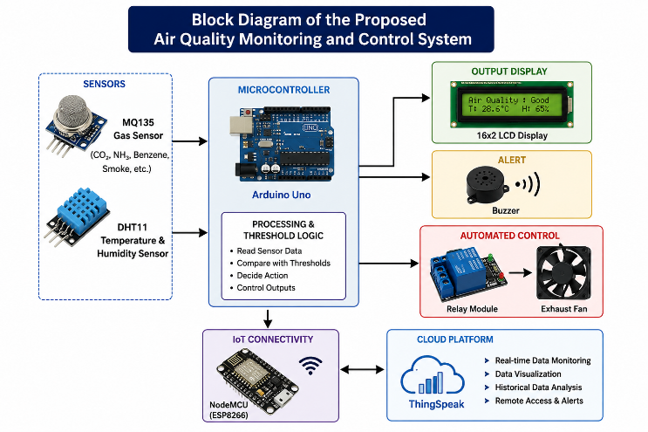
Fig. 1. Block Diagram of the Proposed Air Quality Monitoring and Control System

Sensor Integration
The monitoring setup relies on an MQ135 gas sensor and a DHT11 temperature and humidity sensor, both interfaced with an Arduino Uno microcontroller. The MQ135 senses hazardous gases and pollutants such as carbon dioxide, ammonia, benzene, and smoke, while the DHT11 captures ambient temperature and relative humidity. These sensors are connected to the Arduino’s analog and digital input pins and receive a regulated power supply. Careful wiring and initial tests verified signal integrity and correct sensor operation, establishing a solid foundation for consistent data gathering and the monitoring workflow.

Data Acquisition

Once the sensors are integrated, the system continuously gathers environmental data at fixed time intervals. The MQ135 produces analog signals that change with pollutant concentration. These signals are converted into digital values through the Arduino’s analog-to-digital converter and expressed in parts per million (ppm). The DHT11 directly supplies digital readings for temperature and humidity. Calibration steps and compensation routines are applied to enhance measurement accuracy and reduce the impact of environmental fluctuations. Ongoing data acquisition enables effective real-time tracking of air quality conditions.

Microcontroller Processing and Threshold Logic
The Arduino Uno acts as the system’s central processor, running embedded C/C++ code to analyze the collected sensor data. Preset threshold values classify air quality into levels such as safe, moderate, and hazardous. The microcontroller continuously compares incoming readings against these thresholds and triggers appropriate actions when unsafe conditions arise. The threshold values can be modified based on specific use cases, making the system adaptable to homes, offices, laboratories, and industrial settings. This processing stage turns raw sensor readings into meaningful information and enables intelligent decision-making.

Output Display and Alert Mechanism
A 16×2 LCD module is included to present real-time information about pollutant concentration, temperature, and humidity to users. The displayed values refresh periodically to ensure accurate and up-to-date environmental reporting. Additionally, a buzzer serves as an audible alert device. Whenever pollutant levels exceed the defined safety limits, the buzzer sounds to warn people nearby. The combination of visual and audio notifications improves user awareness and ensures rapid response to dangerous situations. These features enhance usability, making the system practical for everyday use.

Automated Control Using Relay and Exhaust Fan
To combat poor air quality, the system incorporates an automated ventilation setup comprising a relay module and an exhaust fan. When pollutant levels exceed a predefined limit, the Arduino triggers the relay, switching on the exhaust fan to boost airflow and disperse accumulated pollutants. The relay ensures electrical isolation between the low‑voltage control circuitry and the fan, guaranteeing safe and reliable operation. As soon as air quality returns to a safe range, the fan automatically shuts off to conserve energy. This closed‑loop strategy couples real‑time detection with immediate, automatic corrective action.

IoT Connectivity and Cloud Integration
The proposed architecture allows for future expansion by incorporating IoT technologies such as NodeMCU and the ThingSpeak cloud platform. Using Wi-Fi communication, real-time sensor data can be sent to the cloud for remote access and monitoring via web dashboards and mobile devices. ThingSpeak supports data visualization, historical trend analysis, and long-term environmental assessment. Cloud connectivity improves the system’s scalability, making it suitable for smart home applications, industrial IoT, and smart city deployments. Thus, the proposed system evolves from a standalone monitoring device into an intelligent environmental management solution capable of proactive, data-driven decision-making.

RESULTS AND DISCUSSION
The suggested air quality monitoring and control system was built and tested in practice to evaluate its sensor accuracy, reaction time, automation performance, and potential for IoT expansion. The outcomes showed that the system could continuously track pollutant concentration, temperature, and humidity while autonomously activating corrective measures when dangerous conditions arose. Experimental observations confirmed the dependability and practicality of the proposed design for real-time environmental monitoring applications.
In initial tests conducted within a clean indoor setting, the MQ135 gas sensor recorded pollutant levels between 80 and 120 ppm, which fall within acceptable indoor air quality ranges. When the system was exposed to pollution sources such as matchstick smoke or incense fumes, the sensor readings rose sharply and crossed the preset safety threshold of 200 ppm within just a few seconds. This behaviour verified the system’s ability to detect sudden air quality changes in real time. Meanwhile, the DHT11 sensor delivered stable temperature and humidity measurements, with average values around 28–30 °C and 55–60 % relative humidity, respectively. These figures matched expected indoor conditions, confirming the reliability of the sensing modules.
Table 1 summarises how the system responded to different pollutant concentrations. The threshold-based logic implemented on the Arduino Uno successfully sorted air quality into safe, moderate, and hazardous categories. When pollutant levels exceeded 200 ppm, the buzzer alarm was triggered and the relay module automatically turned on the exhaust fan. This rapid reaction minimised the delay between detecting pollution and taking corrective action. Once the pollutant concentration fell below 150 ppm, the exhaust fan switched off automatically to save energy. The transitions between operating states were smooth and free from oscillations, indicating stable control behaviour.
Table 1. Response of the System to Air Quality Levels
Pollutant Level (ppm) | Air Quality Status | Buzzer | Exhaust Fan
< 150 | Safe | OFF | OFF
150–200 | Moderate | OFF | OFF
> 200 | Hazardous | ON | ON
Sensor calibration proved essential for improving measurement accuracy. Initially, the MQ135 gave readings between 150 and 180 ppm in clean air due to sensor drift and humidity effects. After applying baseline calibration and compensation factors, the readings stabilised within 90–110 ppm. Similarly, the DHT11 initially showed humidity values about 5–6 % higher than those of a reference hygrometer. Software-based correction reduced this difference and brought the readings closer to the standard instrument. These calibration steps greatly improved the trustworthiness of the environmental measurements.
Table 2. Sensor Calibration Comparison
Parameter | Raw Sensor Reading | Reference Instrument | Corrected Reading
Clean Air (MQ135) | 165 ppm | 100 ppm | 105 ppm
Humidity (DHT11) | 66% RH | 60% RH | 61% RH
Temperature | 29.5°C | 29°C | 29.2°C

The performance of the automated ventilation mechanism was assessed by introducing cigarette smoke into a sealed environment. The pollutant concentration quickly rose to about 310 ppm, indicating hazardous air quality. As soon as the threshold was crossed, the relay module activated the exhaust fan automatically. Consequently, pollutant levels gradually dropped and returned to safe values of approximately 140 ppm within four minutes. This experiment demonstrated that the system not only detects poor air quality but also actively alleviates it through automatic intervention
.
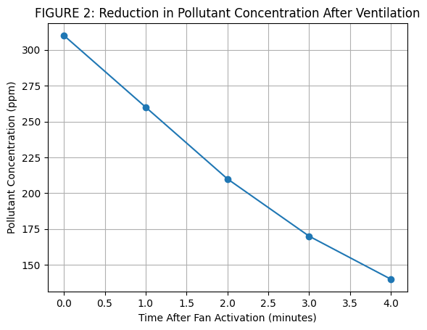Fig. 2. Reduction in Pollutant Concentration Following Exhaust Fan Activation
The LCD display and buzzer alert further enhanced user awareness. Throughout testing, the LCD continuously showed pollutant concentration along with temperature and humidity. For example, a reading of 95 ppm was indicated as safe, whereas a value around 280 ppm was flagged as hazardous. Under hazardous conditions, the buzzer emitted a loud alarm at roughly 2 kHz, ensuring that users were alerted even when they were not looking at the display. The time between crossing the threshold and triggering the alarm was measured at less than two seconds, demonstrating low-latency operation and efficient processing. Long-term monitoring revealed noticeable daily fluctuations in pollutant concentration, driven by indoor activities such as people’s presence, cooking, and cleaning. The highest pollutant levels occurred during cooking periods, while early mornings and nights recorded relatively lower concentrations. These findings underscore the importance of continuous monitoring rather than occasional manual checks.
Table 3. Variation of Indoor Air Quality Throughout the Day
Time of Day | Average AQ (ppm) | Observed Activity
Morning | 110 | Low activity
Afternoon | 180 | Occupancy
Evening | 240 | Cooking
Night | 100 | Minimal activity
The IoT capability of the system was validated by integrating a NodeMCU module with the ThingSpeak cloud platform. Real-time pollutant concentration, temperature, and humidity data were successfully transmitted and visualised through cloud dashboards. Users were able to access environmental information remotely using internet-connected devices. Historical records and graphical trends supported long-term environmental assessment and trend analysis. These features demonstrate the system’s suitability for smart home and smart city applications.
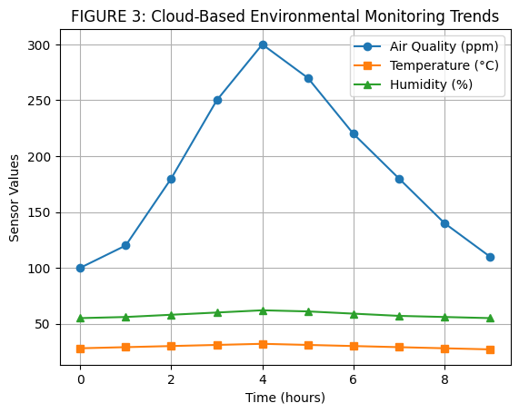Fig. 3. Cloud Visualization of Air Quality Data on the ThingSpeak Platform
System reliability was evaluated by running the device continuously for 72 hours. Throughout this period, no communication failures, sensor dropouts, or processing interruptions were observed. Minor sensor drift was handled effectively through periodic recalibration. The Arduino Uno processed incoming data efficiently without memory overload or performance degradation. Additionally, the system exhibited low power consumption, making it suitable for long-term deployment in practical environments.
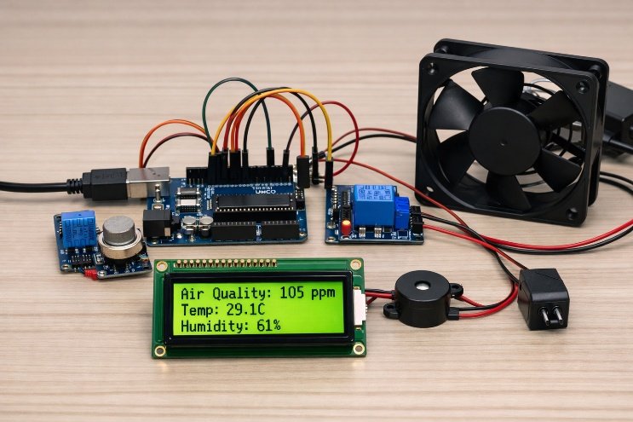
Fig. 4. Experimental Setup of the Air Quality Monitoring and Control System
The combination of gas concentration, temperature, and humidity measurements provided a comprehensive view of indoor environmental conditions. The experiments also revealed that humidity variations slightly influenced MQ135 readings, highlighting the need for environmental compensation techniques. Furthermore, the threshold-based control strategy proved to be simple, reliable, and easily customisable for different applications such as homes, laboratories, offices, and industrial facilities. The modular design also supports future expansion by adding other sensors, including carbon monoxide and PM2.5 detectors.
Overall, the system successfully achieved its primary objectives: low cost, real-time monitoring, automatic response, and IoT connectivity. The calibrated MQ135 and DHT11 sensors performed within acceptable accuracy ranges, and the relay-driven exhaust fan efficiently lowered pollutant levels during hazardous episodes. The blend of audible alerts, on-screen readouts, and cloud-based remote access kept users informed of environmental conditions both on-site and from a distance. These outcomes confirm that the proposed design provides a practical, scalable, and affordable approach to enhancing indoor air quality across homes, workplaces, and urban settings.

Conclusion
In summary, the developed IoT-enabled real-time air quality monitoring and automatic control system delivers a low-cost, dependable, and effective approach to continuous environmental surveillance. By bringing together the MQ135 gas sensor, DHT11 temperature and humidity sensor, Arduino Uno, LCD display, buzzer, relay module, and exhaust fan, the system successfully tracked indoor air conditions, sounded real-time alarms, and independently activated ventilation whenever pollutant concentrations crossed safe thresholds. Test outcomes showed adequate sensor accuracy, swift detection of dangerous air states, meaningful pollutant reduction through automatic fan operation, and steady performance during extended run times. The addition of NodeMCU and the ThingSpeak cloud platform further provided remote data access, graphical trend visualization, and long-term environmental tracking, underscoring the system’s applicability for smart homes and smart cities. Because of its affordability, simple deployment, scalability, and adaptability, the proposed setup offers a practical pathway to better indoor air quality and healthier indoor spaces. Future improvements may incorporate particulate matter and carbon monoxide sensors, machine learning-driven forecasting, mobile alert services, and renewable energy sources to further boost the system’s intelligence, measurement precision, and ease of use.

REFERENCES

- Pellegrino, J., Aziza, H., Guerin, M., Taranto, P., Rahajandraibe, W. and Ravelo, B., 2025. Development of a Multi-Sensor Mobile Device for Urban Air Quality Monitoring at the Street Corner: The SMILE Project. IEEE Access.
- Das, R., Acharyya, A. and Majumdar, S., 2025. Influences of Human Presence on the Indoor Air Quality of Educational Institutions: Concurrent Multi-Pollutant Sensing Approach. IEEE Open Journal of Instrumentation and Measurement.
- Alves, E., Silva, N., Júnior, W., Moraes, A., Silva, N. and Balieiro, A., 2025. FreeRTOS Application in a Real-Time Air Quality Monitoring Architecture for Smart Campus. IEEE Latin America Transactions, 23(4), pp.266-273.
- Rosa-Bilbao, J., Butt, F.S., Merkl, D., Wagner, M.F., Schäfer, J. and Boubeta-Puig, J., 2025. IoT-Based Indoor Air Quality Management System for Intelligent Education Environments. IEEE Internet of Things Journal, 12(11), pp.18031-18041.
- González-Gómez, M., Benito-Altamirano, I., Prades, J.D., Casals, O. and Fàbrega, C., 2025. Ultralow-Cost and Selective Water-Based Colorimetric Ink for Indoor CO₂ Monitoring. IEEE Sensors Journal, 25(11), pp.18722-18730.
- Han, Y., Li, V.O., Lam, J.C., Song, S. and Mo, T., 2025. SmartCamAirDetect: A Contrastive Approach for Probabilistic Ambient Air Pollution Estimation With Limited Images for Smart City Development. IEEE Access.
- Hilario-Tacuri, A., Tamo, A., Pinares-Mamani, M., Butron, W. and Jimenez, R., 2025. Optimal WSN deployment to measure air quality in dynamic multi-source dispersion scenarios: A case study in Arequipa. IEEE Access, 13, pp.24124-24136.
- Li, W. and Zhu, Y., 2024. Forecasting Urban Agglomeration Air Quality: A Data-Driven Model With the Gaussian Decoupled Representation Extractor. IEEE Access, 12, pp.183103-183116.
- Shahbazi, Z., Shahbazi, Z. and Nowaczyk, S., 2024. Enhancing air quality forecasting using machine learning techniques. IEEE access, 12, pp.197290-197299.
- Kong, X., 2024. Complex circular intuitionistic fuzzy Heronian mean aggregation for dynamic air quality monitoring and public health risk prediction. IEEE Access, 12, pp.129897-129916.
- Ramirez-Espinosa, G., Chiavassa, P., Giusto, E., Quer, S., Montrucchio, B. and Rebaudengo, M., 2024. Improving data quality of low-cost light-scattering pm sensors: Toward automatic air quality monitoring in urban environments. IEEE Internet of Things Journal, 11(17), pp.28409-28420.
- Iskandaryan, D., Ramos, F. and Trilles, S., 2023. Graph neural network for air quality prediction: A case study in madrid. IEEE Access, 11, pp.2729-2742.
- Miasayedava, L., Kaugerand, J. and Tuhtan, J.A., 2023. Lightweight open data assimilation of Pan-European urban air quality. IEEE Access, 11, pp.84670-84688.
- Berkani, S., Gryech, I., Ghogho, M., Guermah, B. and Kobbane, A., 2023. Data driven forecasting models for urban air pollution: Moreair case study. Ieee Access, 11, pp.133131-133142.
- Pang, L., Luo, C. and Pan, W., 2023. Research on the impact of indoor control quality monitoring based on Internet of Things. IEEE access, 11, pp.139614-139627.
- Liu, C., Pan, G., Song, D. and Wei, H., 2023. Air quality index forecasting via genetic algorithm-based improved extreme learning machine. IEEE Access, 11, pp.67086-67097.
- Motlagh, N.H., Kortoçi, P., Su, X., Lovén, L., Hoel, H.K., Haugsvær, S.B., Srivastava, V., Gulbrandsen, C.F., Nurmi, P. and Tarkoma, S., 2023. Unmanned aerial vehicles for air pollution monitoring: A survey. IEEE Internet of Things Journal, 10(24), pp.21687-21704.
- Cao, Y., Zhang, D., Ding, S., Zhong, W. and Yan, C., 2023. A hybrid air quality prediction model based on empirical mode decomposition. Tsinghua Science and Technology, 29(1), pp.99-111.
- Al-Eidi, S., Amsaad, F., Darwish, O., Tashtoush, Y., Alqahtani, A. and Niveshitha, N., 2023. Comparative analysis study for air quality prediction in smart cities using regression techniques. IEEE Access, 11, pp.115140-115149.
- López-Ramírez, G.A. and Aragón-Zavala, A., 2023. Wireless sensor networks for water quality monitoring: a comprehensive review. IEEE access, 11, pp.95120-95142.

