3D Structural Prediction of Binding Affinity in Protein – Ligand

INTRODUCTION
In the field of drug discovery, knowing how strongly a ligand (a small molecule, such as a drug) can bind to a protein, a target in the human body is crucial in the field of drug discovery. Binding affinity is the term used to describe this strength of connection. The drug is more likely to function well in the body if the binding is strong.[1]
Scientists typically use lab tests like X-ray crystallography, NMR, or docking studies to determine this binding strength. However, these techniques are difficult to apply to thousands of molecules in the early stages of drug design and are frequently slow, expensive, and time-consuming.[2]
In order to automatically predict the binding affinity using only the 3D structures of protein-ligand complexes, we employ deep learning in this project, specifically a model known as the 3D Convolutional Neural Network (3D-CNN). These three-dimensional (3D) biological structures include precise atomic locations.[3]
Unlike 2D models or simple text-based models, our 3D-CNN learns spatial relationships between protein and ligand atoms in 3D space, which is similar to how they actually interact inside the human body. Our model forecasts the strength of the interaction by processing this 3D data into voxel grids without the need for laboratory experiments.[4]

OBJECTIVES
- To gather and prepare the dataset, including voxelization, so that the 3D CNN model can be trained as efficiently as possible.
- To use the PDBbind dataset to create and train a 3D Convolutional Neural Network (3D-CNN) model.
- To assess the model’s performance using common metrics such as Pearson correlation, RMSE, and MAE.
- To create a basic graphical user interface (GUI) that allows users to upload protein and ligand files (.pdb,
.mol2, etc.) and obtain a binding affinity score.

LITERATURE REVIEW
Jiashan Li and Xinqi Gong proposed a method that uses a pre-trained model with spatial awareness and self-supervised structure perturbations for predicting pro-tein–ligand binding affinity [1]. Their approach improved the correlation of binding affinity predictions across multiple datasets. However, the model lacks explicit relative position modeling and faces difficulties in capturing precise spatial relationships between molecular structures.
Kalemati et al. introduced DCGAN-DTA, which utilizes two deep convolutional generative adversarial networks (DCGANs) to learn features from SMILES representations of drugs and protein sequences [2]. Their model showed improved performance on BindingDB and PDB-Bind datasets. Despite its effectiveness, the approach requires careful training of GANs and still faces challenges related to interpretability and model stability.

Li Han, Ling Kang, and Quan Guo proposed a method that converts protein and ligand sequences into image representations and applies a two-dimensional convolutional neural network (2D-CNN) for binding affinity prediction [3]. This method allows fast prediction without requiring three-dimensional structural data. However, it loses important 3D structural information and performs poorly when dealing with noisy or real-world biological data.
Yuxiao Wang et al. developed Pafnucy, a structure-based convolutional neural network that utilizes three-dimensional voxelized representations of protein–ligand complexes [4]. The 3D convolutional layers capture spatial and chemical binding patterns effectively. However, the model relies heavily on accurate 3D structural data, which may not always be available.
Jiang et al. implemented KC-DTA, a hybrid framework that combines k-mer analysis, Cartesian matrices, and drug graph representations [5]. Their approach achieved better performance than several existing models on datasets such as Davis, KIBA, and Metz. However, its performance declined when evaluated on the PDBBind dataset.
Hu et al. (2025) developed WPGraphDTA, a framework that combines graph-based molecular representations with Word2Vec embeddings for feature encoding [6]. This integration of structural and semantic information improved prediction accuracy. However, the method depends heavily on the quality of graph representations and may face scalability issues when applied to very large datasets.
Jiang et al. (2023) proposed a revised version of KC-DTA that incorporates sequence interaction mining along with molecular graph representations [7]. Their model outperformed several state-of-the-art approaches on datasets such as Davis, KIBA, and Metz. However, similar to earlier versions, it showed reduced performance on the PDBBind dataset and demonstrated limited generalization capability.
Rahman et al. (2024) introduced DAAP, a deep learning approach that combines distance-based features with attention mechanisms for binding affinity prediction [8]. This method improves prediction accuracy by integrating both structural and relational information between proteins and ligands. However, the approach is computationally expensive and requires accurate distance measurements between molecular components.
Zeng et al. (2024) presented a comprehensive review of deep learning approaches used for drug–target affinity (DTA) prediction [9]. Their study highlighted that convolutional neural networks (CNNs), graph neural networks (GNNs), and attention-based models are effective feature extractors for molecular data. The review also identified challenges such as generalization issues, lack of interpretability, and insufficient validation in existing models. Wu et al. (2025) proposed the Folding-Docking-Affinity (FDA) pipeline, an end-to-end framework de-
signed for predicting protein–ligand binding affinity [10]. The pipeline integrates protein folding, molecular docking, and affinity prediction to improve overall prediction accuracy compared to traditional methods. However, the framework requires high-quality input data and its complexity makes large-scale implementation difficult.

BACKGROUND CONCEPTS
- Affinity for Protein–Ligand Binding
Protein–ligand binding affinity refers to the strength of the interaction between a ligand (drug molecule) and a protein (biological target). Predicting binding affinity is essential in drug discovery because stronger binding generally indicates higher biological activity. The interaction between proteins and ligands is governed by various forces such as hydrogen bonding, electrostatic interactions, and hydrophobic effects. Traditional experimental techniques such as molecular docking and X-ray crystallography provide accurate results but are often time-consuming and computationally expensive.

- Machine Learning in Drug Discovery
Machine learning (ML) has become an important tool for predicting drug–target interactions. Early ML-based approaches relied on one-dimensional (1D) representations such as SMILES strings or two-dimensional (2D) chemical graphs to represent molecules. Although these methods are computationally efficient, they have limitations in capturing the true spatial interactions between molecules because they do not fully represent the three-dimensional structure of proteins and ligands.

- Deep Learning and Neural Networks
Deep learning is a subset of machine learning that uses multi-layered neural networks to automatically extract complex features from large datasets. Among deep learning techniques, Convolutional Neural Networks (CNNs) are particularly effective for analysing spatial and image-like data. In drug discovery applications, CNNs can automatically learn structural and chemical patterns in molecular interactions without the need for manual feature engineering.

- Three-Dimensional Convolutional Neural Networks (3D-CNNs)
Unlike traditional 2D CNNs, 3D Convolutional Neural Networks (3D-CNNs) operate on three-dimensional voxelized representations of molecular structures. In this representation, each voxel functions similarly to a 3D pixel and contains atomic and chemical information. By analysing these 3D grids, the network can learn spatial patterns and interactions between atoms, which are critical for accurately predicting protein–ligand binding affinity.

- Voxelization of Molecular Structures
Voxelization is the process of converting protein–ligand complexes into a fixed-size three-dimensional grid. Each voxel encodes various molecular features such as atom type, charge, and hydrophobicity. This structured representation allows 3D-CNN models to analyse atomic-level interactions efficiently. As a result, voxelization helps bridge the gap between computational prediction and experimental validation in drug discovery.

PROPOSED METHODOLOGY
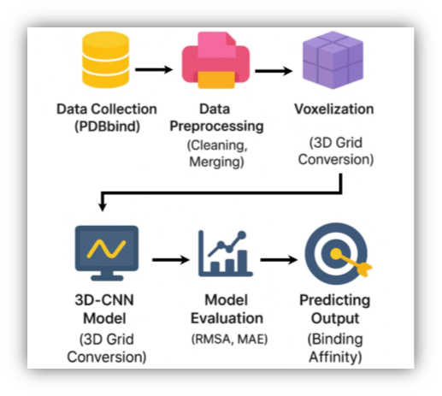

Fig. 1. System Architecture

- Gathering Datasets
The dataset used in this work is obtained from the PDBbind database, which provides thousands of experimentally validated protein–ligand complexes. Each entry contains a protein structure in .pdb format, a ligand file in .mol2 or .sdf format, and the corresponding binding affinity values such as pKd, pKi, or IC50. Using this dataset ensures that the model is trained on reliable and real-world biological data.
- Data Preprocessing
The raw structural data is processed using tools such as Open Babel, Biopython, and RDKit. The preprocessing stage includes several steps:
  - Removing unnecessary molecules such as water, salts, and ions.
  - Fixing missing atoms and aligning the protein and ligand structures properly.
  - Calculating chemical features such as atom type, charge, hybridisation, and aromaticity.
After preprocessing, the dataset becomes clean and structured, making it suitable for voxelization and model training.
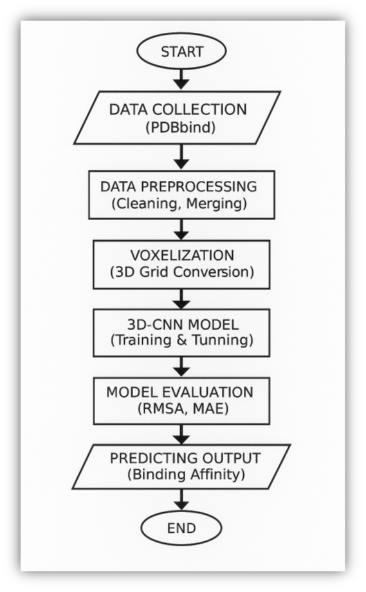

Fig. 2. Flowchart

- Model Design: 3D Convolutional Neural Network (3D-CNN)

The proposed system uses a 3D Convolutional Neural Network to learn spatial interactions between proteins and ligands. The architecture consists of the following components:
  - Convolutional Layers: Extract spatial and chemical interaction patterns from voxel grids.
  - Pooling Layers: Reduce dimensionality while preserving important features.
  - Fully Connected Layers: Map the extracted features to binding affinity predictions.
  - Activation Function: ReLU is used to introduce non-linearity.
  - Loss Function: Mean Squared Error (MSE) is used to minimize prediction error.
  - Optimizer: Adam optimizer is applied to achieve faster convergence.

- Model Training
The 3D-CNN model is trained using GPU acceleration due to the high computational requirements of 3D data. Hyperparameters such as batch size, learning rate, and number of convolution layers are tuned to achieve optimal performance. Training is conducted over multiple epochs with validation to prevent overfitting.
- Model Evaluation
To evaluate the model’s performance, several metrics are used:
  - Root Mean Squared Error (RMSE): Measures the average prediction error.
  - Mean Absolute Error (MAE): Calculates the absolute difference between predicted and actual values.
  - Pearson Correlation: Evaluates how well predicted values follow experimental trends.
- Interpretability and Visualization
To understand the behaviour of the model and ensure biological relevance, different visualization techniques are used. These include 2D heatmaps, 3D surface plots, and 3D scatter plots to display feature importance and prediction patterns. Additionally, protein–ligand docking structures are analysed to identify important interaction regions influencing prediction outcomes.
- GUI Development
A simple Graphical User Interface (GUI) is developed to make the system user-friendly. Users can upload protein and ligand files (.pdb, .mol2, etc.), which are automatically preprocessed, voxelized, and passed to the trained 3D-CNN model. The GUI then displays the predicted binding affinity score in an easy-to-understand format, making the system accessible for researchers.
Dataset Used

TABLE I DATASET
Attribute | Description
Dataset Name | PDBbind
Database Source | Protein Data Bank (PDB)
Data Type | Protein–ligand complexes with experimental binding affinity values (pKd, pKi,  IC50)
File Formats | Protein: .pdb; Ligand: .mol2 / .sdf
Size | Thousands of protein–ligand complexes  (Core / Refined / General sets)
Usage | Training, validation, and testing of the 3D-  CNN model
Preprocessing | Feature extraction and voxelization

RESULTS AND ANALYSIS
The developed system provides an end-to-end framework for predicting protein–ligand binding affinity along with structural visualization. Users can upload protein and ligand files in supported formats such as .pdb and .mol2 using the graphical user interface (GUI).
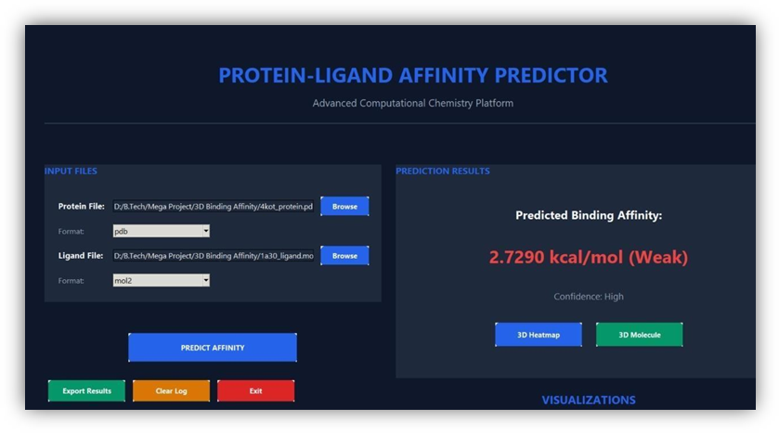

Fig. 3. Protein–Ligand Affinity Predictor
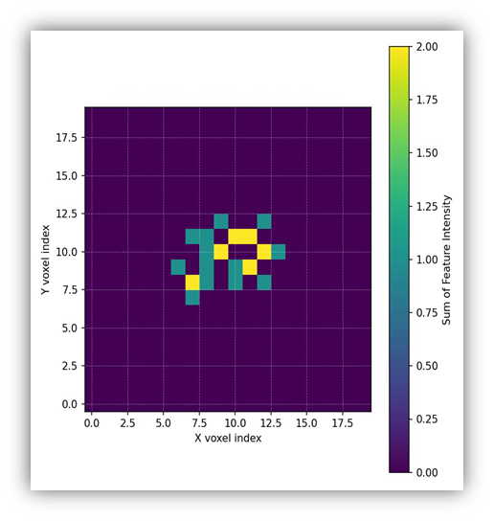

Fig. 4. 2D Heatmap

Fig. 3 shows the graphical user interface developed for the protein–ligand affinity prediction system. The interface allows users to upload protein and ligand files, process the molecular structures, and generate predicted binding affinity values. This user-friendly interface simplifies the workflow and enables researchers to perform analysis without using complex command-line tools.
For the selected protein (2jkp_protein.pdb) and ligand (1a30_ligand.mol2), the predicted affinity value ob-
tained from the model was 3.7597, indicating a moderate interaction strength.
Voxel-based representations were generated to analyse the interaction features captured by the model.
Fig. 4 illustrates the 2D heatmap representing voxel feature intensities across the X–Y plane. Brighter regions indicate areas where stronger molecular interactions are likely to occur between the protein and ligand molecules. Fig. 5 presents the 3D surface plot of voxel features. Peaks in the surface represent regions with higher inter-

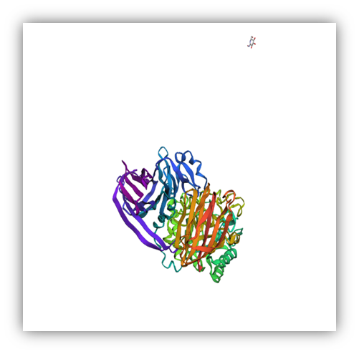

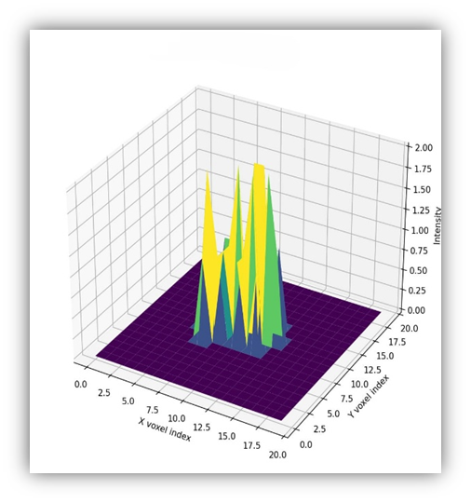
Fig. 5. 3D Surface Plot
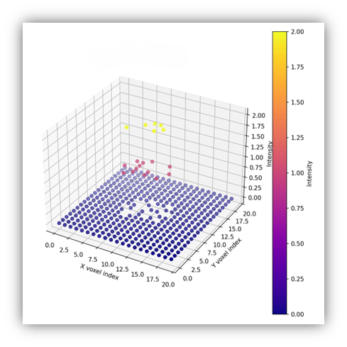

Fig. 6. 3D Scatter Plot

action potential, allowing better visualization of spatial interaction patterns between the protein and ligand.
Fig. 6 shows the 3D scatter plot highlighting voxel-wise feature intensities using colour-coded markers. The clustering of points helps identify regions where molecular interactions are most significant.
Fig. 7 displays the docking visualization of the pro-tein–ligand complex. It illustrates the spatial orientation of the ligand within the protein binding pocket, helping researchers understand how the ligand fits into the active
Fig. 7. Protein–Ligand Docking Visualization

site and contributes to binding affinity.
Combining affinity prediction with voxel-based visualization provides both quantitative and qualitative insights into protein–ligand interactions, supporting drug discovery and molecular docking studies.

DISCUSSION
The proposed 3D-CNN framework highlights the importance of spatial information in predicting protein–ligand binding affinity. Unlike traditional 1D and 2D models, the voxel-based approach captures atomic-level interactions such as hydrogen bonding and hydrophobic effects, thereby improving predictive accuracy [2], [6]. This observation is consistent with previous studies on structure-based convolutional neural networks [4].
Comparisons with existing approaches further validate the advantages of 3D modelling. Although graph-based techniques [6], [7] and GAN-based methods [2] have demonstrated improvements in prediction accuracy, they often suffer from issues related to interpretability and scalability. Structure-aware CNN models such as Pafnucy
[4] have shown the benefits of voxelization for capturing spatial features. Building upon these ideas, the proposed framework uses a customized CNN architecture and optimized preprocessing tailored for the PDBbind dataset.
The framework is computationally feasible and cost-effective. The use of open-source tools such as RDKit, Biopython, and PyTorch, along with publicly available datasets like PDBbind, ensures reproducibility and accessibility [1], [3]. Furthermore, the developed graphical user interface (GUI) enables non-specialist researchers to easily upload molecular structures and obtain affinity predictions, thereby bridging the gap between computational modelling and experimental drug discovery.

However, several limitations remain. The accuracy of predictions depends heavily on the quality and resolution of the input structures. Errors such as missing atoms or improperly aligned ligands can significantly affect performance [9]. Additionally, the voxelization process can be memory-intensive and may lose certain fine-grained chemical features that are preserved in graph-based models [6]. Another challenge is the model’s ability to generalize to unseen molecular scaffolds [7].
Overall, voxelized 3D-CNN models provide a scalable and accurate alternative to conventional docking and sequence-based methods [3], [4]. Future improvements could include integrating attention mechanisms [8], hybrid CNN–GNN architectures [6], and molecular dynamics simulations [10] to further enhance prediction accuracy and applicability in real-world drug discovery.

CONCLUSIONS
This study models atomic-level spatial interactions to predict protein–ligand binding affinity using a voxel-based 3D Convolutional Neural Network (3D-CNN). The framework uses voxelization techniques on the PDBbind dataset and is optimised with GPU-accelerated training to capture intricate structural relationships, in contrast to conventional 1D and 2D methods. The pipeline ensures interpretability and reproducibility in computational drug discovery while reducing reliance on resource- intensive laboratory experiments due to its scalability, feasibility, and cost-effectiveness. 12 The model exhibits great promise as a substitute for traditional docking-based methods, notwithstanding issues like structural noise, voxelization overhead, and restricted generalisation to novel chemical scaffolds. Hybrid modelling techniques, attention-based mechanisms, and integration with molecular dynamics simulations can further improve prediction accuracy and practical applicability. This work establishes the groundwork for structure-aware deep learning in drug–target affinity prediction.
- M. S. Rahman, H. Liu, L. Li, M. A. Ali, M. Liu, and G. Liu, “Distance plus attention for binding affinity prediction (DAAP),” Journal of Cheminformatics, vol. 16, art. 33, 2024.
- H. Zeng, Q. Zhang, Y. Liu, Y. Wu, and J. Wang, “A comprehensive review of the recent advances on predicting drug–target affinity based on deep learning,” Frontiers in Pharmacology, vol. 15, art. 1375522, 2024.
- L. Wu, Y. Liu, Y. Zhao, Q. Liu, Y. Guo, and J. Tang, “A Folding-Docking-Affinity framework for protein–ligand binding affinity pre-diction,” Communications Chemistry, vol. 8, art. 60, 2025.

References
  - J. Li and X. Gong, “Harnessing pretrained models for binding affinity prediction,” Bioinformatics, vol. 41, no. 3, 2025.
  - D. Kalemati, A. K. Singh, and S. Roy, “DCGAN-DTA: A GAN-based approach for drug–target affinity prediction,” GigaScience, vol. 13, no. 1, 2024.
  - Y. Wang, L. Zhang, and H. Liu, “Prediction of binding affinity with deep learning,” Journal of Molecular Modeling, vol. 29, no. 4, 2023.
  - M. M. Stepniewska-Dziubinska, P. Zielenkiewicz, and M. Siedlecki, “Development and evaluation of Pafnucy: A structure-based deep learning model for binding affinity,” Bioinformatics, vol. 34, no. 3,
pp. 366–374, 2022.
  - A. S. Rifaioglu, H. Atas, M. J. Martin, R. Cetin-Atalay, V. Atalay, and
T. Dog˘an, “DEEPScreen: High performance drug–target interaction prediction with convolutional neural networks using 2-D structural compound representations,” Chemical Science, vol. 11, no. 9, pp. 2531–2557, 2020.
  - X. Hu, H. Ma, Z. Zhou, Y. Liang, S. Wang, and L. Yu, “Drug–target binding affinity prediction based on power graph and word2vec (WPGraphDTA),” BMC Medical Genomics, vol. 18, art. 51, 2025.
  - J. Jiang, Y. Wang, Y. Wang, Y. Zheng, and S. Li, “A deep learning method for drug–target affinity prediction based on sequence interaction information mining (KC-DTA),” PeerJ, vol. 11, e16625, 2023.

