Financial Literacy of MSMEs at Tegal Loegood Girikerto,
Sleman Regency, Yogyakarta Special Region, Indonesia

Ula Restu Rafifah
(Ularesturafifah@unisayogya.ac.id, Universitas Aisyiyah Yogyakarta, Indonesia)
Yasin Syarif Hidayatulloh
(Yasinsyarif.hidayatulloh@unisayogya.ac.id, Universitas Aisyiyah Yogyakarta, Indonesia)
Hendrato Setiabudi Nugroho
(hendrato.nugroho@unisayogya.ac.id, Universitas Aisyiyah Yogyakarta, Indonesia)
Marecon C. Viray
(marecon.viray@msumain.ed.ph Mindanao State University, Philippines)
Louvill M. Ozarraga
(louvill.ozarraga@msumain.edu.ph, Mindanao State University, Philippines)

Abstract
Micro, Small, and Medium Enterprises (MSMEs) play a strategic role in the national economy, but they still face various obstacles, particularly in financial management and record keeping. This problem is also experienced by the MSME Tegal Loegood Girikerto, Sleman, which does not yet have an orderly financial recording system and still mixes business and personal finances. This condition has an impact on cash flow instability and hinders business development. This Community Service activity aims to improve the understanding and skills of MSME actors in preparing simple financial reports and encouraging the separation of business and personal finances. The implementation method includes preparation, assessment, program implementation in the form of socialization and assistance in preparing financial reports, and activity evaluation. The results of the activity showed an increase in participants' understanding of the importance of financial recording and the components of MSME financial reports. Participants also received practical solutions related to cash flow management and separation of business funds. Overall, this program has a positive impact on the financial literacy of MSMEs and is expected to encourage the implementation of sustainable financial recording to support business stability and development.
Keywords: MSMEs, financial reports, financial literacy, mentoring, financial management.
Introduction
Micro, Small, and Medium Enterprises (MSMEs) are one of the main pillars of the national economy, which have a significant contribution to employment absorption and increasing community income (Ministry of Cooperatives and SMEs, 2020; Central Statistics Agency, 2022). The existence of MSMEs not only plays a role in driving the local economy but also serves as a means of equalizing welfare and alleviating poverty (Ministry of Cooperatives and SMEs, 2020). Data shows that MSMEs absorb more than 90% of the national workforce and are the backbone of the regional economy in Indonesia (Tambunan, 2019). However, various studies indicate that MSMEs still face managerial challenges, particularly in financial management (Savitri & Saifudin, 2018; Rudiantoro & Siregar, 2012). Weak financial literacy results in MSMEs being unable to prepare systematic financial reports and separate business and personal finances. This condition has the potential to cause distortion in business decision-making (Harahap, 2019; Kasmir, 2020).
This problem was also experienced by the Tegal Loegood MSME located in Girikerto, Sleman. Based on the results of initial observations and communication with partners, it was discovered that business financial management was still carried out informally and had not been well documented. Money from the business is often mixed with the owner’s personal money, and is even used to meet household needs, such as children’s education costs, as well as social activities, such as donations for local residents’ celebrations. This practice, although socially understandable, has a direct impact on the instability of the business’s cash flow and hinders the business’s ability to grow optimally. Mixing business and personal finances can lead to mistakes in business decision-making. This is because MSME actors cannot differentiate between business needs and personal needs. According to Harahap (2019), systematically prepared financial reports function as a tool for evaluating business performance and a basis for future financial planning. Without clear financial records and reports, MSMEs will have difficulty measuring profit levels, determining production costs, and planning business expansion. Furthermore, limited financial record-keeping also impacts MSMEs’ limited access to formal financial institutions, as financial reports are a key requirement for financing applications (Rudiantoro & Siregar, 2012; Financial Services Authority, 2021). Therefore, increasing literacy and assistance in preparing financial reports is an urgent need for MSMEs.
Based on these conditions, ongoing educational and mentoring efforts are needed to increase the understanding of MSME actors regarding the importance of separating business and personal finances, as well as the preparation of simple financial reports. Community Service activities through financial reporting counseling for Tegal Loegood Girikerto Sleman MSMEs are expected to provide practical and applicable knowledge to partners, so that business actors can manage their finances more orderly, maintain cash flow stability, and support sustainable business development.
Implementation Method
The mentoring activity for the preparation of financial reports for Tegal Loegood MSMEs was facilitated by a team of lecturers from the Faculty of Economics, Social Sciences, and Humanities, Aisyiyah University, Yogyakarta, and a team of lecturers from Mindanao State University, Philippines. This mentoring was carried out on January 22, 2026, and took place in the Tegal Loegood Tourism Village located in Giri Kerto, Turi, Sleman.
The problem faced by Tegal Loegood MSMEs is the lack of knowledge in preparing financial reports. Therefore, several solutions offered to address this issue are:
1) Providing outreach on the implementation of PSAK 109; 2) provide assistance in preparing financial reports for Tegal Loegood MSMEs. The community service program activities are carried out through several steps as follows:
- Preparation Stage. The preparation stage begins with a letter of application to carry out assistance activities in preparing financial reports. A community service team consisting of academics from UNISA Yogyakarta and MSU Philippines is then formed. The next step is to identify the problems encountered by the Tegal Loegood MSME.
- Assessment Stage. At this stage, the community service team formulated an appropriate program to solve the problems faced by Tegal Loegood MSMEs and determined the method to be used in delivering the community service material.
- Service Program Implementation Stage. This stage consists of providing educational materials prepared by the community service team, followed by assistance in preparing financial reports.
Study
The implementation of this community service program was carried out by involving three lecturers from Feishum Aisyiyah University Yogyakarta, and two lecturers from Mindanao State University Philippines. This program aims to provide an understanding in preparing financial reports for Tegal Loegood Girikerto MSMEs. The activities included:
- Preparation Stage
The community service program began with a discussion between lecturers from Aisyiyah University, Yogyakarta, and MSU, Philippines. This activity discusses the theme of the community service that will be carried out, then the location that will be the target of the community service program. Then, UNISA’s fostered village was discovered, located in Girikerto, Turi, Sleman. The lecturers then discussed with local MSME activists, ultimately deciding to fill the role of financial management for MSMEs. This was chosen based on the discussion that most MSMEs struggle to manage their finances, especially as they often run out of funds for daily needs, resulting in business operations being hampered.
- Assessment Stage
Based on the results of observations and a short questionnaire conducted during the socialization phase, several issues were identified: a.) There is still no accounting record keeping done so far. b.) There is no financial recording, so personal and business money are still mixed up. c.) Business operational funds are used up because they are used to buy and meet daily needs. d.) This makes it difficult for the business to continue growing.
- Service Program Implementation Stage
The implementation stage of the community service program begins with several sessions as follows:
- Socialization
The implementation of community service activities begins with providing an initial understanding of simple financial reports. It begins by explaining the purpose, scope, definition, recognition, measurement, presentation, and disclosure. After understanding the basic accounting concepts, the session continues with an explanation of the components of financial reports. This session concludes with a brief explanation of accounting treatment for MSMEs to provide participants with a general overview of how financial reports are prepared.
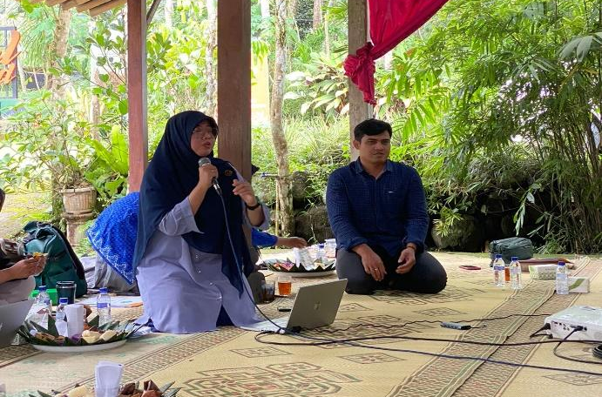
Figure 1. Documentation of the socialization activities conducted.

- Discussion
After the socialization, in this discussion session, the participants in the literacy program on preparing MSME Financial Reports discussed problems related to the preparation of each participant's report. Then the community service team provided solutions to the problems conveyed by the Tegal Loegood Girikerto MSME administrators.
- Evaluation
After completing a series of stages, starting with socialization and discussion, the final stage of the community service program was an evaluation to obtain feedback on the program. The evaluation was delivered by the head of the MSME and members who attended the socialization.

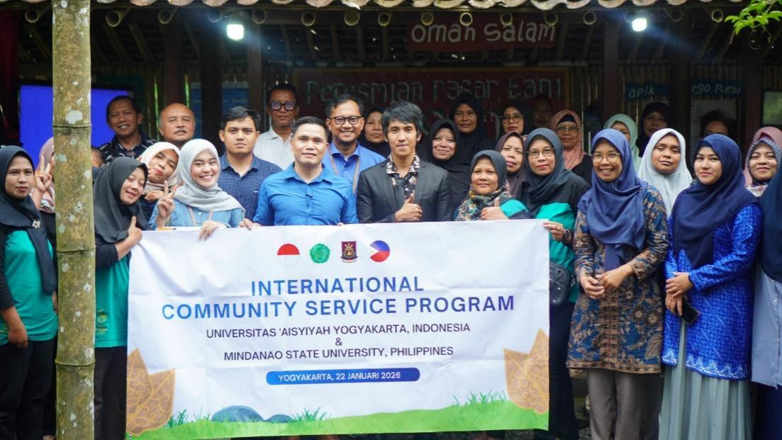
Figure 2. Group photo after the socialization.

Conclusion
The Community Service Program implemented at the Tegal Loegood Girikerto Sleman MSME has been running well and in line with the program’s objectives. This program has successfully increased the understanding of MSMEs regarding the importance of managing and preparing simple financial reports. The results of the activity indicated that the main problems faced by MSMEs were the lack of financial record-keeping, the mixing of personal and business funds, and the use of business funds for daily needs, which disrupted cash flow and hampered business development. Through outreach activities and mentoring discussions, participants gained basic knowledge about MSME financial reporting and practical solutions to the financial challenges they faced. Overall, this activity received a positive response from participants and is expected to encourage MSMEs to start implementing orderly financial records as an effort to support business sustainability and development.
References
Badan Pusat Statistik. (2022). Indonesian MSME Statistics 2022. BPS.
Harahap, S. S. (2019). Analisis kritis atas laporan keuangan. Rajawali Pers.
Ikatan Akuntan Indonesia. (2018). Standar akuntansi keuangan entitas mikro, kecil, dan menengah (SAK EMKM). IAI.
Kasmir. (2020). Analisis laporan keuangan. Rajawali Pers.
Kementerian Koperasi dan UKM. (2020). Perkembangan data UMKM di Indonesia. Kemenkop UKM.
Organisation for Economic Co-operation and Development (OECD). (2018). Financial literacy and SME development. OECD Publishing.
Otoritas Jasa Keuangan. (2021). Indonesia's national financial literacy strategy 2021–2025. OJK.
Rudiantoro, R., & Siregar, S. V. (2012). Kualitas laporan keuangan UMKM serta prospek implementasi SAK EMKM. Jurnal Akuntansi dan Keuangan Indonesia, 9(1), 1–21.
Savitri, E., & Saifudin. (2018). Penerapan pencatatan akuntansi pada UMKM. Jurnal Akuntansi Multiparadigma, 9(2), 298–314.
Tambunan, T. (2019). UMKM di Indonesia: Perkembangan dan tantangan. LP3ES.
World Bank. (2020). Enhancing SME access to finance in emerging markets. World Bank Publications.

