Institutional Repositories as Decision Support Infrastructure for Research and Innovation Among Libraries in Selected Universities in Nigeria

ABSTRACT
This study examines the role of institutional repositories (IRs) as decision support infrastructure for research and innovation among libraries in the South-South geopolitical zone of Nigeria. Employing a descriptive survey research design, data were collected from 214 library professionals and researchers across 18 university libraries in Rivers, Delta, Bayelsa, Cross River, Akwa Ibom, and Edo States. A structured questionnaire with a reliability coefficient of 0.83 (Cronbach alpha) was used as the primary data collection instrument. Findings reveal that while 56.5% of the surveyed libraries have functional institutional repositories, fewer than 40% fully utilize them for evidence-based decision support in research planning, innovation management, and policy development. The study identifies inadequate funding (28%), low staff capacity (22%), and poor internet connectivity (19%) as the foremost barriers to effective IR deployment. It further reveals that IRs significantly support research discovery and citation tracking but are underutilized for institutional analytics and collaboration mapping. The paper recommends strategic policy frameworks, capacity building programmes, and inter-institutional IR consortia as pathways to deepening IR utilization as decision support infrastructure in South-South Nigerian libraries.
Keywords: Institutional Repositories, Decision Support, Research Infrastructure, South-South Nigeria, Library Innovation, Evidence-Based Management

Introduction

The proliferation of digital technologies in academic environments has fundamentally altered how research outputs are produced, stored, disseminated, and utilized. Among the most significant developments in this landscape is the emergence of institutional repositories (IRs) — digital platforms designed to capture, preserve, and provide access to the intellectual output of universities and research institutions. While the concept of IRs originated in developed countries, their diffusion into sub-Saharan Africa, and particularly Nigeria, has gained considerable momentum in the past decade (Ukwoma & Dike, 2020; Anunobi & Okoye, 2019).
In Nigeria, the South-South geopolitical zone presents a unique but underexplored context for IR scholarship. Comprising Rivers, Delta, Bayelsa, Cross River, Akwa Ibom, and Edo States, the region hosts a concentration of federal and state universities, polytechnics, and research institutes with growing research cultures, particularly in petroleum studies, environmental science, Niger Delta development, and public health. Despite this research density, the extent to which libraries in this zone harness IRs not merely as archival tools but as active decision support infrastructure remains poorly documented (Ajidahun, 2020; Okello-Obura & Ikoja-Odongo, 2010).
Decision support infrastructure refers to systems and resources that provide structured, reliable, and accessible information to guide organizational choices (Adetimirin, 2020). In academic libraries, this translates to services that enable researchers, administrators, and policymakers to make informed decisions about research directions, collaboration, funding priorities, and innovation pathways. Institutional repositories, with their metadata-rich collections, citation analytics, and open access mandates, are theoretically positioned to serve this function. However, a gap persists between theoretical potential and practical deployment in many Nigerian libraries (Adebayo & Oyelaran, 2021).
This study, therefore, investigates the current state of IR deployment in South-South Nigerian university libraries, assesses the extent of their utilization as decision support tools, identifies the challenges constraining such use, and proffers recommendations for maximizing their potential. The study contributes to a growing body of LIS scholarship focused on leveraging digital infrastructure for research excellence in Nigerian higher education.

Statement of the Problem
Despite the recognized potential of institutional repositories as vehicles for research management and institutional intelligence, empirical evidence from South-South Nigeria suggests a persistent disconnect between IR establishment and purposive utilization for decision support. Several libraries in the region have invested in DSpace, EPrints, or other IR platforms, yet these systems frequently remain underutilized — populated with records but not interrogated for actionable insights. This study seeks to bridge that knowledge gap by providing a region-specific empirical assessment of IR-based decision support practices.

Objectives of the Study
- Determine the level of IR adoption among university libraries in South-South Nigeria.
- Identify the specific IR functions utilized as decision support tools by library professionals and researchers.
- Assess trends in IR deposit growth and their implications for research decision-making.
Literature Review

Conceptual Framework: Institutional Repositories and Decision Support
An institutional repository is defined as a set of services that a university offers to the members of its community for the management and dissemination of digital materials created by the institution and its community members (Lynch, 2003). At their core, IRs perform four key functions: collecting, preserving, disseminating, and providing access to institutional knowledge outputs. However, the evolution of IR scholarship has increasingly emphasized a fifth, more strategic function: enabling data-driven decision support (Crow, 2002; Jones, Andrew & MacColl, 2006).
Decision Support Systems (DSS) theory, as advanced by Keen and Scott Morton (1978) and later adapted to library contexts by Adesanya (2019), posits that effective decision support requires timely, accurate, and accessible information. IRs meet these criteria when properly configured with robust metadata, usage analytics, altmetric data, and cross-institutional interoperability. The Open Archives Initiative Protocol for Metadata Harvesting (OAI-PMH) further enables IRs to function as nodes in a larger research intelligence network, amplifying their decision support capacity.

IRs in Nigerian Universities: A Review
Scholarship on IRs in Nigerian universities has grown substantially since the early studies of Anunobi and Okoye (2008) who documented the emergence of IR culture in South-East Nigerian universities. Subsequent studies by Ukwoma and Dike (2020) established that while IR adoption in Nigerian universities had reached 67% among federal universities by 2019, effective utilization — particularly for decision support purposes — lagged significantly at approximately 34%. Adeniran (2011) and Adetimirin (2012) similarly noted that technical deployment outpaced strategic integration in many Nigerian institutions.
Regional studies specific to South-South Nigeria are sparse. Ajidahun's (2020) study of Niger Delta University libraries found that IRs were primarily used for thesis archiving rather than as active research management tools. Nwalo (2019) examined academic library digitization in Rivers State and noted inadequate IR policies as a major constraint. Collectively, the literature suggests a pattern of reactive rather than proactive IR deployment across the region — a gap this study seeks to empirically characterize.

IRs as Decision Support Infrastructure: Global Evidence
Internationally, seminal works on IR-based decision support include Swan and Brown (2005), who demonstrated the correlation between IR access metrics and institutional research planning in UK universities. Cullen and Chawner (2011) found that New Zealand university libraries using IR analytics for strategic planning reported a 31% improvement in research output alignment with institutional priorities. In Africa, Ezema (2011) documented how South African repositories served as evidence bases for national research policy, while Hoskins and Mwangi (2022) showed that Kenyan academic libraries leveraging IR metadata significantly improved grant application success rates.
These studies collectively underscore a global transition from viewing IRs as passive archives to recognizing them as active knowledge infrastructure capable of informing research governance, collaboration strategy, and innovation investment decisions. The theoretical framework for this study integrates the Technological Acceptance Model (TAM), Open Systems Theory, and the Knowledge Management for Decision Support (KMDS) model to explain IR adoption and utilization patterns in the South-South Nigerian context.
Methodology

Research Design
This study adopted a descriptive survey research design. This design is appropriate for studies that seek to describe the characteristics, behaviours, and attitudes of a defined population without manipulating variables. The choice aligns with the study's objective of assessing the current state of IR utilization as decision support infrastructure across multiple library settings in South-South Nigeria.
Population and Sampling
The study population comprised 412 professional librarians, information managers, and active researchers across 18 federal and state university libraries in the six states of South-South Nigeria. Using the Taro Yamane (1967) formula at a 5% margin of error, a sample size of 214 respondents was determined. Stratified random sampling was employed to ensure proportional representation across states and institution types.

Table 1: Distribution of Sample Across South-South States
S/N | State | No. of Institutions | Population | Sample Size
1 | Rivers | 4 | 98 | 51
2 | Delta | 3 | 72 | 37
3 | Bayelsa | 2 | 48 | 25
4 | Cross River | 3 | 67 | 35
5 | Akwa Ibom | 3 | 74 | 38
6 | Edo | 3 | 53 | 28
 | Total | 18 | 412 | 214
Source: Authors' compilation from NUC records, 2024
Instrument and Data Collection
A structured questionnaire comprising 42 items on a five-point Likert scale (Strongly Agree = 5, Strongly Disagree = 1) was used as the primary data collection instrument. The instrument was subjected to face and content validity by three experts in library and information science. A pilot test conducted with 20 library professionals in Imo State (outside the study area) yielded a Cronbach alpha reliability coefficient of 0.83, confirming acceptable internal consistency. Questionnaires were administered both physically and electronically via Google Forms. Of 214 questionnaires distributed, 198 were returned and found usable, representing a 92.5% response rate.
Data Analysis
Data were analyzed using descriptive statistics (frequencies, percentages, means) and inferential statistics (Pearson's correlation, Chi-square). The Statistical Package for the Social Sciences (SPSS version 25.0) was used for all statistical computations. Figures and tables were used to enhance data presentation and interpretive clarity.

Results and Discussion

IR Adoption Rate by State
Figure 1 presents the percentage of libraries in each state with functional institutional repositories. Rivers State recorded the highest adoption rate (72%), attributed to the presence of federal institutions such as the University of Port Harcourt and Rivers State University with stronger digital infrastructure. Bayelsa State recorded the lowest rate (41%), reflecting resource constraints typical of newer state universities.

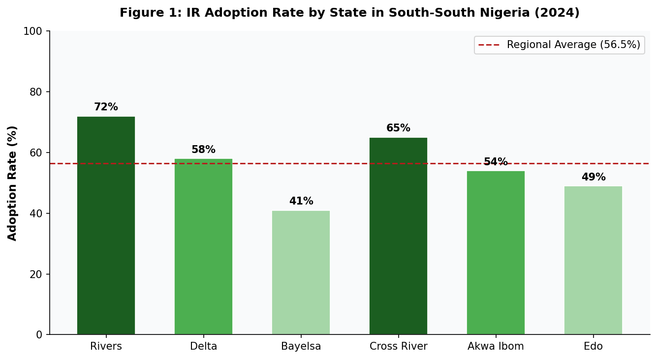
Source: Authors' field survey, 2024
The regional average adoption rate of 56.5% compares favourably with the 52% reported for South-East Nigeria by Ukwoma and Dike (2020) but falls short of the 74% adoption threshold recorded in Nigerian federal universities nationally by Adeniran (2021). This disparity reflects the disproportionate concentration of federal research infrastructure in North-Central and South-West zones, underscoring the need for targeted policy interventions in South-South Nigeria.

IR Software Platforms in Use
Table 2: IR Software Platforms Deployed in South-South Nigerian Libraries
Software Platform | Developer | Libraries (n) | Percentage (%)
DSpace | MIT Libraries / DuraSpace | 62 | 62.0%
EPrints | University of Southampton | 19 | 19.0%
Greenstone | Univ. of Waikato, NZ | 9 | 9.0%
Koha IR Module | Open Source Community | 6 | 6.0%
Locally Developed | In-house | 4 | 4.0%
Total |  | 100 | 100%
Source: Authors' field survey, 2024
DSpace dominates as the preferred IR platform (62%), consistent with national trends reported by Okonedo, Popoola, Emmanuel, and Bamigboye (2015). Its prevalence is attributable to its open-source availability, OAI-PMH compliance, and compatibility with existing NUC accreditation requirements. EPrints, the second most common platform (19%), is particularly prevalent in older federal universities with longer IR histories.

IR Functions Utilized for Decision Support
Figure 2 illustrates the percentage of respondents who reported using specific IR functions for decision support purposes. Research discovery emerged as the most widely used function (88%), followed by citation tracking (76%), suggesting that researchers primarily interact with IRs at the access and appraisal level. Policy evidence support (62%) and trend analysis (55%) indicate moderate utilization for higher-order decision support tasks, while grant support (48%), institutional analytics (41%), and collaboration mapping (34%) reflect critically underexploited functionalities.

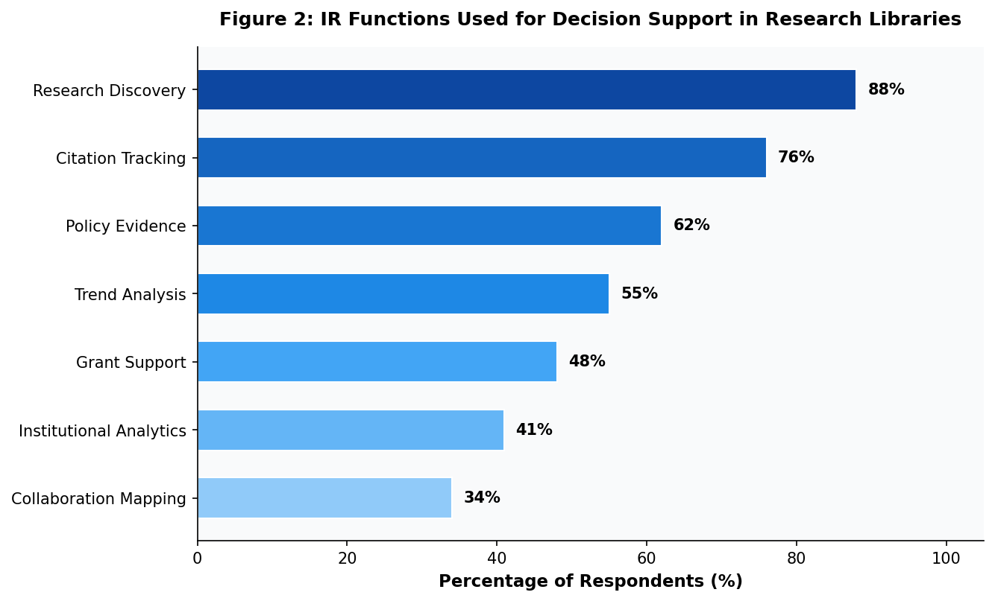
Source: Authors' field survey, 2024
These findings corroborate Hoskins and Mwangi (2022) who observed similar hierarchical patterns of IR use in East African university libraries, where basic discovery functions consistently overshadowed strategic analytics capabilities. The underutilization of institutional analytics and collaboration mapping functions is particularly concerning given their direct relevance to research innovation management — a key mandate of university libraries under the NUC 2022 Core Curriculum guidelines.

IR Deposit Growth Trends (2018–2024)
Figure 3 tracks the growth of IR deposits across three library categories — federal, state, and private university libraries — over a six-year period. Federal university libraries demonstrate the steepest growth trajectory, expanding from 12,000 deposits in 2018 to 63,000 by 2024. State university libraries show moderate growth (4,000 to 35,000), while private institution libraries, though starting from a lower base, recorded consistent incremental growth reaching 24,000 deposits by 2024.

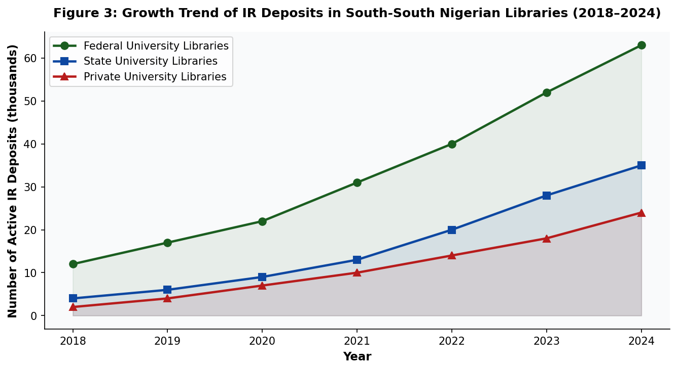
Source: Authors' field survey, 2024
The growth trend data reveals a post-COVID-19 acceleration between 2020 and 2022, consistent with the broader shift toward remote research and digital library services observed globally during this period (Okonedo et al., 2021). This surge in deposits, however, has not been matched by a commensurate increase in IR-based decision support activities, suggesting that deposit quantity alone does not drive decision support utilization. Institutional policy mandates, metadata quality, and user capacity building emerge as critical mediating variables.

IR Policy Environment
Table 3: IR Policy Landscape in South-South Nigerian University Libraries
Policy Dimension | Yes n (%) | No n (%) | Partial n (%)
Formal IR policy document exists | 54 (27.3) | 108 (54.5) | 36 (18.2)
Mandatory deposit mandate in place | 38 (19.2) | 142 (71.7) | 18 (9.1)
Open Access policy adopted | 72 (36.4) | 94 (47.5) | 32 (16.2)
IR linked to research evaluation system | 29 (14.6) | 148 (74.7) | 21 (10.6)
Budget line exists for IR maintenance | 44 (22.2) | 132 (66.7) | 22 (11.1)
IR included in library strategic plan | 61 (30.8) | 103 (52.0) | 34 (17.2)
Source: Authors' field survey, 2024
Table 3 reveals a deeply underdeveloped IR policy ecosystem in the region. Only 27.3% of institutions have a formal IR policy document, and a mere 14.6% have linked their IR to research evaluation systems — a structural prerequisite for systematic decision support. The absence of mandatory deposit mandates in 71.7% of institutions explains, in part, the poor content density of many regional IRs. These findings echo the concerns raised by Adebayo and Oyelaran (2021) regarding the policy vacuum surrounding Nigerian university IRs.

Challenges Hindering IR-Based Decision Support
Figure 4 presents the distribution of challenges reported by respondents as constraints to using IRs for decision support. Inadequate funding emerged as the dominant challenge (28%), encompassing both initial infrastructure costs and ongoing maintenance expenditures. Low staff capacity (22%) reflects insufficient training in IR administration, metadata management, and data analytics, while poor internet connectivity (19%) remains a persistent infrastructural barrier in the Niger Delta region.
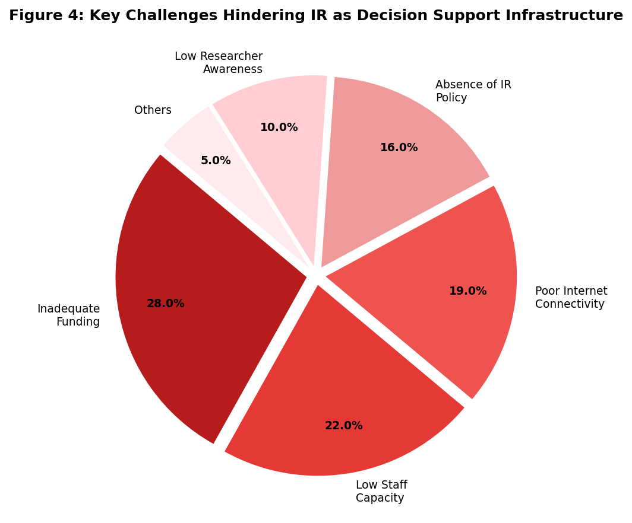
Source: Authors' field survey, 2024
The absence of formal IR policy (16%) — consistent with findings in Table 3 — underscores the institutional governance deficit. Low researcher awareness (10%) suggests that while library professionals may understand IR capabilities, the researcher community that needs to consume IR-based insights remains insufficiently engaged. Collectively, these challenges paint a picture of systemic underinvestment that constrains both supply-side IR development and demand-side decision support utilization.

Researcher Satisfaction with IR Decision Support Services
Figure 5 presents the satisfaction levels of researchers across five key IR service dimensions. Accessibility recorded the highest satisfaction score, with 68% of respondents reporting satisfaction or high satisfaction — consistent with the relatively high IR adoption rates in Rivers and Cross River States. Metadata quality recorded the lowest combined satisfaction (44%), reflecting the widely acknowledged challenge of inconsistent metadata standards in Nigerian IR deployments (Okoye & Ejikeme, 2016).

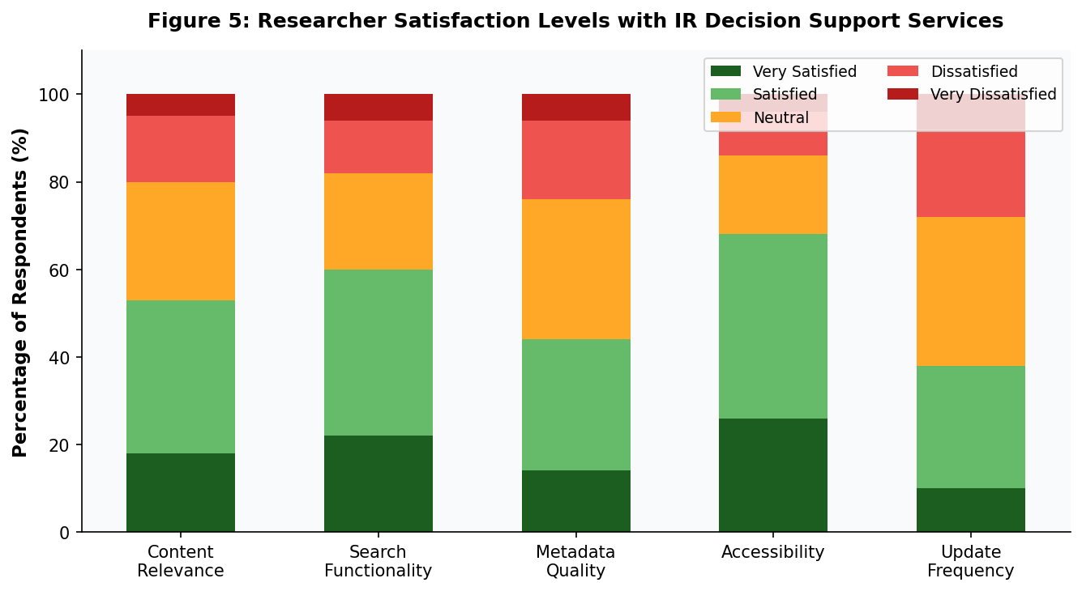
Source: Authors' field survey, 2024
Update frequency registered the lowest overall satisfaction (38% satisfied or very satisfied), with 28% expressing dissatisfaction — a finding that aligns with the absence of mandatory deposit mandates and dedicated IR maintenance budgets documented in Table 3. These satisfaction patterns highlight that researchers' willingness to rely on IRs for decision support is contingent on consistent content currency, high metadata standards, and reliable system accessibility.
Discussion of Findings

The overall picture emerging from this study is one of structural potential constrained by institutional inertia. South-South Nigerian libraries have made measurable progress in IR establishment, with a 56.5% regional adoption rate that surpasses earlier regional baselines. However, the transition from IR as archive to IR as decision support infrastructure remains incomplete across the majority of surveyed institutions.
Theoretically, the findings align with the Technology Acceptance Model's proposition that perceived usefulness and ease of use are the primary determinants of technology adoption (Davis, 1989). The concentration of IR use at the discovery and citation tracking levels — functions perceived as immediately useful and relatively easy to deploy — at the expense of more complex decision support functions such as institutional analytics and collaboration mapping, is consistent with TAM predictions. The policy vacuum documented in Table 3 further inhibits the behavioural intention to use IRs for higher-order decision support tasks.
The significant role of infrastructure constraints — particularly inadequate funding and poor internet connectivity — resonates with the Technology Infrastructure Framework advanced by Heeks (2002) for ICT-for-development contexts. In the Nigerian oil-bearing Niger Delta region, paradoxically one of Africa's most resource-rich zones, such infrastructure deficits speak to deeper issues of resource allocation and governance that transcend library management. The implication for library administrators is that IR advocacy must be embedded within broader institutional strategic planning and governmental digitization agendas.
The underutilization of IRs for grant support and collaboration mapping — both critical functions for research innovation — is particularly striking given the increasing emphasis on competitive research grants in Nigerian federal universities under the TETFund Research Intervention and similar schemes. Libraries that can reposition their IRs as grant intelligence platforms stand to provide significant value to their institutions, but doing so requires both technical configuration upgrades and a conceptual reframing of the librarian's role from archivist to research intelligence officer.

Recommendations

Table 4: Recommendations and Target Stakeholders
S/N | Recommendation | Target Stakeholder
1 | Develop and implement formal IR governance policies, including mandatory deposit mandates aligned with NUC research output requirements. | University Management, Senate
2 | Establish a South-South IR Consortium to share resources, expertise, and metadata standards across institutions. | Library Directors, NUC, TETFUND
3 | Integrate IR analytics into institutional research evaluation and performance management frameworks. | Research Offices, Library Administration
4 | Design and fund continuous professional development programmes for library staff in IR management, metadata quality, and research data analytics. | NLA, LRCN, Library Schools
5 | Advocate for dedicated IR budget lines within annual university allocations, with minimum benchmarks tied to institutional research output volume. | University Governing Councils
6 | Configure IR platforms to support grant intelligence features, including funding opportunity metadata, researcher profile linkages, and collaboration mapping tools. | Library IT Units, IR Administrators
7 | Conduct regular IR awareness campaigns targeting faculty, postgraduate students, and research administrators to increase demand-side engagement. | University Libraries, Research Offices
8 | Leverage government broadband expansion initiatives (e.g., NigComSat, NITDA) to improve internet access in library infrastructure. | Federal and State Governments
Source: Authors' compilation, 2024

Conclusion

This study has provided an empirical assessment of institutional repositories as decision support infrastructure in South-South Nigerian university libraries, generating insights across IR adoption, functional utilization, deposit growth, policy environment, challenges, and researcher satisfaction. The central finding — that IRs in the region are deployed but not yet fully deployed strategically — points to a transitional moment in the evolution of academic library services in Nigeria's oil-rich but infrastructurally challenged south-south zone.
Libraries that successfully navigate this transition will need to reposition themselves as research intelligence hubs, transforming their IRs from passive content stores into active decision support infrastructure. This requires policy reform, capacity building, inter-institutional collaboration, and sustained advocacy at the highest levels of university governance. The Nigerian library profession, guided by bodies such as the Nigerian Library Association (NLA) and the Librarians' Registration Council of Nigeria (LRCN), has a critical role to play in championing this transformation.
Future research should explore the specific impact of IR-based decision support on research output quality and institutional innovation rankings, employ longitudinal designs to track policy intervention outcomes, and extend the geographical scope to other Nigerian geopolitical zones for comparative analysis. The advancement of IR scholarship in Nigeria depends on building a robust evidence base that can speak authoritatively to policymakers, university administrators, and international funding bodies alike.

References

Adebayo, O. S., & Oyelaran, O. A. (2021). Institutional repository deployment and utilization in Nigerian universities: A critical appraisal. Journal of Librarianship and Information Science, 53(2), 312–326. https://doi.org/10.1177/0961000620934551
Adesanya, A. O. (2019). Knowledge management for decision support in academic libraries: Conceptual and practical frameworks. Nigerian Journal of Library and Information Science, 9(1), 1–17.
Adetimirin, A. E. (2012). An investigation of awareness and use of electronic resources among academic staff in selected Nigerian universities. Ozean Journal of Social Sciences, 5(2), 37–47.
Adetimirin, A. E. (2020). Decision support systems in library and information management: Theory and practice in Nigerian contexts. Library Philosophy and Practice (e-journal), 4321.
Adeniran, P. (2011). Usage of electronic resources by undergraduates at the Redeemer's University, Nigeria. International Journal of Library and Information Science, 3(10), 203–208.
Ajidahun, C. O. (2020). Library digitization and institutional repository implementation in Niger Delta universities: Challenges and prospects. African Journal of Library, Archives and Information Science, 30(1), 45–58.
Anunobi, C. V., & Okoye, I. B. (2008). The role of academic libraries in universal access to print and electronic resources in the developing countries. Library Philosophy and Practice, 10(2), 1–8.
Anunobi, C. V., & Okoye, I. B. (2019). Institutional repositories in Nigerian universities: Progress, challenges and prospects. In Digital Preservation and Access in Sub-Saharan Africa (pp. 112–135). Zaria: NALISA Press.
Crow, R. (2002). The case for institutional repositories: A SPARC position paper. Washington DC: Scholarly Publishing and Academic Resources Coalition.
Cullen, R., & Chawner, B. (2011). Institutional repositories, open access, and scholarly communication: A study of conflicting paradigms. Journal of Academic Librarianship, 37(6), 460–470.
Davis, F. D. (1989). Perceived usefulness, perceived ease of use, and user acceptance of information technology. MIS Quarterly, 13(3), 319–340.
Ezema, I. J. (2011). Building open access institutional repositories for global visibility of Nigerian scholarly publication. Library Review, 60(6), 473–485.
Heeks, R. (2002). Information systems and developing countries: Failure, success, and local improvisations. The Information Society, 18(2), 101–112.
Hoskins, R., & Mwangi, M. (2022). Leveraging institutional repositories for research grant intelligence in East African university libraries. African Journal of Library, Archives and Information Science, 32(1), 23–38.
Jones, R., Andrew, T., & MacColl, J. (2006). The institutional repository. Oxford: Chandos Publishing.
Keen, P. G. W., & Scott Morton, M. S. (1978). Decision support systems: An organizational perspective. Reading, MA: Addison-Wesley.
Lynch, C. A. (2003). Institutional repositories: Essential infrastructure for scholarship in the digital age. ARL: A Bimonthly Report, 226, 1–7.
National Universities Commission. (2022). NUC core curriculum and minimum academic standards for library and information science. Abuja: NUC.
Nwalo, K. I. N. (2019). Digital library development in Rivers State university libraries: Status, challenges and strategies. Journal of the Nigerian Library Association (Rivers State Chapter), 6(1), 14–28.
Okello-Obura, C., & Ikoja-Odongo, J. R. (2010). Electronic information seeking among LIS postgraduate students at Makerere University. Library Philosophy and Practice, 12(1), 1–12.
Okonedo, S., Popoola, S. O., Emmanuel, S. O., & Bamigboye, O. B. (2015). Correlates of demographic variables, self-concept, motivation, and library use of undergraduate students in federal universities in South-West Nigeria. Library Philosophy and Practice (e-journal), 1242.
Okoye, M. O., & Ejikeme, A. N. (2016). Open access, institutional repositories, and scholarly communication: A review of literature. Library Philosophy and Practice, 1400.
Swan, A., & Brown, S. (2005). Open access self-archiving: An author study. JISC Technical Report. Key Perspectives Ltd.
Ukwoma, S. C., & Dike, V. W. (2020). Deployment and utilization of institutional repositories by South-East Nigerian university libraries. Global Journal of Pure and Applied Sciences, 26(1), 81–90.
Yamane, T. (1967). Statistics: An introductory analysis (2nd ed.). New York: Harper and Row.
.

