DESIGN AND ANALYSIS OF LOAD FLOW AND FAULT STUDIES FOR AN INDUSTRIAL POWER PLANT
Ananya C^{1*}, Dr. E. Latha Mercy²
¹ Department of Electrical and Electronics Engineering,
Government College of Technology, Coimbatore, India
² Department of Electrical and Electronics Engineering,
Government College of Technology, Coimbatore, India

Email: ¹anan.2403717741122001@gct.ac.in, ²mercy@gct.ac.in

ABSTRACT
In order to assess the steady state performance and dependability of the system, this project uses ETAP (version 19.0.1) software to offer load flow and fault studies of the industrial plant. The substation provides power to the facility (220/33 kV). This bus is connected to two transformers that feed Zone-I with a 25 MVA, 220/33 kV unit, and 60 MVA. A balanced load distribution and steady operation under typical circumstances are confirmed by the load flow simulation results, which show that all bus voltages stay within ±10% of their nominal values. The fault studies mimic single line-to-ground (L-G) and three-phase faults at different bus locations in order to examine how the system responds to anomalous circumstances. Examined are the ensuing fault currents and bus voltages, especially during the sub-transient phase.
Keywords: ETAP, Load flow analysis, Short-circuit analysis, Power system protection, Industrial power systems.

- INTRODUCTION
Load flow analysis and fault studies is a crucial aspect of power system planning, operation and control. It provides the steady state solution for the power system network. The Newton Raphson method is widely regarded as the most dependable and successful load flow method due to its higher accuracy and faster convergence. ETAP 19.0.1 is widely used for Load flow analysis and fault studies due to its ease of use and speed. The program’s operation closely resembles that of a real electrical system. By analysing load flow under various operating conditions using ETAP, power system engineers can evaluate the system response to different disturbances and plan for future system expansion. They involve numerical analysis of the flow of electric power in a power system under steady-state conditions, calculating voltage magnitude and phase angle at each bus, real and reactive power flows in transmission lines.
The primary objectives of load flow studies are to determine voltage levels, calculate power flows, identify potential issues such as overloads and under voltages and optimise system operation. Fault analysis determines how a system responds to abnormal conditions such as symmetrical and unsymmetrical fault.

- OBJECTIVES OF THE THESIS
- To create an accurate model of the Industrial plant using ETAP [Electrical Transient Analyzer Program] 19.1.0.
- To investigate the steady state power flow using the Newton Raphson method. This thesis presents the details for assessing the voltage profile within its nominal range.
- To conduct a short circuit study for the loads connected to the industry by collecting all relevant load data and analysing both symmetrical and unsymmetrical faults.

- STUDY ON LOAD FLOW
Load flow analysis is an important aspect in the study of electrical power networks. It contains critical information on the steady state operation of a power network. The analysis is crucial for system planning and operational research, allowing engineers to determine voltage levels at different buses.
- Assess power flow across transmission cables.
- Identify overloaded equipment.
- Optimize network operations for economic dispatch and stability.
Without reliable Load flow analysis power system operators cannot make educated judgments on network layout or the integration of new generation and load centres.

3.1 TYPES OF BUSES
In load flow studies, buses are grouped into three main classifications depending on known and unknown quantities:
- Slack Bus (Swing Bus): This bus maintains a balance between active and reactive power in the system. Voltage magnitude and angle are provided, but actual and reactive powers are unknown.
- PV Bus (Generator Bus): The actual power generation (P) and voltage magnitude (V) are supplied. The voltage angle and reactive power (Q) need to be determined.
- PQ Bus (Load Bus): The real and reactive power requirements (P and Q) are given. Voltage magnitude and angle are unknowns that must be calculated.

- ANALYSIS ON FAULT STUDIES
A short circuit or fault happens when the systems insulation fails or a conducting object contacts a live point. Fault analysis in power systems involves identifying, calculating and mitigating the effects of faults to ensure system reliability and safety. It occurs due to a low resistance connection between phase conductors or to ground. They are further divided into symmetrical and unsymmetrical faults based on the balance of fault currents [1].

- TYPES OF FAULTS
Various types of faults can occur in the system. Figure 1.2 represents the different types of faults in power system studies.
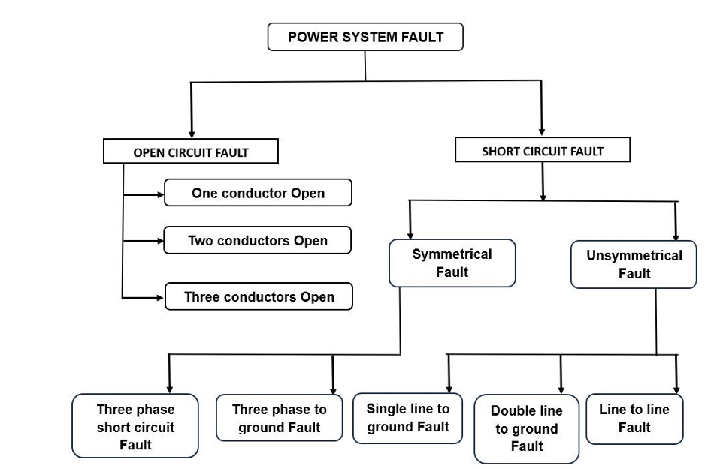
Figure 1.2 Different types of faults in power system studies.

5.1 OPEN CIRCUIT FAULT
An open circuit fault is an interruption in the current path of an electrical circuit that prevents current from reaching the intended load or component. This problem could be caused by disconnected wires, defective switches, broken components or blown fuses. As a result, the circuit becomes incomplete, with a high impedance that restricts current passage, frequently causing systems to malfunction.

  - SHORT CIRCUIT FAULT
A short circuit problem arises when there is an unintentional low resistance channel between two locations in an electrical circuit, allowing electricity to bypass the load. When conductors, like wires make contact directly with each other or conductive materials, they form a connection. As a result, excessive current flows through the circuit, often exceeding the systems safe limit. This can cause overheating, component damage, fires and system failure.

- Symmetrical Faults in Power Systems
A symmetrical fault is a type of fault in a power system where all three phases are affected equally. This type of fault is rare in actual practice (accounts for only about 5% of all faults) but it is the most severe type of fault because it causes maximum fault current to flow through the system. It is very important for designing circuit breakers and protective relays since they must be able to handle the maximum fault level.
There are two main types of symmetrical faults,
(a) Three-Phase Fault (L-L-L Fault)
(b) Three-Phase to Ground Fault (L-L-L-G Fault)

- Unsymmetrical Faults in Power Systems
An unsymmetrical fault is a type of fault in a power system where the three phases of the system are not affected equally. The fault causes an unbalance in voltages and currents in the system. Unlike symmetrical faults, unsymmetrical faults are more common, 9 accounting for nearly 95% of all power system faults, but they generally cause less severe currents compared to symmetrical faults.
There are three main types of unsymmetrical faults,
(a) Single Line-to-Ground (L-G) Fault
(b) Line-to-Line (L-L) Fault
(c) Double Line-to-Ground (L-L-G) Fault

- BLOCK DIAGRAM OF THE INDUSTRIAL PLANT
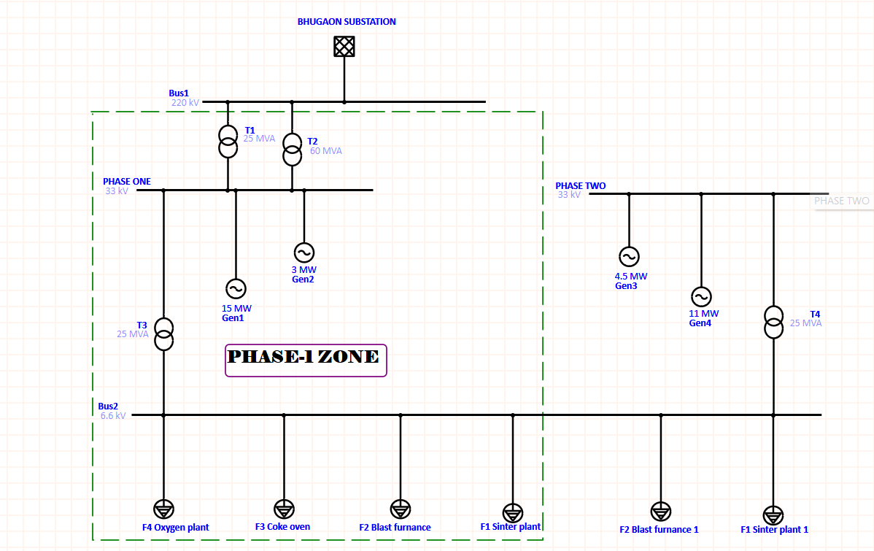
Figure 1.3 Block diagram of the industrial plant
Figure 1.3 illustrates the block diagram of the industrial plant which receives power from the Substation, which feeds a 220/33 kV switchyard. From this switchyard, two outgoing transformers operate: one transformer rated at 25 MVA, 220/33 kV is connected to Zone-I and another transformer rated at 60 MVA. Two generators, rated at 15 MW and 3 MW, are connected to Zone-I.

  - MODELLING OF THE INDUSTRIAL PLANT

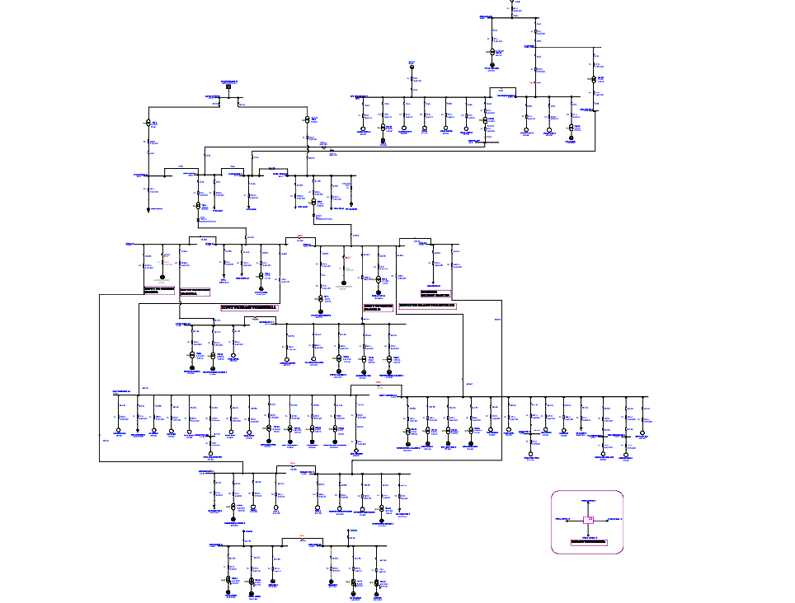
Figure 1.4 Modelling of zone-I
The Figure 1.4 is the detailed modelling of Plant Zone-I which are modelled using ETAP 19.1.0 software. It includes a many inner plants with various voltage ranges, like mentioned at the block diagram.

- SIMULATION TOOL
ETAP is a robust software application for power system engineers to model and simulate electrical networks. It contributes to the creation of an electrical digital twin for analysing system dynamics and protection. ETAP, which was originally built for the MS DOS operating system, was intended to help with the analysis and operation of both commercial and nuclear power systems. ETAP allows electrical engineers and operators to conduct a variety of studies both offline and online. This software can simulate tasks like short circuit investigation and motor starting studies

- SIMULATION RESULTS FOR LOAD FLOW ANALYSIS
As per the standard of load flow analysis, the system maintains its nominal tolerance of ±10% of its range. The load flow analysis results are provided in the Figure 1.5 which specify the voltage of all buses in zones I.
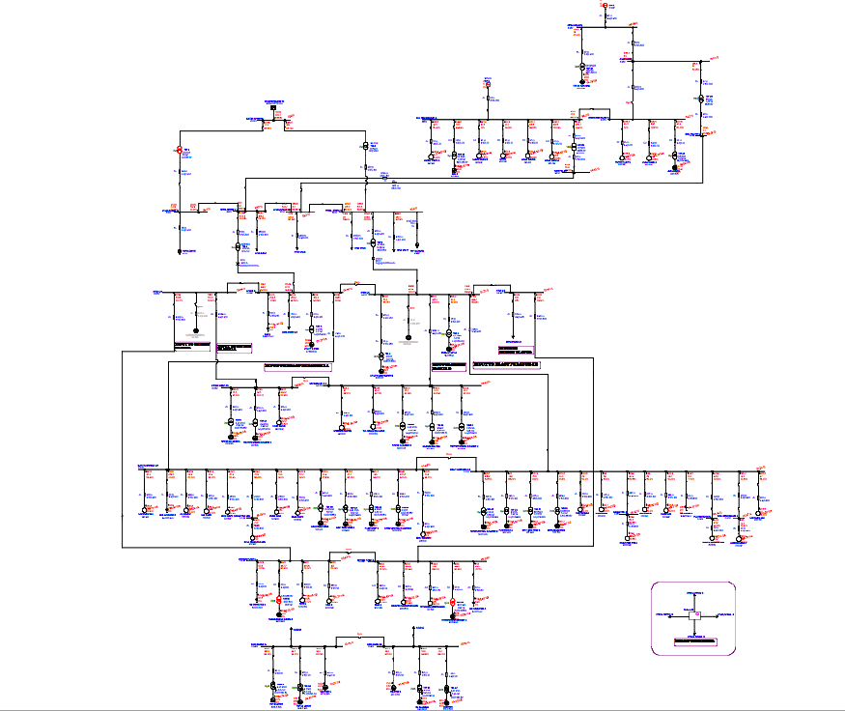
Figure 1.5 load flow analysis results of zone-I

- SIMULATION RESULTS FOR FAULT STUDIES
From the voltage profile obtained through the load flow analysis, fault studies are subsequently performed using the data from the plant. Based on the results of the earlier simulation, the short-circuit current at the grid and the impedance values of the generators are incorporated into the system model. Using this information, various fault conditions are simulated to analyze the system response. The fault analysis includes both three-phase (symmetrical) and single line-to ground (L–G) (unsymmetrical) faults. The results for the symmetrical fault for the zones I are illustrated in Figure 1.6. And the results for the unsymmetrical fault are illustrated in Figure 1.7.
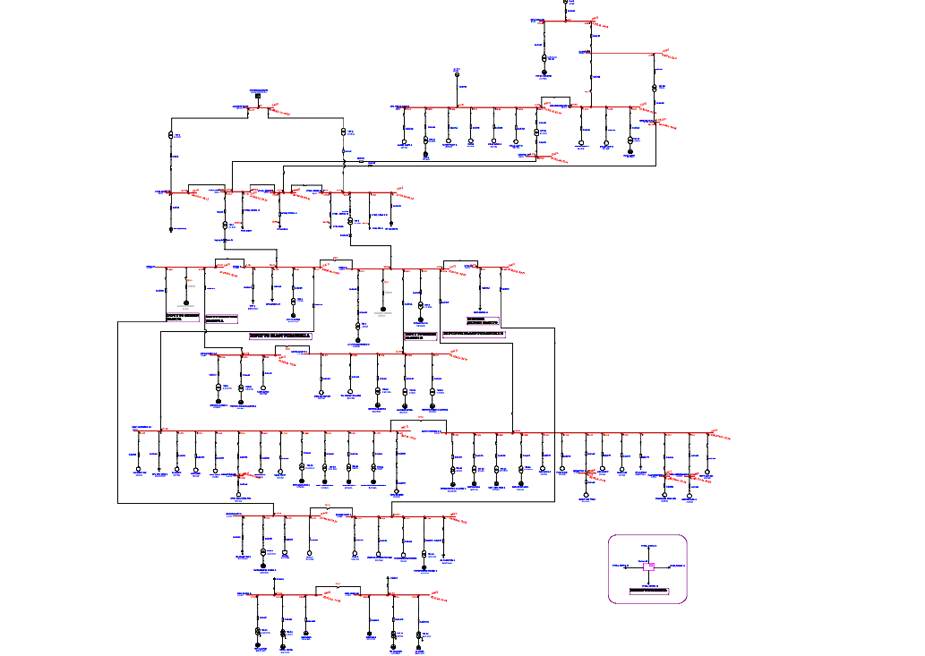
Figure 1.6 Symmetrical fault for the zones I
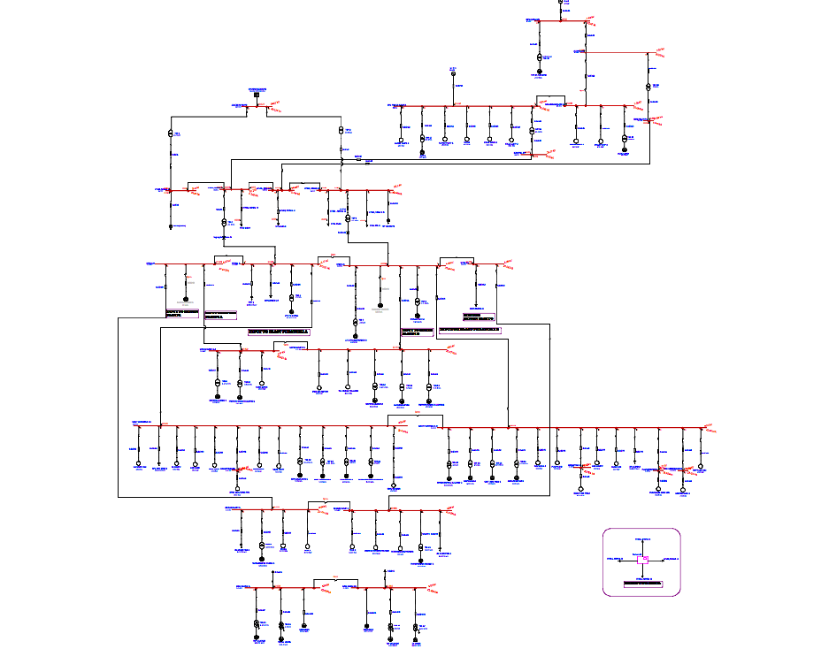
Figure 1.7 Unsymmetrical fault for the zone-I

- CONCLUSION
The Plant has a total power capacity of 33 MW and receives its main power supply from the nearby Substation. In addition, the plant operates four in-house generating stations and the generated and supplied power is distributed to various units within the facility, including the Blast Furnace Plant, Sinter Plant, Coke Oven Plant, Oxygen Plant and Boiler Plant. The entire electrical network of the industrial plant has been modelled and simulated using ETAP (19.1.0) software. The results indicated that the voltage profiles of all buses are within permissible limits, confirming the systems stable operating condition during the load flow analysis. Furthermore, Fault studies are then performed utilizing plant data and the voltage profile acquired from the load flow study. Using this information, various failure conditions are simulated to analyse the system's response. The fault analysis covers both three phase (symmetrical) and single line-to-ground (L-G) (unsymmetrical) faults. As a result, the following values are obtained sub transient short circuit current, peak short circuit current, steady-state short circuit current and breaking short circuit current.

REFERENCES
- [1] Vishal V, Ishwar, April 24, “Load Flow Analysis of Power System in ETAP”, IJIREEICE, ISSN (O) 2321-2004, Vol. 12, Issue 4, pp. 64-69.
- [2] Vishal V, Utkarsh Chaurasia, 2020 “Load Flow Analysis of 66 kV substation using ETAP Software”, JUNE 2022, IRE, Vol. 5, Issue 12, ISSN:2456-8880, pp. 208-211.
- [3] Igbogidi O. N. and Dahunsi, A. A. 2024, “Modern Trend of Power flow Analysis in Power System”, American Journal of Engineering Research (AJER), e-ISSN: 2320-0847 p ISSN: 2320-0936, Vol. 12, Issue 4, pp.53 582024.
- [4] Ukut, Uwem Isong1, Okpura, Nseobong2 March-2023, “The IEEE 33 Bus Distribution System Power flow Analysis Using Newton Raphson Method”, Journal of Multidisciplinary Engineering Science and Technology, Journal of Multidisciplinary Engineering Science and Technology (JMEST), ISSN: 2458-9403, Vol. 10 Issue-3, pp. 16039-16047.
- [5] Muhammad Bilal, Prof. Dr. M. Naeem Arbab, Muhammad Zubair, November 2019, “Using ETAP Power flow Analysis of 132/11kv Kohat Substation: A Case Study”, Global scientific journal (GSJ), ISSN 2320-9186, Volume 7, Issue 11, 1041-1046.


AUTHORS' INFORMATION
Ananya C- Postgraduate scholar in Power Systems Engineering at Government College of Technology, Coimbatore. She received her Bachelor of Engineering degree in Electrical and Electronics Engineering from Dr. N.G.P Institute of Technology, Coimbatore, in 2024. Her research interests include power system analysis and industrial power system studies. She has worked on load flow and short circuit analysis for industrial electrical networks. Her current research focuses on improving reliability and efficiency in power system operation and planning


Dr E. Latha Mercy- Professor and HoD of Electrical & Electronics Engineering is with the Government College of Technology, Coimbatore, TamilNadu. She completed her Doctoral degree from Anna University in 2011, Masters in Applied Electronics in Government College of Technology, Coimbatore from Bharathiyar University in 1999 and Bachelor of Engineering in Electrical Engineering at Thiagarajar College of Engineering from Madurai Kamaraj University, Madurai in 1988. She has more than 37 years of teaching experience in various Government Engineering Colleges under Directorate of Technical Education, Tamilnadu. She is a life member of ISTE. Having 35+ Journal publications, 36+ Conference Publications, attended 100+ FDPs/STTPs/Workshops/Webinars and organized 15+ FDPs. Received few institutional academic awards. Recognized research supervisor under Anna University.

