Assessment And Mitigation of Power Quality Issues in Presence of Optimally Placed DGs in Radial Distribution System Using Heuristic Optimization Algorithms

ABSTRACT
Distributed Generation (DG) integration plays a significant role in improving the efficiency, reliability, and power quality of modern radial distribution systems. However, improper DG placement and sizing can lead to high power losses, unstable voltage profiles, and poor power quality act under changing load conditions. This study aims to improve power quality in the IEEE 33-bus radial distribution system by minimizing real power loss, Total Harmonic Distortion (THD), and voltage sag through optimal DG placement and sizing. A 24-hour load variation profile is considered to represent realistic operating conditions. The Backward-Forward Sweep (BFS) load flow method is utilized to calculate bus voltages, line currents, and power losses, while the Artificial Bee Colony (ABC) algorithm is useful to solve the multi-objective optimization problem involving power loss, THD, voltage deviation, and voltage sag index. Simulation results prove significant improvements after DG integration. The total active power loss is reduced from 159.1074 kW to 54.173 kW, achieving a 65.95% reduction, while the minimum bus voltage expands from 0.9188 p.u. to 0.9678 p.u. The total THD is reduced from 5.2716% to 2.6168%, while the voltage sag index decreases from 0.1958 to 0.1192. The results confirm the use of the proposed ABC-BFS approach for improving overall system performance and power quality under realistic operating conditions.
Keywords: Load Flow Analysis, Backward-Forward Sweep, Artificial Bee Colony, Power Quality, Distributed Generation, Optimization Performance
INTRODUCTION
The increasing demand for reliable and efficient electrical power has encouraged the usage of advanced optimization techniques and DG in radial distribution systems [1]. Renewable energy combination has improved the need for improved voltage stability, loss reduction, and system resilience methods [2]. DG effectively reduces transmission losses and voltage deviations, improving overall system efficiency [3]. Some optimization techniques have been developed to control the optimal DG location and size under different operating conditions [4]. Smart algorithms and advanced control strategies further support sustainable distribution system development [5]. Many studies on IEEE radial distribution systems have analysed DG penetration under varying load conditions [6]. System performance is influenced by load variation, network topology, and DER penetration levels [7]. However, renewable energy sources such as photovoltaics and microgrids introduce intermittency and voltage fluctuations [8]. Proper coordination between DG units, capacitor banks, and D-STATCOM devices is essential for maintaining stability and efficiency [9]. Smart grid and distribution automation technologies also support dynamic system control [10]. Despite these developments, existing studies still face limitations in achieving complete power quality improvement. Most approaches focus mainly on loss reduction or voltage profile enhancement while neglecting THD and voltage sag analysis. To overcome these limitations, the proposed research integrates BFS load flow analysis with the ABC optimization algorithm for optimal DG placement and sizing.
- The main objective of this research is to enhance the power quality of the IEEE 33-bus radial distribution system through optimal placement and sizing of DG units.
- The system is analysed under 24-hour load variation conditions to represent realistic daily demand changes.
- The BFS load flow method is used to calculate bus voltages, line currents, and power losses before and after DG integration.
- The ABC optimization algorithm is employed to identify the optimal DG location and size by minimizing power loss, THD, voltage deviation, and voltage sag.
LITERATURE SURVEY
Chothani et al. [11] proposed optimization techniques to improve microgrid reliability using renewable energy integration and energy storage coordination. Islam et al. [12] applied genetic algorithms for optimal energy storage placement to enhance system stability. Patel et al. [13] developed a multi-objective PSO method for DG and capacitor placement to improve voltage profile. Sundar et al. [14] introduced a hybrid optimization approach for DG and capacitor allocation to enhance efficiency and voltage stability. Lalaymia et al. [15] proposed a self-adaptive optimization method for PV-DG allocation with improved voltage regulation and loss reduction. Malika et al. [16] studied optimal DG and capacitor placement considering technical and economic constraints.
The integration of distributed energy resources, EV charging stations, and compensation devices has increased challenges in maintaining power quality and constancy in radial distribution systems. Existing studies mainly focus on loss reduction and voltage improvement but often neglect dynamic conditions and power quality issues such as THD and voltage sag. Advanced optimization and deep learning methods improve DER integration, but they are computationally complex and require large datasets. Similarly, Jellyfish Search and Crow Search algorithms mainly address techno-economic objectives without comprehensive power quality analysis. To address these limitations, the proposed research combines BFS load flow analysis with ABC optimization for optimal DG placement and sizing while considering THD, voltage sag, and dynamic load variations.
PROPOSED METHODOLOGY FOR POWER QUALITY ENHANCEMENT IN RADIAL DISTRIBUTION SYSTEM USING DG OPTIMIZATION
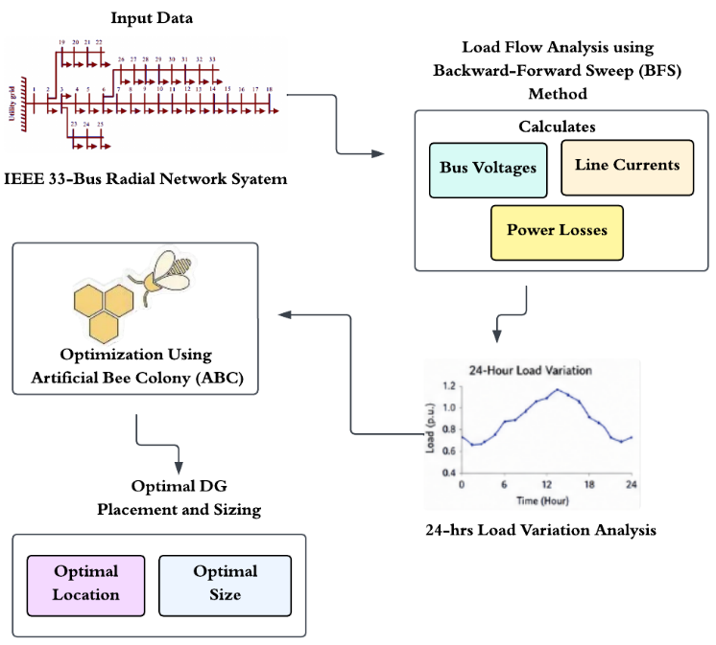
Figure 1: Flow of work carried out in this paper

Test System Initialization
The IEEE 33-bus radial distribution system is modelled in MATLAB using detailed bus and line data for BFS load flow analysis to evaluate system performance before and after DG integration. The IEEE 33 Bus system is shown in Figure 2.
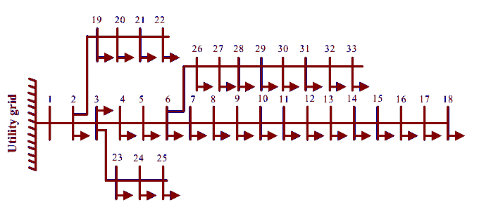
Figure 2: IEEE 33 Bus Radial Network System
The IEEE 33-bus system is a radial network where power flows from the utility grid through the main feeder and connected sub-branches.
Load Flow Analysis using Backward–Forward Sweep (BFS)
The BFS load flow method is applied to the IEEE 33-bus radial distribution system to iteratively calculate bus voltages, branch currents, and power losses before and after DG integration. Primarily, all bus voltages are assumed. The backward sweep calculates the branch power flows by moving from the end buses (leaf nodes) toward the slack bus.
Real Power Flow: Real power flow $P$ represents the actual energy transferred from the source to loads in Equation (1):
$P_{ij}=P_{L}(j)+\sum_{k∈children(j)}{ }P_{jk}+R_{ij}\frac{P_{ij}^{2}+Q_{ij}^{2}}{V_{j}^{2}}$ (1)
where, $P_{ij}$ denote the real power flowing from bus $i$ to bus $j$, $P_{L}(j)$ is active load at bus $j$, $\sum_{k∈children(j)}{ }P_{jk}$ is power flows of downstream branches connected to bus $j$, $R_{ij}$ denotes resistance of line between bus $i$ and $j$, $V_{j}$ represent voltage magnitude at receiving bus $j$.
Reactive Power Flow: Reactive power flow $Q$ represents the energy exchanged between inductive and capacitive in Equation (2):
$Q_{ij}=Q_{L}(j)+\sum_{k∈children(j)}{ }Q_{jk}+X_{ij}\frac{P_{ij}^{2}+Q_{ij}^{2}}{V_{j}^{2}}$ (2)
where, $Q_{ij}$is the reactive power flowing from bus $i$ to bus $j$, $Q_{L}(j)$ denotes the reactive load at bus $j$, $\sum{ }Q_{jk}$ is the power flows of downstream branches connected to bus $j$, $X_{ij}$ is the reactance of line between bus $i$ and $j$, $V_{j}$ Voltage magnitude at receiving bus $j$. After computing power flows, voltages are updated from the slack bus to end buses. Voltage update in Equation (3):
$V_{j}=\sqrt{V_{i}^{2}-2\left(R_{ij}P_{ij}+X_{ij}Q_{ij}\right)-\left(R_{ij}^{2}+X_{ij}^{2}\right)\frac{P_{ij}^{2}+Q_{ij}^{2}}{V_{i}^{2}}}$ (3)
where, $V_{i}$ denotes the sending end voltage (bus i), $V_{j}$ receiving end voltage (bus j), $R_{ij},X_{ij}$ line impedance components, $P_{ij},Q_{ij}$ is power flow through branch, $\left(R_{ij}P_{ij}+X_{ij}Q_{ij}\right)$ voltage drop component due to power flow and $\left(R_{ij}^{2}+X_{ij}^{2}\right)$ Magnitude of line impedance squared. The iteration continues until voltage change is minimal in Equation (4):
$max\left|V_{i}^{(k)}-V_{i}^{(k-1)}\right|<ϵ$ (4)
where, $k$ denotes the iteration number and $ϵ$ denotes the tolerance (${10}^{-6}$). Ensures solution stability and accuracy. After convergence the branch current is calculated by using Equation (5):
$I_{ij}=\frac{\sqrt{P_{ij}^{2}+Q_{ij}^{2}}}{V_{i}}$ (5)
where, $I_{ij}$ is current in branch $P_{ij},Q_{ij}$ denotes the power flow and$V_{i}$ is the sending voltage. Power loss in a radial distribution system occurs due to line resistance and reactance, reducing system efficiency and affecting voltage regulation and stability.
Calculation of THD & Voltage Sag Index (Based on BFS Results)
The BFS load flow results are to utilized calculate power quality parameters such as THD, voltage sag index, real power loss, minimum bus voltage, and weak bus identification. Harmonic voltages are used to evaluate THD at different harmonic orders, while line and source impedances are used to estimate voltage sag conditions. The load flow results also help determine total power loss, the minimum voltage bus, and the weak bus in the distribution system.
Problem Formulation for Optimization
After assessing the system without DG, high power loss, voltage drop, THD, and voltage sag are observed, and the ABC algorithm is applied for optimal DG placement and sizing to improve overall power quality [17]. The losses are called I²R losses (thermal losses) and are calculated in Equation (6):
$P_{L}=\sum_{k=1}^{n-1}{ }R_{k}I_{k}^{2}$ (6)
where, $P_{L}$ is total real power loss of the system (pu or kW), $R_{k}$ is resistance of the $k$ th branch (pu), $I_{k}$ is current flowing through kth branch (pu) and $n$ is total number of buses in the system (here 33 buses). Prevents unrealistic DG values and ensures DG neither too small nor too large. Voltage at a bus due to harmonic current injection. Voltage sag is a temporary reduction in voltage due to faults. Measures severity of voltage dips. A lower value shows improved system concert used as optimization objective.
Artificial Bee Colony (ABC) Algorithm
The ABC algorithm is used to find the optimal DG location and size for minimizing power loss, THD, and voltage sag in the distribution system. The optimization process begins with random generation of DG locations and sizes for fitness evaluation. The fitness is calculated in Equation (7):
$\text{ Fitness }=\frac{1}{1+P_{\text{loss }}+P_{\text{enalty }}}$ (7)
where, $P_{\text{loss }}$ represents the total real power loss obtained from the BFS load flow analysis. In the employed bee phase, better DG solutions replace old solutions based on fitness. In the onlooker bee phase, solutions are selected probabilistically based on their fitness values, as given in Equation (8).
$P_{f}=\frac{\text{ fitness }}{\sum{ } \text{f}\text{ú}\text{tness} }$ (8)
where, $P_{f}$ is the probability of selecting the $f^{\text{th }}$ solution and $f$ fitness $_{f}$ is its fitness value. In the scout bee phase, non-improving solutions are replaced with new ones, and the process repeats until the optimal DG solution is obtained and evaluated using BFS load flow analysis. The optimizer model flowchart has been presented in Figure 3.
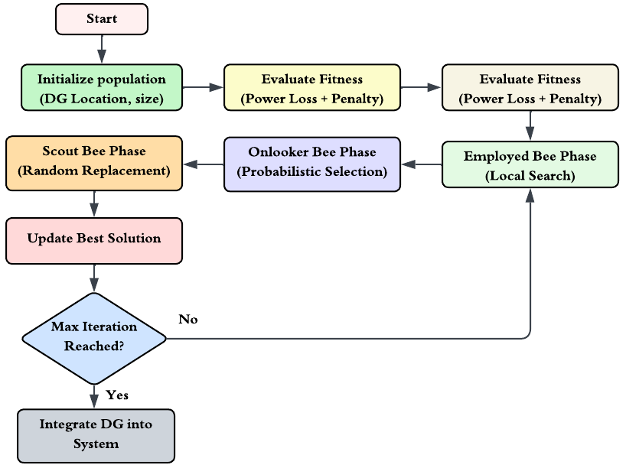
Figure 3: Flowchart for ABC Algorithm
Optimal DG Placement and Sizing
The ABC algorithm is used to regulate the optimal DG location and size for minimizing power loss, THD, and voltage sag, resulting in improved voltage profile and overall power quality performance [18].
Load Flow Analysis with DG Integration
After determining the optimal DG location and size, the DG is integrated into the system and BFS load flow is repeated to evaluate the updated voltage profile, line currents, and power losses. The modified load at the DG bus is given in Equation (9) and (10):
$P_{i,\text{ new }}=P_{i}-P_{DG}$ (9)
$Q_{i,\text{ new }}=Q_{i}-Q_{DG}$ (10)
where, $P_{i},Q_{i}$ is the original active and reactive load at bus $i$, $P_{DG},Q_{DG}$ is the DG injected active and reactive power. The real power loss in the system is recalculated in Equation (11):
$P_{\text{loss }}=\sum_{k=1}^{n}{ } R_{k}I_{k}^{2}$ (11)
where, $R_{k}$ is the resistance of line $k$, $I_{k}$ is the current through line $k$.
RESULTS AND DISCUSSION
The proposed MATLAB-based system analysed the IEEE 33-bus radial distribution network under both base case and DG integrated conditions using the BFS load flow method and ABC-based optimization. The system performance is evaluated under 24-hour varying load conditions considering voltage profile improvement, active power loss reduction, THD mitigation, and voltage sag performance. The obtained results confirm that optimal DG placement and sizing significantly enhance the overall technical performance and power quality of the distribution system.
The obtained base-case results may differ slightly from benchmark IEEE 33-bus studies due to differences in network parameter representation, per-unit conversion, and load-flow implementation. However, all results were generated consistently using the developed MATLAB model and are used as the reference for comparative performance evaluation.
Table 1: Network Configuration of IEEE 33-Bus Radial Distribution System
Parameter | Value
Total Number of Buses | 33
Total Number of Branches | 32
System Type | Radial Distribution Network
Nominal Voltage | 12.66 kV
Base Power | 100 MVA
Slack Bus | Bus 1
Bus Type | PQ Buses (except slack bus)
Load Type | Constant PQ Loads
Load Flow Method | Backward Forward Sweep Load Flow
Optimization Algorithm | ABC Optimization
DG Location | Bus 8
Optimal DG Size | 1.972 MW
Voltage Limits | 0.90 p.u. - 1.10 p.u.
Table 1 presents the network configuration and operating parameters of the IEEE 33-bus radial distribution system used for the analysis.
Table 2: Base Load Flow Results (Without DG) – IEEE 33-Bus System
Bus No. | Voltage (p.u.) | Voltage (kV) | Bus No. | Voltage (p.u.) | Voltage (kV)
1 | 1.000000 | 12.6600 | 18 | 0.918762 | 11.6316
3 | 0.984142 | 12.4592 | … | … | …
5 | 0.970783 | 12.2901 | 21 | 0.992414 | 12.5640
7 | 0.951642 | 12.0478 | 23 | 0.980561 | 12.4149
9 | 0.940596 | 11.9079 | 25 | 0.970578 | 12.2875
11 | 0.933961 | 11.8239 | 27 | 0.951576 | 12.0469
13 | 0.926396 | 11.7282 | 29 | 0.938088 | 11.8766
15 | 0.922740 | 11.6819 | 31 | 0.931415 | 11.7927
17 | 0.919366 | 11.6392 | 33 | 0.930233 | 11.7777
Table 2 presents the base case load flow results of the IEEE 33-bus radial distribution system under without DG condition. It is observed that the voltage magnitude gradually decreases toward the end buses due to increased feeder impedance and load demand. The minimum voltage is observed at Bus 18 with a value of 0.918762 p.u. (11.6316 kV), indicating weak voltage stability under base loading conditions. Only buses with major voltage variations are presented, while the remaining bus values are omitted for brevity.
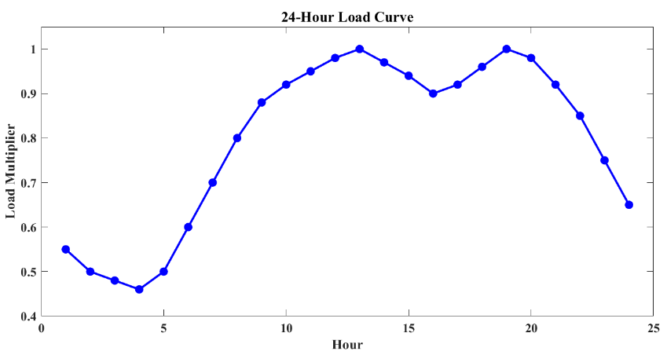  (a) | 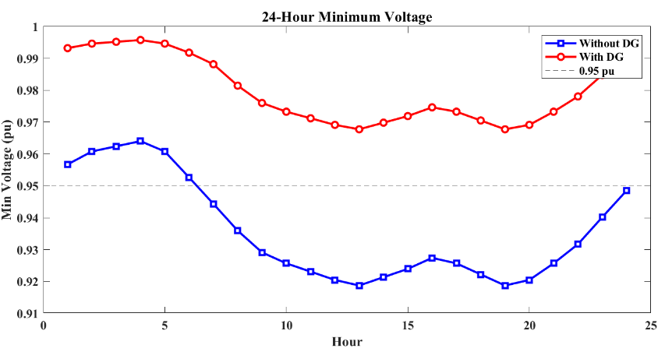  (b)
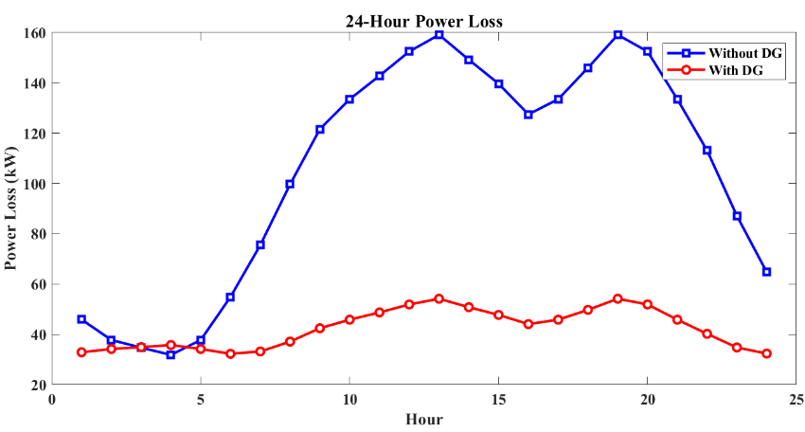
(c)
Figure 4: 24-Hour Analysis (a) Load Curve (b) Minimum Voltage (c) Power Loss
Figure 4 presents the 24-hour operational analysis of the IEEE 33-bus system under varying load conditions. In Figure 4(a), the load curve illustrates that the load factor varies from 0.46 during off-peak periods to a maximum value of 1.0 during peak demand hours. Figure 4(b) shows the minimum bus voltage variation throughout the day, where the voltage decreases during high load periods in the base case but remains significantly improved after DG integration. Figure 4(c) presents the active power loss variation, where the losses increased considerably during peak loading conditions without DG and are substantially reduced after DG placement.
Table 3: 24-Hour DG Analysis Results
Hour | Load Factor | Weak Bus Without DG | V_{min} Without DG (p.u.) | Weak Bus With DG | V_{min} With DG (p.u.) | Loss Without DG (kW) | Loss With DG (kW) | THD Without DG (%) | THD With DG (%)
1 | 0.55 | 18 | 0.9567 | 25 | 0.9932 | 45.91 | 32.88 | 2.74 | 1.37
2 | 0.50 | 18 | 0.9608 | 25 | 0.9946 | 37.76 | 34.20 | 2.48 | 1.24
3 | 0.48 | 18 | 0.9624 | 25 | 0.9952 | 34.73 | 34.93 | 2.38 | 1.19
... | ... | ... | ... | ... | ... | ... | ... | ... | ...
24 | 0.65 | 18 | 0.9485 | 25 | 0.9904 | 64.78 | 32.38 | 3.28 | 1.63
Table 3 presents the 24-hour analysis results of the IEEE 33-bus radial distribution system under changing load conditions with and without DG integration. The table compares the system performance in terms of weak bus location, minimum bus voltage (Vmin), active power loss, and THD. The results indicate that DG integration significantly increase the voltage profile by increasing the minimum bus voltage and shifting the weak bus condition to a more stable operating region. The THD values are also minimized and maintained within the permissible limits specified by IEEE 519 standards, demonstrating enhanced power quality and improved overall system stability throughout the 24-hour operating cycle.
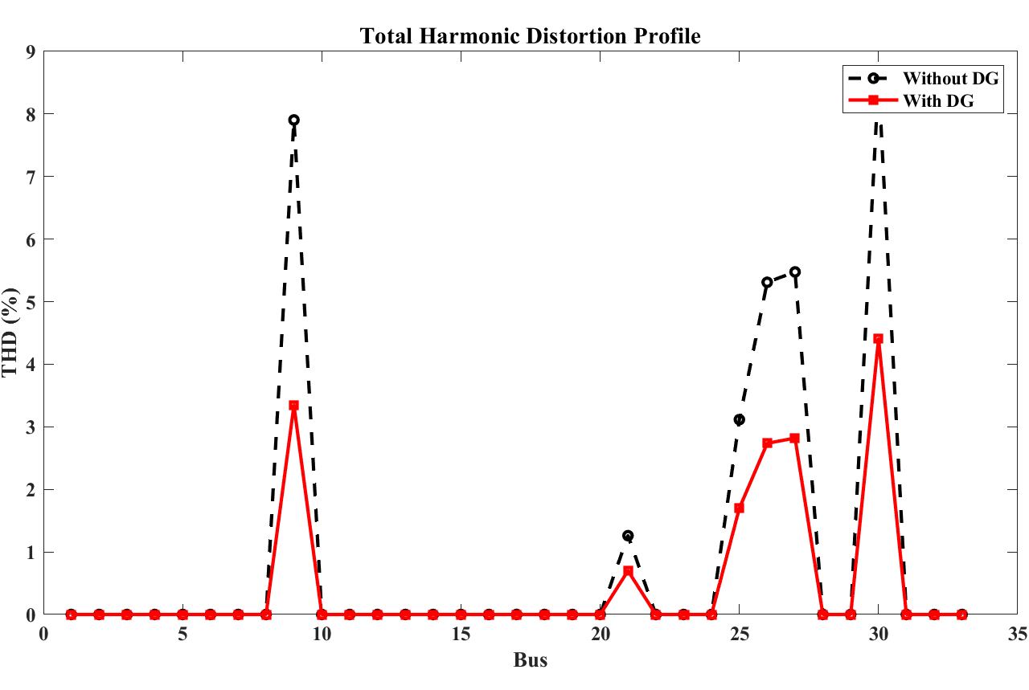
Figure 5: THD Comparison Before and After DG Integration
Figure 5 presents the THD comparison of the IEEE 33-bus system under without DG and with DG conditions. Under the base case (without DG), the maximum THD reaches 5.2716%, which slightly exceeds the IEEE 519 acceptable limit of 5%, indicating poor harmonic performance and reduced power quality. After optimal DG integration, the THD value is significantly reduced to 2.6168%, which falls within the IEEE 519 permissible limit, thereby improving harmonic performance and overall power quality of the distribution system. The found results show that the proposed DG integration achieves approximately 50.36% THD mitigation compared to the base case, confirming effective harmonic suppression and enhanced system stability under changing operating conditions.
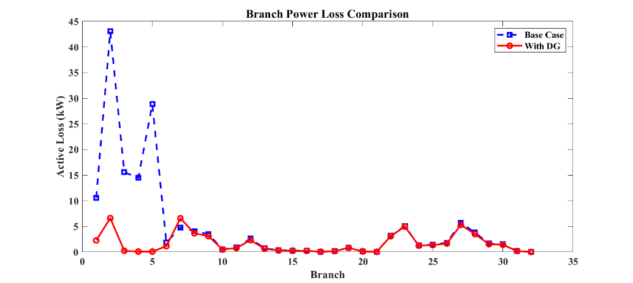
Figure 6: Branch Power Loss Comparison
Figure 6 illustrates the branch-wise active power loss comparison under without-DG and with-DG conditions. It is observed that the branch losses are significantly higher in the base case, particularly in the initial feeder sections, whereas DG integration considerably reduces branch losses due to local power support and reduced feeder current flow.
Table 4: Overall System Performance Comparison
Parameter | Base Case | With Optimized DG
Total Active Loss kW | 159.1074 | 54.173
Minimum Voltage pu | 0.918762 | 0.967767
THD pct | 5.2716 | 2.6168
Voltage Sag Index | 0.195801 | 0.119227
Loss Reduction pct | 0 | 65.95193
DG Location | 0 | 8
DG Size MW | 0 | 1.972413
Active power loss has been significantly reduced after integration with DG, as shown in Table 4.
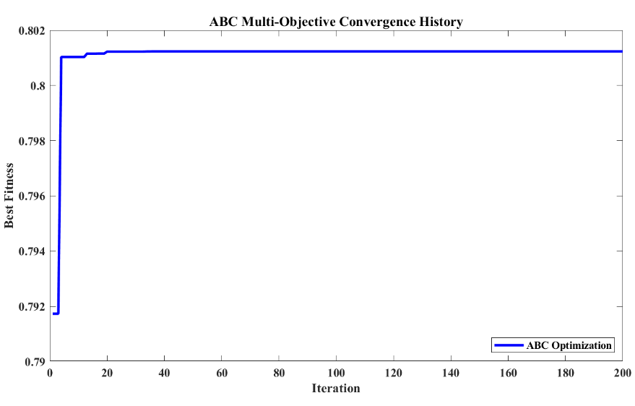
Figure 7: ABC Multi-Objective Convergence History
Figure 7 presents the convergence features of the proposed ABC optimization algorithm. The fitness value increases rapidly during the early iterations and stabilizes at approximately 0.671646937, indicating strong convergence capability and stable optimization performance.

Table 5: Performance Improvement Metrics After DG Integration
Metric | Improvement Pct
Loss Reduction | 65.95193
Voltage Improvement | 5.333763
THD Mitigation | 50.36
Sag Mitigation | 39.10782

The Table 5 shows the significant improvement in system performance after DG placement.
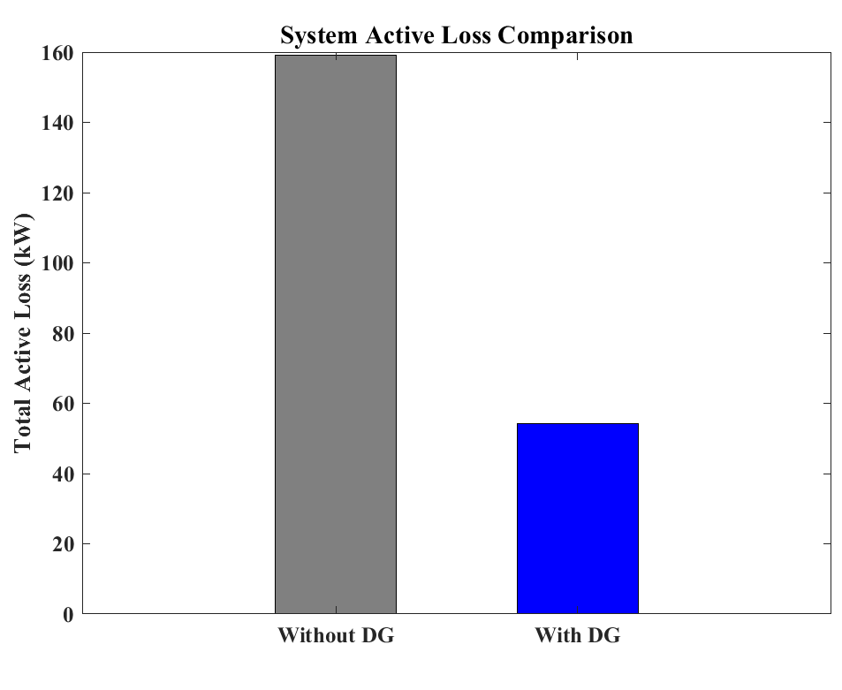
Figure 8: Active Power Loss Comparison
Figure 8 presents the comparison of active power losses in the IEEE 33-bus radial distribution system under without DG and with DG conditions. It is observed that the active power loss is significantly higher in base case due to increased feeder current and higher line losses across the distribution network. After optimal DG integration, the active power loss is considerably reduced because the DG supplies power locally to nearby load buses, thereby reducing the current flow from the substation and minimizing transmission losses. The results demonstrate that the total active power loss decreases from 159.1074 kW under without DG condition to 54.1730 kW after DG integration, achieving approximately 65.95% reduction in system power loss. The reduction in losses confirms the efficiency of the proposed DG placement and sizing strategy in improving overall distribution system efficiency.
CONCLUSION AND FUTURE WORK
Initial analysis without DG revealed poor system performance, including high power losses, low minimum voltage, increased THD, severe voltage sag, and weak bus conditions. After optimal DG integration, the system performance improved significantly, with power losses reduced from 159.1074 kW to 54.173 kW and minimum voltage increased from 0.9188 p.u. to 0.9678 p.u. The THD and voltage sag index were also reduced considerably. The proposed ABC-BFS method achieved major improvements in voltage stability, power quality, and system efficiency under both static and dynamic load conditions, including 24-hour load variation analysis. The methodology can be extended for larger networks, renewable energy integration, energy storage systems, and smart grid applications.

REFERENCES
- Teferra, D.M., 2025. Performance Evaluation of a Radial Distribution Network Under Emerging Load Prediction Modeling Approach and DG Integration Using a Particle Swarm Optimization Algorithm. Journal of Electrical and Computer Engineering, 2025(1), p.1352068.
- H. Iqbal, A. Stevenson, and A. I. Sarwat, “Impact Analysis and Optimal Placement of Distributed Energy Resources in Diverse Distribution Systems for Grid Congestion Mitigation and Performance Enhancement,” Electronics, vol. 14, no. 10, p. 1998, Jan. 2025, doi: 10.3390/electronics14101998.
- S. Mokred, Y. Wang, M. Alruwaili, and M. A. Ibrahim, “A Novel Approach for Voltage Stability Assessment and Optimal Siting and Sizing of DGs in Radial Power Distribution Networks,” Processes, vol. 13, no. 7, p. 2239, Jul. 2025, doi: 10.3390/pr13072239.
- S. Chanbasha, N. Jayakumar, and N. B. Kumar, “DG allocation for radial distribution system through optimal sizing in radial power distribution network using hybrid redfox pathfinder optimization,” Multimed Tools Appl, vol. 84, no. 16, pp. 16605–16629, May 2025, doi: 10.1007/s11042-024-18704-z.
- M. Alanazi, “Optimal Integration of Distributed Generators and Soft Open Points in Radial Distribution Networks: A Hybrid WCA-PSO Approach,” Processes, vol. 13, no. 6, p. 1775, Jun. 2025, doi: 10.3390/pr13061775.
- D. M. Teferra, L. M. H. Ngoo, and G. N. Nyakoe, “Optimizing Radial Distribution Network Performance Through Microgrid Integration Using a Hybrid PSO‐HSA Algorithm,” Journal of Electrical and Computer Engineering, vol. 2025, no. 1, p. 3701507, Jan. 2025, doi: 10.1155/jece/3701507.
- B. K. Malika et al., “A quasi oppositional forensic based investigation algorithm for optimizing distributed generation placement and sizing in power distribution systems,” Sci Rep, vol. 15, no. 1, p. 16471, May 2025, doi: 10.1038/s41598-025-01378-4.
- B. K. Malika, V. Pattanaik, B. K. Sahu, P. K. Rout, S. Panda, and M. Bajaj, “Optimal distributed generation and shunt capacitor bank placement in microgrid distribution planning for enhanced performance,” Neural Comput & Applic, vol. 37, no. 22, pp. 17363–17388, Aug. 2025, doi: 10.1007/s00521-024-10503-9.
- L. F. Grisales-Noreña, D. Sanin-Villa, O. D. Montoya, R. I. Bolaños, and K. X. Bonilla Rojas, “Cost-Optimal Coordination of PV Generation and D-STATCOM Control in Active Distribution Networks,” Sci, vol. 8, no. 1, p. 8, Jan. 2026, doi: 10.3390/sci8010008.
- X. Chen, Q. He, C. Liu, F. Peng, and H. Tian, “Research and application of the impact of distributed photovoltaic power supply access on distribution network automation technology,” Discov Artif Intell, vol. 6, no. 1, p. 353, Mar. 2026, doi: 10.1007/s44163-026-00971-4.
- N. Chothani et al., “Improving microgrid reliability and performance by implementing novel optimizing strategies for renewable energy and storage devices,” Energy Nexus, vol. 21, p. 100671, Mar. 2026, doi: 10.1016/j.nexus.2026.100671.
- A. Islam, S. Rudra, and M. L. Kolhe, “Optimizing the placement of distributed energy storage and improving distribution power system reliability via genetic algorithms and strategic load curtailment,” Neural Comput & Applic, vol. 37, no.22, pp. 17589–17608, Aug.2025, doi:10.1007/s00521-025-11037-4.
- P. Patel et al., “Multi-objective particle swarm optimization algorithm-based method for optimal placement and sizing of distributed generations and shunt capacitors in a radial distribution network,” Results in Engineering, vol. 27, p. 106514, Sep. 2025, doi: 10.1016/j.rineng.2025.106514.
- R. Sundar et al., “Distributed generation and shunt capacitor allocation in radial distribution power networks using a hybrid optimization approach,” Sci Rep, vol. 16, no. 1, p. 6299, Jan. 2026, doi: 10.1038/s41598-026-37713-6.
- H. Lalaymia et al., “Multi-objective optimization of PVDGs in power distribution networks using the self adaptive tyrannosaurus algorithm,” Energy Reports, vol. 15, p. 109074, Jun. 2026, doi: 10.1016/j.egyr.2026.109074.

- B. K. Malika, V. Pattanaik, B. K. Sahu, P. K. Rout, S. Panda, and M. Bajaj, “Optimal distributed generation and shunt capacitor bank placement in microgrid distribution planning for enhanced performance,” Neural Comput & Applic, vol. 37, no. 22, pp. 17363–17388, Aug. 2025, doi: 10.1007/s00521-024-10503-9.
- G. V. K. Murthy, S. Sivanagaraju, S. Satyanarayana, and B. H. Rao, “Optimal Placement of DG in Distribution System to Mitigate Power Quality Disturbances,” International Journal of Electrical and Computer Engineering, vol. 7, no. 2, 2013.
- Al-Ammar, E.A., Farzana, K., Waqar, A., Aamir, M., Haq, A.U., Zahid, M. and Batool, M. ABC algorithm based optimal sizing and placement of DGs in distribution networks considering multiple objectives,” Ain Shams Engineering Journal, vol. 12, no. 1, pp. 697–708, Mar. 2021, doi: 10.1016/j.asej.2020.05.002.

