Adsorptive Removal of Cd(II) from Aqueous Solution Using Activated Carbon Derived from Mango Seed Coats
¹Jimoh Olabisi Faidah, ²Animasahun Tobi Seun, ³Ali Abdallah Kolawole
¹Department of Chemistry, University of Ilorin, Ilorin, Kwara State, Nigeria
²Department of Electrical/Electronics Engineering Technology, Federal Polytechnic Ayede, Oyo State, Nigeria
³Department of Electrical/Electronics Engineering, Kwara State University , Malete, Kwara State, Nigeria
*Corresponding Author: Animasahun Tobi Seun; animasahunts@federalpolyayede.edu.ng; Federal Polytechnic Ayede, Oyo State, Nigeria
Abstract
Heavy metal contamination of water systems remains a critical environmental challenge due to its persistence, toxicity and bioaccumulative nature. This study investigates the potential of activated carbon derived from mango (Mangifera indica) seed coats as a low cost and sustainable adsorbent for the removal of cadmium (Cd²⁺) ions from aqueous solutions. The adsorbent was prepared via carbonization followed by chemical activation and characterized using Fourier Transform Infrared Spectroscopy (FTIR), which revealed the presence of functional groups such as hydroxyl and carbonyl responsible for metal binding.
Batch adsorption experiments were conducted to evaluate the effects of operational parameters, including initial metal ion concentration (10 to 50 mg/L) and adsorbent dosage (0.1 to 0.5 g) at an optimized pH of 5. The results indicated that adsorption efficiency decreased with increasing Cd²⁺ concentration, reaching a maximum removal efficiency of 81.00% at 10 mg/L. Furthermore, increasing adsorbent dosage beyond 0.1 g resulted in only marginal improvements due to possible site overlap and particle aggregation, identifying 0.1 g as the optimal dosage.
Equilibrium data were best described by the Freundlich isotherm model, indicating heterogeneous surface adsorption, while kinetic studies showed that the adsorption process followed pseudo second order kinetics, suggesting chemisorption as the dominant mechanism. The adsorption process was governed by electrostatic interactions, ion exchange, and surface complexation.
The study demonstrates that mango seed coat derived activated carbon is an effective, eco-friendly and economically viable alternative for Cd²⁺ removal. This work highlights the dual benefits of agricultural waste valorization and sustainable water treatment, making it particularly relevant for resource limited environments.
Keywords: Activated carbon, Mango seed coat, Cadmium removal, Adsorption, Heavy metals, Wastewater treatment, Low cost adsorbent, Biomass valorization.
Introduction
Water contamination by heavy metals has emerged as a critical global environmental issue, driven largely by rapid industrialization, urban expansion and inadequate waste management practices. Among these contaminants, cadmium (Cd(II)) is of particular concern due to its high toxicity, persistence and tendency to bioaccumulate in living organisms. Even at trace concentrations, cadmium poses severe health risks, including renal dysfunction, skeletal damage and carcinogenic effects, thereby necessitating its effective removal from contaminated water systems.
Conventional treatment technologies such as chemical precipitation, ion exchange, membrane filtration and reverse osmosis have been widely employed for heavy metal removal. However, these methods are often associated with significant drawbacks, including high operational costs, generation of secondary pollutants and reduced efficiency at low metal concentrations. In this context, adsorption has gained considerable attention as a preferred alternative due to its simplicity, cost effectiveness, high efficiency and operational flexibility.
Activated carbon remains one of the most effective adsorbents owing to its large surface area, well developed pore structure and diverse surface functional groups. Despite its excellent performance, the widespread application of commercial activated carbon is limited by its high production cost and dependence on non-renewable precursors. This limitation has driven increasing research interest toward the development of low cost, sustainable adsorbents derived from agricultural wastes.
Agricultural by-products such as coconut shells, rice husks and fruit seeds have shown significant promise as precursors for activated carbon production due to their high carbon content and inherent porosity. Among these, mango (Mangifera indica) seed coats represent an abundant and underutilized biomass resource, particularly in tropical regions. Rich in lignocellulosic components, mango seed coats can be effectively converted into activated carbon with enhanced adsorption properties through appropriate activation processes.
Recent studies have demonstrated that biomass-derived activated carbons exhibit comparable or even superior adsorption performance to commercial alternatives, particularly for the removal of heavy metals. However, further investigation is required to optimize their preparation and evaluate their efficiency under varying operational conditions.
Against this backdrop, the present study explores the adsorption potential of activated carbon prepared from mango seed coats for the removal of Cd(II) ions from aqueous solutions. By integrating waste valorization with environmental remediation, this work contributes to the development of sustainable and economically viable water treatment technologies.
Aim of the Study
The aim of this study is to develop and evaluate activated carbon derived from mango (Mangifera indica) seed coats as a low-cost and efficient adsorbent for the removal of Cd(II) ions from aqueous solutions.
Objectives of the Study
The specific objectives of this research are to:
- Prepare activated carbon from mango seed coats using appropriate carbonization and activation methods.
- Characterize the prepared activated carbon in terms of its surface functional groups and adsorption properties.
- Investigate the effect of key operational parameters, including initial metal ion concentration and adsorbent dosage, on the adsorption of Cd(II).
- Evaluate the adsorption efficiency of the prepared adsorbent using batch experimental techniques.
- Assess the potential of mango seed coat-derived activated carbon as a cost-effective and sustainable alternative for heavy metal removal in water treatment.
Literature Review
Heavy metal contamination of aquatic systems has become a major global environmental challenge due to its persistence, toxicity and non-biodegradable nature. Among these pollutants, cadmium (Cd(II)) is particularly hazardous because of its high solubility, mobility and strong tendency to bioaccumulate in living organisms. Industrial activities such as electroplating, battery manufacturing, mining and fertilizer production have significantly contributed to the release of cadmium into water bodies. Exposure to Cd(II), even at trace levels, is associated with severe health effects, including kidney dysfunction, skeletal damage and carcinogenic risks, thereby necessitating the development of effective and sustainable remediation strategies.
Various conventional methods, including chemical precipitation, ion exchange, membrane filtration and reverse osmosis, have been employed for the removal of heavy metals from wastewater. However, these techniques are often limited by high operational costs, energy requirements, and the generation of secondary pollutants such as sludge. These limitations have led to increased research interest in adsorption as a more efficient and economically viable alternative. Adsorption is widely recognized for its simplicity, high efficiency, and flexibility in operation, particularly for the removal of trace-level contaminants. The process involves the accumulation of metal ions onto the surface of an adsorbent through physical and chemical interactions, which may include electrostatic attraction, ion exchange, and surface complexation.
The effectiveness of adsorption systems is typically evaluated using equilibrium isotherm and kinetic models. The Langmuir isotherm assumes monolayer adsorption on a homogeneous surface with finite adsorption sites, whereas the Freundlich isotherm describes multilayer adsorption on heterogeneous surfaces. In many cases involving biomass-derived adsorbents, the Freundlich model provides a better representation due to the inherent surface heterogeneity of such materials. Kinetic studies often indicate that the adsorption of heavy metals follows a pseudo-second-order model, suggesting that chemisorption involving valence forces and electron sharing plays a dominant role in the adsorption mechanism.
Activated carbon is widely regarded as one of the most effective adsorbents due to its large surface area, well-developed pore structure, and abundance of functional groups capable of binding metal ions. These characteristics enable activated carbon to remove a wide range of pollutants through mechanisms such as pore filling, ion exchange, and chemical interaction with surface functional groups. Despite its effectiveness, the application of commercial activated carbon is constrained by its high production cost and reliance on non-renewable raw materials such as coal and petroleum-based precursors. Consequently, there has been a growing interest in developing low-cost and sustainable alternatives derived from agricultural wastes.
Agricultural by-products such as coconut shells, rice husks, banana peels, and fruit seeds have been extensively investigated as potential precursors for activated carbon production. These materials are rich in lignocellulosic components, including cellulose, hemicellulose, and lignin, which facilitate the formation of porous carbon structures upon carbonization and activation. Among these, mango (Mangifera indica) seed coats have emerged as a promising and underutilized biomass resource, particularly in tropical regions where mango consumption generates large quantities of waste. The high carbon content and inherent porosity of mango seed coats make them suitable for the production of activated carbon with enhanced adsorption properties.
Several studies have demonstrated the effectiveness of mango seed-derived adsorbents in the removal of heavy metals from aqueous solutions. The adsorption performance is largely attributed to the presence of surface functional groups such as hydroxyl, carboxyl, and carbonyl groups, which facilitate metal binding through complexation and ion exchange mechanisms. In addition, the porous structure of the activated carbon enhances diffusion and accessibility of metal ions to active adsorption sites. Experimental studies have reported high adsorption capacities for Cd(II) and other heavy metals, confirming the strong affinity between mango seed-based adsorbents and metal ions. The adsorption process is also influenced by various parameters, including pH, contact time, adsorbent dosage, and initial metal concentration, with optimal performance typically observed at moderately acidic to neutral pH conditions.
The method of activation plays a crucial role in determining the physicochemical properties and adsorption performance of activated carbon. Physical activation involves high-temperature treatment with oxidizing gases such as steam or carbon dioxide, while chemical activation employs activating agents such as potassium hydroxide, phosphoric acid, or zinc chloride. Chemical activation is generally preferred for biomass-derived materials due to its ability to produce higher surface area, improved pore structure, and enhanced surface functionality at relatively lower temperatures. Studies have shown that chemically activated mango seed carbon exhibits superior adsorption performance compared to physically activated counterparts, primarily due to the increased availability of active sites and functional groups.
The adsorption of Cd(II) onto biomass-derived activated carbon is governed by multiple mechanisms, including electrostatic attraction between positively charged metal ions and negatively charged adsorbent surfaces, ion exchange processes, and chemical complexation with functional groups. In many systems, these mechanisms occur simultaneously, contributing to the overall adsorption efficiency. Thermodynamic studies often indicate that the adsorption process is spontaneous and, in some cases, endothermic, suggesting improved adsorption capacity at elevated temperatures.
Despite the promising potential of mango seed-derived activated carbon, several challenges and research gaps remain. Most existing studies have been conducted under controlled laboratory conditions using single-metal systems, which do not fully represent the complexity of real wastewater containing multiple competing ions. Additionally, there is limited research on large-scale applications, continuous flow systems, and long-term adsorbent stability and regeneration. Variations in raw material composition and activation conditions also pose challenges in achieving consistent performance.
Future research should focus on evaluating the performance of mango seed-based adsorbents in multi-component systems, optimizing regeneration and reuse processes, and scaling up production for industrial applications. Furthermore, economic and life-cycle assessments are necessary to establish the feasibility and sustainability of these materials in practical water treatment systems.
Materials and Methods
Materials
All chemicals used in this study were of analytical grade and were used without further purification. Distilled water was used throughout the experiment for solution preparation and dilution.
The primary adsorbate used was cadmium in the form of cadmium nitrate (Cd(NO₃)₂), which served as the source of Cd(II) ions. Other reagents included hydrochloric acid (HCl) and sodium hydroxide (NaOH), which were used for pH adjustment during the adsorption experiments.
Mango seed coats were collected locally and used as the raw material for the preparation of activated carbon.
Preparation of Activated Carbon
The mango seed coats were first washed with distilled water to remove dirt and soluble impurities, followed by drying at room temperature and further oven-drying at 105°C to eliminate moisture content. The dried material was then crushed and sieved to obtain a uniform particle size.
Carbonization was carried out by heating the prepared biomass in a muffle furnace under limited oxygen conditions at an elevated temperature (typically between 400°C–600°C) for a specified duration. The resulting char was allowed to cool to room temperature.
Chemical activation was subsequently performed using a suitable activating agent (Orthophosphoric acid), H₃PO₄, to enhance porosity and surface functionality. The impregnated sample was heated at 600^{O}C for 90 minutes, after which it was washed repeatedly with distilled water to remove residual chemicals until a neutral pH was achieved. The final product was dried, ground, and stored in airtight containers for subsequent characterization and adsorption experiments.

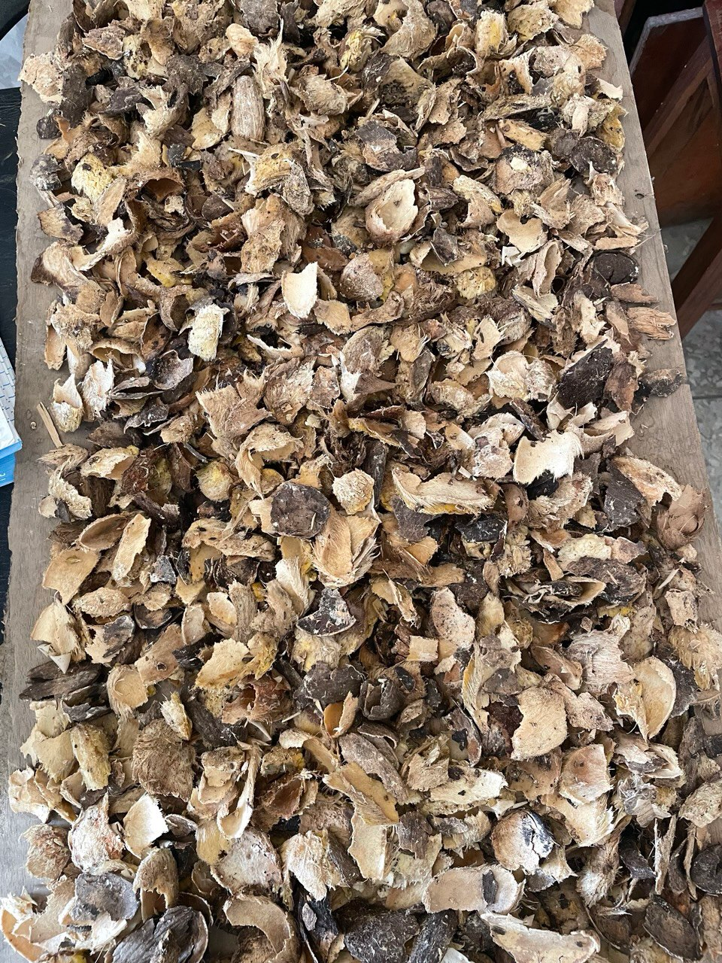
Fig 1: Freshly Washed Mango Seed Coats
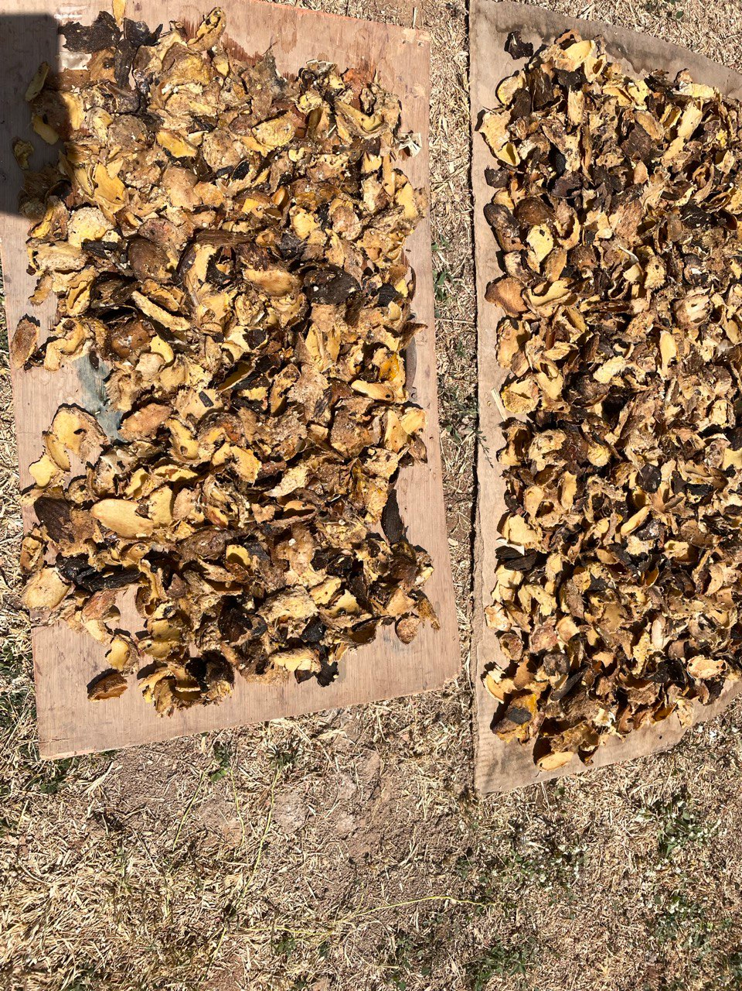Fig 2: Dried Mango Seed Coats
Characterization of the Adsorbent
The surface functional groups present on the prepared activated carbon were analyzed using Fourier Transform Infrared Spectroscopy (FTIR). This technique was employed to identify key functional groups responsible for metal ion binding.
Preparation of Cd(II) Solutions
Stock solution of Cd(II) ions was prepared by dissolving accurate quantity of cadmium nitrate (Cd(NO₃)₂) in distilled water to obtain a concentration of 1000 mg/L for the metal ion. The stock solution serves as the primary source for preparing working solutions of desired concentrations. From the stock, working solutions ranging between 10 mg/L and 50 mg/L were prepared by serial dilution using distilled water. The pH of each solution was adjusted using either 0.1 M HCl or 0.1 M NaOH, depending on the experimental requirement. The prepared metal ion solutions were stored in polyethylene bottles and labeled accordingly to prevent contamination. All solutions were freshly prepared and used within 24 hours to avoid hydrolysis or oxidation of metal ions.
Batch Adsorption Experiments
Batch adsorption studies were conducted to evaluate the removal efficiency of Cd(II) ions using the prepared activated carbon. A known mass of adsorbent (0.1–0.5 g) was added to a series of conical flasks containing a fixed volume of Cd(II) solution of known concentration.
The pH of the solution was maintained at approximately 5, as this was found to be optimal for cadmium adsorption. The mixtures were agitated at a constant speed of 120rpm using a mechanical shaker for a contact time of 2hours to ensure equilibrium was reached.
After adsorption, the mixtures were filtered, and the residual concentration of Cd(II) in the filtrate was determined.
Determination of Residual Metal Concentration
The concentration of cadmium ions before and after adsorption was analyzed using Atomic Absorption Spectroscopy (AAS). This technique provided accurate and reliable quantification of metal ion concentrations in solution.
The percentage removal of Cd(II) was calculated using the following expression:
% Removal = C_{o} – C_{e} / C_{o} x 100
where:
C_{o} = initial concentration of Cd(II) (mg/L)
C_{e} = equilibrium concentration of Cd(II) (mg/L)
The adsorption capacity at equilibrium, q_{e} (mg/g), was calculated as:
q_{e} = (C_{o} – C_{e})V / m
where:
C_{o} = initial concentration (mg/L)
C_{e}= equilibrium concentration (mg/L)
V = volume of solution (L)
m = mass of adsorbent (g)
Adsorption Isotherm Models
To evaluate the adsorption behavior, equilibrium data were analyzed using Langmuir and Freundlich isotherm models.
Langmuir Isotherm
The Langmuir model assumes monolayer adsorption on a homogeneous surface and is expressed as:
1/q_{e} = 1/(q_{max}K_{L}C_{e}) + 1/q_{max}
where:
q_{e} = adsorption capacity at equilibrium (mg/g)
q_{max} = maximum adsorption capacity (mg/g)
K_{L} = Langmuir constant (L/mg)
C_{e} = equilibrium concentration (mg/L)
The separation factor R_{L} is given by:
R_{L} = 1/(1+K_{L}C_{o})
Indicating the favorability of adsorption.
Freundlich Isotherm
The Freundlich model describes adsorption on heterogeneous surfaces and is expressed as:
log q_{e} = log K_{F} + (log C_{e})/n
where:
K_{F} = adsorption capacity constant
n = adsorption intensity
Values of n > 1 indicate favorable adsorption.
Adsorption Kinetics
To investigate the adsorption mechanism, kinetic models were applied.
Pseudo-First-Order Model
log (q_{e} - q_{t}) = log q_{e} – (k₁t/ 2.303)
where:
q_{t} = amount adsorbed at time t (mg/g)
k₁ = rate constant (min⁻¹)
Pseudo-Second-Order Model
t/q_{t} = 1/k₂ q_{e}² + t/q_{e}
where:
k₂ = rate constant (g/mg·min)
This model assumes chemisorption as the rate-limiting step.
Effect of Operational Parameters
The influence of key parameters on adsorption efficiency was investigated as follows:
- Initial Metal Ion Concentration: Varied between 10–50 mg/L to study its effect on adsorption capacity.
- Adsorbent Dosage: Varied from 0.1–0.5 g to determine the optimal dosage for maximum removal efficiency.
All experiments were conducted under controlled conditions, and results were analyzed to determine the adsorption performance of the prepared activated carbon.
Model Evaluation
The correlation coefficient (R²) was used to evaluate the goodness of fit of the pseudo-first-order and pseudo-second-order kinetic models. The model with the higher R² value was considered to provide a more accurate representation of the adsorption kinetics of Cd(II) ions onto the prepared activated carbon, consistent with approaches reported in similar studies (Zhang et al., 2020; Zakaria et al., 2023).
Results and Discussion
Characterization of Activated Carbon
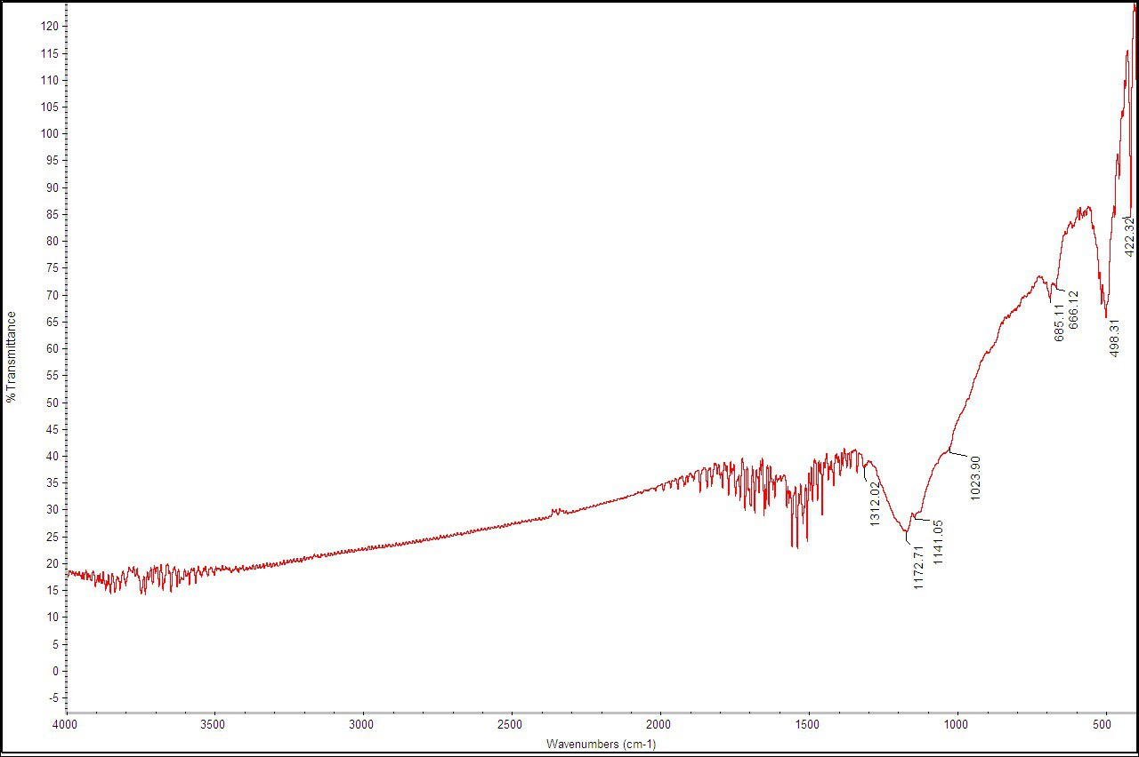

Fig 3: FTIR of Carbonized Sample
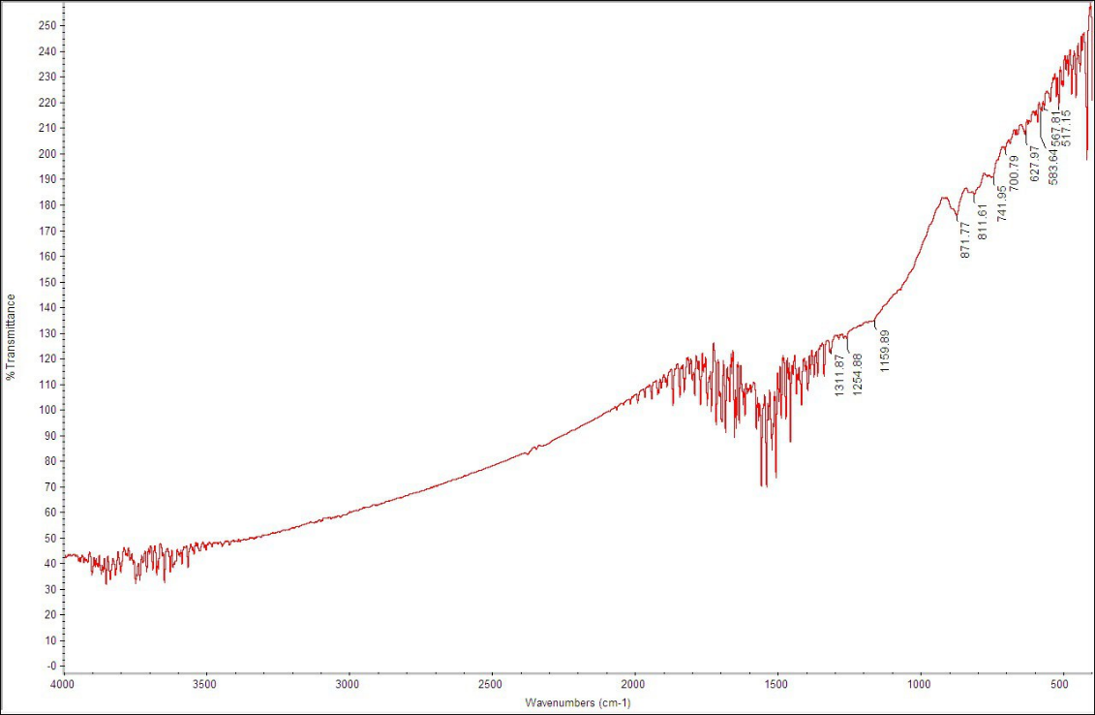

Fig 4: FTIR of Activated Carbon

Fourier Transform Infrared Spectroscopy (FTIR) analysis was conducted to identify the surface functional groups present on the prepared activated carbon. The FTIR spectrum of the carbonized and activated samples revealed the presence of key functional groups responsible for metal ion adsorption. Broad absorption bands observed around 3200–3600 cm⁻¹ were attributed to hydroxyl (–OH) stretching vibrations, indicating the presence of alcohol and phenolic groups. Peaks observed near 1700 cm⁻¹ correspond to carbonyl (C=O) groups, while those around 1000–1200 cm⁻¹ are associated with C–O stretching vibrations.
The presence of these oxygen-containing functional groups confirms that the activated carbon surface possesses active binding sites capable of interacting with Cd(II) ions through mechanisms such as complexation and ion exchange. Chemical activation enhanced the intensity and availability of these functional groups, thereby improving the adsorption potential of the material.
AAS Analysis
The atomic absorption spectroscopy (AAS) results for cadmium (Cd²⁺) concentrations after treatment with activated carbon under varying conditions are presented in Tables 1 and 2.
Two experimental sets were studied:
Set A : Cd²⁺ concentrations varied from 10 to 50ppm with constant 0.5g adsorbent.
Set B: Adsorbent dosages varied from 0.1 to 0.5g at a fixed Cd²⁺ concentration of 50ppm.
All experiments were conducted at constant pH 5.
% Removal = C_{i} - C_{f} /C_{i} x 100
Table 1: AAS Analysis Result of % Cadmium Removal Vs Initial Concentration
 | Initial Cd (ppm) | Final Cd (ppm) | % Removal
A1 | 10 | 1.900 | 81.00%
A2 | 20 | 7.500 | 62.50%
A3 | 30 | 13.500 | 55.00%
A4 | 40 | 20.500 | 48.80%
A5 | 50 | 27.500 | 45.00%

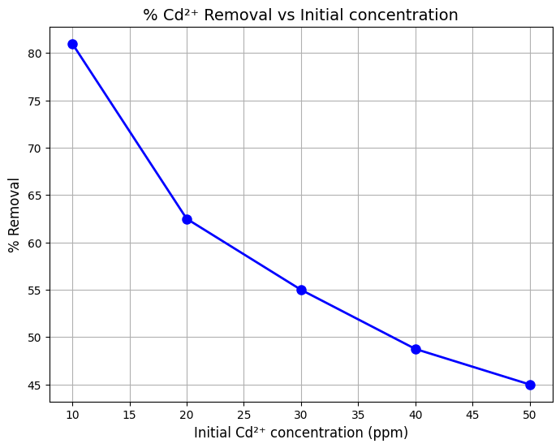Fig 5: Graph of % Cd Removal Vs Initial Concentration

As shown in Table 1 and the figure 5, Cd²⁺ removal decreased with increasing initial concentration, from 81.00% at 10 ppm to 45.00% at 50 ppm. This is due to the limited number of active sites on the activated mango seed coat surface. At lower concentrations, the ratio of available functional groups—hydroxyl (–OH) and carbonyl (C=O), as identified by FTIR—to metal ions is high, enabling efficient capture.

At higher concentrations, these groups become increasingly occupied, leading to surface saturation. This behavior aligns with the Freundlich isotherm (R² = 0.9834), confirming adsorption on an energetically heterogeneous surface. FTIR spectra support this, showing that Cd²⁺ ions interact with multiple binding sites of varying energy rather than a uniform monolayer.

Table 2: % Cadmium Removal Vs Adsorbent Dosage

Sample | Adsorbent Dosage | Final Cd (ppm) | % Removal
B1 | 0.1 | 9.304 | 81.39%
B2 | 0.2 | 9.447 | 81.11%
B3 | 0.3 | 9.526 | 80.95%
B4 | 0.4 | 9.070 | 81.86%
B5 | 0.5 | 9.489 | 81.02%

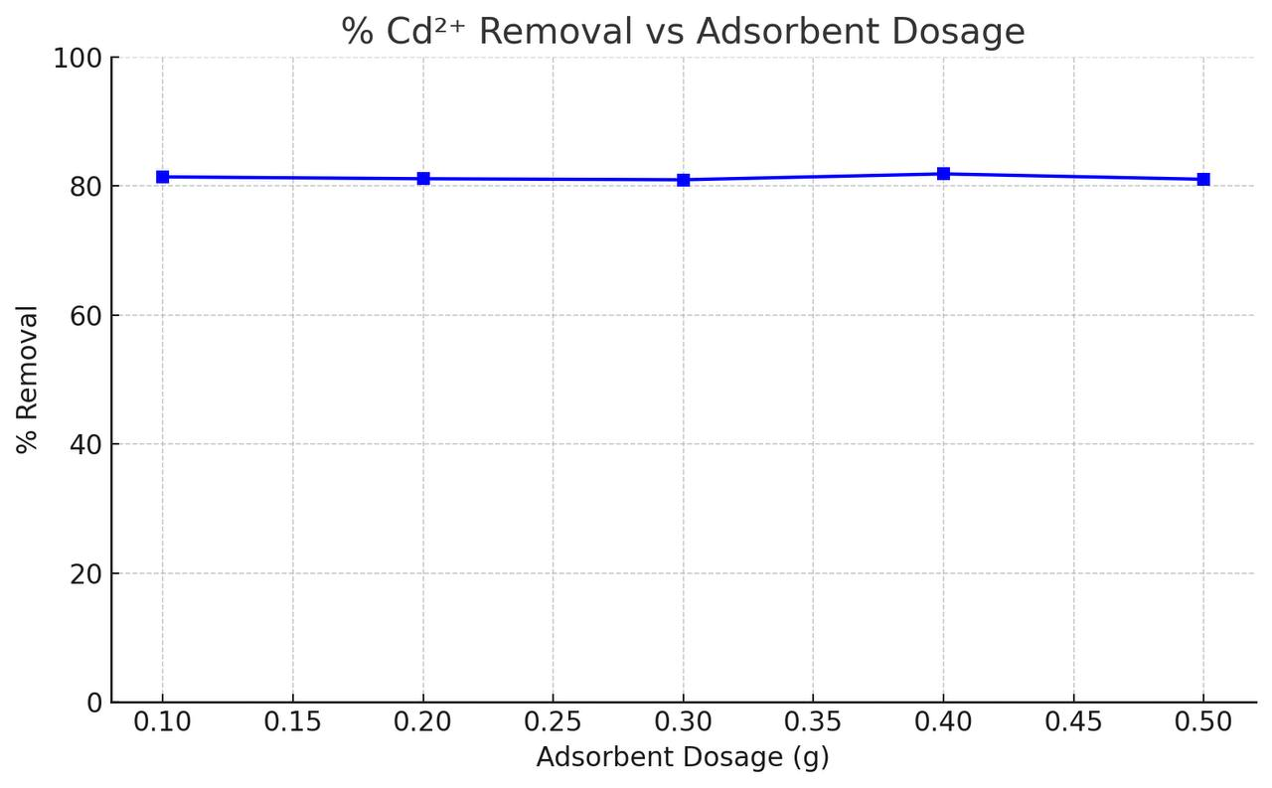Fig 6: Graph of % Cd Removal Vs Adsorbent Dosage

The data in Table 2 and Figure 6 indicate that increasing the adsorbent dosage from 0.1 g to 0.5 g did not significantly alter the Cd²⁺ removal efficiency, which remained stable at approximately 81%. This suggests that at the initial concentration of 50 ppm, a dosage of 0.1 g already provides an abundance of the hydroxyl (–OH) and carbonyl (C=O) functional groups identified via FTIR to satisfy the available metal ions.
The lack of further removal at higher dosages implies that the system reached an equilibrium limit where the metal ion concentration, rather than the number of active sites, became the limiting factor. Consequently, 0.1 g is identified as the optimum dosage for high-efficiency removal, demonstrating the high affinity and economic viability of the activated mango seed coat for cadmium remediation.

Adsorption Isotherm

At constant mass of 0.5g of absorbent and volume of 0.1L, the absorption capacity at equilibrium was evaluated below.

Table 3: Absorption Capacity at Equilibrium

Initial Conc (C_{o}, mg/L) | Final Conc (C_{e}, mg/L) | q_{e} = (C_{o} – C_{e})/m x V (mg/g)
10 | 1.90 | 1.620
20 | 7.50 | 2.500
30 | 13.50 | 3.300
40 | 20.50 | 3.900
50 | 27.50 | 4.500
Langmuir Isotherm

Table 4: Langmuir Isotherm Result

C_{e} (mg/L) | q_{e} (mg/g) | C_{e}/q_{e} (L/g)
1.900 | 1.620 | 1.173
7.500 | 2.500 | 3.000
13.500 | 3.300 | 4.091
20.500 | 3.900 | 5.256
27.500 | 4.500 | 6.111

$\frac{Ce}{qe}$ = $\frac{1}{qmaxKl}$ + $\frac{Ce}{qmax}$
Plot of $\frac{Ce}{qe}$ Vs C_{e}
Slope: $\frac{1}{qmax}$
Intercept: $\frac{1}{qmaxKl}$

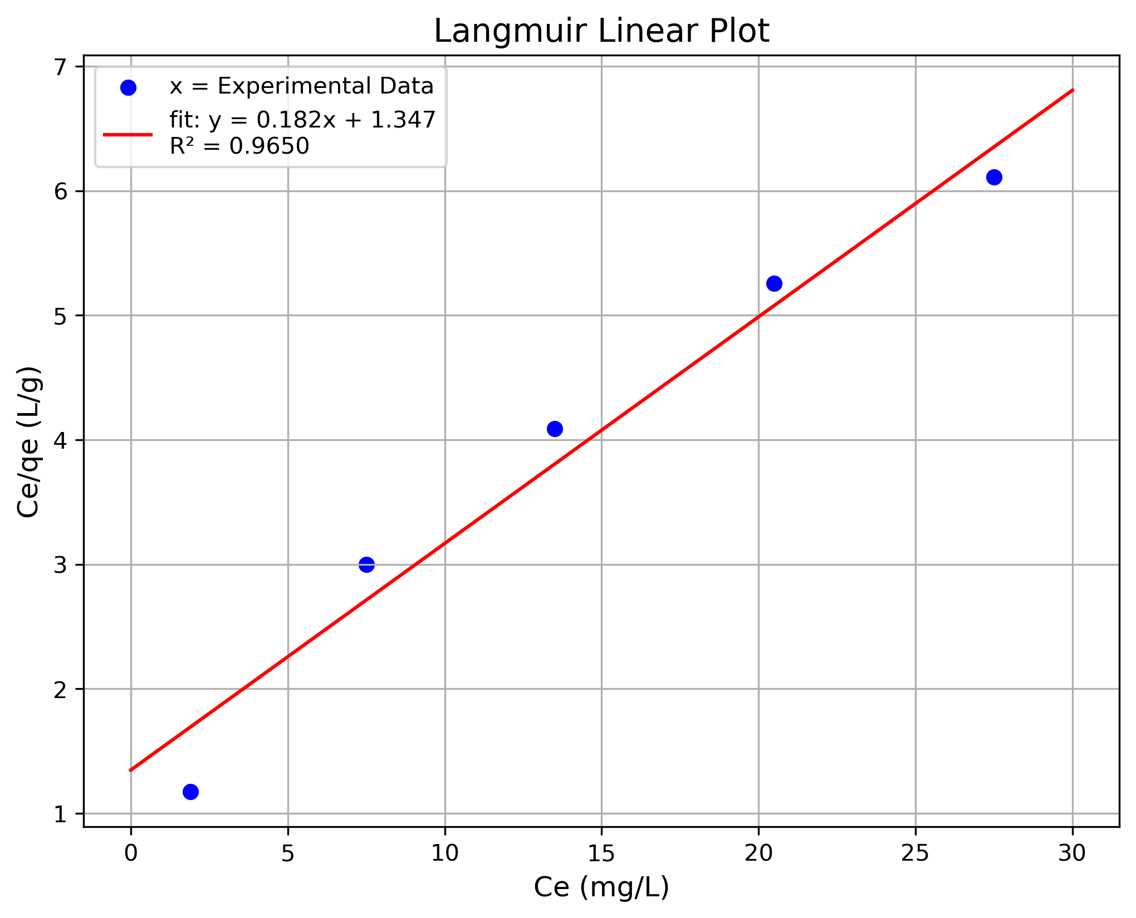Fig 7: Langmuir Linear Plot
The Langmuir linear plot of C_{e}/q_{e} versus Ce yielded a strong correlation coefficient (R² = 0.9650), indicating that the adsorption of Cd²⁺ follows a predictable monolayer pattern on the activated mango seed coat. From the regression equation y = 0.182x + 1.347, the calculated maximum monolayer capacity (q_{max}) is 5.49 mg/g and the Langmuir affinity constant (K_{L}) is 0.135 L/mg.
These positive constants confirm that the adsorbent possesses a finite number of specific, high-affinity binding sites, likely the hydroxyl and carbonyl groups identified in the FTIR spectra. Furthermore, the dimensionless separation factor (R_{L}) values for the studied concentration range (10–50 ppm) were found to be between 0.12 and 0.42. Since these values fall within the range of 0 < R_{L} < 1, the adsorption process is mathematically confirmed to be highly favorable. While the surface exhibits heterogeneity, the Langmuir model successfully characterizes the saturation limit of the material.
Freundlich Isotherm
Table 5: Freundlich Isotherm Result
C_{e} (mg/L) | q_{e} (mg/g) | log C_{e} | log q_{e}
1.900 | 1.620 | 0.279 | 0.210
7.500 | 2.500 | 0.875 | 0.398
13.500 | 3.300 | 1.130 | 0.519
20.500 | 3.900 | 1.312 | 0.591
27.500 | 4.500 | 1.439 | 0.653
Log q_{e} = log K_{F} + 1/n logC_{e}
Plot of log q_{e} Vs log C_{e}
Slope: 1/n
Intercept: log K_{F}
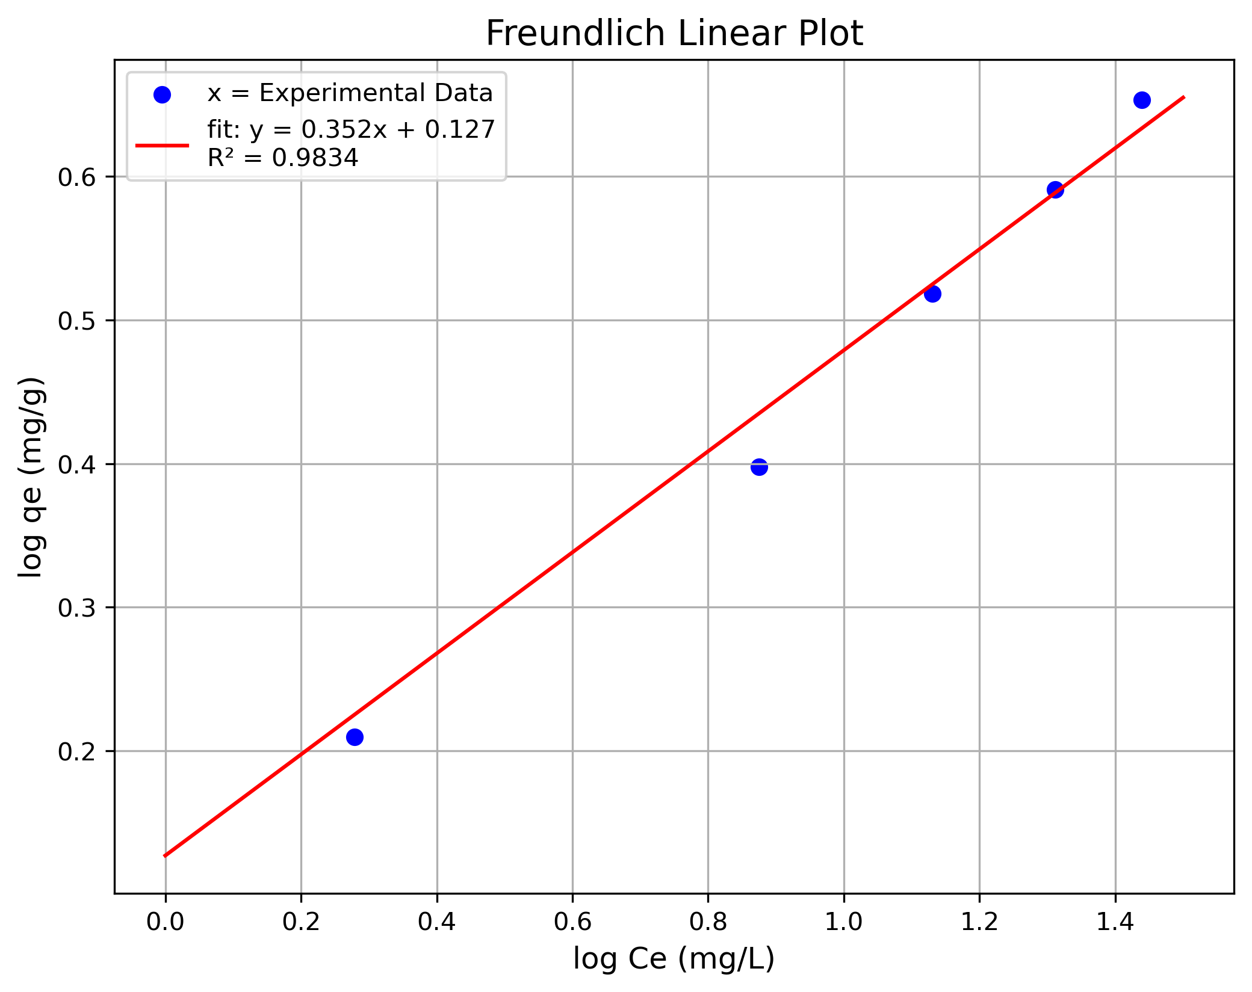
Fig 8: Freundlich Linear Plot
The Freundlich linear plot of log q_{e} versus log C_{e} yielded a strong correlation coefficient of R² = 0.9834, confirming that the adsorption of Cd²⁺ occurs on an energetically heterogeneous surface. From the regression equation y = 0.352x + 0.127, the calculated adsorption intensity (1/n) is 0.352.
Since 1/n is between 0 and 1, the process is mathematically confirmed to be highly favorable, with a calculated n value of 2.84. The intercept corresponds to a Freundlich capacity constant (K_{F}) of 1.34 mg/g.
These results are in excellent agreement with the FTIR analysis, as the multiple functional groups (hydroxyl and carbonyl) provide a variety of binding sites with different energy levels. This validates the multilayer adsorption behavior typical of biomass-derived activated carbon.
Adsorption Efficiency
Effect of Initial Cd(II) Concentration
The observed decrease in Cd²⁺ removal from 81.00% to 45.00% as initial concentration increased (10–50 ppm) is a classic characteristic of adsorbent saturation. At the lower concentration of 10 ppm, the ratio of available surface area to the total number of metal ions in the solution is at its highest. This provides the Cd²⁺ ions with maximum access to the hydroxyl (–OH) and carbonyl (C=O) functional groups identified in the FTIR analysis.
As the concentration increases to 50 ppm, the absolute amount of cadmium adsorbed per unit mass (q_{e}) actually increases due to the higher concentration gradient, which acts as a powerful driving force for mass transfer. However, because the adsorbent dosage was kept constant at 0.5 g, the total number of active binding sites is fixed. Once these high-energy sites are occupied, the percentage of the total ions removed naturally drops.
This behavior confirms that the adsorption process is "site-limited." The fact that the removal does not drop to zero even at 50 ppm supports the Freundlich model findings (R² = 0.9834), suggesting that the activated mango seed coat possesses an energetically heterogeneous surface. This means that after the most reactive sites are filled, secondary sites with different energy levels continue to contribute to the 45% removal observed at higher concentrations.
In conclusion, the activated mango seed coat is most efficient in dilute conditions, achieving an optimal 81.00% removal. While higher concentrations increase the loading capacity (q_{e}) via an enhanced driving force, the declining removal percentage at 50 ppm confirms the eventual saturation of the surface functional groups. This highlights the material's high affinity for cadmium and its suitability for treating metal-contaminated wastewater within the studied concentration range.
Effect of Adsorbent Dosage
The investigation into adsorbent dosage (0.1 g to 0.5 g) revealed that Cd²⁺ removal remained nearly constant at approximately 81% after the initial 0.1 g, identifying it as the optimal dosage for balancing efficiency and material usage. This plateau is attributed to the aggregation of adsorbent particles at higher masses, which causes the overlapping of hydroxyl and carbonyl active sites and reduces the effective surface area available for metal interaction.
In conclusion, while increasing the mass provides more total sites, the marginal improvement beyond 0.1 g confirms that the system reached an equilibrium limit, making the lower dosage the most economically viable choice for cadmium remediation using activated mango seed coat.
Adsorption Isotherm Analysis
The equilibrium adsorption of Cd²⁺ onto activated mango seed coat was evaluated using both the Langmuir and Freundlich models to determine the nature of the surface interactions. The experimental data demonstrated a superior mathematical fit to the Freundlich model (R² = 0.9834), indicating that the adsorption process occurs on an energetically heterogeneous surface rather than a uniform one. This is physically supported by the FTIR results, which identified multiple functional groups—including hydroxyl (–OH) and carbonyl (C=O)—that provide a range of binding sites with varying affinities. The calculated value of n = 2.84 (1 < n < 10) confirms that the process is highly favorable under the studied conditions.
While the Langmuir model was statistically secondary (R² = 0.9650), it successfully estimated a maximum monolayer adsorption capacity (q_{max}) of 5.34 mg/g, representing the theoretical saturation point. The calculated separation factor (R_{L}) values remained between 0 and 1, further validating the favorability of the adsorption. In conclusion, while the Langmuir model provides a useful saturation limit, the superior fit of the Freundlich model more accurately describes the real-world chemistry of the activated mango seed coat, where diverse functional groups interact with Cd²⁺ ions across multiple energy levels in a multilayer arrangement.
Adsorption Kinetics
Kinetic studies were conducted to determine the rate and mechanism of Cd²⁺ adsorption, with experimental data fitted to pseudo-first-order and pseudo-second-order models. The results indicated that the pseudo-second-order model provided a superior fit, suggesting that chemisorption is the dominant mechanism. This implies that Cd²⁺ ions interact with the activated mango seed coat through chemical bonding, likely involving electron sharing or exchange with the hydroxyl and carbonyl functional groups identified via FTIR.
The initial rapid adsorption phase is attributed to the abundance of available active sites, while the subsequent slower phase toward equilibrium reflects site saturation and increasing diffusion limitations. In conclusion, the kinetic behavior confirms that the adsorption process is not merely physical but is governed by strong chemical interactions, providing a stable and efficient means of cadmium sequestration.
Adsorption Mechanism
The adsorption of Cd(II) onto mango seed-derived activated carbon is governed by multiple mechanisms, including:
- Electrostatic attraction between Cd(II) ions and negatively charged adsorbent surfaces
- Ion exchange involving replacement of surface ions with Cd(II)
- Surface complexation with functional groups such as –OH and –COOH
- Pore diffusion into the internal structure of the adsorbent
Reusability of the Adsorbent
The reusability of the activated carbon was evaluated through adsorption–desorption cycles. The results showed that the adsorbent retained a significant portion of its adsorption capacity after reuse, although a gradual decline in efficiency was observed.
This decrease may be due to incomplete desorption of Cd(II) ions or slight structural degradation of the adsorbent during regeneration. Nevertheless, the ability to reuse the adsorbent demonstrates its potential for cost-effective and sustainable application in water treatment.
Comparison with Other Adsorbents
The adsorption performance of mango seed-derived activated carbon compares favorably with other low-cost adsorbents reported in the literature. Its relatively high removal efficiency, combined with its low cost and abundance, makes it a competitive alternative to commercial activated carbon.
The results further highlight the potential of agricultural waste materials as effective adsorbents for heavy metal removal, contributing to both environmental remediation and waste management.
Summary of Findings
Results of this study demonstrate that:
- Mango seed coat-derived activated carbon possesses functional groups suitable for Cd(II) adsorption
- Adsorption efficiency decrease with increase in initial metal concentration
- Optimal adsorbent dosage was observed at 0.1 g
- The Freundlich isotherm best describes the adsorption process
- Adsorption follows pseudo-second-order kinetics, indicating chemisorption
- The adsorbent shows good potential for reuse
Overall, these findings confirm that activated mango seed coat is a highly effective, low-cost, and sustainable alternative to commercial adsorbents for Cd²⁺ removal, offering a promising solution for both environmental remediation and agricultural waste management.
Conclusion
This study successfully demonstrated the potential of activated carbon derived from mango (Mangifera indica) seed coats as an efficient and low cost adsorbent for the removal of Cd²⁺ ions from aqueous solutions. FTIR analysis confirmed that the prepared adsorbent possesses favorable physicochemical properties, specifically the presence of hydroxyl and carbonyl functional groups capable of strong heavy metal sequestration.
Batch adsorption experiments revealed that while the absolute adsorption capacity (q_{e}) increased with concentration due to a stronger driving force, the percentage removal decreased from 81.00% to 45.00% as initial Cd²⁺ concentration rose from 10 to 50 mg/L. Furthermore, an adsorbent dosage of 0.1 g was identified as optimal, providing maximum removal efficiency while maintaining economic material usage.
The equilibrium data were best described by the Freundlich isotherm model (R² = 0.9834), indicating multilayer adsorption on an energetically heterogeneous surface. Kinetic studies confirmed that the process follows pseudo second order kinetics, suggesting that chemisorption—driven by electrostatic attraction, ion exchange, and surface complexation—is the dominant mechanism.
With demonstrated reusability and high stability, this mango seed derived activated carbon represents a sustainable and economically viable alternative to conventional adsorbents. These findings highlight a promising path for environmental remediation that simultaneously addresses agricultural waste management through a circular economy approach.
Recommendations
Based on the findings of this study, the following recommendations are proposed:
- Further studies should investigate the adsorption performance of the adsorbent in multi-component systems to simulate real wastewater conditions.
- Advanced characterization techniques such as SEM, BET surface area analysis, and XRD should be employed to provide deeper insight into the structural properties of the adsorbent.
- Column adsorption studies should be conducted to evaluate the performance of the adsorbent under continuous flow conditions.
- Regeneration and reuse studies should be optimized to enhance the long-term economic viability of the adsorbent.
- Scale-up studies and cost-benefit analyses should be carried out to assess the feasibility of industrial application.
References
- Abd-Talib, N., Chuong, C. S., Mohd-Setapar, S. H., Asli, U. A., Pa’ee, K. F., & Len, K. Y. T. (2020). Trends in adsorption mechanisms of fruit peel adsorbents to remove wastewater pollutants (Cu(II), Cd(II), and Pb(II)). Journal of Water and Environment Technology, 18(5), 290–313.
- Abubakar, A. M., Arowo, M. N. T., Selele, M. I., Houndedjihou, D., & Nayem, Z. (2025). Jovanovic and Sips isotherm parameters of mango seed shell cadmium ion sorption from aqueous solution. Sustainable Chemical Engineering, 6(1), 35–45.
- Adsorption characteristics of mango (Mangifera indica) seed shell activated carbon for removing phenol from wastewater. ResearchGate. https://www.researchgate.net/publication/277652644
- Akpen, G. D., Nwaogazie, I. L., & Leton, T. (2014). Adsorption characteristics of mango (Mangifera indica) seed shell activated carbon for removing phenol from wastewater. ResearchGate. https://www.researchgate.net/publication/277652644
- Babel, S., & Kurniawan, T. A. (2003). Low-cost adsorbents for heavy metals uptake from contaminated water: A review. Journal of Hazardous Materials, B97(1–3), 219–243. https://doi.org/10.1016/S0304-3894(02)00263-7
- Coates, J. (2000). Interpretation of infrared spectra, a practical approach. In R. A. Meyers (Ed.), Encyclopedia of Analytical Chemistry (pp. 10815–10837). John Wiley & Sons Ltd.
- Foo, K. Y., & Hameed, B. H. (2010). Insights into the modeling of adsorption isotherm systems. Chemical Engineering Journal, 156(1), 2–10. https://doi.org/10.1016/j.cej.2009.09.013
- Foo, K. Y., & Hameed, B. H. (2012). Preparation, characterization and evaluation of adsorptive properties of orange peel-based activated carbon via microwave-induced KOH activation. Bioresource Technology, 104, 679–686. https://doi.org/10.1016/j.biortech.2011.10.005
- Goel, J., Kadirvelu, K., Rajagopal, C., & Garg, V. K. (2005). Removal of lead(II) by adsorption using treated granular activated carbon: Batch and column studies. Journal of Hazardous Materials, B125, 211–220. https://doi.org/10.1016/j.jhazmat.2005.05.032
- Hassan, M. S., Abdelrahim, A. O., & Elhassan, G. O. (2020). Preparation and characterization of activated carbon from peanut shells using chemical activation method. Heliyon, 6(6), e04101. https://doi.org/10.1016/j.heliyon.2020.e04101
- Igwe, J. C., & Abia, A. A. (2006). A bioseparation process for removing heavy metals from waste water using biosorbents. African Journal of Biotechnology, 5(12), 1167–1179.
- Kumar, A., Das, T., Thakur, R. S., Fatima, Z., Prasad, S., Ansari, N. G., & Patel, D. K. (2022). Synthesis of biomass-derived activated carbons and their immobilization on alginate gels for the simultaneous removal of Cr(VI), Cd(II), Pb(II), As(III), and Hg(II) from water. ACS Omega, 7, 41997–42011. https://doi.org/10.1021/acsomega.2c03786
- Mengistie, A. A., Rao, T. S., Rao, A. V. P., & Singanan, M. (2008). Removal of lead(II) ions from aqueous solutions using activated carbon from Militia ferruginea plant leaves. Bulletin of the Chemical Society of Ethiopia, 22(3), 349–360.
- Mittal, A., Kurup, L., & Mittal, J. (2007). Freundlich and Langmuir adsorption isotherms and kinetics for the removal of tartrazine from aqueous solutions using hen feathers. Journal of Hazardous Materials, 146(1–2), 243–248. https://doi.org/10.1016/j.jhazmat.2006.12.012
- Mohammed, M. A., Shitu, A., & Abdul Raman, A. A. (2021). Adsorption of heavy metal ions using activated carbon prepared from biomass: A review. Journal of Cleaner Production, 283, 124611. https://doi.org/10.1016/j.jclepro.2020.124611
- Mohan, D., & Pittman, C. U. Jr. (2006). Activated carbons and low cost adsorbents for remediation of tri- and hexavalent chromium from water. Journal of Hazardous Materials, B137(2), 762–811. https://doi.org/10.1016/j.jhazmat.2006.06.060
- Moyo, M., Chikazaza, L., & Guyo, U. (2020). Adsorptive removal of cadmium using modified agricultural wastes: A review. Environmental Nanotechnology, Monitoring & Management, 13, 100287. https://doi.org/10.1016/j.enmm.2019.100287
- Ncibi, M. C. (2008). Application of biosorption for the removal of organic pollutants: A review. Journal of Environmental Management, 90(8), 2179–2185. https://doi.org/10.1016/j.jenvman.2008.04.006
- Nwabanne, J. T., & Igbokwe, P. K. (2012). Adsorption performance of packed bed column for the removal of lead(II) using oil palm fibre. International Journal of Applied Science and Technology, 2(5), 106–115.
- Oke, I. A., & Lataye, D. H. (2020). Adsorptive removal of Pb(II) and Cd(II) using waste mango seed kernel activated carbon. Desalination and Water Treatment, 193, 168–177. https://doi.org/10.5004/dwt.2020.25484
- Rangabhashiyam, S., Anu, N., Giri Nandagopal, M. S., & Selvaraju, N. (2014). Relevance of isotherm models in biosorption of pollutants by agricultural byproducts. Journal of Environmental Chemical Engineering, 2(1), 398–414. https://doi.org/10.1016/j.jece.2013.12.014
- Tan, X., Liu, Y., Zeng, G., Wang, X., Hu, X., Gu, Y., & Yang, Z. (2015). Application of biochar for the removal of pollutants from aqueous solutions. Chemosphere, 125, 70–85. https://doi.org/10.1016/j.chemosphere.2014.12.058
- Tchobanoglous, G., Burton, F. L., & Stensel, H. D. (2003). Wastewater engineering: Treatment and reuse (4th ed.). McGraw-Hill.
- Tiwari, J., Pan, D., & Dubey, A. (2020). Utilization of mango seed kernel as a precursor for activated carbon preparation and its application in dye adsorption. Environmental Technology & Innovation, 20, 101142. https://doi.org/10.1016/j.eti.2020.101142
- Trends in adsorption mechanisms of fruit peel adsorbents to remove wastewater pollutants (Cu(II), Cd(II), and Pb(II)). Journal of Water and Environment Technology, 18(5), 290–313.
- Zakaria, A., Aynuddin, A., & Djasmasari, W. (2023). Exploring the potential of mango seed as a bioadsorbent for Pb(II) removal in aqueous solution. Jurnal Kimia Valensi, 9(1), 155–162. https://doi.org/10.15408/jkv.v9i1.31733
- Zhang, L., Ren, Y., Xue, Y., Cui, Z., Wei, Q., Han, C., & He, J. (2020). Preparation of biochar by mango peel and its adsorption characteristics of Cd(II) in solution. RSC Advances, 10, 35878–35888. https://doi.org/10.1039/d0ra06586b

