Formulation and Sensory Evaluation of Functional Cake Prepared from Sweet Potato Powder

Abstract
The present study aimed to develop and evaluate a value-added cake formulated with sweet potato powder, eggs, cocoa powder, date syrup, baking soda, baking powder, vanilla essence, and oil. Sweet potato powder was incorporated as a functional ingredient to enhance the nutritional quality of the product while maintaining acceptable sensory attributes. The prepared cake was subjected to sensory evaluation for color, texture, flavor, taste, and overall acceptability using a standard hedonic scale. The results indicated that the formulated cake possessed desirable sensory characteristics and good consumer acceptability. The inclusion of sweet potato powder contributed to improved nutritional value by increasing dietary fiber and providing natural bioactive compounds, while date syrup acted as a natural sweetener and flavor enhancer. Cocoa powder and vanilla essence helped in masking the characteristic flavor of sweet potato and improved palatability. The combined use of baking powder and baking soda ensured proper leavening and satisfactory cake volume and crumb structure. The study concludes that sweet potato powder can be successfully utilized in cake formulation to develop a nutritionally enriched bakery product with good sensory quality and potential for application in functional food development.The developed sweet potato powder cake showed good sensory quality and overall acceptability. Sweet potato powder improved the nutritional value by increasing dietary fibers, while date syrup enhanced sweetness and flavor. Cocoa powder and vanilla essence improved palatability, and proper leavening agents provided good cake texture and volume. Overall the cake proved to be a nutritious and acceptable functional bakery product.
Keywords: Sweet Potato Powder, tray drying, cake, sensory attributes

Introduction
Sweet potato (ipomoea batatas) it is a dicotyledonous plant belongs to the family Convolvulaceae. starchy root crop, can be referred to as a "3-in-1 " product, because to its integration of the qualities of cereals (high starch), fruits (high vitamin and pectin content), and vegetables (high vitamin and mineral content).Sweet potato roots contain macronutrients such as starch, dietary fiber, and protein, in addition to a broad range of micronutrients including manganese, copper, potassium, iron, vitamin B complex, vitamin C, vitamin E, and provitamin A (as carotenoids, mostly in yellow and orange-fleshed varieties). The skin is usually brown, beige, red, or purple, while the flesh color may be white, cream, yellow, orange, or purple. Globally, sweet potato is the seventh most important staple, and in developing countries it ranks fifth, after rice, wheat, maize, and cassava. Among the root and tuber crops cultivated globally, sweet potato is the second after cassava sweet potato is drought-tolerant once established[1]. It therefore has the potential of improving food and nutrition security, in the mostly rain-fed agriculture in the developing world, where droughts could severely affect yields of other staples such as cereals It was estimated that more than 2 billion people in Africa, Asia, and Latin America would depend on sweet potato for food.
Sweet potato roots are also regarded as a functional food, as they provide, in addition to nutrients, other physiological benefits. They are rich sources of phytochemical compounds such as carotenoids, tocopherols, phenolic compounds, tannins, flavonoids, saponins, and anthocyanins, with their levels varying based on flesh color and variety. These bioactive phytochemicals, either singly or collectively, exhibit antioxidant, cardio protective, antidiabetic, hepatoprotective, neuroprotective, anti-inflammatory, and antimicrobial activities, as well as bowel-regulation properties[2]. The resulting effects are disease-fighting and immune-system-boosting, which ultimately promote health and longevity. The bioactive phytochemicals found in sweet potato act as potential sources of antioxidants that can scavenge free radicals, and reduce or inhibit cellular damage and reduce metabolic oxidative stress, resulting in disease prevention and better health. In recent years, biofortification programs carried out by several countries in USA, such as Uganda, Malawi, Ghana, Mozambique, Kenya, and Ethiopia, have contributed to the release of new yellow, orange, and purple-fleshed sweet potato varieties, but mainly OFSP for its provitamin A content. In addition, these sweet potato varieties may have other optimized traits such as enhanced disease tolerance and early maturity[3]. However, the great attention received by the biofortified sweet potato has primarily been for the purpose of improving nutrition of low-income groups and vulnerable populations, such as children under five and women of child-bearing age OFSP, for example, has been highlighted as a choice crop for addressing vitamin-A deficiency (VAD) due to its high level of carotenoids, especially ß-carotene, the precursor of vitamin-A [4]. OFSP has therefore been used in product formulations like complementary foods, crisps, and bread.
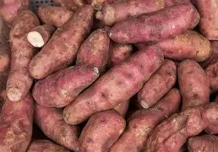
Figure 1: raw sweet potato (ipomoea batatas)
Generally, sweet potato has great value in the food industry and has been used for baked foods, confectionaries, and beverages, among other uses .0wing to its significant levels of bioactive phytochemicals, it is prudent for research Focus on sweet potato varieties in SSA to shift toward their potential use as functional food and how different processing methods affect the retention of the phytochemicals[5]. In other parts of the world, research has investigated the potential of sweet potato as functional food; however, such studies are scanty in SSA. Sweet Potato Flour- It is used in the further processing, Sweet potato tubers can be processed into de-hydration forms and flours for storage and uses in food preparation[6]. The flour gives natural sweetness, color and flavor to the processed foods and it can be consumed for energy and nutrient and mineral to contribute daily nutrient needs for beta -carotene, thiamine, iron, vitamin-c and proteins. This flour is used as a raw material into other products, variety of products can be processed such as cakes, muffins, cookies, churros, donuts, fried chips, ice-cream, brownies made from sweet potato flour[7]. The main objective of the present study mainly focused on preparation of sweet potato powder using various drying techniques and used for developing various healthy food products[8,9]. The novelty of present work was mainly focused on development and formulation of value added cake using sweet potato powder.
Material collection and methodology

Raw material –
sweet potato collected from local market (Local sweet potatoes exhibit a wide range of colors based on variety and growing region, with skin tones including brown, red, and flesh colors ranging from white and yellow Skin color rarely predicts flesh color, which determines the texture—white/ yellow are often starchier.
PROCESSING OF SWEET POTATO POWDER
Sweet potato
↓
Washing/cleaning
↓
Peeling-
↓
Cutting/slicing
↓
Drying
↓
Milling
↓
Sweet potato powder
Flow chart 1: flow diagram showing unit operations for sweet potato powder production.

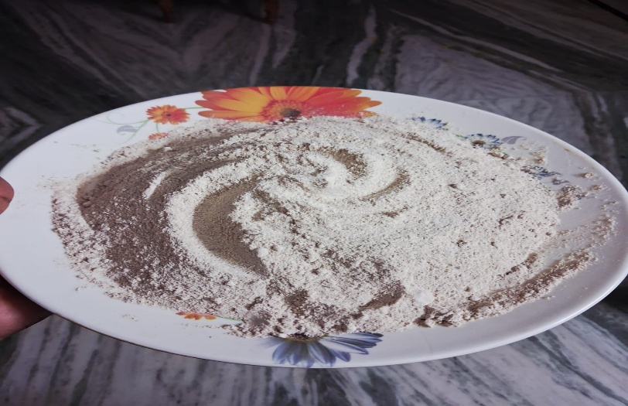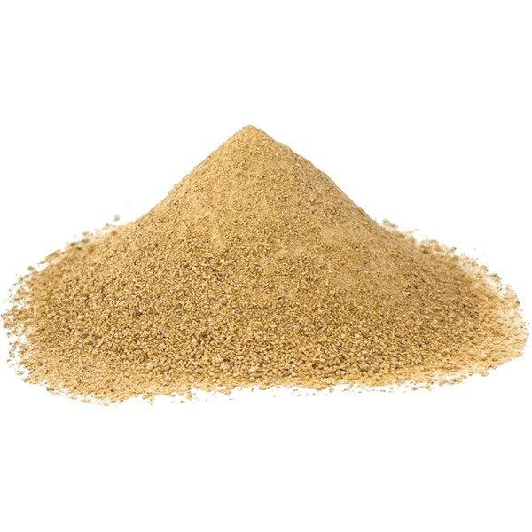
Figure 2: sweet potato powder
Sweet potato is taken from local market and subjected to cleaning and manual washing, washed in vessel or under running water with and brushing: the aim to remove soil, pesticides, microorganisms and other foreign materials from the sweet potato and from the roosts of a sweet potato. Washed with the water (no detergent or chemical substances are used during washing) Remove damaged rotten, or insect- infested portions which are in brown color or any black spots.
Pre-cleaning - shaking & brushing to lose soil & debris are removed. Soaking is optional but common tubers are soaked in clean water for a short time (5-10 min) to help to lose firmly attached mud & dirt. Rinsing-final rinse with clean portable water to remove residual dirt, sanitizer traces. Draining excess water to prevent dilution and spoilage in further processing. Peeling-peeling is to remove the outer layer of sweet potato. Manual peeling- done using knives or peelers. Trimming After peeling remove eyes, blemishes, & damaged portions manually, subjected to washed with potable water remove peel residues & chemicals (if lye peeled). Peeling should cause minimum flesh loss. Avoid excessive exposure to air to prevent enzymatic browning. Peeled tubers should be processed immediately or kept in water with anti-browning agents. Cutting and slicing - sweet potato slicing separates roots into small sizes and increase their drying surface. Manually it is done by stain less knifes to avoid undesirable browning reaction and also ensure sharpness of a blade for uniform edges. Based on the method of drying techniques we are cutting or slicing into the required shapes and size.

Processing Methods Used- oven drying, tray drying, sun drying.

- Drying -in drying techniques they are different processing techniques which we used sun drying, tray drying, and oven drying.

- Oven Drying –oven drying is a method used to remove moisture from sweet potato slices by using heated air inside an oven it helps preserve slices for longer storage and reduces spoilage caused by microorganisms. Oven drying temperature is about (55-70 degree cilices), until the slice become dry and crisp. Later cooled and stored in air tight container.

- Sun Drying – it is a traditional method. Sliced sweet potato is spread on trays or a clean surface and then it is exposed to direct sun light for (2-4days). Externally sliced potatoes are covered by muslin cloth to prevent foreign materials and contamination.

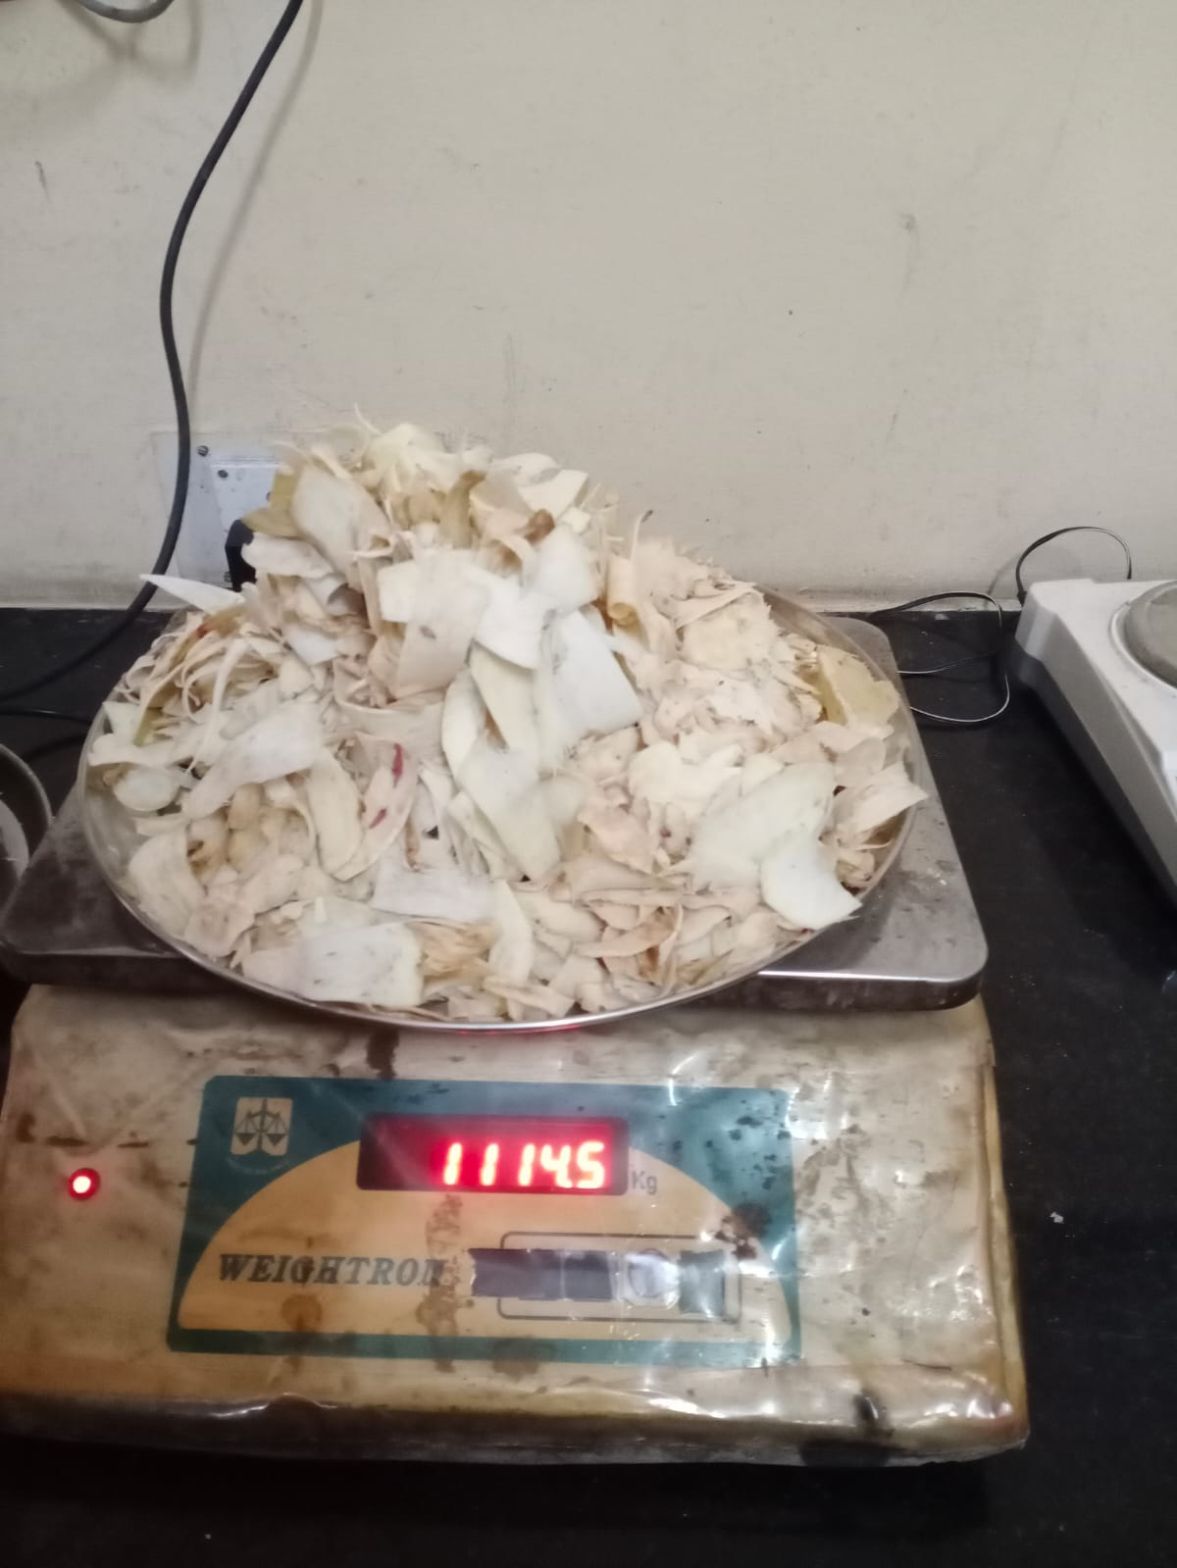

Figure 3: sun dried sliced sweet potatoes

- Tray Drying- sliced sweet potato is placed on a tray where hot air circulates at controlled temperature (50-60degree) drying time depends on the size and dimension of the sliced potato’s approximately (6-8 hours).
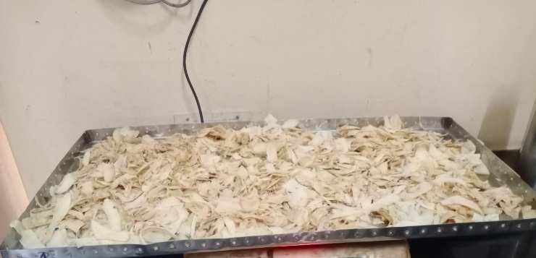

Figure4: Tray drying of sweet potato slices

- Milling- Milling consists of pre-conditioning, it ensures dried slices are cooled to room temperature. Check moisture uniformity. If moisture is too high Re-dry it. If it is too low- Powder may become too fine and dusty Dried sweet potatoes are fed into mixer for fine powder (flour)
- Seiving- After milling the flour is subjected to sieving by using vibratory sieve shaker or a mesh to get a uniform article size which improves, baking quality, mixing properties, re-hydration, packaging stability.

Formulation of ingredients for cake preparations
Different samples were prepared by using sweet potato flour, sugar, and date syrup. Sweet potato flour with different concentrations were incorporated to the samples.

Table 1: formulations of sweet potato powder and ingredients in different ratio

INGREDIENTS | SAMPLE-1 | SAMPLE-2 | SAMPLE-3 | SAMPLE-4
SWEETPOTATO POWDER | 100gm | 50gm | 65gm | 100gm
MAIDA | 50gm | 20gm | 30gm | -
SUGAR | 75gm | 20gm | 50gm | -
EGGS | 2 | 1 1/2 | 2 | 2
COCOA POWDER | 25gm | 10gm | 10gm | 15gm
DATE SYRUP | - | - | - | 40gm
BAKING SODA | 1 1/2ts | 1/1ts | 1 1/2ts | 1 1/2ts
BAKING POWDER | 2ts | 1.5ts | 2ts | 2 tsp.
VANILLA ESSENCE | 3 drops | 2 drops | 2 drops | 3 drops
OIL (ml) | 25ml | 15ml | 20ml | 25ml

Processing of Cake by using Sweet Potato Flour

Sweet potato flour involves adapting traditional cake making methods to account for the unique properties of sweet potato flour (naturally sweet, gluten free, high in fiber & slightly dense). since sweet potato flouris gluten free, structure must be supported with eggs. Below is a clear step by step explanation of the process.

Ingredients Used in Cake Processing
-sweet potato flour, date syrup, eggs, oil, baking powder, baking soda, cocoa powder, vanilla essence.
Collect and weigh the ingredients
(Flour, sugar, eggs, baking powder, baking soda, vanilla essence, oil)
↓

Pre- heat the water (double boiling)
↓
Mix the ingredients
↓
Pour batter into greased baking pan
↓
Place the pan in cooker
↓
Bake till (40-50minutes)
↓
Check with toothpick

If it is fully baked If the cake is not baked
↓ ↓
Remove from cooker bake longer
Cool the cake & serve

Flow chart 2: processing of cake buy using sweet potato powder

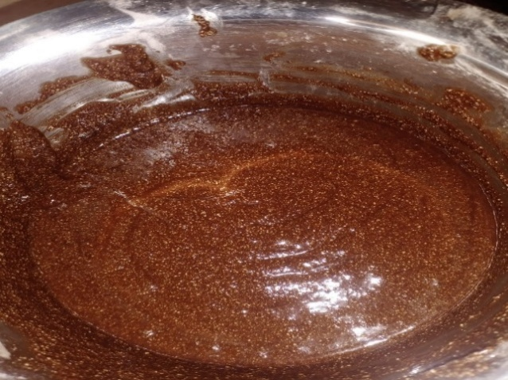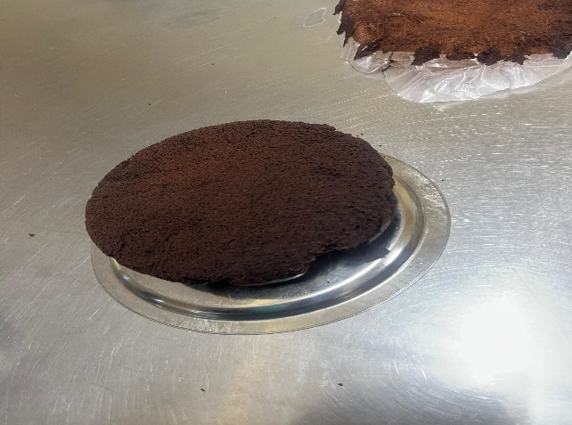
Figure 5: cake batter Figure 6 : fomulated cake

Sensory Analysis of Cake (Sweet Potato Flour)

Sensory evaluation was preformed using 9-point hedonic scale with 30 panelists. The formulated samples along with control sample was analyzed for following parameters such as color, flavor, texture, overall acceptability and were rated according to the method described [10&11] was used to analyze the result. 9 Point Hedonic Scale Performa.
Name:
Date:
Sample:
Taste these samples (sample 1, 2, 3….) and their controls respectively and check
How much you like or dislike each one. The appropriate scale to show your attitude by checking at the point that best describes you’re feeling about the samples following attributes:
• Overall acceptability
Please give a reason for these attitudes
Remember you are the only one who can feel what you like.
An honest Expression of your personal feelings will help us.

TABEL-2 9 POINT HEDONIC SCALE PERFORMA

Sample | Overall acceptability
Like extremely 9
like very much 8
Like moderately 7
Like slightly 6
Neither like or dislike 5
Dislike slightly 4
Dislike moderately 3
Dislike very much 2
Dislike extremely 1

Result and Discussions

Dehydration of Sweet Potato using Tray Drying
Tray drying method was used for dehydration of sweet potato. the results were recorded at the time interval of every one hour up to 6 hours. shown in the (table 3)

TABLE 3: Time intervals of tray drying technique

Time interval | Weight of the sample
1 hour | 3165.0
2 hours | 2730.5
3 hours | 2199.0
4 hours | 1791.0
5 hours | 1114.5
6 hours | 652.0

Figure 6: the above image shows the de hydration of sweet potato by using tray drying technique.

From the above graph the weight of the sweet potato decreased from 3165.0-652.0 indicates the loss of moisture content. This study shows significance reduction of moisture content 100 % to 20%. As shown in the graph the results obtained showed decreased of moisture content up to 20%.

Drying Kinetics Results

TABLE 4: The table presents the drying kinetics results

Methods involved | Time & temperature | Total time taken | After drying
Sun drying | 2-3 days | 250 g | 125g
Tray drying | 6 hours (50-60℃) | 1 kg | 500g
Oven drying | (40-60℃) | 40g | 20g

By using three different drying methods: sun drying, tray drying and oven drying
It compares the drying time temperature, and weight of the sample before and after drying.
- Sun Drying : It took the longest time (2-3 days) and reduced the sample weight from 250 grams to 150 grams ,due to moisture loss
- Tray Drying: it was carried out at 50-60 degrees cecius for 6 hours, reducing the weight from 1 kg to 500 grams.
- Oven Drying : At 40-60 degrees Celsius resulted in the smallest final weight , reducing the sample from 40 grams to 20 grams
Over all, the results showed that all drying methods removed moisture from the sweet potato samples leading to a decrease in weight. Faster drying methods using controlled temperatures were more efficient than sun drying.

Score Card of Sensory Evaluation Results

TABLE 5 : Sensory evaluation results of sweet potato powder cake

Attributes | SAMPLE 1 | SAMPLE 2 | SAMPLE 3 | SAMPLE 4
Appearance | 7 | 8.5 | 8 | 8.5
Color | 8 | 7 | 8 | 8.5
Texture | 7 | 8 | 8 | 8.5
Aroma | 8 | 8 | 8.5 | 8.5
Taste | 8 | 8 | 8.5 | 8.5
Overall liking | 7.5 | 8 | 8.5 | 8.5

Based on the sensory evaluation evaluation results, sample 4 received the highest score for all attributes, including appearance, color, texture, aroma ,taste and over all liking (8.5). Sample 3 also showed good acceptability with scores ranging from 8-8.5. Sample to obtain moderate scores, while sample 1 receive the lowest scores among all samples. Overall, the results indicate that sample 4 was the most preferred sweet potato powder cake by the sensory panelists.

Sweet Potato Powder Cake
The sweet potato powder cake showed good aroma texture with a soft, moist and smooth consistency. the batter mixed uniformly without any lump formation, resulting in a well-structured and evenly baked product. The addition of sweet potato powder enhanced in natural sweetness giving a slightly rich and appealing flavour, the cake developed mild and pleasant flavour, which was well accepted in terms of taste and aroma. The fiber and nutritional compounds of sweet potato powder contributed to improved nutritional value. The cake maintained a firm yet soft structure even after cooling without affecting its overall quality. Over all sweet potato powder incorporation improve the sensory attributes of the cake, making it highly acceptable in terms of texture, flavour, appearance, and stability.

Sensory Analysis

The Sensory evaluation was conducted on different formulations of sweet potato powdered cake, that is labelled with different sample codes, that 1,2,3,4 then the multiple comparison test was done to assess the difference among the samples. A total of 20 untrained panellist was participated in the sensory evaluation, and each panellist received all the coded samples. They were instructed to compare the coded sample based on the sensory attributes. Scores were assessed according to the pre determinate sensory score.

Figure 8 ; Sensory evaluation of sweet potato powder cake

Sample 1 was considered as the control, as it contained 50g of Maida, and sample 2 and 3 were developed by various formulations and the sample 4 was developed by incorporating date syrup and without using Maida and sugar. With the constant quantities of cocoa powder,eggs,baking soda, vanilla essence, oil. The use of sweet potato powder, it is naturally gluten free and safe, nutritious alternative to wheat flour for individual gluten sensitivity. Made simply from dehydrated, grounded sweet-potatoes, it contains no gluten protein, make it ideal for baking and enhancing the nutritious values.
The result of sensory analysis table(fig) In the present study revealed a variation in formulated sample evaluated sample by panellist. Although sample 1 showed a good acceptance result.In sample 4 the date syrup was used instead of sugar and also, eliminating Maida to make gluten free product. In this the flavor,aroma,and texture, taste is increased

Conclusion
The present study demonstrated that sweet potato powder can be successfully incorporated into cake formulation using sweet potato powder. The developed cake showed acceptable sensory characteristics in terms of color, texture, flavor, and overall acceptability. The inclusion of sweet potato powder enhanced the nutritional value of the product by contributing dietary fiber, natural sugars, and bioactive compounds, while date syrup served as a natural sweetener and flavor enhancer.
Overall, the study indicates that sweet potato powder is a functional ingredient for bakery products and can be used as develop value-added, nutritionally improved cakes with good consumer acceptability. This product has potential for commercialization as a healthier alternative to conventional cakes, especially for consumers seeking foods with enhanced nutritional benefits

Reference
- V.D.Truong Sweet potato production, processing and nutritional quality (2018).
- Yuxin Qin,Nathan M. D'Cunha. Nutrition-related health outcomes of sweet potato consumption: A systematic review Food Bioscience 2022.
- Van-Den Truong and Ramesh Y. Avula Sweet Potato Purees and Powders for Functional Food Ingredients((2010).
- Effect of sweet potato flash powder on the proximate, functional, and bioactive properties of fortified confectionery products. - Tupura Khatun and Md. Asaduzzaman (2025)
- Mariya de los angles rosell ,Jazmin Quizhpe. Proximate composition, health benefits, and food applications in bakery products of purple – fleshed sweet potato (ipomoea batatas L.) and its byproducts – (2024).
- VabinGuo,Dongling Qioa. Understanding the application – related features of sweet potato starch varying in multi- scale super molecular structure (2025).
- Aliou Toro Lafia- The feasibility of use of sweet potato (ipomoea potatoes l.) flour in the preparation of bakery products (2020).
- M.O.Oke and T.S. Workneh. -A review on sweet potato post-harvest processing and preservation technology (2019).
- V. D. Truong Sweet Potato Production, Processing, and Nutritional Quality (2015)
- Nelson pereira, Ana Cristina ramos Physical and functional properties of sweet potato flour: influence of variety and drying method (2025).
- Marco alves, Cristina raseiro. Gluten free sweet potato flour: effect of drying method and variety on the quality and bio- activity (2024).

.

