INVESTIGATING THE EFFECTIVENESS OF LOCALIZED CONTEXT-BASED STEM APPROACH USING 5E LESSON PLAN
IN TEACHING SCIENCE 3

Zuhara M. Tampogao
Mindanao State University - Sultan Naga Dimaporo
ztampogao0524@gmail.com

Namila L. Macagaan
Mindanao State University - Sultan Naga Dimaporo
namilalumna@gmail.com

Settie-Zhymah S. Padate
Mindanao State University - Sultan Naga Dimaporo
alradjiepadate@gmail.com

Liezel P. Naquines
Mindanao State University - Sultan Naga Dimaporo
liezel.patadilla-naquines@g.msuiit.edu.ph

Najeb B. Aloyod
Mindanao State University - Sultan Naga Dimaporo
najebaloyod@gmail.com

Abstract
This study employed an experimental research design, specifically the one-group pre-test and post-test design, to investigate the effectiveness of the 5E Lesson Plan integrated alongside the Localized Context-Based STEM approach in improving the conceptual understanding and engagement of the Grade 3 – Plato pupils of Sultan Naga Dimaporo Memorial Integrated School (SNDMIS). The respondents of the study were 34 pupils from Section B, officially enrolled during the Academic Year 2025–2026. A 20-item multiple-choice pretest and posttest aligned with the Science 3 curriculum, together with an engagement survey, were administered before and after the intervention to measure pupils’ learning and participation. Data were analyzed using frequency and percentage distribution, weighted mean, Wilcoxon signed-rank test. Results revealed that pretest scores were relatively low, with only a few pupils demonstrating higher achievement, while posttest results showed a remarkable improvement, with most respondents shifting to the “Very Highly Achieved” category. The Wilcoxon signed-rank test confirmed a significant difference between pretest and posttest scores (p = 0.000), indicating that the intervention was effective. Furthermore, survey findings showed that learners were highly engaged during the lessons, enjoying the use of local materials, hands-on group activities, and inquiry-based tasks. The study concludes that integrating the 5E instructional model with localized, context-based STEM instruction significantly enhances pupils’ conceptual understanding, engagement, and problem-solving skills in Science lessons.

Keywords: 5E Lesson Plan, Localized Context-Based STEM, Conceptual
Understanding, Science

Introduction
Innovative learning strategies have been incorporated into educational procedures more and more in recent years to satisfy the changing needs of the twenty-first century. STEM education, which combines Science, Technology, Engineering, and Mathematics to promote experiential learning, is one notable innovation. To improve pupils’ critical thinking, creativity, and teamwork abilities, STEM education places a strong emphasis on learning through practical experiences and problem-solving exercises (Han, Kelley, and Knowles, 2021). Students are supposed to solve practical issues, come up with original ideas, and take part in worthwhile educational activities as a result of this integration. In addition to developing critical academic competencies, STEM education's growing significance as a transformative learning approach gives pupils the tools they need to succeed in the twenty-first century.
The foundation of STEM education is developing learning spaces that provide people with tangible experiences. Thus, teachers should favor learning models that allow students to gain experience in STEM subjects in order to implement STEM education effectively. Critical thinking abilities can be developed using the 5E learning cycle model. Research indicated that the 5E learning cycle model helps students succeed by giving them the opportunity to learn in a meaningful way, for example, a study conducted by Kuba et al. (2020) showed that pupils’ critical thinking abilities are significantly impacted by the 5E learning cycle model. The findings showed that by involving pupils in activities that encourage critical thinking and the application of knowledge in practical settings, the model successfully supported meaningful learning.
In light of this, the purpose of this study is to examine how well the 5E lesson plan can be incorporated into the Localized Context-Based STEM Approach for teaching Science to elementary school pupils. Its specific goal is to investigate how well it enhances pupils’ conceptual understanding of Science concepts and engagement level in grade 3 Science.

Research objectives
This study aimed to investigate the effectiveness of the integration of the 5E lesson plan alongside the Localized Context-Based STEM Approach in Teaching Grade 3 Science at Sultan Naga Dimaporo Memorial Integrated School. Specifically, it sought to investigate its effectiveness by analyzing pupils’ demographic profile in line with analyzing their conceptual understanding by assessing their pretest and posttest performance, determining the significant differences of their pretest and posttest performance, and their engagement level during the instruction.

Hypothesis
This study proposed that there is a significant difference between the pretest and posttest scores of the pupils taught using the 5E Lesson Plan in a Localized Context-Based STEM.

Research methodology
The instructional intervention implemented in this study was deliberately designed to be localized and context-based, with the goal of increasing learners’ conceptual understanding and engagement by anchoring Science concepts in their immediate environmental and community experiences alongside the 5E (Engage, Explore, Explain, Elaborate, and Evaluate) lesson. The 5E Localized Context-Based STEM Approach fosters curiosity and critical thinking by promoting interactive and meaningful learning experiences (The Grove Center, n.d.), allowing learners to understand the practical applications and significance of scientific concepts in their daily lives. It also strengthened the link between classroom learning and real-life community contexts, consistent with the Constructivist, Experiential, and Inquiry Theories advocating learner-centered and meaningful education.
The study employed an experimental one-group pretest and posttest research design to determine the effectiveness of the 5E Localized Context-Based STEM Approach in teaching Science 3. Quantitative Data were collected through pretest and posttest assessments, engagement survey questionnaires, and prototype evaluation rubrics used to assess pupils’ outputs during the evaluation activity.
A purposive sampling technique was utilized in selecting the respondents of the study. The participants consisted of thirty-four (34) Grade 3 pupils under the Plato section of Sultan Naga Dimaporo Memorial Integrated School, who were anticipated to take the specific topic on the Basic Needs of Living Things (code S3LT-IIi-j14), which aligns with the focus of this research, which is relevant to the objectives of the study. This criterion ensured that the respondents were appropriate for evaluating the effects of the intervention.
Data analysis involved both quantitative and descriptive techniques. Pretest and posttest scores were analyzed using frequency, percentage distribution, and the Wilcoxon Signed-Rank Test to determine whether a significant difference existed between learners’ performance before and after the intervention. Engagement levels and prototype evaluation results were analyzed using weighted mean with descriptive interpretation.
The investigation was conducted with rigorous adherence to ethical considerations. To guarantee voluntary involvement, respondents’ informed consent was obtained before any data was collected. The respondents were properly informed about the study’s objectives, their participation role, and their freedom to discontinue participation at any moment without incurring any fees. In compliance with ethical research guidelines, the participants’ rights and privacy were protected by the assurance of confidentiality and anonymity of responses.

Research findings
4.1 Respondents’ Profile
4.1.1 Age
Table 4.1.1 presents the frequency and percentage distribution of the respondents according to their age. There were eighteen (18) of the total number of respondents, or 52.94% who are in the age of eight (8); nine (9) or 26.47% are in the age of nine (9); there were also three (3) or 8.82% who are in the age of ten (10), another (2) or 5.88% who are in the age of seven (7); and there are those who aged eleven (11) and twelve (12) comprised of one (1) each or 2.94% of the total number of respondents.
The results indicated that the majority of the respondents were eight (8) years old, representing 52.94 % of the total respondents. The predominance of eight-year-old learners suggested that the respondents were at an appropriate developmental stage to engage effectively in structured learning tasks and localized STEM-Based approaches. This finding is consistent with Piaget’s Cognitive Development Theory, which classifies learners within ages 7 to 11 under the Concrete Operational Stage, where logical thinking, classification, and problem-solving skills begin to develop (Piaget, 1972; McLeod, 2018).

Table 4.1.1 Frequency and Percentage Distribution of the Respondents of the Demographic Profile in terms of Age (n=34)
AGE | FREQUENCY | PERCENTAGE
7 | 2 | 5.88
8 | 18 | 52.94
9 | 9 | 26.47
10 | 3 | 8.82
11 | 1 | 2.94
12 | 1 | 2.94

4.1.2 Gender
Table 4.1.2 presents the frequency and percentage distribution of the respondents according to their gender. The result revealed that male learners comprise the majority of the respondents, representing 52.94% or eighteen (18) of the total class, while females account for 47.06% or sixteen (16). Given that gender distribution may have an impact on classroom participation and engagement patterns, this slight predominance of boys should be taken into account when interpreting the study. Regardless of gender, middle childhood students are in the Concrete Operational Stage, where they acquire the logical thinking and problem-solving skills required for structured learning, according to Piaget (1972).
This finding highlighted that early exposure to STEM education can positively impact students’ interest in the subjects and should therefore be incorporated in elementary school classrooms. It also suggests a pre-existing gender difference in interest in Science and engineering among the respondents.

Table 4.1.2 Frequency and Percentage Distribution of the Respondent of the Demographic Profile in terms of Gender (n=34)
GENDER | FREQUENCY | PERCENTAGE
MALE | 18 | 52.94
FEMALE | 16 | 47.06

4.2 Pretest and Posttest Score Results of the Respondents

Table 4.2 presents the data results of the pretest and posttest. As shown in the table, in the pretest result, there were twenty (20) respondents, representing 58.82% of the total class, who got a score ranging from 11-15 with a corresponding interpretation of Highly Achieved. Ten (10) or 29.41% of the respondents got a score ranging from 6-10 and are interpreted as Moderately Achieved. And, there were three (3) or 8.82% who got a score ranging from 16-20, which was interpreted as Very Highly Achieved. Then, there were one (1) or 2.94% who got a score ranging from 1-5, which is interpreted as Not Achieved. This finding clearly implies that only a few of the respondents had shown good performance before the integration of the 5E Localized Context-Based STEM Approach.
Meanwhile, in the posttest result, as shown in the table 4.3, twenty-eight (28) or 82.35% of the total class got a score ranging from 16-20 which is interpreted as Very Highly Achieved, and another six (6) or 17.65% who got a score ranging from 11-15 with a corresponding interpretation of Highly Achieved, more importantly, none among the respondents fell in the category of Moderately Achieved and Not Achieved. This shows a big positive change in the pretest and posttest scores of the respondents.
This strongly suggested the effectiveness of the Integration of the 5E Localized Context-Based STEM Approach in teaching Science lessons among grade 3 learners. As stated by Muhammad et al. (2021), the 5E learning model supports the development of foundational thinking skills by allowing young learners to construct their knowledge through hands-on activities and guided discovery. Unlike traditional, teacher-centered approaches, the instructional model, like 5E, fosters curiosity and critical thinking by promoting interactive and meaningful learning experiences (The Grove Center, n.d.).

Table 4.2 Pretest and Posttest Score Results of the Respondents (n=34)
Score | Pretest |  | Posttest |  | Verbal Interpretation
Score | f | % | F | %
16-20 | 3 | 8.82 | 28 | 82.35 | Very Highly Achieved
11-15 | 20 | 58.82 | 6 | 17.65 | Highly Achieved
6-10 | 10 | 29.41 | 0 | 0.00 | Achieved
1-5 | 1 | 2.94 | 0 | 0.00 | Not Achieved

Figure 4.1 presents the Line graph showing the comparison of the respondents’ pretest and posttest results in the Science lesson using the 5E Localized Context-Based STEM Approach. As shown in the graph, the respondents obtained relatively lower scores in the pretest, where only a few fell under the category Very Highly Achieved, and there were some who fell under the category Not Achieved.
In contrast, the posttest results revealed a notable increase in scores. Most of the respondents shifted to the Very Highly Achieved category, reflecting improved understanding after exposure to the intervention. The comparison demonstrated a significant increase in learners’ performance, as the line representing posttest scores is consistently higher compared to the pretest result. This suggests that the use of the 5E Localized, Context-Based STEM Approach was effective in enhancing learners’ conceptual understanding in Science lessons.
This supports previous findings by Holmes et al. (2021) and Kostøl and Remmen (2022), who emphasized that local and contextual application of lessons improves retention and the ability to apply knowledge across different scenarios, particularly when learning is embedded in meaningful, real-world contexts.
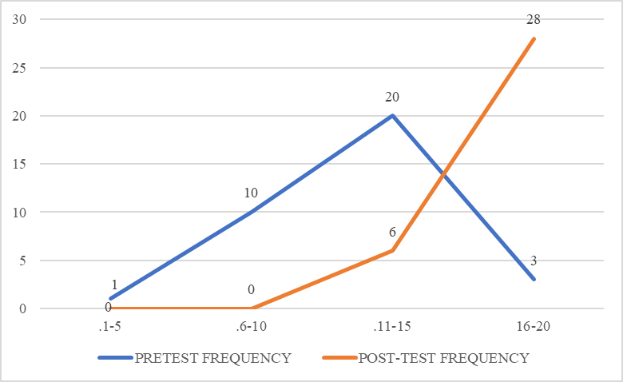

Figure 4.1 Line Graph of the Respondents’ Pretest and Posttest Scores

4.3 Difference Between the Pretest and Posttest Scores of the Respondents
Table 4.3 presents the result of the Wilcoxon Signed-Rank Test, which was employed to determine the difference between the pretest and posttest scores of the respondents. The computed Z-value was -5.10, which exceeds the critical value of $±$1.96 at the 0.05 level. The negative sign of the Z-value indicates that the posttest scores were generally higher than the pretest scores. Since the p-value associated with this test was 0.000 (p < 0.05), the result is statistically significant. This suggests that the intervention produced a meaningful improvement in the respondents’ conceptual understanding in the Science lesson. Hence, the null hypothesis, which stated that there was no significant difference between the pretest and posttest scores, was rejected, indicating that there is a statistically significant difference between the pretest and posttest scores.
This finding implied that pupils obtained significantly higher scores in the posttest than in the pretest, demonstrating that the use of the 5E Localized Context-Based STEM Approach had improved the learners’ conceptual understanding of science concepts.
This supports previous finding by Utami et al. (2018) and Widayanti et al. (2019), who emphasized that the use of a learning model like the 5E learning cycle model, an effective teaching and learning approach is also essential to foster scientific attitudes and improve pupils’ Science learning outcomes. One such approach is STEM, which integrates Science, Technology, Engineering, and Mathematics as a key component of the 21st-century education.

Table 4.3 Difference between the Pretest and Posttest Results of the Respondents. (n=34)
p-value | Z-value | Level of Significance | Discussion
0.000* | -5.10 | 0.05 | H˳. Rejected
Note: **significant
4.4 Evaluation Result of the Water Filter Prototype.

Table 4.4 presents the evaluation results of the Water Filter prototype of the respondents according to their group. The Water Filter prototype is a self-made water filtration system that uses readily available materials to remove impurities and contaminants from water. DIY water filters can be a cost-effective and creative way to purify water, especially in emergencies or areas with limited access to clean water. The respondents were divided into two groups, where each group drew their own design of a water filter using local and recyclable materials. Using their design, each group made its own version of a water filter.
The prototype of the two groups was evaluated by four (4) Science teachers from Sultan Naga Dimaporo Memorial Integrated School, together with six (6) invited visitors who served as guest judges. The projects were assessed based on three significant factors: creativity and relevance, use of local, recyclable, and affordable materials, and teamwork and presentation. The groups had the opportunity to present their work, explain how it functioned, and respond to questions from the panel. This gave the evaluators a clearer view of how well the students understood and applied their concepts.
Following the demonstrations, the judges shared their feedback. They were impressed by the creativity and effort that went into the projects, the collaboration between group members, and the effective utilization of recycled and low-cost materials. However, they offered recommendations for improvement, including enhancing confidence during presentation, and developing the design for better function and appearance.

Table 4.4 Evaluation Result of the Water Filter Prototype
Group | Percentage | Description | Verbal Interpretation
Group 1 | 98.33 | Excellent | Outstanding
Group 2 | 95.83 | Excellent | Outstanding

Group 1
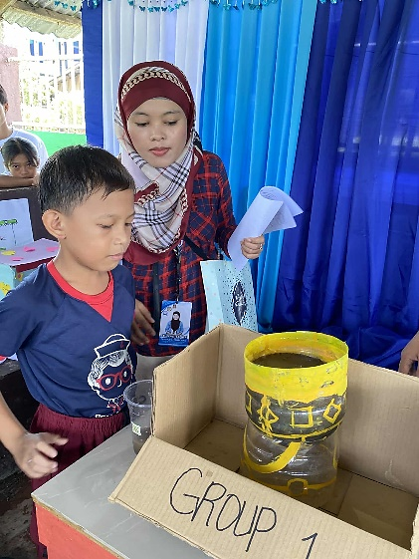
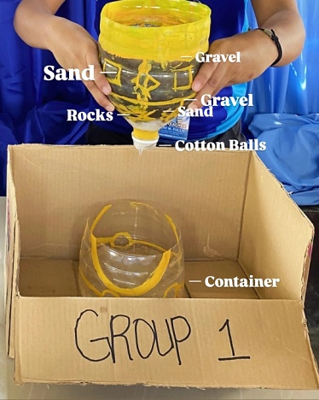

Figure 4.7 Water Filter Prototype of Group 1
Group 2
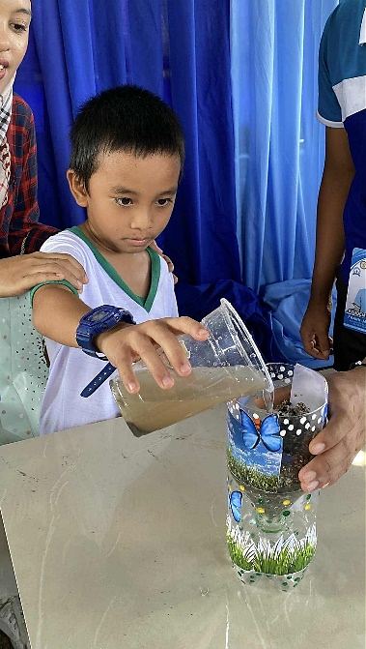
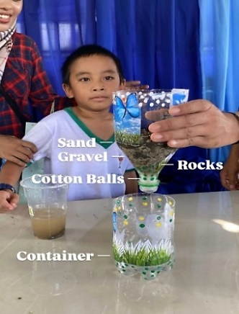

Figure 4.8 Water Filter Prototype of Group 2

When the scores were tallied, Group 2 came out on top with a total of 118 points or 98.33%, showing excellent creativity and teamwork, while Group 1 followed closely with 115 points or 95.83%, also performing very well. Both groups were praised for their hard work and were reminded that the main goal of the activity was not only competition but also learning, collaboration, and improvement.

4.5 Respondents’ Level of Engagement Based on the Survey Questionnaire.

Table 4.5 presents the results of the respondents’ level of engagement during the intervention. Results revealed that all of the indicators had a weighted mean ranging from 2.34 to 3.00, with a corresponding interpretation of Highly Engaged. The highest rating of 3.00 (Highly Engaged) showed that the majority of the pupils enjoyed the 5E Localized Context-Based STEM lesson, which used local examples, integrated group work and experiments, and helped them to focus and pay attention during the whole Science lesson. Meanwhile, the lowest rating, which showed shared ideas, obtained a weighted mean of 2.9 (Highly Engaged), which implies that even the least-rated aspect of engagement was still at a high level among the pupils.
This finding strongly suggested that the 5E Localized Context-Based STEM lesson strategy was effective in sustaining students’ active learning, engagement, and attentiveness.
According to Holmes et al. (2021) and Kostøl and Remmen (2022), localized context-based STEM fosters greater attentiveness, collaboration, and active participation among learners, which was consistent with the high engagement reflected in this study. Pupils were most engaged in listening and group activities, supporting Attard et al. (2021), who highlighted the role of such approaches in enhancing communication and problem-solving.

Table 4.6 Respondents’ Level of Engagement Based on the Survey Questionnaire (n=34)
Indicators | Weighted Mean |  | Interpretation
- I enjoyed the Science lessons that used local stories or examples. | 3.00 | Highly Engaged
- The hands-on activities helped me understand Science better. | 2.97 | Highly Engaged
- I felt excited to join group work and experiments during the Science lessons. | 3.00 | Highly Engaged
Table 4.6 (Continued) Respondents’ Level of Engagement Based on the
Survey Questionnaire (n=34)
- The lessons made me curious and ask more questions about Science.  - I was able to focus and pay attention during the whole Science lesson.  - I liked using things from our community or environment in our Science activities.  - I shared my ideas and helped my classmates during Science activities.  - The steps of the lesson (Explore, Explain, etc.) helped me learn Science well.  - I felt confident to do the experiments or activities by myself.  - I look forward to Science lessons like this again. | 2.97  3.00  3.00  2.9  2.91  3.00  2.97 | Highly Engaged  Highly Engaged  Highly Engaged  Highly Engaged  Highly Engaged  Highly Engaged  Highly Engaged
Grand Weighted Mean 2.97 |  | Highly Engaged
Legend: 1:00-1.66 Not Engaged 2.34-3.00 Highly Engaged
1.67-2.33 Engaged

Discussion
The 5E Localized Context-Based STEM education model produced positive results in terms of student academic performance, engagement, and application of scientific concepts. The respondents, who were primarily 8-year-old Grade 3 students, who are in a developmental stage, based on the data results of the Level of Engagement survey, said that the 5E Localized Context-Based STEM Approach allowed them to participate successfully in structured learning activities and regional STEM-Based activities. This result is in line with Piaget's Cognitive Development Theory, which places students between the ages of 7 and 11 in the Concrete Operational Stage, which is when logical reasoning, categorization, and problem-solving abilities start to emerge (Piaget, 1972; McLeod, 2018).
Following the use of the localized STEM method, learners' science achievement clearly improved, according to the pretest and posttest results. The majority of students had already shown a basic grasp of science topics before to the intervention, although one respondent received a score in the "Not Achieved" range. However, posttest findings indicated a significant change toward higher achievement levels following the implementation of the 5E Localized Context-Based STEM education. Every student received ratings in the "Highly Achieved" to "Very Highly Achieved" ranges, demonstrating increased comprehension of the course material. This improvement implies that scientific concepts were better understood and retained when science training was contextualized using well-known environmental challenges.
The results of the Wilcoxon Signed-Rank Test, which was used to compare the respondents' pretest and posttest scores, further supported the intervention's efficacy. At the 0.05 level, the calculated Z-value of -5.10 is greater than the critical value of ‡1.96. The Z-value's negative sign suggests that the posttest results were often better than the pretest results. The result is statistically significant because the test's p-value was 0.000 (p < 0.05). This implies that the respondents' conceptual grasp of the science lesson significantly improved as a result of the intervention.
According to the findings, students were very involved in the localized STEM programs during their implementation. A "Highly Engaged" level of engagement was indicated by the total weighted mean of 2.97. Students showed great focus throughout class discussions, enthusiasm for practical tasks like designing and building prototypes, and active participation in group activities. These results demonstrate how including collaborative STEM activities and real-world environmental challenges in the 5E class successfully piqued students' interest and maintained their involvement. Even the indication with the lowest rating-sharing ideas obtained a weighted mean of 2.9 (Highly Engaged), suggesting that students were still highly engaged in even the least-rated facet of engagement. However, the 5E Localized Context-Based STEM method produced an interesting and learner-centered classroom environment, as evidenced by the overall high level of engagement.
Through project-based learning, the STEM lesson exemplar's execution also led to the meaningful application of information. Using locally sourced and recyclable materials, students successfully designed and built a prototype water filter. With percentage ratings ranging from 95.83 to 98.33, the examination of the prototypes revealed exceptional performance in every group. These findings show how students may apply STEM (science, technology, engineering, and mathematics) concepts to solve environmental issues in the real world while utilizing recyclable and local resources.
This suggests that learners' academic performance, engagement, and practical application of science concepts were much improved by the 5E Localized Context-Based STEM teaching strategy. Inquiry-based learning, practical STEM projects, and local environmental challenges were integrated to create meaningful learning opportunities that encouraged environmental stewardship, critical thinking, and teamwork. These results confirm that 5E Localized and Context-Based STEM instruction is a successful method for teaching Science 3 and helping elementary students achieve relevant and meaningful learning objectives.

Conclusion
The majority of Grade 3 respondents were 8 years old, and male pupils marginally outnumbered female pupils, according to an analysis of the data from the use of 5E Localized Context-Based STEM Approach. Learners’ achievement and engagement were positively impacted by the intervention, which included incorporating 5E Localized Context-Based STEM activities into classroom instruction. The comparison of pretest and posttest results showed a statistically significant improvement, indicating that the approach effectively enhanced pupils’ conceptual understanding of scientific concepts. Learners actively participated in contextualized learning activities that connected science concepts to real-world experiences, including a DIY Water Filtration system prototype using recyclable materials, educational posters, and group reporting that emphasized the value of water as a means of survival.
These activities improved pupils’ understanding of applied science in their everyday lives while also encouraging creativity, critical thinking, and teamwork. With posttest scores considerably higher than pretest scores and notable improvements in conceptual understanding and science process skills, quantitative data validated the approach’s efficacy. Increased motivation, engagement, and enjoyment in studying science through hands-on activities were noted in the learners’ survey responses.
Overall, the study validates the 5E Localized Context-Based STEM Approach’s viability and efficacy. By highlighting the importance of contextualized, interactive, and inquiry-driven instruction in elementary science education, it not only enhanced pupils’ performance and conceptual understanding but also promoted positive attitudes about science lessons.

References

Bybee, R. W. (2010). The BSCS 5E instructional model: A framework for science education

Cimpian JR, Kim TH, McDermott ZT. Understanding persistent gender gaps in STEM. Science. 2020;368(6497):1317–9. https://d oi.o rg/ 10.1126/science. aba7377.

Han, J., Kelley, T., and Knowles, J.G. (2021). Factors influencing student STEM.

Holmes, K., Berger, N., Mackenzie, E., Attard, C., Johnson, P., Fitmaurice, O., O’Meara, N., and Ryan, V. (2021). Editorial: The impact of place-based contextualised curriculum on student engagement and motivation in STEM education. Frontiers in Education.

Holmes, K., Mackenzie, E., Berger, N., and Walker, M. (2021). Linking K-12 STEM pedagogy to local contexts: A scoping review of benefits and limitations. Frontiers in Education, 6, Article 693808. https://doi.org/10.3389/feduc.2021.693808

Kolb, D. A. (2014). Experiential learning: Experience as the source of learning and development (2nd ed.). Upper Saddle River, NJ: Pearson Education.

Kuba, M. R., Meha, A. M., and Blegur, J. (2020). Pengaruhmodel pembelajaran bersiklus (learning cycle 5E) terhadapkemampuanberpikirkritissiswa. edumaspul: Jurnalpendidikan. Learning: Self-efficacy and outcome expectancy, 21st-century skills, and career awareness. Journal for STEM Education Research. https://doi.org/10.1007/s41979-021-00053-3

McLeod, S. (2018). Jean Piaget’s theory of cognitive development. Simply Psychology. https://www.simplypsychology.org/piaget.html

Muhammad, B. A., Omwirhirem, E. M., and Abubakar, S. (2021). Effects of 5Es teaching cycle on retention ability among secondary school students of varied ability in the mole concept, in Zaria education zone, Kaduna state. ATBU Journal of Science, Technology and Education.

Piaget, J. (1952). The origins of intelligence in children (M. Cook, Trans.). New York, NY: International Universities Press. (Original work published 1936)

Piaget, J. (1972). The psychology of the child (H. Weaver, Trans.). Basic Books. (Original work published in 1966)

Putra, F., Kholifah, I. Y. N., Subali, B., and Rusilowati, A. (2020). 5E-learning cycle strategy: Increasing conceptual understanding and learning motivation. Jurnalilmiahpendidikanfisikaal-biruni. https://ejournal.radenintan.ac.id /index.php/al-biruni/article/view/2898

Sullivan A, Umaschi Bers M. Investigating the use of robotics to increase girls’ interest in engineering during early elementary school. IntJ Technol Des Educ. 2018;29:1033–51. https:// doi. org/ 10. 1007/ s10798- 018- 9483-y.

The Grove Center. (n.d.). The 5Es. Penn State University. https://grovecenter.science.psu.edu/technology/instructional-design/the 5Es
Utamni, N. L. P., Maegala, A. A. A., and Purwadi, I. N. (2021). The implementation of Vygotsky, L. S. (1978). Mind in society: The development of higher psychological processes (M. Cole, V. John-Steiner, S. Scribner, and E. Souberman, Eds. and Trans.). Cambridge, MA: Harvard University Press.

