LITERATURE BEYOND PRINT: THE EMERGENCE OF THE MULTIMODAL LITERARY ERA

EMOJIS, ARTIFICIAL INTELLIGENCE, SPEAKING POETRY, AND THE TRANSFORMATION OF HUMAN EXPRESSION
Ms. Elizabeth Njeri Ngigi
Orangeburg County School District; Orangeburg Wilkinson High School
Master of Education Technology, Mount Kenya University, Thika, Kenya
*Corresponding Author: elizabeth.ngigi@ocsdsc.org

Abstract
This theoretical paper proposes the emergence of a new literary and linguistic epoch referred to as the Multimodal Literary Era. The convergence of smartphones, artificial intelligence, emojis, social media platforms, algorithmic communication systems, and digital performance cultures has fundamentally transformed language, literary production, authorship, and human expression. Unlike earlier literary periods defined by oral traditions, manuscript culture, print modernity, or broadcast media, the Multimodal Literary Era is characterized by interactive, symbolic, performative, algorithmically mediated, and visually integrated systems of communication.
The study explores the rise of emerging literary genres including emoji literature, AI-assisted literature, hypertext fiction, social media micro-literature, speaking poetry, and AI-human collaborative literature. It further proposes a new classification of language consisting of Human Language, Artificial Intelligence Language, Hybrid Digital Language, and Symbolic-Visual Language. The paper also critically examines the decline of literary originality, the commodification of creativity, performative authenticity, algorithmic exaggeration, and the collapse of the distinction between private and public literary space.
The study argues that emojis increasingly function as emotional syntax and semiotic extensions of language, while artificial intelligence introduces a non-human but socially interactive linguistic presence into literary culture. Simultaneously, digital platforms transform intimate human experience into performative spectacle, dissolving traditional boundaries between literature, theater, identity, and everyday life.
The paper concludes that contemporary society has entered a post-print literary civilization in which meaning is increasingly multimodal, compressed, visual, performative, and globally networked.
Keywords: Multimodal Literary Era, digital literature, AI language, emoji linguistics, speaking poetry, multimodality, digital humanities, social media literature, literary theory, algorithmic creativity.

Introduction

Human civilization has historically been shaped by dominant systems of communication. Oral societies produced epics, myths, folktales, and communal storytelling traditions. The manuscript age cultivated sacred texts and elite literary institutions, while the printing press transformed literacy and facilitated the emergence of the modern novel, mass publishing, and literary criticism. Industrial modernity later generated newspapers, realism, broadcast narratives, and global literary circulation.
The twenty-first century, however, marks a different historical transformation. The smartphone has emerged not merely as a communication device but as a portable literary ecosystem that reshapes language, creativity, performance, identity, and social interaction. Literature now unfolds through social media captions, short-form videos, voice notes, livestreams, memes, emojis, artificial intelligence systems, and digitally mediated performance cultures.
This paper argues that contemporary society has entered a new literary and linguistic epoch referred to here as the Multimodal Literary Era. This era is characterized by the transition of literature beyond print into interactive, symbolic, performative, visually integrated, and algorithmically mediated forms of communication. Unlike earlier literary periods centered primarily around written text, the Multimodal Literary Era combines textual, visual, symbolic, auditory, and computational systems into interconnected forms of meaning-making.
The study further argues that the Multimodal Literary Era is marked by several interconnected transformations:
- The rise of multimodal communication systems.
- The integration of emojis into daily linguistic expression.
- The emergence of artificial intelligence as a literary participant.
- The expansion of performative digital literature.
- The decline of literary originality under algorithmic culture.
- The collapse of boundaries between public and private literary expression.
- The commodification and theatricalization of human emotion.
The paper therefore seeks to contribute to literary theory, sociolinguistics, digital humanities, and media studies by proposing a coherent theoretical framework for understanding literature and language in the age of smartphones, artificial intelligence, and multimodal communication.

FIGURE 1 — Conceptual Framework: The Multimodal Literary Era
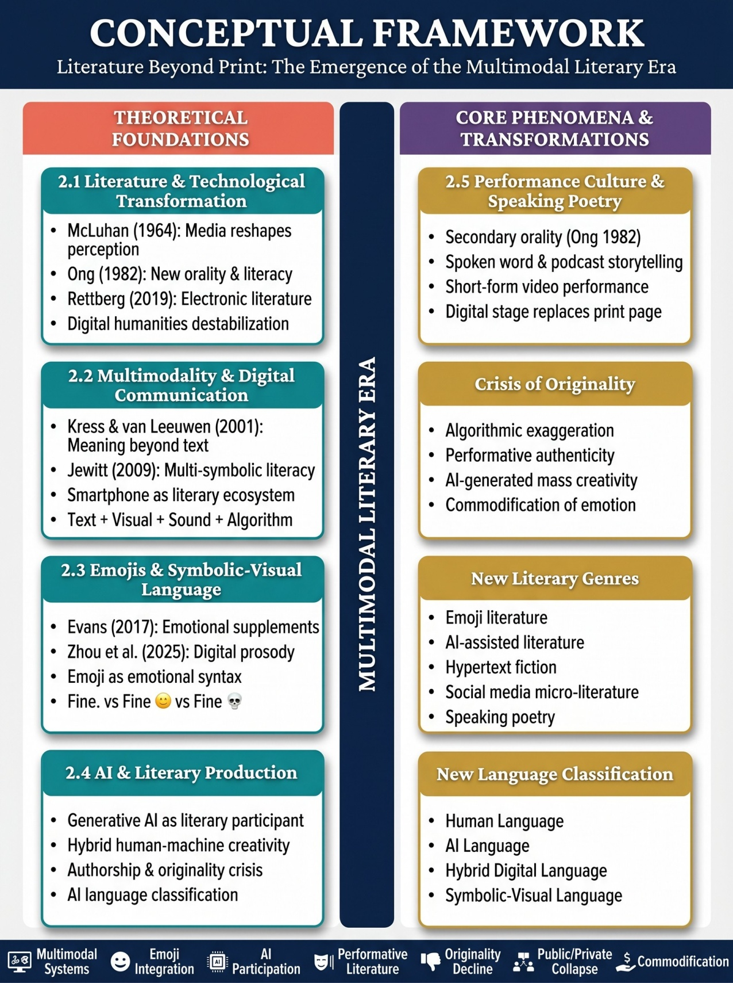

Literature Review

Literature and Technological Transformation
Scholars have long acknowledged that changes in communication technologies significantly reshape literary production and cultural expression. According to McLuhan (1964), media technologies fundamentally alter human perception and social organization, leading to transformations in communication structures and artistic production. Ong (1982) similarly argues that technological shifts generate new forms of orality and literacy, reshaping human consciousness itself.
The transition from print culture to digital communication has generated substantial scholarly interest within digital humanities and media studies.
Rettberg (2019) observes that electronic literature destabilizes traditional literary boundaries by integrating interactivity, nonlinear structures, multimedia systems, and networked participation.
Funkhouser (2007) further demonstrates that digital poetry and electronic literary experimentation significantly expanded literary possibilities beyond conventional print forms.
The rise of social media platforms has intensified these transformations. Social media environments facilitate compressed, immediate, and highly visual forms of expression that challenge traditional assumptions regarding authorship, genre, and literary permanence. Short-form digital texts, caption poetry, hashtag narratives, and meme-based storytelling increasingly occupy literary and communicative spaces once dominated by books and print institutions.
Consequently, contemporary literature can no longer be understood exclusively through print-centered frameworks. Rather, literary production increasingly emerges within digitally mediated ecosystems characterized by interactivity, visuality, algorithmic circulation, and audience participation.

Multimodality and Digital Communication
The concept of multimodality has become central within contemporary communication studies.
Kress and van Leeuwen (2001) argue that meaning is no longer communicated solely through written language but increasingly through the interaction of images, symbols, gestures, sound, spatial arrangement, and visual design. Digital communication environments amplify this multimodal condition by combining text, video, sound, reaction systems, emojis, and interactive interfaces.
Jewitt (2009) further emphasizes that multimodal communication transforms literacy practices by requiring individuals to interpret multiple symbolic systems simultaneously. Within mobile communication environments, meaning increasingly depends on the integration of textual, visual, and emotional markers rather than on alphabetic language alone.
The smartphone accelerates multimodality because it functions simultaneously as:
- a writing device,
- visual medium,
- performance stage,
- communication archive,
- publication platform,
- and algorithmic distribution system.
This convergence creates communicative conditions fundamentally distinct from earlier literary periods.

Emojis and Symbolic-Visual Language
One of the most significant linguistic developments of the digital age is the rise of emojis as communicative symbols. Evans (2017) argues that emojis increasingly function as emotional and pragmatic supplements to written language, compensating for the absence of facial expression, tone, and gesture in digital communication.
Recent scholarship increasingly recognizes emojis as meaningful linguistic systems rather than decorative additions. Chiang and Gomez-Zara (2024) observe that emojis perform important emotional, relational, and communicative functions within digital discourse. Similarly, Zhou et al. (2025) argue that emojis increasingly function as forms of digital prosody, shaping emotional interpretation and communicative nuance.
Examples such as:
- “Fine.”
- “Fine 😊”
- “Fine 💀”
illustrate how emojis modify tone, irony, intimacy, sarcasm, and emotional meaning.
This transformation suggests that communication within the Multimodal Literary Era increasingly incorporates symbolic-visual systems as integral components of linguistic expression.

Artificial Intelligence and Literary Production
Artificial intelligence has emerged as one of the defining technological developments affecting contemporary literary culture. Generative AI systems are now capable of producing poems, narratives, essays, scripts, captions, and conversational discourse that closely resemble human writing.
Scholars have increasingly examined the implications of AI-generated language for creativity, authorship, and literary authenticity. Generative literature, as discussed by Rettberg (2019), destabilizes traditional assumptions regarding the singular human author by introducing algorithmic participation into literary production.
AI-assisted writing tools also alter the relationship between creativity and labor. Writers increasingly collaborate with algorithmic systems for:
- idea generation,
- stylistic refinement,
- language prediction, • narrative continuation,
- and poetic experimentation.
This creates what may be understood as hybrid literary production, where human and machine creativity intersect.
At the same time, concerns emerge regarding originality, authenticity, imitation, and mass-produced creativity. AI-generated literary forms challenge long-standing literary ideals associated with individual genius, reflective authorship, and artistic uniqueness.

Performance Culture and Speaking Poetry
Digital platforms have also transformed literary performance. Speaking poetry, spoken-word literature, podcast storytelling, and short-form video performances increasingly dominate literary spaces previously centered around print.
Ong’s (1982) concept of secondary orality becomes particularly relevant in understanding contemporary digital communication. While print culture historically privileged silent reading and interior reflection.
The Crisis of Originality Digital platforms increasingly reward exaggeration, performative authenticity, emotional intensity, and rapid content production. AI assisted literary generation complicates originality and authenticity.

Conclusion
This paper has argued that contemporary society has entered a new literary and linguistic epoch referred to as the Multimodal Literary Era. Literature increasingly moves beyond print into symbolic, visual, auditory, performative, and algorithmically mediated systems of meaning-making.

References

Chiang, C., & Gomez-Zara, D. (2024). The evolution of emojis for sharing emotions: A systematic review of the HCI literature.

arXiv. Evans, V. (2017). The emoji code: How smiley faces, love hearts and thumbs up are changing the way we communicate. Picador.

Funkhouser, C. T. (2007). Prehistoric digital poetry: An archaeology of forms, 1959–1995. University of Alabama Press.

Jewitt, C. (2009). The Routledge handbook of multimodal analysis.
Routledge. Kress, G., & van Leeuwen, T. (2001). Multimodal discourse: The modes and media of contemporary communication.
Arnold. McLuhan, M. (1964). Understanding media: The extensions of man.
McGraw-Hill. Ong, W. J. (1982). Orality and literacy: The technologizing of the word. Methuen.
Rettberg, S. (2019). Electronic literature. Polity Press.

