Next-Generation Solar-Powered Wireless Charging and Battery Management for Electric Vehicles
Vedant Dhake | Tushar Jadhav | Kartiki Rasal
Department of Electronics & Telecommunication  JSPM’s Bhivarabai Sawant Institute of Technology & Research  Wagholi, Pune, India | Department of Electronics & Telecommunication  JSPM’s Bhivarabai Sawant Institute of Technology & Research  Wagholi, Pune, India | Department of Electronics & Telecommunication  JSPM’s Bhivarabai Sawant Institute of Technology & Research  Wagholi, Pune, India
vedantdhake1108@gmail.com | tjadhav292004@gmail.com | kartikisrasal94@gmail.com
Prof. Priyanka Mahajan | Dr. Y. S. Angal
Department of Electronics & Telecommunication  JSPM’s Bhivarabai Sawant Institute of Technology & Research  Wagholi, Pune, India | Department of Electronics & Telecommunication  JSPM’s Bhivarabai Sawant Institute of Technology & Research  Wagholi, Pune, India
prmahajan_entc@jspmbsiotr.edu.in | ysangal_entc@jspmbsiotr.edu.in

Abstract—Now a days as peoples are switching from combustion engine to Electric Vehicle (EV), the necessity of seamless charging points is needed. This paper presents a wireless charging station for charging EVs using the principle of electromagnetic induction, controlled using the ESP32 microcontroller and using solar panel an renewable energy source. Using an IR sensors for vehicle detection to make the process automatic, and also safety is ensured using temperature sensor and cooling mechanism. Real-time data monitoring can be done using IoT, making it easier for the users to access the data remotely. The proposed system is user friendly, scalable, sustainable and energy-efficient, addressing limitations of wired charging stations. This is an improved solution for the growing usage of EVs.
Keywords – Electric Vehicle, Wireless Power Transfer, Solar Engery, Real-time Monitoring, IoT, ThingSpeak.

Introduction
Now, as electric vehicles (EVs) become more popular, there is a greater need for fast and convenient charging solutions to support eco-friendly transportation. Old charging methods use physical plugs, but they can get damaged, manually we need to plug in, and have the risk of getting an electric shock. Wireless charging is a new and smart solution that transfers power to the vehicle without any physical connection. This paper presents an idea for a smart wireless charging station for EVs that uses renewable energy, tracks charging efficiently, and is easy to use, solving current issues and preparing for future needs.
The system mainly uses renewable energy by collecting power from the sun through solar panels. This method uses less non-renewable electricity, helping reduce pollution and support clean energy. A DC-to-DC converter keeps the power from the solar panels steady, and a battery stores extra energy to keep things running when there’s little sunlight or at night. Grid power works as a backup to keep the system running smoothly, even in bad conditions.
The ESP32 microcontroller acts as the main controller that controls the system and makes quick decisions in real time. It connects to sensors that check voltage, temperature, and detect vehicles, helping the system work safely and efficiently. The ESP32 uses Wi-Fi for wireless communication, making it possible to monitor and control the charging station remotely. Also users can use the ThingSpeak open source IoT platform for checking the real time status of

the solar energy, temperature and battery capacity through their mobile devices.
The main part of the system is wireless charging, where a transmitter coil creates a magnetic field that induces voltage into a receiver coil in the EV. This technology removes the need for plugs, making charging easier and safer. The system has an LED light that shows the charging status, making it clear and easy for EV owners to understand and to make sure the charging is going on.
Safety and efficiency are key in this wireless charging station. Temperature sensors check the heat levels and turn on cooling system when needed to stop overheating. Voltage sensors keep the power at safe levels, protecting both the EV and the charging system. This added safety reduces risks and helps the system last longer, making it useful for both personal and commercial charging.
This system overcomes the limits of traditional charging and creates a more eco-friendly and user-friendly way to charge EVs, with features like real-time monitoring, safety controls, and renewable energy.

Related work
Wireless Charging for EVs have been extensively studied to improve charging efficiency and to make it easier for the user to use. Different researchers had explored the different techniques for charging the EVs. A.S. Sahu, R.B. Choudhary and D.P. Kothari [1] provided a comprehensive review of wireless power transfer (WPT) systems used for charging EVs. S.P. Sharma, R.A. Jayaswal and A.K. Gupta [2] explores the concept of integrating wireless charging system for EVs with solar energy to provide sustainable and efficient energy solution. M.Z.A. Khan, K.A.R. Bakar and N.K. Ghosh [3] implemented an intelligent wireless charging station for EV, focusing on smart energy management and control strategies. N.K. Rathi, S.R. Gadkari and P.T. Mahajan [4] discussed the development of smart wireless charging system for EV that integrates solar energy and Internet of Things(IoT) for real-time monitoring. Despite these advancements, challenges such as charging speed, sensor calibration, data access in real time, and large-scale implementation persist. This study aims to develop an seamless wireless charging station using solar energy and sensors to make the charging process automatic and easier for the users to use and also integrating IoT for remote add access.

Proposed System
Wireless power transfer (WPT) offers a smart and contactless solution for charging electric vehicles efficiently and sustainably. The proposed Advanced Wireless Charging System for EVs leverages IoT-based monitoring and smart control to ensure reliable and optimized charging performance.
A solar panel connected through a DC-DC converter charges a battery, which serves as the primary energy source. The ESP32 microcontroller acts as the central control unit, monitoring real-time parameters using voltage, temperature, and IR sensors. These sensors help detect vehicle, overheating and volatge. Based on sensor feedback, the ESP32 controls relay circuits that manage the operation of a fan and transmitter (TX) coil controller.
The wireless charging mechanism involves TX and RX coils controlled through a dedicated TX coil controller. Power is wirelessly transmitted from the TX coil to the RX coil, which powers the EV battery or an indicator LED. A cloud-based platform ThingSpeak is integrated to allow remote monitoring of energy parameters and system health, enhancing operational visibility and enabling predictive maintenance.
The entire setup is powered by renewable energy, making it a sustainable and efficient solution for smart EV infrastructure. Also providing the grid power supply and battery option at the station to ensure seamless charging in case of low sunlight or at night time. The use of ESP32 and IoT technologies ensures intelligent decision-making, efficient energy distribution, and safe wireless charging in both urban and rural deployment scenarios.
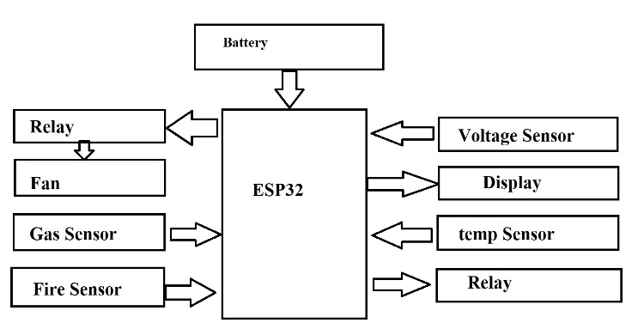
Fig.1 Block Diagram of the System

Wireless Power Transfer (WPT) Mechanism
Wireless power is the process of transferring the electric energy without the need of physical connection. The system uses electromagnetic field for wireless power transfer. It use two coils transmitter coil present at charging station and receiver coil present on EV vehicle. ). The transmitter coil generates an alternating magnetic field when an electric current is passed through it. This magnetic field induces a voltage in the receiver coil placed in the vehicle. The receiver coil then converts this induced voltage into electrical power to charge the vehicle’s battery. The charging station is designed to deliver power to the EV at a distance, which means that the vehicle does not need to physically connect to the charging point.

Integration with Renewable Energy (Solar Panel)
To make the charging station more eco-friendly and energy-efficient, the system integrates solar energy. The solar energy generated is used to power the charging station or is stored in a battery storage system for later use. This integration reduces the dependence on the electric grid and ensures that the charging process is powered by clean energy. When the solar energy supply is insufficient, the system can automatically switch to grid power, ensuring continuous operation. This hybrid energy solution improves the sustainability of the charging station.

Controlling
Using a microcontroller like the ESP32, the system continuously monitors various parameters such as battery status, Solar, voltage and temperature. ESP32 detects the vehicle and starts the charging automatically. In case of any feedback from the sensors used for safety mechanism, it will turn off the charging and start the cooling system such as turn on the fan. This intelligent management system reduces energy waste and improves the efficiency of the charging process.

Communication and monitoring via IoT
To enhance the user experience and operational efficiency, the proposed system employs an Internet of Things (IoT)-based monitoring and control system. Farmers can access live sensor readings via mobile and web applications, ensuring real-time monitoring of field conditions. The system is equipped with sensors that provide real-time data on various parameters, such as the vehicle’s battery status, charging rate, and energy consumption. This data is transmitted to a cloud-based platform ThingSpeak, allowing the station operators and users to monitor the charging status remotely.

Safety Feature
Safety mechanisms are built into the system to protect both the vehicle and the charging station. These include overcurrent protection, thermal management, and voltage regulation to prevent potential hazards like overheating, electrical surges, or short circuits. The system also features a fault detection mechanism that can immediately shut down the charging process if any anomalies are detected. This reduces the risk to life’s of people.

Working

Power Supply
- Transformer: This is a step-down centre-tap transformer with a 12V-0V-12V output rating and 2A current capacity. It takes 230V AC from the mains supply. It provides a dual 12V AC output with a centre tap (0V).
- Lithium-Ion Battery: These rechargeable batteries. It has a total 3 cells and 1 cell voltage is 3.7V, so total voltage is 11.1V. The energy capacity of this battery is 2000mAh as all cells are connected in series. It is use to store energy from solar panel or main power supply. It act as a backup power supply when solar energy is insufficient .
- Solar Panel: This is a solar photovoltaic (PV) panel designed to convert sunlight into electrical energy. It provides a maximum of 5W of power, which is enough for charging batteries or running small circuits. The 18V output is suitable for charging a 12V battery, as a charge controller can regulate it to the appropriate voltage. This panel is used to supply power to the system or recharge backup batteries.

Charging and sensor control
- ESP32 Microcontroller: It acts as the brain of wireless EV charging station. In Wireless Communication it use for remote monitoring and use to control through Wi-Fi. It is also used to read temperature, solar energy data, and other parameters and it also control the relay turn on and turn off based on the condition. It also sends data to LCD to display charging status.
- Relay: It allows the microcontroller (ESP32) to turn the wireless charging coil ON/OFF based on system conditions. It prevents from unnecessary power loss when EV is not present. It also turns the fan ON/OFF based on temperature reading in our project we have set the limit of temperature up to 40 Degree Celsius.

Charging mechanism
- Wireless Power Transfer: The wireless charging takes place through electromagnetic induction. When the vehicle is detected by the IR sensor, it will send the signal to the microcontroller. The microcontroller then initiates the charging by turning on the relay. The receiver coil takes wireless energy from a transmitter coil and converts it into usable DC voltage. The transmitter coil sends an alternating magnetic field and the voltage is induced in the receiver coil. The module captures the energy and converts it into DC power. It provides a direct 5V output for turning on the LED that indicate there is power transfer taking place.
- DC-DC Boost Converter: If the receiver coil generate a low voltage then this module boosts the voltage to a level required for charging the vehicle’s battery. If the received power fluctuates, then this module ensures steady output to prevent disruptions. It ensures that the vehicle gets sufficient voltage for continuous operation.

Display and Monitoring
- LCD Module: It is used to display real time data ,it display the temperature, solar power and battery power and it also shows whether the slot is booked or not.
- Cloud Integration: The communication system connects the charging station to a cloud-based platform ThingSpeak, allowing for real-time monitoring of the charging process. This platform shows the graphs which include the temperature monitoring graph, battery capacity graph and solar energy graph. This makes it easier for the user to know the temperature of the system and any maintenance required can be done.

Safety Mechanism
- Temperature Sensor: The temperature sensor monitors the temperature of the system and whenever the temperature rises above 40 degrees celsuis, it will turn off the charging process by turning off the relay. Once the temperature reduces below 40 degree the charging will start automatically if the vehicle is detected by the IR sensor.
- Volatge Sensor: In our project there are two voltage sensor modules which is "Voltage Sensor VCC < 25V". It is used to measures the voltage from the solar panel to check its performance. And it helps in real-time energy monitoring and it also ensures the panel is generating enough power. It checks the battery charge level and prevents from overcharging, it also ensures the voltage supplied to the charging coil is within a safe range.
- Voltage Regulators: It is also known as step-down voltage regulators. In our project if Solar panels voltage between 20V–40V depending on sunlight then the module converts it to 12V or 5V for charging batteries or powering microcontroller ESP32. These converters also provide stable power to sensors, microcontrollers, and relays. It ensures consistent and safe voltage levels.

Results

Overall System
The figure 2 shows the system where there is no vehicle detected, hence the LCD displays slot empty. In figure 3 the vehicle is detected and the charging has started. The LCD displays slot booked when the vehicle is present at the charging station, and the IR sensors detect the vehicle. The charging process or the wireless power transfer has begun is indicated by the LED present on the vehicle. In figure 4 it shows the safety mechanism were the LCD displays that temperature is high and the system automatic stops the charging process and turns on the fan for cooling down the system.

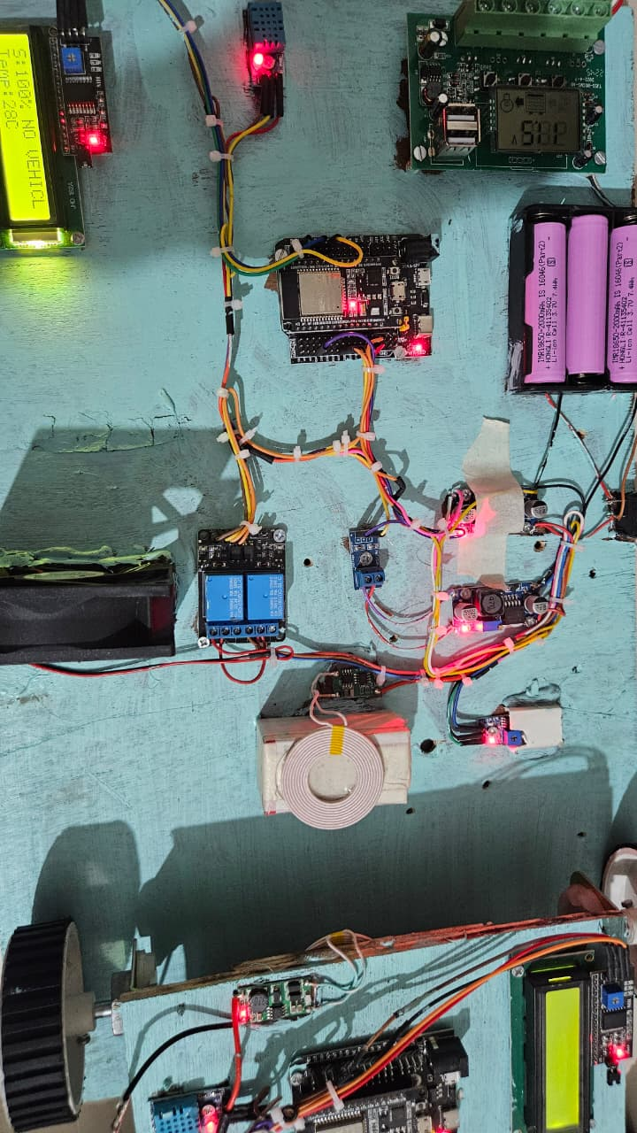

Fig 2. Slot Empty (No Vehicle detected)

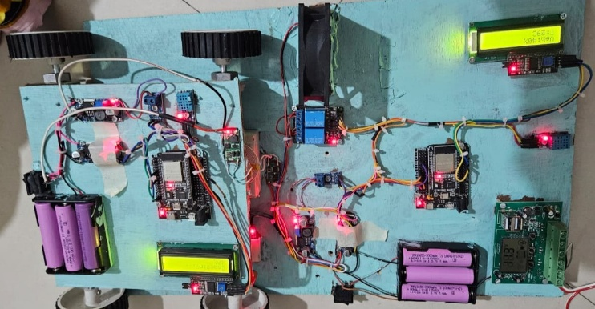

Fig 3. Slot Booked (Vehicle Charging)

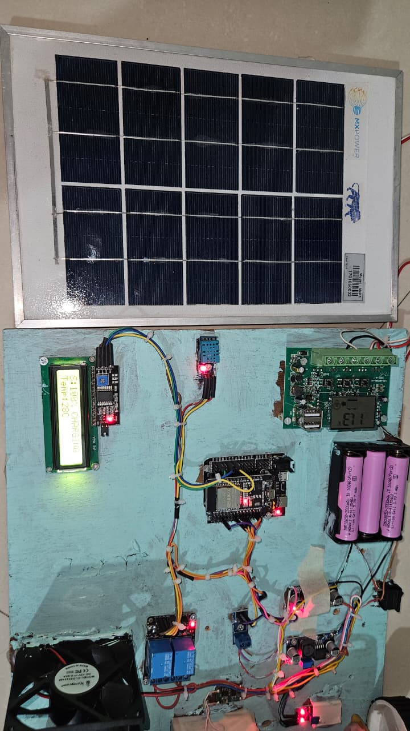

Fig 4. Safety Feature (Temperature High)

ThingSpeak/Cloud
The figure 4 shows ThingSpeak Cloud dashboard, which is used for real-time monitoring and visualization of sensor data in an IoT-based system. The dashboard is labeled "Channel Stats" and consists of four separate field charts, each representing different parameters. The first chart shows temperature over time, indicating the system is operating with the safe value of temperature. The second chart represents Solar volatge, displaying the voltage generated by the solar panel. The third chart shows the voltage of the battery present at the station as a backup option. The fourth chart shows the output voltage generated at the receiver coil. The dashboard includes options to add visualizations, widgets, and export data, making it a useful tool for analyzing data. This also helps reduce the chances of system failure, short circuit or any other damage due to overheating or overvoltage, by allowing the users to take action required by monitoring the system via ThingSpeak.

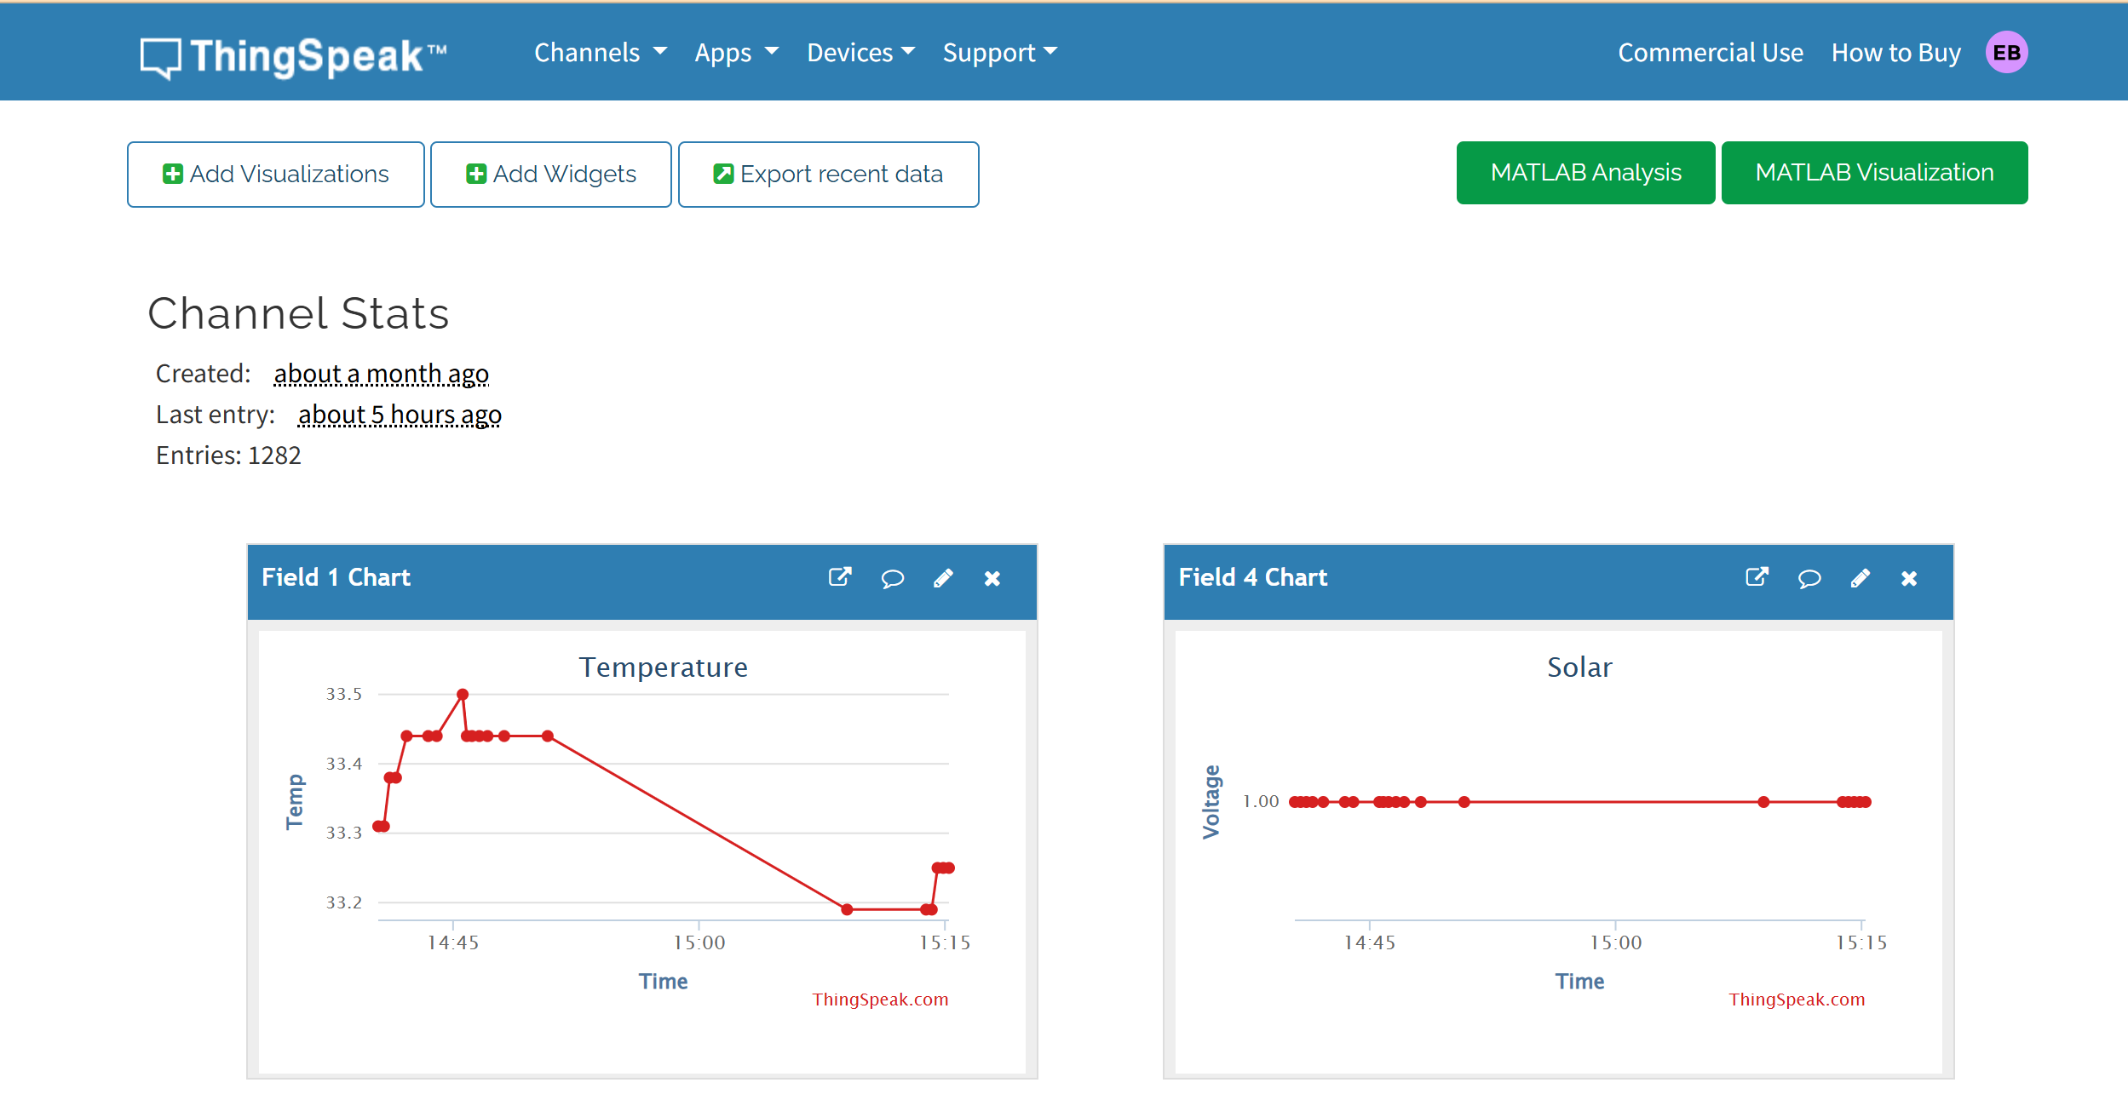
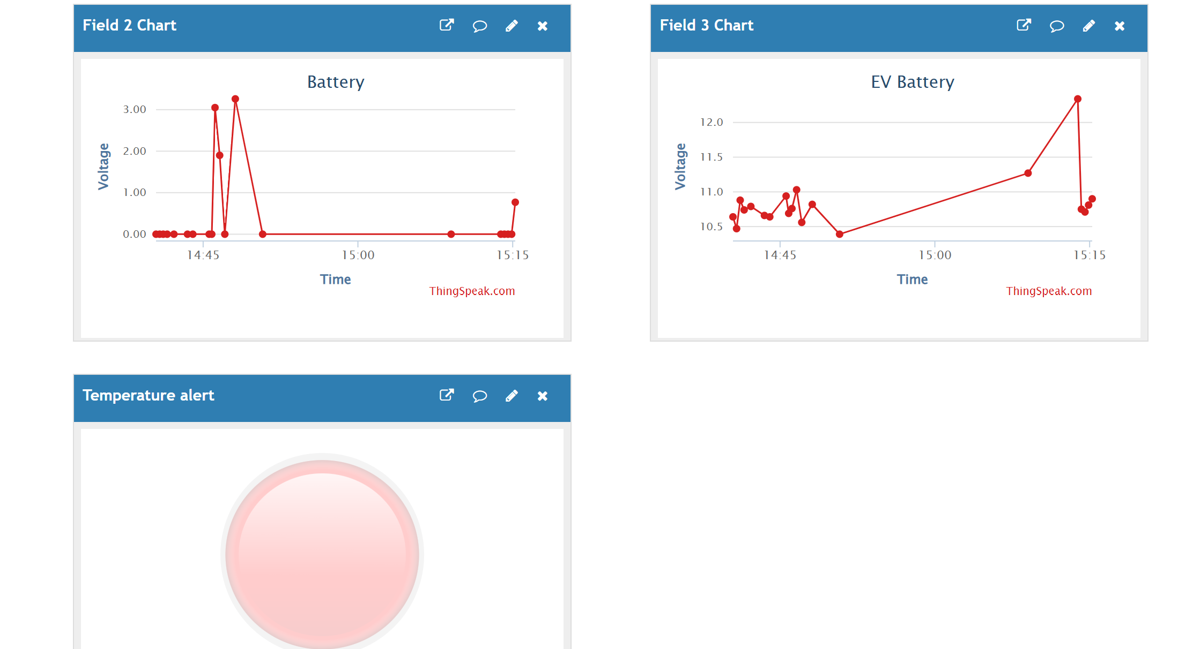
Fig 5. ThingSpeak dashboard

Conclusion
The proposed advanced wireless charging system offers a smart, efficient, and sustainable solution for ElectricVehicle charging by integrating wireless power transfer (WPT), IoT-based monitoring, and renewable energy sources. Its contactless operation enhances user convenience and safety, while the use of solar energy and smart control ensures eco-friendly and reliable performance, making it suited for modern and off-grid EV infrastructure.
Overall, this smart charging solution not only reduces human intervention but also supports the vision of future smart cities and sustainable mobility. With further development, it can be scaled and adapted for public charging stations, home garages, and fleet-based EV operations.

References
- A. S. Sahu, R. B. Choudhury, D. P. Kothari (2020), “Wireless Power Transfer for Electric Vehicles: A Review of Technologies and Applications.” Renewable and Sustainable Energy Reviews, 10.1016/j.rser.2020.109670
- S. P. Sharma, R. A. Jayaswal, A. K. Gupta (2021), “Wireless Charging of Electric Vehicles Using Solar Energy.” IEEE Transactions on Industrial Electronics,10.1109/TIE.2021.3083590
- M. Z. A. Khan, K. A. R. Bakar, N. K. Ghosh (2020), “Design and Implementation of an Intelligent Wireless EV Charging Station with Smart Energy Management” Journal of Energy Storage, 10.1016/j.est.2020.101394
- N. K. Rathi, S. R. Gadkari, P. T. Mahajan (2021), A “Smart Wireless Charging System for Electric Vehicles Based on Solar Energy and IoT” International Journal of Electric and Hybrid Vehicles, 10.1504/IJEHV.2021.113014
- Miss. Shital R. Khutwad & Mrs. Shruti Gaur (2016), “Wireless Charging System for Electric Vehicle” International conference on Signal Processing, Communication, Power and Embedded System (SCOPES), 978-1-5090-4620-1/16/$31.00 ©2016 IEEE
- Gowresudarshan Ashok , Vikas , Sindhu Reddy, Vinay Kumar (2023), “Wireless Electric Vehicle Charging System” IRE Journals, Vol 6 Issue 11, ISSN: 2456-8880
- Adlin Jebakumari S. & A. Jayanthila Devi (2023), “TATA Motors Limited: A Revolution in Electric Cars - A Case Study” International Journal of Case Studies in Business, IT, and Education (IJCSBE), ISSN: 2581-6942, Vol. 7
- Benitto Albert Rayan, Umashankar Subramaniam and S. Balamurugan (2023), “Wireless Power Transfer in Electric Vehicles: A Review on Compensation Topologies, Coil Structures, and Safety Aspects” Energies 2023, 16, 3084. https://doi.org/10.3390/en16073084
- Wang, Y., & Zhang, D. (2021). "Design and Implementation of a Wireless Charging System for Electric Vehicles Based on Inductive Coupling." Journal of Renewable and Sustainable Energy, 13(3), 435-445. https://doi.org/10.1063/5.0030368
- Zhang, H., & Xu, L. (2020). "Design of Wireless Charging Systems for Electric Vehicles: A Comprehensive Survey." Journal of Power Electronics, 20(6), 1535-1545. https://doi.org/10.1109/JPE.2020.2964217
- Lee, Y., & Park, J. (2017). "Analysis of a Wireless Power Transfer System for Electric Vehicle Charging." IEEE Transactions on Power Electronics, 32(4), 2742-2751. https://doi.org/10.1109/TPEL.2016.2562515
- Liu, Z., & Wang, Z. (2019). "High-Efficiency Wireless Power Transfer for Electric Vehicle Charging: A Review." Renewable and Sustainable Energy Reviews, 109, 464-476. https://doi.org/10.1016/j.rser.2019.04.038

