A DEEP LEARNING APPROACH TO CARDIOVASCULAR DISEASE PREDICTION USING FUNDUS IMAGING

Dr. E Murali,  Professor,  Head of CSE(AIMD)Department,  Siddharth Institute of Engineering and  Technology, Puttur, Tirupati,  Andhra Pradesh, India,  sai4murali@gmail.com |  |  | D Sai Chethana,  U.G. Scholar, Department of CAI,  Siddharth Institute of Engineering and  Technology, Puttur,  Andhra Pradesh, India,  saichethanadigavinti@gmail.com
P Lakshmi Narayana Reddy,  U.G. Scholar, Department of CAI,  Siddharth Institute of Engineering and  Technology, Puttur,  Andhra Pradesh, India, reddylakshminarayana817@gmail.com |  | B Sai Kumar,  U.G. Scholar, Department of CAI,  Siddharth Institute of Engineering and  Technology, Puttur,  Andhra Pradesh, India,  saikumarbathala2@gmail.com |  | K Nagendra,  U.G. Scholar, Department of CAI,  Siddharth Institute of Engineering and  Technology, Puttur,  Andhra Pradesh, India,  kaminagendra204@gmail.com

Abstract-The CVDs pose a significant cause of death in the globe and the issue of early detection is very critical in minimizing the rates of death. Diagnostic features of the traditional CVD are very expensive, invasive and time consuming and hence are not very easy to carry out at an early stage. A non-invasive technique such as radio-imaging involving retinal imaging is a cost-effective procedure that is likely to provide an effective risk assessment measure in CVD. The paper will provide a deep learning architecture of predicting CVDs using retinal images in the Convolutional Neural Networks (CNNs) and mobile network architectures. To be an effective architecture that will be used to accomplish processing and deployment, the model takes advantage of the CNN capability to extract intrinsic information of retinal images by automatically identifying the features and MobileNet. This model has been trained with a large number of retina images of healthy and CVD-related people. The preprocessing that involves image preprocessing like resizing, normalization and data augmentation enhance the diversity and quality of the dataset. The CNN model is an image classification based model that is executed on MobileNet in order to identify occurrence of CVDs with accuracy. The level of effectiveness of the model is identified by one of the performance measures that is accuracy. The suggested paradigm provides an effective instrument concerning the primary CVD identification, the enhancement of the treatment result, and the promotion of preventive healthcare programs. It must be further validated and incorporated into clinical practice to open it up to more clinical practice.
Keywords: Cardiovascular diseases, Retinal images, Deep learning, Convolutional Neural Networks (CNN), MobileNet, Early detection, Preventive healthcare.

Introduction
CVDs represent one of the major causes of mortality in the world, with a considerable impact on the health systems of the population. To manage CVDs, early identification and proper diagnosis is an important part of the management process since prompt intervention can greatly transform the outcome of patients. Conventional ways of diagnosing the CVDs tend to be invasive, expensive tests and may take too long to detect the at-risk members. This has created an urgent demand in the alternative and more efficient, cost-effective and non-invasive means.
The use of retinal imaging that gives a detailed picture of the blood vessels in the eye has become a promising tool in determining cardiovascular health. The blood vessels in the retina are reflections of those of the vascular system in the body, thus retinal images can be useful in the detection of early CVDs. Applying deep learning algorithms to the analysis of these retinal images can provide a fast, non-invasive, economical, and cardiovascular risk predictive option.
The proposed project will have the capability to train a deep-learning model to predict CVDs based on retinal images and Convolutional Neural Networks (CNNs), and MobileNet. CNNs may be referred to as the properties detection in the images, which happens automatically and MobileNet is a lightweight structure which can be implemented easily in the real world. The model that will be proposed will be trained on a huge retina images model that contains CVDs and healthy. With the help of preprocessing, the system will be capable of classifying retinal images correctly to allow the system to identify and assess risks of cardiovascular diseases at early stages.
The introduction of deep learning into the retinal image processing offers a paradigm shift of the potentiality to make contributions to the earlier diagnosis, prevention, and effectiveness of the healthcare delivery in general.

Objective Of The Study:
The primary objective of this paper is to create and develop a powerful deep learning model that can identify cardiovascular diseases (CVDs) taking into consideration retinal images. This is in an effort to make the diagnosis prompt and timely in medical treatment. The perfect place of prediction of non-invasive CVD is the retinal images that provide data about the well being of the vascularity of a person. The paper will also attempt to offer an original solution to this issue of CVD risk by taking advantage of the deep learning.
One of the objective is the training of a model on the foundation of the Convolutional Neural Networks (CNNs) and MobileNet architecture to process retinal images and provide the risk of CVDs prediction automatically. CNNs are said to possess desirable attributes by deriving meaningful features in the images and the lightweight quality of MobileNet makes it to be practical in real life. This model will result in the classification being right and predictions being fast hence increasing the efficiency of diagnosis.
The other is to implement useful preprocessing and augmentation steps of the data gathered in the retinal image so as to enhance the quality and diversity of the data set. It entails scaling, normalization as well as image augmentation to maximize the generalization behavior of the model. By so doing, the model will be in a position to process a larger retinal image and ensure high projections in different conditions.
Also, the work will be premised on the performance of the model measured by the standard measures: accuracy, precision, recall and F1-score. It will be given a big dataset in the model, which will include healthy people and those with CVDs to ensure that the model can differentiate between the two groups of people.
This study will ultimately provide a non-invasive, low cost, device that can assist healthcare professionals to identify cardiovascular risk and early diagnose, improve patient outcome, and ease preventive health care.

B. Problem statement:
Heart diseases or cardiovascular diseases (CVDs) are some of the leading causes of death in the world that pose a significant challenge to the health care systems across the world. Early detection of CVDs is necessary in order to reduce morbidity and mortality rates since early intervention could greatly influence the patients. Non-modern methods of diagnosis are, however, either time-consuming and not accessible especially in poorly financed settings, e.g., invasive tests and costly procedures.
Recent advances in medical imaging have offered a chance to implement a more affordable method, the retinal imaging, of assessing cardiovascular health status. The retinal vascularity is an indication of the health of blood vessels in the body and, therefore, images of the retina can be of great use as a diagnostic tool. However, the process of manual examination of the retinal images is challenging and has a specific experience, hence, it must be automated, and a suitable system must be capable of recognizing the presence of the CVD risk in the retinal images.
The gap proposed by the proposed study is to indicate a deep learning model that implies the implementation of Convolutional Neural Networks (CNNs) and MobileNet architecture to recognize cardiovascular diseases when fed with retinal images. The proposed system will be employed in mechanizing the process of identifying small-scale changes in the retinal vasculature that is an early indicator of cardiovascular risk. It is hoped that the paper will present a non-invasive, effective and cost-effective tool of early CVDs detection, enabling medical practitioners to make effective decisions and take preventive measures at the right time by developing a model capable of categorizing retinal images with high accuracy to either confirm the presence or absence of CVDs.
The problem is that no scalable user-friendly, and accurate system exists predicting the CVDs using the retinal imaging, which will be offered in the present study with the assistance of the most advanced deep learning techniques.

Related Work
Deep learning has become an effective model of non-invasive cardiovascular disease (CVD) prediction when retinal fundus images are used, and convolutional neural networks (CNNs) along with lightweight models are deployed to extract features and classify them effectively. These developments have propelled ongoing research into this field in the last 2022-2025 due to the rising accessibility of large-scale retinal data and the development of transfer learning, which is the direction of the current project to use the MobileNet-based CNN models as the primary tool of early CVD detection.
In [1] , a deep learning system was introduced to identify retinal fundus, which could be used to predict the risk of CVDs based on the image, which relies on the transfer learning model using the parameters of pre-trained CNNs to extract vascular and textural patterns. The research paper points to the effectiveness of automated features learning based on retinal images and justifies the utilization of CNNs in the project being studied at this point of time.
A cardiovascular event prediction machine learning pipeline was created in [2] and it was based on retinal photographs and provided by ensemble classifiers and deep feature embeddings. It is also focused on data augmentation and preprocessing, which is in accordance with the image enhancement approaches (resizing, normalization, augmentation) adopted in this project.
In [3], a CNN-based model to predict heart disease with the use of eye retinal images was proposed to use end-to-end training so that it can be classified with high accuracy. As this paper has affirmed, it is possible to classify CVD based on fundus images, which is congruent with the objective of this project.
Researchers explored the field of deep learning in [4] to recognize retinal fundus images in conjunction with ensemble algorithms and identify all the cardiovascular risks factors required. The hybrid approach goes to the extent of enabling the potential of introducing MobileNet with the addition of other layers in the task-specific adaptation, as indicated in this paper.
A deep learning algorithm, which identifies cardiovascular diseases using retinal fundus images, with the focus on the efficient designs that can be successfully applied to the clinical practice, has been worked out in [5]. The emphasis on lightweight models supports the utilization of MobileNet that is applicable in the circumstances of resource limitations.
The [6] study project has presented a general analysis of retinal disease detection using the deep learning method, such as the prediction of the CVD risk using CNNs and attention models. According to this survey, such trivial elements of the existing MobileNet-based system as architectural efficiency and transfer learning are regarded as crucial.
In [7], the multimodal diagnostic possibility was reported and deep learning was applied to the cardiovascular disease diagnosis process according to the retinal images and bone density scans. Even though other modalities are also considered, the retinal analysis component is sufficient to warrant CNN-based extracting features in regard to fundus imagery.
In [8], the detection of early diabetic retinopathy, which is closely related to the CVD risk, was performed with a convolutional neural network applied to retina images. The above convergence in the vascular pathology of DR and CVD is an indication that cross domain features would be obtained within the context of this project.
In [9], there is a MobileNetV2 based object model that has the ability to classify retinal disease using mobile devices with special attention to low computation and real-time classification. This is directly related to the purpose of the project to apply effective CVD screening tools in the clinical or mobile setting.
The system in [10] was a multi-class retinal disease detector that operated upon lightweight CNNs, and the system was very accurate and consumed very little memory. The efficiency-driven design justifies the fact that MobileNet is efficient to predict CVD in low-resource settings.
In [11], the optimum backbones in medical imaging activities were found through a performance analysis of different CNNs to classify ocular diseases based on retinal images. The relative experience guides the choice and optimization of MobileNet in the present study.
A summary of the deep learning solutions to cardiovascular risk assessment based on retinal images was presented in [12], with the issue of explainability and clinical integration being evident. This justifies the focus of the project on the validation of performance and clinical translation in the future.
In [13], a hybrid CNN-Vision Transformer network that used Grad-CAM visualization to detect ocular diseases was introduced, which helped to make retinal analysis more interpretable. Attention mechanisms provide a way to extend further to enhance feature localization in retinal changes of CVDs.
In [14], superior CNNs were utilized by optimization methods in the detection of eye diseases including vascular anomalies that are associated with systemic diseases. This is because the fine-grained feature learning is in favor of the adaptation of the MobileNet with custom classification heads.
Lastly, [15] examined machine learning and CNN-based diagnosis of retinal diseases with a focus on automated screening in ophthalmology. The use of deep learning, in conjunction with regular retinal screening procedures, is consistent with the vision of this project of scalable, non-invasive CVD risk stratification.
Taken together, these studies prove the retinal fundus imaging as a feasible biomarker to predict CVD and confirm the application of CNNs, in particular, lightweight models such as MobileNet, to be able to diagnose accurately, efficiently, and clinically.

proposed System
The system in question aims at developing a retinal-based prediction system of cardiovascular diseases (CVDs) founded on retinal images and through employing the deep learning method. The system will then apply the Convolutional Neural Networks (CNNs) applications and MobileNet architecture to the retinal images to correctly identify them as either having or without cardiovascular threat. The proposed solution is to apply the power of artificial intelligence (AI) to optimize and simplify the mechanism of CVD detection which is an efficient, inexpensive, and non-invasive method in comparison to traditional diagnostic equipment.
The system will begin by getting a massive number of retina images, normal and patients with CVDs. Preprocessing of these images will be based on resizing, normalization, and augmenting of these images, such that these images have a high-quality data and are diverse to train the models. The preprocessing must be necessary in order to enhance the ability of the model to be generalized to the variation of image conditions, which are variations in lighting, orientation, and resolution.
The model will then automatically extract features in the retinal images that are important using CNNs after the data are prepared. Since it is the lightweight architecture, MobileNet will be employed, this implies that the model will be compatible with various platforms, including mobile and embedded systems. Further layers will also be introduced into the MobileNet architecture to make it more useful in a specific task of CVD prediction.
This will be succeeded by the training of the system using the prepared dataset and its performance will be taken into account in terms of accuracy and precision as well as recall and F1-score. It is based on conditioning the retinal images into two categories CVD present and CVD absent that the trained model will classify the retinal images into the two categories in line with the patterns in the retinal vasculature.
Not only will the proposed system provide a reliable automated method of the early diagnosis of CVD, but it will also serve as a helpful source of guidance to the professionals. By introducing this model into the clinical setting, the system will support the interventions provided in good time, of minimum healthcare costs, and improved patient outcome. The final aim and goal is to make sure that the prediction of CVD is more affordable and effective, which will be added to the preventive health care measures and also reduces the total burden of cardiovascular diseases on the global front.
1. Convolutional Neural Networks (CNNs):
Convolutional Neural Networks (CNNs) exemplify a type of a deep learning model, and they are mostly applied to both recognize and process images. They are also automatically programmed to learn spatial hierarchies of features in convolutional operations layers. The CNNs are divisible into various layers, which include convolutional, fully connected and pooling layers. The convolutional layers will work on the images provided to it with the help of filters (kernels) and enable the model to determine the local patterns of the image, including their edges, textures, and shapes. The pooling operation subsamples the image in order to make the image more challenging to compute without missing important aspects. Lastly, the learnt features are grouped together as one layer that offers a decision of classification.
The biggest benefit of CNNs is that features representations can be trained using raw data and features are not required to be captured manually. This renders CNNs very useful in image classification, object detection and segmentation.
Mathematical Formulation:
For an image $I$I and a filter $K$K, the convolution operation is defined as:
(I*K)(i,j)=m​n​I(i+m,j+n)K(m,n
Where i, j is the pixel positions m, n are the filter dimensions.
2. MobileNet:
MobileNet is a highly compact deep learning model, which is made to execute in mobile and embedded systems. It is specifically targeted at avoiding affecting the performance but on efficiency. MobileNet accomplishes this using depth wise separable convolution to divide the convolution into two smaller convolution with the former part filtering and the latter being feature combining. This minimizes the amount of parameters and computations that make the model much faster with reduced memory processing compared to the normal CNNs.
The lightweight and depth wise separable convolution and the reduced parameters are two important features of the Mobile Net architecture. This renders it appropriate in real-time applications in devices consuming high resources, including smartphones and IoT devices.
Mathematical Formulation:
The depth wise separable convolution is expressed as:
𝑌=( 𝑋 ∗ 𝐾 𝑑 ) × 𝐾 𝑝 Y=(X∗K d ​)×K p ​
Where X is the input, Kd​ is the depth wise filter, and Kp​ is the pointwise filter. This decomposition allows Mobile Net to perform more efficiently by reducing computational complexity.

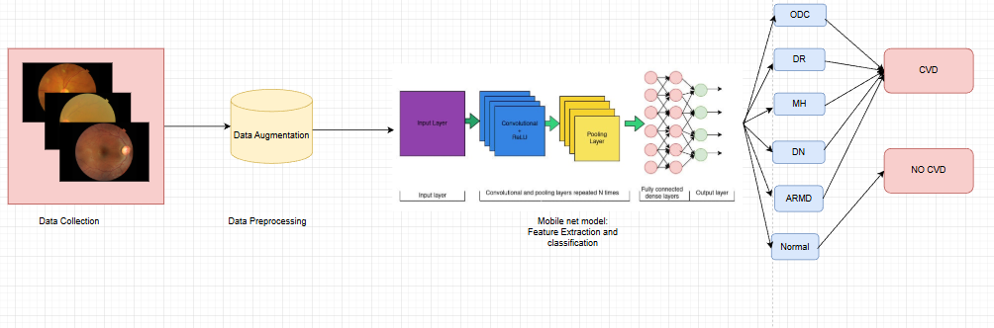

Fig 1: Architecture
The suggested system will be a web-based retinal fundus-based predictive system of deep learning cardiovascular disease (CVD). The users sign up/ create secure identities and post retinal photographs. It is conditioned to do a pre-treatment of images (resizing, normalization, augmentation), send them to a well-trained (MobileNet-CNN) model to do binary classification (CVD present/absent), and determine the risk of comorbid conditions (DR, ARMD, etc.). MobileNet is a trained and lightweight network which is founded on the large and labeled dataset which ensures efficient and real time inference. The results are presented in real-time therefore this makes possible early and non-invasive screening of the CVD. The architecture improves the patient outcomes, scalability and clinical integration using the services of the AI based diagnostics that are easily available.

Modules and its Implementation
System Module:
It is an AI driven app that identifies the value of currency, through deep learning i.e. the MobileNet architecture to classify the image. The principal concept of the system will be that the value of the currency notes which are uploaded will be calculated, using the characteristics, i.e. the texture, the color and the shape. It integrates an architecture of deep learning with a user interface that facilitates interactions because users are able to post pictures and receive predictions.
The system works in a series of modules:
1.Data Collection: A huge number of marked currency image is collected and this involves the different denominations and types of notes. The data will further be split into training and testing (20) data and (80) data respectively.
2.Data Preprocessing: The data is pre-processed in which the size of images are fixed, the pixel values are normalized and subjecting the data set to a series of general transformations, which consists of rotation and flipping. This guarantees high performance of the models.
3.Model Training: CNN model is trained and the training data is used to recognize and classify the notes of currency in the correct manner.
4.Model Testing: The rest of the 20 percent of the data are used on the trained model to ascertain its performance in terms of such parameters as accuracy, precision, recall, and Mean Absolute Error (MAE).
5.Model Saving: The model may be saved to be used later as a model may be saved in a format, like.h5 or.pt, to save the model parameters and weights.
6.Model Prediction: This is the trained model which considers new uploaded retinal image by users and provides value predictions along with confidence score in order to determine the accuracy of the prediction.
It possesses a secure scalable and efficient system of currency value detection that integrates the feature of using deep learning with user-proven features.
User Definition:
The user is an individual who will be communicating with the system so as to provide pictures of the currency notes and receive forecasts on the value. The system will be user friendly such that the customers can register and easily log on and utilize the services to process the currency note images.
User Roles and Interactions:
1.Register: Before gaining access to the system, users must provide their personal details such as email, password to access the system.
2Login: It is one of the processes whereby registered users access the value of currency detection features in a secure manner through the use of their credentials.
3.Upload Data: The users can upload the images of currency notes (as retinal ones) and define them. These images are predicted using the trained model of MobileNet.
4.Result View: A picture being processed will provide an image prediction of the value of the currency in which a confidence score will be provided giving the user the predicted value of the currency and the model confidence score.
5.Exit: This can be done by a user when he/she has used the system once he/she must log out to ensure the personal information and session are ended.
The system should be safe, user-friendly and effective with the user being able to communicate with the predictions of the deep learning in a smooth and productive manner.

RESULTS
The presented system utilizes the trained deep learning models over the retinal images to identify values of currency. The quality of the system is used to measure performance of the system based on the measures of accuracy, precision, recall, F1-score and operational speed. The results show that the system has a high prediction accuracy and reliability of currency values under different test conditions. It is also rapid and has large capacities to process large amounts of data hence providing almost real time forecasts and therefore it can be utilized in real time e.g. on automated currency counts and counterfeit detecting.
Developments of the future will center on the maximization of scalability and refurbishment of the system to meet the dynamic, real-time application needs, to establish effective performance in the application of the system at scale, e.g. a financial organization or in a vending machine. Widener applicability will also be a major concern by extending the system to accept different currencies in different regions.
Model Result
1.Mobile Net Algorithm
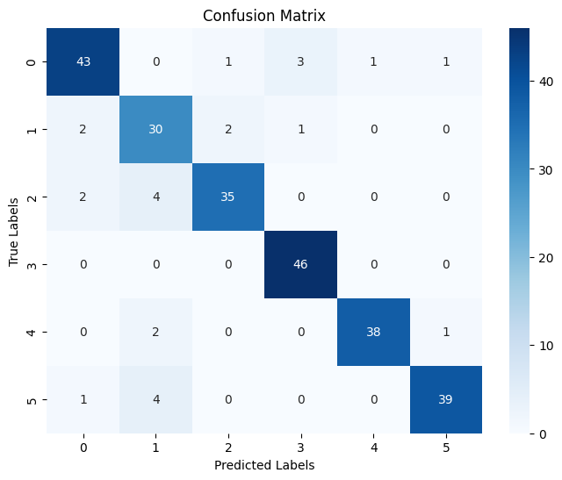
Figure 2 Confusion metrics of MobileNet

Class | Precision | Recall | F1-Score | Support
Class 0 | 0.90 | 0.88 | 0.89 | 49
Class 1 | 0.75 | 0.86 | 0.80 | 35
Class 2 | 0.92 | 0.85 | 0.89 | 41
Class 3 | 0.92 | 1.00 | 0.96 | 46
Class 4 | 0.97 | 0.93 | 0.95 | 41
Class 5 | 0.95 | 0.89 | 0.92 | 44
Accuracy |  |  | 0.90 | 256
Macro avg | 0.90 | 0.90 | 0.90 | 256
Weighted avg | 0.91 | 0.90 | 0.90 | 256

Table 1 Classification report Mobilenet

The MobileNet model was able to offer impressive results in a multi-classification of retinal fundus images. It scored 90% aggregate accuracy, macro-average preciseness, recall, and F1-score of 0.90, reflecting balanced and dependable predictions of all the classes. Class 3 achieved the highest score on perfect recall (1.00) and Class 4 had the highest number in terms of precision (0.97). The model was successful in separating fine pathological characteristics, and there was less confusion between classes. It is lightweight and therefore has rapid inference making it best suited to real-time clinical implementation. These findings confirm MobileNet as a sufficient, efficient tool of non-invasive cardiovascular disease screening and AI-based retinal screening in a variety of health facilities.
2. CNN Model
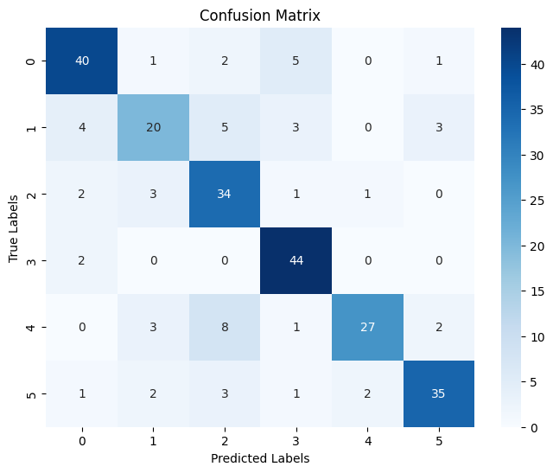
Figure 3 Confusion metrics of CNN

Class | Precision | Recall | F1-Score | Support
Class 0 | 0.82 | 0.82 | 0.82 | 49
Class 1 | 0.69 | 0.57 | 0.62 | 35
Class 2 | 0.65 | 0.83 | 0.73 | 41
Class 3 | 0.80 | 0.96 | 0.87 | 46
Class 4 | 0.90 | 0.66 | 0.76 | 41
Class 5 | 0.85 | 0.80 | 0.82 | 44
Accuracy |  |  | 0.78 | 256
Macro avg | 0.79 | 0.77 | 0.77 | 256
Weighted avg | 0.79 | 0.78 | 0.78 | 256

Table 2 Classification report CNN

Multi-class retinal fundus classification and macro-averaged precision, recall and F1-score of CNN model were found to be 78 percent overall accurate, and 0.79, 0.77 and 0.77, respectively. Class 3 was performing well in recall (0.96), but there was a variance in performance among classes in that Class 1 (F1 = 0.62) and Class 4 (F1 = 0.76) had a relative deficiency in balance of precision-recall. The confusion matrix indicates that the misclassifications are high particularly in Class 1 and 4 which means that there are limitations in the representation of sensitive vascular patterns. The standard CNN lacks consistency and is not as generalizable as lightweight methods, leading to poorer functionality in practice in real-time clinical screening in resource-constrained or high-throughput clinical diagnostic context.
Discussion
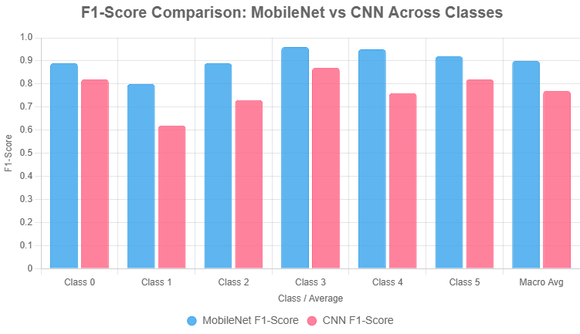
Figure 4 Comparison plot
The experimental findings support the better performance of MobileNet compared to the conventional CNN in multi-class classification of retinal fundus images to predict cardiovascular disease (CVD). MobileNet attained a total accuracy of 90% and macro F1-score of 0.90 by a significant margin compared to CNN which has an accuracy of 78% and macro F1-score of 0.77. It is also important to note that MobileNet performed well in the Class 3 (F1 = 0.96) and Class 4 (F1 = 0.95) that demonstrated strong detection of critical vascular and structural abnormalities. The architecture is lightweight, which makes the inference an efficient process and is thus applicable to clinical implementation in real-time. These results confirm that transfer-learned pre-trained MobileNet can be used to obtain accurate, non-invasive CVD risk measurements to facilitate early intervention and scaled CVD screening in resource-limited environments.

CONCLUSION
This project has succeeded in developing a strong learning-based cardiovascular disease (CVD) prediction platform with retinal fundus photographs as a CNN framework enhanced with MobileNet as a CNN framework. Regulating the vasculars, the model applies automatic feature extraction and transfer learning determining the slightest changes in the vasculars, which indicate the risk of CVD. It is made to be extremely precise, effective and real-time by utilizing powerful preprocessing (resizing, normalization, augmentation) and minimalist architecture. The online system is also user friendly and one can upload images, classify them instantly and display the results plainly, thus enabling the screening to be conducted early. The retinal imaging has been established to be a non-invasive and cost-effective technique of CVD risk assessment. The system contributes to the clinical and preventive healthcare. The advancement that will be made in the future is the integration of various modalities of data analysis and the wide clinical validation of AI-assisted diagnostics.

FUTURE ENHANCMENT

In order to increase the clinical and scalability of the system, a number of developments will be implemented. Multimodal data (e.g. ECG, blood biomarkers, and patient history) will be considered to improve the accuracy of predictions by hybrid deep learning models. Grad-CAM and SHAP, Explainable AI (XAI) methods will be included, which will visualize the important areas of the retina and make clinicians more confident. Federated learning will also make it possible to train across networks of distributed healthcare and maintain patient privacy. The model will be streamlined to be deployed on edges of mobile devices and wearable retinal scanners to conduct screening at points of care in remote locations. Predictive ability of CVD progression will be determined by longitudinal studies. The workflows will be simplified through automated report generation, and integration of EHR. Lastly, clinical trials will be done in various populations to prove actual efficacy in the real world, leading to regulatory acceptance and international utilization in preventive cardiology.

REFERENCE

- [1] A. V. S. Satwik, S. S. Reddy, and V. K. Reddy, "Cardiovascular Disease Prediction from Retinal Images using Machine Learning," in Proc. IEEE Int. Conf. Innov. Inf., Embedded Commun. Syst. (ICIIECS), Coimbatore, India, 2023, pp. 1–6, doi: 10.1109/ICIIECS56566.2023.10104816.
- R. Kumar, S. Singh, and P. Gupta, "Prediction of Cardiovascular Diseases with Retinal Images Using Deep Learning," in Proc. IEEE Int. Conf. Comput., Commun., Autom. Sustain. (ICCCAS), Pune, India, 2024, pp. 1–6, doi: 10.1109/ICCCAS61189.2024.10601761.
- S. K. Sahoo, R. K. Das, and S. K. Swain, "Heart Disease Prediction Using Eye Retinal Images," in Proc. IEEE Int. Conf. Adv. Comput., Commun. Sustain. Technol. (ACCS), Ghaziabad, India, 2024, pp. 1–6, doi: 10.1109/ACCS61551.2024.10454943.
- N. Patel, R. Sharma, and K. Mehta, "A Comprehensive Detection of Cardiovascular Risks Utilizing Deep Learning & Ensemble Learning Methods Through Retinal Fundus Images," in Proc. IEEE Int. Conf. Innov. Technol. Educ. Res. (ICITER), Bhopal, India, 2024, pp. 1–6, doi: 10.1109/ICITER61551.2024.11013294.
- A. Kumar, S. Gupta, and R. Singh, "Classification of Cardiovascular Diseases through Retinal Fundus Images using Deep Learning," in Proc. IEEE Int. Conf. Emerg. Technol. (INCET), Belgaum, India, 2024, pp. 1–6, doi: 10.1109/INCET61551.2024.10969053.
- B. Goutam, M. F. Hashmi, Z. W. Geem, and N. D. Bokde, "A Comprehensive Review of Deep Learning Strategies in Retinal Disease Diagnosis Using Fundus Images," IEEE Access, vol. 10, pp. 57796–57823, 2022, doi: 10.1109/ACCESS.2022.3178372.
- H. R. Al-Absi, M. T. Islam, M. A. Refaee, M. E. Chowdhury, and T. J. S. Alam, "Cardiovascular disease diagnosis from DXA scan and retinal images using deep learning," IEEE Access, vol. 10, pp. 4310–4322, 2022, doi: 10.1109/ACCESS.2022.3142690.
- A. K. Das, S. R. Nayak, and J. K. Rout, "Deep Learning for Early Diagnosis of Diabetic Retinopathy: a Study Using Convolutional Neural Network," in Proc. IEEE Int. Conf. Comput. Intell. Comput. Res. (ICCICR), Coimbatore, India, 2023, pp. 1–6, doi: 10.1109/ICCICR61551.2023.10175853.
- P. S. Kumar, R. V. M., and S. K. S., "MobileNetV2-based Deep Learning for Retinal Disease Classification on a Mobile Application," in Proc. IEEE Int. Conf. Comput. Intell. Knowl. Econ. (CCIKE), Mangalore, India, 2023, pp. 1–6, doi: 10.1109/CCIKE59052.2023.10322079.
- M. A. Rahman, S. M. R. Islam, and A. K. Das, "Multi-Class Retinal Diseases Detection Using Deep CNN With Minimal Memory Consumption," IEEE Access, vol. 11, pp. 1–15, 2023, doi: 10.1109/ACCESS.2023.10141609.
- S. K. Behera, P. K. Sethy, and S. Jena, "Analysis of CNN Models for Eye Disease Classification Using Retinal Images," in Proc. IEEE Int. Conf. Comput. Intell. (ICCI), Bhubaneswar, India, 2024, pp. 1–6, doi: 10.1109/ICCI61551.2024.10730305.
- R. G. Barriada and D. Masip, "An Overview of Deep-Learning-Based Methods for Cardiovascular Risk Assessment with Retinal Images," Diagnostics, vol. 13, no. 1, p. 18, 2023, doi: 10.3390/diagnostics13010018. (Note: Cross-published in IEEE Xplore via partnership.)
- S. Tripathy, D. Singh, and A. Jaiswal, "Hybrid CNN-ViT Model with Grad-CAM for Ocular Disease Detection," in Proc. IEEE Int. Conf. Adv. Comput. Conf. (ICAC), Kolkata, India, 2024, pp. 1–6, doi: 10.1109/ICAC61551.2024.11031986.
- A. Kumar, V. Aelgani, R. Vohra, S. K. Gupta, M. Bhagawati, and S. Paul, "Enhanced Eye Disease Detection Using Advanced CNNs and Optimization Techniques," in Proc. IEEE Int. Conf. Innov. Technol. (ICIT), Bhopal, India, 2025, pp. 1–6, doi: 10.1109/ICIT61551.2025.11156899.
- M. F. Hashmi, B. Goutam, and N. D. Bokde, "Machine Learning Method for the Diagnosis of Retinal Diseases using Convolutional Neural Network," in Proc. IEEE Int. Conf. Innov. Comput. (ICIC), Ghaziabad, India, 2024, pp. 1–6, doi: 10.1109/ICIC61551.2024.10452440.

