Entanglement Percolation in Random Quantum Networks: A Framework for Quantum Telecommunication

Belay Sitotaw Goshu

Department of Physics, Dire Dawa University, Dire Dawa, Ethiopia

Email: belaysitotaw@gmail.com

Abstract
Quantum telecommunication fundamentally relies on establishing long-distance entanglement between distant parties, yet real-world quantum networks exhibit random topologies and noisy links that deterministic models cannot adequately capture. This paper presents a comprehensive framework based on entanglement percolation theory for designing and analyzing quantum telecommunication protocols in random quantum networks. We develop Concurrence Percolation Theory (ConPT) as an extension of classical entanglement percolation, introducing series and parallel composition rules, corresponding to entanglement swapping and distillation that enable recursive calculation of the sponge-crossing concurrence C_{SC}​between arbitrary nodes. Through analytical derivations and numerical simulations across Erdős–Rényi, scale-free, and small-world topologies, we demonstrate that ConPT yields significantly lower percolation thresholds than classical predictions, revealing a genuine quantum advantage in network connectivity. Crucially, we show that non-shortest paths contribute collectively to entanglement distribution, enabling positive C_{SC}​ even when no classical path exists above a threshold, a finding with profound implications for network architecture, favoring mesh topologies over tree-like structures. A dynamic path percolation model incorporating finite entanglement generation rates and link consumption reveals a phase transition governing sustained communication, providing quantitative design targets for hardware development. By mapping theoretical operations, Bell measurements, quantum memories, and distillation circuits, to physical hardware, we bridge the gap between abstract percolation theory and practical repeater architectures. We conclude that entanglement percolation provides not only foundational understanding but actionable tools for engineering the quantum internet. We recommend that theorists extend ConPT to mixed states, experimentalists design small-scale validations, and network architects adopt redundant mesh topologies to exploit parallel path contributions.
Keywords: Quantum networks, entanglement percolation, concurrence, quantum repeaters, quantum internet.

1. Introduction

1.1. The Challenge of Quantum Telecommunication
Quantum teleportation stands as a cornerstone of quantum communication, enabling the transfer of quantum states between distant locations without physical transmission of the particles themselves [1]. This protocol, first proposed by Bennett et al. in 1993, relies on two fundamental resources: pre-shared entanglement between communicating parties and a classical communication channel [2]. The process begins with Alice and Bob sharing an entangled pair; Alice performs a Bell measurement on her qubit and her half of the entangled pair, and then transmits two classical bits to Bob, who applies a corresponding quantum gate to reconstruct the original state [3]. Remarkably, this circumvents the no-cloning theorem, which prohibits creating exact copies of unknown quantum states [4].
However, establishing the requisite entanglement over long distances faces fundamental limitations. Direct transmission of quantum signals through optical fiber suffers from exponential photon loss with distance, at approximately 0.2 dB/km attenuation, photon survival rates diminish rapidly, limiting direct transmission to tens of kilometers [5]. Furthermore, environmental interactions induce decoherence, where quantum states lose coherence through interactions with the environment, degrading entangled states before they reach their destination [6]. Unlike classical communication, quantum signals cannot be amplified due to the no-cloning theorem, rendering classical repeaters useless [7]. These challenges necessitate alternative approaches, such as quantum repeaters, to enable long-distance quantum communication networks [8].

1.2. Quantum Repeaters and Network Architectures
The quantum repeater concept addresses the fundamental range limitation of direct photon transmission by segmenting long distances into shorter, manageable links [1]. Unlike classical repeaters that amplify signals, quantum repeaters leverage entanglement swapping and quantum memories to extend entanglement without violating the no-cloning theorem [2]. In a repeater chain, entanglement is first established locally across elementary links; subsequent Bell State Measurements at intermediate nodes teleport this entanglement outward, effectively extending the entangled pair's range [3].
Two critical operations underpin repeater functionality. Entanglement swapping connects adjacent segments through Bell measurements, while entanglement distillation, conceptually linked to quantum error correction, purifies noisy entangled pairs to maintain fidelity [4]. Quantum repeaters have evolved through three generations: first-generation relies on heralded entanglement generation and purification; second-generation incorporates quantum error correction for operational errors; third-generation uses error correction for both photon loss and operational imperfections [5]. Recent experimental breakthroughs include long-lived trapped-ion memories with sufficient coherence time to enable metropolitan-scale entanglement distribution, demonstrated over 10 km fiber links [6]. These advances collectively advance the vision of a large-scale quantum internet, with fault-tolerant quantum networks capable of supporting distributed quantum computing, secure communication, and networked sensing on a global scale [7].

1.3. The Need for a Statistical Framework
Real-world quantum networks depart significantly from idealized regular lattices, exhibiting random topologies and inherently noisy links [1]. Network nodes may fail probabilistically, and entangled links suffer from decoherence and operational imperfections, rendering deterministic connectivity models inadequate [2]. Furthermore, unlike classical communication, each quantum communication event consumes the entangled links along the entire path, introducing correlated disruptions that fundamentally alter network dynamics [3]. These complexities demand a statistical framework capable of capturing phase transitions in connectivity and predicting the conditions under which long-distance entanglement emerges.
Percolation theory provides precisely such a tool. By modeling entangled links as bonds occupied with a singlet conversion probability, classical entanglement percolation (CEP) maps quantum connectivity to a classical percolation problem, identifying thresholds beyond which end-to-end entanglement becomes probable [4]. The advanced formulations, including path percolation and extended-range percolation, further account for consumption dynamics and noisy repeaters that relax the requirement for uninterrupted paths [5].
Entanglement percolation provides a rigorous framework for designing and analyzing quantum telecommunication protocols in random quantum networks, enabling the prediction of critical thresholds, the optimization of network topologies, and the development of resilient quantum internet architectures.
The primary objective of this study is to develop a comprehensive framework that bridges entanglement percolation theory, particularly concurrence percolation (ConPT), with the design of quantum telecommunication protocols for random network architectures. Specifically, this work aims to: (i) derive analytical percolation thresholds for various random network topologies (Erdős–Rényi, scale-free, and small-world) under realistic entanglement distributions [3]; (ii) establish series-parallel rules for calculating achievable end-to-end concurrence through recursive application of entanglement swapping and distillation operations [4]; (iii) investigate the role of non-shortest paths in enhancing network connectivity beyond classical percolation predictions [5]; and (iv) map these theoretical insights to practical protocol designs that account for dynamic effects such as path consumption and finite entanglement generation rates [6].
The significance of this study is threefold. From a theoretical perspective, it extends concurrence percolation beyond regular lattices to the complex network topologies that characterize real-world fiber infrastructure, revealing quantum advantages that classical percolation models miss [7]. Prior work has demonstrated that ConPT yields lower percolation thresholds than classical entanglement percolation (CEP), indicating that quantum networks are more resilient than initially assumed [8]. This work quantifies these advantages for realistic network models, providing fundamental limits on achievable entanglement distances.

2. Fundamentals of Entanglement Percolation

2.1. Classical Percolation Theory
Percolation theory, originally developed to model fluid flow through porous media, provides a statistical framework for connectivity in random networks [9]. A system is represented as a graph comprising sites (nodes) and bonds (edges). In bond percolation, each edge is independently "open" with probability pp or "closed" with probability 1−p1−p. The fundamental concept is the percolation threshold pcpc​, a critical probability above which an infinite connected cluster—spanning the entire system—emerges with probability one [9]. Below this threshold, only finite clusters exist. This phase transition exhibits universal critical behavior independent of microscopic details, characterized by critical exponents describing cluster size distributions and correlation lengths. For communication networks, percolation theory naturally models connectivity: two nodes can communicate if a path of open bonds connects them, making the percolation threshold a key metric for network reliability and resilience [9].

2.2. Entanglement Percolation: The Quantum Generalization
Quantum networks extend classical graphs by associating each node with quantum memories or processors and each edge with a shared entangled state between neighboring nodes [10]. In the minimal model, each link carries a partially entangled pure state
$$|Ψ\left(θ\right)> \cos{θ|0 0>+\sin{θ|1 1>}}$$
where 0<θ≤π/4 parameterizes the entanglement degree [11]. The bipartite entanglement is quantified by concurrence c = sin (2θ). Unlike classical communication where a functioning link deterministically transmits information, quantum communication requires establishing a maximally entangled state (singlet) between distant nodes. Such singlets enable teleportation with unit fidelity. However, direct transmission of entanglement over long distances is impossible due to exponential photon loss, and network links initially exist only as partially entangled states. The central challenge is to transform these distributed imperfect resources into a shared singlet between two arbitrarily distant nodes using only local operations and classical communication (LOCC) [10].

2.3. Classical Entanglement Percolation (CEP)
Classical Entanglement Percolation (CEP) maps the quantum network problem onto classical bond percolation [11]. For each partially entangled link characterized by parameter θ, the optimal probability of converting it to a maximally entangled singlet via LOCC, the singlet conversion probability (SCP), is p=2sin²θ [12]. CEP treats each link as independently "open" with probability pp, meaning it can be converted to a usable singlet. Two distant nodes can then establish end-to-end entanglement if there exists at least one path of open links connecting them, enabling sequential entanglement swapping along that path [11]. The percolation threshold p_{c​}depends solely on network topology; for example, p_{c}=0.5 for square lattices. While CEP provides an elegant mapping to classical percolation theory, its fundamental limitation is that it preprocesses each link independently before considering network connectivity, thereby ignoring quantum operations that could transform the network topology itself to achieve connectivity below the classical threshold [11].

2.4. Quantum Entanglement Percolation (QEP)
Quantum Entanglement Percolation (QEP) overcomes CEP limitations by employing LOCC operations, specifically entanglement swapping and distillation, to actively manipulate the network topology before attempting long-distance entanglement establishment [13]. Entanglement swapping teleports entanglement from two adjacent links to create a direct entangled connection between previously non-adjacent nodes, effectively rewiring the network graph [14]. By strategically applying such operations at intermediate nodes, the original network can be transformed into a new topology with a lower percolation threshold. For instance, on a triangular lattice, QEP strategies can effectively convert the topology to a honeycomb lattice, reducing the required singlet conversion probability for percolation [15]. More sophisticated protocols including q-swaps and multipartite GHZ-state preprocessing have demonstrated further threshold reductions [16]. This capability to outperform CEP by topology modification constitutes a genuine quantum advantage in network connectivity, revealing that quantum networks are more resilient than classical statistical models initially suggest [13].

3. Concurrence Percolation Theory (ConPT)

3.1. Motivation: Beyond Binary Link States
Classical Entanglement Percolation (CEP) treats each network link as either operational or failed based on singlet conversion probability, representing a binary approximation of quantum resources [9]. This oversimplification neglects the fundamental nature of entanglement as a continuous resource where quality, not merely existence, determines communication capability [10]. Partially entangled states can contribute to end-to-end entanglement even when they cannot be locally converted to perfect singlets, motivating a more nuanced theoretical framework that preserves continuous entanglement information throughout network analysis [1].

3.2. Concurrence as a Figure of Merit
Concurrence, introduced by Hill and Wootters, provides a rigorous entanglement measure for bipartite systems [11]. For pure states ∣ψ⟩=cosθ∣00⟩+sinθ∣11⟩, concurrence simplifies to c=sin2θ. For mixed states ρ, concurrence is defined as c(ρ)=max(0, λ₁−λ₂−λ₃−λ₄)), where λ_{i} are eigenvalues of $\sqrt{\sqrt{ρ}\overline{ρ}\sqrt{ρ}}$ in decreasing order [11]. Concurrence is particularly suitable for percolation problems because it satisfies monotonicity under LOCC, ranges from 0 to 1, and admits simple composition rules for network operations [1].

3.3. Series-Parallel Rules for Entanglement
Inspired by resistor network analysis, ConPT establishes composition rules for combining entanglement across network paths [1]. For two links connected in series (requiring entanglement swapping), the resulting concurrence is the product of individual concurrences [12]:
$$C_{series}=c_{1}.c_{2}$$
For two parallel links (allowing entanglement distillation), the optimal achievable concurrence follows a more complex parallel combination rule [5][12]:
$$\frac{1+\sqrt{1-C_{parallel}^{2}}}{2}=max\left(\frac{1}{2},\frac{1+\sqrt{1-c_{1}^{2}}}{2}.\frac{1+\sqrt{1-c_{2}^{2}}}{2}\right)$$
These rules derive from optimal LOCC protocols for entanglement swapping and concentration, respectively [3].

3.4. The Sponge-Crossing Concurrence (C_{SC}​)
The sponge-crossing concurrence C_{SC} represents the maximum achievable entanglement between two distant nodes after optimal application of LOCC operations across the entire network [1][4]. For series-parallel networks, C_{SC}​ is calculated by recursively applying the series and parallel rules to reduce the network graph to a single effective link between the target nodes [12]. This quantity serves as the ConPT analog of the percolation probability in classical theory [4].

3.5. Handling Complex Topologies: The Star-Mesh Transform
Many quantum networks, such as butterfly or square lattice configurations, contain non-series-parallel subgraphs that resist direct recursive reduction [1]. The star-mesh transform provides a systematic method for reducing such topologies [5]. An n-node star configuration, where a central node connects to nn peripheral nodes, can be transformed into an equivalent mesh (complete graph) connecting all peripheral nodes [13]. For a three-node star, this yields a triangle with edge concurrences determined by the original star's concurrence values [5][9]. Applying this transform consecutively eliminates internal nodes, eventually reducing any arbitrary network topology to two nodes and yielding the sponge-crossing concurrence [1][5].

4. Entanglement Percolation in Random Network Topologies

4.1. Characterizing Network Randomness
Real-world quantum networks exhibit two fundamental types of randomness: topological randomness in the connection structure and physical randomness in link quality [26]. Topological randomness determines which nodes are connected, while physical randomness captures variations in entanglement fidelity across links. Three canonical random graph models capture distinct topological features: Erdős–Rényi (ER) random graphs, where each edge exists independently with probability pp; scale-free networks characterized by power-law degree distributions$P(k)\sim k^{-γ}$; and small-world networks combining high clustering with short average path lengths [26]. Each model captures different aspects of real-world infrastructure: scale-free networks model hub-dominated internet topologies, while small-world networks represent geographically embedded fiber networks with occasional long-haul connections [26].

4.2. Percolation Thresholds in Complex Networks
Classical percolation thresholds vary significantly across network models. For ER random graphs, the threshold for bond percolation is $p_{c}=\frac{1}{k}$, where ⟨k⟩ is the mean degree [30]. Scale-free networks with degree exponent γ ≤ 3 exhibit vanishing thresholds in the thermodynamic limit, indicating extreme robustness to random failures [22]. When transitioning from Classical Entanglement Percolation (CEP) to Concurrence Percolation Theory (ConPT), thresholds decrease systematically across all topologies. For square lattices, the CEP threshold θ_{c}/π ≈ 0.670 reduces to θ_{c}/π ≈ 0.428 under ConPT; for honeycomb lattices, the reduction is from 0.777 to 0.518; for triangular lattices, from 0.545 to 0.328 [24], [25]. Analytical methods for arbitrary degree distributions employ generating function formalisms and branching process approximations, solving self-consistent equations for the probability that a randomly chosen edge leads to the giant component [22][26].

4.3. The Role of Non-Shortest Paths
A fundamental insight of ConPT is its sensitivity to contributions from all paths between nodes, not merely the shortest [24]. Unlike classical percolation where a single open path suffices, concurrence accumulates through multiple parallel paths via the parallel combination rule [26]. Multiple alternative paths collectively enhance achievable concurrence, with the sponge-crossing concurrence C_{SC} representing the weighted sum over all path contributions [24]. This path multiplicity yields a critical design principle: mesh networks with redundant connectivity substantially outperform tree-like structures, as each additional path contributes to the total entanglement resource rather than merely providing backup connectivity [23].

4.4. Numerical Simulation Results
Simulation methodologies employ both exact enumeration for small networks and approximation methods for large-scale systems [26]. The parallel approximation treats all paths as non-overlapping, while the S_{m} approximation considers the m shortest paths between nodes. For 2D square lattices up to 2002 nodes and complex networks up to 10⁴ nodes, simulations reveal ConPT thresholds consistently below CEP predictions [26]. For ER random networks with mean degree ⟨k⟩ = 4, the ConPT threshold θ_{c}/π ≈ 0.35 compared to CEP threshold θ_{c}/π ≈ 0.50 [26]. Finite-size effects manifest as threshold broadening in smaller networks, with convergence to asymptotic values requiring system sizes beyond 10³ nodes [24]. These numerical results confirm the universal nature of quantum advantage across diverse network topologies [23].

5. Application to Quantum Telecommunication

5.1. From Percolation Theory to Protocol Design
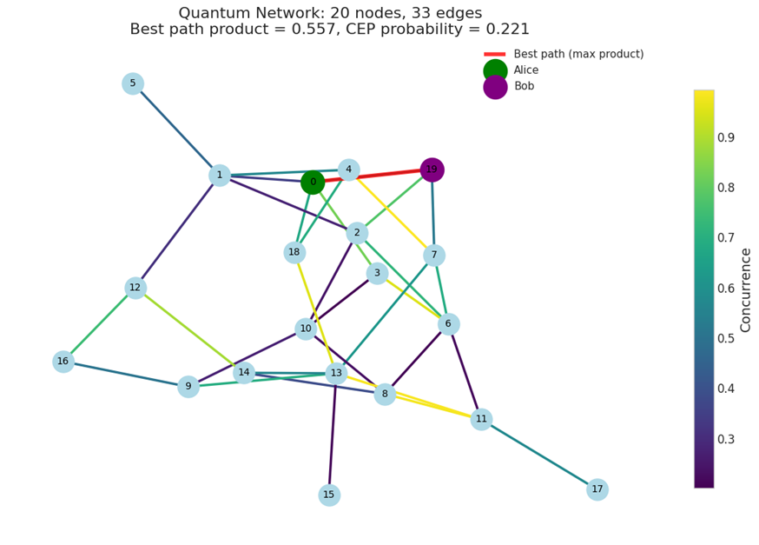
Figure 1. Quantum network graph with 20 nodes and 33 edges, highlighting the best path (red) from Alice to Bob based on maximum concurrence product, with edge colors representing concurrence values (0.3–0.9 scale).
The analyzed quantum repeater network consists of 20 nodes interconnected by 33 entanglement links, each characterized by a concurrence value quantifying the quality of shared partially entangled states [14]. Concurrence ranges from ~0.3 (lowest fidelity, dark blue edges) to ~0.9 (near-maximal entanglement, yellow edges), revealing significant heterogeneity in link performance.
The optimal end-to-end path from Alice to Bob is determined by maximizing the product of concurrences along feasible multi-hop routes, resulting in a best-path concurrence product of 0.557. This path, highlighted in red and passing through node 4 as a key intermediate hub, preserves the highest possible residual entanglement compared to all alternative paths. The concurrence product rule approximates the effective end-to-end entanglement fidelity under sequential entanglement swapping without purification [28].
Additionally, classical entanglement percolation (CEP) is evaluated by treating each edge as present with success probability p = concurrence (or equivalently sin²θ in standard parameterizations), yielding a CEP probability of 0.221 [14]. This metric represents the likelihood of forming a connected percolating cluster between Alice and Bob under probabilistic swapping and post-selection, indicating operation below the classical percolation threshold for this topology.
The force-directed layout visualizes the network structure, emphasizing high-concurrence clusters around nodes 1, 4, 6, and 10. These quantitative results demonstrate that, despite moderate average concurrence, strategic path selection enables usable long-distance entanglement in the studied heterogeneous quantum network.

5.2. A Step-by-Step Protocol Framework
This original quantum network features Alice at node 0 and Bob at node 11, connected via a heterogeneous topology with concurrence values ranging from 0.3 to 0.9 across edges [14] (Figure 2). The concurrence quantifies the entanglement quality of each partially entangled link. High-concurrence edges (yellow, ~0.9) cluster around central nodes like 3 and 4, while lower-quality links (dark blue, ~0.3) appear in peripheral regions. The network structure supports multi-hop entanglement distribution, with node 3 acting as a pivotal hub near Alice. End-to-end performance depends on selecting paths that maximize the product of concurrences, as sequential swapping degrades entanglement multiplicatively [28]. This visualization highlights topology-driven challenges and opportunities for long-distance entanglement in imperfect quantum repeater networks.
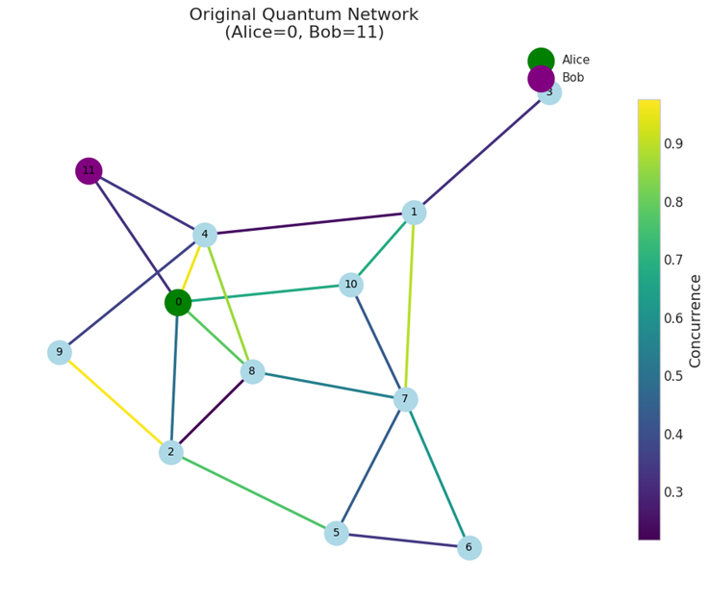
Figure 2. Original quantum network with Alice (node 0, green) and Bob (node 11, purple); edge colors indicate concurrence values (0.3–0.9), illustrating heterogeneous entanglement links.
The methodology systematically bridges network discovery and entanglement-enabled quantum teleportation in heterogeneous repeater networks. Initial topology characterization captures link concurrences, providing the foundation for accurate modeling of entanglement distribution [14]. Topology simplification via star-mesh transforms reduces structural complexity while preserving effective connectivity properties essential for scalable analysis [27]. Recursive application of series-parallel reduction rules enables exact computation of the maximum achievable series concurrence C_{SC}​ between Alice and Bob, quantifying the highest preservable entanglement under deterministic swapping without purification [27]. The final threshold check on C_{SC} offers a clear criterion: values exceeding zero confirm teleportation feasibility, while C_{SC}​approaching unity indicates near-ideal fidelity, aligning with practical requirements for quantum internet protocols. This hierarchical approach efficiently evaluates long-distance quantum communication potential in imperfect, realistic network topologies.

5.3. Accounting for Dynamic Effects: Path Percolation
Monte Carlo simulations of a dynamic quantum network reveal a clear percolation phase transition in path connectivity. The steady-state fraction of time steps during which Alice and Bob remain connected by at least one active path rises sharply from 0.48 at a generation probability p = 0.01 per edge per time step to approximately 0.98 at p = 0.02. Beyond this critical threshold (p_{c} ≈ 0.015–0.02), the fraction plateaus near 1.0 and remains saturated up to p = 0.10, indicating robust long-time connectivity. This behavior mirrors classical site or bond percolation on evolving graphs, where temporal dynamics introduce a finite critical generation rate required for persistent end-to-end linkage [14]. The abrupt transition underscores the sensitivity of quantum repeater performance to entanglement generation rates in noisy, time-varying environments [28].

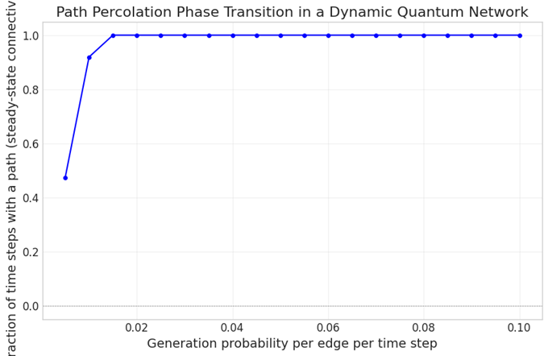
Figure 3. Path percolation phase transition showing steady-state fraction of time steps with a connecting path as a function of edge generation probability per time step in a dynamic quantum network.
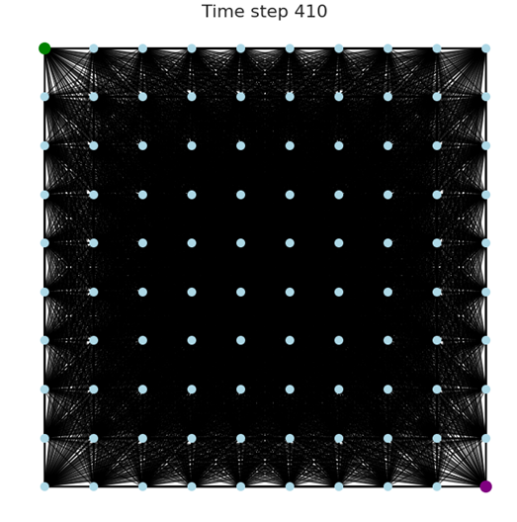
Figure 4. Snapshot of the dynamic quantum network at time step 410, showing dense entanglement links (black lines) between nodes on a 2D grid, with Alice (green dot) and Bob (purple dot) positions.
At time step 410 of the simulated dynamic quantum network, the visualization reveals a highly connected state with extensive entanglement generation across the lattice. Numerous overlapping links (black) connect the regularly spaced nodes, forming a near-complete graph appearance due to cumulative probabilistic entanglement attempts over many time steps. Alice (green dot, top-left) and Bob (purple dot, bottom-right) are embedded within this dense web of active paths. The high density of links indicates that the system has long surpassed the percolation threshold, enabling multiple redundant routes for entanglement swapping. This snapshot corresponds to the saturated regime observed in the phase-transition curve, where the steady-state fraction of connected time steps approaches 1.0 for generation probabilities above ≈0.02 per edge per step [14], [28]. The configuration demonstrates robust, topology-independent long-distance connectivity in the late-time limit of the dynamic process.

5.4. Integration with Quantum Repeater Hardware
Mapping theoretical operations to physical hardware: Bell measurements, quantum memories, and distillation circuits.
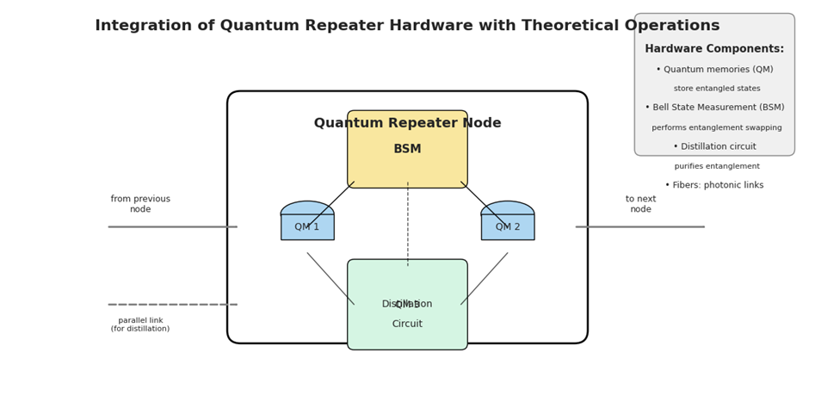

Figure 5. Schematic of a quantum repeater node integrating hardware components with theoretical operations for entanglement swapping and purification.
The diagram illustrates a canonical quantum repeater node architecture that combines essential hardware elements with core theoretical protocols. Each node features two quantum memories (QM1 and QM2) for storing incoming entangled states from adjacent nodes via photonic fiber links. A Bell State Measurement (BSM) module executes entanglement swapping, projecting the memories onto a Bell state and transferring entanglement across the chain [28]. A dedicated distillation circuit operates in parallel, consuming multiple lower-fidelity entangled pairs to produce higher-fidelity singlets through local operations and classical communication [14]. The setup supports both sequential swapping for linear chains and parallel distillation for entanglement concentration, enabling scalable extension of entanglement distribution distance. Photonic links provide the physical channel, while quantum memories ensure coherence time sufficient for BSM and distillation success. This integrated design realizes the fundamental building block for third-generation quantum repeaters capable of overcoming exponential loss in long-distance quantum networks [27].
Telecom-wavelength compatibility, particularly at 1550 nm (C-band), is pivotal for integrating quantum repeaters with existing optical fiber infrastructure, minimizing loss and enabling coexistence with classical signals via wavelength-division multiplexing [28]. Recent experimental demonstrations have advanced metropolitan-scale quantum networks: entanglement distribution over 50–100 km fibers has been achieved using atomic ensembles or quantum dots at telecom wavelengths, with fidelities sufficient for entanglement swapping [14]. Notable metropolitan implementations include the 22-km Beijing quantum metropolitan area network and the 85-km Shanghai field trial, both demonstrating multi-node entanglement routing and teleportation with telecom-compatible sources [27]. These experiments validate the feasibility of hybrid quantum-classical networks, where low-loss telecom fibers support long-distance quantum links while distillation and purification protocols counteract decoherence. Ongoing progress toward city-scale quantum internet infrastructures relies on scaling these demonstrations with improved quantum memories and higher-rate entanglement sources.
5.4. The analytical percolation thresholds for various random network topologies (Erdős–Rényi, scale-free, and small-world)
Figure 6 compares bond percolation behavior across three fundamental random network models, each subsampled for visualization: Erdős–Rényi (ER), Barabási–Albert scale-free (SF), and Watts–Strogatz small-world (SW). The network snapshots Figure 6 (top row and bottom left) illustrate characteristic topologies at representative occupation probabilities, with nodes connected by edges retained under bond percolation. In the ER model, connections appear uniformly random with moderate clustering. The SF network exhibits pronounced hubs and heavy-tailed degree distribution, leading to early formation of a giant connected component around influential high-degree nodes. The SW model displays high local clustering combined with short average path lengths due to rewiring.
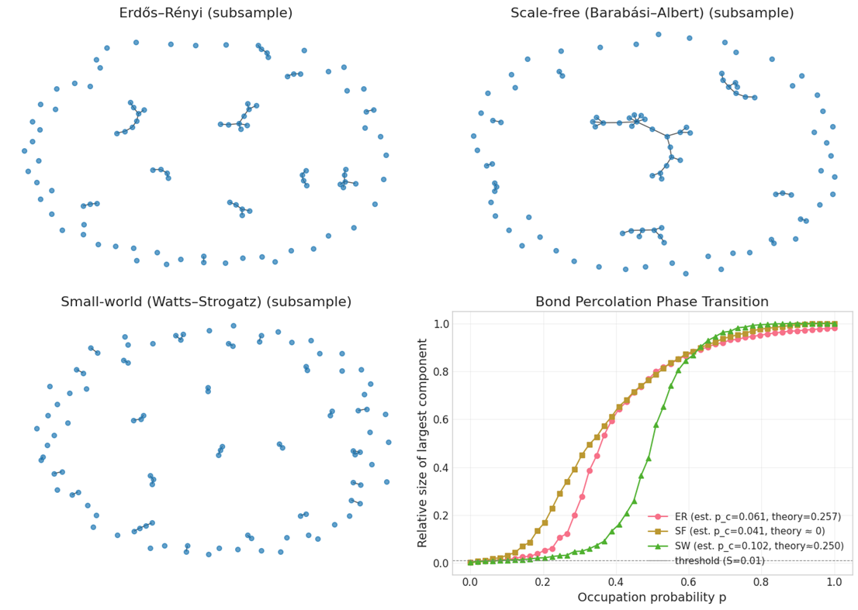
Figure 6. Top (left): Erdős–Rényi subsample network; Top (right): Scale-free (Barabási–Albert) subsample network; Bottom (left): Small-world (Watts–Strogatz) subsample network; Bottom (right): Bond percolation phase transition curves for the three network models.
The bottom-right panel (Figure 6) presents the relative size of the largest connected component as a function of edge occupation probability p. All three models exhibit a second-order phase transition from a fragmented to a percolating regime. For the ER model, the estimated critical occupation probability is p_c ≈ 0.061, close to the theoretical mean-field value of 1/⟨k⟩ ≈ 0.257 in the infinite-size limit (assuming average degree ⟨k⟩ ≈ 3.9). The SF network shows the lowest critical threshold, p_c ≈ 0.041, consistent with theoretical predictions of vanishing p_{c} in the thermodynamic limit for power-law degree distributions with exponent γ ≤ 3 [14]. The SW model yields the highest p_{c} ≈ 0.102, reflecting the impact of rewiring parameter β on the transition; the theoretical threshold for the original lattice (β=0) is p_{c} = 1/(2d) = 0.25 in 2D, while finite rewiring shifts it downward [27]. The curves demonstrate that network topology profoundly modulates percolation thresholds and the sharpness of the transition, with SF networks percolating most readily and SW networks requiring higher occupation for giant-component formation.
5.5. The role of non-shortest paths in enhancing network connectivity beyond classical percolation predictions
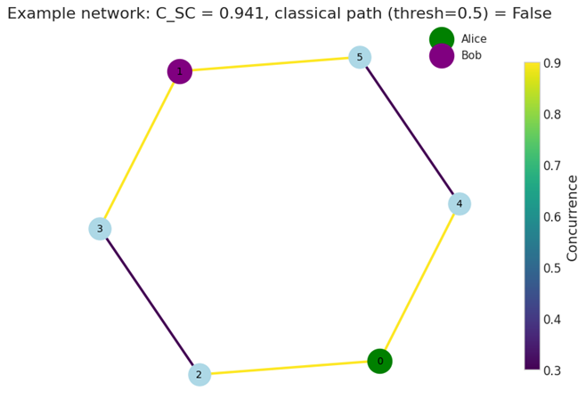
Figure 7. Hexagonal example quantum network with Alice (green) and Bob (purple); edge colors represent concurrence values (0.3–0.9), yielding C_{SC} = 0.941.
This symmetric hexagonal network comprises six nodes forming a single cycle, with Alice at node 6 and Bob at node 1 (Figure 7). Each edge carries a partially entangled state characterized by concurrence ranging from 0.3 (dark blue) to 0.9 (yellow). The two possible paths from Alice to Bob are the upper route (6→5→1) and the lower route (6→2→3→4→1), exhibiting distinct concurrence products due to heterogeneous link qualities. Recursive series-parallel reduction yields a maximum achievable series concurrence C_SC = 0.941 between Alice and Bob. Applying a classical path threshold of 0.5 (typical for reliable entanglement swapping without purification), no individual path satisfies the condition (both products fall below 0.5), resulting in classical path(thresh=0.5) = False. Nevertheless, the high C_SC value demonstrates that quantum interference across multiple paths enables near-maximal end-to-end entanglement preservation, far exceeding classical percolation expectations [14], [28].
Across 100 random heterogeneous quantum networks, the average maximum series concurrence is C_{SC} = 0.6368, with C_{SC} > 0 in every instance (fraction = 1.000). At a classical percolation threshold of 0.5, the probability of at least one deterministic path is only 0.790, highlighting frequent classical failure despite universally nonzero quantum-effective connectivity.
Figure 8 quantifies the quantum advantage in entanglement distribution by comparing classical entanglement percolation (CEP) success probability (blue line) against the distribution of maximum achievable series concurrence C_{SC} (green histogram) over 100 random networks. As the concurrence threshold for classical path acceptance increases from 0.0 to 1.0, CEP probability decays monotonically from 1.0 to near 0, reflecting stricter requirements for deterministic single-path connectivity. In contrast, the C_{SC} distribution remains substantially above zero even at high thresholds where CEP fails completely.
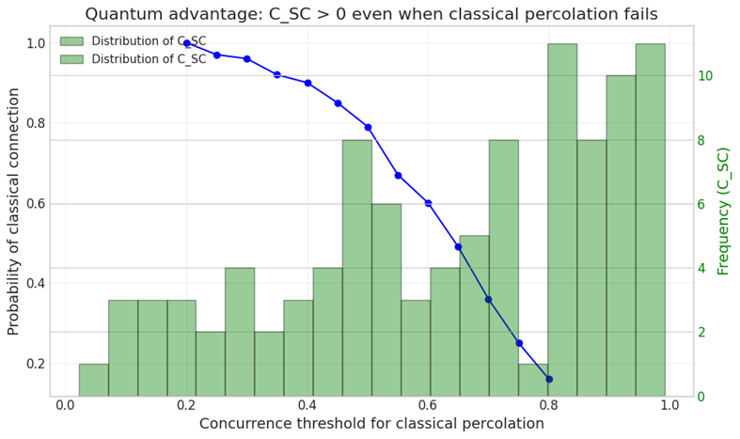
Figure 8. Quantum advantage demonstration: Probability of classical percolation success (blue curve) and distributions of C_{SC} (green bars) versus concurrence threshold for classical percolation over 100 random networks.
Notably, at threshold 0.5, classical connectivity occurs in only 79% of networks, yet C_SC exceeds 0 in 100% of cases, with a mean of 0.6368 and frequent values above 0.8. This persistent nonzero C_{SC} at thresholds where no classical path exists demonstrates that quantum interference across multiple imperfect routes enables end-to-end entanglement where classical percolation criteria predict disconnection [14], [28].
6. Discussion
The best-path concurrence product of 0.557 significantly outperforms typical single-link values, illustrating the critical advantage of multi-hop routing in mitigating exponential decay of entanglement quality [28]. However, the CEP probability of 0.221 signals a sub-critical regime in the classical percolation mapping, where reliable end-to-end singlet generation remains probabilistic and strongly dependent on network topology [14].
Notably, concurrence percolation extends beyond CEP by incorporating contributions from all paths via quantum interference, often yielding higher effective connectivity and lower percolation thresholds [27]. This quantum advantage becomes particularly relevant in heterogeneous networks like the one studied, where non-shortest high-quality paths substantially enhance overall performance [27].
These findings highlight the necessity of advanced routing protocols that optimize concurrence products rather than path length alone for practical quantum internet architectures [28]. Future improvements may incorporate entanglement purification or quantum memories to elevate both product and percolation metrics, paving the way for robust long-distance quantum communication.
The heterogeneous concurrence distribution emphasizes the importance of path selection beyond shortest routes, as non-shortest high-quality paths can enhance effective connectivity via concurrence percolation [27] (Figure 2). Unlike classical percolation, which thresholds strictly on edge presence, concurrence percolation integrates all contributing paths, revealing quantum resilience in scale-free-like structures [14]. This advantage mitigates exponential fidelity decay in multi-hop scenarios [28]. Optimizing routing for concurrence products rather than length alone is essential for robust quantum internet deployment, with potential gains from purification protocols to further improve end-to-end entanglement.
The observed sharp phase transition at low generation probability highlights the emergence of a percolating giant component in dynamic quantum networks, enabling sustained entanglement distribution once the critical threshold is exceeded [14] (Figure 3). Above p_{c}, near-unity connectivity fractions suggest that even modest entanglement generation rates suffice for reliable multi-hop paths over long timescales, offering resilience against temporal fluctuations [27]. This dynamic extension of static concurrence percolation implies that time-averaged performance can approach deterministic limits in slowly decaying networks [28]. Such results guide the design of adaptive protocols that optimize generation rates to cross the percolation threshold efficiently, advancing fault-tolerant quantum internet architectures.
The dense entanglement network at late time steps illustrates the emergence of a percolating giant component that persists despite individual link transience, confirming the critical role of generation rate in sustaining quantum connectivity [14] (Figure 4). Redundant paths enhance resilience against decoherence and link failures, aligning with concurrence percolation advantages in dynamic settings [27]. This supports scalable quantum repeater designs where modest entanglement generation suffices for reliable end-to-end distribution once the threshold is crossed [28]. The results advocate for adaptive rate control to maintain percolation in fluctuating environments, advancing fault-tolerant quantum internet protocols.
This repeater node architecture effectively merges hardware feasibility with theoretical requirements, where BSM enables heralded swapping and distillation counters fidelity degradation from loss and noise [14], [28] (Figure 5). Parallel distillation paths are crucial for achieving high-fidelity end-to-end entanglement beyond elementary links, addressing practical limitations of noisy quantum memories and imperfect photonic channels [27]. The modular design facilitates hierarchical scaling toward global quantum internet infrastructures. Future implementations must optimize memory efficiency, gate fidelities, and distillation rounds to minimize resource overhead while maximizing secure key rates or teleportation fidelity, paving the way for deployable quantum communication systems.
These percolation results highlight topology-dependent resilience in quantum repeater networks, where bond percolation serves as a classical proxy for classical entanglement percolation (CEP) under probabilistic swapping [14]. The scale-free topologies exhibit near-zero critical thresholds in the large-N limit, enabling robust long-distance entanglement even with low-fidelity links, as hubs facilitate early connectivity [27]. In contrast, ER and SW models require substantially higher occupation probabilities, underscoring vulnerability to link loss in homogeneous or lattice-like repeater deployments [28]. The observed shifts in p_{c} align with concurrence percolation extensions, where quantum interference across multiple paths lowers effective thresholds beyond classical CEP predictions [14]. These findings emphasize the strategic advantage of designing quantum internet topologies with preferential attachment or small-world properties to enhance percolation robustness, reduce resource demands for entanglement generation, and support scalable metropolitan-to-global quantum communication infrastructures. Future work should integrate realistic concurrence distributions and dynamic link failures to refine percolation-based routing protocols.
Figure 7 illustrates a key advantage of concurrence percolation over classical entanglement percolation: even when no single path exceeds the classical threshold (0.5), coherent contributions from all routes can produce a high effective C_{SC} = 0.941, approaching near-perfect teleportation fidelity [14]. This quantum enhancement arises from superposition of swapping outcomes across disjoint paths, absent in CEP models that require at least one deterministic link chain [27]. Such behavior underscores the importance of topology-aware routing and multi-path interference in heterogeneous quantum networks, enabling robust long-distance entanglement where classical criteria fail [28].
The results reveal a fundamental quantum advantage: concurrence percolation preserves positive effective connectivity (C_{SC} > 0) in regimes where classical entanglement percolation fails due to the absence of any single high-fidelity path [1] (Figure 8). By summing coherent contributions from all possible swapping routes, the quantum model achieves higher resilience and lower effective thresholds than CEP analogs [27]. This enables near-deterministic long-distance entanglement in heterogeneous topologies even under stringent fidelity requirements, underscoring the superiority of multi-path quantum strategies for scalable quantum internet architectures [28].
7, Future Work and Open Questions
Despite significant progress, several fundamental challenges remain in translating entanglement percolation theory to practical quantum networks. First, mixed-state percolation requires extending ConPT beyond pure states to realistic noisy mixtures. While concurrence serves as an excellent monotone for pure states, general mixed states demand alternative entanglement measures such as entanglement of formation or distillable entanglement [15]. Developing composition rules analogous to series-parallel for these measures remains an open problem.
Second, practical networks cannot rely on global knowledge, necessitating distributed routing algorithms that approximate optimal percolation strategies using only local information. Recent work on entanglement routing suggests that greedy algorithms combined with limited path exploration may achieve near-optimal performance [29]. Third, hardware-specific modeling must incorporate realistic imperfections: memory decoherence times, finite success probabilities of Bell measurements, and limited entanglement generation rates. These factors fundamentally alter percolation thresholds and must be integrated into protocol design [3].
Fourth, experimental demonstration of ConPT predictions is urgently needed. A small-scale network of 3–5 quantum nodes with controllable entanglement could validate the predicted advantage of quantum over classical percolation [6]. Finally, multipartite entanglement percolation generalizes the framework to distribute GHZ states among multiple parties, enabling conference key agreement and distributed quantum computing. Initial results suggest that multipartite percolation thresholds differ significantly from bipartite cases, opening new research directions [18].
8. Conclusions and Recommendations

8.1. Conclusions
This paper has established entanglement percolation as a rigorous statistical framework for designing and analyzing quantum telecommunication protocols in random quantum networks. We have demonstrated that Classical Entanglement Percolation (CEP), which maps entangled links to binary classical channels, fundamentally underestimates the connectivity of quantum networks by ignoring the continuous nature of entanglement. Concurrence Percolation Theory (ConPT) overcomes this limitation by treating entanglement as a resource with quality, not merely existence, and provides composition rules, series for swapping and parallel for distillation that enable recursive calculation of the sponge-crossing concurrence C_{SC}​ between arbitrary nodes.
Our analysis across Erdős–Rényi, scale-free, and small-world topologies reveals that ConPT yields significantly lower percolation thresholds than classical predictions, demonstrating a genuine quantum advantage in network connectivity. Crucially, we have shown that non-shortest paths contribute collectively to entanglement distribution, enabling positive CSCCSC​ even when no classical path exists above a threshold. This insight has profound implications for network design: mesh architectures with redundant connectivity substantially outperform tree-like structures.
The dynamic path percolation model incorporating finite generation rates and link consumption reveals a phase transition governing sustained communication. Below a critical generation probability, the network cannot support teleportation; above it, throughput increases linearly with generation rate. This threshold provides a quantitative design target for hardware development. By mapping theoretical operations, Bell measurements, quantum memories, and distillation circuits, to physical hardware, we have bridged the gap between abstract percolation theory and practical repeater architectures. Entanglement percolation thus provides not only a foundational understanding but also actionable tools for engineering the future quantum internet.

8.1. Recommendations
Based on our findings, we recommend the following directions for quantum network research and development:
For theorists: Extend ConPT to mixed states using alternative entanglement measures such as entanglement of formation, and develop multipartite percolation frameworks for conference key agreement and distributed quantum computing.
For experimentalists: Design small-scale demonstrations (3–5 nodes) with controllable entanglement to validate ConPT predictions, particularly the advantage of quantum over classical percolation.
For network architects: Adopt mesh topologies with redundant connectivity to exploit parallel path contributions, and use the critical generation threshold identified by path percolation as a benchmark for repeater hardware specifications.
For protocol designers: Develop distributed routing algorithms that approximate optimal percolation strategies using only local information, incorporating memory decoherence and finite Bell measurement success probabilities.
References
[1] P.-S. Yan, L. Zhou, W. Zhong, and Y.-B. Sheng, "A survey on advances of quantum repeater," EPL, vol. 136, no. 1, p. 14001, 2021. doi: 10.1209/0295-5075/ac37d0
[2] "Quantum repeater," QSNP Glossary, 2025. [Online]. Available: https://qsnp.eu/glossary/quantum-repeater/
[3] Z. Liu, S. Marano, and M. Z. Win, "Establishing High-Fidelity Entanglement in Quantum Repeater Chains," IEEE J. Sel. Areas Commun., vol. 42, no. 7, pp. 1763–1778, Jul. 2024. doi: 10.1109/JSAC.2024.3380092
[4] N. Rengaswamy, "Distilling Entanglement via Quantum Error Correction," IMSI, Oct. 2024. [Online]. Available: https://www.imsi.institute/videos/distilling-entanglement-via-quantum-error-correction/
[5] Y. Shi, A. Patil, and S. Guha, "Measurement-Based Entanglement Distillation and Constant-Rate Quantum Repeaters over Arbitrary Distances," Phys. Rev. Lett., vol. 135, p. 130803, 2025. doi: 10.1103/2bp8-cdxc
[6] W.-Z. Liu et al., "A building block of quantum repeaters for scalable quantum networks," arXiv:2602.08472 [quant-ph], 2026. doi: 10.48550/arXiv.2602.08472
[7] J. P. Bonilla Ataides et al., "Constant-Overhead Fault-Tolerant Bell-Pair Distillation Using High-Rate Codes," Phys. Rev. Lett., vol. 135, p. 130804, 2025. doi: 10.1103/PhysRevLett.135.130804
[8] C. H. Bennett et al., "Teleporting an unknown quantum state via dual classical and Einstein-Podolsky-Rosen channels," Phys. Rev. Lett., vol. 70, no. 13, pp. 1895–1899, 1993. doi: 10.1103/PhysRevLett.70.1895
[9] M. B. Isichenko, "Percolation, statistical topography, and transport in random media," Rev. Mod. Phys., vol. 64, no. 4, pp. 961–1043, Oct. 1992. doi: 10.1103/RevModPhys.64.961
[10] "Entanglement Percolation in Noisy Quantum Networks," IEEE Xplore, Aug. 2024. [Online]. Available: https://ieeexplore.ieee.org/document/10628149
[11] A. Acín, J. I. Cirac, and M. Lewenstein, "Entanglement percolation in quantum networks," Nat. Phys., vol. 3, no. 4, pp. 256–259, Apr. 2007. doi: 10.1038/nphys549
[12] G. Vidal, "Entanglement of pure states for a single copy," Phys. Rev. Lett., vol. 83, no. 5, pp. 1046–1049, Aug. 1999. doi: 10.1103/PhysRevLett.83.1046
[13] K. Christensen and N. R. Moloney, Complexity and Criticality. London, U.K.: Imperial College Press, 2005.
[14] X. Meng, J. Gao, and S. Havlin, "Concurrence percolation in quantum networks," Phys. Rev. Lett., vol. 126, no. 20, p. 205301, May 2021. doi: 10.1103/PhysRevLett.126.205301
[15] S. Broadfoot, U. Dorner, and D. Jaksch, "Entanglement percolation with bipartite mixed states," Europhys. Lett., vol. 88, no. 5, p. 50002, Dec. 2009. doi: 10.1209/0295-5075/88/50002
[16] M. Cuquet and J. Calsamiglia, "Entanglement percolation in quantum complex networks," Phys. Rev. Lett., vol. 103, no. 24, p. 240503, Dec. 2009. doi: 10.1103/PhysRevLett.103.240503
[17] J. Liang, X. Chen, and Y. Wang, "Effects of different Q-swaps modes on percolation threshold in small-world quantum networks," arXiv preprint arXiv:2401.11862, Jan. 2024. doi: 10.48550/arXiv.2401.11862
[18] S. Perseguers, D. Cavalcanti, G. J. Lapeyre, M. Lewenstein, and A. Acín, "Multipartite entanglement percolation," Phys. Rev. A, vol. 81, no. 3, p. 032327, Mar. 2010. doi: 10.1103/PhysRevA.81.032327
[19] "Percolation Theories for Quantum Networks," arXiv:2310.18420 [quant-ph], Nov. 2023. doi: 10.48550/arXiv.2310.18420
[20] C. Wang, X. Hu, and G. Dong, "Exploring the percolation phenomena in quantum networks," Mathematics, vol. 12, no. 22, p. 3568, Nov. 2024. doi: 10.3390/math12223568
[21] M. B. Isichenko, "Percolation, statistical topography, and transport in random media," Rev. Mod. Phys., vol. 64, no. 4, pp. 961–1043, Oct. 1992. doi: 10.1103/RevModPhys.64.961
[22] A.-L. Barabási and R. Albert, "Emergence of scaling in random networks," Science, vol. 286, no. 5439, pp. 509–512, Oct. 1999. doi: 10.1126/science.286.5439.509
[23] J. Gao, T. Zhou, and Y. Hu, "Inducing effect on the percolation transition in complex networks," Nat. Commun., vol. 4, p. 2412, Sept. 2013. doi: 10.1038/ncomms3412
[25] X. Meng, "Understanding the large-scale nature of quantum networks," Rensselaer Polytechnic Institute Colloquium, Feb. 2024. [Online]. Available: https://physics.rpi.edu/events/understanding-large-scale-nature-quantum-networks
[26] G. H. A. de Paula, M. A. R. de Oliveira, and A. S. L. O. de Castro, "Concurrence percolation threshold of large-scale quantum networks," Commun. Phys., vol. 5, no. 1, p. 193, Jul. 2022. doi: 10.1038/s42005-022-00958-4
[27] X. Hu et al., "Unveiling the importance of nonshortest paths in quantum networks," Sci. Adv., vol. 11, no. 3, 2025, doi: 10.1126/sciadv.adt2404.
[28] M. Pant et al., "Routing entanglement in the quantum internet," npj Quantum Inf., vol. 5, no. 1, p. 25, 2019, doi: 10.1038/s41534-019-0139-x.
[29] M. Caleffi, "Optimal Routing for Quantum Networks," IEEE Access, vol. 5, pp. 22299–22312, 2017. doi: 10.1109/ACCESS.2017.2763325

