Usage and Perceptions of AI-Based Learning Tools Among Grade 12 STEM Learners in Hilongos National Vocational School

ABSTRACT

This study examined the usage and perceptions of AI-based learning tools among Grade 12 STEM learners at Hilongos National Vocational School (HNVS). Specifically, it aimed to identify the respondents’ demographic profile in terms of age and sex, determine the AI-based learning tools commonly used, assess the frequency of AI tool usage, evaluate students’ perceptions in terms of engagement, interaction, behavioral intentions, satisfaction, and perceived improvement in academic performance, and determine whether a significant relationship exists between AI tool usage and students’ perceptions. The study employed a descriptive-correlational quantitative research design. Using stratified random sampling, a total of 76 Grade 12 STEM learners were selected from the STEM population of HNVS during the School Year 2025–2026. Data were gathered through a 20-item standardized questionnaire adapted from Khairuddin, Kamaruddin, and Alwi (2024), with minor modifications to fit the context of the study. Descriptive statistics such as frequency, percentage, mean, and standard deviation were used to summarize the data, while Pearson correlation coefficient was used to determine the relationship between variables. Findings revealed that ChatGPT was the most commonly used AI-based learning tool, and the majority of respondents reported often using AI tools for academic purposes. Students’ overall perceptions of AI-based learning tools were interpreted as neutral, indicating moderate views regarding their influence on engagement, interaction, behavioral intentions, satisfaction, and academic performance. Furthermore, the results showed a moderate positive and statistically significant relationship between AI tool usage and students’ perceptions (r = 0.468, p < 0.001). The study concluded that AI-based learning tools can serve as supportive academic resources when used appropriately and responsibly, but their effectiveness depends on the extent and manner of their integration into students’ learning practices.

Keywords: AI-based learning tools, STEM learners, student perceptions, AI usage

INTRODUCTION

In recent years, artificial intelligence (AI) has rapidly transformed many sectors of society, including education. The growing accessibility of AI-powered tools has significantly changed how students access information, learn lessons, and complete academic tasks. Technologies such as AI chatbots, automated tutoring systems, and machine learning applications allow learners to receive immediate explanations and assistance when studying complex concepts. These innovations can make learning more efficient, interactive, and personalized. However, the increasing reliance on AI also raises concerns about students’ dependence on technology, possible misuse of AI for academic tasks, and its influence on learning behaviors and critical thinking skills. As AI continues to evolve, educators and researchers must determine whether these technologies enhance learning or merely change the way students complete academic tasks.

Globally, AI integration in education has increased significantly in recent years. According to UNESCO (2023), approximately 47% of schools worldwide have begun integrating AI-assisted tools into their learning environments, reflecting a growing acceptance of AI-driven educational practices. These tools include intelligent tutoring systems, automated assessment platforms, and natural language processing applications that help students understand complex academic concepts. Studies suggest that AI can simplify difficult topics by presenting them in clearer and more understandable explanations, allowing learners to grasp challenging lessons more effectively (Liu-Dong, 2025; Xiuxiu-Tang & Xiyu-Wang, 2025). Supporting this, a global survey by EdTech Global (2024) reported that 68% of students experienced improved comprehension of difficult lessons when using AI-driven learning tools.

Several AI technologies, including ChatGPT, machine learning systems, artificial neural networks, and AI-based assessment tools, are widely regarded as innovative tools that can support traditional educational methods. These technologies provide personalized learning experiences, adaptive feedback, and immediate academic assistance, which may enhance students’ engagement in the learning process. Previous research has shown that AI-assisted learning environments can positively influence students’ academic engagement and learning outcomes (Adiguzel et al., 2023; Garcia-Martinez et al., 2023; Lee & Hwang, 2022; Sari et al., 2024). For instance, Sari et al. (2024) reported a 23% improvement in academic performance among students who used AI-assisted tutoring systems compared to those who relied solely on traditional instructional methods.

Despite these advantages, the integration of AI in education remains a topic of debate among educators and researchers. While many studies highlight the benefits of AI-assisted learning tools, others raise concerns about their impact on students’ academic behaviors. A meta-analysis conducted by Adiguzel et al. (2023), which analyzed 45 studies on AI in education, revealed that 79% of studies supported the claim that AI positively influences learning outcomes. However, concerns about academic dishonesty have also been raised. Garcia-Martinez et al. (2023) reported that approximately 35% of teachers expressed concern that AI tools may increase the likelihood of students engaging in cheating or plagiarism.

In the Philippine context, the adoption of AI and digital learning tools among students has also increased in recent years. Marcial (2023) found that Filipino college students frequently use AI technologies to assist with academic tasks such as summarizing lessons and completing assignments, while perceiving these tools as helpful learning aids. Similarly, Dela Cruz and Ramos (2024) reported that Filipino students generally view AIbased learning tools as beneficial for understanding complex academic topics. However, most of these studies focus on college students or general populations, leaving a gap in understanding how AI is used by senior high school learners, particularly those in the STEM academic track who face unique challenges in subjects like mathematics, physics, and chemistry.

Although several international and national studies have explored AI in educational settings, there remains a need to examine the usage and perception of AI-based learning tools specifically among STEM senior high school students. Investigating this phenomenon among Grade 12 STEM students at Hilongos National Vocational School will provide insights into how AI technologies are utilized to support STEM learning and how students perceive their effectiveness in mastering complex concepts. This study will contribute to a clearer understanding of the role of AI in secondary education and help determine whether these tools function as effective pedagogical resources or merely as shortcuts in students’ learning practices

Therefore, this study aims to examine the usage and perceptions of AI-based learning tools among Grade 12 STEM students at Hilongos National Vocational School. Specifically, it seeks to determine how frequently students use AI tools, how they perceive their effectiveness in supporting learning, and how these tools may influence their academic behaviors. By analyzing students’ experiences and attitudes toward AI-based learning tools, this research will provide insights into the role of artificial intelligence in secondary education and its potential impact on student learning outcomes.

Hypothesis
H₀: There is no significant relationship between the usage of AI-based learning tools and students’ perceived understanding.
Ha: There is a significant relationship between the usage of AI-based learning tools and students’ perceived understanding.

Significance of the Study

This study is significant because it investigates the usage and perceptions of AI-based learning tools among Grade 12 STEM learners and how these technologies influence their learning experiences and academic understanding. As artificial intelligence becomes more common in education, it is important to understand how students use these tools, how they perceive their effectiveness, and whether they contribute positively to learning or lead to potential academic misuse.

This study is significant to the following:
Learners: This study can help learners become more aware of how AI-based learning tools influence their study habits, comprehension, and academic performance. By understanding both the benefits and limitations of AI, students can learn to use these technologies responsibly and effectively as learning aids rather than relying on them for academic dishonesty.
Educators: The study provides educators with insights into how students use AI tools in their academic tasks. Understanding students’ perceptions and usage patterns can help teachers adjust their teaching strategies, integrate AI responsibly into the classroom, and develop guidelines that promote ethical and productive use of AI in learning.
Parents: This research will help parents understand how AI technologies are being used by students in their studies. It may guide them in monitoring and supporting their children in using AI tools appropriately while encouraging responsible and productive learning practices at home.
Administrators/School: The findings of this study can assist school administrators in developing policies and strategies regarding the use of AI tools in education. It may help them design programs or guidelines that ensure AI technologies support learning while maintaining academic integrity within the school environment.
Future Researchers: This study may serve as a reference for future researchers who will conduct similar studies related to artificial intelligence in education, student learning behavior, and academic performance. It can also help them identify research gaps and explore additional variables such as AI ethics, digital literacy, and the long-term impact of AI-based learning tools on students.

Statement of Purpose

The purpose of this descriptive–correlational quantitative study is to determine the usage and perceptions of AI-based learning tools among Grade 12 STEM learners at Hilongos National Vocational School. Specifically, this study aims to describe the frequency of students’ use of AI-based learning tools and to assess their perceptions in terms of students’ engagement, interaction, behavioral intentions, satisfaction, and perceived improvement in academic performance.

Furthermore, this study seeks to examine the relationship between the usage of AIbased learning tools and students’ perceptions of these tools as academic support. The findings of this study may provide insights into how AI-based learning tools influence students’ learning experiences and may serve as a basis for improving the integration of artificial intelligence in educational settings.

Specifically, this study seeks to answer the following questions:
1.What is the demographic profile of Grade 12 STEM learners at Hilongos National Vocational School in terms of:
1.1 Age
1.2 Sex
2.What are the types of AI-based learning tools used by Grade 12 STEM learners at Hilongos National Vocational School?
- What is the frequency of usage of AI-based learning tools among Grade 12 STEM learners at Hilongos National Vocational School?
- What are the perceptions of students regarding AI-based learning tools in terms of:
  - Students’ engagement
  - Students’ interaction
  - Behavioral intentions
  - Students’ satisfaction
  - Improvement in academic performance
- Is there a significant relationship between the usage of AI-based learning tools and the perceptions of Grade 12 STEM learners at Hilongos National Vocational School?

Conceptual Framework

Usage of AI
-
Based Learning
Tools

Perceptions of AI
-
Based Learning
Tools

Digital Literacy

Access to
Technology/Inter
net

Independent Variable

Dependent Variable

Moderating

Variable

Mediating

Variable

Figure 1. Schematic Diagram of the Conceptual Framework
This conceptual framework illustrates the relationships among the usage of AI based learning tools, digital literacy, access to technology/internet, and students’ perceptions of AI-based learning tools among Grade 12 STEM learners. The independent variable is the usage of AI tools, referring to how frequently and effectively students use AI technologies, such as intelligent tutoring systems and AI-based assistants, to support their learning. The dependent variable is students’ perceptions of AI-based learning tools, which reflects their attitudes, satisfaction, and perceived usefulness in enhancing understanding of complex concepts. The relationship between these variables is mediated by digital literacy, representing students’ ability to navigate, evaluate, and apply digital technologies, and moderated by access to technology and internet, as availability and quality of devices and connectivity can strengthen or weaken the effect of AI usage on students’ perceptions. This framework provides a structured basis for examining how AI tool usage, digital literacy, and technological access collectively influence students’ learning experiences and attitudes toward AI-based education.

Theoretical Framework
The study is anchored on the Technology Acceptance Model (TAM), the Unified Theory of Acceptance and Use of Technology (UTAUT), Digital Divide Theory, and Constructivism, which explain how students adopt and utilize emerging technologies in educational settings. TAM suggests that technology adoption is influenced by users’ perceived usefulness and perceived ease of use, indicating that students are more likely to use AI-based learning tools if they believe these technologies can enhance their learning and academic performance. Similarly, UTAUT expands this perspective by highlighting factors such as performance expectancy, effort expectancy, social influence, and facilitating conditions that affect technology acceptance and usage. The Digital Divide Theory further explains that differences in access, digital skills, and technological resources may influence how learners utilize AI tools in education. Meanwhile, Constructivist Learning Theory emphasizes that learning occurs actively through interaction, exploration, and knowledge construction, suggesting that AI-based tools can support personalized and student-centered learning experiences. Integrating these perspectives, the study adopts the proposed AI Educational Utilization Theory (AIEUT), which highlights accessibility, adaptability, and applicability as key dimensions influencing the effective use of AI-based learning tools among Grade 12 STEM learners in supporting engagement, interaction, and academic learning practices.

Literature Review

AI in Education
The integration of Artificial Intelligence (AI) in education has significantly transformed how students access information, interact with learning materials, and complete academic tasks. Recent studies indicate that students generally demonstrate positive attitudes toward the use of AI-based learning tools, perceiving them as beneficial in improving learning efficiency and academic performance. Research shows that AI technologies such as chatbots, intelligent tutoring systems, and generative AI platforms can provide personalized feedback, adaptive learning paths, and real-time assistance that support students’ understanding of complex concepts (Chrysafiadi et al., 2023; Li, 2024). AI tools are also widely used for various academic activities including summarizing texts, generating ideas, translating languages, paraphrasing information, and checking grammar and spelling, which makes them valuable learning aids for students in different educational contexts (Salas-Pilco, 2020; Zheng et al., 2024). Studies further reveal that a majority of students perceive AI tools as supportive of self-directed learning, problem-solving, and digital literacy development (Frontiers in Education, 2025). However, while students recognize the advantages of AI technologies in learning, researchers emphasize the need for proper guidance and responsible use to ensure that these tools enhance rather than replace authentic learning processes.

The Role of AI in Enhancing Learning Experiences
Artificial Intelligence has been widely recognized as a transformative innovation in education due to its capacity to provide personalized and adaptive learning experiences.
AI-powered tutoring systems and learning platforms are designed to analyze students’ learning behaviors and provide customized feedback that improves engagement and academic performance (Santhosh et al., 2024; Soto et al., 2024). Personalized AI tutoring systems have been shown to enhance students’ learning outcomes by adapting instructional content to individual learning needs and providing step-by-step explanations that facilitate deeper understanding of academic concepts. Studies also demonstrate that students who actively engage with AI tutoring systems tend to achieve higher academic performance compared to those using traditional learning approaches (Baillifard et al., 2023). Furthermore, AI-based learning environments can increase student engagement, motivation, and satisfaction by offering interactive and learner-centered experiences (Roca et al., 2024).
Despite these advantages, researchers have also identified several challenges associated with the use of AI in education. Concerns have been raised regarding students’ potential over-reliance on AI tools, possible algorithmic biases, and the risk of reduced critical thinking and independent learning skills if AI technologies are used improperly (Elnaffar et al., 2025). Additionally, issues related to academic integrity and ethical AI use have become increasingly important as educational institutions integrate AI technologies into learning environments. Therefore, educators and institutions are encouraged to provide appropriate training, establish clear guidelines, and promote responsible AI usage to maximize the benefits of AI-based learning tools while minimizing potential risks. \

Future Directions
The increasing integration of Artificial Intelligence in education suggests that AI-powered learning tools will continue to play a significant role in shaping future educational practices. Studies indicate that educational institutions should establish policies and training programs that guide teachers and students in the responsible and effective use of AI technologies. According to Nisha Talagala and Aparna Dhinakaran, educational systems must emphasize ethical AI integration and digital literacy to ensure that AI tools support meaningful learning rather than replace critical thinking and independent learning skills. Furthermore, research highlights the importance of developing institutional frameworks that encourage transparency, fairness, and accountability in AI-assisted learning environments (UNESCO, 2023). Future studies are also encouraged to explore how AI-driven learning platforms can be designed to strengthen students’ creativity, collaboration, and problem-solving abilities while maintaining the essential role of teachers as facilitators of learning. By promoting responsible AI use and providing adequate support for educators and students, educational institutions can maximize the benefits of AI technologies while minimizing potential risks associated with over reliance and academic integrity concerns.

METHODOLOGY

Research Design

This study uses a descriptive correlational design to explore how Grade 12 STEM learners at Hilongos National Vocational School (HNVS) use AI-based learning tools and how these tools influence their engagement, interaction, satisfaction, and academic performance. This design allows the researcher to examine relationships between variables without manipulating them. It is suitable for this study because it provides an accurate information of learners’ real experiences and perceptions while showing how different aspects of AI tool usage relate to one another.

Research Environment

This study is conducted at Hilongos National Vocational School, located in Hilongos, Leyte. HNVS is a public vocational school offering Senior High School programs, including a strong STEM track. The school integrates AI-based learning tools into both classroom and online activities to support interactive and research-based learning. Its mission emphasizes producing competent, innovative learners prepared for higher education or future careers. The school environment promotes collaboration among students, provides access to technology, and encourages critical thinking and problemsolving skills, making it an ideal setting to study AI-based learning tools.

Sample Size

The participants of this study were 76 Grade 12 STEM learners enrolled at HNVS during the 2025–2026 school year. The total population consists of 315 learners across seven sections. Using Slovin’s formula with a 10% margin of error, the required sample size was computed as 76:
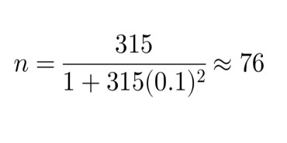
This smaller sample ensures practicality and manageability while still providing a representative snapshot of the population. Only learners who were actively participating in classroom and online activities and who provided informed consent were included.
Inclusion Criteria:
- Learners must be officially enrolled in Grade 12 under the STEM strand at HNVS.
- Learners must voluntarily participate and provide informed consent.
- Learners must be capable of understanding and completing the survey or assessment tools.
Exclusion Criteria:
- Learners from the TVL strand are excluded.
- Learners who are absent or unwilling during data collection will not be included.
- Incomplete or invalid survey responses will not be considered in the analysis.

Sampling Techniques

To ensure a fair and representative sample, the study uses stratified random sampling. The population is divided into seven strata based on their specific STEM sections, and participants are randomly selected from each subgroup. Six sections contributed 11 learners each, and one section (the researcher’s section) contributed 10 learners, for a total of 76 participants. This method ensures that all sections are proportionally represented, reduces sampling bias, and allows the study to capture differences among subgroups. Stratified sampling is appropriate in this context because it allows for more precise and reliable results while maintaining fairness and representativeness (Elfil & Negida, 2017).

Instruments

Data are collected using a 20-item standardized questionnaire adapted from
Khairuddin, Kamaruddin, and Alwi (2024), titled Students’ Perceptions on the Artificial Intelligence (AI) Tools as Academic Support. The questionnaire measures students’ perceptions of AI tools in academic contexts and has been validated in prior research.For this study, minor adaptations are made to ensure the instrument is relevant to HNVS Grade 12 STEM learners. For example, “research activities” is replaced with “classroom tasks and homework,” and “AI tools” is clarified as “AI-based learning tools.” Some items are reworded to improve clarity and comprehension. The instrument has five sections: students’ engagement, interaction, behavioral intentions, satisfaction, and improvement of academic performance. All items are scored on a 5-point Likert scale ranging from 1 (Strongly Disagree) to 5 (Strongly Agree). A dry run with 30 learners not included in the main study tests clarity, reliability, and functionality. Feedback from the dry run is used to make minor adjustments before final data collection.

Data Gathering Procedure

The data collection process follows three stages. Before collecting data, permission is obtained from the school administration, and participants are informed about the purpose of the study, voluntary participation, and confidentiality measures. During data collection, questionnaires are distributed to selected participants and clearly explained. Participants complete the questionnaires individually under supervision to prevent peer influence. After completion, the researcher checks the questionnaires for completeness, codes the responses, and prepares the data for analysis.

Data Analysis

The study analyzes data using descriptive and inferential statistics. Descriptive statistics, including mean, standard deviation, frequency, and percentage, summarize the students’ responses. Pearson correlation analysis determines the relationships between the use of AI-based learning tools and students’ engagement, interaction, behavioral intentions, satisfaction, and academic performance. The study uses Microsoft Excel to perform all computations and interpret results accurately.
- Descriptive Statistics
Descriptive statistics, including frequency, percentage, mean, and standard deviation, were used to determine the profile of the respondents, specifically: Age, Sex, and the AI-based learning tools that they used.
  - Frequency (F): The number of respondents in each category.
  - Percentage (%): Calculated as:
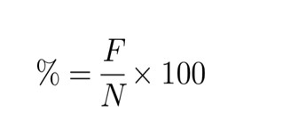
Where:
F = frequency of responses
N = total number of respondents
  - Mean (x̅ ) and Standard Deviation (SD) were calculated to describe central tendency and variability in the respondents’ responses.

- Pearson Correlation Coefficient
The Pearson correlation coefficient (r) was used to analyze the relationship between the use of AI-based learning tools and students’ engagement, interaction, behavioral intentions, satisfaction, and academic performance. This method measures the strength and direction of linear relationships between two continuous variables.

The formula for Pearson correlation is:
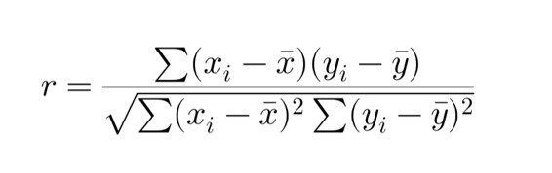
Where:
  - xi= individual score of variable X
  - yi = individual score of variable Y
  - x̅ = mean of X
  - ȳ = mean of Y
  - Σ = summation symbol

A p-value (α) less than 0.05 was considered statistically significant, indicating that the observed correlation is unlikely due to chance. Significant correlations were interpreted in terms of strength (weak, moderate, or strong) and direction (positive or negative).

Ethical Considerations

The study was conducted according to the guidelines outlined in the Declaration of Helsinki (World Medical Association, 2013). Approval was obtained from the Research and Ethics Committee of the University of the Visayas. The study involved adults who voluntarily participated in an online survey. Prior to completing the questionnaires, participants received an informed consent form detailing the study’s purpose, procedures, risks and benefits, confidentiality measures, voluntary participation, and contact information. No financial incentives were offered for participation. The authors declared no conflicts of interest.

RESULTS AND DISCUSSIONS

This section presents the findings of the conducted study on the use and impact of AI-based learning tools on the engagement, interaction, satisfaction, and academic performance of Grade 12 STEM students at Hilongos National Vocational School. Data from 76 respondents were analyzed using descriptive and inferential statistics to address the specific objectives of the study. The results are presented in tables and figures, followed by a discussion that interprets the findings and relates them to the reviewed literature.

The analysis includes the demographic profile of respondents, such as age, sex, frequency of AI tool usage, and their experiences with AI-based learning tools. It also examines the relationship between AI tool usage and academic outcomes, highlighting both the positive effects and areas requiring ethical and responsible application.

Results

Table 1.

Distribution of Respondents According to Age

Age |  | Frequency |  | Percentage
 | 16 |  | 1 |  | 1.32%
 | 17 |  | 52 |  | 68.42%
 | 18 |  | 22 |  | 28.95%
 | 19 |  | 1 |  | 1.32%
TOTAL: |  |  | 76 |  | 100.00%

Table 1 shows the distribution of respondents according to age. The majority of the respondents were 17 years old (68.42%), followed by 18 years old (28.95%). Only a very small proportion of respondents were 16 years old (1.32%) or 19 years old (1.32%).

This indicates that most of the Grade 12 STEM learners at Hilongos National Vocational School fall within the typical age range for senior high school students, with 17 years old being the dominant age group.

Figure 2.

Distribution of Respondents According to Sex
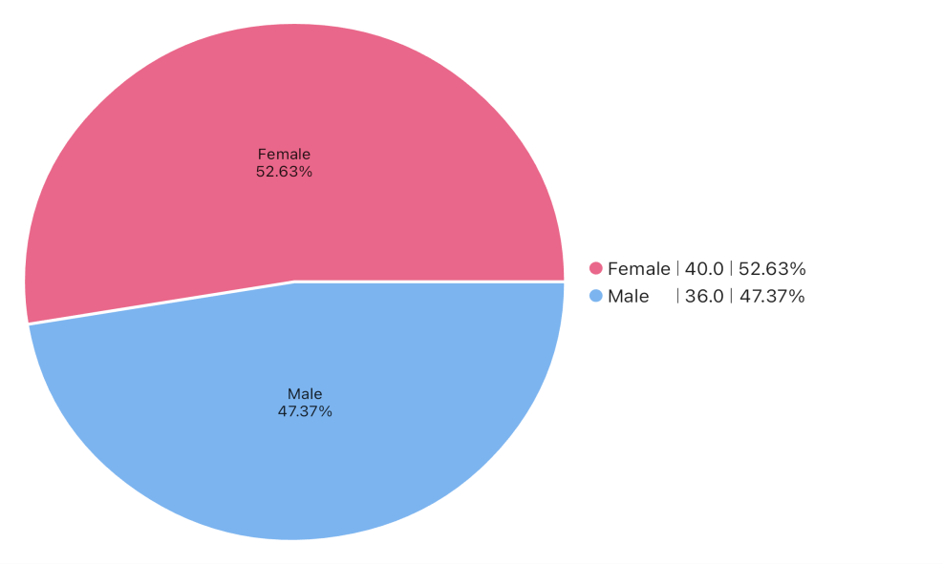

This figure presents the distribution of respondents according to sex. Out of the 76 respondents, 40 (52.63%) were female, while 36 (47.37%) were male. This indicates that female students slightly outnumbered male students among the Grade 12 STEM learners who participated in the study. However, the difference between the two groups is relatively small, showing that both male and female students are well represented in the sample.

Figure 3.

AI-Based Learning Tools Used by the Respondents
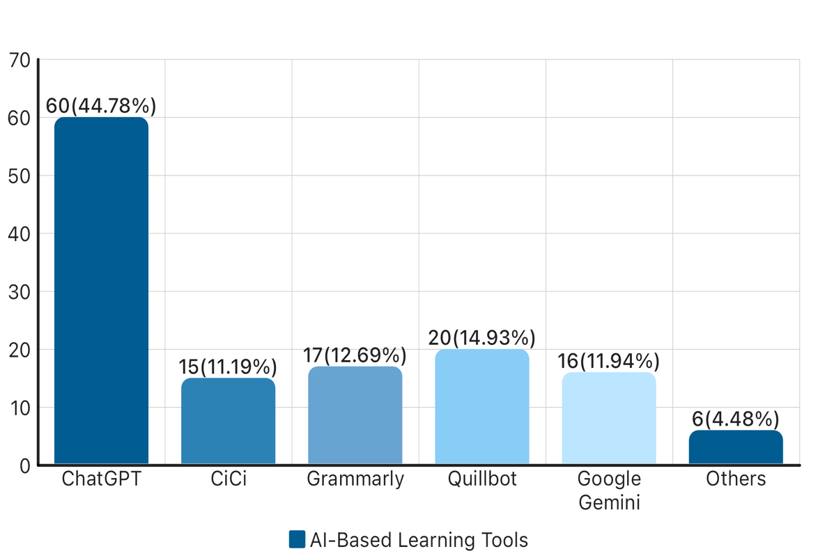
Frequency

Note: Respondents were allowed to select more than one AI-based learning tool; therefore, the total responses exceed the total number of respondents (n = 76).
Figure 3 presents the AI-based learning tools used by the respondents. Among the listed tools, ChatGPT recorded the highest frequency with 60 responses (44.78%), indicating that it is the most commonly used AI tool among the Grade 12 STEM learners. This was followed by Quillbot with 20 responses (14.93%), Grammarly with 17 responses (12.69%), and Google Gemini with 16 responses (11.94%). Meanwhile, CiCi accounted for 15 responses (11.19%), while other AI tools had the lowest frequency with 6 responses (4.48%).

The results suggest that students tend to prefer AI tools that provide instant explanations, writing assistance, and language support, which help them complete academic tasks more efficiently. This finding is consistent with the study of Kasneci et al. (2023), which reported that AI-powered chatbots such as ChatGPT are widely used by students because they can generate explanations, assist in writing tasks, and provide immediate academic support.

B.Frequency of Usage of AI-Based Learning Tools

Figure 4.

Frequency of AI-Based Learning Tool Usage
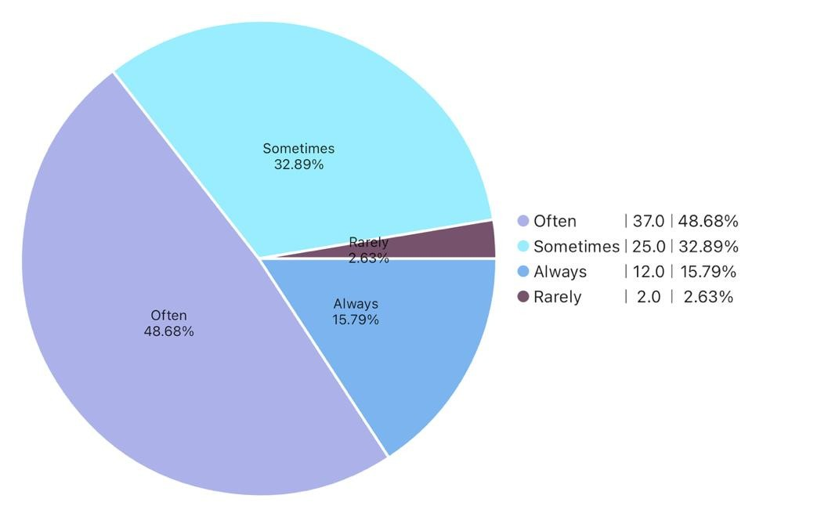

The figure presents the frequency of AI-based learning tool usage among the respondents. The results show that the majority of the students often use AI-based learning tools, with 37 respondents (48.68%) selecting this option. This is followed by 25 respondents (32.89%) who reported sometimes using AI tools, while 12 respondents (15.79%) indicated that they always use them. Only 2 respondents (2.63%) reported rarely using AI-based learning tools.

These findings indicate that most Grade 12 STEM learners at Hilongos National Vocational School use AI-based learning tools frequently as part of their academic activities. The relatively high percentage of students who reported “often” and “sometimes” suggests that AI tools have become integrated into students’ learning routines, particularly for tasks such as searching for explanations, completing assignments, and improving written outputs.

This finding is consistent with the study of Zawacki-Richter et al. (2019), which reported that artificial intelligence technologies are increasingly used in educational settings to support students’ learning processes. The study highlighted that AI tools can enhance students’ access to information and provide personalized learning support, making them valuable resources for academic activities.

Table 2.

Student’s Perception Toward AI-Based Learning Tools
Perceptions | Mean |  | SD |  |  | Interpretation
Engagement |  | 3.32 |  |  | 0.70 | Neutral
Interaction |  | 3.34 |  |  | 0.69 | Neutral
Behavioral Intentions |  | 3.20 |  |  | 0.83 | Neutral
Satisfaction |  | 3.32 |  |  | 0.83 | Neutral
Academic Performance |  | 3.37 |  |  | 0.81 | Neutral
TOTAL |  | 16.54 |  |  | 3.86

Table 2 presents the perceptions of Grade 12 STEM learners regarding AI-based learning tools in terms of engagement, interaction, behavioral intentions, satisfaction, and improvement in academic performance. The results show that academic performance obtained the highest mean (M = 3.37, SD = 0.81), followed by interaction (M = 3.34, SD = 0.69), engagement (M = 3.32, SD = 0.70), and satisfaction (M = 3.32, SD = 0.83). Meanwhile, behavioral intentions recorded the lowest mean (M = 3.20, SD = 0.83) among the five indicators.

Based on the 5-point Likert scale interpretation, all mean values fall within the 2.61–3.40 range, which corresponds to a Neutral interpretation. This indicates that the respondents have moderate perceptions regarding the use of AI-based learning tools in their academic activities. Students neither strongly agree nor strongly disagree that AI-based tools significantly influence their engagement, interaction, satisfaction, and academic performance.

The relatively higher mean for academic performance suggests that students recognize the potential of AI tools in supporting their learning and improving their understanding of academic tasks. This finding is consistent with the study of Adiguzel et al. (2023), which reported that artificial intelligence technologies can support students’ learning processes by providing personalized explanations and feedback that may improve academic outcomes. Similarly, the moderate perceptions related to engagement and interaction align with the findings of Sasika and Ravichandran (2024), who explained that AI-based learning systems can facilitate student engagement and interaction with learning materials, although the level of effectiveness may depend on how frequently students use these technologies.

However, the neutral responses across all indicators suggest that students may still be developing their familiarity and trust in AI-based learning tools. This observation supports the findings of Garcia-Martinez et al. (2023), which noted that although AI has the potential to enhance learning experiences, students’ perceptions of these technologies may vary depending on their level of exposure, digital literacy, and concerns about overreliance on AI for academic tasks.

Overall, the findings indicate that Grade 12 STEM learners demonstrate moderate perceptions toward AI-based learning tools, suggesting that while these technologies are somewhat beneficial for learning, their impact on students’ engagement, interaction, satisfaction, and academic performance may still depend on how effectively they are integrated into educational practices.

Table 3.

Pearson Correlation Between AI Usage and Students’ Perceptions
Variables | r-value | p-value | Interpretation
AI Usage and Students’  Perceptions | 0.468 | < 0.001 | Moderate Positive Correlation,  Statistically Significant

Table 3 presents the relationship between the use of AI-based learning tools and the perceptions of Grade 12 STEM students at Hilongos National Vocational School. The computed Pearson correlation coefficient (r = 0.468) indicates a moderate positive relationship between AI tool usage and students’ perceptions in terms of engagement, interaction, satisfaction, and academic performance. This suggests that students who frequently use AI-based learning tools tend to have more positive perceptions regarding their learning experiences.

Furthermore, the p-value (< 0.001) is lower than the significance level of 0.05, which indicates that the relationship between the variables is statistically significant. Therefore, the null hypothesis stating that there is no significant relationship between AI usage and students’ perceptions is rejected, while the alternative hypothesis is accepted. This means that the use of AI-based learning tools has a significant association with how students perceive their engagement, interaction, satisfaction, and academic performance.

The findings of this study are consistent with the research conducted by Chen et al. (2023), which found that the use of AI-assisted learning tools significantly improved students’ engagement, motivation, and academic satisfaction. Their study emphasized that frequent interaction with AI-based educational platforms can enhance students’ participation and perceived learning performance.

Similarly, the study of Zhang, Zhang, and Li (2025) examined the relationship between students’ attitudes toward artificial intelligence and their learning engagement. The results revealed a moderate positive correlation (r = 0.397, p < 0.01), indicating that students who have more positive attitudes toward AI technologies tend to be more engaged in their learning activities. This finding supports the results of the present study, which also revealed a moderate positive and statistically significant relationship (r = 0.468, p < 0.001) between AI tool usage and students’ perceptions of engagement, interaction, behavioral intention, satisfaction, and academic performance.

These similarities suggest that increased exposure to AI technologies can positively influence students’ learning engagement and perceptions, reinforcing the importance of integrating AI tools responsibly within educational environments.

Overall, the findings of the study demonstrate that the use of AI-based learning tools is significantly associated with students’ perceptions of their learning experiences. The moderate positive correlation (r = 0.468, p < 0.001) indicates that increased use of AI tools tends to correspond with more positive perceptions of engagement, interaction, behavioral intentions, satisfaction, and academic performance among Grade 12 STEM students at Hilongos National Vocational School. Although the relationship is moderate, the results suggest that AI technologies can serve as supportive tools that enhance students’ academic experiences when used appropriately. These findings highlight the growing role of artificial intelligence in education and its potential to improve student engagement and learning outcomes.

Conclusions

This study examined the use and impact of AI-based learning tools on the engagement, interaction, behavioral intentions, satisfaction, and academic performance of Grade 12 STEM students at Hilongos National Vocational School. Based on the findings, several important conclusions were drawn.
First, the demographic results revealed that the majority of respondents were 17 years old, which represents the typical age of Grade 12 students. The distribution of respondents according to sex showed a nearly balanced representation, with slightly more female students than male students participating in the study.

Second, the results showed that students commonly use different AI-based learning tools in their academic tasks. Among the listed tools, ChatGPT was the most frequently used, followed by Quillbot, Grammarly, Google Gemini, and CiCi. These tools are primarily used for generating explanations, improving writing outputs, and assisting with academic activities. This indicates that AI technologies have already become integrated into the learning practices of many students.

Third, the findings revealed that most respondents reported using AI-based learning tools often or sometimes. This suggests that AI tools are becoming regular learning aids among Grade 12 STEM students, particularly for completing assignments, understanding lessons, and improving written outputs.

Fourth, students’ perceptions toward AI-based learning tools in terms of engagement, interaction, behavioral intentions, satisfaction, and academic performance were interpreted as neutral. Although the results did not show strong agreement regarding the impact of AI tools, students acknowledged that these technologies provide moderate support for their learning experiences.

Finally, the correlation analysis showed a moderate positive and statistically significant relationship between AI usage and students’ perceptions (r = 0.468, p < 0.001). This indicates that students who frequently use AI-based learning tools tend to have more positive perceptions regarding their engagement, interaction, satisfaction, and academic performance.

Overall, the findings suggest that AI-based learning tools can support students’ learning experiences when used appropriately. However, their effectiveness may still depend on how frequently students use them and how well these technologies are integrated into educational practices.

Recommendations
Based on the conclusions of this study, the following recommendations are proposed:
- Teachers should guide students in the responsible and ethical use of AI-based learning tools to ensure that these technologies support learning rather than replace students’ critical thinking and independent work.
- Schools may consider integrating AI-assisted learning tools into instructional strategies to enhance student engagement, interaction, and academic support in the classroom.
- Students should be encouraged to use AI tools as supplementary learning resources while still developing their own analytical and problem-solving skills.
- School administrators may organize workshops or training programs to improve students’ and teachers’ digital literacy and awareness of the appropriate use of AI technologies in education.
- Future researchers may conduct further studies related to this topic. These may include: (1) a replication study involving students from other schools or grade levels for comparison; (2) a study using a larger sample size or more advanced statistical methods; (3) research focusing on the long-term effects of AI-based learning tools on academic performance; (4) studies exploring teachers’ perceptions of AI in education; and (5) research examining ethical concerns and responsible AI use among students.

REFERENCES

Adiguzel, T., Kaya, M. H., & Cansu, F. K. (2023). Revolutionizing education with AI:
Exploring the transformative potential of ChatGPT. Contemporary Educational Technology, 15(3), ep429. https://doi.org/10.30935/cedtech/13152
Baillifard, A., Sharma, K., & Dillenbourg, P. (2023). Artificial intelligence in education:
Personalized learning and student performance. Computers and Education:
Artificial Intelligence, 4, 100118. https://doi.org/10.1016/j.caeai.2023.100118
Chang, C. Y., Hwang, G. J., & Tu, Y. F. (2022). Effects of artificial intelligence-supported learning environments on students’ academic performance. Computers &
Education, 178, 104403. https://doi.org/10.1016/j.compedu.2021.104403
Chrysafiadi, K., Virvou, M., & Alepis, E. (2023). Intelligent tutoring systems and adaptive learning technologies in education: A systematic review. Education and
Information Technologies, 28(6), 7255–7280. https://doi.org/10.1007/s10639-02211404-6
Dela Cruz, M. J., & Ramos, P. L. (2024). Students’ perception of artificial intelligence tools in Philippine education. Asia Pacific Journal of Educational Technology, 6(2), 88–101.

EdTech Global. (2024). Global student survey on artificial intelligence learning tools.
EdTech Global Research Institute.
Elfil, M., & Negida, A. (2017). Sampling methods in clinical research: An educational review. Emergency, 5(1), e52. https://doi.org/10.22037/emergency.v5i1.16403
Elnaffar, S., Al-Shamaileh, O., & Al-Tahat, M. (2025). Ethical concerns and challenges of artificial intelligence in education. International Journal of Educational
Technology in Higher Education, 22(1), 15–29. https://doi.org/10.1186/s41239025-00454-0
Garcia-Martinez, I., Fernandez-Batanero, J. M., Cobos Sanchiz, D., & Luque de la Rosa,
A. (2023). Using artificial intelligence in higher education: A systematic review.
Education Sciences, 13(3), 324. https://doi.org/10.3390/educsci13030324
Garcia-Martinez, J., Fernández-Batanero, J. M., & Montenegro-Rueda, M. (2023). The role of artificial intelligence in education: Teachers’ perspectives and concerns.
Education Sciences, 13(2), 142. https://doi.org/10.3390/educsci13020142
Hammda, S., Al-Mansour, R., & Rahman, M. (2024). Challenges of integrating artificial intelligence in digital learning platforms. International Journal of Educational Technology, 21(1), 55–69.

Kasneci, E., Sessler, K., Küchemann, S., Bannert, M., Dementieva, D., Fischer, F., & Kasneci, G. (2023). ChatGPT for good? On opportunities and challenges of large language models for education. Learning and Individual Differences, 103, 102274. https://doi.org/10.1016/j.lindif.2023.102274
Khairuddin, Z., Kamaruddin, N., & Alwi, N. (2024). Students’ perceptions on the artificial intelligence (AI) tools as academic support. Malaysian Journal of Social Sciences and Humanities (MJSSH), 9(11), e003087. https://doi.org/10.47405/mjssh.v9i11.3087
Khalko, R., Sharma, P., & Gupta, V. (2024). Artificial intelligence in education: Opportunities and risks in modern classrooms. Journal of Educational Innovation, 18(2), 77–89.
Lee, D., & Hwang, Y. (2022). Artificial intelligence in education: Applications and future directions. Educational Technology & Society, 25(1), 1–12. https://www.jstor.org/stable/48647028
Li, Y. (2024). Artificial intelligence in education: Opportunities and challenges for student learning. Educational Technology Research and Development, 72(1), 211–226. https://doi.org/10.1007/s11423-023-10273-3
Liu-Dong, Z. (2025). AI-assisted learning systems and their influence on student understanding. Journal of Smart Learning Technologies, 9(1), 15–29.
Marcial, D. E. (2023). Artificial intelligence adoption among Filipino students: Opportunities and challenges in higher education. Philippine Journal of Education and Technology, 17(1), 45–60.
Roca, J. C., García-Peñalvo, F. J., & García-Holgado, A. (2024). Artificial intelligence in higher education: Student engagement and digital learning environments.
Education Sciences, 14(2), 210. https://doi.org/10.3390/educsci14020210
Salas-Pilco, S. Z. (2020). Artificial intelligence and learning analytics in teacher education:

A systematic review. International Journal of Educational Technology in Higher Education, 17(1), 1–20. https://doi.org/10.1186/s41239-020-00211-1
Santhosh, S., Kumar, P., & Bansal, R. (2024). Artificial intelligence in education:
Enhancing student engagement through adaptive learning systems. Journal of
Educational Computing Research, 62(3), 645–662.
https://doi.org/10.1177/07356331231185967
Sari, A., Nugroho, H., & Pratama, Y. (2024). The effectiveness of AI-based tutoring systems in improving academic performance. International Journal of Educational Research, 120, 102189. https://doi.org/10.1016/j.ijer.2023.102189

Sasika, P., & Ravichandran, K. (2024). Artificial intelligence in education: Transforming teaching and learning processes. International Journal of Educational Technology in Higher Education, 21(1), 1–15. https://doi.org/10.1186/s41239-024-00405-9
UNESCO. (2023). Artificial intelligence in education: Guidance for policymakers. UNESCO Publishing. https://unesdoc.unesco.org

Xiuxiu-Tang, L., & Xiyu-Wang, H. (2025). Artificial intelligence and cognitive learning development among secondary students. Journal of Educational Computing Research, 63(2), 345–360. https://doi.org/10.1177/07356331241234567

Yin, L., Li, Q., & Chen, H. (2021). Evaluating the effectiveness of AI tutoring systems on student performance. Computers in Human Behavior, 115, 106612. https://doi.org/10.1016/j.chb.2020.106612
Zawacki-Richter, O., Marín, V. I., Bond, M., & Gouverneur, F. (2019). Systematic review of research on artificial intelligence applications in higher education. International Journal of Educational Technology in Higher Education, 16(1), 1–27.
https://doi.org/10.1186/s41239-019-0171-0
Zheng, L., Niu, J., & Zhong, L. (2024). Students’ perceptions and use of AI tools for academic tasks in higher education. Computers & Education, 201, 104821.
https://doi.org/10.1016/j.compedu.2023.104821

