AUTOMATION OF PAVEMENT MATERIAL TESTING LABORATORY PROCESS

Leka H. Bonoro¹, Prapti Lalpuriya², Khushbu Bhatt³
¹Department of Civil Engineering, Parul Institute of Engineering & Technology, Parul University, P.O. Limda, Wagghodia, Vadodara, India
2403032110004@paruluniversity,ac.in
²Department of Civil Engineering, Parul Institute of Engineering & Technology, Parul University, P.O. Limda, Wagghodia, Vadodara, India
³Department of Civil Engineering, Parul Institute of Engineering & Technology, Parul University, P.O. Limda, Wagghodia, Vadodara, India

ABSTRACT

Laboratory automation has revolutionised sectors such as healthcare, education, research and other industrial laboratories, while Pavement Material Testing Laboratories (PMTLs) in transportation engineering sector particularly in developing countries such as Papua New Guinea (PNG) remain disadvantaged in manual process. The objective of this study is to assess the current practice and past studies and identify suitable automation technology that is customizable to design and develop an end-to-end automated system for PMTL tailored to PNG context. The system designed is a simple customized web-based application developed to streamline and digitize the workflow of laboratory testing processes. The system developed consist of two main user interface, the client and admin panel, the workflow are request submission, review of request, sample registration, data processing and reporting. Each stages ensures data flows consistently without duplication or loss. The system is integrated in two parts, the front end and the back end, and integrates Barcoding and Quick Response (QR) coding, database (MongoDB) as primary database and utilize the following tools, PDF QR code generation, library and development tool, version and environment management, testing and deployment tools. QR and Bar coding system are used to link the different stages. Database (MongoDB) integrate and automate laboratory processes uninterruptedly from test request to reporting, aligning with ISO/IEC 17025 requirements. Data gathered through case study survey questionnaires from six major public accredited PMTLs and the seven major road contractors in PNG indicated strong support for automation. The system designed is cost-effective, scalable, and customized for resource-constrained countries, where high-end commercial Laboratory Information Management System (LIMS) solutions may be financially and technically impractical

Key Words: Laboratory Automation, LIMS, PMT, Laboratory Quality Assurance, ISO/IEC 17025

INTRODUCTION

Globally, laboratory automation has transformed laboratory operational efficiency, data integrity, and decision-making across several sectors, including healthcare, education, research and other industries. Automated laboratory systems, often implemented through advanced technologies such as LIMS, have enabled end-to-end process integration, real-time monitoring, improved turnaround times, and enhanced compliance aligning with accreditation standards such as ISO/IEC 17025[12],[13]. Despite these advances, PMTLs in transportation sector particularly in resource-constrained countries continue to rely heavily on manual paper-based and fragmented processes. The performance, sustainability, and quality of the road pavement structures are fundamentally dependent on the properties of pavement materials that are required to meet specified road design and construction standards. In transportation engineering, the selection and verification of suitable pavement material type rely heavily on accurate, timely, and traceable laboratory testing process undertaken by PMTL. In resource constrained countries meeting the growing demand for road materials, local sources are important. These materials are extracted and carefully tested to check if they are suitable for road material use. Their properties greatly affect how well they perform on the road [1]. With a well-equipped automated PMTL, testing can be done faster and more efficiently, handling many samples at the same time while still meeting project deadlines [3], [7]. The PMT laboratory play a crucial role in ensuring that pavement materials such as soils, aggregates, asphalt, and concrete are tested rigorously to comply with all road design specifications and standards locally and internationally. In resource constraint countries such as PNG, PMTL operational workflows are fragmented, and involves manual effort for test request submission, sample registry and tracking, scheduling of personnel and equipment, test data processing, reporting and billing. These stages are often managed using hand written sample register log books, standalone spreadsheets, handwritten test logs, and isolated records, resulting in inefficiencies, duplication of effort, loss of data, limited traceability, and increased risk of non-conformance with accreditation requirements. The lack of an integrated system restricts management’s ability to monitor laboratory performance, equipment utilization and staff workload in real time. Furthermore, it derails the laboratory managements ability to provide real-time data to the responsible road authorities, road contractors and public to make informed decisions and planning on every road infrastructure projects they involve in.

The aim of this study is to design, develop, and evaluate a simple and customized automated system for PMTL that connects all stages of the laboratory process to improve efficiency, traceability, and compliance. The objective of this research is to reviews current PMTL practices and explore relevant literature to identify practical automation technologies suitable for adoption into resource-constrained countries. The system developed in this reseach study is a cost-effective and user-friendly solution tailored for PMTL in PNG. It uses modern web technologies, a MongoDB database, and QR code tracking to simulate real-time laboratory operations. The system ensures a smooth workflow without duplication or data loss, and it was tested using sample data. With appropriate hardware such as high-performance computers, CPUs, and solid-state drives (SSDs), the system can efficiently support multiple users and faster processing.

LITERATURE REVIEW

Overview

Laboratory automation has evolved significantly with the integration of advanced information technologies, including robotics, artificial intelligence (AI), and Laboratory Information Management Systems (LIMS). Modern laboratories increasingly adopt automation to enhance operational efficiency, reduce turnaround times, and improve data accuracy. Automated systems enable standardized workflows, minimize human intervention, and ensure consistent execution of testing procedures. These capabilities are particularly relevant in high-throughput environments where reliability and repeatability are critical. [2] - [5]
Several studies highlight that automation contributes to improved productivity and reduced operational costs, while also enhancing traceability and compliance with quality standards. However, the level of automation adoption varies across sectors, with PMTLs lagging behind more technologically advanced domains such as biomedical and chemical laboratories. A decision to decide on how and what is best for your laboratory is also essential prior to developing the automated system [4]. It also essential to examine the principles supporting automation and explores their benefits and challenges in long-term use.

Examples of Automation

IOT-based automation: The Internet of Things (IoT) are widely uesd globally to enhance the quality of life, however, it generates unprecedented amounts of data that are difficult for traditional systems. Fog computing was designed to overcome these limitations in building scalable and sustainable software system [6]. Similarly,the Industrial Internet of Things (IIoT) support and manage both hardware and software modernizing digital technologies to utilize internet-connected instrument to automate systems to enhance efficiency, reducing cost and improve safety. [7].
Robotic Process Automation (RPA) and Artificial Intelligence (AI): Researchers and industry professionals are using RPA and AI to improve decision-making in real-world engineering applications. These technologies help automate workflows while allowing systems to adapt to changing conditions and user needs. When combined with soft computing, RPA and AI can significantly enhance traditional decision-making, leading to better efficiency, improved decision quality, and more reliable systems [9]. AI has also transformed healthcare, in medical decision-support system in high-income countries. However, developing countries continue to face challenges such as a high disease burden, shortages of trained healthcare professionals, and weak healthcare infrastructure [8].
IT-based optimization application: The automation and IT-driven optimisation substantially reduce both turnaround time for test reports and errors, improving adherence to reporting deadlines while strengthening the overall quality, reliability, and safety of laboratory testing services [11].
Cloud infrastructure: Cloud infrastructure refers to the foundational suite of technologies; including servers, storage systems, virtualization software, networking components, and data platforms, that collectively enable the delivery and operation of cloud-based services [12]. In 2009, cloud computing was described as the fifth basic utility after water, gas, electricity, and telephone, because it provides essential computing services for everyday use. It works by using virtual machines to create cloud platforms that share resources efficiently and deliver services based on user needs. Today, cloud computing has grown rapidly, and millions of people use software through the cloud instead of installing and running it on their own computers [11]. On the other hand automation, uses software tools and scripts to conduct routine, repetitive, and cumbersome tasks initially dependent on manual effort. This integration empowers businesses and organisations to build strong, scalable, and secure digital infrastructure that can be easily adopted to build, manage, and expand their digital abilities. The use of cloud technology shifted laboratory setting from face to face to online addressing challenges faced during Covid -19 pandemic by introducing remote laboratories to operate physical equipment via the Internet. Such environments allow users to perform real experiments on actual equipment located elsewhere and manipulate variables, observe real-time outcomes overcoming the geographical and temporal limitations associated with conventional laboratory settings [13].
Laboratory Information Management System: LIMS play a central role in laboratory digitalization by managing sample tracking, data recording, reporting, and workflow coordination. These systems facilitate seamless data flow across laboratory processes, ensuring data integrity and accessibility. Despite these benefits, sustainanability and implemention of LIMS in Low - Medium Income Countries is challenging due to high costs, inadequate infrastructure, and limited technical expertise [10].

Effect of Automation on Quality Assurance

Quality Assurance enables process and system are effective and efficient ensuring testing laboratories to implement quality control in meeting the required standard and expectation. In low-income countries accrediting a national laboratory to conduct quality control audit is a challenge in low-income countries, therefore sharing the benefits of accreditation overcome existing challenges to achieve accreditation and a compliant system [14]. The new International Standard ISO/IEC 17025 adopted a new structure blending quality management systems with Metrology to introduce risk-based thinking covering all stages of laboratory processes and documentations [15]. With the integration of automation, quality assurance is embedded into the system, enabling real-time monitoring and control of sample and data quality.

Key Areas of Automation in ISO/IEC17025:2017

Document Control: Automation software ensures that only approved, current documents are used and automates version control and workflow approval.
Equipment Management: Use of LIMS and other similar systems automates scheduling and tracking of equipment, issue alert for service and isolate any non calibrated equipment from being used.
Data Integrity and Reporting: Automation create paperless system that keep the data safe and secure, from manipulation, theft and reduce manual errors.
Personnel Training: Automation track and manage personnel certification, competency and authorise signatories and prohibiting unauthorised personnel from conducting tests.
Method Validation: Automation manage workflow and data authentication preventing the use of invalid data and methods [16].
Nonconforming Work: Automated system issues an alert for any non-compliant results and launch corrective action immediately.

Key Benefits of Automation

Improved Traceability: Instant retrieval of data for audits, query and referencing.
Reduced Human Error: Minimises manual recording and calculation; and duplication of data.
Increased Efficiency: Streamline and standardise workflow seamlessly; and accelerate throughout by operating non-stop for a long time.
Data Quality and Reproducibility: Prevent manual errors, ensuring high consistency results across trials.
Reduce Cost: Minimise wastage and replace human labour shift, and operating multiple task simultaneously.
Reduce Turn Around Time: Replace manual labour and operating multiple task simultaneously continuously.
Enhanced Safety: Reduce human exposure to hazardous and toxic materials, and use of automated security system in workplaces.

Challenges of Automation

Despite overwhelmed benefits of automation were significant in this study, challenges for sustainability are concurrently evident in adoption of automation, and these includes high costs, continuous capacity development, system integration, complexity and technology limitations to their applicability. Similarly, lack of knowledge in implementing quality assurance poses a greater risk when handling multiple tasks manually and therefore, to automate quality assurance may require more effort in training and upskilling. Additionally, inefficiencies in laboratory operations and inadequate laboratory infrastructures compromise quality of pavement materials thus increase cost of road maintenance annually highlighting the need for alternative solutions [2] - [5].

METHODOLOGY

Overview
This study adopts a systematic review and framework development approach to investigate and establish an automation model for PMTL processes. The methodology integrates structured literature analysis with conceptual system design to identify, evaluate, and synthesize applicable automation technologies. The approach is aligned with the objective of developing a practical and scalable solution that enhances laboratory efficiency, data integrity, and compliance with ISO/IEC 17025:2017 requirements

PMTL need Assessment and Requirement Analysis

A detailed assessment of existing PMTL workflows shown in figure 1 was undertaken to identify operational inefficiencies and system limitations. Examining various laboratory documents, such as management guidelines and policies, test mehtods proceduers, local and international road design standards [16] - [29]. The analysis focused on key stages of the laboratory process, including: Request submission and billing; Sample receipt and registration; Test allocation and scheduling; Data recording and processing and Result validation and reporting. Based on this assessment, a gap analysis was performed to highlight critical challenges, such as: Manual and paper-based data handling; High risk of transcription errors; Limited integration between laboratory functions; Delays in reporting and decision-making; Compliance risks associated with ISO/IEC 17025 requirements. These identified gaps formed the basis for evaluating the need and scope of automation.

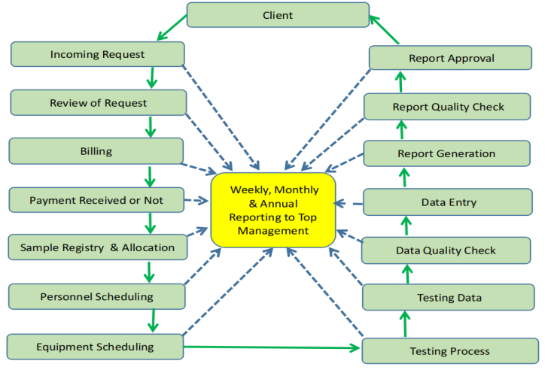
Figure 1: PMTL Manual Process
System Design and Architecture

This phased is based on the findings from the literature review and gap analysis, a conceptual automation system was developed to address the identified challenges in PMTL operations. The systems adopts a systems integration approach, linking all stages of the laboratory workflow through a centralized digital platform includes; Request submission and billing; Automated sample registration using; R/barcode systems; Intelligent test allocation based on resource availability; Automated data processing, quality checks and digital approval; Real-time reporting and client communication. The system is a simple customized web-based application developed to streamline and digitize the workflow of laboratory testing processes. It replaces manual paperwork with a semi-digital system while still supporting physical test procedures. This system integrates modern web technologies with Mongo database management and QR code tracking to simulate a real-world laboratory environment.

Design System Components and their functions

The Automated System Overview: The automated system is designed in two main user interfaces shown in figure 2, the client panel where clients submit their testing request with the bills and admin panel where laboratory staff manage, review and process those request and track the progress of the testing process.

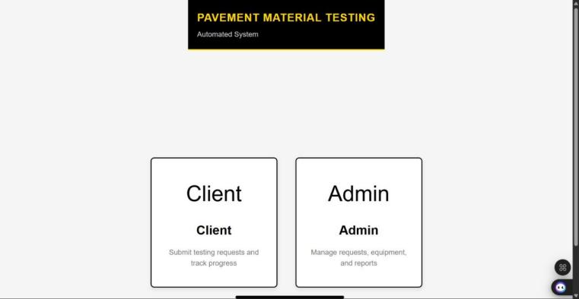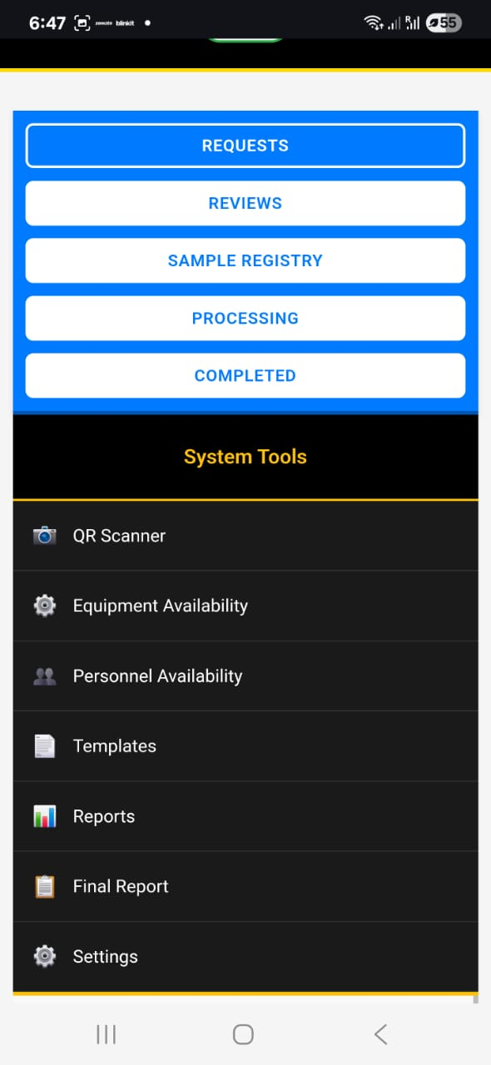
Figure 2: Client and Admin panel Figure 3: Admin Panel - laboratory staff manage, review and process requests

The workflow: of the automated system is developed and follows a sequential structured life cycle in figure 4. Each stages ensures that data flows consistently from one step to the next without duplication or loss.

Figure 4: Workflow structured lifecycle

Client Request Module: In he client panel, user is required to: Enter personal and contact details; Select required test methods with total testing fees; Submit a request for laboratory testing. The selected test methods are stored in the database and become the foundation for all subsequent stages. This ensures that only selected tests are processed later in the system.
Review and Approval System: Once a request is submitted, it appears in the admin panel under the review section. Here, the administrator evaluates the request against the actual sample inspection using predefined criteria such as: Availability of test methods; Resource availability (equipment and personnel); Accuracy requirements; Legal and regulatory considerations.
The review process: ensures that only feasible and approved requests and sample proceed to the next stage complying with ISO/IEC 17025 standard shown in figure 3.
Sample Registry: After approval, the request is registered with a sample. During this stage: A unique Sample ID with a barcode is generated; Equipment and personnel are assigned; Sample details are recorded in the system; Barcode is sent to printer for printing - to be tagged on the sample. This stage acts as a bridge between administrative approval and actual laboratory work.
Processing Module: The processing tab is responsible for initiating laboratory tests. Key features include: Displaying only the test methods selected by the client allowing staff to mark tests as “started”; Providing a Print Form option for each test forms to be printed. To start a test, the system generates a printable PDF test form based on predefined templates. These forms are used physically in the laboratory to record test data obtained from conducting physical laboratory test procedures.
QR Code Integration: A major feature of the system is the integration of QR codes onto test form PDFs. When a standardized test form is generated: A QR code is embedded into the PDF; The QR contains structured data such as: Sample ID; Test Code; Request ID. This allows each printed
form to be uniquely identifiable. The QR code enables quick tracking and reduces manual errors when handling multiple samples.
Completion and Registration of Test Forms: After laboratory testing is completed and the physical form is returned, the system provides a Completed Tab where: The user enters the Sample ID and Test Code; The system updates the test status as completed. This ensures that completion is only recorded after actual lab work has been done, maintaining data integrity. Future enhancements include scanning the QR code directly to automate this process.
Data Entry and Report Generation: After completed test form is signed off the data on test form is entered onto a Reporting tab that system provides: The user enters the test results onto specified reporting template tab; The user enable accepts when all test data are entered and the draft report is sent for quality checks; Quality Checks is complete, the Authorized signatory signs off digitally; The user enables reporting tab and the lab report is generated; The PDFs report is saved in the system, sent to the printer and to the client automatically with a generic notification advising client that report is now issued.
Database Integration (MongoDB): The system uses MongoDB in figure 5 as its primary database. This replaces the earlier JSON-based storage system and provides: Reliable data persistence Structured document storage; • Efficient querying and updates; Support for multi-user environments. Data such as requests, samples, and test statues are stored as documents, making the system scalable and maintainable.

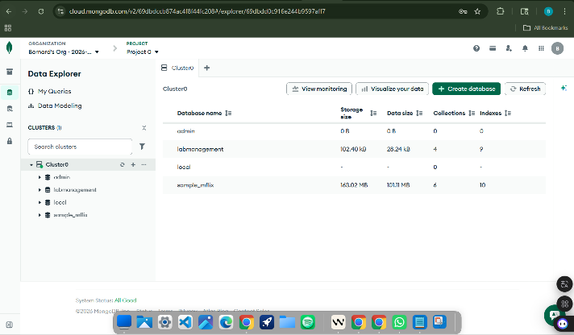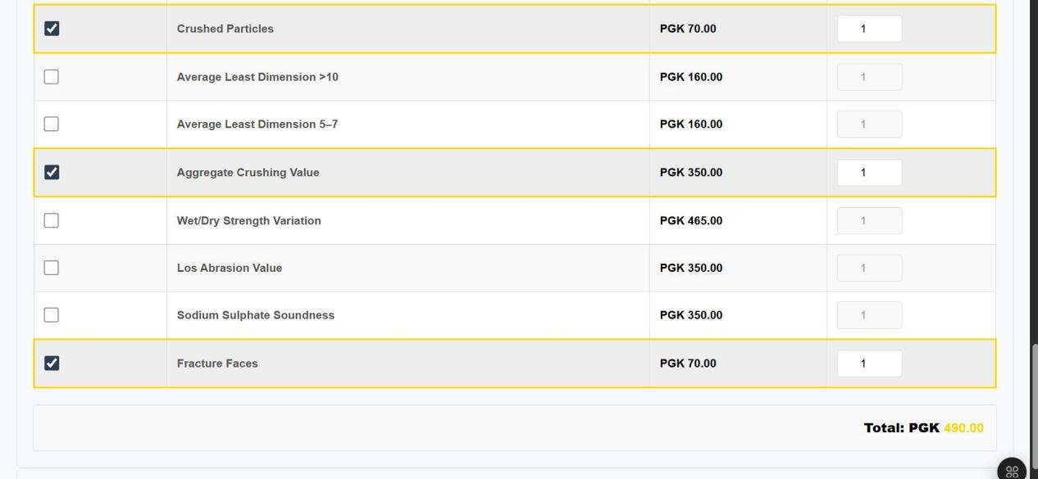
Figure 5: Mongo Database Figure 6: Test request and Invoicing tab

Validation

A simple and scalable database was designed and developed using MongoDB as shown in figure 6 above, combining with the system analysis and database software development This system is validated through trial client, project and sample data inputs and indicated that automated system is practically feasible. It will fully operate when this automated system is uploaded onto a high capacity CPU desktop as the main database storage, accelerating data processing in real-time from multiple users in PMT Laboratory environment. The validation conducted on the system includes:
Submission of Request: The client selects the test method in the front end panel and the system generates the Invoice as shown in figure 6, according to the test selected.

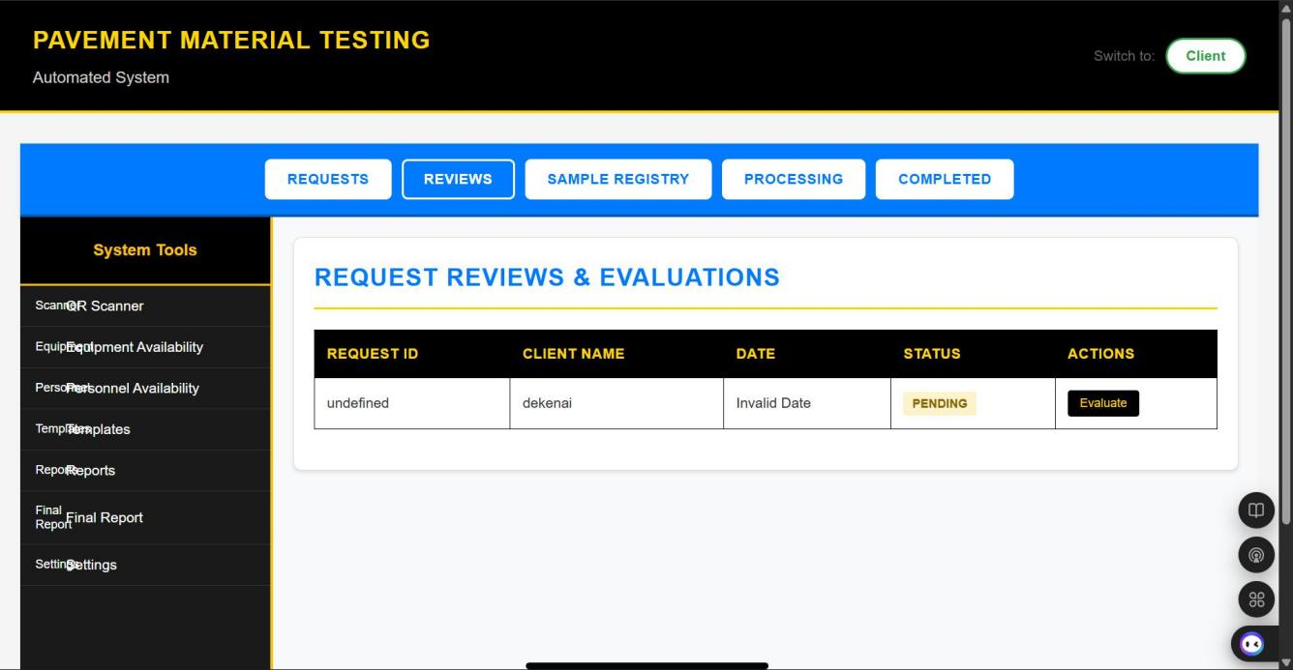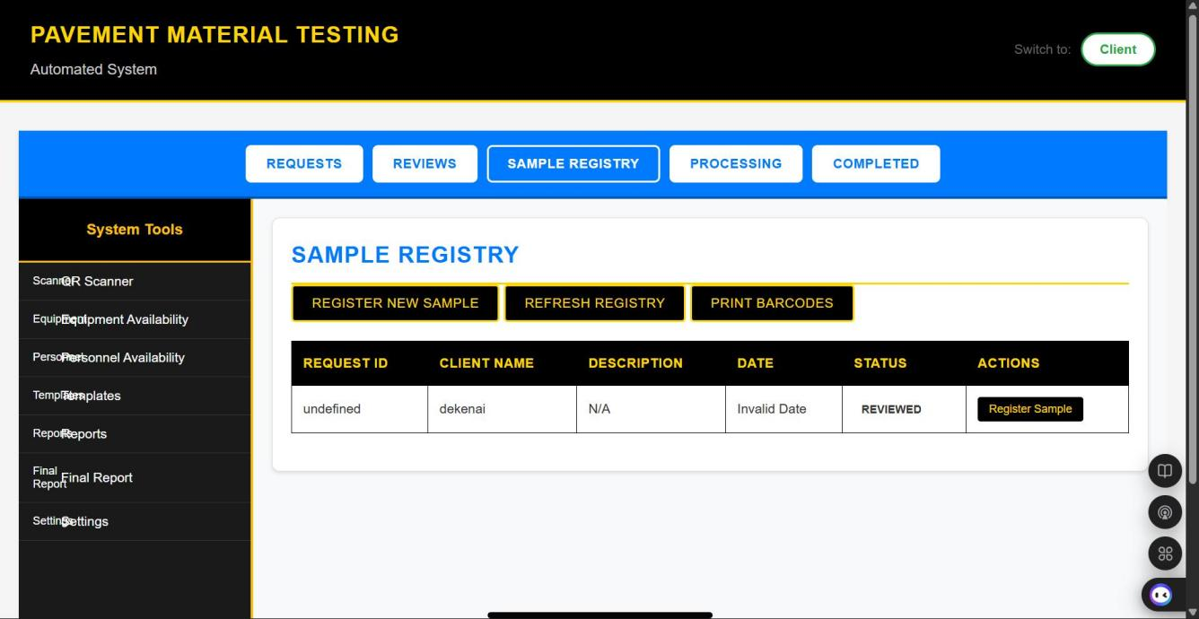
Figure 7: Review of Request tab Figure 8: Sample Registry tab

Review of Request: In this phase in the review request tab figure 7, is reviewed by the user using the checklist in accordance with ISO 17025 against the actual sample received. Once the checklist are all approved the sample is registered
Sample Register: In this stage sample is registered in sample registry tab in figure 8; and unique ID and a barcode is generated and sent to the printer to be printed. In this stage standardized test forms for each test methods are printed as per the request and the same barcode is pasted on the test forms to avoid data loss and duplications during testing process

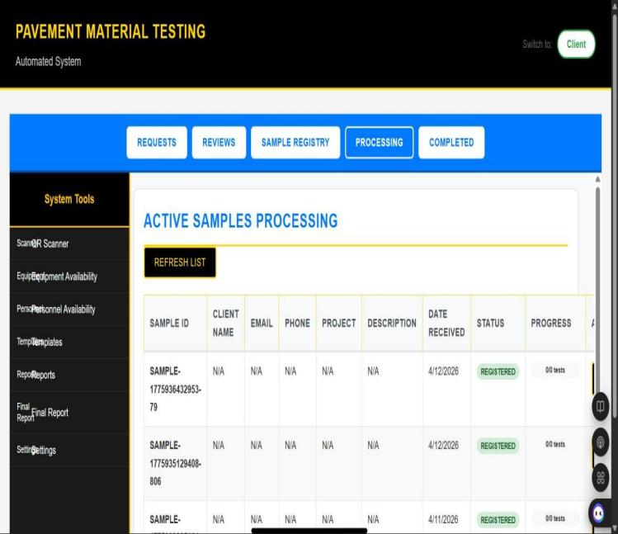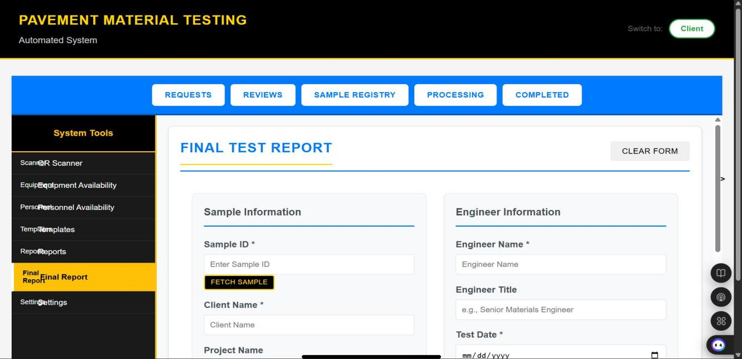
Figure 9 - Sample Processing tab Figure 10: Test Report Generation tab

Personal and Equipment Scheduling: This stages come under sample registry tab, the available equipment and personnel are indicated for the admin user to a ssign the samples.
Sample Processing: In this stage test forms and samples have been barcoded and allocated to the personal assigned in conducting the tests now appears in the sample processing tab in figure 9 on the system here as under progress
Test Reporting: In this stage, the test form is returned and the data is entered in the reporting tab in figure 10 and it will generate the pavement test report that will be sent for quality check and for approval in the next stage

CASE STUDY

Overview

The case study was conducted to collect views of people working and involve PMTL in PNG. Specific structured survey questionnaires administered to collect data to support the automation of PMTL in addressing the research gap in this study. In this case study survey questionnaires were administered to two different groups, the six major public accredited PMTL and the the seven major road contractors who are involve in road design and construction in PNG. The aim of this survey is to collect views of people about laboratory automation and identify challenges they experience working and dealing with current PMTL practices in PNG.

Survey Questiainnaires to PMTL in PNG

PMTL Survey: There were two lots of questionnaires directed to six public commercial accredited PMTL in PNG. The specific questionnaires were directed to the laboratory managers and the laboratory technicians involved in the laboratory testing daily.
Laboratory managers: All lab managers were issued three similar questionnaires on the automation of PMTL process and its effect on their laboratory. Out of the six laboratories, 70% agreed to automate the PMTL processes, while 30% wanted to remain manual and all six laboratories are manually operated. In another questionnaire 80% agreed that automation would improve the laboratory process, while 20% disagreed. Those labs that disagreed and wanted to remain manual argued that all their laboratory testing equipment is currently operated manually, upgrading the laboratory equipment and facilities to accommodate automation will not be feasible due to lack of financial and resource support and lack of relevant technology available in the country.
Laboratory Technicians: There were a total of six sets of questions designed according to the six stages in the PMTLs laboratory process. The stages are testing requests, sample registry, personnel and equipment scheduling, testing procedures, data management, and compliance with ISO/IEC 17025 standards. The views received from 60 lab technicians, 10/60 from each PMTL, the results were then analyzed in quantity base approached. In Stage 1: Receiving requests, 60/60 lab staff encountered issues; 60/60 lab staff had issues with procedures, and 50/60 had issues documenting requests. Stage 2: Sample registry, 52/60 lab staff had issues registering samples, 45/60 had issues collecting sample & client information, and 40/60 staff had issues tracing samples. Stage 3: Linking sample-personal-equipment, 55/60 lab staff had issues scheduling personal to samples tests, 60/60 had issues scheduling equipment for sample tests, and 55/60 had issues with equipment calibration. Stage 4: Testing procedures, 60/60 performed manual testing, 60/60 conducted manual quality checks, and 40/60 had issues with quality checks. Stage 5: Data management, 30/60 had issues recording data, 60/60 verified data manually, and 40/60 had issues managing data. Stage 6: Compliance Check, 60/60 performed manual checks and audits; 45/60 had issues conducting compliance checks. The survey results confirmed that majority of the lab personal have issues in all the six stages of the PMTL processes. The flow chart in Figure 1, was developed to identify every stages in the manual laboratory process in the PMTL. The results were then analyzed and concluded that 80% of the laboratory personal encountered issues in all those 6 stages while performing their laboratory duty every day and 20% encounter minor issues or remain neutral.

Survey Questiainnaires to major PNG Road Contractors

Road Contractor Survey: In this phase a specific survey questionnaires were directed to road contractors who are involved in the design and construction of the road projects in PNG and how the laboratory test data affects the progress of their project delivery and the quality of the pavement structure they design and build in adopting the laboratory data. The final questionnaire is why they agree for the PMTL to be automated?
Project delivery: The questionnaires were structured to obtain views on the turn around time of the report (TAT) and data integrity and quality In TAT; 80% of the contractors indicate that the laboratory data issued is always delayed, by weeks and 20% had no problem with TAT. Data integrity and quality: 70% always encounter issues with data, either incorrect data, data missing and or not within the expected requirement and 30% remain neutral or have no or minor issues only.
Automation: The 80% of the contractors agree with automation to improve laboratory process, reduce TAT and reduce errors. The remaining 20% want to remain with manual, using legally binded agreement with respective laboratories to deliver within the contract time frame enable the laboratories to meet their deadline in issuing laboratory results and are paid accordingly for their services. However, data integrity and quality is compromised with increase impartiality risks when people are involved and therefore automating laboratory system is the appropriate solution to minimize all these issues within the laboratory process.

Overall Outcome of the Case study

PMTL survey: The 80 % of the laboratory agreed for automation and 20% disagree for automation due to the following: The 80% agreed to improve their laboratory processes to be automated to improve efficiency and reduce turnaround time and errors. The 20% disagree due to lack of timely availability of funding and resource to support the adoption, implementation and sustainability of automation technology.
Road Contractors: The 80% wanted automation and 20% remain with manual or neutral due to the following:
The 80% agreed with automation to improve turnaround time and reduce errors in the test data and
20% want to remain with manual or neutral by applying legal agreement between the contractor
and the laboratory to deliver the results on timely basis
Conclusion: Datta integrity and quality are directly compromised when people are involved therefore it is strongly recommended for the laboratory system to be automated to minimize or avoid manipulation and biased in conducting laboratory activities within the laboratory.

FINDINGS AND DISCUSSIONS

Overview
The results of this study present a structured evaluation of the literature review, manual laboratory process, applicable automation technologies that are available and are transferable to PMTL processes. Furthermore their benefits and challenges are also assessed and evaluated to identify practical automation technology that is simple, cost effective and user-friendly that can be customized for PMTL suitable for under developed countries. Through systematic analysis, key technological enablers, operational gaps, and integration opportunities were identified. The findings highlight and discuss the potential for end-to-end automation to significantly improve efficiency, accuracy, and compliance with ISO/IEC 17025:2017.

Literature based - Potential Automation Technologies for PMTL

Automation technologies relevant to PMTL operations were identified from the literature and evaluated using a structured assessment framework. The technologies considered include: Laboratory Information Management Systems (LIMS); Internet of Things (IoT)-enabled laboratory equipment; Artificial Intelligence (AI) for data validation and analysis; Barcode and QR code-based sample tracking systems; Cloud-based data management platforms. Each technology was assessed based on the following criteria: Applicability to PMTL processes; Compatibility with ISO/IEC 17025:2017 requirements; Implementation feasibility and cost-effectiveness; Scalability, flexibility and Integration capability with existing laboratory systems

PMTL Process Gaps and Challenges Identified

Research gap identified: The critical research gap identified in this study is the absence of a fully integrated, end-to-end automated system specifically for PMTL operations. Existing systems do not comprehensively link key laboratory functions such as test request initiation, sample handling and registration, personnel and equipment scheduling, real-time monitoring, data processing, and report generation within a unified workflow.
Challenges identified in Manual PMTL process: The significant challenges identified in the manual PMT laboratory process include: Fragmented process increase delay; Manual labour increase errors; Data integrity and traceability issues; Lack of real-time monitoring; Inefficiency in laboratory operation; Paper based logs increases loss of data and misinformation; Inefficiency in personal and equipment scheduling; Manual process increase environment, safety and compliance risk.

Challenges identified in Automation

Challenges is automation technology identified were: Sustainability of the technology; Costly to purchase; Lack of consistent capacity development; Limitation in the technology applicability; Lack of proper infrastructure to accommodate the technology; Lack of consistent funding and resource support; Non availability of the technology and expert in the country and Lack of knowledge about the technology.

Benefits in Automation

Improved Traceability: Instant retrieval of data for audits, query and referencing.
Reduced Human Error: Minimises manual recording and calculation; and duplication of data.
Increased Efficiency: Streamline and standardise workflow seamlessly; and accelerate throughout by operating non-stop for a long time.
Data Quality and Reproducibility: Prevent manual errors, ensuring high consistency results across trials
Reduce Cost: Minimise wastage and replace human labour shift, and operating multiple task simultaneously.
Reduce Turn Around Time: Replace manual labour and operating multiple task simultaneously continuously
Enhanced Safety: Reduce human exposure to hazardous and toxic materials, and use of automated security system in workplaces.

Findings of the Case Study

PMTL survey questionnaires: The 80% agreed to automate the laboratory process while 20% disagree due to lack of timely available of funding and resource to support the adoption of automation technology.
Contractor survey questionnaires: The 80% of people interviewed agreed to automate the laboratory process to improve turnaround time and reduce errors and 20% want to remain manual by signing legal agreement between the contractor and the laboratory to deliver the results on timely basis within expectation
Conclusion: The data integrity and quality are compromised increasing impartiality risks when people are involved that indicated strong support of automation, therefore it is strongly recommended for the laboratory process to be automated to minimize the issues identified in this study.

Comparing Manual to Automated PMTL processes

Current manual practices in laboratory operations significantly constrain the performance of PMTL processes. These approaches increase the likelihood of errors, inconsistencies, and delays, thereby compromising data integrity, quality, and compliance with relevant standards, while also elevating risks to impartiality. In contrast, the implementation of automated laboratory systems enhances operational efficiency and effectiveness by standardizing workflows, improving traceability, and safeguarding data integrity. Such improvements contribute to the production of reliable, high-quality data, which is essential for informed decision-making and the development of durable and sustainable road pavement structures.

Discussion

Human involvement in laboratory processes introduces potential risks to data integrity and quality, particularly through unintentional errors, inconsistencies, or subjective influences. While human expertise remains essential, reliance on manual processes can increase the likelihood of variability and potential bias in testing, recording, and reporting activities. Therefore, implementing automated laboratory systems is strongly recommended to enhance impartiality and consistency. Automation can standardize workflows, enforce predefined protocols, and maintain secure, traceable data records, thereby minimizing opportunities for data manipulation and reducing bias. At the same time, a balanced approach integrating automation with appropriate human oversight is necessary to ensure that laboratory operations remain both technically valid and compliant with quality management requirements. The customized web-based application is developed in this study to streamline and digitize the workflow of laboratory testing processes. It replaces manual paperwork with a semi-digital system while still supporting physical test procedures. This system integrates modern web technologies with Mongo database management and QR code tracking to simulate a real-world laboratory environment. The “High-end” advance technologies such as LIMS are not practical and too costly to adopt, implement and sustain particularly in resource-constrained countries. This automated system is likely to boost laboratory performance and improve PMT laboratory operation producing timely data for road design and construction projects in PNG.

CONCLUSIONS

This study has both conceptually and empirically validated an end-to-end automated Pavement Materials Testing Laboratory (PMTL) system tailored to the Papua New Guinea (PNG) context. The proposed system effectively addresses critical operational deficiencies, including limitations in traceability, inefficiencies in workflow execution, suboptimal resource utilization, and challenges in maintaining compliance with accreditation requirements. The findings demonstrate that integrating digital technologies into traditional laboratory environments can significantly enhance overall performance and reliability.

By leveraging web-based platforms, structured database management, and QR code technologies, the system establishes a cohesive link between physical laboratory activities and digital data management processes. This integration ensures improved data integrity, streamlined operations, and enhanced transparency, while maintaining alignment with ISO/IEC 17025 principles of quality and impartiality. The results highlight the practical applicability of the system in real-world laboratory settings and its capacity to support consistent, high-quality outputs.
Furthermore, the implementation of the automated PMTL system presents a scalable and sustainable approach to laboratory management, with direct implications for improving the quality and durability of pavement infrastructure. Future enhancements, including real-time QR code scanning and direct digital integration with laboratory equipment, offer the potential to achieve full automation of data capture and report generation. Such advancements would further strengthen system efficiency, reduce human intervention, and reinforce the reliability of laboratory outputs.

REFERENCE

- Saliba J., Al-Shaar W., .Delage M. (2024) “Comparison of Field and Laboratory Tests for Soil Suitability Assessment in Raw Earth Construction” Applied Science (MDPI)
https://doi.org/10.3390/app15041932
- Plebani M. (2025)“Total Laboratory Automation: Fit for Its Intended Purposes?” The Journal of Clinical Chemistry and Laboratory Medicine
https://doi.org/10.1515/cclm-2025-0855
- Alhammad L. A., Ainosah T. K., Ahmad A. M., Samarkandi M. S., Jawi N. H., Alharthi M. A., Alsharif A.M., Anazi E A.A. , Aldugeshem S.A., Johali F.Y. (2023) “The Impact of Laboratory
Automation on Efficiency and Accuracy in Healthcare Settings” International Journal of Community Medicine and Public Health,
https://dx.doi.org/10.18203/2394-6040.ijcmph20233857
- Rupp N., Ries R.,Wienbruch R., Zuchner T. (2023) “Can I benefit from laboratory automation?. A
decision aid for the successful introduction of laboratory automation”. Analytical and
Bioanalytical Chemistry
https://doi.org/10.1007/s00216-023-05038-2
- Ochiai K., Tahara-Arai Y., Kato A., Kaizu K., Kariyazaki H., Umeno M., . Takahashi K,
Kanda G. N., OzakiH., (2025) “Automating Care by Self-Maintainability for full laboratory automation” Royal Society of Chemical
https://doi.org/10.1039/d5dd00151j
- Dastjerdi A.V., Buyya R. (2016) “Fog computing: Helping the Internet of Things realize its potential ” Computer
https://doi.org/10.1109/MC.2016.245
- Calderón D., Folgado F.J., González I., Calderón A.J . (2024). “Implementation and experimental application of industrial IoT architecture using automation and IoT hardware/software”. Sensors, 24(24), 8074. (2024)
https://doi.org/10.3390/s24248074
- Hoodbhoy Z., Hasan B., Siddiqui K. (2019).“Does artificial intelligence have any role in healthcare in low resource settings?” Vol 2 (July 2019): Journal of Medical Artificial Intelligence https://doi.org/10.21037/jmai.2019.06.01
- Syed M., Bandara S., French G., Stewart S. (2021) “A systematic literature review on intelligent automation: Aligning concepts from theory, practice, and future perspectives” Advanced Engineering Informatics,
https://doi.org/10.1016/j.aei.2021.101246
- Oakley T., Vaz J. , da Silva F., Allan R., Almeida D., Champlin K., da Silva E.S., Tilman A. J., Marr 1, Smith-Vaughan H., Yan J., & Francis J.R. (2025) “Implementation of a Laboratory Information Management System (LIMS) for microbiology in Timor-Leste: challenges, mitigation strategies, and end-user experiences” BMC Medical Informatics and Decision Making
https://doi.org/10.1186/s12911-024-02831-6
- Zhang L., Liu Z.H., Lv, S Y. J.. Fu Z.M. & Guo L.M.L.. “Comprehensive Improvements in the emergency laboratory test process based on information technology” BMC Medical Informatics and Decision Making (2023) .
https://doi.org/10.1186/s12911-023-02387-x
- .Buyya R; Yeo C.S.; Venugopal S.; Broberg J. & Brandic I. (2008). ”Cloud computing and emerging IT platforms: Vision, hype, and reality for delivering computing as the 5th utility” Future Generation Computer Systems
https://doi.org/10.1016/j.future.2008.12.001
- Guerrero-Osuna H.A.,.García-Vázquez F., Ibarra-Delgado S., Mata-Romero M.E., Nava-Pintor J.A., Ornelas-Vargas G., Castañeda-Miranda R., Rodríguez-Abdalá V.I. & Sánchez L.S O.(2024) “Developing a Cloud and IoT-Integrated Remote Laboratory to Enhance Education 4.0: An Approach for FPGA-Based Motor Control” Journal of Applied Sciences, .
https://doi.org/10.3390/app142210115
- Okezue M. A., Adeyeye M.C., Byrn S.J., Abiola V.O. & Clase K.L. (2020) “Impact of ISO/IEC 17025 laboratory accreditation in sub-Saharan Africa: case study” BMC Health Services Research
https://doi.org/10.1186/s12913-020-05934-8
- Hajek M., Bavio M.A, Benesch T.N, Suárez R.C., Hamel N., Pinak M. &Tucker D.M., Wilding A.. (2023),“Experiences in transitioning a testing laboratory to the new ISO/IEC 17025:2017 standard ” Radiation Protection Dosimetry, Volume 199, Issue 15-16, Pages 1670–1673,
https://doi.org/10.1093/rpd/ncac209

STANDARDS

- International Standard Organisation. ISO/IEC 17025:2017 General Requirements for the Competence of Testing and Calibration Laboratories. ISO/IEC 17025:2017(E) ed 2017.
- PNG Department of Works Roads & Bridges Specification, 2015 www.works.gov.pg
- AS1289 Method 2.1.1: Determination of the moisture content of a soil—Oven drying method (standard method), 2017,
- AS1289 Method 3.1.1: Soil Classification tests - Determination of the liquid limit of a soil - Four point Cassagrande method, 2015,
- AS 1289 Method 3.2.1: Soil classification tests Determination of the plastic limit of a soil—Standard method, 2015,
- AS 1289 Method 3.3.1: Soil classification tests—Calculation of the AS 1289 Method 3.4.1: Soil classification tests—Determination of the linear shrinkage of a soil—Standard method, 2015,
- AS 1289 Method 3.4.1: Soil classification tests—Determination of the linear shrinkage of a soil—Standard method, 2015
- AS 1289 Method 3.5.1: Soil classification tests—Determination of the soil particle density of a soil—Standard method, 2012,
- AS 1289 Method 3.6.1: Soil classification tests—Determination of the particle size distribution of a soil— Standard method of analysis by sieving, 2020,
- AS 1289 Method 5.1.1: Soil compaction and density tests—Determination of the dry density/moisture content relation of a soil using standard compactive effort , 2017
- AS 1289 Method 5.2.1: Soil compaction and density tests—Determination of the dry density/moisture content relation of a soil using modified compactive effort, 2017
- AS 1289 Method 6.1.1: Soil strength and consolidation tests—Determination of the California Bearing Ratio of a soil—Standard laboratory method for a remoulded specimen, 2017.
- AS 1141 Method 22: Wet / Dry Strength Variation, 2019,
- AS 1141 Method 24: Aggregate Soundness - Evaluation by exposure to sodium sulphate solution, 2018

