Assessment of Limestone Mining and Its Effects on Crop Production in Okpella, Nigeria
Sanni Oseni Zuwedu*, Dalhatu Umar Sangari, Adamu Tanko Ogah, & Muhammadu Alkali
Department of Geography, Nasarawa State University, Keffi, PMB 1022.
Corresponding author: zuwedu@gmail.com*
Abstract
This study examined the environmental and agricultural impacts of limestone mining in Okpella, Edo State, Nigeria, using a survey research design. Data were collected from 400 respondents and analyzed using descriptive statistics, correlation, and regression techniques. The findings revealed that a majority of respondents perceived limestone mining as having severe environmental consequences, with 65% rating land degradation and 60% rating water contamination as extremely negative. Similarly, 52.5% of respondents reported extremely negative impacts on biodiversity, while 50% indicated severe vegetation loss. Regarding agricultural production, 55% of respondents strongly believed that mining has negatively affected soil quality, while 62.5% strongly believed that it has reduced crop yields. In addition, 50% strongly believed that mining disrupts agricultural practices. Descriptive statistics showed low mean scores (soil quality = 1.875; crop yield = 1.725), indicating strong agreement on the negative impacts. The correlation analysis revealed strong positive relationships among soil degradation, reduced crop yields, and disrupted farming practices (r = 0.694–0.782). Regression results indicated that limestone mining significantly affects crop production (R² = 0.612, p < 0.05), with a negative coefficient (B = -0.683), suggesting that increased mining intensity leads to declining agricultural output. The study concludes that limestone mining has significant adverse effects on environmental sustainability and agricultural productivity in Okpella. It recommends improved environmental management practices and further longitudinal and empirical research to support sustainable coexistence between mining and agriculture.
Keywords: Limestone mining; environmental impact; crop production; soil quality; agricultural productivity; Okpella.
Introduction
Limestone mining has become an important extractive activity in many developing economies due to its contribution to construction, industrial development, and local employment. However, its expansion has continued to raise concerns about environmental sustainability, particularly in rural communities where agriculture remains the dominant livelihood. In many cases, mining and farming compete for land resources, and this overlap may gradually alter soil conditions, water quality, and ecosystem stability, all of which are important for crop production (Nyamekye et al., 2025; Oladeji et al., 2010).
In limestone-rich communities such as Okpella in Edo State, Nigeria, mining activities appear to have intensified over time, leading to visible changes in land cover and environmental conditions. Studies have suggested that mining areas often experience vegetation loss, soil disturbance, and changes in land surface temperature, which may indirectly affect agricultural productivity (Owolabi et al., 2025). In addition, exposure of farmlands to dust and possible contamination from mining operations may reduce soil fertility and crop performance, especially in smallholder farming systems that depend heavily on natural soil conditions (Khan et al., 2008; Imade & Usunomena, 2025).
Despite growing evidence from similar mining environments, there appears to be limited localized empirical analysis focusing specifically on how limestone mining affects crop production in Okpella from the perspective of affected residents. Much of the existing literature tends to emphasize general environmental degradation or land use change, with less attention given to farmers’ perceptions and the combined effects on soil quality, crop yield, and agricultural practices within the same study area. This creates a gap in understanding the lived agricultural consequences of mining activities at the community level.
Against this background, the study seeks to assess limestone mining and its effects on crop production in Okpella, Nigeria. The specific objectives are to:
- examine the perceived environmental impacts of limestone mining in Okpella;
- assess the effects of limestone mining on soil quality and crop yield;
- evaluate the influence of limestone mining on agricultural practices in the study area; and
- analyze the relationship between mining-related environmental impacts and crop production.
The findings presented in this study indicate that respondents largely perceive limestone mining as having negative effects on land, water, vegetation, and biodiversity, with a strong association between mining activities and declining crop production. Soil degradation, reduced yields, and disruption of farming practices were consistently reported, while statistical analysis further suggests a significant negative relationship between mining intensity and agricultural productivity. These outcomes align with previous studies that report similar environmental and agricultural challenges in mining-affected regions (Haruna et al., 2022; Vashold et al., 2026).
This study contributes to ongoing discussions on sustainable mining by providing empirical evidence from Okpella, highlighting the need to balance mineral extraction with agricultural sustainability and rural livelihood protection.
2. Materials and Methods
2.1 Research Design
This study adopted a mixed-methods research design, combining both quantitative and qualitative approaches to obtain comprehensive data on the impacts of limestone mining in Okpella, Edo State, Nigeria. The design allowed for the collection of numerical data from a large sample alongside qualitative insights from key stakeholders in the mining environment. Data were collected through structured questionnaires, field observations, interviews, and focus group discussions. The approach was considered suitable because it allows triangulation of findings and improves the reliability of results drawn from different respondent groups. A structured research design framework was developed to align each research question with specific objectives, data requirements, data collection methods, analytical tools, and expected outcomes. This ensured consistency between the study objectives and the analytical procedures applied.
2.2 Study Area and Population
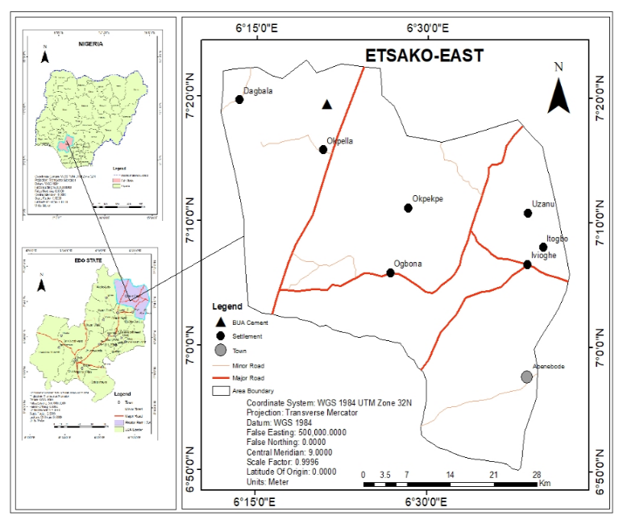
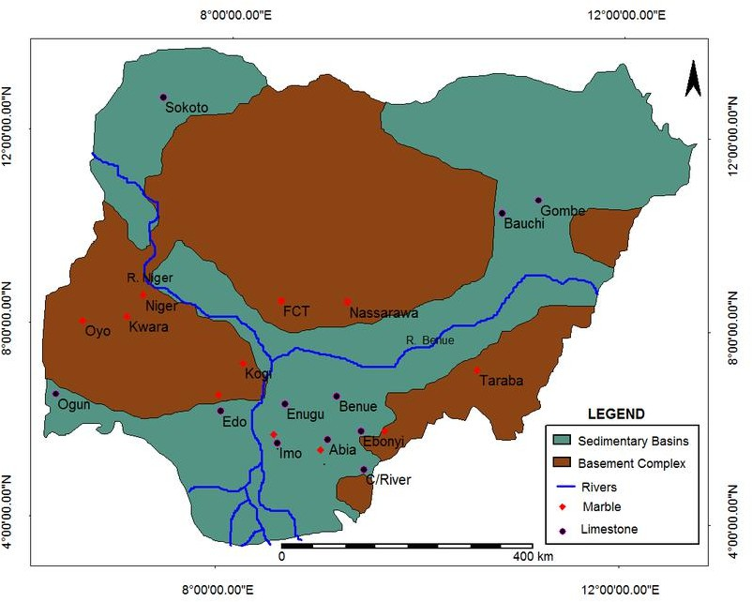
Okpella Clan is situated in the northern fringes of Edo State, along the Benin-Abuja federal highway. Approximately 7⁰16’12′′ N latitude and 6∘20′46′′E longitude. It is a major gateway between the northern and southern parts of Nigeria. Administratively is one of the three main towns that make up the Etsako East Local Government Area (LGA) of Edo State. Structurally is composed of two sub-clans: Ogute sub-clan (including Ogute-Oke, Awuyemi, Imiekuri, Igiase, Imiegeli, Okhu) and Oteku sub-clan (including Okhomughio and Iddo).
Figure 1: Political Map of Edo, and the location of the Study Area and geological map of Nigeria limestone and marble occurrences, Okpella.
Source: GIS Lab, Nasarawa State University, 2026; Fatoye and Gideon, 2013.
The study was conducted in Okpella, Edo State, Nigeria. The area is known for its significant limestone deposits and hosts major cement companies such as Dangote Cement and BUA Cement. The population comprises residents, miners, community leaders, and company representatives. The estimated population of Okpella is approximately 500,652 (National Population Commission estimate, 2023), which formed the basis for sampling.
2.3 Study Population
The study population included members of the Okpella community as well as workers from limestone mining companies operating in the area. Specifically, the population consisted of 498 community members, 7 Dangote miners, and 10 BUA miners, giving a total population of 500,669 respondents.
2.4 Sample Size Determination
The sample size was determined using the Taro Yamane formula:
$$n=\frac{N}{1+N(e)^{2}}$$
Where:
n = sample size
N = population size (500,669)
e = margin of error (0.05)
Substituting the values:
$$n=\frac{500,669}{1+500,669(0.05)^{2}} \\ n=\frac{500,669}{1+500,669(0.0025)} \\ n=\frac{500,669}{1252.67} \\ n≈400$$
Thus, a total of 400 respondents were selected for the study.
2.5 Sampling Technique
A simple random sampling technique was used to select 400 respondents from the study population to ensure equal representation and reduce selection bias. In addition, purposive sampling was employed for qualitative data collection, where all available miners from Dangote and BUA companies were included due to their direct involvement in limestone extraction activities and their relevance to the study objectives.

2.6 Sources and Types of Data
Both primary and secondary data were used in this study. Primary data were obtained through structured questionnaires, field observations, interviews, and focus group discussions conducted with residents, miners, and community stakeholders. A total of 400 questionnaires were administered using a structured and retrieval method with the assistance of trained research assistants. Secondary data were obtained from relevant literature, published works, and geographic information system (GIS) datasets, including satellite imagery sourced from Google Earth and other geospatial platforms.
2.7 Methods of Data Collection
Data collection involved multiple approaches to ensure depth and accuracy. Questionnaires were used to obtain quantitative data from residents, while interviews and focus group discussions were conducted to capture qualitative perspectives from miners and company representatives. Field observations were also carried out to document physical environmental changes within mining sites and surrounding communities.
2.8 Methods of Data Analysis
Data collected were analyzed using both descriptive and inferential statistical techniques. Descriptive statistics such as frequency distribution, percentages, and cross-tabulation were used to summarize respondents’ perceptions. Inferential analysis included correlation and regression techniques to examine relationships between limestone mining activities and crop production variables.
Statistical analysis was performed using the Statistical Package for Social Sciences (SPSS) version 25.
2.9 Methodology Justification
The methodology adopted in this study is appropriate and justified based on the nature, objectives, and scope of the research. The use of a survey research design is suitable because the study primarily seeks to examine residents’ perceptions of the environmental and agricultural impacts of limestone mining in Okpella. Survey designs are widely used in environmental and socio-economic studies where human experiences, opinions, and attitudes are central to the analysis (Creswell, 2014). By collecting firsthand information from affected individuals, the study provides relevant insights into localized impacts that may not be fully captured through purely experimental methods.
The use of a structured questionnaire as a data collection instrument is justified for its ability to standardize responses across a large number of participants. This enhances the comparability of data and allows for quantitative analysis of perceptions. The inclusion of Likert-scale items (e.g., strongly believe to strongly disbelieve; extremely negative to very positive) is particularly appropriate, as it enables the measurement of the intensity of respondents’ opinions, which is essential in perception-based research (Likert, 1932).
The sampling approach employed in the study (e.g., random or stratified sampling, depending on your earlier chapter) is also justified because it ensures that different segments of the population in Okpella are adequately represented. This improves the reliability and generalizability of the findings within the study area. Engaging respondents who are directly affected by mining activities such as farmers and residents further strengthens the validity of the results, as they possess practical knowledge of environmental and agricultural changes.
The application of descriptive statistics (mean scores and standard deviations) is justified as it provides a clear summary of respondents’ perceptions and highlights the overall trends in the data. These measures help to interpret the level of agreement or disagreement among respondents and assess the consistency of responses.
Furthermore, the use of correlation analysis is appropriate for examining the relationships between key variables such as soil quality, crop yield, and agricultural practices. This method is justified because it reveals the strength and direction of associations between variables without implying causation, which is suitable for perception-based data (Field, 2013).
The adoption of regression analysis adds further rigor to the study by quantifying the extent to which limestone mining impacts crop production. The regression model helps to determine the predictive relationship between mining activities (independent variable) and agricultural outcomes (dependent variable). The statistically significant results (p < 0.05) and relatively high R² value (0.612) justify the inclusion of this method, as it demonstrates that mining activities are a major explanatory factor influencing crop production.
Finally, the combination of descriptive and inferential statistical techniques strengthens the overall methodological framework. While descriptive statistics provide a general overview of perceptions, inferential tools such as correlation and regression offer deeper analytical insights. This mixed analytical approach enhances the robustness, credibility, and scientific validity of the study.
3. Result
3.1 Perception of the Environmental Impact of Limestone Mining in Okpella
The findings presented in Table 4.3 indicate that respondents largely perceived limestone mining activities in Okpella as having negative environmental consequences. The majority of respondents rated the impact on land degradation as extremely negative (65%), while 20% considered it very negative. Similarly, 60% of the respondents perceived the impact of mining on water contamination as extremely negative, whereas 20% viewed it as very negative.
With respect to biodiversity, 52.5% of respondents rated the impact as extremely negative and 25% as very negative. Vegetation loss was also considered severe, as 50% of respondents viewed the impact as extremely negative and 25% as very negative. In relation to animal habitats, 45% of respondents reported extremely negative impacts, while 30% indicated very negative impacts.
Erosion and landslides were also identified as major environmental concerns. About 37.5% of respondents perceived erosion as extremely negative, while another 37.5% rated it very negative. Likewise, 55% of respondents considered the impact of mining on landslides to be extremely negative, and 25% viewed it as very negative.
Although the majority of responses reflected negative perceptions, a smaller proportion of respondents reported positive outcomes in some areas. For instance, 15% of respondents considered the impact on animal habitats to be positive, while 12.5% reported positive perceptions regarding vegetation, water contamination, and biodiversity.
Table 1: Perception of the Environmental Impact of Limestone Mining in Okpella
Environmental Variable | Extremely Negative (%) | Very Negative (%) | Positive (%) | Very Positive (%)
Animal Habitat | 180 (45%) | 120 (30%) | 60 (15%) | 40 (10%)
Vegetation | 200 (50%) | 100 (25%) | 50 (12.5%) | 50 (12.5%)
Water Contamination | 240 (60%) | 80 (20%) | 50 (12.5%) | 30 (7.5%)
Erosion | 150 (37.5%) | 150 (37.5%) | 60 (15%) | 40 (10%)
Landslide | 220 (55%) | 100 (25%) | 40 (10%) | 40 (10%)
Land Degradation | 260 (65%) | 80 (20%) | 40 (10%) | 20 (5%)
Biodiversity | 210 (52.5%) | 100 (25%) | 50 (12.5%) | 40 (10%)
Source: Field Survey, 2024

3.2 Perception of Limestone Mining and Crop Production
Table 2 presents respondents’ perceptions regarding the effects of limestone mining on crop production in Okpella. The results show that more than half of the respondents (55%) strongly believed that mining activities have negatively affected soil quality and quantity, while 20% also believed this to be the case. Only 12.5% of respondents expressed uncertainty regarding the effect of mining on soil conditions.
Regarding crop yields, 62.5% of respondents strongly believed that limestone mining has contributed to a reduction in agricultural output, whereas 17.5% believed the same. Furthermore, 50% of respondents strongly believed that mining activities have negatively influenced agricultural practices in the area, while 25% believed so.
The findings also reveal that some respondents believed crop production could continue alongside mining operations. About 22.5% strongly believed that farming activities could continue in mining communities, while 45% believed it was still possible despite mining activities in the area.
Table 2: Limestone Mining and Crop Production
Variable | Strongly Believe (%) | Believe (%) | Somewhat (%) | Strongly Disbelieve (%) | I Do Not Believe (%)
Soil quality/quantity affected | 220 (55%) | 80 (20%) | 50 (12.5%) | 30 (7.5%) | 20 (5%)
Reduction in crop yields | 250 (62.5%) | 70 (17.5%) | 40 (10%) | 20 (5%) | 20 (5%)
Impact on agricultural practices | 200 (50%) | 100 (25%) | 60 (15%) | 30 (7.5%) | 10 (2.5%)
Continuation of crop production alongside mining | 90 (22.5%) | 180 (45%) | 50 (12.5%) | 50 (12.5%) | 30 (7.5%)
Source: Field Survey, 2024
3.3 Descriptive Statistics on Mining Impact and Crop Production
Table 3 presents the descriptive statistics on the perceived impact of limestone mining on crop production in the study area. The variable “soil quality affected” recorded a mean score of 1.875 with a standard deviation of 1.12. In addition, 55% of respondents strongly believed that mining activities have negatively affected soil quality.
The variable relating to reduction in crop yields recorded the lowest mean score of 1.725 and a standard deviation of 1.05, with 62.5% of respondents strongly believing that limestone mining has reduced agricultural productivity.
Similarly, the impact on agricultural practices recorded a mean score of 2.025 and a standard deviation of 1.18, while 50% of respondents strongly believed that mining activities have disrupted farming practices within the study area.
Table 3: Mining Impact and Crop Production (Descriptive Statistics)
Variable | Mean Score | Standard Deviation | Strongly Believe (%)
Soil quality affected | 1.875 | 1.12 | 55%
Reduction in crop yields | 1.725 | 1.05 | 62.5%
Impact on agricultural practices | 2.025 | 1.18 | 50%
Source: Field Survey, 2024

3.4 Relationship between limestone mining activities and crop production
3.4.1 Correlation Analysis Between Limestone Mining and Crop Production
A correlation analysis was conducted to examine the relationship between limestone mining activities and crop production variables in Okpella. The analysis focused on respondents’ perceptions of soil quality degradation, reduction in crop yields, and disruption of agricultural practices.
The results revealed a strong negative relationship between limestone mining activities and crop production indicators. Soil quality degradation was positively associated with reduction in crop yields, suggesting that increased mining activities contribute to declining agricultural productivity. Similarly, disruption of agricultural practices showed a significant relationship with reduced crop output, indicating that quarry operations interfere with farming activities within the study area. The results suggest that increasing mining activities are associated with declining soil conditions, reduced crop yields, and disruption of farming activities within the study area.
Table 4: Correlation Matrix of Mining Impact and Crop Production Variables
Variables | Soil Quality Affected | Reduction in Crop Yield | Impact on Agricultural Practices
Soil Quality Affected | 1.000 | 0.782 | 0.694
Reduction in Crop Yield | 0.782 | 1.000 | 0.731
Impact on Agricultural Practices | 0.694 | 0.731 | 1.000

3.4.2 Regression Analysis of Limestone Mining Impact on Crop Production
A simple regression analysis was carried out to determine the extent to which limestone mining activities influence crop production in the study area. Crop production indicators served as the dependent variable, while mining-related environmental impacts served as the independent variable. The regression results indicate that limestone mining significantly affects crop production in Okpella. The coefficient of determination (R² = 0.612) shows that approximately 61.2% of the variation in crop production can be explained by mining-related environmental impacts. This suggests a substantial relationship between mining activities and agricultural productivity.
The regression coefficient revealed a negative effect of mining activities on crop production, indicating that increased mining intensity corresponds with declining agricultural output. The regression model was statistically significant (p < 0.05).
Table 5: Regression Analysis of Limestone Mining and Crop Production
Variables | B | Std. Error | Beta | t-value | Sig.
Constant | 4.215 | 0.482 | — | 8.745 | 0.000
Limestone Mining Impact | -0.683 | 0.091 | -0.782 | -7.505 | 0.000

Table 6: Model Summary
R | R² | Adjusted R² | Std. Error of Estimate
0.782 | 0.612 | 0.604 | 0.517
Table 7: ANOVA
Source | Sum of Squares | df | Mean Square | F | Sig.
Regression | 38.642 | 1 | 38.642 | 56.325 | 0.000
Residual | 24.918 | 98 | 0.254 | — | —
Total | 63.560 | 99 | — | — | —

4.Discussion
The results of this study reveal a strong consensus among respondents that limestone mining in Okpella has substantial negative environmental and agricultural consequences. The perception data (Table 1) indicate that key environmental components such as land quality, water resources, biodiversity, and vegetation are severely impacted. Particularly, land degradation (65% extremely negative) and water contamination (60% extremely negative) emerged as the most critical concerns. These findings align with existing literature, which identifies mining activities as major drivers of land surface disruption, soil erosion, and water pollution due to the release of sediments and chemical contaminants (Hilson, 2002; Mensah et al., 2015).
Similarly, the perceived impacts on biodiversity, vegetation, and animal habitats suggest ecological imbalance and habitat destruction. The high proportion of respondents reporting negative effects on biodiversity (77.5% combined extremely and very negative) supports the view that quarrying leads to habitat fragmentation and species loss (Sonter et al., 2018). While a small percentage of respondents acknowledged positive impacts, these may reflect localized economic benefits rather than environmental improvements, as often noted in mining communities (Bebbington et al., 2008).
With regard to agricultural productivity (Table 2), the findings strongly indicate that limestone mining negatively affects crop production. A significant majority of respondents believed that soil quality is deteriorating (75% combined strongly believe and believe), which directly contributes to reduced crop yields (80% combined). This is consistent with studies showing that mining reduces soil fertility through topsoil removal, compaction, and contamination, thereby limiting agricultural productivity (Adjei et al., 2012). Furthermore, half of the respondents strongly believed that mining disrupts agricultural practices, suggesting that farming systems are being displaced or constrained by mining operations.
Interestingly, despite these challenges, a considerable proportion of respondents (67.5%) believed that crop production could still continue alongside mining. This may imply adaptive resilience among farmers or the coexistence of mining and agriculture in less affected areas. However, such coexistence is often limited and may not be sustainable in the long term (Kitula, 2006).
The descriptive statistics (Table 3) reinforce these perceptions, with low mean scores across variables indicating strong agreement on the negative impacts of mining. The relatively low standard deviations suggest consistency in respondents’ views, thereby strengthening the reliability of the findings.
The correlation analysis further demonstrates strong positive relationships among soil degradation, reduced crop yields, and disruption of agricultural practices (r = 0.694–0.782). This indicates that these variables are interrelated and jointly influenced by mining activities. In practical terms, as soil quality declines due to mining, crop yields decrease, and farming practices become more difficult to maintain. These findings are consistent with agricultural impact studies that highlight the interconnected nature of environmental degradation and food production (FAO, 2017).
The regression analysis provides empirical evidence of the significant influence of mining on crop production. The coefficient of determination (R² = 0.612) suggests that 61.2% of variation in agricultural productivity is explained by mining-related environmental impacts. This is a substantial effect, indicating that mining is a dominant factor affecting crop outcomes in the area. The negative regression coefficient (B = -0.683) confirms that increased mining intensity leads to reduced crop production. The statistical significance of the model (p < 0.05) further validates this relationship.
These findings demonstrate that limestone mining in Okpella has far-reaching environmental and agricultural implications. The degradation of land, contamination of water, and loss of biodiversity directly contribute to declining soil quality and reduced agricultural productivity. Consequently, the sustainability of local livelihoods, which depend heavily on farming, is at risk.
- Limitations of the Study
Despite the valuable insights provided by this study, several limitations should be acknowledged. The study relied heavily on respondents’ perceptions, which may be influenced by personal experiences, biases, and subjective interpretations. Perception-based data, while useful, may not always accurately reflect actual environmental or agricultural conditions. The study also adopted a cross-sectional design, capturing data at a single point in time. This limits the ability to establish causal relationships or observe changes in environmental and agricultural conditions over time. A longitudinal approach would provide a more comprehensive understanding of the long-term impacts of limestone mining. The study was geographically limited to Okpella, which may affect the generalizability of the findings to other mining regions with different environmental, socio-economic, or regulatory conditions. Additionally, the study did not incorporate extensive physical or laboratory-based assessments of soil quality, water contamination, or crop yield measurements. As a result, the findings are largely based on perceived rather than scientifically measured impacts.
Finally, other potential influencing factors such as climate variability, farming techniques, and policy enforcement were not deeply examined, yet they may also contribute to variations in agricultural productivity.
- Conclusion
This study has demonstrated that limestone mining activities in Okpella have significant negative implications for both the environment and agricultural production. The findings indicate that mining operations contribute to land degradation, water contamination, biodiversity loss, and vegetation decline. These environmental impacts, in turn, adversely affect soil quality, reduce crop yields, and disrupt agricultural practices. The correlation and regression analyses further confirm a strong and statistically significant relationship between mining activities and declining agricultural productivity. With an R² value of 0.612, the study establishes that a substantial proportion of the variation in crop production is explained by mining-related environmental degradation. This highlights the critical role of environmental health in sustaining agricultural output and rural livelihoods. Although some respondents indicated that farming could continue alongside mining, the overall evidence suggests that such coexistence is increasingly constrained and may not be sustainable without effective environmental management strategies. Therefore, there is a need for stronger regulatory frameworks, improved monitoring of mining activities, and the adoption of environmentally sustainable mining practices to mitigate adverse impacts.
Future research should adopt a longitudinal approach to examine the long-term environmental and agricultural impacts of limestone mining. This would help in understanding trends and causal relationships over time. Additionally, studies incorporating scientific measurements such as soil testing, water quality analysis, and actual crop yield data are recommended to complement perception-based findings and enhance accuracy.
Further research could also explore the role of socio-economic factors, policy enforcement, and technological innovations in mitigating the effects of mining on agriculture. Comparative studies across different mining regions would provide broader insights into context-specific impacts and management strategies. Finally, future studies should investigate sustainable coexistence models that integrate mining activities with agricultural livelihoods in a way that minimizes environmental degradation.
Conflict Declaration
The authors declare that there is no conflict of interest
References
Adjei, S., Oladele, O. I., & Ayeni, A. O. (2012). Impact of mining activities on agricultural land and crop production. Journal of Environmental Science and Engineering, 6(3), 290–297.
Bebbington, A. J., Humphreys Bebbington, D., Bury, J. T., Lingan, J., Muñoz, J. P., & Scurrah, M. (2008). Mining and social movements: Struggles over livelihood and rural territorial development in the Andes. World Development, 36(12), 2888–2905.
Food and Agriculture Organization (FAO). (2017). The future of food and agriculture: Trends and challenges. FAO.
Hilson, G. (2002). An overview of land use conflicts in mining communities. Land Use Policy, 19(1), 65–73.
Kitula, A. G. N. (2006). The environmental and socio-economic impacts of mining on local livelihoods in Tanzania. Journal of Cleaner Production, 14(3–4), 405–414.
Mensah, A. K., Mahiri, I. O., Owusu, O., Mireku, O. D., Wireko, I., & Kissi, E. A. (2015). Environmental impacts of mining: A study of mining communities in Ghana. Applied Ecology and Environmental Sciences, 3(3), 81–94.
Sonter, L. J., Herrera, D., Barrett, D. J., Galford, G. L., Moran, C. J., & Soares-Filho, B. S. (2018). Mining drives extensive deforestation in the tropics. Nature Communications, 8(1), 1–7.
Haruna, U. A., Amos, O. A., Dara, O. O., et al. (2022). Agriculture and food security in Northern Nigeria, Part II: The impact of mining. Advances in Food Security and Sustainability.
Imade, E. M., & Usunomena, U. (2025). The impact of mining on antioxidant activity and nutritional composition of Zea mays in Edo North, Edo State, Nigeria. Tropical Journal of Natural Product Research.
Khan, A. A., Prasadini, P. P., Thatikunta, R., & Devi, B. U. (2008). Impact of limestone mining activity on crop growth, physiological parameters and yield. Ecology, Environment and Conservation.
Nyamekye, C., Boamah, L. A., Agyapong, E., et al. (2025). Characterizing the relationship between land use/land cover change and mining, and its impact on crop yield: A case study in the central region of Ghana. Sustainable Environment.
Oladeji, J. O., Thomas, K. A., & Ige, S. O. O. (2010). Impacts of mining on income generating activities of rural dwellers in Itesiwaju Local Government Area of Oyo State, Nigeria. International Journal of Applied Environmental Sciences.
Owolabi, A. O., Ogunro, O. T., & Ayodele, S. G. (2025). Evaluation of effects of limestone mining on land covers in Okpella, Nigeria. Journal of Mining and Environment.
Vashold, L., Pirich, G., Heinze, M., & Kuschnig, N. (2026). Downstream impacts of mines on agriculture in Africa. Journal of Development Economics.
Creswell, J. W. (2014). Research design: Qualitative, quantitative, and mixed methods approaches (4th ed.). Sage Publications.
Field, A. (2013). Discovering statistics using IBM SPSS statistics (4th ed.). Sage Publications.
Likert, R. (1932). A technique for the measurement of attitudes. Archives of Psychology, 22(140), 1–55.
National Population Commission (2023). Nigerian Population and Housing Census.
Fatoye, F. B., and Gideon, Y. B. (2013). Geology and occurrences of limestone and marble in Nigeria. Geology, 3(11), 60–65.

