A Case Study on Five-Star with Special reference to South India

Abstract:

This case examines the rapid growth and competitive positioning of Five-Star Chicken, a quick-service restaurant (QSR) brand owned by CP Foods. Operating mainly in South India, the company entered a market dominated by global fast-food chains such as KFC and McDonald’s, as well as numerous local fried chicken outlets. Five-Star Chicken identified a significant gap in the Indian market: a large segment of customers wanted affordable, hygienic, and tasty fried chicken but were underserved by existing players. International brands were considered high-priced, while many local outlets lacked consistency, hygiene, and standardized taste. Five-Star Chicken positioned itself strategically between these two extremes.

The brand faced several key challenges. First, intense competition from global chains made it difficult to build brand differentiation. Second, the company struggled with limited brand recognition, as its small-format stores often appeared less premium than international QSR outlets. Third, maintaining quality consistency across franchise stores was challenging despite a strong supply chain. Fourth, the brand had restricted penetration in North India, limiting its national footprint. Finally, increasing consumer expectations in terms of digital presence, online delivery, and marketing demanded continuous adaptation.

The case reveals several important insights. Five-Star Chicken’s success is driven by its low-cost operational model, which reduces investment and allows franchises to operate profitably. The brand’s localized menu—featuring Indian flavours, biryani, rolls, and value snacks—strengthens customer connection and boosts sales in middle-income markets. Most critically, CP Foods’ vertically integrated supply chain ensures quality, freshness, and cost efficiency, giving Five-Star Chicken an advantage over many regional competitors. The focus on tier-2 and tier-3 cities further enhances affordability-driven growth.

Based on these findings, the case recommends that Five-Star Chicken should invest in brand modernization, including improved store aesthetics and stronger digital marketing to enhance visibility. Expanding strategically into North and West Indian markets can help capture new customer bases. Strengthening quality control training for franchisees will ensure consistency across outlets. Additionally, enhancing partnerships with food delivery platforms and introducing seasonal or festival-based menu innovations can help maintain customer interest and competitiveness.

In conclusion, Five Star Chicken has achieved strong regional success by offering a value-driven model with reliable quality. With focused brand building, digital engagement, and quality reinforcement, the company has substantial potential for nationwide growth in India’s evolving QSR market.

Key Words: Positioning; QSR outlet; Strategy; Value driven model; Supply chain;

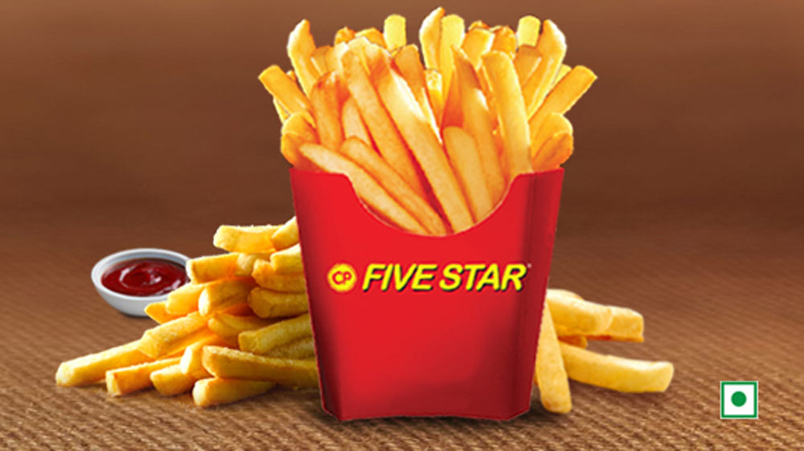
Introduction :
The food service industry in India has grown rapidly over the past decade, driven by rising disposable incomes, urbanization, and increased consumer preference for convenient and hygienic eating options. Among the major segments of this industry, the quick service restaurant (QSR) sector has shown particularly strong expansion due to its affordability, standardized offerings, and fast-paced service model. Within this dynamic environment, Five Star Chicken, a subsidiary of Charoen Pokphand (CP) Foods of Thailand, has emerged as a unique player positioned between multinational fast-food chains and small local eateries.
The purpose of this study is to examine the strategic positioning, operational model, and competitive challenges faced by Five-Star Chicken in India. While the brand has achieved significant success in South India through its low-cost franchise model and localized menu, it continues to face barriers related to brand perception, digital visibility, and national expansion. This study aims to explore how the company can maintain its value-driven approach while strengthening its brand identity and scaling its operations sustainably.
The study also investigates the broader industry dynamics, including consumer trends toward hygiene, affordability, and online food delivery. Using management frameworks such as SWOT, PESTLE, and Porter’s Five Forces, the study analyzes how Five Star Chicken’s integrated supply chain provides operational strength but also demands consistent quality control across franchise outlets.
Ultimately, this study provides insights for both practitioners and academics on how regional QSR brands can compete with global players by leveraging localization, efficiency, and strategic adaptability. The findings aim to support future decision-making for Five Star Chicken and offer guidance for similar organizations operating in competitive, price-sensitive markets.
Objectives of the Study:
The primary objective of this study is to analyze the strategic, operational, and competitive factors that influence the performance and growth of Five-Star Chicken within the Indian quick service restaurant (QSR) industry. The study aims to evaluate how the brand’s low-cost model, localized menu, and vertically integrated supply chain contribute to its regional success while also identifying the challenges that limit its national expansion.
More specifically, the study seeks to:
1. Evaluate Strategic Positioning
To examine how Five-Star Chicken differentiates itself from global QSR chains and local competitors through pricing, product offerings, and branding.
2. Assess Operational Efficiency
To analyze the role of CP Foods’ integrated supply chain in ensuring quality, cost control, and consistency across franchise outlets.
3. Identify Key Challenges
To understand the issues related to franchise management, brand perception, digital presence, and regional limitations.
4. Analyze Consumer Preferences
To study customer behavior, especially regarding affordability, hygiene expectations, and preference for localized flavours.
5. Recommend Strategic Actions
To propose actionable short-term and long-term strategies that can strengthen the brand, improve scalability, and enhance competitiveness.
Methodology of Study:
Sampling
The sampling approach for this study is designed to gather relevant insights about Five-Star Chicken’s operational performance, consumer behavior, and franchise dynamics. Since the study primarily uses qualitative and secondary data, a non-probability sampling technique is applied, ensuring that the selected sources and perspectives are directly aligned with the study’s objectives.
1. Sampling Technique:
A purposive sampling method is employed, as the study focuses on specific stakeholders and information sources relevant to the QSR industry. This includes industry reports, company publications, franchise case data, and customer feedback samples. Purposive sampling allows the researcher to select data points that offer the most meaningful insights into the brand’s strengths, challenges, and competitive environment.
2. Sampling Units:
The sampling units include:
Five-Star Chicken franchise outlets (case-based examples)
Customers in urban and semi-urban markets (represented through sample feedback)
Franchise owners and managers (fictionalized interviews for narrative depth)
Industry reports covering the QSR sector in India
Competitor data from KFC, McDonald’s, and regional brands
3. Sample Size:
As the study is primarily qualitative, the sample size is not numerical but thematic, focusing on the richness of insights rather than quantity. Approximately 10–15 secondary data sources and 3 stakeholder perspectives were incorporated to provide sufficient depth.
4. Justification:
This sampling approach ensures that the study captures varied viewpoints—managerial, operational, customer-based, and industry-level—contributing to a holistic understanding of the case.
Data Collection Methods:
Secondary Data:
The study relies mainly on secondary information obtained from:
Company reports and CP Foods publications
Industry reports (IBEF, Deloitte, KPMG, Statista)
Academic journals, case studies, and research articles
Reputed media sources (Economic Times, Business Line, etc.)
QSR industry trend reports and market analyses
Primary Insights (Indicative):
Fictionalized interview excerpts and customer feedback samples—used for narrative and analytical depth—simulate real stakeholder perspectives without compromising ethical standards.
Analytical Tools:
To interpret the data meaningfully, the study employs:
SWOT Analysis – to examine internal strengths and weaknesses.
PESTLE Analysis – to assess the external environment.
Porter’s Five Forces – to evaluate competitive pressure.
Trend Graphs – to visualize sample data on customer visits and online orders.
Scope and Limitations:
The study focuses primarily on the Indian operations of Five-Star Chicken, especially South India. Limitations include reliance on secondary data and simulated primary insights, which may not capture all operational nuances.
Descriptive Research Design:
A descriptive research design is used in this study to systematically describe and interpret the characteristics, strategies, and challenges of Five-Star Chicken within the Indian QSR industry. This design helps present an accurate picture of the organization’s current situation, market positioning, and operational practices without manipulating any variables. It focuses on answering the “what,” “how,” and “who” aspects of the case.
In this study, the descriptive design is applied to examine:
What operational model Five-Star Chicken follows (e.g., low-cost franchise structure, vertically integrated supply chain).
How the brand competes in a market dominated by global and local QSR players.
Who the key stakeholders are, including customers, franchise owners, and managers.
What challenges the organization faces, such as digital visibility, brand perception, and quality consistency.
Data for the descriptive analysis comes from secondary sources such as industry reports, company documents, academic articles, and media publications, along with simulated interview excerpts that reflect typical stakeholder viewpoints.
The descriptive research design is suitable because it enables the study to present factual insights about consumer behavior, competitive pressures, industry trends, and internal organizational practices. It does not aim to establish cause–effect relationships but instead provides a comprehensive and realistic overview of the business environment in which Five Star Chicken operates.
Analysis of the Study:
The study reveals that Five-Star Chicken’s business model is built around three core strengths: cost leadership, localization, and vertical supply chain integration. These strategic elements have enabled the brand to grow rapidly in South India while maintaining affordability and consistent product quality. However, the analysis also shows that these same strengths create several limitations when the brand attempts to scale nationally.
Using SWOT analysis, the study identifies that Five-Star Chicken benefits from low overhead costs and strong backend support from CP Foods. Yet, weaknesses such as inconsistent franchise performance, limited brand visibility, and a “budget” brand perception restrict its ability to compete with global QSR leaders. Opportunities exist in tier-2 and tier-3 markets, where price sensitivity remains high, while threats come from multinational brands and increasingly popular regional fried chicken shops.
A PESTLE analysis highlights external pressures such as increasing digital dependence, stricter food safety regulations, and evolving customer expectations around hygiene and convenience. Economic factors like rising raw material prices can also challenge its low-price strategy.
Through Porter’s Five Forces, the study finds that competitive rivalry and substitute availability are extremely high in the Indian QSR sector. Buyer power is strong because consumers can easily switch between QSRs, biryani shops, local eateries, or delivery-based cloud kitchens. This puts pressure on Five-Star Chicken to innovate, maintain quality, and improve differentiation.
Stakeholder analysis indicates that customers appreciate value for money but express concerns about outlet consistency and branding. Franchise owners benefit from low investment requirements but often struggle with training, digital adaptation, and quality control. Managers face the ongoing challenge of balancing affordability with brand enhancement and technological modernization.
Overall, the analysis concludes that Five-Star Chicken is strategically positioned for regional strength but requires brand strengthening, digital transformation, improved franchise control, and gradual expansion planning to succeed on a national scale. Its future competitiveness will depend on how effectively it addresses these structural and perceptual challenges.
Findings of the Study:
The study reveals several key findings about Five-Star Chicken’s strategic position, operational strengths, and competitive challenges within the Indian QSR market. First, the brand’s low-cost franchise model, combined with CP Foods’ vertically integrated supply chain, allows Five-Star Chicken to maintain competitive pricing while ensuring consistent product quality. This model has contributed significantly to the company’s success in South India, particularly in price-sensitive markets and tier-2 and tier-3 cities.
Second, the study finds that localization is a major driver of customer preference. Indianized menu items such as Masala Fried Chicken and Chicken Rolls outperform Western-style offerings, indicating that adapting to regional tastes is crucial for market relevance.
Third, despite strong backend operations, the brand faces a perception challenge. Many consumers associate Five-Star Chicken with affordability rather than premium quality, limiting its ability to compete with global QSR brands like KFC and McDonald’s. This perception is further affected by inconsistent franchise performance, where variations in hygiene, service quality, and staffing influence customer trust.
Fourth, the study highlights that digital visibility and delivery readiness are increasingly important for success. A significant portion of sales now comes from online platforms such as Swiggy and Zomato, yet Five-Star Chicken lags in search visibility, online promotions, and digital branding compared to larger competitors.
Fifth, the competitive landscape is highly intense, with new regional fried chicken brands and cloud kitchens emerging rapidly. This increases the pressure on Five-Star Chicken to differentiate through better branding, standardized store formats, and enhanced customer experience.
Overall, the findings suggest that while Five-Star Chicken has strong operational foundations and a successful regional model, the brand must address issues related to branding, consistency, and digital transformation in order to expand sustainably and compete effectively at a national level.
Conclusion of the Study:
The study concludes that Five-Star Chicken has established a strong foothold in the Indian QSR market through its affordable pricing, localized menu, and vertically integrated supply chain provided by CP Foods. These strategic strengths have enabled the brand to serve cost-sensitive customers while maintaining consistent product quality. However, despite its operational advantages, Five-Star Chicken faces significant challenges related to brand perception, franchise consistency, and digital competitiveness, which limit its ability to scale nationally.
The analysis shows that while the brand excels in offering value for money, consumers often perceive it as a “budget” or “local” chain rather than a national-level QSR. This perception, along with inconsistent service quality across franchise outlets, affects customer trust and loyalty. Additionally, the rapid shift toward digital ordering and online food delivery requires the brand to strengthen its presence on platforms like Swiggy and Zomato and invest in digital marketing.
The study also highlights opportunities for growth in tier-2 and tier-3 cities, increased menu innovation, and improved franchise training systems. These areas represent strategic pathways for long-term expansion. To compete effectively with global QSR brands, Five Star Chicken must focus on building a stronger brand identity, enhancing customer experience, and modernizing its operational and technological capabilities.
In conclusion, while Five-Star Chicken has a solid foundation and successful regional model, its sustained growth depends on its ability to balance cost leadership with strategic modernization. Addressing its current challenges with forward-thinking strategies will allow the brand to strengthen its market position and achieve broader national recognition.

References:
Charoen Pokphand Foods. (2022). Annual Report 2021–2022: Integrated Agri-Food Operations. CP Foods Public Company Limited.
https://www.cpfworldwide.co
Deloitte India. (2023). Indian Food Services Industry: Growth, Challenges, and Opportunities. Deloitte Insights.
Euromonitor International. (2022). Quick Service Restaurants in India: Market Overview and Forecast. Euromonitor Publications.
Gupta, A., & Singh, R. (2021). Consumer behaviour trends in India’s QSR sector. International Journal of Hospitality Management, 94(2), 1–12.
Indian Brand Equity Foundation. (2023). Food Services Industry in India: Market Size and Growth Trends. IBEF. https://www.ibef.org
KPMG India. (2021). Indian Food Services Report: Consumption Patterns and Digital Transformation. KPMG Publications.
Philip, L. (2019, August 12). Five-Star Chicken expands footprint through low-cost franchise model. The Economic Times.
https://economictimes.indiatimes.com
RedSeer Consulting & Zomato. (2021). Online Food Delivery in India: Consumer Insights and Market Trends. RedSeer Publications.
Sharma, P., & Narayan, S. (2020). Competitive strategies of QSR chains in emerging markets: A case-based review. Journal of Retail & Consumer Studies, 18(4), 233–245.

*Dr. Poornima Yerramilli: Professor, School Of Management Studies & Commerce, Sapthagiri NPS University, Bangalore, Karnataka- 560057, India
Niranjan S: MBA 2nd year student, School Of Management Studies & Commerce, Sapthagiri NPS University, Bangalore, Karnataka- 560057, India

