Potential of Curcuma amada in Cancer Therapy: A Phytochemical

ABSTRACT:
Medicinal plants are being used for therapeutic purposes since the human civilization. The efficacy of these medicinal plants is due to presence of broad range of phytochemical constituents present. Curcuma amada is very common herb belong to family Zingiberaceae and is used as spice in different regions of the world and also serves as a home remedy for treating different diseases. Curcuma amada is widely evaluated for its anticancer activity. The major constituents found in its rhizomes are Curcuminoids (Curcumin), Phenolic compounds, terpenoids and essential oils. The primary phytoconstituents Curcumin is responsible for its various therapeutic properties. Curcumin possesses broad remedial potential due to its multi targeting effect against many different carcinomas including Leukemia, breast cancer etc. Hence, Curcumin can treat several diseases because of its potential for the development of new medicine.
Key Words: Curcuma amada, Curcumin, Phytoconstituents, Curcuminoids, Anti-cancer

Introduction:
Cancer has been one of the main causes of sickness and death worldwide, which means it’s a major health concern. Estimation of 70% increase in cancer cases is predicted for about next 20 years, even as continuous global efforts has been made to prevent cancer. ^{[1,2]} Estimation says about 63% of deaths in India was caused by NCDs and the cancer was in among top 9% mentioned in Figure_1.
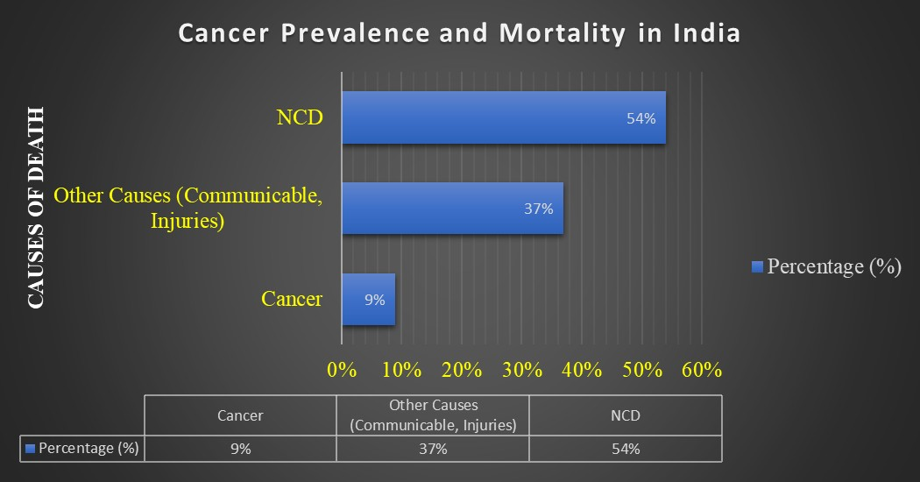
Figure_1 Cancer prevalence and Mortality in India.
According to GLBOCAN 2018 database nearly half of the world’s cancer cases and nearly half of the cancer deaths occurs in Asian nations.^{[3]} Evidences from the domestic and international sources has marked Indian subcontinent as rise in the incidence, morbidity and death related to cancer. ^{[4-8]} Approximately 13.2 million cases have been expected by 2030 as shown in Figure_2 ^{[9]}
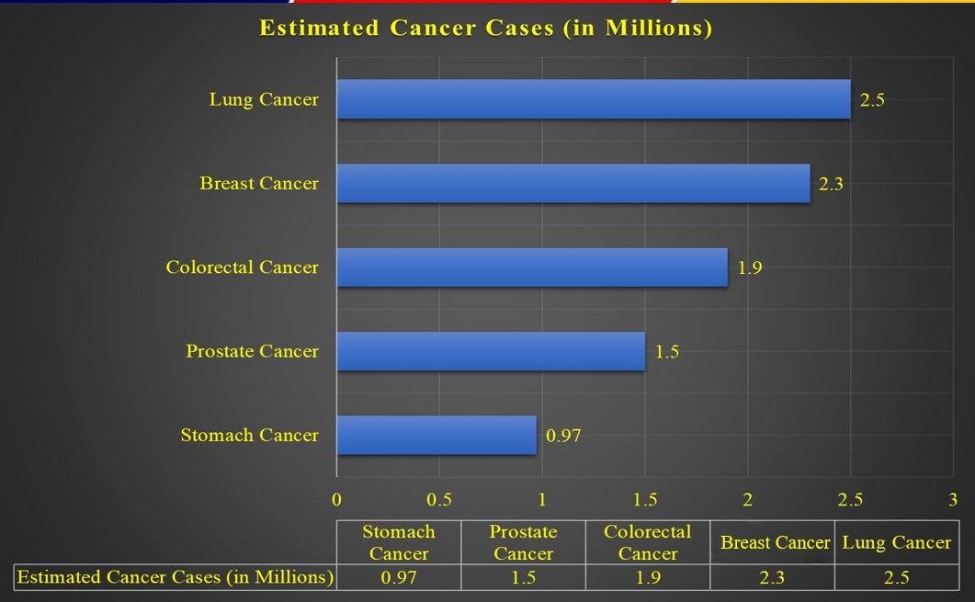
Figure_2 Estimated cases till year 2030
According to the data provided by Global Cancer Observatory report 2022, nearly 10 cancer types have been accounted for nearly two thirds of all new cases and deaths worldwide. Lung cancer led with 2.5 million new cases globally making this the most common cancer, next to this is Colorectal cancer with 1.9 million cases, Prostate cancer with 1.5 million cases, Stomach cancer with 970,000 cases, and female breast cancer with 2.3 million cases summarized in Figure_3 ^{[10,11]}
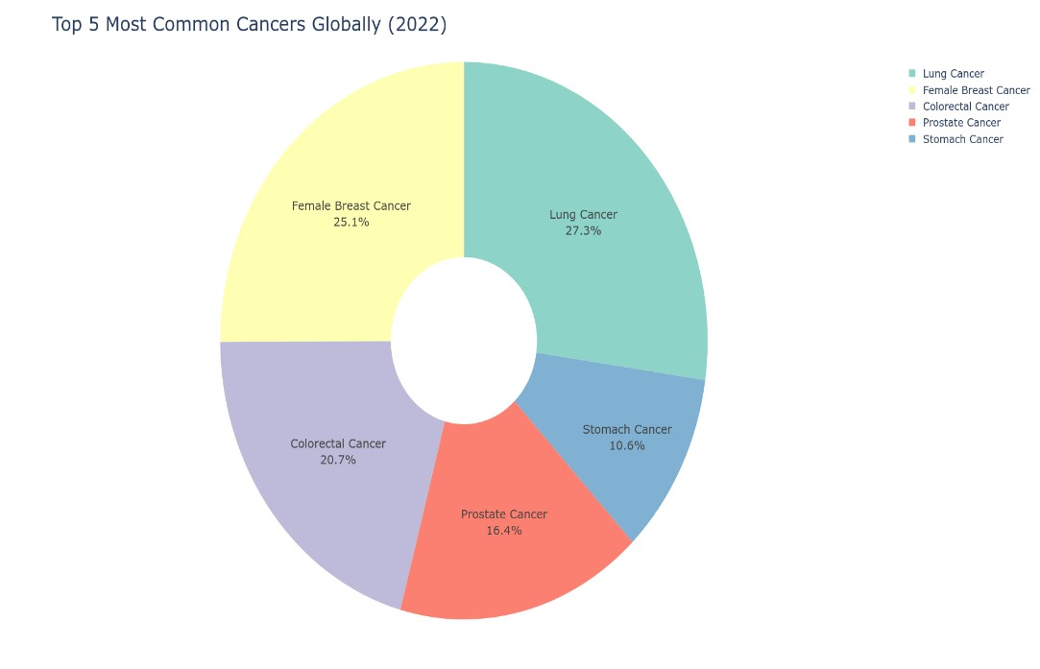

Figure_3 Most common cancer statistics globally
The rising cases of cancer creates major burden on people financially as well as psychologically living in developed as well as in developing countries, driving the need for affordable, targeted and effective treatment strategies. While numerous approaches exist- surgery, immunotherapy, chemotherapy, Cancer vaccination stem cell therapy these often faces limitations such as toxic effects.^{[12]} poor bioavailability, non-targeted or mono-targeted action and rapid clearance. ^{[13-15]} As a result researcher are more inclined on medicinal plants and their phytochemicals has been promising alternatives. Notably such as Curcumin, Epigallocatechin, Isothiocyanates and garcinol are under clinical trials and can soon hit the market. ^{[16]}
Traditional herbal drugs have received notable acceptance as alternative and complementary therapy for the cancer patients. Previous studies have incorporated that herbal products alongside conventional treatments can improve quality of life. Therefore, there is growing interest on plant-based products in search for harnessing novel cancer treatments. ^{[17-22]}
Curcuma amada belongs to family Zingiberaceae and is characterized as perennial and aromatic herb which is commonly known as “Ama-haldi”, “Amba ada”, “Mango ginger” because of the flavor of the rhizome is similar to raw mango as shown in Figure_4. ^{[23,24]} Curcuma has 60-100 species of curcumin found in different countries of the world like in Northern Australia, Indian Subcontinent, America etc. ^{[25]} The rhizomes of this plant have been widely used in food industries and also as an alternative therapy to cure numerous illnesses such as bronchitis, colic, indigestion, cough, loss of appetite and constipation. ^{[26]} There are several reports available on anti-cancer activity of the leaves as well as in the rhizomes of Curcuma amada.

2. Taxonomic classification: ^{[27]}
S.no. | Taxonomy | Classification
1. | Kingdom | Plantae
2. | Subkingdom | Spermatophyta
3. | Division | Magnoliophyta
4. | Subdivision | Angiospearmae
5. | Class | Monocotyledone
5. | Series | Epigynae
6. | Order | Scitaminales
7. | Family | Zingiberaceae
8. | Genus | Curcuma
9. | Species | C amada Roxb

Table_1: Taxonomical classification of Curcuma amada
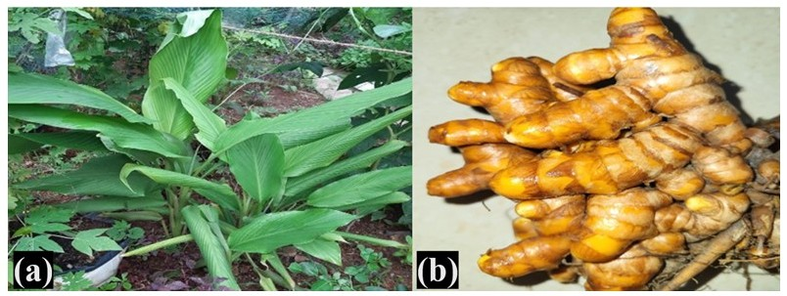
Figure_4 (a) whole plant (b) Rhizomes of Curcuma amada
3. History and Origin:
The beginning of Curcuma amada (Mango ginger) in not well documented and is vague. It is said to have originated from India and is also found across tropical regions of Africa, Australia and Asia. The term Curcuma is believed to have been derived from the Arabic word kurkum which means yellow. ^{[28,29]}
Mango ginger grows in different climatic conditions but the favorable condition is hot climate as it is said that the maximum growth occurs. In India maximum growth is seen in Gujarat, Uttar Pradesh, West Bengal, Karnataka, Tamil Nadu and the hills of western coast. ^{[29,30]}
4. Chemical Constituents:
The Rhizomes of the plant was found to be rich in fibers and starch; the analysis of this edible rhizome plays a crucial role in order to assess its nutritional significance. ^{[31]} There are more than 130 chemical constituents which has been reported in the rhizomes part of which total of 121 has been identified ^{[32-37]} Most of studies is done on rhizome part of the plant while other part is rarely examined. The major constituents present in plant are mentioned in Figure_5 ^{[38]}
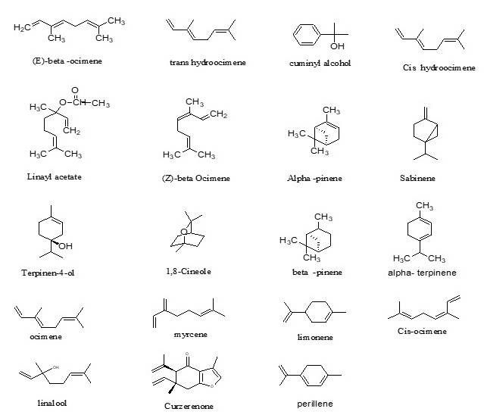
Figure_5 The chemical constituents present in C. amada
Monoterpenoids, are compounds containing a chain of two isoprene units. The known are beta-ocimene, trans-hydro ocimene, cuminyl alcohol, cis-hydro ocimene, Linayl acetate, alpha- pinene, myrcene,1,8 cineole etc are shown in Figure_6.
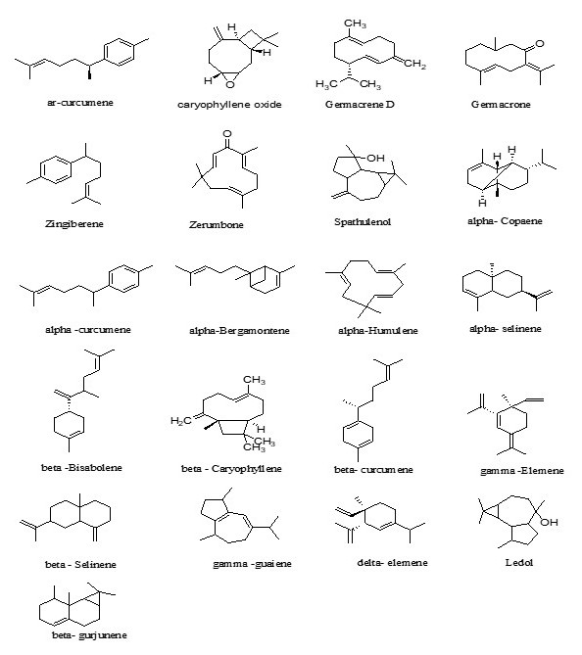
Figure_6 Monoterpenoids compounds of Curcuma amada plant

Sesquiterpenoids, are compounds with three consecutive isoprene units. The well-known compounds include beta-curcumene, ledol, ar-curcumene, caryophyllene oxide, alpha- curcumene, alpha-selinene, gamma -guaiene etc as shown in Figure_6.
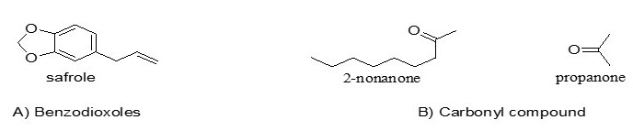
Figure_7 Sesquiterpenoids compounds of Curcuma amada plant

Benzodioxols are the organic compounds containing a benzene ring fused to either isomer of dioxole, Dioxole is a five-membered unsaturated ring of two oxygen atom and three carbon atoms. Important compound includes safrole as shown in Figure_7.
Carbonyl compounds are organic compounds containing a carbonyl group with general structure RC(=O) R’ where R= organyl R’=H, N, O organyl group or halide group. It includes compounds like 2-nonanone and propanone as shown above.

Extraction Techniques:
Curcuma amada rhizomes are extracted using conventional solvent methods (methanol, ethanol, chloroform, acetone, ethyl acetate) and modern intensification techniques as mentioned in Table 2.
S. No | Method & Solvent used | Nature of the compounds | Name of the compound | Method of detection | Use /remark
1 | Steam distillation, extraction and low temperature-high-vacuum distillation technique | Mono-terpenoids | Cis-ocimene  Car-3-ene | GC-MS analysis | Cis ocimene contributes to the aroma of green α-  pinene and car-3-ene is for floral and leafy mango aromas.^{[40]}
2 | Hexane | Monoterpenoids | Myrcene,  Ocimene, Cis  and Tran-di-  hydrocimene | Hexane Extraction | It contributes on the aroma of both raw mango and turmeric.
3 | Dichloromethane, ethyl acetate, methanol and double distilled water | Mono-terpenoids  Phenol ethers | β-myrcene  α-asarone | Spectrophotometric assay | It predominantely has myrcene (88.6%) and  β-pinene (4.9%). Dietary phenolic acids (eg. caffeic, ferulic)  exhibit antiulcer,antibacterialand antioxidant properties
Free compounds of phenol
4 | Gallic acid | Hydroxycinnami  c acids and  Derivative  Benzoic acids  and derivatives  Hydroxycinnami  c acids and  derivatives | Caffeic (26%,195 mg/g  )  Gentisic(24%,180 mg/g)  Gallic acid  (10 %, 75 mg/g) | HPLC  analysis | Serve as an effective  indicator for determining the  physiological age and  quality og rhizome
Bounded phenolic compounds

5 | Methanol AR, ethyl acetate AR and dichloromethane | Hydroxycinnamic acids and derivatives  Cinnamic acids and derivatives  Hydroxycinnamic acids and derivatives | Ferulic acid ( (47%, 391.5 mg/g)  Cinnamicacid (29%, 237 mg/g)  P-coumaric acids(11%, 95 mg/g) | Uv- visible spectrophotometer analysis | It has many medicinal properties like anti-ageing, antibacterial,antioxidant,anti-inflammatory,antiallergic,antifungal,platelet aggregation inhibition activity and analgesic activity
Curcuminoids
6 | EPA-524.2 fortification solution | Linear diarylheptanoids /curcuminiods | Curcumin  Demothoxycurcumi  Bisdemethoxycurcumin | HS-SPME and GC-TOF-MS | Widely used in food industry and alternative medicines to treat a variety of internal diseases such as cough, bronchitis,indigestion,colic,loss of appetite, hiccups and constipation
7 | n-hexane ,chloroform,ethyl acetate,acetone and methanol | Terpenoids  Fatty Acyls/terpenoids  Terpenoids | Diflurocumenonol  Amadaldehyde  Amadannulen | UV, IR, LC-MS,2D-HMQUCT-NMR Spectral data  UV, IR, LC-MS,2D-HMQUCT-NMR Spectral data  UV, IR, LC-MS,2D-HMQUCT-NMR Spectral data | It is demonstrated as high and antibacterial activity against Gram negative and Gram-positive bacteria  It is anti-cancerous and antibacterial properties method in them  It has antibacterial antioxidant and anti-microbial activity

Table_2: Extraction techniques and bioactive compounds identified in Rhizome of Curcuma amada^{[39]}
5. Anti-cancer profile of Curcuma amada:
Recent Investigation had revealed that the curcumin has emerging potential application from Curcuma amada against cancer and its therapy which relates to its complications. It has been proven that Curcuma amada has potential against different types of cancer.
Mango ginger extracts prepared with solvents such as hexane, acetone, chloroform, methanol, and ethyl acetate have been observed to exert cytotoxic effects on both normal and cancerous cell lines. Importantly, their activity is consistently stronger against cancer cells, underscoring their potential as anticancer agents. In terms of relative toxicity, the extracts rank from most to least harmful as follows: hexane, chloroform, methanol, acetone, and finally ethyl acetate. Overall, cytotoxicity assessments indicate that these extracts are considerably less damaging to healthy cells compared to cancer cells.^{[41]}

5.1 Therapeutic role in Breast Cancer Treatment:
Across the world breast cancer is one of the common malignant cancers in females and thus is leading cause of deaths among females. ^{[39]}
However, the Curcuma amada methanolic extract of leaves and the rhizomes was effective against breast cancer cell lines MCF-7 and MDA MB 231. The DNA damage was induced in yeast to assess using diphenylamine method and the DNA damage induced by the extract was assessed using single cell gel electrophoresis summarized in Table_3.

Type of cancer | Plant part used | Solvent used for Extraction | Animal/  Cell line used | Result
Breast  Cancer | Leaves  and rhizomes | Methanol | MCF7, MDA MB 231, HLB-100 | The extract caused cell death in the MCF-7 and MDA MB 231 breast cancer cell with less DNA damage in yeast and HLB -100 cells.^{[42]}
Breast  Cancer | Rhizomes | Hexane, chloroform and methanol | MCF-7 | Curcuma amada shows anticancer activity against MCF-7 cell line With hexane showing IC50 of 75.9µg /ml ,while chloroform and methanol extract had IC50 >10µg /ml demonstrating higher anticancer activity then hexane .^{[43]}
Breast  Cancer | Leaves and rhizomes | Methanol | MCF-7,  MDA MB 231,  HLB-100 | Curcuma amada extract treatment enhanced pro- apoptotic P33 and Bax expression while decreasing the levels of anti-apoptotic Bcl-2 l. ^{[44]}

Table_3: Therapeutic role in breast cancer treatment

5.2 Therapeutic Role in Prostate Cancer Treatment
Prostate cancer is the fifth leading cause of cancer-related death in men and the second most common malignant tumour worldwide.^{[42]} Recent investigations indicate that Curcuma amada (mango ginger) rhizome extract (CARE) could play a beneficial role in prostate cancer therapy, although current findings are restricted to preclinical research. Phytochemical profiling has revealed sixteen active constituents in C. amada, many of which exhibit favorable drug-like characteristics, including flavonoids, terpenoids, and phenolic compounds recognized for their antioxidant and anti-inflammatory properties. CARE has demonstrated the ability to trigger apoptosis, interfere with cell cycle progression, and suppress pro-inflammatory mediators that drive tumor development. Computational analyses further suggest that CARE interacts with multiple signaling pathways, notably PI3K/Akt and MAPK, which are central to cancer progression. Laboratory studies confirm that CARE reduces the viability of prostate cancer cells, while bioinformatics evidence supports its broad therapeutic potential as shown in Table_4 ^{[45]}
Plant part used | Extraction method | Solvent used for Extraction | Animal/  Cell line used | Result
Rhizomes | Soxhlet apparatus | Methanol | PC-23 | In vitro, CARE reduced PC-3 cell growth, induced apoptosis, caused G2/M cell-cycle arrest, and downregulated PI3K-AKT-related genes, indicating its potential as a therapeutic candidate.
Table_4: Therapeutic Role in Prostate Cancer Treatment
5.3 Therapeutic role in Rhabdomyosarcoma Cancer Treatment
Rhabdomyosarcoma (RMS) is a common type of cancer that mainly effects childhood and adolescent, accounting for half (50%) of soft tissue sarcomas. It has an incidence rate of 4.3 occurrences per million people under 20. It is uncommon in adults, accounting for less than 1% of solid tumours and 3% of soft tissue sarcomas.^{[46]} C. amada showed the highest cytotoxic activity against SJRH30 and RD cell lines as shown in Table_5. ^{[47]}
Extraction | Animal/  Cell line used | Result
Supercritical fluid extraction | aRMS (SJRH30),  eRMS (RD) cell lines | Curcuma amada showed the highest cytotoxic activity against SJRH30 and RD cell lines, with IC₅₀ values of 7.133 and 7.501 µg/ml, respectively, compared to other Curcuma species.

Table_5: Therapeutic role in Rhabdomyosarcoma Cancer Treatment
5.4 Therapeutic role in glioblastoma cancer treatment
Glioblastoma is considered as the most prevalent malignant brain tumour, accounting for almost 16% of all the primary brain and central nervous system neoplasms. It is commonly diagnosed around the age of 64, however it can develop at any age, including youth. Men have higher incident than women with a ratio of 1.6:1.^{[48]}
Supercritical fluid extract was used against U-87 MG, mHypoE -N1 and the results are shown in Table_6.
Solvent used for Extraction | Animal/  Cell line used | Result outcome
Supercritical C02 Extract | U-87 MG,  mHypoE -N1 | Curcuma amada super critical CO2 extra exhibit strong cytotoxic activity against U-87MG glioblastoma cells with IC₅₀, IC₇₅, and IC₉₀ values of 4.92 mg/mL, 12.87 mg/mL, and 21.30 mg/mL, respectively. In contrast high concentration were required to suppressed the growth of normal cell m Hypo E-N1 cells.^{[49]}
Supercritical C02 Extract | U-87MG | Curcuma amada extract show cytotoxic activity against U-87MG human glioblastoma cell line with IC50, C75 and 1C90 values of 5.02 ± 0.10, 12.87 ± 0.25,37.14 ± 0.19 mg / ml. The extract resulted in dose dependent apoptosis and downregulation of genes related to drugs resistant, proliferation, telomerase and metastatic^{.[50]}
Supercritical C02 Extract | U-87MG | Supercritical CO2 of Curcuma amada demonstrate potent anti-cancer activity against U- 87 MG human glioblastoma nude mice xenografts. It shows high cytotoxic activity with IC 50, IC 75, IC90 values of 4.93 ± 0.8113.47 ± 0.86 and 23.10 ± 1.13 mg/ml respectively. Oral administration of plant extract to xenografts mice reduced tumor volume by 40.2%, raised the therapeutic ratio to 40.3 and increase survival to 40%.^{[51]}
Table_6: Therapeutic role in glioblastoma cancer treatment. ^{[49-51]}

5.5 Therapeutic role of Curcuma amada on lung cancer treatment
Lung cancer is the main cause of cancer-related death globally, accounting for the highest mortality rates in both men and women. Smoking is the leading cause of lung cancer, accounting for over 85% of cases. The International Agency for Research on Cancer (IARC)'s GLOBOCAN 2020 estimates of cancer incidence and mortality show that lung cancer is the top cause of cancer death, accounting for an anticipated 1.8 million deaths (18%) in 2020.^{[52]}
Curcuma amada rhizomes were evaluated against different cell lines as shown in Table_7.
Plant part used | Solvent used for extraction | Animal /cell line used | Result
Rhizome | n-hexane,  chloroform,  ethyl acetate,  acetone,  methanol and water | A-549 (human small cell lung carcinoma), Vero cell | Among all the ethyl acetate show maximum cytotoxic activity with lowest CTC-50 values (52-65µg). Hexane and chloroform extract showed moderate cytotoxic activity with CTC-50 values 90 to 100µg. Methanol and acetone extract show lower activity with CTC 50 value 132 to 407 µg. ^{[53]}
Rhizome | Acetone, hexane, isopropyl alcohol, phosphate buffer and distilled water for crude protein extraction | NCIH460 | Curcuma amada shows anticancer potential through its antioxidant and cellular action. It neutralises free radicals with 58.6% DPPH activity (60 µg/ml), 68.42% superoxide scavenging and 66.6% hydroxyl scavenging (50 µg/ml) ^{[54]}

Table_7: Therapeutic role in lung cancer treatment. ^{[53,54]}
.
5.6 Therapeutic role of Curcuma amada on skin cancer treatment
Skin cancer is one of the most common malignancies in the world, and its incidence and fatality rates are steadily rising, particularly in places with a white population. Skin cancer accounts for one out of every three cancer diagnoses worldwide, with NMSCs being the most common. It is classified into two types: melanoma skin cancer (MSC) and non-melanoma skin cancers (NMSC). North America and Asia have the greatest incidence and fatality rates for non-melanoma skin cancer. The incidence of non- melanoma skin cancer is 18-20 times higher than melanoma skin cancer, resulting in more deaths.^{[55]}
The rhizome extract was prepared using maceration process and was tested against B16F10 melanoma cells and the result is mentioned in Table_8.

Plant part used | Extraction method | Solvent used for extraction | Animal /cell line used | Result
Rhizome | Maceration | The methanol extract of C. amada was fractionated using water, n-hexane, and ethyl acetate. | B16F10 melanoma cells | Curcuma amada showed higher tyrosinase inhibitory activity with IC₅₀ of 53.4 μg/mL. The IC₅₀ values of mushroom tyrosinase were 108.2, 89.2, 92.3, 21.7, and 41.3µM. All of the compounds decreased intracellular tyrosinase activity and melanin production in B16F10 melanoma cells. Compound 4 was the most potent, exceeding arbutin, and compound 5 had activity comparable to arbutin.

Table_8: Therapeutic role in skin cancer treatment ^{[56]}
5.7 Therapeutic role of Curcuma amada on cervical cancer treatment
Cervical cancer is the fourth most frequent cancer in women globally, with an estimated 660 000 new cases and 350 000 deaths in 2022.The continuous infection with human papillomavirus (HPV) causes cervical cancer. Women living with HIV are six times more likely to get cervical cancer than women who do not have HIV.^{[57]}
C. amada was tested against different cell lines of Cervical cancer and the results are mentioned in Table_9.
Plant part used | Extraction method | Solvent used for Extraction | Animal/  Cell line used | Result
Rhizome | Soxhlet apparatus | Ethanol | Adult female Spraque Dawley Rats (150-200g) | In female Sparaque Dawley rats, BaP exposure significantly induced cervical tumor development (p>0.001), decrease the level of antioxidant, increase lipid peroxidation, elevated serum tumour makers (CEA, CA- 125, GTT) as well as membrane bound enzymes (Na+/K+-ATPase and Ca2+/Mg2+-ATPase).
Rhizome | Soxhlet apparatus | Methanol, chloroform, petroleum ether | HeLa | The cytotoxic effect of Curcuma amada was assessed using MTT test at doses ranging from 50 to 250 mg/ ml. Cell viability decrease in a dose - dependent way. The control group has a vitality of 97.25%, whole treatment with 50 mg / ml reduces it to 83.25%. At higher concentrations viability decrease: 100mg/ml (60.25%), 150mg/ml (55.26%),200 mg/ml (44.25%) and 250 mg/ml (40.12%) respectively.
Rhizome | Maceration | Ethanol, aqueous | HeLa | Curcuma amada ethanolic rhizome extraction was investigated using the MTT test on heLa cells. The IC50 value of 51.1µg/ml suggest strong cytotoxicity in a dose -dependent manner. Trypan blue die exclusion experiment reveals maximum cell killing at increase doses.

Table_9: Therapeutic role in cervical cancer treatment ^{[58,59,60]}

5.8 Therapeutic role of Curcuma amada on different cancer treatment on rhizome
Curcuma amada is potent to have therapeutic role against different types of cancer thus is written in a summarized manner in Table_10.
Type of cancer | Extraction method | Solvent used for extraction | Animal /cell line used | Results
Lung, cervical, pancreatic, breast | Sonication | Methanol | A549, HeLa, PANC-1 PSN-1 MCF7 | Compounds 2-4,7,8,12 and 17 exhibit moderate activity (IC50: 19.7-96.1μM). (E)-14-Hydroxy-15-norlabda-8(17), 12-dien-16-al (compound 11) show potent and selective antiproliferative action against HeLa, PANC-1 and PSN-1 cells, with IC50 values of 5.88, 1.00 and 3.98μM respectively comparable to 5- fluorouracil ^{[61]}
Cervical and Lymphoma (murine T- cell lymphoma) | maceration | Ethanol and water | DLA, HeLa cell line | Curcuma amada ethanolic rhizome extraction was investigated using the MTT test on heLa cells The IC50 value of 51.1µg/ml suggest strong cytotoxicity in a dose -dependent manner. Trypan blue die exclusion experiment reveals maximum cell killing at increase doses.^{[62]}

Table_10: Therapeutic role in different cancer treatment

Local promotions and uses
Regarding Curcuma amada the accumulated knowledge is based on several years of experience, but its rapid disappearance is due to changes in priorities of local communities. Most common reason for the disappearance is knowledge sharing in different communities and generations. Solution is to promote local uses through knowledge sharing at different levels. International organisations and local non-government can participate with the local government in order to support the communities.^{[63]}

6. Conclusion:
Medicinal plants serve as alternative therapeutic options having wide history of use for treating different types of cancer and it is well reported that herbs have potential source of chemotherapeutic compounds. On reviewing available data from different search engines, it was found that Curcuma amada is among less investigated species with genus Curcuma, specifically for its anticancer property. However, its complete description in provided in Ayurvedic system of medicine. ^{[64]} More than 130 chemical constituents have already been identified in rhizomes part. Most study of this plant have centred on its phytochemical properties. Therefore, special attention is needed to explore the pharmacological activities of the various constituents identified in Curcuma amada. Chemotaxonomy and allelopathy are yet to be explored for this plant.
Future prospects:
Curcuma amada is known for its phytochemical constituents thus possesses various pharmacological actions and is prone for anti-cancer activity because of the presence of curcumin. Overall, Curcuma amada stands out to be a promising candidate for sustainable drug discovery and holistic healthcare innovation.

Ethics statement
Ethical approval is not applicable to this study as it does not contain any human/animal participants.
Funding information
None
Declaration of competing interest
There is no conflict of interest.
Declaration of generative AI in scientific writing
No generative AI tools were used in the writing or research of this manuscript.

References:
- Tyagi BB, Bhardwaj NK, Raina V. Time trends of cancer in a tertiary care centre 2013–2017. Int J Med Health Res 2019;5 (11):152–158.
- Sadanandam, Vemula & Dhakshanamoorthy, Kalpanapriya. (2025). Epidemiology of Cancer Incidence Estimates and Statistics 2000–2025: Analysis from National Cancer Registry Programme in India. Indian Journal of Medical and Paediatric Oncology. 46. 10.1055/s-0044-1801767.
- Ofﬁce of the Registrar General & Census Commissioner India.Census of India Website. Censusindia.gov.in. Published 2011 at: http://www.censusindia.gov.in/census.website
- Babu GR, Lakshmi SB, Thiyagarajan JA. Epidemiological correlates of breast cancer in South India. Asian Pac J Cancer Prev 2013;14(09):5077–5083
- Thangjam S, Laishram RS, Debnath K. Breast carcinoma in young females below the age of 40 years: a histopathological perspective. South Asian J Cancer 2014;3(02):97–100
- Jonnada PK,Sushma C, Karyampudi M, Dharanikota A. Prevalence of molecular subtypes of breast cancer in India: a systematic review and meta-analysis. Indian J Surg Oncol 2021;12(Suppl 1):152–163
- Ali I, Wani WA, Saleem K. Cancer scenario in India with future perspectives. Cancer Ther 2011; 8:56–70
- Srinath Reddy K, Shah B, Varghese C, Ramadoss A. Responding to the threat of chronic diseases in India. Lancet 2005;366(9498):1744–1749
- Siegel RL, Miller KD, Jemal A. Cancer statistics, 2019. CA: A Cancer J Clin, 2019; 69(1):7–34. Available via http://doi.wiley. com/10.3322/caac.21551
- Global Cancer Burden Growing, Amidst Mounting Need for Services. Available online: https://www.who.int/news/item/01-02-2024-global-cancer-burden-growing--amidst-mounting -need-for-services#:~:text=In%202022,%20there%20were%20an, women% 20die% 20from% 20the%20disease (accessed on 01 May 2026).
- Ferlay, J.; Soerjomataram, I.; Dikshit, R.; Eser, S.; Mathers, C.; Rebelo, M.; Parkin, D.M.; Forman, D.; Bray, F. Cancer Incidence and Mortality Worldwide: Sources, Methods and Major Patterns in GLOBOCAN 2012. Intl J. Cancer 2015, 136, E359–E386.
- Jain, S.; Rachamalla, M.; Kulkarni, A.; Kaur, J.; Tikoo, K. Pulmonary Fibrotic Response to Inhalation of ZnO Nanoparticles and Toluene Co-Exposure through Directed Flow Nose Only Exposure Chamber. Inhal. Toxicol. 2013, 25, 703–713.
- Chauthe, S.K.; Mahajan, S.; Rachamalla, M.; Tikoo, K.; Singh, I.P. Synthesis and Evaluation of Linear Furanocoumarins as Potential Anti-Breast and Anti-Prostate Cancer Agents. Med. Chem. Res. 2014, 24, 2476–2484.
- Mukherjee, S.; Patra, C.R. Therapeutic Application of Anti-Angiogenic Nanomaterials in Cancers. Nanoscale 2016, 8, 12444–12470.
- Patra, C.R.; Mukherjee, S.; Kotcherlakota, R. Biosynthesized Silver Nanoparticles: A Step Forward for Cancer Theranostics? Nanomedicine 2014, 9, 1445–1448. [CrossRef]
- Ijaz, S.; Akhtar, N.; Khan, M.S.; Hameed, A.; Irfan, M.; Arshad, M.A.; Ali, S.; Asrar, M. Plant Derived Anticancer Agents: A Green Approach towards Skin Cancers. Biomed. Pharmacother. 2018, 103, 1643–1651.
- Peyromaure, M. et al. Management of prostate cancer in china: a multicenter report of 6 institutions. J. Urol. 174 (5), 1794–1797 (2005).
- Yin, S. Y., Wei, W. C., Jian, F. Y. & Yang, N. S. Therapeutic applications of herbal medicines for cancer patients. Evid. Based Complement. Alternat. Med. 2013, 302426 (2013).
- Liu, Z. L. et al. Traditional Chinese medicinal herbs combined with epidermal growth factor receptor tyrosine kinase inhibitor for advanced non-small cell lung cancer: a systematic review and meta-analysis. J. Integr. Med. 12 (4), 346–358 (2014).
- Fu, B. et al. Multi-component herbal products in the prevention and treatment of chemotherapy-associated toxicity and side effects: a review on experimental and clinical evidences. Front. Pharmacol. 9, 1394 (2018).
- Wang, Z. et al. An update on Chinese herbal medicines as adjuvant treatment of anticancer therapeutics. Biosci. Trends. 12 (3), 220–239 (2018).
- Zhang, X., Qiu, H., Li, C., Cai, P. & Qi, F. The positive role of traditional Chinese medicine as an adjunctive therapy for cancer. Biosci. Trends. 15 (5), 283–298 (2021).
- Tamta, A.; Prakash, O.; Punetha, H. and Pant, A.K. (2016). Chemical composition and in vitro antioxidant potential of essential oil and rhizome extracts of Curcuma amada Roxb. Cogent Chemistry, 2(1): 1168067.
- Akter, J.; Takara, K.; Islam, M.J.; Hossain, M.A.; Sano, A. and Hou, D. (2019). Isolation and structural elucidation of antifungal compounds from Curcuma amada. Asian Pacific Journal of Tropical Medicine, 12(3): 123-129.
- Tamara S. Al-Qudah1, Saida Abu Malloh1, Aamir Nawaz2, Muhammad Adnan Ayub2, Shafaq Nisar2*, Muhammad Idrees Jilani2 and Tamadour Said Al-Qudah3 , Mango ginger (Curcuma amada Roxb.): A phytochemical mini review , International Journal of Chemical and Biochemical Sciences. 2017) ; 51-57
- Chen, Y., Shukurova, M. K., Asikin, Y., Kusano, M. & Watanabe, K. N. Characterization of volatile organic compounds in Mango ginger (Curcuma amadaRoxb.) from Myanmar. Metabolites 11 (1), 21 (2020).
- Lalit R. Samant*, Curcuma amada Roxb.: A Phytopharmacological Review, Journal of Pharmacy Research Vol.5 Issue 4. April 2012 ; 5(4);1992-93.
- S. Syamkumar, B. Sasikumar. (2007). Molecular marker based genetic diversity analysis of Curcuma species from India. Scientia Horticulturae. 112(2): 235-241.
- Al-Qudah, T. S., Malloh, S. A., Nawaz, A., Ayub, M. A., Nisar, S., Jilani, M. I., & Al-Qudah, T. S. (2017). Mango ginger (Curcuma amada Roxb.): A phytochemical mini review. Ijcbs, 11, 51-57.
- M.A. Hanif, M.Y. Al-Maskari, A. Al-Maskari, A. Al-Shukaili, A.Y. Al-Maskari, J.N. Al-Sabahi. (2011). Essential oil composition, antimicrobial and antioxidant activities of unexplored Omani basil. Journal of Medicinal Plants Research. 5(5): 751-757.
- Lakshminarayana S, Siddappa GS, SubbaRao MS and Johar DS 1963 Preservation of mango ginger. Food Sci. 12 11–14
- Dutt S and Tayal JN 1941 Chemical examination of the essential oil derived from the rhizomes of Curcuma amada Roxb. Ind. Soap J. 7 200–205
- Golap SG and Bandyopadhyaya C 1984 Characterization of mango-like aroma in Curcuma amada Roxb. J. Agric. Food Chem. 32 57–59
- Rao AS, Rajanikanth B and Seshadri R 1989 Volatile aroma components of Curcuma amada Roxb. J. Agric. Food Chem. 37 740–743
- Choudhury SN, Rabha LC, Kanjilal PB, Ghosh AC and Leclercq PA 1996 Essential oil of Curcuma amada Roxb. from northeastern India. J. Ess. Oil Res. 8 79–80
- Mustafa A, Ali M and Khan ZN 2005 Volatile oil constituents of the fresh rhizomes of Curcuma amada Roxb. J. Ess. Oil Res. 17 490–491
- Srivastava AK, Srivastava SK and Shah NC 2001 Constituents of the rhizome essential oil of Curcuma amada Roxb. from India. J. Ess. Oil Res. 13 63–64
- Bandyopadhyay C. 1993. Recent trends in flavor evaluation of spices. In International Symposium on Newer Trends Essential Oils Flavor, Dhar KL, Thappa RK, Agarwal SG (eds). Tata McGraw-Hill: New Delhi, 153–173.
- Barman PD, Rajasree V, Mohanalakshmi M, Renuka R, Meenakshi P. Phytochemical profiling of Mango ginger (Curcuma amada): A comprehensive review of bioactive compounds and health implications. Plant Science Today.2024;11(sp4):01-14. https:/doi.org/10.14719/pst.5622
- Akter J, Islam MZ, Hossain MA, Takara K. (2021) Anti-tyrosinase properties of different species of turmeric and isolation of active compounds from Curcuma amada. Medicinal Chemistry Research,) 30(6)1669–1676
- Naskar C, Halder S, Ghosh A. Evaluation of cytotoxic activity of the crude extract of Curcuma amada Roxb. Int J Res Anal Rev. 2018; 5(2): 913-15.
- Sivaprabha J , Dharani, B ,Padma P.R & Sumathi S..(2015) Induction of DNA damage by the leaves and rhizomes of Curcuma amada Roxb in breast cancer cell lines.Journal of Acute Disease,4(1),12-17
- Donipati P, Sreeramulu S.H,Donipati P.J, Yugandhar N.M .(2022) .Invitro Anticancer Activity Of Curcuma Amada against Human Breast Cancer Cell Line Mcf-7.NeuroQuantalogy,20(20),2857-2879.
- Sivaprabha J , Dharani, B ,Padma P.R & Sumathi S.(2016).Apoptosis-induced in vitro anticancer activity of methanolic extract of leaves and rhizomes of Curcuma amada Roxb. against breast cancer cells. International Journal of Green Pharmacy ,10(2),99-103.
- Priyadarshini A, Mohanty D, Mohanty S, kerry R .G , Sahoo A,Dash B, Panda P.C, Nayak S , Ray A, Jena S.(2025).Unveiling the anticancer potential of Curcuma amada rhizome extract against prostate cancer through computational and experimental approaches.Scientific Reports ,15,24739
- Dondapati M, Reyes J.V.M, Ahmed S, Stern AS, Lieber JJ. (2021). Rare Adult Subtype of Rhabdomyosarcoma, a Common Childhood Soft Tissue Carcinom. Journal of Investigative Medicine High Impact Case Reports Volume 9: 1–4
- Ramachandran C, Lollett IV ,Escalon E, Quirin K.W, Melnick S.J.(2015) .Therapeutic Effect of Supercritical CO2 Extracts of Curcuma Species with Cancer Drugs in Rhabdomyosarcoma Cell Lines. Phototherapy Research ,29, 1152-1160
- Davis ME.(2016) Glioblastoma: Overview of Disease and Treatment. Clinical Journal of Oncology Nursing, 20(5 suppl), S2-S8.
- Ramachandran C, Lollett IV, Escalon E, Quirin K. W, Melnick S.J.(2015). Anticancer Potential and Mechanism of Action of Mango Ginger (Curcuma amadARoxb.) Supercritical CO2 Extract in Human Glioblastoma Cells. Journal of Evidence-Based Complementary & Alternative Medicine,20(2), 109-119
- Ramachandran C, Juan A , Quirin K .W, Khatib L, Escalon E, Khatib Z, and Melnick S. J.(2018).Anti cancer and Anti -metastatic E ffects of Supercriti cal E xtracts of Hops ( Humulus lupulus L.) and M ango ginger ( Curcum aamada Roxb.) in H uman G lioblastoma. International journal of phytomedicine, 10(4),191-200
- Ramachandran C, Lollett IV ,Escalon E, Quirin K.W, Melnick S.J. .(2017)In Vivo Antitumor Effect of Supercritical CO2 Extract of Mango Ginger (Curcuma amada Roxb) in U-87MG Human GlioblastomaNude Mice Xenografts.Journal of Evidence-Based Complementary & Alternative Medicine ,22(2) ,260-267
- World Health Organization. (2023, June 26). Lung cancer. https://www.who.int/news-room/fact-sheets/detail/lung-cancer (Accessed on 01 May 2026)
- Policegoudra RS , Chandrashekhar RH, Aradhya SM, Singh l.(2011). Cytotoxicity, Platelet Aggregation Inhibitory and Antioxidant Activity of Curcuma amada Roxb. Extracts. Food and Chemical Toxicology.,49(2),162-168
- https://www.researchgate.net/publication/279529866_Anticancer_and_antioxidant_activity_ofCurcuma_zedoaria_and_Curcuma_amada_rhizome_extracts
- https://doi.org/10.1016/j.cpt.2024.08.002
- Akter J, Islam MZ, Hossain MA, Takara K. (2021) Anti-tyrosinase properties of different species of turmeric and isolation of active compounds from Curcuma amada. Medicinal Chemistry Research,) 30(6)1669–1676
- World Health Organization. (2025 December 2).Cervical cancer. https://www.who.int/news-room/fact-sheets/detail/cervical-cancer. (Accessed on 01 May 2026)
- Palanisamy VD, Samiappan S,(2017). Antioxidant and chemotherapeutic potential of curcuma amada rhizome extract on benzo(a)pyrene induced cervical carcinoma in sprague dawley rats. Asian journal of pharmaceutical and clinical research . 10(3), 235-242
- Tariq AL .(2016). Preliminary Phytochemical Screening and Anti angiogenesis Studies of Different Extracts of Curcuma amada . International Journal of Current Microbiology and Applied Sciences. 5(10),109-11
- Prema D, Kamaraj M, Achiraman S, Udayakumar R.(2014). In vitro antioxidant and cytotoxicity studies of Curcuma amada Roxb. (Mango ginger). International Journal of Scientific and Research Publications,4(4),1-6
- Watanabe, K., Gilani, S., Kikuchi, A., & Jatoi, S. (2007). Phytochemical, Pharmacological and Ethnobotanical Studies in Mango Ginger (Curcuma amada Roxb.; Zingiberaceae). Phytotherapy Research, 21(6), 507–516. https://doi.org/10.1002/ptr.2137
- Kirtikar K R and Basu B D. Indian medicinal plants Vol. 4, second edition (Dehra Dun: Bishen Singh Mahendra Pal Singh) 1984; pp. 2422-2423.
- Hussain A, Virmani O P, Popli S P, Misra L N and Gupta M M. Dictionary of Indian Medicinal Plants. Central Institute of Medicinal Plants and Aromatic Plants. Lucknow 199; 2:39.
- Warrier P K, Nambiar V P K and Ramankutty C. Indian medicinal plants—a compendium of 500 species, Chennai: Orient Longman Pvt. Ltd, vol. 1 p. 106; 1994.

