Energy Efficiency as a Pathway to Expanding Energy Access in Sub‑Saharan Africa

ABSTRACT
Energy efficiency plays a critical yet underutilised role in expanding access to clean, affordable, and reliable energy services in developing regions. In Sub‑Saharan Africa, energy policy interventions have historically prioritised supply expansion, often overlooking the significant potential of demand‑side energy efficiency measures. This paper evaluates the economic and systemic effectiveness of reducing energy demand as a strategy for improving energy access while enhancing sustainability. It examines key technical, financial, institutional, and informational barriers that constrain the adoption of energy‑efficient technologies and practices across the region. The analysis demonstrates that targeted policy interventions including regulatory frameworks, financial incentives, and capacity‑building initiatives, can accelerate the uptake of energy‑efficient buildings, appliances, and industrial systems. Strengthening incentives for households, utilities, and industries can support long‑term investments in cost‑effective energy efficiency measures. The study concludes that integrating energy efficiency into national energy access strategies represents a scalable and economically sound pathway toward achieving universal energy access and sustainable development in Sub‑Saharan Africa.
Keywords: Energy efficiency, Energy access, Sub-Saharan Africa, Policy barriers, Cost-effectiveness,
INTRODUCTION
Sub-Saharan Africa remains the most energy-deprived region globally, with approximately 600 million people lacking access to electricity in 2023 [15]. Despite gradual improvements in electrification, access to both electricity and clean cooking remains severely limited across many countries in the region, constraining development, productivity, and public health outcomes. This challenge is compounded by rapid demographic expansion, with Africa’s population expected to rise from around 1.4 billion today to approximately 2.5 billion by 2050, significantly increasing future energy demand [14]. Energy demand in Sub-Saharan Africa is being driven by accelerating urbanisation, industrialisation, and rising incomes, yet supply expansion has not kept pace. As a result, structural energy deficits persist, particularly in rural areas where electrification rates remain far below urban averages. These disparities highlight deep inequalities in energy access, which continue to undermine inclusive economic growth. Energy efficiency presents a critical and cost-effective pathway to addressing this challenge. By reducing waste in buildings, industry, and transport systems, energy efficiency can lower operational costs, reduce pressure on generation infrastructure, and limit emissions growth. Importantly, it can also stimulate employment creation, enhance industrial competitiveness, and improve energy affordability for households and businesses [1]. Given these dynamics, this paper provides an evidence-based analysis of the energy landscape in Sub-Saharan Africa, with particular emphasis on energy efficiency as a strategic tool for improving access, enhancing sustainability, and supporting long-term economic transformation [3]. Despite growing recognition of the importance of energy efficiency globally, its role in addressing energy access deficits in Sub‑Saharan Africa remains inadequately reflected in national electrification strategies and academic literature [2]. Most studies continue to emphasise supply‑side solutions, with limited attention to how demand‑side efficiency improvements can rapidly expand access at lower cost. This paper addresses this gap by critically analysing energy efficiency as a strategic energy resource and evaluating its potential contribution to expanding access, reducing system costs, and supporting long‑term sustainable development in Sub‑Saharan Africa.
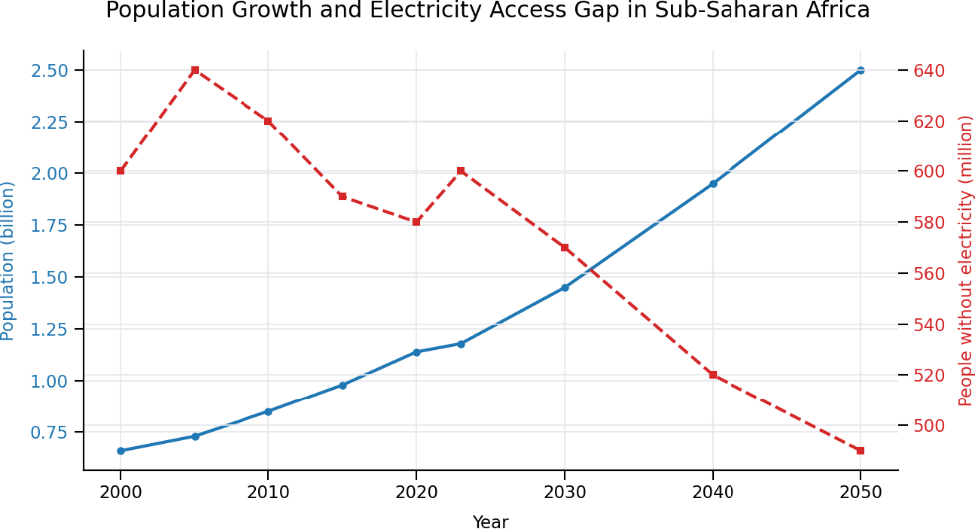
Figure 1 Population growth and electricity access gap in Sub‑Saharan Africa [6]
Figure 1 highlights the structural mismatch between population growth and electrification progress in Sub‑Saharan Africa, demonstrating that supply expansion alone is insufficient to close the access gap without complementary demand‑side interventions such as energy efficiency [14]. Sub‑Saharan Africa’s population is projected to more than double between 2000 and 2050, while the absolute number of people without access to electricity remains persistently high [7]. Despite gradual electrification progress, rapid demographic growth continues to offset supply expansion, highlighting the need for complementary demand‑side strategies such as energy efficiency.
The Role of Energy Efficiency in Improving Energy Access and Development Outcomes
Energy efficiency plays a critical role in enhancing energy access and supporting sustainable development in sub-Saharan Africa. By optimising the use of existing energy resources, efficiency measures enable a greater number of users to benefit from limited energy supply without requiring immediate large-scale infrastructure expansion [9]. This is particularly important in regions where energy demand significantly exceeds supply [21]. Improved energy efficiency reduces overall energy consumption and operational costs for households and businesses, thereby increasing affordability and accessibility of energy services. Lower energy expenditure allows households to reallocate financial resources toward essential sectors such as education, healthcare, and housing [22]. At the macroeconomic level, efficiency gains reduce the need for investment in additional generation capacity, easing financial pressure on governments and utilities. Furthermore, energy efficiency contributes to environmental sustainability by decreasing reliance on fossil fuels and reducing greenhouse gas emissions. This leads to improved air quality and public health outcomes, particularly in urban areas where pollution levels are high [18]. Efficient energy systems also enhance energy security by reducing vulnerability to supply disruptions and price volatility. In addition, energy efficiency facilitates the integration of renewable energy technologies by lowering overall demand and stabilizing grid performance [23]. This enables a more cost-effective transition toward low-carbon energy systems [11]. The implementation of efficiency measures across sectors—including buildings, industry, and transportation is therefore essential for achieving long-term energy access and climate goals in the region. Overall, prioritising energy efficiency provides a cost-effective and scalable pathway to expand energy access, improve economic resilience, and support sustainable development in sub-Saharan Africa [24].
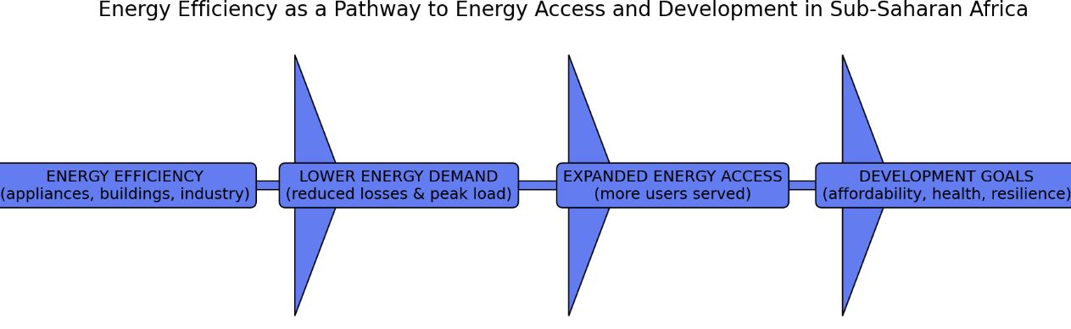
Fig 2 Energy efficiency pathway for expanding energy access in Sub-Saharan Africa
Figure Energy efficiency as a pathway to improving energy access and meeting development goals in Sub‑Saharan Africa. Energy efficiency interventions reduce electricity demand and system losses, freeing capacity within existing infrastructure [4]. This enables expanded energy access without proportional increases in generation capacity, while supporting broader development outcomes including affordability, public health, and economic resilience.
Energy Efficiency as a Demand‑Side Strategy for Expanding Energy Access
Energy efficiency can play a transformative role in increasing energy access in Sub‑Saharan Africa by enabling existing energy resources to serve a greater number of users. However, limited awareness of energy efficiency as an energy resource rather than merely a cost‑saving measure, continues to reinforce a supply‑side approach to addressing the region’s energy challenges [21]. This narrow focus constrains investment in demand‑side solutions that could rapidly and cost‑effectively expand access. Weak regulatory frameworks and governance challenges further undermine incentives for utilities, households, and businesses to invest in energy efficiency. In many countries, electricity tariffs are not cost‑reflective, reducing utility revenues and limiting the financial viability of efficiency programmes [22]. The introduction of cost‑reflective tariffs, alongside targeted lifeline tariffs for low‑income households, can improve utility sustainability while safeguarding electricity access for vulnerable populations [25]. Such tariff structures create stronger economic signals for both electricity conservation and investment in efficient technologies. Human‑capacity constraints represent another significant barrier. The shortage of trained local professionals able to design, install, and maintain energy‑efficient technologies limits the successful deployment of efficiency measures. Addressing this challenge requires sustained investment in workforce training, technical accreditation [26], and institutional capacity building to support long‑term market development. Financial barriers remain among the most critical obstacles to energy efficiency adoption. Many commercial and industrial enterprises, as well as households, face restricted access to affordable financing for energy efficiency investments [18]. Energy‑efficient technologies often involve higher upfront costs compared to conventional alternatives, even though they deliver long‑term cost savings [8]. Perceived investment risks and limited familiarity with efficiency-related business models make financial institutions reluctant to provide credit for such projects [27]. Expanding access to low‑interest loans, credit guarantees, performance‑based financing, and innovative mechanisms such as pay‑as‑you‑save models can significantly improve uptake. Informational barriers further constrain adoption. Awareness of the benefits, availability, and performance of energy‑efficient technologies remains limited among consumers and businesses [28]. In many cases, reliable and accessible information on energy savings, lifecycle costs, and product performance is insufficient or poorly communicated, undermining confidence in efficiency investments. Finally, policy and institutional gaps persist across much of Sub‑Saharan Africa [29]. Many countries lack comprehensive energy efficiency policies, including minimum energy performance standards, labelling schemes, and fiscal incentives to encourage adoption. Where such policies exist, enforcement is often weak due to limited institutional capacity and resources. Strengthening governance structures and integrating energy efficiency into national energy strategies are therefore essential to unlock its full potential as a scalable pathway for expanding energy access [30].
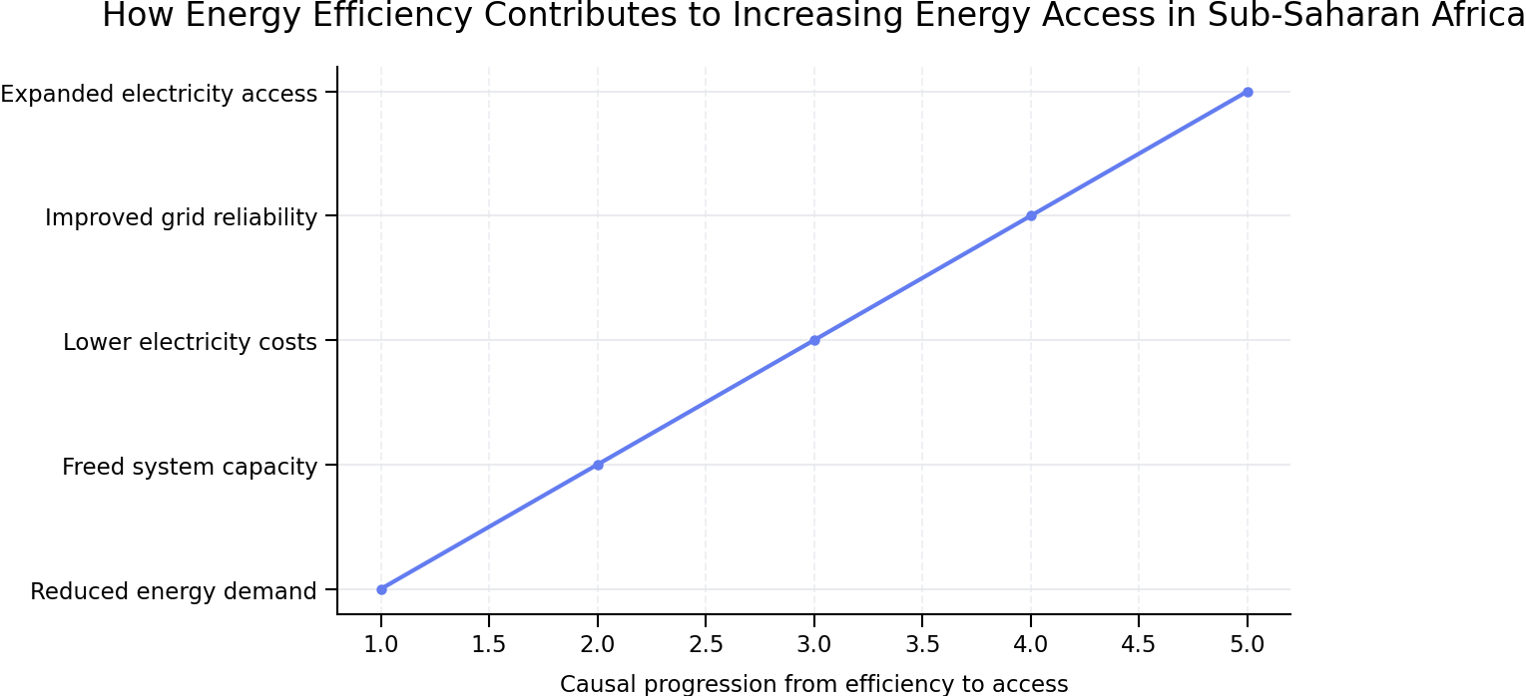
Fig 3 Energy efficiency casual mechanism
Figure above illustrates the causal mechanisms through which energy efficiency enables expanded electricity access by reducing demand, freeing system capacity, and improving affordability and grid reliability.
Barriers to Energy Efficiency Deployment in Sub‑Saharan Africa
Energy efficiency deployment in Sub‑Saharan Africa is constrained by a combination of real and perceived barriers that limit its uptake across residential, commercial, and industrial sectors. Among the most prominent challenges is a widespread lack of information and market understanding regarding energy efficiency as a strategic energy resource [31]. These barriers are deeply interconnected and mutually reinforcing. Financial constraints limit investment in technical capacity, while weak regulatory frameworks undermine market confidence and information transparency [32]. Addressing these challenges therefore requires an integrated policy approach that combines financial mechanisms, institutional strengthening, technical training, and consumer awareness initiatives rather than isolated interventions [33]. In many contexts, limited awareness of the long‑term economic and system‑level benefits of energy efficiency reinforces a continued reliance on supply‑side solutions. Technical barriers remain significant throughout the region [13]. These include limited availability of appropriate equipment, infrastructure constraints, and a shortage of trained professionals capable of designing, installing, and maintaining energy‑efficient technologies and systems [2]. The lack of technical capacity hampers both project implementation and the enforcement of energy efficiency standards. Financial barriers represent one of the most critical obstacles to scaling energy efficiency [34]. High upfront investment costs discourage households and businesses from adopting efficient technologies, even when lifecycle savings are substantial [36]. Although some progress has been made through bulk procurement programmes and demand aggregation mechanisms, perceived investment risks continue to deter financing for energy efficiency projects [16]. Access to affordable credit remains limited, particularly for small businesses and low‑income households. Market and institutional barriers further constrain adoption. Energy‑efficient products are often poorly differentiated from inefficient alternatives, while competition from unregulated used or low‑quality appliance markets undermine confidence in efficient technologies [35]. Underdeveloped supply chains increase costs and lead times, while concerns regarding counterfeit or substandard products contribute to socio-economic factors also play a critical role in limiting energy efficiency adoption [37]. High levels of poverty and economic instability mean that short‑term affordability often takes precedence over long‑term efficiency investments [46]. Cultural practices and resistance to behavioural change can further slow adoption [20]. In addition, the diverse climatic conditions across Sub‑Saharan Africa require locally adapted energy efficiency solutions, particularly for cooling and heating needs. Policy and regulatory challenges remain pervasive [38]. Many countries lack comprehensive energy efficiency frameworks, including minimum energy performance standards, product labelling schemes, and fiscal incentives [9]. Where such policies exist, weak enforcement capacity often limits their effectiveness [5]. Environmental degradation and climate‑related disruptions can also affect infrastructure and project continuity [39]. Despite these challenges, targeted interventions can significantly reduce barriers to energy efficiency deployment [47]. Governments and international partners can facilitate adoption through subsidies, concessional financing, pay‑as‑you‑go models, and innovative instruments such as green bonds [40]. Public awareness campaigns and consumer education initiatives can improve understanding of efficiency benefits [6], while technical training programmes can strengthen local capacity and create a skilled workforce [7]. Strengthening policy frameworks, supporting local manufacturing and distribution, and implementing quality assurance mechanisms can further enhance market confidence and adoption rates [8]. By addressing financial, informational, technical, and policy‑related barriers, Sub‑Saharan Africa can unlock the full potential of energy efficiency as a pathway to improved energy access, reduced costs, and sustainable development [10].
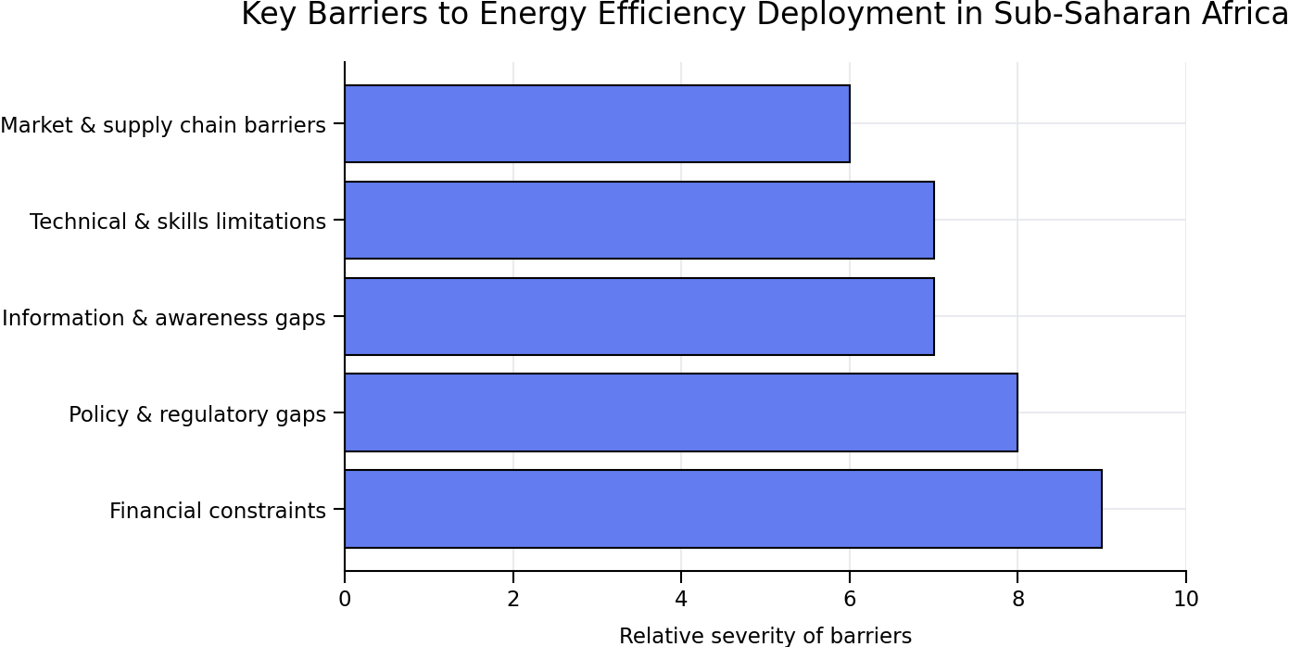
Figure 4 Key barriers to energy efficiency deployment in Sub‑Saharan Africa.
Financial constraints and regulatory gaps are the most severe barriers limiting the uptake of energy efficiency measures in Sub‑Saharan Africa, followed by information, technical, and market‑related challenges. Addressing these barriers is essential for enabling energy efficiency to contribute effectively to expanded energy access and sustainable development.

Energy Efficiency Solutions for Expanding Energy Access
Energy efficiency solutions play a central role in addressing energy access challenges in Sub‑Saharan Africa by reducing energy demand, lowering costs, and maximising the use of limited energy resources [11]. These solutions are particularly important in contexts where expanding supply alone is constrained by financial, technical, and infrastructural limitations [45]. At the household level, the adoption of efficient cookstoves and clean cooking technologies can significantly reduce fuel consumption and indoor air pollution, delivering substantial health and environmental benefits [41]. Clean cooking solutions lower reliance on traditional biomass fuels while improving energy efficiency and household well‑being [44]. In parallel, small‑scale solar home systems provide efficient electricity for lighting and charging essential appliances, reducing dependence on kerosene and disposable batteries and improving energy access for off‑grid and remote communities [12]. Lighting and appliance efficiency represent some of the most immediate and cost‑effective interventions [42]. Transitioning to LED lighting reduces electricity consumption in households, businesses, and public buildings, while energy‑efficient appliances such as refrigerators, fans, and air conditioners lower overall electricity demand without compromising service levels [13]. In the built environment, energy‑efficient building designs, improved insulation, and passive cooling strategies reduce the need for active heating and cooling, leading to long‑term energy savings [43]. In productive sectors, industrial energy efficiency upgrades, including high‑efficiency motors, process optimisation, and waste‑heat recovery, can significantly reduce operational costs and electricity consumption, enhancing competitiveness and productivity [14]. In agriculture, efficient irrigation systems and solar‑powered water pumps improve energy use efficiency while supporting food security and rural livelihoods [15]. System‑level solutions further amplify the impacts of end‑use efficiency. Decentralised renewable energy systems, when combined with efficient appliances, enable reliable and affordable electricity supply for off‑grid communities. Smart grids and advanced metering infrastructure improve electricity distribution, reduce technical and commercial losses, and empower consumers to manage their energy use more effectively [16]. Policy and financing mechanisms are critical enablers of these solutions. Pay‑as‑you‑go business models, micro‑finance schemes, subsidies, and tax incentives can lower entry barriers for low‑income households and small businesses, particularly for solar home systems and efficient appliances [17]. Governments can also implement programmes to retrofit public buildings with efficient lighting and appliances, achieving cost savings that can be reinvested in expanding energy access. More broadly, the enforcement of building codes, minimum energy performance standards, and appliance labelling schemes, alongside workforce training and public awareness campaigns, is essential for scaling energy efficiency across all sectors [18], By reducing energy waste, lowering peak demand, and improving system reliability, energy efficiency enables existing infrastructure to serve more users, reduces electricity bills for households, and limits the need for expensive and polluting generation capacity [19]. When combined with renewable energy technologies, energy efficiency provides a scalable, affordable, and sustainable pathway to expanding energy access, supporting economic growth, job creation, and long‑term development in Sub‑Saharan Africa [20].
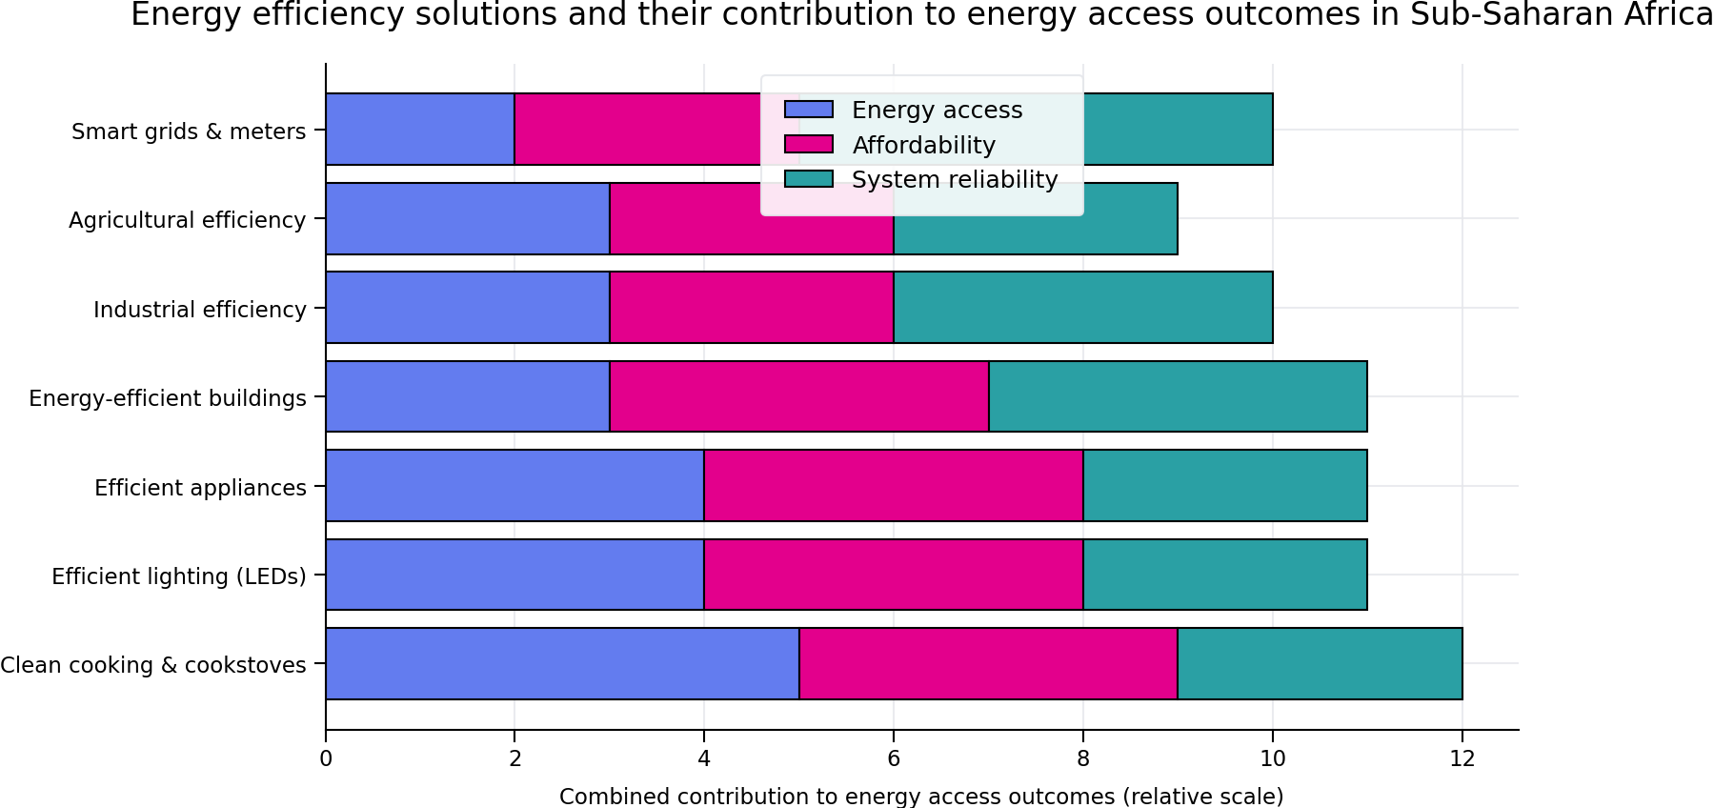
Figure 5 Key energy efficiency solutions supporting energy access in Sub‑Saharan Africa
CONCLUSION
Energy efficiency represents one of the most cost‑effective and scalable pathways for expanding energy access in Sub‑Saharan Africa while reducing the need for capital‑intensive supply‑side infrastructure. Despite recent gains in electrification, between 565 and 600 million people in the region remained without access to electricity in 2023, accounting for most of the global access deficit. Rapid population growth continues to offset new connections, reinforcing the importance of demand‑side strategies alongside generation expansion. Energy efficiency delivers substantial system-level benefits in this context. By reducing energy waste, peak demand, and system losses, efficiency measures enable existing infrastructure to serve a greater number of users at significantly lower cost than new generation capacity. International evidence consistently identifies energy efficiency as the fastest and least-cost option for moderating energy demand growth, particularly in regions facing financial and institutional constraints. Although Sub-Saharan Africa currently contributes a small share of global energy-related emissions, efficiency measures help prevent emissions lock-in while enhancing resilience to climate impacts. Improvements in efficiency also reduce household energy expenditures, enhance industrial competitiveness, and improve public health outcomes. Beyond access expansion, energy efficiency supports broader economic and environmental objectives. Although Sub-Saharan Africa currently contributes a small share of global energy-related emissions, efficiency measures help prevent emissions lock-in while enhancing resilience to climate impacts. Improvements in efficiency also reduce household energy expenditures, enhance industrial competitiveness, and improve public health outcomes. Despite its clear benefits, investment in energy efficiency in Sub-Saharan Africa remains insufficient due to persistent financial, regulatory, and capacity-related barriers. Targeted policy interventions, including cost-reflective tariffs with social protection mechanisms, minimum energy performance standards, innovative financing instruments, and workforce development programmes are essential to unlocking this potential. Overall, integrating energy efficiency into national energy access and electrification strategies provides a resilient, economically sound, and sustainable pathway to narrowing the region’s energy access gap. Prioritising efficiency alongside renewable energy deployment can enable millions more people to benefit from modern energy services while supporting long-term development and sustainability goal

REFERENCES
1. Sandra Backlund et al. Extending the energy efficiency gap Energy Policy (2022).
2. Vesna Bukarica et al. Energy efficiency policy evaluation by moving from techno-economic towards whole society perspective on energy efficiency market Renewable and Sustainable Energy Reviews (2022)
3. Christopher A. Craig et al. Exploring utility organization electricity generation, residential electricity consumption, and energy efficiency: a climatic approach Appl. Energy (2021).
4. Ian M. Hoffman et al. Estimating the cost of saving electricity through U.S. utility customer-funded energy efficiency programs Energy Policy (2023).
5. I.B. Huang et al. multi-criteria decision analysis in environmental sciences: ten years of applications and trends Sci. Total Environ. (2020) J. Jeong et al. Development of a prediction model for the cost saving potentials in implementing the building energy efficiency rating certification Appl. Energy (2023).
7. N. Jollands et al. Policy packaging or policy patching? The development of complex energy efficiency policy mixes Energy Res. Social. Sci. (2020).
8. Ming-Jia Li et al. Review of methodologies and polices for evaluation of energy efficiency in high energy-consuming industry Appl. Energy (2021).
9. Fanyi Meng et al. Measuring China's regional energy and carbon emission efficiency with DEA models: a survey Appl. Energy (2023).
10. Godwing jug et al. Renewable energy and electricity incapacitation in sub-Sahara Africa: Analysis of a 100% renewable electrification in Chad 2023, Energy Reports.
11. olanguena erjuin et al. Urban domestic electricity consumption in relation to households’ lifestyles and energy behaviors in Burkina Faso: Findings from a large-scale, city-wide household survey 2023, Energy and Buildings.
12. birman, D. and orbin. Impacts of energy efficiency projects in developing countries: Evidence from a spatial difference-in-differences analysis in Malawi 2023, Energy for Sustainable Development.
13. Karekezi, S. and Kithyoma, W., 2020. ‘Renewable Energy Strategies for Rural Africa: is a PV-led renewable energy strategy the right approach for providing modern energy to the rural poor of sub-Saharan Africa?, Kenya.
14. Energy Policy, Vol. 30 Nos. 11-12, (2022) special issue – Africa: improving modern energy services for the poor. oxford: Elsevier science limited
15. Karekezi, S., and Ranja, T. 2020. renewable energy technologies in Africa. zed books and afrepren. Oxford, U.K.
16. Karekezi, S. and Turyareeba, P., 2022. renewable energy technologies: mini and micro |hydro power in Eastern and Southern Africa, AFREPREN, Nairobi, Kenya. Pp.2, 6-8
17. Kenya Engineer, 2023. ‘two wind turbines installed at Ngong’, Kenya engineer, Nairobi.
18. Kenya power and lighting company (KPLC) 2020. report And Accounts for the year ended 30th June 2000, Nairobi Kenya.
19. Linden, E., 2023. Namibia’s energy sector – a country review, Namibia’s economic policy research unit (NEPRU), Namibia.
20. Maarita, N. O., 2020. the impact of large-scale energy development on the poor: environmental and social economic in Africa.
21. economic Impact of a geothermal power plant on a poor rural Community in Kenya. Energy Policy, 2022. Elsevier Science, Oxford. U.K.
22. Maghazi, w., 2020. south Africa country proposal for renewables and energy for rural development theme group. Pretoria.
23. Mapiko, m. (2022). renewables and energy for rural development theme group: data and statistics compilation - Zimbabwe. African energy policy research network (Afrepren/Fwd), Nairobi.
24. Mbewe, a. (2021). renewables and energy for rural development theme group: data and statistics compilation - Zimbabwe. African energy policy research network (afrepren/fwd), Nairobi.
25.Mikulkas, m. Ribot, j., Maxson, p., 2022. Djibouti energy initiatives. national energy assessment, volunteers in technical assistance, via, USA.
26. Mosimanyane, M.T., Zhou. p and kgathi, D.L., 2020. renewable energy technologies in Botswana – the case of wind energy for water pumping. sei/afrepren/fwd, draft report.
27. Mwandosya, m. j. and Lubanga, M.L.P., 2023 energy resources flow and end use in Tanzania, Dar es salaam university press, Tanzania
28. national electricity regulator (near), 2020., national electricity regulator annual report 2000/2001. national electricity regulator, Sandton.
29. Razanajatovo, m., Juliette, y. and jean- louis, a., 2022. renewable energy technologies dissemination in Seychelles, afrepren/fwd, Nairobi, Kenya.
30. Sampa, r. c., 2021.’renewable energy technologies Dissemination in Zambia Paper Prepared for The First
31. regional rets workshop, 31may- 1 June 2020 Naivasha, Kenya, sei-afrepren/fwd, Nairobi, pp.14-15.
32. Sawe, E.N., 2020. issues in new and renewable sources of energy (nose) activities and policy formulation in Tanzania, ministry of water, energy and minerals, Dar es salaam, Tanzania, p.14.
33. stassen,2021. die regearing se rol in die ontwikkeling in implementing van alternatiewe hernubare energy one in south -Africa, M.phil. thesis, rand Afrikaans university, Johannesburg.
34. Smalera, a., Kamen, D.M., 2022. design and field testing of a savonius windpump in Kenya. Princeton University, Princeton.
35. Vanderhulst, p. Lanser, h., Bergmeyer, p., Albers, r., 2020. solar energy: small-scale applications in developing countries. tool, Amsterdam.
36. ward, r. f., Ashworth, j, h., burial, g., 2021. renewable energy technologies in Africa: an assessment of field experience and future directions. bureau for Africa/agency for international development. Washington.
37. Wahab working group, 2023vc a framework for action on energy – world summit on sustainable development, Johannesburg 2002
38. world bank,2020. African development indicators 2020. Washington dc: the world bank
39. Tefera, m. 2021 energy sector reform theme group: data and statistics compilation - Ethiopia. African energy policy research network (afrepren/fwd), Nairobi, Kenya.
40. world bank, 2020., rural energy and development- improving energy supplies for two billion people, world bank, Washington, dc.
41. Abramowski, j., Podolski, p., Simonis. p., Mueller, h., 2021. wind energy projects in Morocco and Namibia.
42. journal of energy in southern Africa. cape town. afrepren, 2022. afrepren occasional paper no. 10: renewable energy technologies in Africa. an energy training course handbook. Nairobi: afrepren/fwd
43. afrepren database, 2020. energy data reference handbook vi. African energy policy research network (afrepren/fwd), Nairobi, Kenya.
44. afrepren 2021. African energy data reference handbook: afrepren trimestral report, volume. iv.nairobi, Kenya.
45. BCSE, 2020. geothermal market assessment report, “the eastern Africa market assessment acceleration” geothermal conference agenda. Business Council for sustainable energy (BCSE), Washington, dc.
46. Bronicki. Ormat’s 2022 experience in implementing geothermal projects. the example of Olkaria international, Energy Management in Africa London: Zed Books and African Energy Policy.
47. Chiwaya, a., 2023. energy sector reform theme group: data and statistics compilation – Malawi. African energy

