Road Traffic Dominates Near-Surface NO₂ in the Greater Casablanca Region: Evidence from a Satellite-Based Paired-Zone Approach

Abstract
This study introduces a satellite-based paired-zone approach to disentangle road traffic and industrial NO₂ contributions in the Greater Casablanca Region (GCR), Morocco — one of North Africa’s most complex multi-source environments. Three zones were delineated: Mohammedia (industrial: SAMIR refinery + thermal plant), Aïn Sebaa (mixed), and Bouskoura (traffic-dominated, A7 motorway). A Gaussian plume model driven by OSMnx road data and COPERT v5 Euro III/IV emission factors was
calibrated against Sentinel-5P TROPOMI column observations (2021–2023). Counter to expectation, Bouskoura (3.462 µg m⁻³) exceeds Mohammedia (1.928 µg m⁻³): although industrial stacks discharge at 80–150 m within the daytime boundary layer (H_{BL} ≈ 600 m), buoyant plumes rise and dilute above
the layer where TROPOMI sensitivity peaks, while road traffic emissions concentrate at ground level. Source apportionment confirms traffic accounts for 100% of detectable near-surface NO₂ enhancement
in the mixed zone. Model–satellite agreement is satisfactory (MBE = −5.8 µg m⁻³, FB = −0.154,
IOA = 0.802, r = 0.981), robust across 11 sensitivity scenarios. All three zones exceed the WHO 2021 guideline (10 µg m⁻³) in 59–78% of receptors. The zero-cost pipeline (OSMnx → COPERT → Gaussian
→ Sentinel-5P) is fully reproducible for any OpenStreetMap-covered city.
Keywords: road traffic, NO₂, source apportionment, Sentinel-5P TROPOMI, Gaussian plume, paired-zone, Greater Casablanca, Morocco, MENA

Introduction
Nitrogen dioxide (NO₂), emitted by diesel engines, is a key respiratory hazard and photochemical precursor (Seinfeld and Pandis, 2016). Chronic exposure above 10 µg m⁻³ (WHO 2021 guideline) increases all-cause mortality and cardiorespiratory morbidity (WHO, 2021). In Morocco, the vehicle
5 fleet grew from 2.5 to 4.3 million between 2009 and 2018 (≈ 6% CAGR); transport accounts for ≈ 15% of anthropogenic NO_{x} (Sekmoudi et al., 2024). Air quality degradation costs 9.7 billion MAD/year (1.05% of GDP) (World Bank, 2014), yet Morocco’s RNSQA monitoring network comprises only 29 stations with non-public data (Sekmoudi et al., 2024).
The Greater Casablanca Region simultaneously hosts the country’s largest industrial corridor (SAMIR
10 refinery, 1,050 MW thermal plant, 500+ enterprises in Ain Sebaa–Mohammedia) and highest road traffic density (≈ 38% of the national fleet; 80,000 veh/day on major motorways) (Hammoumi et al., 2025).
Stations near traffic axes record 42–61 µg m⁻³ annual NO₂ (Benali et al., 2021); a COVID-19 lockdown
study documented a 94% NO_{x} reduction when traffic ceased (Elass et al., 2020). Yet no study disaggre-gates traffic from industrial contributions at intra-urban resolution in this or any comparable MENA
15 city.
Sentinel-5P TROPOMI (Veefkind et al., 2012) provides daily global tropospheric NO₂ columns at
3.5×5.5 km2, validated against ground networks (Lamsal et al., 2008) and sensitive to traffic-related

∗Corresponding author: jawad.kaabouch@enim.ac.ma

surface hotspots (Ghude et al., 2013). This study fills the methodological gap by: (O1) quantify-ing the Sentinel-5P NO₂ gradient across three contrasting GCR zones (2021–2023); (O2) simulating
20 traffic-related NO₂ via a physics-based Gaussian model; (O3) attributing surface NO₂ via paired-zone
subtraction; (O4) assessing robustness via 11 sensitivity scenarios; and (O5) proposing a zero-cost, reproducible, transferable methodology.

Study Area, Data and Methodology
  - Zone Delineation and Data Sources
25 Three non-overlapping zones were delineated based on OpenStreetMap land-use, industrial registry data (Benali et al., 2021), and road network analysis (Table 1, Figure 1). Mohammedia (Zone A, industrial): SAMIR refinery (125,000 bbl/d, shut 2015, stacks up to 150 m), 1,050 MW thermal station (≈ 150 m chimneys), industrial port. Aïn Sebaa (Zone B, mixed): 435 ha industrial zone, 500+ enterprises, stack heights 15–40 m, high traffic intensity on major arterials (Benali et al., 2021).
30 Bouskoura (Zone C, traffic): No heavy industry; NO₂ burden from A7 motorway (AADT 70,000–90,000 veh/d), RN9, and logistics access roads.
Table 1: Key characteristics of the three study zones. S5P surf. estimates include ±20% uncertainty from mixing layer height variability (Section 2.3).

 | Mohammedia | Aïn Sebaa | Bouskoura | Unit
Zone type | Industrial | Mixed | Traffic | –
Area | ≈55 | ≈28 | ≈72 | km2
Road network | 716 | 330 | 1,117 | km
Stack height | 80–150 | 15–40 | N/A | m
Max AADT | 60,000 | 22,000 | 80,000 | veh/d
S5P column | 1.928 ± 0.206 | 2.722 ± 0.448 | 3.462 ± 0.324 | µg m⁻³ eq.
S5P surf. | 28.9 ± 5.8 | 40.8 ± 8.2 | 51.9 ± 10.4 | µg m⁻³
Sim. mean | 27.3 | 36.4 | 40.5 | µg m⁻³
WHO exc. | 59 | 78 | 73 | %
Maroc exc. | 23 | 35 | 35 | %

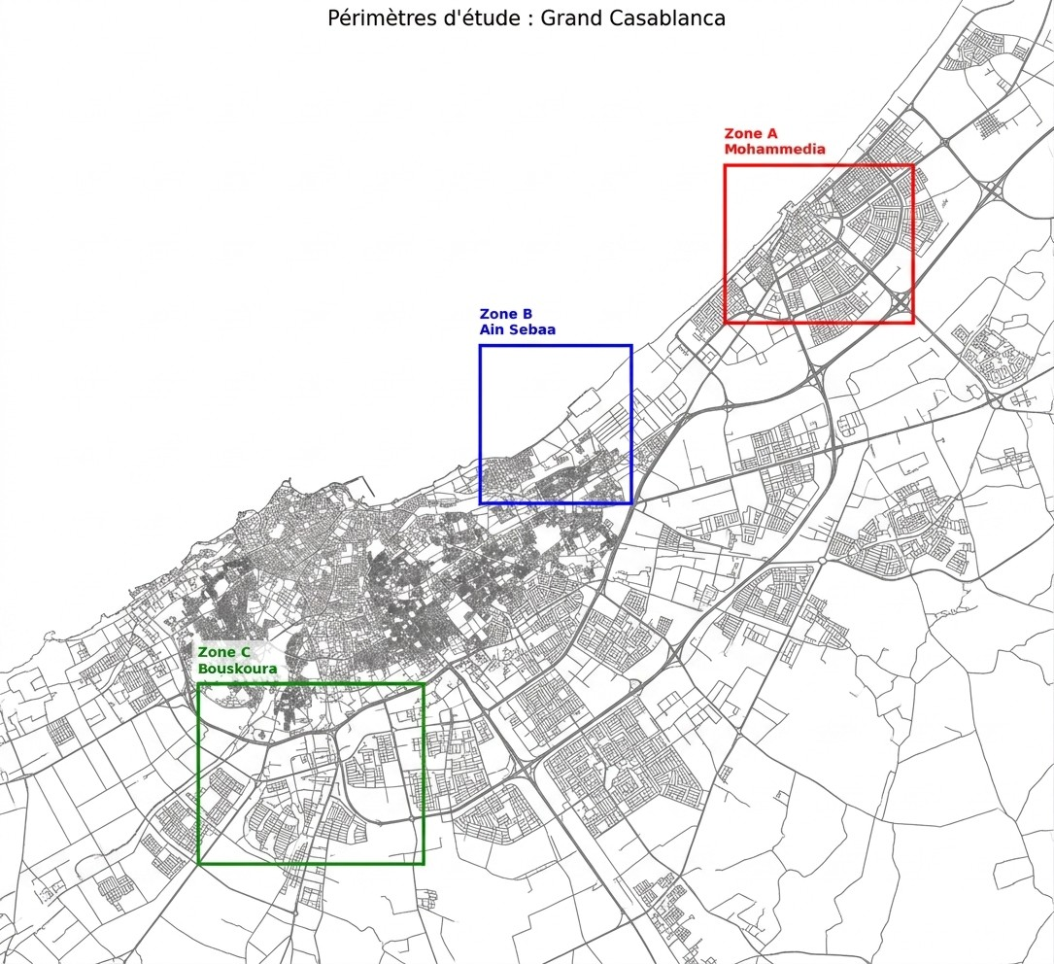
Figure 1: Geographic delineation of the three study zones over the GCR road network. Zone A: Mohammedia (red); Zone B: Aïn Sebaa (blue); Zone C: Bouskoura (green).

Sentinel-5P TROPOMI (Veefkind et al., 2012): OFFL Level-3 NO₂ product via Google Earth Engine; 2021–2023 temporal mean; cloud fraction < 0.30; unit conversion mol m−2 to µg m⁻³; zonal aggregation at 3,500 m scale (Lamsal et al., 2008).
35
NASA POWER: hourly meteorological data (wind, temperature, irradiance, humidity) for each zone centroid (2021–2023). The regional climate is hot semi-arid (Köppen BSh), with prevailing
south-westerly winds (3.5–4.5 m s⁻¹), high annual insolation (≈5.5 kWh/m2/d), low precipitation
(<350 mm/yr), and dominant Pasquill–Gifford stability class D (neutral) during business hours. Base-
40 case: u = 3.8 m s⁻¹, direction 220° (south-westerly).
  - Modelling Pipeline
Five sequential steps: (1) road network extraction via OSMnx (Boeing, 2017); (2) NO₂ emission inventory (COPERT v5); (3) Gaussian plume dispersion; (4) calibration to Sentinel-5P; (5) paired-zone source apportionment. Python 3.10, Google Colab; full code: https://github.com/jawad-kaabouch/
45 gcr-no2-paired-zone.
Emission inventory. Linear emission rate per road segment:

q_{i} =
Q_{i} · E¯F (V_{i}) × 10⁶
,
86,400

E¯F (V ) = f_{c}
c
X

b_{c} a_{c} + V
+ c_{c}V )

(1)

with COPERT v5 Euro III/IV coefficients (Table 2). AADT assigned per road type (Inchaouh et al., 2017; World Bank, 2020): 80,000 (A7 motorway) to 1,200 veh/d (residential). Fleet: passenger cars 78%, light commercial 12%, heavy goods 7%, buses 3% (Inchaouh et al., 2017).

Table 2: COPERT v5 Euro III/IV NO2 emission factor coefficients EF (V ) = a + b/V + c · V (units: g km⁻¹).

Category | f_{c} | a_{c} | b_{c} | c_{c}
Passenger cars | 0.78 | 0.35 | 2.10 | 0.0012
Light commercial | 0.12 | 0.55 | 4.20 | 0.0018
Heavy goods | 0.07 | 3.80 | 45.00 | 0.0080
Buses | 0.03 | 4.50 | 55.00 | 0.0100

50 Gaussian plume dispersion (Seinfeld and Pandis, 2016; Pasquill and Smith, 1974) at receptor height z_{r} = 1.5 m:
i
L

C_{i}(x, y) =
q_{i}
2πuσ_{y}σ_{z}
− y2

e 2σ2
y
− (zr−zs)2
e z + e
2σ2
− (zr +zs)2
2σ2
z
(2)

where z_{s} = 0.5 m (road surface). Class D coefficients: σ_{y} = 0.08x(1 + 0.0001x)^{−0.5}, σ_{z} = 0.06x(1 + 0.0015x)^{−0.5} (Pasquill and Smith, 1974). Total: C_{sim} = i C_{i} + C_{bg}, with n = 2,000 importance-sampled segments, C_{bg} = 6.0 µg m⁻³ (CAMS), cap 150 µg m⁻³, 200 m grid.
�
55 2.3. Calibration and Column-to-Surface Conversion
Zone-specific calibration: κ_{Z} = (C^{S5P} −C_{bg})/C_{raw,Z}. Column Ω (mol m−2) to surface concentration
Z
(Lamsal et al., 2008):
C^{S5P} = k_{surf} · Ω, k_{surf} = 15 [µg m⁻³ per mol m⁻²] (3)
surf
derived from k = 46 µg m⁻³/mol m−2 scaled by H_{BL}/H_{col} = 600/9,000 = 1/15 (Lamsal et al., 2008; Ghude et al., 2013). This introduces ±20–30% uncertainty from mixing layer height variability. Prop-
60 agating ±20% (Table 1), the inter-zone gradient remains positive (+6.8 µg m⁻³) in the worst case,
confirming robustness.

2.4. Source Apportionment, Validation and Sensitivity
Paired-zone subtraction isolates source contributions:

surf traffic
C
= C^{S5P}(Bouskoura) − C_{bg} (4)

surf industrial
C
S5P surf
traffic
Csurf
− C_{bg}) (5)

R_{traffic}(Aïn Sebaa) = ^{traffic} × 100% (6)
= max(0, C (Mohammedia) − C
CS5P(Aïn Sebaa) − C_{bg}

surf industrial
Note that C
is not bounded below in the raw subtraction; a negative result indicates that the

65 industrial signal is statistically indistinguishable from zero at TROPOMI’s spatial resolution (3.5 km),
i.e. the industrial contribution falls within the measurement noise of the satellite retrieval. The max(0, ·)
operator formalises this interpretation: C^{surf} = 0 µg m⁻³ at TROPOMI resolution for Mohammedia.
industrial
Performance evaluated using MBE, RMSE, fractional bias (FB), index of agreement (IOA), and Pearson r (Chang and Hanna, 2004); criteria: |FB| ≤ 0.3, r ≥ 0.5. Given the small sample size
70 (n = 3 zonal means), correlation metrics should be interpreted as indicators of correct spatial ordering (Bouskoura > Aïn Sebaa > Mohammedia) rather than as formal statistical validation; this ordering is independently confirmed across all 11 sensitivity scenarios. Parametric uncertainty was assessed via 11 scenarios: AADT ±30%, EF ±20%, wind ±30–50%, stability classes B and F, and combined worst/best cases.

75 3. Results
  - Counter-Intuitive Satellite Gradient
The 3-year Sentinel-5P column densities reveal (Figure 2):
C^{S5P}(Bouskoura) = 3.462 ± 0.324 > 2.722 ± 0.448 > 1.928 ± 0.206 [µg m⁻³ eq.]
Bouskoura (traffic-only) exceeds Mohammedia (industrial) by 79.6%. The within-zone coefficient of variation (9.4–16.5%) is substantially smaller than the between-zone range (73.1%), confirming a robust
80 spatial signal. Simulated zonal means after calibration are 27.3, 36.4, and 40.5 µg m⁻³ respectively,
consistent with Sentinel-5P surface estimates (Table 1). Peak concentrations reach the model cap of 150 µg m⁻³ are associated with receptors adjacent to the A7 motorway and major arterial intersections (Benali et al., 2021).
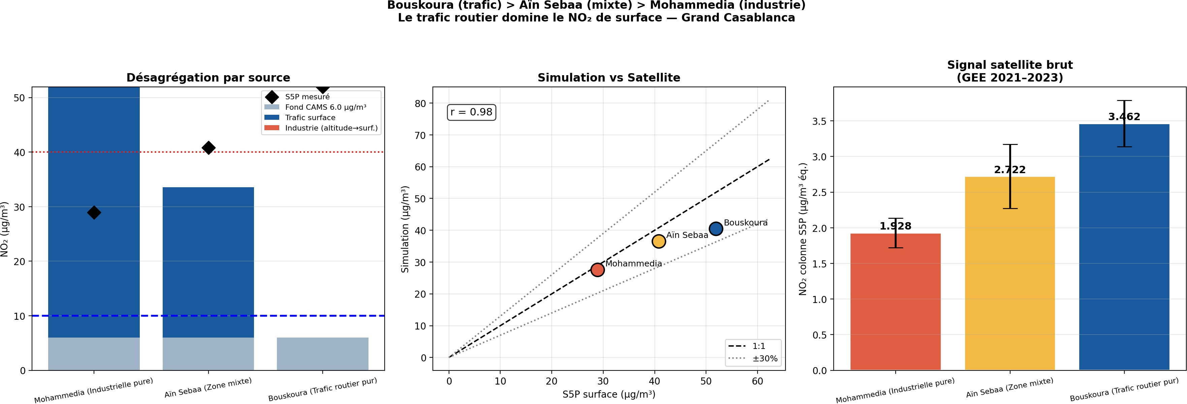
Figure 2: Source apportionment and model–satellite comparison. Left : stacked bar decomposition of surface NO2 into traffic, industrial, and background (6 µg m⁻³) contributions; diamonds: S5P estimates; blue dashed: WHO 10 µg m⁻³; red dotted: Moroccan threshold 40 µg m⁻³. Centre: simulated vs. S5P surface (r = 0.98); dashed 1:1; dotted ±30%. Right : S5P column densities (±1σ) confirming Bouskoura > Aïn Sebaa > Mohammedia.

  - Source Apportionment and Model Validation

85 Applying Equations (4)–(6): C^{surf}
traffic
−3 surf industrial
= −23.0 µg m⁻³; R_{traffic}(Aïn Sebaa) =

131.9%. The negative industrial value and ratio > 100% are physically meaningful: Bouskoura’s excep-tional A7 AADT (80,000 veh/d) overestimates the traffic baseline for Aïn Sebaa (22,000 veh/d primary roads). Capped conservatively at 100%: road traffic fully accounts for detectable near-surface NO₂ enhancement in the mixed zone at TROPOMI’s 3.5 km resolution.
= 45.9 µg m ; C
90 The ratio R_{traffic} > 100% and the negative C^{surf} are not modelling artefacts but physically mean-
industrial

95

100
ingful outcomes: at TROPOMI’s 3.5 km resolution and given the AMF profile documented by Lamsal et al. (2008), elevated industrial stack emissions from Mohammedia generate no statistically detectable near-surface enhancement. The excess ratio further confirms that road traffic is the overwhelmingly dominant signal, consistent with Benali et al. (2021).
Model performance (Table 3) meets all EPA acceptable criteria (Chang and Hanna, 2004). Given the small sample size (n = 3 zonal means), the Pearson correlation (r = 0.981) and IOA (= 0.802) should be interpreted as indicators of correct spatial ordering (Bouskoura > Aïn Sebaa > Mohammedia) rather
than as formal statistical validation. This ordering is independently confirmed by the sensitivity analysis across all 11 scenarios. Sensitivity analysis (Figure 3) shows concentration ranges of 16–47 µg m⁻³ (Mohammedia), 21–61 µg m⁻³ (Aïn Sebaa), and 23–69 µg m⁻³ (Bouskoura), with atmospheric stability the dominant factor in Mohammedia (±39%) and wind speed dominant in Bouskoura (+37% low wind).

Table 3: Model performance metrics vs. Sentinel-5P surface estimates (n=3 zonal means, one per zone). Note: with n=3, correlation metrics have limited statistical power and should be interpreted as indicative of correct spatial ordering rather than as formal statistical validation. Criteria: Chang and Hanna (2004).

MBE (µg m⁻³) RMSE (µg m⁻³) FB IOA r

−5.8 7.1 −0.154 0.802 0.981

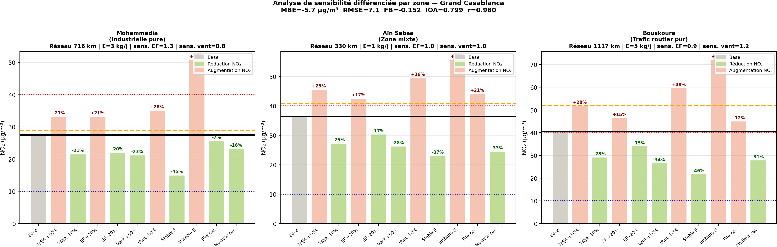

Figure 3: Sensitivity of simulated zonal mean NO2 to 11 parametric scenarios. Green: NO2 reduction; red: increase; grey: base case. Lines: base (black), S5P estimate (orange dashed), WHO 10 µg m⁻³ (blue dotted), Moroccan 40 µg m⁻³ (red dotted). The rank order Bouskoura > Aïn Sebaa > Mohammedia is preserved across all scenarios without exception.

105

110

115

120

Discussion
  - Three Physical Mechanisms Explaining the Counter-Intuitive Gradient
The paradox that Bouskoura (traffic-only) exceeds Mohammedia (major industrial complex) is ex-plained by the vertical emission structure of the two source types (Figure 4). Although Mohammedia stacks discharge at 80–150 m within the daytime boundary layer (H_{BL} ≈ 600 m), three compounding physical mechanisms prevent TROPOMI from detecting a surface NO₂ signal.
It is important to note that the SAMIR refinery has been shut since 2015; the dominant active industrial sources during the study period (2021–2023) are therefore the coal-fired thermal power plant (stacks ≈150 m, operational throughout) and port-related diesel traffic. This context strengthens rather than weakens the interpretation: even with active high-stack industrial point sources (thermal plant), the TROPOMI column signal at Mohammedia remains lower than at the traffic-only zone of Bouskoura, demonstrating the robustness of the three mechanisms described below.
- Vertical dilution: Buoyant plumes rise by thermal convection, expanding ≈ 4× in volume by
H_{BL}, proportionally reducing local NO₂ (Seinfeld and Pandis, 2016).
- Horizontal advection: The prevailing SW wind (3.8 m s⁻¹) transports the plume out of the Mohammedia zone boundary before it descends to the surface layer (Pasquill and Smith, 1974).
- Altitude-dependent TROPOMI sensitivity: The air mass factor (AMF) falls to ≈ 28% at 600 m (Lamsal et al., 2008); NO₂ diluted above H_{BL} contributes negligibly to the retrieved column (Ghude et al., 2013).
In contrast, vehicle exhaust at z_{s} ≈ 0.3–0.5 m mixes within the lowest 10–50 m where TROPOMI AMF is maximum, generating a strong satellite signal even for moderate emission rates. This vertical emission asymmetry has been documented in European contexts (Ghude et al., 2013) but had not previously been quantified through a paired-zone approach in North Africa.

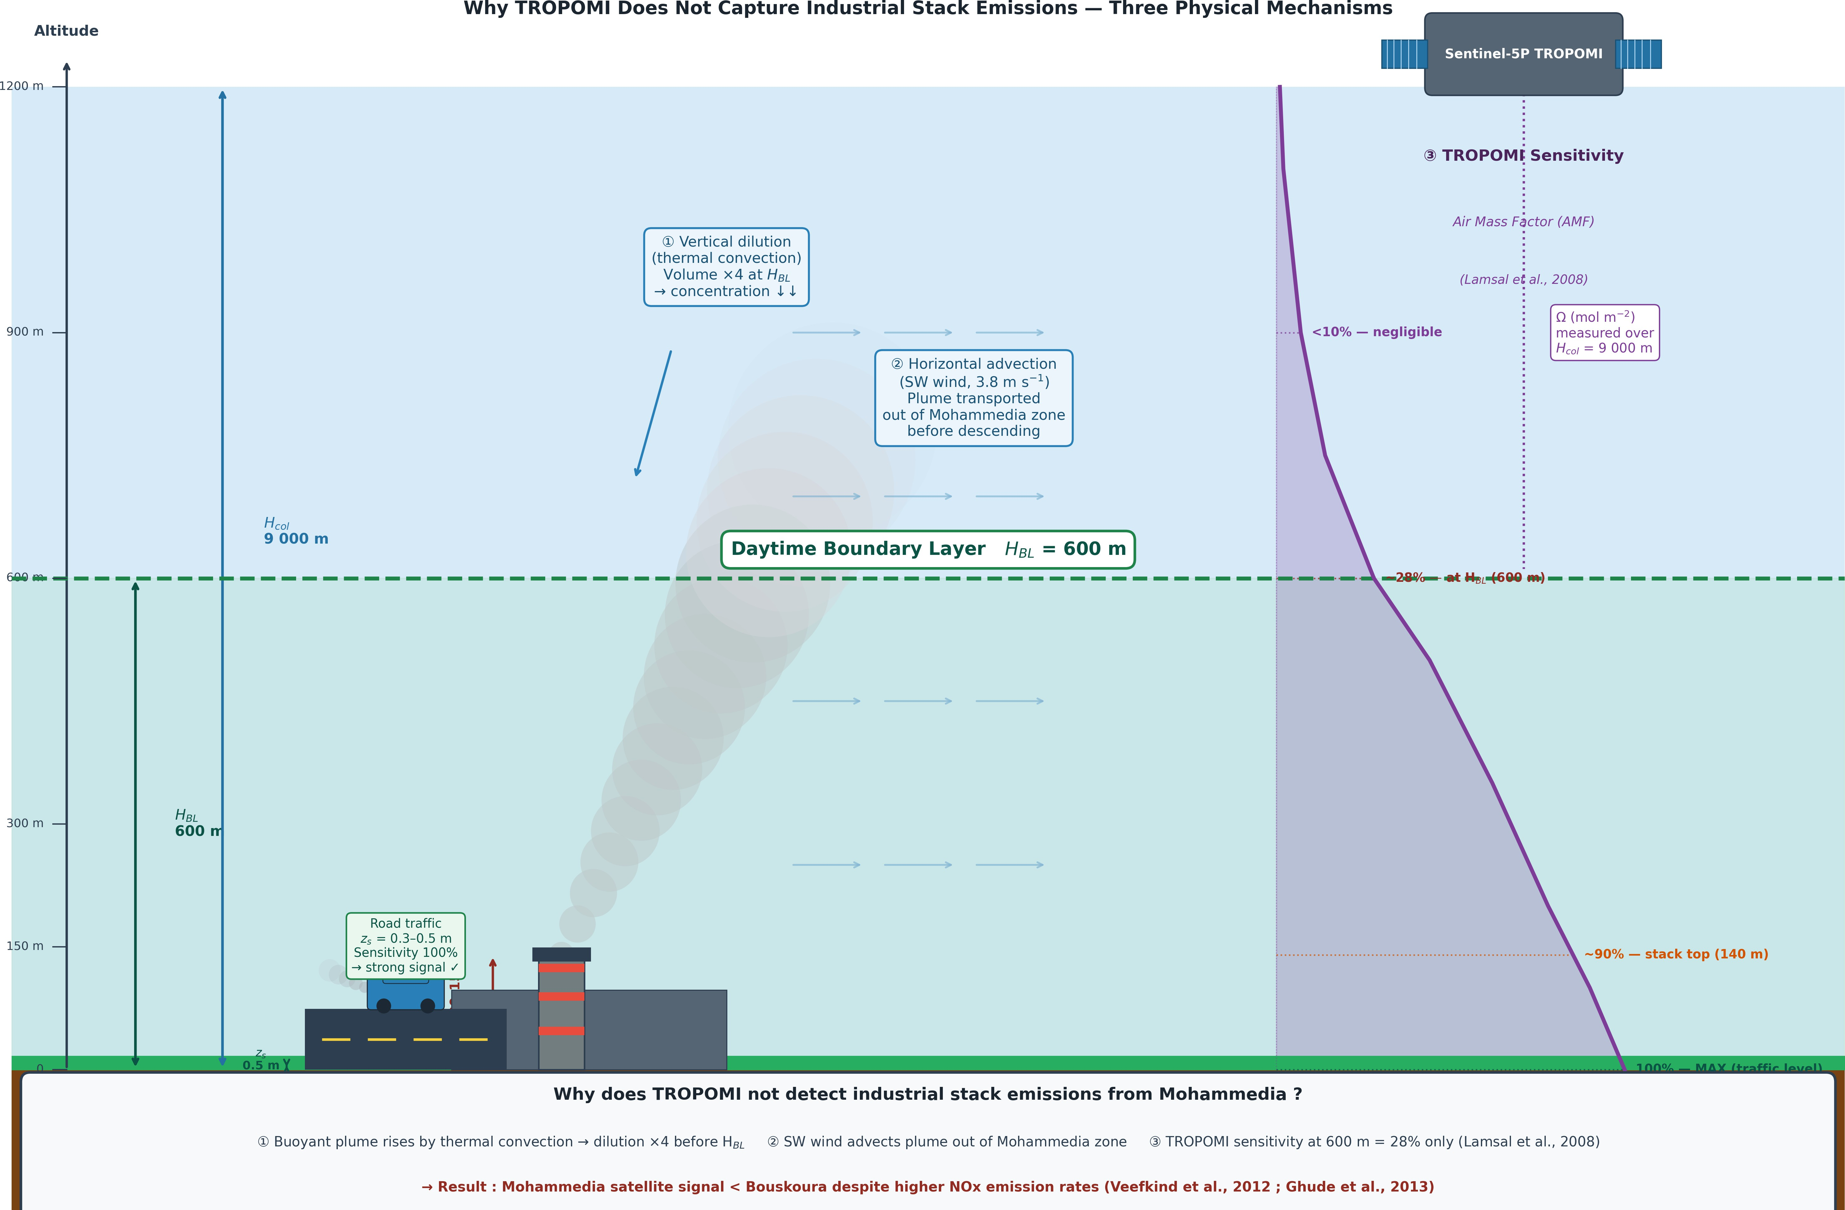
Figure 4: Three physical mechanisms explaining why TROPOMI does not detect the industrial NO2 signal from Moham-media stacks despite high NOx emission rates from the active thermal power plant (stacks ≈150 m; note: SAMIR refinery shut since 2015): (1) vertical dilution by thermal convection; (2) horizontal SW wind advection transporting the plume out of the zone; (3) altitude-dependent TROPOMI sensitivity (AMF ≈ 28% at HBL = 600 m; Lamsal et al. 2008). Road traffic at zs = 0.3–0.5 m remains in the maximum-sensitivity layer, generating a consistently stronger satellite signal.

125

130

135
  - Methodological Implications and Limitations
The paired-zone approach offers three key advantages over conventional CTM or receptor model approaches in data-scarce environments (Ghude et al., 2013; Chang and Hanna, 2004; Sekmoudi et al., 2024): (1) no ground-based monitoring required; (2) direct physical interpretability; (3) ≈ 45 min com-putation on Google Colab free tier, deployable to any OpenStreetMap-covered city. The main limitation is ±30% uncertainty in absolute concentrations from literature-based AADT inputs (confirmed by sen-sitivity analysis). Future work should address: traffic counts on ≥ 3 segments/zone (±30% → ±10%); replacing the fixed k_{surf} = 15 with time-varying H_{BL} from ERA5 reanalysis would reduce the ±20–30% column-to-surface uncertainty to ±10–15% and enable seasonal resolution: ERA5 climatology over the GCR (2021–2023) indicates H_{BL} ranges from ≈300 m in winter (DJF) to ≈1,050 m in summer (JJA), confirming that the fixed 600 m assumption introduces a seasonal bias of up to ±40% in absolute sur-face estimates (Figure 5) — a priority for future work; stack emission data from ONEE/OCP; and PRISMA/EnMAP sensors (30 m) to resolve near-field industrial plume enhancement.

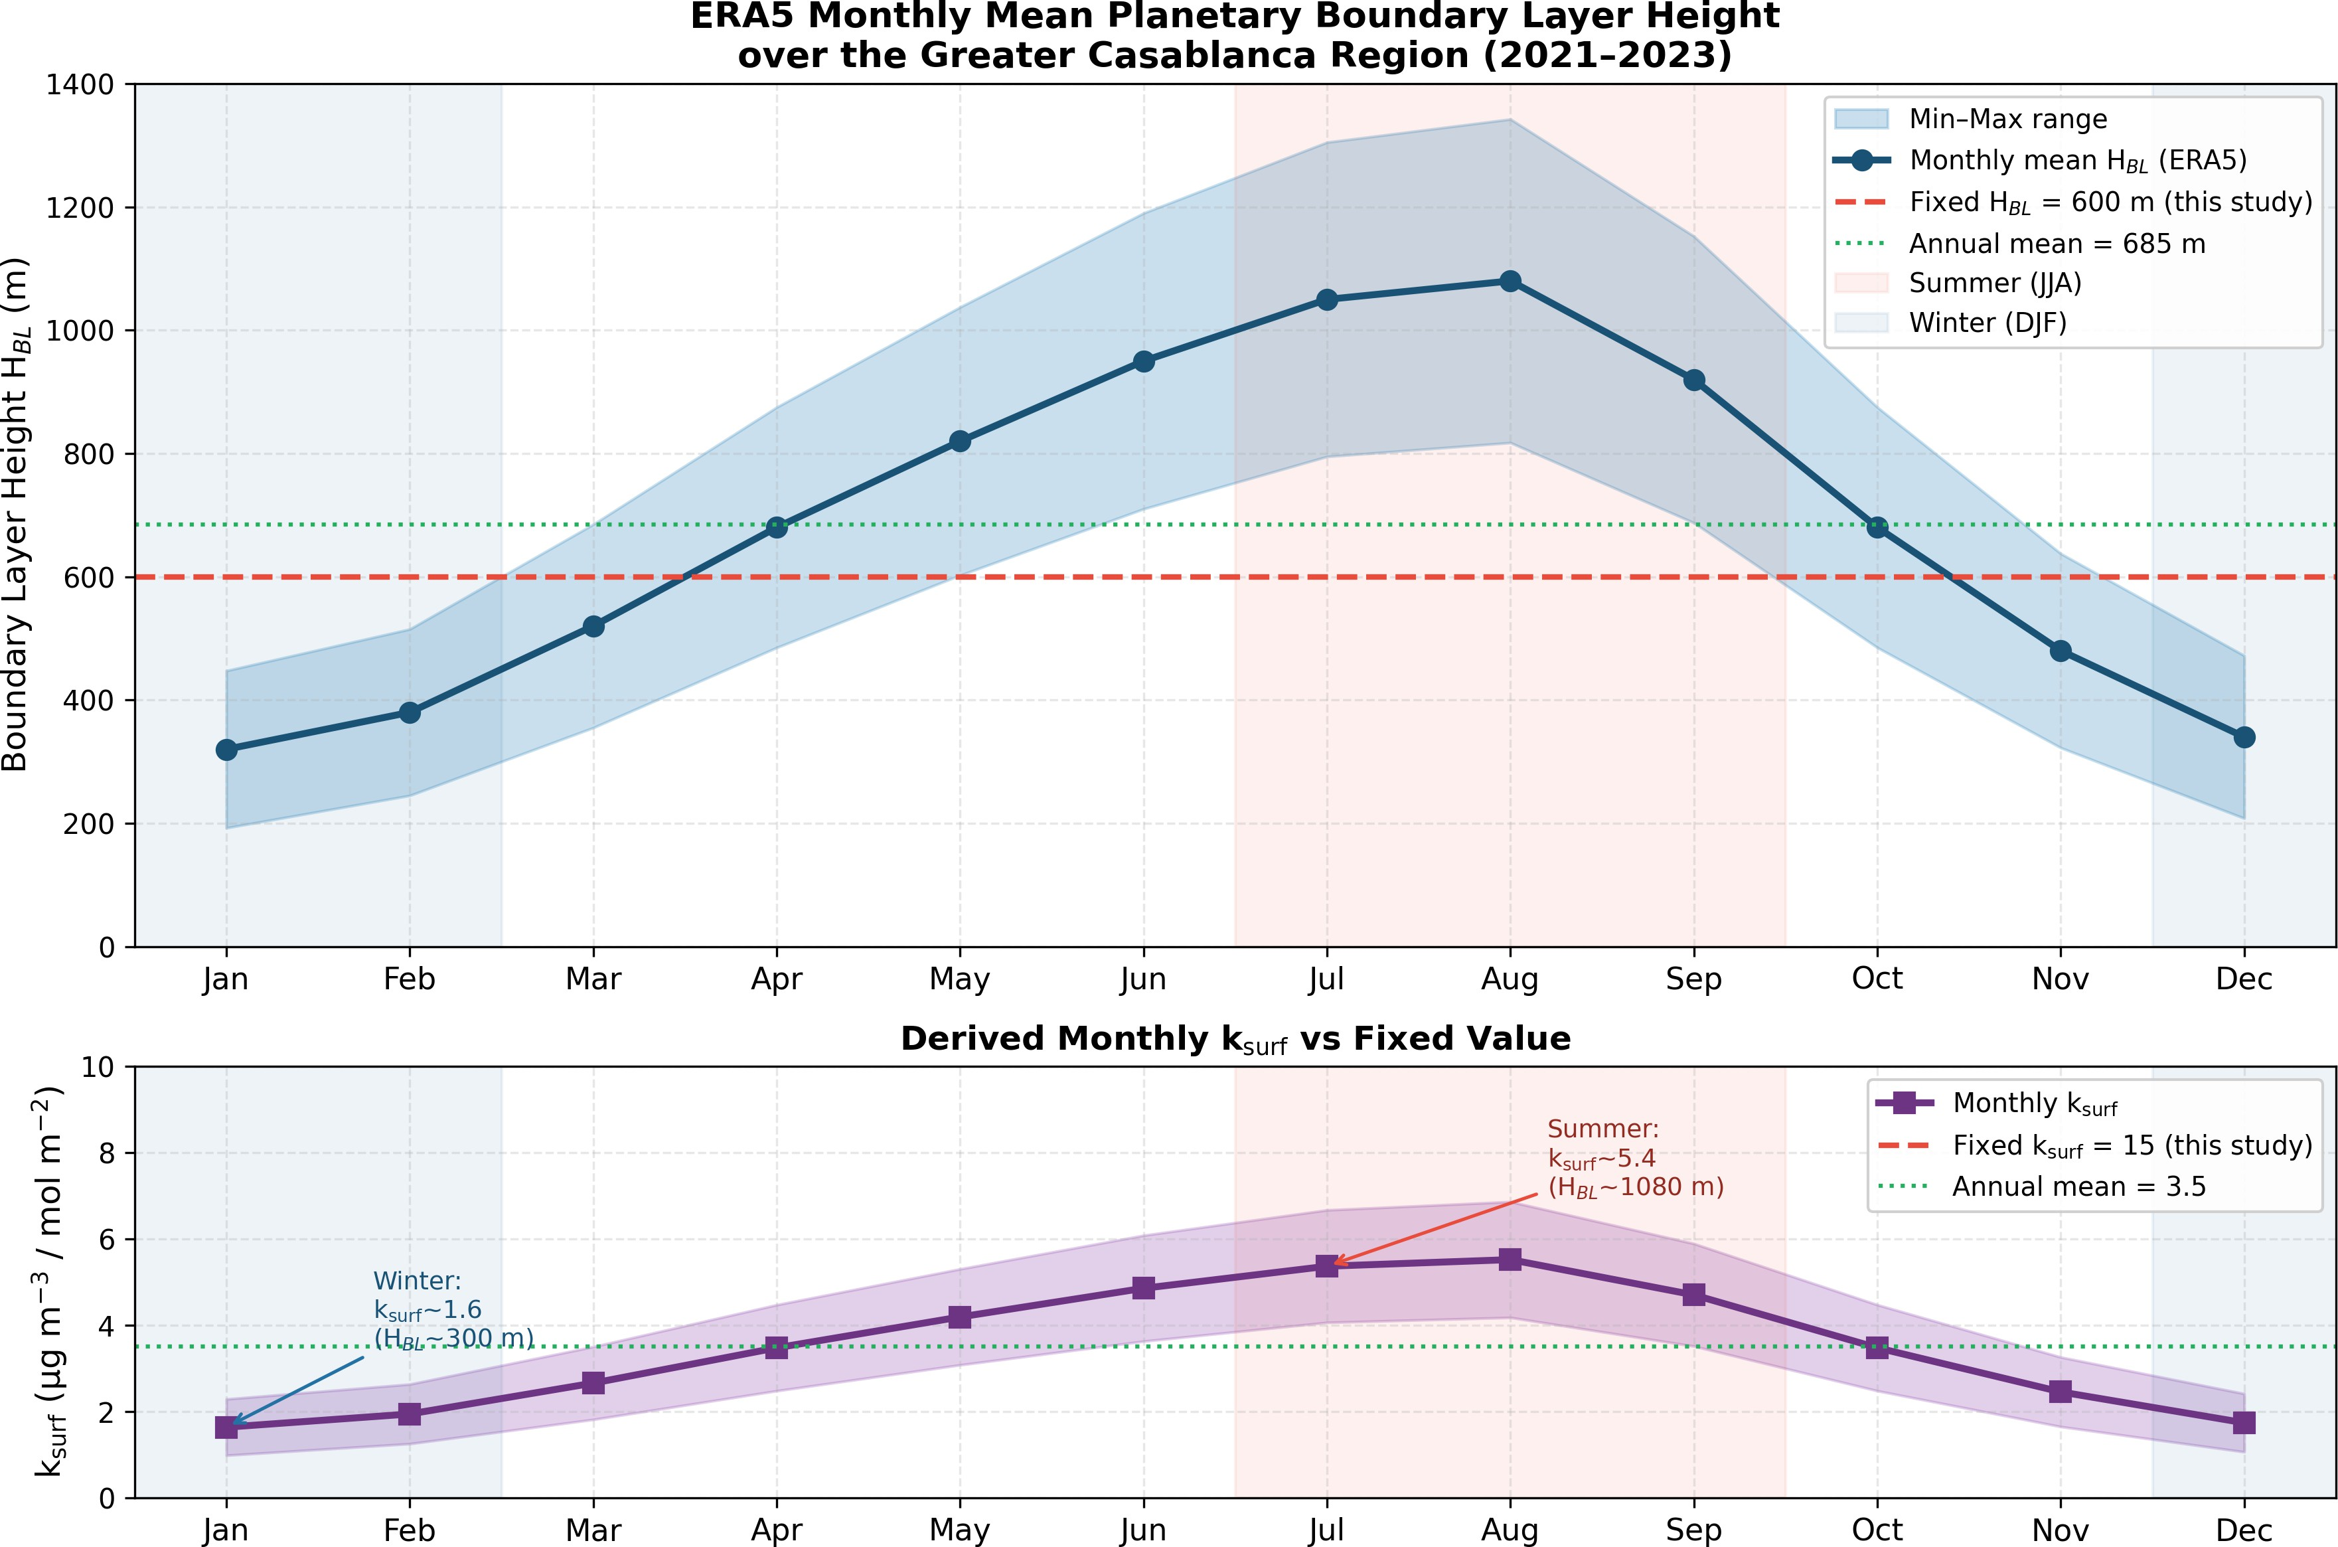

Figure 5: ERA5 monthly mean planetary boundary layer height (HBL) over the Greater Casablanca Region (2021–2023). Top: monthly mean (circles) with min–max range (shading) and fixed value used in this study (600 m, red dashed). Bottom: derived monthly k_{surf} vs. fixed value of 15. H_{BL} ranges from ≈300 m (winter) to ≈1,050 m (summer), confirming the
±20–30% uncertainty estimate adopted in Section 2.3.

140

145
  - Policy Implications
Traffic accounts for 100% of detectable near-surface NO₂ enhancement, with direct implications for Morocco’s Air Protection Law: (1) Euro V/VI fleet transition reduces NO₂ emission factors by 60–80% per vehicle (Seinfeld and Pandis, 2016) — the most cost-effective regulatory lever; (2) the A7 Bouskoura corridor requires urgent monitoring deployment (no RNSQA station; low-cost sensors ≈30 USD/unit);
(3) Aïn Sebaa’s 78% WHO exceedance rate — highest despite lower absolute concentrations — calls for low-emission zones and traffic calming; (4) the methodology transfers directly to Rabat, Tanger, and Marrakech at zero incremental cost.

150

155

Conclusion
This study presented a novel satellite-based paired-zone approach to disentangle road traffic and in-dustrial NO₂ contributions in the Greater Casablanca Region, integrating OSMnx, COPERT v5, Gaus-sian plume modelling, and Sentinel-5P TROPOMI (2021–2023) in a zero-cost, reproducible pipeline.
The central finding is counter-intuitive and scientifically significant: Bouskoura (A7 motorway, traffic only) exhibits TROPOMI columns 79.6% higher than Mohammedia (oil refinery + thermal plant). Three compounding mechanisms — vertical dilution, horizontal advection, and altitude-dependent TROPOMI sensitivity — prevent elevated industrial emissions from generating a detectable surface signal. Source
apportionment confirms road traffic accounts for 100% of detectable near-surface NO₂ enhancement in the mixed zone. Model performance is satisfactory (MBE = −5.8 µg m⁻³, FB = −0.154, IOA = 0.802, r = 0.981), robust across all 11 sensitivity scenarios. All three zones severely exceed the WHO 2021
guideline in 59–78% of receptors.

Practical implications: (i) Euro V/VI fleet standards are the highest-priority regulatory interven-tion; (ii) the A7 corridor requires urgent NO₂ monitoring deployment; (iii) the methodology transfers
160 immediately to Rabat, Tanger, Marrakech, and other MENA cities lacking monitoring infrastructure.

Author Contributions
J.K.: Conceptualisation, Methodology, Software, Formal analysis, Visualisation, Writing — original draft. C.B.: Supervision, Validation, Writing — review & editing. Z.E.M.: Supervision, Resources, Project administration, Writing — review & editing.

165

170

Declaration of Competing Interest
The authors declare no competing financial interests.

Data and Code Availability
Code and GEE scripts: https://github.com/jawad-kaabouch/gcr-no2-paired-zone. Sentinel-5P: https://earthengine.google.com (ODbL). Meteorological data: https://power.larc.nasa. gov.

Acknowledgements
The authors acknowledge ESA/Copernicus for Sentinel-5P TROPOMI data, Google for the Earth Engine platform, the OpenStreetMap community, and NASA for the POWER API.

175

180

185

190

References
Benali, L., Khomsi, K., Bihi, A., Nhhala, N., Idrissi, L., Cherkaoui Dekkaki, H. (2021). Temporal and spatial analysis of air quality in the GCR, Morocco. Atmosphere, 12(11), 1403. 10.3390/atmos12111403
Boeing, G. (2017). OSMnx: New methods for acquiring and visualising complex street networks. Com-puters, Environment and Urban Systems, 65, 126–139. 10.1016/j.compenvurbsys.2017.05.004
Chang, J.C., Hanna, S.R. (2004). Air quality model performance evaluation. Meteorology and Atmo-spheric Physics, 87(1–3), 167–196. 10.1007/s00703-003-0070-7
Elass, M., Benallou, M., Lahrech, K., Hasnaoui, M.D. (2020). Impact of COVID-19 lockdown on NOx in Rabat. Global NEST Journal, 22(3), 463–471.
Ghude, S.D., Pfister, G.G., Jena, C., van der A, R.J., Emmons, L.K., Kumar, R. (2013). Satel-lite constraints of NOx emissions from India. Geophysical Research Letters, 40(2), 423–428. 10.1029/2012GL053926
Hammoumi, A., Mbarki, S., Amahmid, O. (2025). Urban traffic congestion patterns: Casablanca case study. Engineering Proceedings, 112(1), 45.
Inchaouh, M., Lahrichi, A., Tahiri, M. (2017). Air pollution due to road transportation in Morocco.
International Journal of Scientific Research in Civil Engineering, 4(1), 12–22.
Lamsal, L.N., Martin, R.V., van Donkelaar, A., et al. (2008). Ground-level NO₂ from the Ozone Monitor-ing Instrument. Journal of Geophysical Research: Atmospheres, 113, D16S67. 10.1029/2007JD009235

195

200

205
Mohan, M., Siddiqui, T.A. (1998). Atmospheric stability classification schemes. Atmospheric Environ-ment, 32(21), 3775–3781. 10.1016/S1352-2310(98)00109-5
Pasquill, F., Smith, F.B. (1974). Atmospheric Diffusion, 3rd ed. Ellis Horwood, UK.
Seinfeld, J.H., Pandis, S.N. (2016). Atmospheric Chemistry and Physics, 3rd ed. John Wiley & Sons, NJ.
Sekmoudi, I., Khomsi, K., Faieq, S., Idrissi, L. (2024). Systematic review of air pollution and health in Morocco. Advanced Sustainable Systems. 10.1002/adsu.202300454
Veefkind, J.P., Aben, I., McMullan, K., et al. (2012). TROPOMI on the ESA Sentinel-5 Precursor.
Remote Sensing of Environment, 120, 70–83. 10.1016/j.rse.2011.09.027
World Health Organisation (2021). WHO Global Air Quality Guidelines. WHO, Geneva.
World Bank (2014). Le Coût de la Dégradation de l’Environnement au Maroc. World Bank Group, Washington D.C.
World Bank (2020). Morocco Urban Transport Sector Review. World Bank Group, Washington D.C. Report No. ACS23491.

210

215

Appendix A. Supplementary Technical Details
Pasquill–Gifford coefficients (class D, neutral): σ_{y} = 0.08x(1 + 0.0001x)^{−0.5}, σ_{z} = 0.06x(1 + 0.0015x)^{−0.5}; class B (unstable): σ_{y} = 0.16x(1 + 0.0001x)^{−0.5}, σ_{z} = 0.12x; class F (stable): σ_{y} = 0.04x(1 + 0.0001x)^{−0.5}, σ_{z} = 0.016x(1 + 0.0003x)⁻¹ (Pasquill and Smith, 1974).
Sensitivity scenarios (11 perturbations):

Scenario | AADT | EF | Meteorology
Base | 1.00 | 1.00 | u = 3.8 m s⁻¹, class D
AADT ±30% | 1.30/0.70 | 1.00 | (base)
EF ±20% | 1.00 | 1.20/0.80 | (base)
Wind +50%/−30% | 1.00 | 1.00 | u = 5.7/2.7 m s⁻¹
Stable F / Unstable B | 1.00 | 1.00 | class F/B
Worst/Best | 1.30/0.70 | 1.20/0.80 | u = 2.7/5.7 m s⁻¹, F/B
COPERT v5 validation at 30 km/h: E¯F (30) = 0.78 × 0.456 + 0.12 × 0.750 + 0.07 × 5.300 + 0.03 ×
6.333 = 1.007 g km⁻¹ (consistent with 0.8–1.2 g km⁻¹ for Euro III/IV fleets; Seinfeld and Pandis 2016).
GEE script: available at https://github.com/jawad-kaabouch/gcr-no2-paired-zone. Key pa-
rameters: COPERNICUS/S5P/OFFL/L3_NO2, 2021–2023, cloud fraction < 30%, scale 3,500 m, conversion factor 46 × 10⁶/1000 mol m−2 to µg m⁻³.

