Molecular Epidemiology and Virulence Profiling of Escherichia coli from Cattle Carcasses and Slaughterhouse Environments in Abuja, Nigeria
Authors: Chinwe E. Okoli^{1*}, Nicholas N. Pilau² and Kennedy F. Chah³
¹Department of Veterinary Public Health and Preventive Medicine, Faculty of Veterinary Medicine, University of Abuja, Abuja 900109, Federal Capital Territory, Nigeria
² Department of Medicine, Faculty of Veterinary Medicine, Usmanu Danfodiyo University, Sokoto, Nigeria.
³Department of Veterinary Microbiology and Immunology, University of Nigeria, Nsukka, Enugu State, Nigeria

ABSTRACT
This study investigated the molecular characteristics, virulence gene profiles, phylogroup distribution, and genetic relatedness of Escherichia coli isolated from cattle carcasses and slaughterhouse environments in Abuja, Nigeria. A total of 540 swab samples were collected from processed carcasses and meat-contact surfaces, including butchers’ hands, knives, wheelbarrows, kill floors, washing water, and effluent, at a government-owned Gwagwalada slaughterhouse (n = 340) and a privately owned Dei-Dei slaughterhouse (n = 200). Standard microbiological methods were used for isolation and identification. Overall, 105 confirmed E. coli isolates were recovered, yielding a prevalence of 19.4% (18.5% in Gwagwalada and 21.0% in Dei-Dei). All isolates were screened by polymerase chain reaction (PCR) for eight virulence-associated genes (eaeA, EAST, traT, hly, omp, bfp, stx, and cnf) and classified into phylogroups using the Clermont quadruplex PCR method. The most prevalent virulence genes were omp (96.4%), cnf (74.5%), and stx (72.7%). Phylogroup analysis revealed predominance of B1 (38.1%) and A (28.6%), while virulence-associated phylogroups B2 and D accounted for 21.9% of isolates. No statistically significant association was observed between virulence gene carriage and sample source (p > 0.05). Genetic relatedness assessed using the unweighted pair group method with arithmetic mean (UPGMA) clustering demonstrated five major clusters and one singleton at an 80% similarity threshold. Clusters comprised isolation from carcasses, knives, effluent, and washing water, indicating potential intra-facility cross-contamination and shared contamination routes. The coexistence of diverse phylogroups and high prevalence of Shiga toxin and necrotoxigenic determinants underscores significant food safety and occupational health risks. These findings highlight slaughterhouses as critical convergence points for pathogen amplification within animal–human–environment interfaces. Strengthening hygiene enforcement, wastewater treatment, and routine molecular surveillance under a One Health framework is essential to mitigate zoonotic and foodborne transmission in Nigeria and similar settings.
Keywords: Escherichia coli; virulent genes; phylogroups; molecular epidemiology; food safety.
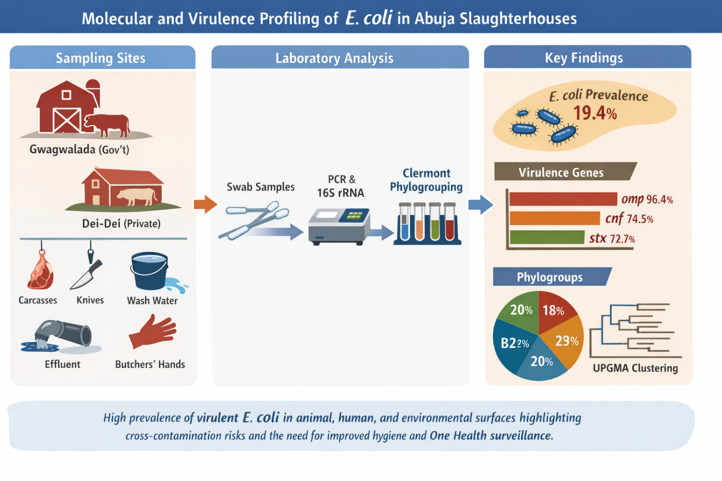GRAPHICAL ABSTRACT
INTRODUCTION
Escherichia coli (E. coli) is the most prevalent and clinically significant species within the genus Escherichia. This Gram-negative, rod-shaped, facultatively anaerobic bacterium commonly inhabits the lower gastrointestinal tract of humans and other warm-blooded animals as part of the normal intestinal microbiota. While most strains are harmless commensals that contribute to intestinal homeostasis, certain strains possess specific virulent determinants that enable them to cause a wide spectrum of intestinal and extraintestinal diseases (1).
Based on clinical manifestations and molecular characteristics, human E. coli strains are broadly categorized into three groups: commensal strains, intestinal pathogenic E. coli (IPEC), and extraintestinal pathogenic E. coli (ExPEC). Although most strains residing in the colon are non-pathogenic, pathogenic variants harbor virulence-associated genes that facilitate colonization, immune evasion, toxin production, and tissue invasion. Most extraintestinal infections, except gastroenteritis and neonatal meningitis, are endogenous in origin. These infections occur when E. coli from the host’s normal microbiota gains access to normally sterile body sites, particularly when host defenses are compromised due to trauma, immune suppression, or underlying disease (2). Clinically, E. coli is implicated in gastroenteritis, urinary tract infections (UTIs), septicemia, bacteremia, neonatal meningitis, cholecystitis, and cholangitis, making it one of the most versatile bacterial pathogens in both community and hospital settings.
Intestinal pathogenic E. coli (IPEC) strains are subdivided into several pathotypes according to their virulence factors, pathogenic mechanisms, and disease presentations. Enterotoxigenic E. coli (ETEC) is a major cause of watery diarrhea characterized by dehydration, nausea, vomiting, fever, and abdominal discomfort. It predominantly affects children under five years of age in developing countries and adults traveling to endemic regions. The pathogenicity of ETEC is mediated by the production of heat-stable (ST) and heat-labile (LT) enterotoxins, along with colonization factors that promote adherence to the small intestinal epithelium (3). Enteropathogenic E. coli (EPEC) is primarily associated with secretory and persistent diarrhea in infants and young children, occasionally affecting adults. EPEC pathogenesis involves the locus of enterocyte effacement (LEE), plasmid-encoded adherence factor (pEAF), bundle-forming pili (BFP), and non-LEE encoded effectors, which together facilitate attaching-and-effacing lesions on intestinal epithelial cells (4).
Enteroaggregative E. coli (EAEC) causes persistent and acute diarrhea across all age groups, including immunocompromised individuals such as those infected with HIV. EAEC exhibits a characteristic aggregative “stacked-brick” adherence pattern mediated by aggregative adherence fimbriae (AAF) and produces toxins such as enteroaggregative heat-stable toxin (EAST-1), plasmid-encoded toxin (Pet), protein involved in colonization (Pic), and Shigella enterotoxin-1 (ShET-1) (5). Shiga toxin-producing E. coli (STEC), also referred to as verotoxin-producing E. coli (VTEC) or enterohemorrhagic E. coli (EHEC), can cause disease ranging from mild diarrhea to severe hemorrhagic colitis with bloody diarrhea and abdominal pain. These strains produce Shiga toxins (Stx1 and Stx2), which are central to their virulence and may lead to hemolytic uremic syndrome (HUS), particularly in young children (6). Enteroinvasive E. coli (EIEC) invades and destroys colonic epithelial cells, initially producing watery diarrhea that may progress to dysentery characterized by fever, abdominal cramps, and blood and leukocytes in stool. Diffusely adherent E. coli (DAEC) has been implicated in watery diarrhea in children and is characterized by the expression of Afa/Dr adhesins. Adherent-invasive E. coli (AIEC), although not typically associated with acute gastroenteritis, has been linked to chronic intestinal inflammation and Crohn’s disease due to its ability to adhere to epithelial cells, invade tissues, and persist within macrophages (7).
Beyond human infections, pathogenic E. coli strains are important causes of disease in animals. In cattle, ETEC is a principal agent of neonatal diarrhea affecting the small intestine, while EPEC and STEC are associated with hemorrhagic dysentery in young calves, and certain strains contribute to bovine mastitis in adult cows. In pigs, ETEC is responsible for neonatal, post-weaning, and young pig diarrhea, whereas STEC strains are implicated in edema disease. Poultry may experience embryonic mortality, dermatitis, cellulitis, and intestinal infections associated with E. coli. Similarly, dogs, cats, and rabbits may develop diarrheal illnesses linked to ETEC or EPEC infections. These animal infections are of both economic and public health importance, particularly because of food-producing animals, especially cattle—serve as reservoirs for zoonotic STEC strains (8).
The pathogenicity of both intestinal and extraintestinal E. coli strains is mediated by a wide range of virulence factors, including fimbrial and afimbrial adhesins, capsules, hemolysins, exotoxins, enterotoxins, invasins, and iron acquisition systems. In ExPEC strains, virulence-associated genes encode proteins that enhance colonization of extraintestinal sites, promote serum resistance, facilitate iron uptake, and enable systemic dissemination. The diversity and distribution of these virulence genes determine the pathogenic potential of specific isolates (9). In developing countries, slaughterhouses frequently operate under suboptimal sanitary conditions, thereby facilitating the transmission of pathogenic E. coli from animal carcasses to workers, equipment, and the surrounding environment (10). Inadequate carcass handling, contaminated water used for washing, poor effluent management, and improper sanitation of meat-contact surfaces contribute to cross-contamination within abattoir systems. Such contamination poses significant risks to food safety and public health, particularly when meat products enter the consumer market without adequate processing or cooking.
Molecular detection of virulence-associated genes and analysis of phylogenetic relatedness among E. coli isolates provide critical insights into contamination sources, transmission pathways, and zoonotic risk. Although several studies have reported the presence of E. coli in Nigerian abattoirs (11, 12), limited research has simultaneously examined both virulence gene profiles and genetic relatedness of isolates recovered from multiple slaughterhouse niches, particularly within Abuja. Therefore, this study aimed to (i) analyze E. coli isolates from cattle carcasses and meat-contact surfaces for virulence-encoding genes and (ii) determine their phylogenetic relatedness. The findings will enhance understanding of the public health implications of pathogenic E. coli in abattoir environments and support the development of evidence-based strategies to improve slaughterhouse hygiene and food safety in Nigeria
2. MATERIALS AND METHODS
2.1 Study Area and Study Design
This cross-sectional study was conducted in two major slaughterhouses located in Abuja, Federal Capital Territory (FCT), Nigeria: the government-owned Gwagwalada slaughterhouse and the privately owned Dei-Dei slaughterhouse. The Gwagwalada facility, situated in New Kutunku Ward, a densely populated residential area adjacent to a tributary of the River Usuma, comprises three operational sections: slaughtering, processing, and waste disposal. Geographically, it lies between latitudes 08°55′N–09°00′N and longitudes 07°00′E–07°05′E (13). The Dei-Dei slaughterhouse is located within the Abuja International Livestock Market at latitude 9.0993°N and longitude 7.2789°E. Operated under the supervision of the Federal Capital Territory Administration (FCTA), it is one of the largest privately managed slaughter facilities in the region, processing both indigenous and exotic livestock breeds (14, 15). The study targeted cattle carcasses, meat-contact surfaces (MCS), and environmental samples within both facilities.
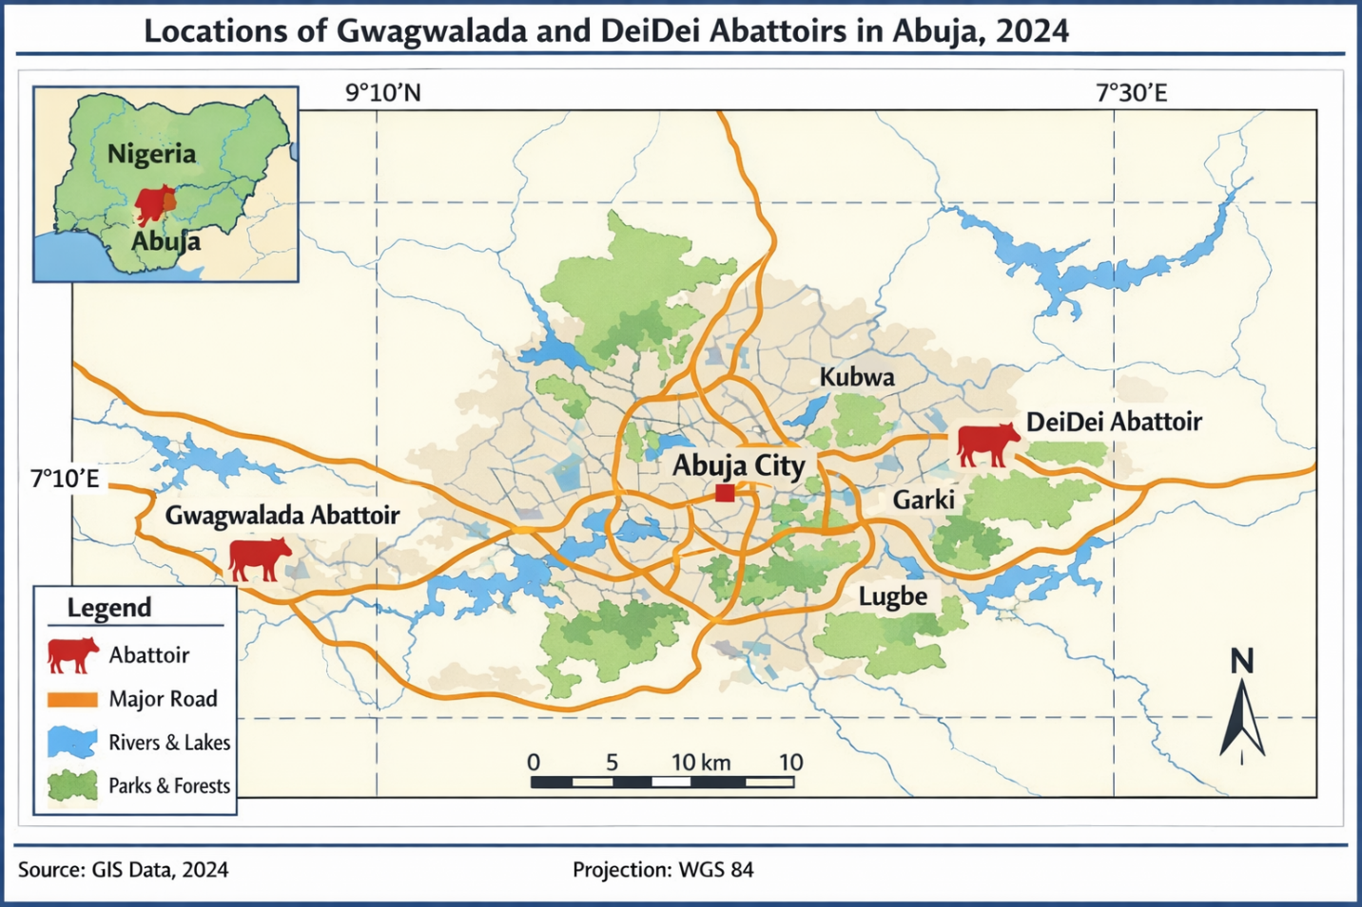
2.2 Sample Size Determination and Sample Collection
Sample size was determined using the Raosoft® Sample Size Calculator (https://www.raosoft.com/samplesize.html).
- Cattle carcasses: A 95% confidence level, 5% margin of error, and assumed prevalence of 50% yielded 277 samples. To improve statistical robustness, the number increased to 300 (16).
- Meat-contact surfaces: Based on a previously reported prevalence of 36%, a minimum sample size of 240 was calculated (17).
Sampling was conducted biweekly over four months, comprising 20 visits to Gwagwalada and 15 visits to Dei-Dei slaughterhouse.
Carcass Sampling
Sterile swabs were collected aseptically from three anatomical sites: flank, loin, and neck.
Meat-Contact Surface Sampling
A total of 240 swabs were collected from: butchers’ hands, knives, wheelbarrows, slaughter floors, effluent channels, and washing water. Swabs were moistened with sterile normal saline and rubbed firmly over predetermined areas using parallel and rotating strokes to maximize bacterial recovery.
All samples were transported in ice-packed containers under aseptic conditions to the Public Health Laboratory at the University of Abuja and processed on the same day.
2.3 Isolation and Phenotypic Identification of E. coli
Isolation and identification were performed following standard bacteriological procedures (18). Swab samples were streaked onto MacConkey agar (MCA) and incubated at 37°C for 18–24 hours. Lactose-fermenting (pink) colonies were subcultured onto Eosin Methylene Blue (EMB) agar and incubated under the same conditions. Colonies exhibiting a characteristic green metallic sheen on EMB were considered presumptive E. coli. Presumptive isolates were further characterized using Gram staining and standard biochemical tests.
2.4 Molecular Confirmation of E. coli
Genomic DNA was extracted from presumptive isolates using the phenol-chloroform method. Fifteen isolates were randomly selected for molecular confirmation via amplification of the 16S rRNA gene using universal primers:
- 27F: 5’-AGAGTTTGATCCTGGCTCAG-3’
- 1492R: 5’-GGTTACCTTGTTACGACTT-3’ (19)
PCR was performed in a GeneAmp 9700 Thermal Cycler (Applied Biosystems, USA). Amplicons were resolved on 1.5% agarose gel, purified, and sequenced using an Applied Biosystems 3130xl Genetic Analyzer. Sequences were aligned using ClustalW and compared to the NCBI GenBank database using BLAST. Phylogenetic analysis was conducted in MEGA version 7, and sequences were deposited in GenBank (Accession Numbers: OP930819–OP930833).
Table 3: Primers Used for PCR Detection of Virulence Genes in E. coli Isolates
PCR Type | Gene | Primer | Sequence (5' → 3') | Expected Amplicon Size (bp) | PCR Conditions | Reference
Multiplex | EAST | EAST-F | CACAGTATATCCGAAGGC | 97 | Initial denaturation 94°C 5 min; 35 cycles of 94°C 30 s, 60°C 30 s, 72°C 60 s; final extension 72°C 10 min | 20
Multiplex | EAST | EAST-R | CGAGTGACGGCTTTGTAG | 97 | Same as above | 20
Multiplex | eaeA | eaeA-F | GACCCGGCACAAGCATAAGC | 248 | Initial denaturation 94°C 5 min; 35 cycles of 94°C 30 s, 55°C 30 s, 72°C 60 s; final extension 72°C 10 min | 20
Multiplex | eaeA | eaeA-R | CCACCTGCAGCAACAAGAGG | 248 | Same as above | 20
Singleplex | traT | traT-F | GGTGTGGTGCGATGAGCACAG | 290 | Initial denaturation 94°C 5 min; 35 cycles of 94°C 30 s, 53°C 30 s, 72°C 20 s; final extension 72°C 10 min | 21
Singleplex | traT | traT-R | CACGGTTCAGCCATCCCTGAG | 290 | Same as above | 21
Singleplex | hly | hly-F | AACAAGGATAAGCACTGTTCTGGCT | 1,177 | Initial denaturation 94°C 5 min; 35 cycles of 94°C 30 s, 53°C 30 s, 72°C 60 s; final extension 72°C 10 min | 20
Singleplex | hly | hly-R | ACCATATAAGCGGTCATTCCCGTCA | 1,177 | Same as above | 20
Singleplex | omp | omp-F | AGCTATCGCGATTGCAGTG | 919 | Initial denaturation 94°C 5 min; 35 cycles of 94°C 30 s, 48°C 30 s, 72°C 50 s; final extension 72°C 10 min | 22
Singleplex | omp | omp-R | GGTGTTGCCAGTAACCGG | 919 | Same as above | 22
Singleplex | bfp | bfp-F | AATGGTGCTTGCGCTTGCTGC | 324 | Initial denaturation 94°C 5 min; 35 cycles of 94°C 30 s, 52°C 30 s, 72°C 30 s; final extension 72°C 10 min | 23
Singleplex | bfp | bfp-R | GCCGCTTTATCCAACCTGGTA | 324 | Same as above | 23
Singleplex | stx | stx-F | TCTCAGTGGGCGTTCTTATG | 388 | Initial denaturation 94°C 5 min; 35 cycles of 94°C 30 s, 47°C 30 s, 72°C 30 s; final extension 72°C 10 min | 20
Singleplex | stx | stx-R | TACCCCCTCAACTGCTAATA | 388 | Same as above | 20
Singleplex | cnf | cnf-F | TCGTTATAAAATCAAACAGTG | 446 | Initial denaturation 94°C 5 min; 35 cycles of 94°C 30 s, 43°C 30 s, 72°C 30 s; final extension 72°C 10 min | 20
Singleplex | cnf | cnf-R | CTTTACAATATTGACATGCTG | 446 | Same as above | 20

2.5 Detection of Virulence Genes by PCR
Fifty-five confirmed E. coli isolates were screened for eight virulence genes (eaeA, EAST, traT, hly, omp, bfp, stx, and cnf) using one multiplex reaction (for eaeA and EAST) and six singleplex reactions (20, 21, 23, 24). PCR reactions were performed in a GeneAmp 9700 Thermal Cycler. Amplicons were resolved on 1.5% agarose gel at 120 V for 45 minutes and visualized under UV light. Band sizes were estimated using a 100-bp DNA ladder, and positive controls were included in each run.
2.6 Clermont Phylogrouping of E. coli
Phylogenetic groups of E. coli isolates were determined using the updated Clermont quadruplex PCR method (25), which classifies isolates into major phylogroups A, B1, B2, C, D, E, and F. Genomic DNA from confirmed isolates was used as the template. The quadruplex PCR targeted four markers: arpA, chuA, yjaA, and TspE4.C2. Each 25 µL PCR reaction contained 12.5 µL of 2× PCR Master Mix (Thermo Fisher Scientific, USA), 0.5 µM of each primer, 50 ng of DNA, and nuclease-free water.
PCR cycling conditions:
- Initial denaturation: 94°C for 5 min
- 30 cycles of:
  - Denaturation at 94°C for 30 s
  - Annealing at 57°C for 30 s
  - Extension at 72°C for 30 s
- Final extension at 72°C for 5 min
Amplicons were separated on 2% agarose gel, stained with ethidium bromide, and visualized under UV light. Phylogroup assignment was determined using the presence/absence of the four markers according to Clermont’s updated algorithm. Representative isolates from each phylogroup were used as internal controls.
2.7 Genetic Relatedness and Phylogenetic Analysis
Fifteen E. coli isolates were analyzed for nucleotide sequence differences in the 16S rRNA gene. Genetic distances were calculated using the Kimura 2-parameter model. Phylogenetic trees were constructed using the Neighbor-Joining method with 1,000 bootstrap replicates in MEGA version 7. UPGMA clustering based on band patterns was used to assess similarities among isolates, with clusters ≥80% similarity considered genetically related (26, 27).
2.8 Statistical Analysis
Data were analyzed using GraphPad Prism version 8.0.4 (GraphPad Software, USA). Associations between virulence gene distribution, phylogroups, and sample sources were assessed using Fisher’s exact test. A p-value < 0.05 was considered statistically significant
3. RESULTS
3.1 E. coli Isolation Rate in Meat and Its Contact Surfaces in Selected Slaughterhouses
A total of 540 carcass samples and their contact surfaces were collected from the privately owned Dei-dei (PDs) slaughterhouse (200 samples) and the government-owned Gwagwalada (GGs) slaughterhouse (340 samples). The samples comprised processed carcasses (90), effluent (35), SHWs hand (10), wheelbarrow (15), knives (20), kill floor (15), and water for washing (15) at PDs, while from GGs, the samples comprised processed carcasses (180), effluent (45), SHWs hand (25), wheelbarrow (20), knives (35), kill floor (20), and water for washing (15) Table 4. E. coli isolation Rate from the various slaughterhouse samples is shown in Table 4. Escherichia coli was isolated from 63 (18.5%) of the 340 samples processed from GGs and 42 (21%) of the 200 samples processed from PDs. The overall prevalence of E. coli across both slaughterhouses was 19.4%, with 18.5% recorded at Gwagwalada and 21% at Dei-Dei. For meat-contact surfaces, the distribution at Gwagwalada was as follows: slaughterhouse floor (45%), butchers’ knives (31.4%), meat-washing water (20%), wheelbarrows (35%), and butchers’ hands (36%), processed carcass (67%), and effluent (26.7%). In contrast, at Dei-Dei, E. coli prevalence was observed on the kill floor (46.7%), butchers’ knives (26.7%), meat-washing water (10%), wheelbarrows (20%), butchers’ hands (40%), processed carcass (10%), and effluent (22.9%). (Table 4). There was no significant association [95% CI = 0.75–1.8, OR = 1.2, p = 0.501] between the E. coli isolation rates at the slaughterhouses and the sample types. Isolation rates of E. coli in the studied slaughterhouses based on a broad group of sample sources (i.e., human-related contact surfaces, animal-related contact surfaces, and environmental-related contact surfaces) are presented in Table 5. In both slaughterhouses, the highest proportions of E. coli were obtained from human-related contact surfaces samples (36% and 40% in GGs and PDs, respectively), followed by environmental-related contact surfaces samples. However, for each sample source, there was no significant association (p<0.05) between isolation rates and slaughterhouse locations.
Table 4: Distribution of E. coli isolation rates in government-owned Gwagwalada (n = 63) and privately owned Dei-dei (n = 42) slaughterhouses in Abuja
Sample Type | Gwagwalada (n = 340) |  | Dei-Dei (n = 200) |  | OR | 95% CI | p-value
 | No. Examined | No. Positive (%) | No. Examined | No. Positive (%)
SHWs’ hands | 25 | 9 (36.0) | 10 | 4 (40.0) | 1.2 | 0.31–5.10 | 0.998
Processed carcasses | 180 | 12 (6.7) | 90 | 9 (10.0) | 1.6 | 0.65–3.60 | 0.343
Wheelbarrow swabs | 20 | 7 (35.0) | 15 | 3 (20.0) | 2.2 | 0.51–8.90 | 0.458
Butchers’ knives | 35 | 11 (31.4) | 20 | 7 (35.0) | 1.2 | 0.34–4.10 | 0.989
Meat washing water | 15 | 3 (20.0) | 15 | 4 (26.7) | 1.5 | 0.32–6.70 | 0.998
Effluent | 45 | 12 (26.7) | 35 | 8 (22.9) | 1.2 | 0.42–3.60 | 0.797
Kill floor | 20 | 9 (45.0) | 15 | 7 (46.7) | 1.1 | 0.29–4.40 | 0.988
Total | 340 | 63 (18.5) | 200 | 42 (21.0) | 1.2 | 0.75–1.80 | 0.501
OR = Odds ratio; CI = Confidence Interval; Fisher's exact test (GraphPad Prism®, version 8.0.4, CA, USA)
Table 5: Distribution of phenotypically identified E. coli isolates (N = 105) from Gwagwalada (n = 63) and Dei-dei (n = 42) slaughterhouses based on broad sample sources
Sample Source Category | Gwagwalada (n = 340) |  | Dei-Dei (n = 200) |  | OR | 95% CI | p-value
 | No. Examined | No. Positive (%) | No. Examined | No. Positive (%)
Human (SHWs’ hands) | 25 | 9 (36.0) | 10 | 4 (40.0) | 1.2 | 0.31–5.10 | 0.999
Animal (Processed carcasses) | 180 | 12 (6.7) | 90 | 9 (10.0) | 1.6 | 0.65–3.50 | 0.343
Environmental* | 135 | 42 (31.1) | 100 | 29 (29.0) | 1.1 | 0.62–1.90 | 0.775
OR = Odds ratio; CI = Confidence Interval; Fisher's exact test (GraphPad Prism®, version 8.0.4, CA, USA)
Human: SHW’s hands
Animal: processed carcasses
Environmental sources: wheelbarrow, butchers’ knife, meat washing water, Effluent, kill floor
3.2 Molecular confirmation of E. coli
The 16S rRNA gene was amplified in all fifty-five (55) selected isolates tested, producing a band of approximately 1.5 mb (Figure 2). The sequencing and BLAST results showed that one (1.8%) of the 55 isolates was Shigella flexneri, while three (5.5%) were Escherichia fergusonii, and the remaining 51 (92.7%) were Escherichia coli. The Shigella flexneri isolates were obtained from the knives of SHWs, while three Escherichia fergusonii isolates were recovered from the kill floor, effluent, and water for washing.
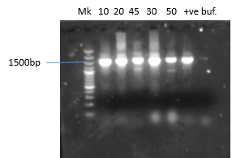
Fig 2: Gel pictures show positive amplification of 16S rRNA genes of the isolates.
Note bands at 1500bp,
MK molecular weight marker (100bp ladder)
tve: control,
buf= buffer (-ve)
3.3 Distribution of Virulence-Associated Genes
Virulence-associated genes detected from E. coli isolates from GGs and PDs in Abuja.
The 55 E. coli isolates were screened for the presence of eight virulence-associated genes by PCR. The amplified product of the detected genes is presented in Fig. 3(A-G), and the prevalence of the genes is shown in Table 6. Overall, omp (96.4%), cnf (74.5%), and stx (72.7%). These were the most frequently detected virulence-associated genes. For GG's slaughterhouse, the predominant virulence-associated genes were omp (94.4%), bfp (72.2%), and cnf (72.2%). stx (72.2%), TraT (52.8%), and EAST (44.4%). While the predominant genes in PDs were omp (100%), cnf (78.9%). stx (73.7%), bfp (47.4%), and TraT (42.1%). For virulence-associated genes, detection was not significantly associated (P>0,005) with sample sources (Table 7). No significant association (p > 0.005) was observed between virulence gene detection and sample sources (human, animal, environmental) (Table 7).

Table 6: Virulence-associated genes in E. coli isolated from the Gwagwalada (n = 36) and Dei-dei (n = 19) slaughterhouses in Abuja, according to sample types
Sample Type | No. of Isolates | eaeA (%) | EAST (%) | TraT (%) | hly (%) | omp (%) | bfp (%) | stx (%) | cnf (%)
Gwagwalada Slaughterhouse (n = 36)
Processed carcass | 6 | 1 (16.7) | 4 (66.7) | 3 (50) | 1 (16.7) | 6 (100) | 5 (83.3) | 4 (66.7) | 5 (83.3)
Wheelbarrow | 5 | 0 (0) | 3 (60) | 2 (40) | 0 (0) | 4 (80) | 4 (80) | 4 (80) | 4 (80)
SHWs’ hands | 3 | 0 (0) | 0 (0) | 2 (66.7) | 0 (0) | 3 (100) | 1 (33.3) | 2 (66.7) | 2 (66.7)
Butchers’ knives | 6 | 0 (0) | 2 (33.3) | 3 (50) | 1 (16.7) | 5 (83.3) | 4 (66.7) | 4 (66.7) | 4 (66.7)
Effluent | 7 | 0 (0) | 5 (71.4) | 5 (71.4) | 0 (0) | 7 (100) | 5 (71.4) | 3 (42.9) | 6 (85.7)
Kill floor | 6 | 2 (33.3) | 1 (16.7) | 3 (50) | 1 (16.7) | 6 (100) | 5 (83.3) | 6 (100) | 5 (83.3)
Meat washing water | 3 | 0 (0) | 1 (33.3) | 1 (33.3) | 0 (0) | 3 (100) | 2 (66.7) | 3 (100) | 0 (0)
GGs Total | 36 | 3 (8.3) | 16 (44.4) | 19 (52.8) | 3 (8.3) | 34 (94.4) | 26 (72.2) | 26 (72.2) | 26 (72.2)
Dei-Dei Slaughterhouse (n = 19)
Processed carcass | 3 | 0 (0) | 1 (33.3) | 2 (66.7) | 0 (0) | 3 (100) | 1 (33.3) | 2 (66.7) | 3 (100)
Wheelbarrow | 2 | 1 (50) | 0 (0) | 1 (50) | 0 (0) | 2 (100) | 0 (0) | 0 (0) | 0 (0)
SHWs’ hands | 2 | 0 (0) | 2 (100) | 0 (0) | 0 (0) | 2 (100) | 2 (100) | 2 (100) | 2 (100)
Butchers’ knives | 4 | 0 (0) | 0 (0) | 3 (75) | 0 (0) | 4 (100) | 2 (50) | 2 (50) | 3 (75)
Effluent | 4 | 0 (0) | 1 (25) | 0 (0) | 0 (0) | 4 (100) | 2 (50) | 4 (100) | 3 (75)
Kill floor | 3 | 0 (0) | 0 (0) | 2 (66.7) | 0 (0) | 3 (100) | 1 (33.3) | 3 (100) | 3 (100)
Meat washing water | 1 | 0 (0) | 1 (100) | 0 (0) | 0 (0) | 1 (100) | 1 (100) | 1 (100) | 1 (100)
PDs Total | 19 | 1 (5.3) | 5 (26.3) | 8 (42.1) | 0 (0) | 19 (100) | 9 (47.4) | 14 (73.7) | 15 (78.9)
Overall Total (n = 55) | 55 | 4 (7.3) | 21 (38.2) | 27 (49.1) | 3 (5.5) | 53 (96.4) | 35 (63.6) | 40 (72.7) | 41 (74.5)

Table 7: Distribution of Virulence Genes by Broad Sample Sources in E. coli Isolates
Virulence Gene | Human (n = 5) | Animal (n = 9) | Environment (n = 41) | p-value
eaeA | 0 (0) | 1 (11.1) | 3 (7.3) | 0.745
EAST | 2 (40) | 5 (55.6) | 14 (34.1) | 0.487
TraT | 2 (40) | 5 (55.6) | 20 (48.8) | 0.853
Hly | 0 (0) | 1 (11.1) | 2 (4.9) | 0.646
Omp | 5 (100) | 9 (100) | 35 (85.4) | 0.317
Bfp | 3 (60) | 6 (66.7) | 26 (63.4) | 0.969
Stx | 4 (80) | 6 (66.7) | 30 (73.2) | 0.859
Cnf | 4 (80) | 8 (88.9) | 29 (70.7) | 0.505
Fisher's exact test (GraphPad Prism®, version 8.0.4, CA, USA)
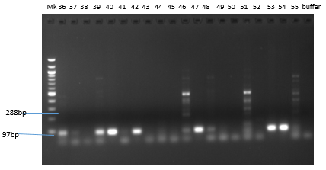

Fig 3(A)
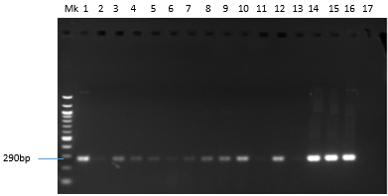

Fig 3(B)
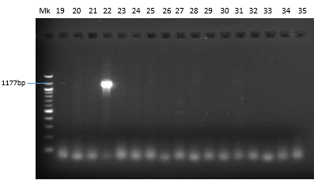
Fig 3 (C)
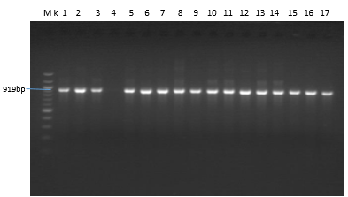

Fig 3(D)

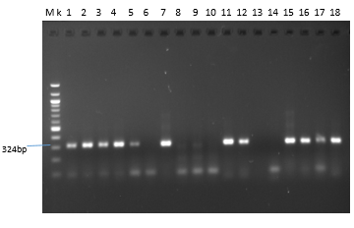
Fig 3(E)
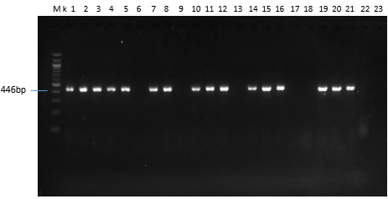 Fig 3(F) 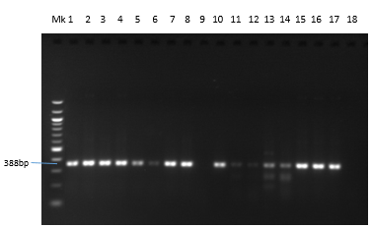Fig 3(G)
Figure 3 A-G. Gel pictures for PCR products of virulence-associated genes detected in E. coli isolates from Gwagwalada and Dei-dei slaughterhouse in Abuja
- eaeA and EAST (288bp and 97bp) (B) TraT (290bp) (C) hly (1177bp) (D) OMP (919bp
(E) bfp (324bp) (F) stx (388bp) (G) cnf (446 bp)
MK 100bp molecular size marker

3.3 Distribution of E. coli Phylogroups (n=105 isolates)
Phylogenetic classification of the 105 confirmed E. coli isolates was performed using the updated Clermont quadruplex PCR method (25). All isolates were successfully assigned to one of the recognized phylogroups (A, B1, B2, C, D, E, and F).
Overall, phylogroup B1 predominated (40/105, 38.1%), followed by phylogroup A (30/105, 28.6%). Phylogroup D accounted for 14.3% (15/105), whereas phylogroup B2, commonly associated with extraintestinal pathogenic E. coli (ExPEC), was identified in 7.6% (8/105) of isolates. The remaining isolates belonged to phylogroups C (4.8%), E (3.8%), and F (2.9%).
When grouped broadly, commensal/environment-associated phylogroups (A and B1) constituted 66.7% of isolates, whereas virulence-associated phylogroups (B2 and D) represented 21.9%.

Table 8. Distribution of E. coli Phylogroups among 105 Isolates

Phylogroup | Number (n) | Percentage (%)
A | 30 | 28.6
B1 | 40 | 38.1
B2 | 8 | 7.6
C | 5 | 4.8
D | 15 | 14.3
E | 4 | 3.8
F | 3 | 2.9
Total | 105 | 100

Table 9: Distribution of virulent genes among phylogenetic groups of E. coli isolates (n = 55)
Phylogroup Category | No. of isolates | eaeA n (%) | TraT n (%) | omp n (%) | bfp n (%) | stx n (%) | EAST n (%) | cnf n (%) | hly n (%)
Commensal (A + B1) | 22 | 2 (9.1) | 15 (68.2) | 20 (90.9) | 11 (50.0) | 14 (63.6) | 10 (45.5) | 11 (50.0) | 3 (13.6)
Pathogenic (B2 + D) | 12 | 0 (0.0) | 7 (58.3) | 10 (83.3) | 5 (41.7) | 9 (75.0) | 5 (41.7) | 8 (66.7) | 2 (16.7)
Minor (C + E + F) | 21 | 4 (19.0) | 10 (47.6) | 18 (85.7) | 9 (42.9) | 13 (61.9) | 8 (38.1) | 11 (52.4) | 3 (14.3)
Total | 55 | 6 (10.9) | 32 (58.2) | 48 (87.3) | 25 (45.5) | 36 (65.5) | 23 (41.8) | 30 (54.5) | 8 (14.5)
Statistical test: Fisher’s Exact Test (Freeman–Halton extension), Significance level: p < 0.05
3.4 Distribution of virulence genes among phylogenetic groups of E. coli isolates (n = 55)
Fisher’s Exact Test showed no statistically significant association (p > 0.05) between phylogenetic groups and most virulence genes, indicating that virulence determinants were widely distributed across both commensal and pathogenic phylogroups. A trend toward higher prevalence of the cnf gene in pathogenic phylogroups (B2 and D) was observed, although this did not reach statistical significance. No statistically significant association (p > 0.05) was observed between phylogroup category and virulence gene distribution, although cnf showed higher occurrence in pathogenic phylogroups. The association between phylogenetic groups and virulence genes among the 55 Escherichia coli isolates was evaluated using Fisher’s Exact Test. Phylogroups were categorized into commensal (A and B1), pathogenic (B2 and D), and minor groups (C, E, and F).
Overall, virulence genes were widely distributed across all phylogroups, with no statistically significant association observed for most genes (p > 0.05). The stx, traT, bfp, and EAST genes were detected across all phylogenetic categories. However, a higher frequency of the cnf gene was observed among isolates belonging to pathogenic phylogroups (B2 and D), suggesting a possible association, although this was not statistically significant (p > 0.05).
These findings indicate that both commensal and pathogenic phylogroups contribute to the dissemination of virulent determinants within the abattoir environment.
3.4 Genetic Relatedness of E. coli Isolates
The UPGMA dendrogram clustering image grouped the 15 selected isolates for genetic profile analysis into five clusters and one singleton at a similarity cut-off of 80% (Fig. 4). Cluster 1 consisted of E. coli isolates from water for washing of carcasses, cluster 2 contained strains from effluent and carcasses, cluster 3 had four strains, two from effluent and two from the kill floor, cluster 4 had three strains from carcass, effluent, and water for washing, and cluster 5 contained strains from carcass, knife, and effluent.
- Cluster 1: isolates from carcass washing water.
- Cluster 2: isolates from effluent and carcasses.
- Cluster 3: four isolates (two effluent, two kill floor).
- Cluster 4: isolates from carcass, effluent, and wash water.
- Cluster 5: isolates from carcass, knife, and effluent.
One isolate remained unclustered.
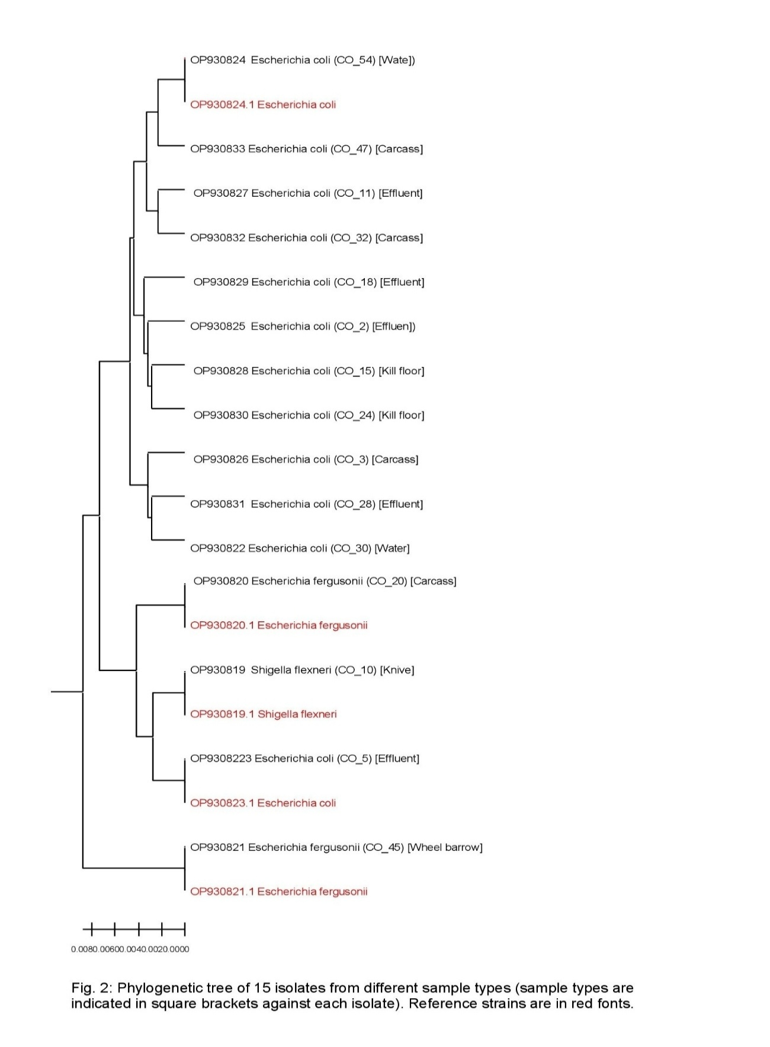
Figure 4. UPGMA dendrogram showing clustering of E. coli isolates from Gwagwalada and Dei-Dei slaughterhouses at 80% similarity cut-off.

┌───────────────┐
│ LIVE CATTLE │
└──────┬────────┘
│
▼
┌───────────────┐
│ CARCASS │
└──────┬────────┘
│
┌───────────┼────────────┐
▼ ▼ ▼
┌────────┐ ┌────────┐ ┌────────────┐
│ HANDS │ │ KNIVES │ │ WHEELBARROW│
└────┬───┘ └────┬───┘ └────┬───────┘
│ │ │
└──────┬─────┴─────┬──────┘
▼ ▼
┌───────────────┐
│ GROUND │
└──────┬────────┘
▼
┌───────────────┐
│ EFFLUENT │
└──────┬────────┘
▼
┌───────────────┐
│ WATER SOURCE │
└───────────────┘
Figure 5: Transmission Pathways in the Abattoir
Schematic representation of contamination pathways of Escherichia coli within the abattoir environment. Cross-contamination occurs through direct contact between carcasses and contaminated hands, knives, and equipment, with subsequent dissemination to environmental reservoirs, including ground surfaces, effluents, and water sources.

DISCUSSION
This study provides important insights into the molecular epidemiology and virulence potential of Escherichia coli isolated from cattle carcasses and slaughterhouse environments in Abuja, Nigeria. The integration of phylogenetic classification with virulence gene profiling offers a deeper understanding of the ecological distribution and pathogenic potential of these isolates. The predominance of phylogroups A and B1 among the isolates aligns with previous reports indicating that these groups are commonly associated with commensal and environmental E. coli strains (28, 29). However, the detection of virulence-associated phylogroups B2 and D, albeit at lower frequencies, is of significant public health concern due to their well-established association with extraintestinal pathogenic E. coli (ExPEC) strains (5, 30).
Notably, the distribution of virulence genes across all phylogenetic groups, with no statistically significant association observed, suggests that virulence determinants are not restricted to traditionally pathogenic phylogroups. This finding supports the hypothesis that horizontal gene transfer plays a major role in the dissemination of virulence factors among E. coli populations in the abattoir environment (4). The widespread presence of key virulence genes such as stx, traT, bfp, and cnf across commensal and minor phylogroups indicates that even non-pathogenic strains may act as reservoirs of virulence genes, thereby contributing to the emergence of pathogenic variants.
The high prevalence of the omp gene across all isolates further emphasizes its conserved role in bacterial survival, structural integrity, and host interaction, as previously reported (31). Similarly, the substantial occurrence of the stx gene across phylogroups raises concerns regarding the potential presence of Shiga toxin-producing E. coli (STEC) in the slaughterhouse environment, which are known to cause severe foodborne illnesses in humans (32). Although no statistically significant association was observed, the relatively higher occurrence of the cnf gene among isolates belonging to pathogenic phylogroups (B2 and D) suggests a possible trend toward increased virulence potential in these groups. Cytotoxic necrotizing factor (CNF) is a well-documented virulence factor associated with tissue invasion and extraintestinal infections (33). The observed pattern, while not statistically significant, may be biologically relevant and warrants further investigation with larger sample sizes.
The detection of virulent genes in isolates recovered from multiple sources, including carcasses, hands, knives, wheelbarrows, and effluent, highlights the role of slaughterhouse practices in facilitating cross-contamination. The contamination flow observed in this study supports previous findings that poor hygiene practices, inadequate sanitation, and improper handling contribute significantly to the spread of pathogenic bacteria along the meat processing chain (31, 34). The presence of virulent E. coil in effluent and water sources further indicates environmental dissemination, which may pose a broader ecological and public health risk.
Importantly, the absence of a strong association between phylogroup and virulence gene distribution suggests that reliance on phylogenetic classification alone may not be sufficient to predict pathogenicity in environmental and food-associated E. coli. This underscores the need for integrated molecular approaches combining phylogrouping, virulence profiling, and antimicrobial resistance analysis to accurately assess risk. The findings of this study reinforce the concept that abattoirs serve as critical nodes for the amplification and dissemination of potentially pathogenic E. coli, necessitating urgent interventions to break the chain of contamination and safeguard food safety.
CONCLUSION
This study demonstrates that Escherichia coli isolates from cattle carcasses and slaughterhouse environments in Abuja exhibit diverse phylogenetic backgrounds, with a predominance of commensal phylogroups A and B1. However, the detection of virulence-associated phylogroups B2 and D, alongside the widespread distribution of key virulence genes across all phylogroups, highlights a significant public health concern.
The lack of a statistically significant association between phylogroups and virulence genes indicates that virulence traits are broadly disseminated among E. coli populations, likely driven by horizontal gene transfer. This suggests that even commensal strains may serve as reservoirs of virulence determinants, contributing to the emergence and spread of pathogenic variants within the abattoir environment.
Furthermore, the presence of virulent E. coli across multiple contact surfaces and environmental samples underscores the critical role of cross-contamination during slaughter and meat processing. These findings emphasize the need for improved hygiene practices, strict biosecurity measures, and effective waste management systems in slaughterhouses to minimize contamination and reduce public health risks.
Overall, this study highlights the importance of continuous surveillance and integrated molecular characterization of E. coli in food production systems to enhance food safety and protect public health.
ACKNOWLEDGMENTS
The authors thank the staff of the Gwagwalada and Dei-Dei slaughterhouses for their cooperation, and the Department of Public Health and Preventive Medicine Laboratory, University of Abuja, for technical support.
FUNDING
This research received no specific grant from any funding agency in the public, commercial, or not-for-profit sectors.w
CONFLICT OF INTEREST
The authors declare no competing interests.
REFRENCES
1.Do, K.-H., Seo, K.-W., & Lee, W.-K. (2022). Antimicrobial resistance, virulence genes, and phylogenetic characteristics of pathogenic Escherichia coli isolated from patients and swine. BMC Microbiology, 22, 199. https://doi.org/10.1186/s12866-022-02604-z
2.Do, K.-H., Seo, K.-W., & Lee, W.-K. (2022). Antimicrobial resistance, virulence genes, and phylogenetic characteristics of pathogenic Escherichia coli isolated from patients and swine. BMC Microbiology, 22, 199. https://doi.org/10.1186/s12866-022-02604-z
3. Mora A, Herrera A, López C, Dahbi G, Mamani R, Pita JM, Alonso MP, Llovo J, Bernárdez MI, Blanco J.E, Blanco M, Blanco J. (2011). Characteristics of the Shiga-toxin-producing enteroaggregative Escherichia coli O104:H4 German outbreak strain and of STEC strains isolated in Spain. Intl Microbiol. 14:121-141
4. Croxen M.A and Finlay B. B. (2010). Molecular mechanisms of Escherichia coli pathogenicity. Nat Rev Microbiol. 8:26-38.
5. Kaper J.B, Nataro J.P and Mobley H.L. (2004). Pathogenic Escherichia coli. Nat Rev Microbiol. 2:123-140.
6. Wellington E.M.H and van Elsas J.D. (1992). Genetic interactions between microorganisms in the natural environment Editors: Pergamon Press. USA.
7. Servin A.L. (2005). Pathogenesis of Afa/Dr diffusely adhering Escherichia coli. Clin Microbiol Rev. 18:264-292.
8. Alteri C.J, Smith S.N and Mobley H.L.T. (2009). Fitness of Escherichia coli during urinary tract infection requires gluconeogenesis and the TCA cycle. PLoS Pathog. 5:e1000448.
9. Wiles T.J, Kulesus R.R and Mulvey M.A. (2008). Origins and virulence mechanisms of uropathogenic Escherichia coli. Exp Mol Pathol. 85:11-19.
10. Ayoade, F., Oguzie, J., Eromon, P., Omotosho, O. E., Ogunbiyi, T., Olumade, T., Akano, K., & Folarin, O. (2021). Molecular surveillance of Shiga toxigenic Escherichia coli in selected beef abattoirs in Osun State, Nigeria. Scientific Reports, 11, 13966. https://doi.org/10.1038/s41598-021-93347-w
11.Oluwafemi, R. A., Ayansina, A. D., & Umeh, C. E. (2023). Detection of virulent and antibiotic-resistant Escherichia coli in abattoir effluents and surrounding environments in Nigeria. International Journal of Environmental Research and Public Health, 20(4), 679. https://doi.org/10.3390/ijerph20040679
12. Olaitan, J. O., et al. (2025). Surveillance and potential health risks of antibiotic-resistant Shiga toxigenic Escherichia coli isolated from beef sold in Nigeria. African Journal of Microbiology Research, 19(2), 55–68.
13. Balogun, O. (2001). The Federal Capital of Nigeria. Geography of Its Development. Ibadan. Ibadan University Press, University of Ibadan
14. NPC (2010). The Population and People of Nigeria. National Population Commission Journals 2017 publications
15. Abubakar MA, Hamzah E, Maher AA, and Alev E. Knowledge Management, Decision-Making Style and Organizational Performance. Journal of Innovation & Knowledge, (2019) 4:104–14. doi: 10.1016/j.jik.2017.07.003
16. Regassa A, Moje N, Megersa B, Beyene D, Sheferaw D, Debela E, et al. Major causes of organs and carcass condemnation in small ruminants slaughtered at Luna export abat toir, Oromia regional state, Ethiopia. Prev Vet Med. (2013) 110:139–48. doi: 10.1016/J. Prevetmed.2012.11.020
17. Elmanama A, Abdelateef N. Antimicrobial resistance of enteric pathogens isolated from acute gastroenteritis patients in Gaza strip, Palestine. Iajaa. (2012) 2:1–15.
18. Barrow GI, Feltham RKA. Cowan and Steel’s Manual for the Identification of Medical bacteria. 3rd ed. Cambridge: Cambridge University Press (1993). p. 216.
19. Gillan DC, Speksnijder AGCL, Zwart G, De Ridder C. Genetic diversity of the bio film covering Montacuta ferruginosa (Mol lusca, Bivalvia) as evaluated by denaturing gradient gel electrophoresis analysis and cloning of PCR-amplified gene fragments coding for 16S rRNA. Appl Environ Microbiol. (1998) 64:3464–72. doi: 10.1128/ AEM.64.9.3464-3472.1998
20. Fagan, P. K., Hornitzky, M. A., Bettelheim, K. A., & Djordjevic, S. P. (1999). Detection of shiga-like toxin (stx1 and stx2), intimin (eaeA), and enterohemorrhagic Escherichia coli hemolysin (hlyA) genes in animal feces by multiplex PCR. Applied and Environmental Microbiology, 65(2), 868–872. https://doi.org/10.1128/AEM.65.2.868-872.1999
21. Afsharnia, M., Naraghi, B., Mardaneh, J., Kianmehr, M., & Biglari, H. (2018). The data on Escherichia coli strains' genes in different types of wastewaters. Data in Brief, 21, 763–766. https://doi.org/10.1016/j.dib.2018.08.167
22. James, E. M., Kimera, Z. I., Mgaya, F. X., Niccodem, E. M., Efraim, J. E., Matee, M. I., et al. (2025). Occurrence of virulence genes in multidrug-resistant Escherichia coli isolates from humans, animals, and the environment: One Health perspective. PLoS ONE, 20(1), e0317874. https://doi.org/10.1371/journal.pone.0317874
23. Anjbar, R., & Farahani, O. (2018). The prevalence of virulence genes and virulotypes of Escherichia coli strains isolated from hospital wastewaters in Tehran, Iran. Iranian Journal of Public Health, 47(5), 713–719.
24. Song, H., Bae, Y., Jeon, E., Kwon, Y., & Joh, S. (2019). Multiplex PCR analysis of virulence genes and their influence on antibiotic resistance in Enterococcus spp. isolated from broiler chicken. Journal of Veterinary Science, 20(3), e26. https://doi.org/10.4142/jvs.2019.20.e26
25. Clermont, O., Christenson, J. K., Denamur, E., & Gordon, D. M. (2013). The Clermont Escherichia coli phylo-typing method revisited: Improvement of specificity and detection of new phylo-groups. Environmental Microbiology Reports, 5(1), 58–65. https://doi.org/10.1111/1758-2229.12019
26. Tauschek, M. Gorrell, R. J. Strugnell, R. A. & Robins-Browne, R. M. (2002): Identification of a Protein Secretory Pathway for the Secretion of Heat-Labile Enterotoxin by an Enterotoxigenic Strain of Escherichia Coli. Proceedings of the National Academy of Sciences of the United States of America, 99(10), 7066–7071. Https://Doi.Org/10.1073/Pnas.092152899

27. Kumar Et Al. (2017): A Strategic Framework For A Profitable Business Model In The Sharing Economy. Industrial Marketing Management, 69, 147-160.
Https://Doi.Org/10.1016/J.Indmarman.2017.08.021
28. Tenaillon, O., Skurnik, D., Picard, B., & Denamur, E. (2010). The population genetics of commensal Escherichia coli. Nature Reviews Microbiology, 8(3), 207–217. https://doi.org/10.1038/nrmicro2298
29 Johnson, J. R., & Russo, T. A. (2005). Molecular epidemiology of extraintestinal pathogenic Escherichia coli. EcoSal Plus, 1(1). https://doi.org/10.1128/ecosalplus.8.1.4
30. Russo, T. A., McFadden, C. D., Carlino, U. B., Beanan, J. M., Olson, R., & Wilding, G. E. (2001). The Siderophore receptor IroN contributes to the pathogenicity of uropathogenic Escherichia coli. Infection and Immunity, 69(6), 3883–3890.
31. Nataro, J. P., & Kaper, J. B. (1998). Diarrheagenic Escherichia coli. Clinical Microbiology Reviews, 11(1), 142–201.
32. Johnson, J. R., Stell, A. L., & Delavari, P. (2003). Escherichia coli virulence factors in strains from patients with urosepsis. Journal of Infectious Diseases, 187(5), 759–768.
33. Grace, D., Omore, A., Randolph, T., Kang’ethe, E., Nasinyama, G., Mohammed, H., ... McDermott, J. (2012). Risk assessment for Escherichia coli O157:H7 in marketed unpasteurized milk in selected East African countries. Journal of Food Protection, 75(12), 2173–2180.
34. Raji, M. A., Jamal, W., & Rotimi, V. O. (2016). Prevalence and characterization of Escherichia coli isolated from retail meat products in developing countries. African Journal of Microbiology Research, 10(21), 751–760.

