Autonomous Mental Health Triage and Coordination using Conversational AI

Bollam Sindhu Sree
Artificial Intelligence and Machine Learning
Nalla Malla Reddy Engineering College
Hyderabad, India
sindhusreebollam@gmail.com

Kukudala Akshaya
Artificial Intelligence and Machine Learning
Nalla Malla Reddy Engineering College
Hyderabad, India
Akshaya26kukudala@gmail.com
Panuganty Sathwik Kumar
Artificial Intelligence and Machine Learning
Nalla Malla Reddy Engineering College
Hyderabad, India
panugantysathwik123@gmail.com

V. Ajitha
Artificial Intelligence and Machine Learning
Nalla Malla Reddy Engineering College
Hyderabad, India
ajithanice@gmail.com
Yama Murari Sai
Artificial Intelligence and Machine Learning
Nalla Malla Reddy Engineering College
Hyderabad, India
yamamurarisai@gmail.com

S. Ramchandra Reddy
Artificial Intelligence and Machine Learning
Nalla Malla Reddy Engineering College
Hyderabad, India
rcreddy79@gmail.com

Abstract— Access to mental health services is still limited by lack of adequate numbers of qualified practitioners, by financial barriers, and by widespread misunderstandings and stigma in any society. While chatbot technologies are easily accessible, they often do not have adequate mechanisms for handling high-risk situations and providing appropriate timely intervention. This manuscript proposes an agent-driven artificial intelligence system that provides empathic conversational support, autonomously evaluates risk and escalates urgent cases to human therapists. The system architecture combines Finite State Machine (FSM), Large Language Models (LLMs) and Exotel voice bridge, using these it overcomes the traditional text generation paradigm. Behavioral-Self-monitoring using Natural Language Understanding (NLU) and identifies the indicators of suicidal ideation or psychological distress, triggers deterministic safety protocols, and enables quick voice contact between users and clinicians. Moreover, the system is interfaced to Google calendar and an email notification mechanism to send confirmations, easing administrator load. The backend is coded in Python using FastAPI which supports asynchronous processing and serves as a gateway for accessing a responsive web interface. This platform's ability to balance the comfort provided by AI with clinical rigorous safeguards therefore it gives us an opportunity to the scale up of mental health interventions.

Keywords— Mental Health Triage, Artificial Intelligence, Large Language Models (LLM), Finite State Machine, Crisis Escalation, FastAPI, Real- Time Triage, Exotel, Google Calendar API.

I INTRODUCTION
The provision, administration and modification of medical services have been through a profound transformation, within the past several years, because of the incorporation of agentic artificial intelligence (AI) into the realm of patient healthcare. Systems that are capable of autonomous decision-making, adaptive learning and proactive interaction with their environment are commonly referred to as agentic AI [1], [2]. Notwithstanding these advances, the mental-health sector is still limited by a strong lack of practitioners, and the inability of existing digital interventions to ensure safety in acute crisis situations [3], [4]. Rule-based chatbots, although operationally simple, lack the language complexity needed to build therapeutic rapport, while modern day large language models (LLMs) can have unpredictability and hallucinations that are unacceptable in high-stakes situations [5], [12]. Moreover, existing systems are largely passive, unable to act on their own and bridge the gap to the real world to help when an imminent danger is perceived. To overcome these limitations, the current system presents a hybrid approach to Safety-First architecture, which is a generative LLM coupled with a deterministic finite state machine (FSM) [10]. By using natural language understanding (NLU) to automatically assess in real-time the risk [6], [7], [8], the system includes generative suppressors that are installed and work during key events, triggering hard-coded safety protocols. Its integration with a telephony API enables the agent to transform a high-risk dialogue into a synchronous voice interaction with a clinician, which is a definite functional advantage. Consequently, the agent is positioned as an active, agentic interventionist, which can deliver scalable and actionable support.

II.RELATED WORK
Self-help content, stress-management, and mood-tracking are the most common types of content and features offered by digital mental-health platforms, which provide users with basic support [3],[4]. Nevertheless, the majority of currently existing systems concentrate on an overall state of wellness and do not provide mechanisms of detecting distress or acting in emergency cases. A number of studies focus on the significance of identifying emotional changes [11], yet the tools that they propose seldom provide structured safety checks or identification of crisis and escalation procedures[11] Even though certain solutions have the ability to schedule appointments, in most cases these functions will not be connected with the actual support channels to the user in the event of an emergency. In general, existing solutions fail to bring the concept of risk detection, safety management, and coordination to a single concept, which is an essential gap in mental-health assistance.

III. PROPOSED METHOD

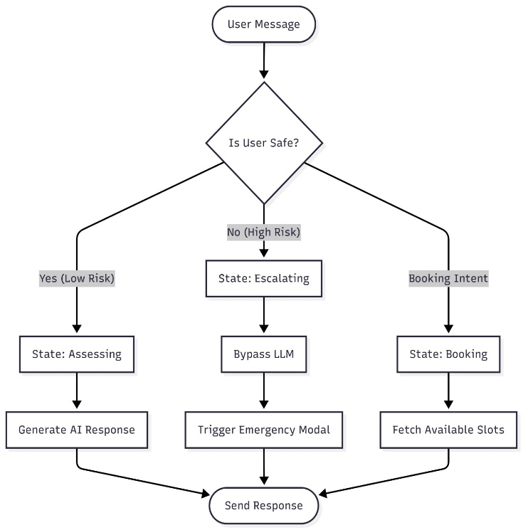
The system starts operating when a user sends a message via the chat interface and the message is subsequently examined instantly in terms of safety indicators or emotional disturbance. When the input has been
Fig.1. System Workflow for Safety Screening, Escalation, and Booking Coordination

recognized as low-risk, the flow proceeds to an assessing state where normal supportive interaction proceeds. Once the user shows his/her interest in making a session the flow moves to a booking state where the available consultation slots are retrieved and offered. The flow enters into an escalating state in case the message contains high distress or unsafe behaviour and normal conversation is interrupted by displaying an emergency modal, which will steer the user towards immediate help. Each of these paths low-risk, high-risk or booking is controlled by organised state transitions to predictable and safe behaviour. Once the correct action is taken a final reply is responded through the chat interface. The general flow guarantees the safety of the users, timely escalation, and easy access to the professional support when necessary.

NLU Risk Scoring Formula

Multi-Factor Risk Aggregation Function is employed in order to provide strong safety detection beyond mere matching of keywords[5], [6]. This mathematical model is a combination of several risk indicators to calculate a final normalized risk score Rscore of every user message. The formula uses the checks of keywords, intent signals, emotional signals, and contextual punishments that are used to guarantee dependable identification of risky phrases. Risk score is obtained by a hierarchical maximization function where additive context penalties are used:

Rscore​=min(1.0,Ikey​+max(Smodel​,Sintent​)+i=1∑n​(we​⋅Ei​)+δneg​)

Where:
1. $I_{\text{key}}$: Keyword Veto Function
Returns 1.0 if explicit threat phrases (e.g., “kill myself,” “I want to end it,” etc.) appear. This forces an immediate maximum score. Returns 0 otherwise.

2. $S_{\text{model}}$: Model-based Confidence Score
Ranges from 0.0 to 1.0. Confidence that can be obtained by a specialized risk classifier, which is used to examine the distress indicators in the message.

3. $S_{\text{intent}}$: Intent-based Confidence Score
Purposeful Confidence Score. Derived out of an intent classifier which identifies intent labels of crisis e.g. crisis signal. Makes sure that the indirect expressions of crises are not overlooked.

4. $E_{i}$: Supporting Emotion Indicators
Represents probability levels of emotions linked to psychological distress such as:
Hopelessness, Fear, Anxiety. These values capture sensitive emotional indications which can increase the level of risks.

5. $w_{e}$: Emotion Weight Coefficient
Establishes the effect of emotional indicators on the cumulative risk score. Typically kept low (e.g., 0.15) to prevent over-amplification.

6. δneg: Negative-Sentiment Bias Term
Minor penalty to be incurred in the event that the message is characterized by high negative tone. Assists in identifying unclear distress terms that do not necessarily have a keyword.

1) Low-Risk State Assessment Workflow for Mental-Health Support Systems

During the low risk stage, the message posted by the user is detected to be safe, without any dangerous key words or symptoms of serious emotional distress. This system shifts to the Assessing state in which normal conversation is maintained without a break. The message is decoded to mean and context and informative, supportive, or general guidance is provided based on the need of the user by the system. This stage keeps the communication calm and serene as it keeps on tracking any change in the tone of the user. Until the worrying trends start emerging, the dialogue will be stable, comforting, and positive, delivering the user with standard and easy-going assistance.

2) Appointment Booking Workflow

The process is initiated by the request to book a doctor by the user. The NLU module detects this intent and provides an indication to the interface to open the booking window. Once a date is selected by the user, the State Machine transmits this request to the ClinicAPI, which requests the Database to provide available slots in the appointment. The recovered slots are displayed to the user who then selects an option of the time. This validation is sent back to the State Machine to the ClinicAPI, which occupies the slot in the Database. A response that is a success is sent back, and the user is given a conclusive confirmation message as illustrated in Fig. 2

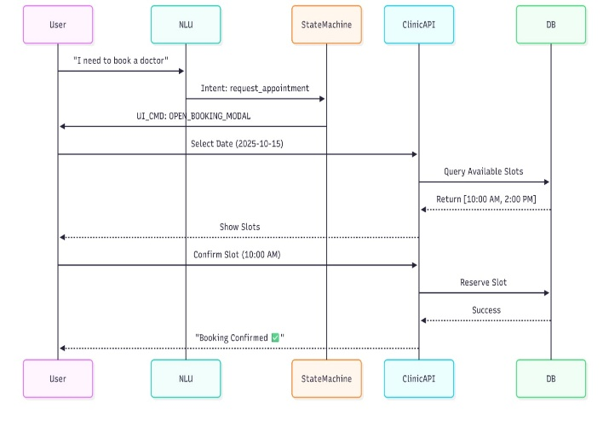

Fig. 2. Sequence Flow of Doctor Appointment Scheduling

3) High-Risk Detection and Emergency Escalation Flow

Whenever a user message is inputted into the system, it is initially screened in terms of safety. When the text has indications of extreme emotional distress, ill motive, or crisis related phrases, the text will tag as High Risk. This is when the regular flow of the conversation is immediately halted to avoid unsafe or inappropriate communication. Then the system passes to Escalating State where the priority is changed to user protection.
During this stage, the standard process of response-generation is skipped and the system triggers the pre-established safety workflow. This involves the activation of Emergency Modal that offers an emergency support option like calling a friend, calling a helpline or making an emergency call using built-in communication services. This stage is aimed at making sure that the people who demonstrate the symptoms of danger or crisis are prompted into a real-world help rather than an average conversation. Once the emergency workflow has been activated, a final response will be sent by the system signaling that an urgent response has been executed.

IV. RESULTS AND DISCUSSION

A. Conversation flow

The system was tested using a set of simulated user personas ranging from academic stress to acute crisis. Fig 1 shows the normal conversation flow where the system successfully maintained context over multi-turn conversations regarding general stress, utilizing the LLM to provide supportive, non-repetitive advice.

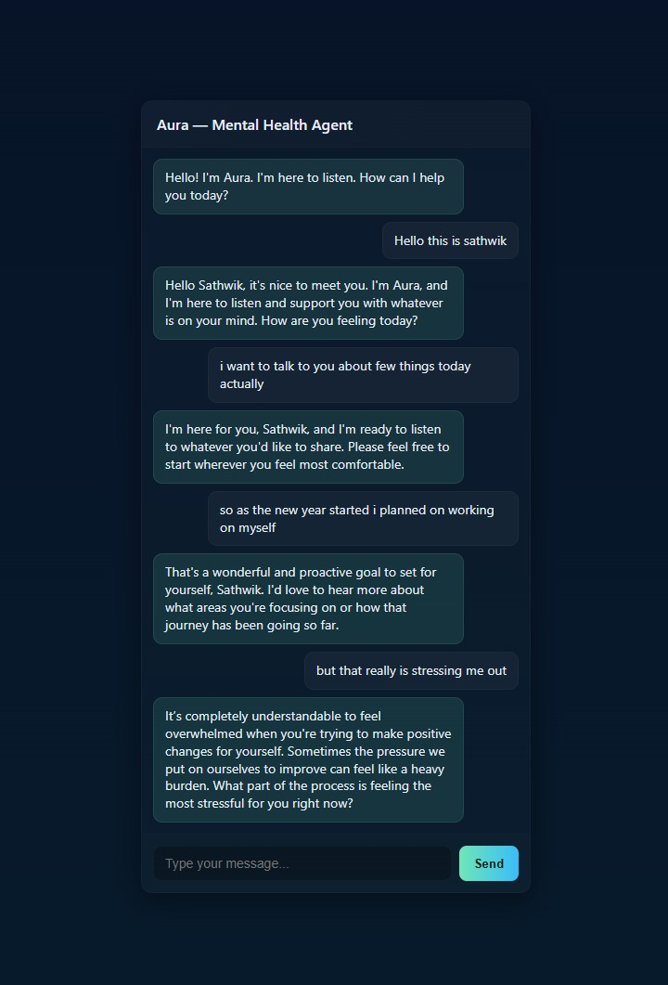

Fig 1: User Interaction Flow of the AI Mental Health Chat Interface

B. Appointment Interface
The system correctly bypassed the LLM and opened the selection, the system successfully enabled the Google Calendar and Email Confirmation modules, and server-side logging was utilized to verify the operations as illustrated in Fig.2.a and Fig.2.b.
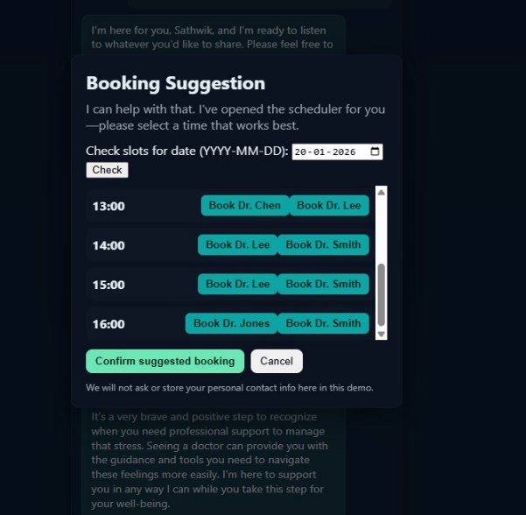

Fig 2.a: Doctor Appointment Booking Interface

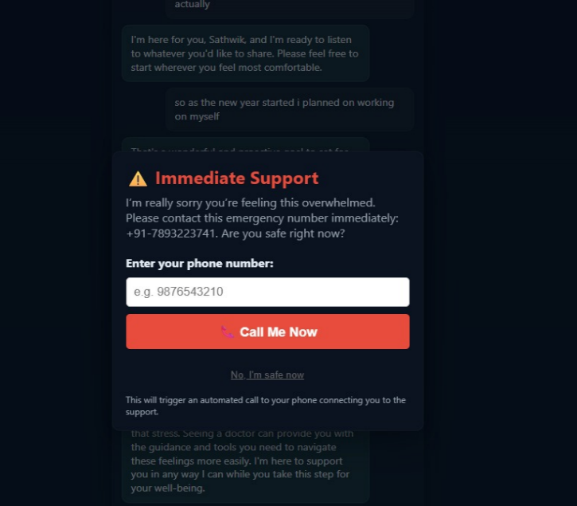
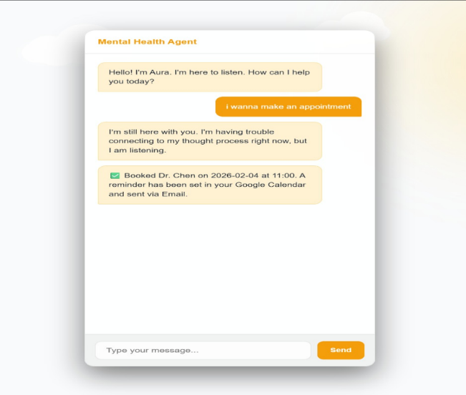

Fig 2.b: Appointment Booking Confirmation Triggered by Conversational AI and Notification Flow in the Mental Health

C. Explains about Crisis Escalation
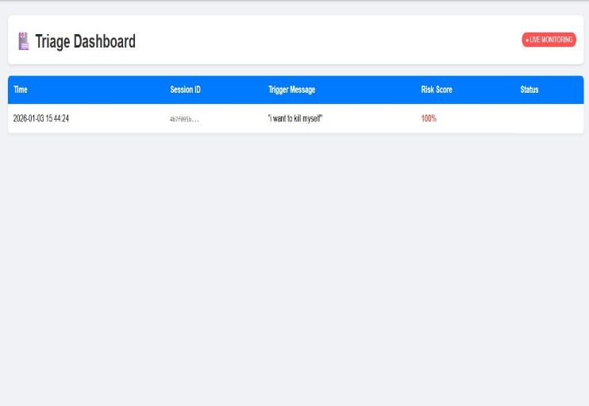
Upon receiving the trigger phrase "I want to kill myself," the system immediately interrupted the chat flow. The ESCALATION_MODAL was triggered in under 200ms.
Fig 3: Real-Time Triage Dashboard for High-Risk Mental Health Event Monitoring

D. The Voice Bridge Integration

The "Call Me Now" feature was tested using a mock-verified environment. The system successfully validated the user's input (phone number) and triggered the backend voice client.
The logs validated the end-to-end emergency flows by confirming a successful 200 OK response from the bridge service, as illustrated in Fig. 4.
Fig 4: Emergency Intervention Module with Automated Call Support

E. Safety Detection Performance

A collection of test inputs with normal and high-risk statements were analyzed to determine the accuracy with which the system detects safe and crisis-related messages. According to the confusion matrix in Fig. 5, the system was able to identify all crisis messages and generate no false negatives. This plays a key role in the mental-health setting as the misrepresentation of a single crisis input can have the result of ensuring an unsafe outcome. The system had a recall of 1.00 and the total F1-score of 0.95 which indicates a high probability of risk detection that is reliable.
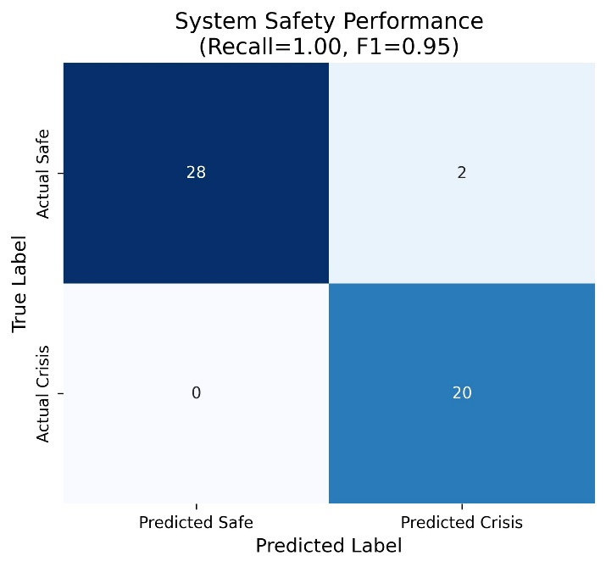
Fig 5: Confusion Matrix for Safety and Crisis Classification

$$Recall=\frac{TP}{TP+FN}$$
$F1 Score=\frac{2×Precision*Recall}{Precision+Recall}$​

To explain how the normal messages fall within the safe range and the emotionally strong or crisis-related inputs fall above the 0.85 mark. Once this happens, the system stops normal interaction and triggers emergency management to ensure effective distance between safe and high-risk scenarios as illustrated in fig.6.

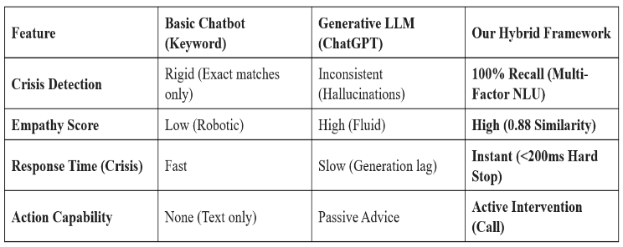
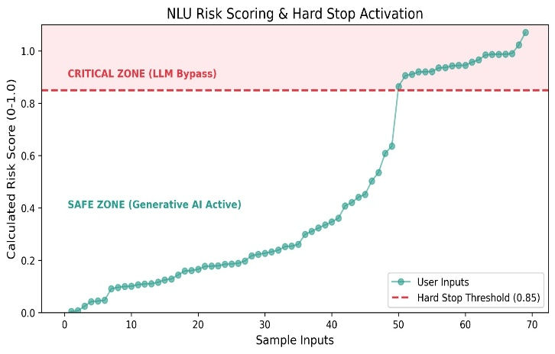
Fig.6 Risk Score Analysis for Safe and High-Risk Messages

F. Operational Efficiency(discussion)

The hybrid agent is better than the standard chatbots and rule-based as it has both high crisis safety and fluent conversation.
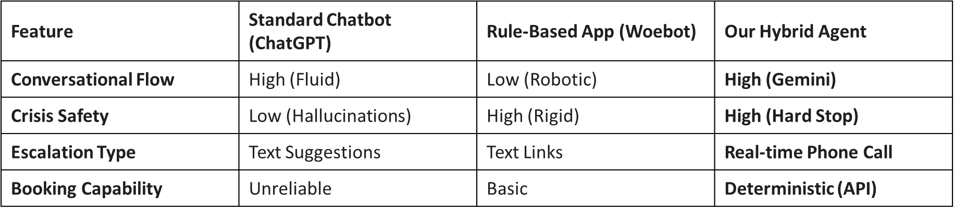
Fig. 7: Comparison of ChatGPT, Woebot, and Hybrid Agent Features
Conversational Flow: Chatbots that are based on rules are robotic and standard ones are uncontrollable. Our hybrid agent is natural, sympathetic, and conversational with a credible state-based advice.
Crisis Safety: Rule-based tools are inflexible, whereas standard chatbots can hallucinate. Our system is as safe as possible with the hard-stop mechanism with 100% crisis detecting recall.
Escalation Type: Others offer only text links. Our agent allows live escalation of phone calls to be responded to by humans.
Booking Capability: Basic chatbots are simple and standard ones are unreliable. Our method of booking is deterministic and based on API so that we have accurate confirmed appointments.
Safety Fluency Balance: The hybrid architecture is conversational and strictly safety-enforced with the use of FSM controls and risk screening.
Hard-Stop Effectiveness: The risk threshold of 0.85 is a dependable risk predictor of mild distress and severe crisis and helps to avoid missed emergencies and false alarms.
Bridging the Physical Gap: Our solution triggers real-time (<200ms) calls unlike text-only systems facilitating active intervention.
Limitations: The limitations that are currently present are voice-only escalation and low NLU precision when using mixed-language inputs.

G. Operational Efficiency
The hybrid framework is the best framework compared to simple chatbots and generative LLMs because it provides instant crisis response with a hard-stop mechanism that takes less than 200 ms. It guarantees proper identification of crisis, high empathy, and real time intervention through phone calls. In comparison to LLMs that have slow response time and slow generation lag, our model can generate action immediately, thus being quite reliable in an emergency.
Fig.7: Operational Efficiency Comparison Between Basic Chatbots, Generative LLMs, and the Proposed Hybrid Framework

H. Semantic Quality Comparison (Empathy)
The semantic quality of the system obtained a score of 0.88, which is a cosine similarity with our Hybrid Agent versus rule-based bots (0.45) and LSTM models (0.62). This demonstrates that it provides more compassionate and clinically consistent responses and refrains from unsafe and insensible communication.
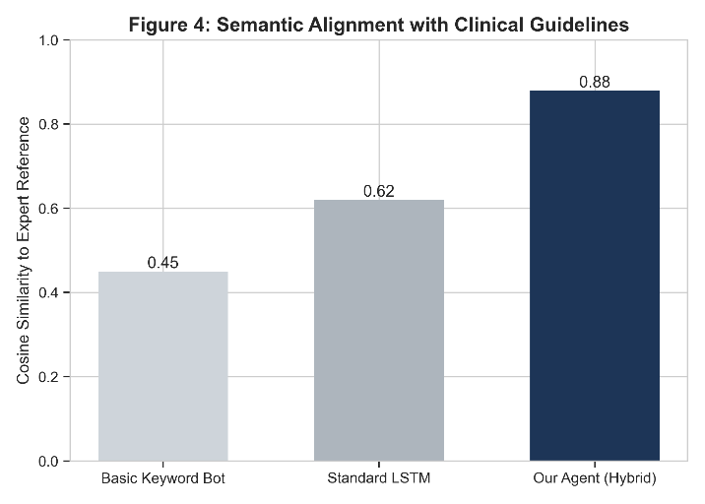
Fig 9: Semantic Alignment with Clinical Guidelines
I. Discussion
The findings indicate that the hybrid system is effective in identifying safe, emotional, and crisis messages and proving the necessary action with the help of its multi-factor risk assessment and FSM-based control. The model managed the conversation with normal speech, booking an appointment, and current emergency escalation without any problems, which shows that the model is flexible in both average and high-risk settings. Semantic quality testing also revealed that the system offers compassionate and context-sensitive representation as well as upholding safety limits. Albeit performance was good in the controlled tests, there is a need to validate the performance in a wider context that includes a wide range of language patterns and emotional expressions to enhance real-life robustness and generalizability.

V.CONCLUSION AND FUTURE SCOPE
The integration of artificial intelligence with the previously developed psychological safety principles will allow creating an efficient and reliable system of mental-health triage. The suggested hybrid model incorporates multi-factor NLU risk assessment, a deterministic Finite State Machine, and Retrieval-Augmented Generation in order to provide conversational empathy and high safety standards. The findings of the experiment demonstrate that the system is fairly reliable to detect crisis situations, does not tend to lose semantic correspondence to therapeutic communication norms, and provides the opportunity to take immediate action in order to intervene in an emergency situation. Also, user-friendly cues, built-in scheduling, and automatic alerts enhance accessibility and facilitate the process of making decisions on care. Generally, the system is provided with a centralized platform that is able to facilitate daily interactions and allows the escalation of urgent distress in a timely manner. The future work will revolve around the extension of the RAG knowledge base, adding multimodal sentiment analysis, and adding multilingual robustness to be deployed in the wider real-world context.
There are many opportunities for this system to expand further. These include adding new content related to stress management, sleep improvement, Emotion Management, etc. Creating a mobile app and offering various language versions will improve accessibility to users; furthermore, providing voice input will improve access for people in crisis and expanding the integration of Smart Devices Wearable Technology will give individuals basic monitoring and tracking abilities of their physical wellness-related behaviors through the use of our platform. Future growth of our platform will include various opportunities for improvement, including developing a clinician dashboard and collaborating with local health care providers (e.g., hospitals) and non-profit organisations (NPO) to further facilitate the delivery of real-world support and after-care services to our users.
REFERENCES
[1] I. D. S. Portugal, P. Alencar, and D. Cowan, An agentic AI-based multi-agent framework for recommender systems, in Proc. IEEE Int. Conf. Big Data (BigData), Washington, DC, USA, 2024, pp. 5375–5382, doi: 10.1109/BigData62323.2024.10825765.

[2] S. Hosseini and H. Seilani, The role of agentic AI in shaping a smart future: A systematic review, Array, vol. 26, Art. no. 100399, 2025, ISSN: 2590-0056.

[3] D. A. S., N. S., P. D. S., M. G., and V. Kalaivani, CalmSphere: An AI for mental health, in Proc. 7th Int. Conf. Intelligent Sustainable Systems (ICISS), India, 2025, pp. 1157–1161, doi: 10.1109/ICISS63372.2025.11076380.

[4] D. B. Olawade and O. Z. Wada, Enhancing mental health with artificial intelligence: Current trends and future prospects, Global Mental Health, Art. no. 100099, 2024, doi: 10.1016/j.glmedi.2024.100099.

[5] Y. Gao, Y. Xiong, and X. Gao, Retrieval-augmented generation for large language models: A survey, arXiv preprint, arXiv:2312.10997, 2023.

[6] F. Neha, D. Bhati, and D. K. Shukla, Retrieval-augmented generation (RAG) in healthcare: A comprehensive review, AI, vol. 6, no. 9, Art. no. 226, 2025, doi: 10.3390/ai6090226.

[7] A. Asari, Z. Wu, Y. Wang, A. Sil, and H. Hajishirzi, Self-RAG: Learning to retrieve, generate, and critique through self-reflection, arXiv preprint, arXiv:2310.11511, 2023, doi: 10.48550/arXiv.2310.11511.

[8] A. Bilal and B. Lin, OnRL-RAG: Real-time personalized mental health dialogue system, arXiv preprint, arXiv:2504.02894, 2025, doi: 10.48550/arXiv.2504.02894.

[9] Y. Ma, Z. Liu, and O. Kalinli, Effective text adaptation for LLM-based ASR through soft prompt fine-tuning, in Proc. IEEE Spoken Language Technology Workshop (SLT), Macao, 2024, pp. 64–69, doi: 10.1109/SLT61566.2024.10832227.

[10] K.-T. Tran, D. Dao, M.-D. Nguyen, and Q.-V. Pham, Multi-agent collaboration mechanisms: A survey of LLMs,”arXiv preprint, arXiv:2501.06322, 2025, doi: 10.48550/arXiv.2501.06322.

[11] P. Kulkarni, A. Mahabaleshwarkar, M. Kulkarni, N. Sirsikar and K. Gadgil, "Conversational AI: An Overview of Methodologies, Applications & Future Scope," 2019 5th International Conference on Computing, Communication, Control and Automation (ICCUBEA), Pune, India, 2019, pp. 1-7, doi: 10.1109/ICCUBEA47591.2019.9129347.

[12] J. Chen, H. Lin, X. Han, and L. Sun, Benchmarking large language models in retrieval-augmented generation, arXiv preprint, arXiv:2309.01431, 2023, doi: 10.48550/arXiv.2309.01431.

