TRANSACTION MANAGEMENT SYSTEM FOR ISSUANCE OF PERMITS APPLICATION SERVICES IN PANABO CITY’S ENGINEERING OFFICE

- Introduction

Company Overview
Panabo City's Engineering Office was established in 1981 and founded by Engr. Edwin P. Sumatra, together with the city's engineer and office assistants within office 1. They can accommodate 5 to 10 applicants per day and are open from 7:00 AM to 5:00 PM, Monday through Friday. The City Engineering's Office is responsible for issuing building, electrical, sanitary/plumbing, mechanical, architectural, and structural permits, ensuring that all construction projects comply with the National Building Code of the Philippines and other relevant regulations. Conducting detailed plan reviews and comprehensive inspections throughout the construction process, guaranteeing that projects meet approved plans and safety standards.
When applying for permits, the applicant must obtain a letter and application form provided by the Receiver. The applicant is required to fulfill the first-step requirements and pay the assessment fees at the cashier to receive an official receipt, which must be submitted to City Engineering Office 1. The Receiver records all applicant submissions using Microsoft Excel. To secure permit approval, the applicant must submit all required documents for review by the administration, specifically the civil and structural engineers, the architect, and the electrical engineer. If the applicant submission is incomplete, the releaser will return all documents. Once all requirements are completed and approved, the applicant can apply a completion form.
The applicant must wait for approval, and the office will notify the applicant via text message. A transaction management system for issuing permits within Office 1 will be beneficial to Panabo City's Engineering Office in streamlining the permit process, handling applicant applications, and monitoring applicant requirements for permit approval. It ensures that all applications are processed with clear communication and updates to the applicant.
The project team's collective efforts led to the successful deployment and operation of the system. Their skills and

collaboration played a vital role in ensuring the system meets all functional requirements and delivers an excellent user experience. With reliable and secure performance, the system is well-positioned to support the city's growth and development efficiently.

Problems Encountered
The City Engineering Office, responsible for issuing permits, currently operates without an information system. Interviews revealed that all transactions are handled manually. This highlights the need for a digital solution to improve efficiency and accuracy.
The reliance on Excel creates delays and difficulties in handling application status and responding to inquiries. This manual process is time-consuming and not well suited for effectively managing the flow of information and ensuring timely updates. As a result, there is a clear need for a more streamlined system to improve the efficiency of permit processing and applicant services.
The problems encountered by the city engineer's office are;
  - Lack of a system that can input applicant's information and application requirements and monitor permit transactions.
  - Encountered difficulty in searching for applicant's application records query.
  - Faces challenges in managing applicants' status due to disorganized paper storage files.

Objectives of the Project
General Objectives
The main objective of this project is to develop a permit transaction Management System for the Panabo City's Engineering Office to streamline the issuance of permits. It aims to replace the existing manual process by integrating modern technologies. This will enhance accessibility, transparency, and accountability for both government employees and applicants.
Specific Objectives Specifically, the system aims to:
- Allow the applicant to input such as:
  - Applicant Information
  - Project Location
  - Tax Account Number
  - Contact Number
  - TCT Number
  - Scope of work
  - Character of occupancy
- Allow the receiver staff to input and manage such as:
  - First-step requirements
  - Assessment Fees
  - OR Number
  - Applicant Code
- Allow the administrators to evaluate the following requirements:
  - Architectural Requirements
  - Civil/Structural Requirements
  - Electrical Requirements
- Allow the administrators to select status such as:
  - Approved
  - Disapproved
- Allow the system to notify applicants such as:
  - Login Confirmation
  - Applicant Code
  - Status Decision
  - Date of release documents
- Allow the scanner staff to scan and store all approved documents
- Allow the releaser staff to select an estimated date of release.
- Provide/show applicant records.
- Generate application form

Scope and Limitations
The scope of the project involves the development of a Permits Transaction Management System (PTMS) for Panabo City’s Engineering Office 1, enabling applicants to submit and monitor permit applications online, while allowing engineering staff including architects, civil/structural engineers, electrical engineers, receivers, scanners, and releasers to manage application requirements, evaluations, and document releases through role-based access. The system includes features such as applicant data input, permit tracking, real-time notifications via Gmail, document scanning and storage, and scheduling of permit release dates. However, the system is limited to Office 1 and requires users to have Gmail accounts and stable internet access.
- Related systems and works
Acquiring a building permit is essential for maintaining order in the development of cities. These are the agreements that suggest land use regulations are met by development. As a result, granting building permits helps to advance controlling development effectively in settlements [1]. A building permit is often required for construction projects and is considered a significant milestone in the project.
Permits are acquired from government agencies. Delays in the processing and issuance of building permits are often due to the complexity, error-proneness, and inefficiency of typical permitting systems [2]. The primary objective of this project was to develop a transaction management system (TMS) to replace the manual operations required to address existing problems and improve performance [3]. TMS enables users to monitor or track each permit that requires the system, as well as track client documents and permit information [4].
A Transaction Management System (TMS) for permit issuance is a digital platform designed to streamline and automate the processes of application, approval, tracking, and record maintenance. It aims to simplify operations and improve service delivery. Governments and organizations increasingly

adopt TMS solutions to boost efficiency, reduce errors, enhance transparency, and provide faster services to citizens and stakeholders [5].
Traditionally, issuing permits has been a manual, labor-intensive process that often experiences delays due to repetitive paperwork, poor interdepartmental coordination, and inadequate tracking systems [6]. A TMS resolves these inefficiencies by offering a centralized, integrated digital platform that oversees all transactional activities. Key elements typically include user sign-up, file submissions, application monitoring, alerts, and data analysis for assessing performance [7].
during its ongoing implementation. On the other hand, you can revert to the previous phases if there are changes to the project. That is why it needs to implement the Modified Waterfall Model, which provides a methodical and well-organized approach to software development. Waterfall development has the benefit of enabling control and departmentalization. Every step of development can have schedules with due dates, and a product can move through the phases of the development process model one at a time [16].

The incorporation of workflow automation is a key characteristic of contemporary TMS solutions. Workflow engines ensure that permit applications follow established approval routes, minimizing human involvement and speeding up processing times [8]. Role-based access control enhances security by ensuring that only authorized individuals can access or modify designated areas of an application [9].
A robust TMS utilizes cloud technology and mobile access to facilitate remote submissions, enabling applicants to track their status in real-time. This ease of use enhances the user experience and broadens the system's accessibility to underserved populations [10]. Additionally, the ability to interconnect with other government databases, such as business registries and tax systems, facilitates data validation and cross-referencing, thereby improving application reliability [11].
Data analytics and reporting features in a TMS offer essential insights into application patterns, departmental effectiveness, and compliance levels. These indicators can assist in developing policies and making administrative changes [12]. Moreover, digital recordkeeping facilitates long-term data storage, retrieval, and audit preparedness, which are essential for compliance with regulations and legal requirements [13]. Cyber security and data protection are also key factors in TMS design. Maintaining adherence to global standards, such as ISO/IEC 27001, is crucial for safeguarding private, personal, and corporate information [14]. The integration of blockchain is also gaining popularity to enhance data permanence and confidence in government-issued licenses.
Implementing a TMS offers broader governance benefits. It promotes transparency, reduces opportunities for corruption, and builds public trust in regulatory bodies [15]. As governments advance digital transformation efforts, transaction management systems become a vital investment for effective public service delivery.

- Methodology

A. Work Plan and Schedule Feasibility
- Project development methodology
The modified waterfall methodology employed by the project team, which is tailored to their needs. The project has a long deployment duration, and there may be potential changes

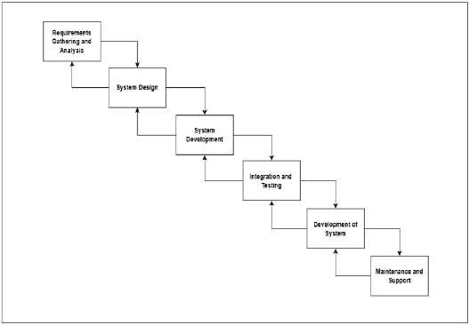
Figure 1. Modified Waterfall Model

Integrated & Proposed New Process
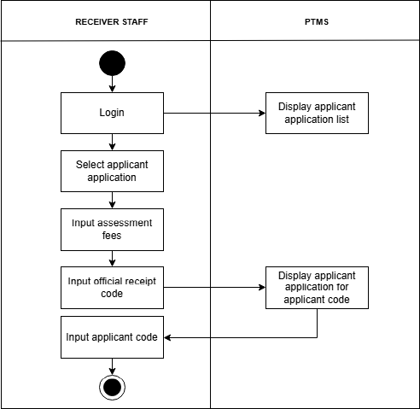
Figure 2. New Application Process

Figure. 2 illustrates the acquisition process for the applicant application code process interaction with the system where the applicant can log in through their Gmail account. It displays the available types of permits for application. The applicant fills out the form as well as downloads the list of requirements for submission.

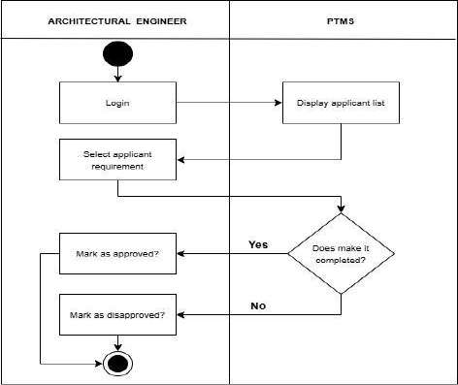

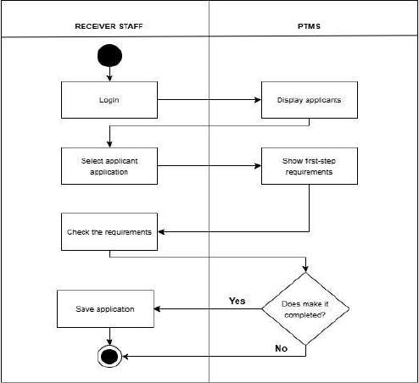
Figure 3. New First-Step Requirements Process

Figure 3 displays the process of interaction with the system, where the receiver staff logs in using their account. It displays the applicant first-step requirements list to check the requirements if completed or not. The applicant cannot proceed to the next step once the first step requirements are undone

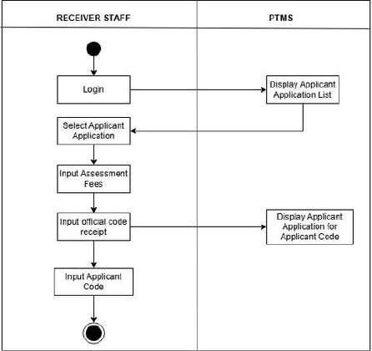
Figure 4. New Applicant Code Process

Figure 4 shows the receiver staff’s interaction with the system, where they log in using their account to view the list of applicant submissions. Once the applicant completes the first-step requirements, they are required to pay the assessment fees. Upon payment, the applicant receives a code to continue with the remaining permit application process.
Figure 5. New Architecture Approval of Permits

Figure 5. Shows the architectural engineer interaction with the system, where the architectural engineer can login using its account. The system will display the applicant list, and the architectural engineer can monitor applicant requirements, whether completed or not. The architectural engineer can select “approved” or “disapproved” within the system.
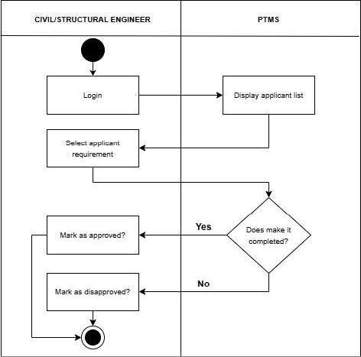
Figure 6. New Civil/Structural Approval of Permits

Figure 6. Shows the civil/structural engineer interaction with the system, where civil/structural engineer can login using its account. The system will display the applicant list, and the architectural engineer can monitor applicant requirements, whether completed or not. The civil/structural engineer can select “approved” or “disapproved” within the system.

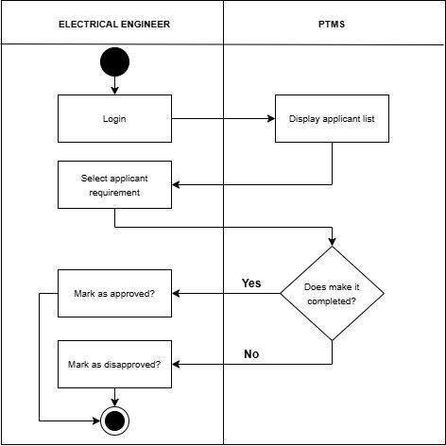

Figure 7. New Electrical Approval of Permits

Figure 7 shows electrical engineer interaction with the system, where the electrical engineer can login using its account. The system will display the applicant list, and the electrical engineer can monitor applicant requirements, whether completed or not. The electrical engineer can select “approved” or “disapproved” within the system.
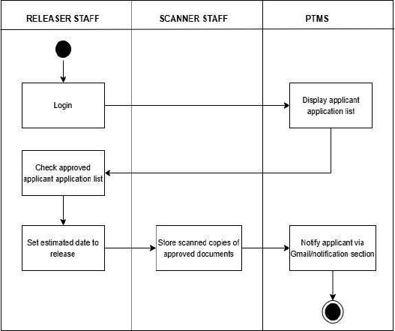

Figure 8. New Releasing of Approved Applicant Application
This section displays the approval and release of applicant applications. The system can also show the overall requirements. If the applicants complete their requirements for a permit, the releaser sets an estimated date for releasing, and the system will notify the applicant via its Gmail and notification section.
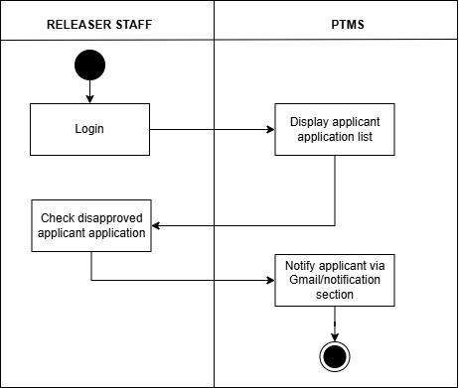
Figure 9. New Releasing of Disapproved Applicant Application Figure 9 outlines the process for releasing disapproved applications,
where the releaser staff reviews the disapproved submissions. The staff then notifies the applicant through their Gmail and/or the system’s notification section. This ensures that all related documents are properly returned to the applicant.

Work Breakdown Structure
The Work Breakdown Structure (WBS) of the project encompasses the following phases: Project Initiation, Specific Project Specification, System Design, System Development, Testing, Deployment, Maintenance and Support, and Project Closure. Each of these WBS components has specific tasks and subtasks that cover every aspect of the project, from planning to execution to evaluation and continuous support, from start to finish. The primary purpose of the WBS is to provide a framework for defining the proposed project activities [17].

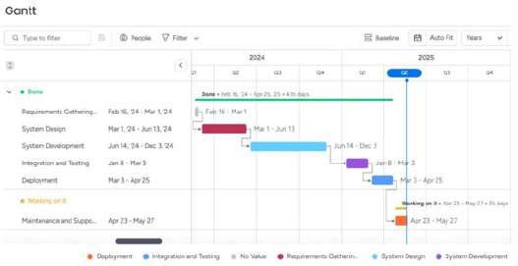

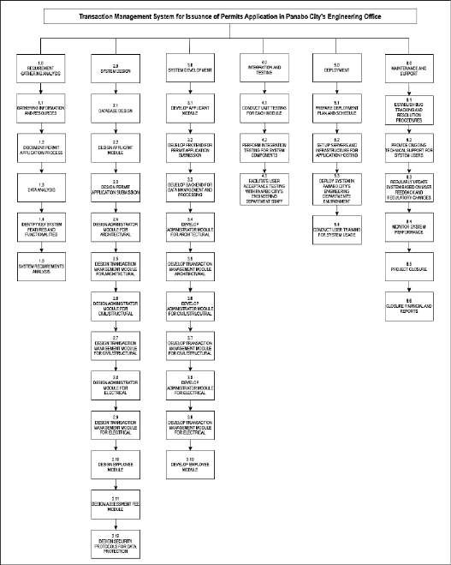
Figure 10. Work Breakdown Structure

Gantt chart
This Gantt chart shows the project's timeline, with start and end dates ranging from February 2024 to May 2025, as well as important events. It provides an accurate timeline for managing and tracking the project's progress, ensuring that each phase is completed within the allocated time range to fulfill the project's overall deadlines. The chart shows the project's phases, which are planning, design, development, testing, deployment, and review. The Gantt chart remains unchanged; the first and last tasks in each section kept their original date and didn't go on revision. Although some middle tasks were revisited and updated, affecting their individual dates, these changes didn't alter the overall timeline. This keeps the chart consistent while still reflecting detailed task adjustments separately. Below is a thorough description of each step and its timeline.
Figure 11. Project Gantt chart

Budget allocation
This project requires to allocates an estimated total budget to successfully develop and complete the project over an estimated number of periods. It states the cost needed includes WBS, technology, audit, and effort to cover every project phase. In addition, this project estimates a budget of a total of
₱405,871.25 to ensure the project is completed.

System Architecture
A system architecture diagram is a visual presentation for Permits Transaction Management System (PTMS) that needs to identify and include the components, such as electrical plans, civil/structural, and architectural, as well as the applicant, staff which is the receiver, releaser, and scanner. This process helps access the key information using an online application or walk-in. The staff will record the processing of permits and secure the important documents. This diagram shows how the permit procedure is designed to preserve an effective and safe built environment while protecting property values and making sure that the development doesn't have a negative impact on the community [18].
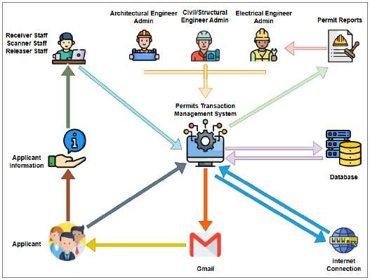
Figure 12. System Architecture

- Result and discussions
This chapter presents the results of deploying and evaluating the Transaction Management System for the Issuance of Permits Application Services at Panabo City's Engineering Office 1. The six-week deployment period involved actual system use in government office settings, where applicants, administrators, and staff interacted with the system during daily transactions.
Furthermore, Table 1 illustrates the evaluation results of the Transaction Management System for Issuance of Permits Application Services using a Likert Scale. This scale, ranging from 1 to 5, corresponds to descriptive ratings as follows: “Highly Agree” indicates the system fully meets all stated objectives; “Agree” suggests above average performance; “Moderately Agree” denotes that minimum standards are met; “Fairly Agree” reflects below-average performance; and “Not Agree” indicates a failure to meet minimum requirements.
Table 1. Likert Scale of the Proposed System

Numerical Description | Range | Descriptive  Equivalent | Description
5 | 4.01-5.00 | Highly  Agree | The system fully meets all the stated objectives
4 | 3.01-4.00 | Agree | The system performs above the average expectations
3 | 2.01-3.00 | Moderately  Agree | The system meets the  minimum required standards
2 | 1.01-2.00 | Fairly  Agree | that the system falls below average performance
1 | 0.01-1.00 | Not Agree | The system does not meet  even the minimum requirements.

A. Results
This section is a summary of the overall findings of the Functional Suitability, Performance Efficiency, Compatibility, Usability, Reliability, and Security of the Transaction Management System for Issuance of Permits Application Services in Panabo City’s Engineering Office. The findings and discussion of the information gathered from the assessments are provided below.
During the deployment phase of the Permits Transaction Management System, the online application module was not used by applicants. Instead, all applications were submitted through walk-in transactions, and the receiving staff manually entered the information into the system. As a result, applicants did not interact directly with the system, and key features such as document uploading, email notifications, and status tracking were not tested by actual users.
Due to this, the applicant evaluation results did not reflect real user experience. Responses to the questionnaire,
based on system quality standards (e.g., usability, performance, reliability), were limited, as applicants had no direct experience with the online system. The evaluation focused more on internal system use rather than full public deployment.

1. Overall Evaluation Result Summary
Administrative users, including engineers, rated the system very highly, with an overall average weighted mean (AWM) of 4.8, indicating strong agreement on its functional suitability, performance efficiency, reliability, compatibility, and security. While all engineers gave perfect scores in most areas, the Architectural Engineer gave slightly lower scores (4.0) in tasks like evaluating requirements and accessing documents, suggesting minor areas for improvement in architectural workflows.
Receiver staff gave perfect scores (AWM = 5.0) across all categories, reflecting complete satisfaction with the system’s functionality, efficiency, usability, reliability, compatibility, and security.
Releaser staff rated all areas with an AWM of 4.0, or "Agree," indicating the system performs adequately for release tasks but has room for improvement in responsiveness, clarity of instructions, and user interface design.
Scanner staff gave perfect scores (AWM = 5.0) in all categories, showing strong confidence in the system’s document handling, reliability, ease of use, and security. Overall, the system received an average rating of 4.7, labeled “Highly Agree,” confirming that it meets user expectations and aligns well with international software quality standards.

Table 2. Summary of User Rating Based on ISO 25010 Software Quality Framework
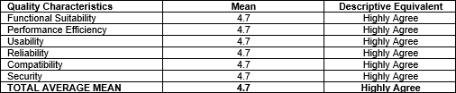
The overall user ratings, based on the ISO 25010 software quality framework, reveal a consistently high level of satisfaction, with each quality characteristic Functional Suitability, Performance Efficiency, Usability, Reliability, Compatibility, and Security achieving a mean score of 4.7, classified as "Highly Agree." This uniform rating across all categories demonstrates that users perceive the system as well-rounded and dependable, excelling in its functionality, speed, user-friendliness, stability, cross-platform compatibility, and security measures. The total average mean of 4.7 further confirms that the system effectively meets user expectations and maintains a strong standard of software quality throughout.

CONCLUSION AND RECOMMENDATIONS
This section summarizes the study's key findings and provides conclusions regarding the system's overall performance and efficiency. It indicates how well the system fulfilled its intended objectives, as evidenced by user feedback and insights. In addition, the following section provides practical recommendations for continuous improvement based on user experiences to improve the system's functionality and ensure it continues to satisfy the needs of administrators, staff, and applicants.

Conclusion
The deployment and evaluation of the Transaction Management System for the Issuance of Permits Application Services at Panabo City’s Engineering Office marks an adjusted advancement in the office’s pursuit of transformation and operational efficiency. Over a structured six-week period, the project team provided consistent technical support and training to staff, ensuring the system was fully integrated into daily workflows. System performance and user experiences were closely monitored, and feedback was collected from administrators and staff.
Despite minor issues such as notification errors and applicant code entry challenges, these were resolved through developer intervention. The system’s effectiveness was substantiated through a comprehensive evaluation using ISO/IEC 25010 software quality standards. Across all six quality characteristics Functional Suitability, Performance Efficiency, Usability, Reliability, Compatibility, and Security the system achieved a strong rating of “Highly Agree,” with an overall average weighted mean of 4.7.
The system effectively achieves all its specific objectives by facilitating each stage of the building permit application process. It enables applicants to input vital information such as personal details, project location, tax account number, and other necessary data, ensuring a complete and accurate submission from the outset. Receiver staff are empowered to manage first-step requirements, assessment fees, official receipt numbers, and generate applicant codes, allowing for efficient handling of preliminary documentation. Administrators can evaluate architectural, civil/structural, and electrical requirements, and are provided with the ability to select and update application statuses either approved or disapproved ensuring clarity and consistency in decision making.
Furthermore, the system enhances communication by notifying applicants of key updates, including login confirmation, applicant codes, status decisions, and document release dates. Scanner staff can scan and store approved documents securely, ensuring all records are properly archived and linked to the appropriate applicants. Releaser staff can easily set and modify estimated release dates, helping to manage applicant expectations and streamline document distribution.
The system also allows for quick access to applicant records, ensuring that all submitted data is viewable when needed. Finally, the system supports the generation of applications and related documents, reducing manual work and improving processing efficiency. Overall, each objective contributes to a user-friendly, reliable, and efficient workflow that supports of building permit processing.
In conclusion, the Transaction Management System significantly improved service delivery at the Panabo City Engineering Office. It met its functional goals, enhanced user satisfaction, and ensured process integrity. The system stands as a successful implementation of government and serves as a model for similar initiatives in other local government units.

Recommendations
To achieve sustained success for the Permits Transaction Management System (PTMS), it is fundamental that existing functions are maintained while new functions-applicant details, assessment fees, and document submission-are expanded upon since user satisfaction for the PTMS is quite high. Serving some common complaints by users-tracking application statuses, timely notification of PTMS updates, and fees for assessing applications being assuredly calculated-will not only enhance the user's confidence but also their satisfaction.
In addition, providing a well-designed user interface that is intuitive and simple for first-time users to demonstrate the full functionality of the system, can lead to lost user confidence due to errors which can improve efficiency. The system assist in this function should provide clear instructions, in depth visualization of commonly used features (such as applicants, document submissions and fee assessments), as well as enable quick access were beneficial. It is also to add a filtering option that has an application month or a particular field for setting custom criteria. This will allow users and administrators to track, sort, and manage permit applications by the submission date, or other criteria they choose as necessary to get to the identified permit managed on that date.
Performance and security are both very important. The system needs to be improved continuously for quick loading times and responsiveness on all devices and browsers, ensuring it works well online and offline. Security measures must be kept strong through regular updates on access controls, encryption, and authentication methods to protect the administration/staff data and stop unauthorized access or breaches. It is also essential to schedule regular updates to fix issues, add new features, and enhance overall performance. Ongoing training for staff and users will help make the system more effective and encourage its use.
Due to the current limitations of the system, which does not have any online functions, any future enhancements should focus on providing complete online processing of the growing needs of applicants and administrators. This should involve

enabling online registration and tracking of applications, real time status updates, and a user-friendly mobile interface. Future upgrades should include documents being verified online, digital notifications (SMS), and embedded feedback options. These will enhance the user experience but more so the capacity and transparency of the entire process.
By following these recommendations, Panabo City’s Engineering can keep the Transaction Management System running smoothly and can solve existing issues and provide for future demands. Ongoing system maintenance and staff training, and addition of key features such as online processing and mobiles access will help optimize workflows, reduce manual processes, and improve service delivery for applicants. Improvements to the accuracy of the data and security measures will better protect sensitive information, achieve compliance, and establish the public's trust in the city's digital services.

REFERENCES

[1]L. Xue, "Application Analysis of Intelligent Information Technology in Transaction Management System," in Proc. 10th Int. Conf. Appl. Tech. Cyber Intell. (ICATCI), 2022, pp. 121–
129. [Online]. Available: https://www.icatci.org/proceedings/2022 [Accessed: April. 15, 2024].
[2]L. W. Pan et al., "Blockchain Based Transaction Management System for IC Industry," in Proc. 3rd Int. Conf. Blockchain Technol., 2021, pp. 60–66. [Online]. Available: https://ieeexplore.ieee.org/document/9456782 [Accessed: April 15, 2024].
[3]R. H. S. Katz, "Transaction Management for Design Databases," 1983.
[Online].Available:https://www.researchgate.net/publication/2 20917153_Transaction_Management_for_Design_Databases [Accessed: May 17, 2024].
[4]E. Odunayo, "Design and Implementation of a Web-Based Transaction Management System," B.Sc. thesis, [Department/University], 2018. [Online]. Available: https://repository.university.edu/theses/odunayo [Accessed May 17, 2024].
[5]K. R. C. L. I. W. E. Ullah, "BIM adoption in the AEC/FM industry–the case for issuing building permits," Int. J. Strateg. Property Manage., vol. 24, no. 6, pp. 400–413, 2020. [Online]. Available: https://www.tandfonline.com/doi/full/10.1080/16427166.2020. 1772639 [Accessed: June 9, 2024].
[6]M. M. E. B. M. M. H. M. R. Abdel Wahed, "Towards an advanced mechanism to benefit from information systems in issuance of building permits," HBRC Journal, vol. 8, no. 1, pp. 58–63, 2012. [Online]. Available: https://www.sciencedirect.com/science/article/abs/pii/S187770 5812000025 [Accessed: December 5, 2024].
[7]R. N. D. R. E. L. B. J. S. H. J. T. Tortor, "An Online Workflow Management System for Streamlining the Processing of Business Permits in A Local Government Unit," Proc. 2019 Int. Conf. E-Business Mobile Commerce, pp. 64–68, 2019. [Online]. Available:
https://dl.acm.org/doi/10.1145/3335031.3335044 [Accessed: January 12, 2025].
[8]S. F. W. Sheerleen, "Legal Assistance in Application of Business Permit in Online Single Submission System (OSS) at Kantor Notaris & PPAT Rian Sugito, SH., M. Kn.," ConCEPt-Conf. Community Engagement Project, vol. 2, no. 1, pp. 686–690, 2002. [Online]. Available: https://www.researchgate.net/publication/355551309_Legal_A ssistance_in_Application_of_Business_Permit_in_Online_Sin gle_Submission_System_OSS [Accessed: February 15, 2025]. [9]M. M. E. B. M. M. H. M. R. Abdel Wahed, "Towards an advanced mechanism to benefit from information systems in issuance of building permits," HBRC Journal, vol. 8, no. 1, pp. 58–63, 2012. [Online]. Available: https://www.sciencedirect.com/science/article/abs/pii/S187770 5812000025 [Accessed: February 13, 2025].
[10]M. D. S. M. S. K. A. P. A. J. A. S. D. Eirinaki, "A building permit system for smart cities: A cloud-based framework," Computers, Environment and Urban Systems, vol. 70, pp. 175–188, 2018. [Online]. Available: https://www.sciencedirect.com/science/article/pii/S019897151 7303389 [Accessed: March. 10, 2025].
[11]M. E. M. M. S. K. A. P. A. J. A. S. D. Eirinaki, "A building permit system for smart cities: A cloud-based framework," Computers, Environment and Urban Systems, vol. 70, pp. 175–188, 2018. [Online]. Available: https://www.sciencedirect.com/science/article/pii/S019897151 7303389 [Accessed: M arch 10 2025].
[12]N. C. B. E. A. N. K. Ulibarri, "A framework for building efficient environmental permitting processes," Sustainability, vol. 9, no. 2, p. 180, 2017. [Online]. Available: https://www.mdpi.com/2071-1050/9/2/180 [Accessed: April 16, 2025].
[13]D. Duchamp, "Transaction management," Contract, vol. 1520, no. 84-K, p. 33615, 1988. [Online]. Available: https://www.contractjournals.com/transaction-management [Accessed: April. 16, 2025].
[14]F. F. S. S. L. D. Lin, "Assessing citizen adoption of e-Government initiatives in Gambia: A validation of the technology acceptance model in information systems success," Government Information Quarterly, vol. 28, no. 2, pp. 271–279,
2011. [Online]. Available: https://www.sciencedirect.com/science/article/pii/S0740624X1 0001235 [Accessed: April. 17, 2025].
[15]C. J. A. C. E. M. R. B. C. A. F. G. M. M. A. P. Diokno-Sicat,
"Baseline study on policy and governance gaps for the local government support fund assistance to municipalities (LGSF-

AM) program: Integrated report," 2020. [Online]. Available: https://www.lgsf.gov.ph/reports/2020 [Accessed: April 17, 2025].
[16]W. W. Royce, "Managing the Development of Large Software Systems," in Proc. IEEE WESCON, 1970. [Online]. Available: https://ieeexplore.ieee.org/document/6466283 [Accessed: April. 17, 2025].
[17]P. M. I. (PMI), A Guide to the Project Management Body of Knowledge (PMBOK® Guide), 7th ed., Project Management Institute, 2021. [Online]. Available: https://www.pmi.org/pmbok-guide-standards [Accessed: April. 19, 2025].

ACKNOWLEDGEMENT
First and foremost, the team want to sincerely thank God for guiding every step of the way until now. Throughout all the paths they have taken especially this capstone journey God has never failed to listen to their prayers and has never left them. Whenever they felt weak or overwhelmed, it was from God that they drew strength. Almighty God was always there, giving them the inspiration to keep going.
The team would also like to express their gratitude to everyone who helped and supported the development of the Permits Transaction Management System (PTMS). Deepest thanks to Engr. Edwin P. Sumatra, Arch. Denis V. Balatero, Engr. Jan Riel Enriquez, and Engr. Goffer Balana for giving the opportunity to deploy the system at the City Engineering Office and for the guidance that shared along the way. Also, thanks to Mr. Peter Alfred D. Cabalda from the Receiver staff, for being there whenever the team needed help or additional information about the organization. And to the friend, John Kristan Torremocha biggest thanks for the guidance and support throughout the process of building the system.
To the amazing team Project Manager Nicole B. Pacaldo, System Designer Raychelle M. Temlor, System Analyst Josyl
T. Capute, and System Programmer April Joy Penton strong communication, teamwork, and mutual trust played a key role in their success. Their collaboration was essential in the successful deployment of the PTMS. They truly did an outstanding job together.
Also, the team extend their deepest gratitude to the respected adviser, Mr. Rafael A. Dela Peña III, for the constant support, wise advice, mentorship, and technical guidance from the beginning until the very end of the project. Mr. Dela Peña’s expertise and constructive feedback played a huge part in the success of the system. From title defense to the final presentation, to encouragement helped the team overcome challenges and stay motivated to finish strong.
The team would also like to thank their panellists Philip John L. Paja, Nelma Mae G. Loja, Kres-Ann B. Oclarit, and Flonie Mae P. Romulo for generously sharing their time and expertise. Their insightful feedback and thoughtful questions during the presentations were greatly appreciated. These contributions helped improve the work and deepen the team’s understanding of the system they built.
Lastly, the team want to express their heartfelt thanks to their parents (Nancy Pacaldo, Gillo B. Pacaldo, Jully M. Temlor, Isidra B. Penton, Gemma T. Capute, Cirilo Capute) for their endless love, support, care, and understanding throughout the academic journey. To their partners, Nic R. Castor and Froilan C. Daarol—also thanks for being an emotional and mental support. The belief from beginning to end, helped the team reach this milestone. The love and encouragement were their constant source of strength and inspiration in achieving success.

