MAPPING INDIGENOUS PEOPLES EDUCATION LEARNERS’ TECHNOLOGY ENGAGEMENT IN ENGLISH THROUGH PICRAT MODEL

Introduction
Technology integration has become an important component of contemporary English Language Teaching (ELT) as schools respond to the demands of digital learning, learner diversity, and 21st-century communication skills. In English classrooms, technology can support language development by providing opportunities for interaction, collaboration, and creativity, as well as access to diverse learning resources. In this context, the study examined the nature and extent of technology-supported English instruction among Indigenous learners by identifying effective pedagogical approaches and informing interventions that promote meaningful, culturally responsive, and transformative learning experiences.
Recent studies emphasise the positive role of technology in enhancing learner engagement, motivation, communication, and instructional effectiveness in ELT (Al-Awidi & Alghazo, 2021; Tondeur et al., 2021; Zheng & Warschauer, 2022; Hiver et al., 2023). In the Philippine context, educational reforms and digitalisation initiatives have strengthened the use of technology across basic education. Research conducted in rural and Indigenous settings likewise suggests that technology can support English language learning and culturally responsive instruction when aligned with local contexts and learner needs (Agaton & Cueto, 2021; Tuazon & Roxas, 2021; Soto et al., 2023).
Despite these developments, research on technology integration in Indigenous Peoples' education remains limited. Existing studies largely focus on technology access, infrastructure, digital readiness, or learner participation, while few have examined how teacher competence and instructional practices affect these outcomes. Furthermore, the application of the PICRAT model in IPEd English classrooms remains underexplored, particularly in geographically isolated and disadvantaged communities. Schindler et al. (2021) note that research on technology and engagement largely focuses on higher education and rarely includes Indigenous or geographically isolated contexts. More specifically, there is a paucity of empirical studies that systematically investigate the interrelationship between teachers’ competence and contextual challenges within the DepEd-Tandag City Division.
This study generates context-specific empirical evidence on teachers’ technology integration practices and learner engagement in English Language Teaching (ELT). Moreover, the study is among the first in Mindanao to apply the PICRAT model within IPEd while explicitly grounding technology integration in culturally sustaining pedagogy. The study provides integrated, context-sensitive, and practice-oriented insights that can inform teacher professional development.

Theoretical Framework
This study is anchored on the premise that meaningful technology integration in English Language Teaching (ELT) within Indigenous Peoples Education (IPEd) classrooms occurs when technology supports language learning, promotes learner engagement, and remains responsive to Indigenous cultural contexts.
The study is primarily grounded in the Interactionist Theory of Second Language Acquisition, which posits that language development occurs through meaningful social interaction, negotiation of meaning, feedback, and collaborative communication. According to Gass, Behney, and Plonsky (2021) and Sato and Loewen (2022), learners acquire language more effectively when they actively participate in interaction-rich learning experiences that encourage communication and authentic language use. In technology-supported English instruction, digital tools provide opportunities for interaction, collaboration, and engagement that facilitate language learning. In the present study, Interactionist Theory explains the learner engagement dimension of technology integration, particularly how technology supports learners’ participation, interaction, collaboration, creativity, and reflection in English learning activities.
Supporting this perspective is Culturally Sustaining Pedagogy (CSP), which emphasises the importance of sustaining learners’ cultural identities, community knowledge, and linguistic resources within formal education. Paris and Alim (2021) and Bang et al. (2023) argue that meaningful learning occurs when instruction recognises and values learners' cultural experiences rather than requiring learners to assimilate into dominant educational practices. Within Indigenous Peoples Education, CSP provides a framework for ensuring that technology integration remains culturally responsive and contextually relevant. It guides teachers in designing English learning experiences that incorporate Indigenous knowledge systems, local narratives, community experiences, and culturally meaningful content. In this study, CSP explains the cultural responsiveness and contextualization components of technology-supported instruction and supports the development of English-learning activities aligned with Indigenous learners’ identities and lived experiences.
The study is further supported by the Technological Pedagogical and Content Knowledge (TPACK) framework, which posits that effective technology integration depends on teachers’ ability to integrate technological, pedagogical, and content knowledge in ways that enhance learning. Research has shown that teachers with stronger TPACK competence are more capable of designing learner-centred, technology-supported instructional experiences that promote meaningful engagement and improved learning outcomes (Tondeur et al., 2021; Schmid, Brianza, & Petko, 2021). Within English Language Teaching, TPACK provides a foundation for understanding teachers’ competence in selecting, adapting, and utilising digital tools that support language instruction. In the present study, TPACK serves as the theoretical basis for examining teachers’ competence in technology integration and their implementation of technology-supported instructional practices in IPEd English classrooms.
These theories converge through the PICRAT model, which serves as the study’s central analytical framework. PICRAT provides a dual lens for examining technology integration by focusing on both learner engagement and teachers’ instructional use of technology. The learner dimension examines the extent to which technology promotes passive, interactive, and creative engagement, while the teacher dimension evaluates technology use as a replacement, an amplification, or a transformation of instructional practice.
Within this framework, Interactionist Theory explains how technology supports learner engagement and language development, CSP ensures that technology-supported instruction remains culturally sustaining and responsive to Indigenous contexts, and TPACK explains how teachers’ competence influences the quality of technology integration. The integration of these perspectives enables the study to examine the relationships among teacher competence, learner engagement, instructional practices, RAT-level technology use, and contextual challenges in Indigenous learning environments. Furthermore, it provides the theoretical foundation for developing a PICRAT-guided intervention program to strengthen culturally responsive and transformative technology integration in English Language Teaching within Indigenous Peoples' Education.

Conceptual Framework
This study is anchored on established scholarly frameworks and relevant national legal and policy foundations that support meaningful and equitable technology integration in English Language Teaching (ELT), particularly within Indigenous Peoples Education (IPEd). This study is anchored on legal and policy frameworks that support the provision of culturally responsive, inclusive, and technology-enhanced education for Indigenous learners. Republic Act No. 8371, otherwise known as the Indigenous Peoples’ Rights Act (IPRA) of 1997, recognises the rights of Indigenous Peoples to culturally appropriate educational systems that preserve and promote their cultural heritage, traditions, and knowledge systems. Likewise, Republic Act No. 10533, or the Enhanced Basic Education Act of 2013, institutionalises a learner-centred, inclusive, and culture-sensitive curriculum that responds to the diverse needs and contexts of Filipino learners. These policies establish the foundation for implementing educational programs that respect Indigenous identities while promoting equitable access to quality education.
Further strengthening this foundation are the Department of Education’s Indigenous Peoples Education (IPEd) Policy Framework under DepEd Order No. 62, s. 2011, which promotes the integration of Indigenous knowledge systems and practices into the basic education curriculum. In addition, the Basic Education Learning Continuity Plan (DepEd, 2020), the Digital Rise Program, and the Connecting the Last Mile Schools Program support the integration of technology in teaching and learning, particularly in geographically isolated and disadvantaged areas. These policies emphasise equitable access to digital resources, teacher capability-building, contextualised instruction, and the development of meaningful learning experiences that address the realities of Indigenous communities. These legal and policy frameworks provide the basis for examining technology-supported English language instruction within Indigenous Peoples' Education settings.
Guided by these policy directions, the study adopts the PICRAT model as the conceptual lens for examining technology integration in English Language Teaching among Indigenous Peoples Education learners. The PICRAT model provides a comprehensive framework for understanding how technology influences both teachers’ instructional practices and learners’ engagement in the learning process.
As shown in Figure 1, the framework identifies teachers’ competence in integrating technology, technology-supported learner engagement, teachers’ technology integration practices, and contextual challenges as the study's primary variables. These variables are examined to determine their individual characteristics, their relationships with one another, and their influence on teachers’ RAT-level technology use.

Teachers’ Level of Competence in Integration Technology
in English Class

Teachers’ Technology Integration
(PICRAT – Teacher Side)
Learners’ Technology Integration
(PICRAT – Learner Side)

Challenges Indigenizing English through Technology – Supported Tasks

PICRAT-Guided Transformative Technology Integration Program for English Teachers in Indigenous Peoples Education (IPEd).

Figure 1. Schematic Diagram of the Study
The schematic diagram of the study, which follows the Input–Process–Output (IPO) model guided by the PICRAT framework to illustrates the relationships among the variables. The input component consists of teachers’ levels of competence in integrating technology in English classes, which includes PICRAT-based pedagogical knowledge, cultural responsiveness and contextualization, technology knowledge and adaptive proficiency, access to technological resources, and reflective teaching practice. It also includes learners’ technology-supported engagement on the learner side of PICRAT, encompassing passive, interactive, collaborative, creative, and reflective forms of engagement, as well as teachers’ technology integration practices on the teacher side of PICRAT, which are categorized as replacement, amplification, and transformation. In addition, the input component accounts for the challenges encountered by teachers in indigenizing English instruction through technology-supported tasks, such as limitations in resources, connectivity, cultural appropriateness, and teacher preparedness. These input variables represent the instructional, learner-related, and contextual conditions that influence how technology is integrated in IPEd English classrooms.
The process component of the framework describes how the input variables are examined and analysed in the study. This involves the collection of quantitative data through validated survey questionnaires administered to English teachers in IPEd schools, followed by the use of appropriate descriptive and correlational statistical techniques to determine the levels of teachers’ competence, learner engagement, and technology integration practices, as well as the extent of challenges encountered. Through this process, the study examines the relationships among teacher competence, instructional practices, learner engagement, RAT-level technology use, and contextual challenges, allowing for the identification of patterns and predictive relationships that explain the depth and quality of technology integration in ELT.
The output component of the framework is the development of a PICRAT-Guided Transformative Technology Integration Program for English Teachers in Indigenous Peoples Education (IPEd). This intervention program is derived directly from the findings of the study and is intended to enhance teachers’ competence in integrating technology, promote higher levels of learner engagement, particularly interactive and creative engagement, support the progression from replacement-level to amplification- and transformation-level technology use, and address the contextual and cultural challenges faced by teachers in indigenizing English instruction through technology. The output serves as a practical and adaptable guide for improving technology-supported English Language Teaching in IPEd classrooms and aligns with the Department of Education’s mandate for culturally responsive, inclusive, and equitable education.
Statement of the Problem
This study examines how teachers in Indigenous Peoples Education (IPEd) classrooms integrate technology in English Language Teaching (ELT) through the PICRAT model. It investigates teachers’ competence in technology integration, their instructional practices, the extent of technology-supported learner engagement, and the challenges that influence technology use in Indigenous English classrooms.
Specifically, this study seeks to answer the following questions:
1. What is the level of teachers’ competence in integrating technology in English instruction with Indigenous Peoples learners in terms of:
1.1 PICRAT-based pedagogical knowledge;
1.2 Cultural responsiveness and contextualization;
1.3 Technology knowledge and adaptive proficiency;
1.4 Access to technological resources; and
1.5 Reflective teaching practice?
2. What is the extent of technology-supported learner engagement among Indigenous Peoples learners in English lessons in terms of:
2.1 Passive engagement;
2.2 Interactive engagement;
2.3 Collaborative engagement;
2.4 Creative engagement; and
2.5 Reflective or metacognitive engagement?
3. What is the level of teachers’ technology integration practices in teaching English in IPEd classrooms based on PICRAT-aligned instructional processes in terms of:
3.1 Active knowledge-building facilitation;
3.2 Activation and linking of prior knowledge;
3.3 Inquiry and problem-solving support;
3.4 Technology-mediated dialogue and collaboration; and
3.5 Culturally responsive task design and scaffolding?
4. To what extent do teachers’ uses of technology in English instruction reflect the RAT dimensions of:
4.1 Replacement;
4.2 Amplification; and
4.3 Transformation?
5. What is the extent of challenges encountered by teachers in indigenizing English learning through technology-supported tasks that promote thinking, reflection, and culturally responsive engagement?
6. Is there a significant relationship between teachers’ competence in integrating technology and their level of technology integration practices in teaching English?
7. Is there a significant relationship between teachers’ level of technology integration and learners’ level of technology-supported engagement?
8. Which among teacher competence, learner engagement, and teachers’ technology integration practices significantly predicts teachers’ RAT-level technology use in English instruction?
9. Is there a significant relationship between the extent of challenges encountered and the extent of teachers’ technology integration and learner engagement?
10. What intervention program may be proposed based on the results of the study?
Hypotheses
The following null hypotheses are formulated and tested at the 0.05 level of significance:
H0₁: There is no significant relationship between teachers’ competence in integrating technology and their level of technology integration practices in teaching English.
H0₂: There is no significant relationship between teachers’ level of technology integration and learners’ level of technology-supported engagement.

H0₃: There is no significant predictive influence of teachers’ competence, learner engagement, and instructional practices on teachers’ RAT-level technology use in English instruction.
H0₄: There is no significant relationship between the extent of challenges encountered and the extent of teachers’ technology integration and learner
Scope and Limitations of the Study
This study examines how teachers in Indigenous Peoples Education (IPEd) classrooms under DepEd–Tandag District 2 integrate technology into English Language Teaching through the PICRAT model during the School Year 2025–2026. It covers English teachers assigned to selected IPEd schools in the district and investigates teachers’ competence in integrating technology, their instructional practices based on the PICRAT teacher dimension of Replacement, Amplification, and Transformation, and the extent of technology-supported learner engagement in terms of Passive, Interactive, Collaborative, Creative, and Reflective engagement.
The study also identifies challenges teachers encounter in indigenizing English instruction through technology-supported tasks that promote thinking, reflection, and culturally responsive engagement. Data are gathered using a researcher-made, validated survey questionnaire and analysed using descriptive and correlational statistical techniques to determine levels, relationships, and predictive influences among the variables examined.
The study is limited to English Language Teaching in IPEd classrooms and excludes other subject areas, grade levels, and non-IPEd schools within the district. It does not measure learners’ academic performance, language proficiency gains, or the effectiveness of the proposed intervention program, as the intervention is designed based on the findings rather than implemented or evaluated within the scope of this research. The findings are based primarily on self-reported data from teachers, which may be influenced by their perceptions, experiences, and familiarity with technology integration and the PICRAT framework. Contextual factors such as varying levels of access to digital devices, internet connectivity, and school-based support systems may also affect the extent and depth of observed technology integration. As such, the results reflect the instructional conditions of the participating IPEd schools and may not be generalizable to other educational contexts.
Significance of the Study
The value of this study extends to the following stakeholders:
Indigenous Peoples Learners. The findings may contribute to the improvement of English instruction that is culturally responsive, engaging, and supportive of meaningful language development. By promoting interactive and creative forms of engagement through technology, the study supports learning experiences that affirm Indigenous identity while strengthening communicative competence.
English Teachers in IPEd Classrooms. The study provides evidence-based insights into effective technology integration practices aligned with the PICRAT framework. It may help teachers reflect on their instructional approaches, strengthen their technological pedagogical competence, and design culturally grounded English learning tasks that move beyond replacement-level technology use toward amplification and transformation.
ICT Coordinators. The findings were derived from a deeper understanding of the technological needs, challenges, and instructional realities of IPEd schools. The results may serve as a basis for planning technical assistance, technology-related training programs, and resource management initiatives that support effective classroom technology integration.
School Administrators and Instructional Leaders. The results may serve as a basis for designing targeted professional development programs, strategically allocating technological resources, and strengthening school-level support systems for culturally responsive technology integration in ELT.
Department of Education (DepEd) and Policymakers. The study offers context-specific empirical data that may inform the implementation of the Indigenous Peoples Education Policy Framework, digital transformation initiatives, and teacher training programs. It provides evidence that can support more responsive and equitable technology integration policies in geographically isolated and disadvantaged communities.
Curriculum Developers and Program Designers. The findings may assist in refining curriculum materials and intervention programs that integrate technology while sustaining Indigenous cultural knowledge and language practices within English instruction.
Future Researchers. This study contributes to the limited body of research on technology integration in Indigenous educational settings, using an engagement-based analytical framework. It may serve as a reference for future studies exploring technology use, learner engagement, culturally sustaining pedagogy, and instructional transformation in similar contexts.
Definition of Terms
The following terms are defined operationally to clarify how they are used in this study:
Amplification. It is a level of technology integration in which digital tools enhance the efficiency, clarity, or effectiveness of an existing English Language Teaching (ELT) activity without fundamentally altering the instructional task. In this study, amplification occurs when technology improves delivery, feedback, or engagement while maintaining the lesson's original structure.
Challenges in Indigenizing English Instruction. The term refers to the contextual, pedagogical, technological, and cultural challenges teachers encounter when integrating technology into English lessons in ways that are culturally responsive and promote higher-order thinking. In this study, these challenges are measured through self-reported indicators such as resource limitations, connectivity issues, curriculum constraints, and lack of training.
Collaborative Engagement. It describes a level of learner engagement in which IP learners work with peers through technology-supported activities to construct meaning, exchange ideas, and complete shared English tasks.
Creative Engagement. It denotes a form of technology-supported learner participation in which IP learners produce original outputs, express ideas, or construct meaning in English through digital or multimedia tools. This aligns with the Creative level of the PICRAT learner dimension and reflects higher-order thinking and authentic language use.
Culturally Responsive Technology Use. It is the application of digital tools in ways that reflect, respect, and incorporate Indigenous learners’ cultural identities, knowledge systems, and community practices. In this study, it refers to teachers’ ability to design and implement technology-supported English tasks that are contextually relevant and culturally appropriate.
Culturally Sustaining Pedagogy (CSP). The term refers to an instructional approach that seeks to sustain, affirm, and extend Indigenous learners’ cultural identities, knowledge systems, languages, and community practices within formal education. In this study, CSP guides the contextualization of English instruction and the design of culturally responsive, technology-supported tasks.
Digital Divide. It is the inequality in access to digital technologies, internet connectivity, and technological resources among learners and schools. In this study, disparities in IPEd classrooms may affect teachers’ ability to integrate technology and learners’ opportunities for engagement.
English Language Teaching (ELT). It is the instructional processes, strategies, and classroom practices used by teachers to develop learners’ English language skills in Indigenous Peoples Education classrooms, particularly through technology integration guided by the PICRAT model.
Indigenous Peoples Education (IPEd). It is a Department of Education program that provides culturally responsive, community-based, and inclusive basic education for Indigenous learners. In this study, IPEd serves as the educational setting for examining technology integration in ELT.
IP Learners (Indigenous Peoples Learners). The term refers to students enrolled in IPEd classrooms who belong to recognised Indigenous cultural communities. In this study, IP learners receive technology-supported English instruction, and their engagement levels are examined using the PICRAT learner dimension.
Interactionist Theory. It is a theory of second language acquisition which posits that language development occurs through meaningful social interaction, negotiation of meaning, dialogue, and collaborative communication. This study explains how technology-supported interaction facilitates English language learning among IP learners.
Learner Engagement. It describes the degree, quality, and depth of IP learners’ participation in technology-supported English lessons. In this study, learner engagement is examined across five dimensions: passive, interactive, collaborative, creative, and reflective/metacognitive.
Mapping. It is a systematic process of identifying, describing, analysing, and categorising teachers’ technology integration practices and IP learners’ levels of engagement in English instruction using the PICRAT model. In this study, mapping involves examining relationships among competence, engagement, instructional practices, RAT levels, and contextual challenges.
Passive Engagement. The term refers to a level of learner engagement in which IP learners primarily receive information through technology, such as watching videos or listening to audio, without active interaction or production.
PICRAT Model. It is a dual-dimensional framework for analysing technology integration that examines learners’ levels of engagement (Passive, Interactive, Creative) and teachers’ instructional use of technology (Replacement, Amplification, Transformation). In this study, PICRAT serves as the primary analytical framework for mapping technology engagement in English.
Reflective or Metacognitive Engagement. It denotes a form of engagement in which IP learners evaluate, monitor, and reflect on their English-learning processes through technology-supported tasks.
Replacement. It is a level of technology integration in which digital tools substitute traditional instructional materials or methods without improving or transforming the instructional task. In this study, replacement represents the lowest level of instructional impact under the PICRAT teacher dimension.
RAT-Level Technology Use. The term refers to the classification of teachers’ instructional use of technology into the categories of Replacement, Amplification, and Transformation. In this study, RAT-level use serves as an outcome variable analysed in relation to teacher competence, learner engagement, and contextual challenges.
Teachers’ Competence in Technology Integration. It is a teacher’s ability to effectively integrate technology in English instruction, including PICRAT-based pedagogical knowledge, cultural responsiveness and contextualization, technology knowledge and adaptive proficiency, access to resources, and reflective teaching practice, as measured through the research questionnaire.
Teachers’ Technology Integration Practices. It is an observable and self-reported instructional strategy employed by teachers when integrating technology into English lessons, categorised according to the PICRAT teacher dimension.
Technology Engagement in English. The term refers to purposeful, strategic, and context-sensitive use of digital tools to support English language development, learner interaction, and culturally responsive instruction in IPEd classrooms.
Transformation. It is a level of technology integration in which digital tools enable instructional activities that were previously impossible through traditional methods. In this study, transformation reflects the highest level of instructional impact under the PICRAT framework and is associated with interactive and creative learner engagement.

Chapter 2
REVIEW OF RELATED LITERATURE AND STUDIES
This chapter presents a thematic review of related literature and studies that provide theoretical, empirical, and contextual foundations for examining technology integration in English Language Teaching (ELT) within Indigenous Peoples Education (IPEd) classrooms. Both foreign and local literature are examined to situate the present study within existing research and to identify gaps that justify conducting the study.
Technology Integration Frameworks and Teachers’ Competence in ELT.
Recent literature consistently emphasizes that effective technology integration in English Language Teaching (ELT) requires structured pedagogical frameworks that guide both instructional practice and learner engagement. Rather than treating digital tools as supplementary add-ons, contemporary scholarship positions technology integration as a pedagogically driven process shaped by theoretical models. Kimmons (2020) introduced the PICRAT model as a dual-dimensional framework examining technology use through learner engagement (Passive, Interactive, Creative) and teacher instructional practice (Replacement, Amplification, Transformation). Since its introduction, the model has been increasingly referenced in digital pedagogy discussions, particularly in contexts seeking to evaluate the instructional depth of technology integration rather than mere tool adoption. Empirical studies conducted between 2020 and 2025 demonstrate the growing application of PICRAT in language instruction. Wang (2023), through classroom-based implementation in university-level English courses, found that PICRAT-guided planning encouraged instructors to design tasks that shifted from passive digital consumption toward interactive and creative learner production. Learners exposed to transformation-level tasks produced longer written outputs and demonstrated increased collaborative engagement. Similarly, Vasylyshyna (2025) reported that teachers trained in engagement-based technology frameworks were significantly more likely to design inquiry-driven and multimodal language tasks than those without exposure to structured frameworks. These findings suggest that PICRAT provides practical scaffolding for intentional instructional design.
Beyond PICRAT, research continues to foreground the Technological Pedagogical and Content Knowledge (TPACK) framework as foundational to meaningful technology integration. Tondeur et al. (2021), in a comprehensive review of research on teachers' digital competence, concluded that effective technology integration is contingent on teachers’ ability to synthesize subject-matter knowledge, pedagogical strategies, and technological affordances. Their findings across multiple educational systems revealed that fragmented knowledge, such as technological skills without pedagogical grounding, rarely results in transformative classroom practices. Schmid, Brianza, and Petko (2021) further validated TPACK's predictive power through structural modeling, demonstrating that teachers with higher TPACK scores were more likely to implement student-centered and collaborative digital instruction.
Specifically in ELT contexts, Tai (2022) examined the relationship between teachers’ TPACK levels and the effectiveness of online English teaching. The study revealed that teachers with stronger integrated knowledge designed tasks emphasizing interaction, feedback, and authentic language use. Rather than relying on slide-based lecture delivery, high TPACK teachers incorporated collaborative writing platforms, peer feedback tools, and multimedia storytelling activities. This aligns with findings by Redmond and Peled (2023), who noted that TPACK competence significantly predicts teachers’ capacity to move from substitution-level to transformation-level integration.
Complementing PICRAT and TPACK, other frameworks such as SAMR (Hamilton et al., 2021) and Digital Competence models (Redecker, 2022) provide additional lenses for evaluating technology integration. Hamilton et al. (2021) argue that transformation-level practices that enable previously inconceivable tasks yield deeper cognitive engagement. However, critiques of SAMR caution that it oversimplifies pedagogical complexity. In contrast, PICRAT explicitly integrates learner engagement, making it particularly relevant to ELT, where communicative interaction is central. These comparative discussions highlight the importance of selecting frameworks that account for both instructional practice and learner participation.
Meta-analytic studies further reinforce the necessity of framework-guided integration. Schindler et al. (2021), synthesizing more than 100 empirical studies, concluded that technology positively affects learning outcomes only when accompanied by intentional pedagogical design. Bond (2022) similarly found that structured engagement strategies significantly moderate the relationship between digital tool use and academic achievement. These large-scale analyses emphasize that frameworks are not theoretical abstractions but practical mechanisms that influence instructional quality.
Research also indicates that teacher beliefs and contextual factors mediate the implementation of the framework. Ertmer and Ottenbreit-Leftwich (2023) demonstrated through qualitative case studies that even technologically skilled teachers may revert to substitution-level practices due to curricular pressures or assessment constraints. This suggests that competence must be accompanied by supportive institutional cultures to enable transformation-level integration. In rural and resource-constrained settings, contextual limitations may further shape the framework's implementation.
In the Philippine context, Agaton and Cueto (2021) examined digital disparities during remote learning and found that infrastructural inequities intersected with pedagogical readiness. Capulong and Bautista (2022) observed that many teachers in geographically isolated schools relied on low-level substitution practices due to limited professional development. Ramos (2023), focusing on Indigenous Peoples Education (IPEd) settings, noted that while digital tools were occasionally used, structured frameworks guiding engagement and transformation were largely absent. These findings underscore the need for contextualized examination of framework-based integration in IPEd classrooms.
Moreover, emerging research highlights the importance of engagement-centered frameworks in language education. Zheng and Warschauer (2022) found that multimodal digital composition tasks increased learner agency and communicative competence when intentionally designed. Hiver et al. (2023) reported that technology-enhanced collaborative tasks positively influenced learners' motivation and identity construction in second-language contexts. Such studies demonstrate that engagement and transformation are interrelated outcomes shaped by pedagogical intentionality.
The literature reveals converging evidence that structured frameworks such as PICRAT and TPACK provide both conceptual and practical lenses for evaluating the depth and quality of technology integration in English Language Teaching. Existing studies consistently demonstrate that teachers’ technological competence, instructional design decisions, and contextual conditions collectively influence whether technology use remains at the level of replacement and amplification or progresses toward transformative learning experiences (Schmid et al., 2021; Tai, 2022; Tondeur et al., 2021). Furthermore, engagement-oriented frameworks emphasize that meaningful technology integration occurs when digital tools are intentionally used to promote interaction, collaboration, creativity, and authentic language use rather than mere content delivery (Kimmons, 2020; Wang, 2023; Zheng & Warschauer, 2022). However, despite the growing body of international research, empirical investigations applying these frameworks within Indigenous Peoples Education (IPEd) contexts remain scarce, particularly in geographically isolated and disadvantaged schools where contextual realities may shape technology integration practices differently (Agaton & Cueto, 2021; Ramos, 2023). This gap highlights the need for context-specific research examining how technology integration frameworks operate in Indigenous English-language learning environments.
The reviewed literature on technology integration frameworks in English Language Teaching collectively underscores that meaningful and transformative digital instruction is not determined by technological availability alone but by the deliberate alignment of pedagogy, content, learner engagement, and contextual responsiveness (Bond, 2022; Schindler et al., 2021; Tondeur et al., 2021). Studies on PICRAT suggest that when teachers design technology-supported tasks that move learners beyond passive consumption toward interactive and creative engagement, deeper participation and more meaningful language production emerge (Kimmons, 2020; Vasylyshyna, 2025; Wang, 2023). Similarly, TPACK research consistently identifies teachers’ integrated technological, pedagogical, and content knowledge as a significant predictor of transformative technology use and effective language instruction (Redmond & Peled, 2023; Schmid et al., 2021; Tai, 2022). Comparative analyses of related frameworks, including SAMR and digital competence models, further reinforce the importance of instructional intentionality in fostering higher-order learning outcomes (Hamilton et al., 2021; Redecker, 2022). Nevertheless, evidence from geographically isolated and Indigenous educational settings indicates that infrastructural constraints, limited professional development opportunities, and contextual challenges frequently restrict technology integration to lower levels of implementation (Agaton & Cueto, 2021; Capulong & Bautista, 2022; Ramos, 2023). Addressing this gap, the present study employs the PICRAT framework to systematically map teachers’ technology integration practices and learners’ technology-supported engagement in English Language Teaching among Indigenous learners.
Technology-Supported Learner Engagement in English Language Learning.
A consistent and enduring theme in English Language Teaching (ELT) research is the central role of learner engagement and social interaction in second language acquisition. Interactionist perspectives argue that language learning develops most effectively through meaningful communication, negotiation of meaning, feedback exchange, and collaborative dialogue. Contemporary syntheses of second language acquisition research (Gass, Behney, & Plonsky, 2021; Sato & Loewen, 2022) reaffirm that interaction facilitates noticing of linguistic gaps and promotes deeper processing of input. These studies demonstrate that learners who engage in negotiated interaction exhibit stronger grammatical development and communicative competence than those exposed to input-only instructional approaches.
Empirical classroom investigations further reinforce this theoretical stance. Sato and Loewen (2022), using quasi-experimental designs, observed that learners participating in collaborative speaking tasks achieved greater gains in fluency and syntactic accuracy than learners engaged in teacher-centered instruction. Loewen and Sato (2023) extended these findings, reporting that interactive tasks increase opportunities for corrective feedback uptake and modified output, both of which are critical mechanisms in language development. These findings suggest that engagement is not merely motivational but cognitively consequential in language acquisition. With the expansion of digital learning environments, researchers have increasingly examined how technology mediates interaction. Al-Awidi and Alghazo (2021) found that digital collaborative platforms significantly increased student participation and motivation in English classes. Learners engaged in interactive tasks with educational applications demonstrated higher engagement scores than those receiving traditional instruction. Similarly, Zheng and Warschauer (2022) reported that multimodal digital composition tasks enhanced learner agency and identity construction, particularly when students were required to co-construct meaning through multimedia tools.
Reviews of ELT technology integration trends further reveal a pedagogical shift toward interactive and collaborative environments. Başar and Şahin (2022), in their systematic review of ELT technology research, identified increasing emphasis on task-based, learner-centered digital instruction. Their analysis showed that studies focusing on collaborative and project-based tasks reported stronger engagement outcomes compared to studies centered on lecture-based digital content delivery. Hiver, Al-Hoorie, and Mercer (2023) similarly found that engagement in technology-enhanced language classrooms is multidimensional, encompassing behavioral participation, cognitive investment, and affective involvement.
Despite these promising findings, research cautions against assuming that technology inherently produces engagement. Tondeur et al. (2021) observed that teachers without structured pedagogical frameworks frequently use digital tools for substitution rather than transformation. In such cases, learner engagement remains passive, characterized by observation rather than interaction. Hsu (2023) confirmed that technology-supported instruction yields minimal gains in engagement when activities are presentation-driven rather than collaborative. These findings underscore the importance of distinguishing between levels of engagement rather than treating engagement as a singular construct.
Moreover, research differentiates types of engagement that contribute differently to learning outcomes. Bond (2022) identified behavioral, cognitive, emotional, and social engagement as distinct but interrelated constructs in digital learning contexts. Collaborative and creative engagement, in particular, was found to correlate strongly with higher-order thinking skills and academic persistence. In ELT settings, interactive tasks that require peer feedback, co-authorship, and problem-solving promote deeper cognitive engagement than passive video viewing or digital reading tasks.
In Asian contexts, Huang et al. (2022) demonstrated that online collaborative writing platforms improved lexical diversity and syntactic complexity among English learners. Lai and Bower (2020) found that structured peer interaction through digital forums enhanced communicative confidence and participation frequency. However, these studies were conducted primarily in urban or higher-education settings, limiting their generalizability to geographically isolated or Indigenous contexts.
Philippine-based research on learner engagement in ELT remains comparatively limited. Tuazon and Roxas (2021) reported motivational challenges among Indigenous learners but did not disaggregate engagement into measurable dimensions. Soto et al. (2023) identified barriers to active participation in IPEd classrooms, including technological limitations and insufficient contextualization of digital tasks. These studies suggest that while engagement is recognized as important, it is rarely examined systematically using structured engagement frameworks. Importantly, emerging scholarship emphasizes reflective or metacognitive engagement as a critical but underexplored dimension of digital learning. Hiver et al. (2023) argue that learners who engage in self-assessment and reflection during technology-mediated tasks demonstrate stronger language retention. Reflective engagement supports metacognitive awareness, allowing learners to monitor progress and adjust strategies. Yet few ELT studies, particularly in Indigenous settings, explicitly measure reflective engagement.
The reviewed literature establishes that interaction and engagement are central to language acquisition and that technology can enhance these processes when used intentionally. Consistent with the Interactionist Theory of Second Language Acquisition, meaningful interaction, collaborative dialogue, and feedback exchange facilitate language development and communicative competence (Gass et al., 2021; Sato & Loewen, 2022). Recent studies further demonstrate that technology-mediated environments can strengthen learner participation, collaboration, and language production when digital tools are aligned with pedagogically meaningful tasks (Al-Awidi & Alghazo, 2021; Zheng & Warschauer, 2022; Hiver et al., 2023). However, engagement varies in depth and quality depending on instructional design and the extent to which technology supports active learner involvement rather than passive content consumption (Bond, 2022; Schindler et al., 2021). Existing research often conceptualizes engagement broadly, focusing on behavioral, cognitive, or affective dimensions without systematically examining passive, interactive, collaborative, creative, and reflective forms of engagement. Moreover, empirical investigations of technology-supported engagement among Indigenous learners in English Language Teaching (ELT) contexts remain limited, particularly within geographically isolated and disadvantaged educational settings. These gaps justify the present study’s systematic mapping of technology-supported learner engagement using the PICRAT learner dimension to capture nuanced engagement patterns within Indigenous Peoples Education (IPEd) classrooms.
Hence, the reviewed literature collectively affirms that learner engagement and social interaction are foundational to second language development, particularly in English Language Teaching contexts where communicative competence is a primary instructional goal. Empirical and theoretical studies consistently demonstrate that interaction through negotiation of meaning, collaborative dialogue, and feedback exchange contributes to measurable linguistic gains, while technology-mediated learning environments can amplify these opportunities when tasks are intentionally designed to promote active participation (Gass et al., 2021; Sato & Loewen, 2022; Zheng & Warschauer, 2022). Nevertheless, research also reveals that digital tools alone do not guarantee meaningful engagement; without structured pedagogical alignment, technology use often remains at a passive or substitution level, limiting learner interaction and knowledge construction (Tondeur et al., 2021; Bond, 2022). Furthermore, although contemporary scholarship increasingly recognizes engagement as a multidimensional construct encompassing behavioral, cognitive, affective, social, and reflective dimensions (Hiver et al., 2023), few studies systematically disaggregate these forms of engagement within Indigenous or geographically isolated ELT contexts.
In the Philippine context, existing research has highlighted challenges related to digital access, teacher readiness, and learner participation in technology-supported instruction (Agaton & Cueto, 2021). However, few studies have comprehensively examined how different levels of technology-supported engagement manifest among Indigenous learners in English classrooms. This gap underscores the relevance of employing the PICRAT learner dimension in the present study to provide a nuanced and context-sensitive mapping of engagement patterns and to determine how interaction-oriented digital practices contribute to meaningful language learning among Indigenous learners.
Technology Integration Practices and Culturally Sustaining Pedagogy.
Culturally Sustaining Pedagogy (CSP) has gained prominence in contemporary educational discourse as an approach that moves beyond cultural responsiveness to actively sustain learners’ linguistic, epistemic, and cultural identities. Paris and Alim (2017) initially conceptualized CSP as a framework that not only acknowledges cultural diversity but also resists assimilationist schooling practices. Recent scholarship has extended this framework into digital learning environments, emphasizing that technology integration must be culturally grounded to avoid reinforcing dominant epistemologies (Paris & Alim, 2021). In language education, CSP calls for instructional practices that integrate learners’ home languages, community narratives, and sociocultural experiences into the formal curriculum.
In English Language Teaching (ELT), culturally sustaining approaches challenge deficit-oriented perspectives that treat learners’ linguistic backgrounds as barriers. Ladson-Billings (2021) argues that culturally grounded instruction enhances both academic achievement and identity affirmation. Bang et al. (2023) further contend that culturally sustaining digital pedagogy promotes epistemic justice by validating Indigenous knowledge systems within technologically mediated spaces. Their research highlights the importance of designing digital tasks that reflect community histories, values, and lived experiences. Technology-supported instruction offers significant potential for CSP when intentionally designed. Tzou et al. (2021) documented community-driven digital storytelling projects that integrated Indigenous ecological knowledge into classroom activities. Their findings revealed increased learner engagement and deeper conceptual understanding when digital tasks were rooted in local realities. Similarly, Kral and Schwab (2022) observed that Indigenous youth participating in digital media production projects reported stronger identity affirmation and motivation. These studies illustrate how digital tools can amplify cultural narratives rather than marginalize them.
However, scholars caution that technology integration without cultural alignment may reproduce inequities. McMahon and Oliver (2021) found that externally imposed digital initiatives in remote Indigenous communities often failed to align with local knowledge systems or community priorities. Selwyn (2023) critiques techno-centric reforms that prioritize innovation over contextual relevance. These perspectives emphasize that culturally sustaining integration requires intentional alignment between technological affordances and community epistemologies.
Indigenous Peoples Education (IPEd) operates within a policy framework that mandates contextualized and culturally responsive instruction. Tuazon and Roxas (2021) reported that teachers in IPEd schools recognize the importance of integrating Indigenous knowledge but face challenges due to limited localized materials and insufficient training. Their qualitative findings indicate that teachers often rely on mainstream digital content that does not fully reflect Indigenous worldviews. Similarly, Soto et al. (2023) observed that while teachers demonstrate openness to integrating technology, they often lack structured guidance for aligning digital tools with cultural practices.
Ramos (2023) further documented that technology use in IPEd classrooms often remains at the substitution level, partly because teachers prioritize content delivery over culturally grounded engagement. This suggests that professional development initiatives may emphasize technical skills without sufficiently addressing cultural contextualization. Consequently, culturally sustaining digital pedagogy remains underdeveloped in many Indigenous school settings.
International Indigenous education research provides comparative insights. Smith (2021) argues that self-determination in education requires community participation in curricular and technological decision-making. McCarty and Lee (2022) emphasize that sustaining Indigenous languages within schooling contexts is central to educational sovereignty. These perspectives align with CSP principles, underscoring that technology-supported instruction must sustain, not supplant, Indigenous linguistic and cultural identities.
Recent empirical studies also highlight the role of culturally contextualized digital tasks in improving learner engagement. Resta et al. (2021) found that culturally grounded technology integration increased participation and collaborative interaction among Indigenous learners. When digital storytelling incorporated local traditions and oral histories, learners demonstrated higher levels of cognitive and affective engagement. These findings suggest that cultural relevance enhances not only identity affirmation but also measurable engagement outcomes. Despite the growing body of research on CSP and digital pedagogy, few studies integrate culturally sustaining principles with structured technology integration frameworks such as PICRAT. Most investigations focus either on cultural pedagogy or on digital competence independently. The intersection of culturally responsive task design, engagement levels, and teacher instructional practices remains underexplored, particularly within ELT contexts in geographically isolated communities.
The literature indicates that technology can function as a tool for cultural amplification when guided by culturally sustaining principles. Culturally Sustaining Pedagogy (CSP) emphasizes the preservation and advancement of learners’ cultural identities, languages, and community knowledge within formal educational settings (Paris & Alim, 2021). Recent scholarship further suggests that digital technologies can support the documentation, representation, and transmission of Indigenous knowledge when integrated through culturally responsive instructional approaches (Bang et al., 2023; McCarty & Lee, 2022). However, without intentional design and contextual alignment, technology integration risks reproducing dominant narratives and marginalizing Indigenous ways of knowing (Paris & Alim, 2021; Soto et al., 2023). In IPEd classrooms, where cultural preservation and language development intersect, integrating CSP into structured technology frameworks is especially critical. This study addresses this need by examining how culturally responsive task design is enacted in teachers’ technology integration practices and how these practices influence learner engagement in English instruction.
The reviewed literature on Culturally Sustaining Pedagogy and technology-supported instruction collectively demonstrates that meaningful digital integration in English Language Teaching must extend beyond technical proficiency to intentionally sustain and amplify learners’ cultural identities, languages, and community knowledge systems. International and local studies consistently affirm that when digital tools are aligned with culturally grounded narratives, community participation, and Indigenous epistemologies, learner engagement, cultural affirmation, and meaningful learning are strengthened (Bang et al., 2023; McCarty & Lee, 2022; Paris & Alim, 2021). Conversely, technology initiatives that prioritize innovation without contextual alignment risk reinforcing dominant cultural norms and limiting opportunities for culturally relevant learning experiences (Soto et al., 2023; Tuazon & Roxas, 2021).
In Philippine IPEd settings, while policy frameworks advocate contextualized and culturally responsive instruction, empirical studies continue to report challenges related to localized digital content, teacher preparedness, and access to culturally appropriate instructional resources (Agaton & Cueto, 2021; Tuazon & Roxas, 2021). Moreover, existing scholarship frequently examines cultural pedagogy and technology integration as separate areas of inquiry, with limited attention given to how culturally sustaining principles intersect with structured technology integration frameworks such as PICRAT (Kimmons, 2020; Tondeur et al., 2021). Therefore, there remains a critical need to systematically examine how teachers design culturally responsive, technology-supported English-learning tasks and how these practices influence learner engagement in Indigenous educational contexts. Despite growing recognition of the importance of culturally sustaining instruction and meaningful technology integration, few empirical studies have examined the relationships among culturally responsive task design, learner engagement, and technology-supported instructional practices in Indigenous Peoples' Education settings (Ramos, 2023; Soto et al., 2023). The present study addresses this gap by situating Culturally Sustaining Pedagogy within a PICRAT-guided analysis of instructional practices and engagement patterns in IPEd English classrooms, thereby contributing context-specific evidence on culturally responsive technology integration among Indigenous learners.
RAT-Level Technology Use in English Language Teaching
Indigenous Peoples Education (IPEd) is fundamentally grounded in the recognition of Indigenous sovereignty, self-determination, and the right of communities to culturally relevant and community-controlled educational systems. Scholarship in Indigenous education consistently emphasizes that schooling must align with Indigenous epistemologies, languages, and sociocultural practices rather than impose externally derived curricular models (Smith, 2021; McCarty & Lee, 2022). Sovereignty in education extends beyond curriculum content to include decision-making authority, pedagogical approaches, and community participation in shaping instructional processes. In this regard, Indigenous education frameworks challenge assimilationist schooling models and advocate for contextually grounded, culturally sustaining approaches.
Contemporary research further highlights that Indigenous sovereignty in education intersects with digital transformation. Bang et al. (2023) argue that technology integration in Indigenous contexts must be approached through an equity and epistemic justice lens, ensuring that digital initiatives amplify rather than marginalize Indigenous knowledge systems. Similarly, McMahon and Oliver (2021) found that technology initiatives in remote Indigenous communities often fail when implemented without meaningful consultation or cultural alignment. Their qualitative research demonstrates that context-insensitive digital interventions may inadvertently reinforce systemic inequities.
E-learning contextualization has become particularly critical in the aftermath of the COVID-19 pandemic. UNESCO (2023) reports that globally, rural and Indigenous learners experienced disproportionate disruption due to limited digital infrastructure. Agaton and Cueto (2021) documented widening digital divides in the Philippines, noting that learners in geographically isolated areas faced severe connectivity and device shortages. These findings suggest that while digital platforms offer expanded access, they simultaneously expose structural inequities.
In Philippine IPEd settings, contextual challenges extend beyond infrastructure. Tuazon and Roxas (2021) observed that teachers in Indigenous schools struggle to balance curriculum requirements with community-based knowledge systems. Soto et al. (2023) similarly reported that teachers often adapt to limited resources by relying on offline or low-tech solutions, including printed modules and radio-based instruction. While these adaptations demonstrate resilience, they also indicate constrained opportunities for transformative digital engagement.
Research comparing urban and rural contexts reveals significant disparities in the depth of technology integration. Capulong and Bautista (2022) found that urban schools were more likely to implement synchronous online learning and interactive platforms, whereas Indigenous schools relied predominantly on asynchronous and low-bandwidth strategies. Ramos (2023) further noted that technology use in IPEd classrooms frequently remains at the substitution level due to infrastructural and training limitations.
International research on Indigenous education provides additional insights into contextualized e-learning. Kral and Schwab (2022), in their study of remote Australian Indigenous communities, found that locally grounded digital projects were more sustainable than externally imposed platforms. Their findings emphasize that community ownership and contextual adaptation are key to long-term success. Similarly, Resta et al. (2021) argue that digital equity must consider cultural compatibility, not merely the provision of hardware.
Moreover, digital exclusion is not solely technological but also socio-cultural. Warschauer (2022) contends that meaningful digital inclusion requires integrating digital literacy with culturally relevant content. Without contextual adaptation, learners may have access to devices yet remain disengaged due to cultural disconnect. Selwyn (2023) critiques technocentric policy narratives that equate device distribution with educational transformation. Policy-level initiatives in the Philippines, such as the Basic Education Learning Continuity Plan and the Connecting the Last Mile Schools Program, aim to address digital inequities.
Importantly, research rarely examines how Indigenous sovereignty principles intersect with structured technology integration frameworks in English Language Teaching contexts. Indigenous education scholars argue that educational initiatives should support self-determination, cultural continuity, and community participation rather than merely providing access to technology (McCarty & Lee, 2022; Paris & Alim, 2021). While studies have documented issues of digital exclusion, unequal access to technological resources, and policy implementation challenges among Indigenous communities, few have explored how teachers navigate these contextual realities as they design culturally responsive, technology-supported English instruction (Agaton & Cueto, 2021; Bang et al., 2023; Tuazon & Roxas, 2021). Moreover, there is limited empirical evidence mapping how technology integration practices align with Indigenous knowledge systems, community values, and principles of educational sovereignty within structured frameworks such as PICRAT and TPACK (Kimmons, 2020; Tondeur et al., 2021; Ramos, 2023).
The literature underscores that Indigenous education and e-learning contextualization are deeply interconnected. Research consistently emphasizes that meaningful technology integration in Indigenous learning environments requires culturally grounded instructional approaches that recognize local knowledge, linguistic diversity, and community realities (Bang et al., 2023; McCarty & Lee, 2022; Soto et al., 2023). At the same time, contextual factors such as infrastructure limitations, connectivity challenges, teacher preparedness, and access to localized digital resources significantly influence the extent to which technology can be effectively implemented in educational settings (Agaton & Cueto, 2021; Capulong & Bautista, 2022; Tuazon & Roxas, 2021). Although international and local studies document these inequities and contextual challenges, there remains insufficient examination of how technology integration practices and technology-supported learner engagement manifest within Indigenous Peoples Education (IPEd) English classrooms. Consequently, this gap underscores the importance of the present study in systematically mapping technology engagement and instructional practices within Indigenous contexts through the PICRAT framework, thereby generating context-specific evidence to inform culturally responsive and transformative English language instruction.
DepEd Technology Initiatives and Last Mile Schools
In the Philippine context, the Department of Education has implemented various initiatives to address digital inequities, including the Basic Education Learning Continuity Plan (DepEd, 2020) and the Connecting the Last Mile Schools Program (DepEd, 2021). The Connecting the Last Mile initiative aims to improve access to quality education for learners in geographically isolated and disadvantaged areas through enhanced connectivity, provision of technological resources, and alternative learning delivery modalities (DepEd, 2021). While these policy frameworks emphasize equitable access and digital inclusion, empirical studies reveal persistent gaps between policy intentions and classroom realities. Research indicates that challenges related to inadequate infrastructure, limited internet connectivity, insufficient technological resources, and varying levels of teacher preparedness continue to hinder effective technology integration, particularly in rural and Indigenous educational settings (Agaton & Cueto, 2021; Tuazon & Roxas, 2021; Ramos, 2023). Consequently, disparities in access and implementation remain significant concerns despite ongoing government efforts to promote technology-enhanced learning.
Local studies indicate that despite DepEd initiatives, many IPEd schools continue to experience shortages in ICT resources and limited teacher training (Ramos, 2023; Capulong & Bautista, 2022). These studies contrast policy-level aspirations with on-the-ground conditions, highlighting the need for research that documents actual classroom practices. The present study contributes to this body of work by providing empirical evidence on how technology is integrated in ELT within IPEd classrooms and how teachers navigate policy expectations and contextual constraints. The reviewed literature collectively affirms that Indigenous Peoples' Education is inseparable from principles of sovereignty, self-determination, and culturally grounded curriculum design, and that these principles must extend into digital and e-learning environments. Studies on Indigenous education emphasize that meaningful educational reform should support community agency, cultural continuity, and the preservation of Indigenous knowledge systems rather than merely expanding access to technology (Bang et al., 2023; McCarty & Lee, 2022; Paris & Alim, 2021).
While global and Philippine studies consistently document infrastructural inequities, device shortages, and connectivity limitations in geographically isolated communities, they also emphasize that digital inclusion involves more than technological access; it requires cultural alignment, community participation, and pedagogical intentionality (Agaton & Cueto, 2021; Tuazon & Roxas, 2021; UNESCO, 2023). Research demonstrates that externally imposed, context-insensitive digital initiatives often fail to sustain meaningful engagement, whereas locally grounded and culturally compatible e-learning approaches show greater sustainability and learner participation (Bang et al., 2023; McCarty & Lee, 2022; Soto et al., 2023).
In the Philippine context, although policy initiatives seek to expand digital equity, empirical studies reveal persistent gaps between policy aspirations and classroom realities, particularly within IPEd settings (DepEd, 2020; DepEd, 2021). Research indicates that inadequate infrastructure, limited internet connectivity, insufficient digital resources, and contextual barriers continue to affect the implementation of technology-supported instruction in geographically isolated schools (Agaton & Cueto, 2021; Capulong & Bautista, 2022; Tuazon & Roxas, 2021). Moreover, existing scholarship frequently examines digital access and Indigenous sovereignty as separate concerns, with limited investigation into how teachers operationalize technology integration within culturally responsive English instruction under contextual constraints (McCarty & Lee, 2022; Ramos, 2023; Soto et al., 2023). Therefore, there remains a critical need to systematically examine how technology integration practices, learner engagement, and contextual challenges intersect within Indigenous ELT classrooms. The present study addresses this gap by mapping technology-supported English instruction in IPEd settings through a structured framework that accounts for sovereignty, contextual realities, and pedagogical depth.
Recent developments in DepEd’s digital transformation agenda further reinforce the urgency of strengthening technology integration in geographically isolated schools. Programs such as the Basic Education Learning Continuity Plan, the Digital Rise Program, and the Connecting the Last Mile Schools Program aim to reduce digital disparities through device provision, connectivity enhancement, and teacher capacity-building initiatives (DepEd, 2020; DepEd, 2021). However, studies indicate that the effectiveness of these initiatives depends largely on local implementation conditions and the availability of school-level support systems (Agaton & Cueto, 2021; Capulong & Bautista, 2022). In many IPEd contexts, limited infrastructure, unstable electricity supply, and inadequate internet access continue to restrict the full utilization of these programs, resulting in uneven integration of technology within classroom instruction (Ramos, 2023; Tuazon & Roxas, 2021; UNESCO, 2023).
Moreover, teacher readiness remains a critical factor in translating policy into actual classroom practice. While national initiatives promote digital competence and technology integration, evidence suggests that many teachers in rural and Indigenous schools require sustained professional development that extends beyond technical training and focuses on pedagogical application, contextualization, and culturally responsive instruction (Tondeur et al., 2021; Schmid et al., 2021; Tai, 2022). Research further indicates that insufficient support and limited opportunities for continuous professional learning often result in technology use remaining at substitution or replacement levels rather than progressing toward transformative instructional practices (Ertmer & Ottenbreit-Leftwich, 2023; Redmond & Peled, 2023; Tondeur et al., 2021). Consequently, learners may experience fewer opportunities for interactive, collaborative, and higher-order learning experiences supported by technology.
The reviewed studies demonstrate that the PICRAT model has been widely utilized as a framework for examining technology integration by assessing learner engagement and instructional technology use (Kimmons, 2020). Existing investigations have primarily employed PICRAT to classify technology-supported activities according to learner participation levels and the extent to which technology replaced, amplified, or transformed instructional practices (Wang, 2023; Vasylyshyna, 2025). These studies contributed valuable insights into technology integration in general education, language learning, and digitally supported classrooms by highlighting the relationship between instructional design and learner engagement (Bond, 2022; Zheng & Warschauer, 2022). However, most applications of PICRAT have been conducted in higher education institutions, urban schools, and technologically equipped learning environments, leaving limited evidence regarding its applicability in geographically isolated and culturally diverse educational settings (Schindler et al., 2021; Wang, 2023).
Furthermore, previous studies typically examined specific dimensions of technology integration in isolation, such as teacher competence, learner engagement, instructional technology use, or digital readiness (Schmid et al., 2021; Tai, 2022; Tondeur et al., 2021). Limited research has simultaneously examined these variables within a single analytical framework that explains how they interact to influence technology integration outcomes (Bond, 2022; Schindler et al., 2021). More importantly, the application of PICRAT within Indigenous Peoples Education contexts remains largely unexplored, particularly in English Language Teaching, where technology integration must address both language development and cultural responsiveness (Kimmons, 2020; Ramos, 2023; Soto et al., 2023).
The present study addresses these gaps by employing the PICRAT model to provide a comprehensive examination of technology integration in English Language Teaching within Indigenous Peoples' Education settings. By investigating the interrelationships among teacher competence, learner engagement, instructional practices, RAT-level technology use, and contextual challenges, the study extends the application of PICRAT to an underrepresented educational context and contributes empirical evidence for the development of culturally responsive technology integration interventions (Kimmons, 2020; Tondeur et al., 2021; Zheng & Warschauer, 2022).

Synthesis
The reviewed literature and studies reveal several interrelated themes concerning technology integration in English Language Teaching, learner engagement, instructional practices, culturally sustaining pedagogy, and Indigenous Peoples Education. Across international and local contexts, research consistently emphasizes that effective technology integration extends beyond the mere use of digital tools and requires purposeful pedagogical planning, teacher competence, and meaningful learner engagement (Bond, 2022; Schindler et al., 2021; Tondeur et al., 2021). Frameworks such as TPACK and PICRAT have been widely recognized for providing structured approaches to examining how technology influences teaching and learning processes and for explaining how instructional decisions shape learner experiences in technology-supported environments (Kimmons, 2020; Schmid et al., 2021; Tai, 2022). Studies utilizing the PICRAT model have demonstrated its usefulness in evaluating both learner engagement and instructional transformation by examining how technology supports passive, interactive, and creative participation while also assessing whether technology functions as a replacement, amplification, or transformation of instructional practices (Kimmons, 2020; Vasylyshyna, 2025; Wang, 2023).
Literature on learner engagement highlights the importance of interactive, collaborative, creative, and reflective learning experiences in promoting language acquisition, motivation, and meaningful participation (Gass et al., 2021; Hiver et al., 2023; Sato & Loewen, 2022). Research on Culturally Sustaining Pedagogy further underscores the need to align technology-supported instruction with learners’ cultural identities, community knowledge systems, and local contexts (Bang et al., 2023; McCarty & Lee, 2022; Paris & Alim, 2021). Within Indigenous educational settings, studies consistently identify challenges related to digital literacy, access to technology, internet connectivity, localized instructional materials, and professional development opportunities, all of which influence the depth and quality of technology integration (Agaton & Cueto, 2021; Ramos, 2023; Tuazon & Roxas, 2021).
The body of literature reviewed provides a comprehensive understanding of how technology integration in Indigenous English-language classrooms is a complex, multidimensional process shaped by pedagogical, cultural, technological, and contextual factors (Bang et al., 2023; Tondeur et al., 2021; Zheng & Warschauer, 2022). The reviewed studies suggest that meaningful technology integration cannot be adequately understood by examining a single variable in isolation, as teacher competence, learner engagement, instructional practices, and contextual realities collectively influence the extent to which technology enhances learning experiences (Bond, 2022; Schindler et al., 2021; Schmid et al., 2021). Moreover, evidence indicates that technology-supported instruction becomes more effective when it promotes active participation, authentic communication, cultural relevance, and learner-centered engagement (Hiver et al., 2023; Sato & Loewen, 2022; Zheng & Warschauer, 2022). However, despite the growing application of technology integration frameworks, there remains limited empirical evidence examining teacher competence, learner engagement, instructional practices, RAT-level technology use, and contextual challenges simultaneously within Indigenous Peoples Education settings (Kimmons, 2020; Ramos, 2023; Soto et al., 2023).
Existing studies have largely focused on technology access, digital readiness, or individual dimensions of technology integration, while very few have employed the PICRAT framework in IPEd contexts, and no known local study has comprehensively examined these variables within a single analytical framework. Consequently, the present study employs the PICRAT model to provide a holistic examination of technology integration in English Language Teaching among Indigenous learners and to generate evidence that may inform culturally responsive and contextually relevant educational interventions.

Chapter 3
RESEARCH METHODOLOGY
This chapter presents the research design, study locale, respondents, sampling procedure, research instruments, data-gathering procedures, and statistical treatment of data used to examine technology integration in English Language Teaching within Indigenous Peoples Education classrooms through the PICRAT model.
Research Design
This study employed a descriptive-correlational research design to examine the levels and relationships among teachers’ competence in technology integration, teachers’ technology integration practices, learners’ technology-supported engagement, RAT-level technology use, and the challenges encountered in integrating technology in English Language Teaching within Indigenous Peoples Education (IPEd) classrooms. According to Creswell and Creswell (2018), descriptive research is appropriate for systematically describing existing conditions, practices, and phenomena as they naturally occur, while correlational research is used to determine the degree and direction of relationships among variables without manipulating them.
This design was considered the most appropriate for the study because it enabled the researcher to describe the current status of technology integration in IPEd English classrooms and examine the relationships among the identified variables within their natural educational context. Furthermore, the study sought to identify factors that significantly predicted teachers’ RAT-level technology use without introducing any treatment or intervention. Since the variables under investigation already existed and could not be ethically or practically manipulated, a descriptive-correlational approach provided the most suitable means of generating empirical evidence regarding technology integration practices, learner engagement, and contextual challenges in Indigenous educational settings.
Research Locale
The study was conducted in selected Indigenous Peoples Education schools under DepEd–Tandag District 2 during the School Year 2025–2026. These schools were situated in geographically isolated and culturally distinct communities where access to technological resources, such as digital devices, reliable electricity, and internet connectivity, remained limited. The locale was selected because it represented authentic instructional environments in which English teachers integrated technology under contextual constraints related to infrastructure, cultural considerations, and policy implementation. Research indicated that educational settings in geographically isolated and disadvantaged areas presented unique challenges that directly influence technology integration and instructional practices (Agaton & Cueto, 2021).

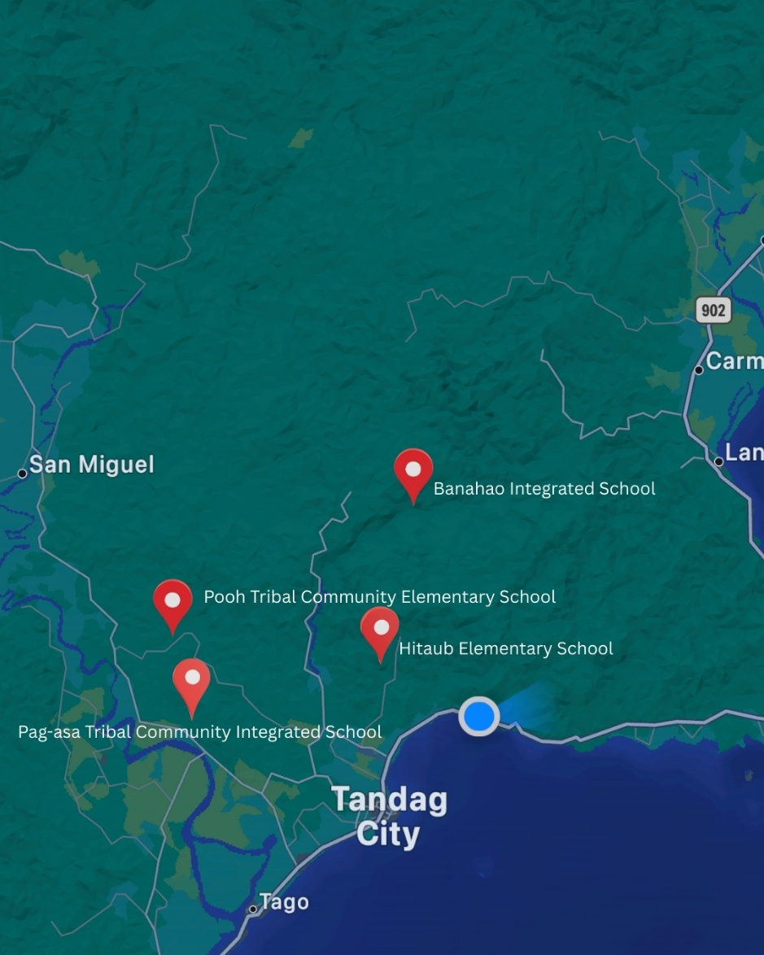
Source: Bing Maps (2026). Location map of selected Indigenous Peoples Education schools in DepEd–Tandag District 2. Retrieved May 11, 2026, from https://www.bing.com/maps?cp=9.065074%7E126.194176&lvl=11&style=r
Figure 2. Location Map of the Study
Research Respondents
The study's respondents were all English teachers assigned to Indigenous Peoples Education (IPEd) schools under DepEd–Tandag District 2 during the School Year 2025–2026. The study employed complete enumeration, also known as census sampling, in which all members of the target population were included as respondents. This approach was appropriate because the total number of English teachers handling IPEd classes in the district was relatively small and manageable, making it feasible to include the entire population in the study.
According to Creswell and Creswell (2018), complete enumeration is appropriate when the population size is limited and when the researcher seeks to obtain comprehensive data that accurately represent the characteristics of the entire group. In the context of Indigenous Peoples Education, where the number of teachers was limited and instructional contexts varied across schools, involving all eligible teachers helped capture diverse experiences and practices related to technology integration in English Language Teaching.
The use of complete enumeration allowed the study to provide a more accurate description of teachers’ competence in technology integration, technology integration practices, learners’ technology-supported engagement, RAT-level technology use, and the challenges encountered in IPEd classrooms within the district. These teachers handled English classes across the participating grade levels in their respective schools. The distribution of respondents was as follows: Banahao Integrated School (12), Pag-asa Tribal Community Integrated School (10), Hitaob Elementary School (4), and Poog Tribal Community Elementary School (4), for a total of thirty (30) respondents. Because the total number of English teachers in the district was relatively small, a census was conducted, allowing all qualified teachers in the population to participate in the study.
Table 1. Distribution of the Respondents
School Name | Respondents
Banahao Integrated School | 12
Hitaob Elementary School | 4
Pag-asa Tribal Community Integrated School | 10
Poog Tribal Community Integrated School | 4
Total | 30

Research Instrument
The primary data-gathering instrument used in this study was a researcher-made questionnaire designed to collect quantitative data on teachers’ competence in technology integration, technology-supported learner engagement, teachers’ technology integration practices, RAT-level technology use, and the challenges encountered in integrating technology in English Language Teaching within Indigenous Peoples Education (IPEd) classrooms. The development of the questionnaire was guided by the Statement of the Problem and anchored on the PICRAT model to ensure alignment between the research objectives, variables, and instrument indicators.
The questionnaire consisted of five major sections corresponding to the key variables of the study. The first section measured teachers’ competence in integrating technology in terms of PICRAT-based pedagogical knowledge, cultural responsiveness and contextualization, technology knowledge and adaptive proficiency, access to technological resources, and reflective teaching practice. The second section assessed learners’ levels of technology-supported engagement in English lessons in terms of passive, interactive, collaborative, creative, and reflective or metacognitive engagement. The third section measured teachers’ technology integration practices in terms of active knowledge-building facilitation, prior knowledge activation, inquiry and problem-solving, dialogue and collaboration, and culturally responsive task design. The fourth section assessed teachers’ RAT-level technology use in terms of Replacement, Amplification, and Transformation. The fifth section identified the extent of challenges encountered in implementing technology-supported English instruction within Indigenous educational settings.
All questionnaire items were structured using a five-point Likert scale, with response options ranging from Strongly Disagree to Strongly Agree. Likert-scale instruments are appropriate for measuring perceptions, attitudes, and self-reported practices and are widely used in descriptive and correlational educational research (Creswell & Creswell, 2018; Fraenkel, Wallen, & Hyun, 2019). The use of a standardized response scale will allow for the computation of weighted means, standard deviations, and correlational statistics required to address the research questions.
To establish the content validity of the research instrument, the researcher-made questionnaire underwent expert validation by five (5) qualified validators from the Department of Education–Tandag City Division, consisting of one (1) Schools Governance and Operations Division (SGOD) Chief and four (4) Education Program Supervisors (EPSs). The validators possessed expertise in English Language Teaching, curriculum implementation, educational research, Indigenous Peoples Education, instructional supervision, and technology integration. They evaluated the instrument based on its clarity, relevance, content adequacy, organization, appropriateness of language, and alignment with the Statement of the Problem and the PICRAT framework. Following the validation process, several revisions were incorporated to improve the quality of the instrument. These revisions included the rewording of selected items for greater clarity and measurability, refinement of sentence structures, and enhancement of the alignment between the questionnaire indicators and the study variables. Suggestions related to cultural responsiveness, contextual appropriateness, and technology integration within Indigenous educational settings were likewise considered in the final revision of the instrument.
After the validation process, the revised questionnaire was pilot-tested among English teachers who were not included in the actual respondents of the study to determine its reliability and internal consistency. Reliability testing using Cronbach’s alpha yielded coefficients of .859 for Teachers’ Competence in Integrating Technology, .814 for Technology-Supported Learner Engagement, .855 for Teachers’ Technology Integration Practices, .843 for RAT-Level Technology Use, and .840 for Challenges in Indigenizing English Language Teaching Through Technology, all of which were interpreted as having good reliability. Based on the recommendations of the statistician, Indicator 1 under Passive Engagement, Indicator 3 under Interactive Engagement, and Indicator 7 under Challenges in Technology Integration were removed to further improve the consistency of the instrument. The obtained reliability coefficients indicated that all sections of the questionnaire demonstrated satisfactory internal consistency and were appropriate for use in the conduct of the study, thereby establishing the instrument's suitability for data collection.
Data Gathering Procedure
The data-gathering process was conducted systematically to ensure the accuracy, consistency, and integrity of the research procedures. Prior to conducting the study, the researcher obtained the necessary approvals and permissions from the appropriate authorities. A formal letter requesting permission to conduct the study was submitted to the Schools Division Superintendent of DepEd–Tandag City. Upon approval, endorsements were secured from the District Supervisor and the school heads of the participating Indigenous Peoples Education (IPEd) schools. These approvals authorized the researcher to administer the research instrument and collect data from the identified respondents.
Before the actual data collection, the researcher finalized the research instrument through content validation and pilot testing. The questionnaire underwent expert validation by qualified education professionals from the Department of Education–Tandag City Division and was subsequently pilot-tested with English teachers who were not included among the study's actual respondents. Necessary revisions were incorporated based on the validators' recommendations and the results of the reliability testing. After the instrument was finalized, the researcher coordinated with the school heads to determine appropriate schedules for administering the questionnaire and to minimize disruption to school activities.
During data collection, the researcher personally visited the participating schools and conducted an orientation for the respondents. The purpose of the study, the voluntary nature of participation, confidentiality measures, and the procedures for completing the questionnaire were explained to the respondents. Informed consent was secured prior to the administration of the instrument. The validated questionnaire was then administered in person to all English teachers identified through a complete enumeration. Standardized instructions were provided to ensure uniform understanding of the questionnaire items and to minimize potential bias or misinterpretation. The researcher remained available throughout the administration process to answer questions and clarify instructions whenever necessary.
Upon completion of the questionnaire, the completed instruments were immediately retrieved and checked for completeness and accuracy. Any incomplete responses were verified, whenever appropriate, while preserving the integrity of the respondents’ answers. The collected data were then coded and organized in a statistical software program for analysis. Responses were classified according to the variables identified in the Statement of the Problem to ensure alignment with the research objectives. Finally, all research data were stored securely in both printed and electronic formats, with access limited solely to the researcher. These procedures ensured the orderly collection, management, and analysis of data throughout the study.
Ethical Considerations
Ethical considerations were carefully observed throughout the study to protect the dignity and rights of all respondents, particularly in the context of Indigenous Peoples Education (IPEd). Prior to data collection, permission to conduct the study was secured from the National Commission on Indigenous Peoples (NCIP)–Surigao del Sur, the Indigenous Peoples Mandatory Representative (IPMR) of Tandag City, the Education Program Supervisor (EPS) in IPEd, and the school heads of the participating schools. Ethical considerations, including voluntary participation, informed consent, anonymity, confidentiality of responses, cultural sensitivity, and data privacy, were clearly communicated to all respondents. Respondents were informed that their participation was entirely voluntary and that they could withdraw from the study at any point without any consequences or penalties. Informed consent forms were provided and attached to the study's annexes.
To ensure confidentiality and anonymity, respondents were not required to disclose personal information that could directly identify them unless they chose to do so voluntarily. Codes or numerical identifiers were used instead of names during data organization and analysis. All responses were treated with strict confidentiality and were used solely for academic and research purposes. The collected data were securely stored in password-protected electronic files and in secure printed copies, accessible only to the researcher.
Given that the study involved Indigenous Peoples' Education communities, particular attention was paid to protecting Indigenous learners, teachers, and communities from potential cultural misrepresentation or misuse of information. The study also demonstrated cultural sensitivity by recognizing the importance of contextualized, community-responsive educational practices in IPEd settings. Respect for Indigenous knowledge systems and cultural practices was maintained throughout the research. Furthermore, the study complied with data privacy principles by ensuring that all collected information would not be disclosed, reproduced, or shared with unauthorized individuals or institutions. All collected data will be properly disposed of upon completion of the study, in accordance with ethical research standards and data privacy protocols.
Statistical Treatment
The quantitative data gathered in this study were analyzed using appropriate descriptive and inferential statistical tools aligned with the research objectives and variables.
Weighted Mean and Standard Deviation were utilized to determine the level of teachers’ competence in integrating technology, the extent of technology-supported learner engagement, the level of teachers’ technology integration practices based on PICRAT-aligned instructional processes, the extent to which teachers’ technology use reflected the RAT dimensions, and the extent of challenges encountered in integrating technology in ELT.
Pearson Product-Moment Correlation Coefficient (r) was employed to determine the significant relationships among the variables. Multiple Linear Regression Analysis was used to identify the variables that significantly predicted teachers’ RAT-level technology use.

Chapter 4
PRESENTATION, ANALYSIS AND INTERPRETATION OF DATA
This chapter presents, analyzes, and interprets the data gathered from the survey questionnaires administered to English teachers in Indigenous Peoples Education (IPEd) schools.
Level of Teachers’ Competence in Integrating Technology in English Instruction
Table 2 presents the teachers’ competence in integrating technology in English instruction among Indigenous Peoples learners.
Table 2.Teachers’ Competence in Integrating Technology in English Language
Teaching

Indicator | Mean | Adjectival Rating
CreativeEngagement/  TechnologyUse | 3.83 | Competent
PICRAT-Based Pedagogical Knowledge | 3.82 | Competent
Cultural Responsiveness and Contextualization | 3.81 | Competent
Access to Technological Resources | 3.66 | Competent
Reflective Teaching Practice | 3.64 | Competent
Overall Mean | 3.75 | Competent
The teachers’ competence in integrating technology in English instruction among Indigenous Peoples learners was generally rated as competent across all indicators. Among the indicators, Creative Engagement/Technology Use obtained the highest mean with an adjectival rating of Competent. This finding indicates that teachers were generally capable of utilizing technology to promote learner creativity, active participation, and meaningful engagement in English learning activities. Such competence reflects teachers’ capacity to design learning experiences that foster higher-order thinking and learner-centered instruction, which are essential components of meaningful technology integration in English Language Teaching.
In contrast, Reflective Teaching Practice obtained the lowest mean, although it remained within the Competent level. While teachers demonstrated the ability to integrate technology into instruction, opportunities for systematic reflection, evaluation, and continuous improvement of technology-supported practices may be less evident compared to other competence dimensions. This result may further indicate that teachers tend to prioritize the implementation of technology-enhanced activities while engaging less frequently in reflective processes that assess the effectiveness, appropriateness, and impact of technology use on learners’ language development and engagement.
The overall mean interpreted as Competent, indicates that teachers generally possessed the necessary competencies to integrate technology in English instruction among Indigenous Peoples learners. This suggests that the respondents were capable of addressing the technological, pedagogical, and contextual demands associated with technology-supported learning despite the realities of teaching in geographically isolated and disadvantaged communities. The finding further implies that teachers were able to utilize technology as a meaningful instructional tool while remaining responsive to the learning needs and cultural contexts of Indigenous learners.
The findings support the Technological Pedagogical and Content Knowledge (TPACK) framework, which emphasizes that effective technology integration requires the intersection of technological, pedagogical, and content knowledge. The results likewise affirm the principles of Interactionist Theory and Culturally Sustaining Pedagogy, which highlight the importance of meaningful learner engagement and culturally responsive instruction. Likewise, Tai (2022) emphasized that competent technology integration contributes to more engaging, learner-centered, and effective language instruction.
Extent of Technology-Supported Learner Engagement in English Lessons
Table 3 presents the extent of technology-supported learner engagement among Indigenous Peoples learners in English lessons.
Table 3.Technology-Supported Learner Engagement in English Lessons
Indicator | Mean | Adjectival Rating
Passive Engagement | 3.63 | Engaged
Interactive Engagement | 3.55 | Engaged
Creative Engagement | 3.52 | Engaged
Reflective / Metacognitive Engagement | 3.48 | Engaged
Collaborative Engagement | 3.39 | Moderately Engaged
Overall Mean | 3.52 | Engaged
The extent of technology-supported learner engagement in English lessons among Indigenous Peoples learners was generally rated as Engaged across most indicators. Passive Engagement obtained the highest mean with an adjectival rating of Engaged. This finding indicates that learners actively participated in technology-supported activities primarily through accessing, viewing, listening to, and responding to instructional content delivered through digital tools. Such engagement demonstrates that digital tools were able to capture learners’ attention and sustain their involvement in technology-enhanced learning experiences.
However, collaborative engagement obtained the lowest mean with an adjectival rating of Moderately Engaged. The opportunities for technology-mediated collaboration, peer interaction, and collective knowledge construction were less evident compared to other forms of engagement. The result may indicate that learners were more frequently engaged in individual technology-supported tasks rather than collaborative digital activities requiring interaction and shared problem-solving. This lower level of collaborative engagement may be influenced by contextual realities within Indigenous educational settings, including limited access to digital devices, connectivity constraints, and challenges in implementing collaborative technology-supported learning activities in geographically isolated and resource-constrained schools.
The overall mean interpreted as Engaged, indicates that learners were generally engaged in technology-supported English learning activities. Technology was able to facilitate learner participation and involvement in English instruction despite the contextual challenges commonly experienced in Indigenous educational settings. Digital tools served as meaningful learning supports that enabled learners to access instructional content, participate in classroom activities, and engage in language learning tasks. Furthermore, technology integration provided opportunities for learners to become active participants in the learning process rather than merely passive recipients of information.
The findings support Interactionist Theory, which emphasizes the importance of interaction, participation, and communication in language acquisition. While learners demonstrated a generally engaged level of participation in technology-supported activities, the comparatively lower level of collaborative engagement suggests that opportunities for meaningful dialogue and social interaction may still be enhanced to further support language development. Similar findings were reported by Zheng and Warschauer (2022), who noted that technology-enhanced learning environments can promote learner participation and engagement when instructional activities are intentionally designed to support interaction and meaningful learning experiences.
to which collaborative digital learning activities are implemented.
Level of Teachers’ Technology Integration Practices Based on PICRAT-Aligned Instructional Processes
Table 4 presents the level of teachers’ technology integration practices based on PICRAT-aligned instructional processes. Specifically, it examines the extent to which teachers implement technology-supported instructional strategies that promote knowledge construction, inquiry, collaboration, cultural responsiveness, and meaningful learner engagement in English Language Teaching.
Table 4.Teachers’ Technology Integration Practices Based on PICRAT-Aligned
Instructional Processes

Indicator | Mean | Adjectival Rating
Active Knowledge-Building Facilitation | 3.20 | Moderately Practiced
Inquiry and Problem-Solving Support | 3.15 | Moderately Practiced
Activation and Linking of Prior Knowledge | 2.95 | Moderately Practiced
Culturally Responsive Task Design and Scaffolding | 2.90 | Moderately Practiced
Technology-Mediated Dialogue and Collaboration | 2.85 | Moderately Practiced
Overall Mean | 3.01 | Moderately Practiced

The teachers’ technology integration practices based on PICRAT-aligned instructional processes were generally rated as Moderately Practiced across all indicators. Active Knowledge-Building Facilitation emerged as the most evident practice. Teachers were more inclined to use technology to support learners’ understanding, exploration of concepts, and construction of knowledge during English instruction. The result implies that technology was utilized not merely as a delivery tool but as a means of facilitating learner engagement and participation in the learning process.
Technology-Mediated Dialogue and Collaboration was the least evident instructional practice. The pportunities for technology-supported communication, peer interaction, and collaborative learning were less frequently implemented in classroom instruction. Techers found it more manageable to facilitate individual technology-supported learning activities than collaborative digital experiences, particularly within Indigenous educational settings where access to devices, internet connectivity, and technological resources may be limited.
The overall mean indicates that teachers moderately practiced technology integration in English instruction.Technology has become part of classroom instruction; however, its integration has not yet consistently progressed toward more transformative and sustained pedagogical applications. Teachers possess the competence necessary to integrate technology, the consistent implementation of technology-supported instructional processes may still be influenced by contextual realities, resource availability, and the demands of adapting instruction to Indigenous learning environments.
The findings are consistent with Interactionist Theory, which emphasizes the importance of interaction, collaboration, and meaningful engagement in language learning. The relatively stronger implementation of knowledge-building activities compared with collaborative technology-supported practices suggests that technology integration was more frequently directed toward individual learning experiences than socially mediated learning processes. Similar findings were reported by Tondeur et al. (2021), who noted that teachers often possess adequate technology-related competence but encounter challenges in translating such competence into higher-level instructional practices.
Extent to Which Teachers’ Uses of Technology Reflect the RAT Dimensions
Table 5 presents the extent to which teachers’ uses of technology in English instruction reflect the RAT dimensions of Replacement, Amplification, and Transformation.
Table 5.Teachers’ Technology Use According to RAT Dimensions
RAT Dimension | Mean | Adjectival Rating
Transformation | 3.53 | Practiced
Amplification | 3.51 | Practiced
Replacement | 3.43 | Practiced
Overall Mean | 3.50 | Practiced

The extent to which teachers’ uses of technology reflected the RAT dimensions was generally rated as Practiced across all dimensions. Transformation emerged as the most evident form of technology use. Teachers were able to utilize technology to support learning experiences that extended beyond traditional instructional approaches and provided opportunities for more meaningful and engaging English learning activities. The result implies that technology was not merely used as a substitute for conventional teaching tools but was increasingly employed to enhance and enrich instructional experiences for Indigenous learners.
Replacement was the least evident dimension of technology use, although it remained within the Practiced level. This finding suggests that teachers relied less on using technology solely as a direct substitute for traditional instructional materials and methods. The gradual shift toward more purposeful and value-added uses of technology, where digital tools were utilized to improve instructional delivery and learner engagement rather than simply replicating existing classroom practices.
The overall mean indicates that teachers generally practiced technology use across the RAT dimensions. This suggests that technology integration had become an established component of English instruction in Indigenous Peoples Education classrooms. Teachers were able to incorporate technology into instructional decision-making and classroom practices, reflecting efforts to enhance teaching and learning despite contextual challenges associated with geographically isolated and resource-constrained educational settings.
The findings support the PICRAT and RAT perspectives on technology integration, which emphasize the progression from basic technology substitution toward more meaningful and transformative instructional applications. Similar findings were reported by Hamilton, Rosenberg, and Akcaoglu (2021), who noted that teachers often demonstrate a combination of replacement, amplification, and transformation practices as they continue to develop more advanced technology integration approaches.
Challenges Encountered in Indigenizing English Learning through Technology-Supported Tasks
Table 6 presents the challenges encountered by teachers in indigenizing English learning through technology-supported tasks.
Table 6. Challenges in Indigenizing English Language Teaching through
Technology

Indicator | Mean | Adjectival Rating
Difficulty in balancing curriculum standards with culturally contextualized digital tasks | 3.77 | Highly Challenging
Need for more guidance on applying PICRAT in ELT | 3.70 | Highly Challenging
Curriculum requirements limiting integration of Indigenous knowledge in ELT | 3.70 | Highly Challenging
Learners’ limited digital literacy skills | 3.70 | Highly Challenging
Limited access to culturally localized digital content | 3.67 | Highly Challenging
Learners’ limited access to devices at home | 3.63 | Highly Challenging
Assessing learners’ performance in technology-supported English tasks | 3.63 | Highly Challenging
Available digital English resources are not culturally appropriate | 3.60 | Highly Challenging
Limited devices, poor connectivity, infrastructure limitations, and insufficient institutional support | 3.57 | Highly Challenging
Overall Mean | 3.58 | Highly Challenging

The challenges encountered in indigenizing English learning through technology-supported tasks were generally rated as Highly Challenging. Difficulty in balancing curriculum standards with culturally contextualized digital tasks emerged as the most evident concern. Teachers experienced challenges in aligning curriculum expectations with technology-supported activities that reflect Indigenous learners’ cultural identities, knowledge systems, and community contexts. Teachers recognize the importance of culturally responsive instruction, integrating Indigenous perspectives into technology-enhanced English lessons while simultaneously meeting curriculum requirements remains a complex instructional task.
Limited devices, poor connectivity, infrastructure limitations, and insufficient institutional support emerged as the least evident challenge, although still perceived as Highly Challenging. Technological and institutional constraints continue to affect the implementation of technology-supported instruction. The result may indicate that despite ongoing efforts to improve access to technology, teachers in Indigenous educational settings still encounter barriers related to resources and support systems that influence the consistency and quality of technology integration in English instruction.
The overall mean indicates that teachers encountered highly evident challenges in indigenizing English learning through technology-supported tasks. Technology integration in Indigenous Peoples Education classrooms occurs within complex technological, pedagogical, cultural, and institutional contexts. The challenges experienced by teachers extend beyond issues of access and infrastructure and include the demands of designing culturally responsive, technology-enhanced learning experiences that remain aligned with curriculum standards and learner needs. Nevertheless, these challenges should not be interpreted as indicators of inadequate teacher competence but rather as reflections of the realities associated with implementing meaningful technology integration in Indigenous learning environments.
The findings are consistent with the principles of Culturally Sustaining Pedagogy, which emphasize the importance of preserving and integrating learners’ cultural identities and community knowledge within educational practice. Agaton and Cueto (2021) identified infrastructural and contextual barriers as persistent concerns affecting technology integration in remote educational environments. Similarly, Soto, Fuentes, and Arnado (2023) emphasized that effective technology integration in Indigenous educational settings requires institutional support, contextualized professional development, and access to culturally responsive instructional resources to address the multifaceted challenges encountered by teachers.
Significant Relationship between Teachers’ Competence and Technology Integration Practices
Table 7 presents the relationship between teachers’ competence and technology integration practices.
Table 7. Correlation between Teachers’ Competence and Technology Integration
Practices

Variable Tested |  | Computed r | p-value | Conclusion
PICRAT-Based Pedagogical Knowledge | Active knowledge-building facilitation | 0.832 | .000 | Significant
PICRAT-Based Pedagogical Knowledge | Activation and linking of prior knowledge; | 0.733 | .000 | Significant
PICRAT-Based Pedagogical Knowledge | Inquiry and problem-solving support | 0.585 | .001 | Significant
PICRAT-Based Pedagogical Knowledge | Technology-mediated dialogue and collaboration | 0.816 | .000 | Significant
PICRAT-Based Pedagogical Knowledge | Culturally responsive task design and scaffolding | 0.857 | .000 | Significant
Cultural Responsiveness and Contextualization | Active knowledge-building facilitation | 0.796 | .000 | Significant
Cultural Responsiveness and Contextualization | Activation and linking of prior knowledge; | 0.675 | .000 | Significant
Cultural Responsiveness and Contextualization | Inquiry and problem-solving support | 0.631 | .000 | Significant
Cultural Responsiveness and Contextualization | Technology-mediated dialogue and collaboration | 0.778 | .000 | Significant
Cultural Responsiveness and Contextualization | Culturally responsive task design and scaffolding | 0.850 | .000 | Significant
Creative Engagement/Technology Use | Active knowledge-building facilitation | 0.641 | .000 | Significant
Creative Engagement/Technology Use | Activation and linking of prior knowledge; | 0.505 | .004 | Significant
Creative Engagement/Technology Use | Inquiry and problem-solving support | 0.595 | .001 | Significant
Creative Engagement/Technology Use | Technology-mediated dialogue and collaboration | 0.576 | .001 | Significant
Creative Engagement/Technology Use | Culturally responsive task design and scaffolding | 0.749 | .001 | Significant
Access to Technological Resources | Active knowledge-building facilitation | 0.723 | .000 | Significant
Access to Technological Resources | Activation and linking of prior knowledge; | 0.563 | .001 | Significant
Access to Technological Resources | Inquiry and problem-solving support | 0.588 | .001 | Significant
Access to Technological Resources | Technology-mediated dialogue and collaboration | 0.100 | .573 | Not Significant
Access to Technological Resources | Culturally responsive task design and scaffolding | 0.182 | .339 | Not Significant
Reflective Teaching Practice | Active knowledge-building facilitation | 0.877 | .000 | Significant
Reflective Teaching Practice | Activation and linking of prior knowledge; | 0.719 | .000 | Significant
Reflective Teaching Practice | Inquiry and problem-solving support | 0.615 | .000 | Significant
Reflective Teaching Practice | Technology-mediated dialogue and collaboration | 0.123 | .793 | Not Significant
Reflective Teaching Practice | Culturally responsive task design and scaffolding | 0.134 | .558 | Not Significant
The results reveal that teachers’ competence in technology integration was generally and significantly related to their technology integration practices in English instruction. Teachers who possess stronger technological, pedagogical, and contextual competencies are more likely to translate these capabilities into meaningful classroom practices. Competence serves as an important foundation for implementing technology-supported instructional processes and designing learning experiences that promote learner participation, inquiry, and knowledge construction. Therefore, the null hypothesis was rejected for the competence dimensions that demonstrated significant relationships with technology integration practices and accepted for those found to be non-significant.
The PICRAT-based pedagogical knowledge, cultural responsiveness and contextualization, creative engagement/technology use, and reflective teaching practice were significantly associated with technology integration practices. In contrast, selected dimensions related to access to technological resources and reflective teaching practice did not demonstrate significant relationships with certain instructional processes.
The findings support the Technological Pedagogical and Content Knowledge (TPACK) framework, which emphasizes that effective technology integration results from the interaction of technological, pedagogical, and content knowledge. Similar findings were reported by Schmid, Brianza, and Petko (2021), who found that teachers’ technological and pedagogical competencies significantly influence classroom technology integration practices.
Significant Relationship between Technology Integration Practices and Learner Engagement
Table 8 presents the relationship between technology integration practices and learners’ technology-supported engagement.
Table 8. Correlation between Technology Integration Practices and
Learner Engagement

Variable Tested |  | Computed r | p-value | Conclusion
Active knowledge-building facilitation | Passive Engagement | 0.565 | .001 | Significant
Active knowledge-building facilitation | Interactive Engagement | 0.650 | .000 | Significant
Active knowledge-building facilitation | Collaborative Engagement | 0.287 | .125 | Not Significant
Active knowledge-building facilitation | Creative Engagement | 0.110 | .561 | Not Significant
Active knowledge-building facilitation | Reflective / Metacognitive Engagement | 0.202 | .285 | Not Significant
Activation and linking of prior knowledge | Passive Engagement | -0.145 | .444 | Not Significant
Activation and linking of prior knowledge | Interactive Engagement | -0.053 | .780 | Not Significant
Activation and linking of prior knowledge | Collaborative Engagement | 0.013 | .947 | Not Significant
Activation and linking of prior knowledge | Creative Engagement | 0.825 | .042 | Significant
Activation and linking of prior knowledge | Reflective / Metacognitive Engagement | -0.069 | .716 | Not Significant
Inquiry and problem-solving support | Passive Engagement | -0.034 | .858 | Not Significant
Inquiry and problem-solving support | Interactive Engagement | 0.693 | .002 | Significant
Inquiry and problem-solving support | Collaborative Engagement | -0.307 | .099 | Not Significant
Inquiry and problem-solving support | Creative Engagement | 0.673 | .000 | Significant
Inquiry and problem-solving support | Reflective / Metacognitive Engagement | 0.069 | .717 | Not Significant
Technology-mediated dialogue and collaboration | Passive Engagement | 0.050 | .792 | Not Significant
Technology-mediated dialogue and collaboration | Interactive Engagement | -0.122 | .519 | Not Significant
Technology-mediated dialogue and collaboration | Collaborative Engagement | 0.412 | .035 | Significant
Technology-mediated dialogue and collaboration | Creative Engagement | 0.032 | .865 | Not Significant
Technology-mediated dialogue and collaboration | Reflective / Metacognitive Engagement | 0.230 | .221 | Not Significant
Culturally responsive task design and scaffolding | Passive Engagement | -0.151 | .426 | Not Significant
Culturally responsive task design and scaffolding | Interactive Engagement | -0.099 | .604 | Not Significant
Culturally responsive task design and scaffolding | Collaborative Engagement | -0.344 | 063 | Not Significant
Culturally responsive task design and scaffolding | Creative Engagement | -0.259 | .166 | Not Significant
Culturally responsive task design and scaffolding | Reflective / Metacognitive Engagement | -0.238 | .206 | Not Significant
The selected technology integration practices were significantly associated with specific dimensions of learners’ technology-supported engagement. Active knowledge-building facilitation was significantly related to passive and interactive engagement, activation and linking of prior knowledge was significantly associated with creative engagement, inquiry and problem-solving support was significantly related to both interactive and creative engagement, while technology-mediated dialogue and collaboration was significantly associated with collaborative engagement. Therefore, the null hypothesis was rejected for the variables that demonstrated significant relationships and accepted for those found to be non-significant.
The different technology integration practices contribute to different forms of learner engagement. Instructional practices that emphasize knowledge construction, activation of prior knowledge, inquiry, problem-solving, and interaction appear to encourage greater learner participation and involvement in English learning activities. Technology-supported instructional processes generally contribute to learner participation; however, not all practices influence engagement in the same manner.
The Interactionist Theory emphasizes the importance of meaningful participation, interaction, and engagement in language learning. Technology contributes most effectively to learner engagement when it is purposefully integrated into instructional practices that encourage learners to actively construct knowledge and participate in meaningful learning experiences.
Predictors of Teachers’ RAT-Level Technology Use in English Instruction
Table 9 presents the model summary of the multiple linear regression analysis, while Table 10 presents the regression coefficients for the predictors of RAT-level technology use.
Table 9. Model Summary for Predictors of RAT-Level Technology Use
Statistic | Value
R | .930
R Square | .865
Adjusted R Square | .849
F-value | 55.465
Sig. F Change | .000

Table 10. Regression Coefficients for Predictors of RAT-Level Technology Use
Predictor | B | Beta | T | Sig. | Interpretation
Competence | .588 | .492 | 3.491 | .002 | Significant Predictor
Engagement | .536 | .470 | 3.337 | .003 | Significant Predictor
Practices | .560 | .114 | 1.585 | .125 | Not Significant Predictor

Teachers’ competence, learner engagement, and technology integration practices collectively provided a significant explanation of teachers’ RAT-level technology use in English instruction. Higher levels of technology integration emerge when teachers possess the necessary competencies, learners actively engage in technology-supported learning, and instructional experiences support meaningful participation. Therefore, the null hypothesis was rejected for teacher competence and learner engagement, which emerged as significant predictors of RAT-level technology use.
Teacher competence and learner engagement were the most influential predictors of RAT-level technology use. This suggests that teachers who possess stronger technological, pedagogical, and contextual competencies, together with learners who actively participate in technology-supported learning, are more likely to implement technology in ways that extend beyond basic substitution toward amplification and transformation.
The PICRAT framework emphasizes the interaction between teacher capabilities, learner engagement, and technology use in achieving meaningful technology integration. Similar findings were reported by Redmond and Peled (2023), who identified teacher competence and learner engagement as significant contributors to effective technology integration.

Significant Relationship between Challenges Encountered and Teachers’ Technology Integration and Learner Engagement
Table 11 presents the relationship between the challenges encountered and teachers’ technology integration practices and learner engagement.
Table 11. Correlation between Challenges Encountered and Technology
Integration Practices and Learner Engagement

Variables Tested |  | Computed r | p-value | Conclusion
 | Challenges and active knowledge-building facilitation | 0.077 | .688 | Not Significant
 | Challenges and activation/linking of prior knowledge | -0.054 | .777 | Not Significant
Challenges | Challenges and inquiry/problem-solving support | 0.103 | .589 | Not Significant
 | Challenges and technology-mediated dialogue/collaboration | -0.450 | .013 | Significant
 | Challenges and culturally responsive task design/scaffolding | -0.413 | .032 | Significant
 | Challenges and passive engagement | 0.080 | .676 | Not Significant
 | Challenges and interactive engagement | 0.181 | .337 | Not Significant
 | Challenges and collaborative engagement | -0.590 | .001 | Significant
 | Challenges and creative engagement | 0.129 | .498 | Not Significant
 | Challenges and reflective/metacognitive engagement | 0.077 | .688 | Not Significant
The challenges encountered by teachers were significantly associated with specific dimensions of technology integration practices and learner engagement. Specifically, challenges demonstrated significant relationships with technology-mediated dialogue and collaboration, culturally responsive task design and scaffolding, and collaborative engagement. Contextual barriers do not affect all aspects of technology-supported instruction in the same manner. Rather, their influence appears to be concentrated on instructional processes that require greater interaction, collaboration, and cultural contextualization. Therefore, the null hypothesis was rejected for the variables that demonstrated significant relationships and accepted for those found to be non-significant.
The challenges encountered in Indigenous Peoples Education settings have a greater impact on collaborative and culturally responsive dimensions of technology-supported instruction than on individual or teacher-directed learning activities. Teachers remain capable of integrating technology and learners continue to engage in technology-supported learning despite existing challenges, the implementation of collaborative learning experiences and culturally grounded instructional tasks may be more difficult to sustain.
The findings are consistent with the work of Warschauer (2022), who emphasized that digital inequities can affect the quality of teaching and learning experiences, particularly those involving interaction and collaboration. Similarly, Selwyn (2023) argued that structural and contextual barriers often limit the realization of meaningful technology integration in marginalized educational settings. In Indigenous education, McMahon and Oliver (2021) reported that contextual challenges frequently influence the implementation of collaborative and culturally responsive instructional practices.
Proposed Intervention Program
The proposed intervention program is entitled PICRAT-Guided Transformative Technology Integration Program for English Teachers in Indigenous Peoples Education (IPEd).The intervention was developed to strengthen teachers’ capacity to design, implement, and evaluate culturally responsive and technology-supported English instruction that promotes interactive, collaborative, creative, and reflective learner engagement. Specifically, it seeks to enhance teachers’ application of PICRAT-aligned instructional processes, support the development of localized digital learning resources, strengthen collaborative and inquiry-based technology-supported learning experiences, and encourage more transformative uses of technology in English Language Teaching. Furthermore, the Department of Education, particularly the Schools Division of Tandag City, may adopt and utilize this intervention program as a guide for professional development, instructional improvement, and capacity-building initiatives aimed at addressing the technology integration challenges encountered by teachers in Indigenous Peoples Education schools. The program may also serve as a reference for future efforts to strengthen culturally responsive, technology-supported English instruction and enhance learner engagement within Indigenous learning communities across the division.
Table 13. PICRAT-Guided Transformative Technology Integration Program for
English Teachers in Indigenous Peoples Education (IPEd)

Implementation Structure
Component | Objectives | Content Focus | Design and Activities | Materials Needed | Expected Outputs | Monitoring and Evaluation | Sustainability Measures
Phase 1: PICRAT-Based Instructional Enhancement | Strengthen teachers’ understanding and application of the PICRAT framework in English Language Teaching. | PICRAT framework, RAT dimensions, learner engagement dimensions, lesson mapping. | Orientation-workshop, lesson analysis sessions, demonstration teaching, peer coaching, collaborative lesson planning. | Training modules, lesson exemplars, PICRAT lesson-mapping templates, projector, printed materials. | PICRAT-aligned lesson plans and instructional materials. | Pre-test and post-test, lesson plan evaluation rubric, classroom observation. | Integration of PICRAT lesson mapping into Learning Action Cell (LAC) sessions and school-based INSET activities.
Phase 2: Culturally Responsive Digital Task Design | Enhance teachers’ ability to design technology-supported English learning tasks that integrate Indigenous knowledge systems and local contexts. | Contextualization strategies, Indigenous knowledge integration, digital storytelling, localized multimedia development. | Workshop on contextualized lesson development, collaborative resource creation, consultation with IP elders and community stakeholders. | Local cultural resources, multimedia tools, laptops, smartphones, internet access, contextualization templates. | Contextualized digital learning resources and culturally responsive English learning tasks. | Output evaluation, classroom implementation review, instructional material validation. | Creation of a localized digital resource repository for IPEd schools within the division.
Phase 3: Technology-Mediated Collaboration and Learner Engagement | Strengthen collaborative, interactive, creative, and reflective learner engagement through technology-supported instruction. | Collaborative learning strategies, inquiry-based learning, digital collaboration tools, reflective learning activities. | Demonstration teaching, peer-learning activities, collaborative digital projects, inquiry-based learning tasks. | Digital devices, collaborative learning platforms, activity sheets, learner engagement monitoring tools. | Increased collaborative and interactive learner participation and technology-supported outputs. | Classroom observation, learner engagement monitoring checklist, learner output assessment. | Integration of collaborative digital activities into regular English classroom instruction.

Target Participants: English Teachers in Indigenous Peoples Education Schools
Duration: One School Year (School-Based Implementation)
Implementing Offices: School Heads, English Coordinators, EPS-English, EPS-IPEd, ICT Coordinators, Learning Resource Coordinators, and Indigenous Community Representatives
Funding Sources: School MOOE, INSET Funds, Division Training Funds, Local Stakeholder Support, and Other Available DepEd Resources
Expected Outcome: Enhanced implementation of PICRAT-aligned, culturally responsive, and transformative technology-supported English instruction characterized by increased collaborative learner engagement, improved contextualized digital learning resources, and strengthened technology integration practices in Indigenous Peoples Education classrooms.
Summary
The study examined technology integration in English Language Teaching among Indigenous Peoples Education (IPEd) teachers through the PICRAT framework. Findings revealed that teachers generally demonstrated a high level of competence in integrating technology across PICRAT-based pedagogical knowledge, cultural responsiveness and contextualization, technology knowledge and adaptive proficiency, access to technological resources, and reflective teaching practice.ower ratings were observed in technology-mediated dialogue and collaboration and in the design of culturally responsive technology-supported learning tasks.
Results further indicated that teachers implemented technology across the Replacement, Amplification, and Transformation (RAT) dimensions, with amplification practices being more prevalent than transformative applications. Inferential analyses revealed significant relationships between teachers’ competence and technology integration practices, indicating that higher levels of competence were associated with more effective implementation of PICRAT-aligned instruction. Regression analysis demonstrated that teachers’ competence and learner engagement significantly predicted RAT-level technology use, confirming their important role in shaping the quality and depth of technology integration in IPEd classrooms.
These findings support the view that effective technology integration is influenced by the interaction of teacher competence, learner engagement, instructional practices, and contextual conditions. Zheng and Warschauer (2022) emphasized the importance of learner engagement in maximizing technology-supported learning outcomes. The findings also align with Agaton and Cueto (2021) and Selwyn (2023), who underscored the persistent impact of contextual constraints on technology integration, particularly in geographically isolated and resource-constrained educational settings.

Chapter 5
SUMMARY, CONCLUSIONS, AND RECOMMENDATIONS
This chapter presents a summary of the study's findings, conclusions, and recommendations on technology integration in English Language Teaching (ELT) within Indigenous Peoples Education (IPEd) classrooms, using the PICRAT model.
Summary of Findings
The findings revealed that teachers generally demonstrated competence in integrating technology into English instruction within Indigenous Peoples' Education classrooms, particularly in PICRAT-based pedagogical knowledge, cultural responsiveness and contextualization, technology knowledge and adaptive proficiency, access to technological resources, and reflective teaching practice.
English teachers in Indigenous Peoples Education (IPEd) classrooms generally demonstrated competence in integrating technology into instruction. Their competencies were evident in their ability to utilize digital tools to support learner engagement, facilitate meaningful learning experiences, and respond to the instructional demands of technology-supported English Language Teaching. Technology integration has become an established component of instructional practice among teachers despite the contextual realities of Indigenous learning environments.
Indigenous Peoples learners were generally engaged in technology-supported English learning activities, showing that technology served as meaningful support for classroom participation and learning. Engagement was more evident in individual and content-focused experiences than in collaborative learning activities, indicating variation across engagement dimensions.
Teachers moderately practiced PICRAT-aligned technology integration processes in English instruction. Technology was used to support knowledge construction, inquiry, and learner participation; however, more interactive, collaborative, and culturally grounded technology-supported instructional processes were still in development. Technology integration has been adopted in classroom practice, but has not yet consistently reached more advanced levels of implementation.
Technology integration increasingly went beyond basic substitution, enriching learning experiences. Teachers incorporated technology in ways that support more meaningful instructional applications within English Language Teaching. Teachers generally practiced technology use across the RAT dimensions of Replacement, Amplification, and Transformation.
Challenges in indigenizing English learning through technology-supported tasks, as encountered by teachers, are highly evident. These challenges were associated not only with technological and infrastructural limitations but also with the complexities of aligning curriculum requirements, culturally responsive instruction, and meaningful technology integration. They reflect the multifaceted realities teachers face in implementing technology-supported English instruction within Indigenous educational settings.
Competence in technology integration was significantly associated with technology integration practices. Teachers who possess stronger technological, pedagogical, and contextual competencies are more likely to implement meaningful technology-supported instructional processes. Competence, therefore, emerged as an important factor influencing the quality of classroom technology integration.
Selected technology integration practices were significantly related to learners’ technology-supported engagement. Instructional practices that promoted knowledge construction, inquiry, problem-solving, and interaction were associated with greater learner participation in English learning activities. This shows that learner engagement is influenced not merely by technology use itself but by how technology is integrated into instructional processes.
Teacher competence and learner engagement were identified as significant predictors of teachers’ RAT-level technology use. Transformative technology integration is more likely to occur when teachers possess the necessary competencies and when learners actively participate in technology-supported learning experiences. These factors were found to contribute substantially to higher levels of instructional technology integration.
Challenges encountered by teachers were significantly related to specific dimensions of technology integration practices and learner engagement. Their influence was particularly evident in instructional processes that required collaboration, interaction, and cultural contextualization. Contextual barriers affect the depth and quality of technology integration more than actual implementation.
The PICRAT-Guided Transformative Technology Integration Program for English Teachers in Indigenous Peoples Education was developed. The proposed intervention program was designed to strengthen teachers’ competence in technology integration, enhance learner engagement, promote transformative use of technology, and address contextual challenges associated with technology-supported English instruction in Indigenous learning environments. The program serves as a context-sensitive and culturally responsive framework supporting the sustainable integration of technology in English Language Teaching.
Conclusions
Based on the findings of the study, the following conclusions were drawn:
Indigenous Peoples learners are capable of engaging in technology-supported English learning experiences. Technology provides opportunities for participation and involvement in language learning activities; however, this engagement tends to be more evident in individual learning experiences than in collaborative settings.
Technology integration practices in IPEd English classrooms are present but remain at a developing stage. While teachers can implement technology-supported instructional processes that facilitate learning, more interactive, collaborative, and culturally responsive applications of technology have yet to be consistently embedded in classroom practice.
Teachers’ use of technology reflects a progression from basic adoption to more meaningful instructional applications. The presence of replacement, amplification, and transformation practices indicates that technology is increasingly used to enrich English learning experiences rather than merely to replace traditional instructional methods.
The process of indigenizing English instruction through technology is influenced by multiple contextual, pedagogical, and cultural challenges. These challenges extend beyond issues of technological access and reflect the complexities of aligning curriculum expectations, meaningfully integrating technology, and providing culturally responsive instruction within Indigenous learning environments.
Teachers’ competence serves as an important determinant of technology integration practices. The findings suggest that stronger technological, pedagogical, and contextual competencies enable teachers to implement more effective and meaningful technology-supported instructional processes in English Language Teaching.
Learner engagement is influenced by the quality of technology integration practices implemented in the classroom. Meaningful instructional processes that promote inquiry, interaction, knowledge construction, and active participation contribute to stronger learner engagement in technology-supported English learning activities.
Teacher competence and learner engagement are key factors that contribute to higher levels of RAT-based technology use. Transformative technology integration is more likely to occur when teachers possess the necessary competencies and when learners actively participate in technology-supported learning experiences.
Contextual challenges exert a greater influence on collaborative and culturally responsive dimensions of technology integration than on individual or teacher-directed instructional activities. This indicates that collaboration, interaction, and cultural contextualization remain the most vulnerable aspects of technology-supported English instruction within Indigenous educational settings.
The PICRAT-Guided Transformative Technology Integration Program provides a context-responsive framework for enhancing technology integration in Indigenous Peoples' Education. By identifying needs in teacher competence, learner engagement, instructional practices, and contextual challenges, the program offers a practical basis for strengthening culturally responsive and transformative English Language Teaching in IPEd classrooms.
Recommendations
In light of the findings and conclusions of the study, the following recommendations are proposed:
English teachers in Indigenous Peoples Education (IPEd) schools may continue strengthening their competence in technology integration through reflective teaching practices, PICRAT-aligned instructional planning, and culturally responsive digital pedagogy. Greater emphasis may be placed on designing technology-supported learning experiences that promote collaboration, inquiry, creativity, and meaningful learner engagement, while integrating Indigenous knowledge systems and local community experiences into English instruction.
School administrators may strengthen Learning Action Cell (LAC) sessions, mentoring programs, instructional coaching, and professional learning communities that focus on technology-mediated collaboration, culturally responsive task design, reflective practice, and transformative technology integration. Efforts may likewise support the development, sharing, and use of localized digital learning resources that are responsive to the realities of geographically isolated and disadvantaged IPEd schools.
The Department of Education, particularly the Schools Division Office of Tandag City, may sustain professional development initiatives and strengthen institutional support mechanisms to enhance teachers’ capacity to implement culturally responsive, technology-supported English instruction. Continued provision of context-appropriate technological resources, technical assistance, and offline or low-bandwidth learning solutions may further address challenges experienced in Indigenous educational settings.
Curriculum developers, learning resource developers, and IPEd implementers may collaborate in producing culturally localized, linguistically appropriate, and technology-supported instructional materials that meaningfully integrate Indigenous knowledge systems, community experiences, and local cultural contexts. Such initiatives may support the implementation of more collaborative, inquiry-based, and transformative learning experiences aligned with the PICRAT framework.
The PICRAT-Guided Transformative Technology Integration Program developed in this study may be adopted and implemented by the Department of Education, school administrators, and IPEd schools as a framework for professional development, instructional improvement, and capacity-building initiatives. The program may serve as a guide in strengthening teacher competence, learner engagement, culturally responsive digital pedagogy, and transformative technology integration in English Language Teaching within Indigenous educational contexts.
Future researchers may evaluate the effectiveness of the proposed intervention program using experimental, quasi-experimental, or mixed-method research designs. Further investigations may also explore learners’ experiences, culturally responsive digital pedagogy, classroom technology integration practices, and the long-term impact of technology-supported English instruction across diverse Indigenous educational settings.

REFERENCES CITED
Agaton, C. B., & Cueto, L. J. (2021). Digital divide in the Philippines: Challenges in remote learning during the COVID-19 pandemic. Asian Journal of Distance Education, 16(2), 144–153. https://doi.org/10.5281/zenodo.5044548
Al-Awidi, H., & Alghazo, I. (2021). The effect of technology integration on student engagement in English language classrooms. Journal of Educational Technology & Society, 24(4), 120–132.
Bang, M., Curley, L., Kessel, A., Marin, A., Suzukovich III, E., & Strack, G. (2023). Indigenous knowledge systems and education for sustainability: Expanding culturally sustaining pedagogies. Educational Researcher, 52(2), 87–98. https://doi.org/10.3102/0013189X221145672
Başar, A. M., & Şahin, İ. (2022). Trends in English language teaching and technology integration research: A systematic review. Journal of Language and Linguistic Studies, 18(1), 452–466. https://doi.org/10.52462/jlls.239
Bing Maps. (2026). Location map of selected Indigenous Peoples Education
schools in DepEd–Tandag District 2 [Map]. Microsoft. Retrieved May 11,
2026, from
https://www.bing.com/maps?cp=9.065074%7E126.194176&lvl=11&style=r
Bond, M. (2022). Schools and emergency remote education during the COVID-19 pandemic: A living rapid systematic review. Asian Journal of Distance Education, 17(1), 1–38.
Capulong, H., & Bautista, M. (2022). Digital literacy and technology integration challenges in geographically isolated Philippine schools. Philippine Journal of Education Studies, 95(2), 77–89.
Creswell, J. W., & Creswell, J. D. (2018). Research design: Qualitative, quantitative, and mixed methods approaches (5th ed.). SAGE Publications.
Department of Education. (2020). Basic Education Learning Continuity Plan. Department of Education. https://www.deped.gov.ph
Ertmer, P. A., & Ottenbreit-Leftwich, A. T. (2023). Teacher technology change: How knowledge, beliefs, and culture intersect. Journal of Research on Technology in Education, 55(2), 157–175. https://doi.org/10.1080/15391523.2022.2030265
Fraenkel, J. R., Wallen, N. E., & Hyun, H. H. (2019). How to design and evaluate research in education (10th ed.). McGraw-Hill Education.
Gass, S. M., Behney, J., & Plonsky, L. (2021). Second language acquisition: An introductory course (5th ed.). Routledge.
Hamilton, E. R., Rosenberg, J. M., & Akcaoglu, M. (2021). The SAMR model: A critical review and suggestions for its use. TechTrends, 65(2), 210– 218. https://doi.org/10.1007/s11528-020-00530-5
Hiver, P., Al-Hoorie, A. H., & Mercer, S. (2023). Student engagement in second language learning: A multidimensional perspective. Language Teaching Research, 27(4), 683–702. https://doi.org/10.1177/13621688211001922
Hsu, H.-C. (2023). Technology-mediated language learning and learner engagement: Revisiting pedagogical alignment in digital ELT. Computer Assisted Language Learning. Advance online publication. https://doi.org/10.1080/09588221.2023.2174890
Huang, Y., Spector, J. M., & Yang, J. (2022). Effects of collaborative digital writing on English language development: Evidence from online platforms. Computers & Education, 180, 104438. https://doi.org/10.1016/j.compedu.2022.104438
Kimmons, R. (2020). PICRAT: A model for technology integration. EdTech Books. https://edtechbooks.org/picrat
Kral, I., & Schwab, R. G. (2022). Learning spaces and digital engagement in remote Indigenous communities. Australian Journal of Indigenous Education, 51(1), 1–15. https://doi.org/10.1017/jie.2021.24
Ladson-Billings, G. (2021). Culturally relevant pedagogy 2.1: A remix. Harvard Educational Review, 91(1), 1–22. https://doi.org/10.17763/1943-5045- 91.1.1
Lai, C., & Bower, M. (2020). How is the use of technology in education evaluated? A systematic review. Computers & Education, 151, 103861. https://doi.org/10.1016/j.compedu.2020.103861
Loewen, S., & Sato, M. (2023). Interaction and instructed second language acquisition. Language Teaching Research. Advance online publication. https://doi.org/10.1177/13621688221141056
McCarty, T. L., & Lee, T. S. (2022). Critical culturally sustaining/revitalizing pedagogy and Indigenous education sovereignty. Educational Researcher, 51(5), 312–321. https://doi.org/10.3102/0013189X221094367
McMahon, M., & Oliver, R. (2021). Issues and challenges in using digital technologies to support learning in remote Indigenous communities. Education in Rural Australia, 31(1), 63–80.
Mishra, P., Koehler, M. J., & Cain, W. (2021). What is technological pedagogical content knowledge (TPACK)? Journal of Education, 193(3), 13–19.
Paris, D., & Alim, H. S. (2017). Culturally sustaining pedagogies: Teaching and learning for justice in a changing world. Teachers College Press.
Paris, D., & Alim, H. S. (2021). What are we seeking to sustain through culturally sustaining pedagogy? A loving critique forward. Harvard Educational Review, 91(3), 364– 383. https://doi.org/10.17763/1943-5045- 91.3.364
Ramos, E. R. (2023). Technology integration challenges in Indigenous Peoples Education schools. Mindanao Journal of Educational Research, 7(1), 45–61.
Redecker, C. (2022). European framework for the digital competence of educators (DigCompEdu): Update and implications. European Journal of Education, 57(3), 350– 364.
Redmond, P., & Peled, Y. (2023). Exploring the relationship between TPACK and instructional innovation in digital learning environments. Computers & Education, 186, 104545. https://doi.org/10.1016/j.compedu.2022.104545
Resta, P., Laferrière, T., McLaughlin, R., & Koury, K. (2021). Digital equity and culturally responsive technology integration in Indigenous education. Journal of Educational Technology & Society, 24(3), 15–28.
Sato, M., & Loewen, S. (2022). Evidence-based second language pedagogy: A collection of research-informed practices. Language Teaching Research, 26(1), 3–27. https://doi.org/10.1177/13621688211050655
Schindler, L. A., Burkholder, G. J., Morad, O. A., & Marsh, C. (2021). Computer- based technology and student engagement: A critical review of the literature. International Journal of Educational Technology in Higher Education, 18(1), 1–28.
Schmid, M., Brianza, E., & Petko, D. (2021). Developing a short assessment instrument for Technological Pedagogical Content Knowledge (TPACK.xs) and comparing integrative and transformative models. Computers & Education, 157, 103967. https://doi.org/10.1016/j.compedu.2020.103967
Selwyn, N. (2023). Education and technology: Key issues and debates (3rd ed.). Bloomsbury Academic.
Smith, L. T. (2021). Decolonizing methodologies: Research and Indigenous peoples (3rd ed.). Zed Books.
Soto, N., Fuentes, L., & Arnado, J. (2023). Technology adoption challenges of teachers in Indigenous Peoples Education (IPEd). Mindanao Journal of Educational Research, 7(1), 88–102.
Tai, S.-J. D. (2022). Exploring the relationship between EFL teachers’ TPACK and online teaching effectiveness. Computer Assisted Language Learning, 35(7), 1389– 1412. https://doi.org/10.1080/09588221.2020.1839500
Tondeur, J., Scherer, R., Siddiq, F., & Baran, E. (2021). A comprehensive analysis of preservice teachers’ TPACK: The roles of teacher education and experience. Educational Research Review, 32, 100379. https://doi.org/10.1016/j.edurev.2020.100379
Tuazon, A. B., & Roxas, R. E. (2021). ICT integration in Indigenous Peoples Education: Perspectives and challenges of teachers in the Philippines. International Journal of Education and Practice, 9(3), 577–589. https://doi.org/10.18488/journal.61.2021.93.577.589
Tzou, C., Bang, M., & Bricker, L. (2021). Designing for culturally sustaining STEM learning: Toward community-driven digital learning ecologies. Journal of the Learning Sciences, 30(3), 406–451. https://doi.org/10.1080/10508406.2021.1883342
UNESCO. (2023). Global education monitoring report 2023: Technology in
education: A tool on whose terms? UNESCO.
https://unesdoc.unesco.org/ark:/48223/pf0000385723
Vasylyshyna, N. (2025). Applying PICRAT and TPACK in digitalizing English instruction. International Journal of Applied Linguistics. Advance online publication.
Wang, H. (2023). Using the PICRAT model to support language instructors in technology integration. Linguistics and Education Innovations Journal, 9(1), 41–58.
Zheng, B., & Warschauer, M. (2022). Technology and language learning: Expanding multimodal composition and learner agency. Language Learning & Technology, 26(1), 1–20.

Appendix A.

RESEARCH SURVEY QUESTIONNAIRE

Research Title: MAPPING INDIGENOUS PEOPLES EDUCATION LEARNERS’ TECHNOLOGY ENGAGEMENT IN ENGLISH THROUGH THE PICRAT MODEL
Dear Respondent,
This questionnaire is part of a research study investigating the integration of technology into English lessons within Indigenous Peoples Education (IPEd) classrooms. The study uses the PICRAT model (Passive, Interactive, Creative/Replacement, Amplification, Transformation) to understand current practices.
Your honest responses are crucial for proposing an effective intervention program. All data gathered will be kept strictly confidential and used solely for research purposes.
Instructions: Please check the box or fill in the blanks that correspond to your answer.
Name(Optional): __________________________________________________
School: __________________________________________________
Part I: TEACHERS’ COMPETENCE IN INTEGRATING TECHNOLOGY IN ENGLISH LANGUAGE TEACHING
Please rate your level of competence in performing the following practices in your English instruction.
Legend (Level of Competence)
5 – Highly Competent
4 – Competent
3 – Moderately Competent
2 – Slightly Competent
1 – Not Competent

A. PICRAT-Based Pedagogical Knowledge | 1 | 2 | 3 | 4 | 5
1. I select digital tools based on how they promote learner engagement in English lessons.
2. I consider whether technology use encourages active English language use among learners.
3. I plan technology-supported English activities using clear instructional objectives.
4. I can distinguish between passive and interactive technology use in ELT
5. I intentionally align technology use with English learning outcomes.
B. Cultural Responsiveness and Contextualization | 1 | 2 | 3 | 4 | 5
1. I use technology to integrate Indigenous culture into English learning activities.
2. I contextualize English lessons using learners’ community experiences through digital tools.
3. I design technology-supported English tasks that respect Indigenous values and identity.
4. I adapt digital English materials to suit the cultural background of IP learners.
5. I consider cultural appropriateness when selecting digital resources for ELT.
C. Creative Engagement/Technology Use | 1 | 2 | 3 | 4 | 5
1. I can operate basic digital tools commonly used in English instruction.
2. I can adapt technology use when internet access is limited.
3. I can select digital tools appropriate for specific English language skills.
4. I can adjust technology use based on learners’ English proficiency levels.
5. I can manage basic technical issues during English lessons.
D. Access to Technological Resources | 1 | 2 | 3 | 4 | 5
1. Availability of digital devices affects my English teaching strategies.
2. Internet connectivity influences how often I use technology in ELT.
3. Electricity availability affects the type of technology I use in English lessons.
4. I have access to digital materials appropriate for English instruction.
5. Resource limitations affect the depth of my technology integration inELT.
E. Reflective Teaching Practice | 1 | 2 | 3 | 4 | 5
1. I evaluate the effectiveness of technology-supported English lessons.
2. I adjust my ELT strategies based on learner engagement in tech- based activities.
3. I review learner outputs after technology-supported English tasks.
4. I modify future English lessons based on previous technology use.
5. I continuously improve my technology integration practices in ELT.

Part II: TECHNOLOGY-SUPPORTED LEARNER ENGAGEMENT IN ENGLISH LESSONS (PICRAT – LEARNER DIMENSION)

Please rate the level of learner engagement you observe during technology-supported English lessons.

Legend (Level of Engagement)
5 – Highly Engaged
4 – Engaged
3 – Moderately Engaged
2 – Slightly Engaged
1 – Not Engaged

A. Passive Engagement | 1 | 2 | 3 | 4 | 5
1. Learners watch English instructional videos during lessons.
2. Learners read English texts displayed on digital screens.
3. Learners listen to recorded English audio materials.
4. Learners receive English information using digital tools.
5. Learners primarily observe during technology-supported English lessons.
B. Interactive Engagement | 1 | 2 | 3 | 4 | 5
1. Learners answer English questions using digital tools.
2. Learners respond to teacher prompts through technology.
3. Learners practice English skills using educational applications.
4. Learners interact with digital content to check understanding.
5. Learners participate in technology-supported English activities.
C. Collaborative Engagement | 1 | 2 | 3 | 4 | 5
1. Learners work with peers on English tasks using technology.
2. Learners collaborate on shared digital English activities.
3. Learners exchange ideas in English using digital platforms.
4. Learners provide peer feedback on English tasks through
technology.
5. Learners cooperate during technology-supported English group
work.
D. Creative Engagement | 1 | 2 | 3 | 4 | 5
1. Learners create original English outputs using digital tools.
2. Learners produce digital stories or presentations in English.
3. Learners express ideas creatively through technology.
4. Learners design digital products to demonstrate English learning.
5. Learners perform English tasks that are not possible without
technology.
E. Reflective / Metacognitive Engagement | 1 | 2 | 3 | 4 | 5
1. Learners review their English outputs using digital tools.
2. Learners revise English work based on digital feedback.
3. Learners monitor their English learning progress using
technology.
4. Learners assess their performance during tech-based English
tasks.
5. Learners show awareness of their English learning process.

Part III: PICRAT-ALIGNED INSTRUCTIONAL PROCESSES

Please rate the extent to which you practice the following technology integration strategies in your English classes.

Legend (Level of Practice)
5 – Highly Practiced
4 – Practiced
3 – Moderately Practiced
2 – Slightly Practiced
1 – Not Practiced

A. Active Knowledge-Building Facilitation | 1 | 2 | 3 | 4 | 5
1. I use technology to engage learners in constructing their own understanding of English concepts.
2. I design activities where learners actively process and apply English knowledge using digital tools.
3. I encourage learners to explore ideas and generate responses through technology-supported tasks.
4. I use technology to support higher-order thinking in English learning activities.
5. I facilitate learner-centered activities rather than teacher-directed instruction using technology.
B. Activation and Linking of Prior Knowledge | 1 | 2 | 3 | 4 | 5
1. I use digital tools to connect new English lessons with learners’ prior knowledge.
2. I design activities that allow learners to relate English concepts to their daily life.
3. I use multimedia to activate background knowledge before introducing new topics.
4. I encourage learners to share prior knowledge using digital platforms.
5. I integrate culturally familiar examples when teaching English.
C. Inquiry and Problem-Solving Support | 1 | 2 | 3 | 4 | 5
1. I use technology to present real-life English-related problems.
2. I design inquiry-based activities using digital tools.
3. I encourage learners to ask and explore questions through technology.
4. I support critical thinking using technology-based tasks.
5. I guide learners in gathering and analyzing information digitally.
D. Technology-Mediated Dialogue and Collaboration | 1 | 2 | 3 | 4 | 5
1. I use digital tools to facilitate interaction in English.
2. I design collaborative tasks using technology.
3. I encourage peer feedback through digital platforms.
4. I support group work using technology.
5. I promote communication and idea exchange through digital tools.
E. Culturally Responsive Task Design and Scaffolding | 1 | 2 | 3 | 4 | 5
1. I design tasks reflecting Indigenous culture.
2. I integrate local knowledge using technology.
3. I provide scaffolding through digital tools.
4. I adapt materials to learners’ cultural background.
5. I ensure technology respects Indigenous values.

PART IV : TEACHERS’ TECHNOLOGY INTEGRATION PRACTICES (PICRAT – TEACHER DIMENSION)

Please rate the extent to which you practice the following technology integration strategies in your English classes.

Legend (Level of Practice)
5 – Highly Practiced
4 – Practiced
3 – Moderately Practiced
2 – Slightly Practiced
1 – Not Practiced

A. Replacement | 1 | 2 | 3 | 4 | 5
1. Technology replaces traditional English teaching materials
without changing the task.
2. Digital slides replace chalkboard explanations in English lessons.
3. Online texts replace printed English materials.
4. Digital quizzes replace paper-based English assessments.
5. English teaching strategies remain unchanged despite technology use.
B. Amplification | 1 | 2 | 3 | 4 | 5
1. Technology improves clarity of English explanations.
2. Digital tools make English lessons more efficient.
3. Technology allows faster feedback on English tasks.
4. Multimedia improves learners’ understanding of English
concepts.
5. Technology enhances classroom management in English
lessons.
C. Transformation | 1 | 2 | 3 | 4 | 5
1.Technology enables English learning tasks that cannot be done
traditionally.
2. Learners engage in authentic English communication using
technology.
3. Technology supports inquiry-based English learning.
4. Technology facilitates meaningful English collaboration.
5. My English teaching strategies change because of technology
use.

PART V. CHALLENGES IN INDIGENIZING ENGLISH LANGUAGE TEACHING THROUGH TECHNOLOGY

Please rate the extent to which the following factors pose challenges in integrating technology in English instruction.

Suggested Legend (Extent of Challenge)

5 – Very Highly Challenging

4 – Highly Challenging

3 – Moderately Challenging

2 – Slightly Challenging

1 – Not Challenging

A. Replacement | 1 | 2 | 3 | 4 | 5
1. Limited digital devices affect technology integration in ELT.
2. Poor internet connectivity limits technology-supported English activities.
3. I lack sufficient training in technology-integrated ELT.
4. Designing culturally responsive digital English tasks is
challenging.
5. Creating technology-supported English tasks that promote
thinking is difficult.
6. Available digital English resources are not culturally appropriate.
7. Time constraints limit planning of technology-supported English lessons.
8. I need more guidance on applying PICRAT in ELT.
9. Curriculum requirements limit integration of Indigenous
knowledge in ELT.
10.Infrastructure limitations prevent transformative technology use in English teaching.
11. Limited access to culturally localized digital content affects lesson contextualization.
12. Learners’ limited digital literacy skills hinder effective participation in technology-supported English tasks.
13. Learners have limited access to devices at home for technology-based English activities.
14. Technical problems during class disrupt English instruction.
15. I find it difficult to balance curriculum standards with culturally contextualized digital tasks.
16. Lack of professional development specific to IPEd digital instruction affects my integration practices.
17. There is insufficient institutional support for culturally responsive technology integration.
18. I struggle to design collaborative digital activities that reflect Indigenous culture.
19. Assessing learners’ performance in technology-supported English tasks is challenging.
20. Monitoring learner engagement in digital English activities is difficult.

Appendix B.
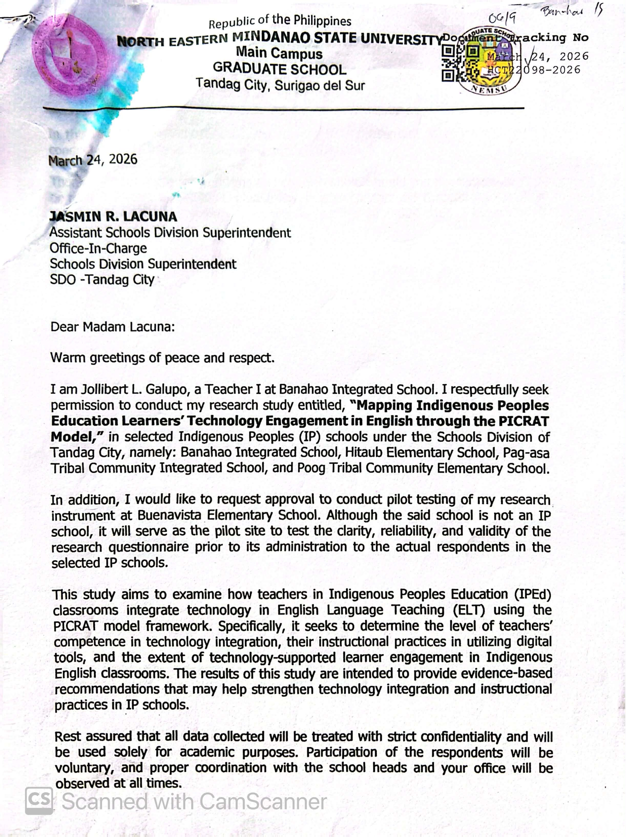
LETTER AND PERMISSIONS



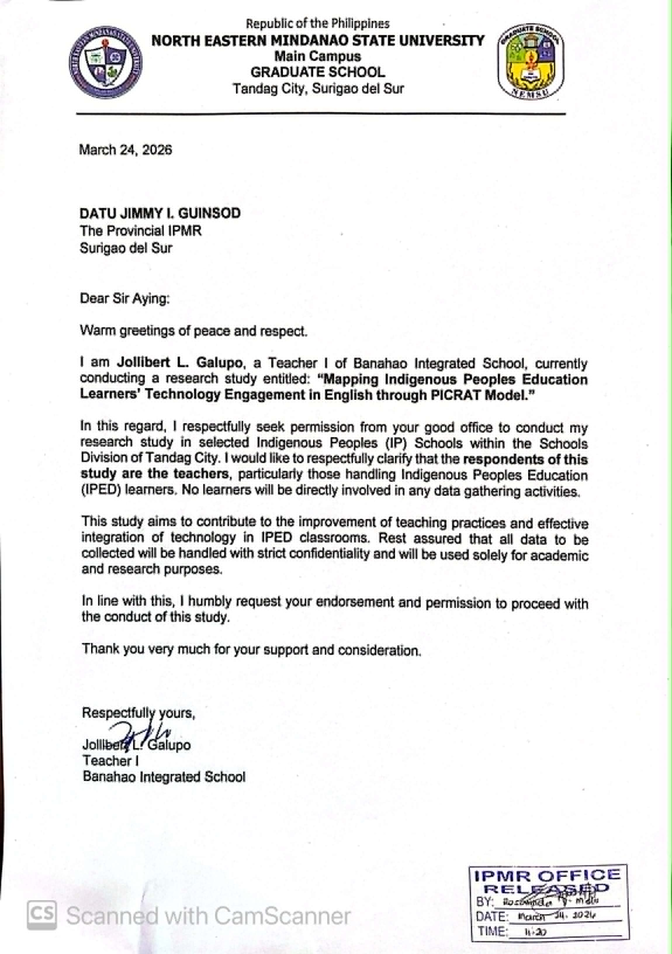
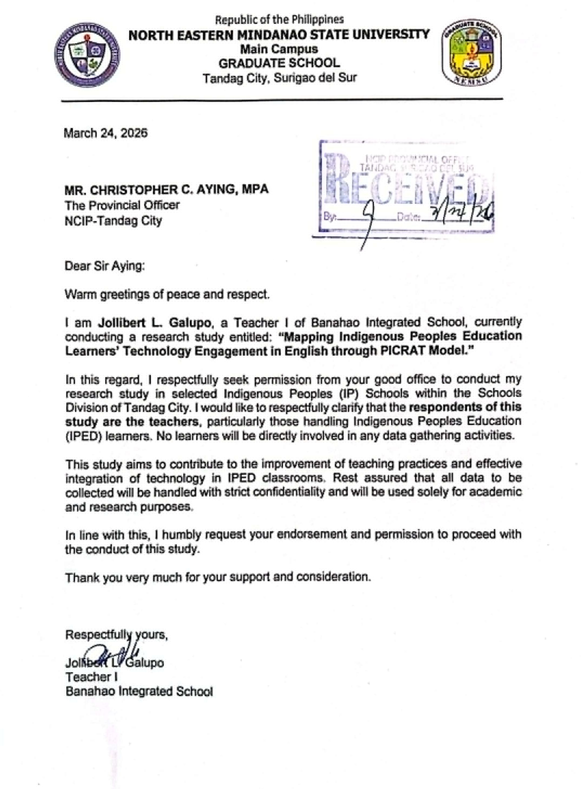

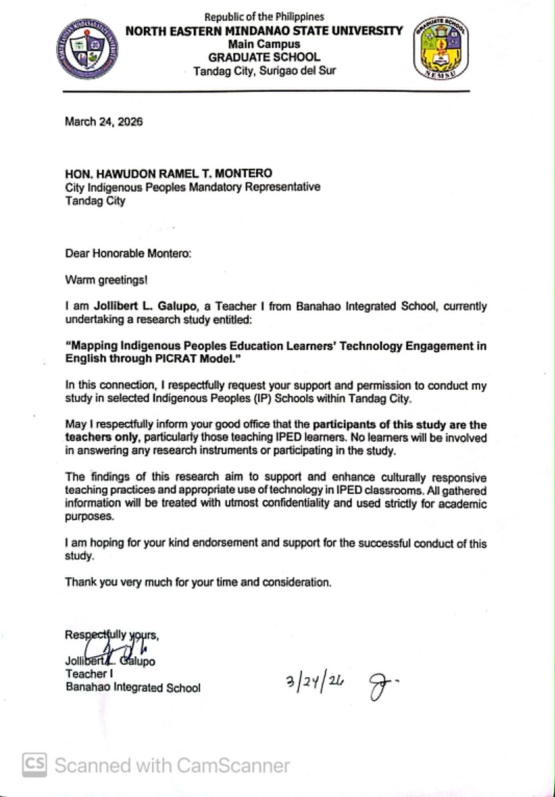

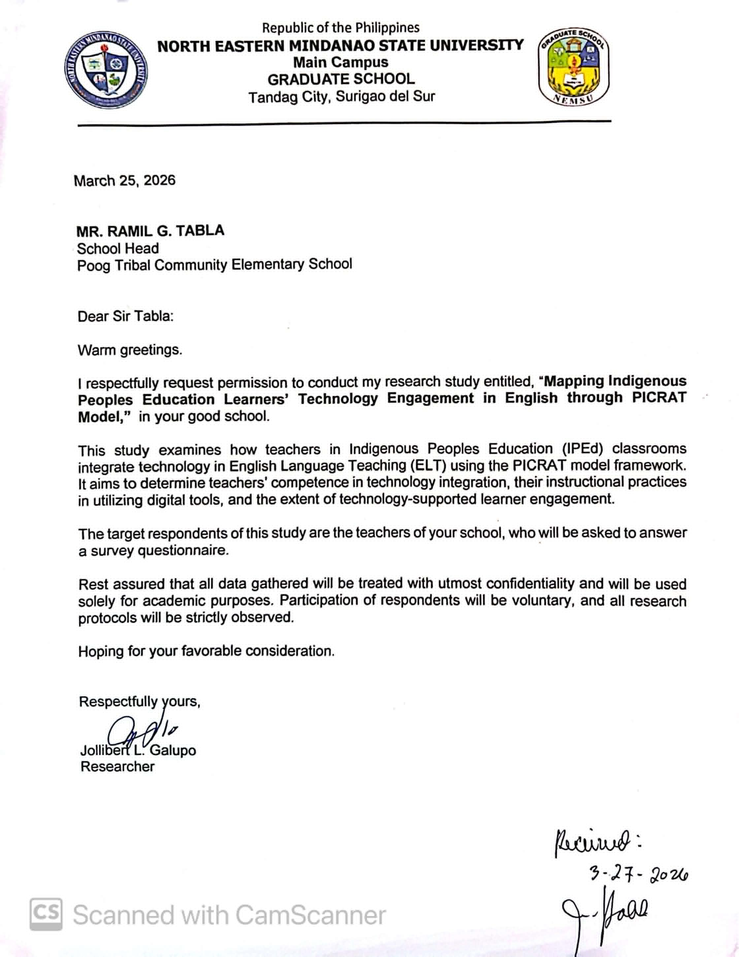

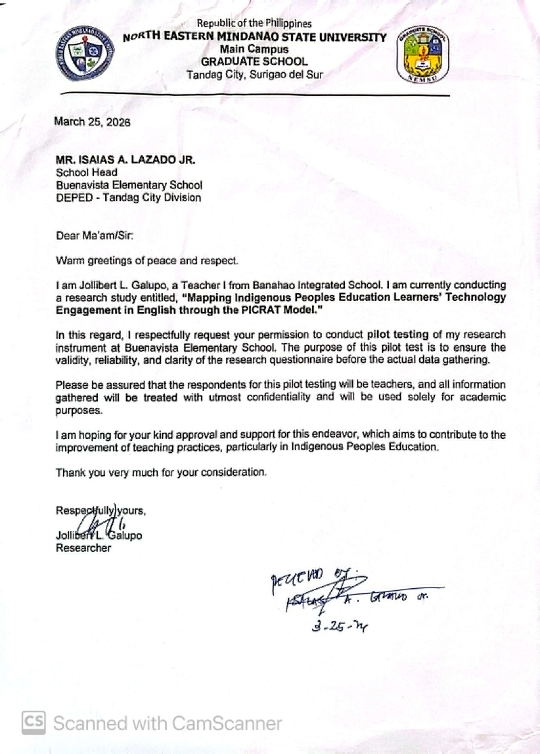



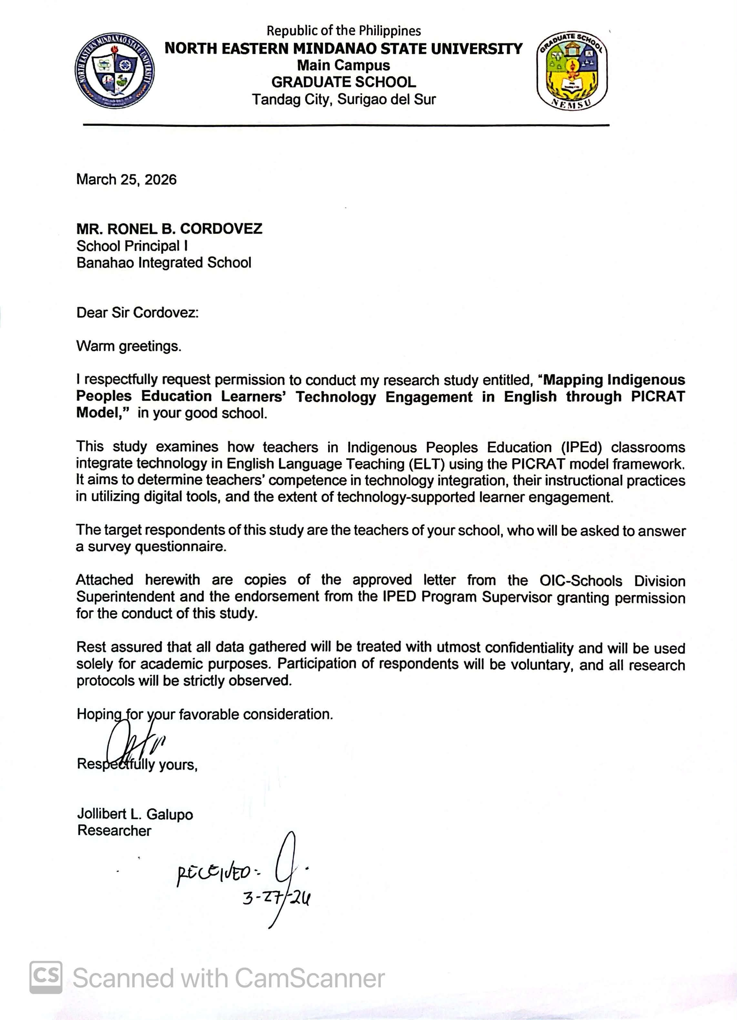

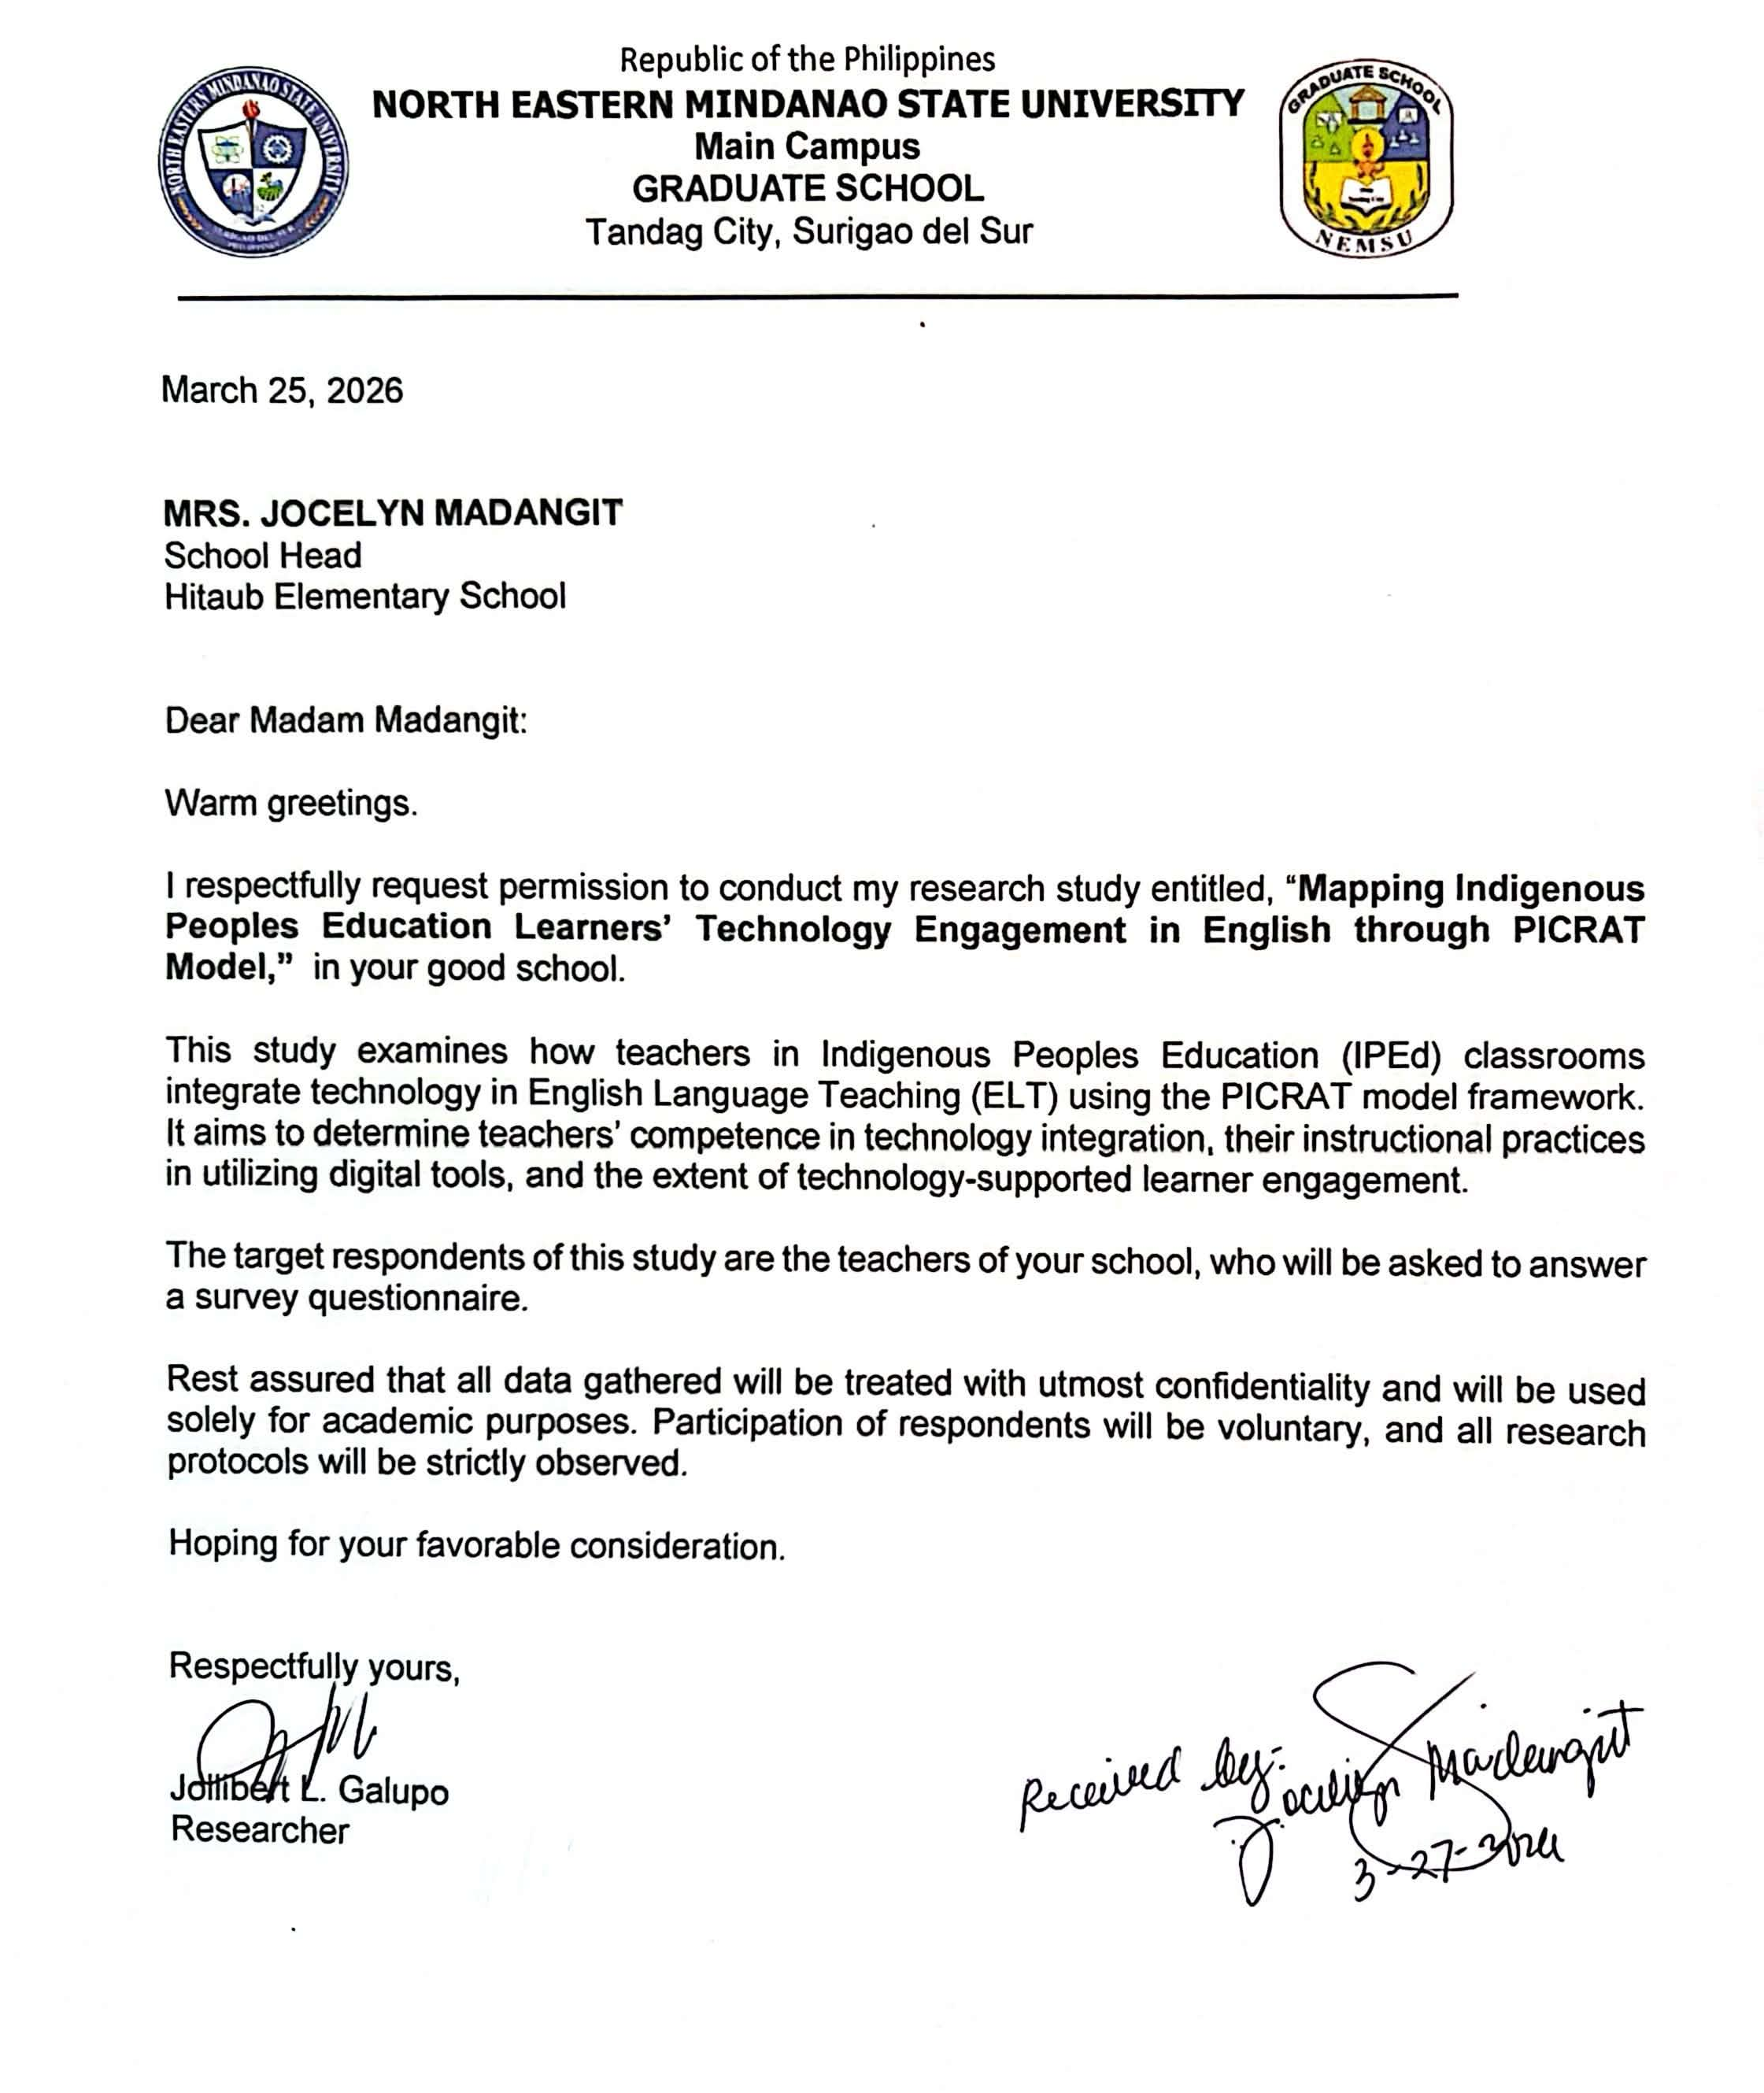

Appendix C.
VALIDITY AND VALIDATION DOCUMENT










Appendix D.
PILOT TESTING RESULT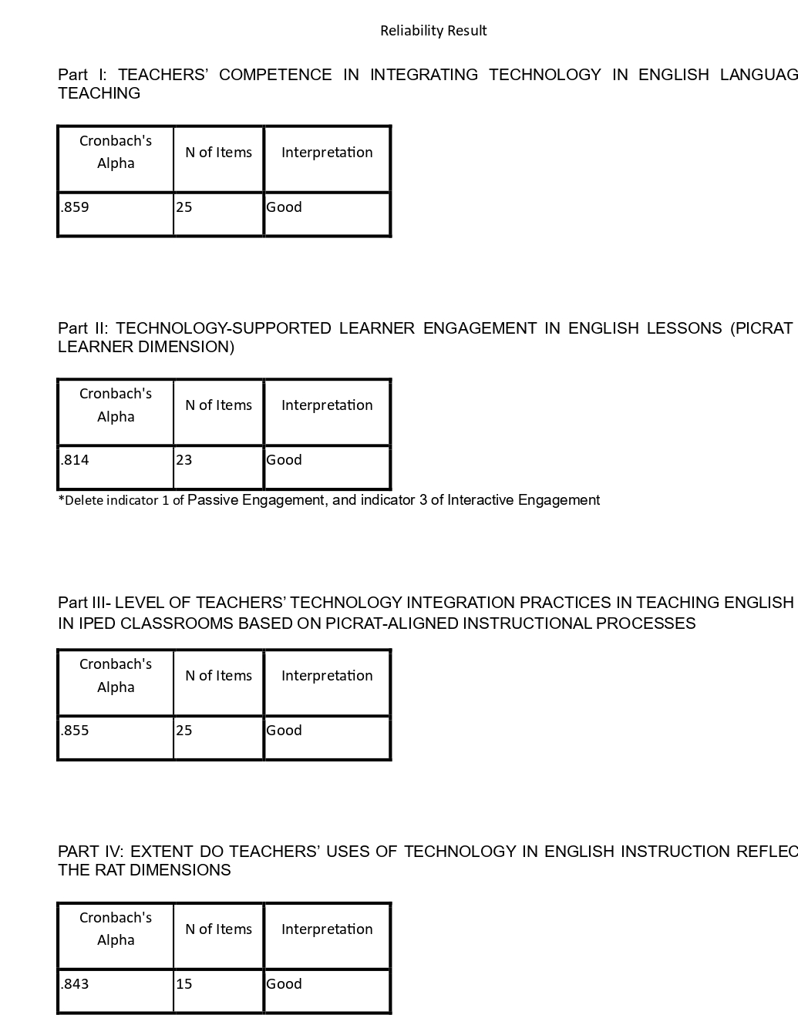


Appendix E.
DETAILED RESULT OF THE STUDY
TEACHERS’ COMPETENCE IN INTEGRATING TECHNOLOGY IN ENGLISH LANGUAGE TEACHING
Indicator | Weighted Mean | Adjectival Rating
PICRAT-Based Pedagogical Knowledge
I intentionally align technology use with English learning outcomes. | 3.67 | Competent
I select digital tools based on how they promote learner engagement in English lessons. | 3.73 | Competent
I plan technology-supported English activities using clear instructional objectives. | 3.80 | Competent
I can distinguish between passive and interactive technology use in ELT. | 3.90 | Competent
I consider whether technology use encourages active English language use among learners. | 4.00 | Competent
Mean | 3.82 | Competent
Cultural Responsiveness and Contextualization
I contextualize English lessons using learners’ community experiences through digital tools. | 3.90 | Competent
I design technology-supported English tasks that respect Indigenous values and identity. | 3.87 | Competent
I adapt digital English materials to suit the cultural background of IP learners. | 3.87 | Competent
I consider cultural appropriateness when selecting digital resources for ELT. | 3.77 | Competent
I use technology to integrate Indigenous culture into English learning activities | 3.63 | Competent
Mean | 3.81 | Competent
Creative Engagement/Technology Use
I can select digital tools appropriate for specific English language skills. | 3.90 | Competent
I can operate basic digital tools commonly used in English instruction. | 3.87 | Competent
I can adjust technology use based on learners’ English proficiency levels. | 3.87 | Competent
I can manage basic technical issues during English lessons. | 3.80 | Competent
I can adapt technology use when internet access is limited. | 3.73 | Competent
Mean | 3.83 | Competent
Access to Technological Resources
Internet connectivity influences how often I use technology in ELT. | 3.73 | Competent
Availability of digital devices affects my English teaching strategies. | 3.70 | Competent
I have access to digital materials appropriate for English instruction. | 3.67 | Competent
Electricity availability affects the type of technology I use in English lessons. | 3.63 | Competent
Resource limitations affect the depth of my technology integration in ELT. | 3.57 | Competent
Mean | 3.66 | Competent
Reflective Teaching Practice
I review learner outputs after technology-supported English tasks. | 3.83 | Competent
I continuously improve my technology integration practices in ELT. | 3.67 | Competent
I modify future English lessons based on previous technology use. | 3.63 | Competent
I adjust my ELT strategies based on learner engagement in tech-based activities. | 3.60 | Competent
I evaluate the effectiveness of technology-supported English lessons. | 3.47 | Competent
Mean | 3.64 | Competent
Over-all Mean | 3.75 | Competent

SUMMARY ON TEACHERS’ COMPETENCE IN INTEGRATING TECHNOLOGY IN ENGLISH LANGUAGE TEACHING
Indicator | Mean | Adjectival Rating
PICRAT-Based Pedagogical Knowledge | 3.82 | Competent
Cultural Responsiveness and Contextualization | 3.81 | Competent
Creative Engagement/Technology Use | 3.83 | Competent
Access to Technological Resources | 3.66 | Competent
Reflective Teaching Practice | 3.64 | Competent
Over-all Mean | 3.75 | Competent

TECHNOLOGY-SUPPORTED LEARNER ENGAGEMENT IN ENGLISH LESSONS (PICRAT – LEARNER DIMENSION)
Indicator | Weighted Mean | Adjectival Rating
Passive Engagement
Learners receive English information using digital tools. | 3.77 | Engaged
Learners listen to recorded English audio materials. | 3.63 | Engaged
Learners read English texts displayed on digital screens. | 3.60 | Engaged
Learners primarily observe during technology-supported English lessons. | 3.53 | Engaged
Mean | 3.63 | Engaged
Interactive Engagement
Learners participate in technology-supported English activities. | 3.67 | Engaged
Learners answer English questions using digital tools. | 3.53 | Engaged
Learners respond to teacher prompts through technology. | 3.5 | Engaged
Learners interact with digital content to check understanding. | 3.5 | Engaged
Mean | 3.55 | Engaged
Collaborative Engagement
Learners provide peer feedback on English tasks through  technology. | 3.47 | Engaged
Learners work with peers on English tasks using technology. | 3.43 | Engaged
Learners cooperate during technology-supported English group work. | 3.40 | Engaged
Learners exchange ideas in English using digital platforms. | 3.37 | Moderately Engaged
Learners collaborate on shared digital English activities. | 3.30 | Moderately Engaged
Mean | 3.39 | Moderately Engaged
Creative Engagement
Learners express ideas creatively through technology. | 3.60 | Engaged
Learners create original English outputs using digital tools. | 3.53 | Engaged
Learners produce digital stories or presentations in English. | 3.53 | Engaged
Learners design digital products to demonstrate English learning. | 3.47 | Engaged
Learners perform English tasks that are not possible without technology. | 3.47 | Engaged
Mean | 3.52 | Engaged
Reflective / Metacognitive Engagement
Learners review their English outputs using digital tools. | 3.60 | Engaged
Learners revise English work based on digital feedback. | 3.57 | Engaged
Learners assess their performance during tech-based English tasks. | 3.50 | Engaged
Learners show awareness of their English learning process. | 3.47 | Engaged
Learners monitor their English learning progress using  technology. | 3.27 | Moderately Engaged
Mean | 3.48 | Engaged
Over-all Mean | 3.52 | Engaged

SUMMARY ON TECHNOLOGY-SUPPORTED LEARNER ENGAGEMENT IN ENGLISH LESSONS (PICRAT – LEARNER DIMENSION)
Indicator | Mean | Adjectival Rating
Passive Engagement | 3.63 | Engaged
Interactive Engagement | 3.55 | Engaged
Collaborative Engagement | 3.39 | Moderately Engaged
Creative Engagement | 3.52 | Engaged
Reflective / Metacognitive Engagement | 3.48 | Engaged
Over-all Mean | 3.52 | Engaged

Level of teachers’ technology integration practices in teaching English in IPEd classrooms based on PICRAT-aligned instructional processes
Indicator | Weighted Mean | Adjectival Rating
Active knowledge-building facilitation
I encourage learners to explore ideas and generate responses through technology-supported tasks. | 3.50 | Practiced
I use technology to engage learners in constructing their own understanding of English concepts. | 3.33 | Moderately Practiced
I design activities where learners actively process and apply English knowledge using digital tools. | 3.33 | Moderately Practiced
I facilitate learner-centered activities rather than teacher-directed instruction using technology. | 3.00 | Moderately Practiced
I use technology to support higher-order thinking in English learning activities. | 2.83 | Moderately Practiced
Mean | 3.20 | Moderately Practiced
Activation and linking of prior knowledge
I use digital tools to connect new English lessons with learners’ prior knowledge. | 3.63 | Practiced
I integrate culturally familiar examples when teaching English. | 3.13 | Moderately Practiced
I encourage learners to share prior knowledge using digital platforms. | 2.97 | Moderately Practiced
I design activities that allow learners to relate English concepts to their daily life. | 2.70 | Moderately Practiced
I use multimedia to activate background knowledge before introducing new topics. | 2.33 | Slightly Practiced
Mean | 2.95 | Moderately Practiced
Inquiry and problem-solving support
I encourage learners to ask and explore questions through technology. | 3.40 | Practiced
I use technology to present real-life English-related problems. | 3.37 | Moderately Practiced
I design inquiry-based activities using digital tools. | 3.20 | Moderately Practiced
I support critical thinking using technology-based tasks. | 3.13 | Moderately Practiced
I guide learners in gathering and analyzing information digitally. | 2.67 | Moderately Practiced
Mean | 3.15 | Moderately Practiced
Technology-mediated dialogue and collaboration
I support group work using technology. | 3.30 | Moderately Practiced
I encourage peer feedback through digital platforms. | 3.10 | Moderately Practiced
I design collaborative tasks using technology. | 2.80 | Moderately Practiced
I promote communication and idea exchange through digital tools. | 2.60 | Moderately Practiced
I use digital tools to facilitate interaction in English. | 2.43 | Moderately Practiced
Mean | 2.85 | Moderately Practiced
Culturally responsive task design and scaffolding
I ensure technology respects Indigenous values. | 3.13 | Moderately Practiced
I design tasks reflecting Indigenous culture. | 2.97 | Moderately Practiced
I adapt materials to learners’ cultural background. | 2.93 | Moderately Practiced
I integrate local knowledge using technology. | 2.87 | Moderately Practiced
I provide scaffolding through digital tools. | 2.60 | Moderately Practiced
Mean | 2.90 | Moderately Practiced
Over-all Mean | 3.01 | Moderately Practiced

SUMMARY ON THE LEVEL OF TEACHERS’ TECHNOLOGY INTEGRATION PRACTICES IN TEACHING ENGLISH IN IPED CLASSROOMS BASED ON PICRAT-ALIGNED INSTRUCTIONAL PROCESSES
Indicator | Mean | Adjectival Rating
Active knowledge-building facilitation | 3.20 | Moderately Practiced
Activation and linking of prior knowledge | 2.95 | Moderately Practiced
Inquiry and problem-solving support | 3.15 | Moderately Practiced
Technology-mediated dialogue and collaboration | 2.85 | Moderately Practiced
Culturally responsive task design and scaffolding | 2.90 | Moderately Practiced
Over-all Mean | 3.01 | Moderately Practiced

Extent Do Teachers’ Uses of Technology In English Instruction Reflect The RAT Dimensions
Indicator | Weighted Mean | Adjectival Rating
Replacement
Digital slides replace chalkboard explanations in English lessons. | 3.47 | Engaged
Online texts replace printed English materials. | 3.47 | Engaged
Technology replaces traditional English teaching materials without changing the task. | 3.43 | Engaged
Digital quizzes replace paper-based English assessments. | 3.40 | Engaged
English teaching strategies remain unchanged despite technology use. | 3.37 | Moderately Engaged
Mean | 3.43 | Engaged
Amplification
Multimedia improves learners’ understanding of English concepts. | 3.63 | Engaged
Digital tools make English lessons more efficient. | 3.60 | Engaged
Technology enhances classroom management in English lessons. | 3.60 | Engaged
Technology improves clarity of English explanations. | 3.40 | Engaged
Technology allows faster feedback on English tasks. | 3.40 | Engaged
Mean | 3.51 | Engaged
Transformation
Technology facilitates meaningful English collaboration. | 3.63 | Engaged
Technology enables English learning tasks that cannot be done traditionally. | 3.57 | Engaged
My English teaching strategies change because of technology use. | 3.57 | Engaged
Technology supports inquiry-based English learning. | 3.53 | Engaged
Learners engage in authentic English communication using technology. | 3.37 | Moderately Engaged
Mean | 3.53 | Engaged
Over-all Mean | 3.50 | Engaged

CHALLENGES IN INDIGENIZING ENGLISH LANGUAGE TEACHING THROUGH TECHNOLOGY
Indicator | Weighted Mean | Adjectival Rating
I find it difficult to balance curriculum standards with culturally contextualized digital tasks. | 3.77 | Highly Challenging
I need more guidance on applying PICRAT in ELT. | 3.70 | Highly Challenging
Curriculum requirements limit integration of Indigenous knowledge in ELT. | 3.70 | Highly Challenging
Learners’ limited digital literacy skills hinder effective participation in technology-supported English tasks. | 3.70 | Highly Challenging
Limited access to culturally localized digital content affects lesson contextualization. | 3.67 | Highly Challenging
Learners have limited access to devices at home for technology-based English activities. | 3.63 | Highly Challenging
Assessing learners’ performance in technology-supported English tasks is challenging. | 3.63 | Highly Challenging
Available digital English resources are not culturally appropriate. | 3.60 | Highly Challenging
Limited digital devices affect technology integration in ELT. | 3.57 | Highly Challenging
Poor internet connectivity limits technology-supported English activities. | 3.57 | Highly Challenging
Infrastructure limitations prevent transformative technology use in English teaching. | 3.57 | Highly Challenging
There is insufficient institutional support for culturally responsive technology integration. | 3.57 | Highly Challenging
Creating technology-supported English tasks that promote thinking is difficult. | 3.53 | Highly Challenging
Lack of professional development specific to IPEd digital instruction affects my integration practices. | 3.53 | Highly Challenging
I struggle to design collaborative digital activities that reflect Indigenous culture. | 3.53 | Highly Challenging
Monitoring learner engagement in digital English activities is difficult. | 3.5 | Highly Challenging
I lack sufficient training in technology-integrated ELT. | 3.47 | Highly Challenging
Designing culturally responsive digital English tasks is  challenging. | 3.47 | Highly Challenging
Technical problems during class disrupt English instruction. | 3.37 | Highly Challenging
Mean | 3.58 | Highly Challenging

Significant relationship between teachers’ competence in integrating technology and their level of technology integration practices in teaching English
Variable Tested |  | Computed r | p-value | Conclusion
PICRAT-Based Pedagogical Knowledge | Active knowledge-building facilitation | 0.832 | .000 | Significant
PICRAT-Based Pedagogical Knowledge | Activation and linking of prior knowledge; | 0.733 | .000 | Significant
PICRAT-Based Pedagogical Knowledge | Inquiry and problem-solving support | 0.585 | .001 | Significant
PICRAT-Based Pedagogical Knowledge | Technology-mediated dialogue and collaboration | 0.816 | .000 | Significant
PICRAT-Based Pedagogical Knowledge | Culturally responsive task design and scaffolding | 0.857 | .000 | Significant
Cultural Responsiveness and Contextualization | Active knowledge-building facilitation | 0.796 | .000 | Significant
Cultural Responsiveness and Contextualization | Activation and linking of prior knowledge; | 0.675 | .000 | Significant
Cultural Responsiveness and Contextualization | Inquiry and problem-solving support | 0.631 | .000 | Significant
Cultural Responsiveness and Contextualization | Technology-mediated dialogue and collaboration | 0.778 | .000 | Significant
Cultural Responsiveness and Contextualization | Culturally responsive task design and scaffolding | 0.850 | .000 | Significant
Creative Engagement/Technology Use | Active knowledge-building facilitation | 0.641 | .000 | Significant
Creative Engagement/Technology Use | Activation and linking of prior knowledge; | 0.505 | .004 | Significant
Creative Engagement/Technology Use | Inquiry and problem-solving support | 0.595 | .001 | Significant
Creative Engagement/Technology Use | Technology-mediated dialogue and collaboration | 0.576 | .001 | Significant
Creative Engagement/Technology Use | Culturally responsive task design and scaffolding | 0.749 | .001 | Significant
Access to Technological Resources | Active knowledge-building facilitation | 0.723 | .000 | Significant
Access to Technological Resources | Activation and linking of prior knowledge; | 0.563 | .001 | Significant
Access to Technological Resources | Inquiry and problem-solving support | 0.588 | .001 | Significant
Access to Technological Resources | Technology-mediated dialogue and collaboration | 0.100 | .573 | Not Significant
Access to Technological Resources | Culturally responsive task design and scaffolding | 0.182 | .339 | Not Significant
Reflective Teaching Practice | Active knowledge-building facilitation | 0.877 | .000 | Significant
Reflective Teaching Practice | Activation and linking of prior knowledge; | 0.719 | .000 | Significant
Reflective Teaching Practice | Inquiry and problem-solving support | 0.615 | .000 | Significant
Reflective Teaching Practice | Technology-mediated dialogue and collaboration | 0.123 | .793 | Not Significant
Reflective Teaching Practice | Culturally responsive task design and scaffolding | 0.134 | .558 | Not Significant

Significant relationship between teachers’ level of technology integration and learners’ level of technology-supported engagement
Variable Tested |  | Computed r | p-value | Conclusion
Active knowledge-building facilitation | Passive Engagement | 0.565 | .001 | Significant
Active knowledge-building facilitation | Interactive Engagement | 0.650 | .000 | Significant
Active knowledge-building facilitation | Collaborative Engagement | 0.287 | .125 | Not Significant
Active knowledge-building facilitation | Creative Engagement | 0.110 | .561 | Not Significant
Active knowledge-building facilitation | Reflective / Metacognitive Engagement | 0.202 | .285 | Not Significant
Activation and linking of prior knowledge | Passive Engagement | -0.145 | .444 | Not Significant
Activation and linking of prior knowledge | Interactive Engagement | -0.053 | .780 | Not Significant
Activation and linking of prior knowledge | Collaborative Engagement | 0.013 | .947 | Not Significant
Activation and linking of prior knowledge | Creative Engagement | 0.825 | .042 | Significant
Activation and linking of prior knowledge | Reflective / Metacognitive Engagement | -0.069 | .716 | Not Significant
Inquiry and problem-solving support | Passive Engagement | -0.034 | .858 | Not Significant
Inquiry and problem-solving support | Interactive Engagement | 0.693 | .002 | Significant
Inquiry and problem-solving support | Collaborative Engagement | -0.307 | .099 | Not Significant
Inquiry and problem-solving support | Creative Engagement | 0.673 | .000 | Significant
Inquiry and problem-solving support | Reflective / Metacognitive Engagement | 0.069 | .717 | Not Significant
Technology-mediated dialogue and collaboration | Passive Engagement | 0.050 | .792 | Not Significant
Technology-mediated dialogue and collaboration | Interactive Engagement | -0.122 | .519 | Not Significant
Technology-mediated dialogue and collaboration | Collaborative Engagement | 0.412 | .035 | Significant
Technology-mediated dialogue and collaboration | Creative Engagement | 0.032 | .865 | Not Significant
Technology-mediated dialogue and collaboration | Reflective / Metacognitive Engagement | 0.230 | .221 | Not Significant
Culturally responsive task design and scaffolding | Passive Engagement | -0.151 | .426 | Not Significant
Culturally responsive task design and scaffolding | Interactive Engagement | -0.099 | .604 | Not Significant
Culturally responsive task design and scaffolding | Collaborative Engagement | -0.344 | 063 | Not Significant
Culturally responsive task design and scaffolding | Creative Engagement | -0.259 | .166 | Not Significant
Culturally responsive task design and scaffolding | Reflective / Metacognitive Engagement | -0.238 | .206 | Not Significant
*Significant if p-value is less than .05
Teacher competence, learner engagement, and teachers’ technology integration practices significantly predict teachers’ RAT-level technology use in English instruction
Coefficientsª
Model |  | Unstandardized Coefficients |  | Standardized Coefficients | t | Sig. | Collinearity Statistics
 |  | B | Std. Error | Beta | t | Sig. | Tolerance | VIF
1 | (Constant) | -2.285 | 1.125 |  | -2.031 | .053
1 | Competence | .588 | .168 | .492 | 3.491 | .002 | .262 | 3.816
1 | Engagement | .536 | .161 | .470 | 3.337 | .003 | .262 | 3.816
1 | Practices | .560 | .353 | .114 | 1.585 | .125 | .999 | 1.001
a. Dependent Variable: Use

Model Summary
Model | R | R Square | Adjusted R Square | Std. Error of the Estimate | Change Statistics
 |  |  |  |  | R Square Change | F Change | df1 | df2 | Sig. F Change
1 | .930ª | .865 | .849 | .38042 | .865 | 55.465 | 3 | 26 | .000
a. Predictors: (Constant), Practices, Engagement, Competence
ANOVA^{b}
Model |  | Sum of Squares | df |  | Mean Square |  | F |  | Sig.
1 | Regression | 24.080 | 3 |  | 8.027 |  | 55.465 |  | .000ª
1 | Residual | 3.763 | 26 |  | .145
1 | Total | 27.843 | 29
Predictors: (Constant), Practices, Engagement, Competence
Dependent Variable: use
Significant relationship between the extent of challenges encountered and the extent of teachers’ technology integration and learner engagement
Variable Tested |  | Computed r | p-value | Conclusion
challenges encountered | Active knowledge-building facilitation | 0.077 | .688 | Not Significant
challenges encountered | Activation and linking of prior knowledge; | -0.054 | .777 | Not Significant
challenges encountered | Inquiry and problem-solving support | 0.103 | .589 | Not Significant
challenges encountered | Technology-mediated dialogue and collaboration | -0.450 | .013 | Significant
challenges encountered | Culturally responsive task design and scaffolding | -0.413 | .032 | Significant
challenges encountered | Passive Engagement | 0.080 | .676 | Not Significant
challenges encountered | Interactive Engagement | 0.181 | .337 | Not Significant
challenges encountered | Collaborative Engagement | -0.590 | .001 | Significant
challenges encountered | Creative Engagement | 0.129 | .498 | Not Significant
challenges encountered | Reflective / Metacognitive Engagement | 0.077 | .688 | Not Significant

Statistical tool
Weighted mean and mean was used to determine the level of teachers’ competence in integrating technology, extent of technology-supported learner engagement, the level of teachers’ technology integration practices in teaching English in IPEd classrooms based on PICRAT-aligned instructional processes, extent do teachers’ uses of technology in English instruction reflect the RAT dimensions, challenges encountered by teachers in indigenizing English learning through technology-supported tasks that promote thinking, reflection, and culturally responsive engagement
Pearson product moment correlation was used to determine the significant relationship between teachers’ competence in integrating technology and their level of technology integration practices in teaching English, significant relationship between teachers’ level of technology integration and learners’ level of technology-supported engagement, and significant relationship between the extent of challenges encountered and the extent of teachers’ technology integration and learner engagement
Regression analysis was used to determine which among teacher competence, learner engagement, and teachers’ technology integration practices significantly predicts teachers’ RAT-level technology use in English instruction


CURRICULUM VITAE
Name: JOLLIBERT L. GALUPO
Address: Buenavista,Tandag City, Surigao del Sur
Email: jollibert.galupo@deped.gov.ph

CAREER OBJECTIVE
Dedicated and passionate teacher committed to providing quality education, fostering meaningful learning experiences, and supporting the holistic development of learners. Committed to continuously enhancing professional skills while contributing effectively to the success of the institution and the community.
EDUCATIONAL BACKGROUND
Postgraduate
North Eastern Mindanao State University 2023-Ongoing
College
North Eastern Mindanao State University 2021-2022
Senior High School/ High School
Buenavista National High School 2017-2018
Elementary
Buenavista Elementary School 2011-2012
WORK EXPERIENCE
Banahao Integrated School 2025-Present
Tandag National Science High School 2024-2025
Jacinto P. Elpa National High School 2024
SKILLS
- Classroom Management
- Leadership and Teamwork
- Microsoft Office Proficiency (Word, Excel, PowerPoint)
- Research and Academic Writing
- Campus Journalism and Editorial Writing
- Event Hosting and Public Speaking
- Time Management and Organization
- Adaptability and Problem-Solving
- Community Engagement and Collaboration
TRAININGS/CERTIFICATES
- Division Research Proposal Presentation
- Virtual workshop on the preparation of an individualized reading intervention Plan (IRIP)
- Aral With Heart & Mind: Integrating Socio-Emotional Learning (Sel) And Science Of Reading For Inclusive Literacy Recovery
- Division Training On Special Needs Education Content And Pedagogy For Select Elementary And Secondary School Teachers
- Division training of grades 2,3,5,8 teachers on the revised k-12curriculum implementation -Phase 2
- 4-day Division Training on the Matatag Curriculum Implementation Phase 2 Iped component

