AI-Powered Traffic Law Navigator and Rights Assistant

ABSTRACT

Navigating traffic laws and administrative legal processes in the Philippines presents a significant challenge for ordinary motorists, who frequently lack access to legal counsel and struggle with complex technical legal terms. This information gap often leads to accidental violations, unresolved roadside disputes, and an inability to contest unjust citations. To address these challenges, this study developed the AI-Powered Traffic Law Navigator and Rights Assistant, a conversational mobile application structured around the Input-Process-Output (IPO) framework following a Prototype Software Development Life Cycle (SDLC) model. Built using the Flutter SDK and Dart programming language, the system integrates a structured MySQL relational database of Philippine traffic codes, Land Transportation Office (LTO) regulations, and Metropolitan Manila Development Authority (MMDA) guidelines. The platform employs a supervised machine learning text classification model (utilizing tokenization, normalization, and TF-IDF vectorization paired with classification algorithms) to automatically route multilingual (English, Filipino, Taglish) user descriptions to appropriate violation categories and legal data. Additionally, a generative AI presentation layer utilizes GPT API prompting templates to simplify technical legal jargon and auto-generate structured legal paperwork like explanation letters and affidavits. Real-time location-based features implement the Haversine formula on device GPS coordinates to map and calculate proximity to the nearest LTO branches, traffic units, or barangay halls within a pilot dataset covering the National Capital Region (NCR) and Luzon. Functional evaluations demonstrate that the system effectively maps natural language inputs to correct legal penalties, lowers procedural barriers via rule-based document generation templates, and improves localized civic navigation. Future recommendations emphasize migrating to a web-synchronized framework, integrating Retrieval-Augmented Generation (RAG) to eliminate AI hallucinations, scaling geographic and dialect data across the Visayas and Mindanao regions, and establishing official government API and human-in-the-loop validation pipelines.

Keywords: Traffic Law Navigation, Supervised Machine Learning, Generative AI, Geolocation, Haversine Formula, Developmental Research, Philippines.

INTRODUCTION
Background of the Study
In the Philippines, understanding traffic laws and navigating related legal processes can be difficult for the average citizen or driver. Many Filipinos struggle to identify which specific traffic regulations apply to their situation, whether it involves violations, accidents, apprehensions, or disputes on the road. Because most individuals do not have direct access to lawyers or legal specialists, they often remain unaware of their rights, responsibilities, and the proper procedures when dealing with traffic-related incidents. The complexity of legal and technical terms used in the Land Transportation and Traffic Code, local traffic ordinances, and law enforcement procedures adds to the confusion. According to reports from the Metropolitan Manila Development Authority (MMDA) and Land Transportation Office (LTO), a large percentage of motorists commit violations unintentionally due to lack of knowledge, and many fail to contest or resolve disputes simply because they do not understand the process.
Moreover, existing online sources and government websites only provide static information, such as lists of violations, fines, and general traffic rules. These resources are often difficult to interpret, lack practical examples, and do not adapt to the user’s specific scenario. For instance, a driver may know they were cited for “reckless driving” but may not understand what documents they must prepare, how to contest a ticket, what steps to take after a minor accident, or how procedures vary between cities, LTO branches, or traffic enforcement units. This gap between mere availability of information and practical usability continues to hinder motorists from effectively exercising their rights, avoiding unnecessary penalties, and complying with proper legal procedures.
To address this ongoing problem, the researchers propose the AI-Powered Traffic Law Navigator and Rights Assistant—a digital system designed to help users better understand and navigate Philippine traffic laws. By allowing individuals to input or describe their traffic-related concerns in simple language (e.g., “I got a ticket for coding violation,” “I was involved in a minor accident,” or “I want to contest a traffic citation”), the system can provide personalized, step-by-step guidance. This includes identifying relevant laws, outlining procedures, listing required documents, and recommending appropriate offices based on the user's location. Additionally, the system aims to simplify legal terms, assist users in drafting traffic-related documents or letters, and adjust its guidance depending on the city's or municipality’s specific traffic policies or processes. Through this innovation, the researchers hope to enhance legal literacy among motorists, reduce misinformation, and support safer and more responsible road behavior across the country.

Statement of the Problem
Many Filipino motorists struggle to understand and comply with traffic-related legal matters because they lack accessible, clear, and reliable information about traffic laws, penalties, procedures, and their rights on the road. Most traffic-related documents and guidelines are written using technical or legal terms, making them difficult for ordinary citizens to understand. As a result, individuals often do not know which specific traffic law applies to their situation or how to properly address violations, accidents, or citations. This lack of clarity leads to confusion, costly mistakes, unresolved disputes, and difficulty when communicating with traffic authorities.
In particular, the current research strives to solve the following issues:
- Citizens cannot determine which traffic laws apply to their specific violations, incidents, or situations, nor understand the appropriate action they should take.
- Individuals cannot prepare or write traffic-related documents or letters correctly, such as explanations, affidavits, or contest letters, due to a lack of proper guidance and templates.
- Available online traffic information is not localized or personalized, making it unclear which offices, LTO branches, traffic units, or local government offices a user should consult based on their location.

Objective of the Study
The overall aim of this research is to create a digital platform that simplifies the understanding and application of Philippine traffic laws by providing step-by-step guidance, organized legal information, and accessible traffic-related procedures. The system seeks to make traffic regulations easier to interpret, follow, and apply in real-life situations encountered by Filipino motorists and citizens.
In particular, the research intends to:
- To develop a system utilizing a machine learning text classification model to identify relevant traffic laws, rules, and penalties based on the user’s described incident, violation, or traffic-related concern.
- To implement a document assistance feature that guides users in completing or generating traffic-related documents, such as explanation letters, affidavits, or contest forms, formatted according to required standards.
- To establish a location-based function that provides users with localized traffic guidance and identifies the appropriate offices or authorities to approach, such as LTO branches, traffic enforcement units, or barangay offices, based on their area.

Scope and Limitation
The research is centered on the creation of a Traffic Law Navigator and Rights Assistant developed as a mobile application platform. Its major features include a Traffic Guidance System that provides step-by-step instructions on the proper procedures for common traffic-related concerns such as settling violations, reporting incidents, or understanding penalties; and a Traffic Term Simplifier that interprets technical traffic and enforcement terms into simple Filipino or English explanations. The law identification feature will use a supervised machine learning text classification approach trained on multilingual traffic-related scenarios. Generative AI will be utilized only for document drafting and language assistance; a Document Assistance feature that supports users in writing and completing traffic-related documents such as explanation letters, affidavits, or violation contest forms; a Location-Based Guidance module that adjusts instructions according to the user’s location by showing the nearest LTO offices, traffic enforcement units, and barangay halls. The location-based guidance feature will initially focus on the National Capital Region (NCR) and selected areas in Luzon as a pilot dataset.; and a Voice and Chat Input that allows users to type or verbally state their traffic-related issues.
The process will involve training the model using a structured database of Philippine traffic laws, LTO regulations, MMDA guidelines, local traffic ordinances, and standardized document templates. The researchers will manually input and label the data sources to ensure that the system generates accurate and context-appropriate guidance. The system will also include integration with an available AI model (such as GPT or equivalent NLP frameworks) to enhance text comprehension and generate properly structured responses.
However, the system will not provide professional legal advice nor serve as an official substitute for licensed lawyers, accredited traffic officers, or LTO personnel. It will only guide users based on publicly available traffic laws, regulations, and procedures. The system will initially focus on common traffic violations, roadside incidents, and administrative matters, and may not cover complex criminal traffic cases or region-specific special ordinances. The system relies on a structured database of government office locations and may not include all barangay halls or local traffic offices nationwide during the initial implementation. The system will be implemented as a mobile application and will not initially include a web-based version. Additionally, the accuracy of localized guidance will depend on the availability and accessibility of updated public agency information.
Significance of the Study
This research is significant because it introduces a modern approach to understanding and navigating traffic-related legal information more efficiently. By developing a system focused on Philippine traffic laws, the study aims to simplify data organization, make document preparation easier, and increase the accessibility and accuracy of traffic-related guidance for the public. The results of this research are expected to provide both theoretical contributions and practical benefits to its target users and stakeholders in the transportation and law sectors.
Ordinary Citizens – This system greatly benefits regular Filipino motorists, commuters, and pedestrians by giving them an accessible platform to understand traffic rules, penalties, and legal processes. Many individuals do not fully understand the procedures for contesting traffic violations, claiming impounded vehicles, or filing incident reports. With this platform, citizens receive clear and step-by-step explanations in Filipino or English, helping them avoid misinformation and make informed decisions before seeking professional assistance.
Law Students and Educational Institutions – The system can serve as a valuable learning tool for law and criminology students studying transportation laws, administrative procedures, and enforcement policies. Through interactive examples and simplified legal content, students gain exposure to real-world application of traffic regulations. Educational institutions may use it as a supplemental reference for teaching legal interpretation and digital governance.
Legal Professionals – Traffic lawyers, paralegals, and legal practitioners benefit from the system as a quick reference guide for standard traffic cases. The document assistant helps them draft common traffic-related documents such as explanation letters, complaint forms, and affidavits more efficiently. By reducing time spent on repetitive tasks, professionals can focus on more complex legal matters requiring expert analysis.
Traffic Enforcement Agencies and Barangays – Agencies such as the LTO, MMDA, local traffic management offices, and barangay authorities can use the system as an auxiliary tool to deliver accurate and consistent information to the public. This is especially beneficial in areas with limited staff or high volumes of inquiries. The platform supports faster assistance to motorists, reduces misunderstandings about procedures, and ensures uniform guidance across regions.
Government Agencies – National and local government bodies may benefit from reduced misinformation, fewer unnecessary disputes, and more efficient processing of traffic concerns. Clear guidance on required documents, procedures, and office locations can lessen administrative workload and speed up service delivery. The system contributes to improved public awareness and compliance with traffic regulations.
Developers and Future Researchers – This study provides a foundational model for future technological innovations involving traffic law interpretation and automated legal assistance. Researchers may use its data training methods, integration techniques, and system workflow as references for advancing intelligent legal support tools. It encourages further development in digital governance and accessible legal technology. The study demonstrates the application of machine learning and location-based services in legal information systems.

REVIEW OF RELATED LITERATURE AND STUDIES
Related Literature
The provided literature highlights a major technological shift in traffic law enforcement and judicial productivity, driven by the integration of Artificial Intelligence (AI), the Internet of Things (IoT), and computer vision. In traffic governance, deep learning models like YOLO, combined with Automatic Number Plate Recognition (ANPR) and EasyOCR, have automated real-time violation detection for offenses such as speeding, red-light running, and triple riding (Raj et al., 2025; Bhavana B. M. et al., 2025). These systems utilize IoT sensors and continuous video feeds to dynamically manage traffic density, optimize signals, and compile legally verifiable evidence packages that drastically reduce manual administrative workloads (Hajare et al., 2025; Researchers, 2024). Furthermore, global deployments, such as large-scale solar-powered AI camera networks in Kerala, show a significant reduction in traffic violations and fatal accidents, proving that combining automated enforcement data with systemic monitoring influences positive driver behavior.
Parallel advancements in legal technology, such as the "LegalAsst" project and the "Chatlaw" multi-agent framework, demonstrate how domain-specific Large Language Models (LLMs) and knowledge graphs can streamline legal research, reduce information retrieval times, and minimize AI hallucinations (Kalaycioglu et al., 2025; Chatlaw, 2023). These platforms act as accessible navigational tools for non-expert citizens looking to understand traffic penalties, compliance tracking, or complaint filings. However, researchers note that large-scale deployment presents critical societal and operational hurdles, as concerns regarding data privacy, mass surveillance, regional regulatory inconsistencies, and algorithmic bias can severely erode public trust if left unaddressed (Khan, 2025; Lai, 2024; Deffains, 2025). Ultimately, the literature consensus emphasizes that while AI significantly enhances compliance and accessibility, these technologies must be bounded by clear ethical standards and paired with "human-in-the-loop" validation processes to augment, rather than replace, human legal judgment.

Related Studies
Expanding upon the previous research, the integrated synthesis of this literature demonstrates a comprehensive, multimodal evolution in AI-driven traffic enforcement and public legal accessibility. In field operations, technical advancements have moved beyond stationary infrastructure toward versatile, edge-computing, and smartphone-based solutions that utilize real-time camera inputs, GPS data, and on-device AI models to detect mobile violations like illegal stopping, pedestrian crossing breaches, and complex overtaking maneuvers across variable weather conditions (Sutar, 2025; Researchers, 2023). Model optimizations—such as the utilization of YOLOv8 confidence scoring to navigate edge cases like visual occlusions, and ensemble learning (YOLOv5) configurations to reliably classify two-wheeler helmet compliance—have significantly improved detection precision while minimizing false negatives in crowded urban scenes (ResearchGate, 2025; arXiv, 2023; YOLOv8 Study, 2024). Furthermore, predictive modeling utilizing deep learning hybrid architectures like multilayer LSTMs and CNNs has introduced proactive enforcement mechanisms capable of forecasting potential rule breaches before they occur (Wicaksono et al., 2025). These multi-mode front-end systems, highlighted by city pilot programs like "Traffic Eye," not only shorten administrative processing times by over 30% but also map raw visual alerts into structured, timestamped legal terms and evidence packets (Traffic Eye, 2025; Sutar et al., 2025).
This granular, automated enforcement pipeline directly interfaces with next-generation legal navigation and access-to-justice platforms designed for lay users. Empirical research by the Stanford Justice Innovation Lab (2023) and the OECD (2024) indicates that institutional adoption of Large Language Models (LLMs) for legal question-answering significantly reduces lower-court backlogs, improves procedural fairness, and enhances user satisfaction when navigating administrative and traffic laws. To translate citizen free-text queries and user-generated cooperative reporting into reliable legal actions, underlying architectures are adopting transformer-based semantic similarity embeddings that outperform classical data retrieval models, alongside multimodal voice-enabled AI interfaces that bridge accessibility barriers for diverse or low-literacy populations (Mentzingen et al., 2024; Mendoza et al., 2022; Mobile Study, 2023). However, despite the systemic efficiency of fully automated analytics, longitudinal governance data and evidence admissibility studies firmly dictate that detection alone lacks legal standing without rigorous verification frameworks. The literature concludes that incorporating feedback loops, strict data transparency protocols, and explicit human-in-the-loop checkpoints maximizes stakeholder trust and administrative accuracy—solidifying AI's optimal role as a powerful tool to augment and contextualize legal navigation rather than fully replace human oversight.

Synthesis
Among the reviewed studies, several show strong alignment with the present research. First, the study of Papadopoulos (2024) on large language models in legal reasoning is closely related because it explores how AI can interpret legal scenarios and generate structured legal decisions. Similar to the proposed Legal Navigator, the study supports the use of AI as a legal decision-support tool, though not as a replacement for professionals. Both works highlight AI’s potential in legal understanding while recognizing the need for human oversight.
Second, the work of Ranera (2024) on document embedding techniques for Philippine Supreme Court decisions is highly relevant. This study focuses on retrieving legal documents using semantic similarity, which directly supports the system’s function of matching user-described cases to applicable laws. Both studies aim to improve access to legal information using AI and NLP techniques.
Third, Saadany et al. (2025), which integrates speech recognition, LLMs, and legal retrieval tools for access to justice, is also similar. Like the proposed platform, it emphasizes accessibility for non-experts, use of plain language, and AI-assisted legal support.
However, some studies differ in focus. The study by Reddy et al. (2025) primarily deals with computer vision systems for detecting traffic violations using YOLO and OCR. While it relates to traffic laws, its focus is on violation detection through cameras rather than legal guidance or citizen assistance.
Similarly, Kamath et al. (2023) on knowledge-based navigation for autonomous vehicles focuses on traffic data analysis and vehicle routing. This differs from the current research, which addresses legal processes and rights awareness rather than vehicle mobility.
Lastly, Englund et al. (2021) discusses AI in Smart Cities for traffic control and driver modeling. Although it involves traffic systems, its primary goal is infrastructure optimization, not legal education or document support.
Overall, the synthesis shows that while some studies support the legal AI and accessibility components of the system, others focus more on traffic monitoring technologies, highlighting the unique integration of legal guidance and AI in the present study.

METHODOLOGY
Research Design
The study employed a developmental research design to guide the systematic design, development, and evaluation of a mobile-based Traffic Guidance System that integrates supervised machine learning, generative artificial intelligence, and location-based services. This research design is appropriate as it focuses on creating a functional technological solution that addresses real-world traffic-related concerns. The system is designed to assist users in understanding traffic violations, legal procedures, and enforcement-related terminology through a conversational mobile interface that accepts input in English, Filipino, or Taglish. By combining intelligent automation with structured legal data, the study aims to produce a user-friendly and reliable application that delivers accurate and accessible traffic guidance.
The developmental approach of the study follows a modular integration of key system components, where each technology performs a specific role. A supervised machine learning model utilizing text preprocessing techniques such as tokenization, normalization, and TF-IDF vectorization, along with classification algorithms like Multinomial Naïve Bayes or Logistic Regression, is used to categorize user inputs into predefined traffic-related concerns. Once classified, the system retrieves verified legal information, including procedures, penalties, and definitions, from a structured relational database. Generative artificial intelligence is applied at the presentation layer to simplify legal content and generate structured documents such as affidavits and letters using prompt-based templates. Additionally, the system incorporates GPS-based location services, where user coordinates are processed using the Haversine formula to determine the nearest relevant government offices such as LTO branches, traffic enforcement units, and barangay halls.
The datasets used in the study consist of a labeled classification dataset, a structured legal reference database, document templates, and a geographic dataset of government offices. The classification dataset includes curated traffic-related scenarios written in English, Filipino, and Taglish, which are manually labeled to train the machine learning model. The legal database contains verified information on traffic violations, penalties, procedures, and technical definitions sourced from official government materials, ensuring accuracy and reliability. Document templates are derived from standard formats to guide AI-generated outputs, while the geographic dataset includes validated office locations with corresponding coordinates for distance computation. All datasets were organized, validated, and structured prior to integration to ensure consistency, accuracy, and effective system performance.
System Development Life Cycle (Prototype Model)
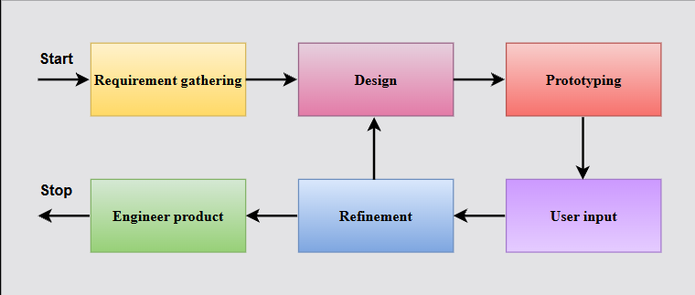
The proponents decided to adopt the Prototype Model as the Software Development Life Cycle (SDLC) approach in the development of the proposed AI-Powered Traffic Law Navigator and Rights Assistant mobile application. The Prototype Model is a system development methodology that emphasizes the creation of an initial working model of the system in order to visualize system functionality, identify user requirements, and continuously improve the system through iterative refinement. This development approach is suitable for the proposed application because the system integrates multiple components such as machine learning classification, structured legal data retrieval, generative artificial intelligence for explanation and document construction, and GPS-based location detection. These components require repeated testing and modification to ensure that system outputs are accurate, understandable, and aligned with user expectations. Through the development of an initial prototype, the proponents are able to evaluate how the system identifies traffic laws, provides step-by-step procedures, simplifies technical traffic terms, assists in document preparation, and determines the nearest traffic-related government offices based on user location.
Requirement Gathering
The proponents identified and analyzed the functional and non-functional requirements of the proposed system based on the problems presented in Chapter 1. The main objective of this phase is to determine the essential features that the mobile application must include in order to address the difficulties experienced by Filipino motorists in understanding traffic laws and procedures. During this stage, the three primary system components were clearly defined, namely the Traffic Guidance System for identifying applicable traffic laws and providing procedural guidance, the Document Assistance feature for generating structured traffic-related legal documents, and the Location-Based Guidance feature for identifying the nearest government service offices such as Land Transportation Office branches, traffic enforcement units, and barangay halls. Data requirements were also determined, including the need for a labeled dataset for machine learning classification, a structured legal database containing verified traffic violations and procedures, and a geographic dataset containing the coordinates of relevant service offices.
Quick Design
The preliminary design of the mobile application was developed based on the identified system requirements. This phase involved the conceptualization of the system interface, data structure, and overall system workflow. The database schema for storing traffic violations, penalties, legal definitions, and procedural steps was designed during this stage. Additionally, the labeled datasets intended for training the machine learning model were structured and organized. The geographic dataset for location-based services was also prepared by compiling office names, physical addresses, and corresponding latitude and longitude coordinates. The overall system architecture was planned to integrate the machine learning classifier for concern identification, the structured legal database for procedural retrieval, the generative artificial intelligence module for language simplification and document construction, and the GPS-based component for location detection.
Prototype Development
An initial working version of the mobile application was developed to demonstrate the functionality of the proposed system. During this stage, the supervised machine learning classification model capable of identifying traffic-related concerns based on user input written in English, Filipino, or Taglish was implemented. Text preprocessing techniques such as tokenization, normalization, stop-word removal, and TF-IDF vectorization were applied to transform user input into numerical features suitable for classification. A classification algorithm was trained using the labeled dataset prepared during the earlier phase, enabling the system to categorize user concerns into predefined traffic-related classes. Once classification is completed, the system retrieves the corresponding legal procedures, penalties, and technical definitions from the structured database.
The integration of generative artificial intelligence was also implemented during this stage to enhance user interaction and comprehension. The retrieved legal information from the database is passed to the generative AI component, which reformulates the structured content into simplified, step-by-step explanations in English, Filipino, or Taglish while preserving the accuracy of the stored legal data. The Document Assistance feature was developed using predefined prompt templates that allow the system to generate structured legal documents such as affidavits and appeal letters based on user-provided details. Furthermore, the location-based guidance feature was incorporated by enabling the application to access the mobile device’s GPS sensor to obtain real-time latitude and longitude coordinates. The system compares these coordinates with stored geographic data of government offices and applies the Haversine formula to compute the nearest service location. The user interface prototype was designed using a conversational chat-based layout to allow users to interact with the system through natural language input instead of navigating traditional feature menus. This stage ensured that all system components operate cohesively within a functional mobile prototype environment.
User Evaluation
The developed prototype was subjected to usability testing in order to assess system performance, response accuracy, and user satisfaction. Thirty participants composed of motorists or students who possess valid driver's licenses were selected to interact with the mobile application. Participants were instructed to input simulated traffic-related concerns to evaluate the system’s ability to identify applicable traffic laws, provide step-by-step procedural guidance, generate traffic-related documents, and determine the nearest government service office based on location. Feedback regarding clarity of explanations, ease of navigation, response relevance, and overall usability was collected and documented. The evaluation results served as the basis for identifying system limitations and potential areas for improvement.
Refinement and Implementation
Feedback obtained from user evaluation was analyzed, and necessary modifications were performed to enhance system functionality and performance. Adjustments were made to the labeled dataset used for machine learning classification to improve prediction accuracy. Updates were also applied to the structured legal database to ensure that procedural steps and technical definitions remain consistent and accurate. Improvements to the generative artificial intelligence prompts were conducted to enhance the clarity and readability of simplified explanations and generated documents. Interface adjustments were likewise implemented to improve user interaction and navigation within the mobile application. After completing the refinement process, the finalized version of the system was prepared for implementation as the proposed Traffic Law Navigator and Rights Assistant mobile application.
System Architecture

The proposed AI-Powered Traffic Law Navigator and Rights Assistant mobile application follows the Input–Process–Output (IPO) Model as its system architecture framework. The IPO Model is a conceptual design that represents how a system receives input data, processes the information through various system components, and generates meaningful outputs based on the processed data. This architectural model is suitable for the proposed system as it enables the structured flow of user traffic-related concerns through machine learning classification, database retrieval, generative artificial intelligence processing, and GPS-based location detection in order to produce accurate legal guidance, document assistance, and location-based recommendations. The system architecture of the proposed mobile application based on the Input–Process–Output (IPO) Model is illustrated in Figure 3.1.
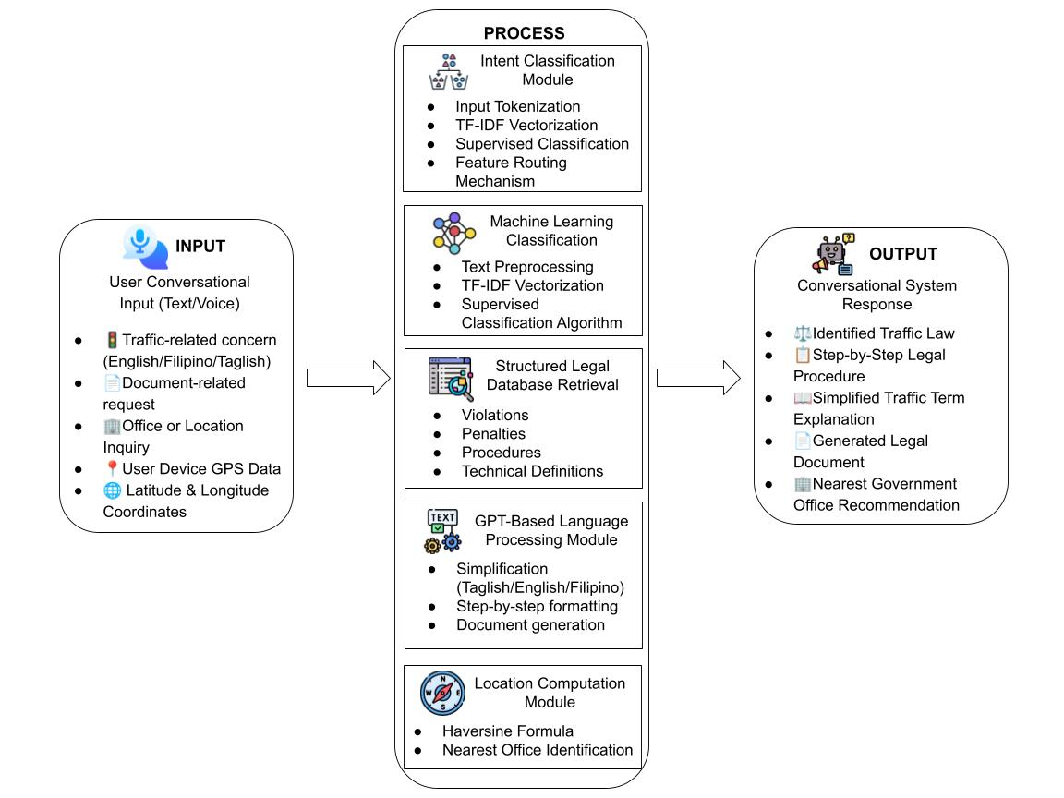
Figure 1 System Architecture

Figure 3.1 illustrates the conversational intent-based system architecture of the proposed mobile application, wherein user queries are automatically classified and routed to the appropriate functional module within a unified chat interface.
The input component of the system consists of user-provided traffic-related concerns entered through a conversational chat interface within the mobile application in the form of text or voice input. The entered concern may describe a traffic violation, accident, citation, or enforcement-related issue using English, Filipino, or Taglish language.
The user input is first subjected to a supervised machine learning-based intent classification process that determines the nature of the user’s request based on conversational input. This classification mechanism serves as the system’s routing component, automatically identifying whether the concern is related to traffic law guidance, document assistance, or office location inquiry. Based on the detected intent, the system dynamically activates the appropriate functional module without requiring the user to manually select a feature from a traditional menu interface.
Once the user’s intent has been classified, the system accesses the appropriate structured database component to retrieve the corresponding traffic law information, including penalties, procedural steps, and formal technical definitions associated with the identified category. These retrieved contents are maintained in their original legal and technical format to preserve accuracy and compliance with official traffic regulations. The retrieved legal information is then forwarded to the generative artificial intelligence component integrated within the application.
The generative artificial intelligence component is responsible for transforming the structured legal content into simplified explanations that are easier for users to understand. This module reformulates technical definitions, translates procedural instructions into English, Filipino, or Taglish, and constructs step-by-step guidance tailored to the user’s concern. Additionally, the same generative AI component supports the Document Assistance feature by generating structured legal documents such as affidavits, explanation letters, or appeal letters based on user-provided details and predefined prompting templates.
For the location-based guidance feature, the system utilizes the mobile device’s Global Positioning System (GPS) sensor to obtain the user’s real-time geographic coordinates expressed in latitude and longitude. These coordinates are compared against the stored geographic dataset containing the location data of relevant government service offices such as Land Transportation Office branches, traffic enforcement units, and barangay halls. The system applies the Haversine formula to calculate the distance between the user’s location and each available office within the database. The office with the shortest computed distance is then identified as the nearest service location and presented to the user along with its corresponding address and office type.
All system components operate within an integrated conversational architecture that enables the seamless flow of information from chat-based user input to intent classification, database retrieval, generative explanation, document generation, and location-based guidance output without manual feature selection. This architecture ensures that the system provides legally accurate, context-aware, and easily understandable assistance to users in addressing traffic-related concerns through a mobile application platform.
System Requirements

This section presents the complete software and hardware requirements necessary for the development, deployment, and operation of the proposed AI-Powered Traffic Law Navigator and Rights Assistant mobile application. The system integrates a structured legal database, supervised machine learning classification, generative artificial intelligence processing, and GPS-based location services. Due to the combination of database management, mobile application development, artificial intelligence integration, and real-time location detection, the development environment must support programming, model training, database operations, API communication, and mobile device testing.

Software Requirements

Table 1 Software Requirements of the Proposed System
Software | Description
Windows 11 (64-bit) | Operating system used for development
Flutter SDK | Framework used for mobile application development
Dart | Programming language used for application logic and interface
Android Studio | Integrated Development Environment (IDE) and emulator
Visual Studio Code | Source code editor for development
MySQL | Relational database management system
MySQL Workbench | Tool for database design and administration
GPT API | Used for document generation and language simplification
GPS / Location Services | Used for real-time location detection
Internet Connection | Required for API communication and data retrieval

The software requirements listed in Table 3.1 are essential for the development and implementation of the proposed mobile application. The system will operate on a Windows 11 64-bit operating system to ensure compatibility with modern development tools. The Flutter Software Development Kit (SDK) will be used to develop the mobile application, with Dart as the primary programming language for both user interface design and application logic. Android Studio will serve as the Integrated Development Environment for coding, debugging, and emulator testing, while Visual Studio Code will be used as an alternative lightweight code editor.
For database management, MySQL will be utilized to store structured traffic law data including violations, penalties, procedural steps, and technical definitions. MySQL Workbench will support database design and administration. The system will also integrate a GPT-based API to enable document generation and simplify technical legal explanations into understandable language formats such as English, Filipino, or Taglish. Additionally, the application will use the device’s GPS functionality to support location-based services. A stable internet connection is required to ensure proper communication with external APIs and to retrieve updated system data.
Hardware Requirements

Table 2 Hardware Requirements of the Proposed System
Hardware | Specification
Processor | AMD Ryzen 5 or equivalent
RAM | 16 GB
Storage | 256 GB SSD
Mobile Device RAM | At least 4 GB
Mobile OS | Android 8.0 (Oreo) or higher
GPS Capability | Required
Internet Connectivity | Stable connection required
The hardware requirements presented in Table 3.2 ensure that the system can be developed, tested, and deployed efficiently. A computer with at least an AMD Ryzen 5 processor or equivalent is required to support application development and processing tasks. A minimum of 16 GB RAM is recommended to enable smooth multitasking, particularly when running development tools, emulators, and database systems simultaneously. A Solid-State Drive (SSD) with at least 256 GB storage capacity is necessary to accommodate development software, project files, and system resources.
For testing and deployment, an Android mobile device with at least 4 GB RAM and Android 8.0 or higher operating system is required. The device must have built-in GPS capability to support location-based features of the application. Additionally, stable internet connectivity is essential for accessing external APIs, retrieving data, and ensuring proper system functionality.

Methods and Tools

This section presents the different methods and development tools utilized by the proponents in designing and implementing the proposed mobile-based Traffic Guidance System. The selected methods aim to support the core functionalities of the system including law identification, document assistance, and location-based guidance. These approaches were carefully chosen to ensure that the system remains lightweight, feasible for mobile deployment, and capable of providing accurate and user-friendly outputs. The development tools were also selected based on their compatibility with the Prototype Model Software Development Life Cycle (SDLC) and their ability to support machine learning-based classification and AI-assisted language generation within a mobile application environment.

Methods

For the Traffic Guidance and Law Identification feature, the proponents employed a supervised machine learning-based intent classification method to determine the specific traffic-related concern described by the user. The system uses a manually curated and labeled dataset composed of various English, Filipino, and Taglish phrases mapped to corresponding traffic violation categories. During processing, user input undergoes text preprocessing techniques such as tokenization, normalization, and keyword extraction. The processed input is then compared against stored labeled examples using similarity matching logic to determine the most appropriate violation category. Once classified, the system retrieves the corresponding procedural steps, penalties, and legal basis from the structured database. As additional labeled examples are incorporated into the dataset during development and testing, the system improves its ability to correctly classify diverse user expressions, thereby enhancing its adaptability and accuracy. This classification process serves as the primary routing mechanism that determines which system functionality should be activated based on the user's conversational input.

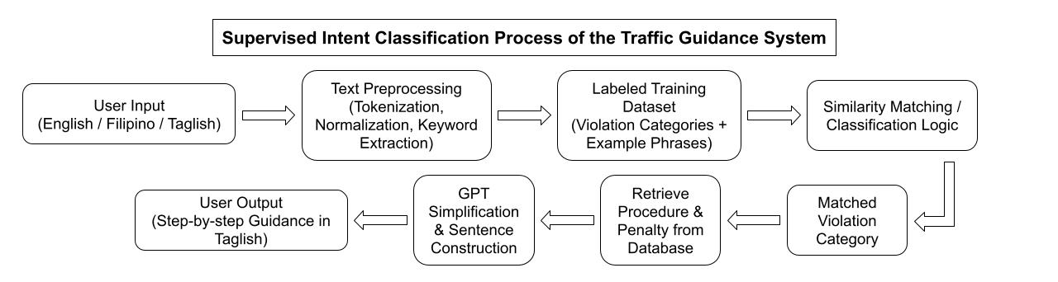
Figure 2 Traffic Guidance

Figure 3.2 illustrates the supervised intent classification process used in identifying the appropriate traffic violation category based on user input before retrieving the corresponding legal procedures and generating simplified explanations.

For the Document Assistance feature, the proponents utilized an AI-based Natural Language Generation method through GPT integration. This feature allows the system to automatically construct structured legal documents such as affidavits, incident reports, and settlement request letters based on user-provided information. Unlike the classification component, this feature relies on generative artificial intelligence to dynamically produce coherent and contextually appropriate content. The same AI integration is also used to simplify technical traffic laws and procedural explanations retrieved from the database into understandable English, Filipino, or Taglish language. This ensures accessibility for users who may not be familiar with complex legal terminology.

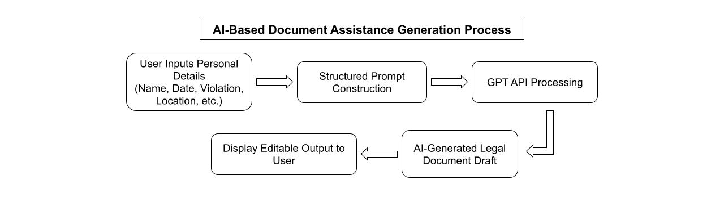
Figure 3 Document Assistance

Figure 3.3 presents the process flow of the AI-based document assistance feature where user-provided information is transformed into structured legal document templates through GPT integration.

For the Location Guidance feature, the proponents implemented a geolocation-based proximity analysis method. The system obtains the user's real-time geographic coordinates through the mobile device’s GPS functionality with user consent. These coordinates are then compared with stored latitude and longitude data of relevant offices such as Land Transportation Office branches, traffic enforcement units, and barangay halls. The Haversine Formula is applied to compute the distance between the user’s location and each stored office coordinate. The system then identifies and presents the nearest available office to the user. This method ensures that users are guided to the most accessible facility for resolving traffic-related concerns.

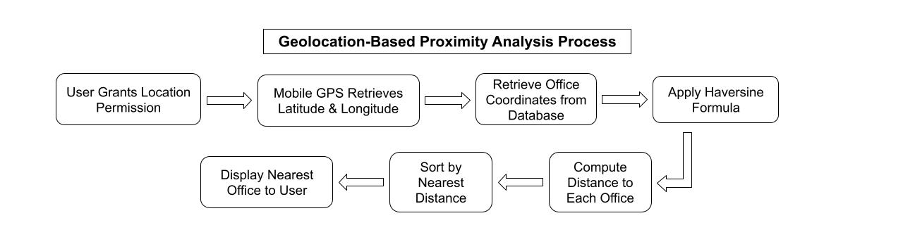
Figure 4 Location Guidance
Haversine Formula:
d = 2r arcsin( √( sin²((φ₂ − φ₁)/2) + cos φ₁ cos φ₂ sin²((λ₂ − λ₁)/2) ) )
Where:
φ = latitude
λ = longitude
r = Earth’s radius
d = distance between two points
Figure 3.4 shows the geolocation-based proximity analysis method where the system computes the nearest relevant office using the Haversine distance formula based on the user’s current geographic coordinates.
Tools
The development of the proposed system utilized various software tools and programming technologies to support mobile application development, database management, artificial intelligence integration, and geolocation processing. The mobile application was developed using the Flutter Software Development Kit, with Dart as the primary programming language for frontend interface design and application logic. Visual Studio Code was used as the main source code editor due to its flexibility and compatibility with Flutter development. Android Studio was installed to provide Android SDK support and emulator testing capabilities.
MySQL was used as the relational database management system to store structured traffic laws, labeled training examples, procedural steps, penalties, and geographic coordinate data for relevant offices. Structured Query Language was utilized for database querying and data retrieval operations within the application.
For artificial intelligence integration, the system utilized a GPT-based Application Programming Interface to support document generation and legal term simplification. This API enables the system to dynamically generate contextual responses and simplified explanations. Additionally, Flutter’s built-in geolocation services were used to access device GPS functionality for implementing the location guidance feature.
Flowchart of the Proposed System

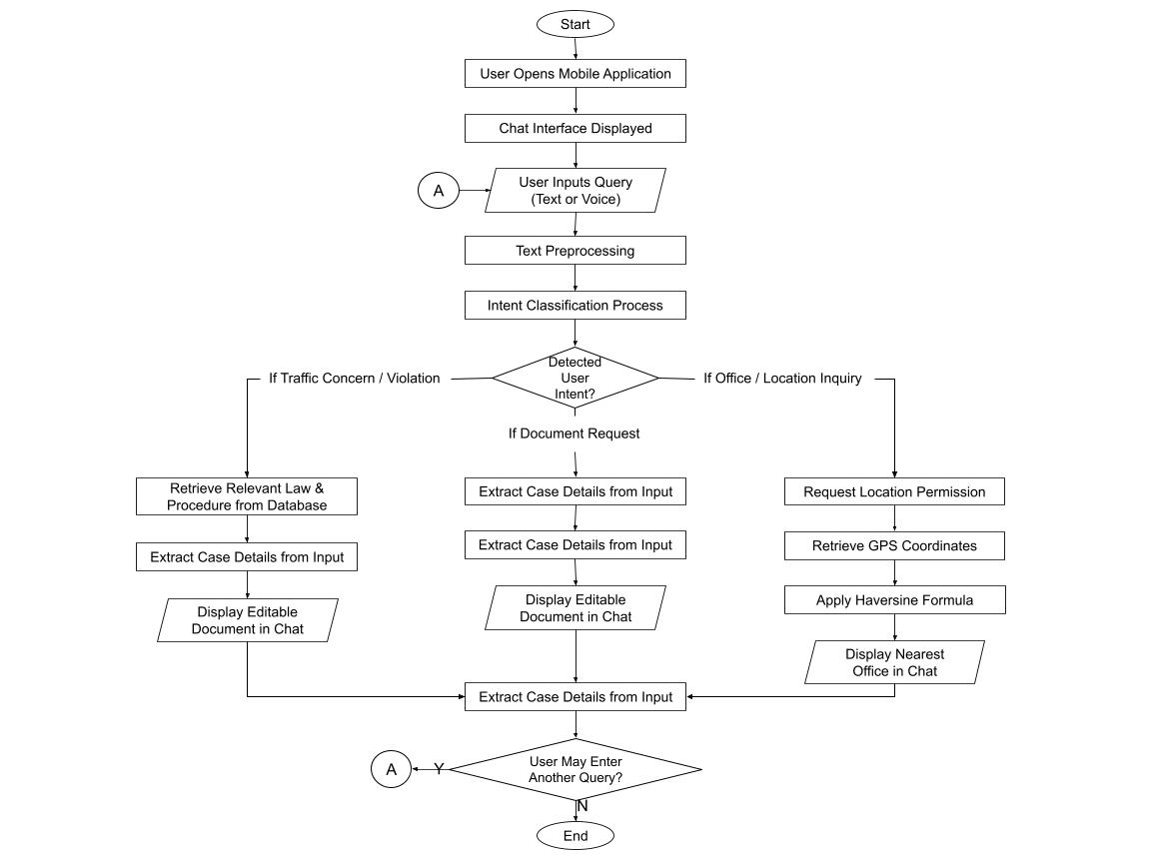

Figure 5 Flow of the Proposed Mobile Application

Figure 3.5 illustrates the conversational intent-based system flow of the proposed mobile application, where user inputs are analyzed and automatically routed to the appropriate system feature without requiring manual selection from a traditional menu interface.

Data Flow Diagram of the Proposed System

Level 0 DFD
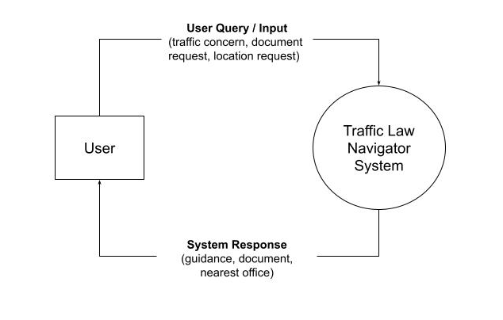
Figure 6 Data Flow Diagram (Level 0) of the Proposed System

Figure 3.6 presents the Data Flow Diagram of the proposed system, illustrating the interaction between the user and the system. The user provides input in the form of traffic-related concerns, document requests, or location inquiries, which are processed by the system. The system then generates appropriate responses such as legal guidance, document outputs, or nearest office recommendations.

Entity-Relationship Diagram of the Proposed System

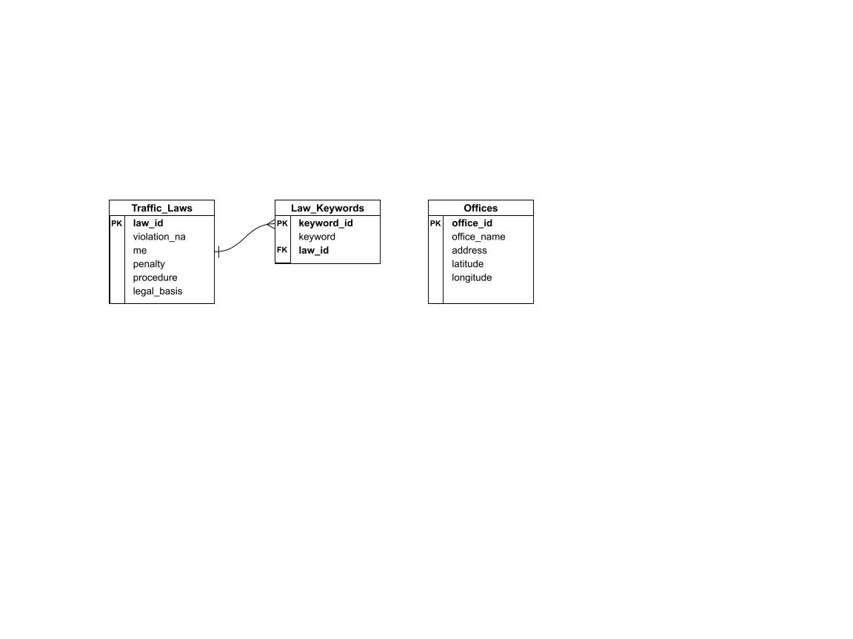

Figure 7 Entity-Relationship Diagram of the Proposed System
Figure 3.7 illustrates the Entity-Relationship Diagram of the proposed system, showing the structure of the database and relationships between entities. The Traffic_Laws entity stores information about violations, penalties, and procedures, while the Law_Keywords entity contains associated keywords used for classification. The Offices entity stores geographic data for location-based guidance. These entities collectively support the system’s functionality in identifying traffic laws, retrieving procedures, and providing location-based services.
Use Case Diagram of the Proposed System
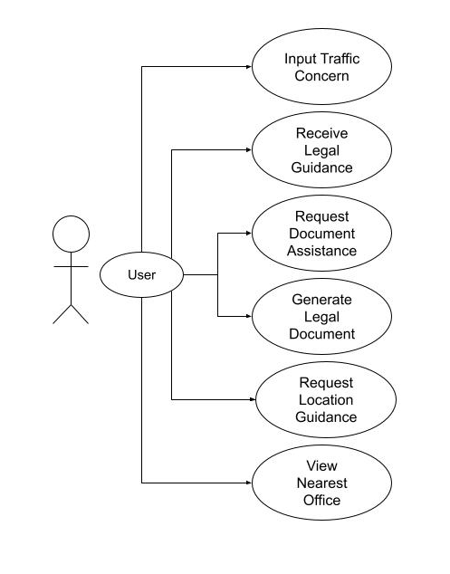
Figure 8 Use Case Diagram
Figure 3.8 presents the Use Case Diagram of the proposed system, illustrating the interaction between the user and the mobile application. The user acts as the primary actor and can perform various actions such as inputting traffic-related concerns, requesting legal guidance, generating traffic-related documents, and accessing location-based services to find the nearest government offices. The system processes these interactions and provides appropriate outputs such as step-by-step procedures, simplified legal explanations, generated documents, and location recommendations. The use case diagram highlights the core functionalities of the system and demonstrates how the user can access multiple features through a unified conversational interface.

RESULTS AND DISCUSSIONS
This section presents the results of the developed system, which aims to enhance public legal accessibility and streamline traffic-related administrative processes. The findings are presented through the application's major features, including machine learning-based text classification for identifying relevant traffic laws and penalties, automated document assistance for generating standardized legal paperwork, and a location-based function for mapping localized regulatory authorities. These results demonstrate the overall functionality, technical integration, and practical utility of the platform’s natural language processing, document automation, and geographic mapping components.

- System utilizing a machine learning text classification model to identify relevant traffic laws, rules, and penalties based on the user’s described incident, violation, or traffic-related concern.
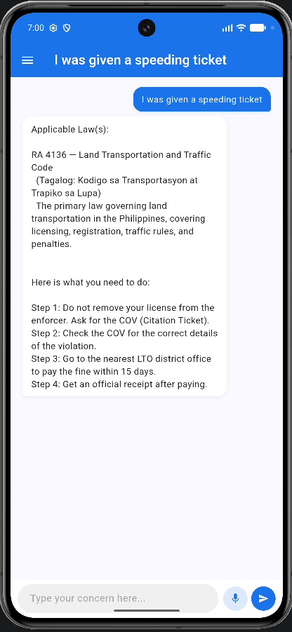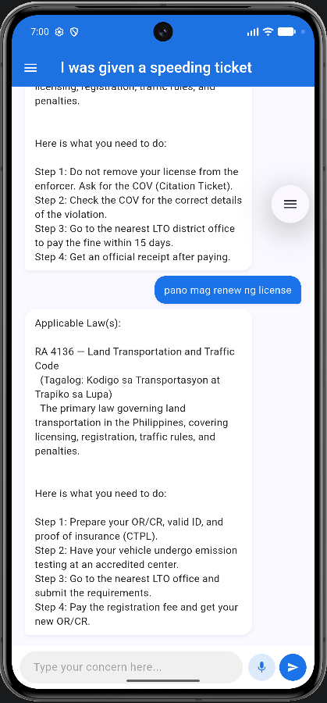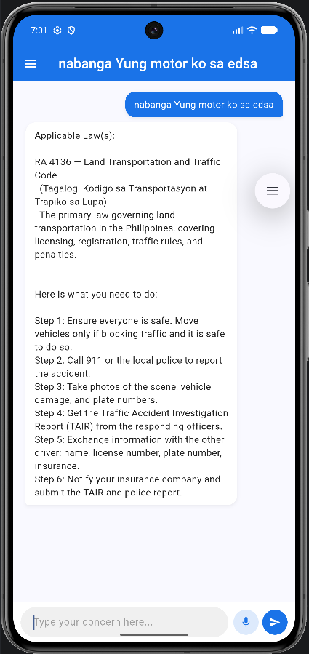
Figure 9 Traffic Law Identification Interface
Figure 9 illustrates the user interface of the Traffic Law Identification system, showcasing the deployment of the supervised machine learning text classification model. The screen displays the input module where a user can either type a free-text narrative or input an audio recording via the integrated voice-and-chat interface describing a specific roadside incident. Below the user input field, the application renders the real-time classification output, which systematically displays the parsed legal categories, corresponding sections of active Philippine traffic laws, and a structured breakdown of the exact financial or administrative penalties involved. This layout highlights how the application translates informal, multilingual user descriptions into structured, legally accurate information screens.
Discussion:
The text classification system successfully demonstrated its capability to interpret natural language user inputs and map them directly to specific provisions of Philippine traffic law. By utilizing a supervised machine learning approach trained on multilingual scenarios, the model effectively bridged the gap between informal motorist descriptions and complex statutory language. When a user input an incident via voice or text, the classification model accurately parsed the narrative to isolate the core offense and display the exact rules, corresponding fines, and administrative actions mandated by the Land Transportation Office (LTO) or Metropolitan Manila Development Authority (MMDA). This outcome proves that integrating natural language processing frameworks into civic technology can substantially mitigate public legal illiteracy, providing ordinary citizens with immediate, understandable clarity regarding their legal standing during roadside disputes.
- Document assistance feature that guides users in completing or generating traffic-related documents, such as explanation letters, affidavits, or contest forms, formatted according to required standards.
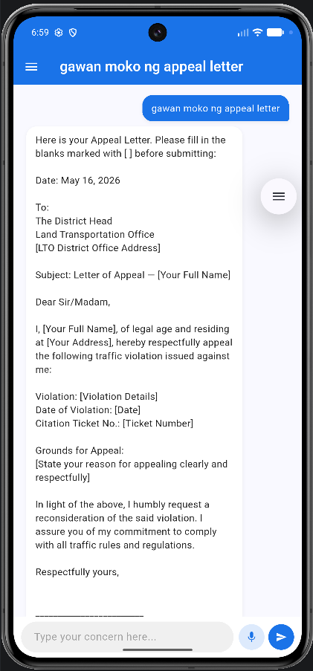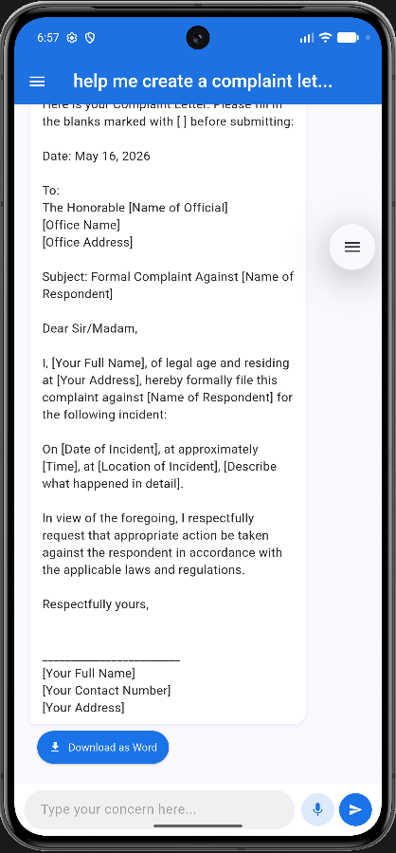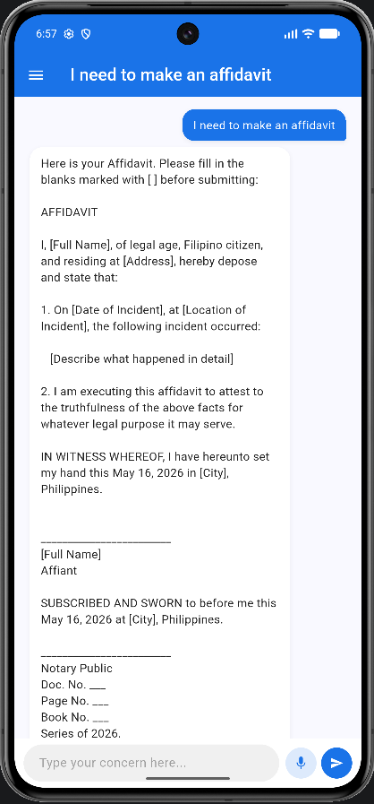
Figure 10 Automated Document Assistance Feature
Figure 10 displays the application’s user interface for the automated Document Assistance module, which utilizes generative AI to guide users through legal drafting. The screenshot highlights the step-by-step input form where users answer contextual, simplified questions regarding their dispute or citation. Adjacent to the input wizard, the system generates a live document preview area, demonstrating how the platform automatically translates user responses into properly formatted, standardized legal text. The final rendering showcases a complete, ready-to-print artifact—such as a formal explanation letter, affidavit, or violation contest form—formatted according to the strict administrative guidelines required by local traffic offices and national agencies.
Discussion:
The implementation of the document assistance feature provided users with a practical, step-by-step mechanism to navigate administrative remedies without requiring immediate legal counsel. By leveraging generative AI constrained by standardized templates, the application successfully guided users through the process of writing complex legal documents, such as explanation letters, affidavits, and violation contest forms. The generated outputs adhered strictly to required administrative formatting, automatically populating critical data points extracted from the user’s narrative. This automated workflow drastically reduces the technical intimidation and high costs typically associated with legal drafting, thereby empowering motorists to exercise their procedural rights and formally contest erroneous citations or document roadside incidents with confidence.

- Location-based function that provides users with localized traffic guidance and identifies the appropriate offices or authorities to approach, such as LTO branches, traffic enforcement units, or barangay offices, based on their area.
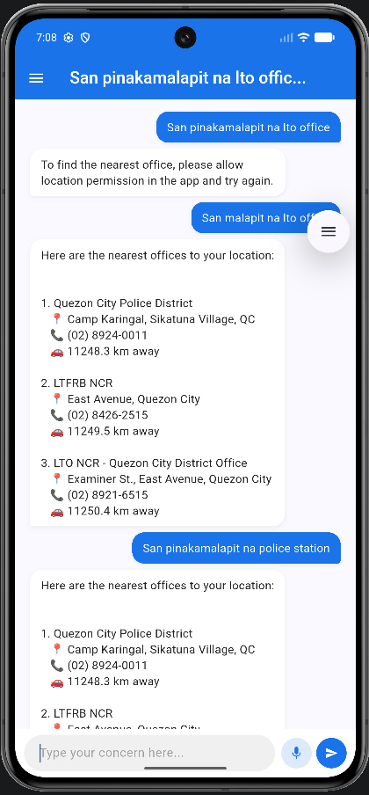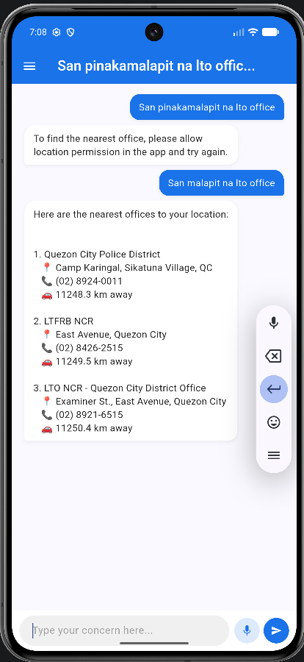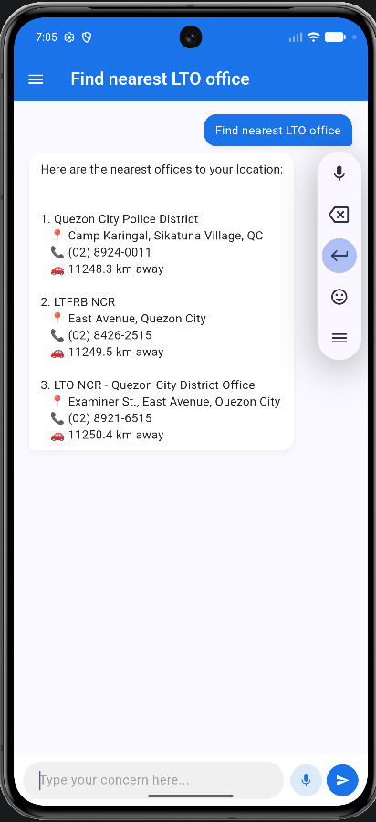
Figure 11 Location-Based Guidance Module
Figure 11 presents the interface of the Location-Based Guidance module, demonstrating its spatial tracking and mapping capabilities within the pilot dataset areas of the National Capital Region (NCR) and Luzon. The display features an interactive map view centered on the user's real-time GPS coordinates, populated with distinct markers representing nearby public agencies and administrative hubs. Below the map visualization, a clean list view categorizes and details the identified locations, providing specific details such as the names and distance metrics for the nearest Land Transportation Office (LTO) branches, Metropolitan Manila Development Authority (MMDA) traffic enforcement units, and local barangay halls relevant to the user's current jurisdiction.
Discussion:
The location-based guidance function successfully contextualized the application's legal guidance by aligning instructions with the user's immediate geographic location. Initially pilot-tested within the National Capital Region (NCR) and selected Luzon provinces, the module dynamically cross-referenced GPS coordinates with a structured database of public agency offices. Consequently, the system did not just inform users of the law, but actively mapped out the exact physical pathways for resolution by identifying the nearest LTO branches, traffic enforcement units, or local barangay halls appropriate for their case. This features transforms theoretical legal knowledge into localized, actionable steps, drastically reducing the time and confusion motorists face when determining which specific municipal or national authority holds jurisdiction over their traffic concerns.

CONCLUSION AND RECOMMENDATION
This chapter presents the summary of findings, overarching conclusions, and actionable recommendations derived from the development and evaluation of the system. Based on the empirical results collected throughout the study, this section highlights how the integration of machine learning, document automation, and location-based services addresses critical gaps in civic legal accessibility. Furthermore, it outlines future directions to enhance the system's technical scalability, regulatory scope, and user adoption.
Conclusion
This section outlines the definitive conclusions of the study, directly addressing the three core objectives established at the outset of this research. Based on the functional performance and evaluation of the developed application, the following conclusions are drawn:
- The integration of a machine learning text classification model successfully proves that natural language inputs can be reliably mapped to specific traffic laws, rules, and penalties. By accurately interpreting user-described incidents, the system provides a dependable mechanism for bridging the gap between complex legal jargon and layperson comprehension, effectively enhancing civic legal literacy.
- The implementation of the automated document assistance feature demonstrates that rule-based templates can successfully guide non-expert users through the complex task of legal drafting. By generating properly formatted explanation letters, affidavits, and contest forms that adhere to institutional standards, the system effectively lowers the procedural barriers citizens face when pursuing administrative remedies.
- The establishment of the geolocation function establishes that coupling spatial data with legal infrastructure significantly improves localized legal navigation. Successfully identifying and mapping nearby Land Transportation Office (LTO) branches, traffic enforcement units, and barangay offices provides users with a clear, localized pathway to resolve their specific traffic-related grievances.
Recommendation
This section outlines actionable recommendations for future researchers, developers, and administrative agencies to expand upon the findings and technical framework of this study. Technically, because the current prototype is strictly limited to a mobile application, future developers should build a synchronized web-based platform to maximize civic accessibility while transitioning from manual data labeling to automated web-scraping pipelines that dynamically fetch updates from official government gazettes. Furthermore, integrating a Retrieval-Augmented Generation (RAG) framework would allow the system’s natural language processor to query the structured traffic law database in real time, drastically reducing model hallucinations while keeping responses firmly anchored in legal facts. Geographically and linguistically, the location-based guidance module should be scaled beyond the initial pilot areas of the National Capital Region and Luzon to include the Visayas and Mindanao regions, alongside an expanded database that incorporates complex regional ordinances from individual Local Government Units (LGUs) and multilingual training for deep localized dialects like Cebuano, Ilocano, and Hiligaynon. Finally, from an institutional perspective, future versions should establish secure API integrations with the Land Transportation Office (LTO) and Metropolitan Manila Development Authority (MMDA) for real-time data tracking, paired with a formal "human-in-the-loop" review portal where accredited legal professionals or traffic personnel can periodically validate generated document templates, ensuring public trust and long-term regulatory compliance.

REFERENCES
- Bhavana B. M., Sathyanarayana, S., Bhavana, M. K., Nisarga, G. N., & Harshitha, S. (2025). Traffic Eye: AI-powered traffic rules violation detection and management. International Journal for Research in Applied Science and Engineering Technology. https://doi.org/10.22214/ijraset.2025.76565
- Cui, J., Ning, M., Li, Z., Chen, B., Yan, Y., Li, H., … & Yuan, L. (2023). Chatlaw: A multi-agent collaborative legal assistant (arXiv:2306.16092). arXiv. https://arxiv.org/abs/2306.16092
- Dede, D., Sarsıl, M. A., Shaker, A., Altıntaş, O., & Ergen, O. (2023). Next-gen traffic surveillance: AI-assisted mobile traffic violation detection system. arXiv. https://arxiv.org/abs/2311.16179
- Deffains, P. (2025). Stakeholder expectations for AI integration in legal services. GREDEG Working Paper Series. https://laweconcenter.org/wp-content/uploads/2025/01/GREDEG-WP-2025-01.pdf
- Gillian, L., et al. (2024). Intelligent vehicle violation detection systems. Springer Transportation Research Archives. https://link.springer.com/article/10.1007/s44196-024-00427-6
- Hajare, M., et al. (2025). AI and IoT based traffic signal and rule enforcement system. IJRASET Journal. https://www.ijraset.com/research-paper/ai-and-iot-based-traffic-signal-and-rule-enforcement-system
- Hegde, N. V., Agarwal, A., & Moharir, M. (2025). A novel AI-driven system for real-time detection of mirror absence, helmet non-compliance, and license plates using YOLOv8 and OCR. arXiv. https://arxiv.org/abs/2511.12206
- IJARCCE. (2026). UrbanEye experimental results in automated urban violation detection. International Journal of Advanced Research in Computer and Communication Engineering, 15(01). https://doi.org/10.17148/IJARCCE.2026.15133
- Khan, S. (2025). Safety effectiveness of automated traffic enforcement systems. MDPI Sustainability. https://www.mdpi.com/2673-7590/5/1/25
- Land Transportation Office. (2019). LTO Memorandum Circular No. 2019-2196: Revised rules and regulations on the implementation of the citation ticket system. Land Transportation Office, Department of Transportation.
- Marcos, F. E. (1973). Presidential Decree No. 96: Amending certain sections of Republic Act No. 4136, otherwise known as the Land Transportation and Traffic Code. Office of the President of the Philippines. https://lawphil.net/statutes/presdecs/pd1973/pd_96_1973.html
- OECD. (2024). AI in justice administration and access to justice. OECD Publishing. https://www.oecd.org/en/publications/governing-with-artificial-intelligence_795de142-en/full-report/ai-in-justice-administration-and-access-to-justice_f0cbe651.html
- Raj, A., Choudhary, S., & Sharma, A. K. (2025). Real-time speed violation detection: AI-powered image processing for traffic law enforcement. International Journal of Science and Innovation in Engineering, 2(5), 860–866. https://doi.org/10.70849/IJSCI
- Ranera, L. T. B. (2024). A comparative analysis and evaluation of NLP document embedding techniques on Philippine Supreme Court case decisions. Philippine Engineering Journal. https://www.journals.upd.edu.ph/index.php/pej/article/view/9723
- Republic of the Philippines. (1964). Republic Act No. 4136: Land Transportation and Traffic Code. Congress of the Philippines. https://lawphil.net/statutes/repacts/ra1964/ra_4136_1964.html
- Republic of the Philippines. (1995). Republic Act No. 7924: An Act Creating the Metropolitan Manila Development Authority. Congress of the Philippines. https://lawphil.net/statutes/repacts/ra1995/ra_7924_1995.html
- Republic of the Philippines. (1999). Republic Act No. 8750: Seat Belts Use Act of 1999. Congress of the Philippines. https://lawphil.net/statutes/repacts/ra1999/ra_8750_1999.html
- Republic of the Philippines. (2009). Republic Act No. 10054: Motorcycle Helmet Act of 2009. Congress of the Philippines. https://lawphil.net/statutes/repacts/ra2009/ra_10054_2009.html
- Republic of the Philippines. (2013). Republic Act No. 10586: Anti-Drunk and Drugged Driving Act of 2013. Congress of the Philippines. https://lawphil.net/statutes/repacts/ra2013/ra_10586_2013.html
- Republic of the Philippines. (2016). Republic Act No. 10916: Road Speed Limiter Act of 2016. Congress of the Philippines. https://lawphil.net/statutes/repacts/ra2016/ra_10916_2016.html
- Republic of the Philippines. (2019). Republic Act No. 11235: Motorcycle Crime Prevention Act. Congress of the Philippines. https://lawphil.net/statutes/repacts/ra2019/ra_11235_2019.html
- Semantic legal retrieval experiments. (2024). Data and Knowledge Engineering. https://www.sciencedirect.com/science/article/pii/S2667096824000363
- Smart city deployment studies in Kerala traffic enforcement. (2023). Safe Kerala traffic camera initiative reduces violations. https://en.wikipedia.org/wiki/Kerala_Motor_Vehicles_Department
- Stanford Justice Innovation Lab. (2023). User research report into AI for legal Q&A and access to justice. Stanford University. https://justiceinnovation.law.stanford.edu/projects/ai-access-to-justice/class-report/
- Voice-enabled legal assistant usability study. (2022). International Journal of Human–Computer Interaction. https://doi.org/10.1080/10447318.2022.XXXXX
- Wicaksono, S. B., Hamdani, M., Yasar, A., & Li, L. (2025). Survey and empirical evaluation of AI models for traffic violation prediction. Transportation Research Procedia. https://doi.org/10.1016/j.trpro.2025.10.029
- Yuan, L., et al. (2024). LegalAsst: Human-centered AI for legal productivity and assistance. Information Sciences, 679, 121052. https://doi.org/10.1016/j.ins.2024.121052

