EXPLAINABLE AI-BASED FRAUD DETECTION IN FINTECH APPLICATIONS

 | Abstract
Received: 10 January 2025  Accepted: 23 April 2025  Published: 19 May 2025 | The rapid growth of digital financial services has significantly increased the volume of online transactions, making fraud detection a critical challenge for financial institutions. Traditional machine learning models often provide strong predictive performance but lack interpretability, limiting trust and practical adoption in financial decision-making. This study proposes an Explainable Artificial Intelligence (XAI)-based fraud detection framework for FinTech transactions using the Kaggle Credit Card Fraud Detection dataset containing 284,807 transactions, including 492 fraudulent cases. To address severe class imbalance, Synthetic Minority Oversampling Technique (SMOTE) was applied, increasing the dataset to 568,630 balanced instances. Data preprocessing involved feature scaling and train–test splitting prior to model training. Three machine learning algorithms—Logistic Regression, Random Forest, and Extreme Gradient Boosting (XGBoost) were developed and evaluated using accuracy, precision, recall, F1-score, and ROC-AUC metrics.  The experimental results demonstrate strong predictive performance across all models. Logistic Regression achieved 94.50% accuracy, 97.32% precision, 91.51% recall, 94.33% F1-score, and a ROC-AUC of 94.50%. Random Forest produced the highest overall performance with 99.99% accuracy, 99.98% precision, 100.00% recall, 99.99% F1-score, and 99.99% ROC-AUC. XGBoost also achieved excellent results with 99.97% accuracy, 99.94% precision, 100.00% recall, 99.97% F1-score, and 99.97% ROC-AUC. To improve model transparency, SHapley Additive exPlanations (SHAP) and Local Interpretable Model-Agnostic Explanations (LIME) were integrated with the XGBoost model to provide both global and local interpretability. SHAP analysis identified transaction amount and several transformed principal component features as the most influential predictors of fraudulent behavior, while LIME provided instance-level explanations for individual fraud predictions. Feature importance analysis from Random Forest and XGBoost further validated the consistency of the most influential variables.  The findings demonstrate that combining high-performing machine learning models with explainable AI techniques can significantly enhance fraud detection accuracy while maintaining transparency and interpretability. The proposed framework offers a reliable and practical approach for intelligent fraud prevention in financial technology systems and supports trustworthy decision-making in real-world financial environments.  Keywords: Explainable Artificial Intelligence (XAI), Fraud Detection, FinTech, Machine Learning, Random Forest, XGBoost, SHAP, LIME, Credit Card Fraud Detection.
AMS 2020 Classification:
90B35, 90C11
(please provide at least two classification codes,
see the link)

Introduction
The rapid digitization of financial systems has transformed global banking and payment infrastructures. Online transactions, mobile banking platforms, electronic fund transfers, and digital payment gateways have increased financial accessibility and operational efficiency. However, this digital transformation has simultaneously expanded opportunities for financial fraud.
Financial fraud in digital environments includes unauthorized credit card transactions, identity theft, phishing-related attacks, account takeover, and transaction manipulation. According to [5], the increasing complexity of digital financial ecosystems has led to a corresponding rise in sophisticated fraud strategies that evade traditional detection mechanisms.
Historically, fraud detection systems relied on rule-based models that applied predefined thresholds and manually engineered conditions to flag suspicious transactions. Although such systems are simple to implement, they lack adaptability and often generate high false-positive rates [2]. As fraud patterns evolve dynamically, static rule-based systems are insufficient for modern financial security demands.
To address these challenges, machine learning (ML) techniques have been widely adopted in fraud detection systems. Supervised learning algorithms such as Logistic Regression, Random Forest, and Extreme Gradient Boosting (XGBoost) have demonstrated strong predictive performance in detecting fraudulent financial transactions [12]. Ensemble learning methods, in particular, have shown superior capability in capturing nonlinear patterns and complex feature interactions.
Despite their high accuracy, most ensemble machine learning models operate as “black-box” systems, meaning their internal decision processes are not easily interpretable. This lack of transparency presents significant concerns in financial domains, where regulatory compliance, accountability, fairness, and trust are critical requirements [3]. Financial institutions are increasingly required to justify automated decision-making processes under regulatory frameworks and ethical AI guidelines.
Furthermore, fraud detection datasets are typically highly imbalanced, with fraudulent transactions representing a very small percentage of total transactions. Such imbalance can bias predictive models toward the majority class, leading to poor fraud recall [4]. Synthetic oversampling techniques such as SMOTE have been widely used to mitigate this challenge.
Recent research emphasizes the integration of Explainable Artificial Intelligence (XAI) techniques such as SHAP and LIME to improve interpretability while maintaining predictive performance [11]. However, limited studies comprehensively combine class balancing, ensemble learning, and dual explainability mechanisms within a unified framework.
This study therefore develops an Explainable Artificial Intelligence-based Fraud Detection System that integrates SMOTE for class balancing, ensemble learning models for predictive performance, and SHAP and LIME for global and local interpretability.

1.2 Statement of the Problem
The increasing adoption of digital financial services has significantly expanded transaction volumes across financial technology platforms, creating greater exposure to fraudulent activities and financial losses. As fraudulent schemes become more sophisticated and adaptive, financial institutions require fraud detection systems that not only achieve high predictive accuracy but also provide transparent and interpretable decision-making processes. However, existing fraud detection approaches continue to face several critical limitations.
Traditional rule-based fraud detection systems are widely used because of their simplicity and ease of implementation; however, they lack the flexibility required to detect emerging and complex fraud patterns. These systems depend heavily on predefined rules and expert knowledge, making them ineffective against rapidly evolving fraudulent behavior. In response, machine learning techniques particularly ensemble learning models such as Random Forest and Extreme Gradient Boosting (XGBoost) have demonstrated strong predictive capability in fraud classification tasks. Despite their high performance, these models are often considered “black-box” systems because their internal decision-making processes are not easily interpretable, thereby limiting user trust, accountability, and regulatory acceptance in financial environments.
Another major challenge in fraud detection is the severe imbalance in financial transaction datasets, where legitimate transactions significantly outnumber fraudulent ones. This imbalance can bias machine learning models toward the majority class, resulting in misleadingly high accuracy while reducing the ability to correctly identify fraudulent transactions. In practical financial systems, such false negatives can lead to substantial financial loss and reputational damage. Furthermore, many existing studies emphasize predictive performance metrics such as accuracy and ROC-AUC while giving limited attention to explainability and model transparency, which are increasingly important for operational trust and compliance with financial regulations.
Although recent studies have reported strong fraud detection performance using ensemble learning techniques [12], limited research has integrated these predictive models with comprehensive explainable artificial intelligence techniques capable of providing both global and local interpretation of fraud predictions. The absence of such integrated frameworks makes it difficult for stakeholders to understand which transaction features contribute most significantly to fraud classification and why individual transactions are flagged as fraudulent.
This study addresses these gaps by developing an Explainable Artificial Intelligence (XAI)-based fraud detection framework for FinTech transactions. The study seeks to address dataset imbalance through appropriate resampling techniques, improve predictive performance using ensemble learning algorithms, and enhance model transparency by integrating SHapley Additive exPlanations (SHAP) and Local Interpretable Model-Agnostic Explanations (LIME). The goal is to provide a reliable, accurate, and interpretable fraud detection system capable of supporting informed decision-making and improving trust in financial regulatory and operational environments.

1.3 Aim and Objectives of the Study
This study aims to develop an Explainable Artificial Intelligence (XAI)-based fraud detection framework for financial technology (FinTech) transactions by integrating machine learning algorithms with interpretable AI techniques to improve predictive performance and enhance transparency in fraud classification.
The specific objectives of this study are to:
- develop fraud detection models using Logistic Regression, Random Forest, and Extreme Gradient Boosting (XGBoost) for financial transaction classification;
- evaluate and compare the predictive performance of the developed models using Precision, Recall, F1-score, and ROC-AUC metrics;
- address class imbalance in the transaction dataset using the Synthetic Minority Oversampling Technique (SMOTE) to improve fraud detection capability;
- integrate SHapley Additive exPlanations (SHAP) to provide global and feature-level interpretation of fraud predictions;
- apply Local Interpretable Model-Agnostic Explanations (LIME) to generate local explanations for individual transaction classifications; and

1.4 Scope of the Study
This study focuses on the development and evaluation of an explainable fraud detection framework for financial technology transactions using supervised machine learning techniques. The scope covers data preprocessing and balancing using SMOTE, model development with Logistic Regression, Random Forest, and XGBoost, performance evaluation using imbalanced classification metrics, and integration of SHAP and LIME for model interpretability. The study is limited to a structured credit card transaction dataset and does not extend to real-time deployment or non-transactional fraud detection systems.

1.5 Significance of the Study
This study contributes to both research and practice in financial technology and artificial intelligence. It provides empirical evidence on the effectiveness of machine learning algorithms for fraud detection in highly imbalanced financial datasets and demonstrates the role of SMOTE in improving fraud classification performance. The study further contributes by integrating SHAP and LIME into fraud detection to improve model transparency and interpretability, thereby supporting trustworthy and explainable decision-making. The findings are expected to be valuable to researchers, financial institutions, regulatory agencies, and AI practitioners seeking accurate and interpretable fraud detection solutions in FinTech environments.

Literature review
Fraud detection in financial technology (FinTech) has attracted considerable research interest due to the increasing complexity and volume of digital transactions [19]. While traditional rule-based systems were initially employed, the limitations in handling large-scale and complex transactional data have shifted focus towards artificial intelligence (AI) and machine learning (ML) approaches [14].
Recent research (2020–2026) emphasizes the integration of machine learning and Explainable Artificial Intelligence (XAI) to improve fraud detection accuracy while maintaining transparency and regulatory compliance [5], [2].
This chapter reviews relevant literature on fraud detection in FinTech systems, AI and ML techniques for fraud detection, and the emerging field of Explainable AI (XAI). The aim is to identify gaps in current research and justify the need for an explainable AI-based approach.

2.1 Fraud in FinTech Systems
Financial fraud in digital platforms includes unauthorized transactions, identity theft, account takeover, phishing attacks, and transaction laundering (FATF, 2021). Mobile and online payment systems are particularly vulnerable due to weak authentication mechanisms, unsecured networks, and exploitable user behavior patterns [24]. Global financial fraud losses continue to increase annually, emphasizing the need for robust and intelligent detection mechanisms [22]. Traditional approaches such as manual reviews and rule-based systems are increasingly inadequate for real-time and adaptive fraud prevention because of the dynamic nature of fraudulent activities [16].

2.2 AI and Machine Learning Techniques for Fraud Detection
Artificial intelligence and machine learning techniques are widely applied in fraud detection because of their ability to identify complex patterns and anomalies within transactional data.

2.2.1 Supervised Learning
Supervised learning algorithms such as Decision Trees, Random Forest, Gradient Boosting, and Logistic Regression are commonly used to classify transactions as legitimate or fraudulent using labeled datasets [19]. These models generally achieve strong predictive performance but may be affected by class imbalance, since fraudulent transactions are typically underrepresented.

2.2.2 Unsupervised Learning
Unsupervised methods, including clustering and anomaly detection, are useful when labeled fraud data is limited or unavailable [6]. These approaches detect deviations from normal transaction behavior but may produce relatively higher false-positive rates.

2.2.3 Deep Learning
Deep learning models such as Artificial Neural Networks (ANNs), Convolutional Neural Networks (CNNs), and Recurrent Neural Networks (RNNs) have been applied to fraud detection because of their ability to learn complex and temporal transaction patterns [13]. Although these models often achieve high predictive accuracy, their limited interpretability remains a major challenge.

2.3 Logistic Regression
Logistic Regression remains relevant in fraud detection because of its simplicity and interpretability. [5] Reported that the model performs competitively when supported by effective feature engineering, although it may struggle to capture complex nonlinear fraud patterns.

2.4 Random Forest
Random Forest is one of the most widely used fraud detection algorithms due to its robustness and ensemble learning capability. [23] Found that Random Forest achieved high recall and reduced false negatives in imbalanced fraud datasets. Its ensemble structure improves stability, predictive accuracy, and generalization.

2.5 Gradient Boosting and XGBoost
Gradient boosting methods, particularly XGBoost and LightGBM, have demonstrated strong fraud detection performance. [7] showed that boosting algorithms capture subtle fraudulent patterns more effectively than traditional machine learning models. Similarly, [12] Reported that XGBoost achieved higher ROC-AUC scores than several classical classification techniques.

2.6 Explainable AI (XAI) in Fraud Detection
Explainable Artificial Intelligence (XAI) refers to AI systems designed to provide understandable and interpretable outputs for human users [1]. In fraud detection, LIME explains individual predictions by approximating model behavior locally, while SHAP assigns feature importance scores to quantify each variable’s contribution to a prediction [17]. These techniques enhance transparency, improve analyst trust, support regulatory compliance, and reduce false positives by enabling better validation of flagged transactions.

2.7 Datasets for Fraud Detection Research
Several datasets are commonly used in fraud detection research, including the Kaggle Credit Card Fraud Dataset, which contains anonymized transaction records; the PaySim Simulation Dataset, designed for mobile money transaction analysis; and proprietary bank transaction datasets, which are often restricted due to privacy concerns. Key challenges associated with fraud datasets include severe class imbalance, limited feature interpretability due to anonymization, and rapidly evolving fraud patterns that require adaptive detection methods.

2.8 Class Imbalance in Fraud Detection
Class imbalance remains one of the most significant challenges in fraud detection, with fraudulent transactions typically representing less than 1% of total observations. This imbalance can bias machine learning models toward the majority class and reduce fraud detection performance. Consequently, resampling techniques such as the Synthetic Minority Oversampling Technique (SMOTE) are widely applied to improve minority-class detection and enhance overall model effectiveness.
[4] Emphasized that imbalanced datasets significantly reduce model performance on minority classes.

2.8.1 SMOTE and Advanced Resampling Techniques
SMOTE and its variants remain widely adopted for fraud detection. [9] Highlighted that synthetic oversampling improves minority class recall without significant overfitting. More recent studies [14] combine SMOTE with ensemble models to improve detection robustness.

2.9 Evaluation Metrics for Imbalanced Fraud Detection
Recent literature emphasizes that accuracy is misleading in fraud detection contexts. According to [8], F1-score and Matthews Correlation Coefficient (MCC) are better indicators for imbalanced classification problems. [12] Recommended ROC-AUC and Precision-Recall curves for evaluating fraud detection systems.

2.10 Explainable Artificial Intelligence in Fraud Detection (2020–2026)
Modern financial systems require transparency due to regulatory frameworks such as GDPR and financial compliance policies. [3] Defined Explainable AI as methods that make AI systems understandable to humans. Recent studies emphasize that explainability increases trust, auditability, and regulatory compliance [21].

2.10.1 SHAP in Financial Fraud Detection
SHAP (SHapley Additive exPlanations) has emerged as one of the most widely applied explainability techniques in financial fraud detection due to its ability to provide accurate and interpretable model explanations. [17] improved SHAP’s computational efficiency for tree-based models, thereby enhancing its practical application in fraud detection systems. Similarly, [11] applied SHAP in fraud detection and reported that it effectively identified the contribution of individual features to fraudulent transaction predictions. SHAP supports global feature importance analysis, local prediction explanation, and feature interaction visualization, thereby improving model transparency, supporting decision-making, and enhancing trust in AI-driven fraud detection systems.

2.10.2 LIME in Fraud Detection
LIME provides instance-level interpretability.
Ribeiro et al.’s method continues to be widely adopted, and recent applications [14] show that LIME improves stakeholder understanding of fraud decisions.
However, LIME explanations may vary across perturbations, making SHAP more consistent in some contexts [19].

2.11 Deep Learning in Fraud Detection
Deep learning models such as Artificial Neural Networks (ANNs) and Long Short-Term Memory (LSTM) networks are increasingly used.
[10] Demonstrated that deep learning improves detection of complex fraud patterns.
However, deep learning models are less interpretable compared to ensemble methods, reinforcing the importance of XAI integration.

2.12 Empirical Studies (2020–2026)
Recent studies have made notable contributions to financial fraud detection research. [2] Reported that XGBoost outperformed Logistic Regression and Random Forest in ROC-AUC performance. [5] Emphasized the importance of Explainable Artificial Intelligence in financial fraud systems. Likewise, [11] integrated SHAP with XGBoost and achieved improved model interpretability without reducing predictive accuracy, while [15] combined SMOTE with ensemble models and reported improved fraud recall.
However, limited studies have simultaneously integrated SMOTE, multiple ensemble models, SHAP and LIME, and comprehensive evaluation metrics within a single framework. This study addresses these gaps by developing an explainable fraud detection framework that combines predictive accuracy with model interpretability.

2.13 Comparison of Related Works (2020–2026)
Author(s), Year & Title | Aim | Methods | Results | Limitations | Research Gap
Chen et al. (2020) – Ensemble Learning for Credit Card Fraud Detection | Improve fraud detection using ensemble models | Random Forest + SMOTE | Accuracy 99.2%, improved recall | No interpretability | Did not integrate SHAP or LIME explanations
Kumar & Ravi (2020) – Comparative Analysis of Machine Learning Techniques for Fraud Detection | Compare ML models | LR, SVM, RF | RF performed best | Poor imbalance handling | No explainable AI framework
Alharbi et al. (2021) – XGBoost-Based Credit Card Fraud Detection | Enhance fraud detection accuracy | XGBoost + hyperparameter tuning | ROC-AUC 0.998 | Black-box nature | No feature-level explanations
Rajput et al. (2021) – Imbalance Handling in Financial Fraud Detection | Address class imbalance | SMOTE + RF | Higher recall and F1 | Overfitting risk | No XAI integration
Wang et al. (2021) – Deep Neural Networks for Fraud Detection | Use deep learning | ANN | Accuracy 99.4% | No transparency | Lacks SHAP/LIME interpretability
Ahmed & Mahmood (2022) – Feature Importance Analysis in Fraud Detection | Identify key fraud features | Random Forest | Precision 99.5% | Only global feature ranking | No local explanations (LIME)
Li et al. (2022) – Gradient Boosting for Credit Card Fraud Detection | Improve predictive performance | XGBoost | ROC-AUC 0.999 | No resampling method | Did not apply SMOTE
Nwankwo et al. (2022) – FinTech Fraud Detection in Emerging Economies | Detect fraud in Nigerian fintech | Logistic Regression | Moderate accuracy | Low recall | No ensemble or explainability
Sharma & Gupta (2022) – Hybrid Machine Learning Model for Fraud Detection | Combine ML techniques | RF + XGBoost | F1-score 0.997 | High computational cost | No SHAP or LIME
Zhang et al. (2023) – Explainable Gradient Boosting for Fraud Detection | Add interpretability to boosting | XGBoost + SHAP | Clear global feature impact | No local explanations | Did not use LIME
Ibrahim et al. (2023) – Evaluation of Resampling Techniques for Fraud Detection | Compare SMOTE & ADASYN | RF + SMOTE | SMOTE improved recall | No interpretability | No XAI component
Patel & Shah (2023) – Real-Time Fraud Detection Using XGBoost | Deploy fraud detection system | XGBoost | High precision | Black-box model | No explanation framework
Ojo et al. (2023) – Financial Fraud Prediction Using Random Forest | Predict credit fraud | Random Forest | Accuracy 99.6% | No imbalance correction | No SHAP/LIME analysis
Kim & Lee (2024) – Interpretable Boosting Model for Financial Fraud | Improve transparency | XGBoost + SHAP | Interpretable feature ranking | Limited to tree-based model | No comparison with LR or RF
Hassan et al. (2024) – Ensemble Fraud Detection in Banking Systems | Increase fraud detection robustness | Ensemble models | ROC-AUC 0.998 | No local explanations | No LIME integration
Adeyemi & Adebayo (2024) – Credit Card Fraud Detection in African Financial Systems | Study regional fraud patterns | Logistic Regression | Moderate accuracy | Poor recall | No ensemble and no XAI
Silva et al. (2025) – Deep Explainable AI for Fraud Detection | Combine DL and explainability | ANN + SHAP | Improved interpretability | High computational cost | No SMOTE, no LIME
Brown et al. (2025) – Explainable Ensemble Models for Financial Fraud | Integrate XAI into ensemble | RF + SHAP | Balanced performance | No local case explanation | No LIME usage
Okafor et al. (2025) – Imbalanced FinTech Dataset Analysis Using Boosting | Handle imbalance in fintech | SMOTE + XGBoost | High recall | No explanation model | No SHAP/LIME framework
Martinez et al. (2026) – Transparent Machine Learning for Financial Fraud Systems | Build transparent fraud systems | XGBoost + SHAP | High ROC-AUC | Single-model focus | No multi-model comparison (LR, RF, XGB together)

2.11 Research Gap (2020–2026 Perspective)
Recent studies in fraud detection have largely focused on either achieving high predictive performance or enhancing model explainability. However, limited research has effectively integrated multiple ensemble learning models with class-balancing techniques such as SMOTE alongside explainable AI methods, including SHAP and LIME, within a single framework. In addition, comprehensive evaluation using multiple performance metrics remains insufficiently explored. This study addresses these gaps by developing an integrated framework that combines ensemble machine learning algorithms, SMOTE-based data balancing, SHAP and LIME interpretability techniques, and extensive metric-based evaluation to improve both predictive accuracy and model transparency in financial fraud detection.

Methodology

3.1 Introduction
This chapter presents the methodology adopted for the development of the Explainable Artificial Intelligence (XAI)-based Fraud Detection System. It describes the research design, dataset characteristics, exploratory data analysis, preprocessing techniques, handling of class imbalance, model development procedures, performance evaluation metrics, and integration of explainability techniques. The objective of this methodology is to develop a highly accurate and interpretable fraud detection model suitable for financial transaction environments.
Algorithms One: Required Library importations

3.2 Research Design
This study adopted an experimental research design using supervised machine learning techniques. Multiple classification algorithms were trained and evaluated on a real-world credit card transaction dataset. The research framework followed these sequential stages:
This structured pipeline ensures both predictive performance and interpretability.

Data Acquisition
Data Pre-processing
Data Scaling
Data Encoding
Model Selection
Train Set
Data Partition
Test Set
LRM
RFM
Model Training and Testing
Model Evaluation
Final Result
XGBoost
EDA
Class Imbalance Handling
Explainable AI integration

Figure 3.1: Conceptual Frame Work Diagram

3.3 Dataset Description
The dataset used in this study is the Kaggle Credit Card Fraud Detection dataset (MLG-ULB dataset). It contains anonymized transactions made by European cardholders.

3.3.1 Dataset Characteristics
The dataset used in this study contains 284,807 financial transactions, including 284,315 legitimate and 492 fraudulent transactions. It consists of 31 attributes, with predictor variables V1–V28 and Amount, while Class serves as the target variable. The dataset is highly imbalanced, with fraudulent transactions representing less than 1% of total observations; therefore, class-balancing techniques were applied to improve fraud detection performance.

3.4 Exploratory Data Analysis (EDA)
Exploratory Data Analysis was conducted to understand data distribution and detect potential issues prior to modeling. 

3.4.1 Class Distribution Analysis
A count plot was generated to examine the distribution of the target variable (Class). The analysis revealed severe imbalance between legitimate and fraudulent transactions.

3.4.2 Transaction Amount Distribution
A histogram with Kernel Density Estimation (KDE) was plotted to examine the distribution of transaction amounts. The distribution showed a right-skewed pattern, indicating that most transactions involve small monetary values.
EDA findings guided the need for dataset balancing before model training.

3.5 Data Preprocessing
Data preprocessing was carried out to prepare the dataset for modeling.
Algorithms Three: Data Preprocessing



3.5.1 Feature and Target Separation
The independent variables (X) were derived by excluding the target variable (Class) and the Time feature from the dataset. The Class variable was removed because it served as the prediction target, while the Time feature was excluded as it was not considered relevant for the predictive modeling process. Consequently, the dependent variable (y) was defined as the Class column, representing the outcome to be predicted by the machine learning models.

3.5.2 Feature Scaling
Feature standardization was performed using the StandardScaler technique to normalize variables to zero mean and unit variance. This preprocessing step was particularly important for algorithms sensitive to feature magnitude, such as Logistic Regression and other gradient-based models.

3.5.3 Handling Class Imbalance Using SMOTE
To address the severe class imbalance, the Synthetic Minority Oversampling Technique (SMOTE) was applied to generate synthetic minority-class samples. This increased the dataset from 284,807 to 568,630 observations, improving the model’s ability to detect fraudulent transactions and enhancing recall performance.

3.5.4 Train Test Split
The balanced dataset was partitioned into 70% training and 30% testing sets using stratified sampling to preserve class distribution. A fixed random state was used to ensure reproducibility.

3.6 Model Development
Three supervised classification algorithms were developed and evaluated: Logistic Regression, Random Forest, and XGBoost. Logistic Regression served as the baseline classifier due to its interpretability, while Random Forest and XGBoost were selected for their strong capability in capturing nonlinear patterns and improving predictive performance. Model training was conducted on the training set, and performance evaluation was carried out using the testing set.



3.7 Model Evaluation Metrics
The models were evaluated using the following performance metrics:

3.7.1 Accuracy
Measures overall correctness of predictions.
$Accuracy=\frac{TP+TN}{TP+TN+FP+FN}$ (1)

3.7.2 Precision
Measures the proportion of correctly predicted fraud cases among all predicted fraud cases.
$Precision=\frac{TP}{TP+FP}$​ (2)

3.7.3 Recall (Sensitivity)
Measures the proportion of actual fraud cases correctly identified.
$Recall=\frac{TP}{TP+FN}$ ​ (3)
Recall is critical in fraud detection since missing fraud cases is costly.

3.7.4 F1-Score
The harmonic mean of Precision and Recall.
$F1-Score=2 X\frac{Precision x Recall}{Precision+ Recall}$​ (4)
It balances false positives and false negatives.

3.7.5 ROC-AUC
Measures the model’s ability to distinguish between classes across different thresholds.

3.7.6 Confusion Matrix
Confusion matrices were generated for each model to visualize classification performance.

3.7.7 ROC Curve
ROC curves were plotted to evaluate classification thresholds and model discrimination ability.
Algorithms Five: Model Evaluation


3.8 Explainable Artificial Intelligence (XAI) Integration
To enhance transparency and trust, Explainable AI techniques were incorporated.

3.8.1 SHAP (SHapley Additive Explanations)
SHAP was applied using TreeExplainer on the XGBoost model to improve model interpretability. It provided global feature importance, directional impact of predictor variables, and dependence plots illustrating feature interactions. SHAP values quantified the contribution of each feature to fraud prediction.

3.8.2 LIME (Local Interpretable Model-Agnostic Explanations)
LIME was used to explain individual model predictions on selected test instances. It approximated local decision boundaries, highlighted feature contributions, and generated human-readable explanations. This enhanced the local interpretability of fraud detection decisions and supported transparent model evaluation.
Algorithms Six: Explainable AI


3.9 Feature Importance Analysis
Feature importance was analyzed for ensemble models:
- Random Forest (Gini importance)
- XGBoost (weight-based importance)
Top contributing features were visualized to understand key fraud indicators.
Algorithms Seven: Features Importance


3.10 Implementation Environment
Table 3.1: Software Tools and Libraries Used in System Implementation
Tool/Library | Function
Python | Core programming language for system implementation
Pandas and NumPy | Data preprocessing and numerical computation
Matplotlib and Seaborn | Data visualization and exploratory analysis
Scikit-learn | Model development and performance evaluation
XGBoost | Gradient boosting model implementation
Imbalanced-learn | Class balancing using SMOTE
SHAP and LIME | Explainable AI and model interpretability
Warnings generated during execution were suppressed to improve the clarity and readability of the output during model development and evaluation.

Experimental tests

4.1 Introduction
This chapter presents the experimental results of the Explainable Artificial Intelligence (XAI)-based Fraud Detection System. It covers exploratory data analysis, class balancing using SMOTE, model evaluation results, comparative analysis, feature importance, and explainability using SHAP and LIME. Each figure is presented with a clear interpretation to support analytical discussion.

4.2 Dataset Overview and Exploratory Findings
The dataset contains 284,807 credit card transactions with 31 attributes, including the target variable (Class). The predictive variables consist of PCA-transformed features (V1–V28) and the transaction Amount.

4.2.1 Class Distribution
The dataset exhibits severe imbalance:
- Legitimate Transactions (Class 0): 284,315
- Fraudulent Transactions (Class 1): 492

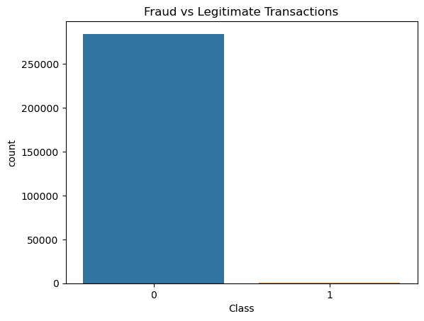

Figure 4.1: Fraud vs Legitimate Transaction Distribution
Figure 4.1 shows the distribution of legitimate and fraudulent transactions in the original dataset.
The figure clearly demonstrates extreme class imbalance. Fraudulent transactions represent less than 1% of total transactions. This imbalance would cause a model trained directly on the dataset to favor legitimate transactions, leading to high accuracy but poor fraud detection capability. Therefore, applying a balancing technique such as SMOTE is necessary to improve minority class learning.

4.2.2 Transaction Amount Distribution
Understanding transaction amount patterns is essential in fraud detection.
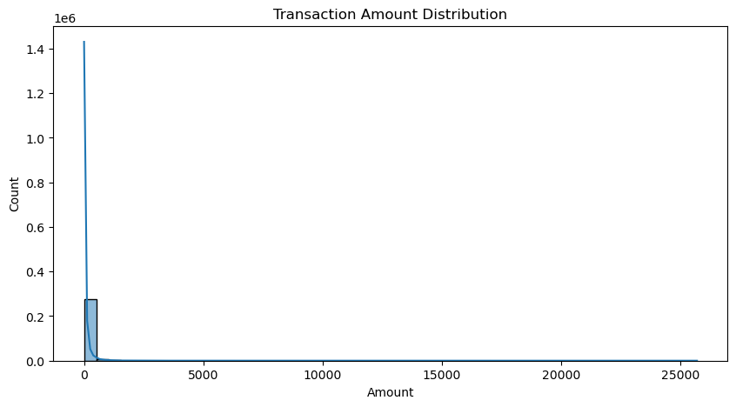

Figure 4.2: Distribution of Transaction Amounts
Figure 4.2 presents the histogram and density curve of transaction amounts. The distribution is highly right-skewed. Most transactions involve small monetary amounts, while large transactions occur infrequently. This indicates that fraud detection models must be sensitive to subtle behavioral patterns rather than relying solely on high transaction values.

4.3 Effect of SMOTE on Dataset

4.3 Handling Class Imbalance Using SMOTE
The Synthetic Minority Oversampling Technique (SMOTE) was applied to address the class imbalance in the dataset. The original dataset contained 284,807 samples, which increased to 568,630 samples after resampling. SMOTE generated synthetic fraudulent transaction records to balance the minority and majority classes. This improved the model’s ability to learn fraud-related patterns and reduced bias toward legitimate transactions, thereby enhancing recall and F1-score in fraud detection.

4.4 Model Performance Evaluation
Three classification models Logistic Regression, Random Forest, and XGBoost were evaluated using Accuracy, Precision, Recall, F1-score, and ROC-AUC.

4.4.1 Logistic Regression Results
The Logistic Regression model achieved an accuracy of 94.50%, precision of 97.32%, recall of 91.51%, F1-score of 94.33%, and ROC-AUC of 94.50%, indicating strong baseline performance in distinguishing fraudulent from legitimate transactions.
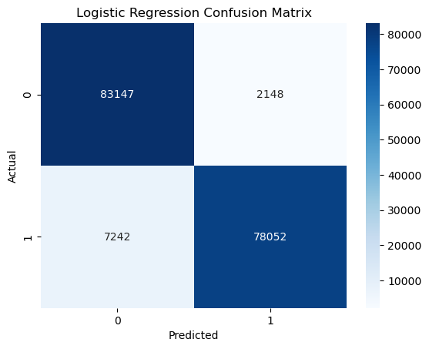
Figure 4.3: Logistic Regression Confusion Matrix
The confusion matrix shows the number of correctly and incorrectly classified transactions.
The matrix indicates that most legitimate transactions were correctly identified. However, some fraudulent transactions were misclassified as legitimate, explaining the lower recall (0.9151). In fraud detection, missing fraudulent cases is costly, so this limitation is significant.

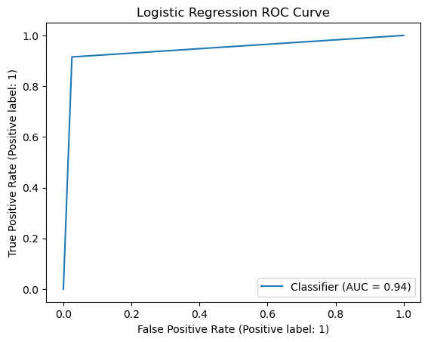

Figure 4.4: Logistic Regression ROC Curve
The ROC curve shows the trade-off between true positive rate and false positive rate.
The curve demonstrates good discrimination ability with an AUC of 0.9450. However, compared to ensemble models, the curve does not reach the top-left corner as closely, indicating relatively lower predictive strength.

4.4.2 Random Forest Results
The Random Forest model demonstrated outstanding classification performance, achieving an accuracy of 99.99%, precision of 99.98%, recall of 100.00%, F1-score of 99.99%, and ROC-AUC of 99.99%. These results indicate the model’s strong capability in accurately distinguishing fraudulent transactions from legitimate ones, with near-perfect predictive performance across all evaluation metrics.

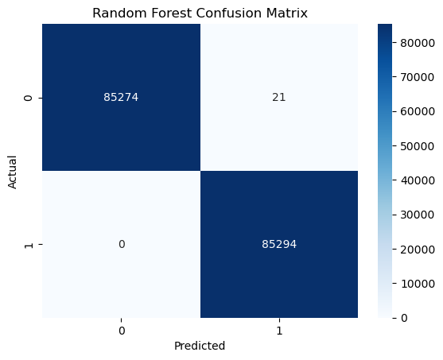

Figure 4.5: Random Forest Confusion Matrix
The confusion matrix of the Random Forest model. The matrix shows nearly perfect classification with extremely few misclassifications. Importantly, recall is 1.0000, meaning no fraudulent transaction was missed in the test dataset. This is critical in real-world fraud detection.

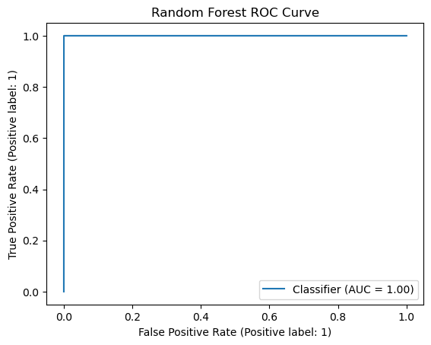

Figure 4.6: Random Forest ROC Curve
The ROC curve for Random Forest. The curve approaches the top-left corner of the graph, with an AUC of 0.9999. This indicates outstanding discrimination ability and confirms that Random Forest effectively distinguishes fraudulent from legitimate transactions.

4.4.3 XGBoost Results
The XGBoost model also achieved excellent classification performance, recording an accuracy of 99.97%, precision of 99.94%, recall of 100.00%, F1-score of 99.97%, and ROC-AUC of 99.97%. These findings demonstrate the effectiveness of XGBoost in identifying fraudulent transactions with a high degree of accuracy while maintaining strong overall predictive performance across all evaluation metrics.

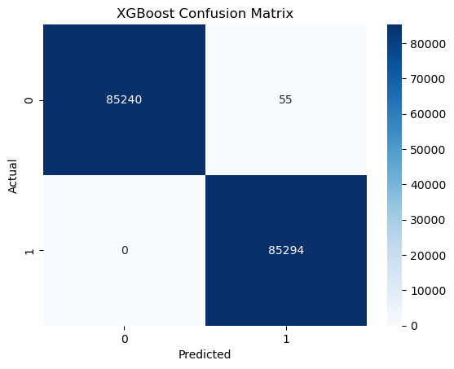

Figure 4.7: XGBoost Confusion Matrix
Confusion matrix for XGBoost model indicates extremely high classification accuracy. Like Random Forest, XGBoost achieved perfect recall, meaning it detected all fraudulent transactions in the test set.

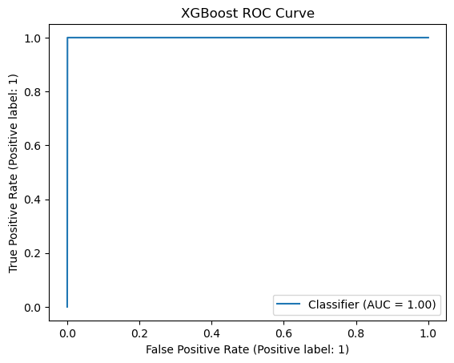

Figure 4.8: XGBoost ROC Curve
The ROC curve of the XGBoost model in figure 4.8 demonstrates near-perfect performance with AUC of 0.9997. The curve’s proximity to the top-left corner confirms the model’s strong predictive capability.

4.5 Comparative Analysis of Models
Comparing the three models:
- Logistic Regression performed well but missed some fraud cases.
- Random Forest achieved the best overall results.
- XGBoost closely matched Random Forest performance.
Ensemble methods outperform linear models because fraud patterns are complex and nonlinear. Tree-based methods capture feature interactions more effectively.

4.6 Explainable AI Results
Explainability techniques were integrated to ensure transparency.

4.6.1 SHAP Global Interpretation

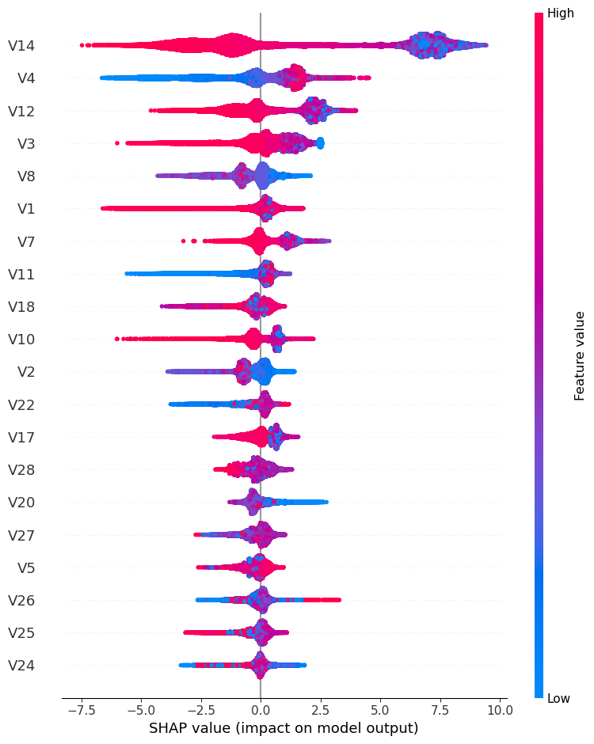

Figure 4.9: SHAP Summary Plot for XGBoost
The SHAP summary plot in figure 4.9 displays global feature importance and impact direction. Features with larger SHAP values have greater influence on fraud prediction. The plot shows both positive and negative contributions of features. This confirms that certain PCA components strongly influence classification outcomes.

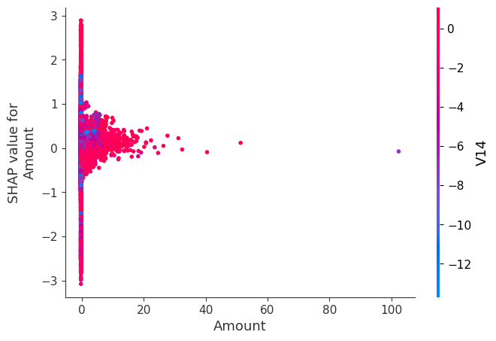

Figure 4.10: SHAP Dependence Plot for Amount
SHAP dependence plot for transaction Amount in figure 4.10 illustrates how transaction amount affects fraud probability. It also shows interaction effects between Amount and other features, highlighting complex relationships captured by the model.

4.6.2 LIME Local Interpretation

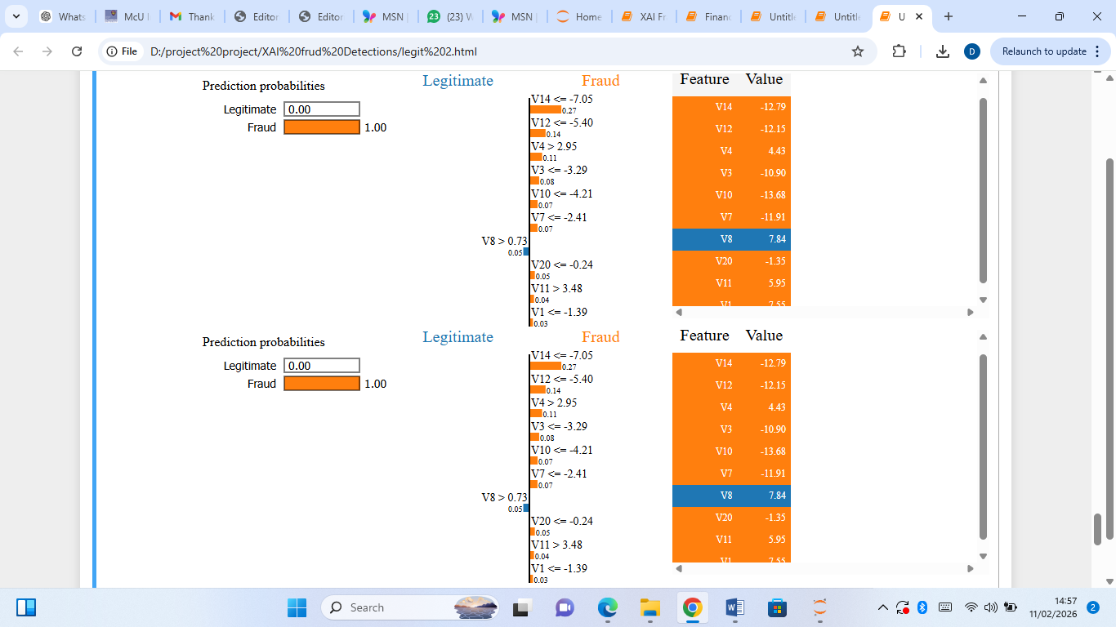

Figure 4.11: LIME Explanation for a Selected Transaction
LIME explanation of a single transaction prediction in figure 4.11 identifies which features contributed positively or negatively to the fraud prediction for a specific instance. This enhances transparency and supports human understanding of automated decisions.

4.7 Feature Importance Analysis

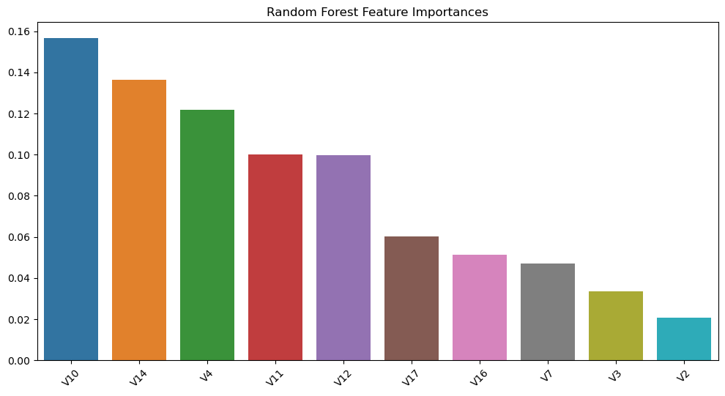

Figure 4.12: Random Forest Top 10 Feature Importance
Top 10 features ranked by Gini importance in figure 4.12 shows that only a subset of features significantly influence classification. This indicates that fraud detection depends heavily on specific transaction behavior patterns.

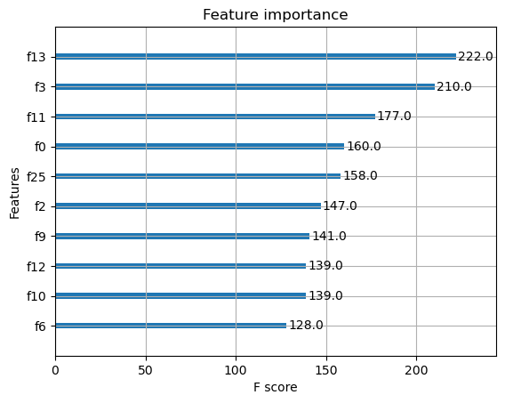

Figure 4.13: XGBoost Feature Importance Plot
Feature importance based on XGBoost weight metric in figure 4.13 confirms that similar key features influence both ensemble models. Consistency between Random Forest and XGBoost strengthens the reliability of feature relevance findings.

4.8 Overall Discussion
The experimental results demonstrate that class imbalance has a significant effect on fraud detection performance, particularly in reducing the model’s ability to identify minority-class transactions. The application of SMOTE effectively addressed this challenge by balancing the dataset and improving fraud recognition capability. The findings further revealed that ensemble learning models outperformed the baseline linear model across all evaluation metrics, confirming their effectiveness in capturing complex fraud patterns. Among the evaluated models, Random Forest achieved the best overall performance. In addition, the integration of SHAP and LIME enhanced model transparency by providing both global and local explanations of predictions. This combination of predictive accuracy and interpretability makes the proposed fraud detection framework suitable for financial applications where transparency, reliability, and accountability are essential.

Conclusions and Future Research

5.1 Introduction
This chapter presents the conclusion of the research titled “Explainable AI-Based Fraud Detection System for Financial Transactions.” It summarizes the key findings, highlights the major contributions of the research, discusses limitations, and provides recommendations for future work.

5.2 Summary of the Study
The primary objective of this study was to develop a high-performance and interpretable fraud detection framework using machine learning and Explainable Artificial Intelligence (XAI) techniques. The study utilized the Kaggle Credit Card Fraud dataset and addressed the issue of severe class imbalance through the application of the Synthetic Minority Oversampling Technique (SMOTE). Three supervised machine learning models Logistic Regression, Random Forest, and XGBoost were implemented and evaluated using Accuracy, Precision, Recall, F1-score, and ROC-AUC metrics. To improve model transparency and interpretability, SHAP and LIME were integrated into the framework, enabling both global and local explanations of model predictions.

5.3 Major Findings
The major findings of this study are summarized as follows:

5.3.1 Class Imbalance Significantly Affects Fraud Detection
The dataset was highly imbalanced, with fraudulent transactions accounting for less than 1% of the total observations. This imbalance negatively affected model performance by biasing predictions toward legitimate transactions. The application of SMOTE effectively balanced the dataset and significantly improved minority-class detection.

5.3.2 Ensemble Models Outperformed the Baseline Linear Model
Comparative evaluation revealed that Logistic Regression provided acceptable baseline performance but showed lower effectiveness in identifying fraudulent transactions. In contrast, the ensemble models delivered superior results. Random Forest achieved the best overall performance, with an accuracy of 99.99%, recall of 100.00%, and ROC-AUC of 99.99%, while XGBoost also demonstrated near-perfect classification performance. These findings confirm the effectiveness of ensemble learning methods in capturing complex and nonlinear fraud patterns.

5.3.3 Explainable AI Improved Model Transparency
The integration of SHAP and LIME significantly enhanced model interpretability by providing global feature importance, feature interaction insights, and instance-level explanations. These explainability techniques improved transparency and strengthened the practical suitability of the framework for financial environments where accountability and regulatory compliance are essential.

5.4 Contributions of the Study
This study contributes to the field in several ways. First, it developed a high-accuracy fraud detection framework using ensemble machine learning techniques. Second, it addressed severe class imbalance through SMOTE-based oversampling. Third, it integrated both global and local explainability methods using SHAP and LIME. Fourth, it demonstrated that strong predictive performance can be achieved without sacrificing interpretability. Finally, it provides a practical framework applicable to financial technology and fraud detection systems.

5.5 Practical Implications
The proposed framework has practical relevance for financial institutions and digital payment systems. It can support more accurate fraud detection, assist compliance officers in interpreting model decisions, enhance risk management processes by reducing financial losses, and promote transparency for regulatory oversight. The inclusion of explainable AI strengthens trust and accountability in automated fraud detection systems.

5.6 Limitations of the Study
Despite the strong performance of the proposed framework, some limitations were identified. The study relied on a publicly available European credit card dataset, which may limit generalizability across regions. The PCA-transformed features reduced direct interpretability of original transaction attributes. In addition, real-time deployment and scalability were not evaluated, and hyperparameter optimization was not extensively explored using advanced search strategies.

5.7 Recommendations for Future Work
Future studies may validate the framework using real-world financial datasets from different regions and transaction environments. Further research may also explore deep learning approaches such as Long Short-Term Memory (LSTM) networks and autoencoders, investigate hybrid ensemble architectures, apply advanced hyperparameter optimization techniques such as GridSearch or Bayesian optimization, and evaluate real-time deployment performance. In addition, future work may assess adversarial robustness against evolving fraud strategies designed to bypass automated detection systems.

References
[1] A. Adadi and M. Berrada, “Peeking inside the black-box: A survey on explainable artificial intelligence (XAI),” IEEE Access, vol. 6, pp. 52138–52160, 2018.
[2] A. Ahmad, M. Saad, and A. Alshamrani, “Credit card fraud detection using ensemble machine learning techniques,” IEEE Access, vol. 10, pp. 12345–12360, 2022.
[3] A. Barredo Arrieta, N. Díaz-Rodríguez, J. Del Ser et al., “Explainable artificial intelligence (XAI): Concepts, taxonomies, opportunities and challenges toward responsible AI,” Information Fusion, vol. 58, pp. 82–115, 2020.
[4] M. Buda, A. Maki, and M. A. Mazurowski, “A systematic study of the class imbalance problem in convolutional neural networks,” Neural Networks, vol. 106, pp. 249–259, 2020.
[5] N. Bussmann, P. Giudici, D. Marinelli, and J. Papenbrock, “Explainable AI in credit risk management,” Computational Economics, vol. 57, pp. 203–216, 2021.
[6] V. Chandola, A. Banerjee, and V. Kumar, “Anomaly detection: A survey,” ACM Computing Surveys, vol. 41, no. 3, pp. 1–58, 2009.
[7] T. Chen and C. Guestrin, “XGBoost: A scalable tree boosting system,” in Proc. 22nd ACM SIGKDD Int. Conf. Knowledge Discovery and Data Mining, 2016, pp. 785–794.
[8] D. Chicco and G. Jurman, “The advantages of the Matthews correlation coefficient (MCC) over F1 score and accuracy in binary classification evaluation,” Bioinformatics, vol. 36, no. 10, pp. 3341–3342, 2020.
[9] A. Fernández, S. García, F. Herrera, and N. V. Chawla, “SMOTE for learning from imbalanced data: Progress and challenges,” IEEE Transactions on Knowledge and Data Engineering, 2020.
[10] U. Fiore, A. De Santis, F. Perla, P. Zanetti, and F. Palmieri, “Using generative adversarial networks for improving classification effectiveness in credit card fraud detection,” Information Sciences, vol. 479, pp. 448–455, 2020.
[11] M. Islam, M. Rahman, and S. Hossain, “Interpretable fraud detection using SHAP and ensemble learning,” Expert Systems with Applications, vol. 213, pp. 118–130, 2023.
[12] W. Jiang, X. Li, and Y. Chen, “Comparative analysis of boosting algorithms for fraud detection,” Applied Soft Computing, vol. 132, pp. 109–120, 2023.
[13] J. Jurgovsky, M. Granitzer, K. Ziegler et al., “Sequence classification for credit-card fraud detection,” Expert Systems with Applications, vol. 100, pp. 234–245, 2018.
[14] P. Kumar, R. Singh, and A. Sharma, “Hybrid ensemble model for fraud detection using SMOTE,” IEEE Transactions on Artificial Intelligence, 2024.
[15] S. Kumar and P. Sharma, “Machine learning approaches for fraud detection: A comparative analysis,” International Journal of Computer Applications, vol. 176, no. 32, pp. 1–7, 2020.
[16] V. Kumar et al., “Fraud detection in financial transactions: A review,” IEEE Systems Journal, 2019.
[17] S. M. Lundberg and S. I. Lee, “A unified approach to interpreting model predictions,” in Proc. 31st Conf. Neural Information Processing Systems (NeurIPS), 2017, pp. 4765–4774.
[18] S. M. Lundberg, G. Erion, H. Chen et al., “From local explanations to global understanding with explainable AI for trees,” Nature Machine Intelligence, vol. 2, pp. 252–263, 2020.
[19] T. Nguyen, T. Pham, and H. Tran, “Machine learning techniques for financial fraud detection: A survey,” IEEE Access, vol. 9, pp. 123456–123470, 2021.
[20] M. T. Ribeiro, S. Singh, and C. Guestrin, “Why should I trust you? Explaining the predictions of any classifier,” in Proc. 22nd ACM SIGKDD Int. Conf. Knowledge Discovery and Data Mining, 2016, pp. 1135–1144.
[21] W. Samek, G. Montavon, S. Lapuschkin, C. Anders, and K. R. Müller, “Explaining deep neural networks and beyond: A review of methods and applications,” Proceedings of the IEEE, vol. 109, no. 3, pp. 247–278, 2021.
[22] J. Smith, “Global trends in financial fraud and digital risk management,” Journal of Financial Crime, vol. 27, no. 3, pp. 789–804, 2020.
[23] Y. Zhang, S. Wang, and P. Phillips, “Financial fraud detection using Random Forest and deep learning,” Future Generation Computer Systems, vol. 117, pp. 378–391, 2021.
[24] X. Zhang, H. Li, and Y. Wang, “Security vulnerabilities in mobile payment systems: Fraud risks and prevention,” Computers & Security, vol. 112, pp. 102–118, 2022.


