Effect of Partial Substitution of Corn Flour in Wheat Bread Production
Bekele Mekuria Emiru¹, Bisrat Walle Wube^{1*}, Melaku Agegne Demelash¹, Daniel Girma Woldegebreal¹, Eleni Asnake Gebremariam¹
¹ Food and Beverage Industry Research and Development Center, Addis Ababa, Ethiopia
*Corresponding author: Bisrat Walle Wube, Food and Beverage Industry Research and Development Center, post box {46883}, Addis Ababa, Ethiopia
Email: bisratwalle@gmail.com , Tel: +25193423569
Abstract
Global wheat scarcity due to supply chain disruptions and rising costs has prompted the exploration of alternative flour blends to sustain bread production. This study was designed using a completely randomized design, with wheat flour partially substituted by corn flour at levels of 5%, 10%, 15%, 20%, and 25%. Standard methods were employed to evaluate the effect of corn flour on gluten content, bread volume, nutritional composition, and sensory attributes. One-way ANOVA was used to determine significant differences among the bread samples (p<0.05), ensuring reliable results. Results revealed a significant reduction in gluten content and bread volume with increasing corn flour substitution compared to 100% wheat bread. However, sensory analysis indicated that blends with 5%, 10%, and 15% corn flour achieved high acceptability, with the 15% blend receiving the highest scores for texture and flavor. The protein content in the bread increased with corn flour substitution, likely due to the interaction between wheat and corn proteins, despite corn's lower protein content. Caloric values also improved due to corn's nutrient-dense profile. The incorporation of 15% corn flour optimized bread quality and provided a cost-effective solution to address wheat shortages. These findings underscore the potential of corn-wheat blends in promoting sustainable baking practices and improving nutritional value in bread production.
Key words: Bread, wheat flour, Corn flour, Composite flour, Wet gluten
- Introduction
Wheat (Triticum aestivum), a vital global cereal crop, is recognized as a staple food, providing a significant portion of protein and calories (Singh et al., 2023). Its composition varies based on factors such as variety and cultivation methods (Filip et al., 2023). In Ethiopia, the largest wheat producer in sub-Saharan Africa, wheat is primarily rain-fed and grown in the highlands. Wheat holds a crucial position as a staple food crop in Ethiopia, serving both urban and rural communities. Its versatility in food production, including bread, pasta, macaroni, biscuits, cakes, and pastries, underscores its significance in the Ethiopian diet. The production and marketing of wheat form the backbone of livelihoods for a significant portion of the agricultural workforce in the country, particularly in regions such as Oromia and Amhara (Habte, 2022). Despite its nutritional significance, wheat productivity in Ethiopia remains low, with an average yield of 2.4 tons per hectare compared to the global average of 3.19 tons per hectare. This low productivity can be attributed to various factors, including but not limited to, the quality and availability of seeds, inappropriate seed sizes and rates, soil fertility, water availability, and pest and disease management practice (Tadesse et al., 2022). The proximate composition of wheat includes protein (N x 5.7) 7-18%, minerals (ash) 1.5 - 2.0%, lipids 1.5 - 2.0%, starch 60 - 68%, cellulose (fiber) 2.0 - 2.5%, and moisture content 8.0 - 18% (Abdel-Gawad et al., 2020; Gadisa, 2019; Habte, 2022).
Maize (Zea mays L.) is an annual plant belonging to the Poaceae family, similar to wheat (Triticum aestivum L.), and is characterized by a single seed leaf and two sets of chromosomes. Both grains are crucial staple crops worldwide, serving as key food ingredients in various products. While wheat is primarily used in bread-making, maize plays a significant role in a wide array of food products, including canned corn, breakfast cereals, and infant foods (Gnanwa et al., 2021; Kumar et al., 2024). Within the genus Zea, which includes four species, Zea mays L. stands out for its economic significance, especially due to its widespread cultivation. Originating in Mexico and Central America, maize has a rich history and cultural importance in these regions, where it was domesticated by indigenous peoples before spreading globally (Gnanwa et al., 2021). The widespread use of maize alongside wheat reflects their shared role in global food security and agriculture (Grote et al., 2021).
Maize (Zea mays), also referred to as corn in some regions, is an essential cereal crop that serves as a staple food for millions of people worldwide, including in Ethiopia, where it is a major component of agricultural production. In many developing countries, including Ethiopia, composite flours, which often include maize, play a crucial role in improving nutrition and supporting local economies (Olamiti & Ramashia, 2024). Composite flours combine various sources of starch and protein, such as corn, wheat, or legumes, to enhance both nutritional value and economic benefits. For example, they can improve dietary diversity, provide cost-effective food options, and contribute to enhanced food security in resource-constrained regions (Eriksson et al., 2018; Marques et al., 2020). Corn offers distinct nutritional advantages compared to other major cereals like wheat and rice (Siyuan et al., 2018). It is richer in fat and fiber, providing additional dietary benefits (Xu et al.; 2019). However, a limitation of corn lies in the quality of its protein. Approximately half of corn's protein content consists of zein, which is low in essential amino acids such as lysine and tryptophan (Yadesa, 2021). This makes corn protein less nutritionally complete compared to proteins from other sources (Yadesa & Diro, 2023). Despite this limitation, utilizing corn flour in the production of baked goods presents an opportunity to reduce the dependence of developing nations on imported wheat. Incorporating corn flour into bread, pastries, and other baked products can help reduce the dependence of developing nations on imported wheat by providing a locally sourced alternative, thereby improving food security and supporting local agriculture (Mbachu et al., 2024).
Due to increasing population, urbanization, and changing food habits in developing countries, there has been a tremendous increase in the consumption of leavened and unleavened wheat flour products in recent years (Noort et al., 2022). This surge in demand has prompted the exploration of alternative options such as composite flour, which is a mixture of various flours, starches, and other ingredients. Composite flour can be utilized to partially or completely replace wheat flour in bakery and pastry products, offering a versatile solution to address changing dietary preferences and promote food security. Composite flour holds considerable advantages for developing countries by mitigating the need for imported wheat flour and promoting the utilization of locally grown crops as flour substitutes (Melesse et al., 2023). This approach not only reduces dependency on external imports but also fosters local agricultural economies and enhances food security by utilizing readily available resources (Dube et al., 2020; Hasmadi et al., 2020).
Bread, a staple widely consumed worldwide, is primarily made from wheat flour, water, yeast, and salt through processes including mixing, kneading, proofing, shaping, and baking (Mounika, Sireesha, 2021). However, given the high cost and demand for wheat, blending it with alternative flours such as corn is being explored to alleviate shortages without compromising bread quality. This study aims to assess the impact of incorporating corn flour into wheat flour for bread production on both nutritional content and health implications, particularly for those with gluten intolerance. Corn flour, rich in vitamins, minerals, and fiber, offers a cost-effective alternative. The research seeks to optimize this blend to enhance the nutritional quality, texture, volume, taste, and color of the bread while maintaining its sensory attributes.
- Materials and Methods
  - Sources of raw materials and experimental location
The necessary raw materials such as wheat and corn flours, yeast, bread improver, salt, and edible oil were easily acquired from Merkato and factories around Addis Ababa. The comprehensive analysis of flour quality, bread production, and overall product quality was successfully conducted in the well-equipped laboratories of Alivima Food Processing Company, Fafa Food Share Company, and Ethiopian Conformity Assessment Enterprise.
  - Blend formulation
The composite flours of the Seven types of Flour blends (composite flours) were prepared by substituting wheat flour with corn flour in precise ratios of 100:0, 95:5, 90:10, 85:15, 80:20, 75:25 and 70:30 using a high-performance mechanical blender (Sharp EM11) in accordance with the well-established method outlined by Arhaliass et al., (2009). The samples were uniformly mixed and made ready for quality analysis and baking. The samples underwent a thorough and consistent mixing process, ensuring optimal quality analysis and baking readiness.
  - Bread processing
Bread production process involved the utilization of the straight dough method, encompassing various stages such as mixing, kneading, fermentation, molding, rounding, intermediate proofing, final proofing, baking, cooling, and packaging. In the production of bread, two types of flour formulations were used: normal flour (100% hard white wheat flour) and substitute flours at varying levels. The substituted levels were as follows: L1 (100% whole wheat flour and 0% corn flour), L2 (95% whole wheat flour and 5% corn flour), L3 (90% whole wheat flour and 10% corn flour), L4 (85% whole wheat flour and 15% corn flour), L5 (80% whole wheat flour and 20% corn flour), L6 (75% whole wheat flour and 25% corn flour), and L7 (70% whole wheat flour and 30% corn flour). The bread was prepared using the straight dough method, as per the protocol established by Amjad et al., (2021). The baking formula comprised 97.5% wheat flour or the blend, 1% yeast, 0.5% bread improver, 1.0% salt, and 56.3% water. All these ingredients were mixed in a dough mixer for duration of 20 min. Subsequently, the dough was fermented in a bowl covered with low-density polyethylene for 20 min at room temperature. It was then deflated and shaped into the desired form. The dough pieces were allowed to ferment for 60 min in a proofing room maintained at a temperature of 35 ºC and a relative humidity of 80%. Finally, the fermented dough was baked at a temperature of 260 ºC for duration of 20 min.
Flour
Sieving
Mixing & kneading
Bulk fermentation
Punching
Dividing
Rounding
Intermediate proofing
Dividing & molding
Panning
Final proofing
Baking
Cooling
De panning
Slicing & packaging
Dispatching
Yeast
Salt
Water
Improver

Figure 1: Flow diagram of bread processing
  - Proximate Determination
The proximate composition of the composite flours and bread samples was analyzed to determine their nutritional characteristics. The analysis included moisture content, protein, ash, crude fiber, fat, carbohydrate, and energy content. The determination of the samples for all parameters was conducted in duplicate.
    - Sample Preparation
To prepare bread samples for analysis, they were dried in an oven at 60°C for 12 h to minimize alterations in physicochemical properties (Arora et al., 2023).
    - Moisture content determination
The moisture content of the 100% wheat flour and wheat-corn substituted samples were determined using a rapid moisture tester, following the method outlined in ICC No. 110/1 (Collar, Armero, 2018). To ensure consistency, the samples were thoroughly mixed and stored in plastic bags until moisture analysis was conducted. A precise weight of 5.0 g of each sample was placed on a stainless-steel moisture testing plate. This plate was then subjected to a temperature of 70 ºC in an oven for duration of 48 h.
$$\% Moisture (\frac{wt}{wt})=\frac{(wt of wet sample - wt of dry sample)}{wt of wet sample}*100$$
Where: wt = weight
    - Protein Content Determination
The Kjeldahl method (AOAC, 2005) was used to determine protein content, applying a nitrogen-to-protein conversion factor of 5.7 for wheat-based samples (Davy et al., 2022).
    - Ash Content Determination
Ash content was analyzed by incinerating samples in a muffle furnace at 550°C for 6 h following AOAC (2005) and ICC Standard No. 107/1 (Akubor et al., 2023).
    - Crude Fiber Determination
Crude fiber content was measured following AOAC (2005) procedures, which involve acid and alkaline digestion to remove soluble materials before ashing the residue (Kure et al., 2021).
    - Fat Content Determination
Fat content was analyzed using the Soxhlet extraction method with petroleum ether as the solvent, in accordance with AOAC (2005) (Ismail et al., 2024).
    - Carbohydrate and Energy Content Determination
Carbohydrate content was estimated by difference:
$$Carbohydrate \left(\%\right)= 100-(\%Moisture+\%Protein+\%Fat+\%Ash+\%Fiber$$
The energy content of the samples was calculated using Atwater conversion factors, assigning 4 kcal/g for carbohydrates and protein and 9 kcal/g for fat (Millar et al., 2019).
    - Functional Properties of Composite Flours
The functional properties of the composite flours, including water absorption capacity (measured using the Farinograph), falling number, wet gluten content, granulation, and color, were determined following standard procedures outlined in AOAC (2005) and ICC Standard No. 107/1 (Milićević et al., 2023).
    - Granulation (Particle Size)
The granularities of the 100% wheat flour the wheat-corn substituted samples were determined by sieving 50 g of the samples using 180 mesh size sieves (ES 1052:2005) (Mekuria, 2015). The percentage through (granulation) of each sample was then calculated using the following formula.
$$\% through=\frac{(Wth)}{Wf}*100$$
Where:
W_{th} = weight of flour through the sieve,
W_{f} = initial weight of flour
    - Color grade
The brightness of the flours were measured to verify the color grade value of the flour samples according to the method described by Popovska, (2023). A beaker containing 50.0 mL of distilled water was used to mix exactly 30.0 g of flour sample. The mixture was stirred continuously for 45 sec using a glass rod to form a uniform paste. The paste was subsequently poured into the sample cell, which was then inserted into the inframatic 9500 grain analyzer. Within 90 sec, the result was displayed.
    - Falling number
The Hagberg falling number apparatus (model 1500, Sweden, Perten Instruments, 2005) was utilized to assess the falling number of the flour samples, following the ICC standard No 107/1 for determining the amylase activity of flour as described by Jukić et al., (2023).
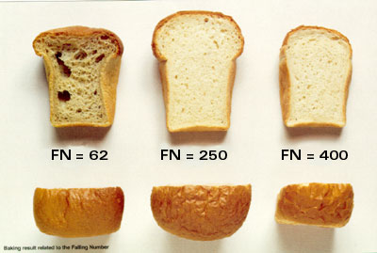
Figure 2: Effect of falling number on bread quality (Perten instruments, 2005)
    - Wet gluten content
As described by Liu et al.,( 2022), a 2% saline solution was prepared by dissolving 40 g of salt in two liters of distilled water. Subsequently, 10 g of flour samples were combined with 4-5 milliliters of the aforementioned 2% saline solution to form dough. The resulting dough was then gradually rinsed with 2% saline water for duration of 4-6 min, until a transparent solution became apparent. Following this, the gluten obtained was subjected to further washing with regular tap water. The percentage of wet gluten was ascertained by the following formula:-
$$\% Wet gluten=\frac{Weight of gluten}{Weight of flour}*100$$
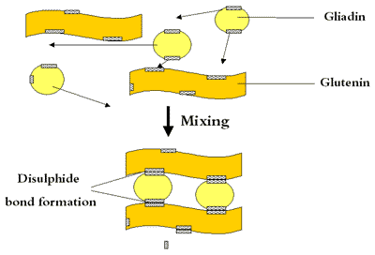
Figure 3: The formation of gluten (Perten Instruments, Glutomatic)
    - Farinograph measurement
The water absorption, stability, dough development, degree of softening, and farinograph quality number of the 100% wheat flour and composite flour samples were measured using the Bra bender Farinograph, following the standard method of ICC No 115/1(Bock, 2022) for determining the farinograph values of wheat flour. The Bra bender Farinograph automatically calculates the required amount of flour based on its moisture content. The mixer of the farinograph has a capacity of 300 g. The mixing process lasted for 20 minutes, with the torque speed set at 63 min.
    - Extensograph measurement
To obtain the necessary data, the dough was first mixed in the farinograph, then shaped into a cylinder, and subsequently placed in the extensograph cradle for a period of rest. Once the rest period was concluded, the cradle, along with the dough was carefully positioned within the instrument, and the dough is steadily stretched at a constant rate using a hook. The height of the resulting curve directly correlates to the dough's resistance-to-extension, while the distance the dough was stretched before rupturing indicates its extensibility. Ideally, a harmonious balance between these two factors was preferred in bread making. As per the outlined procedure, the dough is stretched after rest periods of 45, 90, and 135 min, following the method described by Della Valle et al.; (2022).
  - Sensory evaluation of composite bread products
The determination of the sensory qualities of bread samples involves the evaluation of sensory attributes such as color, taste, texture, odor/smell, and overall acceptability. In order to evaluate the organoleptic characteristics of the bread samples, a sensory assessment was carried out by a group of 40 panelists. These panelists, who were chosen at random from the Food and Beverage Industry Research and Development Center Staff, were experienced food professionals. They were provided with clear instructions to rate the breads using a 9-point hedonic scale, ranging from 9 (liked extremely) to 1 (disliked extremely). The ratings were then statistically analyzed using the method described by Antonius et al.; (2020). All sensory evaluations were carried out at room temperature.
  - The loaf volume
The loaf volume of each bread sample was determined 50 min after removing the loaves from the oven, employing the rape-seed displacement method described by De Bondt et al.; (2021). Teff seeds were substituted for rape-seed. Using a weighing balance, the weight of each bread sample was measured. Subsequently, the volume of the container was obtained from the graduation on its body, denoted as V₁ (cm³). Filling the container with approximately 4-5 times the volume of the loaf sample, the seeds were allowed to drop from a height of 15.24 cm above the container rim until a plateau was formed with the rim. The seeds were then removed, weighed, and recorded as W₁ (g). The weight of the seeds that filled the container corresponded to the total weight of seed that completely occupied the volume of the container. Then, 1/3 of the container volume was filled with seeds, and the loaf was placed flat at the center. The remaining seeds were added until they overflowed from 15.24 cm above the container. Using a ruler, the seeds above the rim were trimmed to form a plateau with the container. The seeds displaced by the loaf were collected, weighed, and recorded as W₂ (g). This weight of seeds corresponded to the volume of space displaced by the loaf sample in the container.
The loaf weight for each bread sample was determined by directly weighing it on a weighing balance with absolute certainty. The specific loaf volume for each sample was confidently determined by dividing the loaf volume of each sample by its corresponding loaf weight.
$$Specific loaf volume=\frac{Loaf Volume ( cm3)}{Loaf weight (gm)}$$
  - Experimental Design and Data Analysis
A completely randomized design (CRD) was employed to evaluate the composite flours and bread quality attributes. Each sample underwent duplicate determinations. Significant differences among treatments were assessed using Duncan’s multiple range tests following a one-way Analysis of Variance (ANOVA). Statistical analysis was performed at a significance level of p<0.05 using Minitab 19.2 software.

- Results and Discussions
  - Quality characteristics of composite flours for bread production
The moisture content, wet gluten, color, granulation, and falling number of all composite flours were determined and are presented in Table 1. It was observed that the moisture content of the flours fell within the standard requirement specified by Ethiopian standard 1015:2017, ranging from 12.06% to 12.45%. The composite flour containing 95% wheat flour and 5% corn flour exhibited the least moisture content, while the composite flour containing 70% wheat flour and 30% corn flour showed the highest moisture content. This can be attributed to the higher percentage of corn flour used in the mixture. The study's findings align with the previous research (Krasnikova et al., 2020; Oyeyinka et al., 2023; Tamba-Berehoiu et al., 2017).
In the production of white bread, lower values of color grade are preferred. Therefore, as the percentage of corn flour increased in the composite flour, the color grade steadily increased as well. This is because the milling process of corn flour includes some bran inclusions. The control sample (100% WF) yielded the highest wet gluten content, while the composite flour (70% WF+30% CF) had the least wet gluten. The reduced wet gluten content in the composite flour was attributed to the higher percentage of corn flour, which lacks the elastic gluten found in wheat. As the percentage of corn flour increased in the composite flour, the wet gluten content decreased. Table 2 demonstrates this trend. Bread bakers prefer higher wet gluten values due to their ability to absorb more water, increase the protein content of bread, improve gas retention, and increase the volume of the loaf. The particle size of the composite flours ranged from 73.25% to 95.20% with a sieve analysis of mesh size 180 micrometer. The largest particle size was observed in 100% corn flour, thanks to its coarser milling. With an increase in corn flour, the granularity of the composite flour significantly decreased. The falling numbers of the 100% wheat flour and composite flours did not differ significantly, although they were slightly higher than the standard requirement (ICC No 107/1) (Heiden et al., 2023). This findings were in alignment with other research studies (Arinola et al., 2023; Atudorei et al., 2021; Torbica et al., 2019).
Table 1: Quality characteristics of composite flour
Composition  (%) | Samples (WF:CF)
Composition  (%) | 100:00 | 95:5 | 90:10 | 85:15 | 80:20 | 75:25 | 70:30
Moisture | 12.06±0.06ª | 11.80±0.06^{b} | 11.96±0.23^{b} | 12.30±0.00ª | 12.20±0.0ª | 12.35±0.07ª | 12.45±0.70^{b}
Wet gluten | 29.50±0.70ª | 29.01±0.00ª | 25.50±0.70^{b} | 25.15±0.71^{b} | 23.00±0.42^{c} | 23.65±0.35^{c} | 21.75±1.20^{d}
Color | 92.23±0.03^{b} | 92.59±0.01^{b} | 92.48±0.01^{b} | 92.79±0.04^{b} | 92.89±0.01^{b} | 93.14±0.15ª | 93.38±0.12ª
Granulation | 95.20±1.83ª | 89.75±0.35^{b} | 87.40±0.56^{b} | 84.15±0.35^{c} | 81.40±0.0^{d} | 77.97±0.47e | 73.25±0.35^{f}
Falling No. | 330.50±3.53ª | 322.50±3.53^{c} | 326.00±2.8^{b} | 322.00±11.31^{c} | 320.00±0.7^{c} | 326.50±0.7^{b} | 312.50±2.12^{d}
All values are means of triplicates ±SD means with the different superscript letters within a row are significantly different at (p<0.05) values, WF= Wheat flour, CF = Corn flour.
    - Farinograph values of composite flours
The Farinograph values of wheat-corn flour blends for bread production are clearly shown in Table 2 and Figures 6-12. The Control (100% WF) demonstrated the higher stability (mixing tolerance), while the composite flour (95% WF + 5% CF) exhibited the least value, likely due to the absence of gluten in the corn flour. As the percentage of corn flour increased in the 70:30 wheat-corn flour blend, the mixing tolerance and stability were improved compared to the 95:5 blend, but remained lower than the 100% wheat flour control. The 100% wheat flour also shows the longest dough development time due to its high gluten content. The 100% wheat flour also achieves the highest farinograph quality number and the least degree of softening. These values clearly indicate that the 100% wheat flour was strong flour. As the quantity of corn flour increases, the strength of the flour decreases. This was because the addition of corn flour leads to a reduction in the gluten content of the composite flour. Therefore, it was highly recommended to use flour that was rich in gluten for the preparation of bread flour. The findings were consistent with those of other studies (Liu et al., 2020; Švec, Hrušková, 2018; Torbica et al., 2019; Zhang et al., 2022).
Table 2: Farinograph values of composite flour
Parameters | Control  (100%WF) | 95% WF  +5% CF | 90% WF  +10% CF | 85% WF  +15% CF | 80% WF  +20% CF | 75% WF  +25% CF | 70% WF  +30% CF
Consistency, FE | 492±0.03^{b} | 488±0.23^{c} | 496±0.03^{b} | 492±0.03^{b} | 508±0.27ª | 502±0.00ª | 506±0.27ª
Water absorption corr. for default consistency | 56.0±0.00ª | 55.4±0.01^{b} | 54.8±0.05^{b} | 53.6±0.12^{c} | 52.8±0.25^{d} | 52.1±0.23^{d} | 51.5±0.01^{d}
Water absorption corr. for default moisture content | 53.8±0.00ª | 53.1±0.07^{b} | 52.6±0.05^{c} | 51.4±0.12^{d} | 50.6±0.08e | 49.9±0.07^{f} | 49.3±0.06^{f}
Stability (min) | 03:09±0.01^{d} | 03:08±0.0^{d} | 03:15±0.07^{c} | 3:32±0.17^{b} | 3:37±0.05ª | 03:36±0.01ª | 03:32±0.04^{b}
Degree of softening (10 min after beginning) | 95±0.00ª | 94±0.01^{b} | 95±0.01ª | 88±0.07^{c} | 87±0.01^{d} | 85±0.02e | 80±0.05^{f}
Degree of softening (ICC /12 min after max.) | 110±0.01ª | 110±0.06ª | 109±0.01^{b} | 103±0.06^{d} | 104±0.01^{c} | 100±0.04e | 99±0.01^{f}
Development time (min) | 02:00±0.59^{c} | 02:13±0.1^{b} | 01:29±0.84e | 1:45±0.16^{d} | 02:17±0.72^{b} | 01:58±0.59^{c} | 02:43±0.85ª
Farinograph quality number | 39±0.00e | 39±0.00e | 38±0.01^{f} | 40±0.02^{d} | 41±0.01^{c} | 42±0.01^{b} | 44±0.02ª
All values are means of triplicates ±SD means with the different superscript letters within a row are significantly different at (p<0.05) values, WF= Wheat flour, CF = Corn flour.
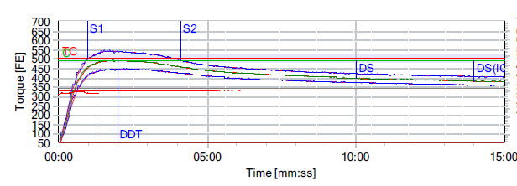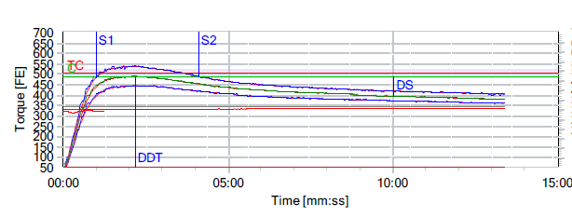
Figure 6: Farinograph of control (100%WF) Figure 7: Farinograph of composite flour (95% WF+5% CF)
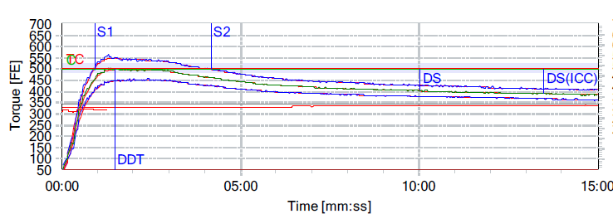
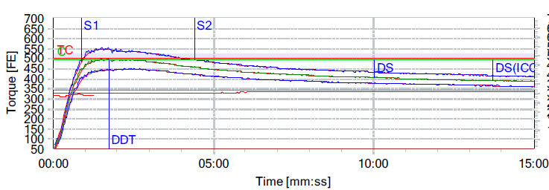
Figure 8: Farinograph of composite flour (90% WF+10% CF) Figure 9: Farinograph of composite flour (85% WF+15% CF)

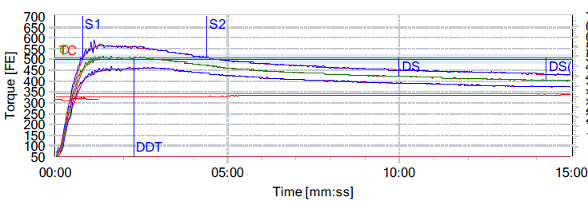
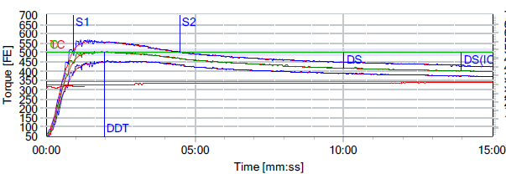
Figure 10: Farinograph of composite flour (80% WF+20% CF) Figure 11: Farinograph of composite flour (75% WF+25% CF)
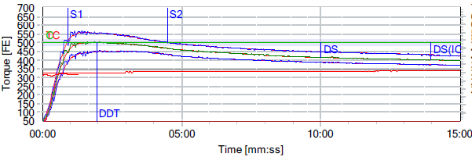
Figure 12: Farinograph of composite flour (70% WF+30% CF)
    - Extensograph values of composite flours
The Extensograph values of blended flours for bread production, as depicted in Figures 13a-13g for sample L1, sample L2, sample L3, and sample L4, exhibit remarkably similar characteristics. The dough possesses the ideal strength and elastic properties required for bread production, resulting in light and voluminous baked goods with excellent volume. The sample L5 dough, on the other hand, displays the characteristics of strong flour dough, with a slightly elastic and extensible nature compared to sample L1. Conversely, samples L6 and L7 exhibit a rigid and tough dough structure, indicating deficient gluten content and poor elastic properties, consistent with the findings of previous studies (Della Valle et al., 2022; Derkanosova et al., 2022; Dube et al., 2021; Manano et al., 2021; Shongwe et al., 2022; Torbica et al., 2019).
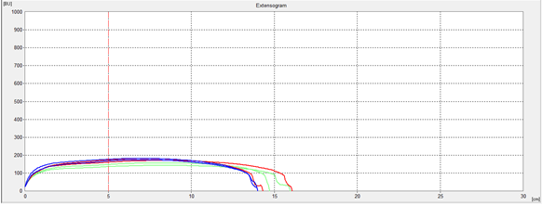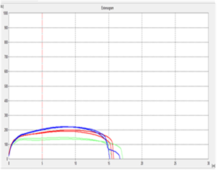
Figure 13(a):- Control (100%WF) Figure 13 (b):- Composite flour (95% WF+5% CF)
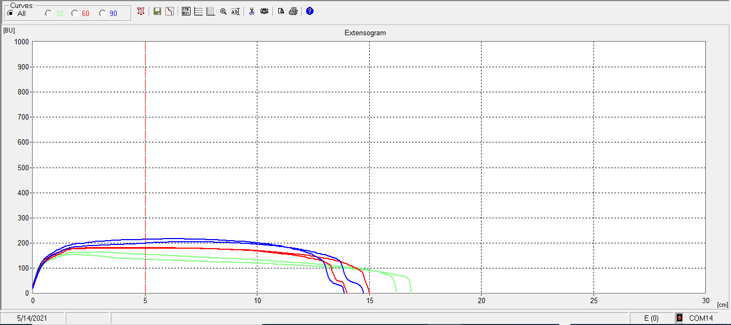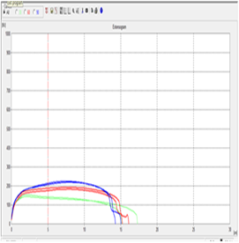
Figure 13 (c): Composite flour (90% WF+10% CF) Figure 13 (d): Composite flour (85% WF+15% CF)
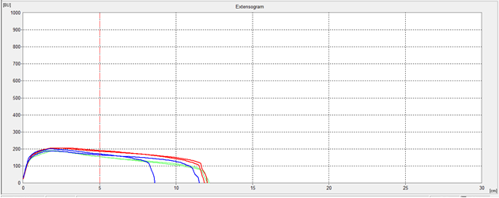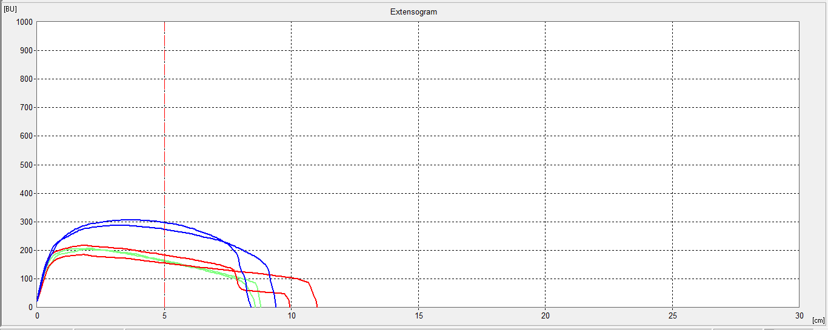
Figure 13 (e): Composite flour (80% WF+20% CF) Figure 13 (f): Composite flour (75% WF+25% CF)
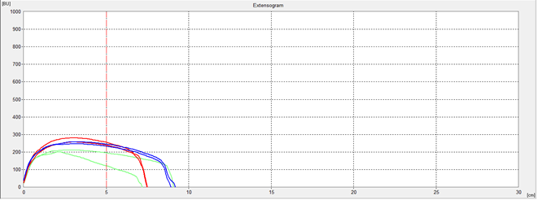
Figure 13 (g): Composite flour (70% WF+30% CF)
Table 3: Extensograph data for flour blends containing varying corn flour levels
Blended flour | Rmax (BU) | Extensibility (mm) | Energy (cm³)
L1 (100% hard wheat) | 167 | 152 | 40
L2 (95% hard wheat, 5% Corn) | 180 | 157 | 47
L3 (90% hard wheat, 10% Corn) | 181 | 157 | 45
L4 (85% hard wheat, 15% Corn) | 180 | 145 | 41
L5 (80% Whard wheat, 20% Corn) | 188 | 120 | 36
L6 (75% hard wheat, 25% Corn) | 168 | 105 | 27
L7 (70% hard wheat, 30% Corn) | 246 | 75 | 29

  - Proximate composition of Composite bread products
The moisture content of the breads from Table 3 clearly demonstrates that the composite flour (70% WF+30% CF) bread possesses the highest moisture content at 33.70%. Among the composite bread, the crude protein content of composite flour (70% WF+30% CF) bread stands out as the highest at 10.27%. Additionally, the crude fiber content of composite flour (70% WF+30% CF) bread was 1.67%, while that of composite flour (95% WF+05% CF) bread is 0.72%. The composite flour bread with the highest crude fat content was the composite flour (90% WF+10% CF) bread. Similarly, the composite flour bread with the highest ash content was the composite flour (95% WF+05% CF) bread. Remarkably, the composite flour (80% WF+20% CF) bread exhibited the highest carbohydrate content among the bread samples at 55.86%. Lastly, the energy content of composite flour (70% WF+30% CF) bread was the highest at 280.88% Kcal/100g. This study was related to previous studies on the properties of composite flour bread samples (Abel et al., 2023; Ewunetu et al., 2023; Guyih et al., 2021; Imoisi et al., 2020; Nehra et al., 2021; Onwurafor et al., 2022; Orhevba, Ndanaimi, 2021; Ronie et al., 2023).
Table 4: Proximate composition and loaf volumes of bread samples
Sample  (WF:CF) | Moisture (%) | Crude protein  (%) | Crude fiber  (%) | Crude fat (%) | Ash (%) | Total carbohydrate (%) | Energy kcal/100g
100:00 | 31.29±0.02^{b} | 10.21±0.00ª | 0.86±0.06^{c} | 1.15±0.04^{b} | 1.66±0.00e | 54.69±0.00^{b} | 269.950.04^{b}
95:5 | 31.56±0.02^{b} | 10.27±0.03ª | 0.72±0.14^{d} | 0.46±0.06e | 1.88±0.02ª | 55.83±0.016ª | 268.540.03^{b}
90:10 | 32.58±0.08ª | 9.89±0.04^{b} | 0.78±0.06^{d} | 1.25±0.07ª | 1.76±0.05^{c} | 54.52±0.01^{b} | 268.89±0.04^{b}
85:15 | 32.52±0.02ª | 9.95±0.06^{b} | 1.23±0.04^{b} | 0.64±0.61^{d} | 1.80±0.06^{b} | 55.09±0.12ª | 265.92±0.02^{c}
80:20 | 31.68±0.08^{b} | 9.89±0.03^{b} | 1.66±0.01ª | 0.72±0.08^{c} | 1.85±0.05ª | 55.86±0.16ª | 269.48±0.03^{b}
75:25 | 32.62±0.01ª | 9.68±0.21^{b} | 1.18±0.04^{b} | 1.21±0.04ª | 1.71±0.00^{d} | 54.75±0.16^{b} | 280.88±0.11ª
70:30 | 33.70±0.02ª | 9.37±0.03^{b} | 1.67±0.01ª | 0.63±0.01^{d} | 1.71±0.00^{d} | 54.59±0.01^{b} | 261.51±0.02^{d}

All values are means of triplicates ±SD means with the different superscript letters within a column are significantly different at (p<0.05) values, WF= Wheat flour, CF = Corn flour.
Table 5: Bread samples loaf weight, volume and specific volume
Sample | Loaf weight (g) | Loaf Volume (cm³) | Specific Volume (g/cm³)
Control (100% WF) | 104.50±0.70ª | 500.00±0.00ª | 4.76±0.26ª
95% WF+ 5%CF | 105.00±0.00ª | 474.75±0.35^{b} | 4.52±0.26^{b}
90% WF+ 10%CF | 105.00±0.00ª | 449.50±0.70^{c} | 4.28±0.05^{c}
85% WF+ 15%CF | 105.00±0.00ª | 400.50±0.70^{d} | 3.80±0.05^{d}
80% WF+ 20%CF | 105.00±0.00ª | 349.75±0.70e | 3.30±0.47e
75% WF+ 25%CF | 105.00±0.00ª | 344.5±0.707^{f} | 2.85±0.47^{f}
70% WF+ 30%CF | 105.00±0.00ª | 270. 50±0.70^{g} | 2.38±0.47^{g}

All values are means of triplicates ±SD means with the different superscript letters within a column are significantly different at (p<0.05) values but loaf weight are not significant, WF= Wheat flour, CF = Corn flour.
The incorporation of corn flour observed in figure 14(a)-14(g) are significantly decreased the volume of the loaf (p<0.05), while the weight of the loaf remained almost the same for all samples. The level of supplementation was found to cause a decrease in specific volume, possibly due to the dilution of gluten protein. Previous investigators (Gujral, 2023) have also noted that the incorporation of low gluten flour leads to a decrease in loaf volume. As shown in Table 4, the control sample (100% WF) bread had the highest loaf volume of 500 cm³ and a specific loaf volume of 4.76 g/cm³. This finding aligns with the studies of other researchers (Chisenga et al., 2020; Dube et al., 2021; Manano et al., 2021; Monteiro et al., 2021; Shongwe et al., 2022; Thielemans et al., 2024).
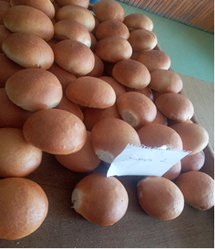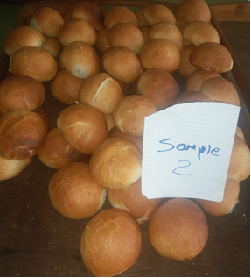
Figure 20(a): Control (100%WF) Figure 21(b): Composite flour (95% WF+5% CF)
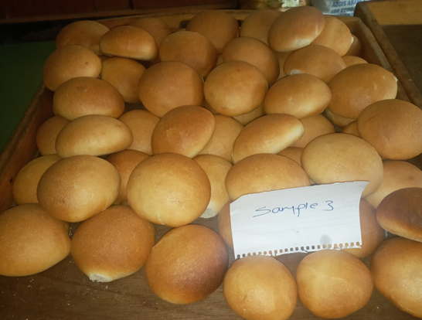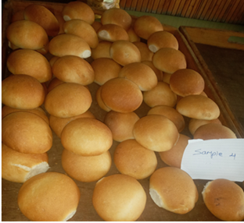
Figure 22(c): Composite flour (90% WF+10% CF) Figure 23(d): Composite flour (85% WF+15% CF)
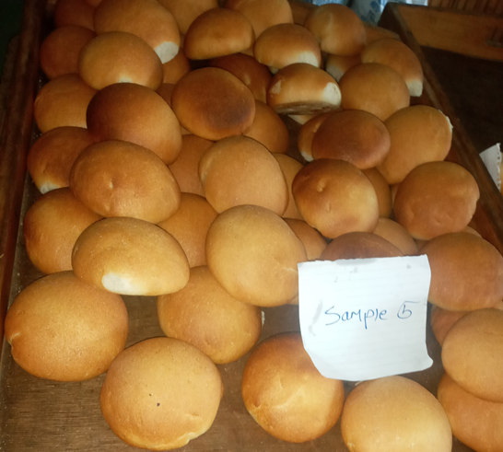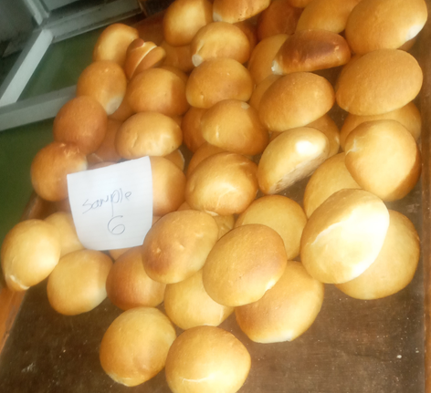
Figure 24(e): Composite flour (80% WF+20% CF) Figure 25(f): Composite flour (75% WF+25% CF)

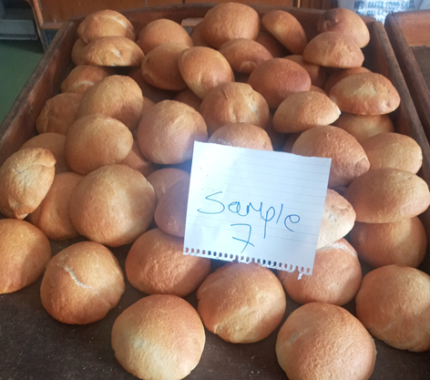
Figure 26(g): Composite flour (70% WF+30% CF)
  - Sensory evaluation of composite flours bread
Sensory analysis of color, taste, texture, odor/smell, and overall acceptability was conducted using 9 hedonic scales with semi-trained panelists. The bread samples' sensory hedonic mean scores can be found in Table 5. As the proportion of corn flour in the blends increased, the mean scores for sensory attributes decreased. The bread made with the Control sample (100% WF) achieved the highest value; while the bread made with composite flour (70% WF + 30% CF) recorded the least value. Based on the sensory quality evaluation, bread made with composite flour (85% WF + 15% CF), using hard wheat flour, fulfilled most of the quality attributes. Generally, the samples with Control (100% WF), Composite flour (95% WF + 5% CF), (90% WF + 10% CF), (85% WF + 15% CF), and (80% WF + 20% CF) were acceptable to consumers. However, the samples with Composite flour (75% WF + 25% CF) and (70% WF + 30% CF) were less acceptable to the panelists due to their color, taste, texture, odor/smell, and overall acceptability. This study is in agreement with other similar studies (Filipini et al., 2021; Ibrahim et al., 2021; Kefale, Yetenayet, 2020; Mollakhalili-Meybodi et al., 2023).
Table 6: Sensory evaluation of bread products
Sensory attributes
Sample | Color | Taste | Texture | Odor | Overall acceptability
Control (100% WF) | 7.75±1.41ª | 7.85±1.48ª | 7.62±1.74ª | 7.60±1.37ª | 7.75±1.44ª
95% WF+5%CF | 7.17±1.55ª | 7.17±1.41^{b} | 6.80±1.66^{b} | 6.95±1.48^{c} | 6.87±1.50^{b}
90% WF+ 10%CF | 7.35±1.49^{b} | 6.70±1.85^{d} | 6.80±1.69^{b} | 6.97±1.40^{c} | 6.72±1.51^{d}
85% WF+ 15%CF | 7.35±1.12^{b} | 6.82±1.19^{c} | 6.42±1.69^{c} | 7.10±1.33^{b} | 6.90±1.41^{c}
80% WF+ 20%CF | 6.85±1.68^{c} | 6.52±1.43e | 6.20±1.71^{d} | 6.75±1.25^{d} | 6.35±1.76e
75% WF+ 25%CF | 6.35±1.98^{d} | 5.92±2.13^{f} | 5.45±2.19e | 5.82±2.09e | 5.80±2.09^{f}
70% WF+ 30%CF | 5.47±2.50e | 4.87±2.37^{g} | 5.07±2.44^{f} | 5.42±2.26^{f} | 5.02±2.53^{g}
All values are means of triplicates ±SD means with the different superscript letters within a column are significantly different at (p<0.05) values with 100% control, 5% corn flour + 95% wheat flour, 10% corn flour + 90% wheat flour, 15% corn flour + 85% wheat flour, 20% corn flour + 20% wheat flour, 2 5% corn flour + 75% wheat flour and 30% corn flour + 70% wheat flour, WF= Wheat flour, CF = Corn flour.
- Conclusion
The quality analysis results demonstrate a significant distinction between the control (100% WF) and the composite flours, particularly in terms of the wet gluten content. The loaf volume of the composite flour breads showed distinct variations across different samples, with the control (100% WF) exhibiting the highest volume, while the sample with 70% WF and 30% CF showed the least volume. Interestingly, the composite flour with 95% WF and 5% CF displayed a loaf volume exceeding 400 cm³, aligning with the control sample. Furthermore, the sensory analysis results indicate that the composite flour samples with 95% WF and 5% CF, 90% WF and 10% CF, and 85% WF and 15% CF were well-received in terms of overall acceptability, as evaluated by the panelists.
The samples' proximate composition, including protein, moisture, ash, fat contents, and caloric values, underwent analysis at the main laboratory of the Conformity Assessment Enterprise. The protein content of the control (100% WF) and the composite flour samples displayed variations, with the addition of corn flour leading to an increase in protein content. Specifically, the protein values for the different samples were 10.21, 10.27, 9.89, 9.95, 9.89, 9.68, and 9.37, for the following sample ratios 100:00, 95:5, 90:10, 85:15, 80:20, 75:25, and 70:30, respectively. Moreover, the addition of corn flour improved the caloric values of the bread loaves, with the values for the control (100% WF) and the composite flour blends of 95:5, 90:10, 85:15, 80:20, 75:25, and 70:30, samples being 269.95, 268.54, 268.89, 265.92, 269.48, 280.88, and 261.51, respectively.
In general, the research findings demonstrated that incorporating 15% corn flour into wheat flour significantly improves the quality of the final product (p<0.05). Moreover, it is entirely feasible to partially substitute wheat flour with corn flour, thereby addressing the wheat shortage and reducing the price of bread loaves. The sensory attributes and overall acceptability of bread baked with 10, 15, and 20% corn flour substitution with wheat flour were found to be indistinguishable from the control (100%). Consequently, the incorporation of corn flour, alongside wheat flour, at a percentage of 10, 15, or 20% was acceptable in bread production. Furthermore, the research work provided compelling evidence that the inclusion of corn flour in bread production significantly enhances the nutritional content of the final product. Hence, it was strongly recommended to add 15% corn flour to wheat flour in order to achieve a bread of exceptional quality and rich in nutrients.
Data Availability
The data supporting the findings of this study are available from the corresponding author upon request.
Author Contributions
Mr. Melaku Agegne and Mss. Eleni Asnake conducted all experiments, and Mr. Bisrat Walle edited, reviewed, and wrote the manuscript. Mr. Bekele Mekuria and Mr. Daniel Girma provided assistance, support, advice, and guidance throughout the research process, particularly during laboratory work, and offered constant encouragement from the initial to final stages of the research. All authors contributed to the manuscript revision and approved the final version.
Acknowledgements
We are grateful to God for His guidance. Special thanks to the top management and research council of the Food and Beverage Industry Research and Development Center for their support. We appreciate the Finance Administration, HR Development desk, FBIRDC staff, FAFA Food Share Company, Alvima Food Processing Company, and our colleagues for their invaluable assistance.
Conflicts of Interest
The authors declare that they have no conflicts of interest.
References
Abdel-Gawad, A., Rashwan, A., Mohamed, R., Hefny, M. A. (2020). Wheat-Legumes Composite Flours. 2. Nutritional Value of Bread. Assiut Journal of Agricultural Sciences 51(1):66–78.
Abel, E. S., Evivie, E. R., Chigbufue, O. T. (2023). Evaluating the proximate chemical composition and sensory properties of composite bread from wheat and cocoyam flour 17(5):74-84.
Akubor, P. I., Agada, T. O., Okereke, G. O. (2023). Quality evaluation of noodles produced from blends of wheat, unripe banana and cowpea flours. Journal of Nutrition Food Science and Technology 4(2):1–3.
Amjad, A., Sohaib, M., Nawaz, H., Javed, M. S., Shah, M., Shah, F.-U.-H., Tariq, M. R., Sajid, M. W., Khan, A. A., Bilal, M. (2021). Assessment of rheological and quality characteristics of bread made by the addition of ginger powder in wheat flour. Food Science and Technology 42:e47820.
Antonius, K., Aef, P., Heri, P. A. (2020). Optimum proportion of indian scad (Decapterus russelli) protein concentrate in traditional food cake designated for undernourished children diet. Russian Journal of Agricultural and Socio-Economic Sciences 99(3):170–183.
Arhaliass, A., Legrand, J., Vauchel, P., Fodil-Pacha, F., Lamer, T., Bouvier, J.-M. (2009). The effect of wheat and maize flours properties on the expansion mechanism during extrusion cooking. Food and Bioprocess Technology 2(2):186–193.
Arinola, S. O., Ogunlade, O. A., Fakomiti, D. M. (2023). Some Quality Attributes of Composite Flour and Bread Produced from Wheat and African Walnut. European Journal of Nutrition & Food Safety 15(5): 41–52.
Arora, K., Tlais, A. Z. A., Augustin, G., Grano, D., Filannino, P., Gobbetti, M., Di Cagno, R. (2023). Physicochemical, nutritional, and functional characterization of gluten-free ingredients and their impact on the bread texture LWT 177:114566.
Atudorei, D., Atudorei, O., Codină, G. G. (2021). Dough rheological properties, microstructure and bread quality of wheat-germinated bean composite flour. Foods 10(7):1542.
Bock, J. E. (2022). The Farinograph: Understanding Farinograph curves. In The Farinograph Handbook, Elsevier 33:41.
Chisenga, S. M., Workneh, T. S., Bultosa, G., Alimi, B. A., Siwela, M. (2020). Dough rheology and loaf quality of wheat-cassava bread using different cassava varieties and wheat substitution levels. Food Bioscience 34:100529.
Collar, C., Armero, E. (2018). Impact of heat moisture treatment and hydration level of flours on the functional and nutritional value-added wheat-barley blended breads. Food and Bioprocess Technology 11:966–978.
Davy, P., Kirkman, T., Scarlett, C. J., Vuong, Q. (2022). Characterisation of a high fibre flour prepared from soy milk by-product and its potential use in white wheat bread. Foods 11(23):3921.
De Bondt, Y., Hermans, W., Moldenaers, P., Courtin, C. M. (2021). Selective modification of wheat bran affects its impact on gluten-starch dough rheology, microstructure and bread volume. Food Hydrocolloids 113:106348.
Della Valle, G., Dufour, M., Hugon, F., Chiron, H., Saulnier, L., Kansou, K. (2022). Rheology of wheat flour dough at mixing. Current Opinion in Food Science 47:100873.
Derkanosova, N. M., Stakhurlova, A. A., Vukic, M., Vujadinovic, D. (2022). Rheological properties of composite mixtures from wheat and amaranth flour. IOP Conference Series: Earth and Environmental Science 954(1):12079.
Dube, N. M., Xu, F., Zhao, R. (2020). The efficacy of sorghum flour addition on dough rheological properties and bread quality: A short review. Grain & Oil Science and Technology 3(4):164–171.
Dube, N. M., Xu, F., Zhao, R., Chen, J. (2021). Effect of using Zimbabwean Marcia sorghum and high‐gluten flour on composite bread specific volume. Journal of Food Processing and Preservation 45(4): e15367.
Eriksson, D., Akoroda, M., Azmach, G., Labuschagne, M., Mahungu, N., Ortiz, R. (2018). Measuring the impact of plant breeding on sub-Saharan African staple crops. Outlook on Agriculture 47(3):163–180.
Ewunetu, M. G., Atnafu, A. Y., Fikadu, W. (2023). Nutritional Enhancement of Bread Produced from Wheat, Banana, and Carrot Composite Flour. Journal of Food Quality. Available at: https://doi.org/10.1155/2023/1917972.
Filip, E., Woronko, K., Stępień, E., Czarniecka, N. (2023). An overview of factors affecting the functional quality of common wheat (Triticum aestivum L.). International Journal of Molecular Sciences 24(8): 7524.
Filipini, G., Passos, A. P., Fernandes, S. S., Salas-Mellado, M. de las M. (2021). Nutritional value, technological and sensory evaluation of gluten-free bread enriched with soybean flour and coconut oil. Journal of Food Measurement and Characterization 15(4):3853–3861.
Gadisa, A. (2019). Review on the effect of seed source and size on grain yield of bread wheat (Tritium aestivum L.). J Ecol & Nat Resour 3(1):155.
Gnanwa, M. J., Fagbohoun, J. B., Ya, K. C., Blei, S. H., Kouame, L. P. (2021). Assessment of minerals, vitamins and functional properties of flours from germinated yellow maize (Zea mays L.) seeds from Daloa (Côte D’Ivoire). Int J Food Sci Nutr Eng 11(2):35–42.
Grote, U., Fasse, A., Nguyen, T. T., Erenstein, O. (2021). Food security and the dynamics of wheat and maize value chains in Africa and Asia. Frontiers in Sustainable Food Systems 4:617009.
Gujral, H. S. (2023). Little Millet (Panicum sumatrense). Nutri-Cereals: Nutraceutical and Techno-Functional Potential. Available at: Books.google.com.
Guyih, M. D., Bongjo, N. B., Chi, E. L., Muyong, M. G., Atam, F. M. (2021). Proximate composition of baked foods produced from various composite flour: a review. Journal of Postharvest Technology 9(4):74–83.
Habte, D. (2022). Achievemeents of Agronomic and Soil Fertility Management Research on Wheat in Ethiopia. Revitalizing the Ethiopian Wheat Sector: Progresses and Challenges of Wheat Research and Seed Production 1(1):164.
Hasmadi, M., Noorfarahzilah, M., Noraidah, H., Zainol, M. K., Jahurul, M. H. A. (2020). Functional properties of composite flour: A review. Food Research 4(6):1820–1831.
Heiden, C., D’Amico, S., Reiter, E., Flamm, C., & Grausgruber, H. (2023). Baking quality of organic heterogeneous material of wheat. Austrian Agency for health and food safety, Spergelfeldstr.191,220 Vinna, Austria. Available at: Cabi digital library.
Ibrahim, A., Bashir, M., Idi, A., Buhari, H. H. (2021). Proximate Analysis, Sensory Evaluation And Production of Bread From Finger Millet And Wheat Flour. Bayero Journal of Pure and Applied Sciences 14(2):101–107.
Imoisi, C., Iyasele, J. U., Michael, U. C., Imhontu, E. E. (2020). The effects of watermelon rind flour on the functional and proximate properties of wheat bread. Journal of Chemical Society of Nigeria 45(5):537.
Ismail, N., Elhassaneen, Y. A. E. E., El Kholey, H. M. (2024). Effect of Mixing Date Seed Powder with Wheat Flour on the Rheological Parameters, Nutrients, Bioactive Compounds Content, and Antioxidant Activity of the Egyptian Balady Bread. Alexandria Science Exchange Journal 45(3):455–477.
Jukić, M., Šumanovac, F., Nakov, G., Šimić, G., Komlenić, D. K., Ivanova, N., Lukinac, J. (2023). Application of the Falling Number Method in the Evaluation of the α-Amylase Activity of Malt Flour. Applied Sciences 13(5):3218.
Kefale, B., Yetenayet, B. (2020). Evaluation of bread prepared from composite flour of sweet lupine and Bread wheat variety. Journal of Food Science and Nutrition Therapy 6(1):7–10.
Krasnikova, E. S., Krasnikov, A. V, Babushkin, V. A. (2020). The influence of composite flour mixtures on saccharomyces cerevisiae biotechnological properties and bread quality. IOP Conference Series: Earth and Environmental Science 421(2):22008.
Kumar, P., Longmei, N., Choudhary, M., Gupta, M., Kumar, B., Jat, B. S., Bhushan, B., Dagla, M. C., & Aggarwal, S. K. (2024). Enhancement of nutritional quality in maize grain through QTL-based approach. Cereal Research Communications 52(1):39–55.
Kure, O. A., Ariahu, C. C., Igbabul, B. D. (2021). Physico-chemical and sensory properties of bread prepared from wheat and orange-fleshed sweet potato (flour, starch and non-starch residue flour) blends. Asian Food Sci. J 20(3):1–17.
Liu, J., Li, Q., Zhai, H., Zhang, Y., Zeng, X., Tang, Y., Tashi, N., Pan, Z. (2020). Effects of the addition of waxy and normal hull‐less barley flours on the farinograph and pasting properties of composite flours and on the nutritional value, textural qualities, and in vitro digestibility of resultant breads. Journal of Food Science 85(10):3141–3149.
Liu, Q., Zhang, W., Zhang, B., Du, C., Wei, N., Liang, D., Sun, K., Tu, K., Peng, J., Pan, L. (2022). Determination of total protein and wet gluten in wheat flour by Fourier transform infrared photoacoustic spectroscopy with multivariate analysis. Journal of Food Composition and Analysis 106:104349.
Manano, J., Ogwok, P., Byarugaba-Bazirake, G. W., Mugampoza, E. (2021). Rheological, baking and sensory characteristics of bread from wheat-cassava composite dough. Journal of Food Research 10(5):18-18.
Marques, R. C. D., Oliveira, É. R., Coutinho, G. S. M., Ribeiro, A. E. C., Teixeira, C. S., Júnior, M. S. S., Caliari, M. (2020). Modeling sorption properties of maize by-products obtained using the Dynamic Dewpoint Isotherm (DDI) method. Food Bioscience 38:100738.
Mbachu, A. E., Otuya, W. A., Mbachu, N. A. (2024). Microbial, Proximate and Sensory Evaluation of Bread Produced from a Blend of Wheat and Corn Flour. Nigerian Journal of Microbiology 38(1):6979-6986.
Mekuria, B., Emire, S. A. (2015). Effects of vital gluten enrichment on qualities of value added products. Journal of Food Processing & Technology 6(11):1.
Melesse, M. B., Tessema, Y. M., Manyasa, E., Hall, A. (2023). An enabling environment for the national flour blending policy: A food systems analysis. Food Systems Transformation in Kenya 16: 409.
Milićević, N., Sakač, M., Šarić, B., Škrobot, D., Filipčev, B., Šimurina, O., Jovanov, P., Pestorić, M., Marić, A. (2023). Soybean bran as the fat replacer in gluten-free cookie formulation: Physicochemical properties and sensory profiles. Chemical Industry and Chemical Engineering Quarterly 29(3):179–187.
Millar, K. A., Gallagher, E., Burke, R., McCarthy, S., Barry-Ryan, C. (2019). Proximate composition and anti-nutritional factors of fava-bean (Vicia faba), green-pea and yellow-pea (Pisum sativum) flour. Journal of Food Composition and Analysis 82:103233.
Mollakhalili-Meybodi, N., Sheidaei, Z., Khorshidian, N., Nematollahi, A., Khanniri, E. (2023). Sensory attributes of wheat bread: A review of influential factors. Journal of Food Measurement and Characterization 17(3):2172–2181.
Monteiro, J. S., Farage, P., Zandonadi, R. P., Botelho, R. B. A., de Oliveira, L. de L., Raposo, A., Shakeel, F., Alshehri, S., Mahdi, W. A., Araújo, W. M. C. (2021). A systematic review on gluten-free bread formulations using specific volume as a quality indicator. Foods 10(3):614.
Mounika, D., Sireesha, G. (2021). Development of Multi Millet Bread with Pearl Millet and Sorghum Millet. Wesleyan Journal of Research 80(14):90–100.
Nehra, M., Siroha, A. K., Punia, S., Kumar, S. (2021). Process standardization for bread preparation using composite blend of wheat and pearl millet: Nutritional, antioxidant and sensory approach. Current Research in Nutrition and Food Science Journal 9(2):511–520.
Noort, M. W. J., Renzetti, S., Linderhof, V., du Rand, G. E., Marx-Pienaar, N. J. M. M., de Kock, H. L., Magano, N., Taylor, J. R. N. (2022). Towards sustainable shifts to healthy diets and food security in sub-Saharan Africa with climate-resilient crops in bread-type products: A food system analysis. Foods 11(2):135.
Olamiti, G., Ramashia, S. E. (2024). Impact of Composite Flour on Nutritional, Bioactive and Sensory Characteristics of Pastry Foods: A Review. Current Research in Nutrition and Food Science 12(3): 1018–1034. Available at: https://doi.org/10.12944/CRNFSJ.12.3.4.
Onwurafor, E., Uzodinma, E., Aronu, C., Nweze, B., Ogbonnia, N. (2022). Proximate Composition, Antidiabetic and Hypolipidemic Activity of Bread Produced from Wheat–Sorghum Base Supplemented with Mung Bean Malt and Carrot Flour. Journal of Medicinal Food 25(8):863–868.
Orhevba, B. A., Ndanaimi, Y. (2021). Proximate and sensory properties of wheat-cocoyam (Colocasia esculenta) composite bread. European Journal of Agriculture and Food Sciences 3(3):86–90.
Oyeyinka, S. A., Bassey, I. A. V. (2023). Composition, Functionality, and Baking Quality of Flour from Four Brands of Wheat Flour. Journal of Culinary Science and Technology 00(00):1–21. Available at: https://doi.org/10.1080/15428052.2023.2191874.
Popovska, O. (2023). Determination of Some Flour Characteristics. European Journal of Agriculture and Food Sciences 5(4):8–12.
Ronie, M. E., Mamat, H., Abdul Aziz, A. H., Zainol, M. K. (2023). Proximate compositions, texture, and sensory profiles of gluten-free Bario Rice bread supplemented with potato starch. Foods 12(6):1172.
Shongwe, S. G., Kidane, S. W., Shelembe, J. S., Nkambule, T. P. (2022). Dough rheology and physicochemical and sensory properties of wheat–peanut composite flour bread. Legume Science 4(3):e138.
Singh, S. K., Kumar, S., Kashyap, P. L., Sendhil, R., Gupta, O. P. (2023). Wheat. In Trajectory of 75 years of Indian agriculture after independence 9(12):137–162.
Siyuan, S., Tong, L., Liu, R. (2018). Corn phytochemicals and their health benefits. Food Science and Human Wellness 7(3):185–195.
Švec, I., Hrušková, M. (2018). Baking value of wheat-fonio flour composites. Advances in Food Science and Engineering 2(2):59–67.
Tadesse, W., Zegeye, H., Debele, T., Kassa, D., Shiferaw, W., Solomon, T., Negash, T., Geleta, N., Bishaw, Z., Assefa, S. (2022). Wheat production and breeding in Ethiopia: retrospect and prospects. Crop Breeding, Genetics and Genomics 4(3):e220003.
Tamba-Berehoiu, R. M., Turtoi, M. O., Visan, L. V., Popa, C. N. (2017). Physico-chemical, rheological and technological characterization of some mixtures of wheat, oat, barley and millet flours. Annals of the University Dunarea de Jos of Galati, Fascicle VI: Food Technology 41(2):102–114.
Thielemans, K., De Bondt, Y., Bautil, A., Roye, C., Sels, B. F., Courtin, C. M. (2024). Amorphisation and chain length reduction of cellulose affect its impact on the water distribution, dough rheology and loaf volume in bread making. Food Hydrocolloids 146:109258.
Torbica, A., Blažek, K. M., Belović, M., Hajnal, E. J. (2019). Quality prediction of bread made from composite flours using different parameters of empirical rheology. Journal of Cereal Science 89:102812.
Xu, J., Li, Y., Wang, W. (2019). Corn. Bioactive Factors and Processing Technology for Cereal Foods 33:53.
Yadesa, L. (2021). Review on Maize (Zea mays L.) Breeding Methods for Improving Quality Protein and Others Nutritional Traits. Journal of Biology, Agriculture and Healthcare 11(21):22–33.
Yadesa, L., Diro, D. (2023). Nutritional and Specialty Maize Production, Consumption, and Promising Impact on Ethiopia’s Food and Nutrition Security: A Review. EAS Journal of Nutrition and Food Sciences 5(05):142–157.
Zhang, Y., Wang, X., Guan, X. (2022). Effects of adding quinoa flour on the composite wheat dough: A comprehensive analysis of the pasting, farinograph and rheological properties. International Journal of Food Science & Technology 57(11):7099–7106.

