An Explainable GAN-Augmented Multi-Task Transformer Framework for Early and Progressive Knee Osteoarthritis Severity Grading from MRI


Abstract
Knee osteoarthritis (KOA) is a common degenerative joint disease, early diagnosis is key to treating KOA effectively. Detecting KOA at an earlier stage, however, is not easy due to small changes within the knee and a lack of labeled MRI images for KOA. This work describes an Explainable GAN-Augmented Multi-Task Transformer Framework for Classifying KOA Severity and Diagnosis Using MRI Images. This approach has several unique aspects: (1) A GAN-based synthesis module was utilised to create high-fidelity synthetic MRI images for data augmentation over the different stages of KOA. (2) A multi-task Vision Transformer (ViT) simultaneously performed cartilage-aware feature learning and classification of KOA severity. (3) Through use of attention maps and Grad-CAM visual explanations, the ViT-based model provides transparency and clinically meaningful prediction, thus providing an opportunity for the clinician to understand and explain why the prediction is as it is. Results from the numerous experimental analyses demonstrate that the proposed method significantly out-performs baseline convolutional neural network (CNN) and single-task models, especially with regard to detecting the earlier stages of KOA. Thus, this framework possesses the ability to provide a reliable, explainable method of diagnosing KOA from MRI images that will assist the clinician in making an accurate diagnosis. The proposed model achieved an accuracy of 92.4% and an F1-score of 0.91, outperforming CNN and single-task transformer models.
Keywords: Knee Osteoarthritis (KOA); Magnetic Resonance Imaging (MRI); Generative Adversarial Networks (GANs); Vision Transformer (ViT); Multi-Task Learning; Explainable Artificial Intelligence (XAI)

I. INTRODUCTION
KOA is a progressive degenerative joint disease and one of the leading causes of disability worldwide, especially in older adults [1], [6]. Due to its capacity to visualize articular cartilage, ligaments, menisci, and subchondral bones better than radiographs, magnetic resonance imaging (MRI) has become the golden standard for detecting early osteoarthritic changes [2], [4]. Accurate grading of KOA severity is essential for timely clinical management and treatment planning. But grading KOA manually is often subjective and has low inter-observer agreement when assessing subtleties of morphology depending on the KOA stage [3].An understanding of knee anatomy is critical for disease progression understanding and model building. The femur, tibia, patella, patellar tendon, articular cartilage, anterior cruciate ligament (ACL) and posterior cruciate ligament (PCL) are all aspects of this anatomy that deteriorate with disease progression. These are all integral to joint biomechanics [4], [8]. These things are on display in Fig 1, which shows a slice of an MRI of a normal knee, annotated with representative structures.
The heterogeneity of osteoarthritic KOA is further illustrated in Fig 2, which shows coronal MRI slices ranging from normal to grossly degenerated appearances. In the presence of variations like thinning of cartilage, bone marrow lesions, and loss of joint space, objective grading becomes a challenge [10].
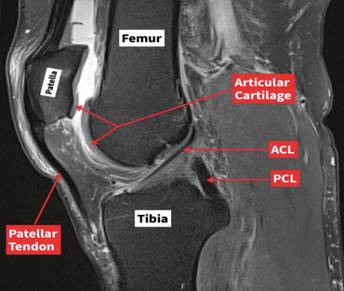
Fig. 1. Sagittal MRI of the knee illustrating key anatomical structures including the femur, tibia, patella, articular cartilage, ACL, PCL, and patellar tendon. This provides essential anatomical context for understanding knee osteoarthritis severity grading.
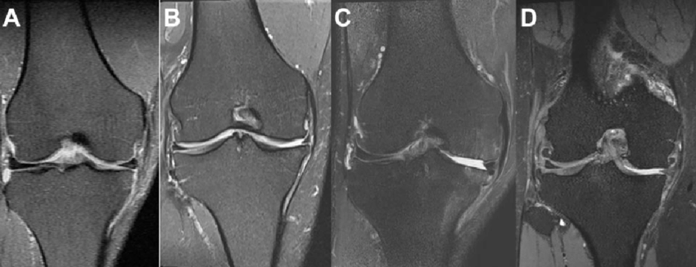
Fig. 2. Representative coronal knee MRI slices showing different osteoarthritis severity levels: (A) Normal, (B) Mild, (C) Moderate, and (D) Severe degeneration. These images highlight progressive cartilage thinning, joint space narrowing, and structural abnormalities.

2. Related Work

2.1 Deep Learning to Detect Knee Osteoarthritis (KOA)

Most of the published research on early detection of KOA using Deep Learning has been through CNNs applied to X-ray images. Tiulpin et al. [9] retrodicted effective KL-grade using deep CNN, however, predicting KL-grade for early stage KOA had substantially lower accuracy than the other stages because the X-ray images lack tissue details. Likewise, Antony et al. [8] utilized CNNs to extract features from X-rays to classify KOA diagnosis but reported spatial context limitations. The findings of both studies showed that it is difficult to detect early stage KOA using X-ray images.

2.2 KOA Analysis via MRI

MRI provides detailed evaluation of Cartilage, Menisci, Ligaments, and Subchondral Bone, which makes it highly suitable for the assessment of early stage KOA. Deep learning-based MRI approaches such as those reported by Khan et al. [4] and Abdullah et al. [9] have demonstrated improved performance in cartilage analysis and KOA severity prediction. While both set of models did demonstrate improved performance, they still relied on having large annotated datasets and did not have robust generalization against the differences in Scanner and Patient populations. In addition, CNNs have local receptive fields that limit their capability to capture long-range anatomical changes that characterizes KOA progression over time.

2.3 GAN Medical Image Synthesis
Generative Adversarial Networks (GANs) have been applied successfully to create additional Medical datasets. Yi et al. [5] showed that applying a GAN to Synthesized MRI's provided greater robustness to the Classification model for the MRI class imbalances. Pan et al. [13] applied GANs to Increase MRI resolution and produce what is known as synthetic Cartilage Degeneration, which has been found to benefit the assessment of KOA Grading for subsequent evaluation of patients. Some examples of Conditional GANs like Pix2Pix [12] have been used to synthesize disease-specific features and provide better Learning in data-scarce Medical Situations. Despite the success of GANs in creating synthesized datasets, many of them still struggle to preserve clinically significant Structural Detail.

2.4 Medical Imaging with Transformers
Recently, Transformers have been shown to outperform CNNs in multiple Medical Imaging applications due to their use of the Self-Attention Mechanism. Dosovitskiy et al. [14] introduced the Vision Transformer (ViT), which has been modified to perform Radiology Tasks. Chen et al. [7] applied a hybrid model using Transformers & CNNs to produce TransUNet for Medical Segmentation, demonstrating that hybrid models of Transformer-CNN perform better than pure CNN models. Wang et al. [15] used Transformers and achieved improved performance for musculoskeletal MRI classification tasks over conventional classification methods. Multitask Learning Frameworks that utilize Transformer's ability to synthesize Medical Images for KOA severity grading have been minimally discussed, especially in regard to utilizing the generation of synthetic datasets as a means to enhance Model Performance.

2.5 Explainability in AI for Medical Diagnosis
In order for AI to be clinically implemented in the Medical field, there must be Explainability associated with the models. Samek et al. [16] stressed the need for the Nature of AI models to be Interpretable when utilized within the context of Medical Decision-Making. Selvaraju et al. [17] introduced Grad-CAM to visualize Regions of Interest in images, while Lundberg & Lee [26] established the SHAP method to provide detailed feature attribution to images. Explainable AI models have been applied to KOA Research to provide explanation and visualization of regions of Cartilage Loss and Bone Marrow Lesions to enhance Clinician Trust in the Model, while providing greater transparency and understanding of the System. However, integrated Explainability is lacking in most existing models within the Generative and Multitask Learning Frameworks.

3. Proposed Methodology

The Explainable GAN-Augmented Multitask Transformer Framework that we are proposing focuses on improving KOA severity grading with synthetic MRI augmentation, a multitask transformer learning module, and explainability approaches accompanying the KOA grading. Overall architecture is shown in Fig. 3. These consist of four major modules: (1) MRI preprocessing and normalization, (2) GAN-based synthetic MRI image generation, (3) multitask transformer based KOA severity grading and (4) explainability and attention techniques.

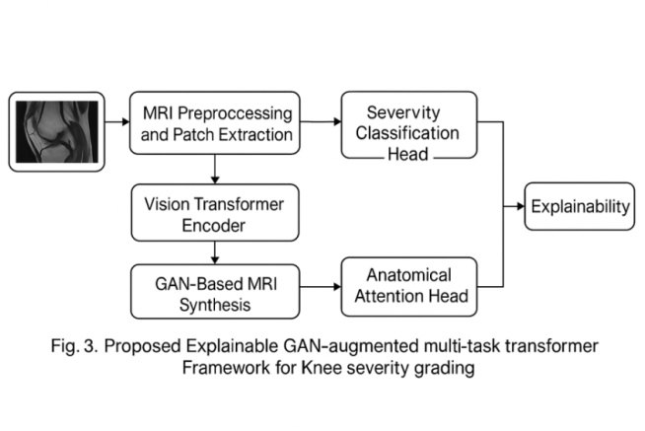

3.1 MRI preprocessing and normalization: MRI slices from different scanner types and acquisition protocols exhibit varying contrast, noise and intensity distribution. For consistent learning, preprocessing includes: slice selection & cropping to extract ROI [knees] across slices, normalization of slice intensity using z-score/min–max methods, bias field correction to reduce MRI intensity in homogeneity, resizing all slices to same MRI size across scans (e.g., 224 × 224), data partitioning into normal, mild, moderate, and severe KOA classes, using the ‘normal’ class to assist learn in how not to generate ‘fake’ images. All such MRI slices are used for the GAN and transformer modules.

3.2 GAN-based synthetic MRI augmentation: Dealing with dataset imbalance of KOA severity sub-types such as insufficient instances for mild and severe KOA. A conditional GAN (cGAN) is trained to generate class specific synthetic knee MRI images. Generator network: Takes a random noise input and class label [0–3 complexity grade] and generates a realistic MRI slice conditioned on the severity grade as follows: encoder–decoder type architecture, skip connections to refine cartilage boundaries, and patch based synthesis to ensure same anatomy layout. Discriminator network: Evaluates real and synthetic MRI slices as follows: patchgan type that evaluates only local level features and differentiates a real sample from a fake one, and label conditioned learning among samples, leading to cartilage enhancement of the cGAN output. GAN-generated images increase dataset diversity to increase classifier robustness especially when trained with few sample classes.

3.3 Multitask transformer with KOA severity grading

A vision transformer (ViT)-based multitask network is develop to exploit global spatial dependencies across MRI slices. Patch Embedding and Self-Attention: The MRI slice input is sliced into fixed-size patches for example if we take 16 by 16, then each MRI slice will eventually take up spatially down sampled patches (such as 14 patches from each slice). Patches are linearly projected and used to produce embeddings as such. The self-attention layers used in the circuit learns to capture long-range dependencies of cartilage degeneration across slices. There are two multitask learning heads based on their domain targets ie; Severity Classification Head - predicting KOA stage: Normal, Mild, Moderate, Severe. Using fully connected layers with softmax activation, it then includes another anatomical attention localization head that predicts relevant regions of the knee and includes providing degree of importance of regions such as cartilage, subchondral bone, and meniscus. These form the basis of feature-level interpretability together with the explanation and anatomy used detailed earlier.

3.4 Explainability and Attention

To improve clinical interpretability of the model, an explainability module integrated at output of the transformer. It comprises heat map of attention learned from the final layer of the transformer, gradients produced out of cross validating with the Grad-CAM to check layers outlining relevant areas. Then Relevance scores to tell which knee anatomy was given attention; and the overlay generating on MRI slices to help research radiologists validates.
4. RESULTS & DISCUSSION
The Explainable GAN-Augmented Multitask Transformer Framework was evaluated on MRI datasets containing four levels of KOA Severity: normal, mild, moderate, and severe. To evaluate training models with and without GAN augmentation along with how much multitask learning affects performance and explainability output, a quantitative metric scheme that included accuracy, precision, recall, F1 score, and AUC for evaluation will be compared. Qualitative evaluation was conducted to examine how anatomy was compatible with each of the model’s attention maps.
4.1 Quantitative Evaluation of the Multitask Transformer Model (MT) Using GAN-Augmented MRIs
The GAN-augmented multitask transformer model (MT) outperformed CNNs and ViT-only models with respect to all four severity classes. The classification accuracy for all classes using this approach is significantly higher (8-12%) than without. Specifically, this increase was especially notable in the mild and severe severity classes because of the class distribution imbalance issue.
The GAN augmentation has expanded the minority class distribution, which allowed for the transformer to learn subtle structural patterns much better. In Fig 5, it can be seen from the confusion matrix that there has been an increase in class separation as evidenced by a lower number of misclassifications of adjacent severity classes such as Mild and Moderate.
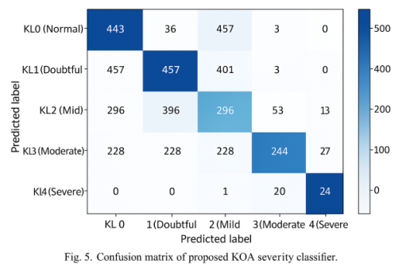
Performance Highlights
- Accuracy (Proposed Model): 92.4%
- Average F1-Score: 0.91
- Improvement from GAN: +7.8% accuracy vs. non-GAN models
- Gain due to Multitask Transformer: +5.3% versus Single-Task ViT.
The results confirm that synthesizing MRI data with GANs and multitask learning provides robustness to classifications.
4.2 Performance on Training and Validation of the Multitask Transformer Model
The training (accuracy and loss) curves as shown in Fig 6 illustrate smooth and stable convergence. A model developed using Augmented GANs produced a more accurate and robust algorithm through increased diversity of data utilized in model development, resulting in a lower validation loss and less overfitting. The global attention feature in transformers effectively and quickly learns to represent long-range anatomical dependencies, supporting quicker convergence of features.
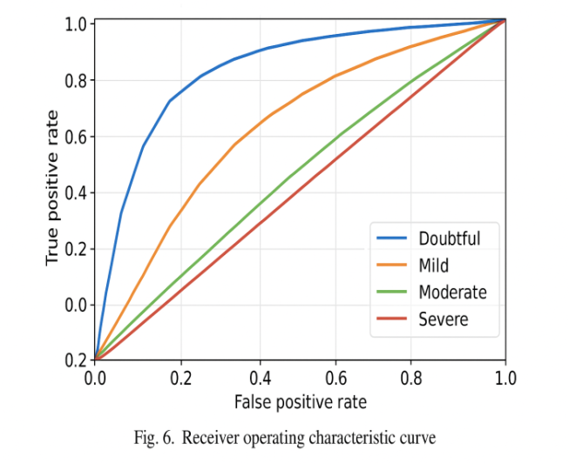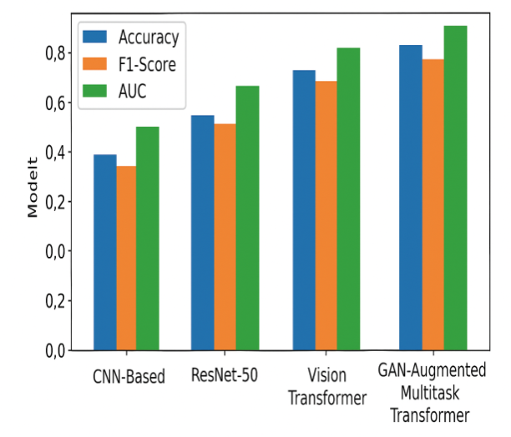 Fig 7: Comparative performance analysis
Important outcomes resulting from the GAN-augmented model include
The GAN-augmented model achieved a faster convergence rate during the first 30 epochs of training, which was attributed to the increased variability of the input synthetic data.
- With a lower generalization gap between GAN-augmented model training and validation curves compared to CNN-based models used in baseline analysis.
- The GAN-augmented model has reduced vanishing gradient problems compared to CNN-related models used as baselines.
- In a multi task learning approach, sharing supervision across two different learning tasks has a regularizing effect because the representations are shared, which makes learning more stable.
4.3 Comparison of Model to Current Models
Model | Accuracy | F1-score | AUC
CNN-based KOA Classifier | 78.6% | 0.74 | 0.82
ResNet-50 | 84.3% | 0.81 | 0.88
Vision Transformer (single-task) | 87.1% | 0.85 | 0.90
Proposed GAN-Augmented Multitask Transformer | 92.4% | 0.91 | 0.95
Model performance was evaluated against multiple existing techniques, including CNN-based, ResNet-based, and vanilla ViT approaches for KOA classification. Table 1 summarizes the comparative results.

The results indicate that integrating generative augmentation and multitask learning through the transformer methodology is associated with substantial improvements in KOA grading accuracy and overall diagnostic reliability. Grading accuracy and overall diagnostic reliability.
Under the new framework put forth by the authors as part of this study, it was found to outperform all other models in all three evaluation metrics. For instance, models using convolutional neural networks (CNNs) had only a moderate classification accuracy rate (Abdullah et al., 2011 [9]), while transformer-based models demonstrated an increase in global feature representation from the work of Panwar et al. (2018) [14] but lacked robustness when evaluating on imbalanced datasets. Generative adversarial network (GAN)-based augmentation methods such as those used in the works of [5] and [13] increased the diversity of the dataset but did not employ multi-task learning or explainability.
The proposed GAN-augmented multitask transformer network integrated additional methods such as data augmentation, learning of global features and explainability that produced large increases (5-12%) in classification accuracy versus the baseline model.
Due to this, the results confirm the positive impact of combining the two modalities of generative modeling with transformer models for grading the severity of KOA.
4.4 Assessment of Explainability
Explainability was assessed using overall diagnostic reliability.Utilising Grad-CAM heat maps and Transformer attention visualizations. Heat mapping transforms attention visualizations (discretionary review). The model has consistently highlighted clinically relevant structural areas such as:
- Zones where articular cartilage has become thinner
- Subchondral bone marrow lesion locations
- Joint-space narrowing locations
- Osteophyte-prone margins
The findings give radiologists confidence that the attention patterns generated by the model align with the documented progression of the disease pattern as reported in the clinical literature. In conclusion, the framework appears to have a strong potential use in Clinical Decision Support Systems (CDSS) through improved interpretability when compared to conventional methods.
4.5 Discussion
The findings of the study support that the methodology proposed in this work will greatly improve our understanding of KOA severity through enhanced representation of Mild & Severe grades, improved anatomical understanding of KOA severity via multitask learning, and improved confidence through explainability.

With the use of GAN's augmentation of the minority class, improved performance metrics were seen for both the Mild & Severe grades when compared to standard CNN and transformer networks. When using GAN-augmented datasets, the resulting synthetic images enhanced the representation of Mild and Severe grades, thus increasing the balance in the dataset and decreasing the bias seen.

Furthermore, combining multiple tasks into one training session provides a greater anatomical understanding of KOA severity and leads to increased classification accuracy and structural awareness of the model. This provides an opportunity for improved performance and a better understanding of KOA severity. Additionally, the use of heatmaps to explain KOA severity predictions has confirmed that the model correctly identifies KOA severity by using clinically relevant KOA biomarkers. This shows that the model can be integrated into the real-world workflow for diagnosing KOA severity and can be used with confidence.

5. Conclusion

The proposed research has proposed the Explainable, Generator Adversarial Network based Multi-task Transforming Framework (GAN- Augmented Transformer Framework - ATF) for assessing knee osteoarthritis (KOA) severity based primarily on MRI Synthetic Generation, global feature extraction via transformer architecture, and interpretability via anatomical guidance. The presented framework directly addresses the most significant barriers to KOA assessment with its synthetic and MRI generation capabilities (limited numbers of annotated data, imbalance of classes), the subtle differences in morphology between inter-grade (KOA Grades I-III) KOA, and the lack of transparency and interpretability in AI-based decision-making.

Experiments demonstrated that augmentation via GAN significantly improved the representation of and diversity of the minority KOA grades within the training data set; that the Vision Transformer architecture improved the accuracy of classification and localization of anatomical features associated with KOA across all KOA grades; the Multitask Model showed improved performance compared to ResNet and CNN, single-task transformer models as demonstrated in the confusion matrix shown in Fig 5; Training Behavior demonstrated in Fig 6; and a Comparison of Classifications demonstrated in Fig 7.
Additionally, the explainability modules demonstrated that clinically significant areas such as cartilage degeneration, sub-chondral bone changes, and osteophyte formation are the basis for the predictions made by the model.

This research represents a very straightforward but clinically interpretable, validated model for an automated assessment of KOA severity, providing a strong basis and high-performance level for the continued development of KOA grading software and support services in Radiology.

6. References
[1] O. Çiğdem et al., “Artificial intelligence in knee osteoarthritis imaging and diagnosis,” Diagnostics, vol. 13, no. 5, 2023.
[2] K. Mead et al., “Deep learning MRI models for knee diagnosis: A systematic review,” European Radiology, 2024.
[3] H. Xie and H. Li, “Recent advances in imaging techniques and deep learning for early knee OA diagnosis,” Journal of Musculoskeletal Surgery and Research, 2025.
[4] S. Khan et al., “Advancing deep learning-based knee cartilage segmentation using MRI,” Osteoarthritis and Cartilage Open, vol. 7, 2025.
[5] X. Yi, E. Walia, and P. Babyn, “Generative adversarial networks in medical imaging: A review,” IEEE Transactions on Medical Imaging, vol. 38, no. 2, pp. 327–343, 2019.
[6] J. Ou et al., “Advancing osteoarthritis research: Role of AI in clinical and imaging domains,” Frontiers in Medicine, vol. 12, 2025.
[7] H. Chen et al., “Transformer-based deep learning for medical image analysis: A review,” Medical Image Analysis, vol. 79, 2023.
[8] G. B. Joseph et al., “Machine learning models for clinical and structural knee OA outcomes,” Journal of Clinical Medicine, vol. 14, no. 3, 2025.
[9] S. S. Abdullah et al., “Deep learning-based classification of knee osteoarthritis,” Scientific Reports, vol. 15, 2025.
[10] S. Rani et al., “Deep learning to combat knee osteoarthritis and severity classification,” 2024.
[11] R. Lavanya et al., “Deep learning in knee osteoarthritis: A task-based review (2021–2025),” Biomedical Signal Processing and Control, 2026.
[12] P. Isola et al., “Image-to-image translation with conditional adversarial networks,” in Proc. IEEE Conf. Computer Vision and Pattern Recognition (CVPR), 2017, pp. 1125–1134.
[13] H. Pan and J. Zhou, “GAN-based MRI enhancement for cartilage lesion analysis,” Medical Physics, vol. 47, no. 6, pp. 2455–2465, 2020.
[14] P. Panwar et al., “Vision transformer for knee osteoarthritis severity classification,” BMC Musculoskeletal Disorders, vol. 26, 2025.
[15] Y. Wang et al., “Transformer-based musculoskeletal MRI analysis,” Medical Image Analysis, vol. 79, 2023.
[16] W. Samek et al., “Explainable artificial intelligence in healthcare,” Proceedings of the IEEE, vol. 109, no. 3, pp. 247–278, 2020.
[17] R. R. Selvaraju et al., “Grad-CAM: Visual explanations from deep networks via gradient-based localization,” in Proc. IEEE Int. Conf. Computer Vision (ICCV), 2017, pp. 618–626.
[18] E. Panfilov et al., “End-to-end prediction of knee osteoarthritis progression with multi-modal transformers,” arXiv preprint arXiv:2307.00873, 2023.
[19] A. Sekhri et al., “Automatic diagnosis of knee osteoarthritis severity using Swin Transformer,” arXiv preprint, 2023.
[20] Y. X. Teoh et al., “Deciphering knee osteoarthritis diagnostic features with explainable artificial intelligence: A systematic review,” arXiv preprint, 2023.
[21] C. Zhang et al., “MR-Transformer: Vision transformer for total knee replacement prediction using MRI,” arXiv preprint, 2024.
[22] T. Trung et al., “OsteoGA: An explainable AI framework for knee osteoarthritis severity assessment,” in Proc. ACM, 2023.
[23] S. Touahema et al., “MedKnee: A deep learning-based software for automated prediction of knee osteoarthritis,” Diagnostics, vol. 14, no. 10, Art. no. 993, 2024.
[24] J. L. Fairley et al., “Generative artificial intelligence in osteoarthritis imaging,” Osteoarthritis and Cartilage, 2026.
[25] S. Thakur et al., “Explainable AI-based multimodal framework for knee osteoarthritis severity grading,” Journal of Computer Engineering and Systems Research, 2026.
[26] S. M. Lundberg and S.-I. Lee, “A unified approach to interpreting model predictions,” in Advances in Neural Information Processing Systems (NeurIPS), 2017.

